**The Rectangle-Midline Illusion: Effects of Attentional Processes**

Sam S. Rakover, Rani Amit Bar-On, Anna Gliklich, and Asa Kinory

Department of Psychology, Haifa University, Haifa, Israel 31905

Running head: The Rectangle-Midline Illusion

Correspondence should be addressed to Sam S. Rakover, Department of Psychology, Haifa University, Haifa, Israel 31905.

Telephone number: 972 4 8240924

Email: [rakover@psy.haifa.ac.il](mailto:rakover@psy.haifa.ac.il)

**Abstract**

In this paper, we present and test the new rectangle-midline illusion by reporting a series of experiments. Participants were asked to move the top or bottom line of an internal rectangle (and also a single line as a control), which appeared on the computer screen within a big external rectangle, so that the line bisected the external rectangle, dividing it into two equal parts. Deviations from the true midline of the external rectangle were used to estimate the magnitude of the illusion. The results show that the rectangle-midline illusion increases as a function of the size of the internal rectangle and its ability to capture attention. The two cognitive processes (TCP) model is proposed to explain the phenomenon, and the findings are compared to previous research in geometric illusions.

Keywords: vision, perception, attention, geometrical illusions

**The Rectangle-Midline Illusion: Effects of Attentional Processes**

**Introduction**

A geometrical illusion is composed of a target stimulus (test element) surrounded by inducer stimuli (e.g., Bulatov, 2017; Coren & Girgus, 1978; Milner & Goodale, 1995). As Coren & Girgus (1978) reported, “… no illusion exists when the test element is presented alone, that is, without the inducing stimuli…” (p.146). Bulatov (2017) found that the magnitude of the Müller-Lyer illusion changes as a function of alterations to the inducer stimuli (inward- and outward-facing wings on either side of a line segment). Roberts et al. (2005) demonstrated that increasing inducer size (in this case the size of an outer circle surrounding an inner target smaller circle) has the effect of increasing the Ebbinghaus illusion (the target stimulus looks smaller). Another prominent example that is particularly relevant to the discovery of the midline-rectangle illusion is experiment 8 in a study of the triangle-bisection illusion carried out by Anstis et al. (2009). (This illusion is also known as the Thiéry-Wundt illusion, see Day & Kimm, 2010.) In this illusion, a dot that is located exactly halfway up the height of an equilateral triangle looks much closer to the apex than to the base of the triangle. In experiment 8, the participants’ task was to move the bottom tip of a diamond in the upper part of an upright triangle up and down on the monitor screen until it seemed to be set halfway up the triangle. The results of ten trials showed that observers consistently placed the bottom tip of the diamond much lower than the actual halfway point of the triangle.

In this experiment, we were impressed by the fact that it is the diamond itself that captures the observer’s attention, thereby increasing the illusion magnitude: this is supported by the observation that the measurement of the effect of the triangle-bisection illusion in experiment 8 was almost twice as strong as the effect of the illusion in experiment 1, which featured an adjustable spot in the place of the adjustable diamond. Consequently, we decided to research the effects of attentional processes on geometrical illusions, a decision that led us to the discovery of the new rectangle-midline illusion. (It should be noted that the connection between visual illusions and attention has been a topic of research since the psychology of visual illusions first began to be studied. See Coren & Girgus, 1978.)

In the present study we used a similar technique to Anstis et al’s (2009) moveable diamond within a triangle. However, here the task was a “rectangle bisection”: on a computer screen participants viewed various configurations in which smaller rectangles appeared within larger rectangles. They were asked to move the top or bottom line of the internal rectangle until it appeared to bisect the external rectangle, dividing it into two equal parts. Based on our pilot study, this simple task created the rectangle-midline illusion: the top or bottom line of the internal rectangle was consistently placed above (or below) the actual midline of the external rectangle. We believe that these results demonstrate that a clearer attentional effect is obtained with the task of adjusting the position of an internal rectangle, since the effects generated by non-parallel lines such as those in a triangle or a diamond are removed. (However, see Figure 7 for the effects of parallel lines on the triangle-bisection illusion.) Given the results of our experiment, how can the rectangle-midline illusion be explained?

Consider Figure 1.A. Clearly, in this situation the observer has to move the top line of the internal rectangle up in order to bisect the external rectangle. It could be suggested that this requires a simple perceptual process. Yet, this cannot be the case because if this were so, then the observer should successfully align the top line of the internal rectangle with the real midline of the external rectangle. Indeed, when the task was to bisect the external rectangle with a horizontal single line, it was consistently placed very close to the actual midline (see Figure 2, and also the results of experiment 2a). It seems, then, that something else must be going on in the task represented by Figure 1.A; it is not just a matter of a perceptual process.

===========================

Insert Figure 1 about here

===========================

Consequently, we suggest that the internal rectangle captures attention, whether this is voluntary or involuntary, and this interferes with the rectangle-bisection task (for further discussion on attentional capture, see e.g., Anderson et al., 2011; Pashler, 1998; Scholl, 2001; Vecera et al., 2000). The interference that generates the rectangle-midline illusion can be explained as follows.

In performing the *task to align the top line of the internal rectangle* with the (invisible) midline of the external rectangle, we suggest that two processes come into play, which operate interactively and nearly simultaneously. We call this the two cognitive processes (TCP) model.

The first process is the attempt to align the midline of the external rectangle with the top line of the internal rectangle. In a rectangle the midline passes through its centroid, which is the point of intersection between the rectangle’s two diagonals. Roberts et al. (2005) suggested that “… the purpose of the visual system is to locate objects and their centroids…” (p. 331).

The second process interferes with the attempt to accurately reach the external rectangle’s midline. The interference is caused by the interaction between two cognitive mechanisms (processes): perception and attention. A perceptual mechanism that generates a global impression, unification, summation, or averaging of certain stimuli interacts with attention in the following hypothetical way:

1. In the present case (top-line instructions), the perceptual unification (PU) includes two areas in the external rectangle’s *lower half:* AC is the *lower-half* area that is covered by the internal rectangle, and AUC is the *lower-half* area that is uncovered by the internal rectangle, i.e., the white area that surrounds the gray internal rectangle up to its top line (see Figure 1).
2. AC captures attention to a greater extent than AUC (because AC is salient and the internal rectangle has to be manipulated by the participant). Therefore, AC distracts attention away from AUC.
3. The more attention captured by AC, the greater the representation accuracy of AC; the less attention captured by AUC, the greater the error in perceiving AUC as smaller than it actually is. One reason for this is that distant objects in our field of view appear smaller and we direct less attention to them than to objects that are closer to us (for more on attentional effects, see e.g., Baek & Chong, 2020; Coren & Girgus, 1978; Handy et al., 1996; Kawahara et al., 2007; Pressey, 2014; Pressey & Pressey, 1992; Tsal, 1994; Yildiz et al., 2022). Handy et al. (1996) proposed the ‘attentional gradient’, according to which perceptual sensitivity decreases as a function of distance from the attended stimulus. According to Pressey’s ‘assimilation’ theory, a stimulus close to the center of the ‘attentive field’ has a greater effect on a geometrical illusion than a distant stimulus (e.g., Pressey & Pressey, 1992; Pressey, 2014). Yildiz et al. (2022) have recently pinpointed the importance of pictorial depth cues in explaining Ponzo-like illusions. It is therefore reasonable to assume that since AUC captures a very low degree of attention, it is perceived as being smaller than it is in reality.

Given the above (points 1, 2, and 3) one may suggest that since the PU of the *lower half* of the external rectangle involves a very low level of processing with regard to AUC, the *lower* PU seems smaller than the PU of the *upper half* of the external rectangle (see Figure 1). Consequently, this creates a tendency in the observer to compensate for the *lower* PU, which makes the AUC look smaller, by moving the bisection line (top line of the internal rectangle) up too far, thereby creating the rectangle-midline illusion. (A similar explanation can be proposed when the task is to bisect the external rectangle using the bottom line of the internal rectangle.) Therefore, one may predict that if AUC = 0, then the illusion will disappear. When AUC = 0 AC becomes a block of gray that spans the entire width of the external rectangle. In this case, it should be easy to correctly bisect the external rectangle using the top side of the expanded gray internal rectangle (see Figure 1.C). Experiment 2a tests this prediction empirically).

There are some points of similarity between the unifying mechanism we have proposed to account for the rectangle-midline illusion and the process of assimilation that has been suggested to explain the Müller-Lyer, Ebbinghause, and Delboeuf illusions. According to previous research, assimilation involves some sort of computational averaging (e.g., Coren & Girgus, 1978; Girgus & Coren, 1982; Goto et al., 2007; Pressey, 2014; Pressey & Pressey, 1992). The idea behind the proposed mechanism is also consistent with certain conceptions of perceptual processes, which are based on summation and averaging in order to efficiently handle the enormous complexity of the visual stimulation to which we are exposed (e.g., Alvarez, 2011; Beak & Chong, 2020; Cobett et al., 2016).

The TCP model established the theoretical basis for three experiments. Experiment 1 tested two important predictions. *First Prediction*: the task to bisect the external rectangle with the *top line* of the internal rectangle will create deviations from the actual midline of the external rectangle so that the perceived midline is located *above* the actual midline, because the PU*below* that line seems small in size. However, when the task is to bisect the external rectangle with the *bottom line* of the internal rectangle, the prediction will be reversed: deviations from the actual midline of the external rectangle will fall *below* it.

*Second Prediction*: the magnitude of the rectangle-midline illusion will increase or decrease (depending on top- or bottom-line instructions) as a function of the size of the internal rectangle. The larger the internal rectangle, the less attention is captured by AUC and this means less interference in the task of approaching the true midline of the external rectangle.

Experiment 2 tested whether the processes of capturing attention can increase or decrease the magnitude of the illusion under study (for more discussion on these issues, see e.g., Anderson et al., 2011; Manini et al., 2021; Wu, 2014; Yantis & Hillstrom, 1994). In addition to the above two predictions of experiment 1, which were partially re-tested in experiment 2, the present study was also designed to test (a) whether increasing the saliency of the internal rectangle (e.g., by pasting a picture of human eyes onto the internal rectangle) has the effect of increasing the illusion, and (b) whether the magnitude of the rectangle-midline illusion decreases when the internal rectangle has reduced attentional capture. Our method of reducing attentional capture was to highlight the top (or bottom) line of the internal rectangle, as this makes it more salient. The highlighted top line should distract attention away from the internal rectangle, thus reducing interference in performing the rectangle-bisection task. In other words, we hypothesized that highlighting the top line would function as *a* *distractor of a distractor*.

Finally, experiment 2a empirically tested whether the elimination of AUC (AUC = 0) results in the disappearance of the illusion.

**Experiment 1**

The internal rectangle was systematically enlarged in order to test the above two predictions.

**Methods**

The study was reviewed and approved by the Institutional Review Board (IRB) of the Psychology Department at the University of Haifa (application no. 288/21). All methods were followed in accordance with relevant guidelines and regulations. The materials and data are available at: **XXX**

*Participants, Design, and Procedure*: There were 45 participants (31 females and 14 males, average age 23.82 years) in experiment 1. The number of participants was determined on the basis of an extended pilot study. All were undergraduate students who were rewarded by payment or course credits. Informed consent was obtained for the experiments reported here. On a computer screen (AOC company, G2460PF model, 24–inch display, 1920 x 1080 resolution) observers were shown the frame of a constant external rectangle containing a horizontal single line or a gray internal rectangle. Examples are presented in Figure 1. The dimensions of the external rectangle were always: width 12 cm; length 22.3 cm. The length of the horizontal single line was 6 cm, and the sizes of the eight gray internal rectangles were: width 6 cm; length 1.5, 3, 4.5, 6, 7.5, 9, 10.5, and 12 cm. For the sake of convenience, we systematically labeled the single line and the 8 internal rectangles with numbers: 0 represented the single line (theoretically its area approached zero), 1 represented the 6 x 1.5 cm internal rectangle, 2 represented the 6 x 3 cm internal rectangle, …, and 8 represented the 6 x 12 cm internal rectangle.

In each trial, participants saw the single line appear once within the contours of the external rectangle, and each of the eight different sized internal rectangles was presented separately and randomly in one of four different places (in two places above the midline of the external rectangle and in two places below the midline). There was a series of 144 trials in total: 9 (8 internal rectangles and single line) x 2 (instructions: adjustment of top line or bottom line) x 4 (places) = 72 trials, each of which was repeated once. The 144 trials were displayed in random order for each participant (in addition, each series of trials began with five practice trials which were not included in the results). While the placement of the single line functioned as the midline estimation of the external rectangle, the placement of the top line or bottom line of an internal rectangle functioned as indicators of the rectangle-midline illusion. For each participant and for each trial, the deviation from the actual midline of the external rectangle was calculated in the following way: percentage deviation (% D) = (deviation/half-length of the external rectangle) x 100 (this calculation can be used for any screen size).

The instructions for each participant were as follows: “The computer screen will display the frame of a constant external rectangle in which either a single line or a gray internal rectangle of varying size will appear. Your task depends on the following three conditions. (1) In the horizontal *single-line* condition, a single line will appear within the external rectangle. Your objective is to move the line up or down with the mouse so that the single line bisects the external rectangle, dividing it into two equal parts. (2) In the *rectangle top-line* condition, a gray internal rectangle will appear within the external rectangle. Your objective is to move the top line of the gray internal rectangle up or down with the mouse so that it bisects the external rectangle, dividing it into two equal parts. (3) In the *rectangle bottom-line* condition, a gray internal rectangle will appear within the external rectangle. Your objective is to move the bottom line of the gray internal rectangle up or down with the mouse so that it bisects the external rectangle, dividing it into two equal parts. In certain cases, part of the gray internal rectangle will hide behind the external rectangle. Moving the mouse up or down will reveal the whole gray internal rectangle. During each trial written instructions will appear at the top right of the computer screen: bisect the external rectangle by moving the *single line,* the *top line, or* the *bottom line* of the gray internal rectangle*.* When you have performed the task, click the left button of the mouse and the next trial will start.”

**Results**

===========================

Insert Figure 2 about here

===========================

A one-way ANOVA with repeated measures revealed that there were no significant differences in % D between the four locations in which the single line or the internal rectangle appeared within the external rectangle [F (3, 132) = 1.634, p = .185]. Hence, the reported statistical analyses do not take into account this variable.

Figure 2 presents the results regarding predictions 1 and 2. Two separate one-way ANOVA tests with repeated measures for the top- and bottom-line instructions (single line and 8 sizes of internal rectangle) revealed the following. For the top line: % D increased as a function of the single line and the size of the internal rectangle [F(8,352) = 3.571 p< .001 η2 = .077]; for the bottom line: % D decreased as a function of the single line and the size of the internal rectangle [F(8,352) = 5.257 p< .001 η2 = .107]. (Note that because in the experiment itself the single line did not appear whenever there were top- or bottom-line instructions, we used the same single-line data in the above two statistical analyses.)

T-tests based on the MSE of the above one-way ANOVAs (for top- and bottom-line instructions) revealed the following. For the top-line instructions: only the mean of the single line was not different from zero (all other means were greater than zero); for the bottom-line instructions: the means of the single line and internal rectangles 1, 2, and 3 were not different from zero (all other means were greater than zero).

Trend analyses for the eight sizes of internal rectangle with the single line revealed that only the linear component was significant for both types of instructions: top- and bottom-line at α ≤ .01; for the top-line instructions the linear equation was Y = .75X + 2.44, and for the bottom-line instructions the linear equation was Y = -1.01X - .16, where X = 0, 1, …, 8 (see Figure 2).

An A (2) (top-line/bottom-line instructions) x B (8) (eight sizes of internal rectangle *without* the data of the single line) ANOVA with repeated measures revealed the following: Given the top-line instruction, % D increased as a function of the internal rectangle’s size *above* the actual midline of the external rectangle, whereas given the bottom-line instruction, % D decreased as a function of the internal-rectangle’s size *below* the actual midline of the external rectangle [F(7, 308) = 9.98 p < .001 η2 = .185].

**Discussion**

The main results of experiment 1 are as follows. First, when the instructions were to bisect the external rectangle with the internal rectangle’s *top line*, the deviations rose *above* the true midline. However, when the instructions were directed to the *bottom line*, the deviations fell *below* the actual midline. Second, the magnitude of the rectangle-midline illusion increased or decreased (depending on top- or bottom-line instructions) as a function of the internal rectangle’s size (see Figure 2). These results support the TCP model, which suggests that the illusion under study is generated by attentional processes: given the *top-line* instruction, the lower half of the external rectangle appears smaller than the upper half. Consequently, a tendency is created to move the *top line* up too far.

Something similar happens in the well-known Delboeuf illusion, in which the size of the target stimulus (inner circle) is overestimated because of the inducer stimulus (outer circle of a certain size) in comparison to the same target stimulus presented alone; and the outer circle is underestimated relative to the same outer circle presented by itself (e.g., Coren & Girgus, 1978; Girgus & Coren, 1982; Goto et al., 2007; Nicolas, 1995.) The Delboeuf illusion can be obtained with squares as well as circles (e.g., Coren & Girgus, 1978; Weintraub & Schneck, 1986). In light of all this, it could be tempting to suggest that the rectangle-midline phenomenon has a similar explanatory mechanism to that of the Delboeuf illusion. However, the present results cast doubt on this hypothesis. Many researchers (see the above references) have found that the maximum magnitude of the Delboeuf illusion is produced when the ratio between the inner circumference of the circle, ICC, (2πr) and the outer circumference of the circle (OCC) equals 2/3 (ICC/OCC = 2/3). If the above hypothesis is correct, one may suggest that the maximum magnitude of the rectangle-midline illusion should be produced when the ratio between the circumference of the internal rectangle and the circumference of half the external rectangle (the part of the external rectangle that is responsible for generating the illusion in conjunction with the internal rectangle) is also 2/3. Accordingly, a simple calculation shows that the maximum illusion magnitude (for a 2/3 ratio) should be obtained when the internal rectangle is: 6 x 9.43 cm2 (which approximates internal rectangle number 6). However, the present results refute this prediction as they do not show an inverted U-shaped function for the top and bottom line graphs (see Figure 2). This means that the mechanism that generates the Delboeuf illusion cannot provide a satisfactory explanation for the illusion under study.

Furthermore, it seems that the present results are not in line with a certain prediction that can be inferred from the ‘assimilation and contrast’ processes that are said to drive the Delboeuf illusion (e.g., Coren & Girgus, 1978; Girgus & Coren, 1982; Goto et al., 2007; Roberts et al., 2005). Girgus & Coren (1982) suggested that the Delboeuf illusion can be grasped in terms of assimilation and contrast: “When the concentric circle surrounding the central circle is just slightly larger than the central circle, …, the central circle tends to be overestimated relative to the undistorted circle …, making this an assimilation. When the concentric circle is much larger than the central circle, …, the central circle tends to be underestimated, thus forming a contrast illusion.” (p. 555). Based on this, one may suggest that both the Delboeuf and the rectangle-midline illusions should display an inverted U-shaped function, caused perhaps by the transition from assimilation effect to contrast effect, as in the ‘pool-and-store’ model proposed by Coren & Girgus (1978) and Girgus & Coren (1982). Transitions might be caused, for example, by changing the size of the inducer or inner stimulus. However, as mentioned above, the present results do not support that prediction: an inverted U-shaped function has not been found.

Nevertheless, the results of experiment 1 can be explained at least partially by taking into consideration the distance between the external rectangle and the internal rectangle. Roberts et al. (2005) proposed that the perceived size of an object in the Ebbinghaus and Delboeuf illusions is determined by two important factors: the relationship between the size of the target stimulus (inner circle) and that of the inducer stimulus (outer-circle[s]), and the distance between these two stimuli. (Note that Roberts et al., 2005, focus mainly on the Ebbinghaus illusion, but in their research they emphasize that the Delboeuf illusion is closely related to the Ebbinghaus illusion, especially with regard to the variable of ‘distance’.)

We therefore checked the relationship between the internal rectangle (whose area varied) and the external rectangle (which remained constant) with regard to the distance between the two. As it turned out, this distance was difficult to specify, because the participant moved the internal rectangle up and down until the subjectively perceived midline was reached. Nevertheless, it is clear that the distance between the external rectangle and the internal rectangle changes with the size of the latter (its width was kept constant, whereas its length varied eight times: 1.5cm, 3cm … 12cm). That is, the smaller the size of the internal rectangle, the greater the distance between the two rectangles (e.g., between the top line of the external rectangle and the top line of the internal rectangle). Roberts et al. (2005) proposed a generalization: the greater the distance between the target stimulus and the inducer stimulus, the lower the magnitude of the Delboeuf illusion. The results of our experiment could be said to support the application of this generalization to the present case: % D increases (or decreases, depending on the instructions) linearly as a function of the increase in the internal rectangle’s size, i.e., the larger it is, the shorter the distance between the two rectangles and the greater the illusion. Thus, it could be proposed that the distance between the external and internal rectangles plays a role in explaining the illusion under study.

**Experiment 2**

Experiment 2 demonstrates two opposing effects. The first illustrates that attentional capture may be considered a crucial factor in generating the rectangle-midline illusion. As before, we hypothesized that enlarging the internal rectangle would increase the magnitude of the illusion. We also hypothesized that increasing the saliency of the internal rectangle would increase the magnitude of the illusion. Intuitively, saliency was increased by performing the following manipulations: We presented a frame of the internal rectangle (low saliency), a gray internal rectangle (medium saliency), and an internal rectangle with a pair of eyes pictured in the middle (high saliency) (see Figure 3).

===========================

Insert Figure 3 about here

===========================

The second opposing effect illustrates that it is possible to reduce the capacity of the internal rectangle to capture attention and thus reduce the magnitude of the illusion. This was achieved by making the top or bottom line of the internal rectangle very salient – it was highlighted in red. Several researchers have pointed out that saliency of physical features, such as the color red, have the property of attentional capture (e.g., Leblanc et al., 2008; Treisman & Gelade, 1980; Wolfe, 2014). In the present case, highlighting the top or bottom line made the line salient. Saliency can be interpreted in terms of bottom-up or top-down processes, since attention is directed to that line by the instructions given in the experiment. The highlighted line (top or bottom) functions as a distractor of a distractor, i.e., a distractor of the ability of the internal rectangle to distract the attention that is required to carry out the bisection task.

Methods

The present experiment was similar to experiment 1 except for several changes that will be specified below. The materials and data are available at **XXXX**

*Participants, Design, and Procedure*: There were 33 participants (25 females and 8males, average age 23.36 years) in experiment 2. **(Due to the Covid-19 epidemic, we could not recruit 45 participants for experiment 2. For this reason, the number of participants in experiment 2a was limited.)** The dimensions of the external rectangle were: width 12 cm; length 22.3 cm, as in experiment 1. The length of the horizontal single line was 6 cm, and the sizes of the three gray internal rectangles were: width 6cm; length 1.5, 3, and 6 cm. Each participant completed 304 trials in random order: 3 (sizes of internal rectangle) x 3 (types of internal rectangle: frame, gray, with eyes) x 4 (places within the external rectangle in which the single line and the internal rectangle appeared) x 2 instructions (top- or bottom-line) x 2 (with or without highlighting the top or bottom line in red) = 144. In addition, there were 8 presentations of a single line (half with highlighting) = 152. All these trials appeared twice, so each series consisted of 304 trials. (Note that there were five additional practice trials at the beginning of each series of trials, as in experiment 1.) The width of a line without the color red was about .287 mm, 1 pixel, and with the color red about 1.2 mm, 4 pixels.

The instructions, which were similar to experiment 1, informed each participant that on the computer screen the frame of a constant external rectangle would appear containing a horizontal single line or an internal rectangle in different sizes or of different types (rectangle frame, gray internal rectangle or internal rectangle with eyes) (see Figure 3). As in experiment 1, the participants were told that their task, which was dependent on the three conditions – single-line, top-line, or bottom-line – was to bisect the external rectangle, dividing it into two equal parts.

**Results**

=======================

Insert about here Figure 4

==========================

The statistical analyses show two aspects: partial replications of experiment 1’s findings, and new findings.

1. *Partial replications*

A one-way ANOVA with repeated measures revealed that there were no significant differences in % D between the four locations in which the single line or the internal rectangle appeared within the external rectangle [F (3, 96) = .391 p = .759]. As in experiment 1, the reported statistical analyses do not take this variable into account.

Figure 4 presents a replication of the main results of experiment 2. Two separate one-way ANOVAs with repeated measures for the top- and bottom-line instructions (single line and 3 sizes of internal rectangle) revealed the following. For top-line instructions: % D increased as a function of the single line and the internal-rectangle’s size [F (3, 96) = 49.24 p < .001, η2 = .606]; for bottom-line instructions: % D decreased as a function of the single line and the internal rectangle’s size [F (3, 96) = 35.82, p < .001, η2 = .528].

T-tests (based on the MSE of the above one-way ANOVAs for the top- and bottom-line instructions) revealed that for the top-line instructions, all the % D means were greater than zero, at α ≤ .05, except the single line whose mean did not differ from zero; similar results were obtained for the bottom-line instructions, i.e., all the % D means were greater than zero, at α ≤ .05, except the single line whose mean did not differ from zero.

Trend analyses for the 3 sizes of internal rectangle with the single line revealed that only the linear component was significant for both types of instructions: top- and bottom-line at α ≤ .001; for the top-line condition, the linear equation was Y = 1.142X + 1.154, and for the bottom-line condition, the linear equation was Y = -.957X + 1.203, where X = 0, 1, 2, 4 (see Figure 4).

1. *New findings: highlighting and types of internal rectangle.*

=======================

Insert Figure 5 about here

==========================

As Figure 5 shows, given the non-highlighted lines and the top-line instructions, % D increased as a function of the internal rectangle’s size *above* the actual midline of the external rectangle, whereas given the bottom-line instructions, % D decreased *below* the actual midline of the external rectangle. Similar results were obtained for highlighted lines (top and bottom) but with *less* *difference* between the top and bottom line graphs.

This description is supported by the following statistical analysis. A three-way ANOVA with repeated measures: A (2) (top-line, bottom-line instructions) x B (2) (highlighted, non-highlighted lines) x C (3) (3 sizes of internal rectangle) revealed a significant triple interaction [F(2,64) = 8.54, p < .001, η2 = .211]. T-tests (based on the MSE of this ANOVA triple interaction) revealed the following for the top-line instructions: The three differences between % D means of internal rectangles 1, 2, and 4 of the non-highlighted and highlighted categories were significant at α ≤ .05. Similar results were obtained for the bottom-line instructions, except for internal rectangle 1.

=======================

Insert Figure 6 about here

==========================

As can be seen from Figure 6, given the top-line instructions, % D (non-highlighted and highlighted) increased slightly as a function of the internal rectangle’s type (frame, gray, or eyes) *above* the actual midline of the external rectangle, whereas given the bottom-line instructions, % D (non-highlighted) decreased very slightly *below* the actual midline of the external rectangle. The difference between the top and bottom non-highlighted line graphs was greater than the difference between the top and bottom highlighted line graphs.

This description is supported by a three-way ANOVA with repeated measures: A (2) (top-line, bottom-line instructions) x B (2) (highlighted, non-highlighted lines) x D (3) (types of internal rectangle: frame, gray, or with eyes) revealed a significant triple interaction [F(2,64) = 3.395, p < .040, η2 = .096]. T-tests (based on the MSE of the present ANOVA triple interaction) for the top lines of the three types (frame, gray, or eyes) of internal rectangle revealed that all the differences between the highlighted and non-highlighted top lines were significant at α ≤ .05. Similar results were obtained for the bottom lines.

**Discussion**

The main results of experiment 2 are as follows. The results of experiment 1 were partially replicated here: (1) *Effect of* *instructions*: When the instructions were to bisect the external rectangle with the internal rectangle’s *top line*, the deviations were *above* the actual midline of the external rectangle. However, when the instructions were directed to the *bottom line*, the deviations were *below* the true midline. (2) *Internal-rectangle’s size*: The rectangle-midline illusion increases as a function of the size of the internal rectangle.

The present results also show new findings: (3) *Distractor of the distractor*: The rectangle-midline illusion decreased with the reduced capability of the internal rectangle to capture attention. In comparison to cases where the top or bottom lines were not highlighted, the illusion was weaker when these lines were highlighted in red color. Therefore, the highlighted line functioned as a distractor of the distractor, the latter being the internal rectangle itself.

(4) *Type of internal rectangle*: The rectangle-midline illusion increased slightly as a function of increased capability of the internal rectangle to capture attention: the simple frame of the internal rectangle; a gray internal rectangle; and especially the internal rectangle with eyes.

These results support the TCP model. Since the results constitute partial replications of the previous experiment, we shall deal here with the two new interesting findings.

The first we refer to as *distractor of distractor*. Figure 5 shows that when the attention captured by the internal rectangle was reduced, the illusion decreased. According to the TCP model, (a) the internal rectangle functioned as a distractor of attention, which interfered with performing an accurate bisection of the external rectangle, and (b) the highlighted line (top or bottom) functioned as a distractor of the distraction caused by the internal rectangle, i.e., the red line drew attention and therefore reduced the attention captured by the rectangle itself. As a result, the highlighted line reduced the magnitude of the illusion.

The second finding concerns the effect of the *type of internal rectangle* (frame, gray, or with eyes). The results show that when an internal rectangle featured the pair of eyes, this mostly increased the illusion (see Figure 6). In accordance with the TCP model, the explanation goes as follows. Since the internal rectangle with eyes strongly captured attention, AC received a relatively high degree of attention in comparison to AUC, which received a low degree of attention. As a result, PU was perceived as being smaller, and the rectangle-midline illusion increased.

**Experiment 2a**

Experiment 2a tested the following prediction: If AUC = 0, then the rectangle-midline illusion will disappear. The reason for this is as follows. When AUC = 0, AC becomes an expansive gray internal rectangle that spans the width of the external triangle – the only area on which PU will be based (see Figure 1 right). Since in this case PU should not be affected by AUC = 0, it will be easy to correctly bisect the external rectangle using the top or bottom side of the full gray internal rectangle, and the present illusion will disappear.

*Method*

Experiment 2a was similar to experiment 1, except for several changes that will be detailed below. The materials and data are available at **XXXX**

*Participants, Design, and Procedure*: 11 participants (7 females, 4 males, average age of 29.00 years) were presented with the external rectangle containing a gray internal rectangle spanning the entire width of the external rectangle (12cm.). A series of 80 trials included: 4 (places in which the gray internal rectangle appeared) x 2 (top-side, bottom-side instructions) x 10 (repetitions) = 80 trials that appeared on the computer screen in random order for each participant (in addition, each series of trials began with 8 practice trials which were not included in the results). The participants were instructed to move the gray internal rectangle up and down with the mouse until its top or bottom side bisected the external rectangle into halves.

**Results and discussion**

The results show that the average deviation from the actual midline of the external rectangle, % D = .45, did not differ from zero (t(10) = .853 p = 0.207). This finding supports the prediction that if AUC = 0 then the present illusion will disappear. It reinforces the results obtained in Experiments 1 and 2, in which the control condition was the presentation of a single line (in this case: AUC = 0 and also AC = 0). These results confirm that the rectangle-midline illusion disappears in these conditions, since the average deviation from the midline of the external rectangle did not differ from zero.

**General discussion**

The TCP model, which is based on the interaction between the processes of visual perception and attention, successfully explains how the rectangle-midline illusion is generated, while also accounting for alterations in the illusion. First, the results of the experiments show that the most important factor in creating the rectangle-midline illusion is the appearance of AUC. In cases where this area is removed from the display (in situations where AUC = 0 or when [AUC = 0 and AC = 0]) the illusion disappears. Second, depending on the instructions (top- or bottom-line) % D increases (or decreases) as a function of the single line and the size of the internal rectangle. Third, (a) % D increases as a function of the internal rectangle’s capacity to capture attention: the frame of an internal rectangle, a gray rectangle, and a rectangle with eyes; and (b) % D decreases when the capacity of the internal rectangle to capture attention reduces as a result of making the top or bottom line salient, that is, by highlighting it in red.

These findings are consistent with the literature that reports several experimental observations illustrating the effects of attention on geometrical illusions (e.g., Coren & Girgus, 1978; Tsal, 1984/1994). For example, Tsal (1984/1994) showed that instructions to attend to the inner-wings in the drawing  produced a short estimation of the length of the central rod, whereas instructions to attend to the outer-wings produced a longer estimation. Instructions to attend to different parts of the same drawing produced the famous Müller-Lyer illusion. Coren & Porac (1983) conducted a similar experiment, and highlighted that “What makes this empirical finding especially significant is that these changes were accomplished in the absence of any alterations to the physical stimulus itself.” (p. 52). In these earlier experiments, the Müller-Lyer illusion was altered by directing attention, without changing the physical stimuli. However, in the reported experiments, the rectangle-midline illusion was produced and altered by manipulating several stimuli that capture attention to different degrees, such as the size of the internal rectangle, and its ability to capture attention, whether by displaying a pair of eyes inside the internal rectangle, or by highlighting the top or bottom line in red.

The importance of attention-capture stimuli in affecting a geometrical illusion is demonstrated in Figure 7.

========================

Insert about here Figure 7

=======================

As can be seen from Figure 7A, the equilibrium trapezoid-bisection illusion (similar to the triangle-bisection illusion) is obtained: the central point, which is located at the exact middle of the line that crosses the trapezoid, is apparently closer to the apex of the trapezoid than to the bottom. However, in Figure 7B the illusion is reduced by the addition of two parallel lines, which create a narrow rectangle. The latter distracts attention away from the effect of the trapezoid that surrounds the target stimulus (the midpoint). Furthermore, in 7C (the triangle-bisection illusion), the true midpoint of the triangle seems closer to its apex than to the bottom. But, in 7D, the illusion is reduced by the narrow rectangle. If one concentrates on the triangle and disregards the rectangle, the illusion appears. However, if one concentrates on the rectangle and disregards the triangle, the illusion decreases (or disappears altogether).

The TCP model is supported by these observations (see Figure 7), because the model is based on the interaction between attentional and perceptual processes. However, this may be viewed as indirect supporting evidence, since the TCP model is presented here as a sketch at the functional level (see Marr, 1982; Rakover & Cahlon, 2001). The model only provides the subprocesses (submechanisms) functionally needed to outline an explanation of how the rectangle-midline illusion can be generated and modified as a result of changes to certain attention-capture stimuli. The TCP model does not actually detail the cognitive mechanism for the perceptual unification of AC and AUC and the effects of the attention-capture stimuli on those processes.

Can other theories explain the study’s results successfully? In answer to this, one could attempt to quantitatively apply Pressey’s ‘assimilation’ theory to the illusion (see Pressey, 2014; Pressey & Pressey, 1992). This, however, is problematic, because Pressey’s theory was mainly developed to explain the Müller-Lyer illusion. Nevertheless, one may try to apply a simple version of this theory to the newly discovered illusion, namely a weighted average of the standard stimulus (S) and the contextual line (C) (see Pressey, 2014, pp. 510-511, Fig. 2A), where S is the actual midline of the external rectangle and C is the single line, or the top or bottom line of the internal rectangle. However, since in the present case neither of these lines changes (their length remains constant throughout the experiment), only a single value can be predicted. Consequently, this simple application cannot give a satisfactory account of the effects of: instructions (top or bottom lines), size of internal rectangle, type of internal rectangle (frame, gray, or eyes), and highlighting of the top or bottom lines.

In view of the above, one may propose that the TCP model demands further theoretical-empirical development to handle the following general questions concerning the relationship between attentional processes and the generation and modification of geometrical illusions. How do attentional processes affect perceptual processes so that an illusion is produced or altered? At what stage of the perceptual process is the illusion generated? Finally, at what stage of the attentional process does an interaction occur with perceptual processes to generate or modify an illusion?

**References**

Alvarez, G. A. (2011). Representing multiple objects as an ensemble

enhances visual cognition. *Trends in Cognitive Sciences*, 15, 122-131.

Anderson, B A, Laurent, P A & Yantis, S (2011). Value-driven

attentional capture. *PNAS,* 108, 10367-10371.

Anstis, S, Gregory, R, & Heard, P (2009). The triangle-bisection

illusion. *Perception*, 38, 321-332.

Beak, J. & Chong, S. C. (2020). Distributed attention model of

perceptual averaging. *Attention, Perception, & Psychophysics*, 82, 63-79.

Bulatov, A. (2017). Weighted positional averaging in the illusions of

The Müller-Lyer type. (pp. 159-164). In Shapiro, A G & Todorovic, D (Eds.), *The* o*xford compendium of visual illusions*. Oxford Scholarship Online.

Corbett, J. E., Venduti, P. & Melcher, D. (2016). Perceptual averaging

In individuals with autism spectrum disorder. *Frontiers in Psychology*, 7, article 1735.

Coren, S., & Girgus, J S (1978). *Seeing is deceiving: The psychology*

*of visual illusions*. Hillsdale, NJ: LA.

Coren, S., & Porac, C. (1983). The creation and reversal of the Muller-

Layer illusion through attentional manipulation. *Perception*, 12, 49-54.

Day, R. H., & Kimm, A C (2010). Analysis and explanation of the

Thiery-Wundt illusion. *Perception*, 39, 942-952.

Girgus, J. S. & Coren, S. (1982). Assimilation and contrast illusions:

Differences in plasticity. *Perception & Psychophysics*, 32, 555-561.

Goto, T., Uchiyama, I., Imai, A., Takahashi, S., Nakamura, S. &

Kobari, H. (2007). Assimilation and contrast in optical illusions. *Japanese Psychological Research*, 49, 33-44.

Handy, T. C., Kingstone, A. & Mangum, G. R. (1996). Spatial

distribution of visual attention: perceptual sensitivity and response latency. *Perception*, 58, 613-627.

# Kawahara, J-I., Nabeta, T. & Hamada, J. (2007). Area-specific attentional effect in the Delboeuf Illusion. *Perception*, 36, 670-

# 685.

Leblanc, E., Prime, D. J. & Jolicour, P. (2008). Tracing the location of

visuospatial attention in a contingent capture paradigm. *Journal of Cognitive Neuroscience*, 20, 657-671.

Manini, G, Botta, F, Martin-Arevlo, E, Ferrati, V & Lupianez, J

(2021). Attentional capture from inside vs. outside the attentional focus. *Frontiers in Psychology*, 12, article 758747.

Marr, D. (1982). *Vision*. Cambridge, MA: MIT Press.

Milner, A D, & Goodale, M A (1995). *The visual brain in action.*

Oxford: Oxford University Press.

Nicolas, S. (1995). Joseph Delboeuf on visual illusions: A historical

sketch. *American Journal of Psychology*, 108, 563-574.

Pashler, H. (1998). *The psychology of attention.* Cambridge, MA:

MIT Press.

Pressey, A. W. (2014). Assimilation theory, attention, and asymmetry

in Müller-layer illusions: quantitative predictions. *Perception & Motor Skills: Perception*. 119, 509-529.

Pressey, A. W. & Pressey, C. A. (1992). Attentional fields are related

to focal and contextual features: a study of Müller-layer distortions. *Perception & Psychophysics*, 51, 423-436.

Rakover, S. S. & Cahlon, B. (2001). *Face recognition: Cognitive and*

*computational processes.* Amsterdam: John Benjamins.

Roberts, B, Harris, M G, & Yates, T A (2005). The roles of inducer

Size and distance in Ebbinghaus illusion (Titchener circles). *Perception,* 34, 847-856.

Scholl, B. J (2001). Objects and attention: the state of the art.

*Cognition*, 80, 1-46.

Treisman, A. M. & Gelade, G. (1980). A feature integration theory of

attention. *Cognitive*, 12, 97-136.

# Tsal, Y. (1984), A Mueller–Lyer Illusion Induced by Selective

# Attention. *Quarterly Journal Of Experimental Psychology*, A 36. 297-333.

Tsal, Y. (1994). Effects of attention on perception of features and

figural organization. *Perception*, 23, 441-452.

Vecera, S, Behrmann, M & McGoldrick, J (2000). Selective attention

to parts of an object. *Psychonomic Bulletin & Review*, 7, 301-308.

Weintraub, D. J. & Schneck, M. K. (1986). Fragments of Delboeuf

and Ebbinghaus illusions: Contour/context explorations of misjudged circle size. *Perception & Psychophysics*, 40, 147-158.

Wolfe, J. M. (2014). Approaches to visual search: Feature integration

theory and guided search. In Nobre, A. C. & Kastner, S. (Eds.)

*The oxford handbook of attention.* Oxford: Oxford University Press.

Wu, W. (2014). *Attention*. London: Routledge.

Yantis, S & Hillstrom, A P (1994). Stimulus-driven attentional

capture: Evidence from equiluminant visual objects. *Journal of Experimental Psychology: Human Perception and Performance*, 20, 95-107.

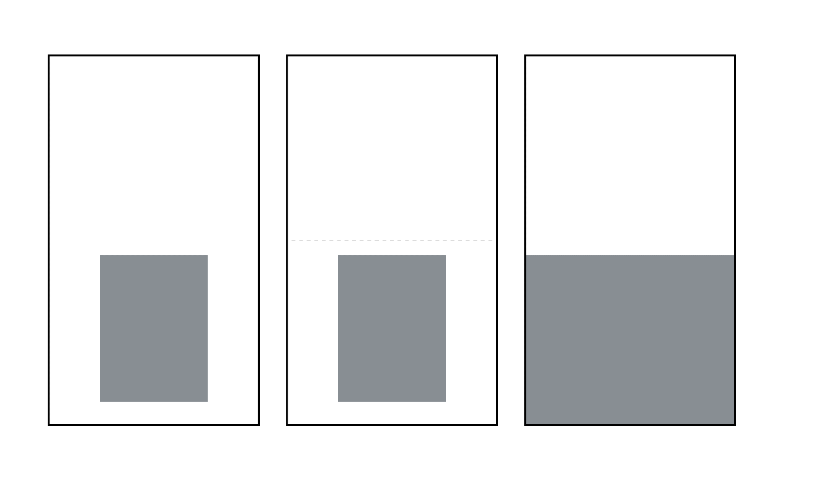

**Figure 1.A** depicts an example of an internal rectangle within an external rectangle. In this case, the instructions were to bisect the external rectangle with the top line of the internal rectangle. Note that Figure 1.A presents what the participant sees in the experiment. The broken line in Figure 1.B is the actual midline of the external rectangle. Figure 1.C shows an example where AUC = 0 and there is no white area surrounding the internal rectangle up to its top line. In this case, the observer has to move up the entire gray rectangle side to bisect the external rectangle.

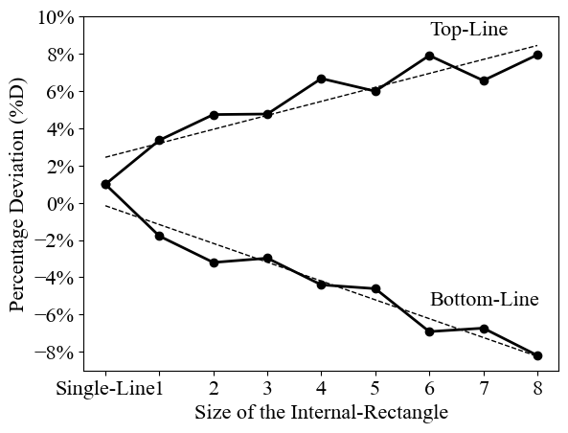

**Figure 2** depicts % D as a function of single line, internal rectangle’s size, and instructions: top-line or bottom-line. The broken line represents a linear equation adapted to the results (see text).

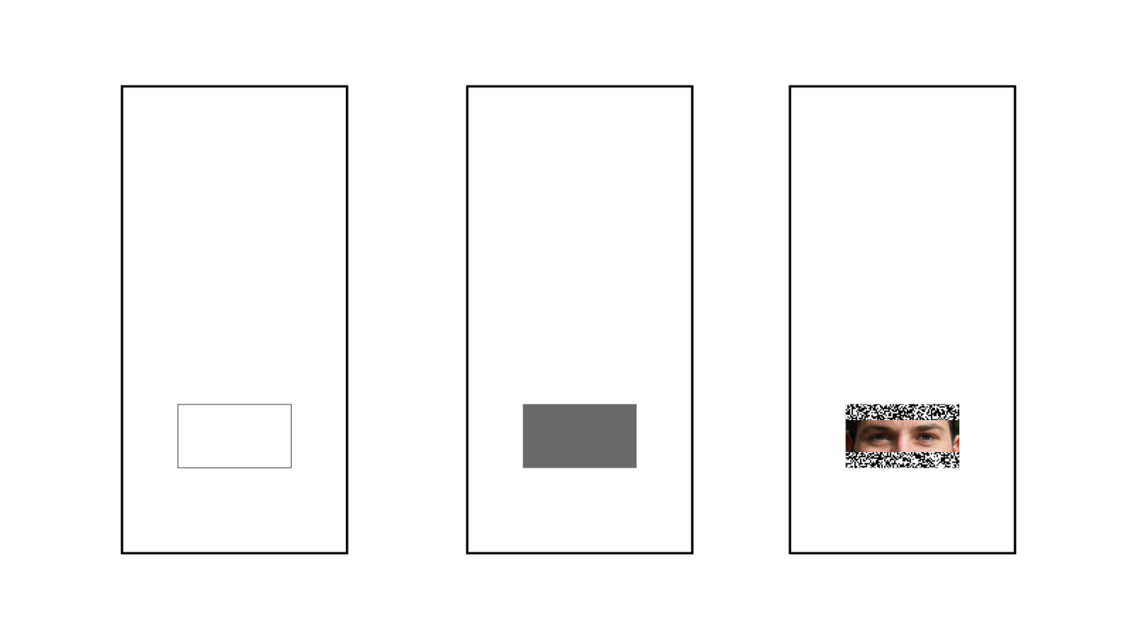

**Figure 3** depicts examples of the configurations used in experiment 2, where an external rectangle contains one of three types of internal rectangle. 3A: the frame of an internal rectangle; 3B: a gray internal rectangle; 3C: internal rectangle incorporating a picture of a pair of human eyes.

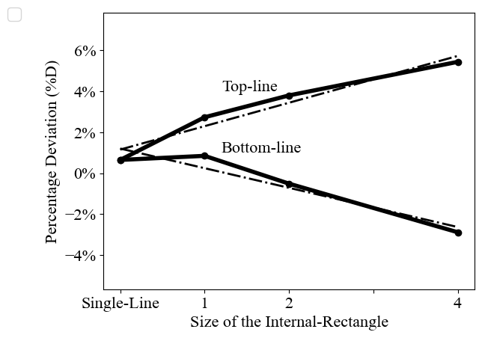

**Figure 4** depicts a partial replication of experiment 1’s results: % D as a function of single line, size of internal rectangle, and top- or bottom-line instructions. The broken line represents a linear equation adapted to the results (see text).

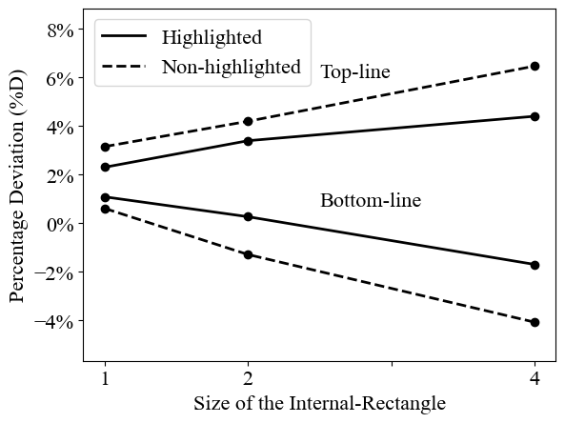

**Figure 5** depicts % D as a function of the size of the internal rectangle, the non-highlighted line, highlighted line, and the top- or bottom-line instructions.

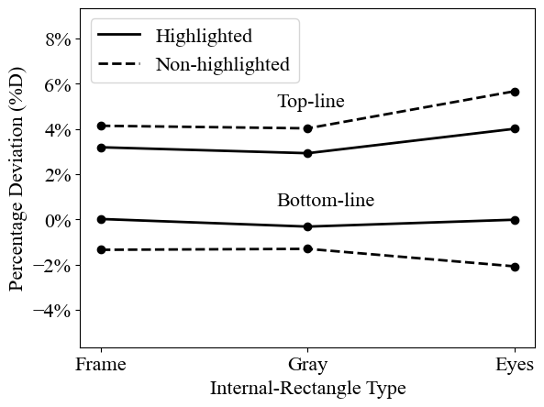

**Figure 6** depicts % D as a function of the type of internal rectangle: frame, gray, eyes, the non-highlighted line, highlighted line, and the top- or bottom-line instructions.

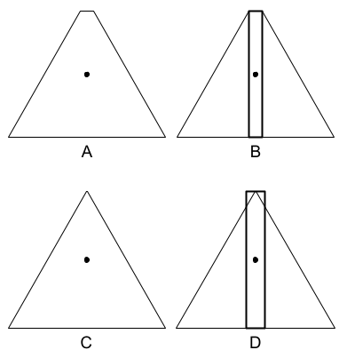

**Figure 7** depicts the equilibrium trapezoid-bisection illusion and the triangle-bisection illusion. In 7A, the central point, which is located exactly halfway up the height of the trapezoid, seems closer to the top than to the bottom. However, in 7B, the illusion is reduced by the addition of two parallel lines that create a narrow rectangle. In 7C, the central point of the triangle seems closer to the top than to the bottom. In 7D, the illusion is reduced by a narrow rectangle. Note that if one concentrates on the triangle and ignores the rectangle, the illusion appears. However, if one concentrates on the rectangle and ignores the triangle, the illusion decreases (disappears).