**Die 4-Cs des Online-Marketing-Mix**

**The 4 Cs of the Online Marketing Mix**

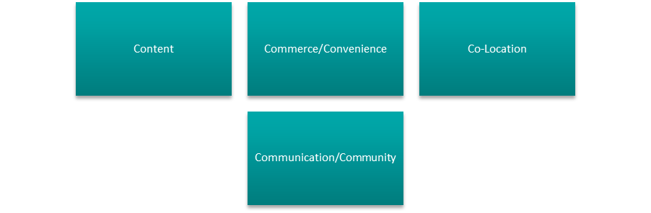

|  |  |
| --- | --- |
| Content | Content |
| Commerce/Convenience | Commerce/convenience |
| Co-Location | Co-location |
| Communication/Community | Communication/community |

**Der klassische Pre-Sales-Funnel**

**The Traditional Pre-Sales Funnel**

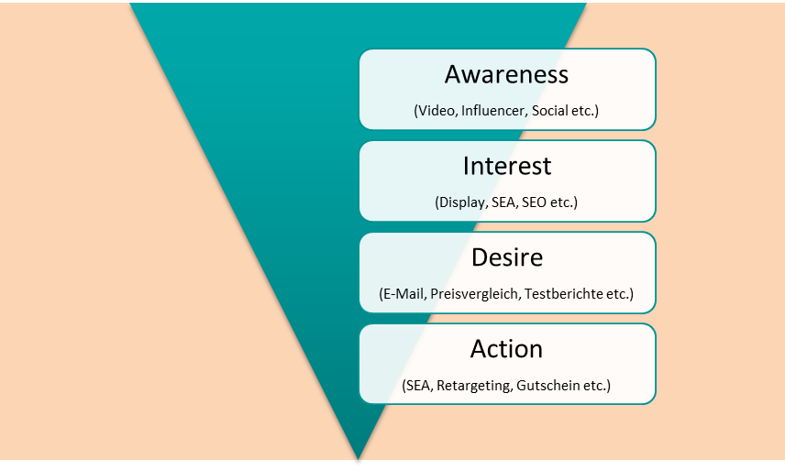

|  |  |
| --- | --- |
| Awareness | Awareness |
| (Video, Influencer, Social etc.) | (Video, influencer, social, etc.) |
| Interest | Interest |
| (Display, SEA, SEO etc.) | (Display, SEA, SEO, etc.) |
| Desire | Desire |
| (E-Mail, Preisvergleich, Testberichte etc.) | (Email, price comparison, test reports, etc.) |
| Action | Action |
| (SEA, Retargeting, Gutschein etc.) | (SEA, retargeting, voucher, etc.) |

**Schema der Conversion Rate**

**The Conversion Rate Schema**

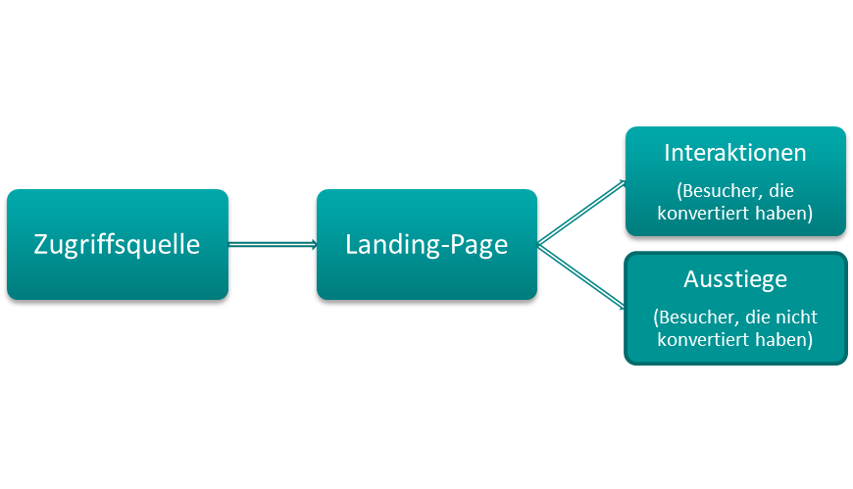

|  |  |
| --- | --- |
| Zugriffsquelle | Access source |
| Landing-Page | Landing page |
| Interaktionen | Interactions |
| (Besucher, die konvertiert haben) | (Visitors who have converted) |
| Ausstiege | Exits |
| (Besucher, die nicht konvertiert haben) | (Visitors who have not converted) |

**Conversion Funnel**

**Conversion Funnel**

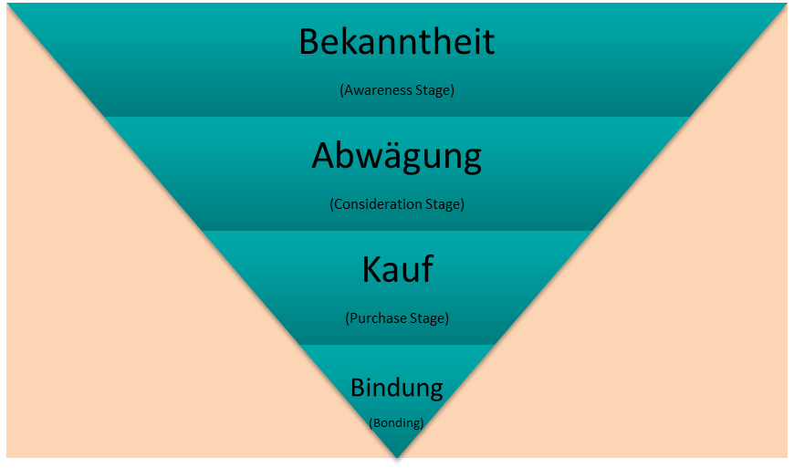

|  |  |
| --- | --- |
| Bekanntheit | Awareness |
| (Awareness Stage) | (Awareness stage) |
| Abwägung | Consideration |
| (Consideration Stage) | (Consideration stage) |
| Kauf | Purchase |
| (Purchase Stage) | (Purchase stage) |
| Bindung | Bonding |
| (Bonding) | (Bonding) |

**„Last Cookie Wins“ im Vergleich zu „First Cookie Wins“**

**“Last Cookie Wins” Compared to “First Cookie Wins”**

|  |  |
| --- | --- |
| Display-Advertising | Display advertising |
| SEA | SEA |
| Social Media | Social media |
| Mobile Banner | Mobile banner |
| E-Mail | Email |

**Der Conversion-Cycle – Prozess zur Conversion-Optimierung**

**The Conversion Cycle – Process for Conversion Optimization**

|  |  |
| --- | --- |
| Analyse | Analysis |
| Hypothese | Hypothesis |
| Umsetzung | Realization |
| Controlling | Controlling |
| Interpretation | Interpretation |
| Implementierung | Implementation |

**Die Perspektiven der SEO**

**The SEO Perspectives**

|  |  |
| --- | --- |
| Suchmaschine | Search engine |
| User:innen | User |

**Der Link-Struktur**

**The Link Structure**

Unterpunkt 1

Unterpunkt 2

Unterpunkt 1

Unterpunkt 2

Thema 1

Thema 2

Homepage

|  |  |
| --- | --- |
| Homepage | Homepage |
| Thema | Item |
| Unterpunkt | Subitem |

**Einordnung SEA**

**SEA Placement**

Marketing-

Mix

Kommunikations-

politik

Distributions-

politik

Produkt-

politik

Preis-

politik

Performance-

Marketing

Online-

Marketing

SEO

SEA

|  |  |
| --- | --- |
| Produktpolitik | Product policy |
| Kommunikationspolitik | Communication policy |
| Marketing-Mix | Marketing mix |
| Distributionspolitik | Distribution policy |
| Preispolitik | Price policy |
| Performance-Marketing | Performance marketing |
| SEO | SEO |
| Online-Marketing | Online marketing |
| SEA | SEA |

**Stufen der Kundenbindung**

**Customer Loyalty Stages**

|  |  |
| --- | --- |
| Kundengewinnung | Customer acquisition |
| Marketing | Marketing |
| Interesse | Interest |
| Funktionale Kundenbindung | Functional customer loyalty |
| Grundleistungen | Basic services |
| Funktionale Lösungen | Functional solutions |
| Emotionale Kundenbindungen | Emotional customer loyalty |
| Dauerhafte Kundenbindung | Long-term customer loyalty |
| Stammkund:innen | Regular customers |
| Öffentliche Berichte | Public reports |

**Schritte zur Potentialausschöpfung des Social-Media-Auftritts**

**Steps for Exploiting the Potential of a Social Media Presence**

|  |  |
| --- | --- |
| Ziele und Zielgruppe definieren | Define goals and intended audience |
| Analyse der Zielgruppe und Abgleich schaffen | Analyze the intended audience and make adjustments |
| Rahmenbedingungen festlegen | Establish boundary conditions |
| Planungsebene | Planning phase |
| Markteintritt | Market entry |

**Die weiterführenden Entwicklungsebenen der Marktausschöpfung**

**The Advanced Development Levels of Market Exploitation**

|  |  |
| --- | --- |
| Markteintritt | Market entry |
| Social-Media-Inseln | Social media islands |
| Gesamtstrategie | Overall strategy |
| Organisationsdurchdringung | Organizational penetration |

**Influencer Marketing und virales Marketing**

**Influencer Marketing and Viral Marketing**

|  |  |
| --- | --- |
| Influencer Marketing | Influencer marketing |
| Auswahl | Selection |
| Aufbau und Pflege | Establishment and cultivation |
| Virales Marketing | Viral marketing |
| Random Virals | Random virals |
| Placed Virals | Placed virals |

**Arten der Anzeigenwerbung**

**Types of Advertising**

|  |  |
| --- | --- |
| Display-Werbung | Display advertising |
| Kooperationen | Cooperations |
| Media-Sharing-Platform | Media sharing platform |

**Bereiche des Proximity-Marketings**

**Types of Proximity Marketing**

|  |  |
| --- | --- |
| Location-Based Marketing | Location-based marketing |
| Beacons | Beacons |
| QR-Codes | QR codes |
| NFC | NFC |