# Course Book

## Performance Marketing: Search and Social

**DLMOMPMSS01_E**

**8** Introduction

### Learning Objectives

###### Introduction **9**



In the area of performance marketing, online marketing instruments are used to obtain measurable responses from users, e.g., downloads, app installations, or transactions. The most prevalent areas of online marketing are presented during this course with a focus on their potential applications.

Additional aspects of the online marketing mix and thus of performance marketing are also discussed and include search engine optimization, search engine advertising, social media, and mobile marketing.

Alongside the specific features of performance marketing, such as its measurability, modularity, optimizability, and crosslinking, the various performance marketing instruments are also presented. Furthermore, after working through this course book, you will be able to strategically integrate performance marketing instruments into the marketing mix with a particular focus on increasing conversion rates, as well as monitoring, measuring, and controlling.

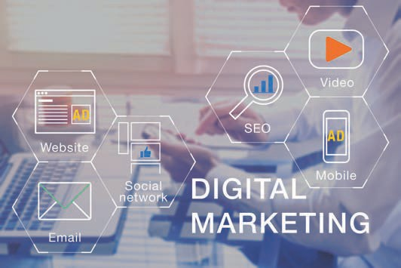

# Unit 1

## Fundamentals of Performance Marketing

##### STUDY GOALS

On completion of this unit, you will be able to ...

... understand the fundamentals of performance marketing as well as its individual performance aspects.

... categorize and differentiate performance marketing as part of the marketing mix.

... characterize the various features of performance marketing.

... understand how key instruments of performance marketing function and apply them.

DL-D-DLMOMPMSS01_D-L01

### Fundamentals of Performance Marketing

#### Introduction

Corporate communication has undergone radical changes in recent decades. In this context, we speak of the *push* and *pull* directions of communication. *Push* means that media are actively conveyed to the recipients, regardless of their desire for it. For example, traditional advertising, such as TV commercials and newspaper ads, falls into this category. In contrast, online communication channels belong more to the *pull* category. In these cases, people actively search the internet for information, products, or services and then voluntarily click on the search hits and ads that appear. Others follow brands or companies on Instagram and Twitter, or they sign up for newsletters. Nevertheless, *push* communication also exists in online marketing. This can be in the form of banners that are placed and embedded among digital texts, such as those found the SPIEGEL media brand website. Overall, the trend is now moving away from *push* and increasingly toward *pull* (Beilharz, 2021). The combination of both communication directions certainly makes sense and as a result, companies and brands are increasingly utilizing the numerous possibilities offered by the world wide web.

As a global communications medium, the internet offers nearly unlimited space for managing goods, services, or brands in communications (IHK für Rheinhessen, n.d.). A major advantage in online marketing is the measurability ofcampaigns. For example, it is possible to track how often an internet ad is clicked and how many people buy a product or service after coming across a particular web page via an ad in a search engine such as Google.

GAFAM

The GAFAM acronym refers to the world's largest IT companies: Google (Alphabet Inc.), Amazon, Facebook (Meta Inc.), Apple and Microsoft, all of which have a significant impact on the economy and society.

Above all, interactivity allows the user to freely choose the scope, as well as the type, time, and duration of interactive exchanges with websites, web stores, apps, social media, or other online marketing instruments (Walsh et al., 2020, p. 539). The **GAFAM** corporations, i.e., Google, Amazon, Facebook (which now calls itself Meta), Apple, and Microsoft dominate much of the western world's online content. This is because these companies also own YouTube, Google Maps, Instagram, WhatsApp, iTunes, Windows, Office, Teams, and LinkedIn (Beilharz, 2021). This means that anyone seeking to properly implement online marketing cannot avoid engaging with these companies, as well as their methods and offers.

Although traditional marketing measures such as advertising space in public places, direct marketing, PR, TV, newspaper, and radio advertising are still effective, online marketing measures are becoming increasingly relevant in the digital environment. It is to be noted here that digital marketing, internet marketing, and online marketing are terms that can be used synonymously.

The traditional advertising measures mentioned above are dwindling in their significance, which has resulted in a shift in marketing budgets toward digital media. In the course of digital transformation processes, online marketing has become a key success factor in reaching people where they now spend an increased amount time – namely on the internet.

Fundamentals of Performance Marketing

Naturally, companies should therefore orient their communication activities toward reaching their customers exactly where they are. The figure below summarizes the online marketing instruments and arranges them into two areas: the activities that are visible to users and those that take place in the background, i.e., are not visible to users .

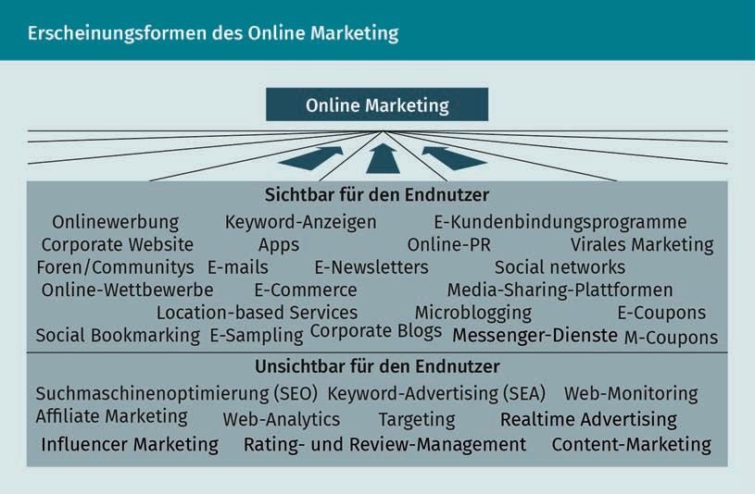

It is essential for companies to direct as many visitors as possible to their website or to encourage them to use the company's app. This is referred to as traffic. Felix Beilharz divides *traffic* into the following categories: *earned traffic*, i.e., merited or provided traffic that companies or brands do not pay for directly. This is also referred to as *organic traffic,* since it is generated automatically, e.g., users reach a company's website via search engines such as Google or Bing, via Facebook or Instagram, via LinkedIn, or via links in online editions of newspapers or online portals. In contrast, *paid traffic* is generated through advertising on the internet. In addition, there is also *owned traffic,* e.g., traffic related to the possession of newsletter recipients’ email addresses. All three types of traffic are important, but it is to be emphasized here that companies should pay particular attention to owned traffic (Beilharz, 2021).

Various instruments can be applied to succeed in this endeavor, all of which are designed to achieve measurable responses or even transactions with the respective users. Online marketing is constantly evolving and gives particular rise to another key term that comes into play: *performance marketing*.

It is therefore important to ask the following questions:

* What is performance marketing?
* What is meant by the terms *search* and *social* in the context of performance marketing?
* How can performance marketing be defined as part of the marketing mix, as well as be distinguished from and supplemented by traditional online marketing?
* What are the specific features of performance marketing?
* What are the various instruments used in performance marketing?

#### Performance Marketing as Part of the Marketing Mix

Measurable responses and transactions

Such measurable responses and transactions include clicks on advertising banners, registration for newsletters, or the purchase of a product in an online store.

Performance marketing is a strategy in online marketing in which marketing measures lead to **measurable responses and/or transactions** (Auler & Huberty, 2019, p. 137).

To be able to categorize online marketing as well as performance marketing, it is necessary to take a closer look at the marketing instruments that form what is known as the marketing mix. The marketing mix is essentially comprised of four different instruments, what is referred to as *4 P's* (Meffert et al., 2019, p. 20):

1. Product (product policy)
2. Price (price policy)
3. Placement (distribution policy)
4. Promotion (communication policy)

Online marketing and performance marketing fall into the area of promotion (communication policy).

As a further *P*, the traditional marketing mix concept these days is often supplemented by the *people* aspect in order to adequately represent the increasing importance of employees to their company’s success on the market (Kreutzer, 2021, p. 50).

While product policy involves product quality, product design, and product range planning, the scope of pricing policy involves decisions on market-oriented pricing that also includes consideration of the business environment. Distribution policy is to be understood as a significant cost factor and encompasses all sales activities and decisions as well as sales channels, choice of sales partner, and logistics.

Since 2000, advertisers have been able to place ads for specific terms in the search results on Google using the AdWords system. Thanks to extensive statistics, the results can be evaluated and optimized to an extremely high degree (Kamps & Schetter, 2020, p. 4).

Fundamentals of Performance Marketing

Since Google Ads (formerly known as Google AdWords) plays a decisive role in online and performance marketing, we will briefly discuss it at this point. As an example, if the term *snowboard* is searched via the Google search engine, the following situation presents itself: to be positioned in the first three ads, for which the advertisers must pay and are marked with the word *Sponsored*, the companies Blue Tomato, Warehouse One, and Euroskateshop offer money (bid) to Alphabet Inc. (which owns Google). The company that is willing to pay the most per click, i.e., per visitor who arrives at the corresponding company’s internet presence via the ad, is placed at the very top and above the organic, i.e., the *normal*, search results.

Performance marketing is positioned within the **communication policy** and in connection with digital media, it is referred to as a component of the marketing mix. Performance marketing serves both customer acquisition and customer retention and is applied with the goal of achieving measurable responses and/or transactions from users. Customers and interested parties are approached in a highly targeted manner, even on an individual basis when possible, to achieve the greatest possible interaction with users.

The German Association for the Digital Economy (BVDW – Bundesverband Digitale Wirtschaft) particularly founded a specialist group for this in April 2005 and offers a description of performance marketing instruments as follows: search engine marketing, web marketing, email marketing, affiliate marketing, online cooperations, and mobile marketing. (Fortmann, 2006). Thus, the question of what is meant by performance marketing is answered. But what do the terms *search* and *social* mean in this context? The term *search* refers to search engines. This is where companies and agencies spend a great deal of money to make products, services, and brands findable – quickly and easily. The term *social* refers to social media, which play a significant role in the western world in the form of Instagram and Facebook, among others. In China, the WeChat and Sina Weibo companies have a similar role.

A key feature of performance marketing is the performance-based remuneration paid to the media within the framework of success-based models: performance marketing services can be defined as clicks (e.g., when referring visitors to websites) or as the generation of **leads** or sales, which also gives rise to specific forms of remuneration (Lammenett, 2019, p. 43). Examples of remuneration in performance marketing include remuneration per sale achieved (pay-per-sale) or remuneration per click generated (pay-per-click) (Kreutzer, 2021, pp. 111–112).

A rethinking of the traditional marketing approach is now necessary, since information and communication technologies in particular are in a constant state of change. The new digital possibilities and ways of addressing intended audiences inevitably result in changed marketing strategies and thus also in adapted measures and marketing goals that can ensure long-term success in the market.

Communication policy

All communication measures are planned, implemented, and evaluated in this area.

Leads

In the context of sales, leads refers to data sets (e.g., name, address, email address) for customers who might be interested in a company's respective offer.

Performance marketing ties in with the key points of today's marketing in which digital corporate activities are professionalized and made measurable. In practice, this means that it is no longer simply the placement of online ads that is to be paid for, but rather the leads or customers acquired as a result (Kreutzer, 2021, p. 28). The targeted use of the services available on the web is pursued through the application of performance marketing, making it an integral part of the overall marketing mix (Lammenett, 2019, p. 39).

Performance marketing thus aims to achieve measurable reactions among the recipients of advertising messages. It is therefore particularly suitable as a results-based approach to marketing activities when considering the following goals:

* Reach – Number of users who see an internet presence or use an application (app).
* Interaction – How users interact with a website or an app. Examples include users playing Candy Crush, checking their account balance on their bank's online app, or consuming third-party posts on YouTube or LinkedIn.
* Transaction – What do users actually do on a website or within an app? An example here would be an order placed with Amazon.

To fully exploit the potential of online marketing mix instruments, they must be implemented holistically within the marketing concept so that the vital synergy effects of an integrated communication do not go untapped (Kreutzer, 2021, p. 29). If this can be achieved, then the use of performance marketing can have positive effects on the overall performance of a company. A holistic overview of the effectiveness of the measures can be created through:

* clear transparency of the online marketing measures carried out,
* their measurability, and
* the option of a success-based remuneration.

While companies can often only assume that their online advertising will lead to action on the part of their customers, performance marketing can be used to quickly check what effect it actually has. Ongoing advertising campaigns can therefore be continually improved on this basis. The reactions achieved and thus the advertising success can be quantified and the achievement of goals can be documented with absolute figures (Kamps & Schetter, 2018, p. 6). Sought-after actions on the part of the advertising recipients and the subsequent results include:

* interactions (such as a click on the corresponding advertising material) and their resulting sales and purchase transactions,
* the winback of customers, and
* strengthening existing customer relationships.

To initiate the corresponding actions sought, it is necessary to implement a highly targeted and, if possible, even an individual customer approach to achieve maximum interaction with the respective user(s) (Lammenett, 2019, p. 43).

Fundamentals of Performance Marketing

It is now clear that in performance marketing, the actual activity only begins after an advertising campaign is put into action. Continual optimization of a campaign can then bring about a convergence toward the established goals until these are ultimately achieved (Kamps & Schetter, 2018, p. 6).

Although the term *performance marketing* was introduced as such in 2008, the practice of response-driven online marketing campaigns was established long beforehand (Kamps & Schetter, 2018, p. 4).

#### Features of Performance Marketing

Performance marketing refers to the use of various online marketing channels to elicit a measurable response among the recipients of the advertising. (Kamps & Schetter, 2018, p. 4). An example of this would be a click on an ad from an online store that sells watches. Naturally in the best case, a watch is then purchased.

Performance marketing can be characterized using four key features (Heinemann, 2020, p. 88):

* + - **Measurability:** The reactions of an intended audience can be recorded clearly, promptly, and completely.
    - **Modularity:** Performance marketing campaigns are divided into many smaller budget modules that can be allocated and assessed individually.
    - **Optimizability:** This results from different measured parameters with which the efficiency of an ongoing marketing campaign can be influenced and thus improved.
    - **Crosslinking:** Performance marketing can also be integrated into a traditional advertising campaign, which can have an effect on the click rate – a wide variety of advertising measures can be linked together.

These four features are considered in more detail below.

Measurability

Generally speaking, it makes sense to use different instruments and build campaigns in a modular way. This means that individual measures are combined with one another. In addition to placing Google Ads to sell travel, it is also possible, e.g., to book banners on travel portals or blogs. Through this modular structure of corresponding campaigns, individual measurable results can be collected from the various performance channels with the help of **key performance indicators** (KPIs). This results in company and decision-relevant evaluations of the effectiveness of the performance marketing measures carried out – and then the optimization potential also becomes apparent.

Key performance indicators

KPIs are key figures that show the business performance of a company and provide information on its efficiency of processes.

.

Conversions Indicate how many transactions were achieved by a campaign and thus indicate the advertising performance (Kamps & Schetter, 2018, p. 7).

This allows companies to decide whether to continue with the campaigns already carried out or utilize their budget allocation elsewhere.

The ability to quickly record the results of marketing campaigns (Kreutzer, 2021, p. 28) and continually improve campaigns undertaken throughout their lifecycle is considered both an essential function and a goal of performance marketing (Kamps & Schetter, 2018, p. 4).

To quantify advertising success, however, exact goals must already be defined before the start of the performance marketing campaign. The goals are not only relevant for the design of measures, but also for the determination of suitable KPIs for measuring success. Since performance marketing should be fundamentally targeted, it is essential to continually measure the success already achieved from the start of the campaign undertaken. The success of a campaign is reflected, e.g., in clicks, **conversions**, or also in the comparison of costs and benefits, which can be measured in real time (Walsh, Deseniss & Kilian, 2020, p. 545).

For effective optimization during campaign activation and due to the large number of evaluation channels in digital marketing, it is therefore important to define the key performance indicators in such a way that the online marketing measures under consideration are actually measured in the course of controlling. Possible key performance indicators can be, e.g., the increase in website traffic and customer retention (customer loyalty) and alongside these, social engagements such as likes, shares, comments, sales, and leads are also relevant metrics in performance marketing (Kamps & Schetter, 2018, p. 7).

Web analysis is used when measuring the performance of websites. This describes the process of evaluating the users’ behavior on a company’s own website. The KPIs can then be derived from the insights gained and conclusions as to whether the previously set goals have been achieved can be drawn. (Kamps & Schetter, 2018, p. 159).

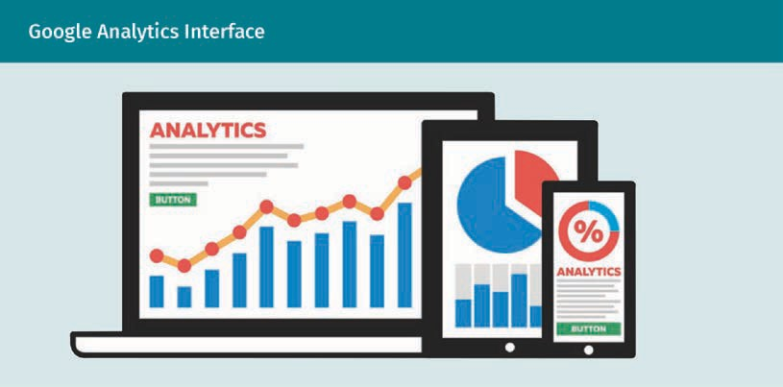

Fundamentals of Performance Marketing

A suitable program that can be accessed from all devices is, e.g., Google Analytics software, in addition to other providers such as StatCounter, AWStats, Econda, Piwik/Matamo, and many others.

Performance marketing performance areas and KPIs

Due to the multitude of possibilities offered by performance marketing, it is necessary to divide it into different, precise performance areas and define the metrics (indicators) to be considered within each area to render the advertising measures as measurable.

If the company-specific goals of performance marketing have been precisely determined, the corresponding performance parameters, as well as the associated **performance metrics**, can be specified for the implementation, whereby the recording of the achieved performance should always be in the forefront throughout the campaign activation. The table below lists exemplary performance areas in the context of performance marketing and the associated KPIs.

|  |  |  |
| --- | --- | --- |
| **Performance Marketing Performance Areas and KPIs** | | |
| Performance area | Performance parameter | Performance metric |
| Maximization of awareness | * Website use * Visibility of a company’s offer in a search engine * Attractiveness of moving image content * Social media * Awareness (brand recognition) | * Cost-per-click (CPC): Cost per click on an ad * Cost-per-action (CPA): Cost per action taken * Website unique visitor: Access frequency to a website per   “single unique visitor”   * Page impressions:   Page accesses or views   * SEO ranking:   Web page positioning within a search engine result   * Search volume:   Number of search queries   * YouTube viewers |

Performance metrics Represent individually relevant evaluation figures or a process for measuring quantifiable values to record the success or efficiency of a performance marketing campaign in various performance areas.

|  |  |  |
| --- | --- | --- |
| Performance area | Performance parameter | Performance metric |
| Intensification of engagement | * Type of use and intensity of use * Social media reputation | * Bounce rate:   Visitor exit rate   * Dwell time on a target page * View time:   Dwell time during a web page access |
| Generation of leads | * Indicated interest in a product or service (e.g., contact form). * Whitepaper downloads * Number of product tests by users | * Cost-per-lead (CPL): Remuneration for a contact (billing model) * Pay-per-lead (PPL): Payment per con- tact (billing model) |
| Conversion into sales | * Sales to end customers/distributors achieved * Completed shopping carts in an e-store | * Cost-per-order (CPO): Cost per completed order * Cost-per-sale (CPS): Cost per completed sale |
| Maximization of loyalty | * Product/service reviews through customer loyalty to a company | * Rate of returning visitors * Number of subscribers * Number of reviews (product and service ratings) and recommendation rate |

This table can be expanded to include other metrics. It should also be noted here that their application always depends on the company in question. The five performance areas listed will now be explained in greater detail.

Fundamentals of Performance Marketing

* **Maximization of awareness:** This first performance area is primarily concerned with increasing brand awareness among potential customers, which is often the prerequisite for the subsequent conversion. Conversion means that, ideally, prospects become customers.
* **Intensification of engagement:** This area focuses on the engagement that occurs between the customer contact and the lead, although it does not necessarily need to result in a purchase, but rather can serve as a metric of the offer’s attractiveness.
* **Generation of leads:** Acquisition of contacts (leads) and increasing active buying interest.
* **Conversion into sales:** Focuses on the completed sales process, which is an essential component in the **pre-sales funnel** (see figure below). Here, we imagine a funnel through which prospects pass. The goal of this funnel is to turn interested persons into valuable customer contacts by passing them through different touchpoints (points of contact with the company or the brand) or stages and ultimately carrying out a specific action. The number of leads decreases in the downward direction – which is why a funnel is referred to in this context. The people reached are concentrated and their quality increases. This means that the contacts reached are filtered and, ideally, buyers remain.
* **Maximization of loyalty**: This key performance area follows after successfully passing through the pre-sales funnel. Costs are incurred during the course of acquiring customers. Therefore, securing loyalty and ultimately acquiring customers who, in the best case, also act as brand ambassadors by recommending a company, brand, product, or service to others, plays an important role in performance marketing. This can also be achieved through reviews, i.e., product and service evaluations (Greunke, 2017, p. 200).

Because a clear understanding is essential here, the pre-sales tunnel principle is discussed in greater detail below.

After attention has been directed toward a product or service, the potential customers should purchase that product or service. The figure below illustrates the different stages that visitors pass through until, ideally, a purchase is made.

Pre-sales funnel

This funnel illustrates the stages that customers go through until they make a purchase decision. It runs from the lead generation stage through to the development of leads and up to

conversion into qualified leads (Kamps & Schetter, 2018, p. 6).

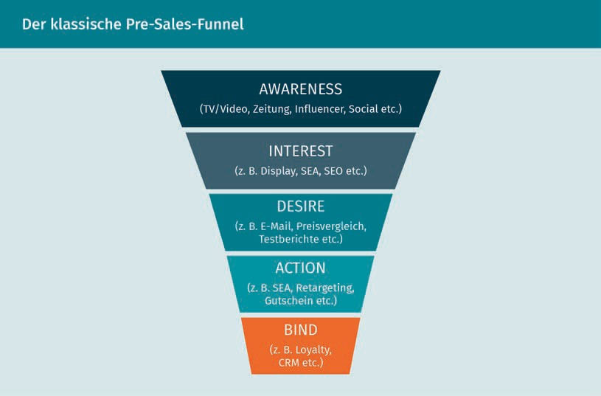

Performance marketing is also characterized by the fact that it is possible to transparently record costs to a company in real time, e.g., for a click, a specific advertising campaign, lead, or even a completed transaction. In specific terms, the advertising budget spent on the campaign in question is divided by the number of clicks, e.g., in order to calculate the cost per click for an ad. It is to be noted here that performance marketing, if it is offered by service providers, e.g., agencies acting on behalf of a company, can also be billed on a success or performance-based basis. (Kreutzer, 2021, p. 112).

The success of performance marketing heavily depends on a variety of key figures that are individually determined by companies. The common performance indicators include conversion data that is comprised of conversion costs and the conversion rate that can be used to record the monetary investment required to convert interested parties to customers on a website. Conversely, the **click-through rate**, which is not listed in the table above, and the cost-per-click are click data that compare the number of clicks with the total number of impressions (page impressions or page views) and indicate the costs incurred when customers click on advertisements (Kreutzer, 2021, pp. 111–112).

Modularity

As already mentioned, performance marketing campaigns are characterized by a modular structure in most cases. This means that different channels can be used simultaneously or independently of one another. Each of these channels provide

Fundamentals of Performance Marketing

their own measurable results, which in turn offer opportunities for improvement (Kamps & Schetter, 2018, p. 4). Modularity provides companies with the opportunity to only use and evaluate individual subareas, such as the use of search engine advertising (SEA) or keyword advertising. The importance of modularity is illustrated by the following statements: companies cannot exclusively use search engine advertising, but they must also do their best to ensure that their own internet presence is displayed on the first page in organic searches, e.g., in the Google search engine. This naturally brings up the question of how many internet users actually carry on to the second and third pages when they search for a term. Therefore, companies must always focus on search engine optimization (SEO).

Optimizability

Email campaigns are a suitable example for describing optimizability. The direct and exact measurement of clicks or responses to an email campaign provides important decision-making aids that can be included in current and future measures. How many addressees responded to the email? How many purchases were made? Was the content the best it could be? Was too much text used, resulting in the recipients deleting the email?

A/B testing, also referred to as split testing, is worth mentioning in the context of optimizability, since it illustrates this approach quite well. The idea behind it is very simple. Two versions of a web page or landing page are created and both are made accessible on the internet to observe which one performs better. As a rule, two entirely different pages are not tested, but rather only individual elements or components are changed so that the first visitor will see Variant A and the second visitor will see Variant B. The variant with the better conversion rate is considered the winner of the test (Herzberger & Jenny, 2020, pp. 213–214).

Crosslinking of Various Measures

Due to the integrated approach of performance marketing, individual components such as search engine marketing and optimization, banner advertising, as well as email and affiliate marketing can be used in parallel. Thanks to web analysis, a summary of the measures with the best cost-benefit ratio can then be prepared.

Click-through rate Also known as CTR or click rate, the click-through rate describes the percentage of clicks on an advertising medium in relation to the number of times the advertising medium is displayed. If an advertising banner is displayed 500 times and clicked on 10 times, this results in a click-through rate of 2 percent (10 clicks/500 ad impressions x 100).

#### Performance Marketing Instruments

Considering the wide variety of different instruments for performance marketing, the following is an outline of those that currently hold the greatest significance and are frequently used in practice.

Search Engine Marketing

Search engine

marketing

This is an umbrella term for the corporate use of search engines for communication purposes.

The goal of **search engine marketing** (SEM) is to achieve the most visible placement of company-related information possible in the search engine results pages (SERPs). The search results page is typically divided into a paid and an organic results area. Organic here means *automatically generated*, i.e., when users search for a term in a search engine and thus automatically come across a specific website without any costs being incurred by the operators of that website.

This also results in the two primary forms of search engine marketing (Meffert et al., 2019, p. 714):

* Search engine advertising (SEA)
* Search engine optimization (SEO)

Search engine marketing (SEM), with the two subareas mentioned above, is one of the most common instruments among online marketing measures and is considered “the engine of online advertising” (Lammenett, 2019, p. 194). This is because search engine marketing enables advertisers to display to consumers precisely those offers in which an actual interest already exists and thus an increased willingness to buy/act can be anticipated.

Both measures, search engine advertising (SEA) and search engine optimization (SEO) are vital to performance marketing and share a common goal: to increase traffic. Thus, the intention here is to attract visitors to websites. The figure below summarizes the most important components:

|  |  |
| --- | --- |
| **Comparison: Search Engine Advertising vs. Search Engine Optimization** | |
| Search engine advertising (SEA) | Search engine optimization (SEO) |
| Paid action | Unpaid measure, unless a service provider is commissioned. |

Fundamentals of Performance Marketing

|  |  |
| --- | --- |
| Search engine advertising (SEA) | Search engine optimization (SEO) |
| Simple process | A lengthy process until a company, web page, or keyword is considered relevant enough by a search engine to appear on the first page. |
| Immediate result and visibility | Under certain circumstances, results are only visible after several months. |
| Customers do not know whether the advertiser is trustworthy. | Based on a search engine’s placement, it can be assumed that the internet presence is reputable. |
| The selection of keywords is easy to understand. | The choice of keywords is difficult to make. |
| Clear selection of an intended audience. | An intended audience cannot be clearly selected. |
| Placement of the ad above the organic search results. | Placement dependent upon a search engine operator’s selection. |

There are many factors that contribute to a search engine like Google placing a web page at the top of the search results. For example, a page that has been present on the web for a long time will enjoy an advantage over a page that has only recently gone online. If the page is reported in the press or other media on the internet, then the search engine assumes that the internet presence has relevance. Furthermore, whether links from other web pages lead to a company’s own web pages also plays a role. It also makes sense to integrate the subject of the page into the domain. For example, if a company offers furniture, it is best to integrate that term into their domain, as the example below illustrates:

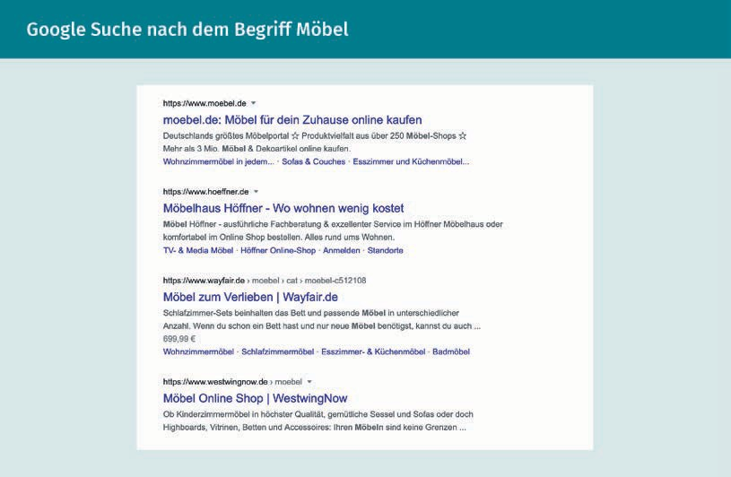

In this example, it can be assumed that the Google search engine places www.moe- bel.de first in the organic search due to the clear reference of the keyword *furniture* and the matching domain.

A look at the Google Trends page shows the popularity of the term *furniture*:

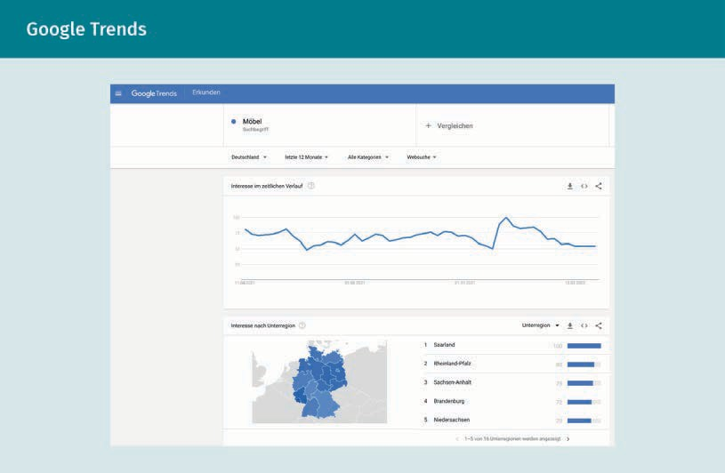Google Trends

Fundamentals of Performance Marketing

In Google Trends, the number 100 refers to the absolute maximum value. Companies that are active in different countries can combine their search here and thereby compare, e.g., Switzerland with Austria.

Search engine advertising

Search engine advertising or search engine marketing is designed to increase the company's visibility within the respective paid results area. The paid placement of promotional information in this area takes the form of so-called sponsored links, which typically consist of different text elements with a hyperlink to a company’s specific landing page and include a reference to their promotional nature.

However, the paid ads only appear if the user's search query is related to specific search terms (keywords) that the advertising company has defined in advance for precisely this ad (Meffert et al., 2019, pp. 714–715).

Based on its Google Ads program, Google is considered the market leader in the context of search engine advertising. While Microsoft’s Bing Ads has also had its own system in operation since 2006, it does not threaten Google's market power (Lammenett, 2019, pp. 194–195).

Search engine optimization

Search engine optimization primarily involves a company’s visibility in the organic area of a search engine results page (SERP). Paid and organic search results are not in competition with each other because they are based on different ranking criteria and varied algorithms (Meffert et al., 2019, p. 714).

All activities that lead to a company's own online offers achieving a better ranking on an organic hit list can be categorized under search engine optimization (Kreutzer, 2021, p. 114). The primary focus here is not on promoting specific online content, but rather on the findability of the content made available online. In contrast to SEA, using SEO measures, such as optimized homepage texts to achieve a high positioning on an organic hit list, means that money does not necessarily need to be paid. Nevertheless, it is quite common that companies must continually invest in the optimization of their corporate website to achieve and maintain the desired position (Kreutzer, 2021, pp. 128–129).

Display Advertising

Display advertising is considered a traditional element of online advertising and particularly includes animated graphic advertising media such as videos, images, banners, and keyword ads, as well as story, photo, and video ads, e.g., in social media or in button and audio formats. These are deployed on web pages to support marketing and communication goals (Lammenett, 2019, p. 332).

Banner Advertising Examples

The two examples below illustrate traditional banner advertising that can be booked on web pages, e.g., on the side, above or below and often also amongst the text (see the figure below, first section, orange highlighting). The terms and conditions can be found in the operators' current media data. This provides information on formats, placement, and billing models.

In this context, a so-called wallpaper is another option. This banner and advertising medium encloses an entire web page like a frame. Thus, a company, brand, product, or service can attract special attention (see figure below, second section, orange highlighting).

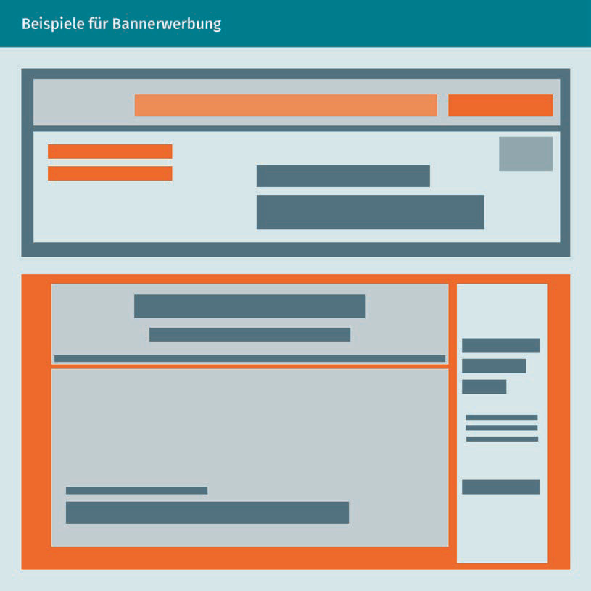

Fundamentals of Performance Marketing

Banners as well as keyword ads that companies buy from third parties to include in their campaigns are categorized within the **paid media** area (Kreutzer, 2021, p. 179), whereas earned media means that users distribute a brand's content themselves and thus become an additional advertising channel (Auler & Huberty, 2019, p. 64).

Due to the graphic design of the advertising media used, display advertising is considered as part of online marketing and is primarily chosen for branding campaigns. As a result of the wide reach of display advertising, this channel is becoming increasingly established in performance-oriented online advertising. In most cases, banner advertising is financed using the principle of cost-per-mille (CPM) or thousand-contact pricing in which the advertiser pays a specified price per thousand impressions (Kreutzer, 2021, p. 249). Another financing option is a pay-per-click or pay-per-lead payment for each user action.

Affiliate Marketing

While display advertising is primarily used to attract attention and functions less as a direct invitation to make a purchase, affiliate marketing can be seen as a useful performance marketing instrument for exactly this purpose (Kamps & Schetter, 2018, p. 7). A special feature here is the purely performance-oriented billing, which can make it a helpful sales channel for online retailers in particular.

Affiliate marketing is an internet-based sales solution in which a commercial provider (advertiser) remunerates its sales partners, the **affiliates**, on a success-oriented basis.

Affiliate Programs in Performance Marketing Examples

An affiliate program can also be described as a traditional partner program on the internet. Suppliers of products or services, i.e., sellers, offer products or services via sales partners (also known as affiliates). For example, Urlaubsguru and Tripadvisor each only receive a commission when trips are booked via their page and are not canceled.

To this end, the online advertising media are placed by the advertiser via an affiliate network. The attractiveness of affiliate marketing arises from the fact that costs for the advertising only result for the advertiser when sales are generated through the affiliate’s web presence. The affiliate therefore bears the cost risk (Kamps & Schetter, 2018, p. 104).

Paid media

This media type describes all forms of paid advertising measures in which the respective company buys into a medium to use its communication channel (Auler & Huberty, 2019, p. 32).

Affiliates

Affiliates are sales partners of commercial providers who place advertisements within their own websites and only receive a commission from the advertisers if they are able to sell the offered product or service through their own internet presence.

Costs aside, affiliate marketing is also a popular instrument because it can be used more flexibly than nearly any other performance marketing channel (Kamps & Schetter, 2018, pp. 104–105). Similar to the previously mentioned instruments, the effect of affiliate marketing can also be measured more precisely and more quickly than traditional advertising measures. Furthermore, there is also the option of short-term scaling in the context of affiliate marketing (change in size) (Kamps & Schetter, 2018, p. 8).

Email Marketing

As a digital form of direct marketing, email marketing is a subarea of performance marketing that makes it possible to acquire new customers and retain existing ones in the long term. Through email marketing, communication with customers can not only be planned, but customers can also be addressed in a particularly targeted manner by sending the company's information and advertising messages to those who have specifically opted in, e.g., by confirming a newsletter registration (Kamps & Schetter, 2018, p. 8). Co-registration through offers from other companies can also serve to generate email addresses.

Email Marketing Example

When visiting the website of the Westwing furniture provider, visitors are asked to register with their email address in order to benefit from daily special offers that can only be used by members of the shopping community.

Not only are the highly accurate, personalized advertising messages an advantage of email marketing that is worth mentioning – it is also a cost-effective option compared to direct mail advertising letters that must be sent by post.

Web Analytics

Web analytics is the cornerstone of performance marketing and includes the process of evaluating the behavior of website users. Among other things, data is collected on the source from which users found their way to the site, how many subpages were accessed, and whether a product was purchased. Data is collected the moment visitors arrive on the website. It can then be evaluated with web analysis tools and key performance indicators (KPIs) can be calculated.

The information obtained is used by advertisers to review their goals and it also acts as a basis for formulating new goals. One common form of analysis is the last-cookie-wins model, which assigns a transaction to the last/most recent advertising contact.

Fundamentals of Performance Marketing

Nevertheless, a more in-depth analysis of the customer journey is required to identify which specific measure was involved in the advertising success (Kamps & Schetter, 2018, p. 159).

In the context of web analytics, relevant key performance indicators (KPIs) can be categorized as follows:

* Sessions
* Unique users
* New users
* Returning users

The origin of the users is recorded according to their source, i.e., where and how the users came across the company. This can be broken down as follows (Kamps & Schetter, 2018, p. 162):

* Organic search
* Paid search
* Referral (links)
* Social media
* Newsletters
* Direct traffic

Website tracking is intended to provide the company advertising with an overview of the attractiveness of its own advertising content and can be collected with the help of the following key figures:

* Bounce rate
* Average session duration
* Users flow
* Average page load time

To obtain information about the financial success of performance marketing campaigns, the following components can be considered (Kamps & Schetter, 2018, pp. 162–163):

* Conversions
* Conversion rate
* Cost per conversion
* Return on investment (ROI)

The return on investment (ROI) analysis checks whether the amount paid out, i.e., the investment has produced the desired success (return).

Social Media Marketing

Social media marketing is concerned with all digital media that allow users to exchange information and media content individually or in a social network. From the advertiser's perspective, this creates new opportunities to develop an enormous advertising impact through the consumers’ global reach and networking. One example of effective social media marketing is digital word-of-mouth marketing through which an exchange takes place between different consumers (Meffert et al., 2019, pp. 42–43). Influencer marketing also ties in with this and includes cooperations with digital opinion leaders so they can report on a company's offers, brand, product, or service (Kreutzer, 2021, p. 6).

An overview of the most successful influencers or those with the most views can be found on the platform: nindo.de (Nindo Charts).

Another key success factor is that social media serves as a platform for interacting with and about companies in real time, which makes it a low-cost opportunity for coming into contact with current and potential customers (Meffert et al., 2019, pp. 42–43).

Content Marketing

Another performance marketing instrument is content marketing, which primarily refers to all forms of content that include sound and text, as well as still and moving images. The use of content marketing is intended to convince potential customers of a product/company by presenting exciting and interesting content. This makes it necessary to set purely sales-driven thinking aside to generate attention within a predefined intended audience using content that is important to them, as well as in order to increase a company’s own reputation and attract buyers for the products/services offered (Kreutzer, 2021, p. 6).

The modularity of performance marketing is also clear from the following example: Influencer Miriam Jacks from Berlin is an excellent master of content marketing. She works for various clients from different industries. She provides content via her website jacks-beautyline.de. Here, her fans can accompany Miriam virtually while shopping.

Overall, it can be said that the decisive factor for advertising success is the use of appropriate performance marketing instruments in combination with one another. This allows important touchpoints to be created in the sense of the customer journey by spreading the necessary marketing stimulus and releasing synergy effects between the different instruments (Kamps & Schetter, 2018, p. 8).

Fundamentals of Performance Marketing

**Summary**

With the increasing importance of e-commerce and the significance of social networks these days – and also in the future – performance marketing is a relevant component of the online marketing mix and aims at measuring the success of marketing measures. The quick and continual measurability of active measures means that they can be optimized, changed, and realigned at any time. Measurability and optimizability are thus among the key features of performance marketing, while networking with traditional advertising measures and the modular structure are also specific features that make performance marketing a success factor in connection with online advertising. With the help of specific key indicators, the efficiency and effectiveness of individual campaigns and measures can be precisely recorded, making performance marketing a suitable marketing strategy – both for acquiring new customers and for retaining existing ones. Alongside this, it can also serve as a success or performance-based billing model, since the interactions achieved can also be rewarded accordingly. This contrasts with traditional advertising media, where customer contact points can only be approximated. The data-oriented principle of performance marketing draws on the fundamentals of controlling and monitoring to quantitatively process the performance of marketing campaigns. This makes it a relevant resource in the context of digital marketing with regard to current and future decisions on planning and implementing measures.



# Unit 2

## Conversion Optimization

##### STUDY GOALS

On completion of this unit, you will be able to ...

... understand the importance of conversion optimization in performance marketing.

... develop and apply conversion-oriented online marketing tactics and strategy.

... recognize the importance of the conversion funnel and apply this knowledge.

... recognize how to largely avoid shopping cart abandonment during a purchase process.

... understand the importance of the content, usability, design, presentation, and corporate design of the company's presence and structure these factors.

... monitor, control, manage, and track performance-driven marketing activities in the search, social, and mobile areas.

DL-D-DLMOMPMSS01_D-L02

### Conversion Optimization

#### Introduction

According to an ongoing survey by Statista, only 66 percent of German companies had a website in 2021 (Statista, n.d.). The figure is shocking – after all, an internet presence serves as a virtual business card.

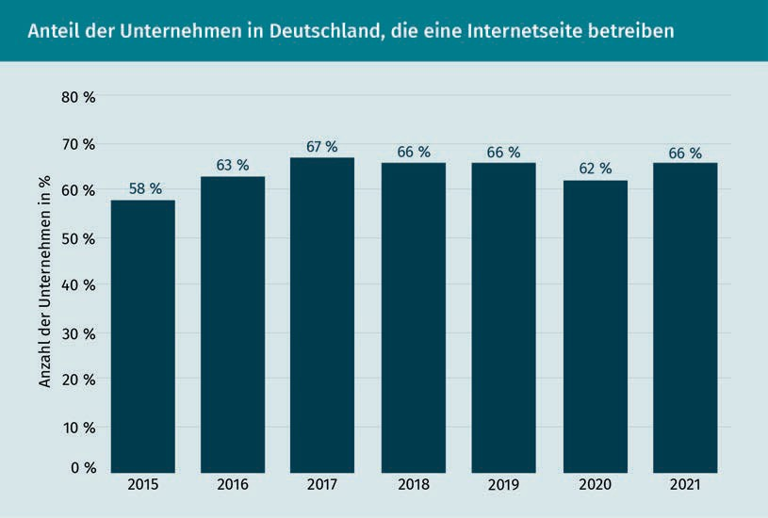

However, an internet presence is only helpful if it is attractively designed and can attract visitors. Furthermore, as already mentioned in detail, an internet presence must also be easy to find in the digital realm, e.g., through search engine optimization (SEO) and search engine advertising (SEA). However, since the goal is not only to generate sufficient traffic on a company’s own homepage, but to also elicit valuable actions such as purchases, registrations, or newsletter subscriptions among users, there is often a need for optimization. A good company website alone is not very useful if it does not encourage users to take action.

Conversion optimization can be used to precisely address this point – it serves as a promising means of increasing existing leads in a structured and systematic manner. For this to succeed, the following points must be considered in greater detail:

* It is necessary to take the relevance of increasing traffic and particularly the correct utilization of existing traffic into account.
* What needs to be considered regarding the shopping cart?
* What needs to be addressed in terms of usability?

Conversion Optimization

* Which content-related adjustments can be made to optimize conversion?
* What impact does website design have on conversion rates?

#### Conversion Optimization as Part of Performance Marketing

As a performance-oriented component of the online marketing mix, performance marketing includes all the instruments that help online campaigns and advertising measures achieve their full potential. This also includes collecting important key figures to measure, evaluate and, if necessary, optimize the efficiency and effectiveness of the measures.

This unit primarily focuses on the online presence of companies. An online presence with a website pursues a specific goal, such as generating sales through a web store by offering products or services. The question is whether and with what success the website can convert interested persons into customers, which can also be undertaken through financial expenditure. Do the visitors come organically, i.e., was a company’s page was automatically suggested in a search engine, or do financial resources need to be utilized to increase brand awareness and make the internet presence known?

As soon as interested parties visit an internet presence, the focus is on the number of so-called conversions. In specific terms, this is about how many transactions can be achieved through a paid campaign. The conversion rate (CR) also refers to the relationship between web impressions and conversions (Kamps & Schetter, 2018, p. 134). The conversion rate is considered a significant performance indicator within performance marketing, which examines an internet presence in terms of the extent to which it is successful in convincing visitors to take the desired action.

For example, if users are to be persuaded to confirm their newsletter subscription, the corresponding conversion point lies in the proof that the newsletter has indeed been subscribed to, as well as in the actual display of the confirmation. Using the same newsletter subscription example, visitors who did not confirm the subscription count as dropouts and thus did not convert or were not converted (Bockhorni & Beauchamp, 2019, pp. 4–5).

The success of a campaign can therefore be represented by relating the number of transactions to the number of visits. The conversion rate is the conversion ratio of visitors to buyers and, according to Kamps and Schetter (2018, p. 117), can be calculated as follows:

*CR* = Number of conversions · 100 Number of visits

A flowchart can be used to schematically illustrate which steps lead to a conversion –or cause it to fail:

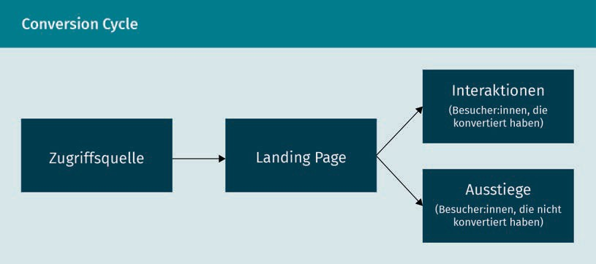

Leaving an application is referred to as exiting – the exit page is therefore the last web page viewed by the visitor. However, the reason for this is not only that the offer was not to the visitor's liking, since it could rather be that the internet browser was closed, another application was accessed, or the session expired (Jacobsen & Meyer, p. 256).

As a subarea of performance marketing, conversion optimization has the task of optimizing those website areas and elements that prompt visitors to carry out an action. The goal of these measures is therefore to increase conversions and improve the conversion rate on the website itself (Erlhofer & Brenner, 2019, p. 507).

If companies want to improve their conversion rate, the boundary conditions must be adapted and optimized so that more transactions are achieved with the same number of pure page visits (Bockhorni & Beauchamp, 2019, p. 5). However, since the conversion rate is a relative value and can neither be described more precisely nor quantified in absolute terms, this indicator reaches its limits insofar as what a normal or even very good CR actually is can only predicted to a limited extent and can therefore be determined quite individually. Depending on the specific industry of the company and the website designed, experience shows that a CR of 2–3 percent can be considered a very good conversion rate (Erlhofer & Brenner, 2019, p. 508).

Conversion Optimization

Macro and Micro Conversions

Conversions can be categorized into macro and micro conversions according to the individual website goals. Macro conversions, also known as hard conversions, include the primary website goals that should generate leads and sales, i.e., purchase transactions.

In contrast, micro conversions, also known as soft conversions, refer to smaller, intermediate steps that are intended to lead to the corresponding website goal and can be represented as individual steps in the conversion funnel. Examples of micro conversions include the following actions (Erlhofer & Brenner, 2019, p. 508):

* Requesting a brochure
* Downloading a whitepaper, e-book, or guidebook
* Subscribing to a newsletter
* Participating in contests

The examples above primarily involve a final step, i.e., pages that contain a so-called conversion element, such as a download button. Other micro goals could be to reduce the bounce rate or increase the number of clicks. However, not only conversion-relevant pages are necessary to achieve the goal – other pages within the website (e.g., distribution/mailing list pages) are also adapted as part of the conversion funnel optimization, since they direct visitors to the conversion-relevant pages.

The decisive factors that can be adapted in the course of conversion optimization are identified in the content and content structure, as well as in psychological levers. In addition, processes and **usability**, as well as the respective call to action, likewise have an active influence on conversion (Erlhofer & Brenner, 2019, pp. 508–509).

Conversion Funnel

With the help of the conversion funnel illustrated in the figure below, the percentage of searchers that have registered as interested persons through a keyword ad can be recorded in the first step during search engine advertising (SEA) in addition to whether an order process or purchase was actually made as a result:

Usability

This describes the user-friendliness, i.e., how effectively, efficiently, and satisfactorily users achieve their goals with an application, system, or service.

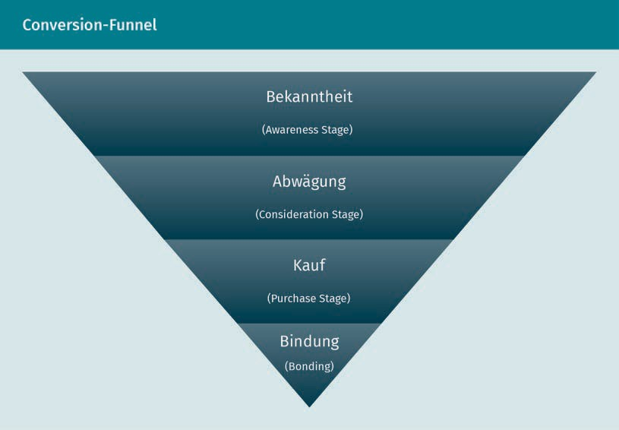

Several communication instruments can simultaneously contribute to conversion, regardless of whether the point of contact is at the beginning or end of the customer journey. The term *customer journey* is best described as the process or journey that a customer travels through from the first contact with a brand, company, product, or service, and ideally through to the final purchase. The figure below summarizes the most significant components of the customer journey.

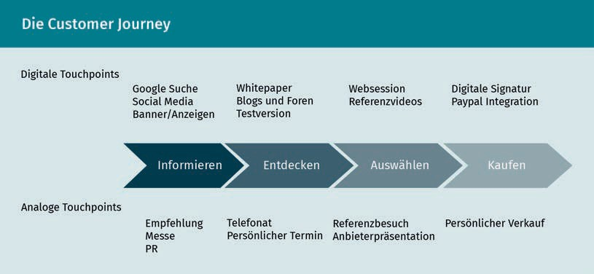

Conversion Optimization

It is clear from the figure above that touchpoints, as points of contact between and with customers, can occur in both the digital and analog worlds.

Attribution

To make sensible distribution decisions in connection with the available media budget, **attribution** is used to identify and attribute user responses to specific marketing channels. Attribution often makes it possible to categorize which communication instrument made which contribution to conversion generation and this can then be taken into account accordingly in subsequent budget planning.

As an example, common attribution models can be identified as follows:

* “Last Cookie Wins”: This model attributes the entire conversion exclusively to the communication instrument that was the last to come into contact with the consumer before the conversion, disregarding the upstream instruments.
* “First Cookie Wins”: The second model exclusively attributes the conversion to the first communication instrument in the customer journey, which means that the downstream instruments are not included in the consideration (Meffert et al., 2019, pp. 802–803).
* Bathtub principle: This model attributes equal weighting to the first and last instruments and either no weighting or only an equally low weighting to the intermediate instruments (Meffert et al., 2019, p. 804).

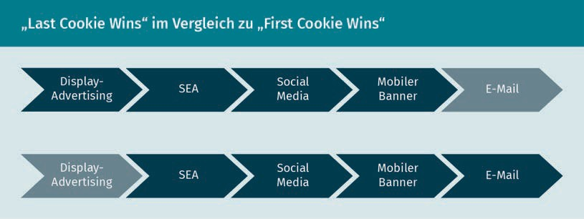

Traffic

Regardless of the challenge relating to the influential communication instruments, the entire amount of **inbound traffic** must be included in the conversion rate calculation. This can be distinguished from what is referred to as outbound traffic. Inbound traffic relates to customers who discover content on their own and come across interesting items (e.g., through social media or search engines), while outbound marketing is generally a one-way communication and the reach is paid for (Lammenett, 2019, p. 317).

Attribution

This refers to the process of identifying and attributing user responses to marketing channels that have contributed to the desired outcome in a specific way.

Inbound traffic This refers to visitors or potential customers who actively and purposefully land on a website and therefore access the

company themselves.

Accordingly, and in order to determine the status quo of the conversion rate, all visitors to a website must be recorded to facilitate correct measurement through the comparative variables of visitors and orders.

There are numerous ways to increase conversion rates. One possible approach is to reduce prices to attract new visitors to the website and initiate sales. However, not only the quantity of customers is important to the long-term success of a company, but also their quality. Long-term customer relationships are necessary to generate the established sales goals as planned, whereas short-term price reductions only lead to long-term customer relationships to a limited extent.

The Conversion Cycle – A Process for Conversion Optimization

For a better understanding, it helps to include the *conversion cycle* (Sens, 2020). Optimizing the conversion rate in the long term requires less of a short-term sales stimulation and more of a structured process. This can be divided into six individual stages.

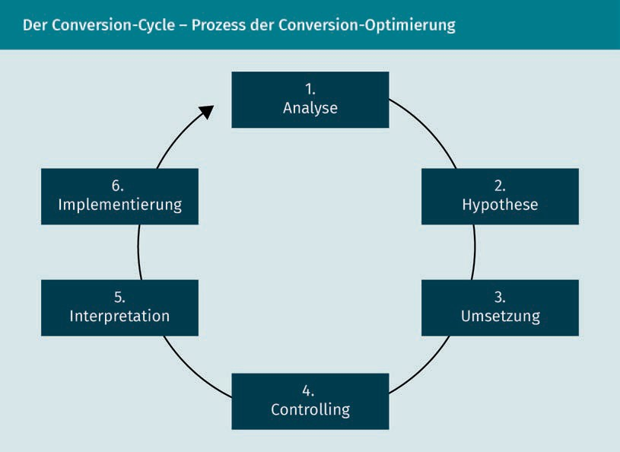

Conversion Optimization

The analysis examines where there is a need for improvement. Are the exit rate and the bounce rate too high? Does the exit or bounce take place on subpages or in the shopping cart? Why are visitors not converting (Sens, 2020)? The use of *heat maps* also helps here.

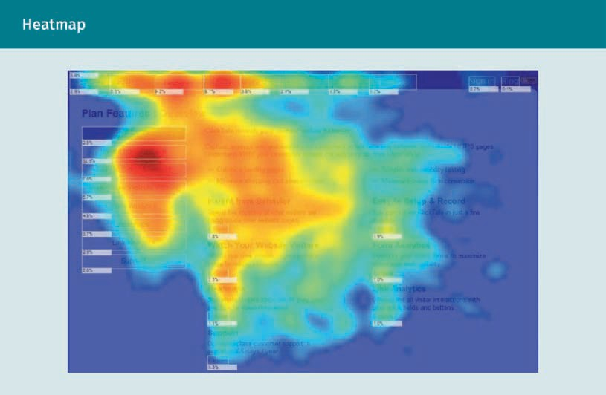

As the figure above shows, heat maps are comparable to thermal imaging cameras. They illustrate users’ interaction with web pages. Although heat maps are not always easy to apply, many service providers who can provide the desired information are available.

Following the analysis, the next step is the hypothesis. A hypothesis is an assumption derived from the analysis (Sens, 2020). Through the previous analysis and the recording of the need for optimization, hypotheses about how the conversion rate can be improved in a targeted manner can be formulated. By deriving hypotheses from the high-conversion web pages as to which features/elements have convinced the visitors there, models are created in order to optimize the less well-functioning areas.

Since the hypotheses are not always directly recognizable from the generated data and website visits are characterized by a high degree of complexity, the behavior of the visitors and their motivations for action must also be included in the hypothesis formulation. By understanding the way the users think and act, relevant factors can be identified and formulated into suitable hypotheses (Erlhofer & Brenner, 2019, pp. 510–511).

In the third step, the hypothesis can be realized, for example, by applying the already mentioned A/B tests in which two different variants of a website are presented. In principle, the two variants can differ in design, colors, reading patterns,

calls to action, or other aspects that could lead to differences in the conversion rates. The results are quite interesting. Which version of the website leads to more conversions?

An example: 50 percent of the traffic is directed to the previous version of the website and 50 percent to the optimized website. To arrive at a result, the conversion goal must be formulated and also measured in the next step, controlling. During this, it is also important to exclude a company’s own accesses to both web page versions (Sens, 2020).

A good overview of an optimal sample size can be provided, e.g., by the free VWO software: www.vwo.com (Sens, 2020).

Controlling is then followed by interpretation. The results are examined at this point. Did the hypothesis prove to be correct or not? This can be understood on the basis of the conversions. Then, the final stage involves implementation where the optimizations must actually be implemented, preferably by someone with the appropriate programming skills. This can involve both content and technical changes to the website (Sens, 2020).

#### Shopping Cart

One way to optimize conversion is to design a shopping cart accordingly. For example, by offering customers complementary products on the shopping cart page or after they have completed their orders, not only the dwell time, but also the conversion rate can be increased. An action can be stimulated if products are positioned in the immediate vicinity of the order button. It can also be useful to present other products that may be interesting as an additional product/accessory to the desired product that has already been added to the shopping cart. This is where companies can learn from Amazon. Who has not seen the following ad: Customers who bought this Product A also ordered Product B, or something similar.

Additional offers on the shopping cart page can be worthwhile because the customer’s willingness at this point in the customer journey is so high that they will usually also buy them without further hesitation. Certain product or service bundles, i.e., the combination of two or more goods, can also convince visitors to accept the proposed offers, i.e., to buy or book them. Since nearly everyone likes a bargain or perceives offers and discounts as positive, price advantages for additional products in a shopping cart are particularly suitable for increasing the willingness to convert and achieving more sales for a company (Erlhofer & Brenner, 2019, pp. 522–523). Companies can learn from McDonald’s here. Many customers tend to buy menu meals due to their combinations of different food items.

Conversion Optimization

Even the name Extra Value Menu suggests a bargain here, even if more is often bought than originally planned.

Shopping Cart Abandonment

Not every shopping cart click leads to a completed purchase. When products and/or services have been placed in a shopping cart without the subsequent *checkout* with payment or purchase on account, this is referred to as shopping cart abandonment. These abandonments must be considered separately in the context of conversion optimization since the worst-case scenario has occurred: the customer abandons the shopping cart shortly before completing the purchase.

This is where retargeting can be used to motivate customers to complete a purchase as well as address these persons again in a targeted manner (Kreutzer, 2021, p. 118). Retargeting is a specific process in which shopping cart abandoners are identified so they can be approached again with targeted advertising on the same or another website in order to ultimately achieve the conversion (Kreutzer, 2021, p. 276). Various email marketing tools enable shopping cart abandoners to be automatically contacted again by email based on their connection with the company’s online store (Kamps & Schetter, 2018, p. 82).

#### Usability

According to Kamps & Schetter (2018, p. 9), “Potential customers today rightly expect perfect usability on a website or in an online store.” In fact, usability has a major impact on the conversion rate, which means that optimization of usability can also have a direct, positive impact on the CR (Erlhofer & Brenner, 2019, p. 523). Fundamental weaknesses in usability can be identified if, e.g., the digital offer is not responsively designed (in this context, this means that a website does not work on all devices), or if the integrated search function does not display any results, or even if modern payment methods are not available (Kamps & Schetter, 2018, p. 9).

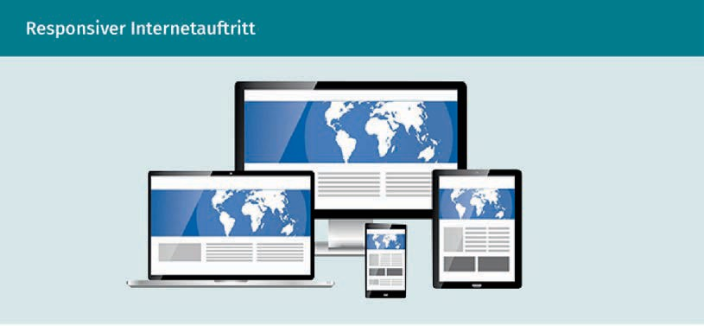

Usability writing These are texts for digital services that are designed in such a way that they create positive experiences for users.

Call to action Is a term used in marketing to describe a strategic course of action

and refers to any means that elicits an immediate response from users or promotes an immediate purchase.

Inconvenient paths and unclear structures also lead to a short dwell time and increased exit rates, which in turn have a negative impact on conversions. Helpful feedback for companies comes from **usability writing**. This can be applied to optimize usability and user experience by using the right wording, e.g., in error messages (Erlhofer & Brenner, 2019, pp. 524–526).

Call to Action

A central point in the context of usability is the **call to action** (CTA). A significant drop in performance can result from an unclear or missing call to action (Kamps & Schetter, 2018, pp. 79–80). In the course of conversion optimization, the call to action must therefore also be improved in order to strengthen the final call to action that turns visitors into customers. One fundamental aspect is the correct placement of the CTA. It should not be placed too far to the right of a web page, since it will then be overlooked by many users due to what is referred to as **banner blindness**; meaning that elements on the right-hand edge are often ignored.

By visually highlighting the CTA buttons (e.g., with high-contrast accent colors), the risk that the button will visually blend into the background is reduced. Another important point here is that concentration is placed on the CTA. Accordingly, no other visual elements to attract the attention of visitors should be used in the vicinity of the CTA. Rather, an expressive caption can be used to motivate the click and inform potential customers about what will happen in the following steps (Erlhofer & Brenner, 2019, pp. 528–529).

Conversion Optimization

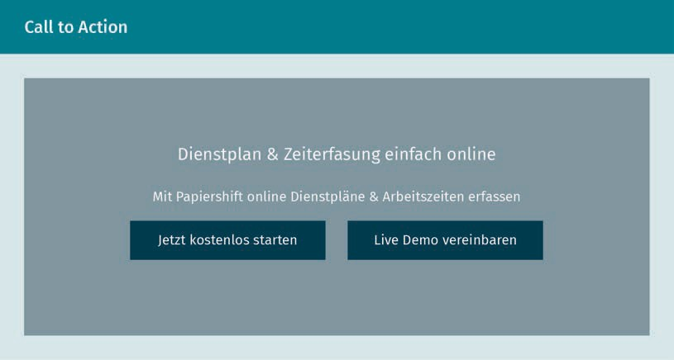

Papershift’s web page serves as a good example of a CTA, since two are placed right in the middle here: “Start now for free” and “Arrange a live demo.”

In order for a call to action to lead to an increase in the conversion rate, the most significant product benefits should be clearly mapped out and presented. Where does a company, product or service have a unique selling point or a unique selling proposition (abbreviated as USP in both cases)? What ultimately leads to a purchase? To further encourage conversion, strategies such as scarcity, social proof, and trust can also be used from a marketing policy perspective, whereby the call to action is provided with messages of urgency and successful actions can be increased.

Creating incentives and trust, e.g., by making a trial offer available, can be cited as an effective instrument in supporting conversion optimization. If the trial offers are placed near the CTA and *teased* as free offers, visitors will become aware of them. The trial offers thus act as a preparation for the true conversion, so to speak, and can ultimately initiate a purchase or booking (Erlhofer & Brenner, 2019, pp. 528–529).

#### Content

Various conversion rate optimization measures can not only be implemented within the structure and usability, but also at the content level. In principle, there are four main options for content presentation that can be divided as follows (Erlhofer & Brenner, 2019, pp. 426–427):

Banner blindness This occurs when users consciously or unconsciously ignore banner ads or banner-like information.

1. Text (website text, blog post, whitepaper, e-book, newsletter)
2. Image (infographic, photo, drawing, comic, slideshow, photo gallery)
3. Video (livestream, reportage, explanatory video)
4. Audio (podcast)

Michael Rüttger (2017) describes just how important the domain name, the appropriate web hosting provider, cost aspects, and the technology utilized are in addition to the right targeting, content, and design.

Presentation Formats

Various presentation formats can be applied to the content to motivate visitors to take action (Erlhofer & Brenner, 2019, p. 434):

* + Information about a product or service
  + Product description/product comparison/product test/review
  + Special offer
  + “How-to”/instructions/guide/tutorial
  + Tips & tricks
  + Checklist
  + Glossary
  + FAQ
  + Analysis/study/report
  + Case study/customer experience
  + Best practice
  + Action that calls for participation

To convince visitors to make a purchase using design, manageability, and content, the content itself must not only be regularly updated and expanded upon, but it must also be exciting and informative. Variations in design allow users to embark on their own customer journey, discover new things and, in the best case, be addressed by the content in such a way that they reward it with a purchase. With regard to existing customers, it is also advantageous to continually publish new content on a website – this dynamism and frequent updates are also registered by search engines, which in turn can increase the conversion rate by encouraging users to visit the page (Erlhofer & Brenner, 2019, p. 426).

Development of a Content Strategy

An optimal content strategy for the respective intended audiences results from what is referred to as the customer journey: it is necessary to consider at which stage the customers should be engaged, whereupon the appropriate content strategy can be developed with reference to the corresponding stages of the conversion funnel.

Conversion Optimization

|  |  |  |
| --- | --- | --- |
| **Development of a Content Strategy** | | |
| Customer journey | Conversion funnel | Content strategy |
| Internet search | Awareness (brand recognition) | * Achieve attention * Evoke emotions (e.g., storytelling) |
| Process information | Interest/consideration | * Information * Helpful texts/advice texts * How-to videos |
| Decide | Persuasion | * Special offers * Highlight USP * Create added value and highlight customer benefits |
| Action (e.g., purchase) | Conversion | * Create trust * Provide final arguments |
| Test/use | Bonding | * Upselling or supplementary offers * Information about new products |

Once the content strategy has been developed, the content can be optimized accordingly. Four factors particularly count as conversion-promoting in content marketing (Erlhofer & Brenner, 2019, p. 436, p. 444): if website operators have paid attention to understandability, conciseness, SEO-optimized texts, and linguistic aesthetics, the chances of success are significantly higher.

#### Design

A professional website is the basis for successful online marketing measures, since many campaigns, instruments, and marketing channels begin and typically end there (Bockhorni & Beauchamp, 2019, pp. 6–7). The goal of website design should therefore be to actively lead users to the offer. This implies corresponding subpages, product pages, detail pages, or even an entire landing page on which visitors quite literally land, e.g., by clicking on paid advertisements or links in social media.

The rauchfrei-info.de homepage serves as a good example of a landing page. The visitors are given many options. In addition, this example shows that not only companies, but also public authorities must present themselves professionally to generate interaction. This landing page is a website originated by the Federal Center for Health Education based in Cologne.

Basically, target pages are as important to the success of a campaign as the campaigns themselves. The online presence and online channels of a company or institution should therefore be professionally designed and programmed to encourage as many interactions as possible. This will be successful as long as the internet presence appears authentic and the content offers true added value for users. If visitors feel comfortable and can quickly find their way around a website, positive emotions will be created, which will not only be apparent in the form of increased dwell time, but also in a high conversion rate.

This also means that the design, content, navigation, and technical aspects of a website focus on the user experience and that visitors are addressed in a manner that is tailored to the intended audience. Conversion-optimizing aspects for the design of a company website are (Bockhorni & Beauchamp, 2019, pp. 6–7):

* + - a stable and modern website infrastructure,
    - a professional and authentic design that is oriented toward an intended audience,
    - unique content with added value for users,
    - supplementary content types such as videos, animations, FAQs, blogs, etc.,
    - a high usability/user experience,
    - state-of-the-art technology,
    - fast load times,
    - an optimization of design, navigation, and content, including for mobile access,
    - ensuring data protection, and
    - a continual target and conversion-optimized improvement, as well as monitoring through additional analysis tools.

Conversion Optimization

In essence, the website is a company's (online) business card: “If it is not convincing, the user may quickly lose interest in the company as well as its offers upon the first contact. Also applicable here: you'll never have a second chance to make a first impression!” (Kreutzer, 2021, p. 84).

**Summary**

A wide variety of different measures can be implemented to optimize conversion, all of which are aimed at increasing the conversion rate. Conversion is a key performance marketing indicator and is comprised of the conversion costs and conversion rate. Conversion is tracked with the goal of highlighting the financial expenditure required for visitors to a website to convert or be converted into customers.

Although the categorization of a good or not very good conversion rate (CR) is subject to limits insofar as it depends on the industry and the individual offer, a comparison to websites with a high CR makes it possible to see where there is potential for optimization.

Conversion-promoting optimizations can be carried out within a shopping cart page, in connection with the usability, and in relation to the content and design. Fundamentally, however, the optimization measures should not only be aimed at turning visitors into customers, but also at making better use of the existing conversions, since high traffic alone does not necessarily lead to more interactions. One way to achieve this, for example, could be to incorporate text-based calls to action to minimize banner blindness effects. Another way could be a realignment of the content strategy – holistically and along the customer journey, as well as within the conversion funnel stages – to achieve an increased number of desired actions from visitors.



# Unit 3

## Search Engine Optimization (SEO)

##### STUDY GOALS

On completion of this unit, you will be able to ...

... understand the importance of search engine optimization for performance marketing.

... distinguish between the terms search engine optimization (SEO) and search engine advertising (SEA) and apply them in practice.

... assess the advantages and differences between on-page and off-page optimization.

... conduct and evaluate keyword research.

... successfully plan web page optimization.

DL-D-DLMOMPMSS01_D-L03

### Search Engine Optimization (SEO)

#### Introduction

The widespread availability of information is continually expanding, with nearly every topic accessible on the internet. Simultaneously, creating a website on any subject is relatively straightforward, even for those with basic knowledge. Given the vast amount of data, it is increasingly crucial to provide information to interested parties in a targeted manner. When interested parties make a query in a search engine, it displays web pages that match the search query. The search engine utilizes a database to determine the web pages relevant to the query for display.

In the realm of online marketing, search engine optimization (SEO) is employed to ensure that a web page appears among the top results in the search engine results.

Specific strategies can be used to influence the web page’s position within a search engine’s results for a particular search query, pushing it to the very front, i.e., higher up. On-page optimization involves modifying and adapting a company’s own web page in such a way that, ideally, it appears as one of the first pages without incurring high costs. This process employs the page’s program code, available in HTML. The term *on-page* refers to the measures taken on a company’s own web page. Conversely, the term *off-page* refers to all actions taken outside of a company’s own internet presence. Off-page optimization can also influence the position in the search engine results through third-party pages. *Backlinks* are suitable for this.

This unit covers the following aspects of search engine optimization:

* How to achieve visibility in a search through search engine optimization (SEO) without incurring costs with a search engine provider.
* The use of search engine optimization as a component of performance marketing.
* The role of keywords in finding and ranking a web page.
* The impact of on-page and off-page optimizations – within and outside a company’s own web pages – and how they are implemented.
* How to evaluate search engine optimization and measure the success of the actions taken.

Search Engine Optimization (SEO)

#### Search Engine Optimization as Part of Performance Marketing

Search engine optimization (SEO) is a component of online marketing and thus forms part of the communication policy.

The communication policy is a facet of the marketing mix and encompasses the following categories, also known as marketing instruments:

* + - Product policy – How should a product or service be designed?
    - Price policy – What prices and conditions should be applied to a product or service?
    - Distribution policy – What distribution channels should be used to sell a product or service, e.g., online (on the internet) or offline (e.g., in retail stores)?

The fourth and final instrument is the communication policy, which includes online marketing as a communication measure and thus also encompasses search engine advertising:

* + - Communication policy – How is a product or service promoted? Traditional advertising, public relations (PR), and online marketing are all part of the communication policy.

Performance marketing, as a marketing instrument, also forms part of the communication policy. Its use extends to both customer acquisition and retention. Therefore, it is not only important to implement the planned measures, but also to monitor, control, measure, and evaluate them.

From a company's perspective, search engines are seen primarily as an advertising medium. Conversely, from internet users’ perspective, search engines such as Google or Bing are perceived more as actual search engines rather than advertising platforms.

Today, we have progressed to the point where searches can be conducted anytime and regardless of location – mobile communication is thus made possible (Meffert et al., 2019, p. 143). It is therefore vital for companies to be discoverable at all times – when searching with a desktop computer, with a tablet while lounging on the couch, or with a cell phone on the go.

When users type keywords into the search function, they are presented with an overwhelming amount of search results in the form of web pages.

An example here: In normal searches, when terms such as *credit without credit reference, cell phone contract*, or *insurance comparison* are entered, entire teams of search engine optimizers work tirelessly behind the scenes to elevate their web pages to the top of the search results using all feasible methods – whether paid (to search engine providers) or unpaid.

Anyone attempting to get involved today has a slim chance of ranking on the first page at all without a significant budget, extensive knowledge, and substantial support from collaborators or agencies (Beilharz, 2021 p. 179).

When the term *insurance* is searched, ads from companies like AXA Konzern AG, CHECK24 Vergleichsportal GmbH, DFV Deutsche Familienversicherung AG, and ARAG SE pay money (to the provider Google) appear predominantly. These companies pay Google according to the principle of Google Ads, formerly known as AdWords. The position of the company on the list depends on how much they are willing to pay per click. This can be a costly endeavor, but caps can be set to avoid exceeding a budget. For example, a company might be willing to pay €4 per click from a potential customer, setting a limit of €10,000 per month to stay within its budget.

Google Search: Paid Results

Scrolling further down reveals local providers from the immediate vicinity. Local companies are generally displayed by default.

Google Search: Local Results

Organic search results only appear after the paid results. These are the results that Google, the search engine provider in this case, places at the top of the list. No money is paid to Alphabet Inc, Google's parent company for these organic results.

Google Search: Organic Results

Additionally, headlines are integrated to lend an overall serious appearance to the results display, giving consumers the feeling of being fully informed. Without familiarity with search engine optimization (SEO) and search engine advertising (SEA), laypersons are unable to distinguish between ads for which money is paid and those that do not generate revenue for the search service providers.

To avoid incurring costs from providers such as Google or Bing through search engine optimization (SEO), it is important to understand how the hierarchy of search results is determined. Primarily, this is contingent upon the alignment between the keywords embedded within a web page and the search query. Which web page best matches the keywords typed in the search box by a searcher? In this case, the keyword used is *insurance*.

Search Engine Optimization (SEO)

Subsequently, the following question is posed: Which internet presence provides the most relevant information for searchers? The operators of the search engines answer these questions. The results displayed within the search engine for each search are customized to the user to ensure a high degree of satisfaction, i.e., to deliver the specific and accurate results to the searchers.

Thus, it can be argued that companies, as operators of their own websites and individual web pages, can secure a high position on the search results without expending funds on search engine providers if their page content is relevant and they use the right keywords.

SEO and SEA are integral components of online marketing (Kollmann, 2021, p. 240) and are essential to success in performance marketing. These two terms should be clearly distinguished from each other before delving deeper into the subject. The following overview, based on Kollmann (2021, p. 240), provides a comparison and contrast of these two valuable tools:

|  |  |
| --- | --- |
| **The Categorization of Online Marketing** | |
| Communication policy  **Online marketing** | |
| Search engine optimization (SEO)   * Search engine optimization * Organic, i.e., certain things happen automatically * Actions and procedures for which no advertising budget is spent * Measures for a better ranking on search engine results pages * Dependent upon a match with the search words | Search engine advertising (SEA)   * Search engine advertising * Non-organic, i.e., website operators have a hand in achieving specific results * Paid results, i.e., advertising budgets are paid to providers * Measures for better advertising placement on search engine results pages |

#### Keywords – Research and Evaluation

In the context of search engine optimization, the question of which search terms should take precedence and how to choose them for success, i.e., to be found by internet users, naturally arises.

There are two perspectives consider, as illustrated in the graphic below. Is this a process of search engine optimization (SEO) viewed from the perspective of a search engine like Google and Bing, or from the users’ perspective, i.e., the searchers?

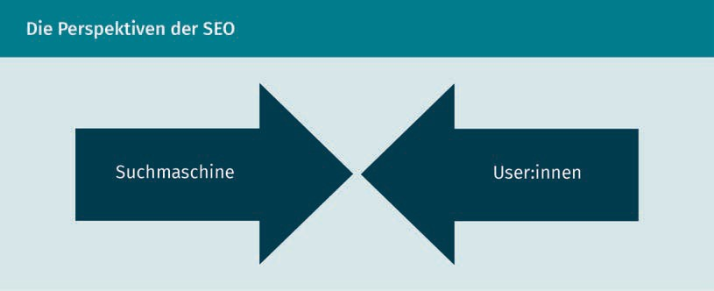

Firstly, it is essential to determine the perspective from which the keywords are handled.

Despite the above figure suggesting that two different forces are clashing, it actually involves companies choosing the right keywords to ensure their visibility to users in the search engine. Search engine optimization (SEO), as the name suggests, is about refining the terms so that the automatic search of web pages guides users, who are interested in the content of certain websites, to these pages. Search engine optimization (SEO) must therefore fulfill both requirements, as demonstrated by the convergence of the arrows.

Keywords should be selected carefully to ensure a high degree of relevance to the respective internet offering. For example, with the term *insurance*, additional words play a role, such as *insurance coverage,* *policy*, *occupational disability insurance*, *liability insurance*, and many more.

Therefore, keyword research is important. Companies gather all search terms pertinent to their own pages in this process. However, web pages can be divided into a main and secondary pages, which is where keyword mapping comes into play. Keyword mapping assigns a specific *main keyword* to the main page and each subpage, and also attributes several *secondary keywords*.

Search engines classify the available web pages on the internet into different categories. The evaluation of information is based on the ranking algorithm of the search engine, assessing its relevance to a search query. Information on web pages that is considered important by the respective search engine automatically have a higher ranking, more potential for good positioning, and thus reach the top of the displayed web pages within a search engine’s results page, such as Google or Bing, more quickly.

Search Engine Optimization (SEO)

What is not transparent here is the criteria search engines use to determine the relevance of information. The search engines' own algorithms and parameters are defined by their programmers and are usually confidential.

The actual appearance and position are dictated by the elusive Google algorithm, the specifics of which are not known. Assumptions, logic, rumors, and publications by Google or SEO specialists provide limited insight (Beilharz, 2021 p. 181).

The following example clarifies an approach used in leveraging the Google algorithm. The term *cold asphalt* in the [www.2r-kaltapshalt.de](http://www.2r-kaltapshalt.de/) domain is helpful. If users search for cold asphalt, e.g., to repair potholes, Google’s search engine automatically ranks the 2r Kaltasphalt page at the top, since the term is also found in the domain. This is a parameter that the search engine operators attach great importance to.

To increase the number of visitors and thus also the conversions, i.e., the resulting numbers of customers, companies strive to align with the Google algorithm’s requirements as closely as possible. Beilharz refers to SEO measures that aim to send Google signals affirming the trustworthiness of the web page, its relevance to the search query, and generally the usability and value of the page. This may involve some programming intervention, content adaptation, or creating links to other pages, as backlinks (the links on other web pages) are regarded by Google as a quality criterion (Beilharz, 2021 p. 181).

It is important that website operators see things from the users’ perspective: What keywords or keyword combinations would users search for? It is not helpful if companies looking to optimize their internet presence employ keywords that are not commonly searched for.

It is likewise important to know that nearly everyone only visits the first Google page and only a few exceptions click on the second page. By the time one reaches the third page, engagement is virtually non-existent. A joke from the SEO community goes like this: “Where would you hide a corpse? On Google on page two, nobody will ever find it there.” The search terms not only need to be appropriately selected but must also appear on the first page in order to be found at all. (Beilharz, 2021 p. 179).

At this point, it is advisable to conduct a search term analysis. The goal of this process is to identify **keywords** that resonate with internet users. Initial considerations should revolve around the keywords one might personally use in a search.

Keywords These are words, phrases, and subjects that people use while searching online.

It is also helpful to ask for advice from peers, friends, and colleagues and to get their input and new ideas. Extensive research can also assist in unearthing relevant and related terms. It is important to filter out specific keywords to stand out from competitors or gain an advantage. If a company chooses specific terms that their competitors overlook, they have a higher likelihood of being discovered and, depending on the relevance and frequency of the keywords, being listed at the top of the search engine results page.

In this context and as a market leader, Google, which belongs to Alphabet Inc., offers the Google Trends function (Google Trends, n.d.). This function is invaluable in obtaining a comprehensive overview and categorizing the chosen keywords.

Likewise, a timeline can be used to gauge the interest or track the popularity of the selected keywords over time, as depicted in the following figure.

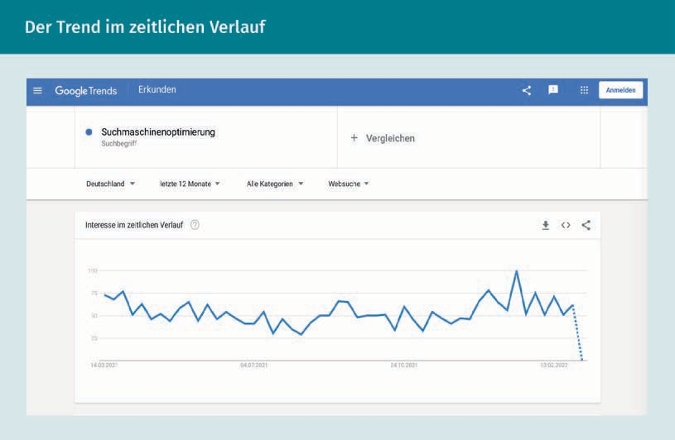

The subject of “search engine optimization” is explored here. As evident, the trend does not follow a linear path. Rather, it is best described as a jagged line, akin to a series of waves. The direction of the line indicates the general trend, which can ascend or descend, or remain steady. Predictably, peaks and troughs occur, as illustrated in the chart above. The higher the line ascends, the more the potential the search term holds (Woll, 2014, p. 495).

Search Engine Optimization (SEO)

For a comparison of two words, for example, Google Trends offers an option to input several words for comparison. The development curves of both words are displayed together in a diagram, facilitating a decision on which search word promises greater success.

Integrating these filtered keywords into a website increases the likelihood of boosting visitor numbers. However, a surge in visitor numbers does not necessarily translate into increased sales. It is worth noting that neither the search engine nor the internet users should be misled. The chosen keywords must align with the website’s content (Kreutzer, 2018, p. 295).

#### On-Page Optimization

On-page optimization refers to the process of enhancing a web page specifically for Google. This is vital due to the continuous updates, improvements, and expansions of the Google algorithm that include factors found on the web page itself. Such factors encompass Google-friendly programming, a quick load time, minimal programming errors, and strategic placement of keywords in headings, as well as content optimization, e.g., text optimization. Linking, i.e., recommending the page on another website is part of off-page optimization (Beilharz, 2021 p. 183).

Given the ever-changing criteria for entry evaluation within the Google algorithm, a company’s web page ranking can fluctuate significantly. In this context, visibility is consistently in a precarious balance, and the significance of search engine optimization becomes increasingly apparent. What does an operator of an internet presence need to do to maintain a consistent forefront position and appear as one of the first results in a search engine? Essentially, SEO is divided into two measures and the two terms are once again summarized below:

* + - On-page optimization, i.e., measures implemented within a company’s own website
    - Off-page optimization, measures implemented outside a company’s own website

On-page optimization within a company’s own internet presence includes all measures taken within the web page itself. These detailed aspects include:

* + - Selection of search engine(s): As an operator, who do we want to cooperate with, or where do we stand the highest chance of being discovered? It is evident that Google's presence is high, with other search engines having only a small market share.
    - Web page design and structure.
    - Text optimization on the page.
    - Reduction of the operated page’s load time.

Search Engine Selection

From a business perspective, the most interesting search engines are those most frequently used. In Germany, the search engine with the greatest reach is Google, which already had the largest market share of 90 percent in 2018 (Lammenett, 2019, p. 243). Globally, its market share is lower because Google, being an American company, is prohibited in China. Instead, China, which accounts for approximately one-fifth of the world's population, relies on domestic search engines. The Baidu search engine (baidu.com), founded in 2000, is by far the most popular search engine in China.

Optimization measures to increase a company’s own website visibility also have a positive influence on smaller search engines (Bing, Ecosia, Yahoo!, DuckDuckGo), since these typically emulate larger corporations. Thus, successful optimization for Google can potentially elevate a web page’s ranking on smaller search engines.

For example, less known search engines in certain countries may hold the top spot in other countries. The figure below shows the market shares of search engines worldwide, categorized by mobile and stationary use in January 2022.

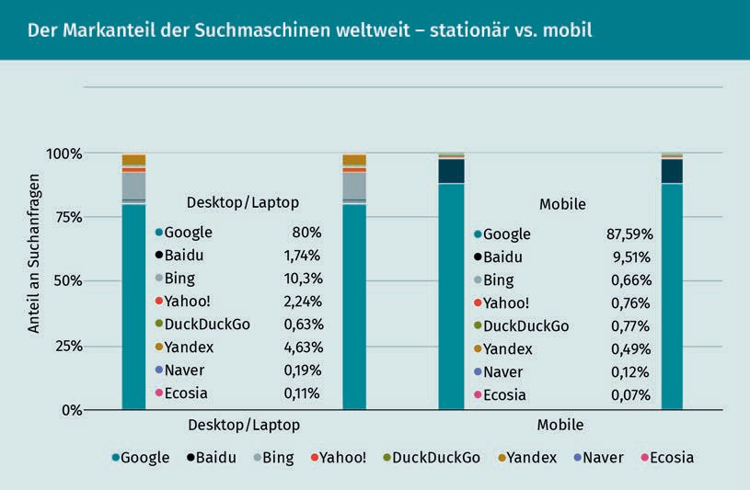

Search Engine Optimization (SEO)

Website Structure

First and foremost, a conventional website structure facilitates the user’s experience. Users should be able to find their way around a web page easily and if the page is clearly structured, the bounce rate will decrease (Kreutzer, 2018, p. 295). At the same time, the structure aids search engine optimization. In this context, internal links within a company’s own pages also play a role, which is shown in the figure below. The pages of an item (subject) area should be interconnected accordingly, enabling the search engine to identify all pages within a website and thus making them accessible to users executing searches (Lammenett, 2019, p. 247).

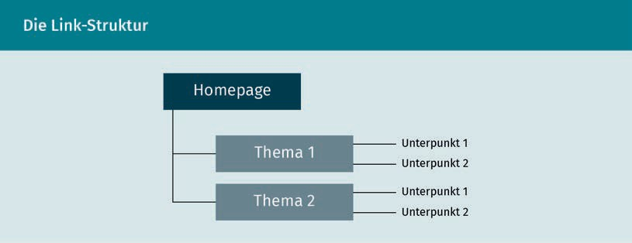

Above all, it is absolutely essential that a company’s own website adheres to the legally mandated regulations in Germany. For example, the legal notice, also referred to as imprint, must be accurately displayed on a company’s own website.

Kreutzer (2018, p. 314) suggests that the following information may be relevant to visitors:

* Postal address
* Contact information
* Opening hours
* Current prices and payment methods
* Photos and videos
* Reviews

Text Optimization

Since search engines also attach great importance to content, i.e., text-oriented work, essential strategies for creating web page text are detailed below. An important aspect of search engine optimization (SEO) in relation to content is the so-called concept of *keyword density*. This refers to crafting web page text to incorporate as many potential search terms as possible. Surprisingly, it is noteworthy that a keyword density of four to eight percent

of all words on a web is deemed high and thus beneficial (Lammenett, 2019, p. 245). Care must be taken to ensure that the text remains comprehensible and easily readable for users, without sounding awkward due to optimization efforts.

The central guideline is to dedicate each web page to a single subject. Thus, each page should concentrate on one specific topic or present a single coherent set of search terms. This strategy enhances the likelihood that that users will come across a web page during keyword searches, particularly if many subject-related terms are used on the web page. (Lammenett, 2019, p. 245).

Until a few years ago, it was possible to create so-called doorway pages. At that time, these web pages with a great deal of content were highly valued by search engines. Today, however, such techniques are actually penalized by removing the modified pages from the search engine index. Ultimately, the emphasis lies on the context. After all, the objective is to provide web page visitors with high-quality and relevant content.

The text can be further enhanced with additional information and content such as

images, videos, graphics, and much more. However, it is important that additional materials do not adversely affect the load time, which will be explained in greater detail later in the unit in relation to measurement and evaluation.

Fast Load Time

User experience This term encompasses all aspects of the user’s impressions of their interaction with a

website.

Load time is a crucial factor in the realm of search engine optimization (SEO). Specifically, this means that the load time has an impact on a page’s ranking factor within a search engine. The benefits of a fast load time, which enhances the **user experience** and potentially elevates the transaction rate, are also important to note.

In the context of a fast web page, we distinguish between two types:

* The time-to-first-byte TTFB) describes the time a server needs for a response.
* This is offset by the time it takes for a web page to load completely.

According to a 2015 study by Searchmetrics, if the sum of both time units above is 0.8 seconds, it is considered a fast-loading page (Lammenett, 2019, p. 253). As of 2021, Google has recommended that the time for a web page to be entirely readable and usable should not exceed 2.5 seconds (Kreutzer, 2021, p. 136). The question then arises: How can the load time be optimized?

Search Engine Optimization (SEO)

The server’s speed and performance are paramount. Different users will use the services of various providers, each of whom offers distinct servers. Consequently, the load time of a web page varies from user to user. Other contributing factors include the server’s connection to the device. The term connection refers to the protocol, which in turn is the communication between the server and the **client**. The different protocols in use also affect speed. Protocol refers to the transmission of data, which should ideally occur without disruption, i.e., without errors and losses. Specifically, it refers to how information is exchanged between different systems.

Other contributing factors include the programming code, the size and format of an image, its compression, and more. The larger the files that need to be loaded, the longer the web page takes to load. The term *size* encompasses not only the file size and format, but also to image resolution, pixel count, and colors, all of which can influence the load time. Certain websites on the internet can enhance the speed of other websites (Lammenett, 2019, p. 253).

Programming Code

Intelligent program code preparation can also achieve a great deal. A valid code, i.e., a code devoid of warnings or errors, is particularly useful. Today, the focus is increasingly on accessible web design: Web pages should be usable by users regardless of personal limitations and technical possibilities (Meffert et al., 2019, p. 707). In fact, this has already become mandatory in the USA. If a web page is published online, it should adhere to the **W3C** standardsto achieve a correspondingly higher ranking in search engines (Lammenett, 2019, p. 248).

In addition to valid code, there are elements in a web page’s source code – which is publicly viewable – that search engine optimizers should be familiar with. These elements influence the web page position within a ranking. The ranking of a web page can be influenced by modifying the elements within the source code.

URL

The URL represents the web page address. There is a great deal of freedom in the design here. Keywords can also be included in the address and alongside this, the company’s name can be integrated into their URL as an advertisement. According to studies, its importance to a search engine has decreased, but the company name still has a significant meaning for internet users (Lammenett, 2019, p. 251). However, there are different views on this. Some rely on the use of keywords in the domain precisely because the Google algorithm is so impenetrable.

Client

The client is a computer program that is executed on the server’s terminal device and thus communicates with the server.

W3C

The World Wide Web Consortium is the body for standardizing technology on the internet.

Image file naming

Nearly every website makes use of images. If the images are named and a text is available as an alternative to the image, this can strengthen the position of a website. This attribute is used when an image file cannot be opened or the search engine accesses the source code.

Finally, it is to be noted here that Google has only recently included user behavior. A website with a very high return rate to Google, on which visitors only stay for a short time, will not be ranked high in the long term because Google assumes that the content is not suitable. In addition to user behavior, user intention, also called “user intent,” plays a role. Specifically, this involves the following questions (Beilharz, 2021 p. 184):

* What do users want to achieve with their search query?
* Are they seeking information?
* Are they intending to make a purchase?
* Are they looking for a local retail store?
* Are they aiming to navigate to a specific website?

Thus, only internet presences that fulfill this user intention have the potential for a high ranking.

The following free SEO tools are recommended by Beilharz (2021, p. 185).

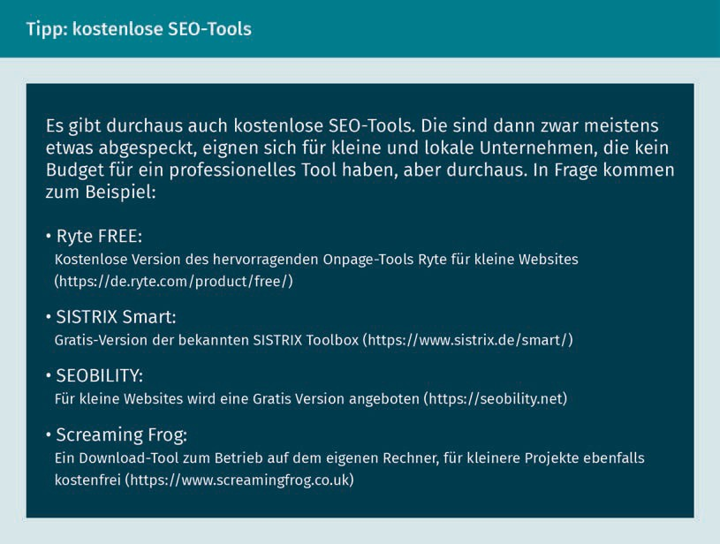

Search Engine Optimization (SEO)

There is also XOVI (www.xovi.net), which displays current website rankings. It also allows for localized action and comparison within a specific radius, e.g., in a specific city. (2021, S. 185).

#### Off-Page Optimization

Off-page optimization refers to measures implemented on external web pages. This includes, e.g., links that point to the page to be optimized, known as *backlinks*. The more backlinks a page has, the higher its ranking by search engines. This type of optimization is often added if, e.g., there is a great deal of competition on the market (Lammenett, 2019, p. 233, p. 256).

The Backlink

A user typically comes across the web page in the normal and usual way by means of a search engine. Thanks to backlinks, this can also work differently. The number of backlinks pointing to a page is described by the term *link popularity* (Kreutzer, 2018, p.301). Here, the website operator enters their backlink in web directories, social media, and referring search engines to generate greater attention.

The overall appearance, i.e., the presentation and display of the link, plays a crucial role in establishing trustworthiness. It is important to avoid generating an excessive number of backlinks, since the search engines' algorithms may register an abrupt increase in link popularity and temporarily lower the web page’s ranking. The links should therefore appear on isolated and well-selected web pages to ensure maximum success (Lammenett, 2019, p. 258).

Several measures can be employed to optimize the use of backlinks:

* + - All of an operator’s websites should be interlinked, which is obvious, since the operators have access to all their own pages.
    - Social media presence is always helpful. The link to a website can be shared in forums, blogs, and groups.
    - Affiliate links are recommended. The backlink is placed on their web page, which in turn is linked to a company’s own web page. This creates a mutual exchange and attracts visitors who would otherwise never visit the web page directly. However, a triangular constellation is recommended. Operator A places their link on operator B’s page. Operator B places their link on Operator C’s page. And lastly, Operator C places their link within Operator A’s internet presence.
      * Benefit can also be derived from press releases in which a link to a company’s website can be found at the end. Even if interest in the topic is minimal, writing press releases and uploading them to databases can catch the attention of journalists. But search engines recognize that there are press texts relating to subjects and web pages, which is always an advantage.
      * Linking a company’s own page on external websites is a good idea. It can be particularly useful in the following cases: With associations, universities, authorities, sponsoring, friends, suppliers, customers, service providers, etc. (Sens, 2018, p. 31).

#### Measurement and Evaluation

After the implementation of these measures to increase visibility, the question is whether the efforts were worthwhile. The following parameters provide initial indications:

* + - **Position on the results page seen by users:** Friends and relatives in different locations in a country search for a product or service offered by a web page using appropriate keywords. If the desired page then appears on the first page in an organic search, the search engine optimization has worked. Unfortunately, however, this is only a snapshot and, as already described, time and effort must be invested here on a continual basis to maintain high rankings. Nevertheless, a manual check is rather unsuitable, particularly if the development is to be observed over many search terms, as well as search term pairs. Software, of which there are many variants, can assist in tracking the development of any number of keywords.
    - **Popularity of a link**: How often do visitors come to a company’s own web page thanks to links placed on external pages?
    - **Definition of search terms that led users to a website**: What was searched for and how did the visitors arrive at a company’s own web page?
    - **The number of visitors who were led to the website via a search term or search term combination is only of secondary importance**: A higher priority is placed on filtering the search terms or search term pairs used by visitors who generate the highest sales or lead to contact or order forms being filled out. To determine these parameters, a statistics program is useful for log file analysis. Log files are files that store events on a website with a timestamp. The statistics program calculates the number of visitors from the log files and evaluates which specific search terms led the respective visitors to the corresponding website (Lammenett, 2019, p. 236).

Search Engine Optimization (SEO)

In addition to the above-mentioned options, many other tools are available, all of which have the same goal. For example, certain apps allow one to see their own page as it is displayed in search engines. Furthermore, websites can be compared with one another. Other tools offer suggestions for improvement and tips.

Google Analytics is significant tool for monitoring. As the term performance marketing suggests, this service not only tracks the performance of a web page, but also displays the results graphically.

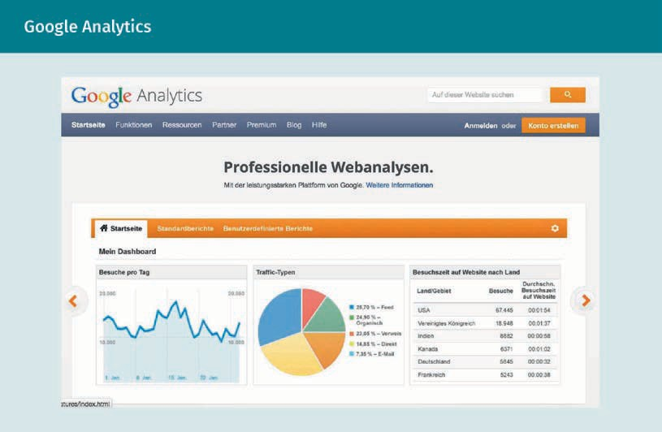

Google Analytics software allows users to track visitor activities, such as how they arrived at the web page and their origin. For example, they entered the name of the website, i.e., the domain, directly into a browser. Or they arrived on a page via a Facebook post or an Instagram ad.

Ultimately, there are limitless ways to achieve success and it can be pursued through various means.

**Summary**

Search engine optimization is a component of the communication policy and is therefore a part of performance marketing. The goal here is for a company to design their own website in such a way that, ideally, it appears in the first position of results pages generated by users’ search queries.

When undertaking optimization measures, many different possibilities are available and can be assigned to either on-page optimization or off-page optimization.

On-page optimizations are implemented directly within a company’s own website. This includes, e.g., the optimization of the structure or the placement of links, or the linking of content on their own page. It is also a good idea to optimize the program codes (also called source code). The goal of on-page optimization is to achieve an improved search results rate. A better match of the text with the users’ search terms should increase visitor numbers to the page. It is important to determine and evaluate the appropriate search terms.

Off-page optimization includes those measures that can be undertaken with the help of external websites. This primarily involves backlinks. Here, the link to a company's own web page is displayed on other web pages on the internet. It is also possible to publish cross references in other public directories.

Ultimately, it comes down to the measurement and evaluation. Success can be considered as achieved when more users have come across a company’s own website. It is important here, particularly for companies that sell products or services, that higher sales are generated. This is not automatically achieved by simply generating more visitors. Therefore, the right internet users must be addressed.



# Unit 4

## Search Engine Advertising (SEA)

##### STUDY GOALS

On completion of this unit, you will be able to ...

... categorize the term search engine marketing in the performance marketing subject area.

... explain what Google Ads are and their role in search engine advertising (SEA).

... analyze important considerations in campaign and conversion optimization.

... explain how ads can be improved using Google Ads Extensions.

... assess how to measure and evaluate the success of search engine advertising (SEA).

DL-D-DLMOMPMSS01_D-L04

### Search Engine Advertising (SEA)

#### Introduction

Search engine advertising (SEA) involves measures that ensure a company's own advertising appears on the first page of a user's internet search engine for a fee. Thanks to increasing digitalization in everyday life, companies now have the opportunity to reach their customers directly (Kreutzer, 2018, p. 231).

This process, also known as *keyword advertising*, presents ads to users after they show interest in certain products and services. After all, everyone has noticed at some point that their searches frequently yield products related to their previous search histories. The determining factor is not only the previous search, but also the clicks made on websites and the information available to the internet search engine (Lammenett, 2019, p. 222).

Through Alphabet Inc, Google’ parent company, Google Ads search engine advertising can be created by individuals with little effort. The following questions will be addressed in this unit:

* What is search engine advertising, or SEA for short?
* How should search engine advertising (SEA) be categorized in the area of performance marketing?
* What are Google Ads?
* How does campaign and conversion optimization work using Google Ads?
* What are the so-called extensions in Google Ads and how do they help with optimization?
* How can the success of search engine advertising (SEA) be measured and evaluated?

#### Search Engine Advertising as Part of Performance Marketing

Search engine advertising (SEA) is the paid counterpart of search engine optimization (SEO). Within the marketing mix, search engine advertising (SEA) forms part of performance marketing and therefore falls under online marketing. Online marketing is part of communication policy. The figure below illustrates how search engine advertising (SEA) can be positioned in the overall marketing mix.

Search Engine Advertising (SEA)

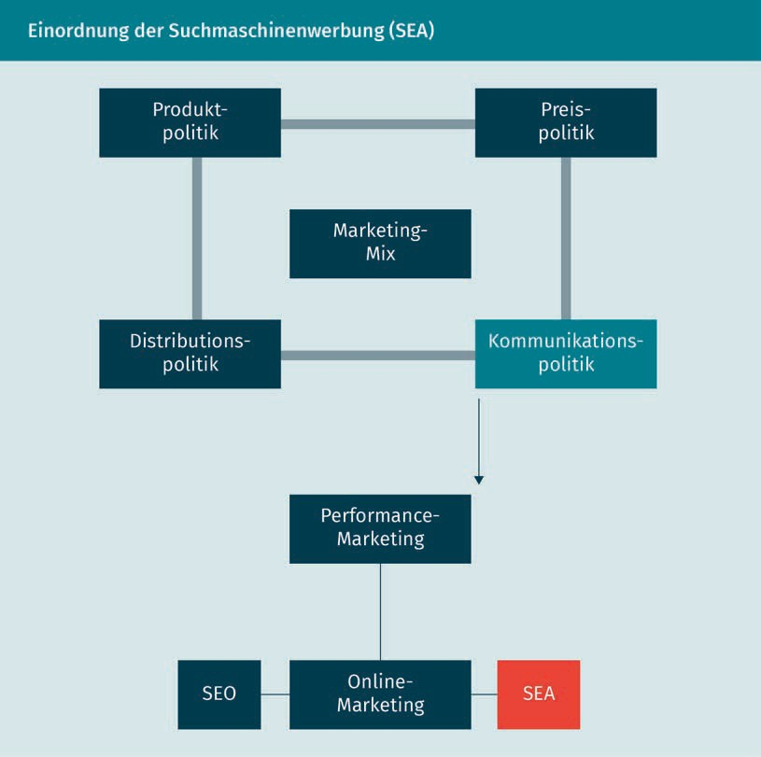

Search engine advertising involves paid search results. The advertising information is displayed at the top, in the paid area of the search results pages. This information is presented as an ad, often referred to as **sponsored links**. The unique feature is that an ad is only displayed to users if they make a search query with the specific search terms that the company has previously defined. This approach is less intrusive. Of course, several companies may select the same keywords. In such cases, an auction mechanism determines the outcome. A bid is placed in advance for each individual keyword. The higher the bid, the higher the ad will appear in the search results (Meffert et al., 2019, p. 715).

Once the predetermined budget of an advertising company is exhausted, the paid ad is removed from the list.

Sponsored links This term refers to

a URL that redirects users to a company’s website. The link is marked with a reference to advertising.

#### Google Ads

Google's successful advertising program Google Ads, formerly known as Google AdWords, has existed since 2000 and helps advertisers conduct search engine marketing. It involves placing small text ads via Google's search results, which then link to the advertiser's web page. Google explains that demographic targeting in Google Ads simplifies the process of reaching the desired audience because the ad can be specifically tailored to a company's customer base. (Google, 2016 cited in Lammenett, 2019, p. 211). Searchers often perceive these as regular search results. Many will not realize that it is an ad. Therefore, Google Ads has made these paid ads clearly identifiable as advertising.

The advantages of keyword ads are the high level of acceptance among target customers and, of course, the ability to address customers in real time. The corresponding ad appears in the form of a search result at the precise moment that something is searched for (Beilharz 2021, p. 161).

The advantages for companies that use Google Ads are enormous. In addition to other forms of online advertising, such as banners or conventional advertising formats of television, radio or even print, many points support the use of Google Ads. Beilharz (2021, pp. 163–164) summarizes them as follows:

* + - The budget can be managed dynamically, used selectively, and capped as desired. Thus, advertising companies can determine their budget per day – and it can also be increased or decreased at any time – and this also applies to the value of a click on the ad. Campaigns can be halted at any time. For example, due to the cap, a debt incurred by the placement of Google Ads is almost impossible.
    - Payment is made on a per click basis, referred to as cost-per-click (CPC) in this context. This means that costs are only incurred when visitors reach the web page via the ad. Banner advertising is not billed in this way; a fixed price per ad is charged.
    - Geographical placement allows for highly localized advertising. A city or state

can not only be specified on Google, but also on Microsoft's competitor Bing, or even on Facebook. This way, only people in the specified area will see a particular ad. And thanks to smartphones (e.g., through GPS or similar methods), or the IP address of a desktop computer or laptop, sales territories can be selected with precision.

* + - Control is an important factor. Compared to an ad in a daily newspaper, it is much easier to track the success of a campaign with the help of Google Ads and the Google Analytics software. This is not so easy when placing a print ad in a magazine. Landing pages also help to track success. How many people visited those landing pages after arriving there due to Google Ads? Who among them actually proceeded to make a purchase?

Search Engine Advertising (SEA)

* Google's reach is enormous, particularly in Germany, where Google’s market share is over 90 percent. In addition, Google collaborates with T-Online, gmx.net, and freenet.de, as well as web.de, each of which act as search partners of the leading search engine.
* Banner ads can also still be booked via the Google Ads interface. Access to the largest advertising network, Google Display Advertising Network, speaks for itself. Almost all relevant websites are connected to it. Even YouTube belongs to Google's parent company Alphabet Inc., and spiegel.de, die Zeit, chef-koch.de, Handelsblatt.de, and kicker.de for soccer fans also belong to this advertising network. The many forums, blogs, and a vast number of other portals that also belong cannot all be listed for reasons of space.

The question is whether there is a more effective and flexible advertising measure. A brief example from Instagram is presented for the sake of comparison: if an ad is placed there, a fixed amount is paid without knowing the achieved results. Instagram campaigns start at small amounts. For example, a 6-day display of a paid post to a total of 10,000 potential prospects costs only 36 €. However, only a fraction will engage with the post and an even smaller number of people will then purchase the product or service. Therefore, the efficacy of such a low-cost campaign is quite questionable.

Goal

The goals that companies pursue using Google Ads are diverse. Primarily, a company wants to attract traffic, i.e., visitors, to its own web page to increase the number of hits and, ideally, conversions. Visitors should become returning customers. But increasing awareness of a company or the provider's products and services, brand awareness, or the name of a particular web presence also play a role. Sales and profit increases are also targeted in connection with this. These are often achieved through the above-mentioned goals. But it must be noted here that more hits, increased traffic, and a higher profile do not automatically translate into increased sales. Quality, not quantity, is what counts. The goal of an ad can be selected directly within the Google Ads interface in order to work strategically.

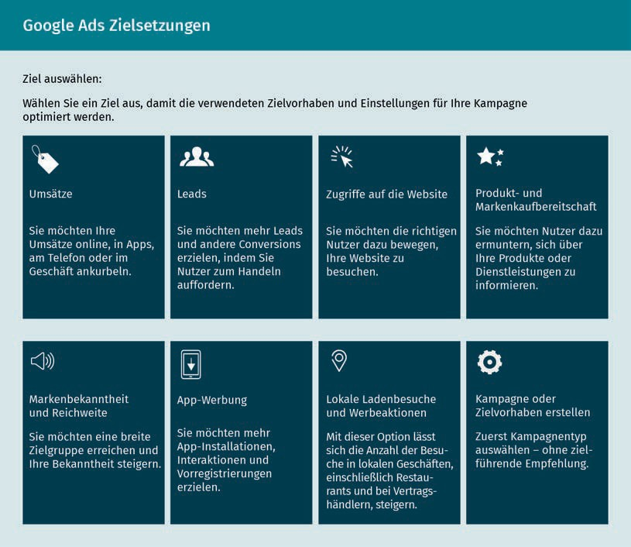

Users have the option to select exactly what the goal of the campaign should be and what they want to achieve as the advertising company. While the terms *sales* and *leads* are closely related, the goal can also be an increase in hits, i.e., visits to the website. Likewise, it could also be the intention of the operators of a web page to inform customers about their products and services. Some companies focus on increasing brand awareness and attempt to increase their reach.

However, the goals can also be set in the offline area. Retailers attach value on-site visits to stores and try to encourage online visitors to physically visit their stores.

Alternatively, a campaign can be created without a specific goal.

Market Segmentation

The intended audiences to be addressed must be considered in a differentiated manner. The Sinus Milieus model can provide guidance in this regard. The SINUS Institute regularly conducts studies on the lifeworld of various intended audiences. The goal of these studies is to describe the market potential of different social milieus (environments).

Search Engine Advertising (SEA)

In these studies, individuals within a country are segmented into groups based on information about their living situation. Criteria such as occupation, family, and leisure time are used for this purpose. These criteria represent influences that can change the values and behavior of the intended audience. The following figure is designed to facilitate understanding.

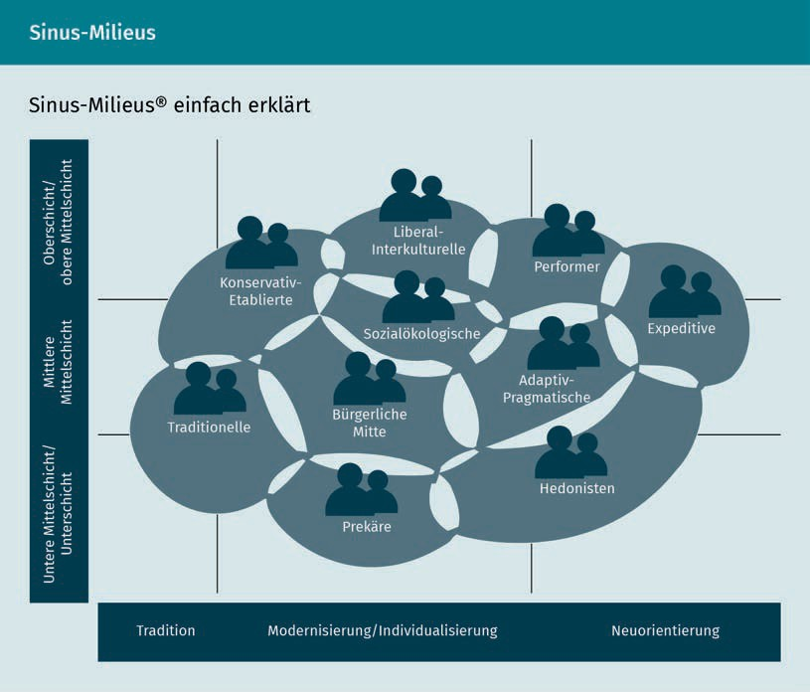

The Sinus Milieus model visualizes and differentiates all identified milieus. The categorization of a milieu is based on the group’s orientation which ranges from “traditional” to “postmodern” and on the social situation (Meffert et al., 2019, p. 232). The milieus identified are not always sharply delineated from one another, so a person can be assigned to several milieus.

This model is used to determine the **market volume** of an intended audience. Within a group, homogeneous perceptions are assumed regarding the performance and benefits of a product or service. This idea distinguishes one specific group from another. As soon as the representation of a group is known, it can be addressed in a targeted manner. This minimizes scatter loss in marketing. In SEA, a clearly defined, delineated intended audience should be identified. By assigning the intended audience to a Sinus milieu, the wishes and ideas of this group can be effectively addressed using Google Ads. (Meffert et al., 2019, p. 232; Heinemann, 2018, p. 201).

Market volume

This refers to the total sales volume of a product in a specific market and within a specific period of time.

The Zalando company exemplifies the practical application of this approach. An examination of their annual report – which can be viewed online – reveals that each of their customers can be categorized into one of the seven so-called zTypes: Hip Popper, Street Snobs, Fresh Families, Modern Main-streamers, Preppy Strivers, Happy Casuals, or Cultured Elites.

Reach

“A key advantage of the internet is its global reach” (Kreutzer, 2018, p. 45). Ads are created in Google Ads locally, globally, or only for certain regions. This setting is determined by the creator of the ad. The reach of the ad is estimated by Google based on the number of users who use Google products in this region. It should therefore be noted that the actual reach differs from the number of people who reside in this area according to population statistics (Kreutzer, 2018, p. 236).

Budget

If a company wants to use Google Ads for advertising purposes, costs are undoubtedly a significant factor. These will be briefly revisited. The placement of the ad is determined through an auction process. The advertisers compete for the best placement of the ad for specific keywords. Google prioritizes the ads of the highest bidders over those who bid less for the ad placement.

In addition, advertisers incur costs when customers undertake the designated action. This action can be either clicking on the company's website, requesting further information, or filling out an inquiry. Advertising success is measured by the maximization of such actions. Based on the advertiser's goal, an automated bidding strategy can be used in Google. The associated costs range from €0.05 to over €20 per visitor referred to a company’s own website (Kreutzer, 2018, p. 238). However, there are extreme examples which are outliers. For example, over €80 per click is offered for the term “Corporate detective agency Frankfurt” or over €50 per click for “Locksmith + City.” The cost escalates with the intensity of competition. (Beilharz, 2021, p. 177). Since locksmiths are overpriced and customers are typically charged astronomical sums, the high cost per click is logically comprehensible. Despite the significant advertising cost, a substantial profit can still be made.

It is important that bidding advertisers establish a maximum monthly budget. Since search engine operators want to help their customers succeed, Google, for example, makes recommendations regarding the amount of the budget to be used. Google communicates with advertisers by email, as well as by telephone.

Search Engine Advertising (SEA)

#### Campaign and Conversion Optimization

After an ad has been placed, it should also be optimized. The goal of this optimization is the best possible design of the advertisement or campaign to maximize its success. This involves campaign optimization followed by conversion optimization.

Different types of ads can be selected within the scope of search engine advertising (SEA). The figure below shows that Google Ads offers the option to freely select and configure a campaign type.

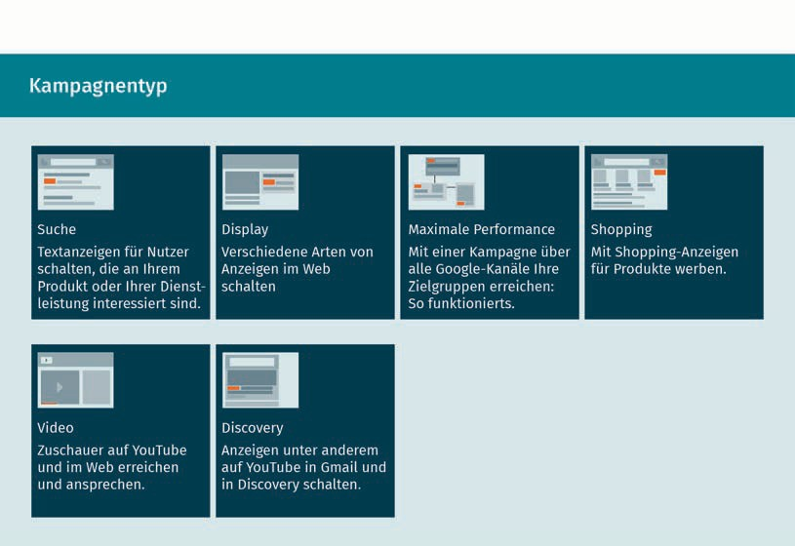

The ad and campaign type can be implemented using different forms of presentation. Advertising companies can place text ads (search), displays, which are comparable to banners, or advertise a product with traditional shopping ads. Videos can also be integrated into YouTube (YouTube also belongs to Google's parent company, Alphabet Inc.).

Campaign Optimization

Campaign optimization is carried out by the advertisers. It is necessary to consider the following: The choice of keywords, also in combination with other words, text variants, and optimization of the website, as well as the budget.

Selection of search terms

* The integration of word combinations often correlates with a higher click rate and lower costs than the simple use of single terms.
* Highly visible and publicly debated topics can generate new search terms that can direct users to a company’s website.
* When selecting search terms, it should be noted that internet users search in both singular and plural forms.
* A specific search for competitors’ ads can reveal the keywords they use, which may be suitable for the company's own search engine advertising (SEA). For example, Jacobs Kaffee, which belongs to Kraft Foods, could theoretically also bid on the term *Tchibo*, which would almost be a bit brazen.
* Misspellings can also be targeted to increase conversion rates.

Text variants

* For important search terms, a separate text ad that includes these search terms should be created. This will display the text ad when the search term is entered and highlight the search term.
* Different text variants should be regularly recreated and tested. Less successful ads should be eliminated from the program.
* The result can potentially be improved upon with slightly modified versions of the best text ads thus far.

Website optimization

* To better reach the respective intended audience, a separate web page can be created for each of them.
* The headlines and ads should be chosen in such a way that they attract the customers’ attention and reach the respective intended audience.
* The ad should not raise false expectations among customers. This is more likely to lead to a long-term migration and many potential customers could be lost.

Price

* The cost per click should depend on how much a prospect is worth to a company. The budget can be determined from how many people perform a desired action when visiting the website. Therefore, the precise expenditure of a company strongly depends on the advertisers’ budget.

Search Engine Advertising (SEA)

For example, an insurance company offering life insurance might be willing to pay more as a successful policy conclusion can generate significant revenue.

* + - Conversion tracking can be used to determine the influence of keywords on the success of a website. The price and the ad’s share in the success are shown for each keyword.
    - The price development of the ad with the current settings and keywords should be monitored, since prices per click can change (Lammenett, 2019, p. 208).

Here, too, Google Ads offers the option of adapting the ad to the advertiser's goals. Specifically, these options are: website visits, calls, store visits, and app downloads.

As part of a campaign optimization, a keyword advertising campaign can be carried out or an external company can be hired for this purpose. The following tasks are performed as part of this campaign:

* + - Define relevant keywords
    - Monitor keywords to be excluded
    - Develop keyword ads
    - Place ads
    - Monitor budget
    - Derive optimization measures
    - Monitor competitor activity
    - Crosslink with other advertising activities (Kreutzer, 2018, p. 249; Lammenett, 2019, p. 210).

In addition, companies also have the option of testing different campaigns. On the one hand, this involves a high cost and time expenditure. On the other hand, however, an advertising company can be sure that they are designing a campaign that promises maximum success. Important factors for the success of a campaign are as follows:

* + - Cost of the campaign
    - Duration of the campaign
    - Campaign reach
    - Coverage of the advertising network
    - Reaching the intended audience

Campaign optimization is then followed by the conversion optimization of the ad.

Conversion Optimization

**Conversion** refers to the performance of desired actions by users when visiting a website. Examples of this are the number of visits to a website or new entries in the newsletter. The term conversion refers to users changing their status with a company,

Conversion When users change their status with a company through specific actions, this is referred to as conversion. Conversion occurs through interaction with a website.

Interaction Users who interact with a website are going through the conversion stage at that moment or have already done so.

e.g., from prospect to buyer. Conversion occurs through interaction with a website (Kreutzer, 2018, p. 170; Kreutzer, 2018, p. 201). The number of conversions indicates how many transactions were achieved by a campaign. The conversion rate (CR) is the ratio between the number of ads and the number of conversions (Kreutzer, 2018, p. 222). The performance indicator provides information about the extent to which visitors are successfully guided toward taking the desired action. In the context of conversion optimization, it is important for companies to know which web page visitors start an **interaction** and who drops back out. But here, too, a simple calculation is not sufficient. The right metric can only be identified and the need for optimization be determined with an optimal evaluation.

There are various methods to augment the conversion rate. In the short term, prices can be reduced or the product offer can be adjusted to attract more visitors. In the long term, other means need to be used to cultivate and expand long-term relationships with customers.

Conversion optimization is divided into six stages (Erlhofer & Brenner, 2019, p. 511):

1. **Analysis:** Analyze bounce rates and dwell time of website visitors; question goal orientations.
2. **Hypothesis:** Create hypotheses to improve performance metrics; filter elements/features that convinced visitors; identify motivations for action.
3. **Realization:** Convert hypotheses into measures, carry out optimization runs on different components.
4. **Controlling:** Control measures that have been taken; summarize results.
5. **Interpretation:** Assess results and summarize user behavior.
6. **Implementation:** Unveil new conversion optimization measures.

#### Ad Extensions

Google provides advertisers with so-called ad extensions. These are extensions to the ad that can be added manually as well as automatically. In the manual variant, a few setup steps are required. Automated extensions are added by the system when it anticipates that this will improve ad performance in Google Ads. No setup is required for automated extensions (Google Support, n.d.).

Search Engine Advertising (SEA)

When manually adding ad extensions, e.g., an app download option is created or specifically chosen user ratings are displayed. With the automated variant, alternating user ratings or information on previous page visits can be displayed (Kreutzer, 2018, p. 238). There are no costs for a campaign extension.

Manual ad extensions include the following items:

* + - **App extension:** An app is displayed under the website link that internet users can download directly with one click.
    - **Call extension:** The company can be directly contacted by phone through clicking on the button.
    - **Location extension:** The company’s address is displayed under the link.
    - **Sitelinks extension:** Links are depicted that directly transport the userto other sections of the site.
    - **Callout extension:** Customers can also be directly informed about terms of purchase here.
    - **Review extension:** Comments from other customers can be displayed on the results page.

Automated ad extensions include:

* + - customer reviews,
    - details of the last visit to the website,
    - retailer ratings, and
    - dynamically generated **snippets**.

The goal of these extensions is always customer growth. Ensuring this involves the success of online ads progressing through three stages:

1. **Customer acquisition:** Successful marketing aims to stimulate interest and new customers can be won through exceptional offers.
2. **Functional customer loyalty:** Customers are tied to a company. This can be promoted through excellent basic services and functional solutions.
3. **Emotional customer loyalty:** For example, an emotional bond with the clientele is established through a customer-oriented approach and surprise additional services. The goal is to attract regular customers (Heinemann, 2018, p. 93).

These three stages are depicted and explained in detail in the following overview. It is particularly clear here that the stages are interdependent. However, it is also possible to bypass the second stage and directly establish and emotional bond with new customers. Furthermore, this model can theoretically be extended by another level, i.e., “recognition.” After securing emotional customer loyalty, it is desirable to a company if the customers become regular customers. Regular customers in

Snippets

This term refers to excerpts from a website that are displayed in the search engine.

particular publicly express their satisfaction with a product, service, or company (Heinemann, 2018, p. 93).

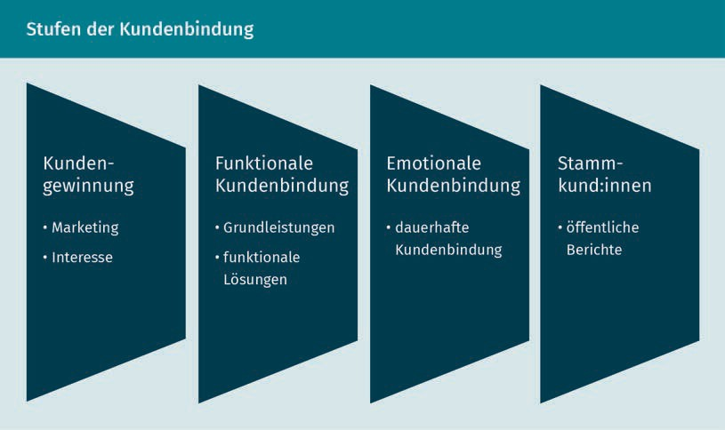

#### Measurement and Evaluation

Search engine advertising cannot manage without effective controlling. The determinations made need constant evaluation, as search engine assessment and thus the success of the ad can change continually. It is important to distinguish between content, formats, and timing concerning the different intended audiences. Conversion tracking tools are used to track visitors’ interactions with a website (Kreutzer, 2018, p. 246).

The controlling instruments are categorized and are listed in the table below (Kreutzer, 2018, pp. 76–78).

The indicators listed on the right side of the table are used for evaluations of individual or multiple keywords. The analysis reveals whether specific keywords appear more frequently or less frequently in certain regions. This information can be considered during further optimization. This is where comprehensive conversion tracking is implemented. However, this success indicator cannot be evaluated after a single assessment. This is where the behavior of the acquired prospects and customers is evaluated. In the next step, for example, the origin of these customers is recorded in a customer history (Kreutzer, 2018, p. 246).

Search Engine Advertising (SEA)

|  |  |
| --- | --- |
| **Controlling Instruments** | |
| Controlling category | Indicator |
| Maximizing attention | * Page impressions: Number of impressions through the search engine * Rank: Average position of the display * Opportunity to see (OTS): Calculates how often each user comes into contact with the advertisement. |
| Costs | * Cost-per-click (CPC): Average cost incurred per click * Cost-per-view (CPV): Average cost incurred per video viewed. * Total daily costs: All costs incurred in one day * Cost-per-order (CPO): Here, the total costs are divided by the number of customers acquired |
| Intensification of engagement | * Usage intensity: Dwell time on the target site * Conversion rate: Number of daily clicks per user |
| Increase loyalty | * Reviews: Rate of returning visitors |

In conclusion, a particularly relevant term should be considered: key performance indicators. We use these to measure our return on investment, i.e., how much money was spent on a campaign and how many new customers, conversions, or sales resulted from it. Typical indicators include page impressions, the number of visitors, dwell time, bounce rate, conversion rate, click-through rate (CTR), subscribers, followers, likes, shares, and newsletter sign-ups. Most of these terms are now familiar to us and can be applied in practice.

**Summary**

Search engine advertising (SEA) is a subarea of online marketing. This involves paid advertisements that are displayed to users when they search online using search engines. The advertising information appears in the paid area of the search results page. However, users are only confronted with the ad if they are interested, since keywords are defined for each ad, which are matched with the search terms. A typical program for placing such ads is Google Ads, but Microsoft also offers a similar tool or the corresponding platform with its search engine Bing. A demographic targeting of the campaign is individually defined to reach an intended audience. Subsequently, the ads, which refer to the advertiser’s web page, are placed online. Afterwards, the campaign’s advertising can be adjusted over and over. The maximum possible success is to be achieved with the help of these optimizations. Extensions to the ads also strive to achieve this goal.

Finally, the success of the search engine advertising is evaluated. Based on the results, adjustments and innovations are always necessary to locate interested parties as well as gain and retain customers. Thus, the optimization of SEA is an ongoing process.



# Unit 5

## Marketing in Social Media

##### STUDY GOALS

On completion of this unit, you will be able to ...

... understand social media marketing as part of performance marketing.

... differentiate between different social networks.

... assess the importance of influencer marketing and viral marketing.

... take advantage of the opportunities offered by paid advertising on social media.

... categorize and apply relevant indicators for measuring the success of a social media post.

DL-D-DLMOMPMSS01_D-L05

### Marketing in Social Media

#### Introduction

In the realm of social media, people present themselves and network with others. Lively exchanges take place within social networks and communities. Content is shared on media-sharing platforms, and users can learn about a wide range of products, services, and companies on rating platforms.

The increasing use of social media opens various opportunities for companies to reach their intended audience online and in real time. Companies can publish posts or go online with promotional videos to reach their intended audience directly. However, they can also reach them indirectly, e.g., via influencers. Through social media, companies have the opportunity to present themselves online and get in touch with interested parties and customers. We distinguish between the use of social media by private individuals and social media marketing, which is the responsibility of companies and agencies.

This unit covers the following topics:

1. The use of social media marketing and its importance as a component or part of performance marketing.
2. How companies can use social networks to engage in dialog with their customers.
3. The use of influencer marketing as well as viral marketing as an instrument.
4. The placement of paid campaigns within social media.
5. The role of data analytics in measuring and evaluating social media posts.

#### Social Media Marketing as Part of Performance Marketing

*Social media* is the umbrella term for online technologies and online media that enable internet users to exchange information and collaborate online. Social media includes social networks, sharing platforms, messaging services (also known as messenger), blogs, forums, and online communities (Kreutzer, 2018, p. 374). Defining the term social media is a complex task given its fluid boundaries, but an attempt will be made nonetheless. All channels based on user-generated content principally fall under social media. These include Facebook, Instagram, LinkedIn, Pinterest, WhatsApp, Xing, TikTok, and YouTube, among many others. In addition, all channels that facilitate not only the consumption but also the creation and sharing of content can be defined as *social media* (Beilharz 2021, p. 29).

Marketing in Social Media

Social media play a significant role in performance marketing and are therefore also assigned to communication policy within the marketing mix. Within the 4P model, the marketing mix comprises the four areas of product, price, placement, and promotion. Communication policy (promotion), which includes advertising and public relations, also includes online marketing. Online marketing, in turn, includes performance marketing and social media marketing.

Few other areas are subject to such incredibly rapid change as social media marketing. New features or court rulings concerning data protection, agitation, or election interference frequently change the rules. Hence, marketing experts are not only constantly faced with new challenges, but also with opportunities that small companies in particular can exploit cost-effectively. Therefore, owner-managed companies, lone wolves, or small businesses are clearly able capitalize on the advantages: Flat hierarchies, short decision-making paths, flexibility, and the possibility of quick reactions (Beilharz 2021, p. 29).

Many companies use social media to achieve their goals, such as increasing sales, attracting new customers, increasing conversions, increasing brand awareness, and drawing attention to their products and services.

The key to the success of any social media channel lies in its users, who are either required to use their real name or are allowed to create their profiles under pseudonyms. The figure below shows an example of a user profile.

Example of a User Profile on Instagram

Rumors that membership for social networks could become chargeable are far from reality (Editorial Chip, 2021). Every single user is worth money in the truest sense of the word. The more users, the larger the potential intended audience for companies advertising on the platforms, which is the main source of income for the operators.

From a corporate perspective, the participants and roles in the context of social media are also diverse, including:

* Users
* Employees,
* Competitors
* Customers
* Suppliers,
* Investors
* Press, i.e., journalists and editors
* Actors in the labor market, i.e., employees
* The public/society.

Traditional media This includes print media, such as posters, magazines, and books, as well as media such as television, film, and

radio.

The interaction between these diverse actors results in an uncontrollable and complex formation of opinion that can either create or destroy value (Kreutzer, 2018, pp. 374–375). This exchange is often referred to as social media communication. In principle, communication is also possible in **traditional media**, but there are significant differences in terms of the characteristics and possibilities of communication. Communication via the traditional media predominantly flows from a few creators to many consumers. Communication toward the creators only takes place occasionally, e.g., in the form of letters to the editor (which many users of the younger generations will no longer even know). If an article in a newspaper stirs up emotions, or if a polarizing or provocative advertisement in a magazine provokes strong reactions, readers write to the editors to express their displeasure. After reviewing the contributions, they are then published if necessary. This type of communication is much easier for social media users. For example, a corresponding article can simply be commented on.

The scope for responding to content in traditional media is limited. In contrast to traditional media, social media are multidirectional, i.e., communication can be directed in a variety of ways. In the case of online content, a response can be made via comments or likes and can be tracked nearly in real time. The transmission of communication is much faster than with a conventional letter to the editor. Contributions in social media are less restricted in their spatial distribution than those in traditional media, since there is no need for physical transmission (e.g., a letter), but rather only access to the respective technology or platform is needed. It should be noted here, however, that letters to the editor in traditional media, such as newspapers and magazines, are often sent via email today.

The publication of traditional media is a meticulously planned activity, wherein the content, length, and publication time or frequency are determined. For cost reasons, publications are limited in scope, and they present content and reports in a linear fashion, i.e., it is not the users, but rather the medium’s program schedule that decides the sequence or timing (Hoepner, 2019).

Social Media Marketing Goals

The goals of social media marketing are multifaceted and can be listed as follows (Kreutzer, 2018, p. 391):

* The increase in awareness is achieved when the number of followers increases. Pictures or short videos on Facebook or Instagram stories serve this purpose. Instagram stories are a succession of pictures or short videos that can be with or without sound.

Marketing in Social Media

Professional networks for employees and employers, such as LinkedIn and Xing, also offer this possibility.

* + The development of an image or the increase of the brand or company perception is promoted. The term *employer branding* involves strategies intended to make companies interesting for applicants and demonstrate to employees the benefits of working for the company.
  + Attempts are made to position oneself as an expert (as done by lone wolves, for example).
  + The improvement of the search engine placement is undertaken. The focus here is the traditional link, which has a positive effect on the Google algorithm. The more high-quality links point to an internet presence, the better the chances of appearing high in the ranking of an organic search engine.
  + The increase in revenue, the sale of goods, and the conclusion of subscriptions (such as mobile communications contracts) are targeted.
  + Customer care, the exchange of ideas, openness to criticism, and signaling a willingness to engage in dialog are gaining in importance.
  + New employees and applicants are recruited.
  + New customer groups are opened up and the customer base is expanded.
  + It is important to maintain contacts, not only with consumers, but also with suppliers.
  + Requests/orders regarding services are accepted (i.e., companies can accept orders, e.g., a craftsman's business).
  + The competition is monitored.
  + Trends are predicted.

Due to the multitude of options, companies always have the opportunity to capture an exact snapshot of the status quo, including their own performance and what their competitors are doing. With the help of Facebook Business Manager, for example, lists can be maintained online that show in detail how active the competition is in social media. Facebook either suggests competitors or they can be searched for specifically to gain an overview of what was posted in which week and the amount of feedback, e.g., such as likes, shares, and comments.

Acquiring Followers and Fans

For a company to achieve the aforementioned goals, an active social media presence is necessary. The process of creating such a presence consists of several steps: Initially, visitors are to be engaged via the content within a company’s social media presence and developed into *fans* of the company. In purely technical terms, a person becomes a fan when they actively request the company’s social media content. An active request can occur, e.g., through a *follow* or

*subscribe* function. Accordingly, the term *fan* here also includes terms such as *follower* or *subscriber* (Kreutzer, 2018, p. 417).

In the second step, fans are engaged through new posts, with the aim of fostering trust in the company. If the content is relevant to the fans, they respond to the content and an exchange or communication takes place between the followers and the company.

The third step involves interested parties sharing relevant content within their social media network. There is typically a level of trust among networked individuals, who often share similar interests. This makes it likely that the content will be shared with friends for whom the subject of the post is also relevant. In that case, people may also share the content within their network.

In the fourth step, the friends of the fans can develop into followers of the company. At the same time, a viral spread of certain posts can occur (Kreutzer, 2018, p. 425).

The terms vary depending on the platform and perspective. For example, private individuals on Facebook are friends, but if they follow a company page, they are referred to as followers.

Certain aspects must be considered when seeking to generate such followers. After all, social media is not exclusively a sales and advertising channel. For this reason, the five basic principles of communication must be taken into account for any social media presence in order to successfully spread a message (Kreutzer, 2018, p. 383):

1. **Honesty:** This principle refers to the authenticity of a company’s social media presence. A company's honesty is demonstrated, e.g., by accepting both positive and negative user comments on its social media presence and responding appropriately (as transparently and de-escalating as possible) in the event of a **shitstorm.**
2. **Transparency:** This principle can improve a company’s credibility. A company generates transparency by consistently addressing criticism from social media.
3. **Communication as equals:** This principle refers to the company's behavior toward public posts. Posts should always be written in an appreciative and respectful manner.
4. **Relevance:** Companies should create content that is relevant and tailored to their intended audience to build a long-term relationship with their followers, fans, and users.
5. **Continuity:** This term refers to the continued publication of posts announcing important events or campaigns. This ensures that the company is perceived as reliable and builds trust with the users.

Marketing in Social Media

Another important aspect is the frequency of article publication. Should this be done daily, only weekly, or even monthly? It is also important to tailor different articles for different platforms and intended audiences. The keyword here is variation. The intended audience that a company encounters on Facebook will not only differ in age from the audience on Instagram and TikTok. In this context, we speak of an intended audience approach. Geographical differences are also significant, as American corporations such as Meta Inc., which owns Facebook, WhatsApp, and Instagram, are generally banned in China. If users frequent Facebook and Instagram, they will quickly tire of identical posts from a company on both platforms. When browsing through both social networks, most people do not wish to encounter the same message.

Each of these basic principles and ideas must be observed and broadly respected if visitors are to become loyal fans and remain followers of a company for a prolonged amount of time.

Potential and Market Exploitation

The five steps outlined in the graphic below are helpful in harnessing the potential of a social media presence.

Shitstorms

This term illustrates how authors of posts on social networks or blogs are punished by comments ranging from negative criticism to defamation and disparagement.

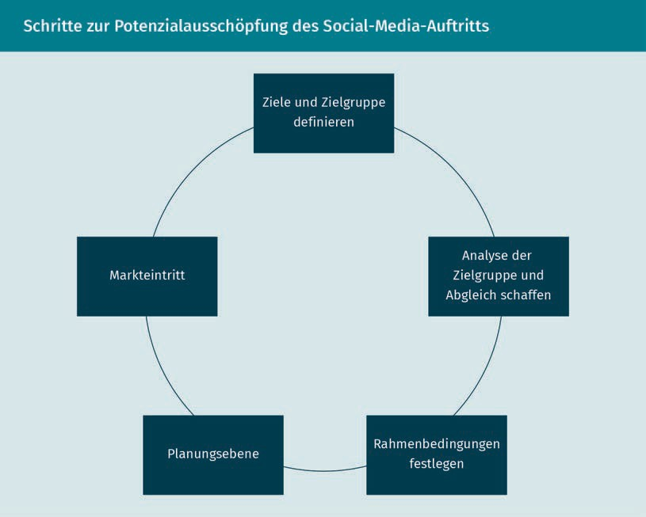

After a company's social media marketing goals have been defined, the intended audience is determined. The more precisely an intended audience can be defined, the better the respective strategy can be tailored toward that intended audience. Important factors in defining the intended audience can include factors such as gender, age, income, and geographic location.

Furthermore, the selected intended audience must be analyzed regarding its usage habits of the channels it actively engages with. This analysis determines whether the intended audience is actually active in the media targeted, i.e., whether it can be found there. If the intended audience uses other channels, the strategy must be revised and adapted. The frequency and duration of use of a channel and the subject areas discussed on it also need to be considered. Subsequently, the insights gained are compared with the company’s image and goals. From this perspective, it is necessary for every company to be clear about its own image among the intended audience. This knowledge contributes to the success of the social media presence. If the actual image differs from the desired image of a company, it can then develop a social media campaign to correct the image. Since the pursuit of multiple goals is commonly undertaken at the same time, it is important to prioritize them carefully. A separate ranking and individual indicators should be defined for each goal.

The next step is to create the boundary conditions for the social media campaign. Procedures are developed during this stage: What specifically should occur and be achieved? The following questions can help a company do this:

* What topics are chosen, used, and implemented?
* Which channels are used?
* Who takes responsibility?
* What budget is available for the social media campaign?
* Is there adequate expertise to realize the campaign?
* Do the accountable employees have sufficient experience to safely move about in the targeted channels and actively post?
* Is advice (external help, e.g., from an agency) needed for the social media campaign?
* Is there a crisis management plan in place if negative comments are written?
* How will a shitstorm be handled?
* In what instances should the company’s executive management be involved?

Only when each of these boundary conditions have been clarified does the planning stage begin. Specific procedures are considered and developed in this stage. An ideal timeline is created and the content for the channels is prepared. This is followed by the *market entry* stage. Even though this term is typically associated more with products, here it denotes the initial appearance in the digital world, on a new platform, e.g., on Instagram, TikTok, or Facebook. The previously developed content is published via the prepared channels and the dialog with the desired intended audience is initiated (Lammenett, 2019, p. 432).

Marketing in Social Media

The process of exploiting the potential of a social media presence is not yet complete with the market entry. Continual controlling and monitoring, i.e., checking the data and evaluating the campaigns undertaken are important.

The amount of experience a company has with social media marketing is illustrated in the following graphic. How far is social media marketing developed in a company and how deeply is it anchored in a company's DNA?

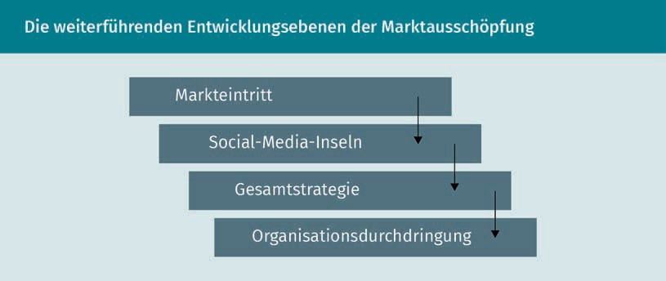

The market entry level is initially an experimental stage. A campaign launched can be considered a test, the results of which can be used in later development levels to further exploit promising social media channels and further develop and expand strategies.

In the next development level, a company is already using a few social media channels occasionally. This stage is referred to as **social media islands**. Here, only a small part of the available resources is spent on social media activities, since both personnel and budget for the area are still limited. At this level, there is a tendency for companies to underestimate the potential of social media.

An interesting example is the Oettinger brewery, whose beers have already won many awards. Oettinger manages to successfully use the relevant channels with minimal effort and without incurring any costs.

The beer has an undeserved bad reputation and can be bought very cheaply in stores. But the low prices do not have a negative impact on the quality. Quite the contrary. The Oettinger Brauerei GmbH supplies retailers using its own trucks, so no transport companies profit from it. Only retailers are supplied, not the restaurant/bar industry. The logistics of supplying restaurants and bars would be far too complex and expensive. Alongside this and for the most part, Oettinger operates without advertising. The owner, Pia Kollmar, only uses Facebook and Instagram, both with Oettinger and with another brand, the well-known festival beer 5.0 and 2.5. Compared to its competitor Krombacher, which spends around 65 million euros a year on advertising, the budget is virtually zero.

Social media islands

This refers to the first social media activities of a company (in the company’s history).

Oettinger Brauerei GmbH is an excellent example of a social media island. Only little attention and no budget is spent on social media. The posts primarily consist of user-generated content, i.e., fans and followers send pictures to the brewery. Everyone involved benefits. Oettinger benefits from free content and the users are happy when their pictures are posted on the pages of one of the 30 largest breweries in the world.

Once the potential of social media has been recognized, the next level of development follows. In this stage, organizational anchoring of social media takes place within the company. The overall strategy for handling social media in a company is developed based on previous experience.

The last development level occurs as soon as each employee in the company feels responsible for representing the company via social media. Tasks relating to social media are available in every area of the company and corporate activities on social media are anchored in a customer-oriented manner (Kreutzer, 2018, p. 513). The last level almost sounds like an ideal utopian state.

#### Social Networks and Platforms

A social network is a social media platform that enables users to establish and maintain relationships with business partners and/or other users. An exchange with like-minded people can take place in various areas of interest. A distinction is made here between different platform-specific social media communication tools. However, the functionalities of social networks are increasingly overlapping, as is clear from Telegram, for example: it is considered both an instant messaging service and a social network. This makes it increasingly difficult to clearly delineate social media platforms based on the separation of the communication tools used (Kreutzer, 2018, p. 419). The following sections suggest a possible categorization including well-known examples:

Blogs

A blog (short for weblog) is now traditionally used as a form of internet diary. Blogs are an important manifestation of social media. A blog is a website that can be operated by an individual, group, or company. The blogger can write about a wide variety of subjects here, as can other authorized persons. The length of the content is not relevant. Images and videos can also be published via the blog. They invite comments and links from third parties, potentially sparking discussions. The blogs are based on software that is easy to use. This enables novice users to publish easily and quickly. Blogs can be hosted independently or through an IT service provider. In the latter case, the data and software are located on the external computers of the corresponding IT service provider. In both cases, the author needs

Marketing in Social Media

quick and direct access to the blog. Well-known platforms for creating blogs are, e.g., Twitter (a special microblog form), WordPress and Tumblr (Kreutzer et al., 2018, p. 397).

Wikis

Wikis are collections of web pages and are based on software that enables the compilation of those web pages. Users can not only read wikis but also edit them directly. Thus, collaboration on a document is made possible. The goal is the collaborative presentation of the authors’ experience and knowledge. Wikis are also often created internally in companies as an instrument for knowledge management among staff (Lammenett, 2019, p. 442).

The figure below shows the perhaps best-known wiki.

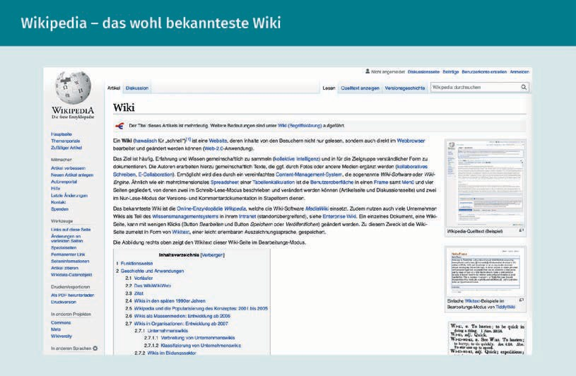

Online forums and communities

Online forums and communities are virtual spaces in which members exchange subject-related ideas, experiences, and opinions. The comments are archived and the exchange is time-delayed. The difference between an online forum and an online community lies in the relationship between the members: In online forums, there is no or only a weak relationship between the members, while an online community is characterized by strong relationships. Here, members work together to generate new content (Kreutzer, 2018, p. 483).

Social networks

Social networks are digital platforms that enable members to establish and expand contact with other members online. Social networks are aimed at private individuals and/or business professionals. Examples of well-known networks are Facebook, WhatsApp, Telegram, Snapchat, XING, and LinkedIn. The last two are well-known business networks. LinkedIn, founded in Silicon Valley, is the world’s largest online career network and has been part of Microsoft since 2006. It enables users to present professional profiles, look for jobs, and network with other members. Large international companies in particular can be found here. A clear advantage of the platform is the controllability of a company’s own presence: access is free, but there are three paid products that determine the reach and the possibilities for establishing contact (Kreutzer, 2018, p. 419).

Media sharing platforms

Groups of people share common content in the form of images and videos, e.g., on Instagram, Pinterest, TikTok, and YouTube. The term has the potential to be somewhat misleading as it might imply the inclusion of the word *social* before media. However, the focus is on the exchange and upload of images and videos that are shared in this way.

Review platforms

Individuals can review companies or their services here and share experiences. The information provided is perceived as trustworthy due to the third-party nature of the review. Yelp, for example, is particularly well known. Amazon also qualifies as a review platform since it meets the relevant criteria.

#### Influencer Marketing and Viral Marketing

Influencers are digital opinion leaders. Influencer marketing refers to the strategic use of these opinion leaders in social media. The reach of influencers is utilized to achieve communication goals and thus also downstream marketing and corporate goals. A company should select influencers for advertising campaigns who align with its intended audience. A contract is drawn up with the influencers so that joint campaigns can be developed and implemented. And finally, the effects of utilizing influencer marketing should be measured (Kreutzer, 2018, p. 387).

In contrast, viral marketing involves the deliberate instigation of a specific form of word-of-mouth communication, intended to result in the rapid and exponentially growing distribution of company-related content. A distinction is made between *random virals* and *placed virals*.

These two measures will be further explored in the sections below.

Marketing in Social Media

Influencer Marketing

This marketing approach involves the use of influencers for social media marketing. Influencers are individuals within a group who have a stronger influence on the communication processes within that group than its other members. As a result, influencers can affect the attitudes and behavior of these people. While opinion leaders in a non-digital context only have a limited reach, influencers reach a larger number of recipients with their contributions. Although there is no clear definition of the term, people with a reach of 1,000 fans are considered *micro-influencers*.

*Mid-level influencers* have approximately 20,000 to 25,000 fans and those with more than 100,000 fans are considered *top-tier influencers* (Lammenett, 2019, p. 149). The prices are set by the influencers themselves, so it is difficult to make statements about this aspect.

Influencers can be active on various social media platforms and be interesting to communities for different reasons, e.g., because they have expert knowledge or offer entertaining contributions. When using influencers for advertising, the trust that a community has in the influencer can boost the credibility of an advertising campaign. The goal is to reach a company’s intended audience through influencers (Lammenett, 2019, p. 143).

The fact that influencers’ opinions are not only listened to but also trusted is particularly interesting to companies.

Influencer marketing aims to incorporate influencers into a company’s communication process. In line with communication goals, the reach and influence of influencers should be targeted strategically. There are two primary strategic areas of responsibility for this:

1. **Influencer selection:** Given the large and continually growing pool of potentially available influencers, it is necessary to select the most suitable ones for achieving communication goals. The first step in the selection process is to filter the influencers who align with the goals established. Here, the degree of match and credibility are often decisive. But personality traits must also be considered. For example, there are **social hubs**, which have many contacts from various circles of people. Then there are also **market mavens**, who may have a smaller reach, but a great potential for influence due to their expert knowledge (Meffert et al., 2019, p. 737).
2. **Establishment and cultivation of the relationship between a company and an influencer:** Once the right influencer has been selected and recruited, they are brought into the process. It is particularly important to aim for a long-term relationship. This enables the influencers to acquire the relevant brand knowledge and behave in accordance with the brand identity. It ensures that the message can have an authentic effect on consumers (Meffert et al., 2019, p. 739).

Social hubs

This term refers to influencers with a wide reach.

Market mavens

This refers to Influencers with a wealth of specialized expertise.

Viral Marketing

Viral marketing is a special form of social media communication that leverages people’s online networks so that information spreads epidemically, much like a virus. The internet, with its multitude of platforms, is ideal for this virus-like distribution. First and foremost, journalists and influencers are targeted. The secondary intended audience consists of customers and interested parties. Two variants are distinguished in viral marketing (Kreutzer, 2018, p. 519):

1. Random virals involve an unplanned development, are picked up by others, and are widely communicated. The viral process is a product of chance.
2. Placed virals are presented online in a planned way to trigger viral effects.

The goal of forwarding information to others hinges on four key success factors:

1. The source of a viral message (products/services/brands/companies).
2. The type of seeding as well as the channels involved. The term *seeding* comes from the notion of planting seeds that will then grow. In specific terms, the goal is to distribute and spread content, images, or messages within a social media channel, e.g., Facebook, in such a way that the intended audience is reached as thoroughly as possible without scatter loss.
3. The core of a viral message (added value) and incentives for forwarding.
4. Characteristics of the senders and receivers.

The goal of viral marketing can have different orientations. First, it aims to generate attention. The focus of viral marketing is that consumers of the ad engage with the brand, product, or company. Then, an attempt can be made to acquire interested parties or customers for an offer. The next step is to invite them to communicate positively. In addition, an attempt can be made to discover which groups of people spread information about the product, service, or company (Kreutzer, 2018, p. 520).

One of the best-known viral campaigns was distributed by a food retailer agency for Edeka grocery stores at Christmas, with the title “Heimkommen” (“Homecoming”).

The challenge here, however, is that virality is difficult to plan. Overall, the following risks associated with viral marketing exist and need to be considered (Kreutzer, 2018, p. 524):

* + Difficult to plan in terms of time
  + No guarantee of viral spread
  + Loss of control
  + No free advertising

Marketing in Social Media

The following opportunities and benefits of viral marketing offset the risks (Kreutzer, 2018, p. 524):

* + - Low costs are incurred
    - Capitalization on interactions
    - Promotion of awareness and credibility
    - Rapid dissemination
    - Wide reach
    - Opportunity for playful engagement with advertising content

Thus, viral marketing must be planned and weighed as much as possible.

#### Paid Advertising on Social Media

Influencer marketing is just one way to advertise via social media. The most common option used by companies is paid advertising in the form of banner and video ads. Additionally, paid advertising can be executed via media sharing platforms. The following graphic shows these three options for paid advertising via social media.

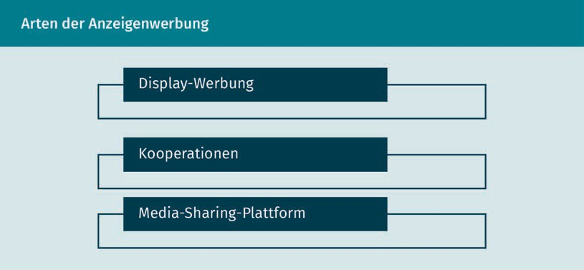

Banner and Video Advertising

Display advertising is particularly common. This includes **banner** and **video advertising** via social media. The key advantage here is that social media platform operators can derive a wide range of personal data from the personal details and browsing behavior of users. Companies can use this data to reach their intended audience without scatter loss.

Banner advertising Refers to the display of brand or company logos on web pages.

Video advertising

These are placed on web pages or within a stream.

A cooperation between companies, influencers, and bloggers can also be formed to attract additional users. In this case, the influencers include advertising for a company's products in their content or links are embedded in an influencer's profile page.

On the whole, recommendation and purchase intentions rise with increasing awareness on social media. The focus is therefore on connecting users so they spread a company's advertising.

#### Measurement and Evaluation

Numerous indicators provide information regarding the success of marketing in connection with social media. (Kreutzer, 2018, p. 502). These particularly include the following parameters:

Reach

* + - **Social buzz:** Number of mentions of a post (count)
    - **Share of buzz:** Number of mentions compared to the competition’s numbers
    - **Development of social buzz:** Number of mentions over time
    - **Number of fans**: Results from social networks (count)
    - **Reach:** Number of people directly reached (1st degree) and indirectly through referrals (2nd degree) (count)

Mood

* + - Number of positive/negative/neutral mentions (count)
    - Ratio of positive/negative/neutral mentions
    - Recommendation rate: Number of posts with a recommendation in relation to the total number of posts

Engagement

* + - Number of posts and likes per post (count)
    - Posts in relevant communities (count)
    - Participation in contests: Number of participants compared to total number of customers

Influence

* + - Social buzz through channels (count)
    - Social buzz through influencers (count)
    - Composition of relevant subjects: Most mentioned subjects about the brand (count)

Marketing in Social Media

Conversions

* + - * Newsletter subscriptions: Number of new subscriptions to a newsletter (count)
      * Downloads of provided content (count)
      * Corporate website traffic: Website visits, session duration, bounce rate, page views, requests, subscriptions (e.g., signing up for a newsletter or following a YouTube channel), etc. (count)
      * Visits to an online store (count) or visits to an offline store on page (count)

Regardless of industry, it is vital for a company to remain vigilant and monitor web activities. Targeted and comprehensive monitoring is important here. Developments must be monitored to determine future trends (Hahn, 2020, p. 684).

Without continual monitoring and analysis of these indicators, changes may be overlooked and go unnoticed. Thus, data analysis and the daily determination of the indicators are vital to the success of social media campaigns.

**Summary**

Social media marketing utilizes the cooperation and exchange of information between internet users. This is because social media is an online technology through which a wide variety of population groups and interested parties are active. Uncontrollable and complex opinions are sometimes formed through these networks, which can have value-creating as well as value-destroying content. This exchange is often referred to as social media communication. Thanks to these connections in the area of social media, new opportunities are available in addition to traditional media to reach the corresponding intended audience. The basic principles of honesty, transparency, communication as equals, relevance, and continuity are important for long-term corporate success. These should be adhered to by companies operating within the sites, because only under these aspects can the potential of a social media presence be fully harnessed. To this end, the goals of the social media presence are set, the implementation is planned, and the market launch subsequently follows.

Relationships among internet users are built on social media platforms. A distinction is made here between blogs, communities, wikis, social networks, media sharing platforms, and review platforms.

**Comment for text within Summary**

Companies also have the opportunity to use influencer marketing. Here, an influencer is integrated into the communication process to generate a wide reach for a company’s message. Viral marketing can also be used as a form of social media marketing. A distinction is made between *random virals* and *placed virals*. With placed virals, content is presented online in a planned manner to trigger viral effects. In the case of random virals, the viral spread of a content is independent of the author’s intention. In contrast to placed virals, random virals are free of charge. Advertising via social media is an additional option and is paid advertising.

Specific indicators can provide a variety of information on reach, sentiment, engagement, influence, and conversions.



# Unit 6

## Mobile Marketing

##### STUDY GOALS

On completion of this unit, you will be able to ...

... explain the significance of mobile marketing for performance marketing.

... describe how mobile websites, apps, and messengers are used for mobile marketing.

... explain the significance of proximity marketing and mobile advertising.

... name the indicators for measuring the success of online marketing.

DL-D-DLMOMPMSS01_D-L06

### Mobile Marketing

#### Introduction

These days, an increasing number of people have mobile devices such as smartphones and tablets. These devices have strong capabilities and frequently have internet access. This means that many actions can be carried out while on the move and data and settings can be adjusted. Apps can be installed on the devices to solve various problems for users. There are no limits to the fields of application. Given the widespread use of smartphones in society, companies are interested in addressing users via these devices. Mobile marketing attempts to reach the intended audience with relevant content. At the same time, smartphones are used to improve the satisfaction of existing customers.

The following questions for advertisers arise from the technological possibilities associated with smartphones:

* What role does mobile marketing play in performance marketing?
* How is mobile marketing done via mobile websites, apps, and messengers?
* What are the options for mobile advertising?
* How does proximity marketing work?
* How is the success of mobile marketing determined?

#### Mobile Marketing as Part of Performance Marketing

Wearables These are devices that users wear during use, such as smartwatches or fitness trackers.

The most important driver of mobile marketing is the increasing spread of mobile and internet-enabled devices. Particular attention should be given to tablets, tablet PCs, and smartphones. This development has opened up new application and usage options for companies and customers. The development is reinforced and supported by the various **wearables**, such as the Apple Watch or a variety of fitness trackers. In addition, smart tattoos have already been developed. These tattoos are made of thin metal foils, e.g., gold, and contain interfaces for controlling devices. The first generation of the Apple Watch was revealed at a public keynote on September 9, 2014. The first Apple iPad was launched on January 27, 2010.

There are additional aspects, which is why the intensity of mobile online access, and thus the relevance of mobile marketing, will skyrocket even more. The number of mobile devices and the intensity of smartphone use have become increasingly widespread (ComScore, 2017; cited from Kreutzer, 2018, p. 355). As a result, fewer households have landline telephones and the demand for desktop computers is also decreasing.

Mobile Marketing

The number of accesses to online offerings is rising along with the increasing use of mobile devices. This is because online purchases and online searches are also increasingly carried out on mobile devices, particularly since relevant information and options for the purchasing process are likewise more readily accessible on mobile devices. This communication between companies and users is referred to as mobile communication. The smartphone is developing into a smart service terminal that is becoming a central, holistic, personal control, and navigation tool. Mobile data transfer will also continue to increase as mobile services become more comprehensive and attractive. Users can receive information simultaneously via different mobile devices. When information is obtained via different mobile devices at the same time, this is referred to as parallel use of these devices.

Altogether, the trend toward **digitalization across the value chain** is increasing. In addition to data and processes, products such as books and magazines are also being digitalized. Physical boundaries are being overcome due to **dematerialization**. Ultimately, the physical transport of goods to the customer is no longer required here. The effects of dematerialization can be seen, e.g., in the newspaper market and in retail through an increasing tendency to offer products online. Companies should therefore consider not only digitizing their communication, but also their products.

In mobile marketing, two types of campaigns can be differentiated to transmit advertising to the specific apps in a user-tailored manner.

* **Push approach:** Advertising companies use the permission received for **push notifications**. In this case, advertising content is displayed on a user's screen like a pop-up. In addition, promotional messages are displayed in an app.
* **Pull approach:** A company uses content marketing so that users develop an interest in certain content and actively request this content from that company (Kreutzer, 2018, pp. 355–359).

One example of push notifications is the offer from Appadia. The company, which is headquartered in the U.S. and has offices in Spain and India, sells an app for shopping centers that can be used by all store operators. Visitors who use the Appadia shopping center app can specify their preferences, e.g., an interest in sportswear. If the visitor using this app and then walks past a sports store in a shopping center, they will receive a push message because permission was given for this in the app settings. In this way, the potential customer is made aware of an offer from the sports store (www.appadia.com).

Digitalization across the value chain

This refers to the services and formerly physical products (e.g., books) that are now available across the value chain.

Dematerialization Conversion of a physical object (e.g., a book) into a non-physical object (e.g., e-book).

Push notifications This is a platform notification service that sends data to apps.

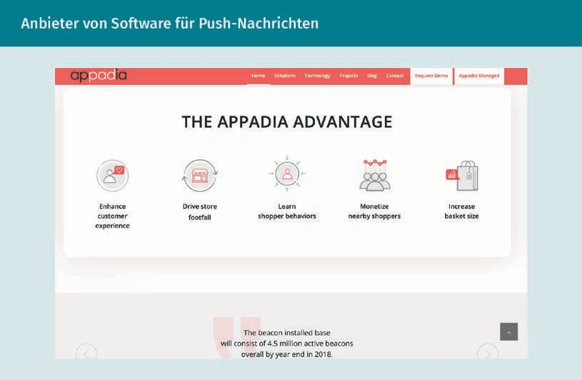

We have all long since been aware of push messages, the simplest form of which is an SMS message or a message in WhatsApp. Here, too, this involves push messages.

#### Mobile Web, Apps, and Messengers

The three approaches: *mobile web*, *mobile apps*, and *mobile messengers* are distinguished in this unit.

Mobile Web

Websites must be programmed in such a way that internet users do not have a negative experience when they access a website on a smartphone. Specifically, this means that the website can be accessed on a desktop computer or laptop, as well as on a smartphone. It is not necessary for the content and presentation to be completely identical. Nevertheless, the display of the respective versions should not be different. Most users have experienced visiting a website from a cell phone that is then displayed in a completely distorted and incorrect way, or maybe does not load properly at all.

The following approaches can be used to implement a modern and mobile website:

Mobile Marketing

1. **Adaptive website:** This is a standalone website that is often accessed via a **subdomain**.When the website is accessed, a decision is made depending on the device and browser used as to whether the user is shown the mobile or the traditional website.
2. **Responsive website:** These websites are displayed in the same way on all devices. The layout and the respective situations adapt. Thus, an optimization of the screen size or, alternatively, an optimization of the touchscreen usage takes place. To achieve this, the websites work with relative sizes and with what are known as **flow elements**. The latter results in the elements appearing next to each other on large screens and automatically below each other on smartphones. There are ready-made templates for creating a responsive website that facilitate its development. Many experts recommend this type of website due to the diversity of devices (Rieber, 2017, p. 48).

Google offers a guide and automated website tests to assist in optimizing a company’s own website: (https://developers.google.com/search/docs/beginner/seo-starter-guide?hl=en). This website evaluates the usability and the loading speed for both traditional and mobile devices, providing a useful tool for measuring success. In addition, optimized websites are preferred by Google’s algorithm in the ranking of search results (Lammenett, 2019, p. 223).

Mobile Apps

Mobile apps are prevalent today because they offer users added value. A distinction is made between different app business models for mobile apps, although these can also be used in combination (Kreutzer, 2018, p. 362):

* + **Free apps:** These apps typically have the largest user base. Revenue is generated through in-app advertising and/or by selling user data.
  + **Freemium apps:** These apps offer additional functionalities for a fee, aside from the free version. In this case, the use of these apps is ad-free.
  + **Subscription apps:** This type of app is popular with media companies. Content is only accessible if a recurring amount is paid to the company. A certain number of free accesses are frequently offered initially.
  + **Paid apps**: These apps require a one-time fee and can be used permanently thereafter.
  + **Shopping apps:** These apps support the sale of digital and/or non-digital products and services.

Subdomains

These allow the sections of a website to be accessed separately from each other.

Flow elements

Refers to moving, variable-sized elements on a website.

Media break This refers to a change of medium within a transmission chain.

For app users to be satisfied, it should be possible to search, obtain information and, if necessary, make purchases within an app without a **media break.** Particularly successful apps can be used to determine how users can interact with that specific app. The following list provides a few examples of successful apps.

Examples

* **Uber app:** This app proved to be a successful competitor to traditional taxi service. It enables users to obtain comprehensive information about their booked ride. For example, users can specify the pickup and arrival locations, as well as the route and arrival time. The costs and vehicle details are also disclosed. In addition, the driver can be rated at the end of the ride.
* **Airbnb app:** This app is extremely successful in the lodging industry. Similar to Uber, it “bypasses” established providers such as hotels and vacation rentals by allowing private individuals to offer their homes or individual rooms as accommodation. The app enables users to find, save, and share accommodations. Payment and communication with hosts are also mobile.
* **Tinder app:** This app has fundamentally changed the process of meeting and dating people. Its key feature is that it allows users to decide whether they are interested in getting to know another user through a chat, based on their displayed profiles (Kreutzer, 2018, p. 363).

App Marketing

App marketing involves using important keywords in the app stores to ensure that the apps can be found. App reviews are also essential to a convincing presentation of an app. To promote their own apps, companies need to integrate the apps into their online and offline communication as standard practice. Furthermore, when using apps, consideration must also be given to the budget for development and ongoing program maintenance, as well as the budget for marketing the app.

App marketing constitutes a large portion of total online advertising revenue. In addition to advertising revenues, data about internet users can also be collected. For example, user location can be defined provided that the user has permitted this information to be used. Payments made via apps (e.g., via PayPal) for products and services can also provide data about users. In addition, surveys and competitions enable informative data flows, particularly if the user’s location is permitted. Information can also be obtained from non-participation. For example, the number of users who responded to a particular contest can be compared (Kreutzer, 2018, p. 362). The app can also be used to offer special services. The company can use this to collect targeted information about the users and display personalized advertising messages, thereby influencing the user’s purchasing behavior to the advantage of the company.

Mobile Marketing

What advantages and disadvantages does the app offer users? Today, there are hardly any problems for which there is no app. From a commercial perspective, a distinction is made between the following three functions:

* Paid or free apps with pursuit of their own purpose, such as games, dictation devices, or drawing programs.
* Apps to support existing business processes, such as banking apps, catalog apps, or pizza service apps.
* Apps that are a competitor to conventional processes, such as Uber as a competitor to traditional cab services.

Despite the widespread distribution and use of apps, there are some disadvantages of apps compared to web applications. If a company decides to use an app in addition to their corporate website, the following specifics should be known (Lammenett, 2019, p. 465):

* Many apps require an internet connection at times to perform actions. Free WiFi in some public places support this. However, user data is processed, which can pose a security risk.
* Compared to web applications, developing an app incurs additional costs.
* A company must provide regular updates for functional apps.
* Apps must be optimized separately for each operating system.

Mobile Messaging

Mobile messengers enable direct communication with a cell phone. A distinction is made here between three communication variants that can be used by companies:

SMS/MMS

Even today, these two instruments remain viable options within customer communication. With SMS, only text messages can be sent. MMS, on the other hand, also allows images and links to be sent. In principle, however, both distinguish between...

* ...reactive sending (pull) and
* proactive sending (push).

In the pull variant, consumers send an SMS to a service number and then receive a reply from the company. In the push variant, the messages are sent by the company to the relevant intended audience. The prerequisite for this is that the telephone number is known and the recipient has given consent. Alternatively, specialized providers can assist in the distribution of targeted advertising messages.

Messenger and chatbots

Messenger services such as Facebook Messenger, WhatsApp, and the Chinese app WeChat connect millions of people worldwide. These instant messaging systems allow for the rapid and convenient exchange of information. Companies can also create a corporate account via these messenger systems. Some companies have integrated their messengers to such an extent that all customer service is handled through these channels.

However, customers’ requirements are increasing and they demand constant access and an immediate response. Chatbots are used to meet this need. These intelligent programs automatically simulate conversations with humans. In the process, they ask questions, filter the keywords, and attempt to answer as best as possible. Because this type of communication is becoming more natural, every company should validate its own chatbot.

Personal assistants

Applications with artificial intelligence (AI) are relevant for users when the AI operates as a cross-provide platform. Here, users can access information and use services via a dialog with the AI. Examples of personal assistants are Google Assistant or Amazon’s voice assistant Alexa. With these in-house home systems, users can interact exclusively via voice. These supports are ideal for those who wish to simplify everyday life and delegate basic tasks. This technology enables users to learn information about companies or to reach out to a company’s contact person (Rieber, 2017, p. 102).

#### Mobile Advertising

Regarding mobile advertising, mobile marketing offers four application areas (Kreutzer, 2018, p. 260):

1. **Mobile transmission of information by companies:** As mobile internet use increases, so does the relevance of integrating advertising into apps. Mobile advertising tends to achieve a high degree of effectiveness for the advertising placed, since users actively engage with the app.
2. **Mobile acquisition of information:** Contact with interested parties can be used to obtain user information. Surveys or contests are ideal for this purpose.

Mobile Marketing

1. **Mobile sales and mobile delivery of virtual products and services:** This involves online games, music, videos, books, and magazines. This content is frequently presented in special apps. A significant characteristic here is that the use of the app is accompanied by a payment transaction.
2. **Mobile sales of physical products and services:** Here, too, the focus is on transactions. However, this applies specifically to physical products and services.

Ads for apps can be placed in app stores. This is known as app store advertising (ASA). However, Google only displays one sponsored ad per search query in its Play Store. This makes it difficult to attract the attention of app users amidst high competition.

Mobile display marketing is another option. Here, ads from external providers are placed in apps (in-app advertising). Using this mobile display advertising, companies can target (groups of) customers more precisely, as the customers disclose information about themselves by using the app. With the help of online targeting, digital advertising media are automatically directed based on various parameters (Meffert, 2019, p. 750). The table below provides an overview of the primary online targeting methods:

|  |  |  |
| --- | --- | --- |
| **Online Targeting** | | |
| Targeting group | Targeting type | Explanation |
| Language | Contextual targeting | The ad will only be displayed if the text contained in the ad contains predefined keywords. |
| Semantic targeting | The ad will only be displayed if the words within the website text correspond to the predefined subject in terms of semantic totality. |
| Keyword targeting | The ads appear depending on the search terms previously entered into a search engine by the consumer. |

|  |  |  |
| --- | --- | --- |
| Targeting group | Targeting type | Explanation |
| Technical parameters | Technical targeting | The ads are displayed based on the technical equipment of the respective consumer. |
| Geotargeting (proximity marketing) | The ads are displayed to consumers who are mobile within a specific region. |
| Time targeting | The ads are displayed based on the exact time of day or hour while taking the time-related differences in the behavior of consumers into account. |
| Socio-demographics | Profile targeting | The ads are displayed based on socio-demographic characteristics, such as age or gender. |
| Behavior | Behavioral targeting | The ads are displayed based on the browsing behavior of the users. |
| Retargeting | The ads are displayed based on consumers’ previous actions. |
| Predictive behavior targeting | In addition to the consumer’s browsing behavior, the ads are displayed based on further insights that were previously determined using surveys and external data sources. |

#### Proximity Marketing

The smartphone has become an everyday companion for many people. Due to its extensive use, it is particularly interesting for companies to draw on the market activities of users. When advertising measures are based on a person’s location, this is referred to as proximity marketing or geotargeting.

Mobile Marketing

This can be divided into several areas (Rieber, 2017, p. 87), as shown in the figure below.

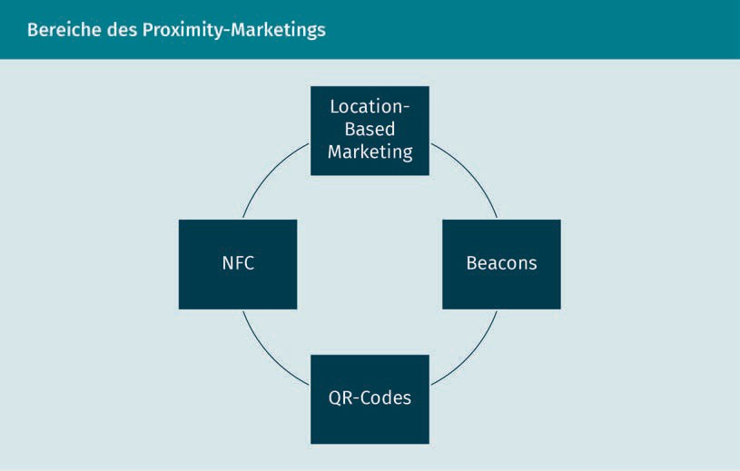

The individual components of the figure are described in detail in the following.

Location-based marketing

Here, the user is provided with ads and information depending on their location. The prerequisite is the (imprecise) analysis of the IP address in the online world. In contrast, the smartphone can release the GPS coordinates determined by the built-in sensor. **GPS** stands for global positioning system and can locate the smartphone to within 5–10 meters with the help of communication with satellites.

In the case of location-based services, such as the Google Maps app, users must permit the use of location data once when first using the app. Location-based advertising enables advertising to be oriented to the current location of the intended audience. However, this variant also requires a declaration of consent from the user (Rieber, 2017, p. 88).

Beacons

What is referred to as beacons, which can be thought of as small transmitters, enable pinpoint locating within meter accuracy – also and particularly inside buildings with poor mobile phone reception.

Global positioning system (GPS)

This refers to the determination of a position by means of satellites.

The name is derived from the fact that beacons are transmitters used to reach receivers. They are also known as hardware transmitters because they are small devices that are installed, e.g., in areas with weak mobile network.

This localization method is significantly more precise than GPS. To succeed, these beacons must be installed inside a store. These devices are small transmitters that are only a few centimeters in size and transmit an identifier via Bluetooth, which is evaluated by the receiving smartphone. A specific app must be installed on the smartphone and Bluetooth must be activated. Three beacons are needed for meter-precise positioning and precise movement data. The effort and expense involved here are therefore high. The goal of their use is to offer customers an optimum user experience within the store. For example, they can be guided through the store to a product via their smartphone. By precisely locating the user, suitable offers directly in the user’s vicinity can be suggested on the smartphone. This optimizes the app users’ experience within a store (Rieber, 2017, p. 91).

The figure below illustrates how greatly beacons can vary in appearance.

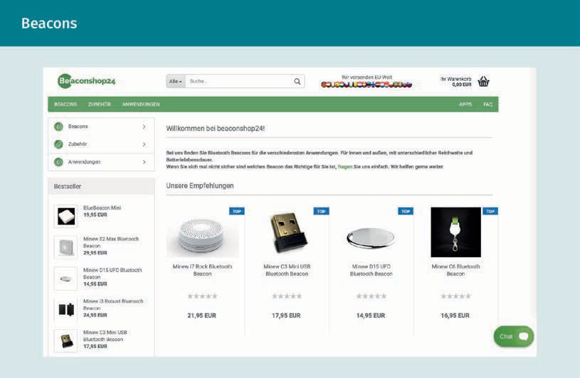

QR codes

Quick response (QR) codes are two-dimensional graphics that can be scanned with an appropriate app to access a predefined website. This involves a radio transmission standard for exchanging data that is available to any smartphone user (Meffert, 2019, p. 747). QR codes are used to direct customers and interested parties to a specific website.

Mobile Marketing

This website can then provide additional information on price tags, packaging, or posters and can increase the interest of potential customers (Rieber, 2017, p. 92).

NFC

Increasingly, cell phones and smartwatches are also being used at checkout points, e.g., at the cash register in supermarkets. Payments can be made, coupons can be redeemed, and points can be collected. Near-field communication (NFC) technology is already widespread today. The appropriate NFC reader is already integrated on the back of many smartphone models. If the NFC reader is held up to a specific NFC tag, it automatically recognizes the application of the NFC tag. The application is then executed via the smartphone. The versatility of NFC provides new opportunities for companies to interact with their customers. For example, Uber ran a campaign in which NFC tags were integrated into beer coasters. Customers who read the NFC tag using their smartphone received a discount on their first ride after signing up with Uber (Rieber, 2017, p. 93).

#### Measurement and Evaluation

Analyzing the user and monitoring actual usage should always be at the center of a mobile marketing strategy. This is also referred to as web analytics, the evaluation of user or visitor behavior. Only those who know relevant details about an intended audience and its behavior can make successful use of marketing in the long term. Various providers and tools are available for this purpose. A distinction is made here between technical measurement and market research. The former includes the evaluation of precise and quantitative data, while market research is equivalent to a survey. A combination of both enables a meaningful picture of the current market situation. Segmentation can be used if the analysis is to be applied to different groups. Here, users are divided into groups, e.g., with regard to purchases (Rieber, 2017, p. 64).

However, optimization also requires specific metrics that provide information. The key measurable indicators and their meaning are listed below:

* + - CPC (cost-per-click): The cost per clicked ad, typically when using Google’s Ads.
    - Number of installations: The installations achieved e.g., when purchasing software or an application (app).
    - CPI (cost-per-installation): The cost per new installation.
    - CPA (cost-per-action): The cost per defined user action.
    - Retention rate: The rate or number of active users after a defined period of time who have remained loyal to a company and therefore continue to count as customers.
    - Loyal user: Loyal users who perform a minimum number of uses.
    - CPLU (cost-per-loyal-user): The cost per loyal user.
    - ARPU (Average-revenue-per-user): Average revenue per user.
    - LTV (Lifetime value): The total value of a user over their lifetime.
    - ROI (return on investment): Additional revenue per advertising euro spent.

Summary

Mobile marketing is becoming increasingly relevant due to the growing prevalence of mobile and internet-enabled devices. Accordingly, companies are increasingly ready to adapt to this change by developing mobile offers and apps.

For campaigns, a distinction can be made between the push and the pull approach. In the pull approach, a company uses content marketing to generate interest in the offer among potential customers. Interested parties then actively request information from the company. In the push approach, companies use the permission of notifications to contact potential customers.

To ensure that customers have a positive experience with a company, an optimized appearance of the website is important, particularly with regard to the display on different devices. For this purpose, either flow elements can be defined or what is referred to as a subdomain can be used. In addition to a corporate website, it is also possible to develop apps for products, services, and companies. Various business models are available for these apps: free apps, premium apps, subscription apps, paid apps, and shopping apps. In addition, the widespread use of smartphones means that SMS/MMS, mobile messengers, and personal digital assistants can be used to communicate with customers.

Mobile advertising is utilized to address customers with relevant advertising. The ads can be automated and targeted with the help of defined parameters. This is known as targeting, which can be divided into four areas: language, technical parameters, socio-demographics, and behavior. Geotargeting is a technical parameter that forms the basis of proximity marketing. By localizing customers, companies can analyze their market activities. For example, payments via smartphone can determine location and user behavior. Information can be obtained from this data so that users can be targeted with suitable advertising. The basis for this information acquisition is the user’s smartphone. Location-based marketing, beacons, QR codes, and NFC are used for advertising in this way.

Mobile Marketing

And finally, mobile marketing involves measuring and evaluating the advertisement placed. Indicators such as CPC (cost-per-click), CPI (cost-per-installation), and ROI (return on investment) are used to evaluate a marketing strategy.