**Optimization of phosphorus removal from agro-wastewater by iron desalinization treatment residue (Fe-DTR)**

Hasan E. Ganem a, b, *, M. Iggy Litaor a, b, Oren Reichmann a, b, Iris Zohar b

a MIGAL – Galilee Research Institute, Hydro-Geochemistry Laboratory, Kiryat Shmona, 11016, Israel

b Department of Environmental and Water Sciences, Tel-Hai College, Upper Galilee, Israel

* Corresponding author. E-mail address: [Ganemhasan65@gmail.com](mailto:Ganemhasan65@gmail.com) (Hasan E. Ganem).

**Abstract**

Phosphorus (P) is a non-renewable macro-nutrient that will soon require recycling. One of the sources for P recycling is cowshed wastewater. This P-rich water requires pretreatment to prevent environmental threats and allow discharge to sewage treatment plants. We aimed to optimize the chemical-physical process of loading P in cowshed wastewater onto iron desalinization treatment residue (Fe-DTR) to examine the interaction. Specifically, we examined the effect of adsorbent dosage, particle size distribution, pH, and temperature on the capacity and kinetics of P adsorption. The greatest adsorption was at pH 3 at room temperature (11,410±1 mg P kg-1 Fe-DTR) after 3 hr, which was significantly more (P<0.05) than adsorption at 40 0C at neutral pH (10,834±371 mg P kg-1 Fe-DTR). We presumed that the lower pH removed competing ligands from Fe-DTR sites, resulting in increased adsorption sites. The higher temperature presumably caused endothermic behavior, precipitating calcium/iron phosphate phases. A probabilistic model known as the Design of Experiment (DOE) gave possible solutions for P adsorption at combinations of pH and temperature, indicating that low pH coupled with high temperature may improve P adsorption. The pseudo-second-order model best described the rate of P adsorption. The activation energy of P adsorption at pH 3 was greater than at pH 7 (8,082 and 3,970 J mol-1, respectively), resulting in stronger bonds at pH 3. We concluded that the optimal conditions for P loading onto the Fe-DTR at environment temperature is pH 3, particle size distribution 45-90 m, solid/liquid ratio of 5 g L-1, and loading time of 3 hr. Nevertheless, other kinetic models imply two-stage adsorption, including a rapid <90 min initial adsorption. Our study demonstrates the concept of the circular economy through the efficient use of two different waste streams, making a new resource.

**Keywords**

Phosphorus adsorption optimization, Kinetic models, Fe-desalinization treatment residual, Agro-wastewater, Phosphorus recycling.

**1. Introduction**

Phosphorus (P) is a crucial but non-renewable macro-nutrient in agriculture, and a significant reduction in P reserves is predicted by the end of this century (Cordell et al., 2009; Cordell and White, 2011). Many attempts to slow the process of P reduction include recycling through P-absorbing materials, such as zeolites, layered double hydroxide (LDH), oxides and oxyhydroxides, porous nano silicates, and polymer ligand exchangers (Bacelo et al., 2020; Wendling et al., 2013; Zohar and Forano, 2021). Agricultural effluents such as dairy wastewater are rich in organic compounds and nutrients, including organic and inorganic P. Thus, wastewater requires pretreatment before discharge to municipal treatment facilities (Barnea et al., 2012; Cordell et al., 2009; Steen, 1998; Wendling et al., 2013). Increasing P concentrations in water bodies will inevitably cause severe environmental pollution, such as eutrophication (Ayele and Atlabachew, 2021; De-Bashan and Bashan, 2004; Haygarth et al., 2013; Litaor et al., 2016).

Waste materials intended for landfills, such as aluminum or iron water-treatment residues (Al-WTR or Fe-WTR), can efficiently adsorb P from wastewater (Song et al., 2011; Zohar et al., 2017). Al-WTR use with acidic soils is problematic because of potential Al toxicity. Thus, the preferred wastewater is Fe-WTR (Flaten, 2001; Hutt and Zealand, 1989), which is generated abundantly by desalinization plants (Fe-DTR). Mixing these residues with dairy wastewater may increase P adsorbed onto iron and other oxides embedded within the Fe-DTR (Banet et al., 2020). Organic P is also adsorbed during the interaction of Fe-DTR with agro-wastewaters (Banet et al., 2020; Guppy et al., 2005; Makris et al., 2004; Massey et al., 2018; Yang et al., 2006; Zohar et al., 2020).

Phosphorus adsorption onto Fe-DTR may be affected by the texture and porosity of the residue (Dayton and Basta, 2005; Razali et al., 2007; Zohar and Forano, 2021) and the concentration of iron and calcium in the sludge (Makris et al., 2005). Other operational parameters affecting P adsorption include the dosage of adsorbent and chemical-physical parameters, such as particle size, pH, temperature, and initial P concentration. A significant issue with iron/aluminum sludge loading experiments is the long operational time and energy requirement (Smaransky, 2021; Zohar et al., 2017). Thus, our objectives for this study were to: (1) optimize loading time and chemical-physical parameters allowing maximum P adsorption; (2) model the kinetics of optimal loading rates for P adsorption on Fe-DTR and determination of indicators such as activation energy and half-life; and (3) explore the feasibility of a commercially competitive P fertilizer produced by mixing dairy wastewater with Fe-DTR.

**2. Materials and Methods**

2.1. Wastewater

Dairy wastewater was collected from a cowshed in Kibbutz Kfar Blum, Northern Israel. The wastewater was pumped into a coaguflocculation system, which used nanocomposites (Rytwo, 2012) to reduce suspended solids by more than 95%; then, the wastewater was filtered using a 0.45 m cellulose acetate (CA) spinneret filter. The clarified wastewater was analyzed for soluble reactive P (SRP) by the ascorbic acid molybdenum blue method (Murphy, J. Riley, 1962; Rodriguez et al., 1994). Total dissolved phosphorus (TDP) and other elements after acid digestion (Carter and Gregorich, 2007) were measured by an Inductively Coupled Plasma Optical Emission Spectroscopy (ICP-OES) instrument (Agilent Dual View ICP-OES 5110, USA) along with standards (Sigma-Aldrich TraceCERT® multielement standard). In addition, pH and electrical conductivity (EC) were measured by standard methods.

2.2. Iron sludge - Fe-desalinization treatment residual (Fe-DTR)

Fe-DTR was collected from a seawater desalinization facility in Ashdod, Southern Israel, in August 2021 and winter 2022. Sludge was formed by adding an iron coagulant (FeCl3) to seawater for clarification as part of the water pretreatment. The sludge was washed with tap water in the desalinization plant to lower the salinity before landfilling and then airdried. In the laboratory, the material was further dried in an oven at 60 0C. The dry material was ground to a particle size <2000 m. Organic matter (OM) content was evaluated based on the loss on ignition (LOI) method (550 0C, 4 hours) (Walter E. Dean, 1974).

A chemical analysis of elements in the Fe-DTR was conducted in the summer and winter seasons to characterize the expected changes in P adsorption and composition of P binding to iron oxides, calcium, and organic matter, as well as the general chemical characteristics of the Fe-refuse. The chemical analysis was done at ICL - Israeli Chemicals Ltd using standard methods.

2.3. Kinetics experiments

Four kinetic models were employed to understand the rate of the adsorption reactions; the pseudo-first-order model, the pseudo-second-order model, the Elovich mass transfer model, and the intra-particle diffusion model (Li et al., 2016; Mezenner and Bensmaili, 2009; Song et al., 2011).

2.3.1. Pseudo-first-order model

A pseudo-first-order model assumes that the reactant is sufficient enough that its concentration remains unchanged during the reaction (Benjamin, 2015):

Where qt (mg g-1) is the experimental uptake capacity of P at time t, qm (mg g-1) is the maximum adsorption capacity, and k1 (min-1) is the rate constant of the pseudo-first-order model.

2.3.2. Pseudo-second-order model

A pseudo-second-order model refers to a situation where at least two factors affect the adsorption kinetics (Benjamin, 2015). However, the adsorption kinetics are also affected by the adsorbent dosage, particle size distribution, and the nature of the solution (Benjamin, 2015; Ho, 2006; Ho and McKay, 1999).

The advantage of this model is that the equilibrium capacity of the solution is unnecessary because it is calculated from the model. In addition, the model distinguishes between chemical adsorption and physical adsorption (Benjamin, 2015; Ho and McKay, 1999). In recent years, pseudo-second-order has been widely applied to P adsorption from aqueous solutions (Li et al., 2019; Maher et al., 2015; Song et al., 2011). The pseudo-second-order model is described by the following equation:

Where k2 (g (mg*min) -1) is the rate constant of the pseudo-second-order model, and the initial adsorption rate is k2q2m (mg (g*min) -1).

2.3.3. Elovich mass transfer model

The Elovich mass transfer model describes second-order kinetics while assuming the adsorbent is energetically heterogeneous. The equation does not suggest any definite mechanism for adsorbate-adsorbent adsorption reactions. The applicability of the simple Elovich equation is generally excellent in adequately describing the kinetics of P and mineral adsorption in soils (Chien and Clayton, 1980):

Where α is the initial adsorption rate constant (mg (g*min) -1) and the parameter β (g mg-1) is related to the extent of surface coverage and activation energy for chemisorption.

2.3.4. Intra-particle diffusion model

The intra-particle diffusion model describes three stages, where one or any combination can be the rate control mechanism (Cheung et al., 2007; Wu et al., 2009):

1. Mass transfer across the outer boundary layer of the liquid surrounding the outer part of the particle.
2. Adsorption in situ on the surface (internal or external) and the time required usually depend on system variations, including solute concentration, pH, temperature, and particle size distribution. It is generally assumed that stage 2 is extremely fast.
3. Diffusion of molecules to the internal adsorption site is considered the stage in the final equilibrium, where the solute (e.g., P) moves slowly from larger pores to micropores resulting in a slow rate of adsorption.

The intra-particle diffusion model is described by the following equation:

Where kp (mg (g*min0.5) -1) is the rate constant of the intra-particle diffusion model, and C is obtained from the intercept.

2.3.5. Batch adsorption experiments

2.3.5.1. Optimization experiments

The experiments were performed in an end-over-end shaker at a speed of 200 rpm. For each experiment, test tubes of three repetitions were removed from the shaker at the times described. The solution was separated from the solids by centrifugation (12,000 rpm at 4 0C for 20 min) and then filtered using a 0.45 m CA spinneret filter. The SRP in the samples was determined by the ascorbic acid molybdenum blue method (Murphy, J. Riley, 1962; Rodriguez et al., 1994).

Two series of kinetic adsorption experiments were performed: 1) A synthetic P solution using KH2PO4 at a concentration of 50 mg L-1 with a background of 0.01M KCl. The P concentration was chosen according to the average concentration in the dairy wastewater; 2) The use of high-P dairy wastewater ~50 mg L-1 after clarification, as described in this Section. The P adsorption rate was characterized using kinetic isotherms for each parameter.

2.3.5.1.1. Effect of sludge dose

Four different solid/liquid ratios of Fe-DTR were tested using 3, 5, 7, and 9 g of Fe-DTR per liter. These values were chosen based on previous work with iron sludge (Smaransky, 2021). Background conditions in the experiment were particle size (<2000 m), temperature of 25 0C, and dairy wastewater pH after clarification of ~ 7.1. The samples were shaken for 72 hr.

2.3.5.2. Kinetic experiments to determine optimal loading conditions

2.3.5.2.1. Effect of particle size

Four particle size ranges of Fe-DTR were tested (<45 m, 45-90 m, 90-425 m, and 425-1000 m). The particle ranges were chosen based on previous work (Elkhatib et al., 2015; Muisa et al., 2020). Background conditions in the experiment consisted of a solid/liquid ratio of 5 g L-1, a temperature of 25 0C, and dairy wastewater pH after clarification of ~ 7.1. All samples were shaken for 24 hr, during which experimental samples were removed at 30, 60, 120, 180, 240, 300, 360, and 1440 min. Separating the solution and measuring the P concentration was done as described in Section 2.3.5.1.

2.3.5.2.2. Effect of pH value

To check the effect of pH on the P sorption, four pH values were tested from highly acidic to neutral pH (3, 4.5, 5.5, 7). In this experiment, the Fe-TDR was placed in a 1 L beaker, and the suspension was mixed at 150 rpm using a vertical electric mixer for 24 hr. A constant pH was maintained using an automated titrator and 0.5 M HCl for corrections. Background conditions in the experiment were solid/liquid ratio of 5 g L-1, a particle size of 45-90 m, and 25 0C. During the experiment, the suspension was sampled at 15, 30, 45, 60, 90, 120, 150, 180, 240, and 1440 min with a 10 ml syringe. The liquid was filtered through a 0.45 m spinneret filter, and P concentration was measured as described in Section 2.3.5.1. The volume was not completed after taking the sub-sample, assuming the injector collected solids and liquids in the same ratio as the initial ratio.

2.3.5.2.3. Effect of temperature

The effect of temperature on P sorption was ascertained at 10, 20, 30, and 40 0C. Background conditions in the experiment were solid/liquid ratio of 5 g L-1, a particle size of 45-90 m, and dairy wastewater pH after clarification of ~ 7.1. The samples were shaken for 72 hr, during which samples were collected at 1, 3, 6, 24, 48, and 72 hr. Separating the solution and measuring the P concentration is described in Section 2.3.5.1.

2.3.5.2.4. Effect of initial phosphorus concentration on adsorption over time

The effect of initial P concentration on Fe-DTR sorption maxima over time was tested at six different synthetic P concentrations (0, 5, 15, 30, 70, and 100 mg L-1) in 0.01M KCl background solution. The experiment was conducted at a solid/liquid ratio of 5 g L-1, particle size of 45-90 m, and temperature of 25 0C. The samples were shaken for 72 hr with samples removed from the test tubes at 1, 3, 6, 24, 48, and 72 hr. Separating the solution and measuring the P concentration is described in Section 2.3.5.1.

2.3.5.3. Combined effect of pH and temperature on P sorption

The combined effect of pH and temperature under aerobic conditions on P adsorption onto Fe-DTR was examined. The experiment was divided into two sub-experiments: 1) an adsorption experiment at 40 0C in a heated bath while measuring the pH; 2) an adsorption experiment at 10 0C (ice water bath) and 30 0C (heated bath) at a constant pH 3 using an automatic titrator and 0.5 M HCl for pH corrections. The sub-experiments incorporated a solid/liquid ratio of 5 g Fe-DTR L-1 of clarified dairy wastewater (63.5 mg L-1) and a particle size of 45-90 m. The experiment used an open 1 L beaker. An electric stirrer was inserted into the beaker vertically to mix the sample at 150 rpm for 180 min. At the end of the experiment, solution samples were taken from the sub-experiments with a 10 ml syringe and filtered using a 0.45 m spinneret filter. P concentrations were measured in the samples as described in Section 2.3.5.1.

2.3.6. Statistical and kinetic analysis

Statistical and kinetic analyses of the data utilized Excel (Microsoft Office - Excel) and Jamovi software (Version 2.3.18). Jamovi was downloaded from <https://www.jamovi.org>. The following analyses were performed:

1. The P adsorption kinetics of Fe-DTR were characterized using four empirical models. The most appropriate kinetic model describing the adsorption process was determined through the linearization method, which determined the greatest R2 values, and by calculating the rate constants, half-life, and other parameters in the four kinetic models (Mezenner and Bensmaili, 2009).
2. Linear regression was also used to examine the fit of the pseudo-second-order kinetic model after linearization (t qt-1 (mg (g*min)-1)), finding the optimal parameters of particle size, pH, and temperature.
3. Statistically significant differences between the adsorption data of each parameter and adsorption times (3 and 24 hr) were analyzed using ANOVA, and the Tukey test established their significance. In addition, the significant difference in the adsorption data was tested at 40 °C during the 3 hr experiment.

2.3.7. DOE systematic method

Design of Experiment (DOE), a systematic method embedded in the JMP software version 16.2.0, was used to optimize the process linking temperature and pH for maximum P adsorption on Fe-DTR. The model presents an optimal middle range of parameters using statistical experiments as a series of tests. In these tests, controlled changes are made to factors affecting the process so the difference in the respective response factor can be expected and identified (Montgomery, 2017). Statistical planning identifies the most influential factor values, incorporates them to predict the reaction value of the reactant, and defines an “optimal” set of influencing factor values. Thus, statistical planning results in a desired value for the control variable. An experiment combining pH and temperature (Section 3.5.3) examined the reliability of the model results.

**3. Results and Discussion**

3.1. Wastewater

The concentration of selected elements in the wastewater after clarification and acid digestion is summarized in Table 1. The total dissolved P (TDP) concentration was 63.5 mg L-1, and the SRP was 55.8 mg L-1. The pH of the wastewater was 7.1, whereas the EC value was 3.42 mS cm-1. Our results are similar to those of Litaor et al. (2019) and Smaransky (2021), who collected wastewater in the spring. Weather significantly affects the concentration of elements in wastewater, especially P. On hot days, cows are cooled by rinsing, causing dilution of P and other elements in the wastewater.

**Table 1.** Mean and standard deviation of main elements in the wastewater that characterize winter conditions in 2022 after clarification and acid digestion.

a SRP, Soluble Reactive phosphorus.

b TDP, Total dissolved phosphorus.

3.2. Iron sludge - Fe-DTR

Our chemical characterization of Fe-DTR sampled in summer and winter showed total P concentrations of 0.41% and 1.3%, respectively (Table 2). The iron concentrations in summer and winter sludge were 10.2% and 5.86%, respectively, whereas the calcium concentrations in summer and winter sludge were 1.49% and 4.42%, respectively. Iron and calcium compounds are the main binding reservoirs for P in Fe-DTR (Zohar et al., 2020). Our sludge contained additional macro and microelements necessary for plant growth, such as potassium and nitrogen, but in relatively low concentrations. But overall, the concentrations of most elements in our two sludges were within the ranges found in the world’s soils (Fig. 1), suggesting no environmental risk in adding sludge to soil as a fertilizer. The concentrations of organic matter (OM) in Fe-DTR collected in the summer were 17.46%, compared to 11.46% in the winter. A previous study found somewhat higher OM content (24%) for Fe-DTR during the summer (Smaransky, 2021).

**Table 2.** Chemical characterization of the Fe-DTR taken in summer 2021 and winter 2022.

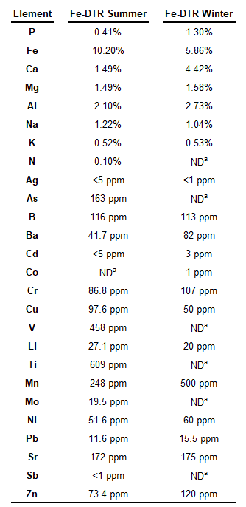

a ND, Not determined

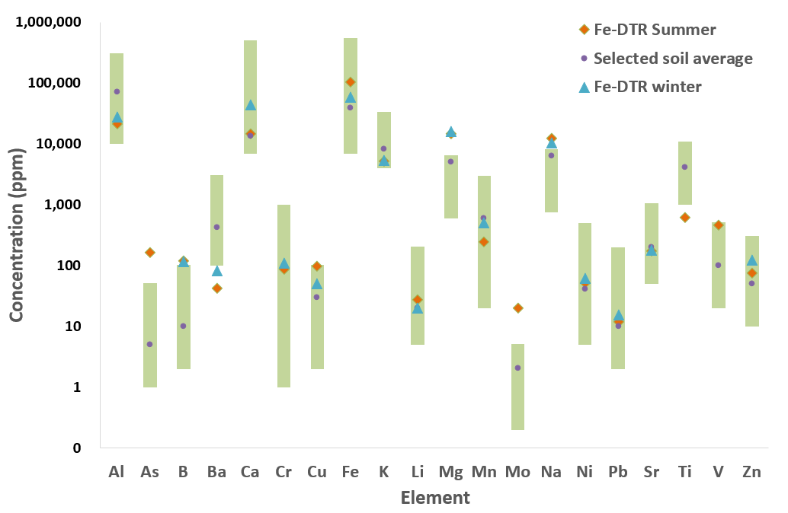

**Figure 1.** Chemical characterization of the Fe-DTR taken in summer 2021 and winter 2022 in relation to the average of the elements in United States soils (Shacklette and Boerngen, 1984).

3.3. Effect of sludge dose on P sorption

The ratio between the Fe-DTR and wastewater significantly affected adsorption onto Fe-DTR and removal of SRP (Fig. 2). In a synthetic solution, SRP removal increased from 39% at 3 g L-1 to 80% at a ratio of 9 g L-1 (F=1485, P<0.05). In wastewater samples, removal increased from 84% at a ratio of 3 g L-1 to 95% at 9 g L-1 (F=112, P<0.05). At a ratio of 3 g L-1, the concentration of specific adsorbed P was greater (17,860±373 mg P kg-1) than at a 9 g L-1 (6,752±39 mg P kg-1) due to a higher density of adsorption sites offered by 3 g of solid compared to 9 g. At a ratio of 5 g L-1 without pH or temperature adjustments, SRP removal efficiency from wastewater was 90%, and the loading capacity was 8,737 mg P kg-1. Although we found that the amount of P loading at a ratio of 5 g L-1 was lower than the 3 g L-1 ratio, the removal efficiency was greater. Therefore, we established the adsorbent dosage as 5 g L-1 in further adsorption experiments. A similar trend, however, with lower P capacity, was reported for calcined ferric sludge by Song et al. (2011). They found that at a ratio of 0.1 g L-1, about 13,000 mg P kg-1 was adsorbed, whereas 90% of P was removed, compared to 3,000 mg P kg-1 and 98% P removal at a ratio of 0.4 g L-1.

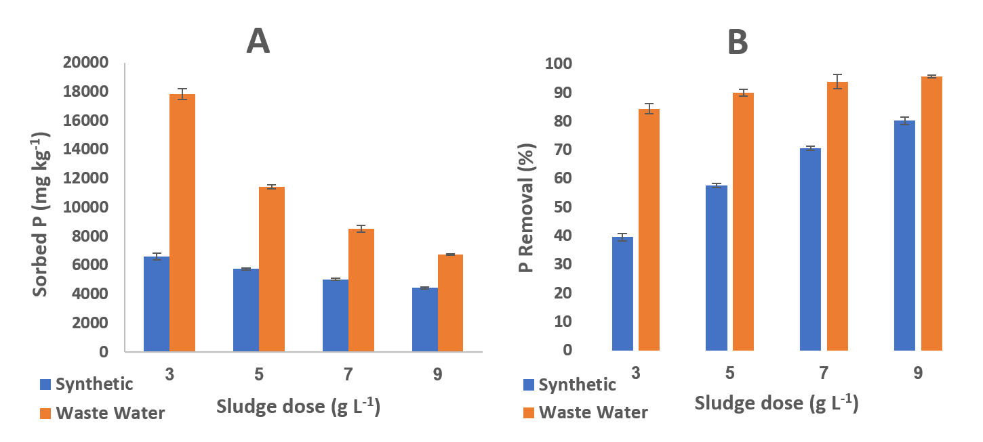

**Figure 2.** Phosphorus sorption onto Fe-DTR using different sludge doses.Sorbed P (A) and Percentage of P removal (B).

3.4. Effect of particle size on phosphorus sorption

Particle size distribution (PSD) affects the rate, speed, and capacity of P adsorption to Fe-DTR (Elkhatib et al., 2015). In a synthetic solution (Fig. 3A), our best adsorption after 24 hr was obtained with a particle size <0.45 m (8,284±270 mg P kg-1). Interestingly, P adsorption to particles with smaller particle size fractions was not significantly different from larger sizes. After 3 hr, we found that adsorption to the 45-90 m fraction differed from the two adjacent smaller size fractions, but the difference was not statistically significant (P=0.05). In a wastewater experiment (Fig. 3B), we obtained the most effective adsorption after 24 hr with a PSD <0.45 m, but a greater amount of P was sorbed compared to the inorganic P solution (9,948±185 mg P kg-1). After 3 hr, P adsorption for all PSDs (Fig. 3B) was not statistically different.

Our removal efficiencies of SRP for particle size ranges of <45 and 45-90 m were 60% and 55%, respectively, compared to 56.5 % for the larger particle sizes. The higher specific load in the small particle fractions demonstrated the adsorptive advantage of a high specific surface area (Li et al., 2016; Yang et al., 2006). Similarly, (Elkhatib et al., 2015) examined the effect of particle size on P adsorption and found a higher adsorption capacity (50,000 mg P kg-1) with a particle size smaller than 0.1 m, which was up to 30 times the maximum adsorption (1,666 mg P kg-1) of a larger particle size (~2,000 m). However, the operation of the system with a PSD smaller than 45 mm is problematic because such small particles float in wastewater. Therefore, in our experiments, we chose a more practical PSD of 45-90 m.

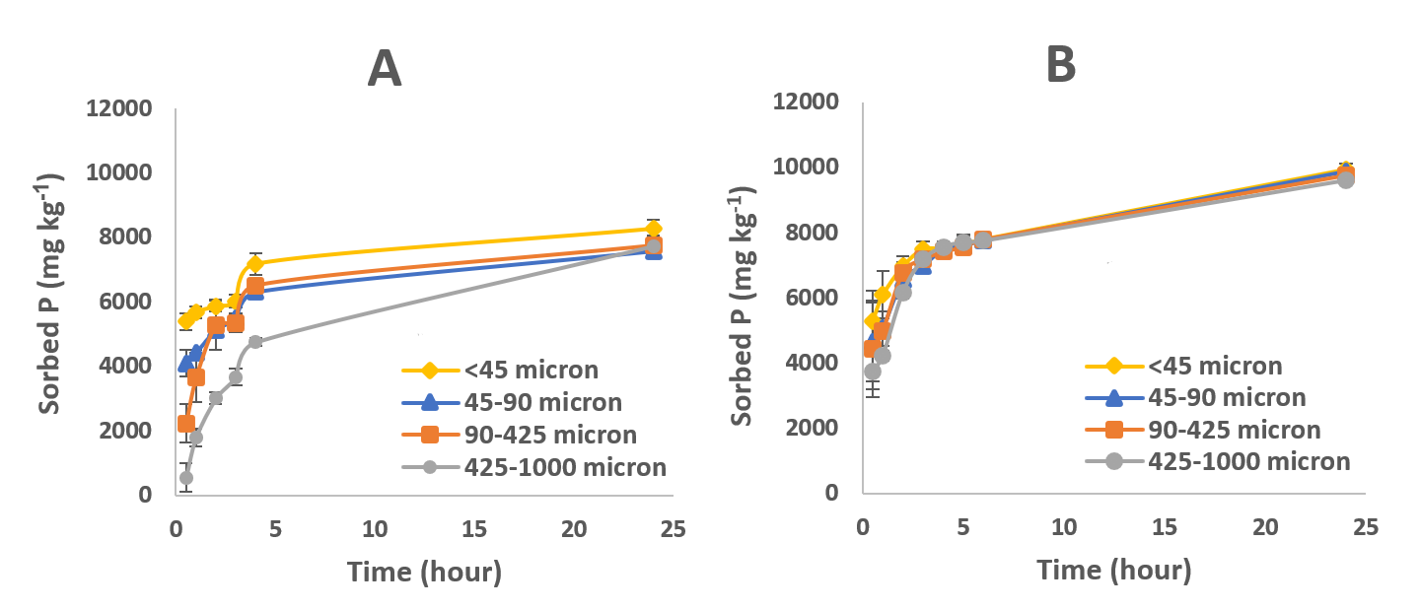

**Figure 3.** Sorption isotherms using different particle sizes with synthetic solutions (A) and wastewater (B).

3.5. Effect of pH on P sorption

Our results of pH on the amount of P adsorbed on Fe-DTR are depicted in Fig. 4. In a synthetic solution (Fig. 4A), P adsorption data varied significantly between the four pHs tested (P<0.05). We obtained the best adsorption after 24 hr at pH 3 (9,621±13 mg P kg-1). The P adsorption from wastewater at pH 3 and 4.5 was significantly greater (F=2161, P<0.05) than at higher pHs (Fig. 4B). At pH 3, most adsorption occurred in the first hour and a half of the experiment (10,897±6 mg P kg-1). After 3 hr, adsorption reached 11,410±1 mg P kg-1; after 24 hr, the concentration of adsorbed P increased slightly to 12,437±2 mg P kg-1. At pH 7, P adsorption increased gradually and peaked at the end of the experiment (9,336±14 mg P kg-1). After 3 hr of wastewater contact time, nearly 90% P removal was achieved at pH 3, whereas only 66%, 52%, and 50% were achieved at pH 4.5, 5.5, and 7, respectively.

Our enhancement of P adsorption onto Fe-DTR under low pH conditions is consistent with previous reports of aluminum and iron oxide-based materials (Lee et al., 2015). However, Zeng et al., (2004) reported lower maximum P adsorption to iron oxide tailings under similar acidic conditions (pH 3.2) (8,600 mg P kg-1), yet more than 4,600 mg P kg-1 at 9.5 pH. Usually, the release of hydroxyl ions results in increased pH allowing more efficient P adsorption on the Fe-DTR. In more acidic solutions, the contact time required for complete P adsorption is reduced by more than half. However, P adsorption at extremely low pH (< 3) is not advisable due to iron oxide dissolution (Li et al., 2016).

Certain anions, such as carbonate, phosphate, nitrate, and arsenate, are adsorbed onto adsorbents such as Fe-DTR through ligand exchange (Yang. et al., 2006). We found that the pH tended to increase during adsorption, especially in the first hours, indicating that hydroxides and carbonates were released into solution, allowing P adsorption through ligand exchange (Muisa et al., 2020; Song et al., 2011). The carbonate anions are strong competitors of P at adsorption sites and can bind with iron and calcium (Muisa et al., 2020). A decrease in pH increases the concentration of protons in solution. The decline releases carbonates (along with hydroxides), which bind to protons that regulate pH. This regulation implies that P adsorption results in carbonate desorption (Muisa et al., 2020).

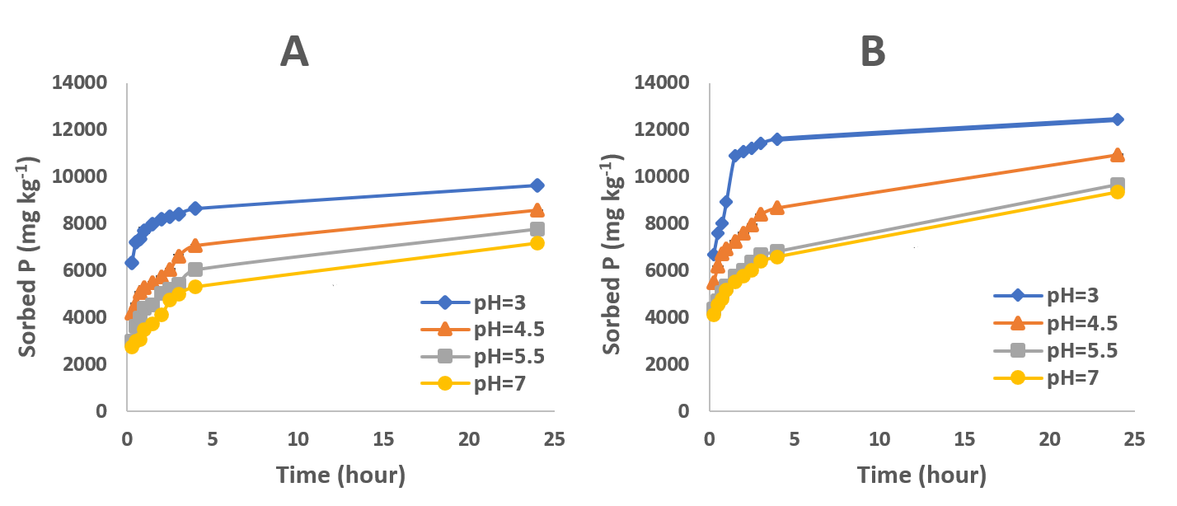

**Figure 4.** Sorption isotherms at different pHs with a synthetic solution (A) and wastewater (B).

3.6. Effect of temperature on P sorption

We next examined the effect of temperature on the amount of synthetic and wastewater P adsorbed onto Fe-DTR (Fig. 5). In a synthetic solution, the best adsorption was obtained after 72 hr at 40 0C (7,308±101 mg P kg-1), whereas adsorbed P was decreased at 10 0C (5,150±106 mg P kg-1). After 3 hr, the adsorption concentrations at 10 and 40 0C were 3,694±189 and 4,712±207 mg P kg-1, respectively. When we examined wastewater after 3 hr at 10, 20, and 30 0C, the adsorption concentrations were similar (about 9170 mg P kg-1). In contrast, adsorption at 40 0C was significantly greater (10,384±370 mg P kg-1, F=8, P<0.05), with most of the adsorption occurring within the first 6 hr (11,000±180 mg P kg-1). After 24 hr and 72 hr, adsorbed P concentration reached 11,579±190 mg P kg-1 and 12,671±12 mg P kg-1, respectively (Fig. 5B).

At high temperatures, the random thermal movement of P ions intensifies, and the probability of contact between these ions and adsorption sites increases (Omari et al., 2019). In fact, the adsorption capacity of all forms of phosphates increases with temperature (Muisa et al., 2020)(Gao et al., 2013)(Maher et al., 2015). Zeng et al., (2004) reported that the adsorption rate and capacity of P on iron oxides were higher at 35 0C (6,600 mg P kg-1) compared to 5 0C (5,500 mg P kg-1). Other studies emphasized that increasing temperature enhances the initial rate of adsorption (Lee et al., 2015; Liu et al., 2018). However, after prolonged contact, the adsorption rate becomes constant, reaching an equilibrium (Lee et al., 2015; Liu et al., 2018), in agreement with our results. Our results further indicate the endothermic nature of the P adsorption by Fe-DTR (Zeng et al., 2004). Gao et al., (2013) suggested that increasing temperature reduces solution viscosity, accelerating the molecular diffusion across the adsorbent contact layer and increasing adsorption capacity. (Devi and Saroha, 2017) also reported that increased temperature causes swelling of the internal structure of the adsorbent. The swelling facilitates molecule entry into the adsorbent nozzles, improving adsorptive capacity. This mechanism raises concerns about releasing the adsorbed P from internal sites after high-temperature loading and “shrinkage” to the structure’s original size. However, our recent desorption experiments indicate otherwise (unpublished data).

In temperature effect experiments, we found that wastewater was a superior P source compared to an inorganic P solution, with the effect being more pronounced than particle size and pH. This observation may result from the temperature effect on other constituents in the clarified dairy wastewater and their impact, in turn, on P sorption.

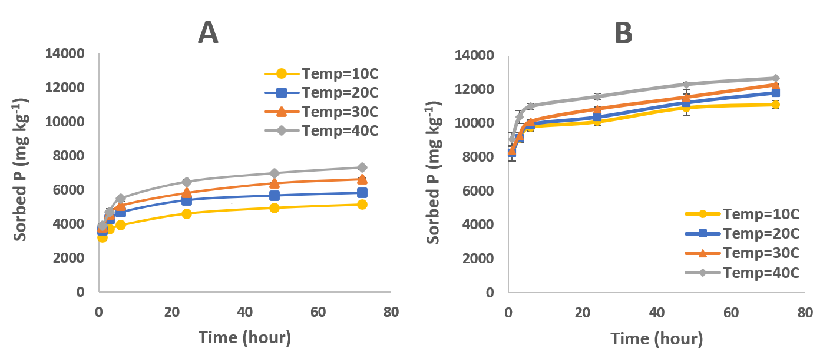

**Figure 5.** Sorption isotherms using different temperatures with synthetic solutions (A) and wastewater (B).

3.7. Effect of initial P concentration on adsorption over time

We tested the effect of the initial P concentration on P adsorption to Fe-DTR using a synthetic solution with different P concentrations at room temperature, without controlling pH (Fig. 6). Remarkably, for all P concentrations, most adsorption occurred in the first hour. At low added P concentrations (5 to 30 mg L-1 initial P concentration), equilibrium was apparent within a few hours. For example, at an initial P concentration of 30 mg L-1, we detected increased adsorption for ca. 24 hr, reaching 3,897±23 mg P kg-1. Later P removal from solution was minimal. At P concentrations greater than 30 mgL-1, adsorption continued over time. At 100 mg L-1, adsorbed P was 6,082±355 mg P kg-1 at 24 hr, increasing to 7,768±192 mg P kg-1 at 72 hr. This data indicated a continuous sorption trend. At 0 mg L-1 added P, the raw Fe-DTR released a negligible concentration of P (0.02 mg L-1), indicating low labile P concentrations in the raw sludge.

We found that increasing the initial P concentration in the solution caused an increase in loaded P, although its removal percentage gradually decreased. Similarly, (Song et al., 2011) reported that the removal capacity at equilibrium increases with increasing initial concentration. While active adsorption sites probably become saturated at greater initial P concentrations (Hamdi et al., 2014), continuous P removal at greater initial P concentrations may result in precipitation as well as adsorption (Massey et al., 2018; Zohar et al., 2018).

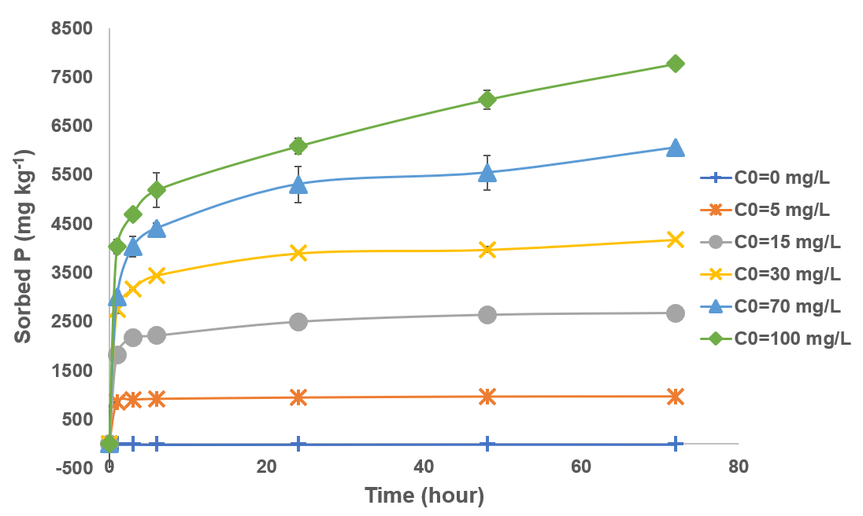

**Figure 6.** The influence of initial P concentrations in solution on sorption capacity over time.

3.8. Combined effect of pH and temperature on P sorption

We next examined the relationship of pH and temperature to P adsorption over time (180 min) (Table 3). By increasing the temperature from 10 to 30 0C at pH 3, more P was adsorbed on the Fe-DTR (11,297 and 11,585 mg P kg-1, respectively). The DOE model predicted P adsorption for all pH and temperature combinations tested (Fig. 7). In the validation experiment, we compared the model results at pH 3 and 30 0C to our experimental results (~11,450 mg P kg-1). We found similar values, indicating a reasonable prediction of the DOE for P adsorption**.**

Our DOE optimization model (Fig. 7) predicted that more adsorption from wastewater occurs at higher temperatures and lower pH until maximum P adsorption (almost 15,700 mg P kg-1) at pH 3, 40 0C, and 3 hr of mixing (Fig. 7). The combination of these extreme conditions was not applicable in the laboratory or field for safety reasons, primarily due to evaporation of hydrogenated acid from the hot solution. Generally, calcium carbonate deposits and associated precipitated P are unstable under acidic conditions and tend to dissolve. As explained, the primary adsorption at pH 3 will be onto iron oxides. This absorption will accelerate without competition from hydroxides and carbonates. In contrast, temperature contributes to efficient adsorption through physical mechanisms such as lowered liquid viscosity, interactions between particles, and swelling of the porous structure of sludge (Muisa et al., 2020).

**Table 3.** P adsorption from Fe-DTR under the combined effects of temperature and pH.

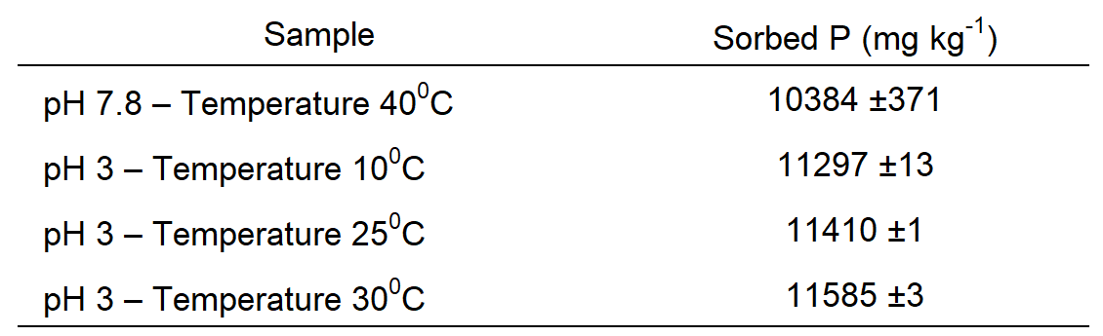



**Figure 7.** Optimization model and relationship between pH and temperature until obtaining maximum P adsorption onto Fe-DTR during 3 hr of mixing.

3.9. Kinetic models

We tested the suitability of the kinetic models using linearization of the measured values. The pseudo-second-order model best predicted the experimental results, exhibiting a coefficient of determinant near 1 (Table S1). Analysis of the rate constants of the pseudo-second-order model of both synthetic and wastewater solutions indicated a higher value at pH 3 compared to particle size and temperature parameters (e.g., in wastewater: k2 0.004 vs. 0.001 g (mg*min) -1, respectively) (Table 4). Because pH was the most influential parameter on the amount and rate of adsorption, the kinetic models are demonstrated for conditions of pH 3 in wastewater solutions (Fig. 8).

The pseudo-first-order, Elovich, and intraparticle diffusion models showed no linearity, instead suggesting two-step adsorption (Fig. 8A, C, and D). The intraparticle diffusion model best demonstrated bi-phasic adsorption, with the first phase lasting up to approximately 1 hr (R2 0.975). The second phase continued from 1.5 hr until the end of the experiment (R2 0.924) (Fig. 8D). The rate constant of the intraparticle diffusion model was greatest at a particle size of 45-90 m and neutral pH, at about 25 °C (kp 0.157 mg (g*min0.5) -1). Diffusivity was slightly lower at pH 3 and 25 °C (kp 0.148 mg (g*min0.5) -1); however, it was significantly decreased at pH 3 and 25 °C (kp 0.053 mg (g*min0.5) -1) (Table 4). Our findings imply that adsorption first occurs at the surface at ambient conditions, probably with P, hydroxides, and carbonates competing for binding sites. The binding may increase P diffusion and adsorption at internal sites in Fe-DTR.

**Table 4.** Parameters of kinetic models of Fe-DTR with particle sizes 45-90 m and pH 3 at 40 0C.

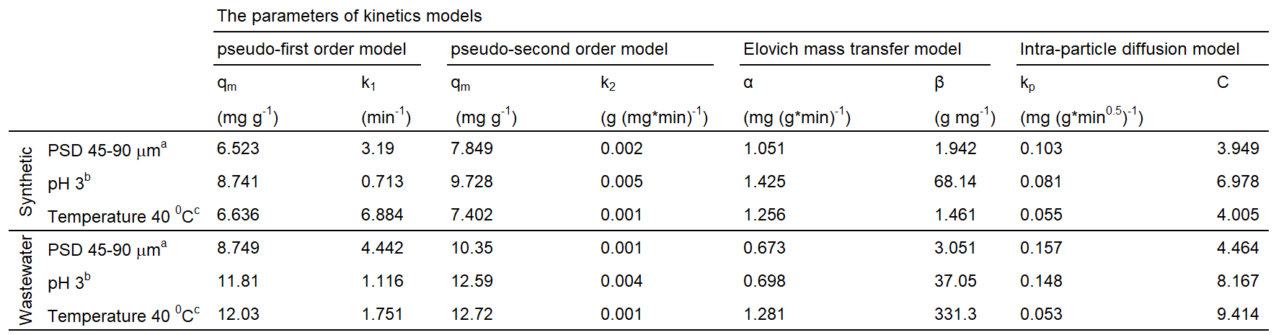

a Sludge doses 5 g L-1, PSD 45-90 m, pH 7, and room temperature.

b Sludge doses 5 g L-1, PSD 45-90 m, pH 3, and room temperature.

c Sludge doses 5 g L-1, PSD 45-90 m, pH 7 at 40 0C.

**Figure 8.** Sorption kinetic models of P at pH 3 using cowshed wastewater (sludge dose 5 g L-1, PSD 45-90 m, pH 3, room temperature). The common models used were pseudo-first-order (A), pseudo-second-order (B), Elovich mass transfer (C), and intra-particle diffusion (D). In all models, time is measured in min.

We obtained kinetic constants for all models at varying pH values, temperatures, and PSD in wastewater solution (Table S3). The maximum P sorption (qm) in the pseudo-second-order model increased with decreasing pH from 9.7 mg g-1 at pH 7 to 12.6 mg g-1 at pH 3 and as the temperature increased from 11.2 mg g-1 at 10 0C to 12.7 mg g-1 at 40 0C. In contrast, we found no significant variation at increased PSD with a qm of ~10 mg g-1. The rate constant at the pseudo-second-order model decreased with increasing pH from 0.0042 g (mg*min) -1 at pH 3 to 0.0016 g (mg*min) -1 at pH 7. Maintaining a constant PSD, our highest rate was obtained with PDS <45 m (0.0014 g (mg*min) -1); however, other PSDs were similar (0.0012 g (mg*min) -1) (Table S3). At 10 0C and 40 0C, the rate constants were 0.0015 and 0.0013 g (mg*min) -1, respectively, which were slightly greater than the rate constants calculated for 20 0C and 30 0C (0.001 and 0.0009 g (mg*min) -1, respectively). Similar results were reported by (Edet and Ifelebuegu, 2020), who studied P adsorption on brick waste which consists mainly of SiO2, Fe2O3, Al2O3, and CaO. Their rate constant in the pseudo-second-order model was higher at a temperature of 25 0C compared to 35 0C (0.06 and 0.03 g (mg*min) -1, respectively). The authors explained the decrease in rate constant with increased temperature by the fact that P tended to migrate and disperse in the solution as temperature increased. This interpretation suggests that at up to 30 0C the energy supplied is insufficient to disperse P in the solution. In addition, decreased P concentrations with increasing temperature may indicate a low energy requirement for P adsorption onto Fe-DTR (Edet and Ifelebuegu, 2020).

We found that the Elovich model, which usually describes adsorption to a heterogeneous surface (Chien and Clayton, 1980; Donald L. Sparks, 1989; Mezenner and Bensmaili, 2009), resulted in a high fit (R2 0.947-0.989), excluding some cases of moderate fit, for example, R2 0.83 at pH 3 in wastewater solution (Table S1). The initial adsorption rate α and coefficient β of applied energy in the Elovich model changed as a function of pH, temperature, and PSD (Table S3). As the solution pH increased from 3 to 7, β decreased from 37 to 1.9 g mg-1. Increasing the temperature from 10 to 30 0C caused β to decrease from 153 to 112 g mg-1 but to sharply increase at 40 0C (331.3 g mg-1). As the temperature increased from 10 to 30 0C, α increased, and β decreased. However, the significant increase in β at 40 0C supports the claim that swelling at high temperatures, in addition to reduced solution viscosity, exposes internal sites unavailable at 10 to 30 0C (Donald L. Sparks, 1989; Mezenner and Bensmaili, 2009; Sparks, 2003).

3.9.1. Half-life

The rate constant in the pseudo-second-order model was affected by pH more than temperature, and at low pH, the reaction rate was greater (Table S3). The half-life in the pseudo-second-order model describes the time required for half of P in solution to adsorb onto Fe-DTR by the following equation (Benjamin, 2015):

Where t0.5 (min) is the half-life, k2 (g (mg*min) -1) is the rate constant of the pseudo-second-order model describing adsorption kinetics, and A0 (mg L-1) is the initial P concentration in solution.

According to equation 5, when applied to a wastewater solution, the half-life was ca. three times greater at 40 0C (12.52 min) compared to pH 3 (3.79 min). This result agrees well with our adsorption experiments, where we found the effect of low pH on P adsorption to Fe-DTR was greater than for temperature in relation to time. Furthermore, the rate constant of the pseudo-second-order model decreased with increasing pH, yielding a half-life of P adsorption increasing from 3.79 min at pH 3 to 9.86 min at pH 7 (Table S3). The extremely fast adsorption rate at pH 3 compared to pH 7 at room temperature and even at 40 0C emphasizes the importance of iron oxide availability on the adsorbing surface.

3.9.2. Initial P concentration

A change in the initial concentration of P in the solution resulted in changes in the adsorption behavior. Again, using the pseudo-second-order kinetic model, we found the best fit, with an R2 close to 1 at all concentrations (Table S4). The rate constant in this model decreases with increasing concentration, indicating additional time to reach equilibrium (Hamdi et al., 2014; Mezenner and Bensmaili, 2009).

We found that the Elovich model presented the best fit after the pseudo-second-order model. The initial adsorption rate α and coefficient β of the applied energy changed as a function of the initial P concentration. For example, by increasing the initial P concentration from 5 to 100 mg L-1, β increased dramatically from 5.93*10-58 to 1.192 g mg-1. In contrast, we observed that an increase in the initial P concentration resulted in a decrease in α from 36.765 to 1.195 mg (g*min) -1. These results imply that the initial amount of P adsorbed on Fe-DTR was more significant at high P concentrations compared to low concentrations, indicating that Fe-DTR has an enhanced capacity to adsorb greater amounts of P from wastewater containing high P concentrations (Karaca et al., 2004) (Mezenner and Bensmaili, 2009). For the intraparticle diffusion model, we observed an increase in the rate constant with increasing initial P concentration. The result can be explained by the increasing effect of the driving force that resulted in the reduction of the diffusion of the P in the boundary layer on the surface and the improvement of the distribution in the internal sites. Thus, P might diffuse into pores prior to surface adsorption (Cheung et al., 2007; Mezenner and Bensmaili, 2009).

At high P concentrations, abiotic mechanisms, sorption, and mineral precipitation govern the partitioning of P between solids and solutions. P sorption is contingent on experimental conditions and the system pH (Zohar et al., 2018). The intimate association of surface areas apparently dominated by adsorbed P with precipitated-like P gives rise to complex processes that initiate precipitation. This mechanism is known for P adsorption onto CaCO3 that results in complexes like Ca3(HCO3)3PO4 (Avnimelech, 1980), which initiate precipitation at concentrations as low as ≤1.6 g L−1) and reaction times as short as ≤3 h (Sø et al., 2011).

**Table 5.** Parameters of the kinetic models for Fe-DTR at various initial P concentrations. (Sludge doses 5 g L-1, particle size 45-90 m, pH 7, and room temperature).

The results of our kinetic modeling indicate that the ability to control adsorption parameters contributes to increased adsorption and efficiency by achieving maximum adsorption in the minimum time.

3.9.3. Activation energy

In most experimental conditions, an increase in temperature will increase the reaction rate. The reaction rate constant can enable the calculation of activation energy using the Arrhenius equation (Benjamin, 2015):

Where k2 (g (mg*min) -1) is the rate constant of the pseudo-second-order model, A (min-1) is the Arrhenius constant, Ea (J mol-1) is the activation energy, which measures the minimum energy level required to break the bonds of reactants (an endothermic process) until products are obtained, and T (K) is the temperature of the solution. Raising the reaction temperature will increase the kinetic energy, allowing more reactants to cross the energy barrier to become products. R is the gas constant (8.314 J K-1 mol-1) (Sparks, 2003).

The value of the activation energy allows the determination of the nature of the adsorption (chemical or physical). A physical adsorption process is characterized by a low activation energy (5-40 kJ mol-1); however, when the energy value increases, the adsorption becomes chemical in nature (Omari et al., 2019). The positive and low value of the activation energy we obtained at neutral pH in wastewater solution (see Section 2.3.5.2.3) at 10-40 0C was 3.970 kJ mol-1, suggesting physical adsorption on the surface of Fe-DT. At pH 3 in the wastewater (see Section 2.3.5.3) at 10-30 0C, positive activation energy was similar but a bit higher, 8.082 kJ mol-1. Our result confirms the dominance of a somewhat stronger adsorption nature (Edet and Ifelebuegu, 2020; Omari et al., 2019), meaning the presence of an energy barrier in endothermic adsorption (Hameed et al., 2007; Mezenner and Bensmaili, 2009). Mezenner and Bensmaili (2009) studied P adsorption on iron hydroxide waste between 20-45 0C and reported a higher value of 32.740 kJ mol-1, indicating a strong chemical binding capacity between P and Fe. Additionally, (Edet and Ifelebuegu, 2020) studied the adsorption of P on brick waste at 20-35 0C and reported an extremely low activation energy of 0.012 J mol-1, indicating fragile P physical binding and a high release potential. We concluded from our activation energy results that the relationship between P and Fe-DTR in a neutral pH solution was weaker than at pH 3, which indicates more efficient P release from sludge loaded at neutral pH (~pH 7) and high temperature compared to pH 3 and room temperature. The organic compounds in the wastewater probably influence this weak indirect physical connection (Edet and Ifelebuegu, 2020) and the potential of P to precipitate with calcium carbonate (Ippolito et al., 2003).

3.10. Sorption of P from wastewater compared to a synthetic solution

Many factors can affect the adsorption of P on Fe-DTR, including the chemical composition of dairy wastewater. Ligand competition with organic compounds in the wastewater may affect inorganic P adsorption as well as desorption capacity (unpublished data). These organic compounds cause weak indirect P binding by forming a bridge between the Fe-DTR and P (Dong, 2004). The Fe-DTR can adsorb P more rapidly in wastewater compared to a synthetic solution in both the amount of P adsorbed and the kinetic rate constants for most parameters (Tables S2 and S3). In addition, these compounds contain organic P, indicating its adsorption and removal (Guppy et al., 2005; Kleber et al., 2007; Lang and Kaupenjohann, 2003; Zohar et al., 2020, 2017; Zohar and Forano, 2021). We hypothesize that organic compound-Fe-DTR bridges increase the surface area of an adsorbent. These mechanisms are yet to be explored.

At neutral to alkaline pH, P precipitates with calcium/calcium carbonate (Avnimelech, 1980). As shown in the background results (Table 1), our collected wastewater contained dissolved calcium not present in the synthetic P solution. Therefore, P-Ca and P-CaCO3 deposition is possible as a complex, which implies that P can be removed from wastewater more efficiently through two mechanisms, adsorbed species and precipitates (Massey et al., 2018).

Insert suggestion

**4. Conclusions**

* Considering our improvement of P binding efficiency, Fe-DTR can be applied as a substrate for treating agricultural wastewater containing high P concentrations.
* Our optimization combines parameters that improve P adsorption and efficiency by reaching Fe-DTR-P saturation in the minimum possible time while controlling five parameters; solid/liquid ratio, particle size, pH, temperature, and contact time.
* Of the two parameters significantly affecting P adsorption (pH and temperature), we achieved increased adsorption by controlling pH to as low as 3 (11,410±1 mg P kg-1).
* A probabilistic model (DOE) gave a range of possible solutions for P adsorption in combination with pH and temperature and suggested that low pH coupled with high temperatures may improve P adsorption.
* The pseudo-second-order model best described the rate of P adsorption for all measured parameters. Nevertheless, kinetic models like Elovich and intra-particle diffusion implied two-stage adsorption, including rapid initial adsorption.
* We found that the activation energy of P sorption at pH 3 was greater than at 40 0C, resulting in stronger bonds at pH 3 and implying increased P solubility from Fe-DTR prepared at high temperatures (e.g., 30 0C).
* Our optimal conditions for efficient P loading onto the Fe-DTR at room temperature are a solid-liquid ratio of 5 g L-1, a PSD of 45-90 m, pH 3, and a loading time of 3 hr.
* The greatest concentration of adsorbed P we achieved in this study was equivalent to 4.1% P2O5.
* Our results offer an innovative method to reduce the amount of sludge sent to landfills, thereby reducing environmental damage while concurrently producing an alternative P fertilizer.

**Acknowledgments**

This research was supported by Israel Innovation Authority (Litaor PI) [grant No. 73603]. We thank Mrs. Anna Giladi for help using Design of Experiment (DOE). We also thank our research partners from the ICL Group Ltd. for performing chemical digestion analyses for the iron sludges before and after loading with phosphorus.

**Appendix A. Supplementary data**

Supplementary data related to this article can be found at…

**References**

Avnimelech, Y., 1980. Calcium-carbonate-phosphate surface complex in calcareous systems. Nature 288. https://doi.org/10.1038/288255a0

Ayele, H.S., Atlabachew, M., 2021. Review of characterization, factors, impacts, and solutions of Lake eutrophication: lesson for lake Tana, Ethiopia. Environ. Sci. Pollut. Res. 28, 14233–14252. https://doi.org/10.1007/s11356-020-12081-4

Bacelo, H., Pintor, A.M.A., Santos, S.C.R., Boaventura, R.A.R., Botelho, C.M.S., 2020. Performance and prospects of different adsorbents for phosphorus uptake and recovery from water. Chem. Eng. J. 381, 122566. https://doi.org/10.1016/j.cej.2019.122566

Banet, T., Massey, M.S., Zohar, I., Litaor, M.I., Ippolito, J.A., 2020. Phosphorus removal from swine wastewater using aluminum-based water treatment residuals. Resour. Conserv. Recycl. X 6, 100039. https://doi.org/10.1016/j.rcrx.2020.100039

Barnea, I., Litaor, M.I., Shenker, M., 2012. Evaluation of phosphorus management practices in East Mediterranean altered wetland soils. Soil Use Manag. 28, 35–44. https://doi.org/10.1111/j.1475-2743.2011.00385.x

Benjamin, M.M., 2015. Water Chemistry, second. ed, Chapter 3, Reaction kinetics and the kinetics-based interpretation of equilibrium. pp. 77-122. University of Washington, United States of America.

Carter, M.R., Gregorich, E.G., 2007. Soil Sampling and Methods of Analysis, In I.P. O’Halloran and B.J. Cade-Menun. Chapter 24, Total and Organic Phosphorus. pp. 265-291. https://doi.org/10.1201/9781420005271

Cheung, W.H., Szeto, Y.S., McKay, G., 2007. Intraparticle diffusion processes during acid dye adsorption onto chitosan. Bioresour. Technol. 98, 2897–2904. https://doi.org/10.1016/j.biortech.2006.09.045

Chien, S.H., Clayton, W.R., 1980. Application of Elovich Equation to the Kinetics of Phosphate Release and Sorption in Soils. Soil Sci. Soc. Am. J. 44, 265–268. https://doi.org/10.2136/sssaj1980.03615995004400020013x

Cordell, D., Drangert, J.O., White, S., 2009. The story of phosphorus: Global food security and food for thought. Glob. Environ. Chang. 19, 292–305. https://doi.org/10.1016/j.gloenvcha.2008.10.009

Cordell, D., White, S., 2011. Peak phosphorus: Clarifying the key issues of a vigorous debate about long-term phosphorus security. Sustainability 3, 2027–2049. https://doi.org/10.3390/su3102027

Dayton, E.A., Basta, N.T., 2005. A Method for Determining the Phosphorus Sorption Capacity and Amorphous Aluminum of Aluminum-Based Drinking Water Treatment Residuals. J. Environ. Qual. 34, 1112–1118.

De-Bashan, L.E., Bashan, Y., 2004. Recent advances in removing phosphorus from wastewater and its future use as fertilizer (1997-2003). Water Res. 38, 4222–4246. https://doi.org/10.1016/j.watres.2004.07.014

Devi, P., Saroha, A.K., 2017. Utilization of sludge based adsorbents for the removal of various pollutants: A review. Sci. Total Environ. 578, 16–33. https://doi.org/10.1016/j.scitotenv.2016.10.220

Donald L. Sparks, 1989. Kinetics of Soil Chemical Processes. New York.

Dong, Z., 2004. Handbook of Processes and Modeling in the Soil–Plant System. J. Environ. Qual. 33. https://doi.org/10.2134/jeq2004.1575

Edet, U.A., Ifelebuegu, A.O., 2020. Kinetics, isotherms, and thermodynamic modeling of the adsorption of phosphates from model wastewater using recycled brick waste. Processes 8. https://doi.org/10.3390/PR8060665

Elkhatib, E.A., Mahdy, A.M., Salama, K.A., 2015. Green synthesis of nanoparticles by milling residues of water treatment. Environ. Chem. Lett. 13, 333–339. https://doi.org/10.1007/s10311-015-0506-6

Flaten, T.P., 2001. Aluminium as a risk factor in Alzheimer’s disease, with emphasis on drinking water. Brain Res. Bull. 55, 187–196. https://doi.org/10.1016/S0361-9230(01)00459-2

Gao, S., Wang, C., Pei, Y., 2013. Comparison of different phosphate species adsorption by ferric and alum water treatment residuals. J. Environ. Sci. (China) 25, 986–992. https://doi.org/10.1016/S1001-0742(12)60113-2

Guppy, C.N., Menzies, N.W., Moody, P.W., Blamey, F.P.C., 2005. Competitive sorption reactions between phosphorus and organic matter in soil: A review. Aust. J. Soil Res. 43, 189–202. https://doi.org/10.1071/SR04049

Hamdi, W., Pelster, D., Seffen, M., 2014. Phosphorus sorption kinetics in different types of alkaline soils. Arch. Agron. Soil Sci. 60, 577–586. https://doi.org/10.1080/03650340.2013.830287

Hameed, B.H., Ahmad, A.A., Aziz, N., 2007. Isotherms, kinetics and thermodynamics of acid dye adsorption on activated palm ash. Chem. Eng. J. 133, 195–203. https://doi.org/10.1016/j.cej.2007.01.032

Haygarth, P.M., Delgado, A., Chardon, W.J., Litaor, M.I., Gil-Sotres, F., Torrent, J., 2013. Phosphorus in soils and its transfer to water: From fine-scale soil processes to models and solutions in landscapes and catchments. Soil Use Manag. 29, 1–5. https://doi.org/10.1111/sum.12036

Ho, Y.S., 2006. Review of second-order models for adsorption systems. J. Hazard. Mater. 136, 681–689. https://doi.org/10.1016/j.jhazmat.2005.12.043

Ho, Y.S., McKay, G., 1999. Pseudo-second order model for sorption processes. Process Biochem. 34, 451–465. https://doi.org/10.1016/S0032-9592(98)00112-5

Hutt, L., Zealand, N., 1989. Phosphate Reactions with Natural Allophane, Ferrihydrite and Goethite 359–369.

Ippolito, J.A., Barbarick, K.A., Heil, D.M., Chandler, J.P., Redente, E.F., 2003. Phosphorus Retention Mechanisms of a Water Treatment Residual. J. Environ. Qual. 32, 1857–1864. https://doi.org/10.2134/jeq2003.1857

Karaca, S., Gürses, A., Ejder, M., Açikyildiz, M., 2004. Kinetic modeling of liquid-phase adsorption of phosphate on dolomite. J. Colloid Interface Sci. 277, 257–263. https://doi.org/10.1016/j.jcis.2004.04.042

Kleber, M., Sollins, P., Sutton, R., 2007. A conceptual model of organo-mineral interactions in soils: Self-assembly of organic molecular fragments into zonal structures on mineral surfaces. Biogeochemistry 85, 9–24. https://doi.org/10.1007/s10533-007-9103-5

Lang, F., Kaupenjohann, M., 2003. Immobilisation of molybdate by iron oxides: effects of organic coatings. Geoderma 113, 31–46.

Lee, L., Wang, B., Guo, H., Hu, J., Ong, S., 2015. Aluminum-Based Water Treatment Residue Reuse for Phosphorus Removal. Water 7, 1480–1496. https://doi.org/10.3390/w7041480

Li, J., Li, B., Huang, H., Lv, X., Zhao, N., Guo, G., Zhang, D., 2019. Removal of phosphate from aqueous solution by dolomite-modified biochar derived from urban dewatered sewage sludge. Sci. Total Environ. 687, 460–469. https://doi.org/10.1016/j.scitotenv.2019.05.400

Li, M., Liu, J., Xu, Y., Qian, G., 2016. Phosphate adsorption on metal oxides and metal hydroxides: A comparative review. Environ. Rev. 24, 319–332. https://doi.org/10.1139/er-2015-0080

Litaor, M.I., Barnea, I., Reichmann, O., Zohar, I., 2016. Evaluation of the ornithogenic influence on the trophic state of East Mediterranean wetland ecosystem using trend analysis. Sci. Total Environ. 539. https://doi.org/10.1016/j.scitotenv.2015.07.103

Litaor, M.I., Schechter, S., Zohar, I., Massey, M.S., Ippolito, J.A., 2019. Making Phosphorus Fertilizer from Dairy Wastewater with Aluminum Water Treatment Residuals. Soil Sci. Soc. Am. J. 83, 649–657. https://doi.org/10.2136/sssaj2018.07.0278

Liu, R., Chi, L., Wang, X., Sui, Y., Wang, Y., Arandiyan, H., 2018. Review of metal (hydr)oxide and other adsorptive materials for phosphate removal from water. J. Environ. Chem. Eng. 6, 5269–5286. https://doi.org/10.1016/j.jece.2018.08.008

Maher, C., Neethling, J.B., Murthy, S., Pagilla, K., 2015. Kinetics and capacities of phosphorus sorption to tertiary stage wastewater alum solids, and process implications for achieving low-level phosphorus effluents. Water Res. 85, 226–234. https://doi.org/10.1016/j.watres.2015.08.025

Makris, K.C., El-Shall, H., Harris, W.G., O’Connor, G.A., Obreza, T.A., 2004. Intraparticle phosphorus diffusion in a drinking water treatment residual at room temperature. J. Colloid Interface Sci. 277, 417–423. https://doi.org/10.1016/j.jcis.2004.05.001

Makris, K.C., Harris, W.G., O’Connor, G.A., Obreza, T.A., Elliott, H.A., 2005. Physicochemical properties related to long-term phosphorus retention by drinking-water treatment residuals. Environ. Sci. Technol. 39, 4280–4289. https://doi.org/10.1021/es0480769

Massey, M.S., Zohar, I., Ippolito, J.A., Litaor, M.I., 2018. Phosphorus Sorption to Aluminum‐based Water Treatment Residuals Reacted with Dairy Wastewater: 2. X‐Ray Absorption Spectroscopy. J. Environ. Qual. 47, 546–553. https://doi.org/10.2134/jeq2017.10.0407

Mezenner, N.Y., Bensmaili, A., 2009. Kinetics and thermodynamic study of phosphate adsorption on iron hydroxide-eggshell waste. Chem. Eng. J. 147, 87–96. https://doi.org/10.1016/j.cej.2008.06.024

Montgomery, D.C., 2017. Montgomery: Design and Analysis of Experiments, John Willy & Sons.

Muisa, N., Nhapi, I., Ruziwa, W., Manyuchi, M.M., 2020. Utilization of alum sludge as adsorbent for phosphorus removal in municipal wastewater: A review. J. Water Process Eng. 35, 101187. https://doi.org/10.1016/j.jwpe.2020.101187

Murphy, J. Riley, J.P., 1962. A modified single solution method for the determination of phosphate in natural waters. Analytica Chimica Acta, 27, 31–36 | 10.1016/s0003-2670(00)88444-5 [WWW Document]. URL https://sci-hub.se/https://doi.org/10.1016/S0003-2670(00)88444-5

Omari, H., Dehbi, A., Lammini, A., Abdallaoui, A., 2019. Study of the Phosphorus Adsorption on the Sediments. J. Chem. 2019. https://doi.org/10.1155/2019/2760204

Razali, M., Zhao, Y.Q., Bruen, M., 2007. Effectiveness of a drinking-water treatment sludge in removing different phosphorus species from aqueous solution 55, 300–306. https://doi.org/10.1016/j.seppur.2006.12.004

Rodriguez, J.B., Self, R., P. N. Soltanpour, 1994. Optimal Conditions for Phosphorus Analysis by the Ascorbic Acid-Molybdenum Blue Method. Soil Science Society of America Journal, 58(3), 866 | 10.2136/sssaj1994.03615995005800030034x [WWW Document]. URL https://sci-hub.se/https://doi.org/10.2136/sssaj1994.03615995005800030034x (accessed 10.27.21).

Rytwo, G., 2012. The use of clay-polymer nanocomposites in wastewater pretreatment. Sci. World J. 2012. https://doi.org/10.1100/2012/498503

Shacklette, H.T., Boerngen, J.G., 1984. Element Concentrations in Soils and Other Surficial Materials of the Conterminous United States. U.S. Geol. Surv. Prof. Pap. 1270.

Smaransky, O., 2021. Feasibility study of phosphorus and iron fertilization from dairy wastewater and desalination water treatment residuals. M.Sc. thesis, Water Science Department, Tel Hai College (in Hebrew). 3.

Sø, H.U., Postma, D., Jakobsen, R., Larsen, F., 2011. Sorption of phosphate onto calcite; results from batch experiments and surface complexation modeling. Geochim. Cosmochim. Acta 75, 2911–2923. https://doi.org/10.1016/j.gca.2011.02.031

Song, X., Pan, Y., Wu, Q., Cheng, Z., Ma, W., 2011. Phosphate removal from aqueous solutions by adsorption using ferric sludge. DES 280, 384–390. https://doi.org/10.1016/j.desal.2011.07.028

Sparks, D.L., 2003. Kinetics of Soil Chemical Processes. Environ. Soil Chem. 207–244. https://doi.org/10.1016/b978-012656446-4/50007-4

Steen, I., 1998. Phosphorus availability in the 21st century : Management of a non-renewable resource. Phosphorus Potassium 217, 25–31.

Walter E. Dean, 1974. Determination of carbonate and organic matter in calcareous sediments and sedimentary rocks by loss on ignition; comparison with other methods. J. Sediment. Res. 44 242–248. https://doi.org/https://doi.org/10.1306/74D729D2-2B21-11D7-8648000102C1865D

Wendling, L.A., Blomberg, P., Sarlin, T., Priha, O., Arnold, M., 2013. Phosphorus sorption and recovery using mineral-based materials: Sorption mechanisms and potential phytoavailability. Appl. Geochemistry 37, 157–169. https://doi.org/10.1016/j.apgeochem.2013.07.016

Wu, F.C., Tseng, R.L., Juang, R.S., 2009. Initial behavior of intraparticle diffusion model used in the description of adsorption kinetics. Chem. Eng. J. 153, 1–8. https://doi.org/10.1016/j.cej.2009.04.042

Yang., Zhao, Y.Q., Babatunde, A.O., Wang, L., Ren, Y.X., Han, Y., 2006. Characteristics and mechanisms of phosphate adsorption on dewatered alum sludge. Sep. Purif. Technol. 51, 193–200. https://doi.org/10.1016/j.seppur.2006.01.013

Yang, Y., Tomlinson, D., Kennedy, S., Zhao, Y.Q., 2006. Dewatered alum sludge: A potential adsorbent for phosphorus removal. Water Sci. Technol. 54, 207–213. https://doi.org/10.2166/wst.2006.564

Zeng, L., Li, X., Liu, J., 2004. Adsorptive removal of phosphate from aqueous solutions using iron oxide tailings. Water Res. 38, 1318–1326. https://doi.org/10.1016/j.watres.2003.12.009

Zohar, I., Forano, C., 2021. Phosphorus recycling potential by synthetic and waste materials enriched with dairy wastewater: A comparative physicochemical study. J. Environ. Chem. Eng. 9, 106107. https://doi.org/10.1016/j.jece.2021.106107

Zohar, I., Ippolito, J.A., Bernstein Rose, N., Litaor, M.I., 2020. Phosphorus pools in Al and Fe-based water treatment residuals (WTRs) following mixing with agro-wastewater — A sequential extraction study. Environ. Technol. Innov. 18. https://doi.org/10.1016/j.eti.2020.100654

Zohar, I., Ippolito, J.A., Massey, M.S., Litaor, I.M., 2017. Innovative approach for recycling phosphorous from agro-wastewaters using water treatment residuals (WTR). Chemosphere 168, 234–243. https://doi.org/10.1016/j.chemosphere.2016.10.041

Zohar, I., Massey, M.S., Ippolito, J.A., Litaor, M.I., 2018. Phosphorus sorption characteristics in aluminum-based water treatment residuals reacted with dairy wastewater: 1. Isotherms, XRD, and SEM-EDS analysis. J. Environ. Qual. 47, 538–545. https://doi.org/10.2134/jeq2017.10.0405