**Inhibition of milk spoilage due to bacterial contamination – Design of biodegradable protein-based preservatives targeting essential signaling pathways of AprX in *Pseudomonas fluorescens***

**1. Abstract**

The mainstays for reducing microbial contamination of milk are pasteurization and clean-in-place technologies. However, post-production microbial inhibition is limited, and there is a growing need to boost safety and extend the shelf life of milk at consumer sites. *Pseudomonas* *fluorescens* (*P*. *fluorescens*) is one of the leading causes of the short shelf life and spoilage of dairy food. *P*. *fluorescens* relies on quorum sensing (QS) signaling to regulate the expression of proteolytic enzymes such as the metalloprotease AprX, a key enzyme involved in the milk spoilage process. The QS mechanism relies on the secretion of signaling molecules, such as N-acyl homoserine lactones (AHLs) in Gram-negative bacteria, that bind to a receptor, leading to high levels of AprX. The present study aims to develop a synergistic strategy for reducing milk contamination by simultaneously: i) inhibiting the levels of small molecule homo-serine lactones, thus leading to lower expression levels of AprX; and ii) directly inhibiting AprX enzymatic activity. The research is based on our recent discovery and characterization of a new lactonase enzyme, marine-origin lactonase-related protein (moLRP), which is capable of degrading homo-serine lactones secreted by *P. fluorescens.* Indeed, the addition of this lactonase to bacterial culture inhibited *P. fluorescens* AprX levels and subsequent proteolytic activity, resulting in inhibition of the sedimentation process in the milk-based medium. Herein, we aim to engineer new variants of the moLRP, with an optimized activity profile for application in milk products. Furthermore, we will design direct inhibitors of the AprX enzyme to block its enzymatic activity. This will form a synergistic solution for efficiently inhibiting bacterial-based milk spoilage and pave the way for additional food-waste applications relying on enzymatic solutions.

**2. Scientific background and state-of-the-art**

**Sensitivity of milk to microbial contaminations.** Milk, with its moderate pH (6.4–6.6), makes an excellent medium for microbial growth[1,2](https://paperpile.com/c/kj4Nd6/OvxZ+4MpQ). Indeed, diverse taxonomic groups may proliferate undesirably along the processing chain, reducing the shelf life of milk through particle formation, premature coagulation, gelification, fat separation, and/or development of off-flavors[1,3](https://paperpile.com/c/kj4Nd6/g2mT+OvxZ). To eliminate bacterial growth and prevent food safety concerns, dairy processing chains apply multiple commercial-level techniques (e.g., pasteurization) to control microbial contamination[4,5](https://paperpile.com/c/kj4Nd6/RAyn+M0lJ). Although pasteurization may reduce the microorganism levelby up to six orders of magnitude[6](https://paperpile.com/c/kj4Nd6/rRPu), almost 50% of fluid milk shows evidence of post-pasteurization contamination (PPC) by organisms that grow at 6°C[7](https://paperpile.com/c/kj4Nd6/HEox). Indeed, Gram-negative bacteria (involved in PPC) can grow rapidly at refrigeration temperatures, resulting in bacterial levels above 20,000 cfu/mL (the regulatory limit in fluid milk in the United States)[7](https://paperpile.com/c/kj4Nd6/HEox).

***Pseudomonas* is a major Gram-negative bacterium leading to milk contamination. Thus,** new approaches to inhibiting *Pseudomonas*are of prime interest to the dairy industry[8](https://paperpile.com/c/kj4Nd6/kOEC). Specifically, *P. fluorescens* is recognized as one of the main species in the dairy chain[9](https://paperpile.com/c/kj4Nd6/eaUb) and is known to engage diverse biochemicals that can drive food spoilage[10](https://paperpile.com/c/kj4Nd6/UbGK). Indeed, untargeted metabolomics and peptidomics experimentally established the changes driven by *P. fluorescens* in both pre-and post-heat milk treatment, affecting milk quality in long-term cold storage[11](https://paperpile.com/c/kj4Nd6/vnwf). Thus, the genetic predisposition of multiple *P. fluorescens* strains towards survival in the milk environment, growth under low-temperature conditions, and release of exoenzymes emphasize the need to design novel strategies of preservation to safeguard milk quality and prevent wastage by inhibiting *P. fluorescens* proliferation.

**Direct inhibition of AprX enzyme for reducing milk spoilage.** Several heat-stable extracellular proteases in the *Pseudomonas* genus have been identified and characterized[12–14](https://paperpile.com/c/kj4Nd6/W7n2+4rXD+1bd8). The secretion of extracellular protease leads to sedimentation and deterioration of milk. The heat-stable **alkaline metalloprotease AprX** secreted by *Pseudomonas* species is one of the leading causes of destabilization and premature spoilage of even ultra-high temperature (UHT) milk and milk products[14–18](https://paperpile.com/c/kj4Nd6/PjRl+1bd8+e1Va+mXbX+lLcE). Since even residual levels of AprX are correlated with milk spoilage[16,19,20](https://paperpile.com/c/kj4Nd6/DsM9+e1Va+ql9h), direct inhibition of residual AprX activity is essential to prevent milk spoilage. This can be achieved via the design of high-affinity gastric-digestible peptides. Although the identification of peptides that target proteins remains challenging, recent progress in the field[21–25](https://paperpile.com/c/kj4Nd6/mexR+8wUX+L9sj+v2IQ+9v55), including in our lab[26](https://paperpile.com/c/kj4Nd6/HQWZ), enables the search for putative candidates. Such peptides could offer an attractive approach to inhibition of bacterial growth in milk, as well as having other food applications[27–31](https://paperpile.com/c/kj4Nd6/qTCc+aJav+bq9O+2fzx+WVmT).

**Quorum-quenching lactonase enzymes regulate the expression of AprX.** A synergistic approach to AprX direct inhibition is to downregulate AprX expression levels.Quorum-quenching (QQ) enzymes have gained increasing interest due to their ability to hydrolyze the small molecule N-acyl homoserine lactones (AHLs), which are the most common autoinducers in Gram-negative bacteria. Above a threshold concentration of these signaling molecules, they bind the regulatory protein/receptor, LuxR, and trigger the expression of QS-regulated genes[32](https://paperpile.com/c/kj4Nd6/pZ8T). Characterized AHL lactonase enzymes, named QQ lactonases, proficiently hydrolyze various AHLs, resulting in the inhibition of bacterial QS-related functions. Notably, the expression of AprX has been shown to be under the regulation of 'quorum-sensing’ (QS) signaling[33](https://paperpile.com/c/kj4Nd6/mMpL), as the secretion of the AHLs C4-HSL and C8-Oxo-HSL was detected[34](https://paperpile.com/c/kj4Nd6/5m8S) and was suggested to play a role in food spoilage by controlling the expression of the proteolytic activity[35–38](https://paperpile.com/c/kj4Nd6/LD2w+IsBI+Ht0o+8ryC). Indeed, in *P. fluorescens* cultures harboring a plasmid encoding an AHL lactonase gene (aiiA from *B. cereus* strain A24), the downregulation of AprX levels was observed upon degradation of AHLs[34](https://paperpile.com/c/kj4Nd6/5m8S). Thus, in addition to direct inhibition of Aprx, interfering with the QS AHL signaling could offer a promising approach to further abolishing AprX activity and reducing milk spoilage.

**Enzyme-directed evolution for the engineering of efficient AHL lactonase to block QS signaling and inhibit milk spoilage.** In recent work, we validated the potential of QQ enzymes to control dairy spoilage. Using a homology pattern search in assembled metagenomics data from the marine environment, we identified new putative QQ lactonases from the phosphotriesterase (PTE)-like lactonase (PLL) family[39](https://paperpile.com/c/kj4Nd6/iya0). Moreover, we showed that this marine-origin lactonase-related protein (moLRP) enzyme efficiently inhibits both biofilm formation and sedimentation in milk[39](https://paperpile.com/c/kj4Nd6/iya0). Thus, the application of an optimized AHL lactonase could be useful for the inhibition of milk spoilage. However, the use of enzymes for such applications can be hampered by the stability and durability of the enzyme, particularly in the milk environment. Directed enzyme evolution (DEE) is used to modify and enhance specific enzyme properties[40–43](https://paperpile.com/c/kj4Nd6/N970+beCA+fVrY+Nh2g). This method has been successfully used to alter various enzyme properties, such as catalytic activity, enzyme stability, substrate specificity, and many other characteristics. Likewise, this method can also be used to develop catalysts for non-natural chemical transformations[44–47](https://paperpile.com/c/kj4Nd6/QWIX+hbWk+00T4+6SBF). DEE is based on the evolutionary principle of successive genetic variation and selection rounds. The process begins by creating genetic variation in the gene of interest, resulting in a DNA library. In the next step, the DNA library is cloned to an expression vector and expressed in a host microorganism. Finally, selection or screening is applied to detect and isolate variants displaying the enhanced desired properties. The improved variants then become the templates for the next round of mutagenesis and screening. Herein, we aim to use DEE, a well-established method in our labs[48–50](https://paperpile.com/c/kj4Nd6/x92O+4my6+r1hn), to engineer new variants of the lactonase enzyme with an improved activity profile for application in milk products. The enzyme will efficiently degrade small molecule AHLs and thus interfere with *P. fluorescens* proliferation and reduce the levels of AprX. Together with direct inhibition of residual AprX activity, our approach will lead to efficient inhibition of milk spoilage and beyond. Scheme 1 illustrates the experimental design involving the iterative optimization of AHL-lactonase aiming to hydrolyze the small molecule AHLs and downregulate AprX expression levels, together with peptides directly inhibiting AprX activity. Selected modulators, a combination of enzymes and peptides, will be tested in milk.

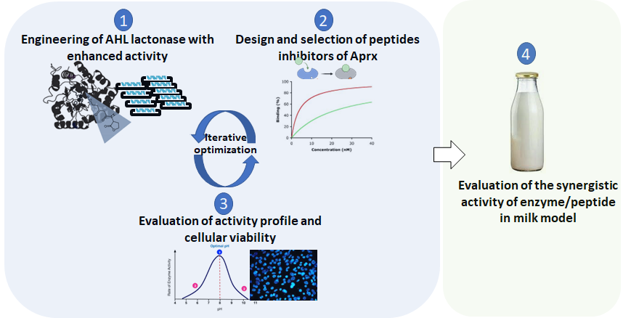

**Scheme 1. Illustration of the experimental design**. Iterative optimization of AHL-lactonase aiming to downregulate AprX levels and peptides directly inhibiting AprX activity. These will be evaluated biochemically along with safety tests, and the best combinations of enzymes with peptides will be analyzed for their ability to inhibit milk spoilage.

**3. Research objectives and specific aims**

Our objective is to develop a viable approach to prevent milk and dairy spoilage based on the inhibition of bacterial QS and proteolytic activity. To this end, we will target orthogonal cellular pathways: i) engineering of an efficient enzyme to hydrolyze small molecule AHL regulators of AprX expression, and ii) direct inhibition of the enzyme AprX. Our approach relies on recent results showing the effective inhibition of *P. fluorescens* QS by a recombinantly expressed and purified enzyme that can degrade AHL[39,50](https://paperpile.com/c/kj4Nd6/r1hn+iya0). We hypothesize that the synergistic effect of interfering with the two AprX-related pathways will lead to an efficient antibacterial solution to prevent dairy food spoilage. Our methodology aims to engineer a new AHL lactonase that will maintain activity and efficiently degrade the AHL molecules in milk products, together with the design of peptides capable of obscuring the AprX catalytic site. These two solutions will be integrated and evaluated for their ability to inhibit milk spoilage and extend its shelf life. To this end, we will pursue the following specific aims:

## **Aim 1: Engineering of moLRP enzyme with enhanced activity in a broad range of pH and temperatures**

The first aim focuses on the optimization by directed enzyme evolution of the lactonase enzyme with enhanced activity and stability in a broad pH and temperature range. We will use directed-evolution techniques to impart specific mutations throughout the sequence of the enzyme.

## **Aim 2: Engineering of peptides that will bind Aprx and inhibits its catalytic activity**

The second aim focuses on the design of peptides capable of inhibiting the activity of *P. fluorescens* AprX protease. We will model the structure of AprX using AlphaFold and explore structure-based design tools to generate binders.

## **Aim 3: Evaluation of enzyme and peptide activity profiles**

Following several rounds of evolution, we will evaluate the enzymatic activity profile of the variant. Enzyme activity in a range of pH and temperatures will be measured and compared to the starting points. Direct binding and IC50 estimation of AprX inhibition will be evaluated for the peptides. Moreover, both the engineered enzyme variants and peptides will be evaluated for their effect on mammalian cell viability to ensure initial safety.

## **Aim 4: Evaluation of the synergistic activity of enzyme/peptide in a milk model**

Combinations of the optimized enzyme and peptides from Aim 3 will be evaluated for their ability to inhibit *P. fluorescens* in milk, as we have shown[39](https://paperpile.com/c/kj4Nd6/iya0). The activity of peptides and enzymes alone will be evaluated, and a synergistic approach will be explored.

Our research entails the application of interdisciplinary tools including computational, biophysical, and enzyme engineering approaches. The robust preliminary results and collaboration of the two research groups with experience in enzymology and protein interaction studies bring complementary expertise and ensure the successful completion of the research, in a timely manner.

**4. Detailed description of the proposed research**

## **Aim 1: Engineering of moLRP enzyme with enhanced activity in a broad range of pH and temperatures**

## Our current enzyme, moLRP, shows remarkable activity against the QS molecules of *P. fluorescens*, with an optimized activity at pH 8 and high stability at high temperatures, but with a 50% loss of its residual activity at temperatures below 55*°*C. Therefore, considering that milk and dairy products have lower pH values, around 6.7, and are kept at low temperatures, using moLRP to inhibit milk spoilage requires optimization under these conditions. For this, we will use directed enzyme evolution, a well-established method in the Afriat-Jurnou group, in multiple iterations to engineer variants with optimized efficiency in lower pH and broad temperature ranges. For this, genetic libraries based on moLRP lactonase will be constructed using “GeneMorph II Random” mutagenesis calibrated to produce an average of 4-5 non-synonymous mutations in the coding region, thereby diversifying the sequence of moLRP. Following the mutagenic PCR, libraries will be cloned into a pMal-c2x expression vector, and following verification, the resulting plasmids will be transformed into *E. coli*-BL21 (DE3) cells, and plated on LB plates. In each round of screening, approximately 600 randomly chosen single colonies will be picked to inoculate 500 μl LB and grown overnight at 37oC with shaking in 96-well deep-well plates. The overnight cultures will be used to inoculate (1:20 dilution) 500 μl of the same media in 96-well deep-well plates. Following induction with IPTG, cultures will be grown overnight at 30oC. Following overnight expression, the cells will be lysed for library screening with 0.1 mM thio-buthyl-γ-butyric-lactone (TBBL), using 5,5′-dithiobis 2-nitrobenzoic acid (DTNB) as a free thiol indicator (Ellman's reagent), at a pH level lower than the pH optimum observed for the moLRP, which is 8, as shown in the preliminary results. Screening at lower pH will be gradual, starting from pH 7.5, with a lowering of the pH of the activity buffer by 0.5 in each round. From each round, the encoding genes of several variants with a 2-fold increase in activity will be used as a starting point for the next round of mutagenesis and screening. Following several rounds of evolution, aimed at obtaining variants with pH optimum in the range of 6, the most promising variants will be sent for sequencing, recombinant expression on a large scale, purification, and biochemical characterization as described in **Aim 3**. All the biochemical characterization assays have been developed; see preliminary results, **Figures 1-2**.

## **Aim 2: Engineering of peptides that will bind AprX and inhibit its catalytic activity**

Recent progress in the ability to model protein structure paves the way for the exploration of new modulators targeting proteins of interest. Herein, we will rely on computational algorithms such as AlphaFold and proteinMPNN[51,52](https://paperpile.com/c/kj4Nd6/KLoe+3o4M) to model the structure of the AprX enzyme of *P. fluorescens.* Based on such models, we will computationally screen for peptides binding AprX. Shared conserved motifs in catalytic or active sites have been reported in AprX[18](https://paperpile.com/c/kj4Nd6/lLcE); among them, the zinc ion binding motif plays a critical role in protease activity[53](https://paperpile.com/c/kj4Nd6/giBL). Based on the predicted structure and contact map, we will utilize machine learning models to screen peptides targeting the sites of interest (e.g., zinc-binding motif) by either mining from possible natural binders or leveraging *de novo* peptide design algorithms[21](https://paperpile.com/c/kj4Nd6/mexR). We will conduct iterative *in silico* evolution of the peptides and explore mutations of the peptides with computational tools such as mCSM-PPI2 to optimize the binding affinity[54](https://paperpile.com/c/kj4Nd6/VMrJ). The docking and binding affinity will be predicted and scored for each evolved peptide. We will cross-examine the peptides in different computational models and choose the binders with strong potency as the candidates for the next *in vitro* validation phase. From the *in silico* filtered peptides, selected candidates will be printed on a chip (e.g., PEPperCHIP®) capable of containing up to 5000 sequences on a single chip, as we have shown recently[26](https://paperpile.com/c/kj4Nd6/HQWZ). Following the chip-based screening, we expect to test 20-50 peptides *in vitro* for their ability to bind and inhibit AprX catalytic activity.

## **Aim 3: Evaluation of enzyme and peptide activity profiles**

**Evaluation of evolved AHL lactonase variants**: Following each directed-evolution round, we will evaluate the activity variants of moLRP at variable pH and temperatures. The purified enzymes will be diluted in buffers with variable pH values of 3.5-11[39](https://paperpile.com/c/kj4Nd6/iya0). Enzyme activity will be measured with 0.1 mM thio-buthyl-γ-butyric-lactone (TBBL), using 5,5′-dithiobis 2-nitrobenzoic acid (DTNB) as a free thiol indicator (Ellman's reagent), as previously described[55](https://paperpile.com/c/kj4Nd6/frjq). To determine the optimal temperature, the purified enzymes will be incubated with TBBL (0.1 mM) and DTNB (0.5 mM) in activity buffer: 100 mM Tris-HCl pH 8, 100 mM NaCl, and 100 µM ZnCl2 at various temperatures (5-95°C). The endpoint readings of the product absorbance at 412 nm will be measured at time 0 and after 15 minutes. The value at time 0 will be subtracted from the value after 15 minutes for each reading. The control sample will be prepared under the same conditions but without the enzyme, and the values subtracted from each corresponding test sample containing the enzyme.

As gene expression of *aprX* was shown to be regulated by AHL-based QS at the transcription level during the late exponential growth phase27, we will examine the extracellular proteolytic activity of *P. fluorescens* cultures using an azocasein assay adjusted to skim milk medium, and the effect on gene expression. *P. fluorescens* cultures will be incubated with and without purified lactonases. Next, qPCR analysis will be performed to quantify the reduction in the transcription level of *aprX* due to the effect of evolved moLRP variants (as performed for wtmoLRP; see **Figure 3A**).Specifically,overnight cultures of *P. fluoresc*ens (OD600=2) will be diluted at a ratio of 1:100 in fresh LB broth containing 1 µM enzyme or activity buffer as a control (100 mM Tris-HCl pH 8, 100 mM NaCl and 100 µM ZnCl2). After overnight cultivation, RNA will be extracted using TRI REAGENT (MRC, Cincinnati, OH, USA) according to the manufacturer’s instructions. RNA will be reverse transcribed using Verso cDNA Synthesis Kit. qPCR will be performed using the LightCycler Instrument II in 384-well plates and quantified as previously described[56,57](https://paperpile.com/c/kj4Nd6/61BA+1st6). Relative quantification of all the samples will be normalized to the housekeeping reference gene *16S rRNA*.

**Evaluation of selected peptide inhibitors of AprX**: Peptides will be selected by testing their direct binding affinity to AprX as well as their ability to inhibit *in vitro* proteolysis of casein. We will use ITC, a robust method in our lab[58–60](https://paperpile.com/c/kj4Nd6/o4Pt+Due0+Sotr), to elucidate the dissociation constant (Kd) of the peptides to AprX. The latter will be expressed in *E.coli* and purified to homogeneity. The protein will be placed in the ITC cells and the different peptides titrated in it to elucidate the ITC binding curve. In addition, we will elucidate the Ki, i.e., the ability of the different peptides to inhibit the catalytic activity of AprX. For this purpose, we will rely on an available casein proteolysis assay (e.g., ThermoFisher cat#23266) to monitor the ability of variable concentrations of the peptides to inhibit AprX catalytic activity. **Cellular viability**: It is essential to ensure that the optimized AHL enzyme and peptides are not toxic to mammalian cells. To this end, the cellular viability of fibroblast primary cells from the oral cavity[61](https://paperpile.com/c/kj4Nd6/hnUw), incubated with variable concentrations of both enzyme and peptide, will be monitored. We will use MTT and cell titer assays to decipher the maximal treatment concentration. The most potent and viable AHL enzymes and peptides will be selected for the following step.

## **Aim 4: Evaluation of the synergistic activity of enzyme/peptide in milk model**

The optimized engineered enzymes (Aim 1) and selected peptides (Aim 2) will be tested in inoculated milk products at the effective concentrations identified in the previous aim. *P. fluorescens* cultures will be incubated with and without purified lactonases and peptides (as previously shown in **Figure 3B**).Their effect will be tested using an azocasein proteolytic activity assayadjusted to skim milk medium[62](https://paperpile.com/c/kj4Nd6/mhRb), as shown in **Figure 3B**. Briefly, overnight cultures of *P. fluorescens* in LB (OD600=1) will be diluted (1:100) in 10% skim milk or LB medium containing mixtures of purified evolved enzymes and peptides. After 24 h growth at 28°C, cultures will be centrifuged. Culture supernatant (150 μl) from each sample will be incubated with 250 μL of 2% (w/v) azocasein. The mixture will be incubated at 30°C at 300 RPM overnight. Following the addition of 1.2 mL of 10% (w/v) trichloroacetic acid at room temperature for 15 min to stop the reaction, the samples will be centrifuged at 4°C, at 15,000 g. Next, 600 μL of supernatants will be removed and added to 750 µL of 1 M NaOH. Finally, the proteolytic activity of *P. fluorescens* supernatants will be quantified at OD440. Skim milk media and skim milk with *P. fluorescens* will be used as controls. The effect of each enzyme or peptide alone will be compared to their effect together in different ratios.

**5. Significance, innovation, and potential benefits of the proposed research**

The global milk market in 2023 is estimated at $331 billion, with an expected annual growth of 6.00% (CAGAR 2023-2027)[63](https://paperpile.com/c/kj4Nd6/8EwV). Pasteurization and actions to prevent bacterial infections are taken several times throughout the entire production chain, with these actions performed effectively most of the time, but where proper treatment is not carried out, almost 50% of fluid milk shows evidence of post-pasteurization contamination with microorganisms that can grow at 6°C[7](https://paperpile.com/c/kj4Nd6/HEox). Current treatments, including antibiotics, disinfectants, and pasteurization, are performed mainly in the early stages of the production chain, while solutions for bacterial contamination in later stages, after pasteurization, are lacking.

Milk and dairy products are an essential part of the human diet. However, no effective post-production preservation strategies for fresh milk exist. Indeed, even following ultra-heat treatments and pasteurization, there are still challenges associated with the remains of thermostable bacteria and enzymes leading to milk spoilage. *P. fluorescens* plays a major role in such spoilage processes via the secretion of the thermo-stable protease AprX. The latter is among the main causes of milk protein denaturation, formation of gelatin, and bitter flavor. Our research aims to find, for the first time, an effective and synergistic solution to inhibit cellular mechanisms involved in bacterial-based food spoilage. This will be done by developing protein-based biological treatments that will inhibit spoilage in milk but will be digested in the gastric system when consumed. Thus, our research offers an innovative solution that could impact the field of milk and food preservation and shelf life.

**6. Applicability**

The solution of using proteins and peptides as food preservatives is highly applicable. They offer several advantages that make them potential candidates for the food industry: i) proteins (enzymes)/peptides are biodegradable and can be consumed and digested. Unlike chemical preservatives, proteins could be green solutions, with no health or environmental effects; ii) enzymes and peptides can be optimized and imparted with activity profiles such as enhanced activity in different pH or temperature ranges; iii) scale-up – current precision fermentation protocols support high-yield production of proteins that will fit industry requirements. Thus, the solution herein is applicable and offers a new direction in modern food preservation.

**7. Work plan and Gantt**

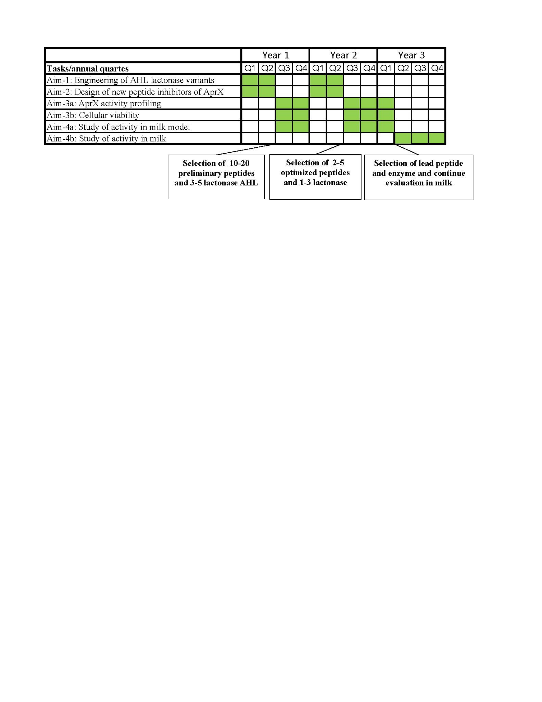

Years I and II will focus on iterative cycles for the generation of an optimized AHL lactonase enzyme with an improved activity profile, and the discovery and selection of potent peptide inhibitors of AprX. We expect by the end of the first year to have selected 3-5 new enzymes and 10-20 initial peptides. These will provide the basis for an additional round of optimization and selection. The third research year will focus on the evaluation of each solution (i.e., AHL lactonase and AprX peptide inhibitors) in milk alone and in a synergistic approach.

**8. Preliminary data**

The Afriat-Jurnou lab has recently identified a **new AHL lactonase (moLRP)** from marine metagenomes that provide the basis for further enzyme optimization[39](https://paperpile.com/c/kj4Nd6/iya0). The new moLRP was verified as an efficient AHL lactonase, with a preference towards short to medium AHL chains. The highest specific activity was detected with C4-HSL, with a *k*cat/*K*M value of 1.92x104 s-1M-1, then with C8-oxo-HSL**,** with a *k*cat/*K*M value of6.94X103 s-1M-1. **Figure 1** shows the catalytic analysis of these two substrates, which also act as QS signaling molecule in *P. fluorescens*.

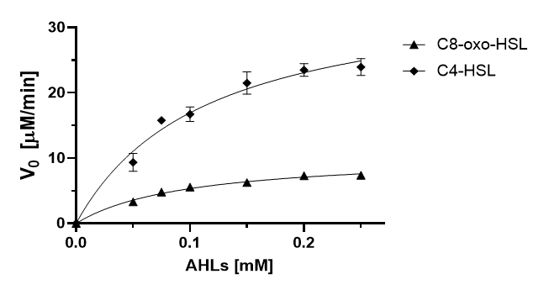

**Figure 1.** Newly identified moLRP is an N-acyl-homoserine lactonase. Michaelis-Menten analysis of the lactonase activity of moLRP with C4-HSL and C8-oxo-HSL, at E0=0.3µM, pH=8, 27°C.

**Biochemical characterization of the new moLRP AHL lactonase**. The biochemical characterizations indicated that moLRP has high temperature and pH stability. **Figure 2** shows the range of activity for two enzymes, the marine moLRP and a terrestrial lactonase, PPH. While both enzymes exhibited similar activity in terms of temperature range (**Figure 2A**), the superior range of activity for the newly discovered moLRP is clearly indicated. moLRP optimal pH was lower, around 8, while for PPH it was at 9.5 (**Figure 2B**). In addition, more than 75% residual activity following incubation at an extremely wide range of pH, from 4.5-11, was observed for moLRP (**Figure 2C**), while PPH was stable only in a narrow pH range.

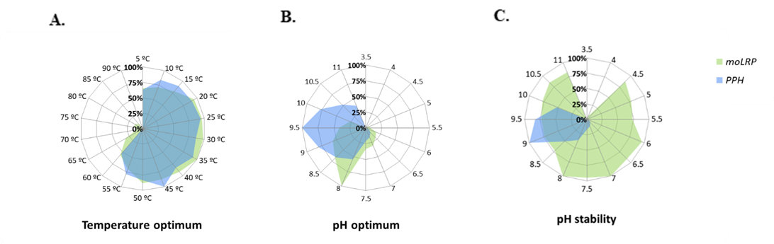

**Figure 2. Comparison of the biochemical properties of moLRP and PPH.** (A) The optimal temperature for the AHL-degrading activity of purified moLRP and PPH. The enzyme activities were determined by measuring the rate of enzymatic hydrolysis of thio-buthyl-γ-butyric-lactone (TBBL) in the temperature range of 5-90°C. Error bars indicate standard deviation from three repeats. The relative activity of 100% was defined as the activity at 45°C for moLRP and 35°C for PPH. (B) The optimal pH was determined by enzyme activities at different pHs (3.5 to 11). Relative activity of 100% was defined as the activity at pH 8 for moLRP and at pH 9 for PPH. (C) pH stability was tested after pre-incubation of the enzymes for 1 h without a substrate at 4°C, in buffers with a range of pH values (3.5-11). Residual activity was measured at optimal pH and at a constant temperature of 25°C. Error bars indicate standard deviations from three repeats.

**The new molRP AHL lactonase inhibits *P. fluorescens* in skim milk**. We assessed the ability of moLRP and PPH to attenuate QS factors in bacterial culture. As gene expression of *aprX* was shown to be regulated by AHL-based QS at the transcription level, we examined the extracellular proteolytic activity of *P. fluorescens* cultures grown in skim milk and the effect on gene expression. *P. fluorescens* cultures were incubated with and without purified moLRP and PPH. While adding purified PPH resulted in 20% lower bacterial exo-proteolytic activity, using the azo-casein as substrate, moLRP inhibited it by 75%. Moreover, **Figure 3B** shows that with moLRP, the relative expression of *aprX* was significantly reduced (by 71%)*.* **Figure 3C** shows that compared to bacterial cultures without lactonase addition, biofilm formation was inhibited by 60% when moLRP was added to the cultures of *P. fluorescens*, and by less than 20% when PPH was added.

**Figure 3.** **moLRP inhibits *P. fluorescens* AprX expression and extracellular proteolytic activity.** (A) Transcription levels of *aprX* in the presence of purified moLRP and its activity buffer (control), normalized to levels of *16S rRNA*. (B) Extracellular proteinase activity of *P. fluorescens* (skim milk medium), with and without purified enzymes. *P. fluorescens* alone was used as a control. 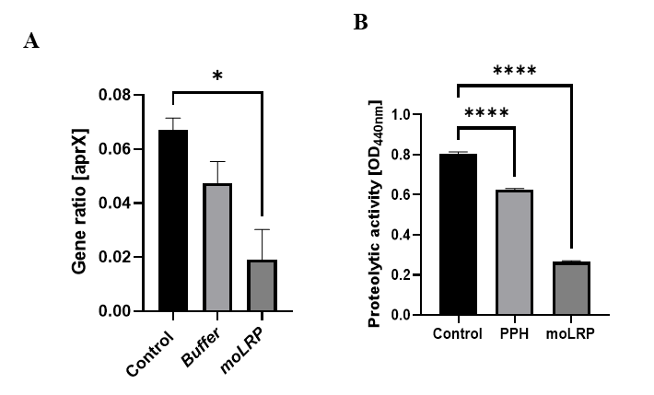

**MolRP efficiently inhibits milk sedimentation. Figure 4A** illustrates the effects of moLRP and PPH on particle aggregation and precipitation in milk cultures caused by *P. fluorescens* after 4 days. Cultures incubated with moLRP appeared homogeneous, similar to skim milk medium without bacteria. The sedimentation process of skim milk cultures of *P. fluorescens* was evaluated by the observed clarification of the upper 10% of cultures (**Figure 4A)** and light transmission (**Figure 4B**), as measured by the LUMIsizer, of *P. fluorescens*-treated milk. **Figure 4B** shows that over time, the skim milk medium alone remained a homogeneous suspension even after 10 h of centrifugation, whereas skim milk medium inoculated with *P. fluorescens* started destabilization, aggregation, and sedimentation processesafter 4 hours of centrifugation. However, adding purified moLRP to skim milk medium inoculated with *P. fluorescens* cultures resulted in a 2-hour delay in sedimentation (from 4 to 6 h). This indicated that the destabilization and sedimentation process of the milk medium was inhibited by moLRP.

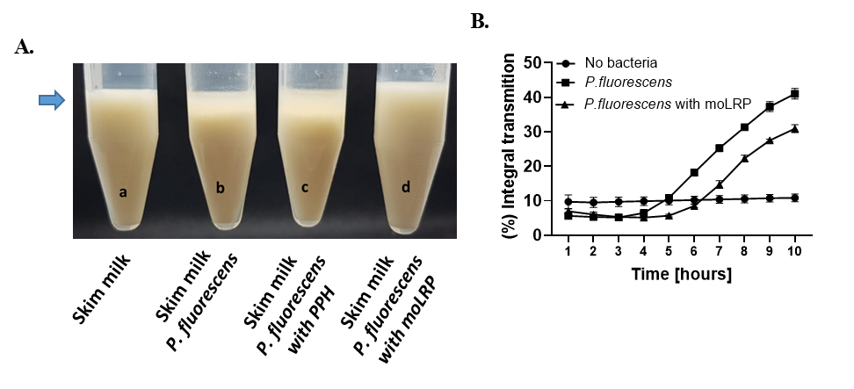

**Figure 4.** **moLRP inhibits *sedimentation* in *P. fluorescens-*treated milk-based cultures.** (A) Skim milk cultures of *P. fluorescens* at 28°C, incubated with or without 1 μM purified enzymes. Pictures were taken after 4 days. (B) Light transmission of bacterial cultures over time measured by LUMisizer analytical centrifuge.

**9. Bibliography**

1. [Machado, S. G., Bagliniere, F., Marchand, S., Van Coillie, E., Vanetti, M. C. D., De Block, J. & Heyndrickx, M. The biodiversity of the microbiota producing heat-resistant enzymes responsible for spoilage in processed bovine milk and dairy products. *Front. Microbiol.* **8**, 302 (2017).](http://paperpile.com/b/kj4Nd6/OvxZ)

2. [Ouamba, A. J. K., Gagnon, M., LaPointe, G., Chouinard, P. Y. & Roy, D. Graduate Student Literature Review: Farm management practices: Potential microbial sources that determine the microbiota of raw bovine milk. *J. Dairy Sci.* **105**, 7276–7287 (2022).](http://paperpile.com/b/kj4Nd6/4MpQ)

3. [Cremonesi, P., Severgnini, M., Romano, A., Sala, L., Luini, M. & Castiglioni, B. Bovine milk microbiota: Comparison among three different DNA extraction protocols to identify a better approach for bacterial analysis. *Microbiol Spectr* **9**, e0037421 (2021).](http://paperpile.com/b/kj4Nd6/g2mT)

4. [Erkmen, O. & Faruk Bozoglu, T. *Food Microbiology, 2 Volume Set: Principles into Practice*. (John Wiley & Sons, 2016).](http://paperpile.com/b/kj4Nd6/RAyn)

5. [Quintieri, L., Caputo, L., Brasca, M. & Fanelli, F. Recent advances in the mechanisms and regulation of QS in dairy spoilage by](http://paperpile.com/b/kj4Nd6/M0lJ) *[Pseudomonas](http://paperpile.com/b/kj4Nd6/M0lJ)* [spp. *Foods* **10**, 3088 (2021).](http://paperpile.com/b/kj4Nd6/M0lJ)

6. [Villamiel, M. & de Jong, P. Inactivation of](http://paperpile.com/b/kj4Nd6/rRPu) *[Pseudomonas fluorescens](http://paperpile.com/b/kj4Nd6/rRPu)* [and](http://paperpile.com/b/kj4Nd6/rRPu) *[Streptococcus thermophilus](http://paperpile.com/b/kj4Nd6/rRPu)* [in Trypticase® soy broth and total bacteria in milk by continuous-flow ultrasonic treatment and conventional heating. *J. Food Eng.* **45**, 171–179 (2000).](http://paperpile.com/b/kj4Nd6/rRPu)

7. [Martin, N. H., Boor, K. J. & Wiedmann, M. Symposium review: Effect of post-pasteurization contamination on fluid milk quality. *J. Dairy Sci.* **101**, 861–870 (2018).](http://paperpile.com/b/kj4Nd6/HEox)

8. [Meng, L., Zhang, Y., Liu, H., Zhao, S., Wang, J. & Zheng, N. Characterization of](http://paperpile.com/b/kj4Nd6/kOEC) *[Pseudomonas](http://paperpile.com/b/kj4Nd6/kOEC)* [spp. and associated proteolytic properties in raw milk stored at low temperatures. Front Microbiol](http://paperpile.com/b/kj4Nd6/kOEC) **[8](http://paperpile.com/b/kj4Nd6/kOEC)**[, 2158 (2017).](http://paperpile.com/b/kj4Nd6/kOEC)

9. [Scatamburlo, T. M., Yamazi, A. K., Cavicchioli, V. Q., Pieri, F. A. & Nero, L. A. Spoilage potential of Pseudomonas species isolated from goat milk. *J. Dairy Sci.* **98**, 759–764 (2015).](http://paperpile.com/b/kj4Nd6/eaUb)

10. [Kumar, H., Franzetti, L., Kaushal, A. & Kumar, D. Pseudomonas fluorescens: a potential food spoiler and challenges and advances in its detection. *Ann. Microbiol.* **69**, 873–883 (2019).](http://paperpile.com/b/kj4Nd6/UbGK)

11. [Bellassi, P., Rocchetti, G., Morelli, L., Senizza, B., Lucini, L. & Cappa, F. A milk foodomics investigation into the effect of](http://paperpile.com/b/kj4Nd6/vnwf) *[Pseudomonas fluorescens](http://paperpile.com/b/kj4Nd6/vnwf)* [growth under cold chain conditions. *Foods* **10**, 1173 (2021).](http://paperpile.com/b/kj4Nd6/vnwf)

12. [Marchand, S., Vandriesche, G., Coorevits, A., Coudijzer, K., De Jonghe, V., Dewettinck, K., De Vos, P., Vevreese, B., Heyndrickx, M. & De Block, J. Heterogeneity of heat-resistant proteases from milk Pseudomonas species. *Int. J. Food Microbiol.* **133**, 68–77 (2009).](http://paperpile.com/b/kj4Nd6/W7n2)

13. [Alves, M. P., Salgado, R. L., Eller, M. R., Vidigal, P. M. P. & Fernandes de Carvalho, A. Characterization of a heat-resistant extracellular protease from Pseudomonas fluorescens 07A shows that low temperature treatments are more effective in deactivating its proteolytic activity. *J. Dairy Sci.* **99**, 7842–7851 (2016).](http://paperpile.com/b/kj4Nd6/4rXD)

14. [Zhang, C., Bijl, E., Svensson, B. & Hettinga, K. The extracellular protease AprX from Pseudomonas and its spoilage potential for UHT milk: A review. *Compr. Rev. Food Sci. Food Saf.* **18**, 834–852 (2019).](http://paperpile.com/b/kj4Nd6/1bd8)

15. [Matéos, A. *et al.* Proteolysis of milk proteins by AprX, an extracellular protease identified in Pseudomonas LBSA1 isolated from bulk raw milk, and implications for the stability of UHT milk. *Int. Dairy J.* **49**, 78–88 (2015).](http://paperpile.com/b/kj4Nd6/PjRl)

16. [Zhang, C., Bijl, E., Muis, K. E. & Hettinga, K. Stability of fat globules in UHT milk during proteolysis by the AprX protease from Pseudomonas fluorescens and by plasmin. *J. Dairy Sci.* **103**, 179–190 (2020).](http://paperpile.com/b/kj4Nd6/e1Va)

17. [Baglinière, F. *et al.* Proteolysis of ultra high temperature-treated casein micelles by AprX enzyme from Pseudomonas fluorescens F induces their destabilisation. *Int. Dairy J.* **31**, 55–61 (2013).](http://paperpile.com/b/kj4Nd6/mXbX)

18. [Aguilera-Toro, M., Kragh, M. L., Vestergard Thomasen A., Piccini, V., Rauh, V., Xiao, Y., Wiking, L., Pousen, N. A., Truelstrup Hanse, L. & Larsen, L.B. Proteolytic activity and heat resistance of the protease AprX from Pseudomonas in relation to genotypic characteristics. *Int. J. Food Microbiol.*](http://paperpile.com/b/kj4Nd6/lLcE) **16**, [391–393 (2023).](http://paperpile.com/b/kj4Nd6/lLcE)

19. [Zhang, C., Bijl, E. & Hettinga, K. Destabilization of UHT milk by protease AprX from Pseudomonas fluorescens and plasmin. *Food Chem.* **263**, 127–134 (2018).](http://paperpile.com/b/kj4Nd6/DsM9)

20. [Andreani, N. A. Carraro, L., Fasolato, L., Balzan, S., Lucchini, R., Novelli, E. & Cardazzo, B. Characterisation of the thermostable protease AprX in strains of](http://paperpile.com/b/kj4Nd6/ql9h) *[Pseudomonas fluorescens](http://paperpile.com/b/kj4Nd6/ql9h)* [and impact on the shelf-life of dairy products: preliminary results. *Ital J Food Saf* **5**, 6175 (2016).](http://paperpile.com/b/kj4Nd6/ql9h)

21. [Gainza, P., Wehrle, S., Van Hall-Beauvais, A. & *et al.* De novo design of protein interactions with learned surface fingerprints. *Nature*](http://paperpile.com/b/kj4Nd6/mexR) **[617](http://paperpile.com/b/kj4Nd6/mexR)**[, 176–184 (2023).](http://paperpile.com/b/kj4Nd6/mexR)

22. [Hashemi, Z. S. *et al.*](http://paperpile.com/b/kj4Nd6/8wUX) *[In silico](http://paperpile.com/b/kj4Nd6/8wUX)* [approaches for the design and optimization of interfering peptides against protein-protein interactions. *Front Mol Biosci* **8**, 669431 (2021).](http://paperpile.com/b/kj4Nd6/8wUX)

23. [Larue, R. C., Xing, E., Kenney, A. D., Zhang, Y., Tuazon, J. A., Li, J., Yount, J. S., Li, P-K. & Sharma, A. Rationally designed ACE2-derived peptides inhibit SARS-CoV-2. *Bioconjug. Chem.* **32**, 215–223 (2021).](http://paperpile.com/b/kj4Nd6/L9sj)

24. [Wichapong, K., Silvestre-Roig, C., Braster, Q., Schumski, A., Soehnlein, A. & Nicolaes, G., A., F. Structure-based peptide design targeting intrinsically disordered proteins: Novel histone H4 and H2A peptidic inhibitors. *Comput. Struct. Biotechnol. J.* **19**, 934–948 (2021).](http://paperpile.com/b/kj4Nd6/v2IQ)

25. [Philippe, G. J. B., Craik, D. J. & Henriques, S. T. Converting peptides into drugs targeting intracellular protein-protein interactions. *Drug Discov. Today* **26**, 1521–1531 (2021).](http://paperpile.com/b/kj4Nd6/9v55)

26. [Tubiana, J., Adriana-Lifshits, L., Nissan, M., Gabay, M., Sher, I., Sova, Ma., Wolfson, H. J. & Gal, M. Funneling modulatory peptide design with generative models: Discovery and characterization of disruptors of calcineurin protein-protein interactions. *PLoS Comput. Biol.* **19**, e1010874 (2023).](http://paperpile.com/b/kj4Nd6/HQWZ)

27. [Shwaiki, L. N., Arendt, E. K., Lynch, K. M. & Thery, T. L. C. Inhibitory effect of four novel synthetic peptides on food spoilage yeasts. *Int. J. Food Microbiol.* **300**, 43–52 (2019).](http://paperpile.com/b/kj4Nd6/qTCc)

28. [Shwaiki, L. N., Lynch, K. M. & Arendt, E. K. Future of antimicrobial peptides derived from plants in food application – A focus on synthetic peptides. *Trends Food Sci. Technol.* **112**, 312–324 (2021).](http://paperpile.com/b/kj4Nd6/aJav)

29. [Perez Espitia, P. J. *et al.* Bioactive peptides: synthesis, properties, and applications in the packaging and preservation of food. *Compr. Rev. Food Sci. Food Saf.* **11**, 187–204 (2012).](http://paperpile.com/b/kj4Nd6/bq9O)

30. [Zhang, F. *et al.* Antimicrobial, anti-biofilm properties of three naturally occurring antimicrobial peptides against spoilage bacteria, and their synergistic effect with chemical preservatives in food storage. *Food Control* **123**, 107729 (2021).](http://paperpile.com/b/kj4Nd6/2fzx)

31. [Luo, X. *et al.* Evaluation of the antimicrobial activities and mechanisms of synthetic antimicrobial peptide against food-borne pathogens. *Food Bioscience* **49**, 101903 (2022).](http://paperpile.com/b/kj4Nd6/WVmT)

32. [Fuqua, C. & Greenberg, E. P. Self perception in bacteria: quorum sensing with acylated homoserine lactones. *Curr. Opin. Microbiol.* **1**, 183–189 (1998).](http://paperpile.com/b/kj4Nd6/pZ8T)

33. [Yuan, L., Sadiq, F. A., Burmølle, M., Liu, T. & He, G. Insights into bacterial milk spoilage with particular emphasis on the roles of heat-stable enzymes, biofilms, and quorum sensing. *J. Food Prot.* **81**, 1651–1660 (2018).](http://paperpile.com/b/kj4Nd6/mMpL)

34. [Liu, M., Wang, H. & Griffiths, M. W. Regulation of alkaline metalloprotease promoter by N-acyl homoserine lactone quorum sensing in Pseudomonas fluorescens. *J. Appl. Microbiol.* **103**, 2174–2184 (2007).](http://paperpile.com/b/kj4Nd6/5m8S)

35. [İnat, G. *et al.* Quorum sensing systems and related virulence factors in Pseudomonas aeruginosa isolated from chicken meat and ground beef. *Sci. Rep.* **11**, 15639 (2021).](http://paperpile.com/b/kj4Nd6/LD2w)

36. [Pinto, U. M., de Souza Viana, E., Martins, M. L. & Vanetti, M. C. D. Detection of acylated homoserine lactones in gram-negative proteolytic psychrotrophic bacteria isolated from cooled raw milk. *Food Control* **18**, 1322–1327 (2007).](http://paperpile.com/b/kj4Nd6/IsBI)

37. [Skandamis, P. N. & Nychas, G.-J. E. Quorum sensing in the context of food microbiology. *Appl. Environ. Microbiol.* **78**, 5473–5482 (2012).](http://paperpile.com/b/kj4Nd6/Ht0o)

38. [Machado, I., Silva, L. R., Giaouris, E. D., Melo, L. F. & Simões, M. Quorum sensing in food spoilage and natural-based strategies for its inhibition. *Food Res. Int.* **127**, 108754 (2020).](http://paperpile.com/b/kj4Nd6/8ryC)

39. [Haramati, R., Dor, S., Gurevicih, D., Levy, D., Freund, Dk., Rytwo, G., Sharon, I. & Afriat-Jurnou, L. Mining marine metagenomes revealed a quorum-quenching lactonase with improved biochemical properties that inhibits the food spoilage bacterium Pseudomonas fluorescens. *Appl. Environ. Microbiol.* **88**, e0168021 (2022).](http://paperpile.com/b/kj4Nd6/iya0)

40. [Markel, U., Essani, K.D., Besirlioglu, V., Schiffels, J., Streit, W. R. & Schwaneberg, U. Advances in ultrahigh-throughput screening for directed enzyme evolution. *Chem. Soc. Rev.* **49**, 233–262 (2020).](http://paperpile.com/b/kj4Nd6/N970)

41. [Farinas, E. T., Bulter, T. & Arnold, F. H. Directed enzyme evolution. *Curr. Opin. Biotechnol.* **12**, 545–551 (2001).](http://paperpile.com/b/kj4Nd6/beCA)

42. [Eijsink, V. G. H., Gåseidnes, S., Borchert, T. V. & van den Burg, B. Directed evolution of enzyme stability. *Biomol. Eng.* **22**, 21–30 (2005).](http://paperpile.com/b/kj4Nd6/fVrY)

43. [Goldsmith, M. & Tawfik, D. S. Directed enzyme evolution: beyond the low-hanging fruit. *Curr. Opin. Struct. Biol.* **22**, 406–412 (2012).](http://paperpile.com/b/kj4Nd6/Nh2g)

44. [Khersonsky, O., Malitsky, S., Rogachev, I. & Tawfik, D. S. Role of chemistry versus substrate binding in recruiting promiscuous enzyme functions. *Biochemistry* **50**, 2683–2690 (2011).](http://paperpile.com/b/kj4Nd6/QWIX)

45. [Khersonsky, O. Röthlisberger, D., Dym, D., Albeck, S., Jackson, C. J., Baker, D. and Tawfik, D. S. *et al.* Evolutionary optimization of computationally designed enzymes: Kemp eliminases of the KE07 Series. *J. Mol. Biol.* **396**, 1025–1042 (2010).](http://paperpile.com/b/kj4Nd6/hbWk)

46. [Pfaff, L., Breite, D., Badenhorst, C. P. S., Bornscheuer, U. T. & Wei, R. Fluorimetric high-throughput screening method for polyester hydrolase activity using polyethylene terephthalate nanoparticles. *Methods Enzymol.* **648**, 253–270 (2021).](http://paperpile.com/b/kj4Nd6/00T4)

47. [Gargiulo, S. & Soumillion, P. Directed evolution for enzyme development in biocatalysis. *Curr. Opin. Chem. Biol.* **61**, 107–113 (2021).](http://paperpile.com/b/kj4Nd6/6SBF)

48. [Tohar, R., Ansbacher, T., Sher, I., Afriat-Jurnou, L., Weinberg, E. & Gal, M. Screening collagenase activity in bacterial lysate for directed enzyme applications. *Int. J. Mol. Sci.* **22**, 8552 (2021).](http://paperpile.com/b/kj4Nd6/x92O)

49. [Afriat-Jurnou, L., Cohen, R., Paluy, I., Ben-Adiva, R. & Yadid, I. Directed evolution of an endoinulinase from Talaromyces purpureogenus toward efficient production of inulooligosaccharides. *Biotechnol. Prog.* **34**, 868–877 (2018).](http://paperpile.com/b/kj4Nd6/4my6)

50. [Gurevich, D., Dor, S., Erov, M., Dan, Y., Moy, J. C., Mairesse, O., Dafny-Yelin, M., Adler-Abramovich, L. & Afriat-Jurnou, L. Directed enzyme evolution and encapsulation in peptide nanospheres of quorum quenching lactonase as an antibacterial treatment against plant pathogen. *ACS Appl. Mater. Interfaces* **13**, 2179–2188 (2021).](http://paperpile.com/b/kj4Nd6/r1hn)

51. [Dauparas, J., Anishchenko, I., Bennett, N. *et al.* Robust deep learning–based protein sequence design using ProteinMPNN. *Science* **378**, 49–56 (2022).](http://paperpile.com/b/kj4Nd6/KLoe)

52. [Jumper, J., Evans, R., Pritzel, A. *et al.* Highly accurate protein structure prediction with AlphaFold. *Nature* **596**, 583–589 (2021).](http://paperpile.com/b/kj4Nd6/3o4M)

53. [Liao, C. H. & McCallus, D. E. Biochemical and genetic characterization of an extracellular protease from Pseudomonas fluorescens CY091. *Appl. Environ. Microbiol.* **64**, 914–921 (1998).](http://paperpile.com/b/kj4Nd6/giBL)

54. [Rodrigues, C. H. M., Myung, Y., Pires, D. E. V. & Ascher, D. B. mCSM-PPI2: predicting the effects of mutations on protein–protein interactions. *Nucleic Acids Res.* **47**, W338–W344 (2019).](http://paperpile.com/b/kj4Nd6/VMrJ)

55. [Khersonsky, O. & Tawfik, D. S. Chromogenic and fluorogenic assays for the lactonase activity of serum paraoxonases. *Chembiochem* **7**, 49–53 (2006).](http://paperpile.com/b/kj4Nd6/frjq)

56. [Yuan, J. S., Reed, A., Chen, F. & Stewart, C. N., Jr. Statistical analysis of real-time PCR data. *BMC Bioinformatics* **7**, 85 (2006).](http://paperpile.com/b/kj4Nd6/61BA)

57. [Dor, S., Prusky, D. & Afriat-Jurnou, L. Bacterial quorum-quenching lactonase hydrolyzes fungal mycotoxin and reduces pathogenicity of](http://paperpile.com/b/kj4Nd6/1st6) *[Penicillium expansum](http://paperpile.com/b/kj4Nd6/1st6)*[-suggesting a mechanism of bacterial antagonism. *J Fungi (Basel)* **7**, 826 (2021).](http://paperpile.com/b/kj4Nd6/1st6)

58. [Sun, Y., Harpazi, B., Wijerathna-Yapa, A. *et al.* A ligand-independent origin of abscisic acid perception. *Proceedings of the National Academy of Sciences* **116**, 24892–24899 (2019).](http://paperpile.com/b/kj4Nd6/o4Pt)

59. [Ratzon, E., Bloch, I., Nicola, M., Cohen, E., Ruimi, N., Dotan, N., Landau, M. & Gal, M. A small molecule inhibitor of Bruton’s tyrosine kinase involved in B-cell signaling. *ACS Omega* **2**, 4398–4410 (2017).](http://paperpile.com/b/kj4Nd6/Due0)

60. [Alali, H., Bloch, I., Rapaport, I., Rodrigues, L., Sher, I., Ansbacher, T. & Gal, M. Application of in silico filtering and isothermal titration calorimetry for the discovery of small molecule inhibitors of MDM2. *Pharmaceuticals* **15**, 752 (2022).](http://paperpile.com/b/kj4Nd6/Sotr)

61. [Tohar, R., Alali, H., Ansbacher, T., Brosh, T., Sher, I., Gafni, Y., Weinberg, R. & Gal, M. Collagenase administration into periodontal ligament reduces the forces required for tooth extraction in an ex situ porcine jaw model. *J. Funct. Biomater.* **13**, 76 (2022).](http://paperpile.com/b/kj4Nd6/hnUw)

62. [Martins, M. L., Pinto, U., M., Riedel, K., Vanetti, M. C., D., Mantovani, H. & De Araújo, E., F. Lack of AHL-based quorum sensing in Pseudomonas fluorescens isolated from milk. *Braz. J. Microbiol.* **45**, 1039–1046 (2014).](http://paperpile.com/b/kj4Nd6/mhRb)

63. [Milk - worldwide. *Statista*](http://paperpile.com/b/kj4Nd6/8EwV) <https://www.statista.com/outlook/cmo/food/dairy-products-eggs/milk/worldwide>[.](http://paperpile.com/b/kj4Nd6/8EwV)