**FIRST- AND SECOND-GRADE PROSPECTIVE TEACHERS RECONSTRUCTING DEFINITIONS OF POLYGON DIAGONALS**

Concept definition and concept image are considered essential for acquiring mathematical concepts. The current study aimed to examine how prospective first- and second-grade mathematics teachers define the polygon diagonals concept, how they reconstruct their definition during and following an intervention, and how their concept images develop over time. To this end, 23 prospective teachers participated in a study during which they were asked to analyse mathematical events involving a conflict that could be resolved using a precise mathematical definition of a polygon diagonal. Data were collected from prequestionnaires, postquestionnaires, and observations of class discussions. The study findings indicate that prior to the intervention, all participants provided incorrect definitions and struggled to identify nonprototypical examples of diagonals in the prequestionnaire. However, the process of analysing mathematical events helped participants reconstruct their definitions of polygon diagonals and identify the critical attributes of this concept, which improved their ability to extend the concept's image to nonprototypical examples. The participants' improved understanding was evident in the significant improvements in the postquestionnaire.

**INTRODUCTION**

Based on the model proposed by Vinner and Hershkowitz (1980) and later by Tall and Vinner (1981) regarding overall mathematical concepts, the acquisition of geometrical concepts requires two main components: concept definition and concept image. The concept definition is the verbal-mathematical description of the concept, whereas the concept image is the cognitive structure that represents the concept in the learner's mind. When the concept image matches the concept definition, the concept is learned. However, a mismatch between these two components can negatively impact a student’s ability to identify examples, construct examples, and engage in proving processes (Haj-Yahya & Hershkowitz, 2013; Fujita & Jones, 2007; Marchis, 2012). Understanding mathematical definitions of concepts is essential to identifying critical features of geometric shapes and developing geometrical understanding (Haj-Yahya et al., 2022).

Early-grade teachers are responsible for laying the foundation for future learning in mathematics, and research has consistently shown that teachers who have a strong understanding of the mathematical concepts they teach are better able to help their students develop their understanding and skills (e.g., Sherstha, 2022; Hill et al., 2005). Specifically, knowledge of geometry and teachers' geometric thinking levels affect their students' geometric thinking levels (Pavlovičová et al., 2022). Despite this connection, studies have shown that teachers' knowledge of geometry is generally limited. For example, Tsamir et al. (2014) reported that only a small percentage of all early-year teachers in their defining geometric concepts. Similar findings were reported in later research (Haj-Yahya, 2019; Haj-Yahya et al., 2019). Shahbari's (2022) study revealed a low level of knowledge in geometry among practicing and prospective first- and second-grade mathematics teachers compared with other mathematics fields. Previous studies also indicated limited mathematical content and pedagogical knowledge among first- and second-grade mathematics teachers; for example, Shaieb and Tabach (2020) found that half of the first-grade teachers in their study had difficulty identifying nontypical examples of a pyramid. Malzahn (2002) reported that close to 50% of the second-grade math teachers in the study expressed a desire to develop a greater level of content knowledge in the subjects they teach. Additionally, half of these teachers emphasised the significance of enhancing their comprehension and understanding of student thought processes. Therefore, there is a need to develop first- and second-grade mathematics teachers' knowledge. A useful tool for helping teachers better understand mathematical ideas is engaging in mathematical event analyses (Stockero et al., 2019). Such analyses might allow for the creation of a community of learners and the opportunity for discussion and argumentation around mathematical concepts. The process of argumentation—in which claims are presented, evaluated, and either accepted or rejected—is a way to build up a whole class understanding (Toulmin, 2003). In the current study, we examined whether analysis of mathematical events related to geometrical definitions affected prospective teachers’ defining processes.

**GEOMETRIC THINKING AND DEFINITIONS**

Van Hiele and Van Hiele (1958) proposed a theory on the development of geometric thinking that involves five levels that follow a sequential and hierarchical order. At level 2, students can list properties of a figure but don't see relationships between them or recognise that some imply others. They use informal analysis of parts and attributes to reason about geometric concepts. Necessary properties are established, but there's no formal organisation of properties yet. Level 3 is characterised by the students' ability to both recognise logical structure among properties of the figure and provide meaningful definitions and informal arguments. At level 4, students can construct proofs, comprehend the role of axioms and definitions, and discern the meaning of necessary and sufficient conditions. The hierarchy in Van Hiele and Van Hiele's theory emphasises the significance and roles of definitions within the formal geometrical system. Mathematical definitions are essential for understanding the meanings of mathematical concepts and for solving problems such as constructing theorems and proofs (e.g., Haj-Yahya et al., 2022).

In Vinner's (1991) study on the significance of definitions, he made five assumptions. One of the assumptions was that learners acquire concepts through their definitions. Another assumption was that students employ definitions to resolve problems and prove processes. Zaslavsky and Shir (2005) mentioned imperative mathematical definitions. The imperative includes the absence of any inherent contradiction between the concept attributes. the absence of ambiguity, the absence of any changes under one or another representation of the concept, hierarchical (based on previous concepts) formulation, and noncircularity. Regarding the logical structure of the mathematical definition, mathematicians and mathematical educators use arbitrary definitions that are equivalent to other definitions of the same concept; in such cases, one statement is chosen from a set of logically equivalent statements to define the concept, and each statement in the set is used as a legitimate definition for particular concept (Harel et al., 2006; Usiskin et al., 2008; Vinner, 1991). The most controversial optional feature is the requirement that a mathematical definition be minimal. A definition is considered to be minimal if it has no superfluous conditions. Mathematical educators discussed the tendency to define a concept using long lists of its attributes. Although this approach is mathematically correct, some educators prefer to omit some of the attributes that could be inferred from other listed attributes (e.g., Leikin & Winicky-Landman, 2001; Linchevsky et al., 1992; Vinner, 1991; Zaslavsky & Shir, 2005).

However, numerous studies have identified difficulties that both students and teachers face when they are required to define mathematical concepts and reflect on the structure and meaning of these definitions (e.g., Haj-Yahya, 2021; Haj-Yahya et al., 2019). Teachers struggled with using "uneconomical definitions," "incorrect definitions," or rejecting equivalent definitions of geometrical concepts. For many participants, the essence and the nature of the geometrical concept is more important than the essence of the definition, so the teachers rejected geometrical definitions that did not emphasise the essence of the concept (Haj-Yahya, 2019; Haj-Yahya et al., 2019). A *minimal definition* is one that includes the necessary and sufficient attributes to deduce the remaining attributes of a concept, whereas an *uneconomical definition* lists all the attributes of a concept, some of which can be omitted and deduced from others. Although these lengthy descriptive definitions may be accurate, many mathematics educators prefer minimal definitions. An incorrect definition includes either non-necessary attributes or insufficient attributes. For instance, defining a kite as a quadrilateral with perpendicular diagonals includes insufficient attributes and defining a trapezium as a quadrilateral with perpendicular diagonals includes non-necessary attributes (Choi et al., 2008; Markovic & Romano, 2013; de Villiers et al., 2009; Zaslavsky & Shir, 2005).

Difficulties in understanding definitions often arise from the relationship between the concept image and the concept definition, especially in cases where the concept image is limited and inaccurate (Fujita & Jones, 2007; Vinner, 1991). When a disconnect exists between an individual's mental image and the definition of the geometric concept derived from practical experience and formal knowledge, difficulties can arise (Seah et al., 2016). In this case, the personal concept definition diverges from the formal concept definition accepted by the broader mathematical community. The personal understanding of a concept is susceptible to interpretations and individual perspectives, which can influence its deviation from the formally accepted definition (Tall & Vinner, 1981). In a study involving 40 prospective teachers who were asked to define a rectangle and a rhombus, the results revealed the effects of the prototypical concept image: More than half of the subjects thought that a rectangle must have two sides that are longer than its other sides (Pickreign, 2007).

In the current study, we focused on polygon diagonals, which have been identified as an essential but difficult concept. Previous research found that students often struggle with understanding polygon diagonals. For example, Wilson and Schmidt (2005) found that high school students had misconceptions about polygon diagonals, such as the belief that the number of diagonals equals the number of sides in the polygon. Regarding other shapes (triangles), in a study conducted by Gutiérrez and Jaime (1999), preservice teachers were given the definition of an altitude and asked to draw an altitude from a given vertex. It was found that preservice teachers ignored the given definition and were unable to identify and build exterior elevations originating from one of the sides (right-angled triangles). However, it was easy for them to build altitudes inside the triangle from top to bottom—that is, the internal features that distinguish the limited concept image were exclusive to prototypical examples of segments.

Vinner (1991) suggests using activities that present learners with a conflict that can be resolved using a precise mathematical definition. This helps students understand the importance of definitions as a tool for effective mathematical communication. The current study adopts mathematical event analyses to test Vinner’s recommendation.

**Mathematical events**

Mathematical events refer to cases and problems that arise in the mathematics classroom, to which a teacher then responds (Markowitz, 2003). The use of analyses of events as a pedagogical tool is common in various fields, including law, business management, medicine, and education. This approach enables learners to explore critical issues and situations relevant to theory and practice (Walen & Williams, 2000). In teacher training, events are regarded as an essential tool, and researchers have used them for many years (Tirosh et al., 2019; Herbst et al., 2017; Shulman, 1992). Participating in analyses of mathematical events helps teachers to gain insight into students' diverse ways of thinking and responding (Markowitz, 2003). This approach fosters critical thinking and enhances teachers' understanding of theory, preparing them to be reflective practitioners (Richardson, 1991). After participating in such exercises, teachers have a repository of precedents they can draw upon in their classroom practice (Shulman, 1992). The significance of the events lies in the discussion that takes place around them, through which a community of learners is formed (Richardson, 1991). The ensuing debate is based on an argumentative discourse (Toulmin, 1969; 2003), where learners explain their reasoning, listen to other's perspectives, and agree or disagree with the arguments put forward.

Moreover, the role of the learner changes from being a marginal participant in the mathematical discourse to a more central one, contributing to knowledge construction (Lave & Wenger, 1991). Analyses of mathematical events provide an opportunity to build on learners' mathematical thinking, helping them understand crucial mathematical concepts (Stockero et al., 2019). Therefore, the incidents should be rich and substantial, allowing for multiple levels of analysis and interpretation to capture the complexity of teaching mathematics in different contexts (Levin, 1995). It is important to monitor the mathematical progress of a class at the whole class level rather than focusing on the individual thinking of each participant. This allows for an understanding of the accepted mathematical meanings within a class community, where the class is treated as its own entity (Toulmin, 1969; 2003).

**Research questions**

The current study examined how participants' understanding of polygon diagonals evolved into a more whole class understanding as they participated in the analyses of mathematical events related to the definition of polygon diagonals and engaged in discussion and argumentation with their peers. This may have included examining how participants' definitions of polygon diagonals developed and how they used evidence and reasoning to support their ideas. Based on the purpose of the study and according to the theoretical background, we formulated the following questions:

1. How do first- and second-grade prospective mathematics teachers define the polygon diagonals concept? To what extent are their concept images of polygon diagonals related to the polygon diagonals definition?
2. How do first- and second-grade prospective teachers reconstruct their definitions through analyses of mathematical events related to the definition of polygon diagonals? How does their concept image develop over time?

**METHOD**

**Research context**

The study was conducted at the College for Arabic Speakers for Teacher Training as a part of a geometry teaching course designed for individuals looking to expand their teaching certification in first and second grades. The course consisted of 14 sessions, each lasting 90 minutes, and focused on four key areas of geometric thinking: properties of shapes, place and space relations, transformations and symmetry, and visualisation. The course contents were developed based on the American National Council of Teachers of Mathematics and National Council for Teachers of Mathematics (NCTM, 2000) standards for geometry education in children from kindergarten through second grade. These standards outline the expected achievements of students in geometry and provide teachers with a framework for age-appropriate instruction. The research took place over two sessions and focused on polygons. The teaching-learning process was based on discussions during mathematical events, emphasising various ways of thinking and misconceptions students make when working with polygons. The two main events, each consisting of several sections, were developed based on previous studies, such as Tsamir et al., 2008, and the researchers' experience teaching geometry and extracting relevant information from previous research (see Figure 1 as an example of one event). The first researcher conducted the course and was accompanied by other researchers. She presented events that encouraged students to build knowledge of polygon definitions. Her role was to facilitate learning, which involved guiding and motivating students to learn, develop, and build their knowledge on their own while providing opportunities for them to examine ways of to analyse and discuss events.

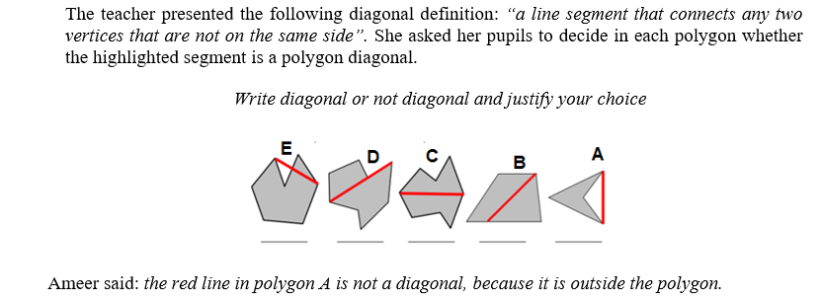

Figure 1: Example of a diagonal event presented during the study

**Participants**

The present study was conducted with 23 prospective teachers who were studying for their teaching certification for first and second grades at a college for teacher training in the Arab community in Israel. The participants are fourth-year students who have completed three years of studies. This course is typically considered a second course and falls under the mathematics education component alongside a calculus teaching course for first and second graders. The participants were chosen using a convenience sampling method.

**Data sources and procedure**

The data for this study were collected from three sources:

* Two-part prequestionnaire: One part focused on the definition task of polygon diagonals, and a second part focused on the identification of prototypical and nonprototypical examples of polygon diagonals (see Appendix 1).
* Two-part postquestionnaire: The first part is identical to the first part in the prequestionnaire, and the second part consisting of two items: The first asked participants to draw polygon diagonals according to a set of instructions. The second was a mathematical event based on students' misconceptions about a polygon diagonal definition (see Appendix 2).
* Observations: Class discussions were recorded by video and transcribed by the first researcher.

At the course's first meeting, the prequestionnaire was administered to participants, and they were required to fill out the postquestionnaire at the end of the course.

**Data analyses**

The prequestionnaires and postquestionnaires were analysed using thematic content analysis (Braun & Clarke, 2006). We used the categories identified in Tsamir et al.'s (2015) research on the definition of geometric concepts. We found three categories consistent with Tsamir et al.'s (2015) categories: (a.1) minimal correct definitions, (a.2) correct definitions that consist of nonminimal definitions, and (b.1) incorrect definitions that consist of insufficient attributes (i.e., are missing critical attributes). We identified a new, fourth category: (b.2) incorrect definitions based on noncritical attributes (see Table 1). We counted the frequencies of each category. For the correct definition of a polygon, we used “a line segment that connects any two nonadjacent vertices,” from the Ministry of Education's website (https://retro.education.gov.il/tochniyot_limudim/math/metzolaim.htm#cm6).

For the observations, we decided that a Toulmin model (1969, 2003) would afford the best representation of the ideas that emerged during the discussion. Therefore, we started by creating an argumentation log to document the observations (see Table 3). Then, we constructed the core of the argument, which consisted of three parts: data, claim, and warrant. More parts were added based the participants’ responses, such as backings, qualifiers, and rebuttals.

In Toulmin's model (1969), in every argument the speaker presents a claim. If the claim is challenged, evidence or data could be presented to support it. Under this model, the *claim* is a statement that is being argued for or against. The *data* are the evidence or reasons that support the claim. The *warrant* is the principle or rule that connects the data to the claim. The *backing* is additional evidence or support for the warrant. The *qualifier* is a statement that limits the degree to which the claim is true. The *rebuttal* is a counterargument or counterclaim.

In a class environment, the Toulmin model involves an incident when one of the listeners/learners does not understand how the data relates to the speaker's conclusion. In that case, the speaker is asked to clarify why and how the data leads to the conclusion. In other words, the authority/credibility of the justification can be challenged, and the speaker must provide backup to explain why the justification and the core of the argument are valid. Therefore, in this study, the Toulmin model examined the participation contribution patterns, argument structure, and key ideas development related to the concept image and concept definition of polygon diagonals.

**FINDINGS**

In this section, we present results from the prospective teachers' prequestionnaire and postquestionnaire to illuminate their understanding and reconstruction of the diagonal concept definition and their ability to identify polygon diagonals. Toulmin’s model represents the argumentation and key concepts raised in the class discussion as the participants reconstructed the polygon diagonals definition. Two episodes from the transcript are included here to illustrate the prospective teachers' discussions.

**Definition and identification of polygon diagonals: Before and after event analysis**

The results of the prospective teachers’ written definitions that emerged from the prequestionnaire and postquestionnaire in terms of correctness and inclusion of critical attributes of polygon diagonals using mathematical language with representative examples are presented in Table 1.

Table 1: Correct and incorrect polygon diagonal definitions

|  |  |  |  |  |
| --- | --- | --- | --- | --- |
|  |  | Frequency | | Examples: A polygon diagonal is … |
|  |  | Pre | Post |
| Correct definitions | Minimal | – | 13 (57%) | * A line segment that connects two nonadjacent vertices * A line segment that connects any two nonadjacent vertices |
| Nonminimal | – | 7 (30%) | * A line segment that connects any two nonadjacent vertices. The diagonal is completely external or internal, or partly internal and partly external   ● A straight line connecting any two nonadjacent vertices. It can be inside or outside the polygon or part inside and part outside |
| Incorrect definitions | Insufficient (missing critical attributes) | 13 (57%) | 2 (9%) | A line segment inside the polygon  A line segment that connects two vertices  A line segment that connects a vertex to a parallel vertex  A straight line that connects a vertex to a parallel vertex |
| Based on noncritical attributes | 10 (43%) | 1 (4%) | * A straight line that divides a shape into two equal parts * The diagonal crosses the polygon * Straight line that connects any two angles * A straight line connecting the sides * The length of the line |

We can see from Table 1 that all participants provided incorrect definitions in the prequestionnaire. It shows that 57% of the participants wrote an incorrect, insufficient definition that was missing critical attributes, and the vast majority mentioned only the critical attribute of “a line segment” or “straight line” without mentioning the nonadjacent vertex. In addition, 43% of the participants added noncritical attributes in the diagonal concept definition, such as using the attributes “inside the polygon,” “crosses the polygon,” and “divided into two equal parts.” These noncritical attributes indicated a limited concept image of a diagonal being just inside the polygon.

The findings provided in the postquestionnaire show that most participants improved their definitions. For example, 87% of the participants wrote the correct definition (minimal or nonminimal), and 57% of the participants gave a minimal definition that included necessary and sufficient attributes, including critical attributes of “a line segment” and “nonadjacent vertices.” In addition, 30% of the participants gave a nonminimal definition that included attributes focused on the diagonal location targeted to expand the concept image, such as “completely or partly internal.” These additional attributes indicate that their concept image of a diagonal developed over time. In addition, the results obtained from the postquestionnaire (see Appendix 2) showed that all participants were able to notice possible student misconceptions relevant to a polygon diagonal definition based on example drawings of polygon diagonals.

The prequestionnaire identification findings indicate that all participants identified the prototypical example presented. All incorrect identifications related to claiming that a nonprototypical example was not an example of a polygon diagonal. None identified the concave polygon diagonals as examples where a diagonal was completely external or partly internal and partly external. This means these diagonals are not part of the concept image of polygon diagonals. The polygon diagonals concept image was limited before event analysis. However, the postquestionnaire indicated that all of the participants were able to successfully draw nonprototype examples such as partly internal and partly or completely external polygon and across one polygon side (see Figure 2). In addition, in the same questionnaire, the participants recognised that two students had a common misconception about the polygon diagonal definition. All participants (23) recognised that they were both aware that the diagonal connects two nonadjacent vertices and must be entirely inside the polygon. Furthermore, most of the participants (21) discovered the difference between the two students: the first knows that the diagonal is *a segment,* but the second student knows that the diagonal is *a line* (straight or curved).

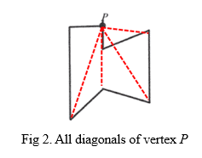

We can summarise and emphasise the importance of the mutual relationship between concept image and concept definition, especially in cases where the concept image is limited and inaccurate.

**Definition development and the relationship with a concept image**

The discussions regarding nonprototypical examples of diagonals contributed to the participants’ understandings of the concept definition of diagonals, which caused various arguments in **Table 2** related to the diagonal definition. The arguments that emerged from participants show that, although the minimal diagonal definition was presented throughout the meeting, they were not always aware of the gap between the prototype example of the diagonal and the analytical aspect arising from the definition. However, during the argumentative discourse, the participants identified the critical attributes of the diagonal as well as others that should not be considered. The evidence for this finding can be found in the last argument in the meeting, which refers to the need to check all the critical attributes found in the diagonal definition. Such a process is the relationship between the concept image and its definition.

Table 2: Arguments that emerged during participants’ diagonal events

|  |  |
| --- | --- |
| **NO.** | **Arguments title** |
| 1 | The diagonal definition is incomplete |
| 2 | The diagonal definition is complete (counterargument to argument 1) |
| 3 | The line segment that connects two vertices in a polygon that is entirely outside the polygon is not a diagonal |
| 4 | The number of diagonals in a concave quadrilateral is two (detailed below, episode 1) |
| 5 | The number of adjacent vertices in a concave quadrilateral is four (detailed below, episode 1) |
| 6 | Eight diagonals adjacent vertices in a concave quadrilateral (detailed below, episode 1; counterargument to argument 5) |
| 7 | Locations of all diagonals in a concave octagon |
| 8 | The line segment that connects a vertex to a side is not a diagonal |
| 9 | The line segment that connects two vertices and is entirely contained in the polygon is a diagonal |
| 10 | The line segment that intersects the side isn’t a diagonal (detailed below, episode 2) |
| 11 | The line segment that intersects the side is a diagonal (detailed below, episode 2; counterargument to argument 10) |
| 12 | The line segment that goes partially inside the polygon and partially outside it is called a diagonal |
| 13 | The line segment direction that connects two adjacent vertices in a polygon is not a critical attribute of diagonal |

Due to space constraints, only two episodes are shared here. A portion of the exchange from the first episode is shown in episode 1:

***Episode 1: The number of diagonals in a concave square***

|  |  |  |  |
| --- | --- | --- | --- |
| 1 | Instructor | How many diagonals does the polygon in front of you have 1234? |  |
| 2 | Sina | There is another diagonal in the middle. From vertex 1 to vertex 4 |  |
| 3 | Instructor | So, how many diagonals does a polygon have? |  |
| 4 | Riwaa | There is only one diagonal |  |
| 5 | Instructor | Why? |  |
| 6 | Riwaa | According to the definition? |  |
| 7 | Instructor | What did you infer from the definition? |  |
| 8 | Riwaa | The only diagonal is the one connecting vertex 1 and vertex 4 | [She only meant those vertices.] |
| 24 | Instructor | What are the numbers of adjacent vertices in the polygon? |  |
| 25 | Riwaa | 2 and 4…..4 and 3 | [She did not explicitly say the number of vertices. But she mentioned the symbol of each vertex by its number in the image.] |
| 26 | Instructor | Are these just the adjacent vertices? |  |
| 27 | All participants | No... | [They mean that there are more adjacent vertices.] |
| 28 | Instructor | Riwaa, please |  |
| 29 | Riwaa | Ahhh, … 2 and 4, 4 and 3, 2 and 1, 1 and 3 |  |
| 30 | Instructor | What do you conclude about vertices 1 and 4? Are they adjacent vertices? |  |
| 31 | Riwaa | No. are not adjacent |  |
| 32 | Instructor | And what about vertices 2 and 3? |  |
| 33 | Riwaa | Are not adjacent. I can connect a diagonal between them |  |
| 34 | Instructor | Are you convinced that the red segment is a diagonal? |  |
| 35 | Riwaa | Yes, of course. The red segment is a diagonal |  |

The discussion related to this episode began with a question: How many diagonals does the polygon in front of you have? [1]. The claim was made by Riwaa [4]. In terms of Toulman’s model, Riwaa’s claim can be broken down as follows:

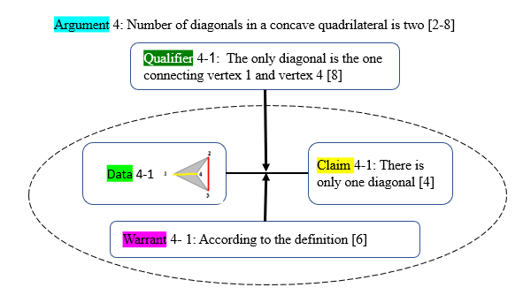

According to argument 4, we can see that the diagonal concept image that Riwaa has is completely external. She does not accept the external diagonal and declares that this polygon has only one diagonal, which is the prototypical one.

Later, the next argument about the number of diagonals adjacent vertices in a concave quadrilateral was made by the same participant, Riwaa:

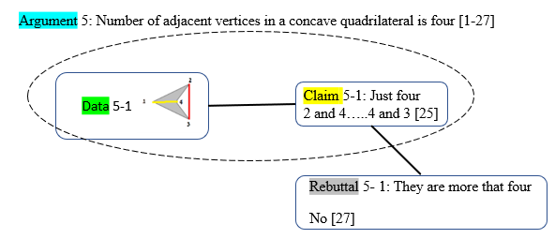

According to argument 5, we can also conclude that Riwaa does not understand the critical attribute of the diagonal definition that is relevant to nonadjacent vertices. Therefore, Riwaa fails to detect all nonadjacent vertices. Immediately, the following argument is made by Riwaa, which is a counterargument to the previous argument:

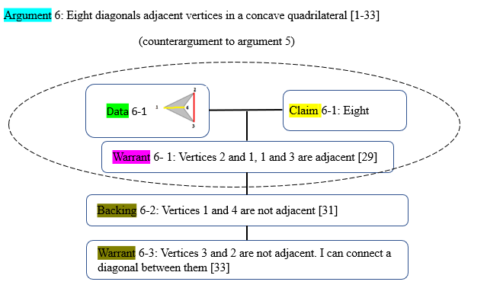

According to the first argument (argument 4), it can be seen that the concept image of polygon diagonal that Riwaa has does not match its definition. Although she looked at the definition and read it, she could not identify the diagonal outside the polygon. She eliminated the example from the examples space for the concept. But during the discussion, especially in the second argument, it became clear that Riwaa did not recognise the concept of "adjacent vertices." As a result, she excluded the external diagonal from all diagonals of the displayed polygon. The evidence is that when she knew all adjacent vertices, she understood the definition well, especially the critical attributes of the diagonal definition. After argument 6 was made, several participants agreed with everything that Riwaa said [33]. This broad consensus is a sign of normative agreement that we believe strengthens the teachers’ utterances in the context of argument 6.

***Episode 2: The diagonals in an octagonal polygon***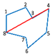

1 Instructor: Is the red segment diagonal or not?

2 Tamir: No … I do not know ... not sure because the segment is above the polygon side. Also, it passes through it.

3 Participants: [noise]

4 Sower: I think that the red segment is a diagonal, regardless of its position relative to the side of the polygon. The most important factor in determining whether a segment is a diagonal is whether it connects two vertices that are not adjacent; in other words, both vertices are not on the same side. For instance, if the segment connects vertices 3 and 4, it would not be considered a diagonal.

5 Tamir: Ahh ... the diagonal is between 4 and 8.

6 Sower: Exactly. If the segment is congruent or across the side that connects vertexes 3 and 4, it cannot be considered a diagonal. Because the two vertices are on the same side. So it is considered a side, not a diagonal.

7 Sajil: Right. It is a side.

8 Sower: The question refers to the segment connecting vertices 4 and 8, not the segment connecting 3 and 4.

9 Instructor: Is it a diagonal, in your opinion?

10 Sower: Yes. It fulfils the definition conditions.

11 Participants: Yeah, right. The segment connects two nonadjacent vertices.

12 Instructor: Is what Tamir said at the beginning true? Can the segment be cancelled from the list of given polygon diagonals if it is congruent with one of its sides? Is the attribute that the segment covers a side part or a whole side critical?

13 Participants: No. This is not critical.

14 Sower: This is how we agreed before: that the segment's location is not essential and is not a critical attribute. Whether internal or external, or even if it covers or intersects the side.

During the discussion, the instructor asked: Is the red segment diagonal or not? [1]. The claim was made by Tamir [4]. In terms of Toulmin's model, Tamir's claim can be broken down as follows:

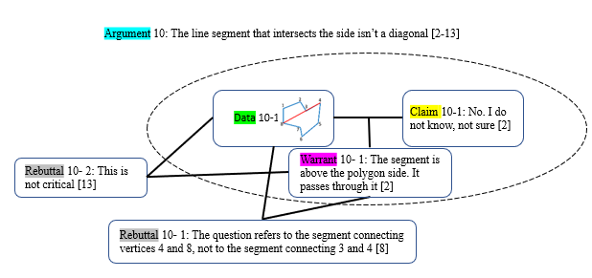

Immediately, the following argument was made by Sower, which is a counterargument to the previous argument:

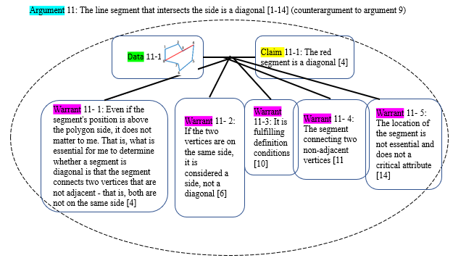

Based on argument 10, it appears that Tamir's understanding of the concept image of a polygon diagonal did not align with its definition. Tamir could not identify a diagonal that intersects the side of the polygon and eliminated that example from the examples space for the concept. However, Sower immediately rebutted Tamir's argument. As a result, Sower presented counterclaims to Tamir's claim and contributed data and part of the warrants, with assistance from Sajal and other participants. This led to a claim collaboratively constructed by Sower and all participants, stating that the segment in question matched the definition of a diagonal. All participants agreed on a critical attribute in the definition and disagreed that the segment location was not a critical attribute for a diagonal definition.

**Tracking participants' development process about polygon diagonal definition**

The results obtained from the prequestionnaire, postquestionnaire, and observations indicated developments in the participants' definition and identification of the polygon diagonal. To illustrate their development processes, we can review one participant, Riwaa, who actively participated in the argumentative discourse during the event analysis. Figure 2 tracks the development in Riwaa's knowledge about polygon diagonals.

A polygon diagonal has two critical attributes: a line segment and two nonadjacent vertices. According to Figure 5, Riwaa’s prequestionnaire findings relevant to a diagonal-polygon definition were inaccurate; her definition, “A straight line that connects a vertex to another vertex,” was missing the full critical attributes of a polygon diagonal because she didn't mention the exact critical attributes such as nonadjacent vertices or segments. Thus, it is not surprising that she did not correctly identify examples and nonexamples of diagonals in the second part of the prequestionnaire. In addition, Riwaa’s reliance on her concept images did not always lead to correct identifications. At the beginning of the class discussion (see episode 1), Riwaa didn't differentiate between sufficient critical attributes (connecting two nonadjacent vertices) and insufficient critical attributes (connecting one vertex to another one). However, on the postquestionnaire, Riwaa wrote a minimal definition, “A line segment that connects two nonadjacent vertices,” indicating she knew the total number of diagonals. She was also able to draw it. This is evidence of she benefitted from the class discussion as well as the other participants' contributions and role in her reconstruction of a polygon diagonal definition.

Fig 5. Riwaa (case study) definition development process

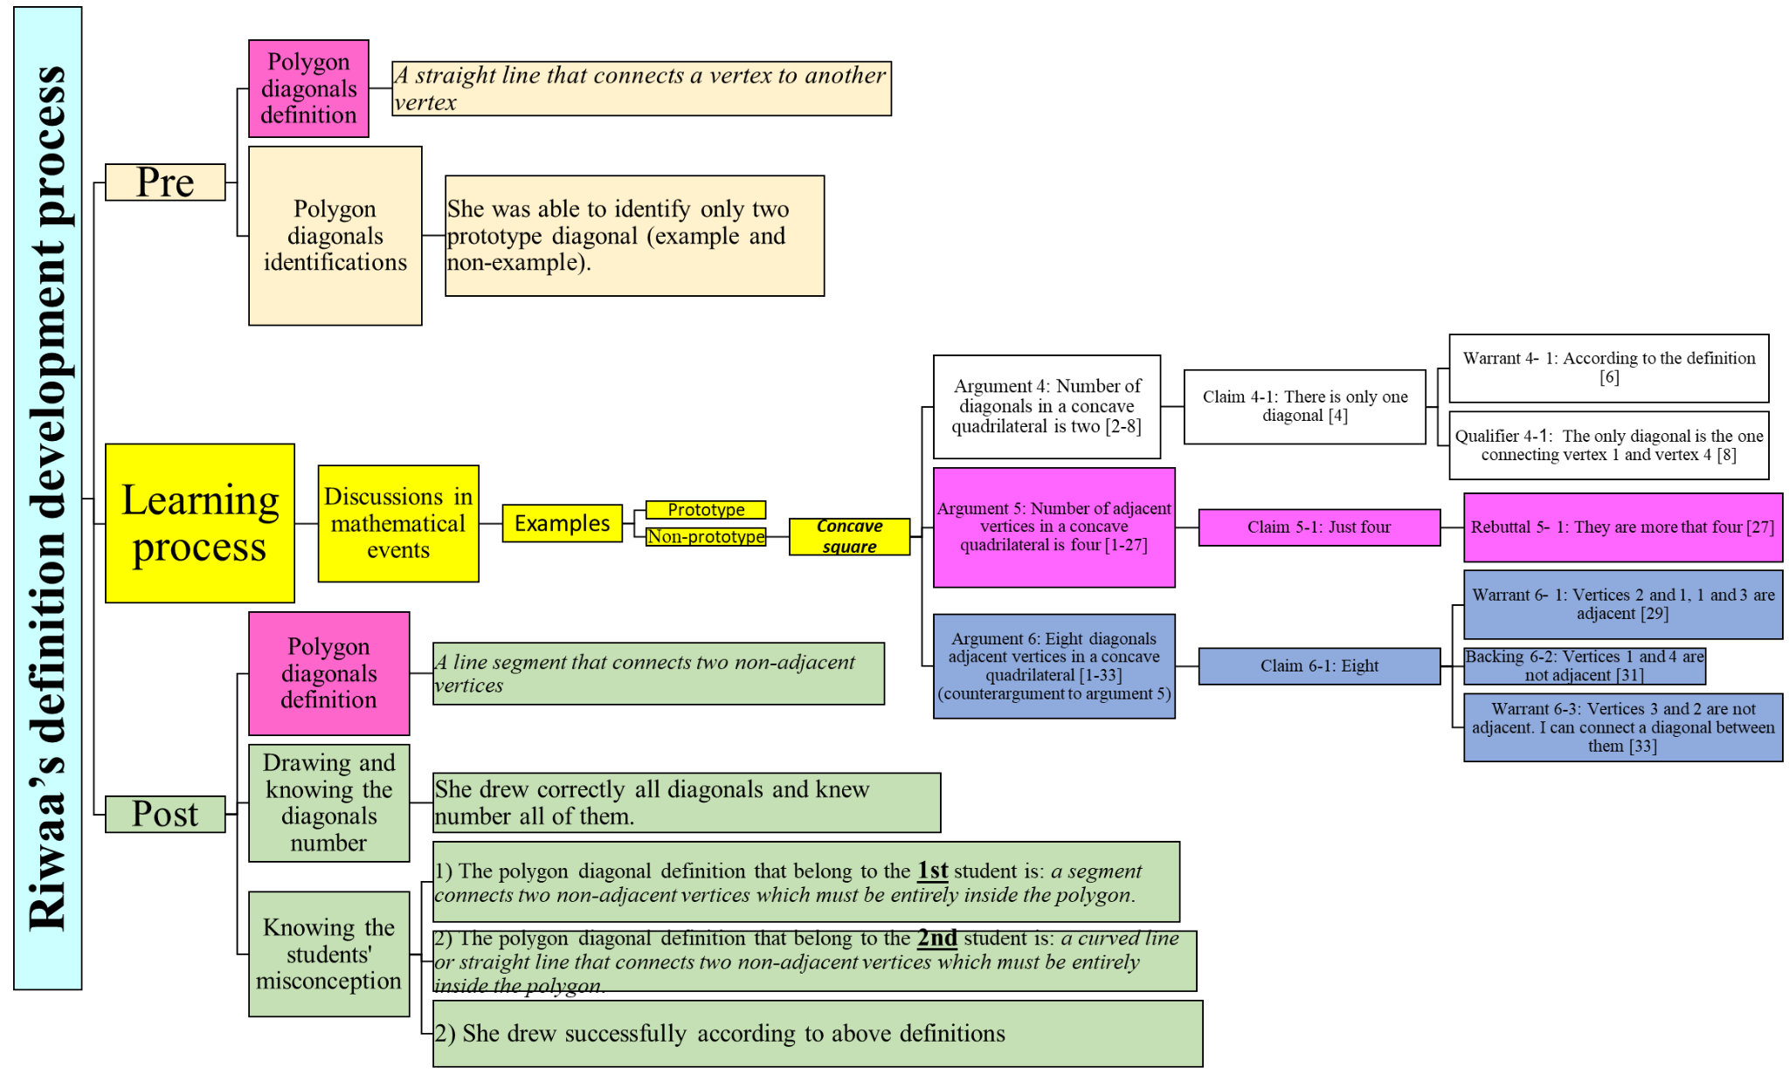

**DISCUSSION**

The current study examined how prospective mathematics teachers of first and second grades define the polygon diagonals concept, how they reconstruct their definition through analyses of mathematical events, and how their concept image develops over time. The study's results show that before engagement in events analyses, prospective teachers were able to identify prototypical examples of polygon diagonals, but they had difficulties identifying nonprototypical examples. These results point to the influence of the noncritical attribute of the diagonal concept—the diagonal is completely drawn inside the shape—and this finding is consistent with previous studies that show the similar findings (Gutiérrez & Jaime, 1999; Haj-Yahya, 2020; Haj-Yahya et al., 2016). Most participants provided incorrect definitions in the prequestionnaire; did not recall the correct definition of polygon diagonal when mentioning noncritical attributes, such as “divide the shape” or “cross the polygon”; or failed to mention sufficient critical attributes of polygon diagonal, such as “adjacent vertex.” This may mean that the prospective teachers relied on a definition that has insufficient conditions, or a nonsufficient definition that fits only some examples of the concept. This result is consistent with previous research (e.g., Berenger, 2018; Haj-Yahya, 2021; Tsamir et al., 2014). However, there was a significant improvement in the postquestionnaires, with more participants providing correct definitions (see Table 2) and correctly identifying examples. When a mathematical event involves the analysis of nonprototypical examples and triggers the concept image of the diagonal, the personal concept definition tends to align more closely with the formal concept definition (Tall & Vinner, 1981).

During the mathematical events analyses and discussions around the attributes of polygon diagonals, the participants' geometrical thinking is influenced by the interconnections and interplay between mathematical ideas, which results in their ideas moving from the second to the third level of Van Hiele's (1958) geometric thinking, meaning that participants recognise the logical structure among attributes of polygon diagonals and make connections between them innovatively. In this study, this was clear in the differences between the prequestionnaire and postquestionnaire. In the prequestionnaire, about 40% of the participants included noncritical attributes incorrectly. However, this tendency dropped drastically in the postquestionnaire. These results align with other studies that emphasise the interplay between the concept image and the concept definition (Fujita & Jones, 2007; Vinner, 1991). In the current study, we can see that improving the concept image might help the learners or teachers more accurately define a geometric concept.

In the postquestionnaire, more participants mentioned nonminimal definitions, including attributes exclusive to nonprototypical examples, such as being external to the polygon or being partly external or internal to the polygon (Vinner & Hershkowitz, 1980). This result both aligns with the claim about the interaction between the concept definition and the concept image (Avcu, 2022; Haj-Yahya & Hershkowitz, 2013; Seah & Berenger, 2016; Vinner, 1991) and helped the participants notice possible misconceptions their future students might face and include attributes that might minimise these misconceptions. The arguments that emerged during the mathematical events analysis strengthen the quantitative results (see Table 2). Here the tendency to provide long lists of the attributes when defining a concept (Leikin & Winicky-Landman, 2001; Linchevsky et al., 1992; Vinner, 1991; Zaslavsky & Shir, 2005) is a positive factor that might help learners develop a more accurate concept image.

The results that emerged in the current study also align with other studies (e.g., Conner, 2011; Pang, 2011) that emphasise the effectiveness of engagement with and analyses of mathematical events in the teaching process. In addition, the results in similar studies (e.g., Moore-Russoet al., 2011) emphasise the effectiveness of applying Tulman’s model (2003), which involves identifying the claims being made, the evidence supporting the claims, and the reasoning connecting the claims and the evidence. In this study, the model helped monitor the participants’ understanding of how they were developing their definitions. The use of the Toulmin model revealed certain participants’ incorrect arguments, which were characterised by missing critical attributes, and showed that their definitions were based on noncritical attributes. It also revealed their limited concept image of polygon diagonals and the disconnect between their concept image and concept definition (arguments 4 and 5). Using the model also revealed the positive impact of shared mathematical ideas in whole class discussions; the counterarguments (see argument 6) that followed incorrect arguments used critical attributes of minimal definition that were presented at the beginning of the discussion. Such a process led other participants to think deeply and reconstruct a diagonal definition and promote diagonal concept images of them as well as maintain the relationship between the two. This highlights the process of understanding, identifying, and correcting misconceptions and shows how participants refined their concept images and developed a more accurate understanding of the definition of polygon diagonals.

In conclusion, engaging in mathematical events involving polygon diagonals proved fruitful in promoting learning among the prospective teachers involved. By sharing their ideas and reasoning processes, they were able to deepen their understanding of the mathematical concept and develop new insights into how it could be taught effectively in the classroom. Given these findings, it is recommended that future research focus on analysing mathematical events related to the definition of other geometric concepts. We recommend that practicing and prospective teachers be exposed to the findings of this study to raise their awareness of specific strategies and help minimise teachers' geometrical difficulties. More research is necessary to gain a deeper understanding of how prospective teachers develop their concept definitions in geometry and mathematics. Conducting additional studies that expose prospective teachers to various geometric and mathematical scenarios would be beneficial.

**Limitations**

The generalizability of our findings may be constrained due to the lack of a more representative research population in this study. It is important to acknowledge another limitation in this study. By considering these aspects, we can enhance the clarity and robustness of our results.

**Data availability**

The data that support the findings of this study are available on request from the corresponding authors.

**References**

Avcu, R. (2022). Pre-service middle school mathematics teachers’ personal concept definitions of special quadrilaterals. *Mathematics Education Research Journal*, 1–46.‏

Berenger, A. (2018). Changes in students' mathematical discourse when describing a square. *Mathematics Education Research Group of Australasia*.‏

Braun, V., & Clarke, V. (2006). Using thematic analysis in psychology. *Qualitative Research in Psychology, 3*(2), 77–101

Conner, A., Wilson, P. S., & Kim, H. J. (2011). Building on mathematical events in the classroom. *ZDM*, *43*, 979–992.‏

Choi, K., & Oh, S. K. (2008). Teachers’ conceptual errors related to the definitions in the area of geometry of elementary school mathematics. *Journal of the Korean Society of Mathematical Education. Series A. The Mathematical Education*, *47*(2), 197–219.

De Villiers, M., Govender, R., & Patterson, N. (2009). Defining in Geometry. In T. Craine & R. Rubinstein (Eds.), *Seventy-first NCTM yearbook: Understanding Geometry for a changing world* (pp. 189–203). Reston, Virginia: NCTM.

Gutiérrez, A., & Jaime, A. (1999). Preservice primary teachers’ understanding of the concept of altitude of a triangle. *Journal of Mathematics Teacher Education, 2*(3), 253–275.

Haj-Yahya, A. (2020). Do prototypical constructions and self-attributes of presented drawings affect the construction and validation of proofs? *Mathematics Education Research Journal*, *32*, 685–718.‏

Haj-Yahya, A. (2021). Students' conceptions of the definitions of congruent and similar triangles. *International Journal of Mathematical Education in Science and Technology*, 1–25.‏

Haj-Yahya, A. (2019). Can classification criteria constitute a correct mathematical definition? preservice and in-service teachers' perspectives. *International Journal of Research in Education and Science*, *5*(1), 88–101.‏

Haj-Yahya, A., Daher, W., & Swidan, O. (2019). In-service teachers' conceptions of parallelogram definitions. In *Eleventh Congress of the European Society for Research in Mathematics Education* (No. 12). Freudenthal Group; Freudenthal Institute; ERME.‏

Haj-Yahya, A., Hershkowitz, R., & Dreyfus, T. (2016). Impacts of students’ difficulties in constructing geometric concepts on their proof’s understanding and proving processes. In *Proceedings of the 40th Conference of the International Group for the Psychology of Mathematics Education: PME 40* (Vol. 2, pp. 345–352).‏

Haj-Yahya, A., Hershkowitz, R., & Dreyfus, T. (2022). Investigating students' geometrical proofs through the lens of students definitions. *Mathematics Education Research Journal (MERJ)*. 1–27.

Harel, G., Selden, A., & Selden, J. (2006). Advanced mathematical thinking: Some PME perspectives. In A. Gutiérrez & P. Boero (Eds.), *Handbook of research on the psychology of mathematics education: Past, present and future* (pp. 147–172). Sense.

Hill, C. H., Rowan, B., & Ball, D. L. (2005). Effects of teachers’ mathematical knowledge for teaching on student achievement. *American Educational Research Journal, 42*(2), 371–406.

Leikin, R., & Winicky-Landman, G. (2001). Defining as a vehicle for professional development of secondary school mathematics teachers. *Mathematics Teacher Education and Development,* *3,* 62–73.

Linchevsky, L., Vinner, S., & Karsenty, R. (1992). To be or not to be minimal? Student teachers views about definitions in geometry. In W. Geeslin & K. Graham (Eds.), *Proceedings of the Conference of the International.*

Marchis, I. (2012). Preservice primary school teachers' elementary geometry knowledge. *Acta Didactica Napocensia*, *5*(2), 33–40.

Markovic, Z., & Romano, D. A. (2013). Gaining insight of how elementary school students conceptualize geometric shape of parallelogram*. Open Mathematical Education Notes*, *3*, 31–41.

Malzahn, K. A. (2002). The 2000 national survey of science and mathematics education: Status of elementary school mathematics teaching. Chapel Hill, NC: Horizon Research, Inc.

Moore-Russo, D., Conner, A., & Rugg, K. I. (2011). Can slope be negative in 3-space? Studying concept image of slope through collective definition construction. *Educational Studies in Mathematics*, *76*, 3–21.‏

Pang, J. (2011). Case-based pedagogy for prospective teachers to learn how to teach elementary mathematics in Korea. *ZDM*, *43*, 777–789.

Pickreign, J. (2007). Rectangles and rhombi: How well do pre-service teachers know them? *Issues in the Undergraduate Mathematics Preparation of School Teachers*, 1.

Seah, R., Horne, M., & Berenger, A. (2016). High school students' knowledge of a square as a basis for developing a geometric learning progression. In B. White, M. Chinnappan & S. Trenholm (Eds.), *Proceedings of the 39th Annual conference of the Mathematics Education Research Group of Australasia (MERGA) Opening Up Mathematics Education Research* (pp. 584–591). Adelaide, Australia.

Shahbari, J. A. (2022). Investigation of mathematical-pedagogical knowledge among prospective teachers in the early childhood program at the college for Arabic speakers. In A. Rasslan, & D. Hasidov (Eds.), *Special issues in early childhood mathematics education research* (pp. 246–265). Leiden, The Netherlands: Brill.

Shrestha, R. (2022). Teachersʼ content knowledge and pedagogical content knowledge for teaching: As preconditions to develop studentsʼ mathematical thinking at grade 1–3 in Nepal. *NUE Journal of International Educational Cooperation, 15*, 123–132.

Stockero, S. L., Leatham, K. R., Ochieng, M. A., Zoest, L. R., & Peterson, B. E. (2019). Teachers’ orientations toward using student mathematical thinking as a resource during whole‑class discussion*. Journal of Mathematics Teacher Education*, 1–31.

Tall, D., & Vinner, S. (1981). Concept image and concept definition in mathematics with particular reference to limits and continuity. *Educational Studies in Mathematics*, *12*(2), 151–169.‏

Tirosh, D., Tsamir, P., Levenson, E. S., & Barkai, R. (2019). Using theories and research to analyze a case: Learning about example use. *Journal of Mathematics Teacher Education*, *22*(2), 205–225.

Toulmin, S. (2003). *The Uses of Argument* (2nd ed.). Cambridge: Cambridge University Press. doi:10.1017/CBO9780511840005

Tsamir, P., Tirosh, D., Levenson, E., Barkai, R. & Tabach, M., (2014). Early-years teachers' concept image and concept definition: Triangles, circles and cylinders. *ZDM Mathematics Education, 47*(3), 1–13.

Usiskin, Z., Griffin, J., Witonsky, D., & Willmore, E. (2008). *The Classification of Quadrilaterals: A Study of Definition*. Information Age Publishing.

van Hiele, P. M., & van Hiele, D. (1958). A method of initiation into geometry. In H. Freudenthal (Ed.), *Report on Methods of Initiation into Geometry* (pp. 67–80). Groningen, Netherlands: Walters.

Vinner, S. (1991). The role of definitions in the teaching and learning of mathematics. In D. Tall (Ed.), *Advanced Mathematical Thinking* (pp. 65–81). Kluwer Academic Publishers.

Vinner, S., & Hershkowitz, R. (1980). Concept image and common cognitive paths in the development of some simple geometrical concepts. In R. Karplus (Ed.), *Proceedings of the Conference of the International Group for Psychology of Mathematics Education* (pp. 177–184). University of California, Berkeley.

Wilson, J. C., & Schmidt, S. L. (2005). Diagnosing and remedying students' misconceptions about polygon diagonals. *Journal for Research in Mathematics Education*, *36*(4), 270–303.

Zaslavsky, O., & Shir, K. (2005). Students’ conceptions of a mathematical definition. *Journal of Research in Mathematics Education,* *36*(4), 317–346.

Appendix 1: Is the highlighted segment a polygon diagonal? (prequestionnaire)

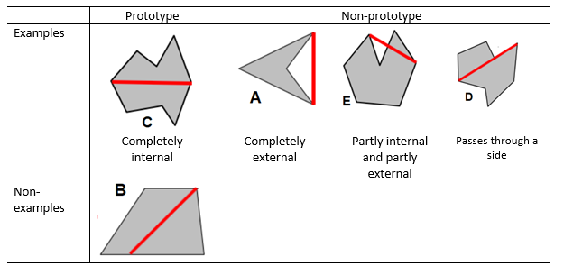

Appendix 2: Identification of students' misconception (postquestionnaire)

|  |  |  |  |
| --- | --- | --- | --- |
| Item | Detail | |  |
| *First* | Write an accepted mathematical definition of polygon diagonal concept. | |  |
| *Second* | Given the following polygon:    **Question** 1: What is the number of all diagonals from vertex *P*?  **Question** 2: Draw all of them. | |  |
| *Third* | The following task was given to the students related to polygon diagonal:  *Different polygons are shown below.*  *For each polygon, draw all diagonals from vertex A.*    The answers for two students were as follows: | |  |
|  | First student | Second student |  |
|  |  |  |  |
|  | **Question** 1: According to the two answers above, analyse what each student understands about the polygon diagonal concept. In other words, write down the definition they both obtained for the polygon diagonal.  **Question** 2: Shown below are two polygons. Draw all the diagonals from *vertex* A according to what the two students understood about the diagonal concept. | |  |