Table 1: Estimated Food Waste Per Household in Israel* in 2022

|  |  |  |  |  |  |  |  |
| --- | --- | --- | --- | --- | --- | --- | --- |
| **Waste per household monthly, in NIS** | **Agriculture** | **Packaging and Handing** | **Industrial Processing** | **Retail and Distribution** | **Institutional Consumption** | **Household Consumption** | **Total** |
| Fruit & vegetables | 68 | 23 | 2 | 81 | 39 | 126 | 340 |
| Grains & legumes | 2 | 1 | 2 | 22 | 34 | 95 | 156 |
| Meat, eggs, fish | 12 | 2 | 15 | 54 | 30 | 46 | 160 |
| Milk & dairy products | 4 | 1 | 1 | 5 | 4 | 18 | 34 |
| Total | 87 | 27 | 20 | 163 | 108 | 285 | 689 |

*A loss of NIS 689 per household per month reflects waste along the entire value chain, which includes, among other things, the direct expenditure of households.

Source: BDO estimates

Table 2: Food Waste at each Stage of the Value Chain (in thousands of tons)

|  |  |  |  |  |  |  |  |
| --- | --- | --- | --- | --- | --- | --- | --- |
|  |  | **Agriculture** | **Packaging and Handling** | **Industrial Processing** | **Net import cleaned for various uses** | **Retail and distribution** | **Consumption** |
| Fruit & vegetables | Rate of waste* | 12% | 5% | 3% | 299+ | 9% | 21% |
| Waste in thousands of tons | 522 | 181 | 20 | 344 | 706 |
| Out of total in thousands of tons | 4233 | 3711 | 667 | 3775 | 3431 |
| Grains & legumes | Rate of waste | 5% | 4% | 5% | +1,243 | 3% | 20% |
| Waste in thousands of tons | 21 | 15 | 18 | 48 | 309 |
| Out of total in thousands of tons | 403 | 382 | 366 | 1592 | 1544 |
| Meat, fish, & eggs | Rate of waste | 5% | 1% | 5% | 170+ | 5% | 12% |
| Waste in thousands of tons | 38 | 5 | 30 | 42 | 102 |
| Out of total in thousands of tons | 789 | 751 | 600 | 855 | 846 |
| Milk & dairy products | Rate of waste | 4% | 1% | 1% | 9+ | 2% | 6% |
| Waste in thousands of tons | 64 | 9 | 19 | 29 | 103 |
| Out of total in thousands of tons | 1714 | 1651 | 1608 | 1739 | 1710 |
| Total | Rate of waste | 9% | 3% | 3% | 1720+ | 6% | 16% |
|  | Waste in thousands of tons | 645 | 209 | 88 |  | 463 | 1220 |
|  | Out of total in thousands of tons | 7140 | 6495 | 3240 |  | 7991 | 7531 |
| Bottom line: Cost of waste |  | 20% of the loss = 4.5 billion NIS | | |  | 80% of the waste = 18.6 billion NIS | |

|  |
| --- |
|  |

**Table 3: Estimated food waste in Israel, in thousands of tons per year**

|  |  |  |  |  |  |  |
| --- | --- | --- | --- | --- | --- | --- |
| **Waste in Thousands of Tons** | **Agriculture** | **Packaging and Handling** | **Industrial Processing** | **Retail and Distribution** | **Consumption** | **Total** |
| Fruit & vegetables | 522 | 181 | 20 | 334 | 706 | 1773 |
| Grains & legumes | 21 | 15 | 18 | 48 | 309 | 411 |
| Meat, eggs, & fish | 38 | 5 | 30 | 42 | 102 | 217 |
| Milk & dairy products | 64 | 9 | 19 | 29 | 103 | 224 |
| Total | 645 | 209 | 88 | 463 | 1220 | 2624 |

Table 4: Food Waste Rates in Israel (by sector)

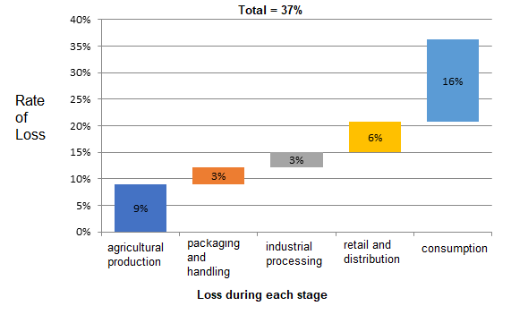

Table 5

|  |  |
| --- | --- |
| 18.6 billion NIS | Food waste from production through consumption |
| 4.5 billion NIS | Food loss through and including the industrial processing stage |
| 23.1 billion NIS | Value of lost and wasted food* |
| 1.4% | Food waste within the Gross National Product |

Source: BDO estimates