**3. Food Loss and Food Rescue During Retail and Distribution[1]**

**5.5 billion NIS** worth of food is lost and wasted during retail and distribution

**370,000 tons of food** could be rescued during retail and distribution

In 2022, food sales in Israel were assessed at approximately 100 billion NIS annually. This includes food sold to consumers in chain stores, open markets (*shuks*), neighborhood food stores, by small retailers, and in the institutional sector. About 460,000 tons of food is lost and wasted during retail and distribution. This is valued at about 5.5 billion NIS, representing 5.5% of the total retail sales of food. Of this, about 370,000 tons, worth some 4.4 billion NIS, could be rescued.[2] Additionally, the environmental cost of food loss during retail and distribution is approximately NIS 860 million.[3]

**Table: Financial Loss During Retail and Distribution**

|  |  |  |  |
| --- | --- | --- | --- |
|  | **Loss in millions of NIS** | **% Lost** | **Loss in thousands of tons** |
| Bread & baked goods | 275 | 11% | 13 |
| Grains & legumes | 500 | 2% | 35 |
| Dairy products & refrigerated foods | 170 | 2% | 29 |
| Fresh fruits & vegetables | 2700 | 11% | 344 |
| Meat, eggs, & fish | 1800 | 5% | 42 |
| Frozen foods & misc. | 60 | 1% | 6 |
| **Total** | **5500** |  |  |

Loss during retail and distribution mainly involves foods with a short shelf life that have passed their expiration date, and those found to have aesthetic defects or damage to their packaging during the marketing process. Food manufacturers, distributors, and retailers have an economic incentive to minimize food loss through effective supply chain management, maintaining proper storage conditions, and inventory planning. However, this incentive is nullified by agreements that allow distributers and retailers to return a certain percentage of unsold food products to the manufacturers at no cost. Even with optimal planning for distribution and marketing, some food surpluses are inevitable, because retailers are expected to provide a wide and varied and food supply at all times. Consumers become quickly dissatisfied when the food products they want are not available. Therefore, the cost to retailers due to poor inventory is far greater than the cost of creating surpluses. In other words, surplus food is an inherent part of the retail sales process. Discarding food surpluses rather than rescuing them is an economic failure of the market. One challenge facing government policy-makers is to create a system of incentives for salvaging surpluses and making them available to people in need. Naturally, the rate of loss is higher for fresh or perishable food products, such as fruits, vegetables, breads and baked goods.

**Graph 1: Loss in Retail and Distribution Segment for Selected Foods**

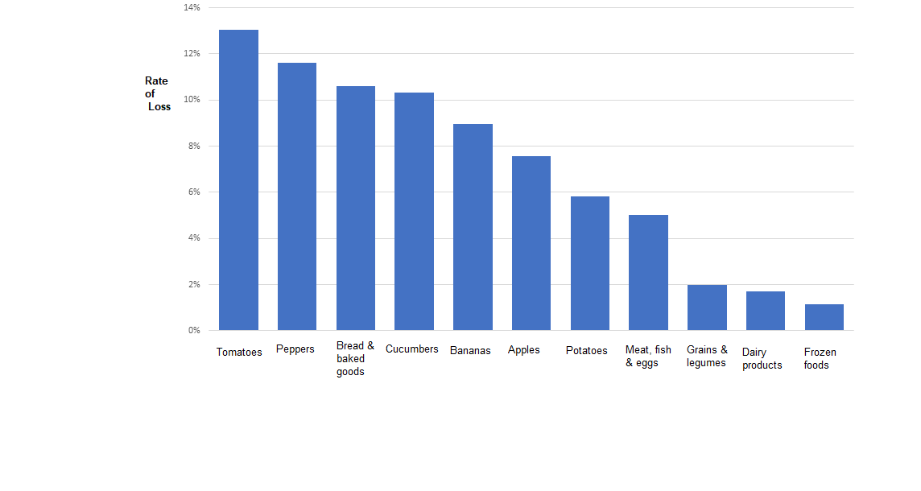

An international comparison found that the rate of food loss during the retail and distribution segment in Israel is similar to that in most developed countries, despite the potential for greater loss in Israel due to its hot weather conditions. This indicates that inventory management during retail and distribution in Israel is conducted according to relatively high standards. In developing countries, loss rates tend to be higher, mainly due to inadequate distribution, storage, and marketing.

In recent years, food marketers in Israel have made efforts to establish advanced logistics centers, inventory management systems, online demand planning, and maintenance of the cold chain in distribution. This has reduced food loss during retail and distribution.

**Graph 2: International Comparison of Food Loss**

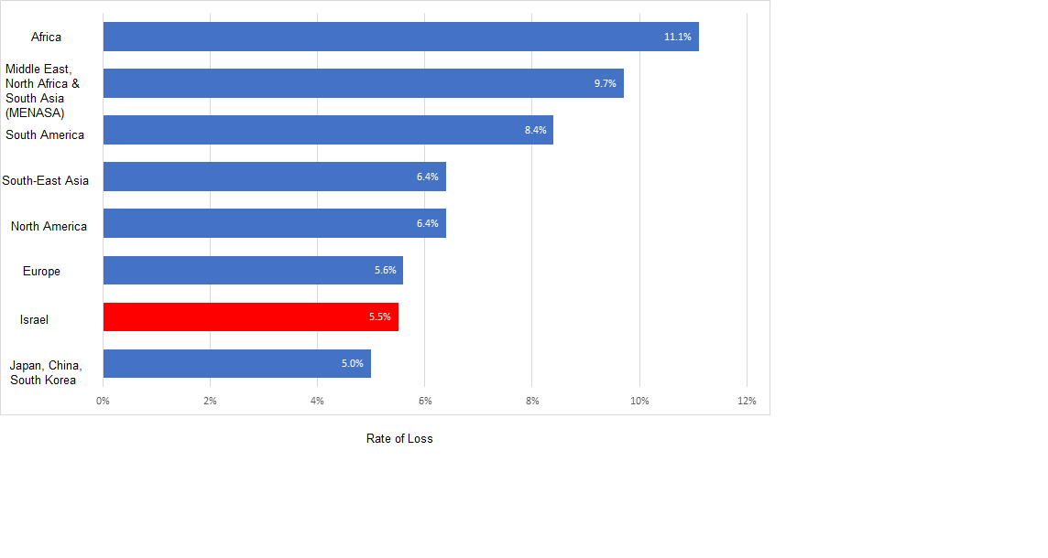

In 2022 there was a trend among consumers towards purchasing online or through chain stores, both of which are characterized by a relatively low loss rate. Accordingly, the rate of food loss in this segment decreased slightly this year.

**Figure: Consumers’ Transition Towards Shopping Venues with Lower Loss Rates**

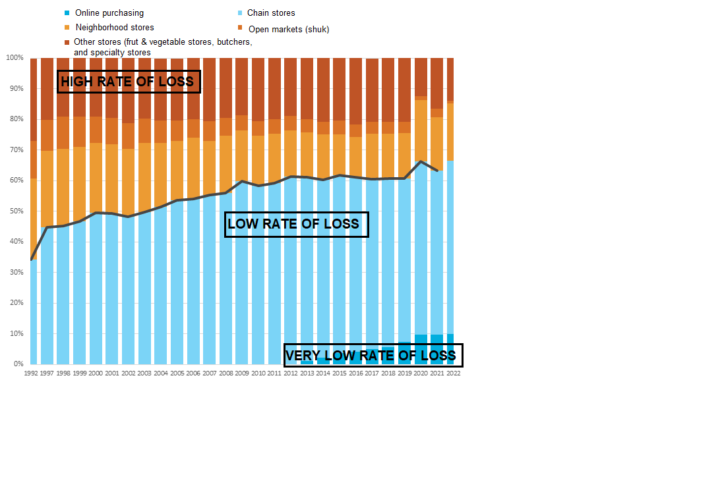

Online retail may also have an environmental benefit by reducing the number of consumers’ trips to stores, and by consolidating shipments to multiple addresses on one delivery route. A 2014 study conducted at the University of Washington found that optimizing shipment and distribution routes could reduce carbon emissions by up to 80%, as compared to when consumer drive to stores to make purchases.[4]

Loss during the retail and distribution segment has a high economic cost since it includes all the investment made thus far, in food cultivation, production, packaging, and transportation. This food is ready for marketing and consumption, but is lost before reaching the final consumer. The vast majority of the food lost at this stage is potentially salvageable. Some 5.5 billion NIS worth of food lost at this stage; approximately 370,000 tons, including 345,000 tons of fruits and vegetables. Of this, it is estimated that some 4.4 billion NIS worth of food could be salvaged. This represents about 70% of the food salvaging necessary to close the nutritional gap for people living with food insecurity in Israel [for more information, see chapter 7]. It would also would prevent excess healthcare costs valued at about NIS 4.3 billion per year [see chapter 8].

**There are three main factors behind food loss during retail and distribution:**

1. **Perishability (short shelf life):** Food products have a limited shelf life, and it is inevitable that some will pass their expiration date before being sold. Food that has passed its expiration date cannot be sold or given to those in need. To minimize food loss during retail and distribution, there is a need for inventory management systems that statistically assess the rate of consumption compared to the inventory. Also, incentives to salvage food may be developed. For example, foods that are nearing (but have not yet passed) their expiration date could be sold at a discount or donated to those in need. There should be a re-examination of the policy for food validity classification. Additionally, consumers should receive explanations regarding the meanings of various markings related to food expiration dates.
2. **Aesthetic defects in products or packaging**. Aesthetic defects lower the product's market value, but in most cases, there has been no damage to its nutritional value. Loss and waste of this nutritious food due to low market value reflects an economic failure.
3. **Damaged food**. Damage during logistical processes represents a relatively minor factor in food loss because maximum efforts are already being made to minimize it. Damage can be caused at various stages of retail and distribution, such as broken eggs, spilled or dropped products, spoiled fruits and vegetables, leftovers from the butcher shop or delicatessen, etc. This food is not salvageable for human consumption, but it can be used for feeding animals or for industrial purposes.

**Actions Undertaken to Reduce Food Loss During Retail and Distribution**

Retailers and distributors already make efforts to reduce loss and salvage food, due to economic considerations. This is done in several ways:

* Sales and promotions of surpluses: Retailers offer discounts on perishables nearing their expiration date or products with damaged packaging.
* Food donations: This may be coordinated centrally through contracts with food rescue associations or as local initiatives by various branches.
* Food producers may donate surpluses or perishables to food rescue associations.
* When it is noted at the factory that products have damaged packaging or aesthetic defects but are still safe and suitable for human consumption, they may be sold to various secondary markets.

1. In this Report, loss during the retail and distribution segment refers to losses incurred from the end of the production phase through sale to the consumer. This entails loss or waste of finished products that are ready to be marketed by the manufacturers, loss at wholesalers, returns from retailers to manufacturers, and loss during retail.
2. These figures for the rate of salvageable food in the retail and distribution segment were assessed using the BDO model, based on data from the Israel Central Bureau of Statistic and information from major marketing chains.
3. This environmental cost was not embodied in the market value of the lost and wasted food. That is, the market value of lost food does not include the cost of natural resources wasted during retail and distribution.
4. <http://depts.washington.edu/sctlctr/sites/default/files/research_pub_files/PacTrans-Changing+Retail_Business_Models.pdf>