**4. Food Waste and Food Rescue at the Institutional Consumption Level**

**226,000** tons of food were lost and wasted in institutional consumption settings in 2022

**5%** increase in food waste from institutional consumption in 2022 compared to 2021

In 2022, Israeli households consumed a significant proportion of their food outside the home, in various institutional settings.[1] This played a large role in the increased rate of food waste.

According to the 2022 Food Waste Report, some 2 million people in Israel ate at least one meal (an average of 1.1 meals) outside the home each day.[2] This represents a total of about 690 million meals, comprising some 770 thousand tons of food, consumed outside the home. The financial expenditure on food purchased and consumed outside the home was about 14 billion NIS per year.

Food waste at the institutional consumption level amounted to 226 thousand tons, an increase of about 5% compared to 2021. The cost of this waste was about 3.6 billion NIS, in addition to the environmental cost of about 255 million NIS.[3]

*“It is possible to save about 74 thousand tons of food per year, with a value of about 1.2 billion NIS, equivalent to about 64 million meals per year, on average.”*

It would be possible to salvage about a third of the food that is lost or wasted in institutional settings each year; an average of about 64 million meals comprising 74,000 tons of food valued at 1.2 billion NIS.

**Graph 1: Rate of Food Waste from Institutional Consumption, by Setting**

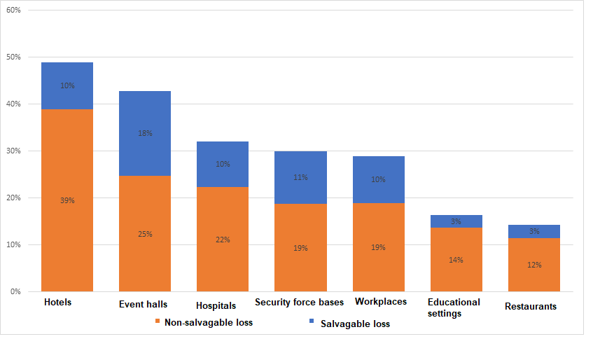

**Table 1: Summary of the Estimated Food Waste in Institutional Settings**

|  |  |  |  |  |  |  |  |  |
| --- | --- | --- | --- | --- | --- | --- | --- | --- |
|  | **Security forces** | **Event halls** | **Workplaces** | **Hotels** | **Hospitals** | **Restaurants** | **Educational settings** | **Total** |
| **Relevant population (thousands of people)\*** | 239 | 117 | 430 | 57 | 184 | 488 | 413 | 1,928 |
| **Meals consumed per year (millions)** | 150 | 47 | 94 | 34 | 89 | 200 | 74 | 689 |
| **Food consumed per year (thousands of tons)** | 171 | 122 | 165 | 51 | 71 | 150 | 37 | 767 |
| **Food waste per year (thousands of tons)** | **51** | **52** | **48** | **25** | **23** | **21** | **6** | **226** |
| **Rate of waste** | 30% | 43% | 29% | 49% | 32% | 14% | 16% | 29% |
| **Amount of wasted food that is rescuable (thousands of tons)** | **19** | **22** | **17** | **5** | **7** | **4** | **1** | **74** |

* This figure was estimated according to the number of working days relevant for each category, and distinguishes between the various populations within each category.

Routinely, about 20% of the food consumed in Israel is eaten in the framework of institutions with catered meals: in cafeterias of factories and workplaces, on bases for the army, police, and Israel Security Agency (Shin Bet), in hotels, event halls, restaurants, schools, hospitals, etc.[4] Because a large number of people eat together in one place, there is a significant potential for reducing waste and saving food. When feeding a large number of people in institutional settings, some food waste is inevitable because there is a need to ensure an adequate amount of food that is varied enough to suit people’s preferences. There are also structural factors of uncertainty that must be considered.

In recent years, most institutional kitchens have been operated by external companies with a high level of expertise in the field. They strive to achieve maximum economic efficiency and minimize waste. Additionally, the Coronavirus crisis forced caterers to change their serving methods, which led to a reduction in waste.

Nevertheless, it is not possible for catering companies working in this field to plan only according to the average number of diners. They must calculate a margin of safety to ensure that they provide an adequate supply of food even on days in which the number of diners exceeds the average.

The analysis in this Report shows that institutional settings with a high level of uncertainty regarding the number of diners tend to have a higher amount of waste. For example, at open military bases or workplaces where diners have other alternatives, waste is greater than in institutional settings where there is less uncertainty about the number of diners, such as schools or prisons (not to equate the two).

In addition, there is greater waste when a higher variety of dishes are offered due to uncertainty about diners' preferences. At event halls and hotels, where a wide variety of dishes are offered, the waste is higher compared to workplaces or military and police bases.

The nature of the food service and the population of diners also affect the extent of waste. In restaurants, where the food is prepared to order and consumers pay according to their actual consumption, the waste rate is lower than in settings that offer buffet-style serving, where the food is prepared in advance.

In 2022, the value of potentially rescuable food that was lost or wasted in the institutional sector was estimated at 1.2 billion NIS. This represents an increase over the previous year, which is attributable to a return to routine activity patterns after the Coronavirus crisis, the impacts of which were still being felt in 2021. Approximately 40% of the salvageable food waste occurred in event halls where we estimated that about 22,000 tons of food worth about 464 million NIS could have been rescued in 2022. A significant amount of food could also be rescued from security force bases, hotels, and workplaces. We estimated that in 2022, food worth between 110 and 190 million NIS could have been saved from each of these types of settings. Food worth 55 million NIS could be rescued from hospitals. In restaurants, there is a significant amount of potentially salvageable food, worth approximately 150 million NIS per year. However, because of the physical distances between restaurants and lack of critical mass at each, the feasibility of actually salvaging food from restaurants is low.

**Table 2: Summary of the Value of Rescuable Food Wasted by Institutional Consumption Each Year**

|  |  |  |  |  |
| --- | --- | --- | --- | --- |
|  | **Meals consumed (in millions)** | **Market share (in millions of NIS)** | **Value of wasted food (in millions of NIS)** | **Value of rescuable food (in millions of NIS)** |
| **Event halls** | 47 | 2,519 | 1,077 | 464 |
| **Hotels** | 34 | 1,341 | 547 | 113 |
| **Hospitals** | 89 | 560 | 179 | 55 |
| **Security forces** | 150 | 1,427 | 428 | 162 |
| **Workplaces** | 94 | 1,838 | 531 | 187 |
| **Educational settings** | 74 | 590 | 96 | 17 |
| **Restaurants** | 200 | 5,499 | 782 | 152 |
| **Total** | **689** | **13,773** | **3,641** | **1,150** |

The high yield of food that could be rescued in the institutional consumption sector is due to the relatively high value of the meals and the relatively low logistical costs of collecting food from large kitchens that tend to be concentrated in city centers and industrial areas.

The 74,000 tons of food per year that could potentially be saved at the institutional consumption level constitute approximately 15% of the amount of food required to complete the nutritional gap in food insecurity in Israel [see Chapter 7]. This has the potential to reduce excess health costs valued by approximately 0.9 billion NIS per year [for more, see Chapter 8].

1. In this Report, the institutional sector includes food consumption in event halls, hotels, hospitals, security force bases, workplaces, educational institutions, and restaurants.
2. The BDO model for food waste in the institutional sector is based on data from the Israel Central Bureau of Statistics, the National Restaurant Association, the Association of Owners of Halls and Event Venues in Israel, and Israeli security forces.
3. This environmental cost was not embodied in the market value of the food wasted in this sector.
4. The model calculated the average size of a meal for each category, according to its characteristics.