part ii

C H A P T E R 3

The Survey of New Spain’s Woodlands: In Search of timber for the Spanish Real Armada (1760–1790)

In contrast to Chapters 1 and 2, this one addresses the exploration of forest resources in the Viceroyalty of New Spain—an overseas territory directly under the authority of the Spanish Crown—carried out by the viceregal administration and military officers. The issue reveals Spain’s interest in exploiting forest resources in the different regions of the Gulf of Mexico and the Caribbean Sea within the framework of the naval development policies unleashed in the second half of the 18th century.
These efforts resulted in a better understanding of the forest resources of the provinces of Veracruz, Oaxaca, Laguna de Términos, and Tabasco, as well as Louisiana and Cuba, and led to logging operations in places like Chimalapas, where pines for masts were cut under the patronage of the Crown, as well as the granting of the first asientos for the harvesting of cedar and mahogany near the Coatzacoalcos River and the settlement of Tlacotalpan. Like Chapter 2, historical documents are interrogated for the identification of logging sites used to meet the needs of the Spanish Navy.

The Exploitation of Timber for the Shipbuilding Industry in the Viceroyalty of New Spain in the 18th Century

During the reign of Philip V, several figures of the Spanish Enlightenment, such as Francisco de Seijas y Lobera, Jerónimo de Uztáriz, and José del Campillo y Cossío described different aspects of the administration of the Spanish Empire and made numerous proposals for fiscal, commercial, administrative, political, and social reform. Concerning trade reform, all of them gave priority to reinforcing the Real Armada, whose task was to protect and uphold commercial exchange with the American colonies. Their works emphasised the importance of American forest resources, which were both abundant and rich in excellent timber, especially cedar and mahogany, which could be used by the Spanish naval industry to build new ships-of-the-line, frigates, and smaller vessels, and thus play their part in the Spanish naval revival. A good example of this is the following passage of Seijas y Lobera’s Gobierno militar y político del reino imperial de la Nueva España (1702):

if to build ships and powerful fleets in both seas [the South and Northern seas] timber is needed, there is no better country in the world for it than New Spain, because, like in the other countries in the [West] Indies, cedar and mahogany are found in both coastlines to make the ship hulls, and for the masts there are guayacanes, pine trees and other trees, like cugues and marías.

Although Seijas y Lobera’s proposal was rejected by Philip V, the idea of using American forest resources stayed alive and grew over time, as reflected by the important economist and influential merchant Jerónimo de Uztáriz, whose Theorica y practica de comercio, y de marina argued that:

a great asset for Your Majesty is the abundance and quality of timber, pitch, and tar in American islands and continent […] and it is a great advantage because if [ships] built in Europe last twelve to fifteen years, [American ones] go on for 30, being made with the hardiest cedar and other superior woods; this also means that they need less maintenance and repairs. That is apart from the fact that in combat cedar absorbs bullets without splintering, which in European ships kills and wounds many.

Unfortunately, this thinker’s interest in intensifying the exploitation of American woods was, again, ignored by state officials. However, the idea did not go away, and came up time and time again in other reformist works, such as Nuevo sistema de gobierno económico para la América (1743), written by José del Campillo y Cossío, ex-governor of Cuba: “cedar, mahogany, and other beautiful woods, but also ship masts, boards, pitch, tar, and other materials that we currently buy from the Baltic, are available at the Indies […] and we could take them there and sell them cheap”.
These efforts to promote the use of American woods in royal ships could not be brought to fruition because of the opposition of the traditionalist party, led by Antonio Gaztañeta, which saw these attempts to encourage naval construction in the Indies with the support of José Patiño as a threat to the metropolitan naval establishment. In addition, previous experiences in New Spain, like the creation of a major shipyard in Coatzacoalcos and another one for smaller ships in Campeche had met with little success. The first attempt to create a royal shipyard, in Coatzacoalcos, aimed to make use of the region’s wood and also the city’s easy access to the mountainous regions of Oaxaca and Veracruz, where pine trees for masts were to be found in abundance. The earliest proposal to build a shipyard there was floated in 1701 by the admiral of the Armada de Barlovento, Don Guillermo Morfi, but nothing was done at the time. Afterwards, the idea was revisited by viceroys Marquis of Valero (1716–1722) and Marquis of Casa Fuerte (1722‑1734), but it was only the latter that could see the project moving ahead, when José Patiño authorised the construction of two ships-of-the-line in Coatzacoalcos in 1726. However, the project was beset with problems from the start, including disagreements with the Creole elite and with naval officials in Havana, who, in essence, refused to send ship carpenters to Mexico. For these reasons, the project was downsized to the construction of a single ship, the 60-gun San José, alias “Nueva España”, with a 66-cubit keel, built over three years (1732–1735) at enormous cost for the Real Erario (431,000 pesos de a ocho). Finally, the government, in view of the administrative and logistic problems encountered and the high cost, decided to cancel the project and continue ship construction in Havana.
It is worth pointing out that, while these projects were in the planning stage, two surveys were undertaken to identify woodland that could be used by the naval industry. One was carried out in 1726 by the navy’s general lieutenant, Antonio Serrano, in the woods of the isthmus of Tehuantepec, where he spotted good pine trees and other useful species. The second survey, by squadron leader Rodrigo de Torres, examined woodland in the region of Coatzacoalcos in 1733, following the complaints filed by Juan Pintado and Pedro de Torres at the beginning of the construction of the Nueva España in the shipyard situated on the river mouth.
Following these failed attempts, the next naval construction programmes for the Marina Real could not be brought forward until the 1760s. The change of policy was triggered by Spanish defeat in the Seven Years War (1756–1763), in which Spain had been involved since January 1762, after the signature of the III Family Pact by French and Spanish Bourbons on 15 August 1761. The occupation of Havana and Manila and several territorial losses shocked Charles III’s government, who immediately ordered reforms to reinforce the navy and the army in both the metropolis and the colonies. This period, which began in 1765 and lasted until the king’s death in 1788, was crucial for military reform in Spain, especially concerning the Armada Real. The reorganisation of the service in the 1780s turned Spain into the second naval power in Europe.
One major change was that the Spanish ceased building ships “English style”, as was still done while the Marquis of Ensenada was in office, and began constructing them “French style”. In 1765, the French shipbuilder Francisco Gautier was put in charge of ship design and the supervision of shipyard work. In addition to this, in 1772 Gautier wrote an important report entitled Observaciones sobre el estado de los montes de España, nota del consumo de la madera de construcción, que, en cada año, se considera necesaria en los departamentos de Ferrol, Cartagena y Cádiz; y proyecto para aprovisionar estos arsenales de maderas de América, in which he described the state of Spanish woodlands and suggested the use of American woods in metropolitan shipyards: “Cádiz uses American wood which is brought at great cost but with little profit, not because it lacks in quality, but because of the carelessness with which it is dispatched [to the metropolis], where it arrives badly cut, badly arranged, and poorly sorted”. In this passage, Gautier was saying more than it seems, because what he was really suggesting was to shift the weight of wood supply from metropolitan shipyards to the American forests; as he pointed out, there was an exchange of wood between Havana and other locations, but this fell short of requirements and was limited to very specific ship parts. This is also reflected in a report issued by Ciprián Autrán, shipbuilder in La Carraca-Cádiz, in 1749, Estado de las piezas de sabicú y caoba que se necesitan para la construcción de un navío de 70 cañones y otro de 80. The engineer pointed out that the sabicú, being harder than oak, was ideal for keels, keelsons, sternposts, stems, mast bases, brackets, yokes, and tillers. He also mentioned mahogany, which was in his opinion ideal for rudders, beams, drums, and bitts.
Gautier’s idea to source all timber for naval construction in American forests aimed to preserve Spanish woodland resources, so that they could be used during emergencies or wartime, when navigation routes and the supply of strategic materials were interdicted. Eventually, in March 1767, the Secretary of the Navy, Julián de Arriaga, heeded Gautier’s advice and ordered the examination of pine and cedar sheathing to confirm which one was more resistant to shipworm. The test was undertaken with two royal frigates, La Flecha and La Perla. The officials Pedro de Acosta, Juan de Mora, Joseph Chenard, Vicente Morand, Salvador del Castillo, and Pedro Prieto reported that the pine sheathing, in the former, lasted 15 months, and the one made of cedar, in the latter, 21: “cedar is more durable, as ships that were sheathed [with it] here went to Spain and back with the same sheathing”. The officials also reported that the main problem with pine was the woody structure, because shipworm attacked the sapwood, thinning out the boards. Cedar, they pointed out, was also attacked by shipworm, but the internal structure was not affected, and the sheathing did not become thinner.
This study, which was undertaken at the maestranza of Havana, was well received by the Secretary of the Navy and was a turning point in the use of American forest resources for naval construction. In the 1760s, Cuba was still regarded as the main warehouse of tropical woods, as shown by a report issued by the Count of Macuriges about tree felling on the island between 1766 and 1769, but by the end of the decade, the first initiatives to use resources from New Spain began to come to fruition.

figure 7 Map from 1793 showing the layout of mountains and rivers in the provinces of Veracruz and Oaxaca. With marked cedars felling sites
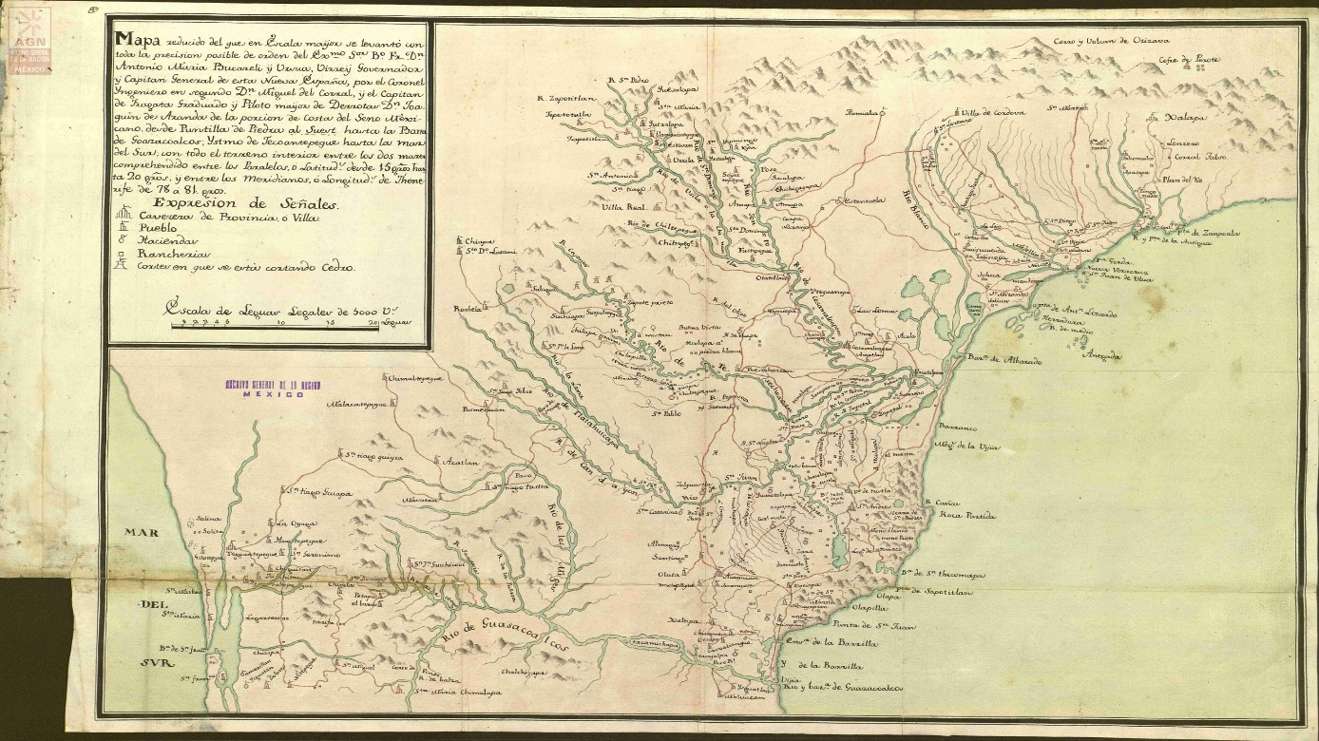
Source: Archivo General de la Nación de México, Mapas, Planos e Ilustraciones (280), mapilu/210100/396 Porción de la Costa del Seno Mexicano desde la Puntilla de Piedra al sureste hasta la Barra de Coatzacoalcos; Istmo de Tehuantepec hasta el mar del Sur (373). Made by Miguel del Corral and Joaquín de Aranda

Pine Felling in the Hills of Chimalapas

The woodlands of Chimalapas, in the isthmus of Tehuantepec, were an important source of wood—cedar, pine, and oak—for shipbuilding from the early years of the colony. The area was regarded as especially suitable for this purpose owing to its strategic location in the corridor that links the Gulf of Mexico and the Pacific Ocean. The Coatzacoalcos River, which runs down from the hills to the Gulf, was used to haul goods and, especially, timber, and the Zoque villages of Santa María and San Miguel, both in Chimalapas, whose inhabitants regarded themselves as the ancestral owners of this vast woodland area, played a prominent role in its exploitation. From an administrative perspective, the region depended on the Alcaldía Mayor of Tehuantepec, but Nexapa (modern Nejapa de Madero, Oaxaca) also had an important part to play, especially by supplying indigenous labour and paying the salary of woodcutters and day labourers, for instance during the felling of trees intended for the masting of royal ships in 1768.
Tree felling in the woodlands of Chimalapas intensified in the 18th century, when the Bourbon reforms and the creation of the Secretary of the Navy and the Indies in 1714 led to plans to build a shipyard in the bar of Coatzacoalcos and promote shipbuilding to leeward of Veracruz. The project failed, but the excellent quality of the region’s woods, especially pine for masts, was not lost on Spanish shipbuilders. In 1735–1736, 1738, 1741–1743, and 1747–1748, limited tree-falling campaigns were carried out to supply the shipyard in Havana, through Veracruz, with timber for masting. Interestingly, these campaigns were preceded by the press-ganging of woodmen in Tlacotalpan and day labourers in Tehuantepec, Nexapa, and Guamelula (modern San Pedro Huamelula, Oaxaca), because nobody wanted to take such demanding and badly paid jobs (in 1735–1736, for instance, the daily wage was only 2 reales). It must be pointed out that only the first of these campaigns yielded satisfactory results, as the others were beset with administrative incompetence and logistic issues when it came to floating the timber down to the mouth of the Coatzacoalcos. Some of the wood became unusable as a result, and tree-felling campaigns in the area did not resume until January 1765, when the Navy Intendent of Havana requested new timber for masting. This was the last time the region supplied pinewood to this department.

Pine Felling in Chimalapas Under Royal Supervision (1765–1771)

The idea to resume tree felling in Chimalapas came up in the discussions held by Lorenzo Montalvo Avellaneda and Juan Gerbaut, navy intendents in Havana and Cádiz, and the Viceroy of New Spain, Joaquín Juan de Montserrat y Cruillas, in which the point was made that “the Coatzacoalcos pines cost just over half as those that come from the north, and although they are of a lesser quality, being of heavy wood, they are fairly good for masting”. For good measure, the intendent in Cuba, Lorenzo Montalvo Avellaneda, emphasised that it was much cheaper to source the timber there than having the masting sent from the metropolitan warehouses in Cádiz and El Ferrol. Eventually, the project began moving forward in early 1765, and by 25 June a total of 223 trees had been felled, for a total cost, including haulage to the bar of Coatzacoalcos, of 27,099 pesos de a ocho reales. In his report, the viceroy mentions that 26 masts were sent to Havana aboard frigate Águila, three were sold to private companies in Veracruz, 13 were loaded onto royal ships, 114 were stored in the port of Veracruz, and 67 were still in the river mouth. The three officials agreed to create a permanent tinglado for masts and cedar and mahogany parts in Veracruz, to meet the needs of navy ships and also to sell to merchant ships (see Figure 6).

figure 8 The royal tinglado project in Veracruz for timber storage (1764)
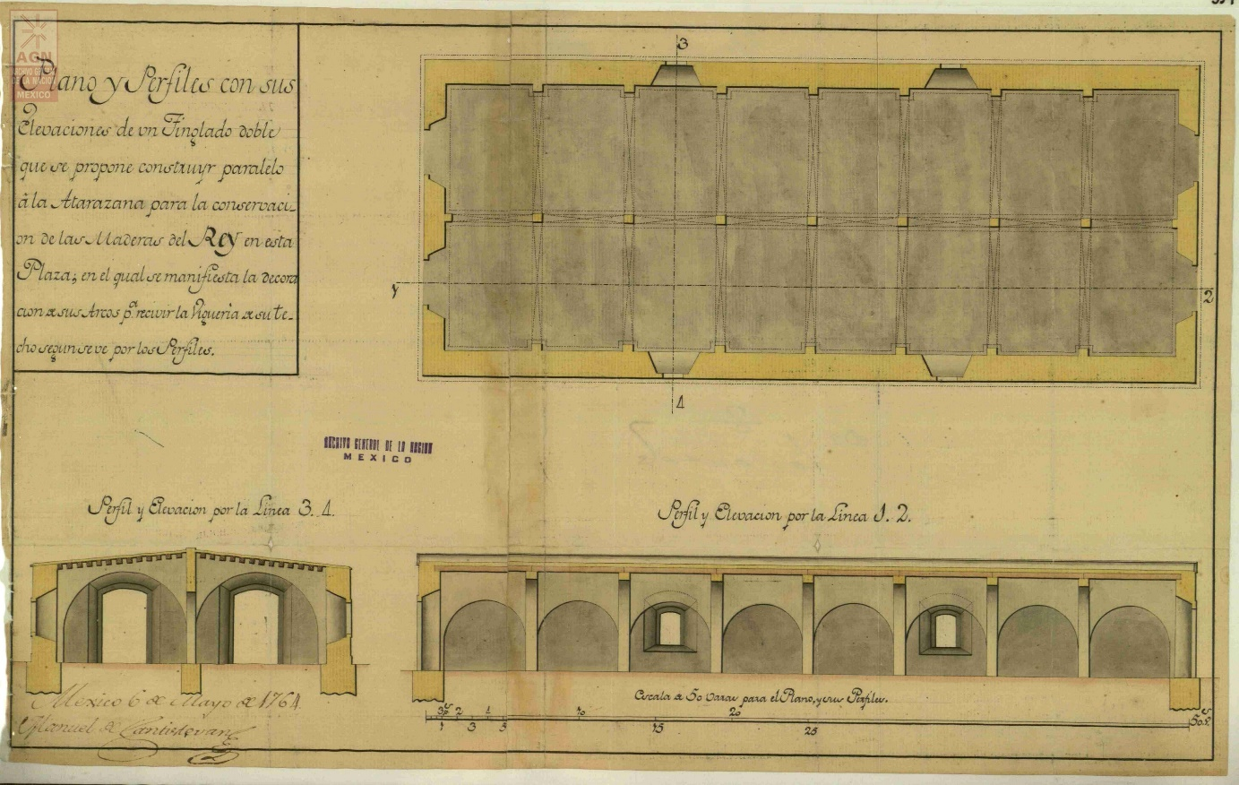
Source: Archivo General de la Nación de México, Mapas, Planos e Ilustraciones (280), mapilu/210100/417 Plano y perfiles con sus elevaciones de un tinglado doble que se propone construir paralelo a la Atarazana (394). Made by Manuel de Santiestevan

It is now worth lingering on some technical aspects related to the pieces of masting requested by the Spanish Royal Navy, in order to better understand the features and size of the trees sought for this purpose. No precise information exists about the length of timber cut in earlier campaigns, but in a document dated 1767, naval officer Antonio de Gregorio included a note about “the provision of trees to make masts, yards, topmasts, and outriggers for 80-, 70- and 60-gun ships and also for two 30-gun frigates”, in relation to the felling campaigns undertaken between 1760 and 1770 (see Table 41).

table 41 Length of timber for masting from Chimalapas, according to Antonio de Gregorio (in cubits)
Type of piece | 80-gun ship | 70-gun ship | 60-gun ship | 30-gun frigate
Mainmast “Palo mayor” | 48–49 | 44–46 | 42–43 | 43
Foremast “Palo de trinquete” | 44–46 | 41–43 | 40–41 | 39
Mizzen “Palo de mesana” | 44 | 43 | 41 | 36
Bowsprit “Palo de bauprés” | 38 | 36 | 34 | 26
Main topmast “Masteleros de gavia” | 36 | 35 | 33 | 25
Topgallant “Mastelero de juanete” | 25–26 | 25 | 20 | 19
Ring-tail boom “Botalones de alas” | 27 | 26 | 24 | 19
Jibboom “Botalón de foque” | 26 | 25 | 24 | 16
Source: ags, sma, Arsenales, leg. 624, fs. 87–90

On the other hand, a shipment of pieces for masting intended for Havana, loaded aboard two royal packet-boats—the San Lorenzo, with 28 pieces, and the San Francisco de Paula, with 37—in June 1769, shows that only five out of 65 were over 40 cubits long (the longest measured 44); 33 of the masts, that is, over half, were between 30 and 39 cubits long; finally, 27 were between 20 and 29 cubits long. Based on this, it can be deduced that most masts were mid-sized, and were suitable as frigate masts and as small parts for larger ships, such as topmasts, outriggers, fishes, spritsails, topgallants, and studding. This suggests that the shipyard in Havana was demanding exactly this kind of timber to conclude the construction of a frigate (Santa Lucía) and three ships-of-the-line (San Francisco de Paula, Santísima Trinidad, and San José).
Returning to tree-felling operations in Chimalapas, the second campaign came to an end in late October 1766. During the rainy season, 220 pine trunks were sailed downriver to the estuary of Tacojalpa and thence to the bar of Coatzacoalcos, and 250 more were left in the hills. Some broke while they were being dragged and others were also left unusable for different reasons. The third campaign took from 5 September 1767 to 2 April 1769. Havana officials appointed Don Juan Bautista Franco as shipbuilding supervisor and mast master, while Lieutenant Don Joseph Ximenez was commissioned to oversee tree felling and to survey the hills near Mijes, Alvarado, and Coatzacoalcos, with the aim of finding additional timber with which to build two schooners; it was urgent to dispatch 67 of the 220 masts cut during the second campaign, which were still sitting in Coatzacoalcos. Overall, between 1767 and 1769 a total of 432 pines were felled for masting, and another 78, left from the 250 trees felled between 1765 and 1766, were finally fitted.
Importantly, the best season for felling depended on weather conditions, tree density, type of tree required, terrain conditions, and the physical conditions of the workers. A report issued by Don Juan Antonio Ytuarte provides detailed dates for the pines felled between 20 December 1768 and 1 April 1769 (fourth felling campaign):
- up to 20 December 1768, 17 pines were made ready;
- up to 1 January 1769, 16 masts were fitted;
- up to 8 January, 32 pines were made ready;
- up to 15 January, 36 masts were fitted;
- up to 28 January, 41 pines were made ready;
- up to 5 February, 14 masts were fitted;
- up to 12 February, 41 pines were made ready;
- up to 19 February, 41 masts were fitted;
- up to 25 February, 30 pines were made ready;
- up to 5 March, 23 pines were made ready;
- up to 11 March, 12 masts and 3 bowsprits were fitted;
- up to 18 March, 40 pines were made ready;
- up to 22 March, 40 masts were fitted;
- up to 1 April, 46 masts were fitted.

After the trees were felled, they were fitted, dragged to the riverside, put in the water, tied in rafts, and driven by bargemen to the bar of Coatzacoalcos. As they floated downriver, some broke against rocks or ran aground. Juan Antonio de Ytuarte gives an account of one of these incidents: “on 16 September [1769] the last of the timber was put in the water, but as we were half-course down five small masts broke; and one of the barges was wrecked in a torrent on the 31st day of last month; there were 10 men on the barge, and they were in danger because the current sent them under a raft, but they were all saved and only the barge and some tools were lost”. The same official also reported an accident on 22 November 1769, when a shipment was ready to go in Malpaso de Guichicovi—i.e. the rafts were already tied up—a river wave broke the ropes and some of the timber was lost in the nearby islets. This incident forced shipments to stop for a few days, and the operatives ran out of supplies. They sent a courier to communicate this unpleasant news to Don Juan Antonio de Ytuarte, who reacted by forcing Sergeant Joseph Ybañez to return to the felling area with all single men, “considering that the season was advanced for the task at hand”. Married men were allowed to go to Tlacotalpan and return to their families. The jam was eventually cleared, and the last masts arrived in Coatzacoalcos in February 1770. The final felling campaign that year ended in November, when 209 trees were felled and sent downriver.
The total cost of the timber felled in Chimalapas was over 202,000 pesos de a ocho reales, although the most remarkable thing is that, as late as July 1773—that is, nearly two years after the felling—350 masts of different sizes and types remained in the mouth of the Coatzacoalcos, according to the evaluation undertaken by Manuel Pérez. This shows that felling operations went at a brisk pace, and that the bottleneck was at the river mouth, where the timber was often left waiting to be taken to Veracruz and Havana for a long time. These logistic difficulties were recurrent, owing to a scarcity of freight ships large enough to accommodate this masting.

Expenses: Wages and Oxen for the Chimalapas Enterprise

In June 1767, Don Joseph Ximenez requested more resources from the royal officials in Veracruz to continue felling in Chimalapas. The money was sent with Don Juan Antonio Ytuarte, who, on his arrival in late August, was put in charge of the operation. The expenses incurred during the third felling campaign, which ran between 5 September 1767 and 19 October 1768, were as follows:
- 3,459 pesos, 7 tomines, and 8 granos in daily supplies for the woodmen;
- 31,042 pesos, 5 tomines and 2 granos in wages;
- 1,705 pesos and 1 tomín in shipments;
- 1,349 pesos in tackle;
- 106 pesos in medicines;
- and 27 pesos in the chapel.

The total cost came to 37,690 pesos, 1 tomín, and 10 granos, most of which went in wages. It is worth mentioning that most of the hands came from the indigenous villages under the Alcaldía Mayor de Tehuantepec, which also paid for their salaries—on the viceroy’s orders—while the rest of the costs were shouldered by the Alcaldías of Guamelula and Nexapa, much to the annoyance of the alcaldes mayores, who had to use funds that had been earmarked for other purposes.
Surveying, felling, and dragging were expensive operations, apart from the fact that, during the transport of the trees to the riverside, many hands ran away, because this was the most demanding job, and nobody wanted to do it. Don Juan Antonio Ytuarte described the stratagems used to retain the men, who drew pay from the moment they left their house to the moment they returned: “they were paid three reales per league [of road]; three reales in working days and one in feasts and rainy days in which no work was done; as they were replaced every fifteen days, more money was spent in days in which no work was done than the opposite. This was because their villages were far away and because in this country [the woodlands of Chimalapas] it is raining all the time”. The supervisor also noticed that the locals did not turn up during the best time for felling, because this coincided with pressing agricultural tasks that could not be postponed. He thus asked the viceroy, Marquis of Croix, to mobilise “250 prisoners for dragging and 25 guards to keep an eye on them, as well as four carpenters, a water carrier, and an ironsmith, [so] the daily cost for food and clothing will be 1 real per man per day, and they will be ready to work when they are told to do so; the advantage of this is such that if one mast now costs 14,000 pesos, in this way it will cost no more than 5,000”.
The document carried another suggestion to save the Real Hacienda some money in wages. Not all of the Tlacotalpan woodmen were required when the river was running low—between October and May—so Juan Antonio Ytuarte recommended that only 16, chosen among the most experienced of them (out of a total of 60), were hired during that period, to prepare and dress the timber while the others returned home. The barges could also remain in Coatzacoalcos, which would also save money. The barges and the remaining woodmen could return in the rainy season (in June) to send the timber, which would be ready to go by then, downriver. Ytuarte’s request for prisoners could not be met and the following season he relied again on hired labour from the Alcaldías Mayores of Tehuantepec, Guamelula, and Nexapa, but in the 1768 campaign the workforce was cut down, reducing the cost for the Real Hacienda.
The royal coffers also had to shoulder the cost of buying oxen to pull the timber. In Chimalapas, it was estimated that 48 animals, working in pairs, would be required during the felling season. The oxen were to be supplied by the corregidor of Jalapa, Don Bartolomé Bejarano, Marquis of Tehuantepec. In the 1768 season, not all the animals provided were found suitable, as pointed out by the timber supervisor, Juan Bautista Franco, who accused Don Juan Antonio Ytuarte of buying so-called “cabestros”, which were good only to drive cattle. These and other accusations—the supervisor also denounced the way tar and food supplies were handled—were not pursued by the authorities but are an illustration of malpractice and corruption in major royal enterprises, often for the benefit of local elites (in this instance in Oaxaca and Veracruz). In a letter dated 10 May 1773, the corregidor of Jalapa, Don Bartolomé Bejarano, presented his accounts in response to the viceroy’s request, claiming that, during the felling campaigns carried out between 1768 and 1772, the administrator Juan Antonio Ytuarte had left 107 oxen in his care:
- 74 oxen, which could not be sold locally, were sent to the city of Oaxaca and were sold by the regidor Don Diego de Villa Santa for 860 pesos and 3 reales;
- an ox found by the people in the indigenous village of Totolapa, in the jurisdiction of Nexapa, was sold to Don Joseph López for 10 pesos;
- 13 oxen, which were too old and were in danger of dropping dead on the road to Oaxaca, were slaughtered and sold for 120 pesos and 2 reales, that is, 9 pesos and 2 reales each;
- four oxen died on arrival on the hacienda of Chicapa, of Don Bartolomé Bejarano;
- two oxen escaped from the hacienda to the potrero in this village, and they were impossible to catch, joining the cimarron livestock;
- seven oxen died in the potrero, two of them killed by “lions” and “tigers”;
- six oxen died on the road to Oaxaca.

Importantly, 312 pesos were discounted to pay for hands, auxiliary oxen, and a foreman, Anastasio Gutiérrez, who looked after the animals in the potrero nearby the hacienda of Chicapa and later drove them to the city of Oaxaca. The final accounts indicate that, with these sales, the Real Hacienda made 778 pesos and 5 reales, which means that, compared with the original expense, a cost of 12 pesos and 4 reales, the Royal Treasury lost 559 pesos and 1 real. These accounts show that the investment in equipment, tools, and animals in military and naval projects was costly but necessary to uphold the Spanish military effort in the Gulf of Mexico and the Caribbean.
Finally, it is worth pointing out that the engineer Miguel del Corral also visited Santa María de Chimalapa during his 1776 and 1777 surveys. In the Relación that he wrote to give an account of his visits, he claimed that:
many pine trees were still to be found […] but hereafter they will be harder to use because they are more out of the way. It is of well-known quality, much masting having made out of it in Havana, and there is still a good deal of it in the esteros of Postmetacan, Tacojalpa, and Tacojalpilla, those that could not be recognised because they were hidden and covered in lechuguilla.
This description suggests that wood was becoming scarcer in the riverside and the region gradually deforested. The woodlands of Chimalapas still had good timber for masting, although it would be costlier to exploit. However, the felling campaigns undertaken between 1765 and 1772 were the last ones, because navy officers in Havana decided to begin sourcing their masting from Louisiana, and a supply centre was established in New Orleans for this purpose.

Forest Resources and Naval Wood Sourcing in Sierra Madre Oriental

In the second half of the 18th century, the strategic importance of New Spain grew gradually, and the need to reorganise its defences mobilised the viceroys; it was no longer a question of seeing off the sporadic attacks of pirates, corsairs, and buccaneers, but of holding up the advance of Great Britain in their strategy to wrestle colonial control from the Spanish. The British colonies in North America revolted while Bucareli was viceroy in New Spain; the Spanish Crown helped the rebels with weapons and money, while the courts of Madrid and Paris negotiated their intervention to expel the British from Florida and the Gulf of Mexico, and even to destroy all their bases in the Mosquito Coast and invade Jamaica. In addition to this, a new actor appeared on the competitive American colonial stage, with Catherine II’s Russia looming over Alaska. The old territorial disputes with Portugal, which went back to the treaty signed in 1750, came to a head; in 1776 a Portuguese expedition attacked Colonia de Sacramento, triggering a Spanish response led by Pedro de Cevallos. These circumstances were a powerful incentive to fortify the territory, reorganise the army and the militias, and intensify the navy’s presence in American waters.
These threats made the Crown keep a particularly vigilant eye on the viceroyalty of New Spain, where administrative, fiscal, economic, commercial, and, it goes without saying, military reforms were launched. One of the first officials to come directly to grips with the situation was José Bernardo de Gálvez y Gallardo, 1st Marquis of Sonora, appointed Visitador General in New Spain in early 1765. His mission was both to ensure that Charles III’s reform programmes were strictly implemented and to compile enough information to improve fiscality in the viceroyalty and promote the royal monopoly over the tobacco trade. He was also invested with powers to investigate the performance of Viceroy Joaquín Juan de Montserrat y Cruillas (1760–1766), against whom many complaints had been filed at the royal court. Finally, open conflict broke out between Gálvez and the viceroy, who was dismissed from his post in August 1766. The Visitador General was in New Spain for five years, during which he became intimately acquainted with the administration of the territory, taxing, the operation of the Real Hacienda, mining, the transport of mercury, and the exploitation of salt mines; he also investigated contraband activities, a major problem, and the issues that undermined legal trade. Before he left for Spain he handed a detailed report to the new viceroy, Bucareli: Informe instructivo del Visitador General de Nueva España al Excmo. Sr. Virrey de ella D. Antonio Bucareli y Ursúa en cumplimiento de la Real Orden de 24 de mayo de 1771. Although this report does not refer to naval construction, it mentions the wood available in several regions of New Spain. Gálvez pointed out the rich woodland between Orizaba and Córdoba, whose resources could be used for various purposes. The Visitador General went into greater detail concerning the department of San Blas: he wrote that excellent woods were to be found near the harbour for the construction of “long and hardy ships”, that two packet-boats had been built there, and that one frigate commissioned by the Marquis of Croix was almost finished.
The new viceroy, another important figure in the administrative, economic, and military development of New Spain, tried to act upon several of the observations contained in Gálvez’s report, for instance, with the reform of the militia in several regions of the viceroyalty. Croix had already tried to revitalise naval construction, bringing about timber extraction for naval masting in the hills of Chimalapas, which was still ongoing in the final year of the Marquis of Cruillas’s tenure (1765), and granting the two first private asientos to supply the Armada with timber. The first, in 1766, was awarded to Antonio Basilio Berdeja, acting on behalf of his father, Captain Don Andrés Berdeja; the five-year contract contemplated the supply of dressed parts of cedar and mahogany to the royal shipyards in Veracruz and Havana. The second was awarded two years later, when Viceroy Croix signed a contract with Domingo Ramos Balcarsel, who committed to supply the masting required for three 80-gun ships, three 70-gun ships, four 60-gun ships, and six 30-gun frigates. It is important to point out that the felling of pine trees in Chimalapas was under the direct supervision of the Real Hacienda of New Spain and the provincial administration, specifically under the navy officials in Veracruz and the alcaldes of Tehuantepec, Guamelula, and Nexapa. Antonio Basilio Berdeja’s and Domingo Ramos Balcarsel’s asientos were entirely private operations (both were members of the local elite of Veracruz).
As a result of increasing felling activity to supply the naval industry, in a letter dated 23 October 1766, the Marquis of Croix suggested creating a regular warehouse for masts and dressed cedar and mahogany parts in Veracruz, “for the Armada’s urgent needs and [also] to sell to private merchants”. In addition, the Marquis also wrote that more forests could be found in the region of Veracruz, for instance in the Tampico hills; however, no surveys had been undertaken to explore their quality, so he recommended operations to continue in known regions, such as Chimalapas and Coatzacoalcos.
Viceroy Antonio María de Bucareli y Ursúa (1771–1779) was an active reformer. Among other things, he spent his time in office putting the Real Hacienda back on a sound footing and reactivating mining operations, while reinforcing the three imperial frontiers of his viceroyalty: the Atlantic coast (the so-called Seno Mexicano), the Pacific coast, and the northern frontier. He improved the fortifications of San Juan de Ulúa, Perrote, and Acapulco, and designed a network of presidios in northern New Spain to protect Spanish colonists in Sonora and Louisiana from the Apache and other native groups. When he heard that a Russian expedition, led by Lieutenant Tschericow, had explored the western coast of North America between 1769 and 1771, Bucareli sponsored three Spanish expeditions to the Pacific coast north of Mexico, in 1774, 1775, and 1779. These expeditions revealed that no foreign settlement had been established, and that the strait of Anián, the alleged northern pass linking the Pacific and Hudson’s Bay, did not exist. This was good news for the Spanish, who had feared a British attack from that side.
Concerning the exploitation of woodland, Bucareli was the royal official who expressed the greatest interest in surveying the badly known woodlands of Sierra Madre Oriental. He promoted several survey projects aimed at finding hardwoods that could be used for naval construction. These expeditions covered from leeward of Veracruz to Laguna de Términos. His original proposals to explore the woodland in Teziutlán and Perote, presented in 1774, were endorsed by a royal order dated 28 February 1776 in which Charles III expressed the need to “increase my fleets, in both Spain and the Indies, as much as possible”.

Antonio María de Bucareli y Ursúa’s Land Survey Instructions

With the support of this royal order, in July 1776 Bucareli issued a report suggesting the resumption of shipbuilding in Tlacotalpan, in the Alvarado River, where “some warships, like the Bizarra and the Nueva España” had been built in the past. This is not entirely correct, because the former was in fact built in Havana and the latter in the bar of Coatzacoalcos. This is not to say that Tlacotalpan was new to shipbuilding; two merchant ships, the Gallo Indiano (425 tons), launched in 1722, and the Paloma Indiana (643 tons), launched in 1725, had been built there. After serving as merchant ships for a short time, both were bought by the Marina Real and refitted as warships, with 58 and 52 guns, respectively. The record also mentions the construction of a third ship in Tlacotalpan, the Rosario de Murguía. All three ships proved to be sound vessels, despite their comparatively low cost.
Interestingly, the king made Bucareli negotiate with the Church councils of New Spain, the Mexican consulate, and other commercial and mining institutions to fund the construction in Tlacotalpan-Alvarado of 50- to 70-gun ships and 30- to 40-gun frigates. Spanish monarchs often involved merchants, miners, and the Church in their projects, especially on the eve of war or during wartime. These subsidies to the Crown were referred to as donativos. This practice is illustrated by the construction of ships-of-the-line in Havana during the American War of Independence and, after the war, in the 1780s. Another well-known example is the construction of the 112-gun Nuestra Señora de Regla or Conde de Regla, by Pedro Romero de Terreros, one of the leading merchants and mining entrepreneurs in New Spain, in 1786.
The viceroy sent engineer Miguel del Corral and a navy officer from the San Blas department to find the best location for the shipyard. Their orders said: “survey the ground, the forests, the proportion of different woods, ease of construction, supplies, the depth of the river and the bar, and the possibility of dredging it to open the way to the ships”. The viceroy put a ship and an experienced crew at the disposal of the surveyors to sound out the river and also promised carpenters to examine the wood. All of this, as Bucareli stressed, contributed to increasing the naval forces, “which are the main support for the conservation of these [American] dominions”. In another report, dated 27 August 1776, the viceroy gave further information about the expedition to the Alvarado River. Interestingly, by the time this report was issued the range of the survey had been increased with the inclusion of the Coatzacoalcos River. The old provisional shipyards in both rivers were to be explored to determine their suitability and determine the best location for the new ones. A first visit to the region around the Coatzacoalcos emphasised the abundance, and accessibility, of wood in the surrounding forest. The Alvarado, however, was barely twelve leagues from Veracruz, presented better mooring conditions, and the bar was better suited to build a fortification. The nearby woodland also offered ideal forests for naval construction. The viceroy also pointed out that there were many skilled ship carpenters in Tlacotalpan, and that they had been involved in felling and dressing trees for ships of various sizes since the early 18th century.
The exploration of the territories of Alvarado, Tlacotalpan, and Coatzacoalcos began right away, as engineer Miguel del Corral and Frigate Captain Joaquín de Aranda left Veracruz in October 1776. Captain de Aranda, instead of an officer from the San Blas department, was chosen for the mission by the fleet commander, Antonio de Ulloa. Bucareli was trying to recruit the commander of New Spain’s latest fleet to help him build a shipyard to the leeward of Veracruz, and the details of the officer’s mission, including his task of finding a good location for a shipyard in Coatzacoalcos or in the village of Tlacotalpan, were mentioned in the Relación published in 1777.

Miguel del Corral and His Contribution to the Scientific Knowledge of New Spain

Military engineer Miguel del Corral arrived in Veracruz in 1764, aboard the expedition organised by Brigadier Juan de Villalba to create the army of New Spain. In 1766, Corral embarked on an expedition to recognise the coast of the Gulf of Mexico, about which he was to write two memoranda, which were the foundation of a series of works about the geography of Veracruz. In 1767, he drew a map entitled Mapa de la porción de las Costas del Seno Mexicano, comprendida entre la Barra de Alvarado y Cabo Puntillas. In 1768, he was in Mexico City working in the construction of a lime and brick factory, and two years later he was in Perote, building a fort. In 1771, Viceroy Bucareli commissioned engineers Agustín Crame and Miguel del Corral to carry out the preliminary studies for the construction of a fluvial connection between the Atlantic and the Pacific oceans. The idea was to establish whether the Coatzacoalcos River would be suitable for the construction of an inter-oceanic channel through the isthmus of Tehuantepec. In 1773, Miguel del Corral, by then a colonel, was drawing plans to leeward and windward of Veracruz along with another six engineers. In 1775 he was sent to the Pacific harbours of San Blas, Matachel and Chacala, where he drew Plano y mapa reducido de un cuadrado fortificado que se proyecta para defender la entrada de la barra y río Coatzacoalcos (see Figure 7), dated to 12 October 1778, and also Planos y perfiles de un fuerte para defender la entrada de la barra y río de Alvarado (see Figure 8); in 1779 he drew Mapa de la Costa de Veracruz, desde Alvarado hasta Boquilla de Piedras; and, finally, in 1780, along with engineer Manuel Santisteban, Elevación y perfil de un puente sobre el río la Antigua. In 1780, del Corral was appointed chief engineer, and on 19 March 1781 Lieutenant commander of the Castle of San Juan de Ulúa. In 1782, Miguel del Corral, as the king’s lieutenant in San Juan de Ulúa, issued, in response to Viceroy Matías de Gálvez’s petition, his Relación circunstanciada del estado de las fortificaciones y edificios militares en la Plaza de Veracruz, su costa y castillo de San Juan de Ulúa, in which he gave his negative opinion about the fortification. In 1784, del Corral drew a project for the water supply of Veracruz, including a general map and the course of a water channel from the Jamapa River. Also in 1784, he drew up the plans for the customs building in San Juan de Ulúa. Until his death in 1794, del Corral remained very active. His career earned him the highest rank in the Engineer Corps: in 1783, he was put in charge of the Dirección de Ingenieros de la Nueva España, and in 1790 he was promoted to brigadier. In addition, he was temporary governor of Veracruz (1782–1786), Lieutenant of the Fortification of Veracruz and Real Fuerza de San Juan de Ulúa (1783), and intendent of Veracruz (1790–1793).

figure 9 Plan that includes the bar and entrance of the Coatzacoalcos River from the Gulf of Mexico
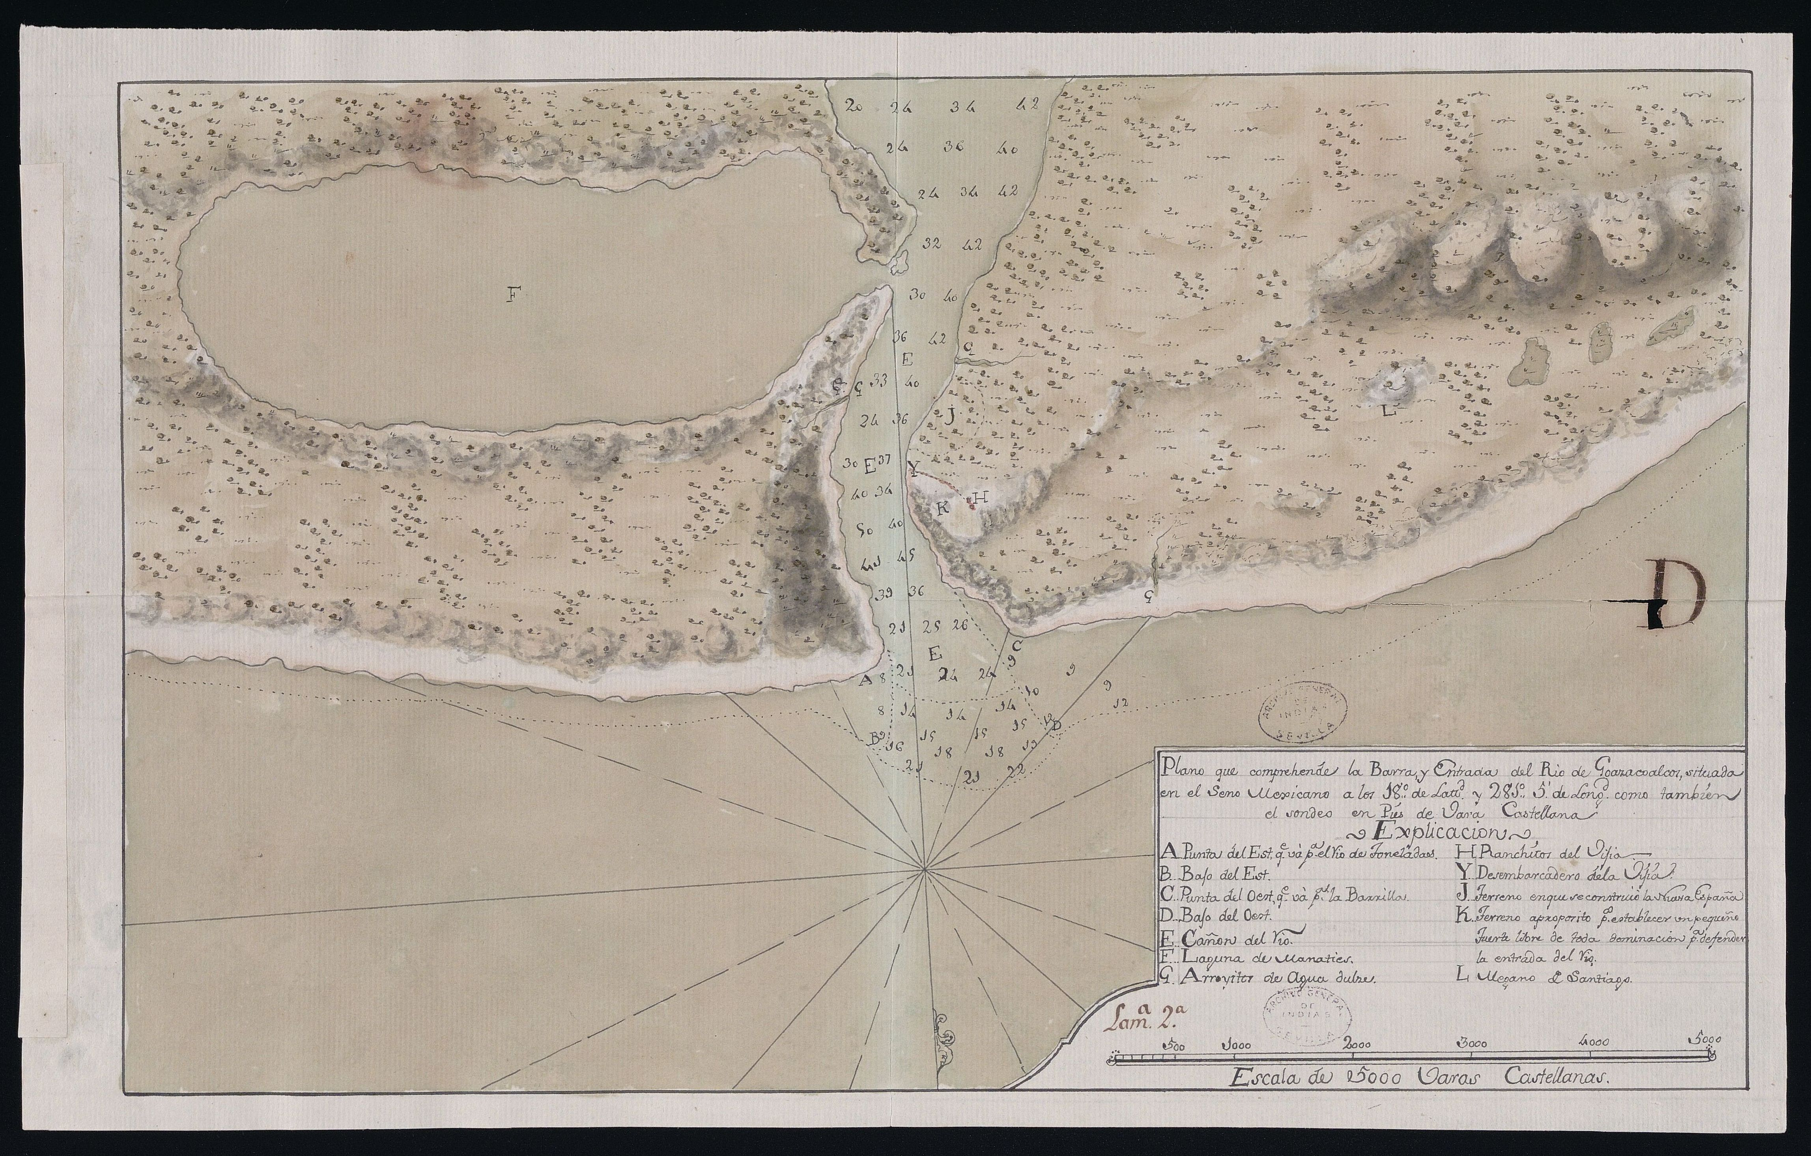
Source: España. Ministerio de Cultura y Deporte. Archivo General de Indias, MP-MEXICO, 331 BIS, “Plano que comprende la Barra y entrada del río de Goazacoalcos, situado en el Seno Mexicano”

figure 10 Plans and sections of a fort to defend the entrance of the bar and river of Alvarado and Tlacotalpan village
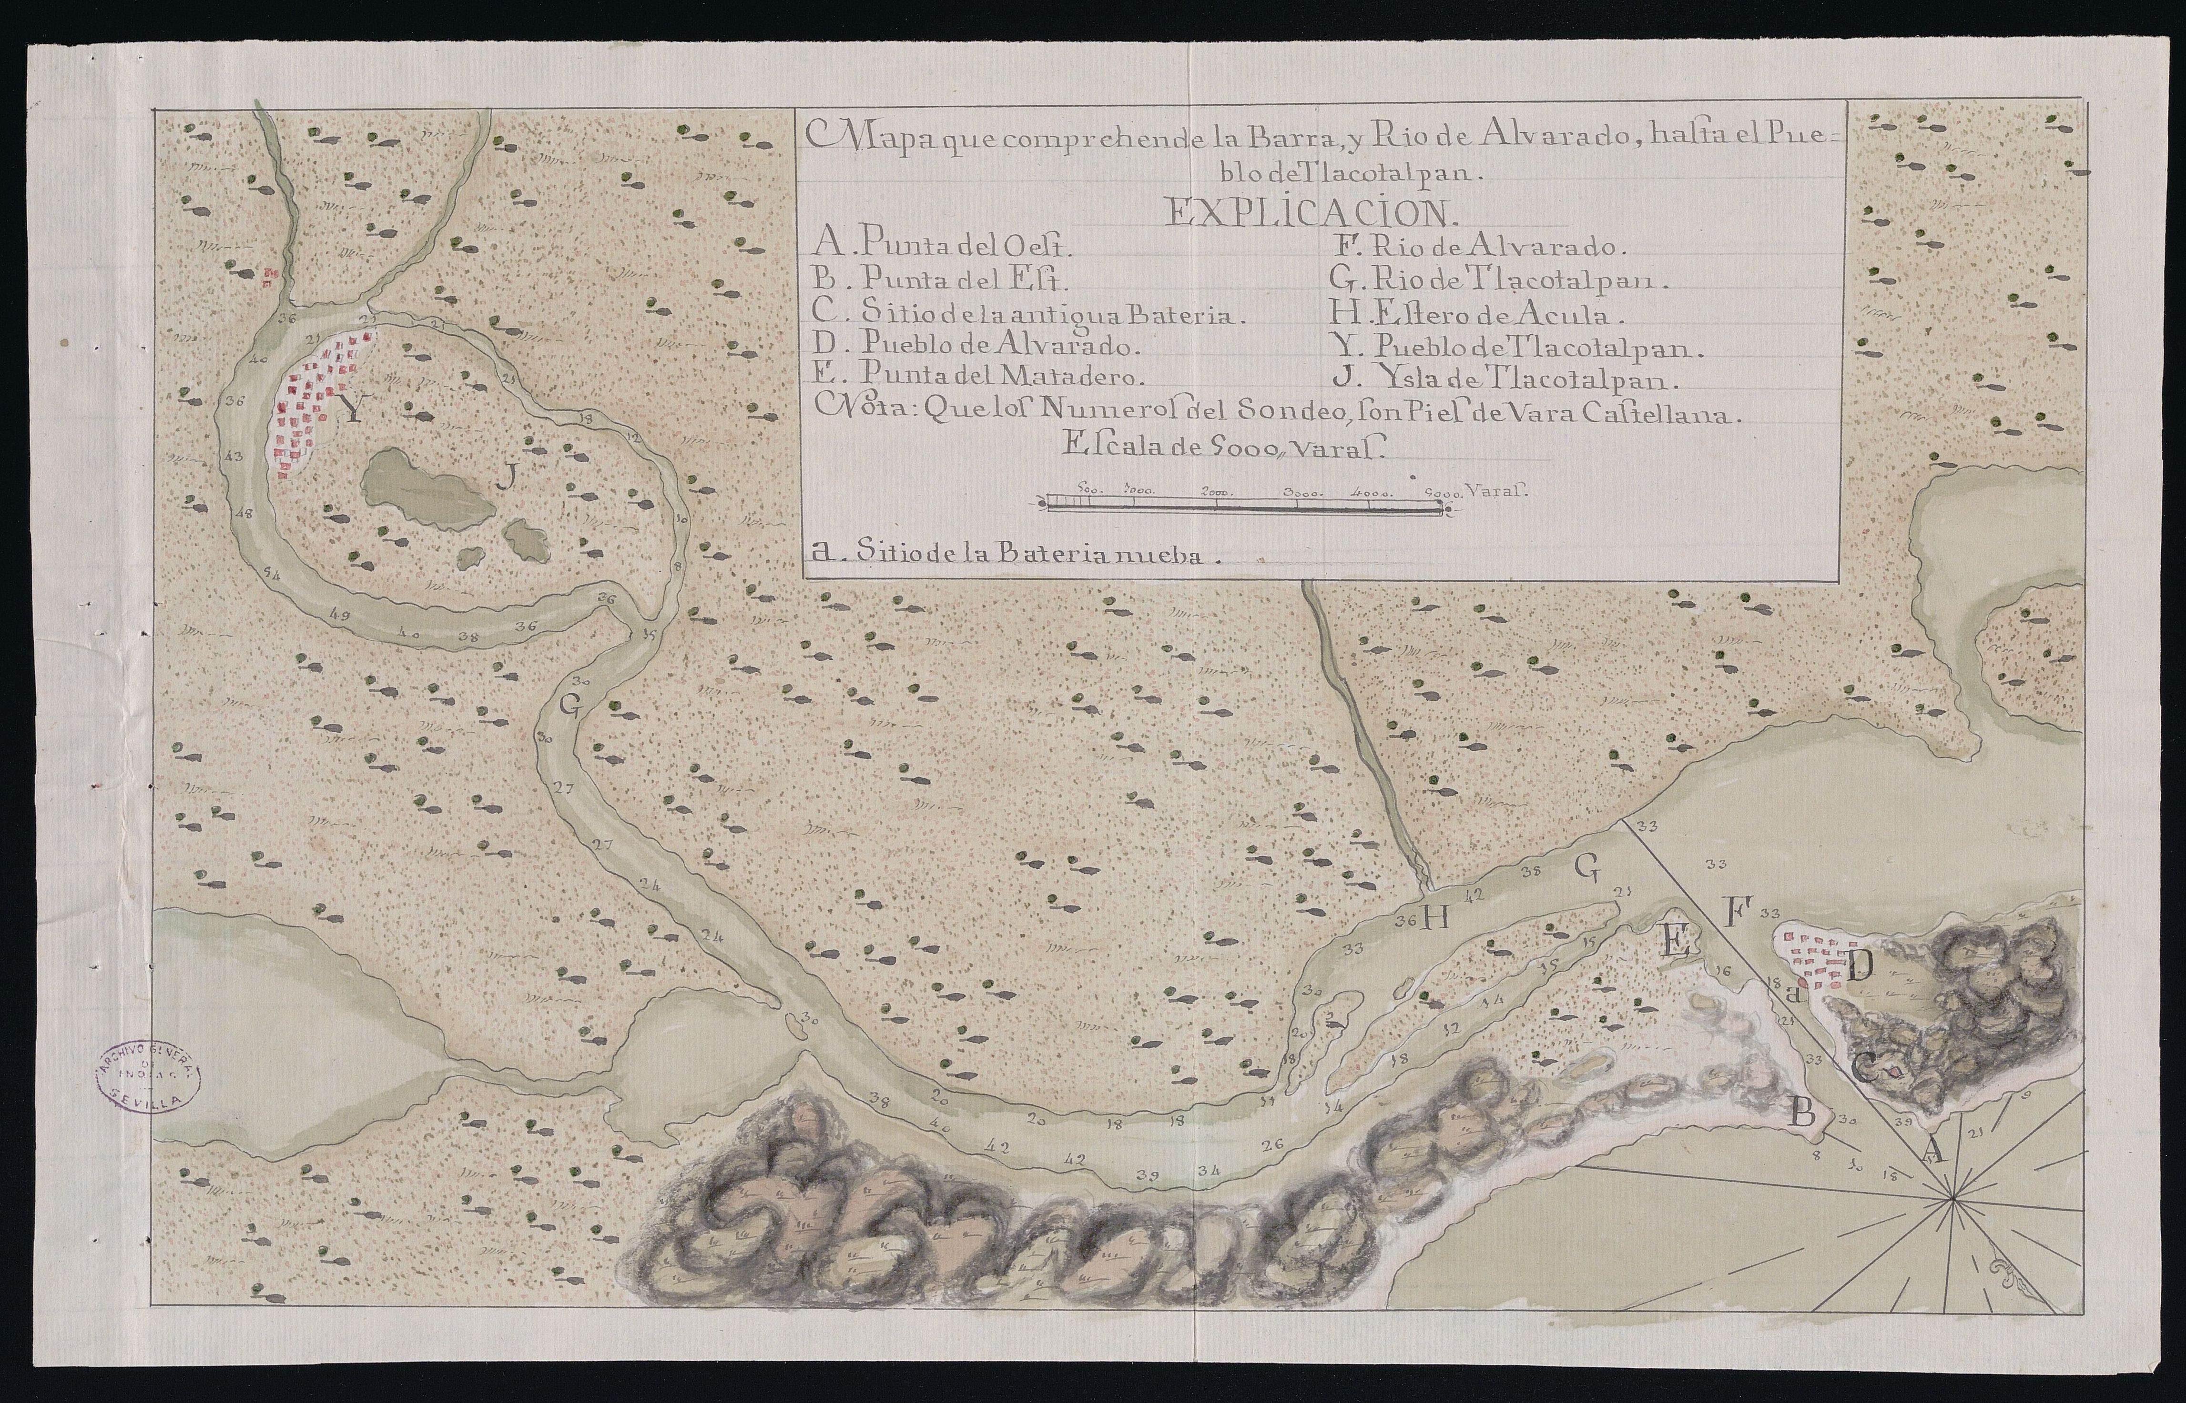
Source: España. Ministerio de Cultura y Deporte. Archivo General de Indias, MP-MEXICO, 385 TER, “Mapa que comprehende la Barra y Río de Alvarado, hasta el Pueblo de Tlacotalpan”

Relation of the Survey Carried out in the Hills of Teziutlán and Perote (Veracruz)

The earliest survey of the hills and woodland of Sierra Madre Oriental was undertaken by engineer del Corral in May 1774, when he was appointed by the head of the Real Maestranza de Veracruz, Joseph Segurola, to assess “masting for all sort of ships, and their transport to this city [of Veracruz] from the hills of Teziutlán and Perote, where it is said there are suitable pine trees for this purpose”. The general administrator of the Real Hacienda, Bernardo Nicolás de Lemos, added that engineer Corral’s mission aimed to find trees for masting near Veracruz, because those from Coatzacoalcos were too costly, owing to transport expenses from the forests of Chimalapas. The relation includes a detailed analysis of hills, terrain, and rivers in several areas, for instance, Tecolotepeque, which was 6 leagues from Perote, where there was a substantial number of Mexican white pines, which the locals called ayacahuite. However, the distance to the Santa María Tlapacoyan River, which runs into the bar of Nautla, in the Seno Mexicano, ruled out this option because of the cost of transport and of preparing the paths; the river was at the bottom of steep slopes and narrow passes. The engineer also visited the woods of Macacalco, 10 leagues from Perote, 12 from Jalapa, and 34 from Veracruz. There he found an abundance of good-quality pines of all sizes, but distance, and the rivers that ran across the way, remained a problem; the path that came down to a place that the locals called La Pila ran across broken terrain and would need to be prepared for the timber to be carried to the bar of Nautla. The cost was again considered too high. Del Corral indicated that the places of Atopa, Llano del Paisano, Potrero de los Caballos, and Alto de Villegas, in the region of Peña del Cofre, were equally rich in pines of all sizes, although not in such abundance as in Mecacalco, because many had been felled to meet the needs of the city of Jalapa.
Del Corral found time to survey the woodland mass south of Peña del Cofre, 5 leagues from Perote and 37 from Veracruz, where he found a large mountain covered in many pines of all sizes and very clean, that is, without dry branches and bark beetles. The officer observed that the Potrero de Ygnes María and a place called Chololoyan were suitable to begin felling and that the timber could be brought through the village of Ysguacan de los Reyes, more or less 5 leagues downslope. This route was formerly used by the locals to drag timber with oxen. Three leagues, also going downhill, separated Ysguacan from the Güisilapam River; the most abrupt passes could be travelled on horseback. Near this tributary river, there was a place called Teya, from which timber had been sourced in the past. Del Corral pointed out that, in order to obtain full masts, the road would need to be prepared, so that the oxen could be used all the way. Asking local fishermen, he learned that rafts could be used downriver all the way to La Antigua when the water ran high, without natural obstacles, rapids, or narrow passes. However, del Corral was aware of the need to recognise the river in detail, writing this “although in many parts it can be walked on foot, the fishermen rafts cannot pass, whatever they say”. He also said that, although the slopes of Peña del Cofre were covered in trees, these were hard to access; the area was rich in other tree species too, such as oak, holm oak, and elm.
Interestingly, del Corral estimated the cost of the felling, dragging, and transport operations between Ysguacan de los Reyes and the mouth of the Antigua River in the Gulf of Mexico. According to his calculations, the costliest part would be to bring the masts from the felling area to the Güisilapam River, which would require a large workforce (1,000 labourers), at a total cost of 6,250 pesos de a ocho reales; the felling and dressing of the trunks, in contrast, would barely fetch 360 pesos, and the same amount for the transport downriver to La Antigua (see Table 42).
His work Relación del reconocimiento hecho en los montes de Teziutlán, y Perote por el Teniente Coronel de Ingenieros Don Miguel del Corral, en solicitud de maderas aptas para toda Arboladura de Navío, in which he gave detailed descriptions of the wood and the obstacles that could get in the way of felling and both overland and downriver transport operations, illustrates Miguel del Corral’s excellent scientific credentials. In his following expedition, to the region between the Alvarado River, in Chimalapas, and the Coatzacoalcos River, he again proved to be equal to this sort of major mission.

table 42 Felling, dragging, and transport costs for one full masting from the hills of Ysguacan de los Reyes to La Antigua
To fell and dress the 36 main masts, 10 pesos each | 360 pesos
To clean the hilly area towards the royal road and cut a dragging area | 600 pesos
To take them out of the hills, and into the royal road | 400 pesos
To drive them from the royal road to the riverside, through the longest route, estimating 1,000 men for 20 days, at a rate of 2.5 reales per day | 6,250 pesos
Bringing rafts to La Antigua, estimating five rafts, each with six bargemen, at a rate of 12 pesos for the trip | 360 pesos
For unexpected expenses, and other small details involved in the preparation of masting | 2,000 pesos
For preparing the road from the felling area to the Güisilapam River, changing its course in places, and improving it as much as possible | 2,500 pesos
Source: agn, Industria y Comercio, vol. 10, exp. 5, f. 105

The Major Survey Expedition of Miguel del Corral and Joaquín de Aranda to Leeward of Veracruz
The Relación that Miguel del Corral wrote during his expedition, between October 1776 and July 1777, is divided into five parts. The first is a geographical description of the ground surveyed alongside the navy head pilot Joaquín de Aranda, and it includes a map (see Figure 11); in the second, de Corral described the hills on which he found wood suitable for naval construction and their condition; in the third, he examines the possibility of building a shipyard in the bar of Coatzacoalcos or the village of Tlacotalpan; in the fourth del Corral mentions the fortifications in the mouths of the Alvarado and Coatzacoalcos rivers; and the fifth addresses the militias that he found in some of the villages during his survey. For this book, the second section in particular, with a detailed account of the species of wood suitable for naval construction available between Tlacotalpan and Coatzacoalcos, has been of great use.

figure 11 Map of the coast of the Mexican Sound from Puntilla de Piedra to Coatzacoalcos, which also includes the Isthmus of Tehuantepec (1777)
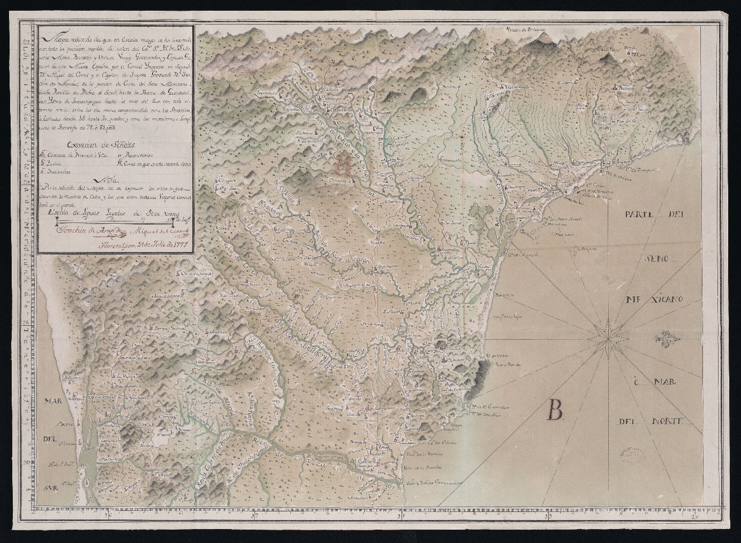
Source: España. Ministerio de Cultura y Deporte. Archivo General de Indias, MP-MEXICO, 329 BIS, “Mapa reducido del que en escala mayor se ha levantado con toda la precisión posible, de orden del Excelentísimo Señor Don Antonio María Bucareli y Ursúa, Virrey, Governador y Capitán General de esta Nueva España”

The first area whose wood resources were described in the Relación published in 1777 was that between the Tlacotalpan and San Juan rivers: “ordinary cedar, mahogany, male cedar, tavi, zapote, guayacán, palo maría, cocuite, and holm oak are driven down all the streams, to both the right and the left”. The description, therefore, claims that timber had long been sourced from the area, for domestic purposes but also for naval construction. According to Germán Andrade, the area began supplying timber for private ships and to the shipyards in Veracruz, Havana, and La Carraca in the early 18th century.
Del Corral also pointed out that previous felling had left some clearings in the woods, but the exploitation of this area of woodland continued as far as the pass of San Juan. He also made an interesting observation: the haciendas of Nopala, Solcuautla, and Cuatotolapan had good mahogany, but the owner of these estates, Don Diego Fentanez, had forbidden them to be felled. From 1748, this landowner was in open conflict with wood contractors, who demanded access to his estates. It is to be noted that his first antagonist was Don Andrés Berdeja, one of the main contractors for the Armada de Barlovento and a highly influential figure in the elite of Veracruz, who probably also represented the interests of the merchant Consulado de México in the province. Del Corral mentions this contractor in one paragraph of his Relación: “Captain Don Andrés Berdeja, who is steadfast, a man of spirit and knowledge in the felling business, was based in the Zapotitlán River for over two months […] to fell some pines, but left after his hopes were shattered”.
The hills of Nopala, Solcuautla, and Cuatotolapan, which had caused so much acrimony between Fentanez and Berdeja, were described by del Corral as rich in cedar, “of thick, long, and high-quality wood”, also mentioning that the place was well communicated with the Tesechoacán and San Juan rivers, which would make it easy to drag the trees to the rivers using oxen. In the next step of his survey, Miguel del Corral visited the hacienda of Santa Catalina de los Pozos, where he spotted much ordinary and male cedar, which would also be easy to bring to the Gulf coast through a spring that was 5 leagues distant from the forest. Afterwards, del Corral followed the course of the Candallón River, where he identified ordinary cedar and some male cedar. There, he also found three active felling areas, one near the hacienda of Santa Catalina, another one around the Tomás Martín Stream, and a third one higher up the hills. He observed that, in the second one, a group of workers was carving canoes, and that four of them were nearly complete. He also spotted 20 large, felled trunks of mahogany, which were to be carved into canoes too, and that paths into the jungle had been opened to bring the timber out.
After this, del Corral headed to the region of the Tataguicapa, La Lana, and Sanguluacan rivers, where he pointed out the presence of abundant cedar in some areas, like the Hill of Coyole, that belonged to indigenous villages; these did not consent to the felling of their trees. In contrast, the areas of Lomba, Corral Nuevo, and Laguna Redonda, in the hill range of Tuxtla, also had abundant wood, the felling of which had begun soon earlier. Despite the intensity of the ongoing operations, there were still trees on offer, but they would be costly to exploit, as some grew in hard-to-access terrain. Cedar could also be found around the Tesechoacán River, which joined the Cosamaloapan. Del Corral reported four active felling areas in the region: two near the Caxonos Stream, one near the Manso River, and one near the Chilapa River, in the jurisdiction of Guaspaltepeque. Similarly, he pointed out that the hillsides were covered in trees, although these were far from the active felling areas, which sought the proximity of water courses. Still in this region, he inspected the hill of Mirador and the surrounding elevations, part of the estate of Chiltepeque, near the Poposoca River, where he found large expanses of virgin cedar woods.
Concerning the Tesechoacán River, it is interesting to note that one of the earliest felling areas was established following the award of an asiento to Don Vicente Villa in 1756–1757; this led to the construction of a mooring area for timber in one of the river’s beaches, from which they were sent to Cosamaloapan, Tlacotalpan, Alvarado, and probably Veracruz, for naval construction. It is also worth pointing out that in these contracts, the main asentista subcontracted the work to two, three, or more woodmen, who spent months at a time in their allocated areas. The subcontractors hired local workmen—in the case of this contract, from Chilapa—but also their own hands, who specialised in felling, dragging, and rafting timber. In this instance, Villa hired mixed-race lumberjacks from Tlacotalpan.
Following this, del Corral entered the jurisdiction of Tuxtepeque, where he found good cedar wood and other useful species for naval construction near the banks of the Chicintla River, an area seldom frequented by woodmen. He also found abundant cedar near the Santo Domingo River, where wood had not previously been sourced intensively, as it was only exploited by locals to build and repair their houses and churches. Finally, del Corral pointed out that, in the area between both banks of the mouth of the Tonto River and the pass of Soyaltepeque, there was wood in abundance, and that the nearby hillsides were also rich in cedar. According to his report, there were enough trees in the area to last for many felling seasons. He also spotted other hardwoods, such as mahogany, in various places, although he clarified that some of the groves were richer than others. Finally, del Corral reported a holm oak grove on the right bank of the Tonto River, going from Pueblo Nuevo to the pass of Soyaltepeque (modern Soyaltepec), and another one, which was also fairly rich, from the pass of San Juan to Acayucan. He described both of these mahogany groves as highly valuable.
When he was done inspecting these areas, del Corral headed to regions rich in pine, which was badly needed for naval masting. First, he arrived at Zapotitlán and Tepetotuptla (modern Tepetotutla), where trees were abundant. The terrain, however, was difficult, and the rivers were full of strong currents and many rocks. As such, unless something was done about it, taking the tree trunks downriver to the Gulf of Mexico would not be possible. The experience of Antonio Berdeja, son of Don Andrés, proved this point; after felling some trees in this area, he found that he could not take them downstream, and was only able to bring a few pieces to the village of Usila.
Back to the 1777 Relación, del Corral also mentions other areas between the Alvarado and Coatzacoalcos rivers, and the hills towards Tehuantepec and Sierra Madre Oriental, where pine, ideally suited for masting, abounded. Del Corral notes that he heard this from Don Lorenzo Arrinda, who “as a lieutenant in the Crown’s regiment knew something about the felling of trees for masting, after spending many a year in the felling areas near Coatzacoalcos”. Similarly, del Corral held Arrinda’s detailed knowledge of the hills in the region of Zapotitlán and Tepetotuptla in great consideration; Arrinda had calculated that between 30,000 and 40,000 pesos de a ocho reales were needed to overcome the obstacles posed by the rivers, so del Corral argued that it was not worth opening new paths in the area to transport the timber, because of the cost.
Continuing his survey, del Corral reached the Coatzacoalcos River, where there was much ordinary cedar, male cedar, guapinole, oak, palo maría, and holm oak. He entered the area between the streams of Chacalapa and Guasuntan, down which the timber used in the ship Nueva España had been driven. He pointed out that, on the hillsides of the range of Minzapam, there was still an abundance of timber that needed to travel only a relatively short distance. It may be interesting to recall the story of this vessel, built as part of the attempt to create a shipyard in Coatzacoalcos and develop the naval industry to the leeward of New Spain. The project took off with the idea of building two 64-guns ships-of-the-line, but the reluctance of navy officers in Havana to send shipwrights forced the project’s promoters to downsize it to a single ship, called San José, alias “Nueva España”, with a 66-cubit keel and carrying 60 guns. As previously noted, the construction spanned 1731 and 1734 and cost a total of 431,000 pesos de a ocho reales, footed by the Real Hacienda of New Spain. The cost was so high because of the mortality rate among the woodmen, as the felling areas were situated in an unwholesome area teeming with moyocuile mosquitos. In the event, the enormous administrative and logistic problems faced by the project, corruption, and the high cost of labour, food, and tools, prompted the viceregal authorities to cancel the projected shipyard and continue building their ships in Havana.
Del Corral then set off for the head of the San Antonio River, in the jurisdictions of Isguatlan, Moluacan, and hacienda San Antonio, where he found areas of virgin woodland of male cedar and palo maría. On reaching the Coatzacoalcos he continued to Malpaso, where he noted the presence of ordinary cedar and male cedar. According to his observations, ordinary cedar was less abundant and more dispersed, but male cedar was found in much greater quantity; del Corral described a specific grove, approximately one square league in size, with between 800 and 1,000 male cedars in it. He made a similar discovery on the banks of the Los Mijes River, where both species were also to be found. Throughout the region, del Corral also spotted other hardwoods, including zapote, oak, guayacan, and palo maría, interspersed among the cedars. Del Corral ended this section of the Relación with an important fact: he mentions that the Coatzacoalcos River and its tributaries were seldom used to transport wood, and only for domestic purposes, and that the only large-scale felling to have taken place in the area was that related to the building of the Nueva España, as well as a cargo of large trunks felled near the Los Mijes River, which had been sent by barge to Tlacotalpan. It is clear that del Corral saw great potential in the region between Alvarado, Coatzacoalcos, and Sierra Madre Oriental, a potential that was to go untapped by the Crown’s naval departments. In this, the shortage of vessels to transport the timber, difficulties with the felling seasons, arrears in pay that often ground work to a halt, the robbing out of tools, the loss of timber to accidents with river rocks, and the impossibility to float the trunks when the river waters were running low, also played a part in the forests of Veracruz remaining underexploited.

Information About the Exploitation of Natural Resources in Miguel Del Corral’s Relación

At the time when Miguel del Corral was surveying the hills to leeward of Veracruz, there was no legislation to regulate the exploitation of wood resources in continental New Spain. In the metropolis, this activity was regulated by the Real Ordenanza sobre Bosques y Plantíos, enacted in 1748. According to del Corral, this lack of rules concerning the felling and dimensions of New Spanish timber led “everyone to cut wood as they please […] without any attention to size, wiping everything out, including saplings, which are barely good enough for a square sesma, which ruins the best-curved woods [for naval construction], wasting much to take straight masts ten varas long”. Del Corral, who was apparently aware of the 1748 Ordenanza, mentions that there was no interest in planting new trees, as established by the metropolitan regulations; he knew of no planting of cedar or other species suitable for naval construction. At the same time, he denounced that the felled trunks were piled up on the riverbanks to float them during the rainy seasons, making them dry out and lose their value for naval construction; these losses, in turn, led to uncontrolled clandestine felling over increasingly large areas and influenced the wood-sourcing strategies followed by locals, who destroyed many trees good for beams and slimmer masts.
In order to solve this, del Corral suggested regulating felling and imposing legal punishments for non-compliance, for instance, the cutting down of cedars from which less than half a vara of board could be got. This was supported by his observations in riverbanks and nearby areas, where young cedars were found in abundance; he also recommended planting large areas of new trees every year, so that sufficient timber for all the king’s ships to be of good cedar was always available. Miguel del Corral also observed that, in the latitudes that he was surveying, cedar grew faster than in other northern regions. He expressed surprise at the incredulity of local ranchers and farmers, who claimed that cedar could not be planted on riverbanks, despite the abundance of saplings there, no doubt the issue of waterborne and windborne seeds. In this and similar passages, del Corral betrays an excellent understanding of the management of forest resources; he even outlined a project for the hacienda owners and the local authorities to plant trees. His Relación recurrently mentions the fact that these woods were necessary for the royal service, and that the king’s arsenals needed to be supplied with good wood, be it through the work of royal officials or by asiento.
Another measure that del Corral recommended in his Relación was to forbid private agents, including hacienda owners and the residents of the villages in whose land woods under royal protection grew, from exploiting them. Woods suitable for naval construction were to be marked, but this task could take years, during which the king would reap little profit from them. In order to save time, he suggested instructing hacienda owners and local authorities to mark the woodland themselves, which would also help prevent illegal felling, as each hacendado and justicia real were to present an inventory with the number of trees of each species found in their jurisdiction. Miguel del Corral was convinced that reserving cedar and other hardwoods for the royal factories would not be excessively detrimental to indios, mestizos, pardos, and Spaniards, because the uses they gave to wood could be perfectly met with other species, such as the ocote and the zapote. Licences to fell wood for the construction of houses, chapels, and churches would be issued, and the felling would be undertaken under the supervision of the local authorities. Del Corral also left open the possibility of granting private asientos to supply the royal shipyards. The 1748 Ordenanza presented similar proposals to benefit the Marina Real and limit private felling, which sparked conflict between the owners of woodland and the Armada’s intendents in charge of supervising it. Notably, the outcome of this situation was a reduction in supply for the naval departments of Cartagena, Cádiz-La Carraca, and El Ferrol, forcing the Secretary of the Navy to import Baltic, Italian, Romanian, and American wood.

The Survey of the Antigua and Nautla Rivers and the Mecacalco Hills

Back to the woodland surveys directed by engineer Miguel del Corral in Sierra Madre Oriental, the exploration of the Antigua and Nautla rivers was undertaken in August 1778, and of the Mecacalco hills in the following September. The survey projects were outlined by Colonel Don Miguel del Corral: “instructions for José Vicente, vecino of Tlacotalpan appointed by the Colonel to survey the pine groves of Antigua and Nautla, with the purpose of establishing if the masting requested by the Havana squadron commander can be easily driven”.
The first expedition to the Antigua and Nautla rivers followed the initiative of the commander of the New Spanish fleet, Antonio de Ulloa, who, in his return voyage to the Iberian Peninsula, brought with him samples of the pines that grew near the volcano Orizaba and Cofre de Perote. During his stop in Havana, which lasted for nearly a month, between February and March 1778, the fleet commander brought some of these samples to be inspected by the head masters of the arsenal, who reported that “these masts are incomparably better than those of Coatzacoalcos, and considering the use that these [naval] forces can make of them […] I thought it worth pointing it out to V. E. [Viceroy Bucareli] so that you can order the felling and transport of the masting specified in the following note”.

table 43 Masting requested by the Havana arsenal
Number of masts | Length in cubits | Hands in diameter
6 | 45 | 9
5 | 43 | 8
5 | 40 | 7½
4 | 38 | 7
6 | 36 | 6
8 | 30 | 5
Source: agn, Industria y Comercio, vol. 10, exp. 10, f. 154

The commander of the Havana department, Juan Bautista Bonet, wrote again to Bucareli in March 1778 to request his support for an expedition to fell said masts and bring them to Havana via Veracruz. Letters exchanged by the viceroy, Colonel del Corral, and the administrator of the Real Hacienda in Veracruz, Pedro Antonio de Cosio, discussed the best place to undertake the felling and the costs to be shouldered by the Royal Treasury. The project was finally accepted by Viceroy Bucareli in July 1778, and on 10 August the explorers left the harbour of Veracruz. Finally, the plan was to survey several areas of pine forest populated by large and good-quality trees. As noted by del Corral: “the most suitable in terms of size are those in the places of Chololoya and Zapotitlán; the former must come out down the Antigua River, and the latter down the Santa María Tlapacoya River and the bar of Nautla; the tree cover in these areas is constant throughout”. The mission was also entrusted with examining timber for masting in the place of Mecacalco, in the jurisdiction of Xalapa, near Santa María Tlapacoya, and confirming whether the timber requested by the fleet commander in Havana, Bonet, could be floated down. The bill for the expedition, which included Miguel del Corral, his assistants José Vicente Martínez and Cayetano Rangel, and four woodmen from Tlacotalpan, was footed by the caja real of Veracruz.

Survey of the Antigua River in August 1778 and Inspection of a Pine Forest in Mecacalco, Santa María Tlapacoya, and Nautla Rivers in September 1778

José Vicente Martínez and Cayetano Rangel, who left to survey the region of Antigua, reported to Miguel del Corral and the administrator Pedro Antonio de Cosio. Their report made a detailed geographical, geological, and physical description of the river. Their expedition set off from the so-called Paso de Gallina, following an ancient driveway. They noted the presence of an islet covered in trees which, in their opinion, should be cleared and the timber used to build docks and barges. Del Corral’s assistants were so meticulous that they even costed the different stages of the operation. For instance, the clearing of fig trees and willows would cost 40 pesos; the clearing of a brushwood area, “approximately half a mile long and 15 varas wide, the extension needed to open the river pass”, was estimated at 100 pesos. In addition to this, the surveyors described every stone, rock wall, and geological outcrop, including their position in the riverbed, size, and estimated weight. They made recommendations as to how these should be worked to bring the river to the necessary depth. The report also includes information on tributaries, currents, and the whirlwinds that formed in the area of Antigua. This description was full of useful details: “in Paso de la Barranca there is a nasty turn, [where] a whirlwind, which the locals call Tragadero, forms”. The river course was surveyed between 12 and 19 August, and the conclusions were not as positive as the viceregal authorities and the Marina Real had expected. José Vicente Martínez and Cayetano Rangel argued that transporting wood in Antigua would be impossible because of the costs involved in cleaning the river and regulating the flow.
After the Antigua River, the surveyors took a break, until they began the survey of Mecacalco along the course of the Nautla River on 5 September 1778. On the first day, they visited the slopes of Monte Tadquapan, which was a league and a half distant from the lumberjacks’ ranches. They identified and noted several species suitable for masting, between 45 and 28 cubits long (see Table 44).

table 44 Trees identified as useful for masting in Monte Tadquapan
Number of pieces | Length in cubits | Hands in diameter
1 | 37½ | 12
1 | 31 | 16
1 | 36 | 12
1 | 45 | 13
1 | 43½ | 14
1 | 44½ | 14
1 | 45 | 13
1 | 42 | 10
1 | 42 | 18
1 | 43½ | 15
1 | 40½ | 15
1 | 30 | 12
1 | 43½ | 15
1 | 28 | 13
1 | 37½ | 16
1 | 37½ | 15
1 | 30 | 16
1 | 31½ | 14
Source: agn, Industria y Comercio, vol. 10, exp. 10, f. 210

Although the wood met good standards, the path down which they would have to be dragged did not, as it was traversed by a number of ravines that made transit hazardous. Afterwards, the surveyors visited another nearby elevation, where they noted “this is not a good place for pine, because the trees are dispersed, and most of them have been tested with axes at the base by the locals to see if they can be used for tajamanil; as a result, most of them are hollow”. This was not a new problem; previous surveys indicated that in other parts of the Sierra Madre Oriental there were clear signs of careless woodcutting by the locals, which ruined many trees that would have been suitable for naval construction. José Vicente Martínez and Cayetano Rangel also pointed out that in other areas there were traces of fire, used by the same locals to clear the undergrowth, which also had a negative effect on the trees. On a hill near Tadquapan, the surveyors felled a young, untouched tree to examine its properties. The wood proved to be unsatisfactory because the core of the trunk was full of fungi and hollow.
During the three following days, the explorers visited two hills between the Sosoguilco River and the ranches of Mecacalco. There they found traces of the survey undertaken by Joseph Benavides and Colonel Miguel del Corral four years earlier. They noted that pines were scarce in that area and headed towards the northeast. In the place of Pila, they found a hill covered in good trees, between 29 and 34 cubits tall (see Table 45). Again, the problem was to take them to the river, because the only available path was steep and rocky.

Table 45. Trees identified as useful for masting in La Pila
Number of pieces | Length in cubits | Hands in diameter
4 | 30 | 14
4 | 30 | 12
1 | 29 | 14
2 | 30 | 13
1 | 31½ | 16
1 | 37½ | 16
1 | 29 | 15
1 | 31½ | 13
1 | 33 | 14
1 | 31½ | 12
1 | 33 | 12
1 | 34 | 16
Source: agn, Industria y Comercio, vol. 10, exp. 10, f. 212

Therefore, the expedition to Mecacalco did not yield the expected results. The appropriate trees were inaccessible, and those that were well located were too few or had been damaged by the locals, making them unsuitable for shipbuilding. However, Martínez and Rangel did not give up and went on to survey the Santa María Tlapacoya River and the bar of Nautla, setting off from a place known as Tallo on 9 September 1778. Like in Antigua, the surveyors filled their report with interesting geological data about the tributaries and described rock types and sizes in detail. This survey lasted until 21 September, and in addition to noting obstacles (islets, waterfalls, trees, whirlwinds) Martínez and Rangel measured the width and depth of the rivers. Like in Antigua, the conclusions were not positive, owing to the abundance of natural obstacles; similarly, they argued that the bar of Nautla did not meet the conditions to house transport vessels. On 28 October 1778, Colonel Engineer Miguel del Corral submitted the final report for the viceroy, pointing out that he had spent a long time talking with the expeditioners and reading their diaries, reaching the conclusion that, although the quality of the wood was better than that in Mecacalco, the river obstacles recommended that further surveys targeted the river and bar of Coatzacoalcos. He also mentioned that the masting requested by the navy commander in Havana could be cut in Tacojalpa, 8 leagues from the river mouth.

Projects to Source Wood in Other Regions in New Spain, such as the Usumacinta River and Laguna de Términos

In 1776, when Miguel del Corral and Joaquín de Aranda were seeking hardwoods suitable for masting in the hills in the region of Perote, Coatzacoalcos, and Oaxaca, the governor of the Presidio del Carmen, Pedro Dufau Maldonado, launched the idea of exploiting the forests near Laguna de Términos (see Figure 11) for naval construction, and of establishing a shipyard at the expense of the Real Hacienda in Tris Island: “to build frigates and other ships from 24 to 30 guns strong”. After he submitted a formal proposal to Viceroy Antonio María de Bucareli y Ursúa in the same year, the viceroy endorsed the plan enthusiastically and made the fleet commander in Havana, Juan Bautista Bonet, send officers to survey the area around Laguna de Términos. The survey was undertaken by shipyard foreman Luis Fernández and Frigate Sub-Lieutenant Miguel Sapiain, who only approved the extraction of hardwoods and cedar to send to Havana, while ruling out the possibility of building a shipyard in the Presidio del Carmen. It appears that trees were felled during the three following years, as reflected in a letter by governor Pedro Dufau Maldonado to the viceroy, dated 21 January 1779; the letter indicates that, between 1776 and 1779, Havana had requested 1,000 curved pieces, and that, in 1777, 400 pieces were dressed under the supervision of a private contractor, master shipbuilder Joseph Nicolás Sánchez. The pieces requested included futtocks; square yards; crotches; beams; cedar or mahogany wales; a right cedar waterway; a jabí keel; a head; and a mahogany pump. Most of these parts were stored in the Presidio del Carmen and, owing to the scarcity of available shipping, dispatched piecemeal in both private and royal ships when the occasion arose. In a document dated March 1779, Pedro Dufau Maldonado reported that 245 dressed parts were still waiting in the presidio, despite the fact that four loads had been dispatched to Havana between 29 July and 22 December 1778.
The shortage of shipping was a chronic problem during this period, one to which the Crown failed time and time again to find a solution. For this reason, many parts, masts, and trunks were ruined, being left at the mercy of the elements for too long. It is also of note that the initiative of the governor of the region around Laguna de Términos and the Usumacinta River led to the marking and the felling of 15,000 trees, although this official clarified that the works undertaken theretofore and those that were projected for the future, “be it bringing timber to the river for floating, be it dragging down long paths, cost the king very dear”.

figure 12 Laguna de Términos, the presidium of Carmen on the Isla del Carmen and main villages and rivers (1792)
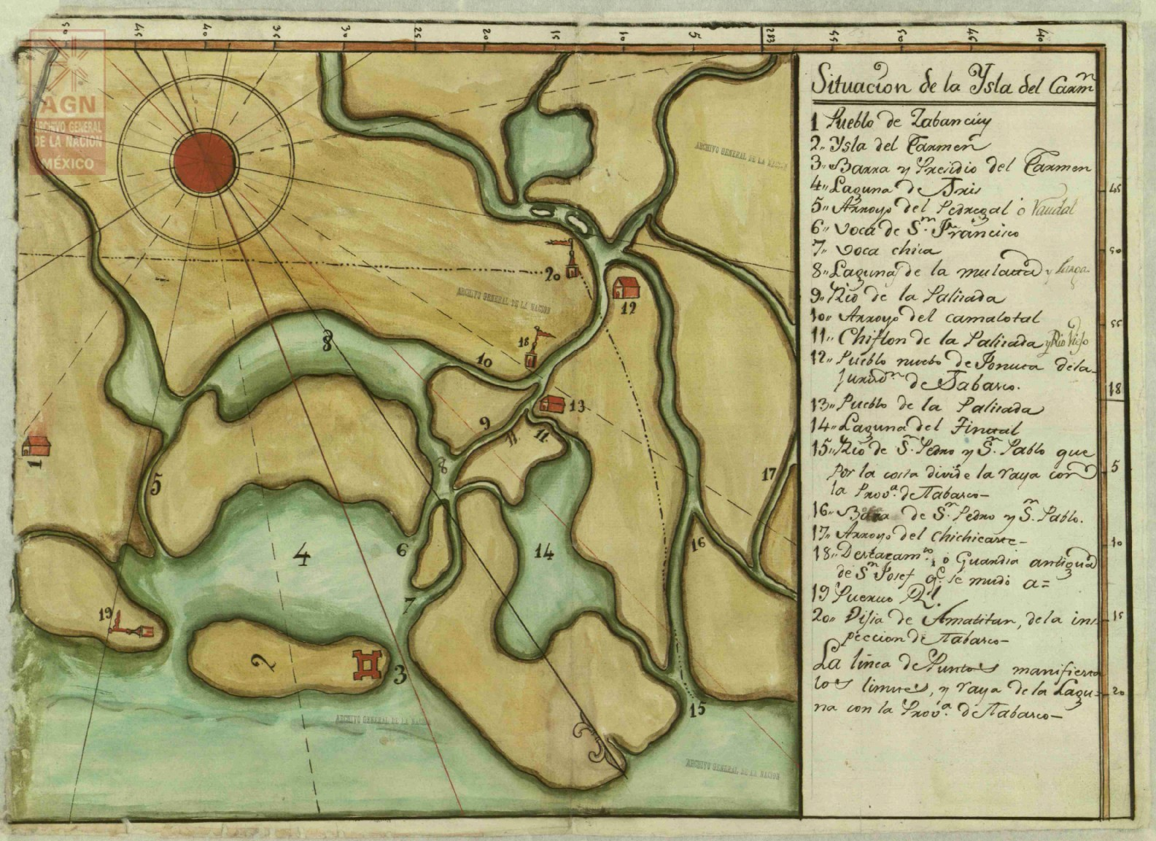
Source: Archivo General de la Nación de México, Mapas, Planos e Ilustraciones (280), mapilu/210100/3504 Isla del Carmen (3256). Made by Juan Manuel de Bonilla

When the governor of Presidio del Carmen, Pedro Dufau Maldonado, realised the obstacles facing the sourcing of hardwood for naval construction in his jurisdiction, he presented the viceroy with the proposal of using forest resources from the Usumacinta River, which he had surveyed previously, cutting down some trees; his informants had reported the presence of abundant quality hardwoods in accessible areas. However, the vast woodlands near the Usumacinta fell under the jurisdiction of the governor of Tabasco. Using the argument that this could keep a steady supply of wood for the navy in Havana, Pedro Dufau Maldonado requested the authority to exploit that area of Tabasco in 1779.
In his account, Dufau Maldonado reported difficulties with his labour force “as the hands needed are many, it is not rare for several to run away at a time”, claiming that they sought, and found, shelter with the villagers of Tabasco, helped by the slack vigilance imposed by the royal officials in the region. The governor of Presidio del Carmen argued that, with his previous experience felling trees in Laguna de Términos, he was especially well qualified to supervise the works.
This appears to have been a widespread problem, for similar complaints can be found elsewhere, for instance during the royal works in Chimalapas in 1767–1768, when the local workmen often fled when the time came to drag the timber to the banks of the Coatzacoalcos River because it was heavy work. Many hands escaped after collecting their wages to tend to their fields and crops.
It is also interesting to note that Pedro Dufau Maldonado accused the locals of felling “trees clandestinely for their own use, and the governor of Tabasco cannot stop it, because the hills are inaccessible, hard to navigate, deserted, and full of streams and debris”. His petition closed with the argument that, if no permission was granted to move to the region around the Usumacinta River, he should at least be allowed to supervise tree felling in the region.
Viceroy Antonio María de Bucareli y Ursúa’s reaction was to address the governor of Tabasco in late March 1779, whom he compelled to “look after the trees and ensure that none were felled near the Usumacinta, punishing those who do”. He also requested support for Pedro Dufau Maldonado’s work in Laguna de Términos. The governor was also asked to report on the “abundance and quality of timber on the Usumacinta’s banks […] so that full information becomes available about woods suitable for naval construction, and how difficult or easy it should be to bring it to Havana”. In any case, the viceroy did not extend the jurisdiction of Presidio del Carmen over the region of the Usumacinta, simply asking the governor of Tabasco to help “with the necessary supplies, and with all the other things requested”.
Summing up, the 1770s witnessed the implementation of several projects to survey the wood available in the regions of the Seno Mexicano, between Veracruz and Campeche, in order to boost the wood supply for the naval departments in Havana and the Iberian Peninsula, as well as the warehouses in Veracruz and Campeche. Not all of these projects had a positive outcome for the Armada Real because in many instances the inaccessibility of woodland areas, natural obstacles, problems with labour and draught animals, and the difficulties of storing ship parts on riverbanks and the seashore made them too costly. However, these ideas, also promoted by local governors, as illustrated by the governor of the Presidio del Carmen, Pedro Dufau Maldonado, greatly contributed to increasing the Spaniards’ topographic and geographical knowledge of these regions, which had theretofore been explored only lightly. In conclusion, the expeditions undertaken by Spanish officials and their agents in Nautla, La Antigua, Perote, Mecacalco, Alvarado, Chimalapas, Coatzacoalcos, Usumacinta, and Laguna de Términos led to a much better understanding of the wood resources available in the provinces of Veracruz, Oaxaca, Tabasco, and Campeche (see Map 9 and Figures 13–15).

map 9 Forests, storage sites, and ports where timber harvested in the provinces of Oaxaca, Veracruz, and Yucatan was shipped
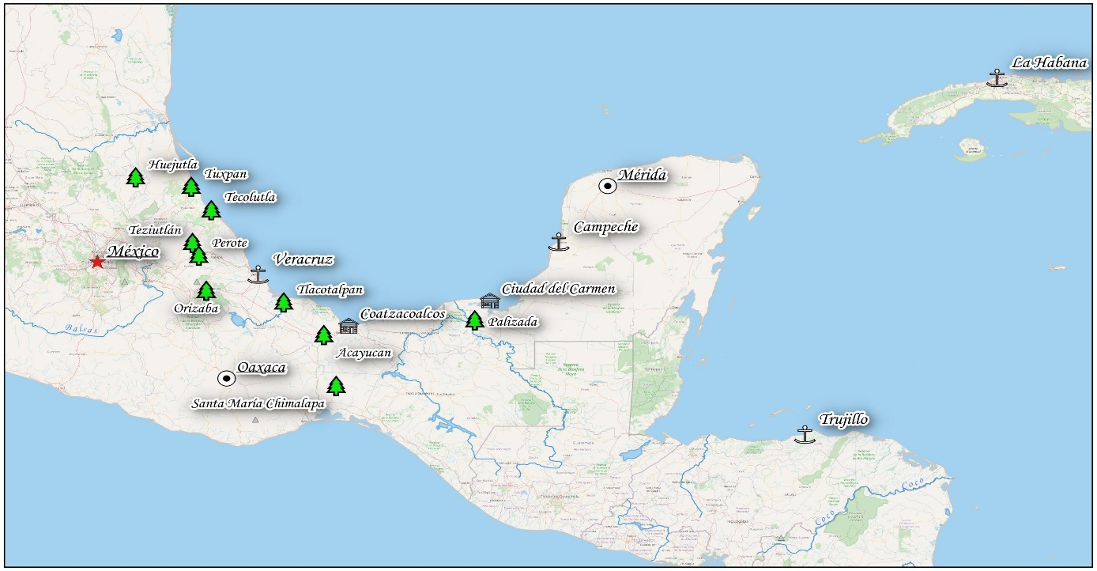
Source: Look4GIS-Lukasz Brylak, Karolina Juszczyk and Daniel Prusaczyk based on qgis software

Wood Species in New Spain, Based on Subdelegate Pedro Cabezas’s Survey of Huejutla

The survey of the New Spanish territory in search of wood resources continued into the first decade of the 19th century for the king’s naval needs, for local uses, and in support of the mining industry. This resulted in several reports issued by royal officials in Morelia, Guanajuato, San Luis Potosí, Zacatecas, Puebla, and Oaxaca in the 1790s. Especially outstanding is a report that inventoried all the tree species available in the region of Huejutla, written in March 1790 by the region’s subdelegate Pedro Cabezas, appointed by the general intendent of the province, Bernardo Bonavia, to find samples of valuable trees. Cabezas explained that he had taken small samples of wood so that their density, colour, veins, and other physical features could be examined. He described the following species:
Smoketree: “this tree is approximately 20 varas tall, and the trunk is approximately 1 vara in diameter. The top is thorny, and the leaves, and even more the flower, are tiny. It produces curly pods, like a snail, and the locals commonly use this fruit. The bark of the trunk is useful to tan leather and even to give cloth a green colour with red veins.”
- Chijol: “this tree is approximately 20 varas tall, and the trunk is approximately 1 vara and a half in diameter. It is used for local construction, as the buildings in the region are generally made of timber. The chijol gives them beams and other parts, which have the advantage of being impervious to moths and damp. Moreover, the parts that get buried in damp soil petrify (as they say around here). The wood is harder than holm oak’s, and although I have not weighed it, it can be seen that it is as dense, or denser.”
- Volantín: “this tree is approximately 30 varas tall and 1 vara in diameter, and it is used for roofs, for it is very hard. It is called volantín because, as the trunk is tall and straight, the Indians use it for the game of volantín: they stick a trunk on the ground, after removing all branches, and on the top they place a cross, from whose arms four ropes hang; one Indian, at the end of each rope, run around the trunk and in this way climb up, and it is something to behold that, while the four dance below, there is another dancing on top of the trunk in a little table barely big enough to set a foot: this is a barbarity that I have never allowed in my jurisdiction.”
- Higuerón: “this tree is between 20 and 25 varas tall and 1 vara in diameter, and the wood is not used, only to extract a sort of milk that it exudes, when the bark is cut, to treat hernias. The tree yields a fruit similar to the fig, but smaller.”
- Hule: “this tree is up to 25 varas tall and over 1 vara in diameter. The wood is also not used, only the milk that it exudes (also called hule), which is used to tar shoes, capes, and other clothing for the rainy season. It is said that the milk is also used in poultices in disjointed bones, so they do not go out of place again”.
- Tzocohuite: “this tree is approximately 15 varas tall and 1 vara in diameter. The wood is good for nothing, except to make charcoal for ironsmiths.”
- Quiebrahachas: “this tree is between 30 and 35 varas tall and one and a half in diameter. The wood is dark, as shiny as mahogany, but locals do not use it because it is too hard, hence the name quiebrahachas, and dressing it is difficult; it as dense or denser than holm oak.”
- Jonote: “this tree is approximately 8 varas tall and three-quarters in diameter. The wood is extremely light, but this makes it suitable for roofbeams, being impervious to moths; it must be kept away from the damp, or it rots.”
- Sangre de dragón: “approximately 20 tall and three-quarters in diameter. When cut, the trunk gives away a blood-red liquid (from which it may have taken the name), sold by apothecaries for various maladies.”
- Chaca or palo mulato: “approximately 20 varas tall and half in diameter. It is deemed to be very fresh, and the boiled leaves are used as a remedy against fever.”
- Brasil: “from 15 to 20 varas tall and over half in diameter. The wood is very hard, being used for roofs and by dyers to get a purple colour.”
- Tepeguage or vochiscoahuite: “approximately ten varas tall and two in diameter. The wood is very hard, and locally it is used only in sugar mills.”
- Chicozapote: “approximately 25 varas tall and one and a half in diameter, the fruit is well known. When the trunk is cut, it gives out a milk vulgarly known as chicle. The wood is used in building, and the least thick branches on staffs, which are highly appreciated owing to their red colour and softness; they are also used for bottoms.”
- Mulberry tree: “approximately 20 varas tall and half in diameter. The wood is soft and a fine yellow colour, used to dye capes. The fruit is called the mulberry, but it is different from those picked in cold regions because it looks similar, but the flavour is different, as well as being larger and green in colour.”
- Copal: “approximately 12 varas tall and nearly 1 in diameter. The wood is only good for firewood, but it exudes a gum or aromatic resin that is used in temples instead of frankincense.”
- Cedar: “up to 25 varas tall and up to 2 in diameter. The wood is very useful, not only for beams and roofs, but also for chairs, chests, wardrobes, and other common pieces of furniture, and especially for frames, statues, and altarpieces. There is a great abundance of these trees in the region, so much that they are also used for benches, steps, doors, windows, balconies, basins, and such, but it is not as fine as the cedars found in Havana.”
- Chiote: “approximately 16 varas tall and one and one-quarter in diameter. The wood is good for nothing, but it gives out a fruit called Guajilote, like a banana from Guinea, but with sharper ends. The Indians eat it regularly and they say it is useful for different maladies and especially to facilitate menstruation.”
- Palo de rosa: “approximately 18 varas tall and three-quarters in diameter. The wood is hard and elastic, so it is used for beds and roofbeams in houses. Around March, it loses most leaves but sprouts a multitude of flowers (white in colour, with ends like a rose) so that every tree looks like a bunch of flowers. The flowers make figures, like buttons and leaves. Five flowers spring from each branch, the two below facing the opposite side as the three above.”
- Orejón: “approximately 10 varas tall and three-quarters in diameter. The wood is good for nothing, but the bark is used to line ramrods. The leaves are tiny.”

This report had little effect, as Huejutla’s wood resources remained largely untapped in the late 18th century, but is a valuable illustration of the relationship between humans and their ecological context. Pedro Cabezas made a thorough description of the types of wood available in the province, including the uses to which they were put: medicinal–ritual; in the textile and footwear industry; and in the construction of buildings and furniture. In some passages, Cabezas mentioned the local communities, on whose knowledge of these trees the Spaniards plainly relied, making use of it for their own purposes. This and similar reports written in the 1790s betray a change of perception in wood use. The trees were no longer only seen as a possible source of naval timber; other uses were also contemplated. In addition, reports written in mining regions began warning about deforestation, the result of overexploitation and cattle ranching. Finally, concerning the matter of naval construction, Cabezas’s opinion that the cedars from Huejutla were not “as fine as the cedars found in Havana” is of note. This reference suggests that the subdelegate had previous experience with wood in other regions, even distant ones, like Cuba, where cedars were chiefly used by the naval industry.

figure 13 The map shows the territorial draft of Intendencia of Oaxaca (1774)
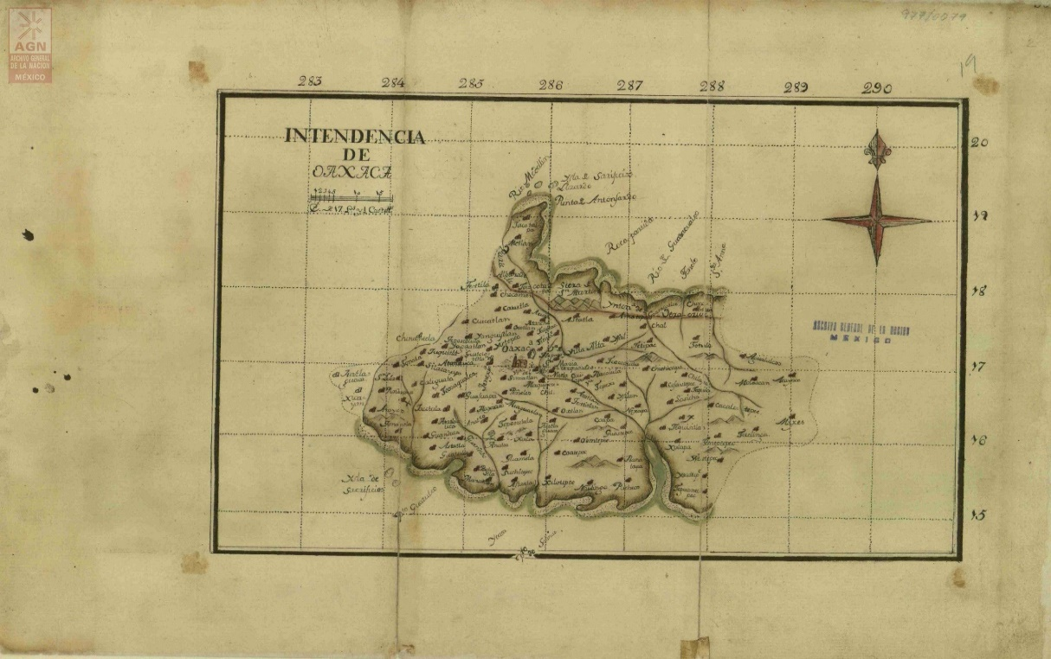
Source: Archivo General de la Nación de México, Mapas, Planos e Ilustraciones (280), mapilu/210100/88 Intendencia de Oaxaca (84)

figure 14 The map shows the territorial draft of Intendencia of Veracruz (1774)
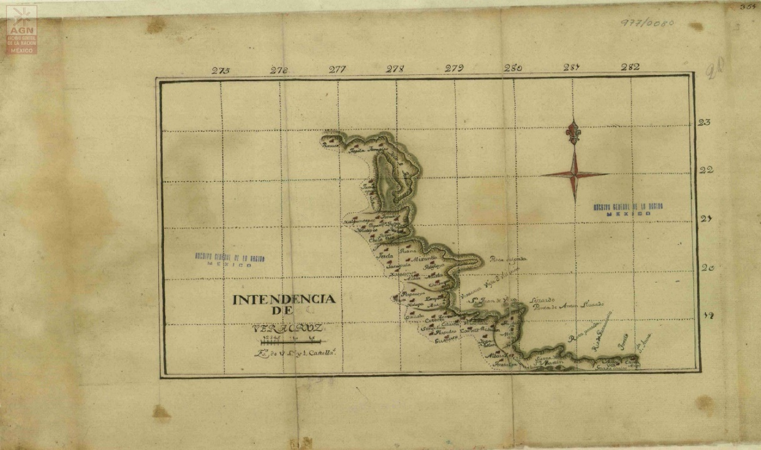
Source: Archivo General de la Nación de México, Mapas, Planos e Ilustraciones (280), mapilu/210100/89 Intendencia de Veracruz (85)

figure 15 The map shows the territorial draft of Intendencia of Yucatan (1774)
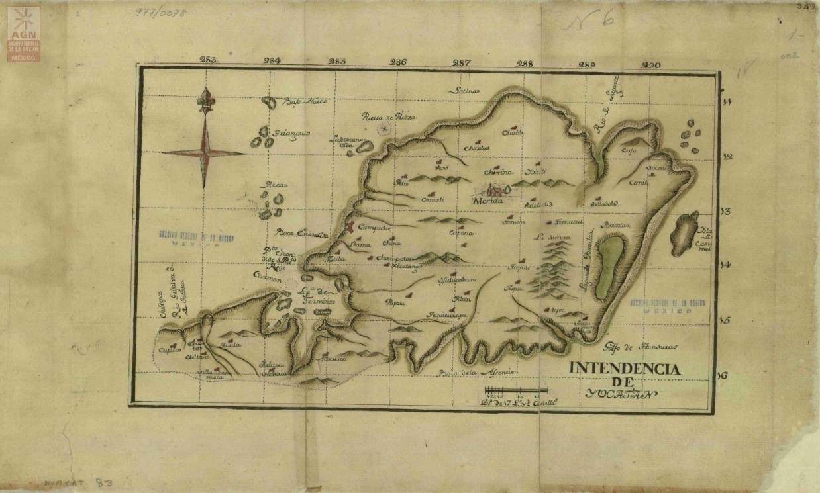
Source: Archivo General de la Nación de México, Mapas, Planos e Ilustraciones (280), mapilu/210100/87 Intendencia de Yucatán (83)

Francisco de Seijas y Lobera’s Gobierno militar y político del reino imperial de la Nueva España, is the seventh of 14 volumes written under the overall title Memoria sobre el gobierno de las Indias españolas realizada por don Francisco de Seijas y Lobera para servir a la verdadera unión de las dos coronas de España y Francia (published between 1702 and 1704).
Jerónimo de Uztáriz, Theorica y practica de comercio, y de marina: en diferentes discursos y calificados exemplares, que con específicas providencias, se procuran adaptar á la Monarquia española, book dedicated to Philip V (published in 1724).
José del Campillo y Cossío, Nuevo sistema de gobierno económico para la América: con los males y daños que le causa el que hoy tiene, de los que participa copiosamente España; y remedios universales para que la primera tenga considerables ventajas, y la segunda mayores intereses (written in 1743 and published in 1789).
See Geoffrey J. Walker, Spanish Politics and Imperial Trade, 1700–1789 (London: Macmillan, 1979); David B. Bradind, Bourbon Spain and Its American Empire (Cambridge: Cambridge University Press, 1981); Henry Kamen, Spain's Road to Empire: The Making of a World Power, 1492–1763 (London: Allen Lane, 2002); María Baudot Monroy, La defensa del Imperio. Julián de Arriaga en la Armada (1700–1754) (Madrid: Ministerio de Defensa-Universidad de Murcia, 2013); Adrian J. Pearce, The Origins of Bourbon Reform in Spanish America 1700–1763 (New York: Palgrave Macmillan, 2014).
He was deployed in America between 1692 and 1701.
si para fabricar en ambos mares [del Sur y Norte] poderosas armadas se requiere en primer lugar las maderas, no hay países en todo el mundo más aptos para ellas que los de la Nueva España, porque como en los demás de aquellas Indias, se hallan en los puertos y costas de ambos mares las famosas y permanentes maderas de cedro y las de las caobas para hacer los cascos de los bajeles, y para arbolarlos los guayacanes, los pinos y otros árboles como son los cugues y marías. (Seijas y Lobera, Gobierno militar y político, 293)
son grandes las ventajas que en las islas y tierra firme de la América tiene su majestad de muchas y exquisitas maderas y abundancia de brea y alquitrán para la construcción de bajeles […] con el considerable beneficio de que si los [buques] fabricados en Europa duran de 12 a 15 años, [estos de América] se conservan más de 30, ya que se hacen allá con el cedro, roble más duro y otras maderas de superior firmeza y resistencia; lo que es causa también de que necesitan de menos carenas y de otros reparos. Fuera de que en un combate tiene también el cedro la ventaja de que embebe en sí las balas, sin que se experimenten los efectos de los astillazos, que en los navíos fabricados en Europa, y que suelen maltratar y aun matar mucha gente. (Uztáriz, Theorica y practica de comercio, 216)
“cedro, caoba y otras maderas hermosas, pero también mástiles para navíos, tablazón, brea, pez y otros géneros gruesos que ahora nos vienen del Báltico, los tendremos de nuestras Indias […] y los podremos llevar allá y venderlos baratos” (Campillo y Cossío, Nuevo sistema de gobierno económico, 158).
Iván Valdez Bubnov, Poder naval y modernización del Estado, 204.
Between 1702 and 1721, the shipyard in Campeche built a minimum of two ships for the Real Armada. The first was the 50-gun Nuestra Señora de Guadalupe, launched in 1702, and the second was the La Potencia del Santo Cristo, alias “El Blandón”, launched in 1720. Amparo Moreno Gullón, “La Matrícula de Mar de Campeche (1777–1811)”, Espacio, Tiempo y Forma, serie IV, Historia Moderna 17 (2004), 275.
German Andrade Muñoz, Un mar de intereses (México: Instituto Mora, 2006), 85‑87; Valdez-Bubnov, Poder naval y modernización del Estado, 240–241.
agn, Reales Cedulas Originales, vol. 53, fs. 122–123; Antonio Béthencourt Massieu, “Arboladuras de Santa María de Chimalapa Tehuantepec en las construcciones navales indianas 1730–1750”, Revista de Indias 20 (1960), 70–72; John T. Wing, Roots of Empire: Forests and State Power in Early Modern Spain, c.1500–1750 (Leiden: Brill, 2015), 195.
“Cádiz utiliza la madera de América que viene a mucha costa y de la cual se saca muy poco provecho, no por su calidad, que es de preferir a cuanto roble hay en España, sino por el ningún cuidado de los que la envían a [la metrópoli], donde llega muy mal delineada, mal configurada y nunca surtida”. ags, sma, Arsenales, leg. 349, Observaciones sobre el estado de los montes de España, nota del consumo de la madera de construcción, que, en cada año, se considera necessaria en los departamentos de Ferrol, Cartagena y Cadiz; y proyecto para aprovisionar estos arsenales de maderas de America.
ags, sma, Arsenales, leg. 317, Estado de las piezas de madera de sabicú y caoba que se necesitan para la construcción de un navío de 70 cañones y otro de 80.
“El cedro es de más duración, pues hemos visto, que navíos que se han forrado aquí y han ido a España, han vuelto en los mismos foros”.
ags, sma, Arsenales, leg. 317, Se contexta el Real Orden expedido, para que el forro exterior de los navíos sea de tablas de pino; y se expone, con dictamen de la Maestranza ser esta calidad de madera de muy corta duración según experiencias.
Ibid., leg. 343. The intendent of the department in Havana reported that contractors had delivered 33,247 pieces for the construction of approximately eight 60- to 70-gun ships; 2,142 for frigates; and 697 for xebecs for the coastguards; while another 3,000 pieces were still to be brought to the port. In 1769, Francisco Mendoza, navy officer, and Joseph Chenar, building assistant, arrived in Havana to inspect the island’s woodland and supervise woodcutting operations. They were asked to supply 24,000 pieces of different sorts, for 60- to 120-gun ships. Rafal Reichert, “Recursos forestales, proyectos de extracción y asientos de maderas en la Nueva España durante el siglo XVIII”, Obradoiro de Historia Moderna 28 (2019), 63.
Laura Machuca, “Proyectos oficiales y modos locales de utilización del Istmo de Tehuantepec en la época colonial: historias de desencuentros” in Emilia Velázquez and Éric Léonard and Odile Hoffmann and M.-F. Prévôt-Schapira (eds.), El istmo mexicano: una región inasequible. Estado, poderes locales y dinámicas espaciales (siglos XVI–XXI) (Marseille: IRD Éditions, 2009), 66.
agn, Industria y Comercio, vol. 10, exp. 1, fs. 46–47, “Corte real de arboladuras en Chimalapa”.
Béthencourt Massieu, “Arboladuras de Santa María de Chimalapa Tehuantepec”, 65–101.
“Coatzacoalcos pines” is a recurrent expression in the record, which alludes to the place where they were loaded onto the waiting ships; i.e. the bar of Coatzacoalcos, in the Gulf of Mexico. These pines, however, were in all probability sourced in the woodlands of Chimalapas.
“pinos de Coatzacoalcos salían a poco más de la mitad del costo que le tienen al Rey, los pinos del Norte, que aún de inferior calidad que estos, por ser a mayor peso su madera, son de bastante bondad para arboladuras de navíos”. ags, sma, Arsenales, leg. 339, f. 28, Pinos de arboladura de Goatzacoalcos.
ags, sma, Arsenales, leg. 339, f. 8.
A solid wooden or masonry structure where timbers and carved pieces were stored.
Andrade Muñoz, Un mar de intereses, 99–105.
“la provisión de árboles para elaborar palos, vergas, masteleros y botalones de navíos de 80, 70 y 60 cañones y también para dos fragatas de 30 cañones”.
ags, sma, Arsenales, leg. 624, fs. 85–90, Instrucción de Antonio de Gregorio para el corte de arboladuras en Chimalapa.
agn, Industria y Comercio, vol. 10, exp. 1, fs. 31–33.
José Manuel Serrano Álvarez, El astillero de La Habana en el siglo XVIII: historia y construcción naval (1700–1805) (Madrid: Ministerio de Defensa, 2018), 530–531.
agn, Industria y Comercio, vol. 10, exp. 1, f. 43.
agn, Marina, vol. 26, fs. 232–233v.
agn, Industria y Comercio, vol. 10, exp. 1, f. 19.
agnm, Industria y Comercio, vol. 10, exp. 1, f. 19.
el día 16 de septiembre [1769] acabé de echar al agua toda la madera, y me hallé con ella a medio andar del río, en este tránsito se han desgraciado cinco palos de poca consideración, con una de las canoas que el 31 del pasado se hizo pedazos en un raudal, iba equipada con 10 hombres, quienes se liberaron de este lance en que se vieron con bastante peligro, por haberlos metido la corriente bajo de una partida de palos y solo se perdieron la canoa y algunas herramientas. (agnm, Industria y Comercio, vol. 10, exp. 1, fs. 39–40)
“considerando lo avanzado del tiempo para los sucesivos trabajos” (ibid., fs. 54–56).
Ibid., f. 68.
ags, sma, Arsenales, leg. 351, fs. 22 and 24, Relación de arboladuras en Goatzacoalcos por Manuel Pérez.
agnm, Industria y Comercio, vol. 10, exp. 1, f. 12.
For example, in 1769 the alcalde mayor of Nexapa sent 9,000 pesos, and the other one from the Alcaldía Mayor of Tehuantepec 6,185 pesos, 3 tomines, and 6 grains.
se les pagaba tres reales por cada diez leguas [de camino]; tres reales el día que trabajaban y uno el que por día de fiesta o agua no trabajaban, que relevándose unas a otras de quince en quince días, más importaban los días de camino y los durante que no trabajaban que los de trabajo. Ello por la distancia de los pueblos y las continuas aguas de este país [es decir de la selva de Chimalapas]. (agn, Industria y Comercio, vol. 10, exp. 1, f. 17)
para esas faenas de los tiros y arrastres 250 forzados con 25 hombres de tropa para su custodia, incluyendo en este número de jurados cuatro carpinteros, un jarrero y un herrero, [así] el costo que tendrá diariamente cada uno para la comida y vestuario será de un real y se hallarán prontos a trabajar cuando se les mande, cuya ventaja es tan considerable que si ahora una Arboladura cuesta catorce mil pesos, por este medio se conseguirá con cinco mil. (Ibid.)
Ibid., f. 18.
Ibid., fs. 51–52.
Probably, the official is referring to Mesoamerican felines, such as the jaguar.
agn, Industria y Comercio, vol. 10, exp. 26, fs. 4–5, Arboladuras de Chimalapa. Sobre yuntas de bueyes.
se halló haber todavía abundancia de pinos […]; pero los que en adelante se sacasen serán algo más costosos por hallarse ya más retirados. Su calidad es bien conocida respecto haberse conducido muchas arboladuras a La Habana, de las que todavía queda porción en los esteros de Postmetacan, Tacojalpa y Tacojalpilla, los que no se pudieron reconocer bien por hallarse muchos sumergidos y cubiertos de lechuguilla. (Alfred H. Siemens and Lutz Brinckmann “El sur de Veracruz a finales del siglo XVIII. Un análisis de la relación de Corral”, Historia Mexicana 26, no. 2 (1976), 315)
José Antonio Calderón Quijano (ed.), Los virreyes de Nueva España en el reinado de Carlos III (Seville: Escuela Gráfica Salesiana, 1967); María Luisa Ramos Catalina y de Bardaxí, “Expediciones Científicas a California en el siglo XVIII”, Anuario de Estudios Americanos 13 (1956), 217–310.
Vicente Salvador y Monserrat, El marqués de Cruilles, Biografía del Excmo. Sr. Teniente general D. Joaquín Monserrat y Cruilles, Marqués de Cruilles, Virrey de Nueva España de 1760 a 1766 (Valencia: Nicasio Rius, 1880).
“de mucha manga y de igual resistencia”.
Archivo General de Indias (agi), Estado leg. 34 doc. 35.
This will be explained in more detail in the next chapter.
Reichert, “Recursos forestales, proyectos de extracción y asientos de maderas”, 71–72.
agn, Industria y Comercio, vol. 10, exp. 1, fs. 1–47, Corte real de arboladuras en Chimalapa.
“las urgencias de los bajeles de Armada y [también] para vender[los] a los mercantes”. agn, Correspondencia de Virreyes, serie 2, vol. 11 exp. 57 f. 102.
Ramos Catalina y de Bardaxí, “Expediciones científicas a California en el siglo XVIII”, 217–310.
The region between the Alvarado and Coatzacoalcos rivers.
“aumentar, cuanto sea posible, sus armadas navales así en España como en las Indias”. agn, Correspondencia de Virreyes, serie 2, vol. 12, exp. 159, f. 26.
“algunos bajeles de guerra, entre ellos la Bizarra y la Nueva España” (ibid.).
Gervasio de Artíñano y Galdácano, La arquitectura naval española (en madera) (Madrid: Oliva de Vilanova, 1920), 57–58; Bibiano Torres Ramírez, La Armada de Barlovento (Seville: Escuela de Estudios Hispano-Americanos, 1981), 96.
agn, Correspondencia de Virreyes, serie 2, vol. 12, exp. 162, f. 31v.
Ibid., exp. 159, f. 27.
Guillermina del Valle Pavón, Donativos, préstamos y privilegios: los mercaderes y mineros de la Ciudad de México durante la guerra anglo-española de 1779–1783 (Mexico: Instituto Mora, 2016: 44).
“reconocer el terreno, los bosques, proporción de maderas, facilidad de las obras necesarias, subsistencia de víveres, fondo del río y su barra, y disposiciones de mejorarla para dar salida a los buques que puedan construirse allá”. agn, Correspondencia de Virreyes, serie 2, vol. 12, exp. 159, f. 27.
“deben ser el principal apoyo de la conservación de estos dominios americanos”. agn, Correspondencia de Virreyes, serie 2, vol. 12, exp. 159, f. 27v.
agn, Correspondencia de Virreyes, serie 2, vol. 12, exp. 162, f. 30.
Ibid., exp. 162, f. 34.
Horacio Capel Sáez, Los ingenieros militares en España. Siglo XVIII: repertorio biográfico e inventario de su labor científica y espacial (Barcelona: Universitat Barcelona, 1983); José Antonio Calderón Quijano, Historia de las fortificaciones en Nueva España (Sevilla: Escuela de Estudios Hispano-Americanos, 1953); Omar Moncada Maya, Ingenieros militares en Nueva España. Inventario de su labor científica espacial. Siglos XVI a XVIII (México: Universidad Nacional Autónoma de México, 1993).
“arboladuras, para toda clase de embarcaciones y su conducción a esta ciudad [de Veracruz] desde los montes de Teziutlán y Perote, donde según dicen hay pinos apropósito para el efecto”. agn, Industria y Comercio, vol. 10, exp. 5, fs. 101–111v, Relación del reconocimiento hecho en los montes de Teziutlán, y Perote por el Teniente Coronel de Ingenieros Don Miguel del Corral, en solicitud de maderas aptas para toda Arboladura de Navío.
agn, Industria y Comercio, vol. 10, exp. 5, fs. 102v–103.
Ibid., f. 103v.
Modern Ixhuacán de los Reyes.
The Chichiquila River, which runs into the Antigua River.
A frigate or a ship-of-the-line requited approximately 36 masts of different diameters.
“aunque en muchas partes se anda, no pueden cruzarlas balsitas por contrario que sirven a los pescadores”. agn, Industria y Comercio, vol. 10, exp. 5, f. 104v.
Ibid.
Full title: “Relación de los reconocimientos practicados por el coronel ingeniero en segundo don Miguel del Corral y el capitán de fragata graduado y piloto mayor de derroteros de la Real Armada don Joaquín de Aranda, de orden del excelentísimo señor don Antonio María Bucareli y Ursúa, Virrey Gobernador y Capitán General del Reino de la Nueva España; a que dieron principio por la barra de Alvarado en 28 de octubre del año pasado de 1776 y finalizaron el día de la fecha [en Tlacotalpan el 21 de julio de 1777]”.
Siemens and Brinckmann “El sur de Veracruz a finales del siglo XVIII”, 311–316.
“por todos los arroyos de la derecha e izquierda, empezando desde la hacienda del Zapotal, se han sacado maderas de cedro ordinario, caobano o cedro macho, tavi, zapote, guayacán, palo maría, cocuite, y encino”.
Andrade Muñoz, Un mar de intereses, 87–98.
Reichert, “¿Cómo España trató de recuperar su poderío naval?”, 83.
“el capitán don Andrés Berdeja, que es constante, fue un hombre de mucho espíritu y práctica para cortes de madera, estuvo establecido en el río de Zapotitlán más de dos meses […] para sacar pinos, y se retiró sin esperanza de conseguirlo”. Siemens and Brinckmann, “El sur de Veracruz a finales del siglo XVIII”, 313.
“madera muy gruesa, larga y de buena calidad”.
Siemens and Brinckmann, “El sur de Veracruz a finales del siglo XVIII”, 311–312.
Ibid., 312.
Rafael Palma and Odile Hoffmann “La conformación de una frontera interna en las riberas del Tesechoacán”, in María Teresa Rodríguez and Bernard Tallet (eds.), Historias de hombres y tierras. Una lectura sobre la conformación territorial del municipio de Playa Vicente, Veracruz (México: Centro de Investigaciones y Estudios Superiores en Antropología Social, 2009), 53.
Siemens and Brinckmann, “El sur de Veracruz a finales del siglo XVIII”, 313.
agn, Industria y Comercio, vol. 10, exp. 2, fs. 50–63v, Asiento de maderas celebrado con Antonio Berdeja, apoderado del capitán Andrés Berdeja.
“siendo teniente del regimiento de la corona tenía inteligencia en los cortes de arboladura por haber estado muchos años en los cortes de la región de Coatzacoalcos”.
Siemens and Brinckmann, “El sur de Veracruz a finales del siglo XVIII”, 313.
Andrade Muñoz, Un mar de intereses, 85–87.
Siemens and Brinckmann, “El sur de Veracruz a finales del siglo XVIII”, 315.
“cada uno corta, y ha cortado las maderas según su antojo o conveniencia […] la han cortado sin atención ninguna a su tamaño, arrastrando con todo, hasta con los pimpollos que apenas daban una sesma en cuadro, dejando pérdida o extraviada la mejor madera como curvas muy apreciables [en la construcción naval], echando a perder mucha para sacar palos derechos de diez varas” (ibid.)
Ibid.
Ibid., 315–316.
Ibid., 316.
“informe, y de instrucción de lo que deba ejecutar José Vicente vecino de Tlacotalpan propuesto por dicho Coronel para el reconocimiento de los pinos de la Antigua, y de Nautla que corresponde hacerse con el fin de ver la mayor facilidad de conducir por ellos las Arboladuras que tiene pedidas el Señor comandante general de la escuadra de la Habana”. agn, Industria y Comercio, vol. 10, exp. 10, f. 151.
The samples were taken from two different locations.
“incomparable ventajosa de estos [palos] a los de Coatzacoalcos y considerado que esta escuadra, y demás fuerzas [navales] que se la puedan agregar y utilizar […] me ha parecido importante hacerlo presente a V. E. [virrey Bucareli] para que se sirva disponer el corte, y conducción del número de perchas según las dimensiones que expresa la nota adjunta”. agn, Industria y Comercio, vol. 10, exp. 10, f. 152.
“entre los que los más proporcionados para extraerse son los que se hallan en los sitios llamados Chololoya y Zapotitlán, los primeros que deben salir por el Río de la Antigua, y los segundos por el de Santa María Tlapacoya y la Barra de Nautla, la extensión de estos pinos, y su abundancia es constante”. Ibid., f. 156v.
Ibid., f. 161v.
Ibid., fs. 179–181.
“de largo como de media milla y de ancho como quince varas que será lo necesario el desmontar para franquear el río”. Ibid., fs. 182v–183.
“en el Paso de la Barranca es una vuelta muy obligada [donde] hay un gran remolino que los pescadores llaman Tragadero”. Ibid., f. 186.
“este paraje no es terreno de Maderas de Pino, pues los que se hallan están muy salteados, y los más tuertos, y todos a pie hachados de los Naturales para reconocer si la hebra es apropósito para rajar para Tajamanil y los más de estos se hallan por dichos hachazos huecos”. Ibid., f. 210v.
agn, Industria y Comercio, vol. 10, exps. 1 y 5.
Ibid., exp. 10, f. 212.
Ibid., fs. 212v–227.
Ibid., fs. 236–237v.
“para construir fragatas y otros buques desde 24 hasta 30 cañones de fuerza”. agnm, Correspondencia de Diversas Autoridades, vol. 29, exp. 59, f. 195.
Ibid., fs. 204–205v, 222–223.
The order was increased by another 181 pieces, coming to a total of 581 dressed parts. agnm, Real Caja, vol. 15, fs. 25–28v.
Rafal Reichert, “El transporte de maderas para los departamentos navales españoles en la segunda mitad del siglo XVIII”, Studia Historica 43 no. 1 (2021), 47–70.
“sea caer maderas al río en que se embalsan, sea el tiro demasiadamente largo, resultaban costosos y sumamente gravosos al Rey”. agnm, Industria Artística y Manufacturera, vol. 2, exp. 3, f. 37.
agnm, Industria Artística y Manufacturera, vol. 2, exp. 3, f. 38.
“siendo grande el número de los individuos de que se forma el trabajo, acontece frecuentemente que desertasen varios mozos”.
agnm, Industria Artística y Manufacturera, vol. 2, exp. 3, fs. 39–40.
agnm, Industria y Comercio, vol. 10 exp. 1, f. 17.
“los cortes furtivos de maderas para intereses propios de algunos sujetos particulares, y es dificultosísimo que pueda impedirlo el gobernador de Tabasco, pues en la actualidad acontece que sin su permiso se están cortando, y sacando maderas a causa de ser los montes inaccesibles intrincados, desiertos, llenos de raudales y desechos”.
agnm, Industria Artística y Manufacturera, vol. 2, exp. 3, fs. 40–41.
“cuide, cele y vele, no se ejecuten cortes de maderas en los ríos de Usumacinta, castigando a los que lo ejecutaren”.
“la abundancia, y calidad de maderas de las riberas de aquellos ríos de Usumacinta […] para tomar, una radical y plena instrucción de las maderas de aquel país, si son abundantes de solides, y calidad, propia para fábrica de navíos y de facilidad, o dificultad que pueda haber de no extracción de aquel país, y conducción para la Habana, y porque conducto pueda practicarse informador con toda justificación sobre este asunto”.
“auxilie con víveres necesarios, y en lo de más que le va prevenido”. agnm, Industria Artística y Manufacturera, vol. 2, exp. 3, f. 42.
agnm, Industria y Comercio, vol. 31, exps. 13, 19, 20, 21, and 24.
Ibid., exp. 10, fs. 239–243v.
“es un árbol como de 20 varas de altura y su tronco tiene por lo regular como una vara de diámetro. Las ramas de la copa todos son espinosas. La hoja es menuda y mucho más la flor. Produce unas vainas enroscadas como caracol y esta es fruta corriente de que usan por aquí. La cascara del tronco es muy útil para curtir pieles y aun para dar a las gamuzas un color verde con vetas rojas”.
“es un árbol como de 20 varas de alto y una y media de diámetro. Es muy útil para los edificios de estos países, que por lo regular son de madera. Pues del Chijol sacan horcones, vigas, y demás piezas las que tienen la ventaja de no entrarles jamás polilla, ni podrirse con la humedad. Pues antes se petrifica (según asientan aquí todos de voz común) la parte que se enclava en terreno húmedo. Es esta una madera más dura que la encina y aunque no he tenido la curiosidad de calcular su peso pero hecho de ver que es de igual o mayor gravedad especifica que la de la encina”.
“es árbol como de 30 varas de altura y una de diámetro y se aprovecha para techumbres de edificios por ser madera muy maciza. Le dicen volantín porque con motivo de ser su tronco muy recto y alto usan de él los Indios para el juego llamado Volantín que consiste en poner fijo o clavado uno de estos Palos (quitado toda la ramificación) y puesta en la punta una cruceta que voltea fácilmente, penden de sus cuatro brazos, cuatro cuerdas en cuyos extremos se sientan otros tantos Indios y dan vueltas en contorno, con cuyo movimiento van adquiriendo una grande elevación siendo lo más digno de admirar que ínterin dan vueltas los cuatro Indios de las cuerdas, esta otro bailando sobre la punta del madero en una especie de mesilla en cuyo plano apenas cabe la planta de un pie: barbaridad que nunca he permitido yo en este partido”.
“es un árbol de 20 a 25 varas de alto y una de diámetro y aunque para nada aprovechan su madera, pero utilizan una leche que vierte (picando el tronco verde) para curar a los relajados o quebrados. Da este árbol una fruta de la figura de la breva, pero más pequeña y su sabor es parecido al del higo”.
“es un árbol hasta de 25 varas de alto y más de vara de diámetro. Tampoco se aprovechan de su madera sino de una leche que vierte (llamada también hule) con la que embetunan zapatos, capingones y otras ropas a efecto de defenderse del agua en tiempo de lluvias. Se dice que también sirve esta leche para bilmas que se aplican a los que han tenido huesos dislocados para que no vuelvan a dislocarse”.
“árbol como de 15 varas de alto y una de diámetro cuya madera no sirve más que para carbón de herreros”.
“es de 30 a 35 varas de alto y su tronco como de vara y media de diámetro. Es madera negra tan lucida como el ébano pero no la aprovechan para piezas porque es tan sumamente dura que por eso le llaman quiebrahachas y cuesta mucha dificultad el labrarla fuera de que también es tan pesada o más que la encina”.
“como de ocho varas de alto y tres cuartas de diámetro. Su madera es sumamente leve cuasi tanto como el corcho y sin embargo esto sirve para vigas de las casas porque no le entra polilla y es de mucha duración en no teniendo humedad porque con el agua luego se pudre”.
“como de 20 varas de alto y tres cuartas de diámetro. Su tronco en dándole un tajo vierte un licor rojo, color de sangre (que acaso de aquí tomó el nombre este árbol) que se vende en las Boticas para que la aplican los Médicos para varias enfermedades”.
“como de 20 varas de alto y media de diámetro. Se dice ser muy fresco y cocidas las hojas en agua común se usa esta bebida para destruir las fiebres”.
“de 15 a 20 varas de alto y más de vara de diámetro. Es madera muy dura que sirve para techumbres y la usan los tintoreros para dar color morado”.
“como de diez varas de alto y dos tercios de diámetro es madera muy dura que por aquí solo se aprovecha para los trapiches o molinos de caña”.
“como de 25 varas de alto y una y media de diámetro cuya fruta es muy conocida. Hendido su tronco vierte una leche que vulgarmente llaman chicle. Su madera se aprovecha para edificios, y las varas menos gruesas sirven aquí para báculos que son muy lucidos por su tersidad y color rojo y pueden aplicarse también para tacos de trucos”.
“como de 20 varas de alto y media de diámetro. Su madera es muy tersa de un color amarillo muy fino que sirve para teñir Gamuzas. Su fruta se llama mora pero es distinta de la de tierras frías pues aunque se parece en la figura pero es de diverso sabor de mayor tamaño y de color verdoso”.
“como de 12 varas de alto y cerca de una de diámetro. Su madera no sirve más que para leña, pero vierte una goma o resina odorífera que molida en polvo sirve en los Templos en lugar de Incienso”.
“como de 25 varas de alto y hasta de dos de diámetro. Es madera muy útil no solo para Viguerías y techumbres, sino para Sillas, Baúles, Roperos, y demás piezas del uso común y especialmente para toda labor de talla como Óvalos, Estatuas, Retablos. Hay de estos árboles mucha abundancia por aquí tanto que no se usan de otra cosa todos los muebles de Bancas, Escaños, Puertas, Ventanas, Balcones, Tinas, Bateas, y demás, pero no es este cedro tan fino como el de La Habana”.
“como de 16 varas de alto y una y cuarta de diámetro. De nada sirve su madera pero da una fruta que llaman Guajilote de figura de plátano guineo, aunque con los extremos más agudos, la que comen regularmente los Indios, y se dice ser muy útil para varias enfermedades especialmente para facilitar la menstruación de las Mujeres”.
“como de 18 varas de alto y tres cuartas de diámetro. Su madera es muy elástica y dura por lo que se aplica para catres y también suelen hacer de ella las Vigas de las Casas. Por el mes de marzo se le cae la mayor parte de las hojas pero produce una multitud de flores (color blanco con los extremos aportillados como la Rosa) de suerte que cada árbol parece un Ramillete. Va dibujado un ramo con la figura de las flores, botones y hojas. De estas nacen cinco en cada ramito, las dos inferiores con inclinación opuesta a la de las tres superiores”.
“como de diez varas de alto y tres cuartas de diámetro. Su madera de nada sirve pero la corteza del tronco se aprovecha para curtir Baquetas. La hoja es muy menuda”. agnm, Industria y Comercio, vol. 31, exp. 10, fs. 239–243v.
Ibid., exp. 13, fs. 258–265v.
“tan fino como el de La Habana”. Ibid., exp. 10, fs. 241v–242.

