**Citation Mapping:**

**A Powerful Tool for Producing and Visualizing Data-driven Reviews of Research Fields**

ABSTRACT

How can political science researchers use citation mapping tools to refine the development of research on complex theoretical concepts? Citation mapping, a powerful research tool commonly used in the natural sciences, is not yet widely used in political science. This study illustrates citation mapping’s capabilities by producing citation maps of academic research on the term “organizing.” We describe our multi-step methodological approach for generating the citation maps and demonstrate how these maps can be analyzed to produce insights about themes, potential gaps, canonical literature, and levels of dialogue across and between research streams. The paper concludes by outlining future research possibilities based on this study’s citation mapping approach.

Visually mapping research fields offers a powerful tool for helping scholars grasp a particular field’s academic landscape on a larger scale than would be possible using traditional literature reviews. This paper demonstrates the capabilities of scientific mapping tools for studying complex concepts in political science, focusing on the illustrative example of scholarship on organizing. The methods used are documented in the appendices, facilitating replication or expansion of our approach.

Citation mapping tools have been used extensively in the natural sciences (Goncalves et al. 2019; Pauna et al. 2019; Yeung et al. 2019) and information science (Van Eck and Waltman 2014; Waltman, Van Eck, and Noyons 2010). Although political science researchers have used multiple approaches to systematically analyze relevant literature (e.g., Barnett et al. 2022; Cammett and Kendall 2021), citation mapping is not yet widely employed in political science scholarship, despite its potential for producing data-driven insights. Several recent social sciences studies using citation mapping have made significant contributions to advancing research on specified topics. For example, authors have assessed the scope and trends of an emerging field of research (Congge et al. 2023; Park et al. 2020; Patra, Pandey, and Sudarsan 2022), proposed a holistic framework integrating various existing approaches (Adro and Fernandes 2022), mapped a specific scientific journal’s contribution and impact (Mas-Verdu et al. 2021), and analyzed collaboration networks’ influence on scientific output (Fu and Shao 2023).

This paper contributes new insights relevant for political scientists. First, by adapting established methods in the bibliometric literature (Arora et al. 2013; Huang et al. 2015), we developed a search method for generic terms with complex meanings, such as “organizing.” This method can be used to overcome difficulties scholars may face when working with a range of terms of similar complexity. Second, we demonstrate methods for reaching new insights into a body of scholarship using citation maps, including identifying main themes, potential gaps, the canon’s composition, dialogue levels across research streams, and studies bridging between research streams.

**Defining “Organizing”**

The importance of advancing scholarship on organizing as a distinct form of collective action has been emphasized in classic studies of organizing (Ganz 2009; Han 2014; Han, McKenna, and Oyakawa 2021; McAlevey 2016; Warren 2001; Woodly 2021). According to Woodly (2021) and Han (2014), the goal with the organizing approach is not merely to mobilize a passive mass of people to support pre-defined political or policy ends, but to transform individuals by enhancing their capacity and willingness to become agents of change. Organizing has been characterized as vital for democracy due to its capacity to build power from the ground up, (Ganz 2004; McAlevey 2016; Speer and Han 2018; Woodly 2021). However, scholars have attributed numerous meanings to the term “organizing,” not all of which conform to the above definition. This study uses citation mapping tools to map research from around the world on the various meanings of the term “organizing” in the context of collective action.

**Data and Methods**

Cross-national data on scholarly works were sourced from the Web of Science (WoS), a leading scientific literature database (Visser, Van Eck and Waltman 2021). Following common practice in the literature, we used WoS as the source for all data related to our studied topic, due to its comprehensive documentation and smooth integration of output files with citation mapping software (Huang et al. 2015; Kullenberg and Kasperowski 2016; Van Eck and Waltman 2018).

A simple search for “organizing” in the WoS “Topic” field yielded numerous mainly irrelevant results (82,215[1]). Reviewing the technical literature on search strategies, we found that most studies focused on expanding the search beyond the original term (Arora et al. 2013; Chen and Song 2019; Huang et al. 2015). However, to meet our main challenge of narrowing and focusing the search, we developed a strategy combining existing approaches, which we called a “targeted lexical search” (Arora et al. 2013; Huang et al. 2015). We adapted techniques from two established bibliometric studies approaches—a core lexical search and an expanded lexical search (Huang et al. 2015)—to ultimately narrow the search of a concept expressed by a generic and versatile term, such as “organizing.”

In a core lexical search, search terms are identified through a literature review and followed by expert vetting (Arora et al. 2013; Huang et al. 2015), yielding a core dataset. An expanded lexical search can then be conducted by extracting frequently occurring terms in the core dataset’s keyword fields of records and vetting these terms using a “noise ratio” measurement—an estimate of the percentage of irrelevant records retrieved by the search term (Arora et al. 2013; Huang et al. 2015). To further enhance this search’s precision, we defined some of the terms as contingent terms, including them in the search only when appearing alongside another term.

To implement our targeted search strategy, rather than using “organizing” as an independent search term, we identified adjacent contingent terms in the literature that appeared next to the term “organizing” and modified its meaning (e.g., *community* organizing). All our search terms met this contingency format. We then developed a modified version of the “noise ratio” measurement, using the core dataset as a benchmark for its calculation. In our case, because such a benchmark dataset did not exist, we created an equivalent measurement, termed “hit ratio,” evaluating the relevancy of the 10 most cited records retrieved for each search term. Following the expanded lexical search (Huang et al. 2015), we applied a 70% hit rate threshold to determine whether to include or exclude each contingent term. This process yielded 21 contingent terms that were used in our search. For a full list of terms, hit rates, and the final Boolean search term, see Appendix A.

This strategy yielded a dataset of 2,334 records on the WoS.[2] To validate the method and establish its robustness, we manually vetted all search results in the dataset. After two independent coders determined whether a record was relevant for the study of organizing in the context of politics and democracy (see Appendix B: Vetting Instructions), the relevant dataset included 2,156 records, comprising 92.4% of the original dataset. Inter-coder reliability was 95.7%. The high hit rate of relevant results demonstrates our search strategy’s strength, producing a low noise ratio of only 6.6% irrelevant results. This study’s tables and figures all use the vetted dataset. Nevertheless, our search strategy’s high hit rate suggests that this method may be used without manual vetting. The detailed characterization of the resulting 2,156 record-dataset, including disciplinary breakdown, timeline, and document types, along with relevant limitations, are included in Appendix C.

To create the visual maps, we used VOSviewer (version 1.6.18), a commonly-used software tool for constructing and visualizing bibliometric networks (Van Eck and Waltman 2010). Appendix D includes a simplified synthesis of multiple guides and tutorials for using VOSviewer (e.g., McAllister, Lennertz, and Mojica 2022; Van Eck and Waltman 2018) that are relevant for replicating our findings. We also followed the literature’s recommendations to create and use thesaurus files for certain maps (McAllister, Lennertz, and Mojica 2022), as documented in Appendix E. Data and replication files are available in Harvard Dataverse at (*doi to be added upon publication*).

**Results**

The terms co-occurrence map (Figure 1) visually represents the topics and sub-fields found in the study of organizing and their mutual connections. Following common practice in the literature, the map shows terms that appeared at least 15 times in the dataset’s author keywords and keyword plus fields (Van Eck and Waltman 2017). Appendix F includes the list of keywords and their frequencies.

In the map, the nodes’ size represents the frequency of each term’s appearance. The links between nodes represent two terms’ co-occurrence in the same record. A term’s association with other terms is marked by its color and map location. Two terms appearing close to each other are therefore more strongly connected than those appearing at a greater distance.

Figure 1. Terms Co-occurrence Map

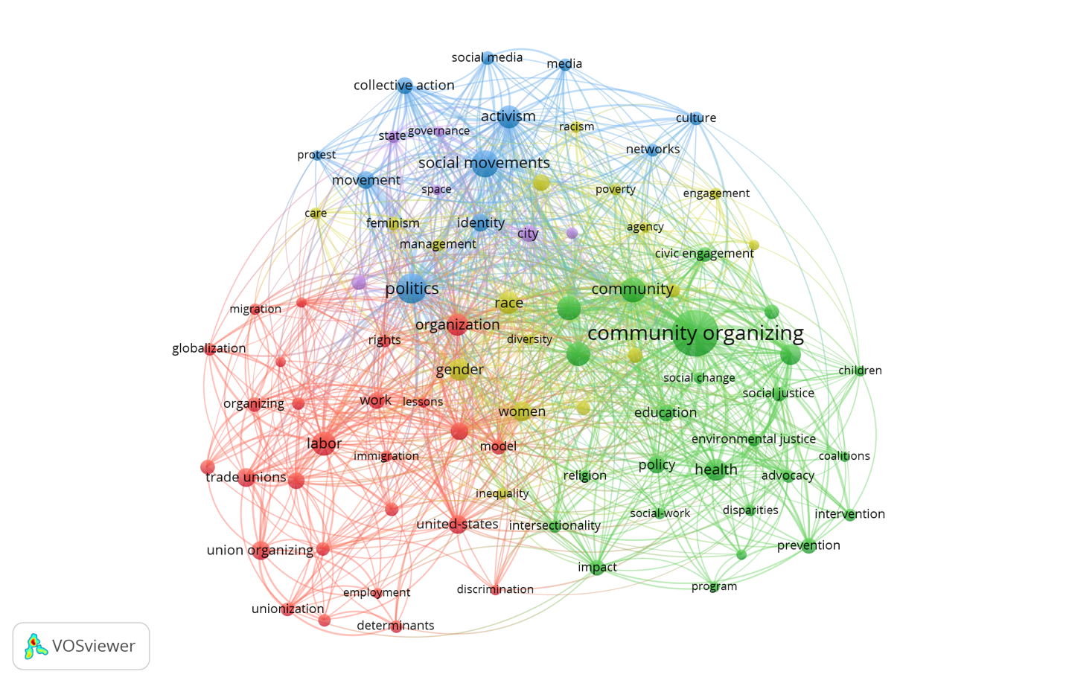

*Note:* n=85 out of N=4,893, threshold 15.

Figure 1 presents a cohesive map for the term “organizing” relative to research on other topics (e.g., Kullenberg and Kasperowski 2016; Van Eck et al. 2013). The map further reveals that scholarship on organizing is structured around five distinct clusters characterized by thematic interests. Observing the most frequently appearing terms, we characterized each of these clusters’ main themes, from largest to smallest:

(1) Labor (red)

(2) Community organizing (green)

(3) Race/gender (yellow)

(4) Social movements (blue)

(5) Urban studies and community development (purple)

An analysis of the terms’ locations shows that the labor and community organizing sub-fields, while connected to other themes, are relatively autonomous and self-referential. The absence of red or green nodes within other clusters’ general area suggests that research on these themes tends to be more independent than research on social movements, race/gender, and urban studies.

An examination of the terms’ location within the labor and community organizing clusters also revealed thematic differences between terms appearing at the map’s periphery and at its center. For example, in the labor cluster, remote terms included all keywords related to unions, indicating that there is a body of literature on union organizing that is relatively disconnected from the community organizing and social movements literature. Likewise, in the community organizing cluster, peripheral terms included keywords such as intervention, prevention, and participatory research. This suggests the existence of a body of literature on intervention and prevention programs found mainly in applied research fields, such as healthcare, social work, and psychology, and including a community organizing component that is relatively disconnected from the labor organizing and social movements literature.

***Organizing and Democracy***

A co-occurrence map can be further used to visualize the study of a research field’s sub-theme and to identify potential gaps in the literature by locating sub-themes that are disconnected from others. We used this method to explore the study of democracy within scholarship on organizing, focusing on the relationship between the keyword “democracy” and other keywords in the map. These relationships are highlighted in Figure 2.

Figure 2. Democracy in the Terms Co-Occurrence Map

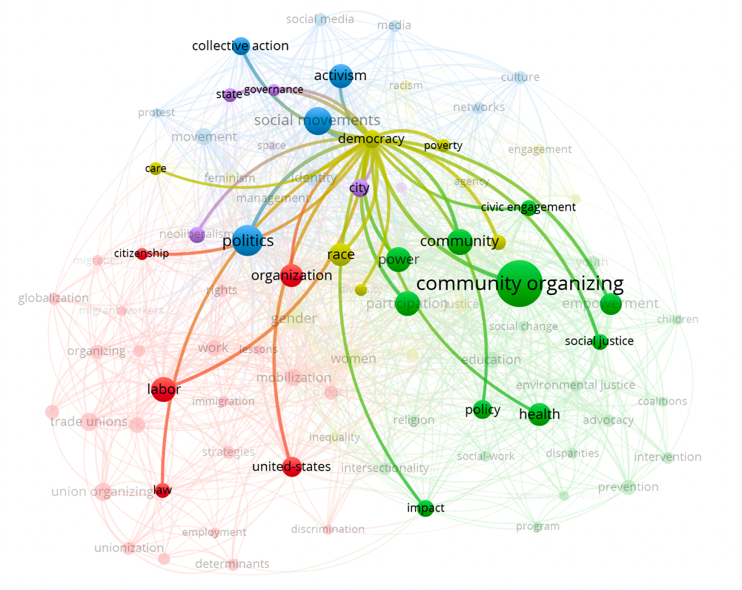

*Note*: This map, structurally identical to Figure 1’s map, visually highlights the keyword “democracy” and its relationship with other keywords.

Overall, the data showed that “democracy” draws considerable interest from scholars of organizing. Ranked by the number of its occurrences, “democracy” places 23 (out of a total of 4,893 keywords). The term “democracy” appears in the keywords of 38 records , and is connected to another 47 frequently occurring keywords (out of 85) . The data also showed that the relationship of organizing and democracy is studied across a wide range of fields, as evidenced in the links between “democracy” to keywords in all five clusters in the terms co-occurrence map.

Despite this interdisciplinary reach, some “organizing” sub-themes were significantly detached from the study of democracy. Particularly noticeable in Figure 2 are the peripheral areas of the labor cluster focusing on unions, the community organizing cluster focusing on prevention and intervention programs, and the social movements cluster focusing on social media, none have which have a relationship to the keyword “democracy.” We can use these observations to characterize potential gaps in the literature. For example, we found that in labor studies, the few studies in the dataset that explicitly explored the relationship between unions and democracy focused on unions’ internal democratic practices, without specifically relating to unions’ contribution to democracy on a societal level.

***Canonical Literature***

The co-citation map (Figure 3) enables us to characterize the canonical literature of a field’s distinctive themes and to analyze distinctive research streams originating from the canonical literature that engage in more intense dialogue. Additionally, this map enables us to identify core works bridging different research streams.

Figure 3. Co-citation Map

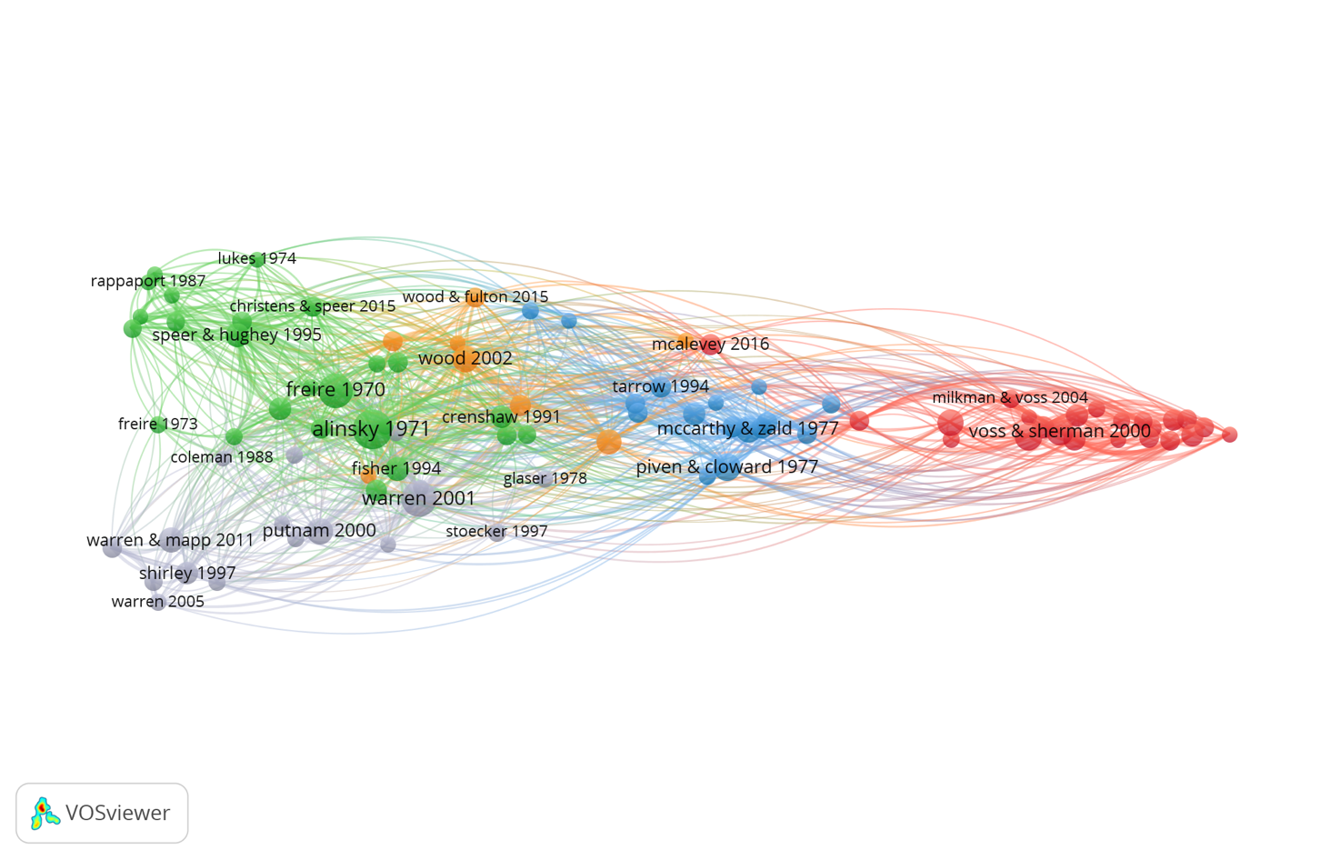

*Note*: n=89 out of N>70,000 references, threshold 15.

Following common practice (Ding and Yang 2022), this co-citation map displays all references cited at least 15 times by our dataset’s records (89 references). The lines between nodes represent the co-citation of two references by the same record. This map documents the core body of literature frequently cited by scholars of organizing. All the map’s records are interconnected. The average number of times a reference was cited alongside other references in the map is 97. These two findings indicate that the canonical literature is well-connected and that scholars of organizing tend to cite a consistent set of core studies.

The map contains five clusters representing five cores of canonical literature that have generated thematically distinct research streams. We characterized the thematic content of each core, ordered by cluster size beginning with the largest cluster, as follows (for the full list of references ordered by thematic clusters, see Appendix G):

1. Community organizing (green)
2. Labor (red)
3. Civic associations (gray)
4. Social movements (blue)
5. American democracy (orange)

Three clusters in the co-citation map (Figure 3)—community organizing, labor, and social movements—resemble the thematic clusters found in the keyword-based terms co-occurrence map (Figure 1). Notably, two clusters in the co-citation map—civic associations and American democracy—reflect distinct themes found in the canonical literature but not in the keyword analysis.

The co-citation map can provide a nuanced analysis of this theoretical landscape by characterizing each co-citation cluster in more detail, analyzing its map location, and reviewing the themes of its prominent works. We illustrate this analysis below on the map’s two largest clusters—community organizing and labor organizing.

*Community Organizing*

The community organizing cluster includes practice-based, praxis-oriented works concerned with strengthening oppressed groups through grassroots organizing and with empowering local leadership. These works have contributed to an extensive research stream on community organizing among underserved populations, especially in applied fields, including social work, healthcare, psychology, and education. Prominent studies in the community organizing cluster include Alinsky (1971) and Freire (1970), also the two most cited references across all the literature on organizing.

The community organizing cluster is located closest to the civic associations and the American democracy clusters, suggesting significant dialogue between community organizing stream’s scholarship and scholarship in these two other streams. In contrast, it is positioned furthest away from the labor cluster, indicating that community organizing stream scholarship rarely enters into dialogue with studies in the labor organizing stream.

*Labor Organizing*

Prominent studies in the labor organizing cluster are focused mainly on how labor organizations have coped with changing political and economic conditions between the first half of the twentieth century, when the traditional unions evolved, and the second half of the twentieth century, when globalization and neo-liberalism emerged (Fine 2006; Kelly 1998; Milkman 2006; Voss and Sherman 2000). These studies have contributed to a body of literature on organizing workers’ conditions, prospects, and outcomes in today’s transnational and precarious labor market.

The labor organizing cluster is located furthest away from all the other clusters, and its references are positioned close to each other, indicating that it is coherent, self-referential, and less frequently engaged in dialogue with other research streams, than are the other clusters. Specifically, it is furthest away from the civic associations and the community organizing clusters, indicating that its scholarship is the least related to studies in other areas, albeit with some relation with social movements stream studies.

Interestingly, the map enables us to identify studies serving as bridges between two research streams. For example, Ganz’s (2000) study of how unions overcome resource shortages by cultivating leaders’ strategic capacity is located in the labor cluster, but positioned closer to the social movements cluster. Engaging with classic social movements theories, such as resource mobilization and opportunity structure, Ganz has informed subsequent research in the labor and social movements streams.

**Conclusion**

This study demonstrates how citation mapping can contribute new levels of analysis for political science researchers aiming to sharpen and deepen their understanding of the literature on complex topics and terms. Other research has provided applied examples of how this approach can be used to identify theoretical distinctions across multiple concepts (Booth-Tobin et al. 2021, 28–29).

A promising direction for future research is a temporal comparison of the scholarly landscape to understand historical changes in the literature. For example, such an analysis of organizing could help explain why themes like gender and race appear in the terms co-occurrence map (figure 1) but not in the co-citation map (figure 3), which includes older studies. A temporal comparison may also help identify emerging themes not yet represented in the comprehensive historical data, as it has in other disciplines (Goncalves et al. 2019).

Additionally, scholars could also apply this study’s approach to help identify sub-areas in their fields of research meriting a meta-analysis synthesizing quantitative data from multiple studies to calculate summary effects (Booth, Papaioannou and Sutton 2016). For example, using the keywords co-occurrence map (Figure 1), we identified a significant body of literature on the effects of health-related intervention programs with a community organizing component. As has been done in other disciplines (e.g., Bellos 2021), citation mapping can also help identify citation bias—a significant problem in political science (Esarey and Wu 2016). Overall, the multiple ways citation mapping can generate valuable insights make it an effective tool for producing and visualizing comprehensive data-driven reviews of political science research fields.

**References**

Adro, Francisco D., and Cristina Fernandes. 2022. “Social Entrepreneurship and Social Innovation: Looking inside the Box and Moving out of It.” *Innovation-the European Journal of Social Science Research* 35(4): 704–0.

Alinsky, Saul D. 1971. *Rules for Radicals: A Practical Primer for Realistic Radicals*. New York: Vintage.

Arora, Sanjay K., Alan L. Porter, Jan Youtie, and Philip Shapira. 2013. “Capturing New Developments in an Emerging Technology: An Updated Search Strategy for Identifying Nanotechnology Research Outputs.” *Scientometrics* 95(1): 351–70.

Barnett, Carolyn, Michael FitzGerald, Katie Krumbholz, and Manika Lamba. 2022. “Gender Research in Political Science Journals: A Dataset.” *PS: Political Science & Politics* 55(3): 511–18.

Bellos, Ioannis. 2021. “A Metaresearch Study Revealed Susceptibility of Covid-19 Treatment Research to White Hat Bias: First, Do No Harm.” *Journal of Clinical Epidemiology* 136(August): 55–63.

Booth, Andrew, Diana Papaioannou, and Anthea Sutton. 2016. *Systematic Approaches to a Successful Literature Review*. 2nd ed. Thousand Oaks: Sage.

Booth-Tobin, Jane, Kal Munis, Lynsy Smithson-Stanley, Hahrie Han. 2021. “Understanding Strategic Capacity in Constituency-Based Organizations.” *P3 Lab, Johns Hopkins University.*

Cammett, Melani, and Isabel Kendall. 2021. “Political Science Scholarship on the Middle East: A View from the Journals.” *PS: Political Science & Politics* 54(3): 448–55.

Chen, Chaomei, and Min Song. 2019. “Visualizing a Field of Research: A Methodology of Systematic Scientometric Reviews.” *PLOS ONE* 14(10): e0223994.

Congge, Umar, María-Dolores Guillamón, Achmad Nurmandi, and Iradhad Taqwa Sihidi. 2023. “Digital Democracy: A Systematic Literature Review.” *Frontiers in Political Science* 5.

Ding, Xue, and Zhong Yang. 2022. “Knowledge Mapping of Platform Research: A Visual Analysis Using VOSviewer and CiteSpace.” *Electronic Commerce Research* 22(3): 787–809.

Esarey, Justin, and Ahra Wu. 2016. “Measuring the Effects of Publication Bias in Political Science.” *Research & Politics* 3(3).

Fine, Janice R. 2006. *Worker Centers: Organizing Communities at the Edge of the Dream*. Ithaca and London: Cornell University Press.

Freire, Paulo. 1970. *Pedagogy of the Oppressed*. New York: Continuum.

Fu, Hui-Zhen, and Li Shao. 2023. “Telling Our Own Story: A Bibliometrics Analysis of Mainland China’s Influence on Chinese Politics Research, 2001–2020.” *PS: Political Science & Politics* 56(1): 18–28.

Ganz, Marshall. 2000. “Resources and Resourcefulness: Strategic Capacity in the Unionization of California Agriculture, 1959–1966.” *American Journal of Sociology* 105(4): 1003–62.

Ganz, Marshall. 2004. Organizing. in Geothals, George R., Georgia J. Sorenson, and James M. Burns, *Encyclopedia of Leadership*, Thousand Oaks: Sage: 1134–44.

Ganz, Marshall. 2009. *Why David Sometimes Wins: Leadership, Organization, and Strategy in the California Farm Worker Movement*. New York: Oxford University Press.

Goncalves, Maria C. P., Theo G. Kieckbusch, Rafael F. Perna, Jaqueline T. Fujimoto, Sergio A. V. Morales, and Joao P. Romanelli. 2019. “Trends on Enzyme Immobilization Researches Based on Bibliometric Analysis.” *Process Biochemistry* 76(January): 95–110.

Han, Hahrie. 2014. *How Organizations Develop Activists: Civic Associations and Leadership in the 21st Century*. New York: Oxford University Press.

Han, Hahrie, Elizabeth McKenna, and Michelle Oyakawa. 2021. *Prisms of the People: Power and Organizing in Twenty-First-Century America*. Chicago: University of Chicago Press.

Huang, Ying, Jannik Schuehle, Alan L. Porter, and Jan Youtie. 2015. “A Systematic Method to Create Search Strategies for Emerging Technologies Based on the Web of Science: Illustrated for ‘Big Data.’” *Scientometrics* 105(3): 2005–22.

Kelly, John E. 1998. *Rethinking Industrial Relations: Mobilization, Collectivism, and Long Waves*. London and New York: Routledge.

Kullenberg, Christopher, and Dick Kasperowski. 2016. “What Is Citizen Science?–A Scientometric Meta-Analysis.” *PloS one* 11(1): e0147152.

Mas-Verdu, Francisco, Jose-Maria Garcia-Alvarez-Coque, Paula Andrea Nieto-Aleman, and Norat Roig-Tierno. 2021. “A Systematic Mapping Review of European Political Science.” *European Political Science* 20(1): 85–104.

McAlevey, Jane F. 2016. *No Shortcuts: Organizing for Power in the New Gilded Age*. New York: Oxford University Press.

McAllister, James T., Lora Lennertz, and Zayuris A. Mojica. 2022. “Mapping a Discipline: A Guide to Using VOSviewer for Bibliometric and Visual Analysis.” *Science & Technology Libraries* 41(3): 319–48.

Milkman, Ruth. 2006. *L.A. Story: Immigrant Workers and the Future of the U.S. Labor Movement*. New York: Russell Sage Foundation.

Park, Andrew, Matteo Montecchi, Kirk Plangger, and Leyland Pitt. 2020. “Understanding Fake News: A Bibliographic Perspective.” *Defence Strategic Communications* 8(Spring): 141–72.

Patra, Raj Kishore, Neha Pandey, and Desul Sudarsan. 2022. “Bibliometric Analysis of Fake News Indexed in Web of Science and Scopus (2001-2020).” *Global Knowledge, Memory and Communication*, 72(6/7), 628–47.

Pauna, Valentina H., Elvira Buonocore, Monia Renzi, Giovanni F. Russo, and Pier P. Franzese. 2019. “The Issue of Microplastics in Marine Ecosystems: A Bibliometric Network Analysis.” *Marine Pollution Bulletin* 149(December): 110612.

Speer, Paul W., and Hahrie Han. 2018. “Re-Engaging Social Relationships and Collective Dimensions of Organizing to Revive Democratic Practice.” *Journal of Social and Political Psychology* 6(2): 745–58.

Van Eck, Nees Jan, and Ludo Waltman. 2010. “Software Survey: VOSviewer, a Computer Program for Bibliometric Mapping.” *Scientometrics* 84(2): 523–38.

Van Eck, Nees Jan, and Ludo Waltman. 2014. “Visualizing Bibliometric Networks.” In *Measuring Scholarly Impact: Methods and Practice*, edited by Ying Ding, Ronald Rousseau, and Dietmar Wolfram, 285–320. Cham: Springer.

Van Eck, Nees Jan, and Ludo Waltman. 2017. “Citation-Based Clustering of Publications Using CitNetExplorer and VOSviewer.” *Scientometrics* 111(2): 1053–70.

Van Eck, Nees Jan, and Ludo Waltman. 2018. *Manual for VOSviewer Version 1.6.8.* Leiden: Univeristeit Leiden.

Van Eck, Nees Jan, Ludo Waltman, Anthony FJ van Raan, Robert JM Klautz, and Wilco C. Peul. 2013. “Citation Analysis May Severely Underestimate the Impact of Clinical Research as Compared to Basic Research.” *PloS One* 8 (4): e62395.

Visser, Martijn, Nees Jan van Eck, and Ludo Waltman. 2021. “Large-Scale Comparison of Bibliographic Data Sources: Scopus, Web of Science, Dimensions, Crossref, and Microsoft Academic.” *Quantitative Science Studies* 2(1): 20–41.

Voss, Kim, and Rachel Sherman. 2000. “Breaking the Iron Law of Oligarchy: Union Revitalization in the American Labor Movement.” *American Journal of Sociology* 106(2): 303–49.

Warren, Mark R. 2001. *Dry Bones Rattling: Community Building to Revitalize American Democracy*. Princeton: Princeton University Press.

Woodly, Deva R. 2021. *Reckoning: Black Lives Matter and the Democratic Necessity of Social Movements*. New York: Oxford University Press.

Yeung, Andy W. K., Nikolay T. Tzvetkov, Osama S. El-Tawil, Simona G. Bungau, Mohamed M. Abdel-Daim, and Atanas G. Atanasov. 2019. “Antioxidants: Scientific Literature Landscape Analysis.” *Oxidative Medicine and Cellular Longevity* 2019: 8278454.

1. Search performed November 16, 2022.
2. Search performed January 10, 2023.