**5. Food Waste and Rescue at the Household Consumption Level**

**9.5 billion NIS**: value of food wasted via household consumption in 2022

**4,000 NIS**: value of food wasted each year, per household in Israel

In Israel in 2022, some 990,000 tons of food were wasted through household consumption. This was about 4% higher than the previous year, as a result of population growth and increased agricultural output.[1] The value of the food wasted via household consumption in 2022 was approximately 9.5 billion NIS, reflecting a 5% increase in food prices between 2021 and 2022. Along with this direct cost, the environmental costs from household food waste were approximately 1.0 billion NIS.[2]

**Food Waste in 2022**

“Food waste in households results from a combination of consumer habits and the culture of abundance, along with how food is stored and kept fresh.”

An average household in Israel throws away about 14% of the food it purchases. This means that in 2022, the average Israeli family threw away about 4,000 NIS worth of food -- the amount they would spend on food in six weeks. The average household financial cost of wasted food was 335 NIS monthly. Of this, 148 NIS were fruit and vegetables, 111 NIS of grains and legumes, 54 NIS of meat, eggs, and fish, and 21 NIS of dairy products.

**Table 1: Costs of Food Waste**

|  |  |  |  |
| --- | --- | --- | --- |
|  | Monthly expenditure on food in NIS | Monthly food waste in NIS | Rate of waste |
| Fruit & vegetables | 640 | 148 | 23% |
| Grains & legumes | 800 | 111 | 14% |
| Meat, eggs, & fish | 695 | 54 | 8% |
| Milk & dairy products | 320 | 21 | 7% |
| Total | **2,455** | **335** | **14%** |

**Figure 1: Waste Rate at the Household Consumption Stage for Selected Products**

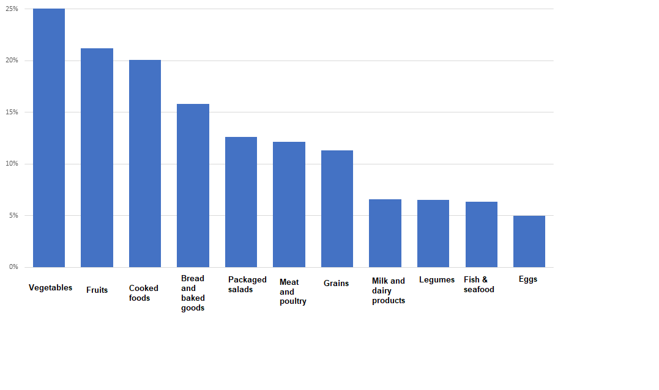

Source: BDO estimates

**Primary Causes of Household Food Waste: Preparation of Excess Food and Expiration**

Food waste within households results from a combination of consumer habits and the culture of abundance, and how food is stored. The value of food waste from household consumption is approximately NIS 9.5 billion per year.

The primary causes of food waste via household consumption are:[3]

* **Excess preparation:** Cooking and preparing more food than is needed, sometimes due to over-purchasing.
* **Expiration (spoiling)**: Some food is not consumed before it spoils or passes its expiration date. This can also be related to overbuying. The desire for variety, together with uncertainty about how much the household will consume, creates a situation in which some of the purchased food expires before it is consumed.
* **Over-purchasing:** Buying more food than the amount consumed results in high amounts of food waste.
* **Improper storage**: Improper storage shortens the shelf life of food products. Consumers’ lack of knowledge about optimal storage conditions or lack of attention to proper storage leads to spoilage and disposal of food products.
* **Other causes**: Some foods are spilled or damaged during preparation or cooking.

“In Israel, where expenditure on food is relatively high compared to other countries, food waste is one of the factors that affects the cost of living.”

**Figure 2: Rate of Food Waste from Household Consumption, in Israel and Worldwide**

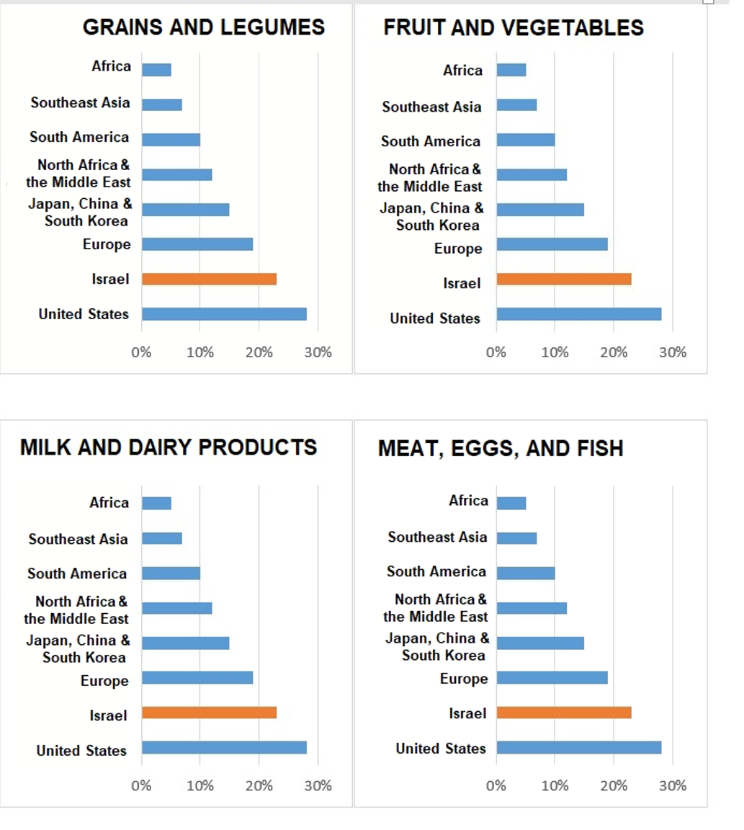

**Table 2: Annual Food Waste in Israeli Households – 2022**

|  |  |  |  |
| --- | --- | --- | --- |
|  | Waste in millions of NIS | Rate of waste | Waste in tons |
| Meat, eggs & fish | 1,600 | 8% | 55 |
| Fruit & vegetables | 4,200 | 23% | 664 |
| Grains & legumes | 3,100 | 14% | 179 |
| Milk & dairy products | 600 | 7% | 94 |
| Total | **9,500** |

Loss and waste of food within households are not unique to Israel, and the waste rates in Israel are similar to those in other developed countries.[4] The highest rate of waste in Israel, as well as in other Western countries, is in fruit and vegetables: 23% of the vegetables and fruit bought in Israel are thrown away, compared to 28% in the USA, and 19% in Europe. This is mainly due to their short shelf life and failure to store them in optimal conditions.

For meat, fish, and dairy products, the rate of waste is about 8%. This lower rate is due, in part, to their extended shelf lives if frozen, as well as their higher cost per unit of weight, which creates an economic incentive to reduce waste. The waste rate of these products in Israel is similar to that in Europe, and lower than in the US.

For grains and legumes, the rate of waste is about 14%. This reflects the relatively short shelf life for breads and pastries alongside the long shelf life of uncooked grains and legumes.

**9,900 NIS: Total Value of Annual Food Waste per Household[5]**

In Israel, where food expenditure is relatively high compared to other countries, food waste is a factor that affects the cost of living. This includes excess expenditures on food and the effect of loss and waste on increasing food prices. Overall, food waste from households drives up the cost of living by NIS 9,900 per household per year.

**Table 3: Impact of Food Waste on Cost of Living**

|  |  |  |
| --- | --- | --- |
|  | Cost per household per year, in NIS | Impact on food prices |
| Value of food thrown away at home | 4,000 |  |
| Healthcare costs due to not utilizing food to its potential | 2,200 |  |
| Cost of removal and disposal of wasted food | 215 |  |
| Costs due to producing greenhouse gases and air pollutants | 235 |  |
| Retail price increases due to food waste via markets | 1,950 | **6%** |
| Wholesale price increase due to loss in agriculture and industry | 1,300 | **5%** |
| Total | **9,900** | **11%** |

**Impacts on Cost of Living**

**Excess expenditures**: Buying food that is then thrown away is a direct cost to a household. On average, the direct financial loss per household (without indirect, external costs)[6] from wasted food is 335 NIS per month, or 4,000 NIS annually. The costs of disposing of food and burying it in landfills also eventually come out of consumers’ pockets through property taxes and municipal taxes, causing an additional annual household cost of NIS 215 for the removal of wasted food.

**Increased food prices:** Beyond households’ direct excess expenditures on food that they purchased but did not consume, food loss has an impact at all stages of the value chain, prior to consumption. From an economic point of view, the cost of food reflects all production and sales expenditures at all stages of the value chain: cultivation, production, packaging, transportation, and marketing. Therefore, the price of food in marketing outlets includes food waste from the retail sector. Similarly, the wholesale food price reflects food loss in the agricultural and industrial sectors. Eventually, the consumer pays the costs of loss at all stages of the value chain, resulting in an additional NIS 3,250 per year, due to an increase in food prices by 11%.

**Health costs from wasting food**: Food waste indirectly affects healthcare costs because not fully using the food purchased by households exacerbates food insecurity. Food insecurity is a risk factor for chronic disease and mental illness, and it impacts the national economy by increasing healthcare costs. The cost of these health impacts on the Israeli economy overall was estimated at about 6.2 billion NIS in 2022 or about 2,200 NIS per household [see Chapter 8].

**Environmental impacts from emission of greenhouse gases and air pollutants**. The environmental effects of food waste indirectly impact the cost of living. The emission of air pollutants has negative effects on human health and the environment. These external costs resulting from environmental damage affect the economy as a whole, mainly due to additional expenditures on healthcare. The monetary value of these negative environmental impacts on social welfare in 2022 was estimated at about 1.5 billion NIS for the Israeli economy overall, and about 235 NIS per household [see Chapter 10].

Beyond these direct impacts on the cost of living from wasted food, and the indirect costs from removing and transporting wasted food, burning fossil fuels, and environmental damage caused by greenhouse gas emissions, there are additional effects such as traffic congestion and soil pollution, which are not included in the environmental cost estimates in this Report [see Chapter 10].

When landfilled organic waste breaks down, it emits methane gas, a greenhouse gas whose Global Warming Potential (GWP) is 84 times higher than that of carbon dioxide in the short term (20 years), and 28 times higher in the long term (100 years).

According to the findings of the 2022 Food Waste Report, 990,000 tons of household food waste were sent to landfills, causing an additional 310,000 trips per year, approximately, by garbage collection trucks that cause air pollution, road congestion, noise pollution, and accidents. Therefore, beyond the 9.5 billion NIS in costs due to household food waste, and 0.5 billion NIS for the removal of wasted food from households, additional external costs are incurred from traffic congestion and environmental impacts.

1. Based on the BDO value chain model, using weighted data from the Israel Central Bureau of Statistics for 2022, a national waste composition survey conducted by the Israel Ministry of Environmental Protection for 2012-2013, a survey conducted by Geocartography in January 2019, and the research article: Ayalon, O., Elimelech, E. and Art, E. (2018). “What gets measured gets managed: A new method of measuring household food waste,” *Waste Management 76*, 68-81.
2. The market value of the food waste does not include the environmental cost of the natural resources wasted on unconsumed food during this stage.
3. From the findings of the Geocartography survey carried out in March 2021 by Leket Israel and BDO.
4. 2022 Global Food Security Index, Economist
5. Cost of living, including taxes and external costs
6. External costs not included in this are: removing and burying the discarded food, the financial impacts of greenhouse gas emissions and air pollutants, and the increase in wholesale price due to loss in agriculture and industry.