Personal Details

National ID number: 340903137 Name: Shapiro Leonard Z Gender: M Phone: 0543171706 Mobile: 0543171706
Age: 86.4 Family: Married Children: 4 Occupation: Ophthalmologist Insurance: MaccabiSheli Date joined: Aug 23, 2013
Primary care physician: Dr. Rosen Efraim, Hagdud HaIvri 4, Jerusalem
Eligibility data: Eligible

Contact Information

Name | Relation | Significance | Contact information | Phone
Joseph Shmidman | Son in law |  | jshmidman@gmail.com | 0544858929
Rachel Shmidman | Granddaughter |  | shmidmoster@gmail.com | 0546898511
Dial Shmidman (Shapiro?) | Wife | Emergency contact | delenshapiro@gmail.com | 0547234902
VJ | Caregiver |  |  | 0508629848
Yafi (Lisa) Shmidman | Daughter |  | lisashmidman@gmail.com | 0544468804

Listed conditions: Hypertension, osteoporosis, pre-diabetes

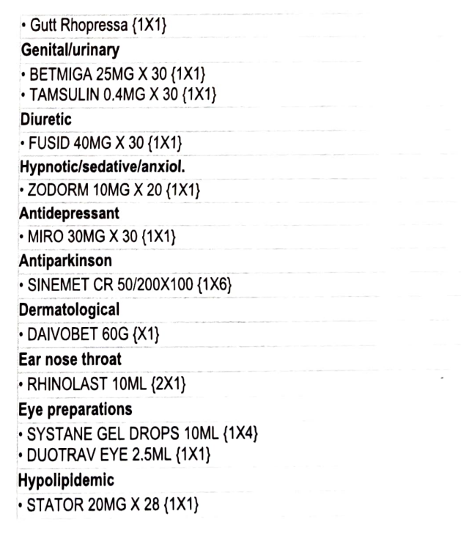  Regular Medications  Last Visit  Dec 20, 2022 - Family, Internal and General Medicine - Dr. Rosen Efraim  Complaints  Patient was not present at visit, in the present of his daughter Ms. Yafi Shmidman  Patient needs update on functionality status due to deterioration and necessity to update National Insurance Institute in order to receive additional aid  Diagnosis  FILL OUT FORMS  Additional active medications  - FUCITALMIC 5GR  - CRESTOR 20MG X 28  - PROMNIX 0.4MG X 30  - CRESTor 20MG X 28 | Known Problems  General  - BASAL CELL CARCINOMA (BCC) Status post (01/2022)  Side rt eye post mohs Dr Gilad  Cardiology  - HYPERTENSION  Nephrology/Urology  - PROSTATE HYPERPLASIA BENIGN (BPH)  Neurology  - PARKINSON’S DISEASE (9/2016)  Orthopedics/Rheumatology  - SPINAL STENOSIS LUMBAR (10/2016)  On CT - neurogenic claudication  Opthalmology  - AGE RELATED MACULAR DEGENERATION (AMD)  - CENTRAL RETINAL VEIN OCCLUSION Right  - PRIMARY OPEN ANGLE GLAUCOMA Bi-lateral  ENT  - HEARING LOSS SENSORINEURAL Bi-lateral  Uses hearing aids  Dermatology  - PSORIASIS  Minimal  Surgery  - VENOUS INSUFFICIENCY CHRONIC Bi-lateral  Legs  Other  - VITAMIN D DEFICIENCY UNS  - HYPERCHOLESTEROLEMIA  - EDEMA LEG Bi-lateral  - HYPERCHOLESTEROLEMIA  - ATRIAL ENLARGEMENT UNS Left Severe (11/2019) 55mm  - OBSTRUCTIVE SLEEP APNEA Mild  - IMPAIRED FASTING GLUCOSE (100-125) (08/2018)  (Oct 2, 2022)  Allergies  Medications  AMLODIPINE - leg edema  CEFAZOLIN  CIPROFLOXACIN - diffuse rash  QUINOLONES  Risk factors  Smoking: Unknown  Past Treatments/Surgeries  - NASAL POLYPECTOMY (12/2016) Ca in situ  - CATARACT EXTRACTION (09/2016)  Treatments  Dr. Fisher Leona - July 7, 2022  LIQUID NITROGEN  Dr. Laurent Klapholz - January 27, 2022  LIQUID NITROGEN  Dr. Applebaum Efraim - January 21, 2022  FUNDUS IN MYDRIASIS  Dr. Laurent Klapholz - October 18, 2021  LIQUID NITROGEN

