**Chapter 10**

**Environmental Impacts and Costs of Food Loss and Waste**

3.9 billion NIS: Annual Environmental Costs of Food Waste in Israel:

* 1.5 billion NIS – wasted natural resources[1]
* 1.5 billion NIS – greenhouse gas emissions and air pollutants
* 0.9 billion NIS – treatment of disposed waste

Food production utilizes resources such as land, water, fertilizers, chemicals, and energy and is responsible for about one-fifth of all greenhouse gas emissions in the world.[2] Many of the resources required to grow and produce food in the modern era are non-renewable, and their use potentially damages the quality of water, soil, air, and biodiversity.[3]

The environmental cost of food waste in Israel for 2022 is estimated at approximately 3.9 billion NIS. Of this, approximately 1.5 billion NIS is due to the unnecessary waste of land and water resources, 1.5 billion NIS is from emissions of greenhouse gases and air pollutants, and 0.9 billion NIS is the direct cost of waste treatment. About 2 million tons of food and its packaging from the various sectors (not including the agricultural sector) are discarded, comprising approximately 34% of the municipal solid waste in Israel.

However, because the positive external benefits of food consumption are higher than the negative environmental impacts associated with growing and producing food, agriculture is not viewed as a polluting industry. Generally, environmental levies and taxes are not imposed on food production, and in many developed countries there are direct or indirect subsidies for food production or consumption. However, growing, producing, and disposing of food that is not consumed has all of the negative environmental impacts, with no benefit to anyone; therefore, food waste represents a net damage to the environment.

In recent years, there has been increased recognition of the problem of food waste around the world. To assist in global efforts to address this, the Food and Agriculture Organization (FAO) of the United Nations and the United Nations Environmental Program (UNEP) are working to implement a uniform international index for estimating the scope of food waste. In 2019, the United Nations published a report emphasizing the importance of considering environmental aspects of food waste, in addition to economic and social ones.[4] The report advocates using a life cycle assessment (LCA) approach to food waste and its disposal to formulate policies to reduce food waste. Currently, countries around the world have differing policies and methods aimed at reducing food waste, which include, for example, measures to minimize food surpluses at the source, encouraging the salvaging of surpluses, and disposing of wasted food through composting or anaerobic digestion, rather than landfilling.

This Report examines the environmental impacts of food loss and waste in Israel. This chapter focuses on environmental impacts in 2022 as a result of food waste, including emissions oof greenhouse gases and air pollutants along the entire production and consumption chain, wasted natural resources (water and soil), and disposing of wasted food. The quantification of the external costs of greenhouse gas emissions and air pollutants is based on the methodology established by the FAO.[5] Externalized environmental impacts concerning water and soil quality and biodiversity were not examined at this stage. These missing elements may be considered in future assessments of the overall environmental costs of food loss and waste in Israel.

**It is important to note that this chapter only presents quantification of environmental impacts originating within the geographical area of the State of Israel.** The use of natural resources or emissions of pollutants associated with growing and producing food outside of Israel are not considered. Israel imports a significant proportion of its food, particularly certain types (cereals and grains, sugars, oils, fish, meat). Approximately 80% of the calories consumed by people in Israel come from imported food products.[6] Therefore, the total environmental impact of food that is wasted and disposed of in Israel is greater than the environmental impacts quantified in this chapter.

**Food Waste Accounts for 6% of Greenhouse Gas Emissions in Israel**

The energy consumption and resource use associated with food production along all stages (growing, processing, marketing, consumption, and disposal) have environmental impacts. Additionally, there are economic and environmental costs associated with disposing of wasted food and its packaging. These impacts vary between various types of crops.

The year addressed in this Report was a *shmittah* year, during which there was an 8% decrease in vegetable production in Israel. Nevertheless, there was an increase in the scope of environmental impact, even without taking into account the impacts caused by the increased imports necessary to compensate for decreased local production.[7]

In addition to the food products themselves, the other resources related to food that were squandered in Israel in 2022 were assessed as follows:

* 1,320 million kilowatt hours of electricity – equivalent to the amount needed to produce computers and electronic and electrical equipment in Israel each year;
* 80 thousand tons of fuel – enough to fuel about 175,000 cars for a year;
* 180 million cubic meters of fresh water – enough to fill 55,000 Olympic-sized swimming pools;
* 210 million cubic meters of wastewater;
* 1 million dunams of agricultural land – 20 times the area of Tel Aviv;
* 200,000 tons of garbage (packaging, industrial waste, etc.);
* 60,000 tons of fertilizers;
* 3,000 tons of ammonia emissions from animals.

Taking these factors together, about 5 million tons of greenhouse gases were emitted in 2022 as a result of food waste; about 6% of the total for the country.[8] Government Decision 171, *Transition to a Low-carbon Economy* (July 25, 2021) set a national goal of a 27% reduction in greenhouse gas emissions by 2030, and an 85% reduction by 2050, in relation to greenhouse gas emissions in 2015.[9] In October 2021, the Prime Minister announced an intention to reach the goal of zero carbon emissions in Israel by 2050.[10] Decision 171 established goals for reducing greenhouse gas emissions and optimizing energy consumption in various sectors of the economy including:

* at least a 47% reduction in greenhouse emissions from solid waste by 2030 as compared to the 2015 level;
* at least a 92% reduction in greenhouse gas emissions originating in municipal waste by 2050 as compared to the 2015 level (which was about 5.5 million tons);
* at least a 71% reduction in the amount of municipal waste landfilled by 2030, as compared to the amount landfilled in 2018 (about 4.5 million tons);

Reducing food waste in Israel can contribute to the national effort to meet these goals for reducing greenhouse gas emissions and reducing the landfilling of municipal waste.

On September 12, 2023, the Israel Ministerial Committee for Legislation approved the Climate Law, which establishes a national goal of a 30% reduction in greenhouse gas emissions by 2030 and zero net emissions by 2050. The text of the law must be discussed in Knesset committees and be approved by a majority in three readings before it will be formally accepted into Israeli law.

**55,000 Olympic-sized swimming pools could be filled with the water that was unnecessarily used in 2022 due to food waste**

In an arid country like Israel, water is a precious and limited resource. In 2022, 180 million cubic meters of potable (drinking quality) water, valued at 670 million NIS, went down the drain together with wasted food. This could fill 55,000 Olympic-sized swimming pools, raise the level of the Sea of Galilee by over a meter, or provide water to approximately 3.5 million residents for a year.[11]

Land is another valuable and limited resource in Israel. Some 1 million dunams of agricultural land, with a value of approximately 0.8 billion NIS, were used to grow food that was eventually discarded.

**Table: Environmental Costs of Food waste 2021, in billions of NIS, by Source**

|  |  |  |  |  |
| --- | --- | --- | --- | --- |
| **Source generating the cost** | **Wasted resources** | **Cost of emissions** | **Cost of waste treatment** | **Cost of natural resources (land and water)** |
| Solid waste | 2.0 million tons municipal waste  0.9 million tons agricultural waste | 0.5 | 0.9 |  |
| Electricity  (not including electricity for desalination and water purification) | 1.34 billion kilowatt hours | 0.3 |  |  |
| Emissions from animals | 3,000 tons of ammonia | 0.4 |  |  |
| Burning fuels | 80,000 tons | 0.2* |  |  |
| Water | 185 million m3 of potable water;  215 million m3 of wastewater | 0.1 |  | 0.7 |
| Use of fertilizers | 60,000 tons | 0.04 |  |  |
| Land | 1 million dunams agricultural land |  |  | 0.8 |
| **Total** |  | **1.5** | **0.9** | **1.5** |

* The cost of fuel emissions in 2022 was over 150 million NIS, an increase of about 20 million NIS compared to 2021. Source: BDO

**Food-derived Waste Comprises about a Third of the Household Waste in Israel**

The environmental impacts of food waste are not only due to use of natural resources and pollutant emissions associated with excess production of food and consumption patterns, but also from the way food is treated after it is discarded. Treatment of food waste after it has been thrown away, especially landfilling, has environmental impacts. It has been assessed that 34% of household waste in Israel is organic waste originating from food.[12] Discarded food increases the volume of waste required for treatment and, in the absence of waste separation, impairs the ability to recycle other materials in the household waste stream.

Most of Israel’s solid waste is landfilled. This has many negative environmental impacts. Landfills take up significant space and deplete Israel’s limited land resources. Transporting waste to remote landfill sites throughout Israel causes air pollutants to be emitted, in addition to the emission of greenhouse gases.

Municipal waste in Israel is estimated at 5.9 million tons per year.[13] In 2022, it was estimated that 2.6 million tons of food was wasted.[14] Of this, about 1.8 million tons of food and an additional 200,000 tons of its packaging had to be treated as part of the municipal waste stream,[15] resulting in a total of 2 million tons of food and packaging waste, which comprises about a third of the volume of the solid waste in Israel that requires treatment. About 200,000 compactor trucks are required to collect, remove, and transport this waste each year; that is 550 trucks loaded with solid waste every day.[16]

Additionally, treating this solid waste necessitates financial and statutory support including: storage, collection, removal, sorting and transit stations, transportation, the treatment itself (costs vary depending on treatment type) and landfill levies. The direct annual cost of treating waste in Israel that originates from wasted food and its packaging is 0.9 billion NIS (according to waste treatment cost estimates in the Ministry of Environmental Protection, *Waste Policy 2030*).[17] Beyond that, the external cost of greenhouse gas emissions and air pollutants from waste treatment is 0.5 billion NIS. The total direct and indirect economic costs for the treatment of food waste in Israel for 2022 is approximately 1.4 billion NIS.

**Approximately Half the Environmental Costs of Food Waste Occur During the Consumption Phase**

The quantification of the environmental impacts of agriculture refers to the full life cycle of the products, including growing and harvesting the crops, post-harvest treatment, storage, processing, distribution, consumption, and disposal. The later in this process that the product is wasted or discarded, the greater its environmental impact. Three factors affect the environmental footprint of food waste: the impacts during stage in the value chain during which food was discarded; the impacts of the product ultimately becoming waste; all the previous stages (if any). For example: for food thrown away in the grocery store embodies all the greenhouse gas and emissions attributed to growing it (the production phase), transporting it from the field to the packing house and then to the grocery store, storage at the grocery store (cooling and lighting), transportation to the landfill, and emissions from landfilling the waste.

Approximately half the environmental costs of food waste occur during the consumption phase. A product thrown away by consumers embodies all the environmental impacts involved in its production, transportation, processing, and distribution. In 2022, 1.2 million tons of food (including its packaging), worth 13 billion NIS, was discarded during the consumption phase.[18] In addition to the cost of the food waste, this results in economic damage in terms of the cost of waste treatment, assessed at approximately 0.5 billion NIS, which paid for by consumers indirectly through municipal taxes. Additionally, there was environmental damage, costing approximately 0.9 billion NIS, as a result of emissions of greenhouse gases and air pollutants.

**Table: Environmental Costs of Food Waste in Israel 2022, by Stage at which the food was thrown away, in millions of NIS**

|  |  |  |  |  |  |
| --- | --- | --- | --- | --- | --- |
|  | **Agriculture\*** | **Processing** | **Distribution** | **Consumption\*\*** | **Total** |
| Fruits and vegetables | 387 | 29 | 461 | 874 | **1,750** |
| Grains and legumes | 104 | 69 | 122 | 346 | **642** |
| Dairy products | 121 | 45 | 71 | 257 | **494** |
| Meat, eggs, and fish | 143 | 150 | 204 | 494 | **991** |
| **Total** | **754** | **294** | **858** | **1,970** | **3,876** |
| Total rate | 19% | 8% | 22% | 51% | 100% |

* The agricultural phase includes losses during packaging and handling.

** Emissions due to the domestic use of water, electricity and cooking gas were not included in the consumption phase.

Source: BDO

This analysis **according to the stage during which the environmental impacts originate** indicates that approximately 60% of the environmental impacts **originate** during the agricultural stage. This is because the total costs associated with food that was discarded at the subsequent stages of processing, distribution, or consumption, embody all the costs of the preceding stages. Emissions in the agricultural phase are caused, among other things, by the use of fuels and electricity, fertilizers, sludge and compost, water desalination, and emissions from animals. A significant amount of water and land are used to grow food. Environmental impacts of food that was discarded during the consumer phase include environmental impacts from all the previous phases, including fuel for transportation and electricity for cooling, but the non-agricultural phases require minimal amounts of water and soil compared to the agricultural phase. Therefore, the environmental impacts during the agricultural stage, which are attributed to all wasted food, are estimated at about 60% of the total environmental impacts of food waste that are considered in this Report.

Cumulative Environmental Costs per Kg of Food Lost and Wasted in Israel 2022, in NIS

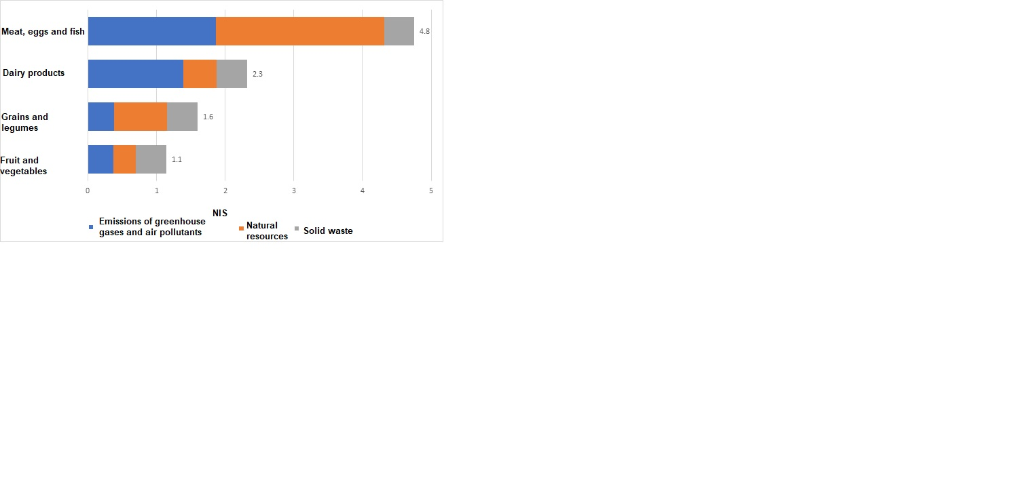Source: BDO

**Table: Environmental Costs of Food Waste, by Stage during which it was Discarded, 2022, millions of NIS**

|  |  |  |  |  |  |  |
| --- | --- | --- | --- | --- | --- | --- |
|  | **Emissions** | **Land resources** | **Water resources** | **Waste treatment** | **Total** | **Total, thousands of tons** |
| Agriculture | 339 | 238 | 177 | 0 | **754** | **854** |
| Processing | 103 | 88 | 61 | 43 | **294** | **85** |
| Distribution | 282 | 196 | 156 | 224 | **858** | **420** |
| Consumption | 829 | 303 | 283 | 608 | **2,023** | **1,118** |
| **Total, billions of NIS** | **1.6** | **0.8** | **0.7** | **0.9** | **3.9** | **-** |

Source: BDO

**Animal-based Food Products Have the Greatest Environmental Impact**

Examining the environmental impacts of the various categories of food products shows that **animal-based food products have the greatest environmental impact**. Meat, eggs, and fish products that are wasted in the agricultural stage have an environmental cost of 5.6 NIS per kg (resulting from greenhouse gases and air pollutants). If these products are thrown away during the consumption stage, this cost rises to 7.7 NIS per kg. Dairy products wasted at the agricultural stage have an environmental cost of 2.2 NIS per kg, and this rises to about 2.8 NIS per kg if these are thrown away in consumers’ homes. Fruits and vegetables wasted in the field have environmental cost of 90 NIS per kg, which almost doubles if they are thrown away by consumers.

The factors affecting environmental costs differ between the various types of foods. For meat, eggs, and fish, about half of the environmental costs are attributed to the loss of natural resources. For dairy products, the main cost results from greenhouse gas emissions and air pollutants. For fruits and vegetables, the cost is divided equally between waste treatment, loss of natural resources, and emissions of greenhouse gases and air pollutants.

**International Comparison: Greenhouse Gas Emissions from Food Waste**

According to UN estimates, about 1.7 billion tons of food are wasted each year around the world. An estimated 4.3 billion tons greenhouse gases were emitted as a result of the growing and producing food products that were not consumed. This includes greenhouse gas emissions during all of the stages of growing and producing food and treating it as part of the waste stream.[19]

The global environmental cost of greenhouse gas emissions as a result of food waste is estimated at approximately 515 billion dollars per year.[20] This cost varies according to local conditions and the types of agricultural crops.

An international comparison based on the FAO study and the recent, updated UN report, indicates that it is not possible to assert that greenhouse gas emissions per capita in low-income countries differ significantly from those in higher-income countries. The UN report states that food waste per capita in the consumption phase is similar across countries. This contradicts the prevailing perception that in developed countries waste occurs predominantly in the consumption and retail segments, whereas in developing countries waste occurs predominantly in the production, storage, and transportation stages.

**Greenhouse Gas Emissions from Food Waste by Geographic Region, Kg Per Capita[21]**

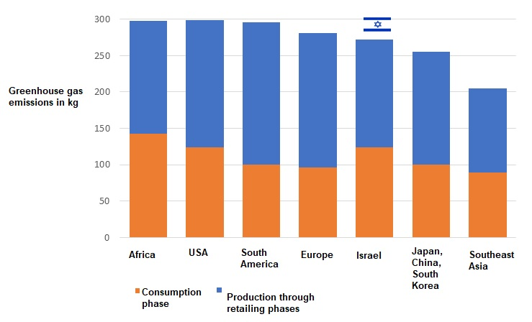

Source: BDO estimates based on data from FAO, UNEP, BDO estimates of Israeli data

The findings of the UN report reflected in the graph above indicate that food waste per capita during the consumption segment in Israel is similar to that in the USA, lower than in Africa, but higher than in Europe.

In Israel, 5 million tons of greenhouse gases are emitted as a result of the production and growing of food that is not consumed, comprising about 6% of the greenhouse gases emitted there annually.

1. The cost of wasted natural resources is internalized into the market price of approximately 23.1 billion NIS of food waste.
2. FAO, Food and Agriculture Statistics<http://www.fao.org/economic/ess/environment/data/emission-shares/en/>
3. Value Chain Management Center (2012). *Cut Waste, GROW PROFIT: How to Reduce and Manage Food Waste, Leading to Increased Profitability and Environmental Sustainability.* <https://vcm-international.com/wp-content/uploads/2013/05/Cut-Waste-Grow-Profit-FINAL-DOCUMENT-Oct-3-12.pdf>
4. Heller, M. (2019). *Waste Not, Want Not: Reducing Food Loss and Waste in North America through Life Cycle-Based Approaches.* United Nations Environment Programme. <https://wedocs.unep.org/bitstream/handle/20.500.11822/27688/WasteNot.pdf?sequence=1&isAllowed=y>

  
5. FAO, *Food Waste Footprint Full Cost Accounting*, 2014
6. Amador, L. (2022). *The Climate Crisis and Our Success: Policy Paper*. Yesodot. <https://www.yfpp.org.il/article/164>
7. Environmental impacts occur along the entire food value chain, not only as a result of production. Although the volume of vegetables grown in Israel decreased in 2022, there was an increase in the volume of other foods produced, food imports, and thus an increase in the total food waste along the value chain, resulting in a cumulative increase in the scope of the environmental impact.
8. In 2022, 4.88 million tons of greenhouse gases were emitted, compared to 4.76 million tons in 2021.
9. <https://www.gov.il/he/departments/policies/dec171_2021>
10. <https://www.gov.il/he/departments/news/carbon_emissions291021>
11. Residential water consumption.
12. According to the waste composition survey conducted for the Israel Ministry of Environmental Protection, 2013
13. As estimated by the Ministry of Environmental Protection in 2020.
14. Including agricultural produce left in the field
15. About 860 million tons is food waste from the agricultural stage, which is generally left in the field and does not require treatment.
16. Compactor trucks with a capacity of 10 tons.
17. Not including food waste in the agricultural phase.
18. The consumption phase includes household and institutional consumption.
19. Since the FAO study did not quantify air pollutant emissions as a result of food production and disposal, the comparison presented below only deals with greenhouse gas emissions as a result of food waste.
20. Assessed by the FAO in 2014.
21. The FAO and UNEP draw on studies published in the various countries, which may use different methodologies to make these estimates.