The Kramer Institute’s New Unpublished Tablet Collection: Full Scientific Editions and A Study of Philological and Sociohistorical Aspects

Scientific Background
Recently, the Kramer Institute for Assyriology and Ancient Near Eastern Studies at Bar-Ilan University received a generous and significant donation of 460 unpublished cuneiform tablets. The tablets were donated to the institute by the collector, Ms. Lisa Marie Knothe (via Prof. James Ford), after being officially registered with the Israel Antiquity Authority. This donation now joins ten tablets that have been kept at the Kramer Institute for several years, also still awaiting publication. Together, the Kramer Institute tablets constitute one of the largest collections of cuneiform tablets in the Israeli academic world. The collection was received at Bar-Ilan by the two PIs, Noga Ayali-Dashan, acting head of the Kramer Institute, and Nili Samet, a member of the board. The PIs will oversee research and publish and curate the collection.
The new Kramer Institute collection reflects a variety of genres and languages, providing complex insights into the daily life, language, literature, and literacy of societies across southern Mesopotamia over three millennia, from the Early Dynastic period to the Achaemenid period.
Due to the collection’s large scope, and in order to allow for realistic scheduling, decipherment and research of the tablets will be carried out in two stages. The currently proposed project pertains to the first stage, which includes the decipherment, study, and edition of 230 tablets. These include 20 Early Dynastic texts; 17 Old Akkadian texts; 180 Ur III texts; 6 Old Babylonian texts; 4 Neo-Babylonian texts; and 3 Late Babylonian/ Achaemenid texts. Full details appear in the catalog below, and several examples can be found under Preliminary Results. The second half of the Kramer Institute tablet collection will be deciphered and studied after the successful completion of the currently proposed project.
Preliminary Catalog
The catalog below is based on a rough and preliminary sorting. The notes briefly refer to the period, genre, content, provenance, and some physical features of the tablets. All these will be re-examined during the first stage of the proposed project (see below). The PIs would like to thank project advisor Prof. Uri Gabbay of Hebrew University for his assistance in preparing this catalog.
Early Dynastic Texts
Temp. No. | Genre | Preliminary Notes
KI-1001 | Admin | Large rounded four-column tablet.
KI-1002 | Admin | Large square-rounded three-column tablet.
KI-1003 | Admin | Oblong rounded two-column tablet. Reverse uninscribed.
KI-1004 | Admin | Rounded two-column tablet.
KI-1005 | Admin | Rounded two-column tablet.
KI-1006 | Admin | Large rounded three-column tablet. Rev. uninscribed.
KI-1007 | Admin | Large square-rounded five-column tablet.
KI-1008 | Admin | Oblong rounded two-column tablet.
KI-1009 | Admin | Square-rounded four-column tablet. Only one line is inscribed on the reverse.
KI-1010 | Admin | Rounded tablet.
KI-1011 | Admin | Square-rounded two-column tablet, partly broken. Rev. uninscribed.
KI-1012 | Admin | Round three-column tablet.
KI-1013 | Admin | Square-rounded three-column tablet.
KI-1014 | Admin | Square-rounded three-column tablet.
KI-1015 | Admin | Square-rounded three-column tablet.
KI-1016 | Admin | Large square-rounded five-column tablet. Obv. partly effaced.
KI-1017 | Admin | Large rounded four-column tablet.
KI-1018 | Admin | Rounded three-column tablet.
KI-1019 | Admin | Rounded three-column tablet.
KI-1020 | Admin | Rounded two-column tablet. Only two lines are inscribed on the reverse.
Old Akkadian Texts
KI-2001 | Admin | Rounded three-column tablet.
KI-2002 | Admin? | Small rounded tablet.
KI-2003 | Admin | Oblong rounded tablet.
KI-2004 | Admin? | Rounded two-column tablet. Only the right column is inscribed on the reverse. ^{d}IM is mentioned on the obverse.
KI-2005 | Admin | Oval tablet. Only the first line is inscribed on the reverse.
KI-2006 | Admin | Small rounded tablet. Rev. uninscribed.
KI-2007 | Admin | Small oblong tablet, recording amounts. A gala is mentioned on the obverse.
KI-2008 | Admin | Small rounded two-column tablet.
KI-2009 | Admin | Circular two-column tablet. Only the left column is inscribed.
KI-2010 | Admin | Round two-column tablet.
KI-2011 | Admin | Oval tablet recording wool expenditure, apparently belonging to the Mesag archive (see no. 1 in Preliminary Results).
KI-2012 | Admin | Oblong rounded tablet. Rev. uninscribed.
KI-2013 | Admin | Oval tablet. Rev. uninscribed.
KI-2014 | Admin | Rounded oblong tablet.
KI-2015 | Admin | Rounded oblong tablet.
KI-2016 | Admin | Rounded oblong tablet.
KI-2017 | Admin | Oval tablet. Rev. uninscribed.
Ur III Texts
KI-3001 | Admin | Small square slightly oblong tablet. Sealed receipt.
KI-3002 | Admin | Tag label.
KI-3003 | Admin | Tag label. Rev. sealed.
KI-3004 | Admin | Tag label, sealed, recording rations.
KI-3005 | Admin | Small square tablet. Receipt.
KI-3006 | Admin | Small square tablet, recording rations, month kin-^{d}inana, year AS 1 or Š 48.
KI-3007 | Admin | Envelope recording rations.
KI-3008 | Admin | Small square tablet, year Š 45.
KI-3009 | Admin | Small square-oblong tablet recording rations, month diri, year ŠS 9.
KI-3010 | Admin | Oblong tablet recording expenditure, month ezem-a-dara₄, year AS 8.
KI-3011 | Admin | Small square tablet recording skins, year ŠS 8.
KI-3012 | Admin | Small square tablet recording fodder for sheep, month é-iti-6 (viii?), year IS 2, probably from Umma.
KI-3013 | Admin | Square-oblong tablet recording expenditure on rations to messengers (soldiers?), year IS 1, Irisaĝrig.
KI-3014 | Admin | Oblong tablet recording fodder for sheep, month AN-pa₄-ú-e, year IS 2.
KI-3015 | Admin | Oblong tablet recording expenditure. Obv. mentions years IS 2 and si-mu-ru-um^{ki} ba-ḫul (Š 25, 44 or IB 3?). Rev. mentions IS 1.
KI-3016 | Admin | Small oblong tablet recording fodder. Rev. mentions month ezem-^{d}šul-gi, year IS 2.
KI-3017 | Admin | Oblong tablet recording expenditure on boats and grain, year IS 2.
KI-3018 | Admin | Oblong tablet, recording rations, month min-èš (vii?), year IS 2, prob. from Umma.
KI-3019 | Admin | Oblong tablet recording the names Ur-^{d}Šul-pa-è, Ur-^{d}Ma-mi son of Ur-^{d}[…] and Ur-^{d}Šára, year ŠS 7.
KI-3020 | Admin | Small square tablet, messenger text, Irisaĝrig.
KI-3021 | Admin | Small rounded tablet, recording ration of barley, year AS 4.
KI-3022 | Admin | Small square tablet, month ezem-a-dara₄ (xi?), Irisaĝrig.
KI-3023 | Admin | Small square tablet recording expenditure, month še-kin-ku₅, year AS 7. Obv. mostly effaced.
KI-3024 | Admin | Small square-oblong tablet, recording expenditure, month ezem-a-bi (v), Irisaĝrig.
KI-3025 | Admin | Small square tablet, mentioning the scribe Puzur₄-me-a, Irisaĝrig.
KI-3026 | Admin | Small square tablet, year Š 43.
KI-3027 | Admin | Small square tablet recording expenditure on beer?, year Š 43 or IS 2.
KI-3028 | Admin | Small square tablet recording expenditure, month šu-ĝar-gal (i?), year Š 43?, Irisaĝrig.
KI-3029 | Admin | Small square tablet recording expenditure on beer, month ezem-a-bi (v), Irisaĝrig.
KI-3030 | Admin | Small square tablet recording expenditure, year AS 8.
KI-3031 | Admin | Small square tablet, month níĝ-^{d}en-líl-lá (viii), year IS 1?, Irisaĝrig.
KI-3032 | Admin | Small square tablet recording expenditure on beer and bread, ezem-a-bi (v), Irisaĝrig.
KI-3033 | Admin | Small square tablet recording amounts, Irisaĝrig.
KI-3034 | Admin | Small square tablet recording expenditure on bread and beer, month níĝ-e-ga (x), year IS 1, Irisaĝrig.
KI-3035 | Admin | Small square tablet, month ezem-a-dara₄ (xi?), Irisaĝrig.
KI-3036 | Admin | Small square tablet recording expenditure on bread, month ezem-a-dara₄ (xi?), year IS 2, Irisaĝrig.
KI-3037 | Admin | Small square tablet recording expenditure on beer for libations, month ezem-a-dara₄ (xi?), year IS 9, Irisaĝrig (see no. 2 in Preliminary Results).
KI-3038 | Admin | Small square tablet.
KI-3039 | Admin | Small square tablet, corner broken, month ezem-^{d}me-ki?-ĝál?, year IS 2?
KI-3040 | Admin | Small square tablet, month kir₁₁-si-ak (iii?), year IS 1, Irisaĝrig.
KI-3041 | Admin | Small square tablet recording expenditure on beer, month ^{ĝeš}apin (ii?), year IS 2?, Irisaĝrig.
KI-3042 | Admin | Small square tablet, month iše-KIN-[ku₅]. Obv. partly effaced.
KI-3043 | Admin | Small square tablet recording expenditure, year IS 2?. Obv. effaced.
KI-3044 | Admin | Small square tablet, sealed. Obv. mostly effaced.
KI-3045 | Admin | Small square tablet, year IS 2. Obv. partly broken and effaced.
KI-3046 | Admin | Small square tablet recording expenditure, month níĝ-e-ga, year ŠS 5.
KI-3047 | Admin | Small square tablet recording expenditure, month níĝ-e-ga, year ŠS 5. Obv. partly effaced.
KI-3048 | Admin | Small square tablet recording expenditure, month gi-sig-ga (vi), year IS 2, Irisaĝrig.
KI-3049 | Admin | Small square tablet.
KI-3050 | Admin | Small square tablet, month ezem-^{d}šul-gi, year [si]-mu?-[ru]-um^{ki} [ba]-ḫul? (Š 25, 44 or IS 3?).
KI-3051 | Admin | Small square tablet. Surface is effaced.
KI-3052 | Admin | Small square tablet recording expenditure, month kir₁₁-si-ak (iii?), year ŠS 5, Irisaĝrig. Obv. partly effaced (salt).
KI-3053 | Admin | Small square tablet, month ezem-a-dara₄ (xi?), Irisaĝrig.
KI-3054 | Admin | Small square tablet. Rev. effaced.
KI-3055 | Admin | Small square tablet regarding sheep. Rev. effaced.
KI-3056 | Admin | Small square tablet recording expenditure on bread, month níĝ-e-ga (x), year IS 1?, Irisaĝrig.
KI-3057 | Admin | Small square-oblong tablet, recording expenditure on beer and bread, kir₁₁-si-ak (iii?), Irisaĝrig.
KI-3058 | Admin | Small square tablet.
KI-3059 | Admin | Small square tablet recording expenditure on beer, month ezem-^{d}li₉-si₄? (iv), year IS 1, Irisaĝrig. Obv. partly effaced.
KI-3060 | Admin | Small square tablet, partly effaced, recording expenditure on bread, month [kir₁₁]-si-ak (iii?), year IS 1?
KI-3061 | Admin | Small square tablet, corner broken, year AS 9.
KI-3062 | Admin | Small square tablet recording expenditure, month níĝ-^{d}en-líl-lá (viii), year AS 7, Irisaĝrig.
KI-3063 | Admin | Small square tablet recording expenditure, month še-KIN-ku₅.
KI-3064 | Admin | Small square tablet. An envelope with a tablet.
KI-3065 | Admin | Sealed oblong tablet, corner broken, regarding sheep, month pa₄-ú-e (xi?), year IS 2?, prob. from Umma.
KI-3066 | Admin | Small square tablet, month min-èš, year ŠS 1.
KI-3067 | Admin | Small square tablet recording amounts of barley, month dal, year IS 2.
KI-3068 | Admin | Small oblong tablet.
KI-3069 | Admin | Small square-oblong rounded tablet recording amounts of fodder.
KI-3070 | Admin | Small square-oblong tablet regarding sheep and fodder, month ^{d}li₉-si₄, year IS 2.
KI-3071 | Admin | Small square tablet, month [š]e-KIN-ku₅, year ŠS 5.
KI-3072 | Admin | Oblong tablet regarding sheep and fodder, month min-èš, year ŠS 9.
KI-3073 | Admin | Small square tablet representing a receipt for barley, year ŠS 9?
KI-3074 | Admin | Small oblong tablet recording rations.
KI-3075 | Admin | Tag label.
KI-3076 | Admin | Oblong rounded tablet.
KI-3077 | Admin | Small square tablet, sealed.
KI-3078 | Admin | Oblong tablet recording amounts.
KI-3079 | Admin | Oblong tablet recording amounts.
KI-3080 | Admin | Oblong tablet recording amounts.
KI-3081 | Admin | Oblong tablet recording amounts.
KI-3082 | Admin | Small oblong tablet regarding ewes.
KI-3083 | Admin | Tag label.
KI-3084 | Admin | Small square tablet. Rev. effaced (salt).
KI-3085 | Admin | Oblong tablet recording amounts.
KI-3086 | Admin | Oblong tablet recording a list of sheep and their food rations that were redeemed for Barani, month ezem-^{d}šul-gi (vii), year IS 2, from Drehem or Garšana (see no. 3 in Preliminary Results).
KI-3087 | Admin | Oblong tablet recording beer for gods. Rev. partly broken.
KI-3088 | Admin | Oblong tablet recording amounts.
KI-3089 | Admin | Small oblong tablet.
KI-3090 | Admin | Large two-column tablet recording amounts.
KI-3091 | Admin | Small oblong tablet, sealed, regarding sheep, month dal, year IS 2.
KI-3092 | Admin | Small square tablet regarding sheep.
KI-3093 | Admin | Small square tablet.
KI-3094 | Admin | Medium square-oblong tablet, sealed.
KI-3095 | Admin | Small square tablet recording amounts of barley and beer.
KI-3096 | Admin | Small square-oblong tablet recording rations, year ŠS 9.
KI-3097 | Admin | Small-medium square tablet, sealed, year AS 2.
KI-3098 | Legal | Oblong tablet recording oath and witnesses.
KI-3099 | Admin | Oblong tablet recording rations.
KI-3100 | Admin | Oblong tablet recording fodder for calves, year si-mu-ru-um^{ki} ba-ḫul (Š 25, 44 or IS 3?).
KI-3101 | Admin | Oblong tablet. Top and bottom are inscribed.
KI-3102 | Admin | Oblong tablet recording expenditure on fodder, year si-mu-ru-um^{ki} ba-ḫul (Š 25, 44 or IS 3?).
KI-3103 | Admin | Medium oblong tablet recording amounts of fodder. Rev. uninscribed.
KI-3104 | Admin | Oblong tablet, month ezem-a-dara₄/bi (xi?/v), year IS 2, Irisaĝrig. Obv. partly effaced (salt).
KI-3105 | Admin | Large two-column tablet recording amounts.
KI-3106 | Admin | Small square tablet, sealed, year ŠS 5. Obv. effaced.
KI-3107 | Admin | Small square tablet, sealed. Obv. cracked on top.
KI-3108 | Admin | Small deformed tablet. Rev. uninscribed.
KI-3109 | Admin | Small square slightly oblong tablet, sealed, representing a receipt for skins, month nesaĝ, year ŠS 8.
KI-3110 | Admin | Small square tablet, sealed, representing a receipt for soup, month šu-ĝar-gal (i?), year IS 2, Irisaĝrig.
KI-3111 | Admin | Tablet in an envelope, sealed.
KI-3112 | Admin | Small square tablet recording rations, year IS 2.
KI-3113 | Admin | Small square tablet recording expenditure on baskets belonging to the estate of Šu-enlil, month šu-ĝar-gal (i?), year ŠS 2, Irisaĝrig (see no. 4 in Preliminary Results).
KI-3114 | Admin | Small square tablet recording rations of silver, month šu-ĝar-gal (i?), year AS 9, Irisaĝrig.
KI-3115 | Admin | Small square tablet, receipt, year IS 1.
KI-3116 | Admin | Small square tablet, year IS 2.
KI-3117 | Admin | Small square tablet, receipt, month še-numun, year IS 2. Obv. partly broken.
KI-3118 | Admin | Oblong tablet, Irisaĝrig. Rev. effaced.
KI-3119 | Admin | Small square tablet recording fodder, month šu-numun, year ŠS 7.
KI-3120 | Admin | Small square tablet, month ^{d}dumu-zi, year ŠS 6. Obv. partly effaced.
KI-3121 | Admin | Oblong tablet recording rations, Irisaĝrig. Rev. partly effaced (salt).
KI-3122 | Admin | Small square tablet recording flour, month ^{d}li₉-si₄, year ŠS 6.
KI-3123 | Admin | Small square tablet recording a delivery, month ^{d}li₉-si₄, year IS 2.
KI-3124 | Admin | Oblong tablet recording fodder, month dal, year IS 2.
KI-3125 | Admin | Small square tablet, sealed, year IS 2. Obv. effaced.
KI-3126 | Admin | Small square, slightly oblong tablet representing a receipt for skins, month nesaĝ, year ŠS 8.
KI-3127 | Admin | Small square tablet, sealed, recording barley for removing silt of canal, month ezem⸣-a-dara₄ (xi?), year IS 2, Irisaĝrig.
KI-3128 | Admin | Small square tablet, sealed, month min-èš, year ŠS 9.
KI-3129 | Admin | Small square tablet, sealed, ^{d}dumu-zi, year IS 2.
KI-3130 | Admin | Small square tablet, sealed, month ezem-^{d}šul-gi, year ŠS 7.
KI-3131 | Admin | Small square tablet, month gi-sig-ga (vi), year IS 2, Irisaĝrig. Obv. effaced (salt).
KI-3132 | Admin | Small square tablet, sealed, recording expenditure on beer and bread, month níĝ-^{d}en-líl-lá (viii), year IS 2, Irisaĝrig.
KI-3133 | Admin | Small square tablet (envelope with tablet?), recording expenditure, mentioning A-bu-šu-ni the scribe, month še-KIN-[ku₅] (xii), year IS 2, Irisaĝrig.
KI-3134 | Admin | Envelope and tablet, sealed, recording expenditure, year IS 2?.
KI-3135 | Legal | Small square tablet, sealed, year ŠS 4. Obv. partly effaced.
KI-3136 | Admin | Small oblong tablet, month níĝ-e-ga (x), year AS 7, Irisaĝrig. Obv. effaced.
KI-3137 | Admin | Small square tablet representing a receipt, year IS 1.
KI-3138 | Admin | Small square tablet regarding sheep and soup, year IS 2.
KI-3139 | Admin | Small oblong tablet, Irisaĝrig. Rev. effaced.
KI-3140 | Admin | Small square tablet, year ŠS 1?.
KI-3141 | Admin | Small square tablet, year ŠS 3.
KI-3142 | Admin | Small square tablet, month ezem-a-bi, year IS 2. Obv. effaced.
KI-3143 | Admin | Small square tablet representing a receipt, ŠS 1.
KI-3144 | Admin | Small square tablet, year IS 2.
KI-3145 | Admin | Small square tablet, sealed, corner broken, recording expenditure on oil, month ^{ĝeš}apin (ii?), year ŠS 9, Irisaĝrig.
KI-3146 | Admin | Small square tablet recording barley, year ŠS 7?. Rev. partly effaced.
KI-3147 | Admin | Small square tablet, year IS 1.
KI-3148 | Admin | Small square-oblong tablet recording rations of beer, ezem-a-bi (v), year IS 2, Irisaĝrig.
KI-3149 | Admin | Small square tablet, representing a receipt, year IS 1. Obv. partly effaced (salt).
KI-3150 | Admin | Small square tablet recording beer, month kir₁₁-si-ak (iii), year IS 2, Irisaĝrig.
KI-3151 | Admin | Small square tablet representing a receipt, year IS 2. Obv. partly effaced.
KI-3152 | Admin | Small square tablet, Irisaĝrig. Rev. effaced.
KI-3153 | Admin | Small square tablet, recording expenditure on beer?, month ezem-a-bi (v), year IS 2, Irisaĝrig.
KI-3154 | Admin | Small oblong tablet, year IS 2?
KI-3155 | Admin | Small square tablet, mentioning the months ezem-a-dara₄ (xi?) and še-KIN-ku₅ (xii), Irisaĝrig. Obv. mostly effaced.
KI-3156 | Admin | Small slightly oblong tablet recording expenditure, month ^{ĝes}apin-d[u₈-a], year ŠS 5. Obv. partly effaced.
KI-3157 | Legal | Small square tablet representing a receipt, month ĝiš-apin-du₈-a, year ŠS 9.
KI-3158 | Admin | Oblong tablet recording rations for messengers, month šu-ĝar-gal (i?), year IS 2, Irisaĝrig.
KI-3159 | Admin | Small slightly oblong tablet, year IS 2.
KI-3160 | Admin | Oblong tablet, year ŠS 7.
KI-3161 | Admin | Small square slightly oblong tablet recording amounts, year ŠS 9.
KI-3162 | Admin | Small square tablet, receipt, month ezem-^{d}šul-gi, year ŠS 7.
KI-3163 | Admin | Square slightly oblong tablet, Irisaĝrig. Rev. effaced.
KI-3164 | Admin | Small square tablet, receipt, year ŠS 8, prob. from Umma.
KI-3165 | Admin | Small square tablet, receipt, year IS 2.
KI-3166 | Admin | Small square tablet recording delivery of sheep to Ur, year ŠS 8.
KI-3167 | Admin | Small square tablet recording a delivery of grain, year ŠS 8.
KI-3168 | Admin | Small square tablet, year IS 1, prob. from Umma.
KI-3169 | Admin | Small square tablet, recording a delivery of barley, year ŠS 8.
KI-3170 | Admin | Small square tablet, year ŠS 7.
KI-3171 | Admin | Oblong tablet, recording expenditure, month šu-numun, year IS 2.
KI-3172 | Admin | Small oblong tablet, year IS 2. Obv. partially broken.
KI-3173 | Admin | Small square tablet, year IS 2?.
KI-3174 | Admin | Small square tablet, recording rations of barley, year ŠS 9.
KI-3175 | Admin | Small square tablet, year IS 2.
KI-3176 | Admin | Small square slightly oblong tablet, year ŠS 8?.
KI-3177 | Admin | Small square tablet, recording amounts.
KI-3178 | Admin | Small square tablet, month še-KIN-ku₅, year IS 2.
KI-3179 | Admin | Small oblong tablet, list of names.
KI-3180 | Admin? | Tag label. Obv. partially effaced, rev. mostly effaced.
Old Babylonian Texts
KI-4001 | Lit.  Sum. | Two-column tablet inscribed with a hymn, probably composed in honor of the goddess Ninmah, at the initiative of King Šu-ilišu (see no. 5 under Preliminary Results).
KI-4002 | Letter | Small square tablet. Letter sent to Iluni by Ḫa-da-an-ḫu-ḫa-ma regarding manpower, garments, etc. located elsewhere.
KI-4003 | Letter | Small square tablet. Letter sent to Iluni by Ḫa-da-an-ḫu-ḫa-ma.
KI-4004 | Letter | Small square tablet. Letter sent to Iluni, mentioning ^{d}UTU?-na-ṣí-ir.
KI-4005 | Letter | Oblong tablet. Letter sent to Iluni by ÌR?-ZA?-ma.
KI-4006 | Letter / note | Square tablet mentioning Iluni.
Neo-Babylonian Texts
KI-5001 | Admin (letter) | Oblong tablet mentioning the city of Babylon.
KI-5002 | Royal | A Nebuchadnezzar brick.
KI-5003 | Royal | A Nebuchadnezzar brick.
KI-5004 | Royal | A Nebuchadnezzar brick.
Late Babylonian/Achaemenid Texts
KI-6001 | Legal? | Half-broken oblong tablet recording a dispute over payment for a house.
KI-6002 | Admin | Pillow-shaped tablet recording large amount of silver for payments/purchase of a field on the king’s land, year 36 of Artaxerxes, Šāṭir.
KI-6003 | Admin/  legal | Pillow-shaped tablet recording Imittu-payments of 21 kor of barley owed by Ilu-dannu-ahhē-ibni son of Puršû, month Nisan, year 27 of Artaxerxes, Šāṭir (see no. 6 in the Preliminary Results).

Research Objectives and Expected Significance
The proposed project will focus on preparing full scientific editions of 230 tablets from the Kramer Institute collection and making them available for the academic community in print as well as digitally. For each tablet, the project team will prepare the following: professional images and/or scans; hand copies; description; transliteration; translation; full philological commentary; and an extensive scholarly introduction. The tablets will be published in several monographic volumes, as part of a series to be initiated by the Kramer Institute. The project staff will also strive to provide full digital access to the editions, by collaborating with a relevant leading international online platform, such as CDLI.
In addition to supplying a complete edition for each tablet, we expect that decipherment of the tablets, whose exact content is not known at this stage, will give rise to extensive research relating to the tablets’ historical, economic, legal, and literary significance. These accompanying studies will be published in scientific journals and/or in special monographic volumes that will supplement the publication of the tablets.
The implementation of a project of this scale at the Kramer Institute of Assyriology is expected to give a significant boost to Assyriological studies at the institute in particular and in the Israeli academic world in general. It will enable advanced students in this unique field to gain first-hand acquaintance with original cuneiform tablets and to take part in their decipherment and publication, similar to their colleagues at leading universities abroad. The project is also expected to contribute to the Assyriological discourse and activity in Israel and to the cultivation of existing research and teaching frameworks.

Detailed Description of the Proposed Research
Research Design and Methods
The proposed project will be conducted in four stages:
- Preparation of a definitive catalog for the entire collection
In the first stage, the PIs, in collaboration with the postdoctoral fellow, will thoroughly examine all the tablets in the collection in order to catalog and characterize them, assigning each tablet a permanent number in the collection. The catalog will be based on the current preliminary catalog prepared for the submission of this proposal. The definitive catalog will include, for each of the collection’s tablets: a serial number; the tablet dialect, period, and genre; a short description of content; dimensions; and additional notes regarding paleography, scribal habits, archival provenance (especially in relation to other tablets in the collection), and any other special characteristics.
While the following stages specifically relate to the 230 tablets included in the current project, the initial stage of cataloging will encompass the entire collection, creating a firm foundation for curating and managing the collection, and for its long-term research.
- Professional photography of the 230 tablets
In the second stage, professional images of each of the 230 tablets included in this project will be taken, using advanced photography equipment: the Reflectance Transformation Imaging (RTI) dome system. This technology allows for a clear view of the tablet from all angles and includes many important features that are crucial for research (see below under Conditions). The photographs will be suitable for both printed and digital editions, as part of our aim to collaborate with grand-scale online cuneiform projects.
- Preparation of a full edition for each of the 230 tablets
In the third and main stage of the project, the postdoctoral fellows, with the assistance of younger research students and under the guidance of the PIs, will prepare complete editions for the 230 tablets. For each tablet, the team will prepare hand copies; a description; a transliteration; a translation; an extensive philological commentary; and an introduction relating to linguistic, historical, and other relevant aspects of the tablet. In making the hand copies, the team will use the special feature of hand-copy styled images generated by the RTI equipment, and process these into finalized hand copies using Photoshop software. The editions will be published in dedicated monographic volumes.
The tablets will be deciphered from their source with the assistance of high-quality images wherever needed. Due to the large number of tablets, and considering the challenging nature of the decipherment process, this stage is expected to be the longest and most significant in this research project. The project team will hold a weekly group meeting to discuss the status of the deciphering process and to deliberate the problems and challenges involved.
- Preparation of extended supplementary studies
In the fourth stage, the project team will conduct extensive research on background issues that are expected to arise during the process of deciphering the tablets and preparing the editions. These studies may include linguistic, historical, legal, economic, prosopographic, literary, and other issues related to the texts. Some of these potential issues are briefly exemplified below under Preliminary Results. The study of the tablets will be discussed on a regular basis in the meetings of the project team, and will be later developed into full studies, to be presented at conferences and published in scientific journals and/or monographs.

Preliminary Results
The initial editions prepared by the research team for several of the tablets demonstrate the collection’s extensive research potential. Below are a few examples. Note that the transliterations and translations are all preliminary, as part of a work in progress that still involves many uncertainties and ongoing adjustments.
Text No. 1’ (=KI 2011): An Old Akkadian/Sargonic text, presumably from the Mesag archive
The Mesag archive, presently scattered across various collections such as Yale, Jena, and Berlin, documents the actions of Mesag, a prominent official who served during the reigns of Narām-Suen and Šar-kali-šarrī. This unique archive presents the colonial activities of the Sargonic Empire across Sumerian regions and towns in southern Babylonia, such as Umma. The text below reflects the extensive agricultural estates established by the Sargonids with the aim of both regional control and economic exploitation. The text records an amount of wool given to a tailor to produce garments for high-ranking individuals working as carpenters or architects at the estate.
Preliminary Transliteration: Obv. (1) 10 Síg Ma-na (2) Uš-túg Zì (3) 8 Nagar-gal-e (4) Gur? Ma-bu-ú (5) Ba-ús (6) Síg zi-ga-àm Rev. (7) 5.mu 11.ud
Preliminary Translation: (1) 10 minas of wool (2) (for) cut menswear (3) (for) 8 chiefs of carpenters. (4) A kor? for Mabû (5) was deducted (from the accounts). (6) This is regarding deducted wool. (7) The 5th year, 11th day.
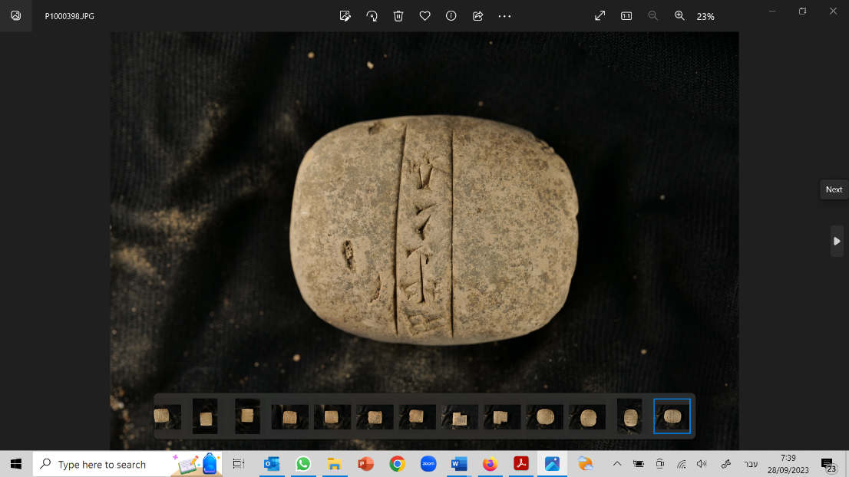
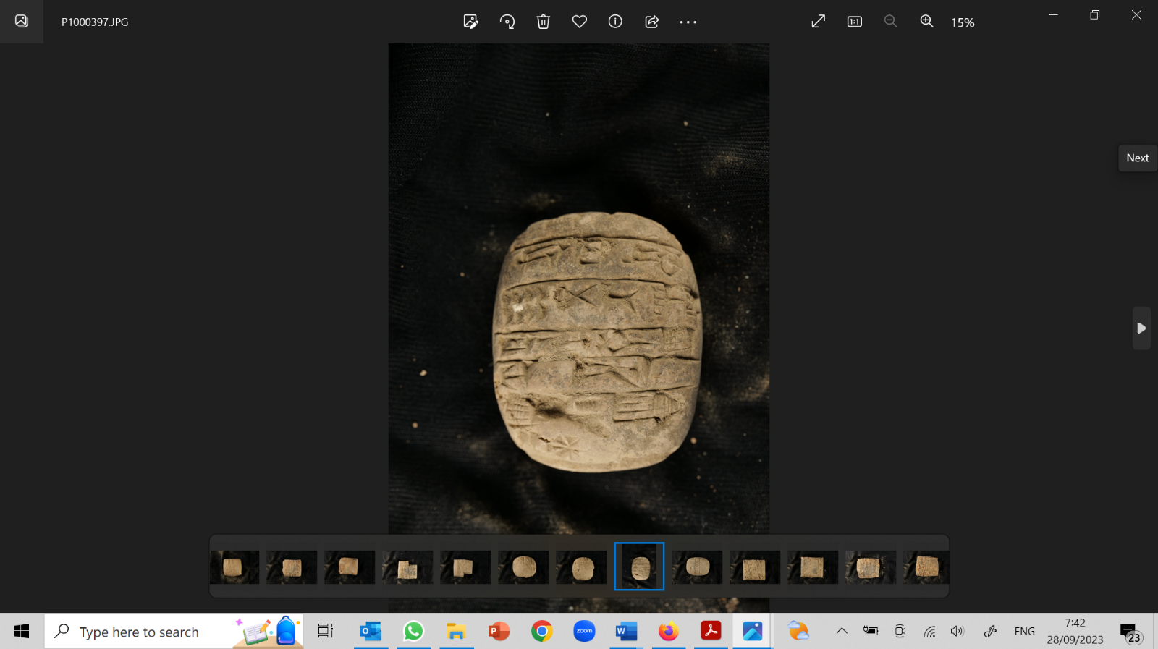
Images:

Texts No. 2’, 3’, 4’: Three Ur III administrative texts, probably from Irisaĝrig and Drehem/Garšana
The three texts below shed light on daily life, royal administration, and temple economy during the days of Ibbi-Suen (texts 2’ and 4’) and Šu-Suen (text 3’). They add to our gradually growing knowledge of the economy and administration in the city of Irisaĝrig and other economically influential cities at the time. Throughout the Ur III period, Irisaĝrig served as a significant provincial capital and a pivotal hub for transportation. It maintained economic connections with the cities of Garšana and Der.

Text No. 2’ (=KI 3037): An administrative text dated to the 9th year of Ibbi-Suen, 11^{th?} month, originating from Irisaĝrig
Preliminary Transliteration: Obv. (1) 25 kaš baneš-ta/ 3b qa (2) dug ba-an-dé (3) nin-ĝu₁₀ Rev. (4) zi-ga (5) ĝìri lugal (6) iti ezem-a-dara₄ (7) mu hu-uh₂-/nu-ri^{ki} ba-hul
Preliminary Translation: (1) 25 beer containers measuring 3.1 QA (2) (as) jugs for pouring libations, (3) (for) my Lady, (4) were deducted (from the accounts) (5) at the command of the king. (6) Month: “Festival of the wild goats.” (7) Year: “Hunhuri was destroyed.”
Images:
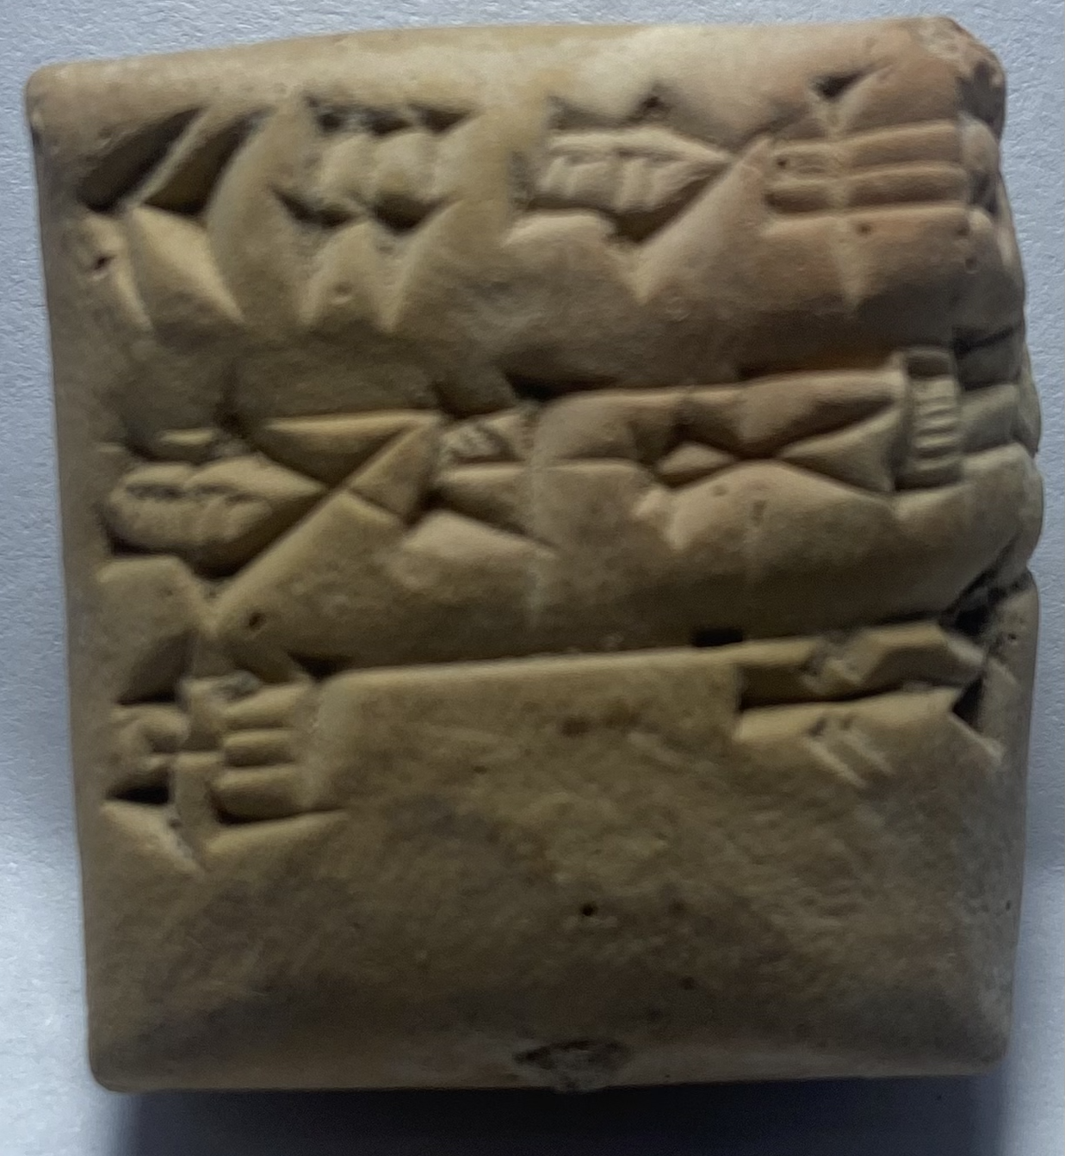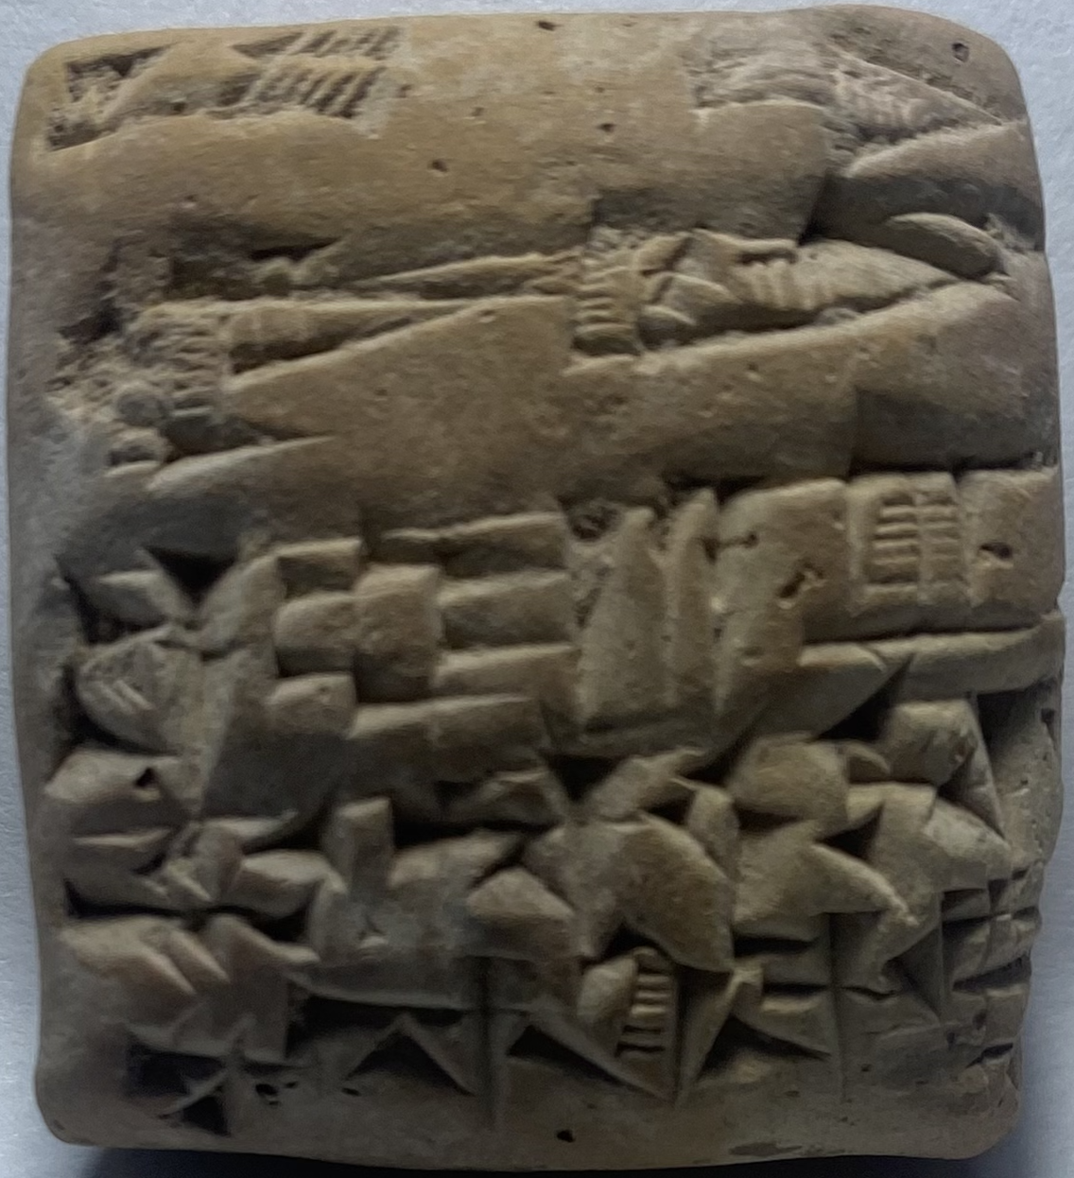
Text No. 3’ (=KI 3086): An administrative text from the 2nd year of Ibbi-Suen, 7th month, originating from Drehem or Garšana
Preliminary Transliteration: Obv. (1) 7 u[du..] (2) 12 ud[u…] (3) 10 [...] (4) udu niga 1 qa [...] (5) 5 u₈ (6) 1 u₈ udu.siki 60 (7) 1? sila₄ nita gal níg šà.dub/ ki.ta 10 (8) 7 (9) u₈ niga ½ qa-ta (10) šà-gal-ga 2b 2 qa 60 (11) ud-1-kam ud-30-šè Rev. (12) 60 niga!-bi! 21 2b gur (13) 1 udu-ka-gi 61 qa (14) iti-ta ud.17 ba-ra-ni (15) du₈-hu-àm (16) ud-13-šè niga-bi ½ b 3 qa (17) 60? 27 udu-niga-hi-a (18) 60? niga-bi 21 ½ qa gur (19) ki RA-GÍN-KAB (20) iti ezem ^{md}šul-gi (21) mu en-^{d}inanna (22) unug^{ki} máš-e ì-pà
Preliminary Translation: (1) 7 sh[eep], (2) 12 shee[p], (3) 10… (4) fattened sheep (with) 1 QA daily (food rations). (5) 5 ewes, (6) 1 ewe (of) wool sheep (with) 60. (7) 1 lamb, big male, belonging to the workers, below 10, (8) 7 (9) fattened ewes with ½ QA (10) food for fodder, 2.2 QA for 60, (11) from the first to the 30th day, (12) 60 fattened (with) 21.2 kor. (13) Sheep fed with reed thicket (with) 61 QA, (14) from day 17 of the month, for Barani (15) he redeemed. (16) From the 13th day, fattened with ½ and 3 QA, (17) 60?, 27 fattened sheep, (18) 60? fattened (with) 21. ½ QA for each kor (19) at the city of RAGINKAB. (20) Month: “Festival of Šulgi.” (21) Year: “The high priest of Inanna (22) in Uruk was chosen by means of omens (by the king).”
Images:
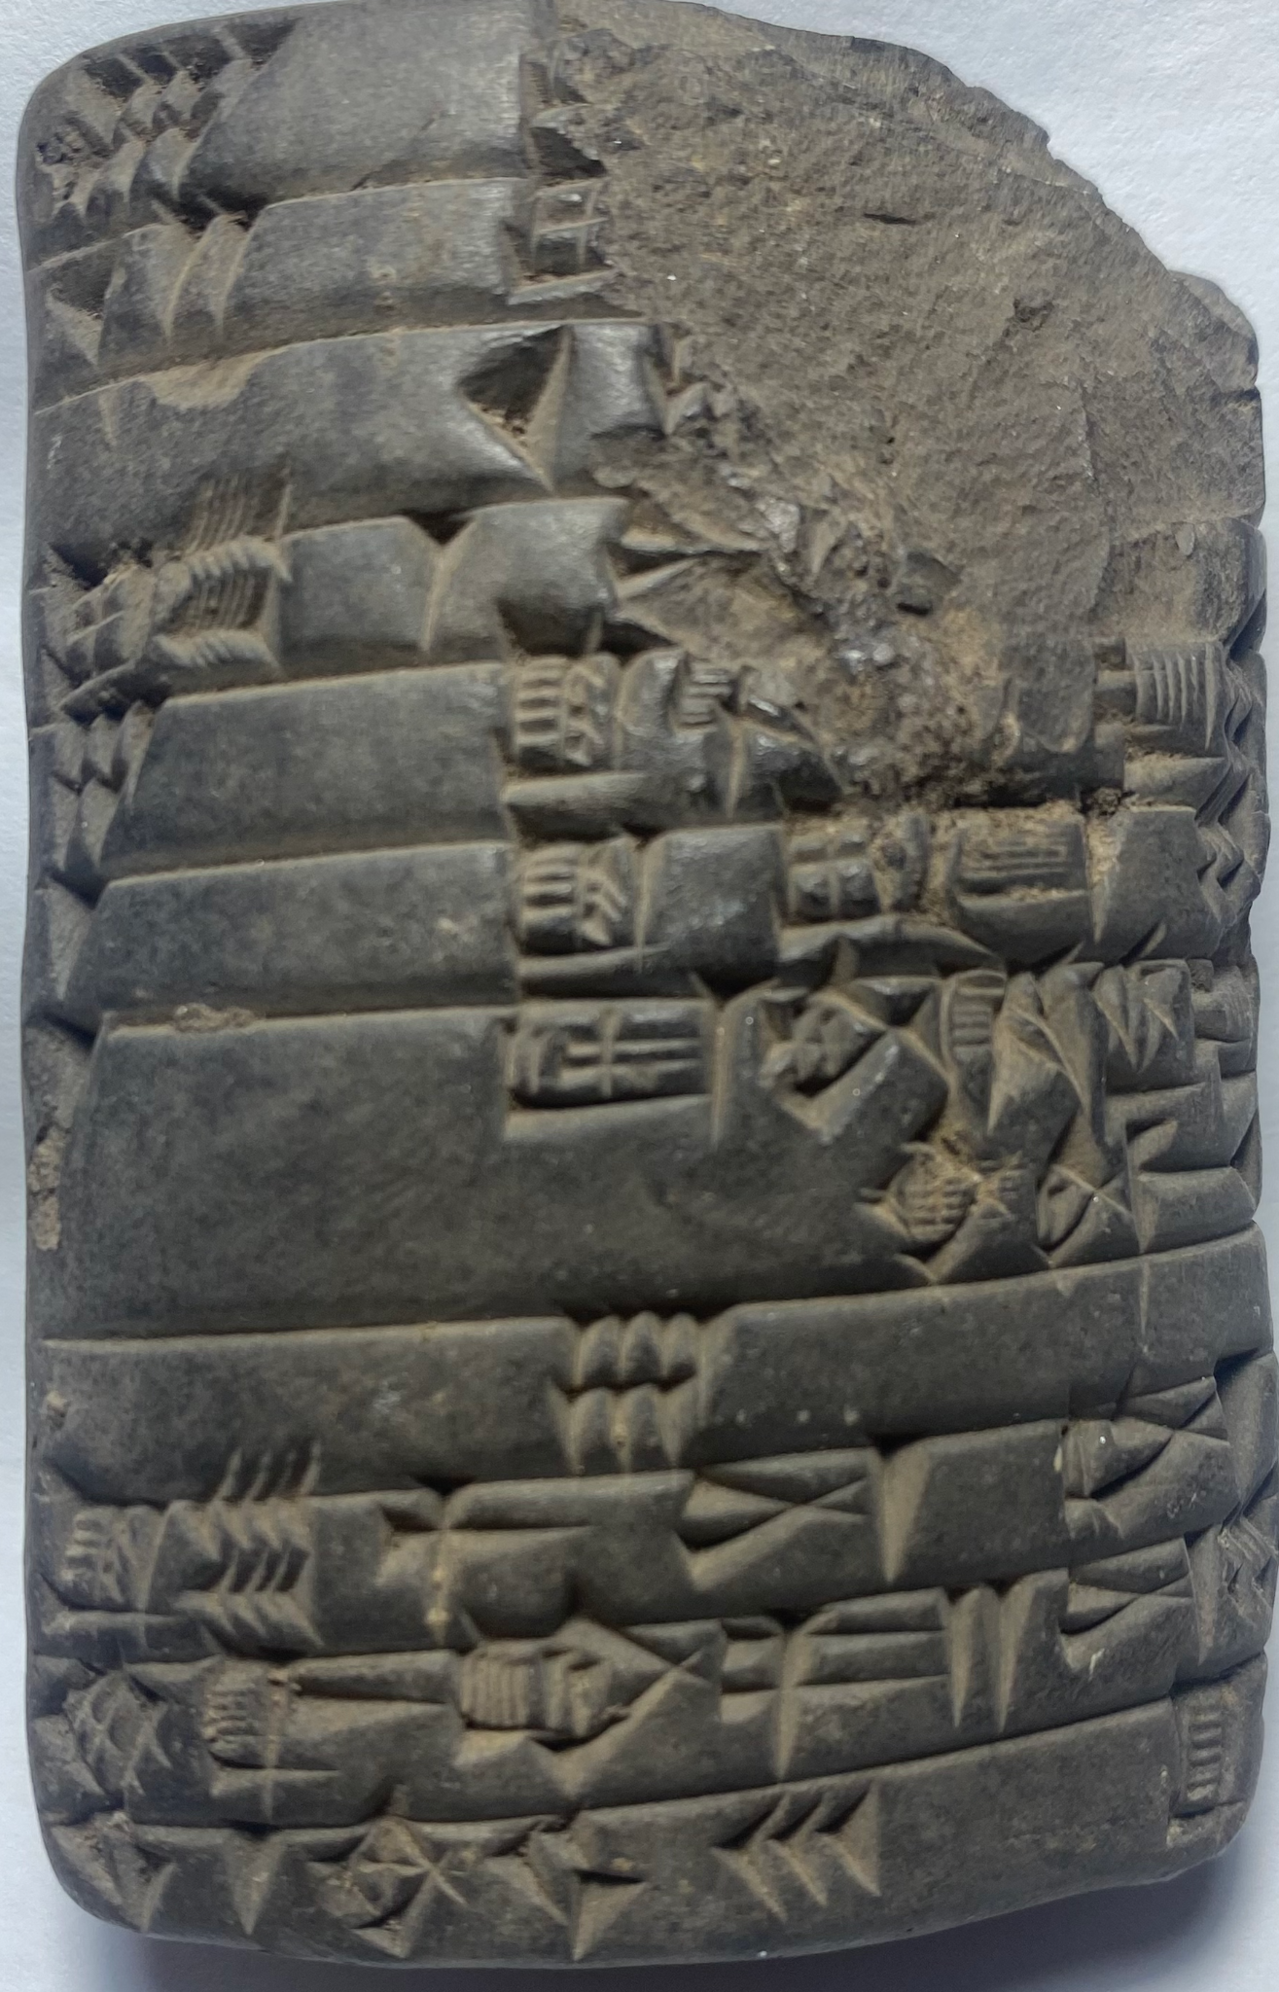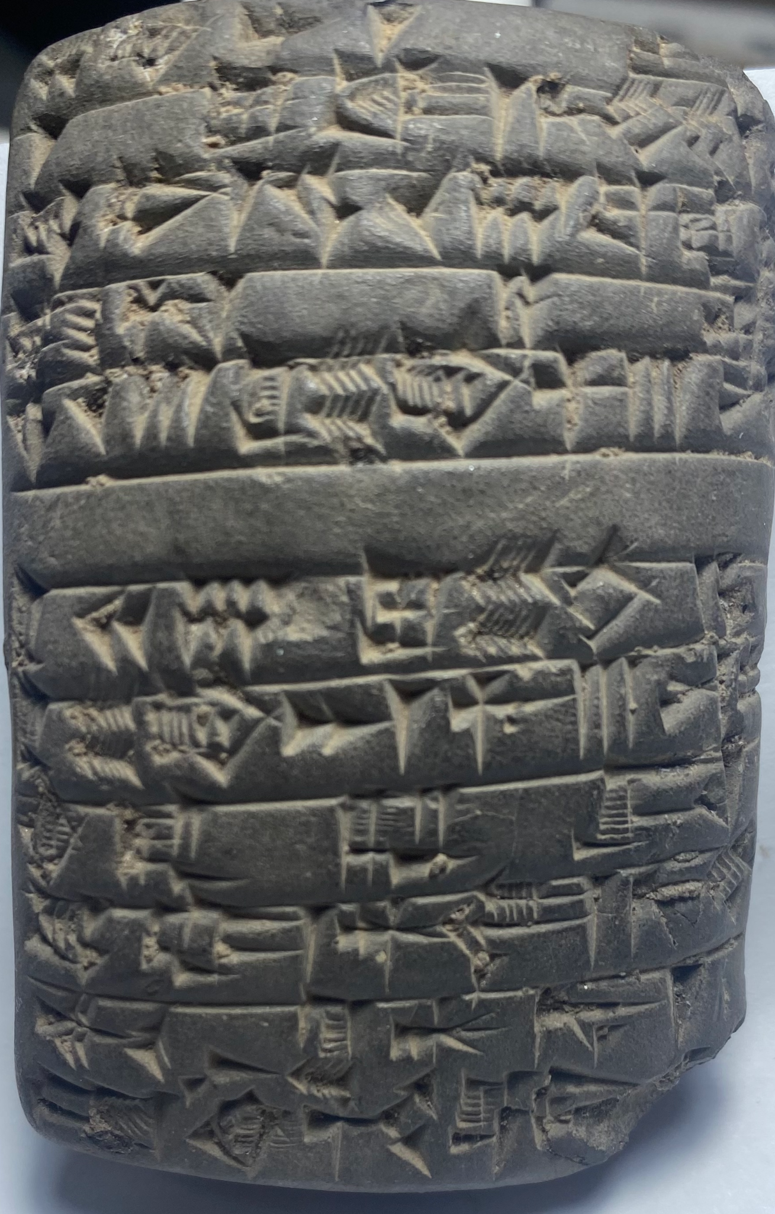
Text No. 4’ (=KI 3114): An administrative text dated to the 2nd year of Šu-Suen, 1st month, originating from Irisaĝrig
Preliminary Transliteration: Obv. (1) 2 hal ha-NE/ 1-ta (2) dim-me (3) níg é dingir šu-^{d}en-líl (4) dù-ù-dè Rev. (5) im-e-re-ša-a (6) zi-ga (7) iti šu-ĝar-gal (8) mu má-dàra-abzu (9) ^{d}en-ki-ka ba-ab (10) du₈-a
Preliminary Translation: (1) 2 baskets…, (2) bound, (3) belonging to the estate of Šu-enlil (4) brought forth. (5) They arrived (6) (and it was) deducted. (7) Month: “performance of the major (corvée obligation)”. (8) Year: “The boat ‘Ibex of the Abzu’ (9) of Enki (10) was made (by the king).”
Images:
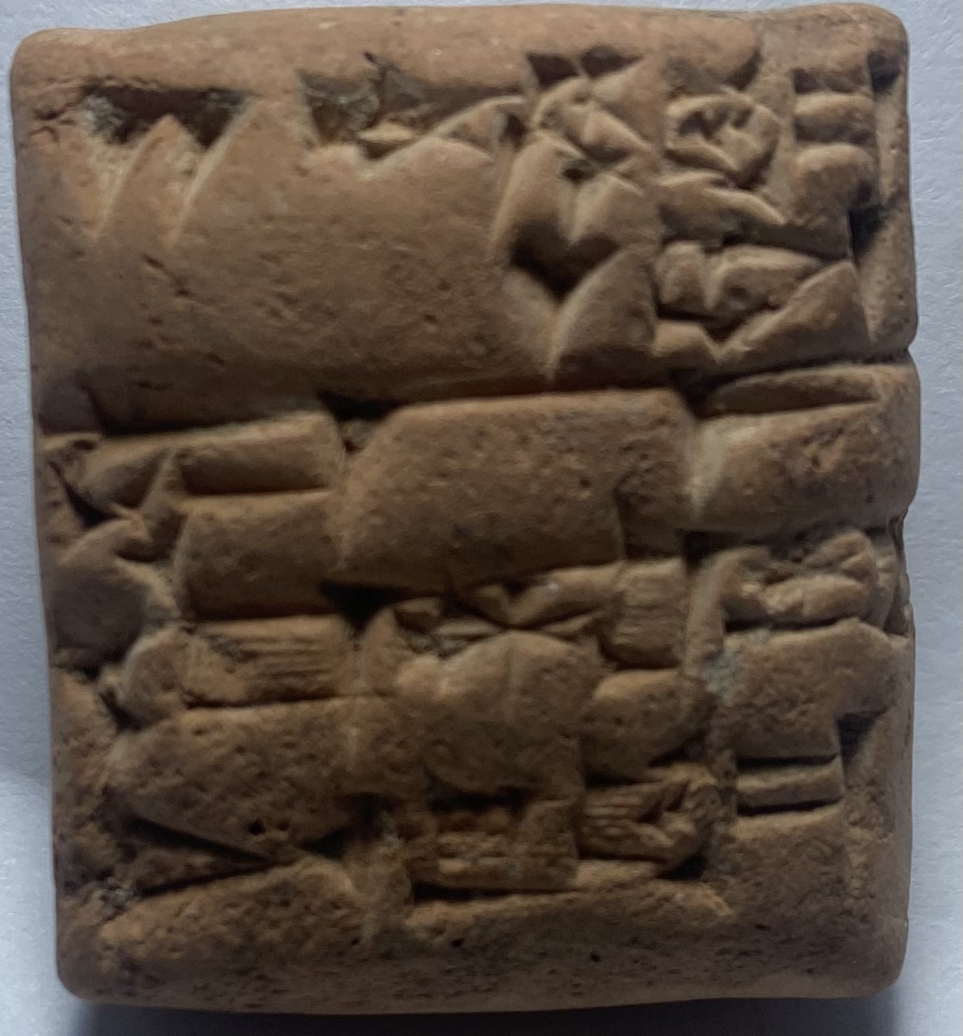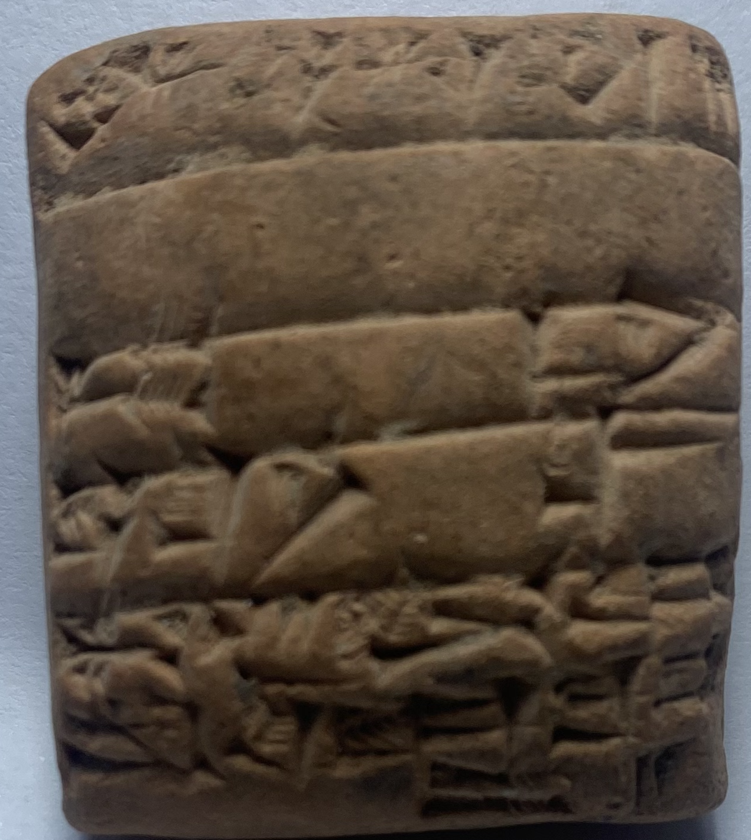
Text No. 5’: An Old Babylonian Sumerian hymn
The collection also includes a tablet inscribed with what seems to be a previously unknown Old Babylonian Sumerian hymn. The hymn was probably composed in honor of the goddess Ninmah, at the initiative of King Šu-ilišu, the second ruler of the Isin dynasty. The text reveals formulations typical of Sumerian royal hymnology, such as the repeated use of lugal-ĝu₁₀ (‘My king’, Rev. ii, 3, 5, 7, 15 and passim, and the rubrics ĝiš-gi-ĝál-bi and sa-gíd-da. For other parallels see BaU, CT 36, 39-40: 31-34; EkurHy 28-30; Ishbi-Erra C 20-22; Ninlil A 11-13; Ur-Ninurta D 22-24).
Preliminary Transliteration of the first two lines:
(1) ^{d}šu-ì-lí-šu inim?-inim-e a-dab kur-kur-ra (2)
inim! mah du₁₁!-ga zi nig₂-kúr-ru?-dam? X X
/íb-mu-un-téĝ-ĝál /sa-gíd-da-àm
Image of obverse:
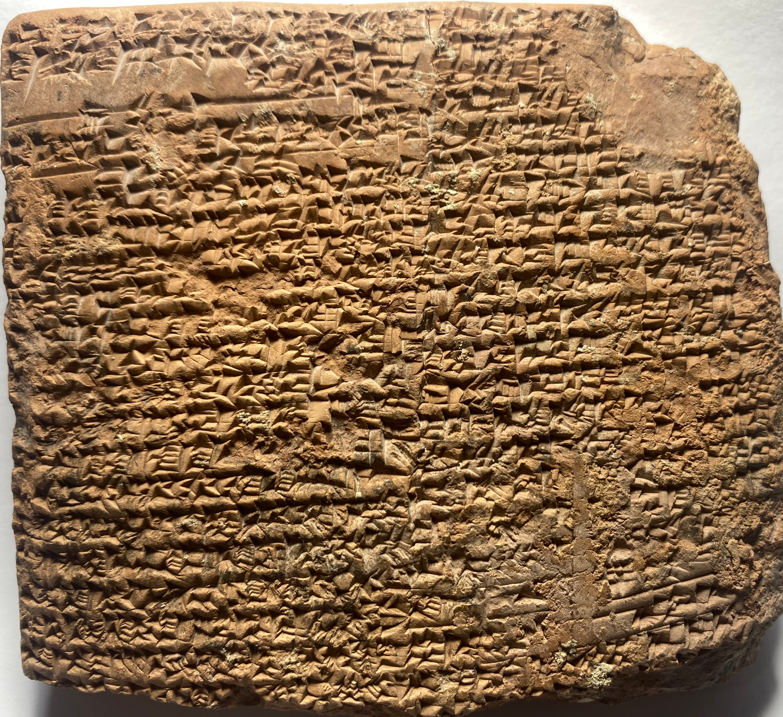
Text No. 6’: A Late Babylonian tablet, dated to the 27th year of Artaxerxes, month of Nisan, originating from Šāṭir
The city of Šāṭir, located in the Chaldean region of Bīt-Amukānu, tells a unique story of life in the rural hinterland of southern Babylonia under Persian rule. The Šāṭir archive documents the affairs of the city’s residents, including Babylonians, West-Semites, and Iranian nobles. The texts from the Šāṭir archive display syncretism between West-Semites and Babylonians, and shed light on the socioeconomic reality of the majority of the population in Babylonia, i.e. peasants and farmers, during the 5th century BCE. The following textual example demonstrates this complex social environment by presenting Babylonians and West-Semites interacting in business and legal activities.
Preliminary Transliteration: Obv. (1) 21 gur še.bar zag qaq-qar (2) ina igi kàr šá lugal (3) šá ^{m}a-di-im-mil-ki-dingir-ú-a (4) a-šú šá ^{md}utu-numun-dù (5) ina ugu-ḫi ^{md}dingir-dan-nu-šeš^{meš}-dù (6) dumu šá ^{m}pur-šu-ú (7) ina ^{iti}gu₄ še.bar a₄ (8) 21 gur ina ^{giš}ma-ši-ḫu (9) šà 1 pi ina šá-ṭir^{ki} LoEd. (10) i-nam-din Rev. (11) ^{lú}mu-kin-nu ^{md}ag-bul-liṭ-su (12) a-šú šá ^{m}ur.sag-dingir (13) ^{md}en-bul-liṭ-su (14) a-šú šá ^{md}en-mu (15) ^{md}dumu-é-su (16) a ^{md}en-šú-nu ^{lú}umbisag (17) ^{m}gi-^{d}amar.utu a ^{m}silim-a (18) šá-ṭir^{ki iti}bára (19) ud.15.kam mu.27.kam (20) ^{m}ar-tah-sa-su (21) lugal kur.kur LeEd. (22) ṣu-pur (23) ^{m}dingir-dan-nu/-šeš⸢^{meš}-dù⸣
Preliminary Translation: (1) 21 kor of barley, the rent of the land, (2) in front of the King’s Quay, (3) belonging to Addî-milki-ilu’a (4) son of Šamaš-zēr-ibni, (5) owed by Ilu-dannu-ahhē-ibni (6) son of Puršû. (7) In Ayyar, (8) 21 kor in the measure (9) of 1-PI, in the city of Šāṭir, (10) he will give back. (11) Witnesses: Nabû-bullissu (12) son of Qarrad-il, (13) Bēl-bullissu (14) son of Bēl-iddin, (15) Mār-bīti-erība (16) son of Bēlšunu, the scribe (17) Mušallim-Marduk son of Šullumâ. (18) Šāṭir. Month Nisan, (19) day 15th, year 27th (20) (of) Artaxerxes, (21) King of the Lands. (22) Fingernail (mark): (23) Ilu-dannu-ahhē-ibni.
Images:
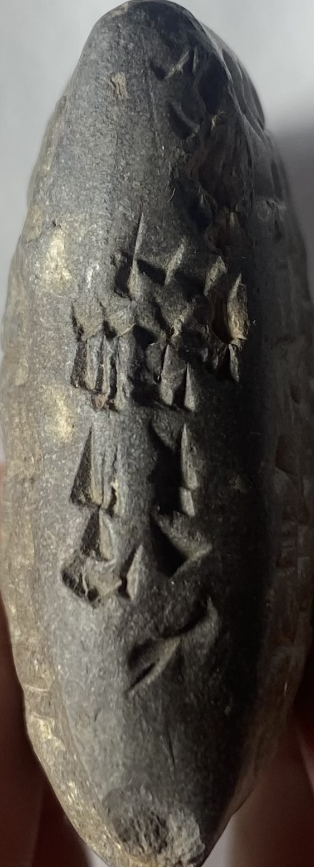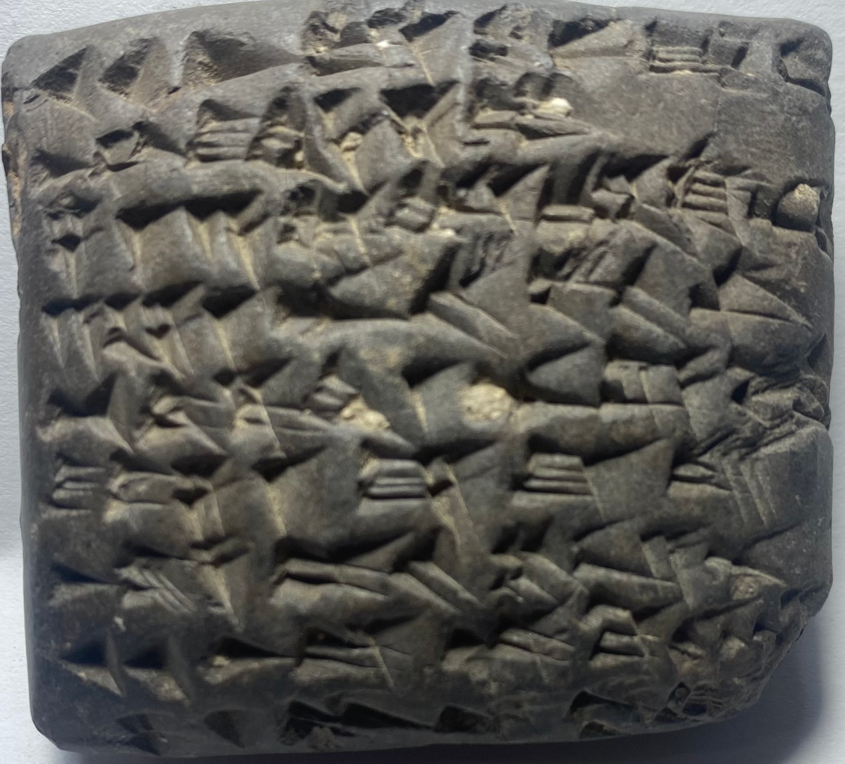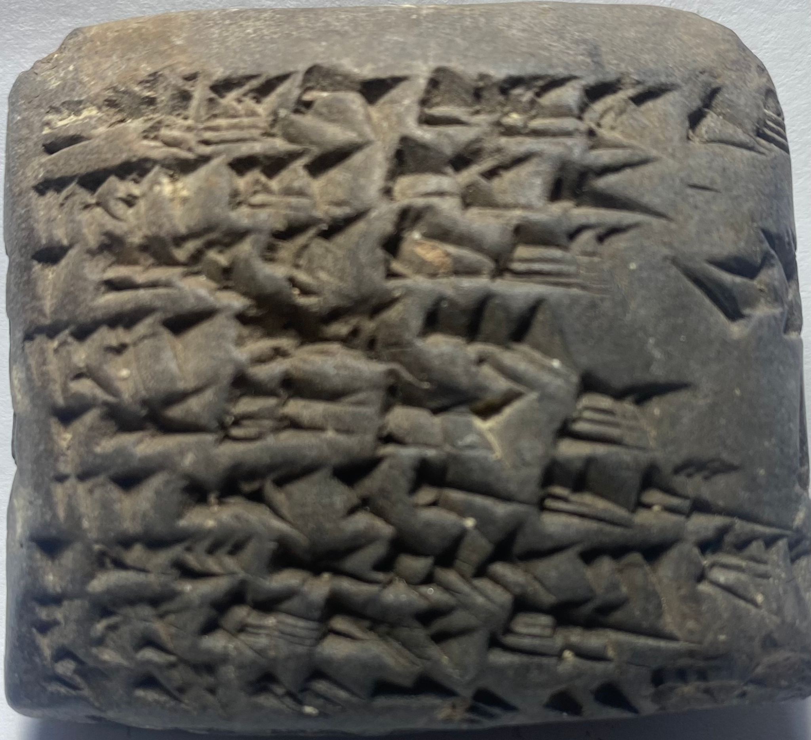
Conditions: Manpower and Infrastructure
To maintain the time schedule (a detailed time schedule is attached), we will require a full-time experienced postdoctoral fellow. We have recruited Dr. Peter Zilberg, currently a Martin Buber fellow at Hebrew University, who is an outstanding young Assyriologist with vast relevant experience. Dr. Zilberg will take a leading part in preparing the editions and the other studies. Two additional part-time assistants at PhD and/or MA level will assist us, on an hourly basis, in preparing the editions and in other research needs as they arise.
The research will require three advanced laptop computers, one for the use of each PI and one for the postdoctoral fellow. These computers should be equipped with Adobe products, as well as Photoshop software, for preparing enhanced hand copies and for various other needs (see above under stage 3 of the project).
In line with common practice in leading collections and museums worldwide, we intend to photograph the tablets using RTI technology, which is currently considered the most advanced and suitable tool for capturing detailed images of cuneiform tablets. RTI creates computer-generated images, each based on a large number of photographs taken from various angles. These supply a sharp view of the tablet from any direction, and enable the identification of important features that cannot be discerned under regular lighting, such as ink marks, shape characteristics (e.g., curvature), and material properties. We intend to purchase a RTI dome system, which includes a custom-built LED dome, a Nikkor-lens & allied vision 30M camera, and specialized software. This system generates images with special features such as visualization filters, relighting options, automatic generation of line drawings of the cuneiform writing, and 3D models of the tablets.
The results of the project will be published in journal articles and monographs. The preparation of these materials for publication will require professional editing services. Additional required research aids include the purchase and photocopy of professional literature, which is not always available for borrowing in the university library, and basic office supplies.

Expected Results
The final product of this project will be a series of monographic volumes that will include full editions of all the relevant 230 tablets. In addition, these editions will be made available digitally through collaboration with a leading online project. Alongside the editions, the project is expected to generate a series of studies that will address philological, historical, economic, and other aspects of the texts. In addition to its significant contribution to research in the fields of Assyriology and Sumerology, the project is expected to significantly advance research and education in these areas within the Israeli academic community.

