**MIF modulation in different subtypes of ALS: from basic mechanisms to therapeutic potential**

**Detailed Description of the Research Program**

1. **Scientific Background**

Amyotrophic lateral sclerosis (ALS), the most prevalent motor neuron disease affecting adults, is a devastating neurodegenerative disorder characterized by the progressive degeneration of both upper and lower motor neurons (MNs) [1, 2]. Approximately 90% of ALS cases manifest sporadically, while the remaining cases are familial and typically inherited in an autosomal dominant manner [3]. Notably, nearly 20% of familial ALS cases are linked to missense mutations in the gene encoding cytoplasmic Cu/Zn superoxide dismutase (SOD1) [3]. Although the precise mechanisms driving MN degeneration in ALS remain elusive, mounting evidence suggests a tight correlation between the aberrant accumulation of misfolded SOD1 and the severity of the disease [4-6]. Transgenic animal models, including mice [7-10] and rats [11, 12], engineered to express SOD1 harboring ALS-associated mutations, exhibit late-onset MN degeneration and muscle atrophy, mirroring ALS symptoms. Intriguingly, this degeneration occurs in a non-cell autonomous manner [13-22] and is accompanied by the selective accumulation of misfolded SOD1 within the spinal cord, specifically at the cytoplasmic surface of intracellular organelles including mitochondria [23, 24] and the endoplasmic reticulum (ER) [25-27]. Our research has revealed that misfolded SOD1 interacts with the mitochondrial protein VDAC1 [23, 28, 29], hampering its conductance across the outer mitochondrial membrane and potentially compromising energy supply [23]. Furthermore, mutant SOD1 alters the composition of mitochondrial proteins and disrupts the protein import mechanism [30], although these effects are confined to spinal cord mitochondria and are not observed in unaffected tissues.

To date, the most effective strategies for mitigating the toxicity of mutant SOD1 in animal models or ALS patients involve the suppression of SOD1 expression using microRNAs, shRNAs, or antisense oligonucleotides (ASOs) [31-33]. While the US Food and Drug Administration (FDA) has recently approved ASO-based therapy for ALS patients with SOD1 mutations, this approach is limited by its inability to distinguish between misfolded (toxic) and intact SOD1. Given the critical role of SOD1 as a vital antioxidant enzyme, its long-term depletion in the central nervous system (CNS) has the potential to impact neuron physiology, particularly under various disease-related stresses. Indeed, recent reports have linked a loss-of-function SOD1 variant associated with undetectable SOD1 activity to a debilitating neurological phenotype characterized by hyperekplexia, ataxia, muscular hypotonia, and severe psychomotor retardation [34-36]. Therefore, there is an urgent need for alternative therapeutic approaches that selectively target misfolded SOD1 while preserving intact SOD1 proteins.

In light of the ubiquitous expression of SOD1, a major unanswered question in the field revolves around the structural determinants that underlie the selective misfolding of mutant SOD1. Our laboratory aims to identify the factors responsible for mutant SOD1 misfolding and its exclusive association with mitochondria in specific cell types, particularly those affected in ALS. In pursuit of this goal, we previously investigated whether this association is governed by mitochondria or the cytosol and found that the cytosol plays a pivotal role in the mitochondrial association of mutant SOD1 in affected tissues in the SOD1 ALS model [25]. Moreover, through the inhibition of the mitochondrial deposition of misfolded SOD1, we identified and purified a 12 kDa multifunctional protein with chaperone activity known as macrophage migration inhibitory factor (MIF), which is abundant in non-neuronal tissues. MIF exhibits ATP-independent protein folding chaperone activity [25], despite its primary role as one of the earliest-described cytokines [37] that plays a crucial role in the immune response [38-40]. Although a portion of MIF can be sequestered into vesicles and released extracellularly in response to various signals, MIF is primarily synthesized as a soluble cytoplasmic protein. Notably, MIF has been previously been implicated in intracellular protein chaperone activities, transitioning from a multimeric to a monomeric form and exposing a hydrophobic surface that facilitates ATP-independent chaperone activity [41]. Our research has demonstrated that recombinant MIF directly binds to mutant SOD1, inhibiting its misfolding in NSC-34 cells and its association with mitochondria and the ER [25]. Elevating MIF levels in neuronal cells reduced the accumulation of misfolded SOD1 and its association with intracellular membranes, while also extending the survival of mutant SOD1-expressing MNs [25]. Additionally, our follow-up study revealed that the absence of endogenous MIF accelerates disease onset and late disease progression, shortening the lifespan of mutant SOD1G85R mice [42]. These results thus emphasize the critical role of MIF in mitigating mutant SOD1 toxicity.

It is noteworthy that MIF protein levels are extremely low in the spinal MNs of rats and mice [25, 42], implying that low levels of chaperone activity may contribute to the selective vulnerability of MNs to mutant SOD1 misfolding and toxicity. Consequently, therapies aimed at enhancing intracellular MIF chaperone activity hold promise. In fact, our studies have demonstrated that overexpressing MIF in the spinal cord of newborn transgenic mutant SOD1G93A and SOD1G37R mice delayed disease onset and significantly extended their lifespan, accompanied by reduced misfolded SOD1 accumulation in the spinal cord [43].

Apart from its role as a protein-folding chaperone for misfolded SOD1, MIF plays a crucial role in the immune response [38-40]. Hence, to mitigate potential side effects when elevating MIF levels, it is imperative to decouple MIF's chaperone activity from its extracellular role as a cytokine. Additionally, MIF possesses tautomerase and thiol-oxidoreductase activities [44-47]. Importantly, by abolishing these activities using site-directed mutagenesis, we demonstrated that they are not essential for MIF's chaperone function, [48]. Lastly, MIF has been proposed to act as an endonuclease under specific circumstances [49, 50].

The MIF superfamily encompasses MIF and its recently identified homologue, D-dopachrome tautomerase (D-DT or MIF-2), which are closely located on chromosome 22q11.23 [51]. MIF-2 shares tautomerase activity with MIF [52] and exhibits biological similarities [53-56]. Moreover, MIF-2 has shown receptor binding to CD74 [55] and a potential ability to activate an inflammatory cascade downstream of CD74 [57-60]. However, further investigations are needed to elucidate and compare the roles of MIF and MIF-2. Our recent studies revealed that although MIF-2 was able to inhibit the formation of SOD1 amyloid aggregates *in vitro*, it had no impact on misfolded SOD1 accumulation or toxicity in cellular models [61]. Furthermore, MIF and MIF-2 expression patterns vary among tissues, suggesting distinct roles for these MIF homologues and underscoring the importance of focusing on MIF but not MIF-2 upregulation in the context of ALS in future research endeavours. Top of Form

1. **Research Objectives & Expected Significance**

**Objectives:** The primary objective of this proposal is to comprehensively investigate various facets of MIF, including its functions and properties, with the aim of understanding the mechanisms by which MIF exerts its protective capacities in the context of ALS. To address MIF's pivotal role as a modifying factor in ALS, we will focus on the following specific research objectives: 1) Augment MIF expression in various subtypes of ALS, other than SOD1, with the intent of elucidating its mechanism of action and to determine whether its function may be variable within the context of different ALS-based mutations; 2) Further expand our knowledge of MIF’s function in a human-relevant model of ALS by overexpressing MIF in MNs derived from induced pluripotent stem cells (iPSCs) sourced from both sporadic and familial ALS patients carrying distinct mutations; 3) Reveal and characterize novel MIF variants with enhanced stability and decreased immune reactivity, and to determine their effects on ALS pathology; 4) Unveil whether MIF exhibits endonuclease activity in the context of ALS pathogenesis and its potential involvement in a cellular process of cell death known as parthanatos, shown to be involved in dopaminergic neurodegeneration. These research pursuits will employ a multifaceted approach, encompassing molecular genetics, gene targeting, biochemical methodologies, and advanced imaging techniques. This comprehensive investigation will be conducted using a combination of mouse models and iPSC-derived cells, facilitating a comprehensive exploration of these four primary research aims, as elaborated below.

**Specific aims**

**Aim 1. Evaluate the impact of MIF overexpression on different subtypes of ALS.** Our prior research has demonstrated that MIF serves not only as a chaperone influencing SOD1 misfolding and aggregation, but also exerts its influence on diverse cellular pathways, including those related to inflammation, neurogenesis, and metabolism (manuscript under review). Furthermore, treatment with MIF has facilitated significant improvement in motor and neurological functions, leading to extended survival in mutant SOD1 mice. Given that diminished MIF protein levels have been observed not only in iPSC-derived MNs from SOD1-related cases but also in cases associated with C9orf72 and TDP43, as well as in the spinal cords of sporadic ALS patients, our aim here is to assess whether MIF overexpression may confer benefits in other ALS subtypes and whether MIF may demonstrate mechanistic variability across the various ALS subtypes. We aim to replicate the successful gene-targeting approach previously employed by us in SOD1 models, utilizing adeno-associated virus (AAV)-mediated delivery of MIF into the central nervous system (CNS) of various ALS mouse models, including those linked to TDP43 and Profilin1. This investigation holds the potential to determine which common pathways play a crucial role in the pathogenesis of various forms of ALS, whether MIF has a protective role not only for familial SOD1 cases but potentially for ALS cases across the spectrum, and whether its mechanism may vary depending on the ALS model.

**Aim 2.** **Determine the effect of MIF overexpression in MNs derived from iPSCs of sporadic and familial ALS patients carrying various mutations.** The recognition of MIF's significant role in slowing disease progression in mutant SOD1 mouse models of ALS has underscored the necessity to elucidate MIF's role in the context of human disease. Given the limitations and disparities between animal models and the manifestation of ALS in humans, we aim to address this gap by utilizing MNs derived from induced pluripotent stem cells (iPSCs) obtained from ALS patients carrying different mutations (in collaboration with Prof. Gad Vatine). Our objective is to investigate whether the observed low levels of MIF protein in both familial and sporadic ALS patients may signify a common underlying mechanism rendering MNs vulnerable. To this end, we seek to determine whether the overexpression of MIF can ameliorate their diseased phenotype and whether this effect involves a different mechanism of action between human and mouse models as well as different ALS subtypes. This endeavour holds the potential to further expand our comprehension of MIF's likely protective role, not only in mouse models of ALS but also in patient-derived cells, and will provide useful mechanistic insight in a more relevant human setting.

**Aim 3.** **Discover and characterize MIF variants with enhanced stability and decreased immune reactivity.** Our previous studies revealed that MIF protein level is extremely low in spinal MNs [25, 62] implicating low chaperone activity as a component of selective vulnerability of MNs to mutant SOD1 misfolding and toxicity. A clearer understanding of the cause for these low MIF levels, may be beneficial in optimizing future therapeutic approaches. MIF instability and subsequent degradation may be a contributing factor, thus utilizing directed evolution techniques such as yeast surface display (YSD) screening (in collaboration with Prof. Amir Aharoni), we aim to identify specific amino acids which contribute to the stability of the protein. In addition, apart from MIF's protective function as a chaperone for misfolded SOD1, we must take into consideration the inflammatory effects of MIF when overexpressed in a tissue for prolonged periods [63]. Therefore, we will use directed evolution techniques to screen for MIF variants with reduced affinity to CD74 receptor, thus dissociating between these functions of MIF with the further aim of determining whether these functions are mutually exclusive. Ultimately, our plan involves employing a gene targeting strategy utilizing CNS-targeted AAV delivery to facilitate the expression of these novel MIF variants in mouse models of ALS. This critical step will pave the way for a better understanding of MIF’s protective mechanism of action in the context of ALS.

**Aim 4.** **Investigate the impact of MIF endonuclease activity on ALS pathogenesis.** Recently, Dawson and his research team reported that MIF plays a role in triggering cell death through an endonuclease activity that hinges on Poly (ADP-ribose) polymerase (PARP) activation. This process involves the release of Apoptosis-Inducing Factor (AIF) from mitochondria to the cytosol, the formation of an AIF-MIF complex, and its subsequent translocation to the nucleus, resulting in a distinctive form of cell death termed "parthanatos" [50], shown to be a fundamental mechanism in the neurodegenerative process in mouse models of Parkinson’s disease [49]. In this aim, we will use primary neurons and employ advanced biochemical and imaging techniques to ascertain whether the neurodegeneration observed in different forms of ALS, including those associated with SOD1, TDP-43, and C9orf72, involves the activation of this specific cell death pathway. This will provide crucial mechanistic insights into whether MIF acts as a protective or detrimental factor in various forms of neurodegeneration. Additionally, it will shed light on the commonalities or distinctions between the pathways implicated in different subtypes of ALS, and potentially, in other neurodegenerative diseases as well.

**Expected Significance**: The fundamental mechanisms underlying neurodegeneration in ALS remain incompletely understood, highlighting the need to uncover these mechanisms as the initial step toward developing therapeutic interventions. In light of accumulating evidence, which includes the harmful effect of misfolded SOD1, the potential risks associated with prolonged reduction of total SOD1 levels, and the multifaceted protective role of MIF—acting not only as a chaperone for misfolded SOD1 but also as an agent with broader effects impacting numerous pathways linked to neurodegeneration—we believe that modulating MIF levels holds promise for making a constructive impact. This impact may extend beyond SOD1-associated ALS cases to encompass other ALS forms and potentially even offer broader applications within the realm of neurodegenerative diseases.

**Detailed Description of the Proposed Research**

**C.1. Working hypothesis**

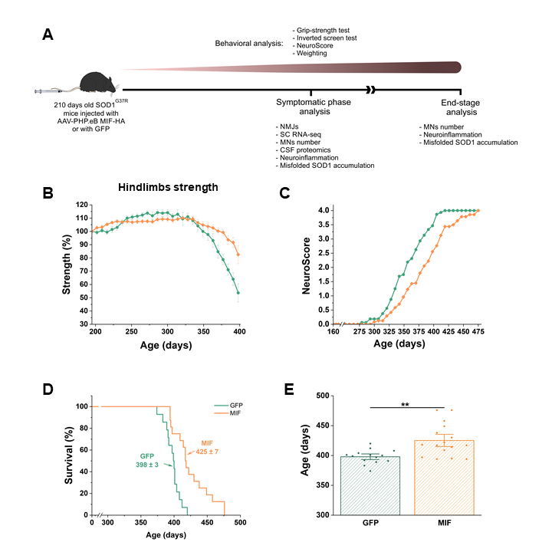

**Fig. 1. Peripheral delivery of AAV-PHP.eB-MIF to mutant SOD1G37R mice after disease onset improves motor function, neurological symptoms, and survival.** (**A**) Schematic representation of the experiment. AAV PHP.eB-MIF-HA or AAV PHP.eB–eGFP were delivered via tail vein injection after disease onset.  (**B**) Hindlimb strength (%) measured with a grip-strength meter. (**C**) Neuroscore measurement. (**D-E**) Survival (%) (**D**) and mean survival + SE (**E**) of SOD1G37R mice injected with AAV-PHP.eB-eGFP: green, n=16 or SOD1G37R mice injected with AAV PHP.eB-MIF: orange, n=15. Statistics were performed using multiple t-tests. **p < 0.01.

Our underlying hypothesis posits that the neurodegeneration observed in ALS may stem from a diminishment or impairment of specific chaperones, notably MIF, as supported by our previous findings. This insufficiency results in the accumulation and subsequent toxicity of misfolded proteins, initially within MNs, commencing even before the onset of the disease. As the disease advances, the buildup of misfolded proteins escalates, culminating in their association with intracellular organelles, causing organelle dysfunction. Ultimately, this cascade leads to MN demise, triggering an overactivation of glial cells, the release of toxic factors, and further MN loss, thereby hastening the progression of the disease. We believe that by suppressing the buildup of misfolded proteins and influencing various biological pathways within MNs through the elevation of MIF levels, we can potentially retard the progression of the disease. Consequently, we postulate that modulating MIF levels may provide substantial benefit not only to SOD1-related ALS cases but also to other ALS forms and neurodegeneration in general.

Top of Form

**C.2. Experimental Design & Methods, Preliminary Results and Expected Outcomes**

**Aim 1. A gene targeting approach to evaluate the impact of MIF overexpression across different subtypes of ALS.** We have previously demonstrated that MIF levels are extremely low in spinal MNs and that overexpressing MIF in mutant SOD1 neuronal cultures or primary MNs extends cell survival [25, 62]. Moreover, we have shown that the injection of AAV9 carrying MIF into the spinal cord of newborn mutant SOD1G93A and SOD1G37R mice reduced the degree of misfolded SOD1 accumulation, delayed disease onset, and extended survival [43]. Importantly, the Gradinaru group has recently taken a step forward and elegantly developed novel engineered AAV capsids (AAV-PHP.eB) for efficient noninvasive gene delivery to the central and peripheral nervous systems [64]. AAV-PHP.eB vectors were shown not only to easily cross the BBB following intravenous injection, but to express their targets at levels ~40-fold higher than those for normal AAV9 [64]. We thus exploited this novel capsid to determine the effect of inhibiting misfolded SOD1 accumulation starting at a symptomatic point. Specifically, we aimed to determine whether reducing misfolded SOD1 within the CNS can slow disease progression following peripheral administration of AAV-PHP.eB to drive MIF expression in a mouse model of ALS. Cohorts of mutant SOD1G37R mice were injected via the tail vein with the AAV-PHP.eB vector carrying MIF at 210 days of age (disease onset). Control cohorts were injected with an AAV-PHP.eB-GFP virus, and both experimental groups were followed and analyzed (**Fig. 1A**). Mutant SOD1G37R mice injected with MIF maintained their hindlimb (**Fig. 1B**) and total limb strength longer than the GFP-injected group, who started to lose their hindlimb strength around 330 days of age. Moreover, the inverted screen test revealed that the MIF-treated mice were able to suspend longer than the GFP-injected mice from 350 days of age. NeuroScore of the mice shows a slower disease progression in the MIF treated mice (**Fig. 1C**). Finally, mutant SOD1G37R mice treated with MIF showed an extended survival of about four weeks compared to the GFP-injected group (**Fig. 1D*,* E**). For the first time, we performed RNA sequencing of lumbar spinal cord samples from these MIF-treated SOD1G37R mice and compared them to their untreated littermates. A total of 3,856 genes were significantly differentially expressed between the non-transgenic (NT) and SOD1G37R mice, of which 2,115 were upregulated and 1,741 were downregulated (**Fig. 2A**). MIF treatment was able to at least partially correct 63.1% of the upregulated and 53.6% of the downregulated genes in SOD1G37R mice, as indicated by gene hierarchical clustering (**Fig. 2B**). Gene ontology (GO) enrichment analyses performed using ShinyGO [65] indicated that MIF overexpression reverted the upregulation of genes related to the inflammatory response, cytokine production, cell death, phagocytosis, gliogenesis, response to oxidative stress, and lipid oxidation (**Fig. 2C**), while MIF treatment reverted the downregualtion of genes including genes related to nervous system development, axonogenesis, neurogenesis, synaptic signaling, neurotransmitter transport, learning and memory (**Fig. 2D**). Notably, although MIF was mainly overexpressed in MNs, this treatment affected the expression of genes that were previously reported to be related to other cell types in single-cell RNA sequencing [66], including astrocytes and microglia, which play essential roles in driving disease progression in the late phase [67, 68].

Proteomic analysis of the CSF profile of SOD1G37R mice further revealed the upregulation of inflammatory proteins and neurofilaments, which is a known hallmark of neurodegeneration. These mice also exhibited the downregulation of metabolic and CNS development-related proteins. Supporting these findings, are several studies suggesting defects in metabolic pathways as a mechanism for neurodegeneration in general, and ALS in particular, due to the high energy demands of the nervous system [69, 70]. MIF treatment was able to upregulate a portion of these neurogenesis and metabolic pathway-related proteins (**Fig. 3**). Notably, many metabolic-related upregulated proteins in the mouse CSF were highly correlated with MIF protein expression in the Answer-ALS iPSC-derived MN database, both in the whole dataset and specifically in the SOD1 cases (manuscript under review), suggesting MIF involvement in these metabolic pathways in cells derived from ALS patients as well, and implying its beneficial potential.

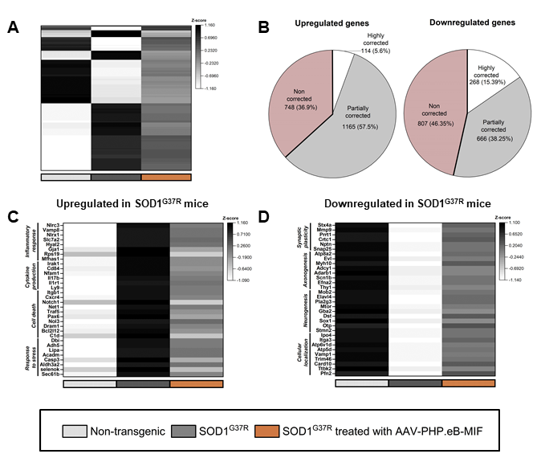

**Fig. 2. Overexpression of MIF in the nervous system partially corrects the expression of several genes that were altered in symptomatic mutant SOD1G37R mice. (A)** Heatmap of all the genes that were significantly altered in SOD1G37R (grey) compared to non-transgenic (NT) mice (white) and were at least partially corrected in the MIF-treated mice (orange). (**B**) Pie charts of all the upregulated or downregulated genes in the spinal cord of the mutant SOD1G37R compared to NT mice, representing the portion of highly corrected, partially corrected, and non-corrected genes in AAV-PHP.eB-MIF treated compared to untreated SOD1G37R mice. (**C-D**) Heatmaps of the expression of representative genes that were significantly upregulated (**C**) or downregulated (**D**) in SOD1G37R mice compared to NT, ordered according to their gene ontology (GO) pathways. Heatmaps were generated using gene expression Z-scores.

In summary, our recent findings shed light on the diverse roles of MIF in the CNS in general and its importance in MNs specifically, when administered in a therapeutically relevant manner. MIF not only functions as a SOD1 chaperone that modulates SOD1 misfolding and aggregation, but also affects diverse pathways, including the inflammatory response, neurogenesis, and metabolism, thus resulting in better motor and neurological functions leading to extended survival. These findings, together with the fact that low MIF protein levels were found in MNs derived from iPSCs of SOD1, C9orf72, and TDP43 cases (**Fig.** 4**A**) and in the spinal cord of the sporadic patients (**Fig.** 4**B**), suggest a therapeutic potential for MIF not only for SOD1 ALS but for ALS cases in general. Thus, in this Aim we will determine whether the overexpression of MIF in the CNS affects disease course in different subtypes of ALS using mouse models and a gene targeting approach as used above. Specifically, after disease onset, we will inject AAV-PHP.eB-MIF-HA via the tail vein into two different mouse models: hPFN1G118V [71] and TDP-43Q331K [72],. Following AAV-PHP.eB-MIF-HA or AAV-PHP.eB-GFP injection, we will monitor these mice through weight, NeuroScore, and grip strength measurements until they reach end-stage disease. After sacrificing these animals, we will examine MN numbers, neuroinflammation, neuromuscular junctions, and TDP-43 localization. In addition, we will isolate RNA from the lumbar spinal cord and CSF of symptomatic mice to perform RNA-seq and CSF proteomic analyses, respectively, comparing MIF-treated and untreated mice as we have done before with mutant SOD1 mice (**Figs. 2**and **3**). These experiments will provide us with important information regarding the pathways corrected or unaffected by MIF treatment in these different models.

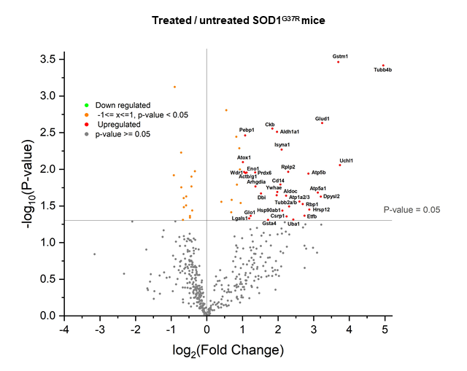

**Fig. 3. Upregulation of MIF in the nervous system partially corrects the expression of altered proteins in the CSF of symptomatic mutant SOD1G37R mice.** Volcano plot of proteomics data. The –log (P-value) plotted against the log2 of the fold change of proteins in the CSF of AAV-PHP.eB-MIF treated compared to untreated SOD1G37R mice.

The AAV approach is a promising gene delivery modality. The small DNA genome of AAV can be replaced with a gene of interest that is packaged into replication-defective viral particles. In essence, the AAV-coated proteins provide an efficient mechanism for intracellular delivery of a gene of interest. Importantly, AAV vectors do not require integration for gene expression. This feature has made recombinant AAVs attractive as a therapeutic delivery tool in the nervous system, especially since wild-type AAV is known to be non-pathogenic and viral genes can be successfully removed and replaced [73]. In addition to being efficient, AAV-mediated expression is also stable. For example, recombinant AAV expression has been shown to be sustained for over 3.5 years in the primate brain and up to 19 months in the rat brain with no obvious side effects [74]. Encouragingly, the FDA has already approved AAV gene therapytreatment for inherited retinal disease (IRD), spinal muscular atrophy (SMA), hemophilia B, and Duchenne muscular dystrophy; and many other AAV clinical trials are currently underway, including trials for neurodegenerative diseases.

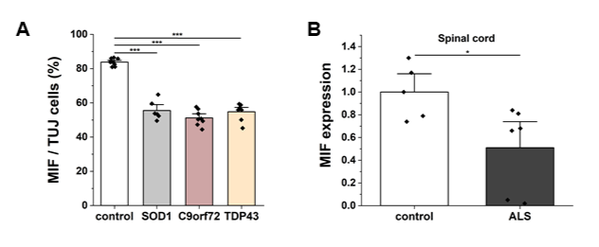

**Fig. 4. Reduced MIF protein expression in ALS patient-derived motor neurons and human ALS post mortem tissue. (A)** MIF expression in human iPSC-derived MNs from control, SOD1, C9orf71, and TDP-43 patients (**B**) MIF expression normalized to α-Tubulin in human post-mortem tissue samples from spinal cord (n=4-7) of sporadic ALS patients and healthy controls determined by immunoblot (unpaired two-tailed t-Test, *p < 0,05).

***Expected outcome and pitfalls:***

Even if MIF is not able to rescue the toxicity of any other form of ALS except mutant SOD1 disease, the experiments proposed herein will provide us with important mechanistic insight and useful information regarding the mechanisms through which the chaperone-like activity and general functions of MIF impact ALS pathogenesis. In addition, they will provide us with critical information about the common or differing pathways involved in different subtypes of ALS that will likely be used for the future development of therapeutics for this devastating disease.

**Aim 2. Determine the effect of MIF overexpression in MNs derived from iPSCs of sporadic and familial ALS patients carrying various mutations.** Revealing the important role of MIF in slowing ALS disease progression in SOD1 mouse models of ALS has resulted in a need to understand the role of MIF in human disease, given the limitations of animal models and their differences from human disease manifestation. Importantly, we also observed low MIF protein levels in iPSC MNs derived from SOD1, TDP43, and C9orf72 ALS cases (**Fig. 5A**). Additionally, we found that sporadic ALS patients, who have been reported to accumulate misfolded SOD1 according to several groups [75-80], have lower MIF protein levels in the spinal cord (**Fig. 5B**). These low MIF protein levels found in familial and sporadic ALS patients may thus represent a common mechanism of MN vulnerability. We therefore aim to determine whether the upregulation of MIF is sufficient to revert disease phenotypes in a human-related model. To this end, we have begun modeling and studying ALS through the innovative utilization of patient-derived iPSCs in close collaboration with Prof. Gad Vatine (BGU). These iPSCs provide a unique platform that allows us to recapitulate the complex disease processes in a controlled laboratory setting [81]. In iPSC-derived MNs from SOD1 ALS patients, studies have shown higher levels of misfolded or aggregated SOD1 in the cytosol displaying phenotypic toxicity and insolubility [82-84], cellular degeneration, and impaired neural viability of cultured MNs besides morphological alterations of affected MNs[82, 85-87], decreased neurite length, and an overall decrease in the number of neurites per neuron consistent with degeneration and loss of connectivity [82, 85, 86]. In addition, electrophysiological activity is the main functional output for neural cells. Thus, investigating the electrophysiological dysfunction in ALS cases is crucial and can provide data on the functionality of the neural systems (mainly MNs) in fALS and sALS. Clinically, one of the features of ALS is MN hyperexcitability, specifically at early stages of neurodegeneration in both fALS and sALS cases[88-91]. While many studies conducted using transgenic mice with different ALS-related mutations show similar early-stage hyperexcitability [92-97], other studies using different unrelated mouse models of ALS have reported neuronal hypo-excitability [98]. Recordings from iPSC-derived MNs from ALS patients have similarly displayed neural hyperexcitability in some cases [99, 100], but hypoexcitable neurons in others [87]. More recent studies recording iPSC-derived MNs at different stages of neural maturation *in vitro* have reported hyperexcitability to be an early-stage phenotype that later transitions into hypoexcitability, suggesting that these neural function phenotypes could be indicative of the disease progression and MN degeneration from a very early stage of neural development [81, 87, 98-100]. This suggests that modeling ALS by differentiating patient iPSCs could be a very effective means of studying various aspects of this disease including molecular features, cell functionality and morphology, cell viability, and even neural connectivity. In this Aim, we plan to focus on studying distinct patient lines of iPSCs, with each line contributing to the understanding of a wide range of ALS cases. Working with a diverse set of patients will help us shed light on the mechanisms that may drive MN degeneration. We have so far successfully managed to differentiate cells from four lines (healthy control, sporadic ALS, SOD1A4V, and SOD1H44R) and we have characterized their neural and motor profiles. All lines showed positive staining for beta-III tubulin and ChAT (**Fig. 5**). In addition, all lines have been recorded for functional characterization and showed spontaneous activity as expected after the determination of their neural fate. Further experiments have shown that SOD1 mutant lines, but not the sporadic or healthy controls, show positive staining for misfolded SOD1 using the B8H10 antibody (**Fig. 6**). As for the functional phenotype, so far, we have managed to show a significant pattern of hyperexcitability at early neural development in SOD1A4V MNs. All experiments were performed following sequencing for both SOD1 mutations mentioned above.

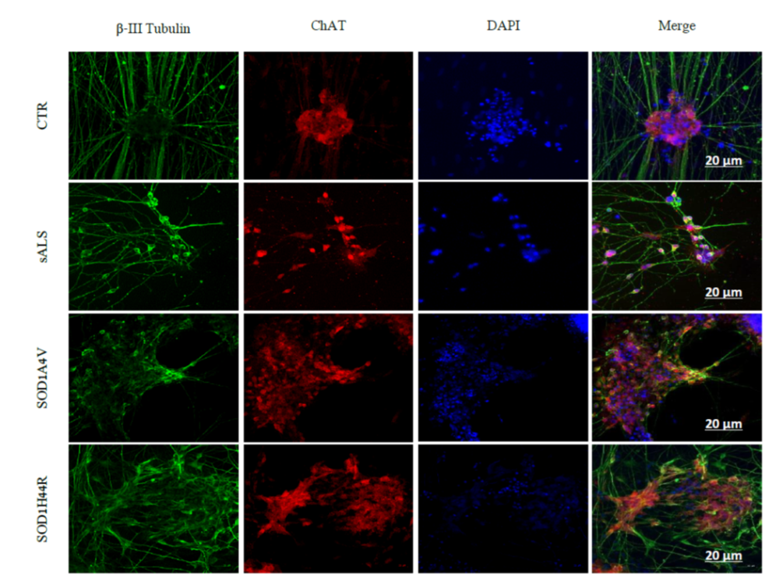

**Fig. 5.** Immunocytochemistry staining representative images of differentiated MNs of all cell lines stained with b-Tubulin (green), ChAT (red) and DAPI (blue). CTR, sALS, familial ALS patient with A4V SOD1 mutation (SOD1A4V), and familial ALS patient with H44R SOD1 mutation (SOD1H44R), Scale bar: 20μm.

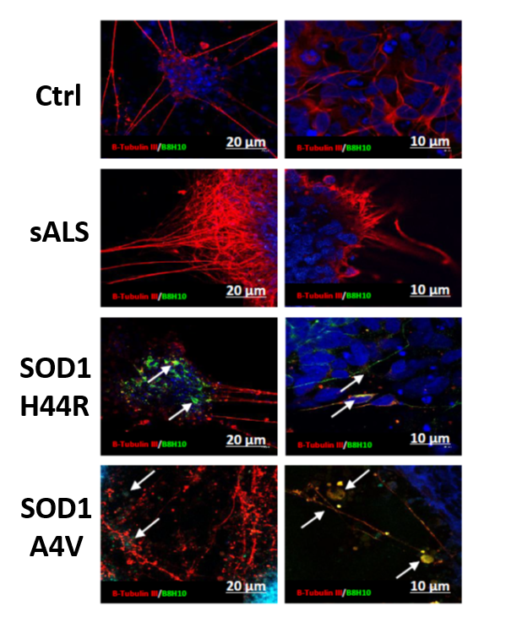

**Fig. 6.** Immunocytochemistry staining representative images of differentiated MNs for all cell lines stained with anti-β-Tubulin (red) and B8H10 (green). Scale bars: 10, 20μm.

In our proposed study we plan to increase MIF levels in MNs derived from different subtypes of ALS: SOD1, TDP43, C9orf72, and sporadic (we have kindly received the new lines from Dr. Michael Ward (iNDI initiative) with the aim of examining its effect on the ALS iPSCs MNs. In our preliminary results, we have shown that MIF overexpression using a lentiviral vector resulted in the reduction of misfolded SOD1 levels in iPSC-derived MNs from SOD1 patients (**Fig. 7**). Furthermore, we will determine whether MIF overexpression affects MN viability and MN morphology, including neurite length and number of neurites per neuron. Finally, we will use a microelectrode array (MEA) to measure the hyperexcitability pattern in untreated ALS MNs compared to MIF-overexpressing MNs. Ultimately, we aim to advance the understanding of ALS pathogenesis at the cellular, molecular, and functional levels, contributing valuable knowledge to the field of ALS research in general and more specifically the role of MIF in disease pathogenesis.

***Expected outcome and pitfalls:*** Although our model offers a promising avenue for research, it also comes with several limitations that are important to address. Firstly, since this is an isolated *in vitro* system, we cannot rule out the involvement of other cell types in disease pathogenesis. Secondly, disease heterogeneity poses a major challenge that iPSC models may not be able to fully capture. Finally, one of the greatest challenges in the field of disease modeling using iPSCs-derived cells, specifically with respect to late-onset diseases, is that iPSCs exhibit an embryonic rather than a senescent state, which makes it harder to replicate the clinical phenotypes of these diseases *in vitro*. To at least partially overcome these challenges, we will repeat our experiments using different lines and using isogenic controls for the familial forms of ALS. One of the major advantages of using the INDI cell lines (provided by Michael Ward) is that they have common isogenic controls, reducing dramatically the variability.

**Aim 3. Discover and characterize MIF variants with enhanced stability and decreased immune reactivity.** We have shown that MIF protein levels are extremely low in spinal MNs, [25, 62] implicating low chaperone activity as a component of the selective vulnerability of MNs in ALS. Deciphering the cause of these selectively low MIF levels in ALS-associated tissues may prove fundamental to our understanding of the role of MIF in ALS pathogenesis. One possible explanation for low MIF levels may be its short lifespan as a result of degradation. Thus, our first aim will be to identify variants with higher stability. The primary protein engineering approach that we will utilize for the generation of improved MIF variants is directed evolution. This methodology is based on the generation of large mutant libraries followed by powerful screening/selection assays to isolate proteins with desired properties [101-103]. In this Aim, we will use a screening approach based on yeast surface display (YSD) of a large MIF library (in collaboration with Prof. Amir Aharoni), followed by the fluorescence-activated cell sorting (FACS) of mutants with enhanced stability (**Fig. 8A**). YSD is a powerful method for engineering proteins with increased affinity, specificity, and stability [104] and it has been previously utilized by the Aharoni group for the display and engineering of different proteins, including PCNA, glucose oxidase, and IL-17 receptor [105-107]. Our preliminary results using this system have achieved the optimization of YSD conditions to enable the display of MIF on the yeast cell surface at high levels (**Fig. 8B**). Following MIF library YSD, we will perform 3-5 rounds of library cell sorting by FACS to enrich MIF mutants with enhanced stability. These engineered MIF variants will then be characterized using biochemical and cell-based assays to assess MIF’s stability, inhibition of SOD1 misfolding, and rescue of MN cell death.

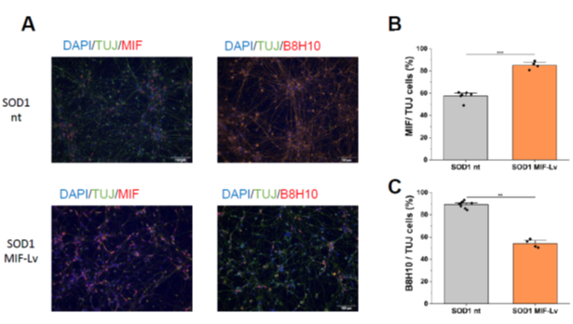

**Fig. 7. Lentiviral transduction of mutant SOD1 iPSC-derived MNs with MIF reduces SOD1 misfolding. (A)** ICC-staining for MIF and misfolded SOD1 before and after transduction of iPSC-derived mutant SOD1 MNs. **(B,C)** Quantitative analysis of MIF and misfolded SOD1 protein expression in IPSC-derived MNs. MIF expression **(B)** and misfolded SOD1 accumulation (**C**) after MIF transduction in relation to TUJ positive cells. Scale bars: 100 µm

**Generation of MIF mutant libraries:** DNA libraries based on the existing human MIF will be generated. We have already begun generating these MIF libraries using site saturation mutagenesis (SSM). Taking advantage of the small size of the MIF protein (115 amino acids) and the structure of its C-terminus, which seems to contribute less to overall MIF stability, we will mutate residues 1 – 99, while leaving the functional cysteine residues at positions 57, 60 and 81 intact. This library will allow us to systematically explore the effect of each mutation in residues 1-99 of MIF on the stability of the protein. Following library screening and the isolation of mutants with enhanced stability (see below), we will be able to combine beneficial mutations and generate a second comprehensive library with a high potential to dramatically improve MIF stability relative to the wild-type (WT) protein.

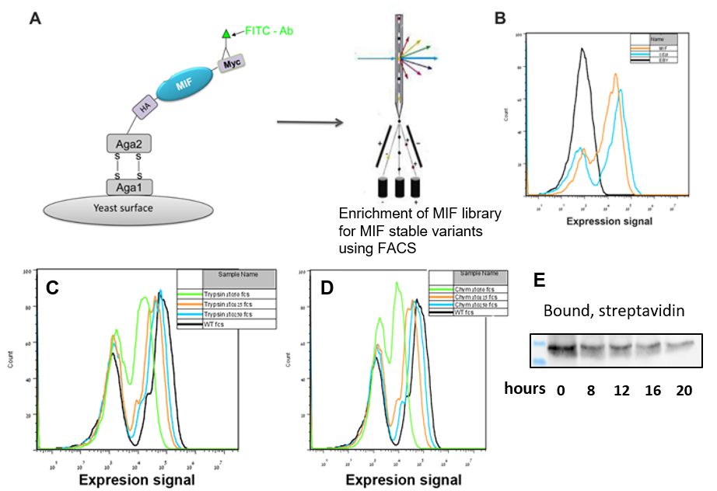

**Fig. 8. A.** Scheme describing the YSD approach. MIF is displayed on the yeast surface by fusion to Aga2 through its N-terminus and to a Myc tag on the C-terminus. MIF display levels are monitored using fluorescently labeled anti-Myc antibodies. The level of Myc display and the screening for MIF mutants with enhanced stability is performed by FACS. **B**. Histogram showing that MIF is displayed at a high level using the YSD approach. The display level of MIF (orange) was compared to the display levels of CD20 (blue) that is a known ScFv previously shown to display using the YSD approach. EBY100 (black) are yeast cells not displaying any tagged protein of interest. **C, D.** WT MIF was incubated with different concentrations of trypsin (**C**) or chymotrypsin (**D**). A stock solution of 100 µM trypsin or 40 µM chymotrypsin was diluted 1:250 (blue), 1:125 (orange), 1:50 (green), or no protease (black) for 5 min prior to labeling with α-myc-FITC antibody to assess the level of MIF that was un-cleaved on the yeast surface. **E**. Immunoblot showing MIF degradation as a function of time measured by the SPAAC pulse-chase assay.

**Screening of MIF mutant libraries:** To enable the screening of large MIF libraries for the isolation of variants with improved stability, we first established a protease stability assay for MIF. This assay enables the isolation of MIF variants with improved resistance to protease digestion. The assay is based on the incubation of yeast displaying MIF variants with different trypsin (**Fig. 8C**) and chymotrypsin (**Fig. 8D**) concentrations for a short duration. Following incubation, digested MIF will lose its C-terminal Myc tag and yeast cells will exhibit reduced a-Myc fluorescence intensity. Thus, increased protease concentrations lead to a decrease in the fluorescence signal obtained following labeling with the a-Myc antibody. We will utilize this assay to screen large MIF libraries for variants with increased stability and resistance to protease digestion.

**Characterization of improved MIF mutants:** To characterize the improved MIF mutants, we will estimate the half-life of these MIF variants compared to the WT form of MIF using the novel SPAAC pulse-chase method [108]. Compared to other commonly used methods, this new technique overcomes several limitations. First, the SPAAC pulse-chase protocol is non-radioactive such that it minimizes DNA and cellular damage, and does not require the use of biohazardous radioisotopes or the need for specific permits and equipment. In addition, this non-toxic method does not require treatment with cycloheximide, a highly cytotoxic reagent that inhibits protein synthesis and may negatively influence cellular proteostasis. The SPAAC protocol allows for the live-labeling of newly synthesized proteins, with a non-toxic component conjugated to a reactive azide moiety. The labeled proteins are then reacted with dibenzocyclooctynol (DIBO) conjugated to biotin, and detected by using a streptavidin-HRP probe. We have already established the protocol in our group using SH-SY5Y cells transiently transfected to express MIFWT where MIF degradation can be clearly observed as a function of time (**Fig. 8E**). We propose to then use this assay to compare the half-life of MIFWT with the novel stable variants. In order to examine a possible superior functionality of these variants, we will determine their ability to inhibit SOD1 misfolding and the formation of amyloid aggregates. To this end, we will sequence, express, and purify the novel mutants using fast protein liquid chromatography (FPLC). Subsequently, we will use the ThT assay, as we have described previously, to examine amyloid aggregation [48, 61, 109]. Furthermore, we will overexpress different MIF variants in SH-SY5Y or NSC-34 cells together with plasmids encoding SOD1 mutants and determine the levels of misfolded SOD1 accumulation by immunoprecipitation with the B8H10 antibody as well as cell viability using the XTT assay. These assays are routinely performed in our laboratory as described previously [4, 25, 28, 48, 61, 62, 109]. The identification of those residues affecting MIF stability will provide mechanistic insight into the causes of low MIF levels in MNs while also providing us with target sites for improving MIF stability that may aid the future development of a MIF-based therapeutic approach.

In addition to its protective function as a chaperone for misfolded SOD1, we cannot ignore the inflammatory effects of MIF when overexpressed in a tissue for extended periods [63]. Therefore, we will use directed evolution techniques to screen for MIF variants with reduced affinity for the CD74 receptor, with the goal of dissociating these two MIF functions. To this end, DNA libraries based on the existing human MIF will be generated. An effective approach for generating gene libraries highly enriched in mutants with reduced CD74 affinity entails the targeted mutagenesis of residues that deviate from the consensus sequence of the gene family [107, 110-112]. We will identify these residues based on phylogeny and MIF structure and will generate a MIF library via the partial mutagenesis of the targeted positions according to our previously reported protocols [107, 110-112]. Then, the screening will be performed in a similar manner as described above but we will screen for variants with lower CD74 affinity. After performing 3-4 rounds of FACS for the enrichment of these variants, we will combine the single mutants to identify the variant with the lowest affinity for CD74. Finally, these mutants will be characterized for MIF cytokine function. MIF binds to the extracellular domain of CD74, activating a signal transduction pathway that is followed by CD44 activation, which induces MIF-mediated phosphorylation of the ERK1/ERK2 signaling pathway [113]. Accordingly, we aim to compare the CD74 binding affinity of the novel variants to that of MIFWT by testing MIF-mediated ERK activation. To do so, we will treat cells with MIF, collect cell lysates, and check for ERK1/2 phosphorylation by immunoblotting using phospho-specific anti-ERK antibodies as described previously [114-116]. Lower ERK phosphorylation levels will indicate less activation of the pathway and therefore reduced CD74 binding affinity. Next, we will determine the chaperone function of these novel variants as described above.Once we have characterized both the stable variants and the mutants with reduced affinity for CD74, we will test our novel MIF variants both in cellular models of ALS and subsequently in a SOD1 mouse model of ALS using AAV-PHP.eB as we have recently done (**Fig. 1**). Cohorts of animals carrying a mutant SOD1G37R transgene (already in our colony) will receive tail vein injections of AAV-PHP.eB virions carrying the MIF variants at seven months of age. Control cohorts will be injected with AAV-PHP.eB-GFP virus, and the experimental groups will be followed and analyzed for behavior, disease onset and progression, survival, pathology, and viral distribution. The treated mice will be monitored for disease progression through weekly body weight and hind limb grip strength measurements. Survival curves for these groups will be compared to establish any effect on disease progression and survival (end-stage is defined by the inability of mice to right themselves 20 seconds after being placed on their sides). We will also test whether the administration of AAV-PHP.eB together with novel MIF variants inhibits the accumulation of misfolded SOD1 and neuroinflammation as we have previously shown. Additionally, MN loss will be quantified.

***Expected outcome and pitfalls:*** These experiments will provide us with important insights into how MIF’s stability affects MN death in the context of ALS. Even if the MIF variants with enhanced stability or lower affinity for CD74 are not able to delay disease progression and extend survival or are unable to further improve its protective effect as compared to MIFWT, we will still have a clearer understanding of MIF’s mechanism of action as a protective factor in ALS. For instance, if the MIF variant lacking CD74 binding is not as protective as MIFWT in the mouse model of ALS, it will confirm that the binding to CD74 plays a crucial role in MIF’s protective mode of function. In contrast, if the new MIF variants exert a protective effect similar to that of MIFWT, this will suggest that CD74 binding is not crucial for this protective activity.

**Aim 4. Investigate the impact of MIF endonuclease activity on ALS pathogenesis.** Recently, Dawson and colleagues reported that the neurodegeneration observed in mouse models of Parkinson’s disease occurs via a PARP-dependent cell death pathway (parthanatos), which involves AIF release from the mitochondria to the cytosol, AIF interaction with MIF, and translocation of the AIF-MIF complex to the nucleus followed by MIF nuclease activity [49]. Moreover, parthanatos was suggested to be involved in the neurodegeneration observed in traumatic brain injury [117], spinal cord injury [118], or ceramide-induced reactive oxygen species levels [119]. Parthanatos is a unique, caspase-independent cell death pathway distinct from apoptosis, necrosis, or other identified forms of cell death. Toxic stimuli that induce parthanatos activate nuclear PARP-1 excessively, causing it to synthesize a vast amount of PAR polymer. PAR polymer reaches a toxic level and translocates into the cytosol, where it constitutes a death signal through which mitochondrially localized AIF is forced out of its normal location into the cytosol and finally into the nucleus [49]. In this Aim, we will determine whether the neurodegeneration observed in different forms of ALS also involves this cell death pathway. To this end, we will use SH-SY5Y neuronal cells and primary neurons. First, the endogenous expression and localization of AIF and MIF will be examined in control SH-SY5Y cells and SH-SY5Y MIF KO cells (kindly provided by the Dawson lab) by immunocytochemistry or by using a density gradient separation of intracellular organelles followed by immunoblotting. Then, the effect of MNNG, a carcinogenic substance that causes cellular stress (used as a positive control), will be tested. MNNG has been shown to drive the translocation of AIF and MIF in the context of cell death [49]. Once the system is well established, we will transfect cells with plasmids encoding different ALS mutants (SOD1, TDP43, FUS, C9orf72). The transfected cells will then be tested for AIF and MIF localization and interaction using immunoblotting, immunocytochemistry, and immunoprecipitation approaches. As a negative control, the SH-SY5Y MIF KO cells will be used and co-transfection of MIF in the MIF KO cells will be performed to ultimately determine the role of MIF in this pathway. Finally, we will utilize mouse cortical neurons and MNs to determine the role of different ALS mutants in this cell death pathway. This will be achieved by infecting primary neurons with different mutants cloned into AAV expression vectors as we have previously reported [43]. Then, the localization of AIF and MIF will be determined by immunocytochemistry. If we observe a MIF-dependent cell death pathway in one or more forms of ALS, we will then determine if this pathway is also relevant in a human disease context using iPSC lines from patients carrying different ALS mutations as described above in Aim 2.

***Expected outcome and pitfalls:*** These results will provide us with crucial insight into MIF’s role as a protective or detrimental factor within different contexts of neurodegeneration. Moreover, it will extend our knowledge regarding the common or distinct pathways involved in different subtypes of ALS in particular and other neurodegenerative diseases in general. Separating intracellular fractions is a delicate process that is not always successful even if the protocol is carried out with great precision, and this has the potential to impact the accuracy of the results. Thus, a combination of different experimental methods will be employed in order to ensure reliability. In addition, neuronal cell lines are not always the most precise model to investigate neurodegenerative phenotypes. Therefore, we propose to extend our study to primary cortical neurons and MNs in order to refine the quality of these results. Finally, the use of MNs derived from the iPSCs of ALS patients will give us a more reliable answer regarding the relevance of our results in a human context.

**C.4. Conditions available for the research.** The personnel involved in this project will include the principal investigator, four Ph.D. students and a technician. My laboratory is fully equipped, and has access to all equipment required for the proposed study of ALS pathogenesis including the described biochemical, molecular biology, imaging, and animal experiments. The laboratory is equipped with an FPLC system, real-time PCR machine, cryostat, low-speed and ultra-centrifuges, imaging systems including fluorescence and confocal microscopes, an ECL imaging apparatus, tissue culture room, incubators, and equipment for animal behavioral tests (Rotarod, hind limb grip strength). Institutional services at BGU include a new state-of-the-art animal facility equipped with animal surgical equipment, DNA sequencing unit, mass spectroscopy facility, and flow cytometers.

**Bibliography**

1. Bonafede R and Mariotti R (2017) ALS Pathogenesis and Therapeutic Approaches: The Role of Mesenchymal Stem Cells and Extracellular Vesicles. Front Cell Neurosci 11:80. doi: 10.3389/fncel.2017.00080

2. Cleveland DW and Rothstein JD (2001) From Charcot to Lou Gehrig: deciphering selective motor neuron death in ALS. Nat Rev Neurosci 2:806-19.

3. Da Cruz S and Cleveland DW (2011) Understanding the role of TDP-43 and FUS/TLS in ALS and beyond. Curr Opin Neurobiol 21:904-19.

4. Abu-Hamad S, Kahn J, Leyton-Jaimes MF, Rosenblatt J and Israelson A (2017) Misfolded SOD1 Accumulation and Mitochondrial Association Contribute to the Selective Vulnerability of Motor Neurons in Familial ALS: Correlation to Human Disease. ACS Chem Neurosci 8:2225-2234. doi: 10.1021/acschemneuro.7b00140

5. Wang Q, Johnson JL, Agar NY and Agar JN (2008) Protein aggregation and protein instability govern familial amyotrophic lateral sclerosis patient survival. PLoS Biol 6:e170. doi: 10.1371/journal.pbio.0060170

6. Prudencio M, Hart PJ, Borchelt DR and Andersen PM (2009) Variation in aggregation propensities among ALS-associated variants of SOD1: correlation to human disease. Hum Mol Genet 18:3217-26. doi: 10.1093/hmg/ddp260

7. Bruijn LI, Becher MW, Lee MK, Anderson KL, Jenkins NA, Copeland NG, Sisodia SS, Rothstein JD, Borchelt DR, Price DL and Cleveland DW (1997) ALS-linked SOD1 mutant G85R mediates damage to astrocytes and promotes rapidly progressive disease with SOD1-containing inclusions. Neuron 18:327-38.

8. Gurney ME, Pu H, Chiu AY, Dal Canto MC, Polchow CY, Alexander DD, Caliendo J, Hentati A, Kwon YW, Deng HX, Chen W, Zhai F, Sufit RL and Siddique T (1994) Motor neuron degeneration in mice that express a human Cu,Zn superoxide dismutase mutation. Science 264:1772-5.

9. Wang J, Slunt H, Gonzales V, Fromholt D, Coonfield M, Copeland NG, Jenkins NA and Borchelt DR (2003) Copper-binding-site-null SOD1 causes ALS in transgenic mice: aggregates of non-native SOD1 delineate a common feature. Hum Mol Genet 12:2753-64.

10. Wong PC, Pardo CA, Borchelt DR, Lee MK, Copeland NG, Jenkins NA, Sisodia SS, Cleveland DW and Price DL (1995) An adverse property of a familial ALS-linked SOD1 mutation causes motor neuron disease characterized by vacuolar degeneration of mitochondria. Neuron 14:1105-16.

11. Howland DS, Liu J, She Y, Goad B, Maragakis NJ, Kim B, Erickson J, Kulik J, DeVito L, Psaltis G, DeGennaro LJ, Cleveland DW and Rothstein JD (2002) Focal loss of the glutamate transporter EAAT2 in a transgenic rat model of SOD1 mutant-mediated amyotrophic lateral sclerosis (ALS). Proc Natl Acad Sci U S A 99:1604-9.

12. Nagai M, Aoki M, Miyoshi I, Kato M, Pasinelli P, Kasai N, Brown RH, Jr. and Itoyama Y (2001) Rats expressing human cytosolic copper-zinc superoxide dismutase transgenes with amyotrophic lateral sclerosis: associated mutations develop motor neuron disease. J Neurosci 21:9246-54.

13. Barbeito L (2018) Astrocyte-based cell therapy: new hope for amyotrophic lateral sclerosis patients? Stem Cell Res Ther 9:241. doi: 10.1186/s13287-018-1006-y

14. Benkler C, Barhum Y, Ben-Zur T and Offen D (2016) Multifactorial Gene Therapy Enhancing the Glutamate Uptake System and Reducing Oxidative Stress Delays Symptom Onset and Prolongs Survival in the SOD1-G93A ALS Mouse Model. J Mol Neurosci 58:46-58. doi: 10.1007/s12031-015-0695-2

15. Diaz-Amarilla P, Olivera-Bravo S, Trias E, Cragnolini A, Martinez-Palma L, Cassina P, Beckman J and Barbeito L (2011) Phenotypically aberrant astrocytes that promote motoneuron damage in a model of inherited amyotrophic lateral sclerosis. Proc Natl Acad Sci U S A 108:18126-31. doi: 10.1073/pnas.1110689108

16. Harlan BA, Pehar M, Sharma DR, Beeson G, Beeson CC and Vargas MR (2016) Enhancing NAD+ Salvage Pathway Reverts the Toxicity of Primary Astrocytes Expressing Amyotrophic Lateral Sclerosis-linked Mutant Superoxide Dismutase 1 (SOD1). J Biol Chem 291:10836-46. doi: 10.1074/jbc.M115.698779

17. Kunis G, Baruch K, Miller O and Schwartz M (2015) Immunization with a Myelin-Derived Antigen Activates the Brain's Choroid Plexus for Recruitment of Immunoregulatory Cells to the CNS and Attenuates Disease Progression in a Mouse Model of ALS. J Neurosci 35:6381-93. doi: 10.1523/JNEUROSCI.3644-14.2015

18. Pehar M, Ball LE, Sharma DR, Harlan BA, Comte-Walters S, Neely BA and Vargas MR (2016) Changes in Protein Expression and Lysine Acetylation Induced by Decreased Glutathione Levels in Astrocytes. Mol Cell Proteomics 15:493-505. doi: 10.1074/mcp.M115.049288

19. Rojas F, Gonzalez D, Cortes N, Ampuero E, Hernandez DE, Fritz E, Abarzua S, Martinez A, Elorza AA, Alvarez A, Court F and van Zundert B (2015) Reactive oxygen species trigger motoneuron death in non-cell-autonomous models of ALS through activation of c-Abl signaling. Front Cell Neurosci 9:203. doi: 10.3389/fncel.2015.00203

20. Trias E, King PH, Si Y, Kwon Y, Varela V, Ibarburu S, Kovacs M, Moura IC, Beckman JS, Hermine O and Barbeito L (2018) Mast cells and neutrophils mediate peripheral motor pathway degeneration in ALS. JCI Insight 3. doi: 10.1172/jci.insight.123249

21. Vaknin I, Kunis G, Miller O, Butovsky O, Bukshpan S, Beers DR, Henkel JS, Yoles E, Appel SH and Schwartz M (2011) Excess circulating alternatively activated myeloid (M2) cells accelerate ALS progression while inhibiting experimental autoimmune encephalomyelitis. PLoS One 6:e26921. doi: 10.1371/journal.pone.0026921

22. van Zundert B (2017) ALS: new molecular mechanisms and emerging therapeutic targets. Neurosci Lett 636:1-2. doi: 10.1016/j.neulet.2016.10.014

23. Israelson A, Arbel N, Da Cruz S, Ilieva H, Yamanaka K, Shoshan-Barmatz V and Cleveland DW (2010) Misfolded mutant SOD1 directly inhibits VDAC1 conductance in a mouse model of inherited ALS. Neuron 67:575-87.

24. Li Q, Vande Velde C, Israelson A, Xie J, Bailey AO, Dong MQ, Chun SJ, Roy T, Winer L, Yates JR, Capaldi RA, Cleveland DW and Miller TM (2010) ALS-linked mutant superoxide dismutase 1 (SOD1) alters mitochondrial protein composition and decreases protein import. Proc Natl Acad Sci U S A 107:21146-51.

25. Israelson A, Ditsworth D, Sun S, Song S, Liang J, Hruska-Plochan M, McAlonis-Downes M, Abu-Hamad S, Zoltsman G, Shani T, Maldonado M, Bui A, Navarro M, Zhou H, Marsala M, Kaspar BK, Da Cruz S and Cleveland DW (2015) Macrophage migration inhibitory factor as a chaperone inhibiting accumulation of misfolded SOD1. Neuron 86:218-32. doi: 10.1016/j.neuron.2015.02.034

26. Fujisawa T, Homma K, Yamaguchi N, Kadowaki H, Tsuburaya N, Naguro I, Matsuzawa A, Takeda K, Takahashi Y, Goto J, Tsuji S, Nishitoh H and Ichijo H (2012) A novel monoclonal antibody reveals a conformational alteration shared by amyotrophic lateral sclerosis-linked SOD1 mutants. Ann Neurol 72:739-49. doi: 10.1002/ana.23668

27. Nishitoh H, Kadowaki H, Nagai A, Maruyama T, Yokota T, Fukutomi H, Noguchi T, Matsuzawa A, Takeda K and Ichijo H (2008) ALS-linked mutant SOD1 induces ER stress- and ASK1-dependent motor neuron death by targeting Derlin-1. Genes Dev 22:1451-64. doi: 10.1101/gad.1640108

28. Shteinfer-Kuzmine A, Argueti S, Gupta R, Shvil N, Abu-Hamad S, Gropper Y, Hoeber J, Magri A, Messina A, Kozlova EN, Shoshan-Barmatz V and Israelson A (2019) A VDAC1-Derived N-Terminal Peptide Inhibits Mutant SOD1-VDAC1 Interactions and Toxicity in the SOD1 Model of ALS. Front Cell Neurosci 13:346. doi: 10.3389/fncel.2019.00346

29. Shteinfer-Kuzmine A, Argueti-Ostrovsky S, Leyton-Jaimes MF, Anand U, Abu-Hamad S, Zalk R, Shoshan-Barmatz V and Israelson A (2022) Targeting the Mitochondrial Protein VDAC1 as a Potential Therapeutic Strategy in ALS. Int J Mol Sci 23. doi: 10.3390/ijms23179946

30. Babtie A, Tokuriki N and Hollfelder F (2010) What makes an enzyme promiscuous? Curr Opin Chem Biol 14:200-7. doi: S1367-5931(09)00199-9 [pii]

10.1016/j.cbpa.2009.11.028

31. Abati E, Bresolin N, Comi G and Corti S (2020) Silence superoxide dismutase 1 (SOD1): a promising therapeutic target for amyotrophic lateral sclerosis (ALS). Expert Opin Ther Targets 24:295-310. doi: 10.1080/14728222.2020.1738390

32. Bravo-Hernandez M, Tadokoro T, Navarro MR, Platoshyn O, Kobayashi Y, Marsala S, Miyanohara A, Juhas S, Juhasova J, Skalnikova H, Tomori Z, Vanicky I, Studenovska H, Proks V, Chen P, Govea-Perez N, Ditsworth D, Ciacci JD, Gao S, Zhu W, Ahrens ET, Driscoll SP, Glenn TD, McAlonis-Downes M, Da Cruz S, Pfaff SL, Kaspar BK, Cleveland DW and Marsala M (2020) Spinal subpial delivery of AAV9 enables widespread gene silencing and blocks motoneuron degeneration in ALS. Nat Med 26:118-130. doi: 10.1038/s41591-019-0674-1

33. Mueller C, Berry JD, McKenna-Yasek DM, Gernoux G, Owegi MA, Pothier LM, Douthwright CL, Gelevski D, Luppino SD, Blackwood M, Wightman NS, Oakley DH, Frosch MP, Flotte TR, Cudkowicz ME and Brown RH, Jr. (2020) SOD1 Suppression with Adeno-Associated Virus and MicroRNA in Familial ALS. N Engl J Med 383:151-158. doi: 10.1056/NEJMoa2005056

34. Ezer S, Daana M, Park JH, Yanovsky-Dagan S, Nordstrom U, Basal A, Edvardson S, Saada A, Otto M, Meiner V, Marklund SL, Andersen PM and Harel T (2022) Infantile SOD1 deficiency syndrome caused by a homozygous SOD1 variant with absence of enzyme activity. Brain 145:872-878. doi: 10.1093/brain/awab416

35. Park JH, Elpers C, Reunert J, McCormick ML, Mohr J, Biskup S, Schwartz O, Rust S, Gruneberg M, Seelhofer A, Schara U, Boltshauser E, Spitz DR and Marquardt T (2019) SOD1 deficiency: a novel syndrome distinct from amyotrophic lateral sclerosis. Brain 142:2230-2237. doi: 10.1093/brain/awz182

36. Park JH, Nordstrom U, Tsiakas K, Keskin I, Elpers C, Mannil M, Heller R, Nolan M, Alburaiky S, Zetterstrom P, Hempel M, Schara-Schmidt U, Biskup S, Steinacker P, Otto M, Weishaupt J, Hahn A, Santer R, Marquardt T, Marklund SL and Andersen PM (2023) The motor system is exceptionally vulnerable to absence of the ubiquitously expressed superoxide dismutase-1. Brain Commun 5:fcad017. doi: 10.1093/braincomms/fcad017

37. George M and Vaughan JH (1962) In vitro cell migration as a model for delayed hypersensitivity. Proc Soc Exp Biol Med 111:514-21.

38. Calandra T and Roger T (2003) Macrophage migration inhibitory factor: a regulator of innate immunity. Nat Rev Immunol 3:791-800. doi: 10.1038/nri1200

39. Lue H, Kleemann R, Calandra T, Roger T and Bernhagen J (2002) Macrophage migration inhibitory factor (MIF): mechanisms of action and role in disease. Microbes Infect 4:449-60.

40. Morand EF, Leech M and Bernhagen J (2006) MIF: a new cytokine link between rheumatoid arthritis and atherosclerosis. Nat Rev Drug Discov 5:399-410. doi: 10.1038/nrd2029

41. Cherepkova OA, Lyutova EM, Eronina TB and Gurvits BY (2006) Chaperone-like activity of macrophage migration inhibitory factor. Int J Biochem Cell Biol 38:43-55. doi: 10.1016/j.biocel.2005.07.001

42. Leyton-Jaimes MF, Benaim C, Abu-Hamad S, Guetta A, Bucala R and Israelson A (2016) Endogenous Macrophage Migration Inhibitory Factor Reduces the Accumulation and Toxicity of Misfolded SOD1 in a Mouse Model of ALS. PNAS.

43. Leyton-Jaimes MF, Kahn J and Israelson A (2019) AAV2/9-mediated overexpression of MIF inhibits SOD1 misfolding, delays disease onset, and extends survival in mouse models of ALS. Proc Natl Acad Sci U S A 116:14755-14760. doi: 10.1073/pnas.1904665116

44. Leyton-Jaimes MF, Kahn J and Israelson A (2018) Macrophage migration inhibitory factor: A multifaceted cytokine implicated in multiple neurological diseases. Exp Neurol 301:83-91. doi: 10.1016/j.expneurol.2017.06.021

45. Kudrin A, Scott M, Martin S, Chung CW, Donn R, McMaster A, Ellison S, Ray D, Ray K and Binks M (2006) Human macrophage migration inhibitory factor: a proven immunomodulatory cytokine? J Biol Chem 281:29641-51. doi: 10.1074/jbc.M601103200

46. Kleemann R, Kapurniotu A, Frank RW, Gessner A, Mischke R, Flieger O, Juttner S, Brunner H and Bernhagen J (1998) Disulfide analysis reveals a role for macrophage migration inhibitory factor (MIF) as thiol-protein oxidoreductase. J Mol Biol 280:85-102.

47. Rosengren E, Bucala R, Aman P, Jacobsson L, Odh G, Metz CN and Rorsman H (1996) The immunoregulatory mediator macrophage migration inhibitory factor (MIF) catalyzes a tautomerization reaction. Mol Med 2:143-9.

48. Shvil N, Banerjee V, Zoltsman G, Shani T, Kahn J, Abu-Hamad S, Papo N, Engel S, Bernhagen J and Israelson A (2018) MIF inhibits the formation and toxicity of misfolded SOD1 amyloid aggregates: implications for familial ALS. Cell Death Dis 9:107. doi: 10.1038/s41419-017-0130-4

49. Park H, Kam TI, Peng H, Chou SC, Mehrabani-Tabari AA, Song JJ, Yin X, Karuppagounder SS, Umanah GK, Rao AVS, Choi Y, Aggarwal A, Chang S, Kim H, Byun J, Liu JO, Dawson TM and Dawson VL (2022) PAAN/MIF nuclease inhibition prevents neurodegeneration in Parkinson's disease. Cell 185:1943-1959 e21. doi: 10.1016/j.cell.2022.04.020

50. Wang Y, An R, Umanah GK, Park H, Nambiar K, Eacker SM, Kim B, Bao L, Harraz MM, Chang C, Chen R, Wang JE, Kam TI, Jeong JS, Xie Z, Neifert S, Qian J, Andrabi SA, Blackshaw S, Zhu H, Song H, Ming GL, Dawson VL and Dawson TM (2016) A nuclease that mediates cell death induced by DNA damage and poly(ADP-ribose) polymerase-1. Science 354. doi: 10.1126/science.aad6872

51. Merk M, Mitchell RA, Endres S and Bucala R (2012) D-dopachrome tautomerase (D-DT or MIF-2): doubling the MIF cytokine family. Cytokine 59:10-7. doi: 10.1016/j.cyto.2012.03.014

52. Sugimoto H, Taniguchi M, Nakagawa A, Tanaka I, Suzuki M and Nishihira J (1999) Crystal structure of human D-dopachrome tautomerase, a homologue of macrophage migration inhibitory factor, at 1.54 A resolution. Biochemistry 38:3268-79. doi: 10.1021/bi982184o

53. Coleman AM, Rendon BE, Zhao M, Qian M-W, Bucala R, Xin D and Mitchell RA (2008) Cooperative Regulation of NSCLC Angiogenic Potential by Macrophage Migration Inhibitory Factor and its Homolog, D-Dopachrome Tautomerase. Journal of immunology (Baltimore, Md. : 1950) 181:2330-2337.

54. Xin D, Rendon BE, Zhao M, Winner M, Coleman AM and Mitchell RA (2010) The MIF homolog, D-dopachrome tautomerase (D-DT), promotes COX-2 expression through β-catenin-dependent and independent mechanisms. Molecular cancer research : MCR 8:1601-1609. doi: 10.1158/1541-7786.MCR-10-0101

55. Merk M, Zierow S, Leng L, Das R, Du X, Schulte W, Fan J, Lue H, Chen Y, Xiong H, Chagnon F, Bernhagen J, Lolis E, Mor G, Lesur O and Bucala R (2011) The D-dopachrome tautomerase (DDT) gene product is a cytokine and functional homolog of macrophage migration inhibitory factor (MIF). Proceedings of the National Academy of Sciences of the United States of America 108:E577-E585. doi: 10.1073/pnas.1102941108

56. Roger T, Schlapbach LJ, Schneider A, Weier M, Wellmann S, Marquis P, Vermijlen D, Sweep FCGJ, Leng L, Bucala R, Calandra T and Giannoni E (2017) Plasma Levels of Macrophage Migration Inhibitory Factor and d-Dopachrome Tautomerase Show a Highly Specific Profile in Early Life. Frontiers in Immunology 8:26. doi: 10.3389/fimmu.2017.00026

57. Kim BS, Tilstam PV, Hwang SS, Simons D, Schulte W, Leng L, Sauler M, Ganse B, Averdunk L, Kopp R, Stoppe C, Bernhagen J, Pallua N and Bucala R (2017) D-dopachrome tautomerase in adipose tissue inflammation and wound repair. J Cell Mol Med 21:35-45. doi: 10.1111/jcmm.12936

58. Kim B-S, Stoppe C, Grieb G, Leng L, Sauler M, Assis D, Simons D, Boecker AH, Schulte W, Piecychna M, Hager S, Bernhagen J, Pallua N and Bucala R (2016) The clinical significance of the MIF homolog d-dopachrome tautomerase (MIF-2) and its circulating receptor (sCD74) in burn. Burns 42:1265-1276. doi: <https://doi.org/10.1016/j.burns.2016.02.005>

59. Ochi A, Chen D, Schulte W, Leng L, Moeckel NG, Piecychna M, Averdunk L, Stoppe C, Bucala R and Moeckel GW (2017) MIF-2/D-DT Enhances Proximal Tubular Cell Regeneration Through SLPI and ATF4-dependent Mechanisms. Am J Physiol Renal Physiol:ajprenal 00683 2016. doi: 10.1152/ajprenal.00683.2016

60. Tilstam PV, Qi D, Leng L, Young L and Bucala R (2017) MIF family cytokines in cardiovascular diseases and prospects for precision-based therapeutics. Expert Opin Ther Targets. doi: 10.1080/14728222.2017.1336227

61. Alaskarov A, Barel S, Bakavayev S, Kahn J and Israelson A (2022) MIF homolog d-dopachrome tautomerase (D-DT/MIF-2) does not inhibit accumulation and toxicity of misfolded SOD1. Sci Rep 12:9570. doi: 10.1038/s41598-022-13744-7

62. Leyton-Jaimes MF, Benaim C, Abu-Hamad S, Kahn J, Guetta A, Bucala R and Israelson A (2016) Endogenous macrophage migration inhibitory factor reduces the accumulation and toxicity of misfolded SOD1 in a mouse model of ALS. Proc Natl Acad Sci U S A 113:10198-203. doi: 10.1073/pnas.1604600113

63. Leyton-Jaimes MF, Kahn J and Israelson A (2017) Macrophage migration inhibitory factor: A multifaceted cytokine implicated in multiple neurological diseases. Exp Neurol. doi: 10.1016/j.expneurol.2017.06.021

64. Chan KY, Jang MJ, Yoo BB, Greenbaum A, Ravi N, Wu WL, Sanchez-Guardado L, Lois C, Mazmanian SK, Deverman BE and Gradinaru V (2017) Engineered AAVs for efficient noninvasive gene delivery to the central and peripheral nervous systems. Nat Neurosci 20:1172-1179. doi: 10.1038/nn.4593

65. Ge SX, Jung D and Yao R (2020) ShinyGO: a graphical gene-set enrichment tool for animals and plants. Bioinformatics 36:2628-2629. doi: 10.1093/bioinformatics/btz931

66. Han X, Wang R, Zhou Y, Fei L, Sun H, Lai S, Saadatpour A, Zhou Z, Chen H, Ye F, Huang D, Xu Y, Huang W, Jiang M, Jiang X, Mao J, Chen Y, Lu C, Xie J, Fang Q, Wang Y, Yue R, Li T, Huang H, Orkin SH, Yuan GC, Chen M and Guo G (2018) Mapping the Mouse Cell Atlas by Microwell-Seq. Cell 172:1091-1107 e17. doi: 10.1016/j.cell.2018.02.001

67. Yamanaka K, Chun SJ, Boillee S, Fujimori-Tonou N, Yamashita H, Gutmann DH, Takahashi R, Misawa H and Cleveland DW (2008) Astrocytes as determinants of disease progression in inherited amyotrophic lateral sclerosis. Nat Neurosci 11:251-3.

68. Boillee S, Yamanaka K, Lobsiger CS, Copeland NG, Jenkins NA, Kassiotis G, Kollias G and Cleveland DW (2006) Onset and progression in inherited ALS determined by motor neurons and microglia. Science 312:1389-92.

69. Han R, Liang J and Zhou B (2021) Glucose Metabolic Dysfunction in Neurodegenerative Diseases-New Mechanistic Insights and the Potential of Hypoxia as a Prospective Therapy Targeting Metabolic Reprogramming. Int J Mol Sci 22. doi: 10.3390/ijms22115887

70. Tefera TW, Steyn FJ, Ngo ST and Borges K (2021) CNS glucose metabolism in Amyotrophic Lateral Sclerosis: a therapeutic target? Cell Biosci 11:14. doi: 10.1186/s13578-020-00511-2

71. Fil D, DeLoach A, Yadav S, Alkam D, MacNicol M, Singh A, Compadre CM, Goellner JJ, O'Brien CA, Fahmi T, Basnakian AG, Calingasan NY, Klessner JL, Beal FM, Peters OM, Metterville J, Brown RH, Jr., Ling KKY, Rigo F, Ozdinler PH and Kiaei M (2017) Mutant Profilin1 transgenic mice recapitulate cardinal features of motor neuron disease. Hum Mol Genet 26:686-701. doi: 10.1093/hmg/ddw429

72. Arnold ES, Ling SC, Huelga SC, Lagier-Tourenne C, Polymenidou M, Ditsworth D, Kordasiewicz HB, McAlonis-Downes M, Platoshyn O, Parone PA, Da Cruz S, Clutario KM, Swing D, Tessarollo L, Marsala M, Shaw CE, Yeo GW and Cleveland DW (2013) ALS-linked TDP-43 mutations produce aberrant RNA splicing and adult-onset motor neuron disease without aggregation or loss of nuclear TDP-43. Proc Natl Acad Sci U S A 110:E736-45. doi: 10.1073/pnas.1222809110

73. Mandel RJ and Burger C (2004) Clinical trials in neurological disorders using AAV vectors: promises and challenges. Curr Opin Mol Ther 6:482-90.

74. Mandel RJ, Manfredsson FP, Foust KD, Rising A, Reimsnider S, Nash K and Burger C (2006) Recombinant adeno-associated viral vectors as therapeutic agents to treat neurological disorders. Mol Ther 13:463-83. doi: 10.1016/j.ymthe.2005.11.009

75. Grad LI, Yerbury JJ, Turner BJ, Guest WC, Pokrishevsky E, O'Neill MA, Yanai A, Silverman JM, Zeineddine R, Corcoran L, Kumita JR, Luheshi LM, Yousefi M, Coleman BM, Hill AF, Plotkin SS, Mackenzie IR and Cashman NR (2014) Intercellular propagated misfolding of wild-type Cu/Zn superoxide dismutase occurs via exosome-dependent and -independent mechanisms. Proc Natl Acad Sci U S A 111:3620-5. doi: 10.1073/pnas.1312245111

76. Bosco DA, Morfini G, Karabacak NM, Song Y, Gros-Louis F, Pasinelli P, Goolsby H, Fontaine BA, Lemay N, McKenna-Yasek D, Frosch MP, Agar JN, Julien JP, Brady ST and Brown RH, Jr. (2010) Wild-type and mutant SOD1 share an aberrant conformation and a common pathogenic pathway in ALS. Nat Neurosci 13:1396-403. doi: 10.1038/nn.2660

77. Guareschi S, Cova E, Cereda C, Ceroni M, Donetti E, Bosco DA, Trotti D and Pasinelli P (2012) An over-oxidized form of superoxide dismutase found in sporadic amyotrophic lateral sclerosis with bulbar onset shares a toxic mechanism with mutant SOD1. Proc Natl Acad Sci U S A 109:5074-9. doi: 10.1073/pnas.1115402109

78. Medinas DB, Rozas P, Martinez Traub F, Woehlbier U, Brown RH, Bosco DA and Hetz C (2018) Endoplasmic reticulum stress leads to accumulation of wild-type SOD1 aggregates associated with sporadic amyotrophic lateral sclerosis. Proc Natl Acad Sci U S A 115:8209-8214. doi: 10.1073/pnas.1801109115

79. Forsberg K, Andersen PM, Marklund SL and Brannstrom T (2011) Glial nuclear aggregates of superoxide dismutase-1 are regularly present in patients with amyotrophic lateral sclerosis. Acta Neuropathol 121:623-34.

80. Pare B, Lehmann M, Beaudin M, Nordstrom U, Saikali S, Julien JP, Gilthorpe JD, Marklund SL, Cashman NR, Andersen PM, Forsberg K, Dupre N, Gould P, Brannstrom T and Gros-Louis F (2018) Misfolded SOD1 pathology in sporadic Amyotrophic Lateral Sclerosis. Sci Rep 8:14223. doi: 10.1038/s41598-018-31773-z

81. Vasques JF, Mendez-Otero R and Gubert F (2020) Modeling ALS using iPSCs: is it possible to reproduce the phenotypic variations observed in patients in vitro? Regen Med 15:1919-1933. doi: 10.2217/rme-2020-0067

82. Chen H, Qian K, Du Z, Cao J, Petersen A, Liu H, Blackbourn LWt, Huang CL, Errigo A, Yin Y, Lu J, Ayala M and Zhang SC (2014) Modeling ALS with iPSCs reveals that mutant SOD1 misregulates neurofilament balance in motor neurons. Cell Stem Cell 14:796-809. doi: 10.1016/j.stem.2014.02.004

83. Imamura K, Izumi Y, Watanabe A, Tsukita K, Woltjen K, Yamamoto T, Hotta A, Kondo T, Kitaoka S, Ohta A, Tanaka A, Watanabe D, Morita M, Takuma H, Tamaoka A, Kunath T, Wray S, Furuya H, Era T, Makioka K, Okamoto K, Fujisawa T, Nishitoh H, Homma K, Ichijo H, Julien JP, Obata N, Hosokawa M, Akiyama H, Kaneko S, Ayaki T, Ito H, Kaji R, Takahashi R, Yamanaka S and Inoue H (2017) The Src/c-Abl pathway is a potential therapeutic target in amyotrophic lateral sclerosis. Sci Transl Med 9. doi: 10.1126/scitranslmed.aaf3962

84. Seminary ER, Sison SL and Ebert AD (2018) Modeling Protein Aggregation and the Heat Shock Response in ALS iPSC-Derived Motor Neurons. Front Neurosci 12:86. doi: 10.3389/fnins.2018.00086

85. Fujimori K, Ishikawa M, Otomo A, Atsuta N, Nakamura R, Akiyama T, Hadano S, Aoki M, Saya H, Sobue G and Okano H (2018) Modeling sporadic ALS in iPSC-derived motor neurons identifies a potential therapeutic agent. Nat Med 24:1579-1589. doi: 10.1038/s41591-018-0140-5

86. Kiskinis E, Sandoe J, Williams LA, Boulting GL, Moccia R, Wainger BJ, Han S, Peng T, Thams S, Mikkilineni S, Mellin C, Merkle FT, Davis-Dusenbery BN, Ziller M, Oakley D, Ichida J, Di Costanzo S, Atwater N, Maeder ML, Goodwin MJ, Nemesh J, Handsaker RE, Paull D, Noggle S, McCarroll SA, Joung JK, Woolf CJ, Brown RH and Eggan K (2014) Pathways disrupted in human ALS motor neurons identified through genetic correction of mutant SOD1. Cell Stem Cell 14:781-95. doi: 10.1016/j.stem.2014.03.004

87. Naujock M, Stanslowsky N, Bufler S, Naumann M, Reinhardt P, Sterneckert J, Kefalakes E, Kassebaum C, Bursch F, Lojewski X, Storch A, Frickenhaus M, Boeckers TM, Putz S, Demestre M, Liebau S, Klingenstein M, Ludolph AC, Dengler R, Kim KS, Hermann A, Wegner F and Petri S (2016) 4-Aminopyridine Induced Activity Rescues Hypoexcitable Motor Neurons from Amyotrophic Lateral Sclerosis Patient-Derived Induced Pluripotent Stem Cells. Stem Cells 34:1563-75. doi: 10.1002/stem.2354

88. Park SB, Kiernan MC and Vucic S (2017) Axonal Excitability in Amyotrophic Lateral Sclerosis : Axonal Excitability in ALS. Neurotherapeutics 14:78-90. doi: 10.1007/s13311-016-0492-9

89. Shibuta Y, Shimatani Y, Nodera H, Izumi Y and Kaji R (2013) Increased variability of axonal excitability in amyotrophic lateral sclerosis. Clin Neurophysiol 124:2046-53. doi: 10.1016/j.clinph.2013.02.117

90. Vucic S and Kiernan MC (2013) Utility of transcranial magnetic stimulation in delineating amyotrophic lateral sclerosis pathophysiology. Handb Clin Neurol 116:561-75. doi: 10.1016/B978-0-444-53497-2.00045-0

91. Vucic S, Nicholson GA and Kiernan MC (2008) Cortical hyperexcitability may precede the onset of familial amyotrophic lateral sclerosis. Brain 131:1540-50. doi: 10.1093/brain/awn071

92. Kim J, Hughes EG, Shetty AS, Arlotta P, Goff LA, Bergles DE and Brown SP (2017) Changes in the Excitability of Neocortical Neurons in a Mouse Model of Amyotrophic Lateral Sclerosis Are Not Specific to Corticospinal Neurons and Are Modulated by Advancing Disease. J Neurosci 37:9037-9053. doi: 10.1523/JNEUROSCI.0811-17.2017

93. Marcuzzo S, Terragni B, Bonanno S, Isaia D, Cavalcante P, Cappelletti C, Ciusani E, Rizzo A, Regalia G, Yoshimura N, Ugolini GS, Rasponi M, Bechi G, Mantegazza M, Mantegazza R, Bernasconi P and Minati L (2019) Hyperexcitability in Cultured Cortical Neuron Networks from the G93A-SOD1 Amyotrophic Lateral Sclerosis Model Mouse and its Molecular Correlates. Neuroscience 416:88-99. doi: 10.1016/j.neuroscience.2019.07.041

94. Martinez-Silva ML, Imhoff-Manuel RD, Sharma A, Heckman CJ, Shneider NA, Roselli F, Zytnicki D and Manuel M (2018) Hypoexcitability precedes denervation in the large fast-contracting motor units in two unrelated mouse models of ALS. Elife 7. doi: 10.7554/eLife.30955

95. Moldovan M, Alvarez S, Pinchenko V, Marklund S, Graffmo KS and Krarup C (2012) Nerve excitability changes related to axonal degeneration in amyotrophic lateral sclerosis: Insights from the transgenic SOD1(G127X) mouse model. Exp Neurol 233:408-20. doi: 10.1016/j.expneurol.2011.11.008

96. Pieri M, Albo F, Gaetti C, Spalloni A, Bengtson CP, Longone P, Cavalcanti S and Zona C (2003) Altered excitability of motor neurons in a transgenic mouse model of familial amyotrophic lateral sclerosis. Neurosci Lett 351:153-6. doi: 10.1016/j.neulet.2003.07.010

97. Shibuya K, Otani R, Suzuki YI, Kuwabara S and Kiernan MC (2022) Neuronal Hyperexcitability and Free Radical Toxicity in Amyotrophic Lateral Sclerosis: Established and Future Targets. Pharmaceuticals (Basel) 15. doi: 10.3390/ph15040433

98. Calvo-Gallardo E, de Pascual R, Fernandez-Morales JC, Arranz-Tagarro JA, Maroto M, Nanclares C, Gandia L, de Diego AM, Padin JF and Garcia AG (2015) Depressed excitability and ion currents linked to slow exocytotic fusion pore in chromaffin cells of the SOD1(G93A) mouse model of amyotrophic lateral sclerosis. Am J Physiol Cell Physiol 308:C1-19. doi: 10.1152/ajpcell.00272.2014

99. Burley S, Beccano-Kelly DA, Talbot K, Llana OC and Wade-Martins R (2022) Hyperexcitability in young iPSC-derived C9ORF72 mutant motor neurons is associated with increased intracellular calcium release. Sci Rep 12:7378. doi: 10.1038/s41598-022-09751-3

100. Wainger BJ, Kiskinis E, Mellin C, Wiskow O, Han SS, Sandoe J, Perez NP, Williams LA, Lee S, Boulting G, Berry JD, Brown RH, Jr., Cudkowicz ME, Bean BP, Eggan K and Woolf CJ (2014) Intrinsic membrane hyperexcitability of amyotrophic lateral sclerosis patient-derived motor neurons. Cell Rep 7:1-11. doi: 10.1016/j.celrep.2014.03.019

101. Aharoni A, Amitai G, Bernath K, Magdassi S and Tawfik DS (2005) High-Throughput Screening of Enzyme Libraries: Thiolactonases Evolved by Fluorescence-Activated Sorting of Single Cells in Emulsion Compartments. Chemistry & Biology 12:1281-1289.

102. Arnold FH, Wintrode PL, Miyazaki K and Gershenson A (2001) How enzymes adapt: lessons from directed evolution. Trends Biochem Sci 26:100-6.

103. Tao H and Cornish VW (2002) Milestones in directed enzyme evolution. Curr Opin Chem Biol 6:858-64.

104. Chao G, Lau WL, Hackel BJ, Sazinsky SL, Lippow SM and Wittrup KD (2006) Isolating and engineering human antibodies using yeast surface display. Nat. Protocols 1:755-768.

105. Fishilevich S, Amir L, Fridman Y, Aharoni A and Alfonta L (2009) Surface display of redox enzymes in microbial fuel cells. J Am Chem Soc 131:12052-3. doi: 10.1021/ja9042017

106. Fridman Y, Palgi N, Dovrat D, Ben-Aroya S, Hieter P and Aharoni A (2010) Subtle Alterations in PCNA-Partner Interactions Severely Impair DNA Replication and Repair. PLoS Biol 8:e1000507.

107. Zaretsky M, Etzyoni R, Kaye J, Sklair-Tavron L and Aharoni A (2013) Directed evolution of a soluble human IL-17A receptor for the inhibition of psoriasis plaque formation in a mouse model. Chem Biol 20:202-11. doi: 10.1016/j.chembiol.2012.11.012

108. Morey TM, Esmaeili MA, Duennwald ML and Rylett RJ (2021) SPAAC Pulse-Chase: A Novel Click Chemistry-Based Method to Determine the Half-Life of Cellular Proteins. Front Cell Dev Biol 9:722560. doi: 10.3389/fcell.2021.722560

109. Alfahel L, Argueti-Ostrovsky S, Barel S, Ali Saleh M, Kahn J, Azoulay-Ginsburg S, Rothstein A, Ebbinghaus S, Gruzman A and Israelson A (2022) 4-Phenylbutyric Acid (4-PBA) Derivatives Prevent SOD1 Amyloid Aggregation In Vitro with No Effect on Disease Progression in SOD1-ALS Mice. Int J Mol Sci 23. doi: 10.3390/ijms23169403

110. Aharoni A, Gaidukov L, Yagur S, Toker L, Silman I and Tawfik DS (2004) Directed evolution of mammalian paraoxonases PON1 and PON3 for bacterial expression and catalytic specialization. Proc Natl Acad Sci U S A 101:482-7. doi: 10.1073/pnas.2536901100

111. Amar D, Berger I, Amara N, Tafa G, Meijler MM and Aharoni A (2012) The transition of human estrogen sulfotransferase from generalist to specialist using directed enzyme evolution. J Mol Biol 416:21-32. doi: 10.1016/j.jmb.2011.12.013

112. Tokuriki N and Tawfik DS (2009) Stability effects of mutations and protein evolvability. Curr Opin Struct Biol 19:596-604. doi: 10.1016/j.sbi.2009.08.003

113. Starlets D, Gore Y, Binsky I, Haran M, Harpaz N, Shvidel L, Becker-Herman S, Berrebi A and Shachar I (2006) Cell-surface CD74 initiates a signaling cascade leading to cell proliferation and survival. Blood 107:4807-16. doi: 10.1182/blood-2005-11-4334

114. Leng L, Metz CN, Fang Y, Xu J, Donnelly S, Baugh J, Delohery T, Chen Y, Mitchell RA and Bucala R (2003) MIF signal transduction initiated by binding to CD74. J Exp Med 197:1467-76. doi: 10.1084/jem.20030286

115. Mitchell RA, Metz CN, Peng T and Bucala R (1999) Sustained mitogen-activated protein kinase (MAPK) and cytoplasmic phospholipase A2 activation by macrophage migration inhibitory factor (MIF). Regulatory role in cell proliferation and glucocorticoid action. J Biol Chem 274:18100-6. doi: 10.1074/jbc.274.25.18100

116. Shi X, Leng L, Wang T, Wang W, Du X, Li J, McDonald C, Chen Z, Murphy JW, Lolis E, Noble P, Knudson W and Bucala R (2006) CD44 is the signaling component of the macrophage migration inhibitory factor-CD74 receptor complex. Immunity 25:595-606. doi: 10.1016/j.immuni.2006.08.020

117. Ruan Z, Lu Q, Wang JE, Zhou M, Liu S, Zhang H, Durvasula A, Wang Y, Wang Y, Luo W and Wang Y (2021) MIF promotes neurodegeneration and cell death via its nuclease activity following traumatic brain injury. Cell Mol Life Sci 79:39. doi: 10.1007/s00018-021-04037-9

118. Yang D, Shu T, Zhao H, Sun Y, Xu W and Tu G (2020) Knockdown of macrophage migration inhibitory factor (MIF), a novel target to protect neurons from parthanatos induced by simulated post-spinal cord injury oxidative stress. Biochem Biophys Res Commun 523:719-725. doi: 10.1016/j.bbrc.2019.12.115

119. Fan C, Tian Y, Zhang Y, Teng J and Zhao X (2022) Ceramide induces macrophage migration inhibitory factor -mediated parthanatos in mouse neurons by increasing ROS levels. Neurosci Lett 788:136862. doi: 10.1016/j.neulet.2022.136862