# Analyzing the Varied Impact of COVID-19 on Stock Markets: A Comparative Study of Low- and High-Infection-Rate Countries

Sharon Teitler-Regev,* *Department of Economics and Management, The Max Stern Yezreel Valley College, Israel 19300. ORCID 0000-0001-5288-0458*.[sharont@yvc.ac.il](mailto:sharont@yvc.ac.il)

Tchai Tavor,*Department of Economics and Management, The Max Stern Yezreel Valley College, Israel 19300. ORCID 0000-0001-9282-7352.* [ttavor0@gmail.com](mailto:ttavor0@gmail.com)

Data share: 10.6084/m9.figshare.18972923

JEL: G11, G14, I12, I18

**Declarations**:

Competing interests:

There is no conflict of interests.

Funding:

There was no funding for this research

# Abstract

The global health crisis initiated by the coronavirus disease 2019 (COVID-19) pandemic triggered unparalleled economic upheaval. In this comprehensive study encompassing 16 countries categorized by their infection rates, we scrutinize the impact of a range of variables on stock market indices and calculate four critical ratios derived from those variables. Our regression analyses bring to light striking differences in how the variables influenced stock indices in countries with low and high infection rates. Notably, in countries with low infection rates, all variables exhibited significant impacts on stock returns. An increase in infection numbers and fatalities correlated with more substantial stock market decline, underscoring the market’s sensitivity to the health and economic risks posed by the pandemic. Recovery and testing rates also displayed positive associations with stock returns, which reflects investor optimism concerning potential recovery scenarios. Conversely, nations grappling with high infection rates experienced notably weaker influences from these variables. Although fatalities had a negative impact on stock indices, other factors, including recoveries, infections, and testing rates, did not yield significant effects. This suggests that the markets in high-infection countries had factored pandemic conditions into their pricing, thereby reducing the immediate impact of these metrics on stock returns. Our findings underscore the intricacies of the impact of the COVID-19 pandemic on stock markets, highlighting the importance of tailored strategies and policies for distinct country categories. This study furnishes valuable insights for policymakers and investors navigating financial markets during global health crises and preparing for future epidemics.

# Keywords: COVID-19 pandemic, Stock market indices, Infection rates, Economic impact, Tailored strategies

# Introduction

The year 2020 will be remembered as a year of public health crisis caused by coronavirus disease 2019 (COVID-19), which led to some of the greatest economic disruption the world has known. The health emergency and the extreme measures implemented to slow the spread of the virus generated economic crises whose extent and outcome are yet to be fully understood. The circumstances are unique in that the virus swiftly spread around the world to nearly every country. Commencing in December 2019, the initial economic shocks affected specific sectors, such as hospitality and culture, before extending to encompass entire markets. Schools closed, employees faced layoffs, and supply chains were disrupted, leading to declines in consumption and investment. Notably, the impact of COVID-19 on the US stock market resembled the repercussions of the major economic crises in 2008, 1987, and 1929 more closely than it resembled the consequences of other outbreaks of infectious disease [1].

Motivated by these extraordinary circumstances, our study investigates how COVID-19 affected capital markets in 16 countries. We classify these countries into two groups: those with a low infection rate and those with a high infection rate. We gather two types of data: pandemic impact metrics, which consist of numerical data, and pandemic response metrics, which encompass categorical data. Our use of a comprehensive methodological approach, with ten variables and four calculated metrics, enables us to offer valuable insights for capital market participants and policymakers.

Our study was conducted during the initial wave of COVID-19 from January 2020 to June 30, 2020. This period, which marks the onset of the pandemic, is crucial for examining the measures taken by different countries and their economic effects in preparation for future health crises [2]. Focusing on this early, uncertain phase, our research pre-dates the development of strategies and the introduction of vaccines and treatments that subsequently reduced financial market volatility. Our focus on this period offers vital insights into the economic ramifications of health crises that will inform future preparedness, policy development, and investment strategies within capital markets.

This study makes numerous contributions to the literature. It diverges from the norm by encompassing a broad international perspective, analyzing 16 countries categorized into low and high infection rates. It adopts a comprehensive dataset comprising ten variables classified into pandemic impact metrics and pandemic response metrics. It is unique in its inclusive use of diverse data sources, including previously omitted categorical data on public behavior and government responses, which facilitates a comprehensive analysis of the impact of the pandemic. Notably, it offers a balanced assessment by investigating both positive and negative indicators of the pandemic. Its temporal focus on the initial outbreak wave of COVID-19, a period marked by significant effects on capital markets, sets it apart from studies concentrating on later phases or shorter timeframes. In essence, this research enriches the existing literature by providing a nuanced and insightful understanding of the COVID-19 pandemic’s relationship with capital markets.

The findings reveal that in countries with low infection rates, all variables significantly influenced stock index returns. In countries with high infection rates, the effects were weaker and observed for fewer variables. Generally, greater numbers of deaths and infections correlated with larger stock market declines, whereas higher rates of recovery and testing had a positive impact. Government-imposed restrictions and public unresponsiveness resulted in declining market indexes, whereas proactive measures led to increased returns, as did the easing of workplace and educational restrictions. Notably, the variable for VIP infections was associated with a decrease in returns.

# Literature review

**Analyzing the influence of health crises and disasters on stock markets**

This literature review explores the findings of a range of studies on the impact of diseases and pandemics on stock markets. The effects of natural disasters, health crises, and even acts of terrorism on economic activities have drawn extensive attention in the academic world, particularly concerning the escalation of such events. Tavor and Teitler-Regev [3] conducted a comprehensive study exploring the impact of different event types on stock markets. In terms of economic impact, natural disasters had the highest impact and artificial disasters (such as those caused by terrorist acts) the lowest. Chen’s [4] study in Taiwan revealed that extreme incidents, including earthquakes, the 9/11 terrorist attacks, and the 2003 SARS outbreak, significantly affected hotel sales, but that their impact on the stock prices of hotel companies was comparatively mild. Chopra and Mehta [5] expanded the scope of research by examining the effects of major crises, including the Asian financial crisis, the US Supreme Court crisis, the Eurozone debt crisis, and the COVID-19 pandemic, on Asian stock markets. Their investigation identified the US Supreme Court crisis as the most severe among these events.

In the context of disease, Donadelli et al. [6] explored the role of media coverage and World Health Organization (WHO) alerts in shaping investor attitudes and pharmaceutical stock prices in the United States. Their findings indicated that media coverage of infectious diseases and WHO alerts had a positive influence on investor sentiment on Wall Street. Similarly, Bai et al. [7] examined the impact of infectious disease pandemics on stock market volatility from 2005 to 2020 in a study that spanned the US, China, the UK, and Japan. They uncovered a substantial positive influence on the longer-term volatility of these markets, with effects persisting for up to 24 months. Notably, the actions taken by individual countries in response to pandemics produced varied outcomes on their respective stock markets. Schell et al. [8] investigated the influence on stock markets of six WHO announcements from 2008 to 2020; with the exception of COVID-19, diseases did not exert significant effects on stock markets within a 30-day window.

Some research has concentrated on specific diseases. Pendell and Cho [9] focused on the outbreaks of foot-and-mouth disease in Korea between 2000 and 2010, uncovering a range of stock market reactions, including both anticipated and unexpected responses, with cumulative abnormal returns extending over several days. Chen et al. [10] centered their study on the impact of the SARS outbreak in Taiwan, employing an event-study approach to assess the outbreak’s effect on hotel stock prices. They found a sharp decline in earnings and stock prices for seven publicly traded hotel companies during the outbreak that resulted in significantly negative cumulative mean abnormal returns. Ali et al. [11] delved into the dramatic impact of the SARS outbreak on the Malaysian stock market. Nippani and Washer [12] explored the effects of SARS on stock markets in a range of countries, concluding that only China and Vietnam exhibited significant impacts. Ichev and Marinč’s [13] investigation of the effect of the Ebola outbreak on the US stock market found that the greatest impact was on the stocks of companies exposed to West African countries or to events in those countries.

**The global impact of COVID-19 on stock markets**

The COVID-19 pandemic has sparked an extensive body of research into its far-reaching effects on global stock markets and economies. Researchers have explored the pandemic’s impact at both the national and international levels, focusing on diverse metrics and variables. Their investigations have yielded numerous insights into the intricate relationship between health crises and financial markets. Several studies have adopted a single-country approach, investigating how the stock markets of a specific country responded to the pandemic. For instance, Hatmanu and Cautisanu’s [14] research offers valuable insights into the stock market dynamics of Romania amid the crisis. Liu et al. [15] focused on China, providing a detailed analysis of the pandemic’s effects on the stock market there.

In addition to single-country analyses, researchers have conducted comparative studies to identify disparities in market reactions across countries. Tetteh et al. [16] undertook a comparative study of Ghana and Botswana, which yielded a nuanced understanding of the differing impacts on these two African countries. Meanwhile, Ganie et al. [17] expanded the scope of their analysis to compare stock market reactions in the USA, Brazil, India, Russia, Mexico, and Spain, thus providing a broader perspective on the pandemic’s financial ramifications. Global comparative studies have also been instrumental in shedding light on market dynamics across countries. Ali et al. [18] conducted a comprehensive assessment of the correlation between the worldwide spread of COVID-19 and its impact on financial markets, revealing notable differences between global financial markets and the Chinese market. Singh and Shaik’s [19] scrutiny of the effects of WHO announcements on various sectors found significant negative impacts on all markets, albeit with distinctions between developed and emerging economies.

In the context of the United States, researchers have closely examined the country’s unique stock market characteristics and their interactions with the pandemic. Baker et al. [1] reported an unusual number of market jumps during a specific period, for which they offered multiple explanations, including the severity of the disease and the policy responses to the pandemic. Chowdhury and Abedin [20] employed an event-study approach to scrutinize the US stock market’s response to confirmed COVID-19 cases and death tolls. Similarly, Chowdhury et al. [21] conducted a comprehensive analysis from January 2020 to April 30, 2022 that highlighted the market’s sensitivity to the number of deaths and the positive market response to government financial aid announcements.

Market responses worldwide have been evaluated across various timeframes, from the short term to more extended periods. Studies adopting this longitudinal approach have provided insights into the nuanced effects of COVID-19 on stock markets and the factors influencing these outcomes, underscoring the intricate relationship between the pandemic and the financial markets and the importance of tailoring strategies to navigate these complex interactions [22-25]. The media’s role during the pandemic has also drawn attention, with researchers investigating its impact on investment sentiment and equity market volatility. In this realm, Haroon and Rizvi [26] discerned a substantial contribution by the media to investment uncertainty, while Teitler-Regev and Tavor [27] found differential effects between the market situation and that of the global landscape in a range of variables related to COVID-19.

# Hypotheses and theoretical framework

Drawing from the empirical evidence presented in the previous section, we propose the following hypotheses.

Hypothesis 1 (H1): Pandemic impact metric variables exhibit different effects on stock indices when applied to countries with low versus high infection rates.

Hypothesis 2 (H2): Calculated metrics exhibit different effects on stock indices when applied to countries with low versus high infection rates.

These hypotheses are founded on a robust theoretical framework and are substantiated by empirical evidence garnered from an extensive review of the existing literature. As shown in the work of Tavor and Teitler-Regev [3] and Chopra and Mehta [5], among others, the type and severity of events exert differential influences on financial markets, which underscores the importance of considering various metrics to comprehend the unique repercussions of health crises, particularly within the context of countries marked by different infection rates. Moreover, the pivotal roles of information and media coverage in shaping investor sentiment during pandemics, as emphasized by Donadelli et al. [6] and Bai et al. [7], accentuate the influence of diverse pandemic impact metric variables as critical determinants of investor behavior and, consequently, stock market dynamics.

The diverse stock market responses to various pandemics, elucidated by Schell et al. [8], indicate that not all pandemics have identical effects on financial markets, especially when disparities in infection rates among countries are taken into account. Accordingly, H1 postulates that pandemic impact metric variables, including the numbers of infections, deaths, recoveries, and tests conducted, will result in distinct consequences on the stock indices of countries according to whether their infection rates are high or low. H2 posits that the calculated metrics for deaths per infection (DPI), recoveries per infection (RPI), tests per infection (TPI), and tests per death (TPD) will have diverse effects on the stock indices of different countries according to their infection rates. Thus, our hypotheses take into account the nuanced and multi-dimensional nature of stock market responses to pandemics, recognizing that each metric makes a distinct contribution to the overall market impact.

# Material and methods

**Data**

Our research explores the impact of COVID-19 on the capital markets in 16 countries, covering the daily data from January 2 to June 30, 2020. The countries are divided into two distinct categories: those with a high incidence of infections (the UK, Italy, Spain, Sweden, France, Germany, the US, and Brazil) and those with lower infection rates (New Zealand, Austria, Slovenia, Argentina, China, Taiwan, Singapore, and Israel). Table 1 describes the variables collected for regression analysis. In Panel A, the variables are divided into two primary groups: pandemic impact metrics, which consist of numerical data, and pandemic response metrics, which encompass categorical data. The pandemic impact metrics comprise four quantitative variables representing the numbers of infections, deaths, recoveries, and tests conducted. The pandemic impact metrics comprise six categorical variables representing governmental and public responses to the epidemic, namely restrictions on movement, public compliance with government instructions, levels of infection among VIPs, positive government measures for dealing with the pandemic, restrictions in the education system, and restrictions in workplaces.

Panel B provides a detailed description of four calculated metrics to enhance the robustness and reliability of the regression results obtained from the initial variables. These metrics (DPI, RPI, TPI, and TPD) contribute to a more comprehensive data evaluation. Detailed data sources for their generation are available in Appendix A.

Table 1: Overview of explanatory variables

|  |  |  |
| --- | --- | --- |
| Panel A: Collected variables | | |
| Variable | Details | Values |
| Pandemic impact metrics variables | | |
| Infections | Numbers of people infected by COVID-19 | Exact value collected |
| Death | Numbers of COVID-19 fatalities | Exact value collected |
| Recovered | Numbers of people who recovered from COVID- 19 | Exact value collected |
| Tests | Numbers of tests for COVID-19 performed in the country | Exact value collected |
| Pandemic impact metrics variables | | |
| Restrictions | The level of restrictions in the country including closures and travel bans, restrictions on citizens’ movements, limitations on tourists coming into the country, lockdowns, and isolation measures | -1= New restriction applies |
| 0 = Unchanged |
| 1= Restrictions are removed |
| Public behavior | Public responsiveness to government instructions | -1= Disobeying the government's instructions |
| 0 = Unchanged |
| 1= Obeying the government's instructions |
| VIP | The level of infection among key figures in the country, including leaders, medical personnel, and security personnel | -1 = New infections |
| 0 = Unchanged |
|  |
| Dealing | Positive measures taken in order to deal with COVID-19 including publishing economic measures, developing vaccines, testing experimental treatments, and increasing the number of tests available to citizens | 1 = Announcement of a positive step |
| 0 = Otherwise |
| Education | Level of restrictions in the education system | -1 = New restriction applies |
| 0 = Unchanged |
| 1 = Restrictions are removed |
| Working | Restrictions in workplaces | -1= New restriction applies |
| 0 = Unchanged |
| 1= Restrictions are removed |
| Panel B: Calculated metrics | | |
| Ratios | Details | Values |
| DPI | Deaths per infection - ratio between the number of people death from COVID-19 to the number been infected | Calculated value |
| RPI | Recoveries per infection - ratio between the number of recoveries and the total number of infections | Calculated value |
| TPI | Tests per infection - ratio between the number of tests performed and the number of infections | Calculated value |
| TPD | Tests per death - the ratio of the number of tests performed to the total number of deaths from COVID-19 | Calculated value |

Note: Table 1 provides a comprehensive description of the variables included in the study. In Panel A, the variables are categorized into two primary groups. The first group, pandemic impact metrics, consists of four quantitative variables representing infections, deaths, recoveries, and tests conducted. The second group, pandemic response metrics, consists of six categorical variables representing governmental and public responses to the epidemic in the form of restrictions, public behavior, VIP, dealing, education, and working arrangements. Panel B offers a detailed explanation of the four calculated metrics: the ratios of deaths per infection (DPI), recoveries per infection (RPI), tests per infection (TPI), and tests per death (TPD).

**Methods**

To evaluate the impact of COVID-19 on stock markets in the specified country categories, we conducted two distinct regression analyses. The initial regression was tailored for the primary examination. The ten collected variables were assigned as independent variables, with stock index returns designated as the dependent variable. In the subsequent robustness analysis, we employed four calculated metrics as independent variables, keeping stock index returns as the dependent variable. The standard regression equation was formulated as follows:

(1)

$$AR_{FC,t}=α_{a}+\sum_{i=1}^{I}{β_{i}X_{a,t}^{i}}+\sum_{j=1}^{J}{γ_{j}C_{a,t}^{j}}+ε$$

and

(2)

$$AR_{MC,t}=α_{a}+\sum_{i=1}^{I}{β_{i}X_{a,t}^{i}}+\sum_{j=1}^{J}{γ_{j}C_{a,t}^{j}}+ε$$

*ARFC,t* denotes the average return in countries experiencing low infection rates, while *ARMC,t* signifies the average return in countries experiencing high infection rates on a given day, denoted as day *t*. Parameter *αa* represents a constant term within the regression model. *Xi* refers to the pandemic impact metric variables, encompassing infections, deaths, recoveries, and tests. *C*j represents the variables associated with government actions and policies, which include restrictions, public behavior, VIPs, dealing, education, and working arrangements.

The regression analyses for assessing robustness were as follows:

(3)

$$AR_{FC,t}=α_{a}+\sum_{k=1}^{K}{δ_{i}Y_{a,t}^{k}}+ε$$

and

(4)

$$AR_{MC,t}=α_{a}+\sum_{k=1}^{K}{δ_{i}Y_{a,t}^{k}}+ε$$

*Yk* denotes the calculated metrics, specifically, DPI, RPI, TPI, and TPD.

# Empirical results

**Descriptive statistics**

This section provides an overview of the data through descriptive statistics. Table 2 presents a statistical analysis of the stock indices in each group of countries, as gathered from Investing.com. These indices serve as the dependent variables in the regression analysis.

Table 2: Descriptive statistics of the research indices

|  |  |  |  |  |  |  |  |
| --- | --- | --- | --- | --- | --- | --- | --- |
| Country | Index | N | Mean (%) | Median (%) | Std. Dev. (%) | Max (%) | Min (%) |
| Panel A: Low infection | | | | | | | |
| Israel | TLV 35 | 118 | -0.173 | -0.079 | 2.158 | 7.099 | -6.699 |
| Austria | ATX | 125 | -0.235 | -0.310 | 2.952 | 10.740 | -13.650 |
| Slovenia | SBITOP | 123 | -0.054 | 0.100 | 1.758 | 6.140 | -8.960 |
| Argentina | Argentina General | 119 | -0.004 | -0.160 | 3.974 | 10.460 | -14.850 |
| China | SSEC | 117 | -0.009 | 0.110 | 1.362 | 3.150 | -7.720 |
| Taiwan | TPEX 50 | 116 | 0.059 | 0.305 | 2.194 | 7.490 | -8.290 |
| Singapore | FTSE Singapore | 129 | -0.149 | -0.090 | 1.974 | 6.940 | -7.210 |
| New Zealand | NZX 50 | 125 | -0.025 | 0.000 | 1.972 | 14.200 | -6.160 |
| Panel B: High infection | | | | | | | |
| UK | FTSE 100 | 125 | -0.133 | 0.110 | 2.345 | 9.530 | -10.820 |
| Spain | Madrid 35 | 126 | -0.185 | 0.020 | 2.605 | 7.820 | -14.060 |
| Italy | Milano 40 | 126 | -0.111 | 0.195 | 2.850 | 9.060 | -16.640 |
| Sweden | Stockholm 30 | 123 | -0.024 | 0.130 | 2.302 | 7.090 | -10.570 |
| France | CAC 40 | 126 | -0.119 | 0.085 | 2.563 | 8.390 | -12.280 |
| Germany | DAX | 125 | -0.025 | 0.070 | 2.620 | 10.980 | -12.240 |
| US | S&P 500 | 125 | 0.009 | 0.190 | 2.893 | 9.380 | -11.980 |
| Brazil | Brazil INDEX 50 | 123 | -0.084 | -0.050 | 3.824 | 14.700 | -14.990 |

Note: Table 2 provides descriptive statistics for the primary stock indices under examination, categorized into two groups. Panel A displays the findings for countries characterized by low rates of infection, while Panel B presents the results for countries characterized by high rates of infection. The statistical measures (mean, standard deviation, minimum, median, and maximum values) are expressed as percentages.

Table 2 illustrates notable trends in daily return rates across countries in the context of infection rates. Among the countries characterized by a low infection count, Taiwan saw the highest average daily return (0.059%); among the high-infection count group, the United States registered the highest daily return (0.009%). Austria, a country with a relatively low infection rate, reported the lowest daily return (-0.235%) in its group. Spain, a country with a high infection rate, recorded the lowest daily return (-0.185%) in its group. Argentina and Brazil demonstrated considerable index variation, whereas China displayed the most stable index. On average, countries with a low infection rate exhibited a daily return of -0.074%, which surpassed the daily returns of countries with a high infection rate, standing at -0.084%.

Table 3 presents a comprehensive dataset characterizing the countries in our sample with respect to several key COVID-19 indicators, namely the numbers of infections, deaths, recoveries, and tests conducted, standardized per million residents to facilitate cross-country comparability. Panel A consists of eight countries with relatively low infection rates and Panel B consists of eight countries with higher infection rates. Within these panels, cumulative values for each variable were computed. To ascertain the significance of disparities between the two groups, an independent t-test was employed to determine the extent to which countries with varying infection rates differed in these critical COVID-19 metrics.

Table 3. Cumulative values of stock indices and pandemic impact metric variables

|  |  |  |  |  |  |  |  |  |  |
| --- | --- | --- | --- | --- | --- | --- | --- | --- | --- |
| Panel A: Low infection | | | | | | | | | |
|  | Israel | Austria | Slovenia | Argentina | China | Taiwan | Singaporeb | New Zealand | ALL |
| Return | -20.75% | -30.43% | -8.72% | -8.36% | -3.26% | 2.45% | -12.50% | -5.64% | -9.42%** |
| Infections | 2,823.74 | 1,961.49 | 762.41 | 1,377.45 | 58.9 | 18.77 | 7,462.98 | 244.29 | 1636.53*** |
| Death | 36.86 | 78.06 | 53.39 | 28.32 | 3.22 | 0.29 | 4.44 | 4.56 | 23.27*** |
| Recovered | 2003.46 | 1829.59 | 665.73 | 487.39 | 55.33 | 18.35 | 6580.81 | 240.74 | 1,329.64*** |
| Tests | 115,648.60 | 68,035.60 | 48,933.30 | 7,797.23 | 0a | 3,228.05 | 0a | 83,363.81 | 47,176.38*** |
| Panel B: High infection | | | | | | | | | |
|  | UK | Spain | Italy | Sweden | France | Germany | US | Brazil | ALL |
| Return | -18.69% | -25.38% | -18.67% | -7.98% | -18.30% | -8.03% | -4.84% | -19.80% | -15.21% |
| Infections | 4,595.42 | 5,331.46 | 3,976.66 | 6,700.19 | 2,516.49 | 2,318.57 | 7,826.38 | 6,436.77 | 4,962.74 |
| Death | 641.89 | 606.46 | 574.64 | 525.78 | 456.74 | 107.1 | 381.09 | 274.34 | 446 |
| Recovered | 0a | 3,216.30 | 3,146.60 | 0a | 1,098.67 | 2,125.70 | 2,177.12 | 3,708.69 | 2,578.84 |
| Tests | 87,243.10 | 74,219.80 | 89,148.90 | 0a | 14,375.51 | 0a | 97,578.04 | 6,956.51 | 61,586.98 |

Note: Table 3 shows the cumulative values of the stock indices and pandemic impact metric variables, categorized into two groups. Panel A presents the outcomes for countries characterized by low rates of infection, and Panel B showcases the results for countries characterized by high rates of infection. Statistical significance is denoted by p-values, with asterisks ***, **, and * representing significance at the 1%, 5%, and 10% levels, respectively.

a. *Data omissions*: Missing data indicate instances where data points are not available.

b. *Singapore inclusion*: Singapore’s inclusion in Panel A is attributed to its limited susceptibility to the COVID-19 pandemic. Nonetheless, it should be noted that despite its modest size, Singapore experienced a relatively high infection rate in terms of infections per million individuals.

Of the countries characterized by lower infection rates (Panel A of Table 3), Austria and Israel displayed the most significant declines in their respective index returns, with reductions of 30.43% and 20.75%, respectively. Of the countries with higher infection rates (Panel B of Table 3), a specific cluster of five countries experienced substantial declines in their index values: the United Kingdom (-18.69%), Spain (-25.38%), Italy (-18.67%), France (-18.30%), and Brazil (-19.8%). It is worth mentioning that of the seven countries whose indexes exhibited a decline, five are European.

Comparison of the panels reveals a substantial divergence in the average cumulative number of infections per million individuals, with Panel A countries reporting a significantly lower average (1,636.53) than Panel B countries (4,962.74). Taiwan (18.77) and China (58.9) reported the lowest infection rates, while the United States (7,926.38), Brazil (6,436.77), and Sweden (6,700.19) registered the highest infection rates. In terms of fatalities related to COVID-19, average numbers of deaths per million residents in Panel A countries were notably lower than for countries in Panel B (23.27 vs. 446). The countries with the lowest numbers of deaths were Taiwan (0.29) and China (3.22); the United Kingdom (641.89), Spain (606.46), and Italy (574.64) reported the highest numbers of deaths.

In terms of recovery from COVID-19 illness, Panel A countries exhibited significantly lower numbers of recoveries per million residents (averaging 1,329.64) than Panel B countries (averaging 2,578.84). Notably, Brazil (3,708.69), Spain (3,216.3), and Italy (3,146.6) reported the highest numbers of recoveries, whereas Taiwan (18.35) and China (55.53) exhibited the lowest figures. Regarding testing efforts, the average numbers of tests conducted per million people were significantly higher in Panel B countries (61,586.98) than in Panel A countries (47,176.38). Israel (115,648.56) and the United States (97,578.04) had the highest testing rates, while Taiwan (3,228.0) and Brazil (6,956.51) reported the lowest numbers of tests administered per million individuals.

Figures 1.1 to 1.4 elucidate the performance of the indices over the course of the examination period for both cohorts, Panel A countries (with a low incidence of infections) depicted by a continuous line and Panel B countries (with a high prevalence of infections) depicted by a dashed line. Figure 1.1 shows the ratio between the count of COVID-19 deaths and the count of infections (DPI), Figure 1.2 the ratio between the counts of recoveries and infections (RPI), Figure 1.3 the ratio between the counts of tests administered and infections (TPI), and Figure 1.4 the ratio between the counts of tests administered and deaths (TPD).

Figure 1: Performance of calculated metrics during the pandemic period

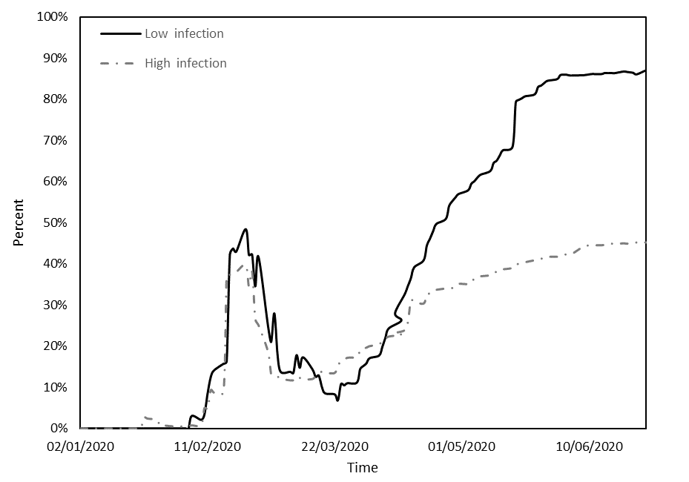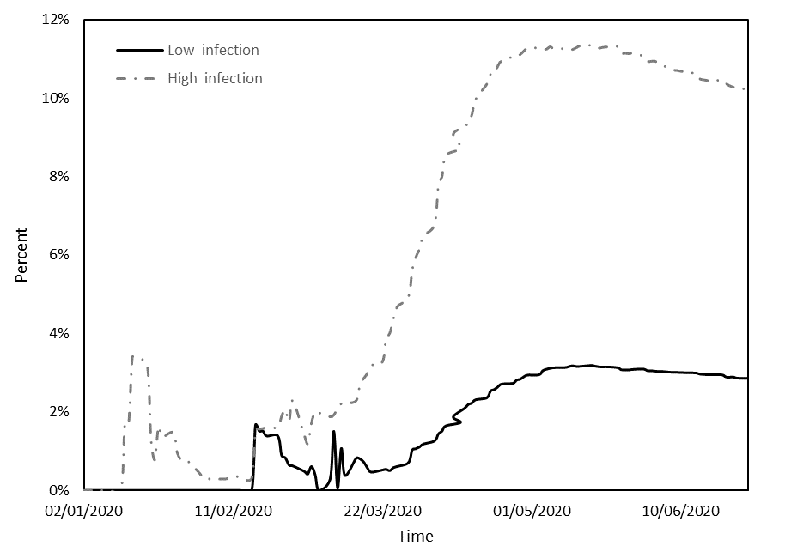

Figure 1.2. Performance of the *RPI* index.

Figure 1.1. Performance of the *DPI* index.

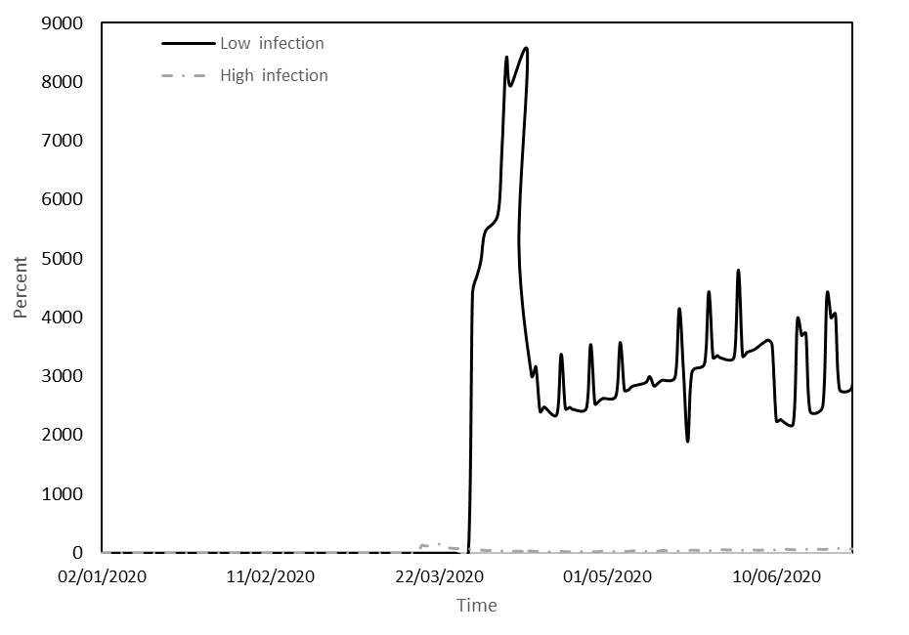

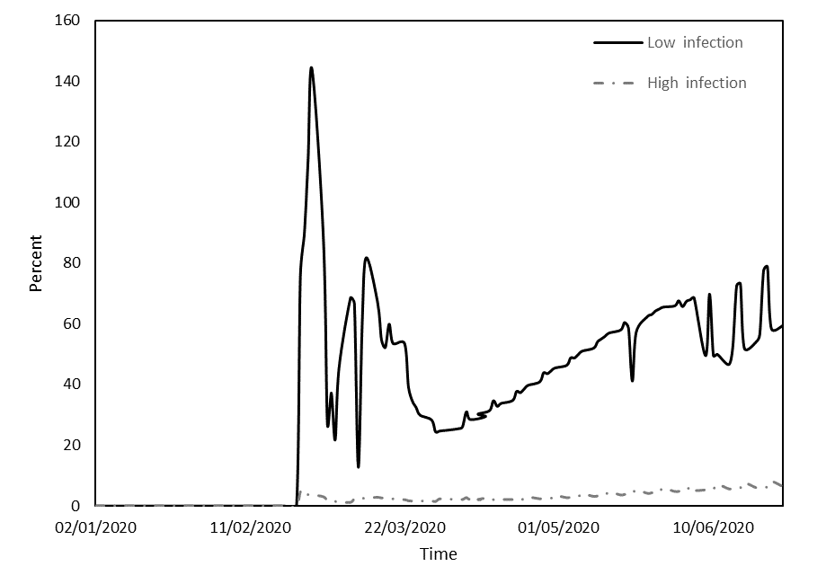

Figure 1.4. Performance of the *TPD* index.

Figure 1.3. Performance of the *TPI* index.

Note: Figures 1.1 to 1.4 illustrate the dynamics of key calculated metrics, namely deaths per infection ratio (DPI), recoveries per infection ratio (RPI), tests per infection ratio (TPI), and tests per death ratio (TPD), over the duration of the pandemic. The horizontal axis represents the timeline by date. Solid black lines represent countries with low infection rates, and dashed lines represent countries with high infection rates.

Figure 1.1 reveals three distinct phases within the study period. The initial phase extended until mid-March, and was followed by a second phase from mid-March to the end of April and a final phase from the beginning of May to the end of June. During the initial phase, both groups had relatively low DPI values but with Panel B countries experiencing notably higher values. This phase saw a significant surge in fatalities in Asian countries during January, coinciding with a substantial number of infections. This initial wave of fatalities gradually receded, leading to a decline in DPI that lasted until mid-March. In the second phase, a conspicuous disparity emerged between the groups: Panel B countries experienced an exponential escalation in DPI, whereas Panel A countries observed a more moderate increase. The third phase saw a decline in DPI for both groups, possibly due to the implementation of various restrictive measures by the respective countries.

Figure 1.2 illustrates that during the initial phase there was no discernible difference between the groups in terms of RPI, which underwent a pronounced increase until mid-February, followed by a decline (primarily impacting Asian countries). In the subsequent phases of transmission and containment, there was a substantial surge in RPI for countries with lower infection counts (Panel A), juxtaposed with a more modest increase for countries with higher infection counts (Panel B). This phenomenon may be attributed to the rapid surge in infections in the former group compared to the gradual increase in the latter.

Figure 1.3 compares the number of tests conducted and the number of infections (starting from February 24, when data on numbers of tests began to be documented). TPI displayed an upward trend in both cohorts, but with significantly higher values in Panel A countries compared to Panel B countries. A plausible rationale may be found in Table 3, where it is evident that although the number of tests in countries with higher infection counts increased somewhat more than in countries with lower infection counts, the sheer volume of infections in the former group led to a more substantial increase in TPI.

Figure 1.4 compares the number of tests conducted and the number of deaths (again, starting from February 24, when data on numbers of tests began to be documented). TPD displayed an upward trend in both cohorts, but with significantly higher values in Panel A countries compared to Panel B countries. A plausible rationale may be found in Table 3, where it is evident that, although the number of tests in countries with higher infection counts increased somewhat more than in countries with lower infection counts, the sheer volume of deaths in the former group led to a more substantial increase in TPD.

Figure 2: Changes in response metrics during the pandemic period

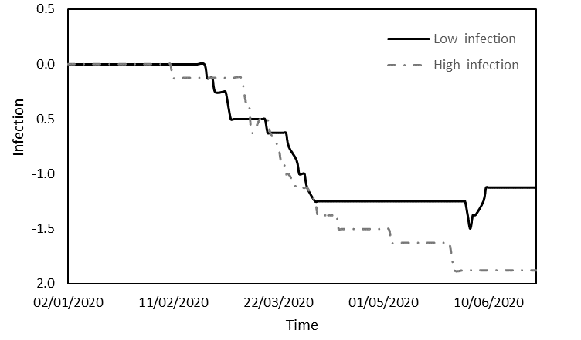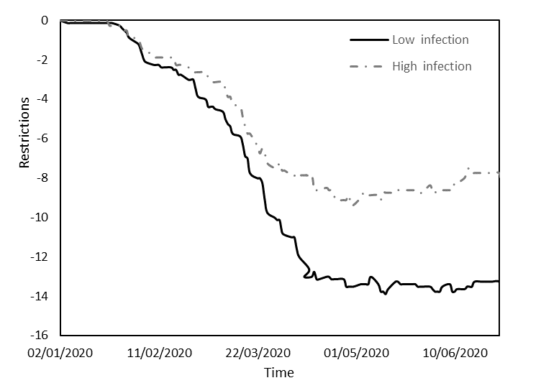

Figure 2.2. Changes in the *VIP* variable.

Figure 2.1. Changes in the *Restrictions* variable.

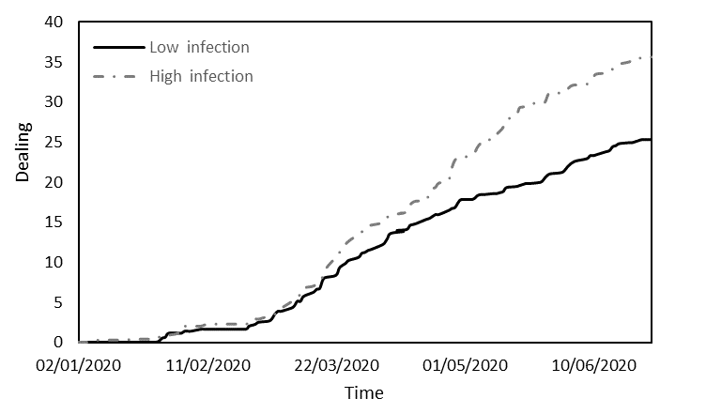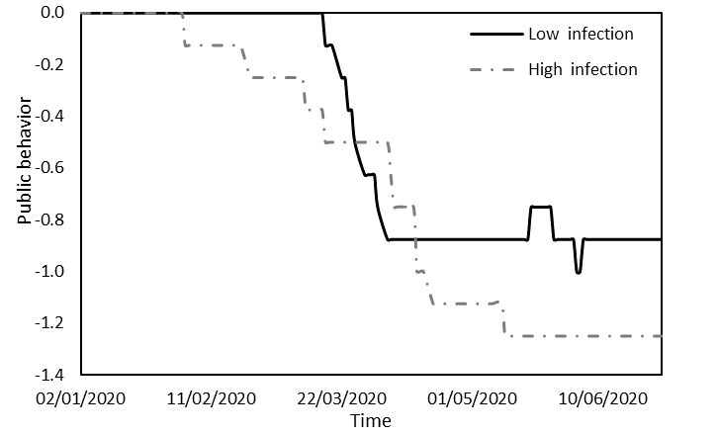

Figure 2.4. Changes in the *Dealing* variable.

Figure 2.3. Changes in the *Public behavior* variable.

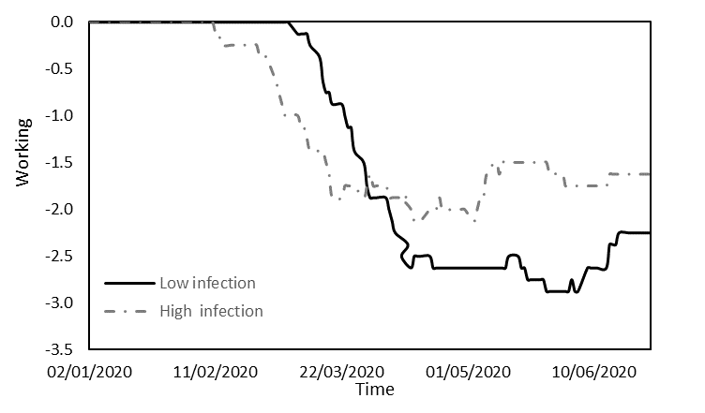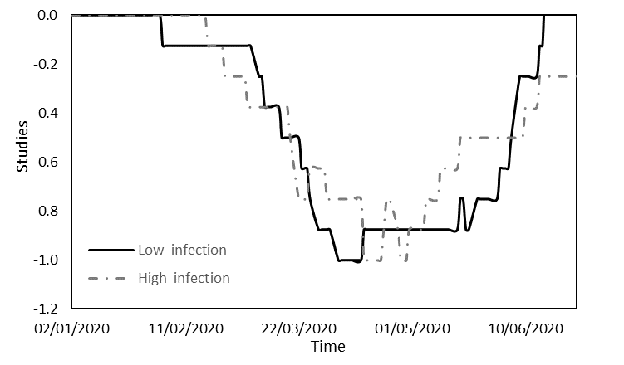

Figure 2.5. Changes in the *Education* variable.

Figure 2.6. Changes in the *Working* variable.

Note: Figures 2.1 to 2.6 present an analysis of six pandemic impact metrics in relation to restrictions, public behavior, VIP, dealing, education, and working arrangements over the course of the pandemic. The horizontal axis represents the timeline by date. Solid black lines represent countries with low infection rates, and dashed lines represent countries with high infection rates.

Figures 2.1 to 2.6 provide a comprehensive analysis of the distinct responses and behaviors exhibited by Panel A and Panel B countries during the period under study. Figure 2.1 offers insight into the average values of an index reflecting a spectrum of restrictions imposed: limitations on movement, lockdowns, quarantine measures, and constraints on incoming international tourists. Until early February, both groups of countries experienced minimal restrictions, resulting in negligible disparity. Subsequently, governments began implementing measures aimed at containing the virus. Panel A countries, with lower infection rates, enforced stringent restrictions, while Panel B countries, marked by higher infection rates, imposed milder restrictions, facilitating transmission of the virus. By mid-April, both groups had reached a state of equilibrium, as indicated by the horizontal lines on the chart.

Figure 2.2 focuses on the average infection levels among VIPs (leaders, health personnel, and security forces) in each group. In both groups of countries, infections were infrequent until mid-February but surged from mid-February to early April. From early April onward, countries with low infection counts reported minimal VIP infections; Panel B countries maintained a moderate, yet persistent trend. This discrepancy may be attributed to the stringent restrictions in countries with lower infection rates, which curbed transmission of the virus to VIPs.

Figure 2.3 shows variations in public responsiveness to government directives. Public behavior oscillated between initial compliance, a subsequent weakening of compliance, and a return to stricter adherence to directives. Extended periods of compliance corresponded to lower infection rates, with compliance eroding to a lesser extent in countries with low infection counts (from mid-March to early April) compared to their high-infection counterparts (from early February to mid-May). These findings, in conjunction with the observations in Figure 2.2, suggest that, in high-infection countries, responsibility for virus transmission can be attributed both to governments and to the general public.

Figure 2.4 focuses on active measures undertaken by countries to address COVID-19: economic interventions, vaccine development, experimental treatments, and enhanced testing availability for citizens. The trajectory is analogous in the two groups. Until the end of February, government involvement remained minimal in both groups. Subsequently, as the impact of the virus on public health and the economy became more apparent, governments initiated measures to assist their populations. These measures were more robust in countries with higher infection rates than in those with lower infection rates, likely due to the greater health and economic challenges faced by the former group.

Figure 2.5 describes the educational landscape, which was marked by similar levels of restrictions in both groups and characterized by four discernible phases. Initially, restrictions were virtually absent, with countries with lower infection counts leading slightly in terms of implementing restrictions. Subsequently, concerns about infections in educational settings prompted the gradual imposition of further restrictions. In the third phase, restrictions for both groups were at their height. In the final phase, governments began to ease these restrictions. Although the trends were comparable, countries with lower infection rates experienced a more extended period of maximum restrictions (from mid-April to the end of May) than their counterparts (from mid-April to the end of April), which likely contributed to their lower infection rates.

Figure 2.6 outlines the work environment, which is also characterized by similarities between the groups and can be divided into three phases. Initially, workplace restrictions were minimal. Subsequently, increasing concern about infection in the workplace prompted governments to introduce restrictions, with Panel B countries initiating these measures three weeks earlier. In the third phase, all countries reached the peak of their workplace restrictions. Countries with lower infection rates enforced more stringent restrictions than those with higher infection rates.

**The impact of model variables on index returns**

Through the application of ordinary least squares (OLS) regression, this section investigates the influence of pandemic impact metrics and government actions and policies on the performance of financial indices. Panel A in Table 4 shows the results of the regression analysis for countries characterized by a low incidence of infections, while Panel B present the results for countries marked by a high prevalence of infections.

Table 4. Regression estimates of key variables during the pandemic period

The regression models are as follows:

$AR_{FC,t}=α_{a}+\sum_{i=1}^{I}{β_{i}X_{a,t}^{i}}+\sum_{j=1}^{J}{γ_{j}C_{a,t}^{j}}+ε$ and $AR_{MC,t}=α_{a}+\sum_{i=1}^{I}{β_{i}X_{a,t}^{i}}+\sum_{j=1}^{J}{γ_{j}C_{a,t}^{j}}+ε$

In the models, *ARFC,t* denotes the mean return observed in countries with a minimal incidence of infections, while *ARMC,t* denotes the mean return in countries marked by a substantial prevalence of infections at a given time point *t*. Parameter *αa* is a constant term. Vector *Xi* encompasses the variables related to pandemic impact metrics representing infections, deaths, recoveries, and testing. Vector *Cj* encompasses the variables representing government actions and policies, namely restrictions, public behavior, VIPs, dealing strategies, education measures, and work-related policies.

|  |  |  |  |  |  |  |  |
| --- | --- | --- | --- | --- | --- | --- | --- |
|  | Panel A: Low infection | | |  | Panel B: High infection | | |
|  | R2 = 0.929, F = 168.731 | | |  | R2 = 0.896, F = 102.085 | | |
| Variable | Coefficient | Std. error | t-statistic |  | Coefficient | Std. error | t-statistic |
| C | 0.018*** | 0.006 | 2.924 |  | 0.029*** | 0.008 | 3.609 |
| Infections | -1.04E-05*** | 0.000 | -2.484 |  | 0.000 | 0.000 | -0.136 |
| Death | -2.06E-07*** | 0.000 | -3.438 |  | -1.02E-05*** | 0.000 | -3.125 |
| Recovered | 5.91E-05*** | 0.000 | 7.148 |  | 0.000 | 0.000 | 0.216 |
| Tests | 5.64E-07*** | 0.000 | 2.799 |  | 4.26E-08 | 0.000 | 1.067 |
| Restrictions | -0.023*** | 0.005 | -4.119 |  | -0.030*** | 0.012 | -2.582 |
| Public behavior | -0.434*** | 0.063 | -6.838 |  | -0.215*** | 0.076 | -2.816 |
| VIP | -0.081*** | 0.033 | -2.451 |  | -0.137*** | 0.048 | -2.878 |
| Dealing | 0.048*** | 0.004 | 10.789 |  | 0.032*** | 0.006 | 5.759 |
| Education | 0.073** | 0.038 | 1.927 |  | -0.075 | 0.055 | -1.371 |
| Working | 0.065*** | 0.025 | 2.649 |  | 0.144*** | 0.031 | 4.607 |

Note: In Table 4, Panels A and B show the regression results for countries categorized by low and high infection rates, respectively. The set of independent variables comprises pandemic impact metrics and pandemic response metrics. For each panel, the first column gives the regression coefficients, the second column the standard deviations, and the third column the associated t-statistics. Statistical significance is denoted by p-values, with asterisks ***, **, and * representing significance at the 1%, 5%, and 10% levels, respectively.

The results presented in Table 4 illuminate the impact of the COVID-19 pandemic on index returns in the two groups of countries, those with low infection rates and those with high infection rates. The results reveal that the pandemic-related variables exerted varying degrees of influence on index returns between the groups, thus providing insight into the nuanced dynamics at play. In countries with a low incidence of infections, all the variables under study exhibited statistically significant effects on stock returns. Notably, an increase in the numbers of deaths and infections correlated with a more pronounced decline in the country’s stock market, highlighting the market’s sensitivity to the health and economic risks posed by the pandemic. Conversely, a positive correlation was observed between stock returns and the numbers of recoveries and tests, which is indicative of investor optimism regarding potential recovery scenarios.

Implementation of new government restrictions and a lack of responsiveness from the public were correlated with declines in stock market performance. This relationship suggests that stringent measures and public non-compliance were perceived by the market as detrimental to economic activity, leading to negative market reactions. Conversely, proactive government measures, such as the easing of restrictions in workplaces and educational institutions, contributed to gains in stock market indices. This response may signify the market’s confidence in the potential economic recovery and stability associated with such policy adjustments. In contrast, an increase in the VIP variable, which captures levels of infection among key figures in the country, including political leaders, medical personnel, and security personnel, was associated with decreases in stock returns. This negative correlation can be attributed to concerns over the economic implications of infections within these critical sectors. Infections among key figures may increase uncertainty about the stability and effectiveness of leadership, public health, and security measures, potentially leading to market pessimism.

In countries characterized by a high prevalence of infections, the impact of these variables was comparatively subdued. Although the number of deaths did exhibit a negative effect on stock indices, the numbers of recoveries, infections, and tests did not yield statistically significant impacts. The absence of significant effects of these pandemic-related variables in high-infection countries suggests that the market had already integrated the prevailing pandemic conditions into its pricing, thereby reducing the immediate influence of these metrics on stock returns. The negative correlation between government restrictions and public behavior in high-infection countries and stock market performance suggests that the market perceived stringent measures as indicative of prolonged disruption and potential economic strain, and the unfavorable market response may reflect apprehension about the persistence of adverse conditions, given the high infection rates. Conversely, positive market reactions to the easing of workplace restrictions indicate that market participants saw such policy changes as potentially alleviating economic stress and opening up a path to recovery.

The disparities in the influence of pandemic-related variables and government actions between countries with low and high infection rates, respectively, can be attributed to a range of factors. In countries with low infection rates, the heightened sensitivity of stock markets to pandemic metrics such as deaths and infections may reflect market reactions to perceived health and economic risks, with optimism accompanying increases in recoveries and testing. In contrast, the muted market response in high-infection countries could be attributed to ongoing challenges, market adaptation to the persistent pandemic context, and investor skepticism regarding the effectiveness of stringent government measures. These differences underscore the complex interplay of pandemic-related factors and government actions, leading to divergent market responses based on the specific circumstances in each category of countries.

The results in this section support H1, indicating that pandemic impact metrics exhibit different effects on stock indices in countries with different infection rates. This is consistent with research by Tavor and Teitler-Regev [3], who have shown that the type and severity of events have varying impacts on financial markets, underlining the need to consider multiple metrics to understand the specific consequences of health crises. The results in the present study are also in line with the conclusion of Chopra and Mehta [5] that different crises, including the COVID-19 pandemic, have had varying degrees of impact on Asian stock markets, highlighting the non-uniform nature of market responses to such events. In countries with low infection rates, we observed heightened market sensitivity to the pandemic metrics of deaths and infections, optimism being associated with recoveries and testing. In contrast, the impact of these metrics in high-infection countries was subdued, likely because the market had already factored the effects of the pandemic into its pricing. These findings meet our study’s objective of investigating the impact of COVID-19 on capital markets in 16 countries categorized by infection rates. The divergent market responses underscore the importance of tailoring investment strategies and government policies to country categories. These results have significant implications for policymakers and investors facing the challenges of global health crises, and they provide guidance for navigating financial markets amid extreme uncertainty.

**Robustness checks**

The robustness checks conducted in this study used OLS regression analysis to examine the impact of the DPI, RPI, TPI, and TPD metrics on index returns. In Table 5, Panel A reports the regression results for countries characterized by a low number of infections, and Panel B reports the results for countries characterized by a high number of infections.

Table 5. Regression estimates for calculated metrics during the pandemic period

The regression models are as follows:

$AR_{FC,t}=α_{a}+\sum_{k=1}^{K}{δ_{i}Y_{a,t}^{k}}+ε$ and $AR_{MC,t}=α_{a}+\sum_{k=1}^{K}{δ_{i}Y_{a,t}^{k}}+ε$

Where, Yk represents the ratios: *DPI, RPI, TPI and TPD*.

|  |  |  |  |  |  |  |  |
| --- | --- | --- | --- | --- | --- | --- | --- |
|  | Panel A: Low infection | | |  | Panel B: High infection | | |
|  | R2 = 0.564, F = 47.693 | | |  | R2 = 0.553, F = 34.011 | | |
| Variable | Coefficient | Std. error | t-statistic |  | Coefficient | Std. error | t-statistic |
| C | -0.049*** | 0.013 | -3.769 |  | -0.051*** | 0.013 | -4.186 |
| DPI | -1.10E+01*** | 1.48E+00 | -7.432 |  | -1.652 | 1.307 | 1.264 |
| RPI | 0.635*** | 0.054 | 11.759 |  | 0.219*** | 0.098 | 2.237 |
| TPI | 2.08E-03*** | 0.000 | 8.501 |  | 0.005 | 0.006 | 0.768 |
| TPD | 1.39E-05*** | 0.000 | 3.371 |  | 0.002*** | 0.000 | 5.894 |

Note: In Table 5, Panels A and B show the regression outcomes for countries categorized by low and high infection rates, respectively. The independent variables are a specific set of calculated epidemiological metrics. Within each panel, the first column presents the regression coefficients, the second column the standard deviations, and the third column the associated t-statistics. Statistical significance is denoted by p-values, with asterisks ***, **, and * representing significance at the 1%, 5%, and 10% levels, respectively.

The results of the robustness analysis lend further support to the findings obtained in the standard tests, reaffirming the substantial influence of the COVID-19 pandemic on stock returns. As detailed in Table 5, even when the analysis uses ratio-based variables, a statistically significant effect of COVID-19 on stock returns is evident for both groups of countries. In countries with a low incidence of infections, a compelling association between the examined ratios and stock returns is discerned; specifically, an increase in the ratio of deaths to infections is linked to a corresponding decline in stock returns. Conversely, elevated ratios denoting numbers of RPI, TPI, and TPD are correlated with higher stock returns. For countries grappling with a high prevalence of infections, the impacts were less pronounced, with only two ratios demonstrating a positive and statistically significant effect on stock returns: increases in the ratio of RPI and in the ratio of TPD were associated with increased stock returns.

In summary, the robustness tests reinforce the conclusions drawn from the standard tests, underscoring the greater sensitivity of stock returns to the examined variables in countries with a low incidence of infections. This phenomenon may be attributed to the proactive policy measures implemented by governments in these countries during the early stages of the pandemic, with each policy adjustment leaving a discernible imprint on stock indices. In contrast, in countries marked by a high number of infections, government interventions transpired at a later juncture, by which time financial markets had already adapted to the ongoing circumstances, leading to a diminished responsiveness of stock indices to changes in the variables under scrutiny.

These findings confirm H2, which predicted varying effects of the calculated metrics on stock indices according to whether countries had low or high infection rates. They also echo insights from the literature review emphasizing the pivotal role that event characteristics and severity play in stock market responses, as noted by Tavor and Teitler-Regev [3] and Chopra and Mehta [5]. The DPI, RPI, TPI, and TPD metrics provide nuanced insights that go beyond basic infection, death, or recovery counts, and they align with the findings of Donadelli et al. [6] and Bai et al. [7] on the influence of information and data on investor attitudes and stock market responses. These metrics constitute vital information for investors when making decisions. The research of Schell et al. [8] highlights the need to consider diverse metrics due to variations in stock market responses to different pandemics. In summary, our results underscore the importance of incorporating metrics such as DPI, RPI, TPI, and TPD when assessing the impacts of a pandemic on financial markets. They carry significant implications for policymakers and investors, emphasizing the need to adapt strategies to the distinct dynamics of stock markets during health crises. These insights provide valuable guidance for navigating financial markets amidst extreme uncertainty.

# Discussion

The year 2020 will be remembered as a year dominated by the unprecedented COVID-19 pandemic. This global crisis has had profound and far-reaching implications, particularly on the world’s economies. Our study delves into the intricate interplay between COVID-19 and capital markets in 16 countries categorized by infection rates. This unique analysis yields a number of valuable insights.

In countries with low infection rates, we observed a heightened sensitivity of stock markets to pandemic metrics. Specifically, stock returns were significantly affected by the numbers of deaths and infections, highlighting the market’s vulnerability to health and economic risks. This sensitivity was mirrored by the positive correlation between stock returns and the numbers of recoveries and tests, signifying investor optimism regarding potential recovery scenarios. Our findings also emphasize the critical role of government actions and policies in influencing stock market performance. Proactive government measures, such as the easing of restrictions in workplaces and educational institutions, were associated with positive stock market responses. Conversely, stringent measures and public non-compliance were linked to negative market reactions, reflecting the market’s perception of these actions as detrimental to economic activity.

In countries with high infection rates, the impact of pandemic-related variables was notably subdued. Here, the stock market had likely already integrated the ongoing pandemic conditions into its pricing, thereby reducing the immediate influence of these metrics on stock returns. In high-infection countries, the negative correlation between government restrictions and public behavior, on the one hand, and stock market performance, on the other, suggested that the market perceived stringent measures as indicative of prolonged disruption and potential economic strain. Positive market reactions to the easing of workplace restrictions indicated that market participants viewed such policy changes as potentially alleviating economic stress and opening up a path to recovery.

Nevertheless, it is important to acknowledge certain limitations of our study. Many countries affected by COVID-19 were not included in our analysis. Furthermore, although our study used data reported by different countries, it should be noted that not every country reported complete data and that different countries used different measures, which may influence any comparisons. Nevertheless, the observed differences in the influence of pandemic-related variables and government actions between countries with low and high infection rates underscore the need for tailored and adaptable strategies in response to health crises. The unique circumstances in each category of countries reflect the complex interplay between pandemic-related factors and government actions and lead to divergent market responses.

**Conclusion and policy implications**

**Conclusion**

This study illuminates the notable and divergent effects of COVID-19 on financial markets. The pandemic significantly disrupted economies worldwide, and our investigation provides insights into how different infection rates and governmental reactions exerted different influences on stock markets. The heightened responsiveness identified in countries with lower infection rates emphasizes the need for timely and efficient health and economic interventions to mitigate disturbances and uphold market trust. Importantly, these findings offer a nuanced perspective on how governments and policymakers can better respond to similar crises in the future. Although the immediate actions and policies in high-infection countries may not have the same pronounced impact on stock markets, clear and effective communication remains paramount. The ability to maintain public confidence and foster public cooperation is essential in mitigating the economic impact of pandemics. The need for well-calibrated interventions that balance health measures and economic considerations is a critical takeaway for policymakers worldwide.

**Policy** **implications**

The policy implications of our study are both practical and actionable. Policymakers should consider the following three factors.

1. *Effective communication:* Effective and transparent communication is crucial. To ensure public understanding and to foster cooperation, policymakers should convey the rationale behind their measures. Public behavior plays a significant role in shaping market reactions, and clarity in communication can help maintain public confidence during health crises.
2. *Adaptive policy approaches:* Policymakers should adopt an adaptive approach to policy, recognizing that the impact of government actions and policies can vary based on the unique circumstances of each country. This flexibility is essential in responding to the evolving nature of health crises.
3. *Proactive government measures:* Proactive government measures, particularly those that support economic recovery, can have a positive impact on stock market performance. The easing of restrictions in workplaces and educational institutions, when done safely, can be viewed favorably by investors as a potential step toward stability and recovery.

In conclusion, our study provides a valuable framework for policymakers and market participants to better navigate the complex dynamics of health crises and their impact on capital markets, including practical guidelines for a more effective response to similar challenges in the future.

**References**

**[1]** Baker, S., N. Bloom, S. J. Davis, K. Kost, M. Sammon, and T. Viratyosin. 2020. The Unprecedented Stock Market Reaction to COVID-19. *Review of Asset Pricing Studies* 1(3). [doi:10.1093/rapstu/raaa008](https://doi.org/10.1093/rapstu/raaa008).

**[2]** Osterholm, M. T. (2020). Preparing for the next pandemic. In *The COVID-19 Reader* (pp. 11-20). Routledge.‏

**[3]** Tavor, T., and S. Teitler-Regev. 2019. The Impact of Disasters and Terrorism on the Stock Market. *Jàmbá: Journal of Disaster Risk Studies* 11(1): 1–8.‏

**[4]** Chen, M. H. 2011. The Response of Hotel Performance to International Tourism Development and Crisis Events. *International Journal of Hospitality Management* 30(1): 200–212.

**[5]** Chopra, M., & Mehta, C. (2022). Is the COVID-19 pandemic more contagious for the Asian stock markets? A comparison with the Asian financial, the US subprime and the Eurozone debt crisis. *Journal of Asian Economics*, *79*, 101450.

**[6]** Donadelli, M., R. Kizys, and M. Riedel. 2017. Dangerous Infectious Diseases: Bad News for Main Street, Good News for Wall Street? *Journal of Financial Markets* 35:84–103.‏

**[7]** Bai, L., Y. Wei, G. Wei, X. Li, and S. Zhang, S. 2020. Infectious Disease Pandemic and Permanent Volatility of International Stock Markets: A Long-Term Perspective. *Finance Research Letters*: 101709.‏ doi:[10.1016/j.frl.2020.101709](https://doi.org/10.1016/j.frl.2020.101709).

**[8]** Schell, D., Wang, M., & Huynh, T. L. D. (2020). This time is indeed different: A study on global market reactions to public health crisis. *Journal of behavioral and experimental finance*, *27*, 100349.‏

**[9]** Pendell, D. L., and C. Cho. 2013. Stock Market Reactions to Contagious Animal Disease Outbreaks: An Event Study in Korean Foot‐and‐Mouth Disease Outbreaks. *Agribusiness* 29(4): 455–468.‏

**[10]** Chen, M. H., S. S. Jang, and W. G. Kim. 2007. The Impact of the SARS Outbreak on Taiwanese Hotel Stock Performance: An Event-Study Approach. *International Journal of Hospitality Management* 26(1): 200–212.‏

**[11]** Ali, N., A. M. Nassir, T. Hassan, and S. Z. Abidin. 2010. Short Run Stock Overreaction: Evidence from Bursa Malaysia. *International Journal of Economics and Management* 4(2): 319–333.‏

**[12]**Nippani, S., and K. M. Washer. 2004. SARS: A Non-event for Affected Countries’ Stock Markets?” *Applied Financial Economics* 14(15): 1105–1110.

**[13]** Ichev, R., and M. Marinč. 2018. Stock Prices and Geographic Proximity of Information: Evidence from the Ebola Outbreak. *International Review of Financial Analysis* 56: 153–166.

**[14]** Hatmanu, M., & Cautisanu, C. (2021). The impact of COVID-19 pandemic on stock market: Evidence from Romania. *International Journal of Environmental Research and Public Health*, *18*(17), 9315.

**[15]** Liu, Z., Huynh, T. L. D., & Dai, P. F. (2021). The impact of COVID-19 on the stock market crash risk in China. *Research in international Business and Finance*, *57*, 101419.

**[16]** Tetteh, J. E., Amoah, A., Ofori-Boateng, K., & Hughes, G. (2022). Stock market response to COVID-19 pandemic: A comparative evidence from two emerging markets. *Scientific African*, *17*, e01300.

**[17]** Ganie, I. R., Wani, T. A., & Yadav, M. P. (2022). Impact of COVID-19 outbreak on the stock market: an evidence from select economies. *Business Perspectives and Research*, 22785337211073635.

**[18]** Ali, M., N. Alam, and S. A. R. Rizvi. 2020. Coronavirus (COVID-19): An Epidemic or Pandemic for Financial Markets. *Journal of Behavioral and Experimental Finance* 2020: 100341. doi:[10.1016/j.jbef.2020.100341](https://doi.org/10.1016/j.jbef.2020.100341).

**[19]** Singh, G., & Shaik, M. (2021). The short-term impact of COVID-19 on global stock market indices. *Contemporary Economics*, 1-18.

**[20]** Chowdhury, E. K., and M. Z. Abedin. (2020). COVID-19 Effects on the US Stock Index Returns: An Event Study Approach. *SSRN*. doi:10.2139/ssrn.3611683.

**[21]** Chowdhury, E. K., Dhar, B. K., & Stasi, A. (2022). Volatility of the US stock market and business strategy during COVID‐19. *Business Strategy & Development*, *5*(4), 350-360.

**[22]** Anh, D. L. T., & Gan, C. (2021). The impact of the COVID-19 lockdown on stock market performance: evidence from Vietnam. *Journal of Economic Studies*, *48*(4), 836-851.

**[23]** Chen, L., Li, T., Jia, F., & Schoenherr, T. (2023). The impact of governmental COVID‐19 measures on manufacturers' stock market valuations: The role of labor intensity and operational slack. *Journal of Operations Management*, *69*(3), 404-425.

**[24]** Sharif, A., Aloui, C., & Yarovaya, L. (2020). COVID-19 pandemic, oil prices, stock market, geopolitical risk and policy uncertainty nexus in the US economy: Fresh evidence from the wavelet-based approach. *International review of financial analysis*, *70*, 101496.

**[25]** Tanjung, A. A., Ruslan, D., Lubis, I., & Pratama, I. (2022). Stock Market Responses to Covid-19 Pandemic and Monetary Policy in Indonesia: Pre and Post Vaccine. *Cuadernos de Economía*, *45*(127), 120-129.

**[26]** Haroon, O., and S. A. R. Rizvi. (2020). COVID-19: Media Coverage and Financial Markets Behavior – A Sectoral Inquiry. *Journal of Behavioral and Experimental Finance* 27: 100343. doi:[10.1016/j.jbef.2020.100343](https://doi.org/10.1016/j.jbef.2020.100343).

**[27]** Teitler-Regev, S. & Tavor T. (2021) Behavior of financial markets during the COVID-19 crisis: a comparison of Israel and the rest of the world, Israel Affairs, 27:4, 691-710, DOI: 10.1080/13537121.2021.1940604.

# Data sources

administracion.gob.es. 2020. Retrieved from Nueva normalidad. Crisis sanitaria COVID-19: https://administracion.gob.es/pag_Home/atencionCiudadana/Nueva-normalidad-crisis-sanitaria.html#-bb7ad21ed1cf

Argentina.gob.ar. 2020. Retrieved from nuevo coronavirus COVID-19: https://www.argentina.gob.ar/salud/coronavirus-COVID-19

Bundeskanzleramt. 2020. Retrieved from Bundeskanzleramt - Bundesregierung: https://www.bundeskanzleramt.gv.at/bundeskanzleramt/die-bundesregierung.html

Bundesministerium für Gesundheit. 2020. Retrieved from Coronavirus: https://www.bundesgesundheitsministerium.de/coronavirus/chronik-coronavirus.htmlGouvernement.fr. 2020. Retrieved from Les actions du Gouvernement: https://www.gouvernement.fr/les-actions-du-gouvernement

Congress.gov. 2020. Retrieved from Current Legislative Activities: https://congress.gov/

Gov.il. 2020. Retrieved from News: https://www.gov.il/he/departments/news?limit=10

Gouvernement.fr.2020. Retrieved from Les actions du Gouvernement: https://www.gouvernement.fr/les-actions-du-gouvernement

gov.sg. 2020. Retrieved from Latest update: https://www.gov.sg/features/covid-19

GOV.UK. 2020. Retrieved from Coronavirus (COVID-19) - News and communications: https://www.gov.uk/search/news-and-communications?level_one_taxon=5b7b9532-a775-4bd2-a3aa-6ce380184b6c

Governo do Brasil. 2020. Retrieved from Legislação COVID-19: http://www.planalto.gov.br/CCIVIL_03/Portaria/quadro_portaria.htm

Governo Italiano. 2020. Retrieved from Coronavirus, le misure adottate dal Governo: http://www.governo.it/it/approfondimento/coronavirus/13968

HDX. 2020. Retrieved from Novel Coronavirus (COVID-19) Cases Data: https://data.humdata.org/dataset/novel-coronavirus-2019-ncov-cases

Investing.com. 2020. Retrieved from Investing.com: https://il.investing.com/indices/major-indices

Israel Ministry of Health. 2020. Retrieved from: https://govextra.gov.il/ministry-of-health/corona/corona-virus/?gclid=CjwKCAjw0_T4BRBlEiwAwoEiAaeH0-sYUL95P5WMn0ThqucoCRlSMvw662XArQJRI6OkaaZGK5ZlsRoCNLYQAvD_BwE

New Zealand Legislation. 2020. Retrieved from COVID-19 legislation: http://www.pco.govt.nz/covid-19-legislation/

Regeringen styr Sverige. 2020. Retrieved from Regeringsförklaringen: https://www.regeringen.se/tal/20192/09/regeringsforklaringen-den-10-september-2019/

Republike Slovenije. 2020. Retrieved from Vlada Republike Slovenije: https://www.gov.si/drzavni-organi/vlada/novice/

World Health Organization. 2020. Retrieved from WHO Coronavirus Disease (COVID-19) Dashboard: https://covid19.who.int/

中国政府. 2020. Retrieved from 中国政府: http://www.gov.cn/

台湾政府. 2020. Retrieved from 台湾政府: https://www.president.gov.tw/

|  |  |
| --- | --- |
| Use | Source |
| Spain | Aministracion.gob.es |
| Argentina | Argentina.gob.ar |
| Germany | Bundesministerium für Gesundheit |
| France | Gouvernement.fr |
| Israel | Gov.il |
| UK | GOV.UK |
| Italy | Governo Italiano |
| Brazil | Gov.br |
| Numbers of people who recovered | HDX |
| Stock index | Investing.com |
| Israel | Israel Ministry of Health |
| New Zealand | New Zealand Legislation |
| Singapore | New Zealand Legislation |
| Austria | Österreich |
| Sweden | Regeringen styr Sverige |
| US and VIX | U.S*.*gov |
| Slovenia | Vlada Republike Slovenije |
| COVID-19 data | World Health Organization |
| China | 中国政府 |
| Taiwan | 台湾政府 |

Appendix A. List of data sources.