**Inhibiting Pathological Calcium Phosphate Mineralization: Implications for Disease Progression**

Yarden Nahmias1, Gabriel Yazbek Grobman1, Netta Vidavsky1,2

1 Department of Chemical Engineering, Ben-Gurion University of the Negev, Beer Sheva

2 Ilse Katz Institute for Nanoscale Science & Technology, Ben-Gurion University of the Negev, Beer Sheva

Keywords: Biomineralization; Ductal carcinoma *in situ*; Cancer calcifications

**Abstract**

Pathological calcifications, especially calcium phosphate microcalcifications (MCs), appear in most early breast cancer lesions, and their formation correlates with more aggressive tumors and poorer prognosis. Hydroxyapatite (HA) is a key MC component that crystallizes in the tumor microenvironment. It is often associated with malignant breast cancer lesions and can trigger tumorigenesis *in vitro*. Here, we investigate the impact of additives on HA crystallization and inhibition, and how precancerous breast cells respond to minerals that are deposited in the presence of these additives. We show that non-stoichiometric HA spontaneously crystallizes in a solution simulating the tumor microenvironmental fluids and exhibits lump-like morphology similar to breast cancer MCs. In this system, the effectiveness of polyaspartic acid and polyacrylic acid (PAA) to inhibit HA is examined as a potential route to improve cancer prognosis. In the presence of additives, the formation of HA lumps is associated with the promotion or only minimal inhibition of mineralization, whereas the formation of amorphous calcium phosphate (ACP) lumps is followed by inhibition of mineralization. PAA emerges as a robust HA inhibitor by forming spherical ACP particles. When precancerous breast cells are exposed to various HA and ACP minerals, the most influential factors on cell proliferation are the mineral phase and whether the mineral is in the form of discrete particles or particle aggregates. The tumorigenic effects on cells, ranging from cytotoxicity and suppression of proliferation to triggering of proliferation, can be summarized as HA particles < HA aggregates < ACP particles < ACP aggregates. The cellular response to minerals can be attributed to a combination of factors, including mineral phase, crystallinity, morphology, surface texture, aggregation state, and surface potential. These findings have implications for understanding mineral-cell interactions within the tumor microenvironment and suggest that, in some cases, the byproducts of HA inhibition can contribute to disease progression more than HA itself.

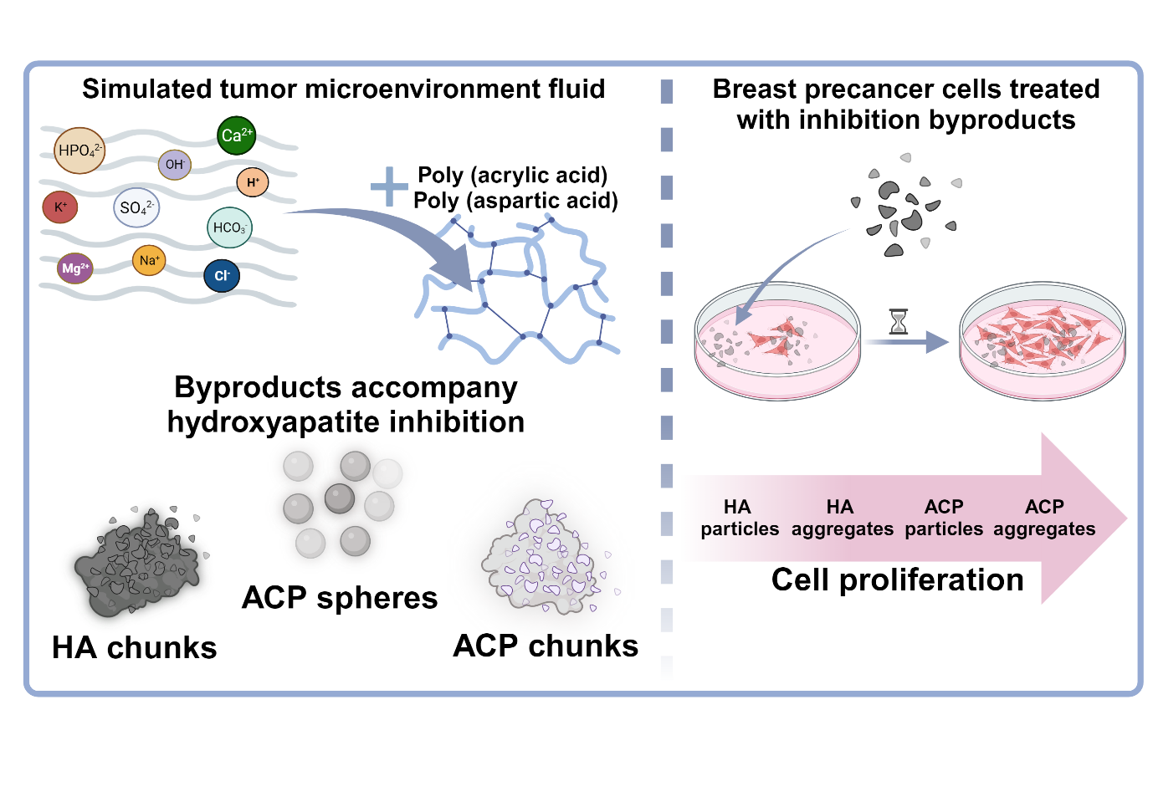

1. Introduction

Pathological calcifications have been linked to various health conditions such as renal and cardiovascular disorders, inflammation, and cancer[1–6]. In particular, in breast and thyroid cancers, microcalcifications (MCs) have been linked to increased malignancy and poorer prognosis[1,6–10]. These MCs primarily comprise calcium phosphate (CaP) minerals, mainly carbonated hydroxyapatite (HA)[11–13]. *In vitro* studies have demonstrated that breast cancer cells exposed to HA crystals exhibit enhanced malignancy behavior, suggesting a potential connection between inhibiting crystallization and suppressing the progression of precancerous conditions[14–16]. The crystallization of MCs typically occurs within the extracellular matrix (ECM), an environment in which the surrounding fluid, such as blood, is expected to be supersaturated with respect to HA[2,7,17,18]. Under normal physiological conditions, certain mineralization inhibitors found in ECM fluids play a pivotal role in inhibiting MC formation[19–21]. Developing a solution that mimics the properties of blood-like ECM fluid can provide a valuable platform for both investigating and controlling the crystallization of CaP in the tumor microenvironment. Simulated body fluids (SBFs) initially introduced by Kokubo have been extensively studied for biomimetic apatite formation and derived biomaterials[22–24]. SBFs are designed to mimic the physiochemical properties of blood serum, include inorganic ions, and maintain a pH of 7.4 at 37°C. Despite numerous studies evaluating the bioactivity of SBFs for bone-like apatite formation on various substrates or in seeded systems, the spontaneous crystallization of HA from SBFs remains poorly understood. Many studies have modified the solution composition, buffers, and overall conditions, leading to CaP minerals with different properties[25–28]. In the context of breast cancer, HA is found in both benign and malignant breast lesions, and higher crystallinity is associated with increased cancer invasiveness[29–31]. We hypothesize that inhibiting HA formation or promoting the formation of less crystalline CaP byproducts could potentially suppress or prevent the progression of breast precancer. Previous studies have explored the inhibition of HA using additives containing negatively charged functional groups, particularly carboxylic acids in a variety of aqueous solutions such as SBFs and effluent wastewater, but not in the context of cancer MC inhibition[32–35]. Polyamino acids such as polyglutamic acid and polyaspartic acid (PAsp) have significantly inhibited HA formation in such systems[36–38]. Additionally, synthetic polyamino acid mimics, such as polyacrylic acid (PAA), have demonstrated similar effects[34,39–41]. These additives mediate the formation of amorphous calcium phosphate (ACP), which can be a transient phase. Alterations in apatite composition often correlate with lesion malignancy; however, previous studies utilizing these additives focused on seeded HA growth systems or systems in which the solution composition was constant, but the pH varied[32–42]. Furthermore, these studies often lacked $HCO_{3}^{-}$ ions required for the biomimetic formation of carbonated apatite. Therefore, here we investigate the spontaneous crystallization of HA in commonly used SBFs[22,24,27], including conventional SBF (c-SBF) with lower $HCO_{3}^{-}$ content, revised SBF with the same ion composition as blood (r-SBF), and modified SBF (m-SBF) with moderate $HCO_{3}^{-}$ concentration. We modified these SBFs to facilitate the spontaneous formation of carbonated HA while maintaining physiological relevance. We explored the required conditions, preferred buffers, and properties of the precipitating phase over seven days. Following the development of the modified SBF in which HA spontaneously mineralizes, we utilized it to investigate HA inhibition using PAsp and PAA and characterized the mineral byproducts of HA inhibition. Ultimately, the byproducts resulting from effective HA inhibition were evaluated for their potential to promote or reduce tumorigenesis in precancerous human breast cells compared to HA which precipitates spontaneously without inhibition.

2. Results

2.1. Identifying an SBF solution in which HA crystallizes spontaneously

We examined the ability of commonly used SBFs to undergo spontaneous HA formation by modifying their composition. The time until visible precipitation, the type of mineral formed, and the initial and final pH values are summarized in Table 1. To ensure consistency, the SBFs were formulated with identical concentrations of $Na^{+}$, $Cl^{-}, K^{+}, Mg^{2+}, and SO_{4}^{2-}$. Only the concentrations of $Ca^{2+}, HPO_{4}^{2-}, and HCO_{3}^{-}$ were adjusted. Each SBF solution contained 41 mM of TRIS or HEPES buffer to maintain a constant pH similar to that of blood serum. A closed vessel system was employed during the reactions to minimize external influences. Notably, when an open beaker was used, the pH increased from 7.4 to 7.8-8.0 within a day due to gradual loss of $HCO_{3}$ resulting from the release of $CO_{2}$ from the solution.

**Buffer type.** The impact of TRIS and HEPES buffers on maintaining a physiological pH of 7.4 was assessed throughout the reaction. HEPES-based SBFs displayed a decrease in pH to 7.15, indicating an inability to sustain the desired pH during mineralization. Conversely, TRIS buffer maintained a constant pH of 7.4 for seven days.

**Composition.** Concentrations of $Ca^{2+}, HPO_{4}^{2-}, and HCO_{3}^{-}$ played a crucial role in the mineralization. The c-SBF, with the lowest $HCO_{3}^{-}$ concentration of 4.2 mM, showed no observable precipitation over the seven-day period. On the other hand, the r-SBF, characterized by the same $Ca^{2+}$ and $HPO_{4}^{2-}$ concentrations as the c-SBF (2.5 and 1.0 mM, respectively), but a higher $HCO_{3}^{-}$ concentration (27.0 mM), like that of blood serum, exhibited instantaneous cloudiness, indicating precipitation. Fourier transform infrared spectroscopy (FTIR) analysis confirmed the presence of calcium carbonate as the precipitating phase in the r-SBF (Table 1). Further modification of the r-SBF, designated as r'-SBF, involved increasing the concentrations of $Ca^{2+}$ (5 mM) and $HPO_{4}^{2-}$ (3 mM) to enhance the supersaturation of HA. However, even in this modified SBF, calcium carbonate precipitated instead of HA. When the $HCO_{3}^{-}$ concentration was set at the calcite saturation level (10 mM in m-SBF), no precipitation occurred. Applying the same modifications as in the r'-SBF led to the spontaneous formation of HA in the y-SBF. The y-SBF overcame the limitations of conventional SBFs, in which the precipitate is calcium carbonate or no precipitate. It included the appropriate buffer system to ensure a stable physiological pH over time. Additionally, MC analogs precipitating from y‑SBF incorporated higher fractions of $HCO_{3}^{-} , Mg^{2+}, Na^{+} and Cl^{-}$ ions (Figure S1), essential for the biomimetic formation of carbonated apatite. This modification allowed for the spontaneous formation of HA without seeding, making y-SBF an ideal model to study HA formation and inhibition, mimicking the extracellular fluids in the tumor microenvironment.

|  |  |  |  |  |  |  |  |  |  |
| --- | --- | --- | --- | --- | --- | --- | --- | --- | --- |
|  | **Blood serum** | **DIW** | **NaCl** | **c-SBF** | **r-SBF** | **r'-SBF** | **m-SBF** | | **y-SBF** |
| $$Ca^{2+}$$ | 2.5 | 2.5 | 2.5 | 2.5 | 2.5 | 5.0 | 2.5 | | 5.0 |
| $$HPO_{4}^{2-}$$ | 1.0 | 1.5 | 1.5 | 1.0 | 1.0 | 3.0 | 1.0 | | 3.0 |
| $$HCO_{3}^{-}$$ | 27.0 | - | - | 4.2 | 27.0 | 27.0 | 10.0 | | 10.0 |
| $$Na^{+}$$ | 142 | - | 150 | 142 | 142 | 142 | 142 | | 142 |
| $${Cl}^{-}$$ | 103 | - | 150 | 103 | 103 | 103 | 103 | | 103 |
| $$K^{+}$$ | 5 | - | - | 5 | 5 | 5 | 5 | | 5 |
| $$Mg^{2+}$$ | 1.5 | - | - | 1.5 | 1.5 | 1.5 | 1.5 | | 1.5 |
| $$SO_{4}^{2-}$$ | 0.5 | - | - | 0.5 | 0.5 | 0.5 | 0.5 | | 0.5 |
| **Ca/P** | 2.5 | 1.67 | 1.67 | 2.5 | 2.5 | 1.67 | 2.5 | | 1.67 |
| **Buffer** | - | - | - | TRIS | HEPES | HEPES | TRIS | TRIS | |
| **Initial pH** | - | 7.4 | 7.4 | - | 7.4 | 7.4 | 7.4 | 7.4 | |
| **Final pH** |  | 5.9 | 5.9 | 7.4 | 7.1 | 7.1 | 7.4 | 7.4 | |
| **Ionic strength** | 150 | 10 | 155 | 157 | 172 | 177 | 167 | 165 | |
| **SI (HA)** | 9.6 | 12.9 | 10.3 | 9.7 | 9.5 | 12.3 | 10.0 | 12.4 | |
| **SI (calcite)** | 0.8 | - | - | -0.03 | 0.8 | 1.1 | 0.4 | 0.6 | |
| **Instantly** | - | - | - | - | - | $$Calcite$$ | - | ACP | |
| **Day 1** | - | HA | - | - | $$Calcite$$ | $$Calcite$$ | - | HA | |
| **Day 3** | - | HA | - | - | $$Calcite$$ | $$Calcite$$ | - | HA | |
| **Day 7** | - | HA | HA | - | $$Calcite$$ | $$Calcite$$ | - | HA | |

**Table 1.** Compositional comparison of human blood serum and the SBFs used in this study to induce spontaneous HA crystallization. The ion concentrations (mM), buffer types (41 mM), pH maintenance during the reaction, calculated ionic strengths (mM), and supersaturations for HA and calcite are shown. The precipitating phase was characterized by FTIR instantly and after 1, 3, and 7 days. DIW = Deionized water, SI = Saturation index.

2.2. Crystal properties of the minerals precipitating in y-SBF

The crystals formed in the y-SBF were analyzed to determine their phase, morphology, and elemental composition. On day 1, the minerals exhibited irregular shapes resembling “chunks” without well-defined crystal facets and composed of aggregates of sub-micrometer particles (Figure 1A). Similar lumps were observed on days 3 and 7. The FTIR spectra showed characteristic peaks of carbonated apatite, specifically the $v_{4} PO_{4}^{3-}$ (563, 604 $cm^{-1}$), $v_{3} PO_{4}^{3-}$ (1040, 1109 $cm^{-1}$), $v_{1} PO_{4}^{2-}$ (957 $cm^{-1}$), and $v_{2} CO_{3}^{2-}$ (878 $cm^{-1}$) peaks (Figure 1B). Furthermore, energy-dispersive X-ray spectroscopy (EDS) analysis was employed to determine the elemental composition of the minerals. The Ca/P ratio demonstrated transition from a calcium-deficient apatite on the first day (Ca/P=1.5) to a more stoichiometric apatite on the seventh day (Ca/P=1.7) (Figure 1A, Figure S1A). The minerals contained trace amounts of other elements, such as Mg, Na, and Cl. As the carbonated apatite that spontaneously precipitated from y-SBF was similar in crystal phase, composition, and morphology to the mineral observed in pathological breast cancer calcifications, we moved forward to inhibiting its formation.

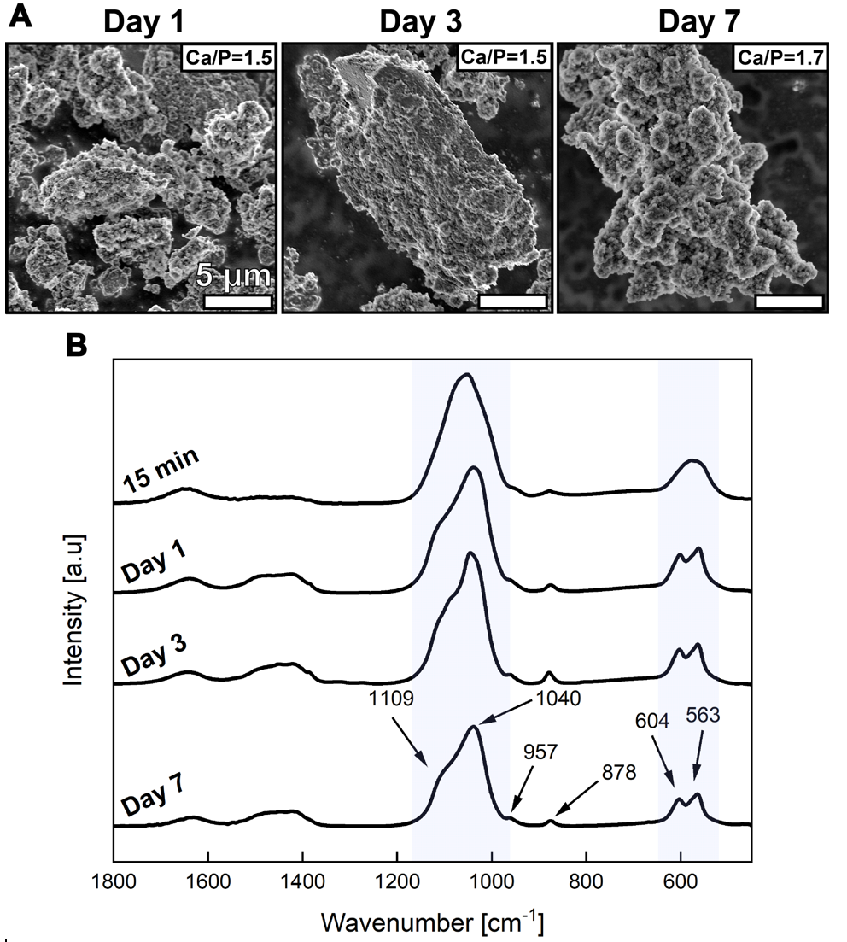

**Figure 1.** Characterization of the minerals spontaneously precipitating from y-SBF according to the reaction time. **A.** SEM imaging and SEM-EDS analysis after 15 minutes and on days 1, 3, and 7 of crystallization. **B.** FTIR spectra of the minerals.

2.3. Mineralization in y-SBF in the presence of additives

The mineralization process in the y-SBF solution was assessed by light microscopy imaging over time (Figure 2). In the absence of additives (control), HA crystals formed lumps. In the presence of PAsp, small particles were observed after 15 minutes, and their quantity increased with longer crystallization times, irrespective of the PAsp concentration. When 8K PAA was present, the lower additive concentration ($100 µg mL^{-1}$) led to faster crystallization compared to the higher concentration ($200 µg mL^{-1}$). At $100 µg {mL}^{-1}$**,** after 15 minutes, the minerals appeared as a cloudy layer covering most of the available surface, with a few denser, dark particles. However, at a concentration of $200 µg mL^{-1}$, only a few particles were formed. Within the first day at $100 µg mL^{-1}$, the cloudy layer transitioned into minerals with a more defined shape, while at $200 µg mL^{-1}$, the cloudy appearance persisted. This suggested that the minerals formed on the first day with $200 µg mL^{-1}$ 8K PAA may be similar to those observed after 15 minutes of mineralization with $100 µg mL^{-1}$. In the presence of higher molecular weight PAA (100K), the initial precipitates exhibited spherical morphology at both additive concentrations. After one day, these spheres either transformed into minerals such as those formed in the control ($100 µg mL^{-1}$) or remained stable throughout the entire seven-day period at $200 µg mL^{-1}$. These spherical particles rarely aggregated in the SBF.

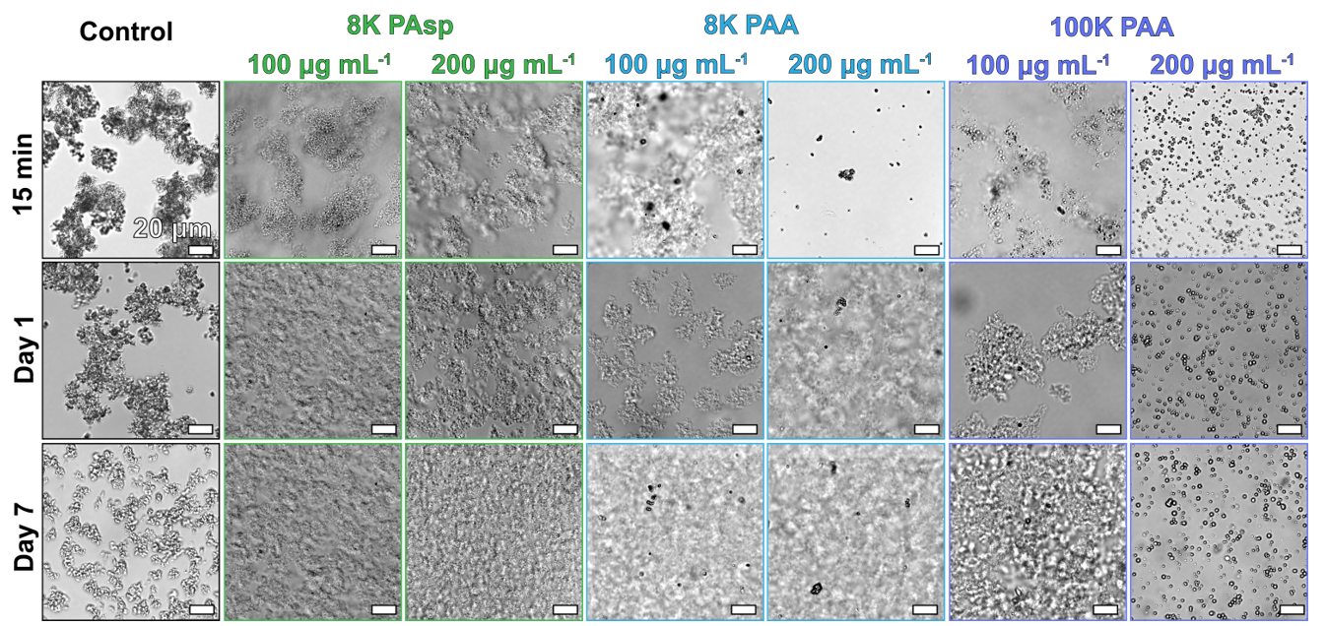

**Figure 2.** Light microscopy imaging of the mineralization from y-SBF of the control (no additives) and in the presence of $100 µg mL^{-1}$ or $200 µg mL^{-1}$ additives (8K Pasp, 8K PAA and 100K PAA).

2.4. Crystal properties of the minerals precipitating in y-SBF in the presence of additives

The minerals formed in the y-SBF in the presence of additives were characterized by their crystal properties. In the presence of $100 µg mL^{-1}$ additive, FTIR analysis showed that the minerals consisted of carbonated apatite on all days for all additives (Figure 3A, C). However, in the presence of 8K PAsp, on the first day of crystallization, FTIR results showed poorly defined peaks for $PO_{4}^{3-} v_{3}$ and $v_{4}$, which were replaced with wide bands characteristic of ACP. This transient ACP transformed to HA by day 3 and was not detected under the other conditions (Figure 3C). SEM imaging demonstrated heterogeneous mineral sizes ranging from a few to tens of micrometers (Figure 3A). The minerals had rough surfaces and were composed of sub-micrometer particles with a lumpy morphology, and a Ca/P ratio ranging from 1.4 to 1.7. Overall, an additive concentration of $100 µg mL^{-1}$ did not significantly affect the resulting minerals compared to carbonated HA formed without additives, prompting an increase in the additive concentration to $200 µg mL^{-1}$ (Figure 3B, D).

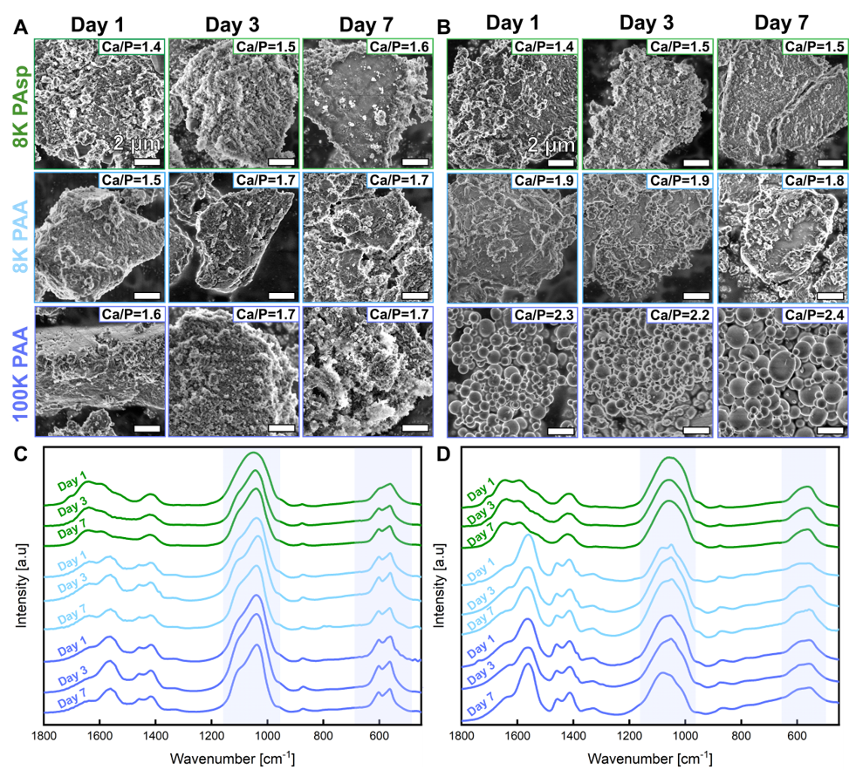

**Figure 3.** Characterization of the precipitating minerals from y-SBF in the presence of 8K PAsp, 8K PAA, and 100K PAA on days 1, 3, and 7 of crystallization. **A.** SEM imaging and SEM-EDS analysis in the presence of $100 µg mL^{-1}$ additive. **B.** SEM imaging and SEM-EDS in the presence of $200 µg mL^{-1}$ additive. **C.** FTIR spectra of the minerals ( $100 µg mL^{-1}$ additive). **D.** FTIR spectra of the minerals ( $200 µg mL^{-1}$ additive).

While the mineral morphology and Ca/P ratio of ACP formed in the presence of $200 µg mL^{-1}$ PAsp resembled the carbonated HA formed at the lower additive concentration, ACP formed in the presence of PAA was notably different (Figure 3B). ACP formed with 8K PAA (low molecular weight) exhibited a relatively higher Ca/P ratio of 1.8-1.9 compared to 1.4-1.7. Additionally, these minerals had a similar lumpy morphology but possessed smoother surfaces. In the presence of 100K PAA (high molecular weight), the minerals were small (<2 µm) spherical ACP particles with a high Ca/P ratio (2.2-2.4). The minerals formed at an additive concentration of were no longer carbonated apatite. They exhibited poorly defined peaks for $PO_{4}^{3-}$ $v_{3}$ and $v_{4}$ (Figure 3D), which were replaced with wide bands indicating the presence of ACP, similar to the minerals formed in the presence of $100 µg mL^{-1}$ PAsp on day 1. However, the ACP phase remained stable throughout all seven days at this additive concentration.

**2.5. Mineralization inhibition in y-SBF in the presence of additives**

The inhibitory effect of each additive on HA mineralization was quantitatively determined by measuring the weight of the precipitate normalized to the weight of the control (Figure 4). PAsp either promoted or inhibited mineralization, depending on its concentration. A lower concentration ($100 µg mL^{-1}$) promoted HA formation, with more than twice the amount precipitated compared to the control. However, at a PAsp concentration of $200 µg mL^{-1}$, the observed mineralization was 60% of the control mineralization. Similarly, $200 µg mL^{-1}$ of 8K PAA showed a comparable effect with 63% mineralization, while the $100 µg mL^{-1}$ had a minimal inhibitory effect on mineralization, and the highest inhibitory effect, with only 13% mineralization, was observed at a concentration of. Considering the HA inhibition percentage and the related mineral phase and morphology, the formation of HA lumps was associated with either the promotion, deposition, or minimal inhibition of mineralization, particularly at low additive concentrations. In contrast, the formation of ACP lumps was followed by inhibition of mineralization. Lastly, the most significant inhibition of mineralization was observed when spherical ACP particles were formed rather than HA or ACP lumps, as seen in the presence of other additives.

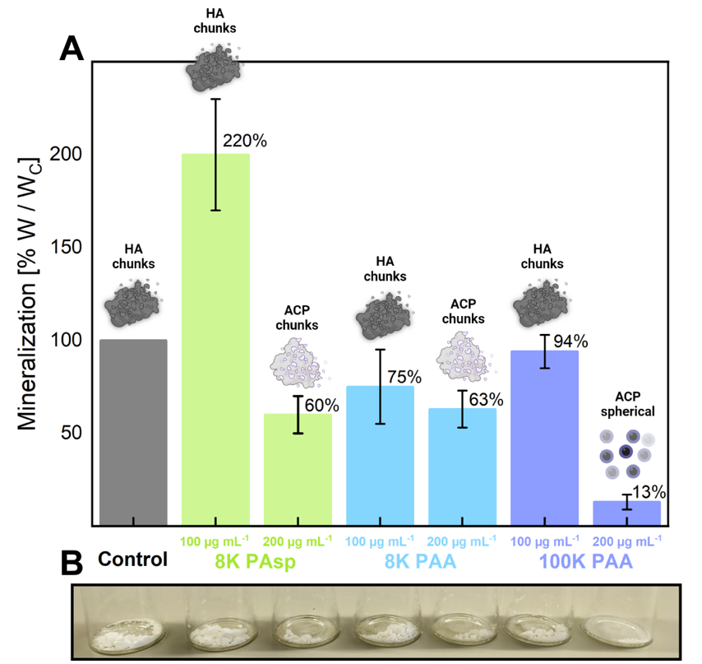

**Figure 4.** Inhibition of mineralization by additives after seven days of reaction. **A.** The mineralization percentage as determined by the precipitant weight divided by the final control weight for each additive. The corresponding phase and morphology of the precipitated minerals are shown as illustrations. **B.** Visual illustration of the resulting mineral yields for each additive.

**2.6. Mineralization kinetics in y-SBF in the presence of additives**

For sections 2.3-2.5, the $Ca^{2+}$-containing SBF was pre-mixed with the additive, followed by the addition of the $HPO_{4}^{-}$-containing SBF to initiate mineralization. However, the process of mineralization in the ECM remains unclear, and it could potentially occur through various mechanisms wherein an elevation of either $Ca^{2+}$ or $HPO_{4}^{-}$ concentration might initiate crystallization. Therefore, an additional procedure was employed in which the additive was pre-mixed with $HPO_{4}^{-}$ to further establish its inhibitory capacity. The mineralization in the y‑SBF solution, along with the additives, was monitored utilizing a Ca2+ ion selective electrode employing two different procedures. The additives were either pre-mixed with Ca2+ (Ca+Add procedure, Figure 5A, B) or with $HPO_{4}^{2-}$ (P+Add procedure, Figure 5C, D). The Ca2+ curves can be divided into four stages: the initial state before the addition of $HPO_{4}^{2-}$ (I) and the $HPO_{4}^{2-}$ addition period (II), followed by concentration drops due to volume increase during $HPO_{4}^{2-}$ addition, mineralization, and additive- $Ca^{2+}$ complexation (III, IV). In the Ca+Add procedure, the initial stages of the reaction (I, II, and III) exhibited similar behavior in the presence of both 8K and 100K PAA at both concentrations. However, in the mineralization stage (IV), a distinct difference in Ca2+ concentration was observed between the reaction in the presence of $200 µg mL^{-1}$ 100 PAA and the other additives (Figure 5B). At a concentration of , the Ca2+ concentration decreased more slowly and stabilized at around 40% of its initial value after approximately 200 seconds. Considering that the Ca2+ concentration should be 50% of its initial value after mixing equal volumes of solutions, the additional decrease can be attributed to mineralization, as observed by light microscopy (Figure 2, $200 µg mL^{-1}$ 100K PAA). A more significant drop in free Ca2+ concentration was observed in the control and in the presence of 100 and $200 µg mL^{-1}$ of 8K PAA and $100 µg mL^{-1}$ 100K PAA, which exhibited similar behavior. With these additives and concentrations, immediate mineralization occurred, forming large HA or ACP lumps (Figure 3A). The small decrease in free Ca2+ concentration at $200 µg mL^{-1}$ of 100K PAA was only observed when spherical ACP particles were formed, which coincided with the lowest mineralization yield (Figure 4).

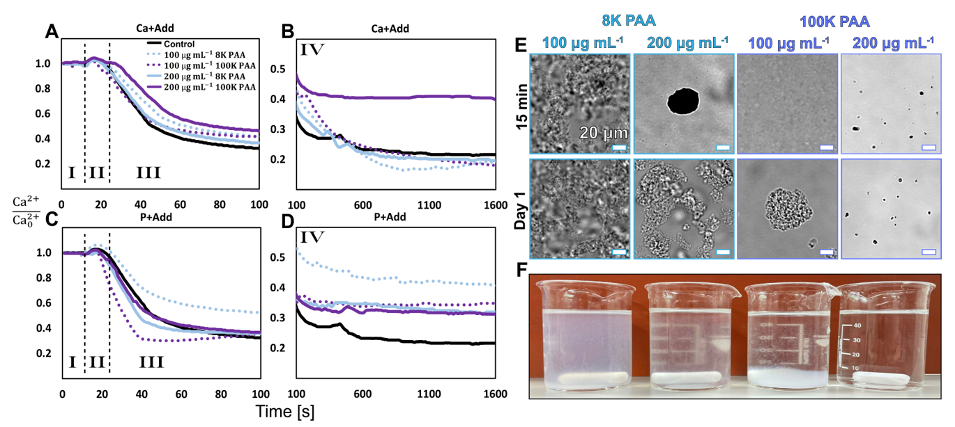

**Figure 5.** Ca2+ Ion selective electrode measurements and light microscopy imaging during mineralization with and without additives. Additives were either pre-mixed with Ca2+ (**A, B**) or with $HPO_{4}^{2-}$ (**C-F**). **A-D:** Ion selective electrode measurements show several stages: I: the initial state before the addition of $HPO_{4}^{2-}$; II: the controlled addition period; III, IV: volume increase during $HPO_{4}^{2-}$ addition and mineralization. Ca2+ concentrations are normalized by the initial concentration. **E.** Light microscopy imaging of the minerals after 15 minutes and one day in the $HPO_{4}^{2-}$ + Additive procedure. **F.** The corresponding suspensions on day 1 of mineralization.

In the P+Add procedure, the initial stages of the reaction (I, II) were similar for all conditions, with a slight difference in the Ca2+ drop at stage III. However, stage IV showed a different trend than the former procedure. In the presence of 100 and $200 µg mL^{-1}$ 100K PAA and $200 µg mL^{-1}$ 8K PAA, there was a slightly slower drop than the control, which stabilized after approximately 600 seconds (IV). The smallest drop was observed for $100 µg {mL}^{-1}$ 8K PAA. The greatest drop was accompanied by the formation of the "cloudy" minerals (Figure 5E), which was also observed in the Ca+Add procedure for this additive and concentration. This was also the only case in which the solution became turbid after 15 minutes of reaction, compared to the Ca+Add procedure, in which all solutions became turbid almost immediately. In the presence of 100 and $200 µg mL^{-1}$ 100K PAA and $200 µg mL^{-1}$ 8K PAA, a slightly larger free Ca2+ drop was observed, and almost no minerals formed after 15 minutes. After one day, ACP lumps and spherical HA lumps formed in the presence of $200 µg mL^{-1}$ 8K PAA and $100 µg mL^{-1}$ 100K PAA, respectively (Figure 5E and Figure S2B). However, in the presence of $200 µg mL^{-1}$ 100K PAA, no change was observed after one day compared to after 15 minutes, at which time small particles formed. In addition, only the solution for this additive and concentration was clear after a day, and no minerals precipitated (Figure 5F), indicating that complete mineralization inhibition was achieved.

**2.7. Proliferation of DCIS cells treated with different MC analogs**

Inhibiting HA can yield diverse mineral byproducts, both stable and transient, with distinct characteristics. When assessing HA inhibition as a strategy to improve cancer prognosis, it is crucial to account for the biocompatibility of the inhibitor, to establish its non-cytotoxic nature. Indeed, the additives used in this study are not cytotoxic to precancerous breast cells (Figure S4). Furthermore, the cellular response to the mineral byproducts of the HA inhibition, which are prone to accumulation within the tumor microenvironment, should also be evaluated. Consequently, we examined the cellular response of precancerous breast cells to potential byproducts. Based on their distinguishing properties, six distinct minerals were selected as MC analogs for *in vitro* investigation. For both HA and ACP, two morphologies were characterized: "lumps" and "spheres". In addition to the previously identified byproducts of HA inhibition, lumpy (C-ACP) and spherical (S-ACP) ACP, we investigated several other minerals. Lumpy HA after calcination (Cal-HA) was examined due to its smoother surface compared to lumpy HA (C-HA). HA with spherical morphology (S-HA) served to assess the impact of the crystal phase (HA versus ACP) in a spherical form. Mixed ACP (M-ACP) are spherical ACP particles of heterogeneous size obtained when employing a mixture of $100 µg mL^{-1}$ 8K PAA and $100 µg mL^{-1}$ 100K PAA for HA inhibition. This additive combination exhibited a comparable inhibition efficacy to that of $200 µg mL^{-1}$ 100K PAA, and the resulting spherical ACP particles may provide insight into the influence of sphere size on cellular response and the alterations that may arise from employing a blend of PAAs as the inhibitor. These minerals differed in phase, morphology, particle size, topology, and zeta potential (Figure 6A, Table S1). The zeta potential was measured for all MC analogs (Figure 6B). Notably, all MC analogs exhibited a negatively charged zeta potential, except for the commercial spherical nanocrystalline HA (S-HA). ACPs exhibited a more negative zeta potential, indicating greater colloid stability.

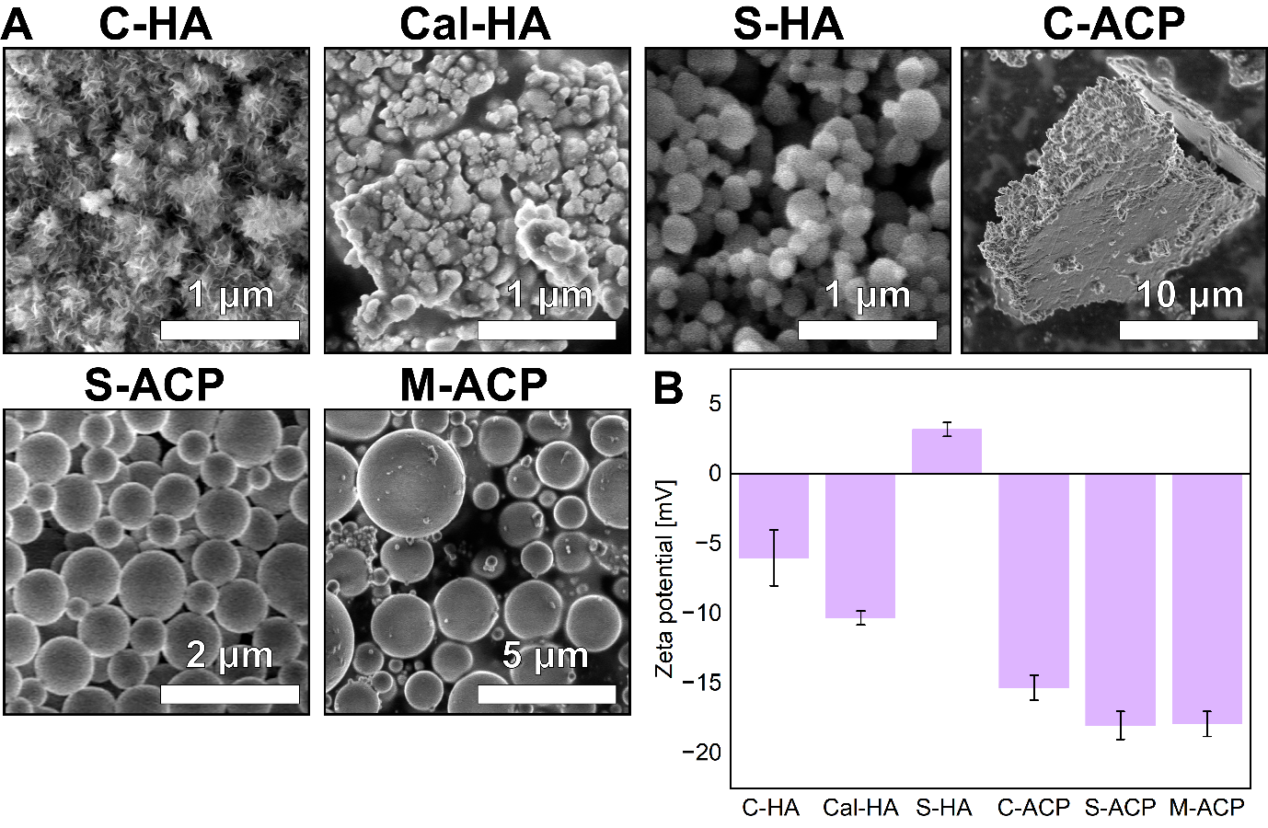

**Figure 6.** Characterization of the MC analogs. **A.** SEM imaging. **B.** Zeta potential measured in SBF. C-HA = hydroxyapatite with lump-like morphology from y-SBF (no additives, control), Cal-HA = HA after calcination at 900 $℃$ for 8 hours. All ACPs were the amorphous byproducts of HA inhibition using 8K PAA, 100K PAA, and 8K/100K PAA mixture, respectively (**Figure S3** and **Table S1**). S-HA = Commercial spherical nanocrystalline HA, C-ACP = ACP with lump-like morphology, S-ACP = Sperical ACP, M-ACP = Spherical ACP of heterogeneous size.

Various MC analogs exhibit distinct particle sizes, which can affect the cellular response when exposed to them. Additionally, it is crucial to consider the influence of particle aggregation since MCs are rarely encountered in the cancer microenvironment as isolated particles. We evaluated the impact of MC analogs on MCF10DCIS.com precancerous breast cells. Cell proliferation was analyzed, taking into account both aggregated and non-aggregated scenarios (Figure 7A, B). Following the drying process, MCs tended to aggregate strongly and could subsequently be ground into fine powders. These fine powders could further disintegrate into individual particles when subjected to ultrasonication. This approach provided a platform to assess how size and agglomeration influence the cellular response in cancer. S-HA, S-ACP, and M-ACP aggregates were the largest (Figure 7A). Comparison of DCIS cell proliferation in the presence of MC analogs to that in their absence (control) was assessed using crystal violet (CV) assay by normalizing the absorbance values to the control (Figure 7B). In the case of DCIS cells exposed to MC analogs as particles, C-HA and Cal-HA resulted in 25% or lower cell proliferation compared to the control (Figure 7C, E). Notably, this effect was slightly more pronounced for these analogs in their aggregated form (Figure 7D, E). Conversely, S-HA demonstrated a relatively modest impact on cell proliferation in both non-aggregated and aggregated states, while C-ACPs exhibited no discernible effect when presented as particles. In their aggregated forms, all ACPs promoted cell proliferation.

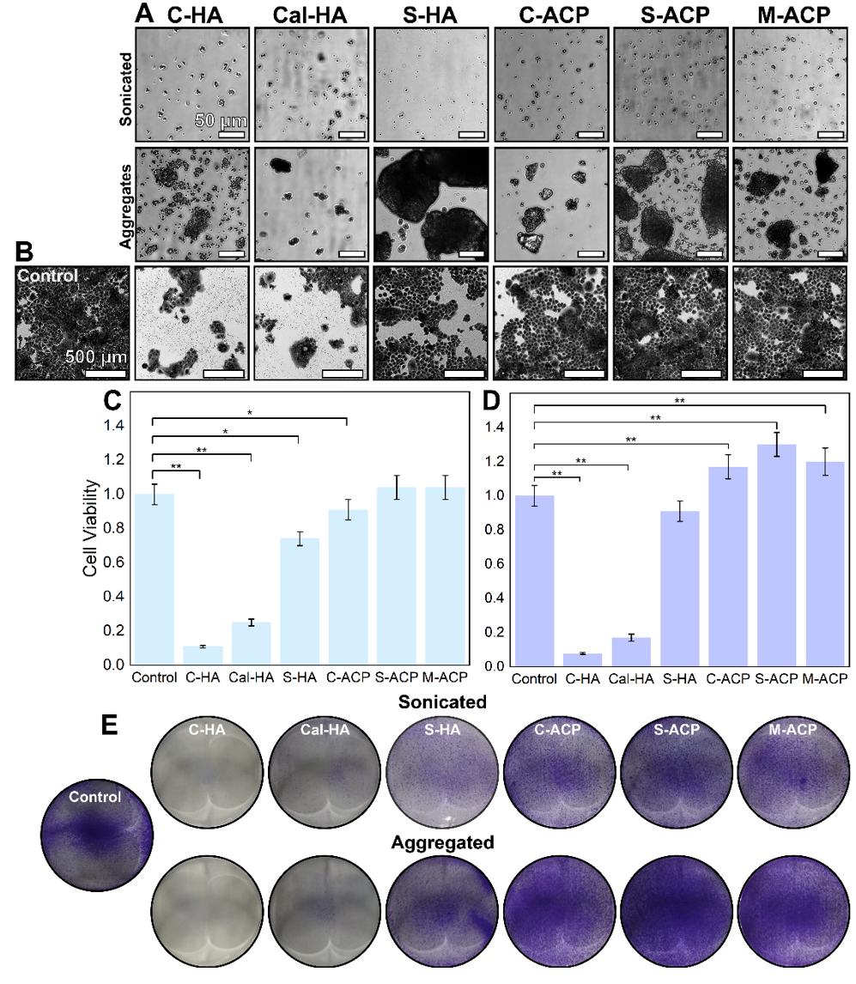

**Figure 7.** Characterization of aggregation of MC analogs and the cellular response to treatment with these minerals. **A.** Light microscopy imaging of sonicated and aggregated MC analogs in cell culture media. **B.** Light microscopy imaging of DCIS cells stained with CV following 72 hours of treatment with non-aggregated MC analogs. **C, D.** The effect of the non-aggregated (C) and aggregated (D) MC analogs on cell proliferation according to the MC type as measured by CV assay after 72 hours of treatment. **E.** Representative images of the corresponding wells. Absorbance is normalized to the control. Error bars represent the standard deviation. *P* < 0.05 (*) and P<0.01 (**).

3. Discussion

The y-SBF, a simulated tumor microenvironmental fluid platform, was developed to study and regulate the biomimetic formation of calcium phosphates. It was designed to facilitate the spontaneous formation of carbonated HA at physiologically relevant pH, with inorganic components, and at an ionic strength mimicking the tumor microenvironment, with subtle modifications to deter the formation of other minerals, notably calcite. Among the additives studied, PAA has emerged as a more potent inhibitor than PAsp, especially at higher molecular weight. PAA can either completely prevent HA formation or significantly reduce crystal yield. Lower PAA concentrations lead to HA formation with minor reductions in crystal yield, while higher concentrations stabilize the transient ACP phase, resulting in better inhibition. Additionally, ACP, a byproduct of HA inhibition, does not impact cell proliferation as non-aggregated particles but can promote it when in aggregated form. This highlights the influence on cellular responses by a combination of parameters, as negatively charged ACP aggregates with diverse morphologies demonstrate increased cell proliferation. Without additives, transient ACP formed quickly and became carbonated HA within a day. Over seven days, the Ca/P ratio of HA increased from 1.5 to 1.7, indicating a transformation from calcium-deficient apatite to a more stoichiometric form through structural rearrangements[43–45]. These HA minerals are sub-micrometer lumps with irregular spike-like structures, closely resembling those found in breast and thyroid cancer clinical samples[6,11]. Several trends emerged when additives were pre-mixed with $Ca^{2+}$ in y-SBF. At an additive concentration of $100 µg mL^{-1}$, there was no significant impact on HA mineralization for PAA. However, this concentration enhanced HA crystal yield in the case of PAsp, with ACP lumps initially forming, similar to the control. This ACP had a low Ca/P ratio, was unstable, and eventually transformed into HA. This concentration of PAsp likely provided a larger surface area for nucleation, promoting HA formation by attracting $Ca^{2+}$ and $HPO_{4}^{2-}$ ions, resulting in increased local supersaturation[38,41,46,47]. Overall, PAsp exhibited concentration-dependent effects, either promoting or inhibiting HA formation, although its inhibitory effect was less significant than that of PAA. At a higher additive concentration ($200 µg mL^{-1}$), ACP was formed and stabilized for seven days, regardless of the additive used. ACP exhibited two morphologies: lumps resembling control HA (PAsp and 8K PAA) or small spherical particles (100K PAA). The formation of ACP lumps was associated with approximately 60% mineralization, similar to the control without additives. However, when spherical particles formed, significant inhibition of mineralization occurred (only 13% mineralization), accompanied by the highest concentration of free $Ca^{2+}.$ In the Ca+Add procedure, the additive was pre-mixed with $Ca^{2+},$ leading to the formation of additive-calcium complexes before initiation of mineralization. Subsequently, upon the addition of $HPO_{4}^{2-},$ all solutions rapidly turned cloudy, like the control, indicating instant mineralization. The higher free $Ca^{2+}$ in the presence of $200 µg mL^{-1}$ 100K PAA is most likely due to liquid-liquid phase separation in the SBF pre-mixing. Liquid phase separation was previously observed, where liquid-like precursors were initially formed prior to amorphous calcium carbonate (ACC) and ACP[48–50]. Charged electrolytes can direct crystal growth through an intermediate liquid phase in a process called polymer-induced liquid precursor, in which the polymer kinetically stabilizes the liquid condensed phase. Pre-mixing $Ca^{2+}$ and additive allows for calcium-rich liquid droplets to form initially, then interact with $HPO_{4}^{2-}$ ions after their addition, forming spherical particles rich in calcium and poor in phosphorous (Ca/P=2.2-2.3). These particles form almost immediately, effectively consuming small amounts of $Ca^{2+}$/ $HPO_{4}^{2-}$, whereas the rest is free in the solution, but may possibly be blocked from further transfer to the ACP particles by the PAA coverage. Despite both $200 µg mL^{-1}$ 8K and 100K PAA having the same number of carboxylic acid groups in the solution, 8K PAA did not exhibit a comparable inhibitory effect, and ACP formed differently, resulting in a more substantial decrease in free $Ca^{2+}$. This highlights the significance of the molecular weight of the additives (polymer chain length) over the number of functional groups for chelating calcium ions. Although 100K PAA has a higher molecular weight and is expected to be less flexible than 8K PAA, it demonstrated a more significant inhibitory effect. Performance of the additives as inhibitors can be assessed in terms of their ability to prevent nucleation or act as crystal growth modifiers. Low molecular weight inhibitors are known for their rapid and efficient adsorption, whereas high molecular weight ones offer increased adsorption capacity and surface coverage[51,52]. The longer 100K PAA allows for greater chain entanglements and extended conformation when adsorbed onto the ACP surface. Consequently, it forms more extensive interactions with the surface, leading to improved surface coverage. This may also explain why spherical ACP particles do not aggregate, as the high quantity of 100K PAA adsorbed on their surface results in a more negative surface charge, causing repulsion between particles. In the P+Add procedure, this trend differs. In this case, 8K PAA at $100 µg mL^{-1}$ results in the highest free $Ca^{2+}$, while 100 $µg mL^{-1}$ 100K PAA and 200 $µg {mL}^{-1}$ 8K/100K PAA have lower free $Ca^{2+}$, but still more than the control. The highest free ${Ca}^{2+}$ coincides with 15-minute mineralization, likely following a similar process as before. The lower free $Ca^{2+}$ in other additives may be due to increased volume and the formation of additive-calcium complexes post-mixing. By introducing the additive to the calcium-containing solution only after mixing, calcium ion chelation occurred more uniformly but in a larger volume compared to the Ca+Add procedure. This aligns with mineralization taking 30 minutes for 100 $µg mL^{-1}$ 100K PAA and up to the following day for 200 $µg mL^{-1}$ 8K PAA, with minimal mineralization for 200 $µg mL^{-1}$ 100K PAA, which exhibited the highest mineralization inhibition in the Ca+Add procedure. Typically, HA forms from nearly spherical $Ca_{9}{\left(PO_{4}\right)}_{6}$ clusters that pack together to form ACP spheres with water molecules in the interstices, observed *in vivo* and *in vitro*, including in SBFs[39,40,53,54]. ACP is usually highly unstable, rapidly transforming into HA without additives. However, in this study, these ACP spheres remain exceptionally stable over seven days. Previous *in vitro* studies have shown that exposure to HA in 2D cell culture systems can lead to increased cellular mitogenesis, proliferation rates, enhanced cell adhesion, upregulated matrix metalloproteinase activity, and elevated secretion of pro-osteoclastic interleukin-8 (IL-8)[7,55–58]. Additionally, exposure to HA crystals has resulted in the enlargement of cell spheroids, resembling tumor-like structures, and increased HER2 expression in precancerous breast cells[16]. In this study, we examined six distinct minerals as CaP analogs to assess their impact on the proliferation of DCIS cells. This systematic categorization aimed to determine if CaPs influence the potential for malignancy, and identified the relevant parameters contributing to this effect. HA formed in SBF with a lumpy morphology showed significant cytotoxicity and strong suppression of cell proliferation. To investigate whether this effect was due to its rough spike-like surface texture, which could potentially damage cell membranes or organelles upon contact, we also examined the same HA after calcination, which had a smooth surface. However, similar outcomes were observed, whether the analogs were in the form of small particles or large aggregates. This effect may be attributed to surface chemistry and how these analogs interact with their surroundings, including cellular components like proteins and lipids, possibly through adsorption. Additionally, ion release from the analogs containing Mg, Cl, and Na ions and local pH alterations might contribute to cytotoxic effects. Another potential mechanism could be the cellular uptake of the analogs. Cancer cells are known for their strong ability to absorb minerals and nutrients, and much research has been done to exploit the altered uptake mechanisms of cancer cells using nanoparticles loaded with specific minerals or drugs. Even more specifically, the uptake of HA nanoparticles was shown to potentially suppress cancer cell proliferation. HA nanoparticles can enter breast cancer cells, nuclear membranes, and membranous structures (lysosomes, mitochondria, and intracellular vesicles)[59–61]. Often, the cytotoxicity of HA nanoparticles is found to be cell-, shape-, and size-dependent, with increased effect for smaller particles[62,63]. Although large aggregates were used in both experiments, numerous nanoparticles remained, possibly contributing to cytotoxicity through cellular uptake. Another variant examined was S-HA, which consists of spherical nanocrystalline HA particles. Unlike previous findings, S-HA did not stimulate cell proliferation, whether presented as individual particles or as aggregates[16]. These differences can likely be attributed to differences in cell-to-mineral ratios, underscoring the need for meticulous consideration of experimental conditions when investigating cell-mineral interactions. None of the tested HA variants exhibited the potential for malignancy typically seen in clinical samples containing MCs. Instead, they either suppressed proliferation (S-HA) or could be considered potential therapeutic candidates (C-HA and Cal-HA). The analogs of ACP displayed unique characteristics: when in aggregate form, they unexpectedly enhanced cell proliferation in the order of S-ACP > M-ACP > C-ACP. This is significant as clinical samples often feature MCs in aggregate configurations[6,11]. Aggregates offer a substantial local surface area that plays a pivotal role in facilitating interactions with adjacent cells, promoting cell adhesion, enabling signaling, and serving as substantial substrates for cellular attachment. While individual small particles exhibit a higher surface-to-volume ratio than aggregates, the crux of the matter lies in the localized influence on cellular interactions. Individual particles may have limited impact at a local level, whereas substantial aggregates provide a considerably larger local surface area, making them highly influential components within cellular environments. Typically, cells possess a negative surface charge, which would suggest repulsion from negatively charged ACPs. However, positively charged surfaces have been reported to influence cell proliferation and migration, especially in early cell responses, activating immune system signaling and regenerative responses to biomaterials[64–67]. The seemingly counterintuitive increase in cell proliferation when exposed to negatively charged aggregates could be attributed to enhanced repulsion exerted by ACP aggregates on cells and proteins. This directed repulsion may guide cells to specific areas, fostering cell attachment, adhesion, and, consequently, proliferation. The distinction between aggregates and individual particles in terms of their repulsion dynamics is crucial: aggregates exert more organized and directed repulsion effects, while non-aggregated particles generate diffuse repulsion effects without the ability to guide cells to specific destinations. PAA that is present in the ACPs is known to repel proteins like human serum albumin[68], which may contribute to the repulsion dynamics. This distinctive repulsion mechanism underscores the complexity of cell-mineral interactions and their role in influencing cell behavior within a multi-dimensional microenvironment. These findings support the theory that the malignancy potential of cells when exposed to minerals cannot be solely attributed to the mineral phase. While HA has traditionally been associated with high malignancy potential in DCIS cells, especially when present at higher degrees of crystallinity, the results demonstrate that malignancy does not hinge merely on the phase. Interestingly, in this context, the amorphous by-products resulting from HA inhibition are found to be more harmful than crystalline HA, challenging the conventional perception. The consideration of morphology in our study yielded limited effects, as no morphology displayed a strong correlation with increased cell proliferation. Instead, mineral aggregation, specifically particle size, emerged as the most influential factor. Larger ACP aggregates with highly negative surface charges exerted the most significant impact on cell proliferation. However, this observation does not entirely negate the potential of PAA as an inhibitor of HA for biological applications. Firstly, it is important to note that the different ACPs are unlikely to aggregate without external dehydration as a part of the drying process from suspension to powder. For instance, S-ACP does not aggregate in SBF, and when presented as single particles (at 200 $µg mL^{-1}$), it did not induce any increase in proliferation. Additionally, the use of PAA results in significantly smaller quantities of by-products compared to the potential deposition of HA. This aspect is particularly advantageous, especially when considering that the HA formed in SBF may differ from what is generated in a biological system, potentially leading to varying effects on cancer cell malignancy. Lastly, our findings underscore PAA as a highly effective, biocompatible inhibitor of HA formation *in vitro*, ultimately preventing its formation. The potential of PAA to inhibit HA in biological contexts extended beyond breast cancer MCs. PAA can be used in conditions such as kidney stones, cardiovascular calcifications, calcifications on heart valves, and prostate issues, where the inhibition of HA crystallization can have substantial clinical impact. The insight gained from this study could also have implications in the field of biomaterials, especially in systems characterized by liquid-liquid phase separation mechanisms. Moreover, these findings may shed light on crystal nucleation and growth processes from bodily fluids in general, offering a broader perspective on the regulation and manipulation of mineralization processes within the human body. Further research and clinical studies should be conducted to fully elucidate the wide-ranging implications of our findings, ultimately transforming our understanding of HA dynamics in various physiological and pathological contexts.

4. Conclusion

We have developed a robust model to investigate the spontaneous crystallization of HA within a solution relevant to the tumor microenvironment (y-SBF). PAA has emerged as a highly effective HA inhibitor, with its high molecular weight demonstrating exceptional inhibitory capacity. PAA can completely inhibit the formation of HA or highly decrease crystal yield. While low PAA concentrations resulted in the formation of HA and only a slight reduction in crystal yield, higher concentrations stabilized the transient ACP phase, resulting in a much more significant inhibition. Our findings challenge conventional associations between HA and malignancy, as different HA variants do not induce malignancy in DCIS cancer cells. Instead, they exert cytotoxic or proliferation-suppressing effects, regardless of their morphology or aggregation status. ACP, a byproduct of HA inhibition, does not affect cell proliferation as non-aggregated particles, but promotes it when in an aggregated form. These insights underscore the complexity of mineral-cell interactions and emphasize the importance of considering byproducts in therapeutic strategies. Ultimately, our study prompts a reevaluation of the impact of HA inhibition on the progression of DCIS precancerous lesions to invasive breast cancer. It suggests that the cellular response to minerals cannot be attributed simply to the mineral phase or crystallinity, but that a combination of these and morphology, surface texture, size, and surface potential should be considered.

5. Experimental Methods

All materials were purchased from Sigma Aldrich (St. Louis, MO, USA), except the calcium chloride, which was purchased from Fisher Scientific (Loughborough, UK).

**SBF preparation**

The following reagents were dissolved in 900 mL deionized water (DIW) in the following order: ( $NaCl, Na_{2}CO_{3}, KCl, MgCl_{2}∙6H_{2}O, Na_{2}SO_{4}, NH_{2}C{\left(CH_{2}OH\right)}_{3} (TRIS))$ (solution A). The pH was adjusted to 7.4 by the addition of 5.0 M HCl. Additional DIW was added to a final volume of 1000 mL. The final solution was filtered using a 0.45 $μm$ Millipore® membrane filter. Finally, the resulting solution was kept in a sealed bottle and used only before the addition of $Ca^{2+}$ and $HPO_{4}^{2-}$. The pH was measured with a combined polymer electrode connected to a 912 portable conductometer (Metrohm). The ionic strength and SI calculations for the different SBFs were carried out using Visual Minteq 4.0.

**Mineralization in SBF**

Control: Carbonated HA was synthesized by preparing separate A solutions of equal volume (75 mL) containing $CaCl_{2}$ (solution B) and $Na_{2}HPO_{4}$ (solution C). The reaction was initiated by mixing solutions B and C at and 300 RPM for a final volume of 150 mL. The addition of ${Ca}^{2+}$ and ${HPO}_{4}^{2-}$ ions to the SBF only before the reaction ensured that no precipitation occurred until this point. For the reaction in the presence of an additive, the additive was pre-mixed with either $Ca^{2+}$ (B) or $HPO_{4}^{2-}$ (C), depending on the procedure. The resulting suspensions were centrifuged, washed with DIW and ethanol, and left to dry overnight at $37℃$.

**Mineral phase characterization**

All mineral precipitates were analyzed using FTIR spectroscopy (Nicolet iS5, Thermo Fischer). First, 1 mg from each sample was mixed with 200 mg of KBr until the powder was homogeneous; then, a pellet was made with a compressor rated at 2 tons for 2 minutes. The Nicolet iS5 instrument was operated in the spectral range of 400–4000 cm−1 with 16 scans and a resolution of 8 $cm^{-1}$. Background substruction and baseline correction were performed using Omnic Spectra (Thermo Fischer), whereas plotting and spectrum analysis were performed using OriginPro 2020.

**Imaging and elemental analysis of the minerals**

The mineral particles were mounted on an SEM stub using conductive carbon adhesive tape for size and morphological characterization. The particles were imaged using a field emission SEM (Verios 460L, Thermo Fisher) at a voltage of 3 kV. The elemental composition was examined by the Verios 460L Energy dispersive spectroscopy (EDS) at 10 kV. Adobe Photoshop was used for brightness and contrast adjustments. Image processing was performed consistently in all conditions.

**Monitoring the mineralization inhibition**

The minerals were imaged during the mineralization in the SBF after 15 min, 1, 3, and 7 days. The suspension) was dropped in a $μ$-slide, 15-well, 3D polymer bottom and imaged using a Nikon ECLIPSE Ti2-U inverted microscope equipped with a DS-QI2 mono-cooled digital camera with a 40× objective. Adobe Photoshop was used for brightness and contrast adjustments. Image processing was performed consistently for all conditions. Additionally, the free $Ca^{2+}$ concentration was monitored by a combined calcium-selective electrode with a polymer membrane (Metrohm) connected to a 912 portable conductometer (Metrohm).

**Zeta potential measurement**

The *ζ*-potential measurements were performed in suspensions of 0.1 mg $mL^{-1}$ HA/ACP particles in SBF (pH=7.4 and $37℃)$ using the Zetasizer instrument (Nano-ZS90, Malvern, UK). Each measurement was repeated at least four times for two different batches of the mineral.

**MC analog characterization**

The minerals were dispersed in the cell culture media using a pipette tip to achieve smaller aggregates, which were then seeded into the wells. The mineral suspensions were then subjected to one hour of ultrasonication to disintegrate aggregates into smaller particles. Both aggregated and sonicated (non-aggregated) mineral suspensions were added at a concentration of $0.05 mg mL^{-1}$ to a 35 mm Ibidi µ-dish containing cell culture media. Subsequently, these were imaged using a Nikon ECLIPSE Ti2-U inverted microscope equipped with a DS-QI2 mono-cooled digital camera with a 10× objective.

**The effect of MC analogs on cell proliferation**

MCF10DCIS.com immortalized precancerous human breast epithelial cells (Barbara Ann Karmanos Cancer Institute) were cultured in minimal DMEM/F12 medium (1% penicillin/streptomycin, 5% horse serum) at 37°C and 5% CO2 with medium refreshed three times a week. The cells were routinely tested for mycoplasma contamination.

To investigate the impact of MC analogs on cell proliferation, DCIS cell monolayers were cultured in 6-well plates, with 90,000 cells seeded per well. The cells were exposed to a concentration of $0.05 mg mL^{-1}$ of one of the examined minerals, which was introduced immediately following cell seeding. Prior to their addition to the culture medium, the minerals underwent sterilization using 70% ethanol and UV light. Control cells were cultured without the addition of any minerals. Following 72-hour incubation, the medium was aspirated, and the cells were washed with phosphate-buffered saline (PBS). Subsequently, 1 mL of a 0.1% crystal violet (CV) solution dissolved in DIW was added to each well, followed by incubation for 10 minutes. The cells were then washed with DIW until the water became transparent, after which the plates were allowed to air dry and imaged using a Nikon ECLIPSE Ti2-U inverted microscope equipped with a DS-QI2 mono-cooled digital camera with a 10× objective. Next, 2 mL of acetic acid was added to each well to dissolve the CV, and absorbance at 570 nm was measured using an Infinite M200 plate reader (TECAN).

**Statistical analysis**

All data were expressed as the mean +/− standard deviation (SD). One-way ANOVA analysis was used to compare differences between the cell proliferation experiments. P-values less than 0.05 were considered significant. Statistical analysis was performed using OriginPro 2020. All experiments and measurements were performed three independent times. The *in vitro* experiments were performed with three biological replicates and minerals from two different batches.

**Conflicts of interest**

The authors declare no conflicts of interest.

Acknowledgments

This work was supported by the Israeli Science Foundation [grant number 565/21]. NV is the incumbent of the Joseph and May Winston Career Development Chair in Chemical Engineering. The illustrations were created with BioRender.com.

**References**

[1] D. Bazin, M. Daudon, C. Combes, C. Rey, *Chem Rev* **2012**, *112*, DOI 10.1021/cr200068d.

[2] N. Vidavsky, J. A. M. R. Kunitake, L. A. Estroff, *Adv Healthc Mater* **2021**, *10*, DOI 10.1002/adhm.202001271.

[3] J. A. Wesson, M. D. Ward, *Elements* **2007**, *3*, DOI 10.2113/GSELEMENTS.3.6.415.

[4] B. S. Franklin, M. S. Mangan, E. Latz, *Annu Rev Immunol* **2016**, *34*, DOI 10.1146/annurev-immunol-041015-055539.

[5] N. M. Eisenstein, S. C. Cox, R. L. Williams, S. A. Stapley, L. M. Grover, *Adv Healthc Mater* **2016**, *5*, DOI 10.1002/adhm.201500617.

[6] L. Gotnayer, D. Aranovich, M. Fraenkel, U. Yoel, N. Vidavsky, *Acta Biomater* **2023**, 161, DOI 10.1016/j.actbio.2023.03.010.

[7] R. F. Cox, M. P. Morgan, *Bone* **2013**, *53*, DOI 10.1016/j.bone.2013.01.013.

[8] R. Holland, J. H. C. L. Hendriks, *Semin Diagn Pathol* **1994**, *11*.

[9] S. Hofvind, B. F. Iversen, L. Eriksen, B. M. Styr, K. Kjellevold, K. D. Kurz, *Acta radiol* **2011**, *52*, DOI 10.1258/ar.2011.100357.

[10] E. Thurfjell, M. G. Thurfjell, A. Lindgren, *Breast Cancer Res Treat* **2001**, *67*, DOI 10.1023/A:1010648919150.

[11] L. Frappart, M. Boudeulle, J. Boumendil, H. C. Lin, I. Martinon, C. Palayer, Y. Mallet-Guy, D. Raudrant, A. Bremond, Y. Rochet, et al., *Hum Pathol* **1984**, *15*, DOI 10.1016/S0046-8177(84)80150-1.

[12] R. Baker, K. D. Rogers, N. Shepherd, N. Stone, *Br J Cancer* **2010**, *103*, DOI 10.1038/sj.bjc.6605873.

[13] R. F. Cox, A. Hernandez-Santana, S. Ramdass, G. McMahon, J. H. Harmey, M. P. Morgan, *Br J Cancer* **2012**, *106*, DOI 10.1038/bjc.2011.583.

[14] M. P. Morgan, M. M. Cooke, P. A. Christopherson, P. R. Westfall, G. M. McCarthy, *Mol Carcinog* **2001**, *32*, DOI 10.1002/mc.1070.

[15] S. Choi, S. Coonrod, L. Estroff, C. Fischbach, *Acta Biomater* **2015**, *24*, DOI 10.1016/j.actbio.2015.06.001.

[16] A. Cohen, L. Gotnayer, S. Gal, D. Aranovich, N. Vidavsky, *J Mater Chem B* **2023**, 11, DOI 10.1039/d3tb00439b.

[17] T. Sharma, J. A. Radosevich, G. Pachori, C. C. Mandal, *J Mammary Gland Biol Neoplasia* **2016**, *21*, DOI 10.1007/s10911-015-9349-9.

[18] X. Lu, Y. Leng, *Biomaterials* **2005**, *26*, DOI 10.1016/j.biomaterials.2004.05.034

[19] A. L. Boskey, M. Maresca, W. Ullrich, S. B. Doty, W. T. Butler, C. W. Prince, *Bone Miner* **1993**, *22*, DOI 10.1016/S0169-6009(08)80225-5.

[20] W. Jahnen-Dechent, C. Schäfer, M. Ketteler, M. D. McKee, *J Mol Med* **2008**, *86*, DOI 10.1007/s00109-007-0294-y.

[21] W. Jahnen-Dechent, A. Heiss, C. Schäfer, M. Ketteler, *Circ Res* **2011**, *108*, DOI 10.1161/CIRCRESAHA.110.234260.

[22] T. Kokubo, S. Yamaguchi, *J Biomed Mater Res A* **2019**, *107*, DOI 10.1002/jbm.a.36620.

[23] T. Kokubo, H. Takadama, in *Handbook of Biomineralization: Biological Aspects and Structure Formation*, **2008**.

[24] T. Kokubo, H. Takadama, *Biomaterials* **2006**, *27*, 2907.

[25] L. Müller, F. A. Müller, *Acta Biomater* **2006**, *2*, DOI 10.1016/j.actbio.2005.11.001.

[26] E. I. Dorozhkina, S. V. Dorozhkin, *Colloids Surf A Physicochem Eng Asp* **2002**, *210*, DOI 10.1016/S0927-7757(02)00217-0.

[27] A. Oyane, H. M. Kim, T. Furuya, T. Kokubo, T. Miyazaki, T. Nakamura, *J Biomed Mater Res A* **2003**, *65*, DOI 10.1002/jbm.a.10482.

[28] A. Oyane, K. Onuma, A. Ito, H. M. Kim, T. Kokubo, T. Nakamura, *J Biomed Mater Res A* **2003**, *64*, DOI 10.1002/jbm.a.10426.

[29] S. Gosling, R. Scott, C. Greenwood, P. Bouzy, J. Nallala, I. D. Lyburn, N. Stone, K. Rogers, *J Mammary Gland Biol Neoplasia* **2019**, *24*, DOI 10.1007/s10911-019-09441-3.

[30] R. Scott, N. Stone, C. Kendall, K. Geraki, K. Rogers, *NPJ Breast Cancer* **2016**, *2*, DOI 10.1038/npjbcancer.2016.29.

[31] R. Vanna, C. Morasso, B. Marcinno, F. Piccotti, E. Torti, D. Altamura, S. Albasini, M. Agozzino, L. Villani, L. Sorrentino, et al., *Cancer Res* **2020**, *80*, DOI 10.1158/0008-5472.CAN-19-3204.

[32] H. A. Fleisch, R. G. G. Russell, S. Bisaz, R. C. Mühlbauer, D. A. Williams, *Eur J Clin Invest* **1970**, *1*, DOI 10.1111/j.1365-2362.1970.tb00591.x.

[33] M. D. Francis, R. G. G. Russell, H. Fleisch, *Science (1979)* **1969**, *165*, DOI 10.1126/science.165.3899.1264.

[34] Z. Amjad, *Langmuir* **1987**, *3*, DOI 10.1021/la00078a032.

[35] M. D. Francis, *Calcif Tissue Res* **1969**, *3*, DOI 10.1007/BF02058658.

[36] I. Erceg, N. Maltar-Strmečki, D. D. Jurašin, V. Strasser, M. Ćurlin, D. M. Lyons, B. Radatović, N. M. Mlinarić, D. Kralj, M. D. Sikirić, *Crystals (Basel)* **2021**, *11*, DOI 10.3390/cryst11070792.

[37] X. Yang, B. Xie, L. Wang, Y. Qin, Z. J. Henneman, G. H. Nancollas, *CrystEngComm* **2011**, *13*, DOI 10.1039/c0ce00470g.

[38] P. Bar-Yosef Ofir, R. Govrin-Lippman, N. Garti, H. Füredi-Milhofer, *Cryst Growth Des* **2004**, *4*, DOI 10.1021/cg034148g.

[39] W. Jin, S. Jiang, H. Pan, R. Tang, *Crystals (Basel)* **2018**, *8*, DOI 10.3390/cryst8010048.

[40] S. Jiang, H. Pan, Y. Chen, X. Xu, R. Tang, *Faraday Discuss* **2015**, *179*, DOI 10.1039/c4fd00212a.

[41] S. Jiang, Y. Cao, S. Li, Y. Pang, Z. Sun, *J Cryst Growth* **2021**, *557*, DOI 10.1016/j.jcrysgro.2020.125991.

[42] A. Tsortos, G. H. Nancollas, *J Colloid Interface Sci* **2002**, *250*, DOI 10.1006/jcis.2002.8323.

[43] S. Kim, H. S. Ryu, H. Shin, H. S. Jung, K. S. Hong, *Mater Chem Phys* **2005**, *91*, DOI 10.1016/j.matchemphys.2004.12.016.

[44] F. Abbona, A. Baronnet, *J Cryst Growth* **1996**, *165*, DOI 10.1016/0022-0248(96)00156-X.

[45] J. E. Harries, D. W. L. Hukins, C. Holt, S. S. Hasnain, *J Cryst Growth* **1987**, *84*, DOI 10.1016/0022-0248(87)90046-7.

[46] D. Rautaray, S. Mandal, M. Sastry, *Langmuir* **2005**, *21*, DOI 10.1021/la048541f.

[47] M. Tavafoghi, M. Cerruti, *J R Soc Interface* **2016**, *13*, DOI 10.1098/rsif.2016.0462.

[48] T. T. Thula, F. Svedlund, D. E. Rodriguez, J. Podschun, L. Pendi, L. B. Gower, *Polymers (Basel)* **2011**, *3*, DOI 10.3390/polym3010010.

[49] A. S. Schenk, H. Zope, Y. Y. Kim, A. Kros, N. A. J. M. Sommerdijk, F. C. Meldrum, *Faraday Discuss* **2012**, *159*, DOI 10.1039/c2fd20063e.

[50] M. A. Bewernitz, D. Gebauer, J. Long, H. Cölfen, L. B. Gower, *Faraday Discuss* **2012**, *159*, DOI 10.1039/c2fd20080e.

[51] *Mineral Scale Formation and Inhibition*, **1995**.

[52] C. H. Nestler, *J Colloid Interface Sci* **1968**, *26*, DOI 10.1016/0021-9797(68)90265-8.

[53] M. Li, L. Wang, W. Zhang, C. V. Putnis, A. Putnis, *Cryst Growth Des* **2016**, *16*, DOI 10.1021/acs.cgd.6b00637.

[54] A. Dey, P. H. H. Bomans, F. A. Müller, J. Will, P. M. Frederik, G. De With, N. A. J. M. Sommerdijk, *Nat Mater* **2010**, *9*, DOI 10.1038/nmat2900.

[55] F. He, N. L. Springer, M. A. Whitman, S. P. Pathi, Y. Lee, S. Mohanan, S. Marcott, A. E. Chiou, B. S. Blank, N. Iyengar, et al., *Biomaterials* **2019**, *224*, DOI 10.1016/j.biomaterials.2019.119489.

[56] S. P. Pathi, D. D. W. Lin, J. R. Dorvee, L. A. Estroff, C. Fischbach, *Biomaterials* **2011**, *32*, DOI 10.1016/j.biomaterials.2011.03.055.

[57] S. P. Pathi, C. Kowalczewski, R. Tadipatri, C. Fischbach, *PLoS One* **2010**, *5*, DOI 10.1371/journal.pone.0008849.

[58] S. O’Grady, M. P. Morgan, *Biochim Biophys Acta Rev Cancer* **2018**, *1869*, DOI 10.1016/j.bbcan.2018.04.006.

[59] Q. Fu, N. Zhou, W. Huang, D. Wang, L. Zhang, H. Li, *J Biomed Mater Res A* **2005**, *74*, DOI 10.1002/jbm.a.30322.

[60] Y. Han, S. Li, X. Cao, L. Yuan, Y. Wang, Y. Yin, T. Qiu, H. Dai, X. Wang, *Sci Rep* **2014**, *4*, DOI 10.1038/srep07134.

[61] R. Meena, K. K. Kesari, M. Rani, R. Paulraj, *Journal of Nanoparticle Research* **2012**, *14*, DOI 10.1007/s11051-011-0712-5.

[62] X. Zhao, S. Ng, B. C. Heng, J. Guo, L. Ma, T. T. Y. Tan, K. W. Ng, S. C. J. Loo, *Arch Toxicol* **2013**, *87*, DOI 10.1007/s00204-012-0827-1.

[63] J. S. Sun, Y. H. Tsuang, W. H. S. Chang, J. Li, H. C. Liu, F. H. Lin, *Biomaterials* **1997**, *18*, DOI 10.1016/S0142-9612(96)00183-4.

[64] H.-I. Chang, Y. Wang, in *Regenerative Medicine and Tissue Engineering - Cells and Biomaterials*, **2011**.

[65] S. Metwally, U. Stachewicz, *Materials Science and Engineering C* **2019**, *104*, DOI 10.1016/j.msec.2019.109883.

[66] H. B. Carter, D. S. Coffey, *Journal of Urology* **1988**, *140*, DOI 10.1016/s0022-5347(17)41521-7.

[67] A. H. Rajabi, M. Jaffe, T. L. Arinzeh, *Acta Biomater* **2015**, *24*, DOI 10.1016/j.actbio.2015.07.010.

[68] N. L. Burns, K. Holmberg, *Prog Colloid Polym Sci* **1996**, *100*, DOI 10.1007/bfb0115792.