**Supporting information for: "Inhibiting Pathological Calcium Phosphate Mineralization: Implications for Disease Progression"**

Yarden Nahmias1, Gabriel Yazbek Grobman1, Netta Vidavsky1,2

1 Department of Chemical Engineering, Ben-Gurion University of the Negev, Beer Sheva

2 Ilse Katz Institute for Nanoscale Science & Technology, Ben-Gurion University of the Negev, Beer Sheva

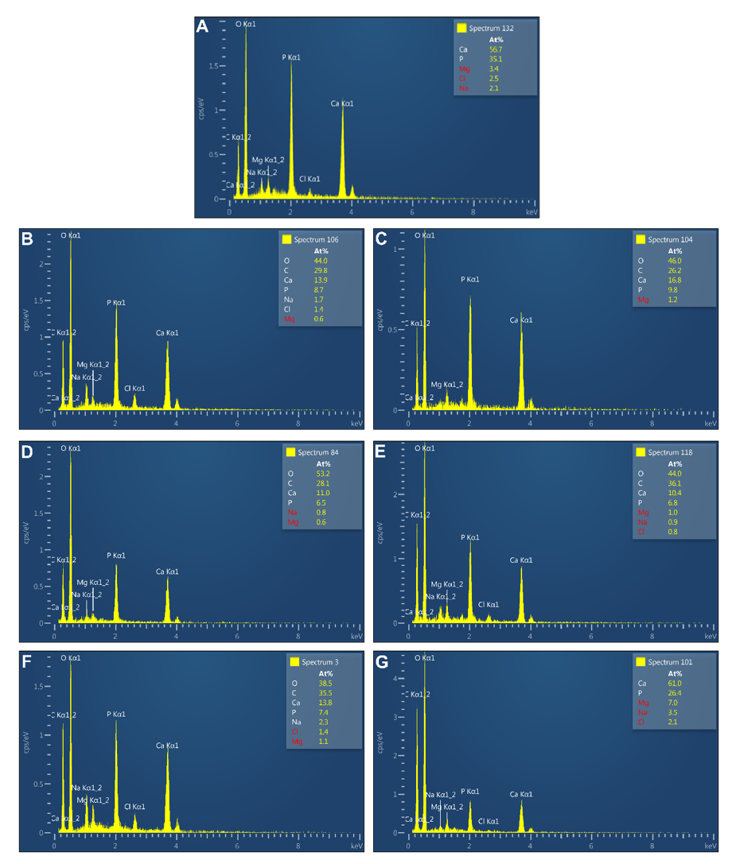

**Figure S1.** Elemental analysis of the precipitates in y-SBF by EDS. **A:** control (HA). **B, C, D:** Precipitates (HA) in the presence of $100 µg {mL}^{-1}$ additives 8K PAsp, 8K PAA, and 100K PAA, respectively. **E, F, G:** Precipitates (ACP) in the presence of $200 µg {mL}^{-1}$ additives 8K PAsp, 8K PAA, and 100K PAA, respectively.

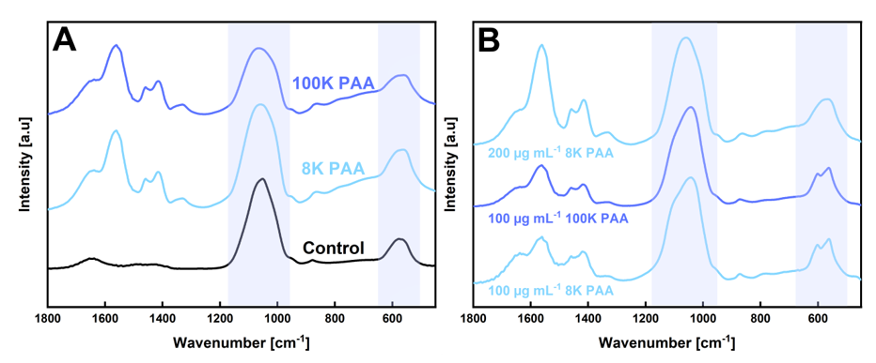

**Figure S2. A.** FTIR spectra of the minerals after 15 min in the absence of additives (control) and in the presence of $100 μg {mL}^{-1}$ PAA in the Ca+Add procedure. **B.** FTIR spectra of the minerals at day 1 in the presence of $100 and 200 μg {mL}^{-1}$ PAA in the P+Add procedure.

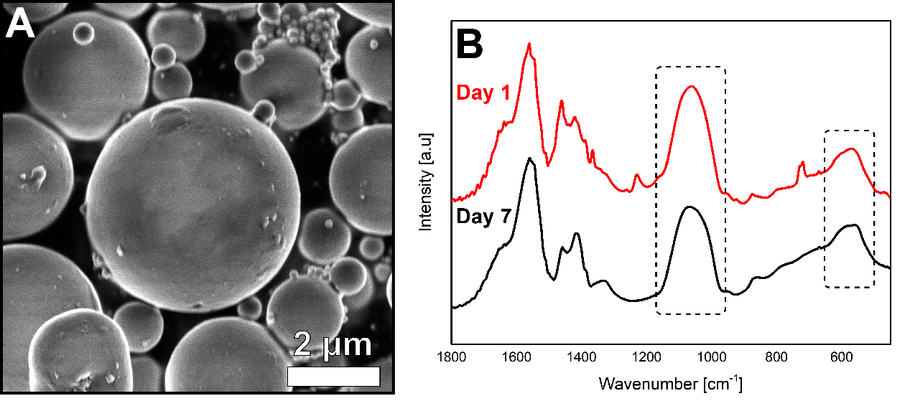

**Figure S3.** Crystallization in the presence of 100 $μg mL^{-1}$ of 8K PAA and 100 $μg mL^{-1}$ 100K PAA**. A:** SEM imaging on day 7 of the resulting spherical ACP particles (M‑ACP). **B:** FTIR spectra of the mineral on day 1 (M-ACP) and day 7 (ACP).

|  |  |  |  |  |  |
| --- | --- | --- | --- | --- | --- |
| **MC analogs** | **Description** | **CaP phase** | **Morphology** | **Surface texture** | ***ζ* potential**  **[mV]** |
| **C-HA** | HA from y-SBF after 7 days, dried at $37℃$ | HA | Lumps | Spike-like | $$-6±2$$ |
| **Cal-HA** | HA from y-SBF after 7 days of synthesis and 8 hours of calcination at 900 $℃$ | HA | Lumps | Smooth | $$-10.3±0.5$$ |
| **S-HA** | Nanocrystalline HA purchased from Sigma-Aldrich | HA | Spherical | Smooth | $$3.2±0.5$$ |
| **C-ACP** | Synthesized in y-SBF in the presence of 200 $μg mL^{-1}$ 8K PAA, dried at $37℃$ | ACP | Lumps | Smooth | $$-15.3±0.9$$ |
| **S-ACP** | Synthesized in y-SBF in the presence of 200 $μg mL^{-1}$ 100K PAA, dried at $37℃$ | ACP | Spherical | Smooth | $$-18±1$$ |
| **M-ACP** | Synthesized in y-SBF in the presence of 100 $μg mL^{-1}$ 8K PAA + 100 $μg mL^{-1}$ 100K, dried at $37℃$ | ACP | Spherical | Smooth | $$-17.9±0.9$$ |

**Table S1.** The different MC analogs used in the cell culture proliferation experiments. A description of the synthesis and drying procedure, the CaP phase, morphology, surface texture, and the *ζ* potential.

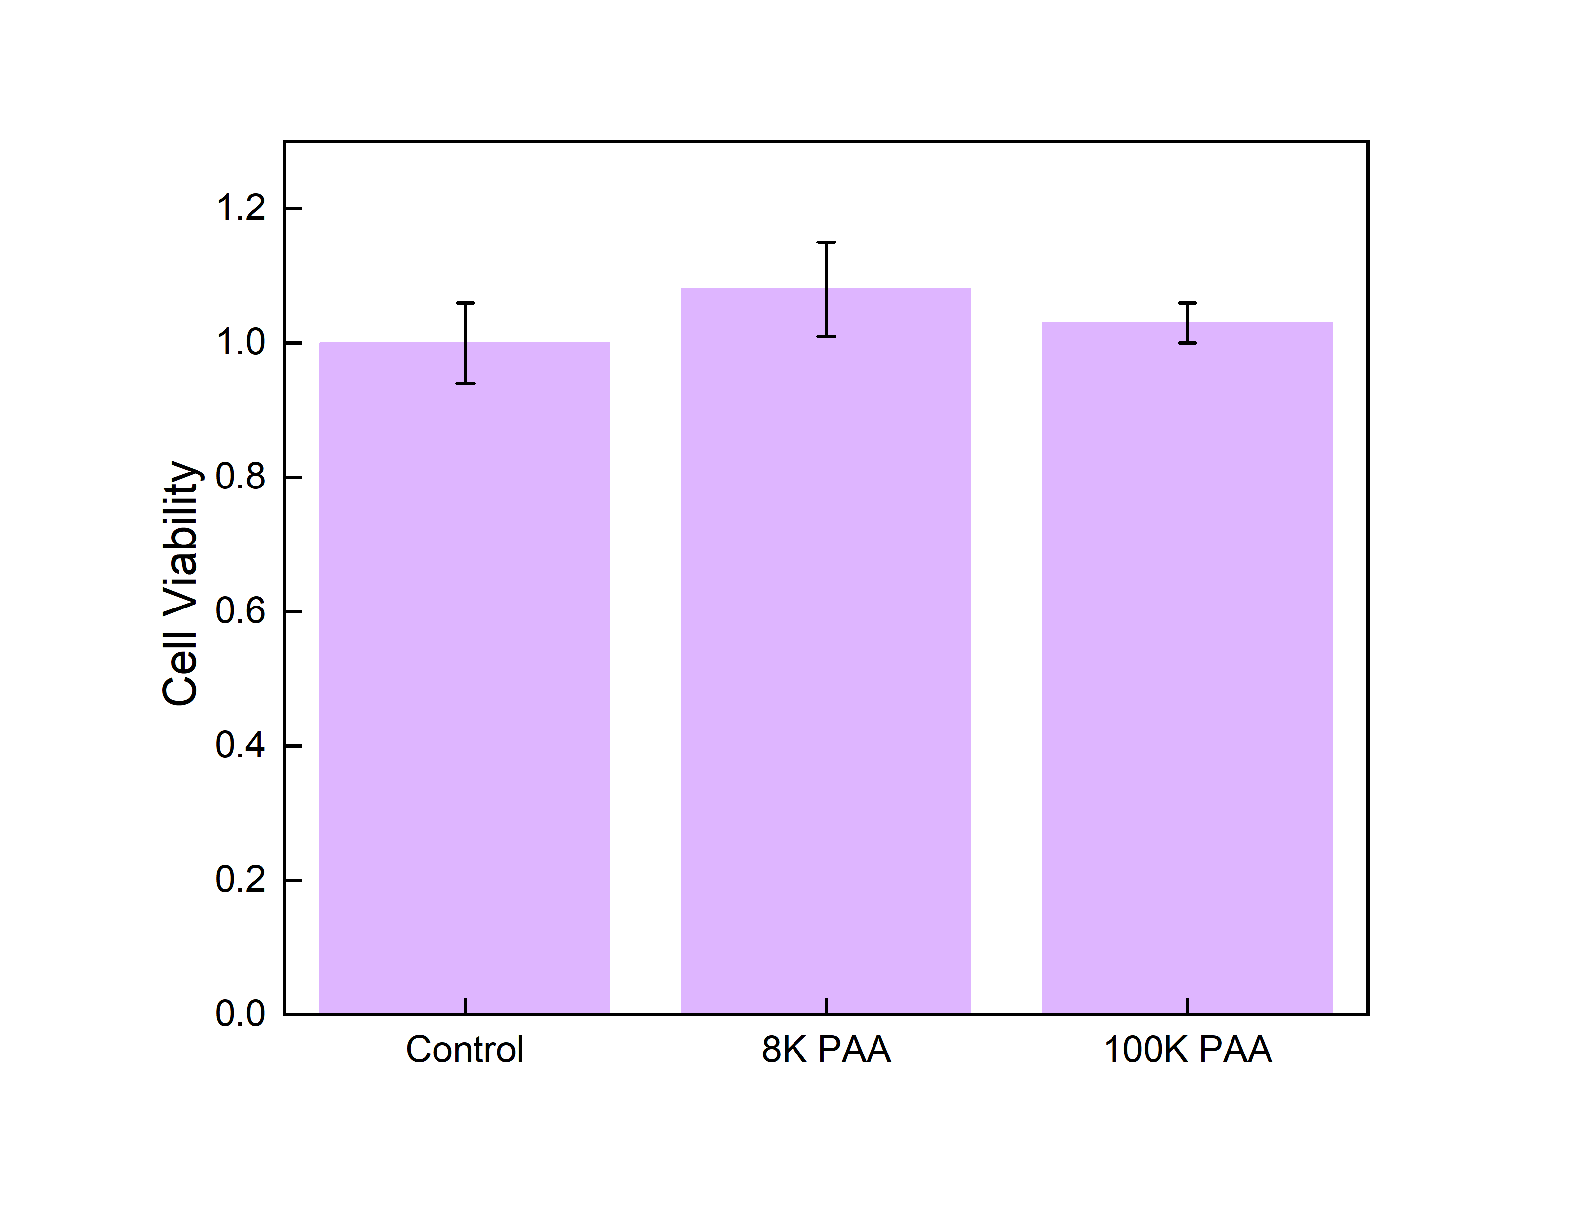

**Figure S4.** Cytotoxicity of the additives 8K PAA and 100K PAA. 400K MCF10DCIS.com cells were seeded in 6-well plates and treated with 200 $μg mL^{-1}$ PAA. Cell viability was measured after 24 hours by a CV assay. The absorbance was normalized to the control (no treatment).

**Cover Letter**

Dear Prof. Goebel,

Attached is our manuscript entitled "Inhibiting Pathological Calcium Phosphate Mineralization: Implications for Disease Progression" for your consideration as an original research article in Advanced Healthcare Materials.

Pathological calcifications have profound implications for various health conditions, including the renal and cardiovascular systems and in the context of cancer. Calcium phosphate microcalcifications, especially hydroxyapatite crystals, are frequently associated with aggressive tumors and a poorer prognosis, particularly in early breast cancer. These crystals were also reported to trigger tumorigenesis behavior *in vitro*. Hence, inhibiting hydroxyapatite formation in the tumor microenvironment has the potential to impact disease progression and prognosis.

We developed a simulated body fluid platform that closely resembles the tumor microenvironment in which hydroxyapatite spontaneously forms, allowing us to control its crystallization and investigate its inhibition through the use of additives. We show that additives containing carboxylic acids effectively inhibit hydroxyapatite mineralization in this system and that significant inhibition is achieved by stabilizing amorphous calcium phosphate (ACP) nanospheres. Not only do these ACP nanospheres form as inhibition byproducts, but in some cases, using additives for hydroxyapatite crystallization inhibition results in the precipitation of several other calcium phosphate minerals. The size, morphology, aggregation, surface charge, and surface texture of these inhibition byproducts vary considerably.

As a second step, we investigated the influence of mineral byproducts on the disease, an often-neglected aspect of crystallization inhibition design. We treated precancerous human breast cells with various minerals formed as byproducts of hydroxyapatite inhibition to evaluate their impact on cell tumorigenesis. Unlike conventional assumptions, all hydroxyapatite minerals in this study exhibited cytotoxic or proliferation-suppressing effects. Additionally, ACP unexpectedly increased cellular proliferation when present as agglomerates.

Our research underscores the complexity of mineral-cell interactions and challenges the simplistic attribution of cellular responses to mineral phase and crystallinity. Insights from this research lie not only in advancing our understanding of the role of hydroxyapatite in breast cancer but also in highlighting the potential harm caused by its inhibition byproducts. This has the potential to influence clinical practices and offer innovative approaches to pathological biomineralization. Furthermore, it is also relevant for bone regeneration and the development of composite biomaterials for tissue engineering applications.

Given these innovative results, we believe this manuscript will be of interest to the broad readership of *Advanced Healthcare Materials*, including researchers in the fields of biomineralization, pathological crystallization, and biomaterials.

We suggest the following individuals as referees based on their expertise in pathological biomineralization, biomedical engineering, and biomaterial properties: