Burg et al., main figures:

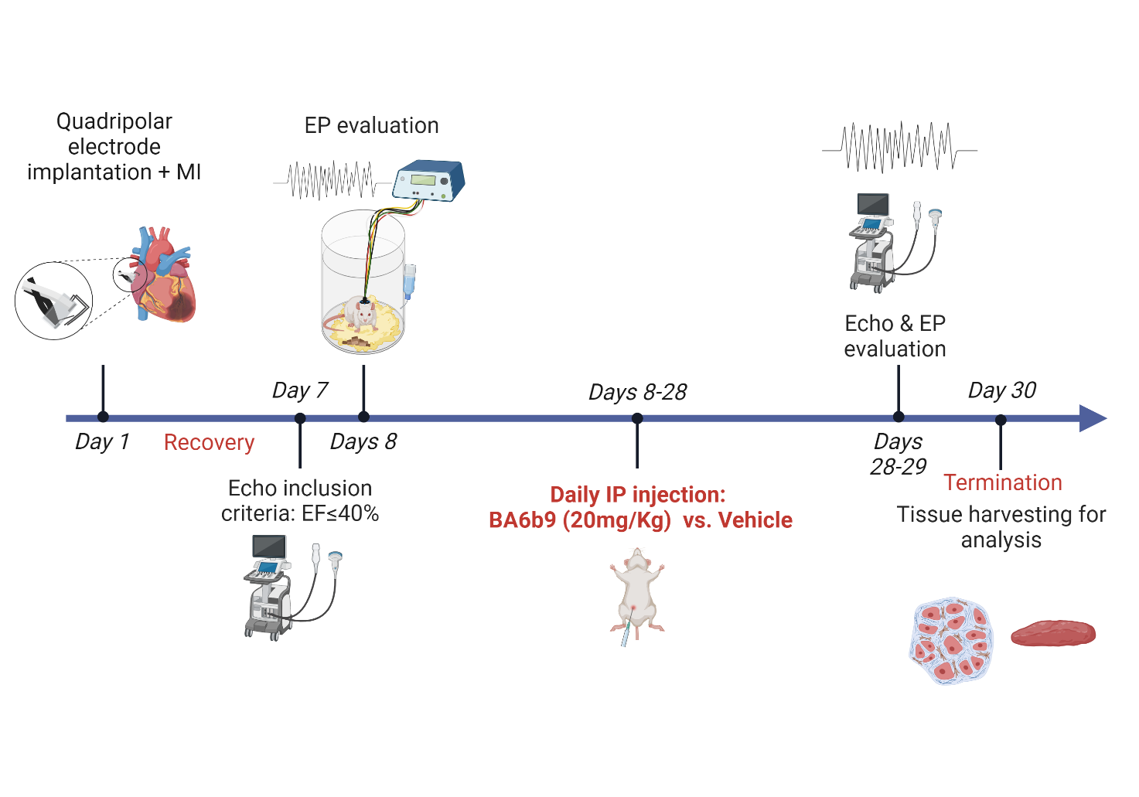

Figure 1: Experimental protocol and timeline for the assessment of BA6b9 treatment on the AF substrate of HFrEF rats post-MI. The initial operation (day 1) included left coronary artery ligation + quadrupolar electrode implantation for long-term EP evaluation. Rats with EF≤40% at seven days post the surgery were randomly assigned to daily injection of either BA6b9 or vehicle for 3 weeks. At the end of treatment final echocardiography and EP study were performed and hearts were collected for further analysis.

Figure 2: BA6b9 treatment reduce the AF substrate of post-MI rats. A. Confirmation in-vitro recordings. Left, Representative trace of WT SK4 currents in the absence and presence of 20 µM BA6b9, displaying an inhibition of ≈56%. Right: Representative traces of an inside-out macro-patch from a CHO cell expressing WT SK4 channels in the absence and presence of 10 µM BA6b9 under internal saturating calcium concentration. Currents were recorded by 10 repetitive 1s duration voltage ramps from -100mV to +100mV from a holding potential of 0 mV. B. BA6b9 treatment significantly reduced AF induction: and AF duration. C. Example of post burst AF episodes in the Vehicle (left) and BA6b9 (right) groups. D. Mean power spectrum of the AF episodes following long-term BA6b9 vs. vehicle treatment. Notably, the vehicle group demonstrates greater amplitudes over a wide range of frequencies, relative to the BA6b9 group. Notch (arrow) indicates the zone were a notch filter was applied due to power supply related noise (50Hz). E. Quantitative analysis of delta between the power spectrum integrals of arrhythmic episodes and pre-burst NSR. Note significantly higher values in the vehicle group compared to the AF events in the BA6b9 treated rats.

Figure 3: Effect of BA6b9 on collagen deposition in the left atrium of rats with MI-induced HF. A. Statistical summary of entire left-atrial fibrosis; Vehicle Vs. BA6b9 treated rats, compared to control (n=7, n=8, n=4, respectively; one-way ANOVA, F (2, 16) = 16.53, Sidak's multiple comparisons test P=0.0001). B1. Representative histological cross section of a control rat LA (left), stained with Masson-Trichrome. B2-B3. Representative histological cross sections of the LA in post-MI rats treated with vehicle (middle) Vs. BA6b9 (right) for 21 days; stained with Masson-Trichrome. Blue staining indicates collagen deposition. An inset in each photograph shows the full LA tissue in low resolution.

Figure 4: Effect of BA6b9 on SK4 expression in the left atrium of rats with MI-induced HF. A. Statistical summary of entire left-atrial SK4 expression; Vehicle Vs. BA6b9 treated rats, compared to control (n=7, n=8, n=4, respectively; one-way ANOVA, F (2, 16) = 14.27, Sidak's multiple comparisons test P=0.0003). B1. Representative histological cross section of a control rat LA (upper left), stained with DAB. B2-B3. Representative histological cross sections of the LA in post-MI rats treated with vehicle (upper right) Vs. BA6b9 (lower left) for 21 days; stained with DAB. Brown staining intensity indicate SK4 level of expression in the tissue. Darker brown indicate stronger expression. B4. Negative control for SK4 staining. An inset in each photograph shows the full LA tissue in low resolution.

Figure 5: Effect of BA6b9 on NLP3 expression in the left atrium of rats with MI-induced HF. A. Statistical summary of entire left-atrial NLRP3 expression; Vehicle Vs. BA6b9 treated rats, compared to control (n=7, n=8, n=4, respectively; one-way ANOVA, F (2, 16) = 35.38 , Sidak's multiple comparisons test P<0.0001). B1. Representative histological cross section of a control rat LA (upper left), stained with Sirius Red. B2-B3. Representative histological cross sections of the LA in post-MI rats treated with vehicle (upper right) Vs. BA6b9 (lower left) for 21 days; stained Sirius Red. Positive red staining indicate NLRP3 expression. B4. Negative control for NLRP3 staining. An inset in each photograph shows the full LA tissue in low resolution.

Figure 6: Effect of BA6b9 on Cx43 distribution in atrial myocardium rats with MI-induced HF. A. Statistical summary of Cx43 lateralization in left-atrial myocardium (analysis of 200 atrial cardiomyocytes in longitudinal sections, per animal). Cx43 distribution was analyzed in immunofluorescent confocal images stained for Cx43 (red), cardiomyocyte membranes (green) and nuclei (blue). Cx43 lateralization was determined as such only if paralleled/colocalized with the longitudinal cardiomyocyte membranal staining in green. Lateralization is presented and quantified as the ratio between Cx43 length (µm) when paralleled/colocalized with the cell’s membrane (+SEM) to the cell’s width+SEM. The histogram compares control to vehicle Vs. BA6b9 treated rats (n=4, n=7, n=8 , respectively; one-way ANOVA, F (2, 16) = 34.22, Sidak's multiple comparisons test P<0.0001). B1. Representative longitudinal section of a control rat LA (left), demonstrating clear and strong Cx43 expression in the intercalated discs. B2. Representative longitudinal section of the LA in post-MI rats treated with vehicle (middle). Note the marked lateralization of Cx43 as well as evident reduction in Cx43 expression and increased cellular hypertrophy compared to control. B3. Representative longitudinal section of the LA in post-MI rats treated with BA6b9 (right) for 21 days. Note Cx43 intensity and distribution in the intercalated discs are similar to the control rat (significant decrease in Cx43 lateralization) as well as decrease in cellular hypertrophy.

Figure 7: Effect of BA6b9 on collagen deposition, α-SMA and SK4 expression in LA epicardium of rats with MI-induced HF. A. Statistical summary of LA epicardial fibrosis; (analysis of 6 randomized epicardial fields for each atrial section, total of 18 atrial-epicardium fields per animal); Vehicle Vs. BA6b9 treated rats, compared to control (n=7, n=8, n=4, respectively; one-way ANOVA, F (2, 16) = 16.53, Sidak's multiple comparisons test P=0.0001). A1. Representative histological cross section of a control rat LA myocardium attached to the epicardial tissue, stained in light blue (left upper bar). *The analyzed area is marked by dashed lines. A2-A3. Representative histological cross sections of the LA in post-MI rats treated with vehicle (left middle bar) Vs. BA6b9 (left lower bar) for 21 days. A1-A3 stained with Masson Trichrome. B. Statistical summary of LA epicardial α-SMA expression; (analysis: same as in A; Vehicle Vs. BA6b9 treated rats, compared to control (n=7, n=8, n=4, respectively; one-way ANOVA, F (2, 16) = 16.53, Sidak's multiple comparisons test P=0.0001). B1. Representative histological cross section of a control rat LA myocardium attached to the epicardial tissue (middle upper bar). B2-B3. Representative histological cross sections of the LA in post-MI rats treated with vehicle (mid- middle bar) Vs. BA6b9 (middle lower bar) for 21 days. B1-B3 stained with Sirius Red. C. Statistical summary of LA epicardial α-SMA expression; (analysis: same as in A; Vehicle Vs. BA6b9 treated rats, compared to control (n=7, n=8, n=4, respectively; one-way ANOVA, F (2, 16) = 10.21, Sidak's multiple comparisons test P=0.0014). C1. Representative histological cross section of a control rat LA myocardium attached to the epicardial tissue (right upper bar). C2-C3. Representative histological cross sections of the LA in post-MI rats treated with vehicle (right middle bar) Vs. BA6b9 (right lower bar) for 21 days. C1-C3 stained with DAB. Note the marked thickening of the atrial epicardium in MI-rats compared to control as well as a significant reduction in collagen deposition (A,A1-A3), α-SMA (B, B1-B3) and SK4 (C,C1-C3) expression in the BA6b9 treated rats compared to the vehicle group. An inset in each photograph shows the full LA tissue in low resolution.

