Burg et al., main figures:

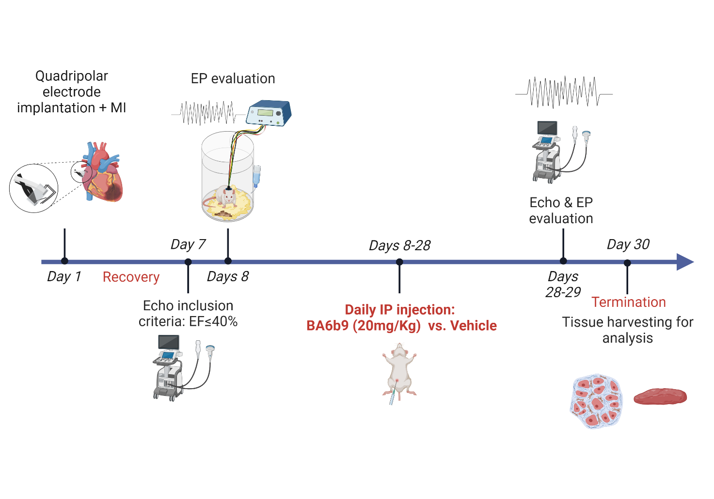

Figure 1: Experimental protocol and timeline for the assessment of the effects of BA6b9 treatment on the AF substrate of HFrEF rats post-MI. The initial operation (day 1) included left coronary artery ligation + quadrupolar electrode implantation for long-term EP evaluation. Rats with an EF ≤ 40% at seven days post-surgery were randomly assigned to receive daily injections of either BA6b9 or vehicle for 3 weeks. At the end of treatment, final echocardiography and EP studies were performed and hearts were collected for further analysis.

Figure 2: BA6b9 treatment reduces the AF substrate of post-MI rats. A. Confirmatory in vitro recordings. Left, Representative trace of WT SK4 currents in the absence and presence of 20 µM BA6b9, displaying a degree of inhibition of ≈56%. Right: Representative traces of an inside-out macro-patch from a CHO cell expressing WT SK4 channels in the absence and presence of 10 µM BA6b9 under internal saturating calcium concentrations. Currents were recorded by 10 repetitive 1s duration voltage ramps from -100 mV to +100 mV from a holding potential of 0 mV. B. BA6b9 treatment significantly reduced AF induction and AF duration. C. Example of post-burst AF episodes in the Vehicle (left) and BA6b9 (right) groups. D. Mean power spectrum of the AF episodes following long-term BA6b9 vs. vehicle treatment. Notably, the vehicle group demonstrated greater amplitudes over a wide range of frequencies relative to the BA6b9 group. Notch (arrow) indicates the zone where a notch filter was applied due to power supply-related noise (50 Hz). E. Quantitative analysis of delta between the power spectrum integrals of arrhythmic episodes and pre-burst NSR. Note the significantly higher values in the vehicle group compared to the AF events among BA6b9-treated rats.

Figure 3: Effect of BA6b9 on collagen deposition in the left atrium of rats with MI-induced HF. A. Statistical summary of total left-atrial fibrosis; Vehicle vs. BA6b9 treated rats, compared to control (n=7, n=8, n=4, respectively; one-way ANOVA, F (2, 16) = 16.53, Sidak's multiple comparisons test P=0.0001). B1. Representative Masson’s trichrome-stained histological LA cross-section from a control rat (left). B2-B3. Representative Masson’s trichrome-stained histological cross-sections of the LA from post-MI rats treated with vehicle (middle) or BA6b9 (right) for 21 days. Blue staining indicates collagen deposition. An inset in each photograph shows the full LA tissue in low resolution.

Figure 4: Effect of BA6b9 on SK4 expression in the left atrium of rats with MI-induced HF. A. Statistical summary of overall left-atrial SK4 expression; Vehicle vs. BA6b9 treated rats, compared to control (n=7, n=8, n=4, respectively; one-way ANOVA, F (2, 16) = 14.27, Sidak's multiple comparisons test P=0.0003). B1. Representative histological LA cross-section from a control rat (upper left), stained with DAB. B2-B3. Representative DAB-stained histological cross-sections of the LA from post-MI rats treated with vehicle (upper right) or BA6b9 (lower left) for 21 days. Brown staining intensity indicates the level of SK4 expression in the tissue, with darker brown indicating stronger expression. B4. Negative control SK4 staining. An inset in each photograph shows the full LA tissue in low resolution.

Figure 5: Effect of BA6b9 on NLP3 expression in the left atrium of rats with MI-induced HF. A. Statistical summary of entire left-atrial NLRP3 expression; Vehicle vs. BA6b9 treated rats, compared to control (n=7, n=8, n=4, respectively; one-way ANOVA, F (2, 16) = 35.38, Sidak's multiple comparisons test P<0.0001). B1. Representative histological LA cross-section from a control rat (upper left), stained with Sirius Red. B2-B3. Representative Sirius Red-stained histological cross sections of the LA from post-MI rats treated with vehicle (upper right) or BA6b9 (lower left) for 21 days. Positive red staining indicates NLRP3 expression. B4. Negative control NLRP3 staining. An inset in each photograph shows the full LA tissue in low resolution.

Figure 6: Effect of BA6b9 on Cx43 distribution in the atrial myocardium of rats with MI-induced HF. A. Statistical summary of Cx43 lateralization in the left-atrial myocardium (analysis of 200 atrial cardiomyocytes in longitudinal sections, per animal). Cx43 distribution was analyzed in immunofluorescent confocal images stained for Cx43 (red), cardiomyocyte membranes (green), and nuclei (blue). Cx43 lateralization was determined to be evident only if the red Cx43 staining paralleled/colocalized with the longitudinal cardiomyocyte membranal staining in green. Lateralization is presented and quantified as the ratio between Cx43 length (µm) when paralleled/colocalized with the cell membrane (+SEM) to the cell’s width+SEM. The histogram compares values for control, vehicle-treated, and BA6b9-treated rats (n=4, n=7, n=8, respectively; one-way ANOVA, F (2, 16) = 34.22, Sidak's multiple comparisons test P<0.0001). B1. Representative longitudinal section of the LA from a control rat (left), demonstrating clear and strong Cx43 expression in the intercalated discs. B2. Representative longitudinal section of the LA from post-MI rats treated with vehicle (middle). Note the marked lateralization of Cx43 as well as the evident reduction in Cx43 expression and increased cellular hypertrophy compared to control. B3. Representative longitudinal section of the LA from post-MI rats treated with BA6b9 (right) for 21 days. Note that Cx43 intensity and distribution in the intercalated discs are similar to those in control rat sections (significant decrease in Cx43 lateralization) with a corresponding reduction in cellular hypertrophy.

Figure 7: Effect of BA6b9 on collagen deposition, α-SMA expression, and SK4 expression in the LA epicardium of rats with MI-induced HF. A. Statistical summary of LA epicardial fibrosis (analysis of 6 randomized epicardial fields for each atrial section, total of 18 atrial-epicardium fields per animal); Vehicle vs. BA6b9 treated rats, compared to control (n=7, n=8, n=4, respectively; one-way ANOVA, F (2, 16) = 16.53, Sidak's multiple comparisons test P=0.0001). A1. Representative histological cross-section of LA myocardium attached to the epicardial tissue from a control rat, stained in light blue (left upper row). The analyzed area is marked by dashed lines. A2-A3. Representative histological cross sections of the LA from post-MI rats treated with vehicle (left middle row) or BA6b9 (left lower row) for 21 days. Sections A1-A3 were stained with Masson’s Trichrome. B. Statistical summary of LA epicardial α-SMA expression; (analysis: same as in A; Vehicle vs. BA6b9 treated rats, compared to control (n=7, n=8, n=4, respectively; one-way ANOVA, F (2, 16) = 16.53, Sidak's multiple comparisons test P=0.0001). B1. Representative histological cross-section of LA myocardium attached to the epicardial tissue from a control rat (middle upper row). B2-B3. Representative histological cross-sections of the LA in post-MI rats treated with vehicle (center) Vs. BA6b9 (middle lower row) for 21 days. Sections B1-B3 were stained with Sirius Red. C. Statistical summary of LA epicardial α-SMA expression; (analysis: same as in A; Vehicle vs. BA6b9 treated rats, compared to control (n=7, n=8, n=4, respectively; one-way ANOVA, F (2, 16) = 10.21, Sidak's multiple comparisons test P=0.0014). C1. Representative histological cross-section of LA myocardium attached to the epicardial tissue from a control rat (right upper row). C2-C3. Representative histological cross-sections of the LA in post-MI rats treated with vehicle (right middle row) or BA6b9 (right lower row) for 21 days. Sections C1-C3 were stained with DAB. Note the marked thickening of the atrial epicardium in MI rats compared to controls as well as the significant reductions in collagen deposition (A, A1-A3), α-SMA expression (B, B1-B3), and SK4 expression (C, C1-C3) in the BA6b9-treated rats compared to the vehicle group. An inset in each photograph shows the full LA tissue in low resolution.

