**First- and second-grade prospective teachers reconstructing definitions of polygon diagonals**

Huda Shayeb,1* Juhaina Awawdeh Shahbari,1 and Aehsan Haj-Yahya2

1 Al-Qasemi Academic College of Education, Baqa-El-Gharbia, Israel

2 Arab Academic Institute for Education, Beit Berl College, Kfar-Saba, Israel

The current study examined how prospective first- and second-grade mathematics teachers define the polygon diagonals concept, how they reconstruct their definition during and following an intervention, and how their concept images develop over time. Twenty-three prospective teachers participated in the study, during which they were asked to analyze mathematical events involving a conflict that could be resolved using a precise mathematical definition of a polygon diagonal. Data were collected from prequestionnaires, postquestionnaires, and observations of class discussions. The study findings indicate that before the intervention all participants provided incorrect definitions and struggled to identify nonprototypical examples of polygon diagonals in the prequestionnaire. However, the process of analyzing mathematical events helped the participants reconstruct their definitions of polygon diagonals and identify the critical attributes of this concept, which improved their ability to extend the concept’s image to include nonprototypical examples. The participants’ improved understanding was evident in the significant improvements in the postquestionnaire.

**Keywords**: prospective mathematics teachers, polygon diagonals, concept image, concept definition, mathematical events

# **1** **Introduction**

Based on the model proposed by Vinner and Hershkowitz (1980) and later by Tall and Vinner (1981) regarding overall mathematical concepts, the acquisition of geometrical concepts requires two main components: concept definition and concept image. The concept definition is the verbal-mathematical description of the concept, whereas the concept image is the cognitive structure that represents the concept in the learner’s mind that includes all the mental pictures and associated properties and processes (Tall & Vinner, 1981, p. 2). Vygtosky’s sociocultural constructivism, as emphasized by Liu and Matthews (2005), underscores the pivotal role of social interaction and cultural influences in learning. According to Vygotsky, learning involves collaborative engagement, constructing knowledge through dialogue and guided experiences. Similarly, Tall and Vinner’s (1981) concept image aligns with this view, illuminating the evolving mental representations of concepts and exemplifying various processes. Learners’ constructions exhibit a wide range of alignments with the concept, as they refine their concept image over time. Both theories emphasize interaction, context, and the continuous evolution of understanding, shaping individuals’ conceptualization through socially-mediated knowledge construction facilitated by well-informed instruction and pedagogy. When the concept image matches the concept definition, the concept has been grasped. A mismatch between these two components can negatively impact a student’s ability to identify examples, construct examples, and engage in proving processes (Haj-Yahya & Hershkowitz, 2013; Fujita & Jones, 2007; Marchis, 2012). Understanding mathematical definitions of concepts is essential to identifying critical features of geometric shapes and developing geometrical understanding (Haj-Yahya et al., 2022).

Early-grade teachers are responsible for laying the foundation for future learning in mathematics, and research has consistently shown that teachers who have a strong understanding of the mathematical concepts they teach are better able to help their students develop their understanding and skills (e.g., Shrestha, 2022; Hill et al., 2005). Specifically, knowledge of geometry and teachers’ geometric thinking levels affect their students’ geometric thinking levels (Pavlovičová et al., 2022).

Unfortunately, studies have also shown that teachers’ knowledge of geometry is generally limited. For example, Tsamir et al. (2014) reported that only a small percentage of early-year teachers can fully define geometric concepts. Later research reported similar findings (Haj-Yahya, 2019; Haj-Yahya et al., 2019). Shahbari’s (2022) study revealed a low level of knowledge in geometry among practicing and prospective first- and second-grade mathematics teachers compared with other mathematics fields. Previous studies also indicated limited mathematical content and pedagogical knowledge among first- and second-grade mathematics teachers. For example, Shayeb and Tabach (2020) found that half of the first-grade teachers in their study had difficulty identifying nonprototypical examples of a pyramid. Malzahn (2002) reported that close to 50% of the second-grade math teachers in the study expressed a desire to develop a greater level of content knowledge in the subjects they teach. Additionally, half of the teachers emphasized the significance of enhancing their comprehension and understanding of student thought processes.

Therefore, there is a need to develop first- and second-grade mathematics teachers’ knowledge. A useful tool for helping teachers better understand mathematical ideas is engaging in mathematical event analyses (Stockero et al., 2019). Such analyses might create a community of learners and allow discussion and argumentation around mathematical concepts. The process of argumentation—in which claims are presented, evaluated, and either accepted or rejected—is a way to build up a whole class understanding (Toulmin, 2003). In this study, we examined whether analyzing mathematical events related to geometrical definitions affected the process of defining for prospective teachers.

It is pivotal for students to understand the concept image and concept definition of geometric concepts alongside a coherent exploration of the logical structure between them. As teachers, fostering insights into these aspects is essential to shaping their understanding of parallel geometric concepts. Although the curriculum traditionally might not heavily focus on diagonals in concave polygons during Grades 1−12, acknowledging the foundational content knowledge of geometry remains crucial for prospective teachers, even at the earlier stages of Grades 1 and 2.

**2** **Literature review**

## **2.1** **Geometric thinking and definitions**

Pierre and Dina Van Hiele (1958) proposed a theory on the development of geometric thinking that involves five sequential and hierarchical levels. At level 1, students recognize geometric figures based on their shape as “a whole” and compare them with prototypes or everyday objects. At level 2, students can establish a list of necessary properties of a figure but don’t see relationships between them or recognize that some imply others. They use informal analysis of components and attributes to reason about geometric concepts. Level 3 is characterized by the students’ ability to recognize the logical structure among properties of the figure, provide meaningful definitions and informal arguments, and distinguish between the necessary and sufficient properties in a set to determine the concept. At level 4, students can reason formally within the context of a mathematical system, construct proofs, and comprehend the role of axioms, theorems, and definitions. At level 5, students can grasp the establishment of mathematical systems and become proficient in using all types of proofs. They demonstrate a comprehensive understanding of both Euclidean and non-Euclidean geometry. The hierarchy in Pierre and Dina Van Hiele’s theory emphasizes the significance and roles of definitions within the formal geometrical system. Mathematical definitions are essential for understanding mathematical concepts’ meanings and solving problems such as constructing theorems and proofs (e.g., Haj-Yahya et al., 2022). The Van Hiele model provides a valuable theoretical lens through which to analyze students’ engagement with definitions in geometry, a crucial stepping stone in their progression toward more sophisticated geometric reasoning and proof construction.

In Vinner’s (1991) study on the significance of definitions, he made five assumptions. One of the assumptions was that learners acquire concepts through their definitions. Another assumption was that students employ definitions to resolve problems and prove processes. In addition, definitions should be concise and elegant, aiming for minimalism. However, it is essential to acknowledge that definitions can be subjective and may vary based on arbitrary choices. Zaslavsky and Shir (2005) mentioned imperative features of mathematical definitions. These features include the absence of any inherent contradiction between the concept attributes, the absence of ambiguity, the absence of any changes under one or another representation of the concept, hierarchical (based on previous concepts) formulation, and noncircularity. Regarding the logical structure of the mathematical definition, mathematicians and mathematics educators start with an arbitrary definition that is equivalent to other definitions of the same concept; for example, when we adopt the initial definition of a rectangle is (a parallelogram with at least one right angle), we can then logically deduce several equivalent definitions, such as a parallelogram with diagonals of the same length. In such cases, one statement is chosen from a set of logically equivalent statements to define the concept, and each statement in the set is used as a legitimate definition for the particular concept (Harel et al., 2006; Usiskin et al., 2008; Vinner, 1991). The most controversial optional feature is the requirement that a mathematical definition be minimal. A definition is considered minimal if it has no superfluous conditions and it includes the necessary and sufficient properties and attributes to deduce the remaining attributes of a concept, whereas an uneconomical definition lists all the properties and attributes of a concept, some of which can be omitted and deduced from others. Mathematical educators have discussed the tendency to define a concept using the latter approach, with long lists of its properties and attributes (e.g., Haj-Yahya, 2022; Haj-Yahya et al., 2022). Although such lengthy descriptive definitions may be accurate, many mathematics educators prefer minimal definitions, choosing to omit attributes that could be inferred from other attributes (e.g., Leikin & Winicky-Landman, 2001; Linchevsky et al., 1992; Vinner, 1991; Zaslavsky & Shir, 2005). For example, defining a rectangle as a parallelogram with right angles and diagonals of equal length is uneconomical. The attribute of equal diagonal length is superfluous because it can be deduced from the other attributes. In other words, the attribute of having right angles within a parallelogram inherently ensures that its diagonals will be of equal length. Lastly, an incorrect definition includes either nonnecessary attributes or insufficient attributes. For instance, defining a kite as a quadrilateral with perpendicular diagonals includes insufficient attributes, and defining a trapezium as a quadrilateral with perpendicular diagonals includes unnecessary attributes (Choi et al., 2008; Markovic & Romano, 2013; de Villiers et al., 2009; Zaslavsky & Shir, 2005).

Previous studies have identified difficulties that both students and teachers face when they are required to define mathematical concepts and reflect on the structure and meaning of these definitions (e.g., Haj-Yahya, 2022; Haj-Yahya et al., 2019). Teachers struggled with using uneconomical definitions, incorrect definitions, or rejecting equivalent definitions of mathematical concepts. For many students and teachers, the essence and the nature of the geometrical concept is more important than the essence of the definition, so students and teachers rejected mathematical definitions that did not emphasize the essence of the concept (Haj-Yahya, 2019; Haj-Yahya, 2022; Haj-Yahya et al., 2019). Difficulties in understanding definitions often arise from the relationship between the concept image and the concept definition, especially in cases where the concept image is limited and inaccurate (Fujita & Jones, 2007; Vinner, 1991). When a disconnect exists between an individual’s mental image and the definition of the geometric concept derived from practical experience and formal knowledge, difficulties can arise (Seah et al., 2016). In this case, the personal concept definition diverges from the formal concept definition accepted by the broader mathematical community. The personal understanding of a concept is susceptible to interpretations and individual perspectives, which can influence its deviation from the formally accepted definition (Tall & Vinner, 1981). In a study of 40 prospective teachers, participants were asked to define a rectangle and a rhombus. The results showed that the learners' understanding of mathematical concepts was influenced by their prototypical concept image, which excludes non-prototypical examples. More than half of the participants thought that a rectangle must have two sides that are longer than the other sides (Pickreign, 2007).

Maymon-Erez and Yerushalmy (2007) highlighted the efficacy of dynamic geometry software, emphasizing how its users understand that manipulating different examples of a concept does not alter its critical features across variations. This significantly contributes to enhancing the concept image of geometrical concepts. In line with this, Prusak et al. (2013) advocated for instructional design focused on fostering problem-solving skills and conceptual learning. Their study involving third-grade students employed a curriculum structured around five guiding principles: encouraging multiple solutions, creating collaborative learning environments, introducing socio-cognitive conflicts, providing tools for hypothesis validation, and prompting reflection on solutions. Implementing tasks aligned with these principles notably improved students’ development of the concept image concerning the area concept. This illustrates a coherent approach to nurturing a deeper understanding of mathematical concepts, aligning insights from dynamic geometry software with effective instructional strategies.

In the current study, we focused on polygon diagonals, which have been identified as an essential but difficult concept. A diagonal is defined as a line segment that connects two nonadjacent vertices of a polygon. Previous research found that students often struggle with understanding polygon diagonals. For example, Wilson and Schmidt (2005) found that high school students had misunderstandings about polygon diagonals, such as the belief that the number of diagonals equals the number of sides in the polygon. Cunningham and Roberts (2010) reported that prospective teachers also find it challenging to identify nonprototypical examples of diagonals in polygons, such as horizontal diagonals or external diagonals. Similar challenges were reported by Gutiérrez and Jaime (1999): Prospective teachers were given the definition of an altitude and asked to draw an altitude from a given vertex. It was found that the prospective teachers ignored the given definition and were unable to identify and build exterior elevations, coalescing with one of the sides (right-angled triangles). However, it was easy for them to build altitudes inside the triangle from top to bottom—that is, the internal features that distinguish the limited concept image were exclusive to prototypical examples of segments.

Vinner (1991) suggested using activities that present learners with a conflict that can be resolved using a precise mathematical definition. This helps students understand the importance of definitions as a tool for effective mathematical communication. The current study adopts mathematical event analyses to follow Vinner’s recommendation.

## **2.2** **Mathematical events**

Mathematical events refer to the dynamic interplay between teacher actions, student engagement with tasks or responses, and the subsequent adjustments made by the teacher in response to these interactions (Markowitz, 2003). Mathematical events occur almost every day in a learning environment. An event might be a student’s question or comment; it could be an ambiguous statement in a textbook or a teacher’s remark. Frequently, these events offer unique opportunities to explore an idea, connect mathematical concepts, or reinforce ideas that are developing within the minds of mathematical learners (Conner et al., 2011).

The use of analyses of events as a pedagogical tool is common in various fields, including law, business management, medicine, and education. This approach enables learners to explore critical issues and situations relevant to theory and practice (Walen & Williams, 2000). In teacher training, events are regarded as an essential tool, and researchers have used them for many years (Tirosh et al., 2019; Herbst et al., 2017; Shulman, 1992). Participating in analyses of mathematical events might help teachers to gain insight into students’ diverse ways of thinking and responding (Markowitz, 2003). This approach has the potential to foster critical thinking and enhances teachers’ understanding of theory, preparing them to be reflective practitioners (Richardson, 1991). After participating in such exercises, teachers have a repository of precedents they can draw upon in their classroom practice (Shulman, 1992). The significance of the events lies in the discussion that takes place around them, through which a community of learners is formed (Richardson, 1991). The ensuing debate is based on an argumentative discourse (Toulmin, 1969, 2003), where learners explain their reasoning, listen to other’s perspectives, and agree or disagree with the arguments put forward.

Moreover, the role of the learner changes from being a marginal participant in the mathematical discourse to a more central one, contributing to knowledge construction (Lave & Wenger, 1991). Analyses of mathematical events might provide an opportunity to build on learners’ mathematical thinking, helping them understand crucial mathematical concepts (Stockero et al., 2019). Therefore, the incidents should be rich and substantial, allowing for multiple levels of analysis and interpretation to capture the complexity of teaching mathematics in different contexts (Levin, 1995). It is important to monitor the mathematical progress of a class at the whole class level rather than focusing on the individual thinking of each participant. This allows for an understanding of the accepted mathematical meanings within a class community, where the class is treated as its own entity (Toulmin, 1969, 2003).

## **2.3** **Research questions**

The current study examined how the understanding of polygon diagonals among prospective teachers evolved into a more comprehensive class understanding as they participated in analyzing mathematical events related to the definition of polygon diagonals and engaged in discussions and arguments with their peers. This included examining how participants’ definitions of polygon diagonals developed and how they used evidence and reasoning to support their ideas. Given the purpose of the study and according to the theoretical background, we formulated the following questions:

1) How do first- and second-grade prospective mathematics teachers define the polygon diagonals concept before and after the analyses of mathematical events related to the definition of polygon diagonals?

2) How do first- and second-grade prospective teachers reconstruct their definitions through analyses of mathematical events related to the definition of polygon diagonals? How does their concept image develop over time?

# **3** **Methodology**

## **3.1** **Research context**

The study was conducted at the College for Arabic Speakers for Teacher Training as a part of a geometry teaching course designed for individuals looking to expand their teaching certification in first and second grades. The course is typically considered a second course and falls under the mathematics education component alongside a calculus teaching course for first and second graders. The course consisted of 14 sessions, each lasting 90 minutes, and it focused on four key areas of geometric thinking: properties of shapes, place and space relations, transformations and symmetry, and visualization, concept minimal and nonminimal definitions. The course content was developed based on the National Council for Teachers of Mathematics (NCTM, 2000) standards for geometry education for children in kindergarten through second grade. These standards outline the expected achievements of students in geometry and provide teachers with a framework for age-appropriate instruction. The research took place over two 90-minute sessions in the middle of the course and focused on polygons. The teaching-learning process was based on discussions during mathematical events, built according to Markowitz’s (2003) clarification of affective mathematical events. The two main mathematical events, each consisting of several sections, focused on students’ mistakes that occur when they deal with polygons and were based on previous studies (e.g., Tsamir et al., 2008) and the researchers’ experience teaching geometry and extracting relevant information from previous research. The tasks provide opportunities to expose nonprototypical diagonals, such as part of a diagonal intersecting with one side. The case of the concave polygon has an external diagonal, a diagonal extending outside and inside the polygon.

The first researcher conducted the course and was accompanied by other researchers. She presented events ’that encouraged prospective teachers to build knowledge of polygon definitions. Figure 1 presents an example of one event including context, a task, and a student’s response. The researcher’s role was to facilitate learning, which involved guiding and motivating prospective teachers to learn, develop, and build their knowledge on their own while providing opportunities for them to examine ways to analyze and discuss events.

Figure 1. Example of a diagonal event presented during the study

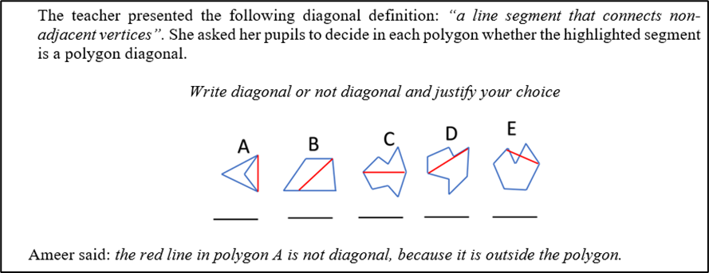

## **3.2** **Participants**

The present study was conducted with 23 prospective teachers who were studying for their teaching certification for first and second grades at a college for teacher training in the Arab community in Israel. The participants were fourth-year prospective teachers who had completed three years of studies. The participants were selected based on availability and accessibility rather than through a random or systematic process (i.e., a convenience sampling method). They were all the participants in a geometry teaching course that the first author taught. All the participants, who were enrolled in the geometry teaching course we mentioned in the earlier section, were familiar with the notions of concave and convex polygons and adjacent and nonadjacent sides.

## **3.3** **Data sources and procedure**

The data for this study were collected from three sources:

* *Prequestionnaire:* The prequestionnaire consists of two tasks; the participants were first asked to provide the definition of polygon diagonals and then to decide whether a particular segment could be considered a diagonal of the polygon. The first task aims to expose participants’ definitions of a polygon diagonal, and the second task aims to assess participants’ identification of nonprototypical examples of polygon diagonals (see Appendix 1).
* *Postquestionnaire:* The postquestionnaire consists of three tasks; the first task is similar to the first in the prequestionnaire. In the second task, the participants were asked to draw polygon diagonals from a specific vertex*.* In the third task, two students’ solutions for drawing polygon diagonals from a specific vertex were presented to the participants, and based on that, participants were required to analyze students’ conceptions of a polygon diagonal definition (see Appendix 2). The objective of the second task is to assess the practical application of the polygon diagonal definition in nonprototypical examples, whereas the third task emphasizes critical thinking and aims to evaluate how well participants can communicate their understanding of the polygon diagonal definition in a pedagogical context.
* *Observations:* The first researcher video recorded class discussions and transcribed the discussions.

At the course’s first meeting, the prequestionnaire was administered to participants, and they were required to fill out the postquestionnaire at the end of the course.

## **3.4** **Data analyses**

The prequestionnaires and postquestionnaires were analyzed using thematic content analysis (Braun & Clarke, 2006). We used the categories identified in Tsamir et al.’s (2015) research on the definition of geometric concepts. We found three categories consistent with Tsamir et al.’s (2015) categories: (a.1) minimal correct definitions, (a.2) correct definitions that consist of nonminimal definitions, and (b.1) incorrect definitions that consist of insufficient attributes (i.e., are missing critical attributes). In addition to these categories, we generated a new fourth category: (b.2) incorrect definitions based on noncritical attributes. We counted the frequencies of each category. For the correct and minimal definition of a polygon, we used “a line segment that connects any two nonadjacent vertices” from the Israel Ministry of Education’s website (2023).

For the observations, we decided that a Toulmin model (1969, 2003) would afford the best representation of the ideas that emerged during the discussion. Therefore, we started by creating an argumentation log to document the observations. Then, we constructed the core of the argument, which consisted of three components: data, claim, and warrant. More components were added based on the participants’ responses, such as backings, qualifiers, and rebuttals. In Toulmin’s model (1969), in every argument the speaker presents a claim. If the claim is challenged, evidence or data can be presented to support it. In a class environment, the Toulmin model involves an incident when one of the listeners/learners does not understand how the data relates to the speaker’s conclusion. In that case, the speaker is asked to clarify why and how the data leads to the conclusion. In other words, the authority or credibility of the justification can be challenged, and the speaker must provide backup to explain why the justification and the core of the argument are valid. Therefore, in this study, the Toulmin model examined the participation contribution patterns, argument structure, and key ideas development related to the concept image and concept definition of polygon diagonals (see Table 1).

Table 1. Explanations and analyses of Toulmin model components

|  |  |  |
| --- | --- | --- |
| Toulmin’s model components | Explanation | Example |
| Claim | The claim is a statement that is being argued for or against | The red segment is a diagonal. |
| Data | The data are the evidence or reasons that support the claim | Identification of the diagonal from vertex 1 to vertex 4. |
| Warrant | The warrant is the principle or rule that connects the data to the claim | Vertices 1 and 2, 1 and 3 are adjacent |
| Backing | The backing is additional evidence or support for the warrant. | Vertices 1 and 4 are not adjacent |
| Qualifier | The qualifier is a statement that limits the degree to which the claim is true | The only diagonal is one connecting vertex 1 to vertex 4. |
| Rebuttal | The rebuttal is a counterargument or counterclaim | Counterargument suggesting that the red segment is a side, not a diagonal, because it aligns with one of the polygon’s sides. |

# **4** **Results**

In this section, we present results from the prospective teachers’ prequestionnaire and postquestionnaire to illuminate their understanding and reconstruction of the diagonal concept definition and their ability to identify polygon diagonals. Toulmin’s model represents the argumentation and key concepts raised in the class discussion as the participants reconstructed the definition of polygon diagonals and the relationship between the concept image and its definition. Two episodes from the transcript are included here to illustrate the discussion among the prospective teachers.

## **4.1** **Definition and identification of polygon diagonals: Before and after event analysis**

Table 2 presents the prospective teachers’ written definitions, as they emerged from the prequestionnaire and postquestionnaire, in terms of correctness and inclusion of critical attributes of polygon diagonals using mathematical language with representative examples.

Table 2. Correct and incorrect polygon diagonal definitions

|  |  |  |  |  |
| --- | --- | --- | --- | --- |
|  |  | Frequency | | Examples: A polygon diagonal is … |
|  |  | Pre | Post |
| Correct definitions | Minimal | – | 13 (57%) | A line segment that connects two nonadjacent vertices  A line segment that connects any two nonadjacent vertices |
| Nonminimal | – | 7 (30%) | A line segment that connects any two nonadjacent vertices. The diagonal is completely external or internal or partly internal and partly external  A straight line connecting any two nonadjacent vertices. It can be inside or outside the polygon or part inside and part outside |
| Incorrect definitions | Insufficient (missing critical attributes) | 13 (57%) | 2 (9%) | A line segment inside the polygon  A line segment that connects two vertices (post)  A line segment that connects a vertex to a parallel vertex (post)  A straight line that connects a vertex to a parallel vertex |
| Based on noncritical attributes | 10 (43%) | 1 (4%) | A straight line that divides a shape into two equal parts  The diagonal crosses the polygon  Straight line that connects any two angles  A straight line connecting the sides  The length of the line |

Table 2 shows that all participants provided incorrect definitions in the prequestionnaire. It shows that 57% of the participants wrote an incorrect, insufficient definition that was missing critical attributes, and the vast majority mentioned only the critical attribute of “a line segment” or “straight line” without mentioning the nonadjacent vertex. The difference between these two is that a straight line in geometry is a line that connects two points in a plane and extends to infinity in both directions. A line segment is a section of a line bounded by two points or connecting two points. In addition, 43% of the participants added noncritical attributes in the diagonal concept definition, such as using the attributes “inside the polygon,” “crosses the polygon,” and “divided into two equal parts.” These noncritical attributes indicated a limited concept image of a diagonal being just inside the polygon.

The findings provided in the postquestionnaire show that most participants improved their definitions. For example, 87% of the participants wrote the correct definition (minimal or nonminimal), and 57% of them gave a minimal definition that included necessary and sufficient attributes, including critical attributes of “a line segment” and “nonadjacent vertices.” In addition, 30% of the participants gave a nonminimal definition that included attributes focused on the diagonal location targeted to expand the concept image, such as “completely or partly internal.” These additional attributes indicate that their concept image of a diagonal developed over time. In addition, the results obtained from the third task postquestionnaire (see Appendix 2) showed that all participants were able to notice possible student mistakes (such as diagonals located only in the interior part of the polygon) relevant to a polygon diagonal definition based on example drawings of polygon diagonals.

## 

## **4.2** **Definition development and the relationship with a concept image**

The discussions during the sessions regarding nonprototypical examples of diagonals contributed to the participants’ understanding of the concept definition of diagonals, which caused various arguments shown in Table 3 related to the diagonal definition. The arguments that emerged from participants show that, although the minimal diagonal definition was presented throughout the meeting, they were not always aware of the gap between the prototype example of the diagonal and the analytical aspect arising from the definition. However, during the argumentative discourse during the sessions, the participants identified the critical attributes of the diagonal as well as others that should not be considered. The evidence for this finding can be found in the last argument in the meeting (see Table 3, argument 13), which refers to the need to check all the critical attributes found in the diagonal definition. Such a process is the relationship between the concept image and its definition.

Table 3. Arguments that emerged during participants’ diagonal events

|  |  |
| --- | --- |
| Arguments numbers | Arguments title |
| 1 | The diagonal definition is incomplete |
| 2 | The diagonal definition is complete (counterargument to argument 1) |
| 3 | The line segment that connects two vertices in a polygon that is entirely outside the polygon is not a diagonal |
| 4 | The number of diagonals in a concave quadrilateral is two (episode 1) |
| 5 | The number of adjacent vertices in a concave quadrilateral is four (episode 1) |
| 6 | Eight adjacent vertices in a concave quadrilateral (episode 1, counterargument to argument 5) |
| 7 | Locations of all diagonals in a concave octagon |
| 8 | The line segment that connects a vertex to a side is not a diagonal |
| 9 | The line segment that connects two vertices and is entirely contained in the polygon is a diagonal |
| 10 | The line segment that intersects the side isn’t a diagonal (episode 2) |
| 11 | The line segment that intersects the side is a diagonal (episode 2, counterargument to argument 10) |
| 12 | The line segment that goes partially inside the polygon and partially outside it is called a diagonal |
| 13 | The line segment direction that connects two adjacent vertices in a polygon is not a critical attribute of diagonal |

Table 3 shows that the participants used two concepts: line segment and straight line. At the beginning of the discussion, the participants used the straight line concept instead of a line segment. They were not aware of the difference between these two concepts: a straight line in geometry is defined as a line that connects two points in a plane and extends to infinity in both directions, whereas a line segment is defined as a section of a line bounded by two points or connecting two points.

Due to space constraints, only two episodes are shared here. A portion of the exchange from the first episode is shown in episode 1:

*Episode 1: The number of diagonals in a concave quadrilateral*

|  |  |  |  |
| --- | --- | --- | --- |
| [1] | Instructor | How many diagonals does the polygon in front of you have? |  |
| [2] | Sina | There is another diagonal in the middle, from vertex 1 to vertex 4 |  |
| [3] | Instructor | So, how many diagonals does a polygon have? |  |
| [4] | Riwaa | There is only one diagonal |  |
| [5] | Instructor | Why? |  |
| [6] | Riwaa | According to the definition? |  |
| [7] | Instructor | What did you infer from the definition? |  |
| [8] | Riwaa | The only diagonal is the one connecting vertex 1 and vertex 4 | [She only meant those vertices.] |
| [24] | Instructor | What are the numbers of adjacent vertices in the polygon? |  |
| [25] | Riwaa | 2 and 4…..4 and 3 | [She did not explicitly say the number of vertices. But she mentioned the symbol of each vertex by its number in the image.] |
| [26] | Instructor | Are these the only adjacent vertices? |  |
| [27] | All participants | No... | [They mean that there are more adjacent vertices.] |
| [28] | Instructor | Riwaa, please |  |
| [29] | Riwaa | Ahhh, … 2 and 4, 4 and 3, 2 and 1, 1 and 3 |  |
| [30] | Instructor | What do you conclude about vertices 1 and 4? Are they adjacent vertices? |  |
| [31] | Riwaa | No, are not adjacent |  |
| [32] | Instructor | And what about vertices 2 and 3? |  |
| [33] | Riwaa | Are not adjacent. I can connect a diagonal between them |  |
| [34] | Instructor | Are you convinced that the red segment is a diagonal? |  |
| [35] | Riwaa | Yes, of course. The red segment is a diagonal |  |

The discussion in this episode began with a question: How many diagonals does the polygon in front of you have? [1]. The claim was made by Riwaa [4]. In terms of Toulman’s model, Riwaa’s claim can be broken down as in Figure 2.

Figure 2. Argument 4: Number of diagonals in a concave quadrilateral is two [2-8]

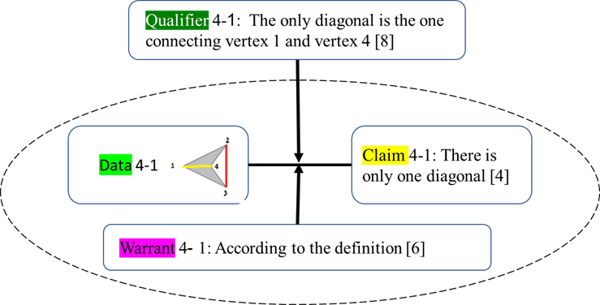

From Figure 2, we can see that Riwaa’s concept image only allows for internal diagonals. She does not accept the external diagonal and declares that this polygon has only one diagonal, which is the prototypical one.

Later, the next argument about the number of adjacent vertices in a concave quadrilateral was made by the same participant, Riwaa (see Figure 3).

Figure 3. Argument 5: Number of adjacent vertices in a concave quadrilateral is four [1-27]

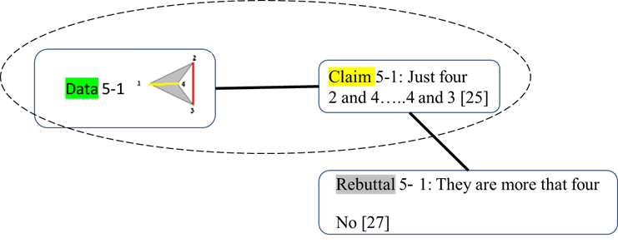

From Figure 3, we can also conclude that Riwaa does not understand the critical attribute of the diagonal definition that is relevant to nonadjacent vertices. It seems that for Riwaa the word ‘nonadjacent’ is problematic. Therefore, Riwaa fails to detect all nonadjacent vertices. For the definition to have meaning, the words within the definition need to have generalized meaning. In trigonometry, an adjacent side is next to an angle, and opposite means "on the opposite side" of the angle. Nonadjacent might be taken to mean directly opposite in the first instance.

Immediately, the following argument is made by Riwaa, which is a counterargument to the previous argument (see Figure 4).

Figure 4. Argument 6: Eight diagonals adjacent vertices in a concave quadrilateral [1-33] (counterargument to argument 5)

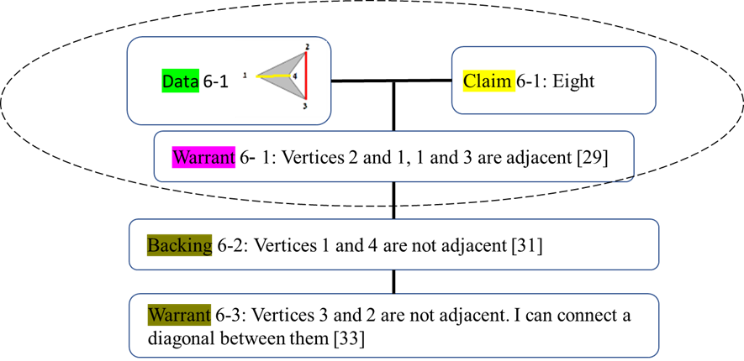

Based on the first argument in Figure 2, it can be seen that Riwaa’s concept image of a polygon diagonal does not match its definition; she could not identify the diagonal outside the polygon. She did not have this example from the examples space related to the diagonal concept. During the discussion, especially in the second argument, it became clear that Riwaa did not recognize the concept of adjacent vertices. As a result, she excluded the external diagonal from all diagonals of the displayed polygon. The evidence is that when she knew all adjacent vertices, she understood the definition well, especially the critical attributes of the diagonal definition. After argument 6 was made (see Figure 4), several participants agreed with everything that Riwaa said [33]. This broad consensus is a sign of normative agreement that we believe strengthens the teachers’ utterances in the context of argument 6.

Based on argument 6, the instructor first prompted the participants to consider which vertices were adjacent and nonadjacent by providing nonprototypical examples of diagonals. As a result, they augmented their concept images of diagonals.

*Episode 2: The number of diagonals in a concave octagon*

|  |  |  |  |
| --- | --- | --- | --- |
| [1] | Instructor | Is the red segment a diagonal or not? |  |
| [2] | Tamir | No … I do not know ... not sure because the segment is above the polygon side. Also, it passes through it. |  |
| [3] | Sower | I think that the red segment is a diagonal, regardless of its position relative to the side of the polygon. The most important factor in determining whether a segment is a diagonal is whether it connects two vertices that are not adjacent; in other words, both vertices are not on the same side. For instance, if the segment connects vertices 3 and 4, it would not be considered a diagonal. |  |
| [4] | Tamir | Ahh ... the diagonal is between 4 and 8. |  |
| [5] | Sower | Exactly. If the segment is congruent or across the side that connects vertexes 3 and 4, it cannot be considered a diagonal. Because the two vertices are on the same side. So it is considered a side, not a diagonal. |  |
| [6] | Sajil | Right. It is a side. |  |
| [7] | Sower | The question refers to the segment connecting vertices 4 and 8, not the segment connecting 3 and 4. |  |
| [8] | Instructor | Is it a diagonal, in your opinion? |  |
| [9] | Sower | Yes. It fulfills the definition conditions. |  |
| [10] | Participants | Yeah, right. The segment connects two nonadjacent vertices. |  |
| [11] | Instructor | Is what Tamir said at the beginning true? Can the segment be removed from the list of given polygon diagonals if it is congruent with one of its sides? Is the attribute that the segment covers a side part or a whole side critical? |  |
| [12] | Participants | No. This is not critical. |  |
| [13] | Sower | This is how we agreed before: that the segment’s location is not essential and is not a critical attribute. Whether internal or external, or even if it covers or intersects the side. |  |

During the discussion, the instructor asked: Is the red segment a diagonal or not? [1]. The claim was made by Tamir [4]. In terms of Toulmin’s model, Tamir’s claim can be broken down in Figure 5.

Figure 5. Argument 10: The line segment that intersects the side isn’t a diagonal [2-12]

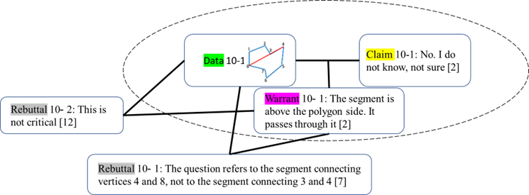

Immediately, the argument in Figure 6 was made by Sower, which is a counterargument to the previous argument.

Figure 6. Argument 11: The line segment that intersects the side is a diagonal [1-13] (counterargument to argument 9)

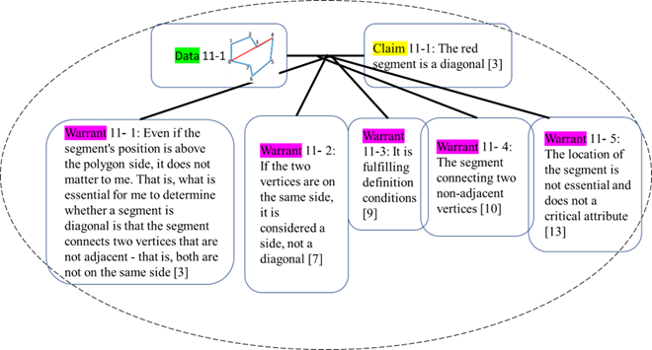

Based on Figure 6, it appears that Tamir’s understanding of the concept image of a polygon diagonal did not align with its definition. Tamir could not identify a diagonal that intersects the side of the polygon and did not have that example from the examples space for the concept. However, Sower immediately rebutted Tamir’s argument. As a result, Sower presented counterclaims to Tamir’s claim and contributed data and part of the warrants, with assistance from Sajal and other participants. This led to a claim collaboratively constructed by Sower and all participants, stating that the segment in question matched the definition of a diagonal. All participants agreed on a critical attribute in the definition and that the segment location was not a critical attribute for a diagonal definition, whether internal or external or even if it covers or intersects the side.

Consistent with the discussion examples during the sessions regarding nonprototypical examples of diagonals, findings from the prequestionnaire and postquestionnaire reflect the development process in reconstructing definitions through analyses of mathematical events related to the definition of polygon diagonals. The prequestionnaire identification findings indicate that all participants identified the prototypical example presented. All incorrect identifications related to claiming that a nonprototypical example was not an example of a polygon diagonal. None of the participants identified the concave polygon diagonals as examples where a diagonal was completely external (see Appendix 1, Figure A) or partly internal and partly external (see Appendix 1, Figure E). This means these diagonals are not part of the concept image of polygon diagonals. Thus, we can infer that the concept image is not closely connected to the concept definition and that the polygon diagonals concept image was limited before event analysis. However, the results of the postquestionnaire indicated that participants’ concept image of the diagonal improved. All the participants were able to successfully draw nonprototype examples, such as partly internal and partly or completely external polygons and across one polygon side (see Figure 7). In addition, in the same questionnaire, the participants recognized that the two students had a common misconception about the polygon diagonal definition. All participants (23) recognized that the two students were aware that the diagonal connects two nonadjacent vertices and that it must be entirely inside the polygon. Furthermore, most of the participants (21) discovered the difference between the two students: The first knows that the diagonal is a segment, but the second student knows that the diagonal is a line (straight or curved). Therefore, we can infer that the concept image is closely connected to the concept definition.

Figure 7. Non-prototype examples of diagonal

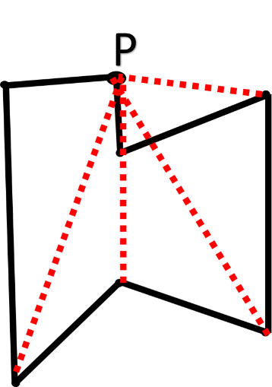

We can summarize and emphasize the importance of the mutual relationship between concept image and concept definition, especially in cases where the concept image is limited and inaccurate.

## **4.3** **Tracking participants’ development**

The results obtained from the prequestionnaire, postquestionnaire, and observations indicate developments in the participants’ definition and identification of the polygon diagonal. To illustrate their development, we can review the process of one participant, Riwaa. Riwaa was selected because of her questionnaire answers and the fact that she actively participated in the argumentative discourse during the event analysis. Figure 8 tracks the development in Riwaa’s knowledge about polygon diagonals.

A polygon diagonal has two critical attributes: a line segment and two nonadjacent vertices. According to Figure 8, Riwaa’s prequestionnaire responses relevant to a diagonal-polygon definition were inaccurate. Her definition, “A straight line that connects a vertex to another vertex,” was missing the full critical attributes of a polygon diagonal because she did not mention the necessary critical attributes: nonadjacent vertices and segments. Thus, it is not surprising that she did not correctly identify examples and nonexamples of diagonals in the second part of the prequestionnaire. In addition, Riwaa’s reliance on her concept images did not always lead to correct identifications. At the beginning of the class discussion (see episode 1), Riwaa did not differentiate between sufficient critical attributes (connecting two nonadjacent vertices) and insufficient critical attributes (connecting one vertex to another one). However, on the postquestionnaire, Riwaa wrote a minimal definition, “A line segment that connects two nonadjacent vertices,” indicating she knew the total number of diagonals. She was also able to draw it. This is evidence that she benefited from the class discussion, as well as the contributions of other participants, in her reconstruction of a definition for a polygon diagonal.

Figure 8. Riwaa (case study) definition development process

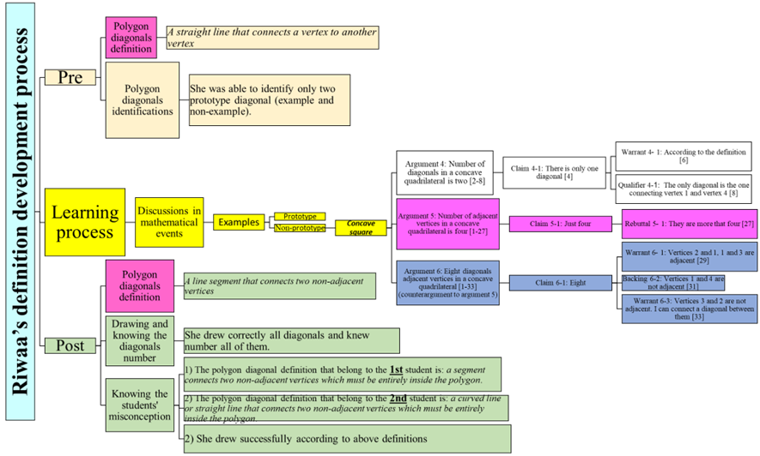

# 

# **5** **Discussion**

The first research question of the current study sought to learn how first- and second-grade prospective mathematics teachers define the concept of polygon diagonals before and after the analyses of mathematical events related to the definition of polygon diagonals. The study’s results show that prospective teachers could identify prototypical examples of polygon diagonals before engaging in events analyses, but they had difficulties identifying nonprototypical examples. These results point to the influence of the noncritical properties of the diagonal concept—the diagonal is completely drawn inside the shape—and this finding is consistent with previous studies that show similar findings (Gutiérrez & Jaime, 1999; Haj-Yahya, 2020; Haj-Yahya et al., 2016). Most participants provided incorrect definitions in the prequestionnaire; did not recall the correct definition of polygon diagonal when mentioning noncritical properties, such as “divide the shape” or “cross the polygon”; or failed to mention sufficient critical attributes of polygon diagonal, such as “adjacent vertex.” This may mean that the prospective teachers relied on a definition with insufficient conditions or an insufficient definition that fits only some examples of the concept. This result is consistent with previous research (e.g., Berenger, 2018; Haj-Yahya, 2022; Tsamir et al., 2014). In the postquestionnaire, more participants supplied minimal definitions, including properties exclusive to nonprototypical examples, such as being external to the polygon or partly external or internal to the polygon (Vinner & Hershkowitz, 1980).

The second set of research questions sought to understand how prospective mathematics teachers of first and second grades reconstruct their definition through analyses of mathematical events, and how their concept image develops over time. The results indicate a significant improvement in the prospective mathematics teachers’ understanding of the concept of the diagonal, with more participants providing correct definitions (see Table 3) and correctly identifying examples. When carefully selected nonprototypical examples are analyzed in well-facilitated mathematical events that trigger the concept image of the diagonal when making a well-considered choice among multiple potential examples, the personal concept definition aligns more closely with the formal concept definition (Tall & Vinner, 1981). During the mathematical events analyses and discussions around the attributes of polygon diagonals, the participants’ geometrical thinking was potentially influenced by the interconnections and interplay between mathematical ideas, which revealed a potential shift in their geometric thinking toward the third level of Van Hiele’s (1958) geometric thinking, at which point they recognize the logical structure among properties of polygon diagonals and make connections between them innovatively. In this study, the differences between the prequestionnaire and postquestionnaire were clear. In the prequestionnaire, about 40% of the participants included noncritical properties incorrectly. However, this tendency dropped drastically in the postquestionnaire.

The findings indicate a dynamic relationship between concept definition and concept image, particularly within the context of a mathematical event featuring the diagonal concept (refer to episode 1 and Figures 2 and 3). When the instructor prioritized explicating the concept definition, the corresponding concept image underwent development, and students began to identify nonprototypical examples of the diagonal concept. An opposite direction of the relationship was observed as well: As the concept image developed, we noticed a tendency to provide accurate, nonminimal definitions that included long lists of properties or attributes that highlighted the locations of nonprototypical diagonals when defining the diagonal concept in the postquestionnaire (see Table 1). Providing an accurate, nonminimal definition, as illuminated in this study, underscores a positive impact on learners, aiding in the cultivation of a more precise concept image (Leikin & Winicky-Landman, 2001; Linchevsky et al., 1992; Vinner, 1991; Zaslavsky & Shir, 2005). These results align with previous research that underscores the dynamic interplay between concept image and concept definition (Avcu, 2022; Fujita & Jones, 2007; Haj-Yahya & Hershkowitz, 2013; Seah & Berenger, 2016; Vinner, 1991).

The results that emerged in the current study also align with other studies (e.g., Conner, 2011; Pang, 2011) that emphasize the effectiveness of engagement with and analyses of mathematical events in the teaching process. In addition, the results in similar studies (e.g., Moore-Russoet al., 2011) emphasize the effectiveness of applying Tulman’s model (2003), which involves identifying the claims being made, the evidence supporting the claims, and the reasoning connecting the claims and the evidence. In this study, the model helped monitor the participants’ understanding of how they were developing their definitions. Using the Toulmin model revealed certain participants’ incorrect arguments (incomplete claim and/or insufficient warrant), which were characterized by missing critical attributes, and showed that their definitions were based on noncritical properties. Using the model also revealed the positive impact of shared mathematical ideas in whole class discussions; the counterarguments (see Figure 4) that followed incorrect arguments used critical attributes of a minimal definition that were presented at the beginning of the discussion. Such a process led other participants to think deeply to reconstruct a diagonal definition and promote diagonal concept images of them as well as maintain the relationship between the two. This highlights the process of understanding, identifying, and evolving their initial understanding of polygon diagonals, moving toward a more accurate and comprehensive definition.

In conclusion, engaging in mathematical events involving polygon diagonals proved fruitful in promoting learning among prospective teachers. By sharing their ideas and reasoning processes, they were able to deepen their understanding of the mathematical concept and develop new insights into how it could be taught effectively in the classroom. Enabling educators to impart insights into the essence of geometric concepts and their interconnectedness is instrumental in guiding the thoughtful design of parallel geometric concepts.

Given these findings, it is recommended that future research focus on analyzing mathematical events related to the definition of other geometric concepts. We recommend that practicing and prospective teachers be exposed to the findings of this study to raise their awareness of specific strategies and help minimize their future students’ geometrical difficulties. More research is necessary to understand how prospective teachers develop their concept definitions in geometry and mathematics. Conducting additional studies that expose prospective teachers to various geometric and mathematical scenarios would be beneficial.

**References**

Avcu, R. (2022). Pre-service middle school mathematics teachers’ personal concept definitions of special quadrilaterals. *Mathematics Education Research Journal*, 1–46.‏ <https://doi.org/10.1007/s13394-022-00412-2>

Berenger, A. (2018). Changes in students’ mathematical discourse when describing a square. In J. Hunter, P. Perger, & I. Darragh (Eds.), Proceedings of the 41st Annual Conference of Mathematics Education Research Group of Australasia (pp. 170–177). Mathematics Education Research Group of Australasia.

Braun, V., & Clarke, V. (2006). Using thematic analysis in psychology. *Qualitative Research in Psychology, 3*(2), 77–101. <https://doi.org/10.1191/1478088706qp063oa>

Conner, A., Wilson, P. S., & Kim, H. J. (2011). Building on mathematical events in the classroom. *ZDM*, *43*, 979–992.‏ <https://doi.org/10.1007/s11858-011-0362-1>

Choi, K., & Oh, S. K. (2008). Teachers’ conceptual errors related to the definitions in the area of geometry of elementary school mathematics. *Journal of the Korean Society of Mathematical Education. Series A. The Mathematical Education*, *47*(2), 197–219.

Conner, A., Wilson, P. S., & Kim, H. J. (2011). Building on mathematical events in the classroom. *ZDM*, *43*, 979–992.‏ <https://doi.org/10.1007/s11858-011-0362-1>

Cunningham, R. F., & Roberts, A. (2010). Reducing the mismatch of geometry concept definitions and concept images held by pre-service teachers. *Issues in the Undergraduate Mathematics Preparation of School Teachers*, *1*.‏

De Villiers, M., Govender, R., & Patterson, N. (2009). Defining in geometry. In T. Craine & R. Rubinstein (Eds.), *Seventy-First NCTM Yearbook: Understanding Geometry for a Changing World* (pp. 189–203). Reston, Virginia: NCTM.

Gutiérrez, A., & Jaime, A. (1999). Preservice primary teachers’ understanding of the concept of altitude of a triangle. *Journal of Mathematics Teacher Education, 2*(3), 253–275. <https://doi.org/10.1023/A:1009900719800>

Haj-Yahya, A. (2020). Do prototypical constructions and self-attributes of presented drawings affect the construction and validation of proofs? *Mathematics Education Research Journal*, *32*, 685–718.‏ <https://doi.org/10.1007/s13394-019-00276-z>

Haj-Yahya, A. (2022). Students’ conceptions of the definitions of congruent and similar triangles. *International Journal of Mathematical Education in Science and Technology*, *53*(10), 2703–2727.‏ <https://doi.org/10.1080/0020739X.2021.1902008>

Haj-Yahya, A. (2019). Can classification criteria constitute a correct mathematical definition? preservice and in-service teachers’ perspectives. *International Journal of Research in Education and Science*, *5*(1), 88–101.‏

Haj-Yahya, A., Daher, W., & Swidan, O. (2019). In-service teachers’ conceptions of parallelogram definitions. In *Eleventh Congress of the European Society for Research in Mathematics Education* (No. 12). Freudenthal Group; Freudenthal Institute; ERME.‏

Haj-Yahya, A., Hershkowitz, R., & Dreyfus, T. (2016). Impacts of students’ difficulties in constructing geometric concepts on their proof’s understanding and proving processes. In *Proceedings of the 40th Conference of the International Group for the Psychology of Mathematics Education: PME 40* (Vol. 2, pp. 345–352).‏

Haj-Yahya, A., Hershkowitz, R., & Dreyfus, T. (2022). Investigating students’ geometrical proofs through the lens of students definitions. *Mathematics Education Research Journal (MERJ)*. 1–27. <https://doi.org/10.1007/s13394-021-00406-6>

Harel, G., Selden, A., & Selden, J. (2006). Advanced mathematical thinking: Some PME perspectives. In A. Gutiérrez & P. Boero (Eds.), *Handbook of Research on the Psychology of Mathematics Education: Past, Present and Future* (pp. 147–172). Sense.

Hill, C. H., Rowan, B., & Ball, D. L. (2005). Effects of teachers’ mathematical knowledge for teaching on student achievement. *American Educational Research Journal, 42*(2), 371–406. <https://doi.org/10.3102/00028312042002371>

Israel Ministry of Education. (2023). Glossary of terms in geometry. Retrieved from https://retro.education.gov.il/tochniyot_limudim/math/metzolaim.htm#cm6

Leikin, R., & Winicky-Landman, G. (2001). Defining as a vehicle for professional development of secondary school mathematics teachers. *Mathematics Teacher Education and Development,* *3,* 62–73.

Linchevsky, L., Vinner, S., & Karsenty, R. (1992). To be or not to be minimal? Student teachers views about definitions in geometry. In W. Geeslin & K. Graham (Eds.), *Proceedings of the Conference of the International Group for the Psychology of Mathematics Education* (Vol. 2, pp. 48–55). PME

Liu, C. H., & Matthews, R. (2005). Vygotsky’s Philosophy constructivism and its criticisms examined. *International Educational Journal, 6*(3), 386–399.

Marchis, I. (2012). Preservice primary school teachers’ elementary geometry knowledge. *Acta Didactica Napocensia*, *5*(2), 33–40.

Markovic, Z., & Romano, D. A. (2013). Gaining insight of how elementary school students conceptualize geometric shape of parallelogram*. Open Mathematical Education Notes*, *3*, 31–41.

Malzahn, K. A. (2002). The 2000 national survey of science and mathematics education: Status of elementary school mathematics teaching. Chapel Hill, NC: Horizon Research, Inc.

Maymon-Erez, M., & Yerushalmy, M. (2007). "If you can turn a rectangle to a square then you can turn a square to a rectangle…": On the complexity and importance of psychologizing the dragging tool by young students. *International Journal of Computers for Mathematical Learning, 11*(3), 271–299. <https://doi.org/10.1007/s10758-006-9106-7>

Moore-Russo, D., Conner, A., & Rugg, K. I. (2011). Can slope be negative in 3-space? Studying concept image of slope through collective definition construction. *Educational Studies in Mathematics*, *76*, 3–21.‏ <https://doi.org/10.1007/s10649-010-9277-y>

Pang, J. (2011). Case-based pedagogy for prospective teachers to learn how to teach elementary mathematics in Korea. *ZDM*, *43*, 777–789. <https://doi.org/10.1007/s11858-011-0352-3>

Pickreign, J. (2007). Rectangles and rhombi: How well do pre-service teachers know them? *Issues in the Undergraduate Mathematics Preparation of School Teachers*, *1*.

Prusak, N., Hershkowitz, R., & Schwarz, B. B. (2013). Conceptual learning in a principled design problem solving environment. *Research in Mathematics Education*, *15*(3), 266–285.‏ <https://doi.org/10.1080/14794802.2013.836379>

Seah, R., Horne, M., & Berenger, A. (2016). High school students’ knowledge of a square as a basis for developing a geometric learning progression. In B. White, M. Chinnappan, & S. Trenholm (Eds.), *Proceedings of the 39th Annual conference of the Mathematics Education Research Group of Australasia (MERGA) Opening Up Mathematics Education Research* (pp. 584–591). Adelaide, Australia.

Shahbari, J. A. (2022). Investigation of mathematical-pedagogical knowledge among prospective teachers in the early childhood program at the college for Arabic speakers. In A. Rasslan & D. Hasidov (Eds.), *Special Issues in Early Childhood Mathematics Education Research* (pp. 246–265). Leiden, The Netherlands: Brill. <https://doi.org/10.1163/9789004510685_012>

Shayeb, H., & Tabach, M. (2020). Argumentative discourse as mean for promoting first and second grade teachers’ mathematical knowledge in Professional development program: the case of pyramid. *Mispar Hazaq* *2000*, 16–27. [In Hebrew]

Shrestha, R. (2022). Teachersʼ content knowledge and pedagogical content knowledge for teaching: As preconditions to develop studentsʼ mathematical thinking at grade 1–3 in Nepal. *NUE Journal of International Educational Cooperation, 15*, 123–132.

Stockero, S. L., Leatham, K. R., Ochieng, M. A., Zoest, L. R., & Peterson, B. E. (2019). Teachers’ orientations toward using student mathematical thinking as a resource during whole‑class discussion*. Journal of Mathematics Teacher Education*, 1–31. <https://doi.org/10.1007/s10857-018-09421-0>

Tall, D., & Vinner, S. (1981). Concept image and concept definition in mathematics with particular reference to limits and continuity. *Educational Studies in Mathematics*, *12*(2), 151–169.‏ <https://doi.org/10.1007/BF00305619>

Tirosh, D., Tsamir, P., Levenson, E. S., & Barkai, R. (2019). Using theories and research to analyze a case: Learning about example use. *Journal of Mathematics Teacher Education*, *22*(2), 205–225.

Toulmin, S. (2003). *The Uses of Argument* (2nd ed.). Cambridge: Cambridge University Press. https://doi.org/10.1017/CBO9780511840005

Tsamir, P., Tirosh, D., Levenson, E., Barkai, R. & Tabach, M., (2014). Early-years teachers’ concept image and concept definition: Triangles, circles and cylinders. *ZDM, 47*(3), 1–13. <https://doi.org/10.1007/s10857-017-9386-y>

Usiskin, Z., Griffin, J., Witonsky, D., & Willmore, E. (2008). *The Classification of Quadrilaterals: A Study of Definition*. Information Age Publishing.

Van Hiele, P. M., & van Hiele, D. (1958). A method of initiation into geometry. In H. Freudenthal (Ed.), *Report on Methods of Initiation into Geometry* (pp. 67–80). Groningen, Netherlands: Walters.

Vinner, S. (1991). The role of definitions in the teaching and learning of mathematics. In D. Tall (Ed.), *Advanced Mathematical Thinking* (pp. 65–81). Kluwer Academic Publishers. <https://doi.org/10.1007/0-306-47203-1_5>

Vinner, S., & Hershkowitz, R. (1980). Concept image and common cognitive paths in the development of some simple geometrical concepts. In R. Karplus (Ed.), *Proceedings of the Conference of the International Group for Psychology of Mathematics Education* (pp. 177–184). University of California, Berkeley.

Wilson, J. C., & Schmidt, S. L. (2005). Diagnosing and remedying students’ misconceptions about polygon diagonals. *Journal for Research in Mathematics Education*, *36*(4), 270–303.

Zaslavsky, O., & Shir, K. (2005). Students’ conceptions of a mathematical definition. *Journal of Research in Mathematics Education,* *36*(4), 317–346.

**Appendix 1. Prequestionnaire**

|  |  |
| --- | --- |
| **Task 1:** | Write an accepted mathematical definition of the polygon diagonal concept. |
| **Task 2:** |  |

**Appendix 2. Postquestionnaire**

|  |  |  |
| --- | --- | --- |
| **Task 1:** | Write an accepted mathematical definition of the polygon diagonal concept. | |
| **Task 2:** | Given the following polygon:    Question 1: What is the number of all diagonals from vertex P?  Question 2: Draw all of them. | |
| **Task 3:** | The following task was given to the students related to polygon diagonal:    Different polygons are shown below.  For each polygon, draw all diagonals from vertex A.  The answers for two students were as follows: | |
|  | First student | Second student |
|  |  |  |
|  | Question 1: Based on the two answers above, analyze what each student understands about the polygon diagonal concept. In other words, write down the definition they both obtained for the polygon diagonal.    Question 2: Shown below are two polygons. Draw all the diagonals from vertex A according to what the two students understood about the diagonal concept. | |