**Supporting Information for:**

**The interplay between crystallinity and the levels of Zn and carbonate in synthetic microcalcifications directs thyroid cell malignancy**

Lotem Gotnayer1, Yarden Nahmias1, Gabriel Yazbek Grobman1, Lonia Friedlander2, Dina Aranovich1, Uri Yoel3,4, Netta Vidavsky1,2\*

1Department of Chemical Engineering, Ben-Gurion University of the Negev, Beer Sheva, Israel

2Ilse Katz Institute for Nanoscale Science & Technology, Ben-Gurion University of the Negev, Beer Sheva, Israel

3Faculty of Health Sciences, Ben-Gurion University of the Negev, Beer Sheva, Israel

4Endocrinology, Soroka University Medical Center, Beer Sheva, Israel

\* Corresponding author

C:\Users\gotnayer\Desktop\Lotem\My 2nd Article\Figures\figure 1\Figure 1 EDS only for SI.tif

**Figure S1**. The elemental composition of an FNA-derived MC extracted from a cancerous thyroid nodule, as depicted in Figure 1 b, was assessed using EDS analysis.

**Table S1.** Areas and ratios of carbonate and phosphate peaks in MC analogs determined through FTIR measurements.

|  |  |  |  |
| --- | --- | --- | --- |
| **Zn fraction in the MC analog** **(wt%)** | $CO_{3}$**area** | $PO_{4}$**area** | $CO_{3}$**/ $PO_{4}$** |
| **0** | 0.128 | 10.7 | 0.012 |
| **0.74** | 0.0489 | 12.3 | 0.0040 |
| **1.2** | 0.0737 | 9.28 | 0.0079 |
| **2.6** | 0.0609 | 11.4 | 0.0054 |
| **5.2** | 0.0308 | 5.95 | 0.0052 |

The integration range was calculated between 850 and 890 cm−1 for the carbonate peak and between 900 and 1200 cm−1 for the phosphate peak.

C:\Users\gotnayer\Downloads\XRD_SI (3).tif

**Figure S2**. X-ray diffractograms of the MC analogs. Peak broadening is associated with a Zn increase.

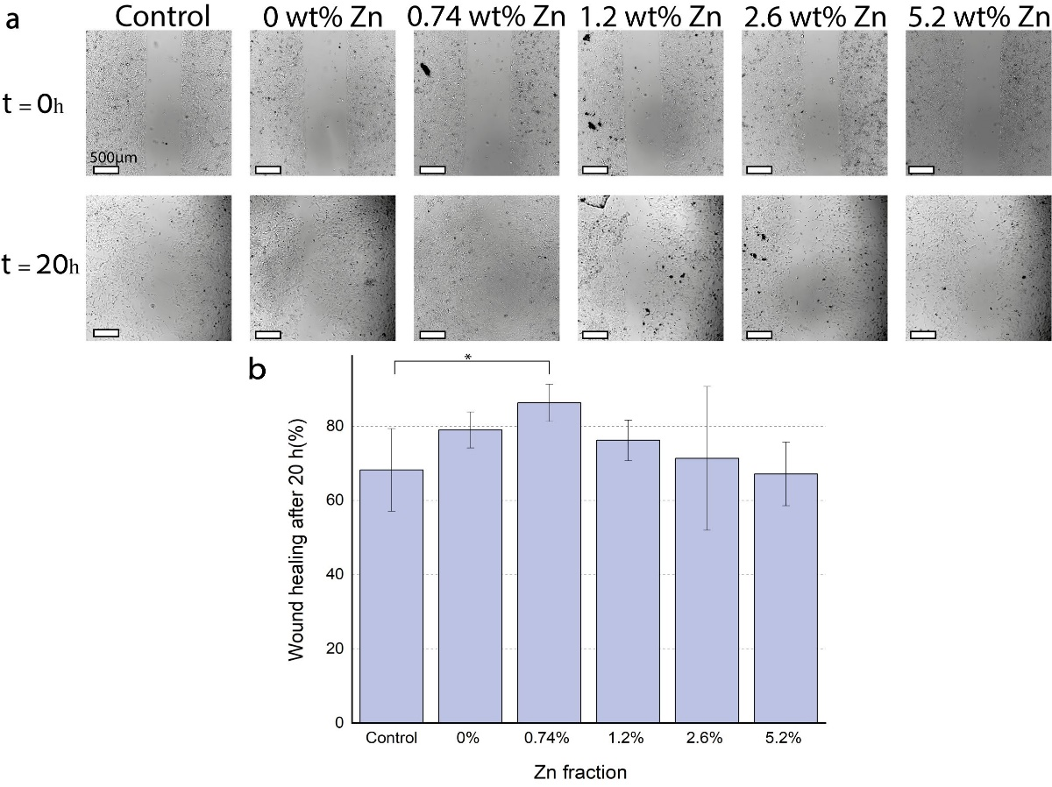

**Figure S3.** Cell migration assay according to Zn content in the MC analogs. **a**. Light microscopy imaging of the wound healing assay. **b**. The extent of cell migration, quantified as wound coverage, was evaluated after 20 hours of culture with MC analogs. Wound healing was calculated as the gap area covered by cells after 20 h divided by the gap area at time 0. Error bars represent the standard deviation. \*P<0.05.

Add figure here

**Figure S4.** Western blot with anti-ERK, anti-p-ERK, anti-AKT, anti-EGFR, and anti-β-actin antibodies. The samples were loaded in two duplicates on the same gel. After the transfer, the membrane was cut into two halves. One half was incubated with anti-ERK, anti-p-ERK, anti-AKT, and anti-EGFR diluted at 1:50 while the second half was incubated with anti-β-actin diluted at 1:400.