**Written in the Stars:**

**Huppahstein in Synagogues in Southern Germany**

**Tal Garmiza**

A unique phenomenon was documented in southern Germany between the 17th and 19th centuries.[1] Written sources from the time described the wedding ceremony under the *huppah* in the synagogue courtyard, during which the groom would throw and smash a glass full of wine against a decorated stone or tile fixed to an outer wall of the synagogue. The congregation would shout “*Mazel tov*!” [2] After throwing the glass, the groom would turn away from the huppah and walk or run with his companions to a room where he would meet his bride in private.[3]

I became interested in these decorated stones or tiles because they link symbols, a community ritual, a belief system, and a distinctive art form. Huppah stones (*Huppahstein)* were common in synagogues in the Lower Franconia region of southern Germany (Bavaria and Baden-Württemberg). Huppah stones were usually about 40x40 cm and set about two meters above ground on an exterior wall of the synagogue. There was apparently no uniformity in their location. Many huppah stones were on the north wall of the synagogue, probably alluding to a belief that “evil will arise from the north” (Jeremiah 1:14). Others were set in the wall facing Jerusalem.

Usually, one of three symbols was carved or engraved on huppah stones: a star, a flower-like shape, or a hexagram identified as the Jewish Star of David.[4] Many of the stones were engraved with the Hebrew letters: K"SH K"SH, K"H K"K

(ק"ש ק"ש, ק"ח ק"כ) acronyms for *kol sasson* *kol simcha,* *kol hatan* *kol kala* (the voice of rejoicing and the voice of happiness, the voice of the groom and the voice of the bride) (Jeremiah 33:11) or M"T (מ"ט) *mazel tov* (good fortune).

The huppah stone phenomenon sheds light on an area of research that has received little attention: the visual expression of magical beliefs among Jewish communities in southern Germany. While the study of texts regarding such beliefs is being revitalized, the study of visual images and symbols in Jewish culture is still in its infancy. I have come to the conclusion that a magical status and meaning was attributed to huppah stones and their role in a central ritual performed at Jewish weddings.

Huppah stones were more than works of art; they were visual expressions of the community’s belief system and how the mystical beliefs held by Jewish communities in southern Germany reflected and influenced the visual world around them. The symbols engraved or sculpted on the stones, combined with the act of breaking the glass, created a ritualistic and visual illustration of a connection between form and action. This combination of ritual and symbols in the marriage ceremony was meant to bring the new couple good fortune, protection, and divine providence. This study of the symbols carved on the huppah stones will help explain the reasons behind this.

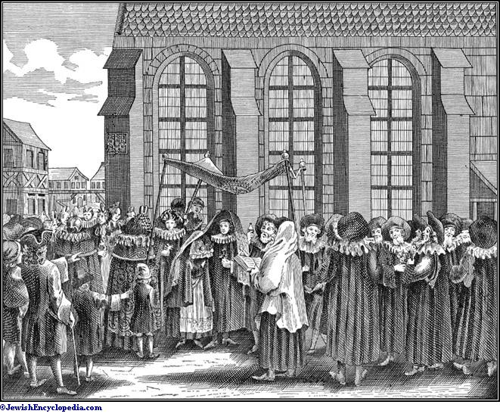

# Printed engraving from P.S. Kirchner, "A Jewish Wedding in Nuremberg" in *The Jewish Ceremony, 1724-1726.*

B.

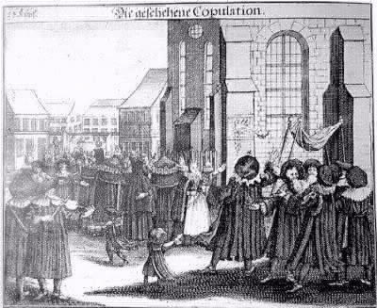

Georg Fuchner, "If I forget you Jerusalem." Illustration of breaking the glass on a huppah stone in Firth, Germany, 1724-1726. Copper engraving from *The Jewish Ritual* by P.S. Kirchner.

C.

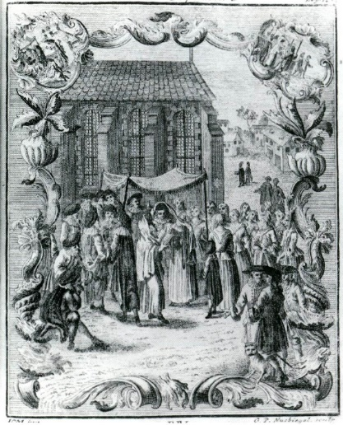

J. Bodenschatz. A Jewish wedding ceremony in Ashkenaz: A huppah stone is fixed on the wall of the synagogue. Germany, 1748.

**Cotemporary Documentation and Studies of Huppah Stones**

The research literature includes records of about thirty huppah stones that survived Kristallnacht in 1938, in various states of preservation. Kristallnacht is a significant landmark in research on this subject because many huppah stones were damaged when synagogues were destroyed. Even before World War II, the construction of new synagogues in place of old ones did nothing to contribute to the preservation of huppah stones, and many more were damaged during the war.

We lack basic information about how and where these stones were made and who made them. Huppah stones that remained in the walls of synagogues in southern Germany are usually in the same condition as the building. Some buildings and their huppah stones were preserved and renovated in a manner that was as faithful to the original as possible, such as the huppah stones in the Weisenau and Freudenal. In some buildings, huppah stones were discovered behind a layer of plaster that the new residents covered it with when the building was converted to another use after the destruction of the local Jewish community. In buildings that were not renovated or preserved, the stones may have been taken or left to crumble, such as in the city of Reckendorf.

Today, some huppah stones are in museums, while others are still fixed to the walls of the original synagogue buildings. They date from the 17th to the 19th centuries. Many have been documented by researchers such as David Davidovitch, who described huppah stones and their use in the wedding ceremony,[5] or by local Jewish memorial associations in Germany or Jewish museums. However, the meanings of the symbols on the stones have not been extensively researched.

There is a crucial gap in the research because these stones are an important tool for learning about the Jewish communities in southern Germany. There are few examples that have been preserved well enough for historical investigation and, perhaps as a result, researchers have not delved into the meanings of the symbols on the huppah stones or come to conclusions about folk beliefs or mystical ideas in these communities. The rare studies, such as Davidovich’s work, emphasized the rituals and customs involving the stones, which, he estimated, gradually faded during the 19th and early 20th centuries following the flourishing of the Enlightenment.[6] Davidovich’s article is documentary, presenting some of the surviving stones and describing the related customs, while drawing attention to other marriage customs that were common in this area of Germany, including breaking objects. However, his research did not delve into the meanings of the symbols on the stones or their connection to the breaking of the glass in the huppah ceremony.

Naomi Feuchtunger-Sarig also wrote about this custom and compared it to German wedding customs in the region without delving into the meaning of the symbols.[7] David Z. Lauterbach discussed the breaking of the glass on huppah stones in the Ashkenaz region, but did not elaborate on the visual symbols engraved on them.[8] Likewise, Daniel Sperber’s study about wedding customs in Ashkenaz included documentation of these objects and described the custom of throwing glasses on stones on the outer walls of the synagogues without specifying or delving into the distinctive symbols that appear on them. [9]

These studies did indicate that the star at the top of many huppah stones was associated with the concept of luck or fortune. Indeed, many of the stones are engraved with the Hebrew acronym M''T for *mazel tov* (good fortune). But no researchers asked why the star was associated with the concept of fortune in marriage ceremonies in Jewish communities, why the star had different visual representations, or why these stones were not linked to other lifecycle rituals in which good fortune was also desired.

To understand the beliefs of the Jewish communities in this region regarding the marriage ceremony, questions must be asked about the meaning of the symbols on the object and its role in the ritual that involved breaking a glass and spilling wine. We know that the custom existed, it is documented. But if we do not delve into questions about the meanings of the custom beyond the knowledge that it was believed to bring good fortune, if we do not direct the magnifying glass at the symbols on the huppah stones and seek to understand their context in the ritual, we will not learn anything new about these communities’ lifestyles. Therefore, this article investigates why these symbols were used during this period as part of the ritual of breaking the glass. When we seek to understand why and are not satisfied with simply knowing that the phenomenon existed, we can reach new conclusions about the beliefs of the community.

Research on weddings and folk customs in Ashkenaz requires the craft of compilation. From the Middle Ages through modern times, Ashkenaz communities underwent cycles during which they were subject to destruction and riots, followed by their return to the city or town and reconstruction. Many documentary materials were destroyed over the generations, but a picture of rituals may be constructed by studying objects that show the fabric of life in these communities.[10] This is the aim of this study of huppah stones. Because it is not always possible to find manuscripts or decorative objects from synagogues that had huppah stones, visual materials from nearby geographic spaces must be used to shed light on their meanings.

Although it is possible to trace the origins of this custom to the late Middle Ages,[11] there are no huppah stones left from this period. The earliest surviving stone dates to 1661. In the Vitri cycle (מחזור ויטרי) compiled by Rabbi Simcha ben Shmuel in the 12th century,[12] it is documented that it was customary to throw glasses against walls during the huppah ceremony, and he claimed that the custom was known since the early Middle Ages. Therefore, it may be assumed that decorated stones associated with the custom of breaking glass against walls were common well before the 17th century.[13] That is, it can be concluded that stones and parts of the wall were used as a target for throwing the glass even before the appearance of huppah stones. It is possible that the popularity of the custom led to the appearance of decorated stones and tiles for use in the ceremony that would enhance it with symbols of magical significance.[14]

2. A.

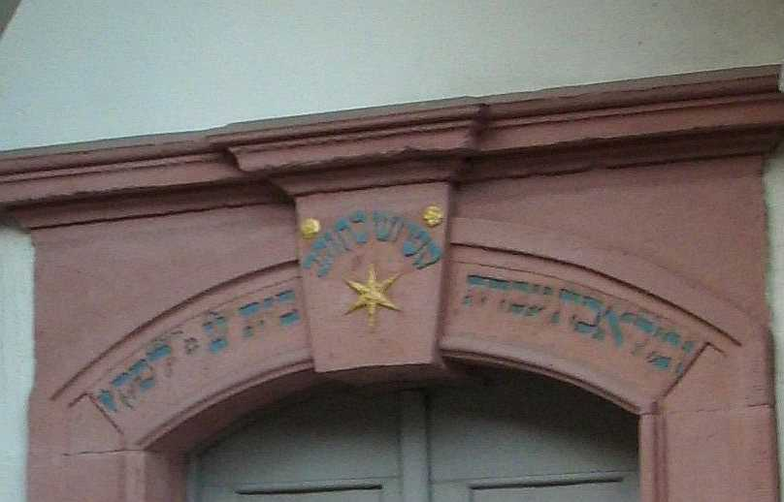

Huppah stone from Weitznau, Germany, 1691.

B.

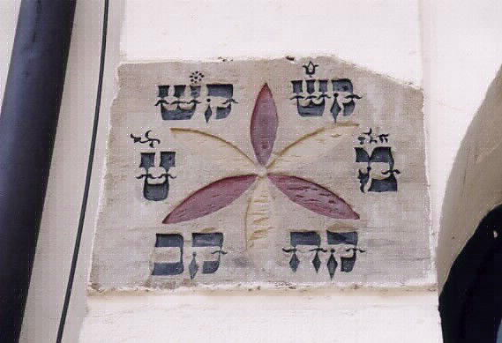

Huppah stone from Freudenthal, Germany, 1770.

C.

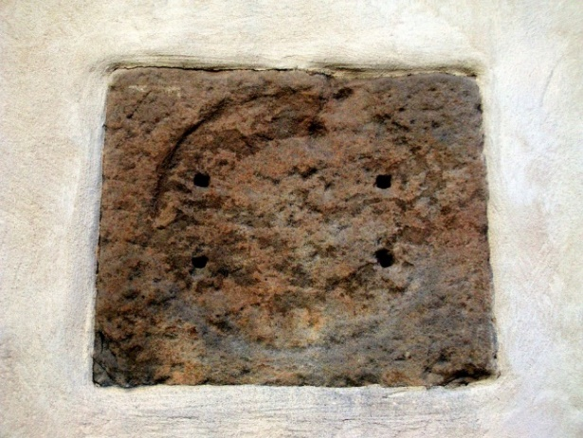

Ruined huppah stone from Reckendorf, Germany, 1732.

**The Shapes of the Symbols and Their Meaning**

We will examine the stones by dividing them into three categories according to the symbol that appears in their center: stars, flower-like shapes, and hexagrams.

**Star Shape**

The star was the most prominent and common symbol on the surviving stones. In the center of a tile from Welbhausen, there is an eight-pointed star with the inscription M''T for *mazel tov*. Beneath it is the inscription, “Hear a pleading voice,” which is unique to this stone. On both sides of the square stone, there are engravings of flowers in a cup that resembles the shape of a lily.

3. A

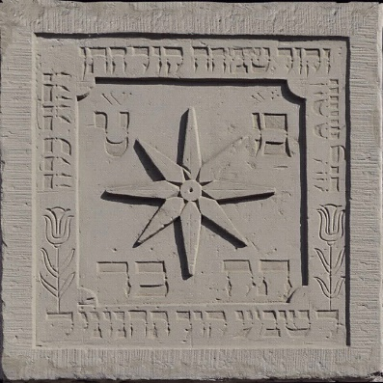

Huppah stone from Wollhausen, Oppenheim, Germany 1763

The huppah stone from Bingen, now in the Israel Museum, is made of sandstone and bears another interesting decoration – flower-filled cornucopias that surround or delimit the star.

B.

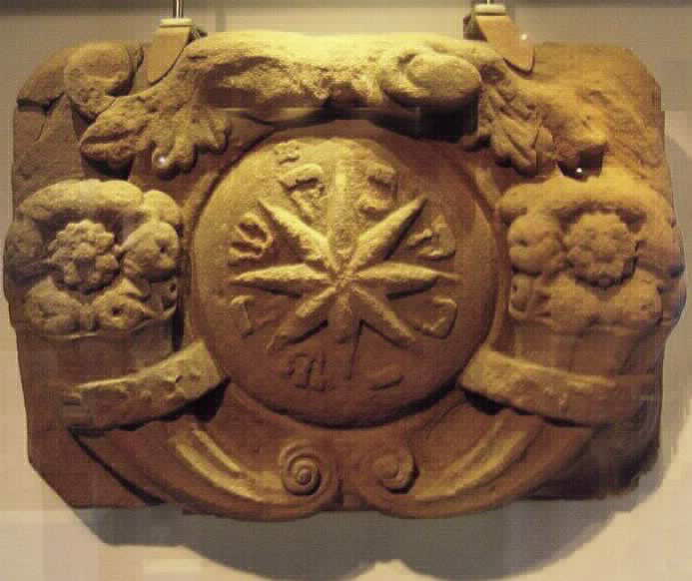

Huppah stone from Bingen, Germany, 1700

In the huppah stone from Eppingen, its green and pink colors stand out. In the center is a star with eight rays in relief, with the decoration of a smaller green star, and a decoration in the form of a flower or cup of roses above the star.

C.

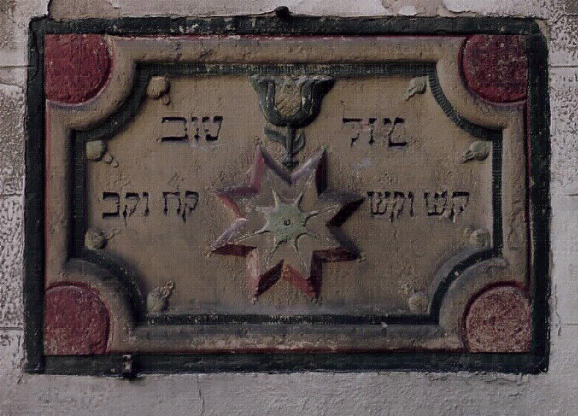

Huppah stone from the old synagogue in Eppingen, Germany, 1772

Some stones have not undergone restoration and preservation, but the symbol in their center can be distinguished, such as the stone from Memmelsdorf from 1728, which has a relief of a star surrounded by a circle. However, the inscription in the center has eroded.

D.

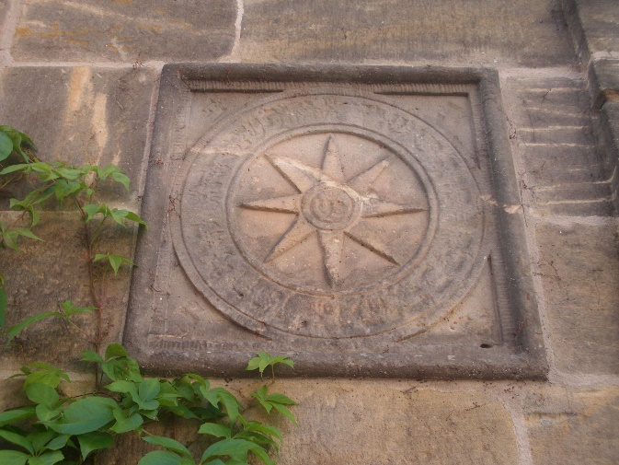

Huppah stone from Melsdorf, Oppenheim, Germany 1728

***The Star as a Symbol of Good Luck***

Among Ashkenazi Jews, the star has often been associated with the concept of luck. How was this possible in a culture that forbids worship of the heavenly bodies? A source can be found in the biblical story in which God tells Abraham that his seed will multiply like the stars of the sky: “For I have blessed you and multiplied your seed like the stars of the sky and the sand that is on the shore of the sea…” (Genesis 22:17). In God’s blessing to Abraham, the stars represent abundance and good fortune, due to their large number.

# The meanings of breaking the glass and the symbols on the huppah stones are related to one another. The Babylonian Talmud (Berakhot 30, 12 - 31 AA) tells the story of two sages in Babylon who shattered glasses on the floor during their children’s wedding. The sages claimed it was important to balance the joy of the celebration with sadness so that the joy does not become excessive and the guests would not drink excessively and commit inappropriate acts of debauchery.

# According to Jacob Zallel Lauterbach (1873-1942), who studied the origins of the custom in the 1920s, smashing and breaking glasses and clay vessels had meanings related to changing luck, fate, protection, and warding off demonic forces.[15] In Ashkenazi Judaism during this period, magic was used to create supernatural defenses from demons and evil spirits. Smashing glasses against a wall reflected an ancient belief (which became widespread in the Middle Ages) that demons and evil spirits hide in shadowy and dark areas, such as near walls and in the corners of houses and street corners.[16] Vessels, plates, and glasses were smashed or shattered to scare away demons and evil spirits by creating sharp and dangerous fragments that could stab or hurt them if they came close, along with a threatening sound.

According to Joseph Dan, secret and magical teachings in Ashkenaz took great interest in the stars and their influence on the world and individuals’ fortunes. A star was often associated with the concept of *tselem* (צלם), meaning the image of God or the divine as reflected in human existence. A person’s *tselem* is an echo of the divine *tselem* and therefore worthy of its providence. According to the Hasidic concept of *torat ha’tselem* (תורת הצלם) the *tselem* is split, with a divine half that resides in the heavens and a corporeal half that exists below the stars and fulfills what has been decreed for the person from above. A supervising angel connects the heavenly half of the soul with the physical human half, shelters the person under its wings, and fulfills the person’s destiny and fortune as written in the heavens. This concept was described by Rabbi Elazar of Worms (who lived and wrote in the 12th and 13th centuries) in his book *Hochmat Ha’Nefesh* (*The Wisdom of the Soul*).[17] The stars are the meeting points of those two worlds, the hidden and the seen. The fate or luck of a person is written in the stars and seeps through them to the human *tselem*. Good fortune in marriage or finding one’s destined spouse is a fate decreed in the heavens. When people see stars, they become aware of this.

The shattering of the glass on the huppah stone called on this divine providence to ward off evil and jealous spirits.[18] Therefore, the star of the huppah stone has a double meaning. First, it represents destiny in the form of the pairing of a husband and wife. The community wished them *mazel tov* so the fate written for the couple, as represented by the star, would be blessed.[19] It is also a sign of divine and magical protection provided for each person and symbolizes the connection between this world and the heavens.

In the Dresden cycle from southern Germany, which dates to the beginning of the late 13th century, there is an illustration in which the hand of God is giving Moses the tablets of the covenant from a sky in which stars, planets, and the Moon visually represent the seven heavens. The illustration of God’s hand reflects the belief that divine luck permeates from the upper heavens, and that providence and destiny are dictated from above and written in the stars.

1. A.

# Illustration of giving the Torah from the Dresden cycle, southern Germany, 1290-1300

Another interesting representation can be found in an illustration at the beginning of the Song of Songs in the Tripartite Cycle from southern Germany, dating to the beginning of the 14th century. This illustration shows King Solomon pointing to a Torah scroll inside the Ark. Next to him are six eight-pointed stars.[20]

# B.

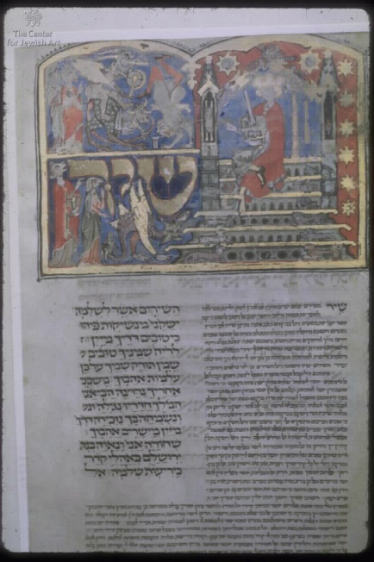

# Opening of the Song of Songs, from the tripartite cycle, Southern Germany, 1322

# *Stars as A Symbol of Mating and Fertility*

# The star that expresses divine light and providence reflects a person's luck and destiny. One may ask why this image appeared on stones intended for use specifically in wedding ceremonies. In the biblical blessing that God gave to Abraham, the stars symbolized many descendants, fertility, and future family abundance: “For I will bless you and multiply your seed as the stars of the sky” (Genesis 22:17-18), so the stars on huppah stones may represent luck that specifically relates to family and fertility. The idea that stars increase fortune in the marital and family sphere may have originated in various pagan beliefs rooted in Eurasia and found their way into the mystic Jewish writings in Ashkenaz.

# An example of ancient traditions that infiltrated Jewish writings can be found in the Song of Songs. Meir Bar Ilan claimed that the erotic images and the manifestations of love between the man and the woman in this text echo a belief in female deities responsible for fertility and love. Euro-Asian goddesses of love, such as Ashtaroth, Aphrodite, and Venus, were represented by bright stars and planets visible in the night sky, such as Venus.[21] Marital pairing was an area almost exclusively in the realm of the goddesses of love and fertility, and this concept permeated the Song of Songs. Asherah was the Canaanite goddess of fertility to whom that culture turned in matters of fertility and love. Asherah would ascend to all the deities in the sky with her maidens, present the prayers and requests of the people, and influence their fortunes through the stars.[22] The “hinds of the field” in Song of Songs[23] were the Earth and wind goddesses who roamed the fields under the starry sky, accompanying those who came to pray for love under the stars, like the speakers in Song of Songs who seek each other. People seeking a spouse or love would wander under the Moon and stars and the watchful eyes of the deities of fertility and pray for help. According to this view, everything depends on luck and divine will, even love.

# Goddesses of mating and fertility were sometimes embodied in female human form. In Song of Songs, there are many references to a female figure such as bride or young woman. The bride in the huppah ceremony shines with divine radiance because she is the key to blessings of harmony, happiness, and fertility in a marriage.[24]

# If this is the case, are ancient female deities, such as those alluded to in the Song of Songs, relevant to the huppah stones? A female divine presence in the form of the *shekhinah* was not alien in Ashkenazi culture. It is possible that these communities believed that the presence of the *shekhinah* hovers over couples under the *huppah* and that she would arouse love between them and bless the marriage.[25]

# Kabbalistic writings from the late Middle Ages, such as Rabbi Yosef Jakatila’s *Sha'arei Ora*, described the ten *sefirot* as places in the heavens where the *shekhinah* resides and unites with the divine male. The devout worshiper who learns the secret Kabbalistic teachings experiences a union with the female *shekhinah* as well as the divine male.[26] This pleasure is reserved for those who tap into this union. The *shekhinah* is likened to the womb and the entrance to heaven.[27] Kabbalistic teachings, such as those that flourished from the end of the Middle Ages, may echo ancient ideas and Jewish mysticism from various periods and regions, many of which saw the embodiment of the divine female as a source of blessing and pleasure and the key to the unseen heavens beyond the stars.

# This may be the meeting point between ideas that permeated the ancient world to the modern era and were embodied in the symbol of the star on the huppah stone: the union between the divine female and divine male with the human bride under the huppah as the representative of the *shekhinah* on Earth.[28] The woman represented the embodiment of divine femininity. The female referent was seen as the source of blessing in the heavenly realm as well as the earthly one. It was customary for a man to connect with the divine *shekhinah* and then physically unite with his wife, forming a link to the *shekhinah*. The idea that goddesses are incarnate in a woman’s body echoes ancient ideas, but the essential difference here is that the spiritual work and ascension of the human male allows the *shekhinah* to find the way to the human woman. In contrast, in the ancient world, the connection was between the goddess and the woman without male mediation; she was the source of abundance.

# Mystical and Kabbalistic teachings give varying opinions regarding the manner of this union and the uniqueness of the divine female (Rabbi Yosef Jakatila was a Castilian, and his composition is from the end of the 13th century). However, the divine female appears in all of these teachings and is identified as dwelling in the heavens beyond the stars, where true pleasure and the source of blessing resides. This shows that the divine female had an important role in the wedding ritual, and the star made a connection between her and events on Earth: “A man and a woman, if they merit, the *shekhinah* is between them.”[29] The star symbolizes a connection between male and female on Earth, which has a counterpart in the heavens, as in beliefs from the ancient world.

# Did Torah scholars know about these mystical teachings identifying the *shekhinah* with the stars or ancient goddesses? It is possible. Did the bride and groom and members of the community know this? This may be a far-fetched hypothesis. But I believe it can be assumed that ancient meanings of the star symbol and its connection to femininity, abundance, and fertility through the female-feminine aspect of the deity went through many incarnations. It permeated the huppah stone phenomenon in the form of a carved star, and the community believed the star to symbolize abundance, fertility, mating, and good luck.

# Flower-Like Shapes

The flower-like shape is another visual representation, similar to the star, which has the same meanings as discussed above: good fortune, divine providence, and fertility. The flower-like symbol may be distinguished from the star by its six or eight rounded petals radiating out of the center, as opposed to the straight or angled arms of the star. The huppah stone from Höchberg has a carved relief of a flower-like shape with six petals enclosed in a circle surrounded by the verse:

קול חתן וכל כלה קול ששון וקול שמחה (the voice of rejoicing and the voice of happiness, the voice of the groom and the voice of the bride), and letters that probably represented the year in which the stone was set.

5. A.

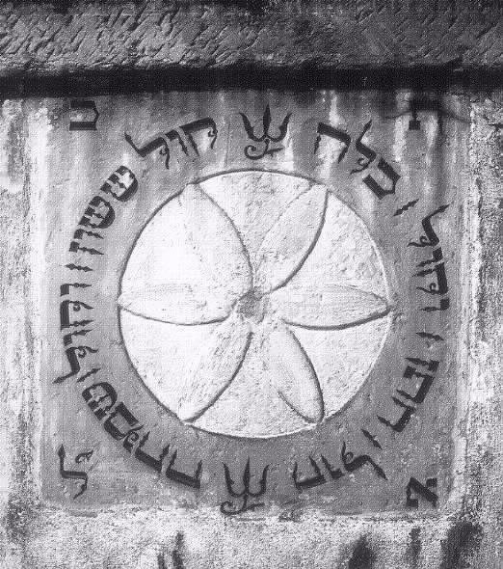

Huppah stone from Höchberg, Germany, 1661

The stone from Hüttenheim had a similar configuration in the center. It was damaged, but there seems to be a relief on the sides with the phrase*: kol sasson* *kol simcha,* *kol hatan* *kol kala*.

B.

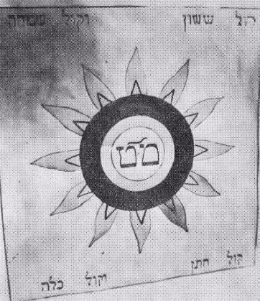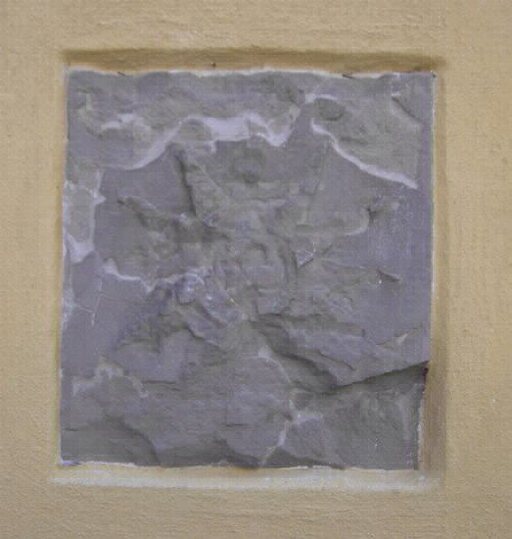

An illustration that roughly reproduces the huppah stone from Hüttenheim next to the remains of the stone, 1820

In the huppah stone from Freudenthal (image 2. B), there is an engraving or an embossed form with petals in red and yellow. The inscription is black and the letters are partly decorated. This stone underwent a conservation and restoration process when the building was restored in 1984. It was discovered by chance behind a layer of plaster that covered it in 1938 when the synagogue building was taken from the Jewish community because the stone was a sign of the Jewish history of the building.

Another stone with a flower in the center that has not yet undergone a comprehensive conservation process (it is unclear if such conservation is planned) is the stone from Mühlhausen.

C.

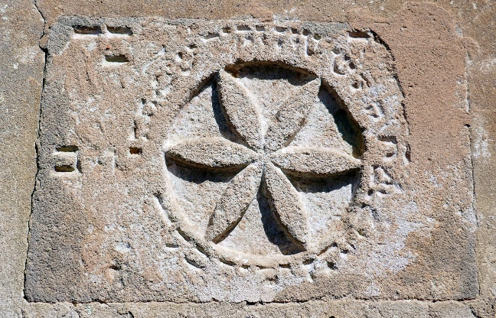

Huppah stone from Mühlhausen, Germany, 1775/6

***Flower-Like Shapes as Celestial Bodies***

How can it be determined that this shape also symbolizes stars and not flowers? Flowers hold meanings relevant to the huppah ceremony from ancient written sources that were well-known in the Jewish world. Flowers are associated with blossoming and prosperity. Additionally, in the cultural space of Ashkenaz, the flower symbolizes innocence and the bride’s virginity. This is well-known from Christian culture, in which Mary was described as a “lily among thorns” and thus a receptacle for Jesus. In the art of the Middle Ages and the Renaissance, a white lily often appears next to Mary, symbolizing her innocence and holy womb. Such images overlap with images of the heavenly bride in Song of Songs.

# The feminine purity embodied in flowers can be relevant to the ceremony of smashing the glass against the huppah stone. The Maharil (Rabbi Ya'akov Halevi ben Moshe Molin), who lived and worked among the German Jewish communities of Shpira, Warmaisa, and Magenza (ShUM) in the 15th century, described the throwing of a glass of red wine on the huppah stone. The combination of red wine and flowers can symbolize the loss of innocence and virginity.

# Another explanation pertaining to the spilling of wine from the shattered glass (on the wall or sometimes underneath the huppah, before it was thrown) was that it was a *minha,* an offering to appease the demons, welcome them to join the celebration, and assure them that the community meant no harm, so the demons would be benevolent to them in return.[30] The Jewish custom of pouring wine and breaking glasses under the huppah, like the custom of the bride and groom not leaving their houses alone during the days before the wedding, or the community accompanying the groom to meet the bride after the huppah, expressed the fear of evil forces that might be jealous of their happiness, hurt them, or covet the bride for themselves.

If we take all of this into consideration, how can we ascertain that this symbol is also a star? The floral decorations that surround the central symbol (not the central symbol itself) in the huppah stones at Bingen and Ifangen are different in shape from the flower-like configuration in the center of the huppah stones of Höchberg, Freudenthal, and Gottenheim. Even in the copy of the stone from Altenschudkestadt, which is entirely decorated with flowers and has no central symbol except for the Hebrew letters M''T, the flower decorations look completely different from the flower-like shape described above. To analyze this shape, we may turn to Jewish manuscripts from northern Italy that presented the study of celestial bodies and astronomy and the wimpels that were woven and sewn in Jewish communities.

6.

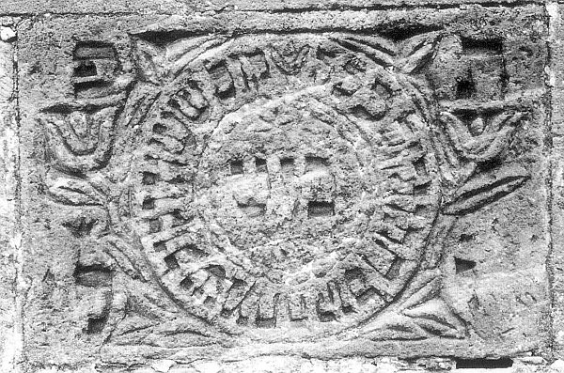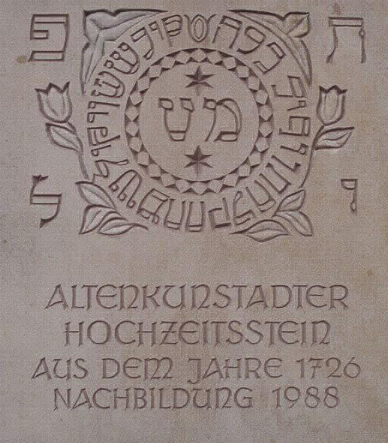

1. Grote, 1988. A replica of a huppah stone from Altenschudkestadt, Lichtenfels, Germany, 1726 (original on the left)

***Manuscripts and Wimpels***

Astronomical manuscripts from 15th-century Italy often showed flower-like shapes to represent the Sun and stars. A shape that looks identical to the shape on the huppah stone represents not flowers but the planets. It is possible that there were mutual influences between the communities of southern Germany and northern Italy, and the visual representation of the heavenly bodies strengthens the claim that the flower-like shape in the center of huppah stones are celestial bodies and that this was a well-known representation in these regions. In an Italian astronomical manuscript from 1431 that explains the movement and distance of the celestial bodies, the Sun, or a large source of light is described with the same shape and has six rays.

1. A.

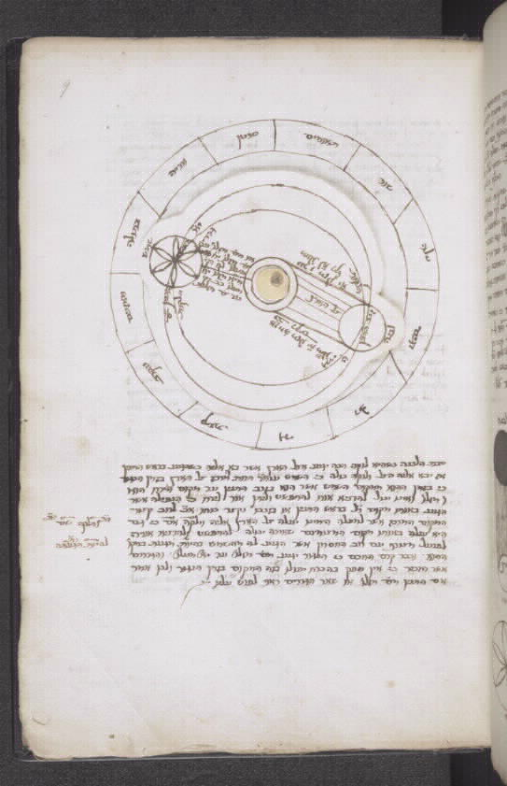

Author unknown, “Manuscript on matters of astronomy owned by Ish G.R (איש ג"ר),” Siena, Italy, 1431

In a micrographic illustration that appears on an Italian decoration for a sukkah from the 18th century, there is an astrolabe that measures the size of the Sun and its distance from the Earth. The depiction of the Sun is similar to the shape on the huppah stones, although it has seven rays. Interestingly, the illustrations in these examples refer to the Sun and not necessarily to the stars. However, a representation of any large light source can certainly fit the image on the huppah stones and represent divine light and providence.

B.

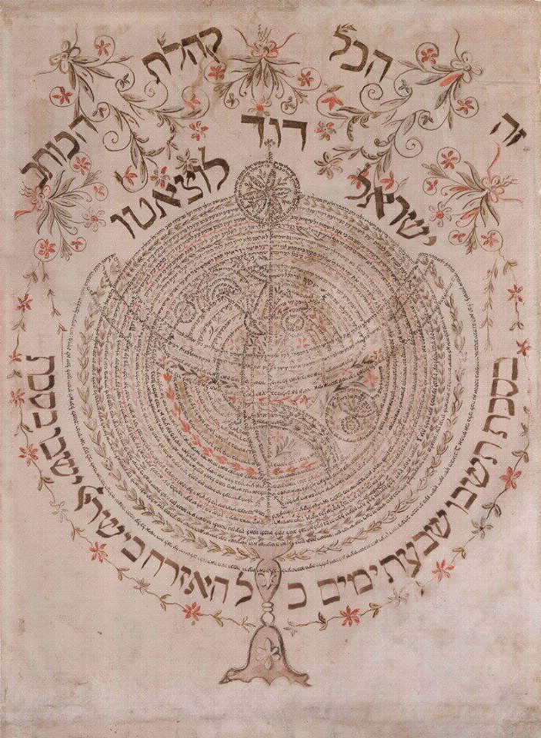

Israel David Lozato, "The book of Ecclesiastes as an ornament for the sukkah," Trista, Italy, 1775

The next example jumps forward more than 300 years. The visual materials that have survived from Jewish communities in Europe, such as huppah stones, tend to be quite rare, so to formulate an understanding of a symbol, we must draw on a collection that extends from the end of the Middle Ages to almost the 20th century. This is the unavoidable result of the situation and the continuous loss of materials.

In this case, we see a form that has retained its meaning and use over time in a discrete geographical space. In the Worms cycle (מחזור וורמס) from 1272, there is an illustration at the opening of the poem “A Rising God” (אל מתנשא) that shows the Moon and Sun at the top of the page, and the Sun is similar in shape to that on the huppah stone from Freudenthal. The Worms cycle predates the stone from Freudenthal and the illustrations from Italy by several centuries, and this was not the first time that this configuration of celestial bodies appeared on a huppah stone.

C.

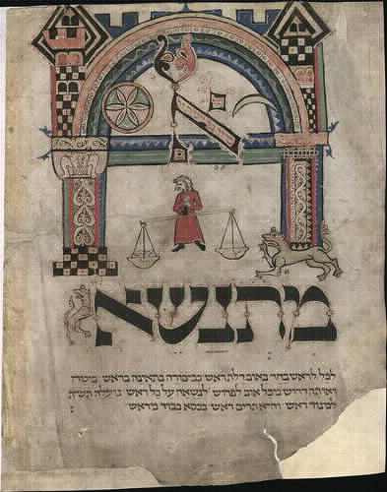

The opening of the poem “A Rising God” from the Worms cycle, Germany 1272

Another example that strengthens the claim that the flower-like shape is actually a star can be found in the phenomenon of wimpels. A wimpel was a sash the parents of a newborn cut from the child's cloth diaper at the circumcision ceremony and later dedicated to the synagogue to be used as a belt for a Torah scroll.[31] The wimpel was decorated with various decorative fabrics, the child's name, and the name of his parents. When the child reached the age of three (in some communities this was the age at which the child first went to synagogue), the wimpel was given to the synagogue to be tied around the Torah scroll. When the boy reached the age of bar mitzvah, the wimpel would be removed from the Torah and added to the synagogue's collection. Images were woven or embroidered into the wimpel to bring luck and blessings to the newborn. Many wimpels have stars to symbolize luck, and many of these stars are identical to the flower-like shape on the huppah stones.

1. A.

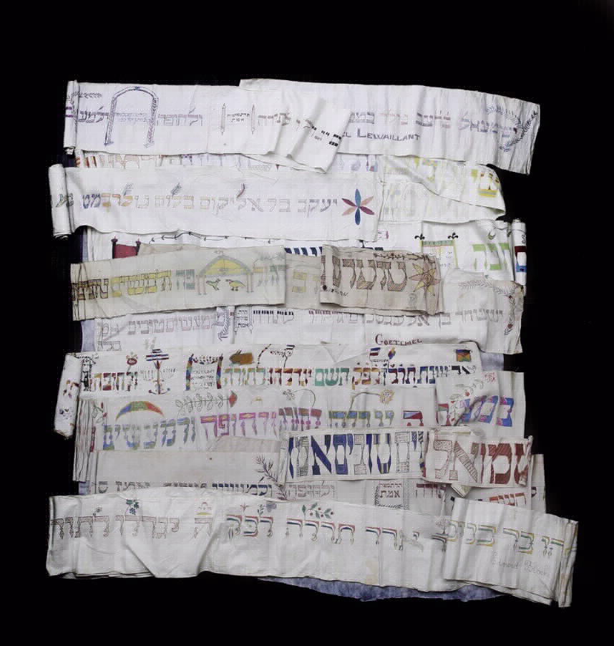

Collection of Wimples, Western Europe, 1859-1897

Shalom Sabar described several wimpels on which decorations related to the status of marriage were embroidered, perhaps as blessings for the child’s adulthood (or even added to a specific wimpel before the man married).[32] Images of couples under the huppah, symbols, and *mazel tov* were embroidered on these wimpels. In many wimpels on which a huppah is depicted, there are stars above the couple. In two such wimpels, the embroidered stars recall the flower-like shapes as in the huppah stones in Höchberg and Freudenthal. This demonstrates how commonly these symbols were used in depicting the meanings attributed to the star. Hence, the flower-like shape is another visual representation of a star, and these huppah stones retain the same meanings described earlier: good luck, providence, and fertility.

B.

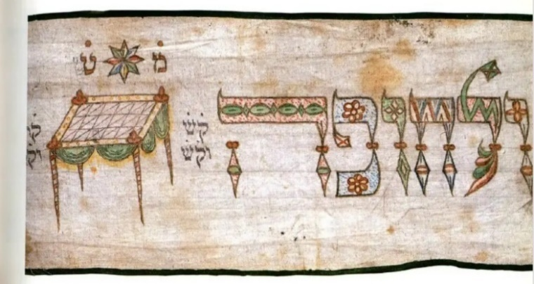

Wimpel, Germany, 1837

C.

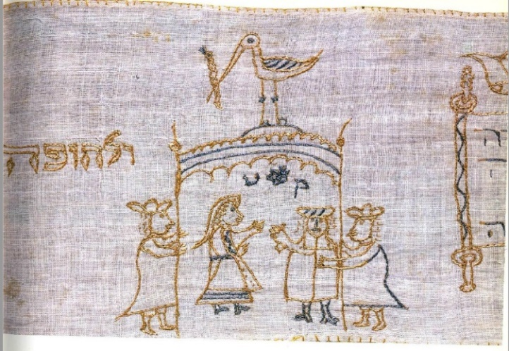

Wimpel, Germany, 1778

**The Shape of the Hexagram**

The best known of all these forms is the hexagram, which over the years has become known as the Star of David. The hexagram is an ancient geometric form of two equilateral triangles, one placed upside down on top of the other (one on its base and one on its apex). Together, they create a symmetrical geometric shape with six vertices. The hexagram has appeared in visual culture from ancient Greece and throughout Asia and Europe. During the 18th and 19th centuries, the hexagram became a symbol that appeared on many huppah stones.

1. A.

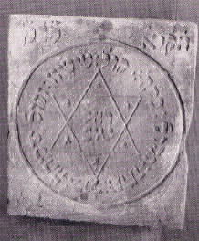

Huppah stone from Niederstetten, Germany, 1747

Hexagrams appear in the center of huppah stones from Dittigheim, Niederstetten, and Ehrstädt. In these stones, decorations and inscriptions surround the central shape. In the huppah stone from Digitheim, a hexagram relief was painted in light blue on a pink square, inside which are the letters M''T in yellow. It underwent a restoration, the documentation of which is difficult to locate. In the heart of the hexagram are the words *mazel tov* and around it is the phrase “*Kol sasson*....” Above it are engraved letters that probably symbolize the Hebrew year in which the stone was fixed to the wall.

B.

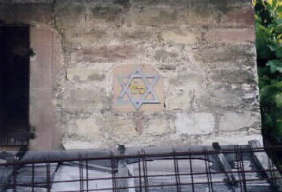

Huppah stone from Digtheim, Germany, 1769

The hexagram is also embossed on the huppah stone from Arstad, with the letters M''T engraved inside it. In the corners of the frame are decorations that look like seashells, a unique decoration that does not exist in any other surviving stones.

C.

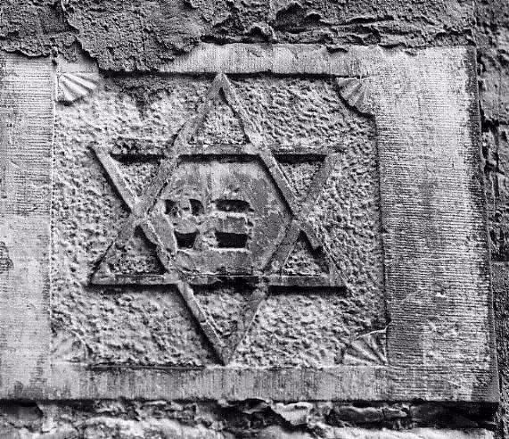

Huppah stone from Arstadt, Germany, 1836

On the huppah stones from Gelnhausen and Aufhausen, which date from the 18th and 19th centuries, there seems to be a fusion between two symbols - a star with six (not eight) rays and the shape of the hexagram.

D.

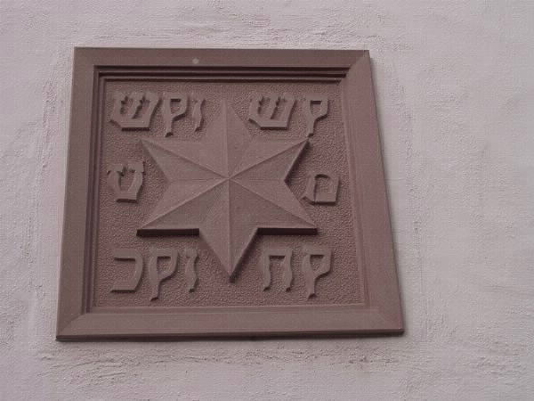

Huppah stone from Glenhausen, Germany, 1736

H.

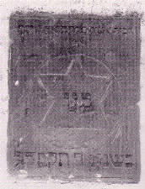

Huppah stone from Aufhausen, Germany, 1824

***The Hexagram as a Magical Symbol of Protection and Duality***

It is important to emphasize several points in the history of this symbol that are relevant to this study. Beginning in the late Middle Ages, Jewish magic flourished as Kabbalah in Provence and Spain and reached northern Italy and southern Germany, where it met the ancient secret teachings in Ashkenaz and continued to exist as an amalgamation of all these. Symbols with magical meanings were part of this and were seen as part of the practical application of mystical teachings. In addition, Jewish magic absorbed motifs from pre-Islamic, Christian, and local Germanic magic. Even in early times, it is possible to observe that there was a cultural willingness among Jewish communities to borrow magical elements from the societies that surrounded them. Prominent elements in magic during the Renaissance period came from Islam. Gershom Shalom claimed that the hexagram permeated Jewish culture from pre-Islamic magical teachings in which it was a symbol of protection.[33] In Islamic magic, the hexagram was considered to be a ‘shield’ that people could use to protect themselves from supernatural demons.[34] This idea indicates that the hexagram offers visual divine protection while performing the ritual of breaking the glass on the huppah stone, just like the star.[35]

The hexagram can be found from the time that huppah stones appeared, as a symbol of protection in magical writings and on amulets. For example, magical acts were described in a practical Kabbalah text from Italy. The date of the manuscript is unclear, but in any case, it is based on centuries-old copies.

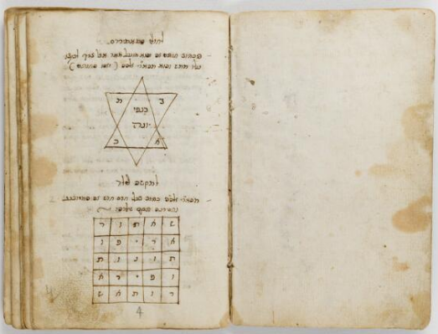

Unknown author, practical Kabbalah text in Italian, date unknown

In addition, in Italian and German alchemical writings, the hexagram was an important symbol. In alchemy, balance and equality were often interpreted as a union and balance between a female element and a male element, such as a connection between the Earth, which has been associated with femininity, and the sky, which has been associated with masculinity.

Similarly, the hexagram has been associated with balance and harmony, a female deity based on the Earth and a male deity based in the heavens. In the ancient, pre-monotheistic world, a union between a divine male and female was a source of fertility, and it was explained above that pre-monotheistic meanings permeated Jewish symbolism. A union between a man and a woman was considered both spiritual and physical and a sublime spiritual action. The transformation of the hexagram triangles into six small triangles around a common center became a symbol of a harmonious marriage that would lead to fertility and offspring. The hexagram physically and visually expressed these ideas.[36]

11.

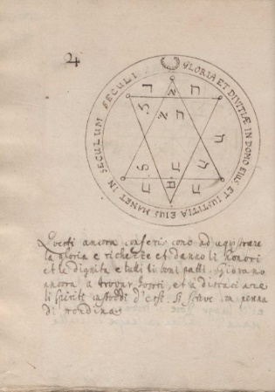

Unknown author, "Solomon the King of the Hebrews Colloquium of the Duke of Mantua," Italy, dated 1453. Its translation from Italian to Hebrew is attributed to Rabbi Avraham Colorano. A copy from 1750 was found in Soma, Turkey.

In the context of the huppah ceremony, viewing the hexagram as a symbol of protection during the ritual and a representation of harmonious marriage makes sense. The breaking of the glass was intended to ward demons lurking near the walls away from the young couple and the guests. This is consistent with the hexagram being a magical symbol whose purpose is to ward off malicious supernatural forces. It is also possible that the hexagram's visual representation of the shape of the star, which has six to eight rays, allowed its penetration into the huppah stone tradition and reinforced the meaning of divine providence and good luck. The hexagram is a component of magical action, and its visual representation rooted it in reality during the ritual, both in the sense of protection, reinforced by the breaking of the glass, and as a star meant to bring the couple luck and a happy, balanced marriage.

**The Hexagram as a Star of David**

The hexagram became more common on huppah stones as it spread as a national symbol and became identified as the Star of David. In addition to the hexagram being a mystical symbol, there is another explanation for this phenomenon.

The use of the hexagram as a Jewish-national symbol began when the Jews of Prague adopted it as their symbol at the beginning of the modern era. It became widespread in Central Europe only in the 17th and 18th centuries. The adoption of the hexagram as a Jewish symbol resulted, among other things, from the need to find an identifying symbol for Jewish communities that could be displayed on synagogues, just as crosses were displayed on churches. This only became possible after the Jews of Europe were granted emancipation in the 17th and 18th centuries.

According to Gershom Scholem, the hexagram became established and identified as the Star of David only in the 18th and 19th centuries. The Zionist movement definitively established the hexagram as a Jewish-national symbol when it emerged as a Jewish-national movement.[37] This does not mean that the connection of the hexagram to the Star of David symbol or its prevalence in Jewish communities was unknown before this. However, the Zionist movement's use of this symbol established it as a distinctly Jewish symbol in the European space. The Zionist movement was eager to adopt the hexagram, which had been associated over the centuries with the Star of David, precisely because it did not have a distinctly religious meaning, unlike a menorah, shofar, or lulav.

Increasing identification of the hexagram as the Star of David and a national Jewish symbol may have helped the symbol become more popular. However, huppah stones have a ceremonial significance in the Jewish lifecycle outside the nationalist movement. Their use faded and disappeared with the flowering of the Enlightenment and the awakening of nationalism. In the 18th century, many huppah stones were decorated with hexagrams, but this was likely due to the hexagram’s resemblance to the star symbol and its magical meanings, not necessarily its growing popularity as a national symbol. On the huppah stones from Glenhausen and Aufhausen from the 18th and 19th centuries, there seems to be a fusion between the two symbols - a star with six (not eight) rays and the hexagram. The development of this symbol and a visual union between the two symbols may have helped to perpetuate the use of the huppah stones.

One can see the turning point at which the visual representation of the hexagram became more common on huppah stones. It easily took the place of the star due to the visual similarity and the various protective meanings of the two symbols. In my opinion, these huppah stones preserved the magical meaning of the symbol, as the star became a hexagram or hexagonal star. The stones were still only used in wedding ceremonies and were not linked to any nationalist use or representation. Indeed, precisely in the 19th century when there was a flourishing of nationalism and national symbols, the huppah stones began to disappear. The function of the stones on which hexagrams were engraved was still ritual and magical, and as the Ashkenazi communities distanced themselves from folk beliefs in the Age of Enlightenment, the use of the stones with their magical symbols faded.

**Reason Versus Magic and Changing the Custom**

There was a long-standing polemic between rabbis in the Ashkenaz Jewish community regarding the breaking of glasses in the huppah ceremony and the use of huppah stones. Opposition to the custom of smashing a glass on a stone decorated with magical symbols spread with the Enlightenment, and appeared in rabbinic writings as early as the late Middle Ages. Lauterbach referred to the writings of Rabbi Eliezer ben Natan of Mainz from the 12th century, who questioned the practice in his composition *Even HaEzer* and called it a waste of drink and objects.[38] He knew the story from the Babylonian Talmud of the sages shattering glasses at their children’s wedding but claimed that the reason for the custom and its origin was not clear enough. He did not see smashing dishes as a ritual necessity because great sadness cannot be caused by destroying a cheap and common object that had no financial or emotional value to the celebrants.[39]

He also represented the opinion that making offerings to demons or any act that acknowledged their existence gave power to foreign ideas and idol worship that had no place in the worship of God in Judaism, even if they were seen as negative forces that must be fought against. Indeed, it is interesting to note that in the rabbinic writings, there were almost no magical explanations for the practice. The 14th-century Italian Rabbi Menachem ben Binyamin Recanati knew the explanation of the custom as exorcizing demons, and Rabbi Yeshayahu Halevi Horowitz, born in Prague, quoted this explanation in his book *The Two Tablets of the Covenant* written in the 17th century.[40] Aside from these references, the magical explanation rarely appeared in rabbinical writings. Even essays that documented the breaking of the glass against the wall, such as the writings of the Maharil or the Vitri cycle, avoided explaining it in this way.[41]

According to Lauterbach, it cannot be ignored that the custom of breaking the wine glass contains remnants of an ancient custom of offering food and wine to demons since the wine was spilled when breaking the glass or before it. This represented a deal between the two parties - we will offer you [demons] a drink, and you will not bother the newlyweds. The wine and glass may have represented the two elements in the ritual act - offering and shattering - one solution in the form of gifts to the demons and one solution in the form of fighting them off. Each protected the celebrants.

It is not impossible that the custom changed over time from gifts of offerings to gifts of prevention. The element of scaring the demons away was perhaps a later explanation born out of the rabbinic opposition to making offerings to demons. This may have resulted in some communities beginning to pour the wine from the glass before throwing it to prevent it from being an “offering.” Perhaps the rabbis thought that if they introduced an ideological element of exorcism into the custom, it would lose its grip on the popular beliefs of the communities. It seems that instead of fighting a custom that had a firm hold on the lives of the communities, the rabbis tried to reframe it. Indeed, glasses are still smashed in huppah ceremonies today. However, stamping on the glass is now understood as symbolizing the destruction of Jerusalem, a modern framing of the custom.[42]

**The Decline of the Use of Huppah Stones and Their Disappearance**

It is difficult to find an exact explanation for the cessation of the use of huppah stones. However, the Enlightenment that swept the region gradually suppressed popular beliefs and customs related to the world of demons and spirits among many communities. New synagogues built before World War II did not always have huppah stones. Their use waned during the 19th century, although crushing or shattering a glass did not disappear from the world and continues to exist in the form of crushing a glass with the foot in contemporary huppah ceremonies.

Huppah stones remain partially fixed in the walls of some synagogues, evidence of a ritual custom that included various magical explanations. In my opinion, examining the *huppahstein* phenomenon opens a window into the folk beliefs of Ashkenazi communities. The symbols on huppah stones teach us about the conduct of the Jewish communities of southern Germany through a visual medium that was at the heart of an important ceremony. However, magical ideas slowly faded with the Enlightenment. This study of huppah stones and the symbols and rituals of Ashkenazi Judaism may shed light on another layer of the lifestyles, ideas, and beliefs in the lifecycle of Jewish communities in southern Germany.

1. 1 “ …And he will pour more into it and bless seven blessings and drink and drink and pour and slam the glass cup against the wall and break it.“ Rabbi Simcha ben Shmuel Moytri, ‘Mechzor Vitry’ (from the 13th century). Digital scan in the National Library: Mechzor Vitry 27200 London BL Add.
2. David Davidovich, “Breaking the glass on a ‘wedding stone’ - Jewish wedding customs that have disappeared in recent generations,” *Israel – Nation & Land*, Vol. 4, 1987, p. 254.
3. “…When the blessing was over, he gave the groom a drink and then the bride and the rabbi held the cup and then put the cup in the groom’s hand and the groom turned his face back and stood facing north and threw the cup at the wall to break it. And immediately they hurried with the groom in a happy way to bring him to the wedding house before the bride.” Maharil, marriage laws, a copy printed in the Bionta press in northern Italy in 1556.
4. Gershom Scholem, (Edited by Galit Hasan-Rokem and Shlomo Tzoker), *Magen David: The history of a symbol: An expanded version that includes the completeness from the author’s estate* (Ein Harod: Mishkan Museum of Art, 2008), p. 25.
5. Davidovich, p. 254.
6. Ibid.
7. # Naomi Feuchtwanger-Sarig, “Interrelation between the Jewish and Christina wedding in medieval Ashkenaz,” *Proceedings of the World Congress of Jewish Studies,* Vol. 9‎, division D, volume II: Art, folklore, theatre, music (1985), pp. 31-36.

  
8. Jacob Z. Lauterbach, “The Ceremony of Breaking Glass at Weddings,” *Hebrew Union College Annual* no. 12 (January 1925): 369-370.
9. Daniel Sperber, “The ‘Huppah’ – The Wedding Canopy\Ceremony,” in *The Jewish Lifecycle: Custom, Lore and Iconography – Jewish Costumes from the Cradle to the Grave* (Bar Ilan University Press & Oxford University Press, May 2008), p. 217.
10. Avital Davidovich-Eshed’s research, “Between Braiding and Confinement: On Hair and Virginity in the Jewish Culture of Ashkenaz in the Middle Ages,” brings to the fore the customs of braiding women’s hair for the wedding ceremony, and through this custom opens a new prism of observation for the place of the marriage ceremony in the lives of women in Ashkenaz communities. Her article was published in Zmanim – Quarterly Magazine (2012), p. 118.
11. Sperber, p. 217.
12. The earliest known copy of this Mahzor is from the 13th century, although Rabbi Simcha ben Shmuel lived during the 12th century.
13. In the composition ‘Minahagei Worms’ written by Yozefa (Yosef) Shemesh in the 17th century, the throwing of glass on a stone with a lion’s head that was fixed on the outer wall of the synagogue is described. This was an unusual symbol for a huppah stone, but since it did not survive, it is not clear how it looked or was designed.
14. In Great Britain, stones called ‘marriage stones’ were common in the 16th and 17th centuries. These stones announced marriages between spouses of usually high social status and bore the initials of their names and symbols of the aristocratic families. But, except for the announcement of the marriage and a new division of the families’ estates, it is difficult to conclude that there was a relevant connection between these marriage stones and huppah stones. It can be assumed that a few Ashkenazi Jews went as far as Scotland in the British Isles and saw marriage stones, but if they recognized them, it is doubtful that they considered them of special ritual importance. Therefore, the huppah stone remains a phenomenon unique to southern Germany, to our best knowledge.
15. Lauterbach, p. 357.
16. Davidovich and Feuchtunger-Sarig pointed out similar wedding customs in the Christian communities surrounding the Ashkenazi communities, which included breaking objects such as sticks, which symbolized that marriage is a decision that cannot be changed. Another German custom (probably originating with the Germanic tribes) called *polterabend* involved the groom breaking porcelain vessels before the wedding ceremony to ward off evil spirits that may desire his bride.
17. In his article about the reading faces and palms, Ron Margolin gave an interpretation attributed to the Book of Zohar: “Just as above there is a firmament with stars in it, so in man there is skin with lines in it, and on this, it is written: ‘And God created man in his image‘ (Genesis 1:27), that the secret of man below Everything is like the secret above, and as in this firmament above the canopy over everything, records were written in it, to understand and know in those lists, in which matters and vanishing secrets were determined, and they are the lists of the stars and zodiac signs, which were recorded and determined in this firmament of the canopy from outside. The image represents man who was created in the image of God, while the stars represent destinies, and all these come to me in the human body.” Ron Margolin, “Physiognomy and chiromancy: From prediction and diagnosis to healing and human correction (Zohar 2, 70a-78a Tiqqueni Zohar 70)” in *Teuda* vol. 20-21 - Chidushei Zohar (2007), p. 215.
18. # Joseph Dan, *The Esoteric theology of Ashkenazi Hasidism* (Bialik Institute: Jerusalem, 1968), p. 226.

   
19. An interesting discussion about the complex relationship to stars, zodiac signs, and astrology in Ashkenazi Judaism and northern Italy during this period, a broad topic and an object of research in itself, can be found in Moshe Idel’s *The Magical and Neoplatonic Interpretation of Kabbalah during the Renaissance* (Cambridge, MA: Harvard University Press, 1983) pp. 76-77.
20. King Solomon was blessed with divine wisdom and the representation of stars above him can indicate the blessing and providence bestowed upon him. The six stars allude to the kingdom of heaven from which King Solomon received the approval for his earthly kingdom and his great wisdom. This illustration predates the earliest known huppah stone, an early indication of the connection between divine providence and the shape of the star.
21. George A. Barton, “Ashtoreth and Her Influence in the Old Testament,” in *Journal of Biblical Literature*, Vol. 10, No. 2 (1891), p. 75.
22. Meir Bar Ilan, “Text Criticism, Erotica and Magic in The Song of Songs,“ in *Shnaton: An Annual for Biblical and Ancient Near Eastern Studies*, vol. 9 (1987), p. 40.
23. Gazelles later become a symbol of the *shekhinah*, the female manifestation of the divine.
24. According to the halakhhic judge Jacob ben Asher, who lived and wrote in Ashkenaz in the 14th century, a man without a wife lives without a blessing. The union between man and woman brings inner peace that is equivalent to Torah studies. This opinion mentions the blessing that the female figure in the Song of Songs represents, which Ilan and Bacher referred to in their studies. The woman is a vessel for blessing.
25. The huppah stone of Vitznau is an interesting case. It had a golden star in its center and was affixed above the door to the synagogue so that the worshipers would pass under it when entering and leaving the synagogue. The relationship between the Knesset (people) of Israel and God is likened to a marital relationship. The *shekhinah* is described in works such as Sefer HaBahir as one who rests in God’s embrace in a marital and almost sexual manner. It seems that in Vitznau, a kind of huppah ceremony took place every time worshipers entered the prayer hall. This was an expansion of the function of the huppah stone beyond the marriage ceremony.
26. # Daniel Abrams, *The Female Body of God in Kabbalistic Literature - Embodied Forms of Love and Sexuality in the Divine Feminine* (Magnes Press, Jerusalem, 2004), p. 29.

   
27. Ibid., p. 30.
28. Ibid., p. 165.
29. Gemara, Sota 17, 1.
30. In the Bible, a cup is a symbol of human destiny. In the Psalms, it is written: “It is man who fills his cup and carries it to God.” Man is likened to a vessel that belongs to and is served to God (“For a cup is in the hand of the Lord, and the wine is bitter and full of bitterness, and he will drink from it, but those who keep it will drink, and all the wicked of the earth will drink.” Psalm 9). This took on a tangible and symbolic meaning in Ashkenaz because breakable vessels symbolized the status of human life. For example, some communities in Ashkenaz would break a long, narrow cup for a virgin bride, and for a widow who was remarrying, they would break a wide plate. Moreover, in the writings of the Sages, a cup symbolizes a woman, and breaking it symbolizes breaking her virginity in the union between man and woman. For further reference see Avital Davidovich-Eshed, “Between Shooting and Imprisonment: On Hair and Virginity in Ashkenazi Jewish Culture in the Middle Ages,” In *Zmanim: History Quarterly* 118 (2012).
31. Tali Berner, “Children and Rituals in Early Modern Ashkenaz,” in *[The Journal of the History of Childhood and Youth](https://muse-jhu-edu.rproxy.tau.ac.il/journal/400)* Vol. 7 no. 1 ([Johns Hopkins University Press](https://muse-jhu-edu.rproxy.tau.ac.il/search?action=browse&limit=subscription:y&limit=publisher_id:1&min=1&max=10&t=publisher_facet_select), winter 2014), p. 66.
32. # Shalom Sabar, “‘May he grow up to the huppah’ Representations of Weddings on Ashkenazi Torah Binders,” in *Romance and Ritual: Celebrating the Jewish Wedding, Exhibition Catalog* Grace Cohen Grossman, ed., (Los Angeles: Skirball Cultural Center, 2001), p. 34.

   
33. Moshe Idel, “Judaism, Jewish mysticism and magic”, in *Jewish Studies* (1996), p. 33.
34. Scholem, p.3.
35. The number six, which is related to the hexagram’s six vertices, represents protection. Mezuzahs made in the Middle Ages were often engraved with six-edged shapes because the number six is considered a number that prevents the entry of demons and evil spirits. The mezuzah marks a territory that divides the area beyond the threshold as dangerous and the space inside the building as safe and under divine protection. Many decorated mezuzah houses were made of wood, and so they, and the inner parchments that were also sometimes decorated with magical symbols and names of angels, did not survive and it is difficult to find relevant objects for research purposes. It is possible that the use of mezuzahs with magical symbols and inscriptions was an ancient practice that allowed the penetration of additional objects that were fixed in the walls and represented protection such as the huppah stone.

    Franz Landsberger, “The Origin of the decorated Mezuzah,” in *Hebrew Union College Annual*, Vol. 31 (1960), p. 154.
36. An interesting theory links the origins of the hexagram to the white lily with six petals. In the Zohar, the Deity is revealed in the lily flower, a sign of satiety, shekinah, femininity, and the female reproductive organ. The image of the lily between the thorns in the Zohar alludes to a sexual act in the womb of the shekinah from which God will give birth to the blessing. In the book ‘The Introduction to the Zohar’ the lily is described as a female pain as a cup of blessing held by five male fingers. Interestingly, the lily is seen as a cup, the same vessel that is smashed in the huppah ceremony uniting the male and the female. The hexagram in the huppah ceremony constitutes a physical-corporeal, ritualistic, and visual embodiment of this situation. For further reference see Avi Elkayim, “Kashoshna between the home: the secret of the rosehip as the image of all the images in the Zohar book,” in Kabbalah, Mysticism, and Poetics: The Journey to the End of the Vision, edited by Avi Elkayim, Shlomi Moalem, first edition (Jerusalem: Publishing House Magnes - The Hebrew University, 1976).
37. Scholem, p. 27.
38. Sperber, p. 220.
39. Lauterbach, p. 365.
40. Ibid., pp. 374-375.
41. Rabbis in Ashkenaz reflected the mindset in their Jewish communities. Some dealt with the world of magic as a direct continuation of their occupation, with secret teachings and practical Kabbalah. An example is the 17th-century Rabbi Yonatan Eybshitz, who worked and wrote in Hamburg. He received requests from all over Germany to write talismans and various versions of talismans he wrote and prepared spread and became popular among the communities. A possible copy of a talisman he wrote for a woman (as reported by his disciples) includes a hexagram. Rabbi Eliyahu Lunatz, a rabbi in Vermeiza, was also involved in writing amulets and learned Kabbalah from Rabbi Menachem Mendel Avgidorsh. Eliyahu Lonatz was the rabbi of Yosef Shemesh who documented the life of the Jews in Vermeiza, including the huppah customs in which the glass was smashed against the synagogue walls. Rabbis who lived and worked in Germany did not rule out the existence of folk magical beliefs. On the contrary, they were part of their occupation just as they were part of their communities. For further reference see Shlomo Eidelberg, “Rabbi Yeftah Yosef Mentsepach of Vermeiza, Shemesh, Na’aim haKhal, records (1604-1678),” in Proceedings of the American Academy for Jewish Research, Vol. 51 (1984): 1. In addition see Gershom Scholem, “On one amulet of R. Jonathan Eybshitz and his commentary on it,” in *Tarbitz* (1942), p. 226.
42. In chapter 9 dealing with the laws, it is noted: “And for this reason the custom of breaking a cup after seven blessings was simplified.” The concept gradually became established in Ashkenaz with the publication of the writings of Rabbi Moshe Iserlish in the 16th century: “And there are places where they used to break a cup at the time of the Huppah or put a black map or other words of mourning on the groom’s head, a reminder of the mourning of Jerusalem.” We come across a written explanation that links the crushing of the cup and saying the ‘seven blessings’ to the destruction of Jerusalem in the halachic book *Kal Bu*, whose initial writing Lauterbach placed in the 14th century. This is relatively early documentation for this explanation from these regions. See Lauterbach, p. 371.