Clans and Educational Attainment

Doron Shiffer-Sebba & Limor Gabay-Egozi

## Abstract

The transfer of resources across generations within families lies at the heart of intergenerational stratification. Most stratification research focuses on dyadic relationships between children and significant family members, such as parents and grandparents. This paper broadens the conceptual lens to view extended families as comprehensive units, which we term “clans.” Specifically, we examine associations between clan characteristics and children’s educational attainment, and how these characteristics interact with parental attributes, in the United States. We use a multilevel approach to the Panel Study of Income Dynamics, finding that clan educational attainment robustly predicts children’s educational attainment above and beyond dyadic associations between children and other specific family members, namely parents, grandparents, and aunts/uncles. Notably, clan wealth and income do not exhibit the same association. Further, we find that clans’ educational attainment serves as a “multiplier” of parental education: those with higher levels of parental education benefit from clan education to a greater extent than those with lower levels of parental education. Our findings stress the importance of moving beyond discrete, dyadic familial ties and towards larger, heterogenous family units. Even in a supposedly individualistic society like the United States, important social processes take place within large, complex, and varied family structures.

## Introduction

The intergenerational transmission of social status has long occupied a central position in sociological research, with scholars investigating how families’ varied backgrounds influence individuals’ socio-economic attainment (Blau and Duncan 1967; Sewell and Hauser 1975). Sociologists have conceptualized families as social units that extend beyond nuclear households and encompass an extensive array of relatives. Stratification is thus understood as a process that unfolds over and across multiple generations: throughout the course of their lives, individuals in each generation accrue both advantages and disadvantages (DiPrete and Eirich 2006; Merton 1988) that compound further across generations (Mare 2011). These resources then influence descendants’ socioeconomic outcomes over their lifetimes.

Despite the pivotal role played by extended familial networks, stratification researchers have encountered conceptual inertia and data limitations that have restricted the breadth of analysis on families in post-industrial contexts. Consequently, research on intergenerational stratification has traditionally focused on the transmission of advantages and disadvantages from parents to children (Blau and Duncan 1967; Erikson and Goldthorpe 1992; Featherman and Hauser 1978; Hout 1988; Shavit and Blossfeld 1993).[1] While yielding valuable insights, this dyadic approach overlooks important players in intergenerational processes (Mare 2011). An early focus on fathers’ social standing, for example, systematically excluded mothers from analyses (Beller 2009). Likewise, a focus on nuclear families has led researchers to neglect the complexities introduced by single-parent families, grandparents, aunts, uncles, and other, more distant, relatives (Mare 2011).

The parochial focus on households stems from the circular limitations of theory and data: scholars use households as the central unit of measurement in post-industrial societies, limiting their ability to conduct empirical work beyond household units. The lack of data on extended families, in turn, yields household-focused findings that further reaffirm the pre-existing data-collection paradigm. After all, in contexts like Kenya, surveys pay attention to large, complex family units (Schmidt 2018): it is possible to collect data in this way, but it is traditionally regarded as irrelevant in contexts like the United States. Past research has thus failed to capture how many individuals experience familial advantage in practice. This omission has become more pronounced in the context of substantial increases in life expectancy, declining fertility rates, and the growing prevalence of single-parent households. For example, many younger family members share a significant portion of their lives with older family members and are thus influenced by non-parental kin (Bengtson 2001; Mare 2011).

Indeed, as part of his Presidential Address for the Population Association of America in 2011, Robert Mare criticized the prevailing two-generation paradigm, contending that the process of intergenerational transmission is likely misconstrued within existing mobility research (Mare 2011). Mare urged scholars to transcend the confines of two succeeding generations, advocating a more expansive view of extended family influence. His call was answered with a flurry of compelling studies on the multigenerational processes shaping the transmission of advantage (Anderson, Sheppard, and Monden 2018; Pfeffer 2014). Scholars have begun to study the impacts of grandparental resources (Bol and Kalmijn 2016; Hällsten 2014; Hällsten and Pfeffer 2017; Pfeffer and Killewald 2018) and even those of aunts and uncles (Jæger 2012; Prix and Pfeffer 2017). However, as such studies tend to focus on dyadic relationships between children and specific family members, they do not typically capture the holistic role of the extended family unit.

This paper proposes a novel measurement that facilitates a renewed focus on extended families in the United States, constituting a better match between how scholars have conceived of *the family* in theory and how it has been operationalized in practice: “clans,” which encompass multiple generations and extended kin ties in each family unit. This measurement aims to provide an analytic framework for studying extended family units and their resources holistically. By including all available familial ties, it can unveil latent familial resource transmission that is overlooked by a parochial focus on specific dyadic family relations, and facilitates comparison between different family structures. In turn, this offers a more comprehensive understanding of how families and their resources shape social stratification. By utilizing the concept of “clans,” we offer a statistical measurement of families that aligns with both how stratification scholars are increasingly thinking of families, and how the term “family” is used in everyday life.

We investigate the role of clans in the United States using information on education, wealth, income, and other demographic features at three levels of analysis – individuals, households, and clans. We use the Panel Study of Income Dynamics (PSID) to analyze how these clan resources, beyond parental and individual resources, relate to children’s educational attainment. Clans are constructed by linking together all the descendants of a single household surveyed in the original PSID, along with their household members. We use multilevel models to assess how clans serve as an independent channel that reproduces advantage across generations. We focus on two key extended family resources: educational attainment (Bourdieu 1984; Lareau 2011) and economic resources (Killewald, Pfeffer, and Schachner 2017; Piketty 2014). We further examine how clan resources relate to household resources, and how clans pattern the transmission of resources along race (O’Brien 2012; Oliver and Shapiro 2006).

We find that the clan’s average educational attainment significantly predicts a child’s educational attainment, even after controlling for parental, grandparental, and aunt/uncle resources. This demonstrates the conceptual utility of clans as social units that warrant independent measurement. Additionally, we find that clan education constitutes a *multiplier* of parental education: adult children’s likelihood of attending college increases more rapidly as clan education increases when these children come from households where at least one parent attended college than when neither parent attended college. Our findings indicate that stratification scholars should broaden their conceptual purview from discrete dyadic relations to encompass comprehensive multigenerational extended families.

## Literature Review

### Clans: Re-Conceptualizing Family in Stratification

Stratification research has traditionally focused on the transmission of advantages from parents to children (Blau and Duncan 1967). Early studies hypothesized a Markovian process, by which the advantages received by one generation flow directly and entirely to the next, with the process starting anew with every subsequent generation. Accordingly, scholars have measured the intergenerational transmission of educational attainment (Shavit and Blossfeld 1993), occupational attainment (Blau and Duncan 1967; Erikson and Goldthorpe 1992), and income (Solon 1992) between parents and children. There are several reasons why scholars have focused on parent-child transmission. First and foremost is the conceptual fixation on the household as the central social unit in post-industrial societies (Bengtson 2001; Burgess 1916; Weber 2013). However, the limited availability of richer longitudinal family data represents another key reason behind the continued focus on parents and children. Most surveys were designed around households, making it relatively easy to link parents with children. Conversely, only a few surveys make it possible to link multiple generations and members of the extended family together. As a result, *the family* in stratification scholarship has conventionally been conceptualized as households comprised of parents and children (Bengtson 2001; Mare 2011). The influence of unobserved non-resident kin was, at best, subsumed under parental effects.

Nonetheless, recent work has shed light on the significant role played by non-parental family members, like grandparents, aunts, and uncles, in influencing children’s outcomes (Adermon, Lindahl, and Waldenström 2018; Erola et al. 2018; Hällsten 2014; Hällsten and Pfeffer 2017; Møllegaard and Jæger 2015; Olivetti, Paserman, and Salisbury 2018; Song and Mare 2019). As increasing amounts of data become available, the number of such studies has grown exponentially in recent years (Anderson et al. 2018). Grandparental wealth, for example, shapes grandchildren’s status net of the influence of parental resources (Hällsten and Pfeffer 2017; Pfeffer and Killewald 2018), and the same holds true for other grandparental resources (Chan and Boliver 2013; Hertel and Groh-Samberg 2014). Moreover, aunts’ and uncles’ educational levels are positively associated with children’s educational attainment, even after accounting for parental resources (Jæger 2012; Prix and Pfeffer 2017).

The conventional focus on direct dyadic familial relationships has provided valuable insights into the persistence of intergenerational inequality, but it has fallen short when it comes to comparing various family structures where different family members play distinct roles in relation to young family members. The need to broaden the conceptual lens beyond parents and children is underscored by demographic shifts, such as delayed homeownership, prolonged cohabitation, later and fewer marriages, decreasing fertility rates, and longer life expectancy. These shifts have altered the composition of households over time (Bengtson 2001; Mare 2011; Song and Mare 2019; Swartz 2009), changing how children experience familial dynamics. As a result, a focus on dyadic ties is becoming less apt for comparing different family arrangements. These demographic processes affect the nature of the relationships that children have with their parents, decreasing parent-child reproduction for some (Fasang et al. 2014). In essence, the interplay between households and members of the extended family in the United States is becoming more diverse, and therefore increasingly important. Hence, the familial processes that comprise intergenerational stratification cannot be fully understood using the traditional approach centered on dyadic analyses anchored in households (Anderson et al. 2018; Mare 2011; Pfeffer 2014; Solon 2014).

Though stratification scholars have increasingly shown the importance of non-parental family members for the transmission of advantages (Hällsten 2014; Hällsten and Pfeffer 2017; Jæger 2012), they tend to measure each relationship in isolation. For example, scholars have examined the effects of grandparental resources on grandchildren, but not broader family units that include grandparents together with other kin ties. Focusing on specific ties ignores several axes of family heterogeneity, including differences in family composition and divergent patterns of resource sharing within families. Shifting our lens from specific dyadic familial ties and parental households to larger extended kin family units would facilitate a broader understanding of the role of family resources in shaping social stratification. We thus reconceptualize families as broader extended kin units, which we refer to as “clans,” to assess their influence on children’s educational attainment.

In the context of a population sample, we define clans as family units composed of linked households spanning multiple generations and extended family ties. Such clans are comprised of all households linked via birth, marriage, or adoption, where households tied through multiple links (of birth, marriage, etc.) are considered part of the same clan. By introducing this new conceptualization, we aim to contribute to sociological efforts to expand our understanding of the family beyond its traditional nuclear structure (Furstenberg et al. 2020; Furstenberg 2020; Jæger 2012; Swartz 2009). We theorize clans as consequential sites where bonds and obligations emerge, and analyze their role in the process of intergenerational stratification.

### Clan Resources

Parents, grandparents, and other members of the extended family play a pivotal role in shaping the achievements of young adults within a clan. They exert their influence through the direct investment of time and financial resources, as well as by bestowing intangible assets like social networks, cultural capital, preferences, aptitudes, and genetic material (Pfeffer 2014). Importantly, the effects of extended family resources can persist even in situations where there is little co-residence or physical proximity, and without active involvement, for instance by factoring into the “reference frame” of other family members (Hertel and Groh-Samberg 2014). In essence, the impact of clans goes beyond the immediate actions of clan members, entailing a continuous and multifaceted influence on the development and success of younger generations.

Clans may shape children’s educational outcomes through *economic resources*, either income or wealth; each of these serves distinct roles in intergenerational stratification (Hansen and Toft 2021). Particularly in a context of escalating higher education costs like the United States (Hanson 2022), children might benefit from the direct financial support of wealthier non-parental family members. However, this dynamic could also curtail upward mobility when families possess little economic capital (Stack 1983). Additionally, extended family economic resources may function as a protective buffer for children, shielding them from adverse parental circumstances (Erola et al. 2018; Jæger 2012). Similarly to parental economic resources, the impact of non-parental economic resources may extend beyond pecuniary aspects, encompassing elements like security, power, status, prestige, social entitlement, and social norms. Economically advantaged family members may act as role models through their achievements, promote certain orientations towards investment, confer normative aspirations like pursuing a college education and certain well-renumerated occupations, and provide access to valuable information and social connections (Coleman 1988; Hällsten and Pfeffer 2017; Pfeffer and Killewald 2018; Prix and Pfeffer 2017). Additionally, wealth may provide social insurance (Pfeffer 2011), as individuals who know they have access to extended family wealth in case of emergency may feel at liberty to pursue higher-risk, higher-gain career paths or business ventures.

Similarly, clan *educational attainment* may be crucial for shaping children’s educational outcomes. Through their educational attainment, clan members may serve as role models for children, defining their tastes, habits, and goals (Bourdieu 1984; Lareau 2011; Willekens and Lievens 2014). These influences may be more likely in family formations where extended family members participate in caregiving. Whether through caregiving practices (Lareau 2011) or implicit educational expectations and aspirations (Bourdieu 1984), the educational disposition of extended families may shape children’s outcomes.

In some cases, however, the resources of the extended family may have a negative relationship with children’s outcomes. Becker and Tomes (1979) first noted that grandparental resources should show negative associations with grandchildren’s outcomes when parental resources are controlled. They reasoned that grandparental resources would be negatively associated with grandchild resources if parental resources, “market luck,” and the “endowed luck” of grandchildren were kept constant. As Solon (2014) later clarified, grandparental resources are expected to increase parental resources, but when these are fixed, other factors must be at play for grandparental resources to fail to increase parental resources. These other factors can then endure to the next generation and harm children’s outcomes (see also Pfeffer (2014)).[2] Thus, negative effects of the extended family may be capturing a sub-sample for whom extended family resources failed to shape parental outcomes. These kinds of negative effects have been observed frequently (Blau and Duncan 1967; Erola et al. 2018; Goldberger 1989; Hällsten and Pfeffer 2017; Warren and Hauser 1997).

The recent demographic shifts described above, which have brought about a wider spectrum of family formations, may have introduced new practices of resource transmission within families (Furstenberg et al. 2020; Furstenberg 2020). For example, grandparents who reside with their grandchildren during early childhood may extend greater support as their grandchildren approach adulthood. Aunts and uncles may offer substantial endowments, perhaps even more so if they are childless, share information, provide access to social networks, and serve as role models to their nieces and nephews. These dynamics may contribute to the social reproduction of extended families even without direct transfers (Spilerman 2000), making them difficult to capture through conventional survey measures. Nonetheless, these effects can potentially be captured by analyzing extended families as comprehensive units.

Children, however, differ. Their different characteristics and parental circumstances may shape whether and how they gain from clan resources. For example, clan members may transmit different advantages to children based on their race or ethnicity, mirroring existing racial and ethnic differences in family support in the United States (Swartz 2009). Notably, White families are more likely than Black or Latinx families to exchange financial resources (Hogan, Eggebeen, and Clogg 1993; Sarkisian, Gerena, and Gerstel 2007; Sarkisian and Gerstel 2016). These disparities are highly associated with (household) social class, where higher SES families are more likely to exchange financial support and lower SES families are more likely to offer practical help (Berry 2016; Sarkisian and Gerstel 2016). Such financial support then has a consequence in terms of achievements like home purchases and educational attainment (Semyonov and Lewin-Epstein 2001). Differences across SES also extend to tertiary family members. For example, grandparents’ effects on children’s outcomes are stronger at the upper sections of the distributions of multiple markers of socioeconomic status (Chan and Boliver 2013; Chiang and Park 2015; Hertel and Groh-Samberg 2014; Pfeffer 2014), indicating that total clan resources may matter more for higher status clans.

Moreover, it is likely that clan resources are not utilized equally among clan members. Clan resources may act as a social “multiplier” of origin family resources (Deindl and Tieben 2017; DiPrete and Eirich 2006), whereby clan children born into better-resourced households enjoy the clan’s resources to a disproportionate extent. That said, clans may also use their resources to offset a lack of parental unit resources (Erola et al. 2018; Jæger 2012),[3] where clan resources mainly aid the outcomes of children from less affluent or less educated parental households.

## Data

We define clans as multigenerational inter-household kin networks comprising all households linked by birth, marriage, and adoption. Theoretically, all humans share a certain degree of genetic relatedness. If we had data on an entire population, we might identify clusters of families (i.e., clans) and construct an indicator of association with each cluster. These measures could reflect a person’s connection to multiple clans, with lower values indicating a weaker connection to a given clan. In short, a measurement of this nature would reflect how closely each individual is linked to each large family unit in the population. In practice, this paper uses all the descendants of one original Panel Study of Income Dynamics (PSID) household, and their partners, to designate each clan.

Relatively few datasets enable clans to be measured. Of the major representative surveys of the United States, the PSID enables the most comprehensive clan measurement. The PSID (1968–2021) is a longitudinal survey conducted annually from 1968 and biennially since 1997. The PSID follows all the descendants of an original sample – a “genealogical” sample – that oversampled low-income households. Specifically, individuals interviewed in the first PSID wave in 1968 pass on their sample membership to their descendants, who are then followed as they set up their independent households (McGonagle et al. 2012). A PSID clan thus includes an original household as sampled in 1968 and all its descendants – children, grandchildren, and great-grandchildren, as well as their spouses – and therefore often contains young adult children, their parents, grandparents, aunts, uncles, and cousins (and in some cases great-grandparents, great-uncles, second cousins, and so on). See Figure 1 for an illustration of the data structure.

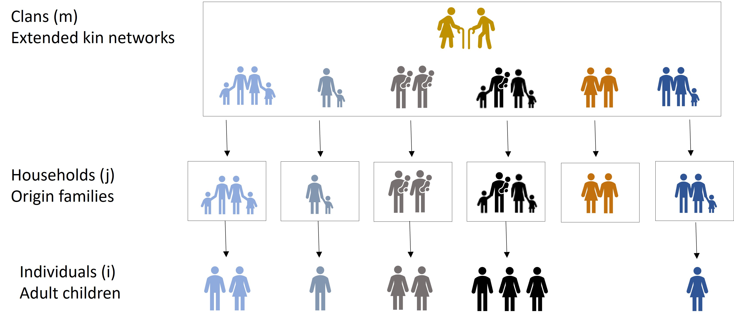

Figure 1: Individuals, Households, and Clans.

Of the 4,802 original households in the 1968 sample, the PSID contains sufficiently detailed information on 2,060 clans with adult children aged 25–41 as of 2021. We focus on clan children born between 1980 and 1996 to capture the third (or later) generation of PSID respondents who have reached the age of 25 by the most recent survey. The remaining 2,742 households sampled in 1968 either had no documented descendants, did not have descendants who were young adults by 2021, or only had descendants for whom we were missing information on at least one key variable.

As such, our complete analytical sample includes 2,060 clans comprised of 6,040 households containing 9,448 sample adult children. These clans have on average 18.5 individuals across 3.8 households, with the smallest clan consisting of 2 individuals and the largest of 105. Each clan has on average 4.6 focal adult children, with a range between 1 and 32. On average, PSID clans are 34.8% Black and 65.2% non-Black (in the unweighted sample).[4] Because we use clans emanating from the 1968 respondents, our sample only includes 15% non-White, non-Black respondents, around half of whom are of Latin American origin, and the other half “other.” We therefore group the sample into Black and “non-Black” categories. For analyses that deconstruct clans into grandparents, aunts/uncles, and residual clan members, we use a subsample of 3,788 adult children who have relevant information on at least one grandparent, one aunt/uncle, and one residual clan member. These residual clan members include family members such as cousins, their spouses and offspring, great-aunts and great-uncles, their spouses and offspring, and so on. Siblings who are old enough to form their own households by the time the focal child reaches age 14 but are not themselves part of the sample are included in the clan.

The prospective design of the PSID (Song and Mare 2014), by which the descendants of the original respondents are followed as they form new households, makes the PSID the only major United States-based dataset that allows a sufficiently large sample of clans to be measured. Nonetheless, this unique dataset only permits us to capture half of the descendants’ clans in most cases, either the paternal or maternal branch. In other words, because the PSID sampled grandparents (or great-grandparents) and not grandchildren, each grandparent is linked to all their grandchildren, but each grandchild is only linked to one branch of grandparents. This sampling feature will only bias results if substantial resources travel across grandparental branches and the PSID oversampled net “giver” or net “receiver” family branches; we do not have any reason to suspect this.

### Variables

Our focal dependent variable is college attendance, which we assume is shaped by familial influence to a greater extent than college completion. We measure college attendance using the PSID’s measure for years of education, marking individuals with 13 years of education and above as having attended college. We model attendance using the individual, household, and clan-level variables listed in Table 1.

Table 1: Variables at Three Levels

|  |  |  |
| --- | --- | --- |
| **Individuals** | **Households** | **Clans  (Extended Family)** |
| College Attendance (13+ Years of Education) | Maximum Parental College Attendance | Clan College Attendance Decile |
| Gender | Parental Wealth Decile | Clan Wealth Decile |
| Race | Parental Income Decile | Clan Income Decile |
| Birth Cohort |  | Clan Number of Households |

Time-varying variables on the household and clan levels – namely, wealth and income – are averaged across years when adult children were aged between 0–14 to reflect the familial resources available to them during this formative time. We longitudinally impute values within person for those who do not have observations in these focal years but have observations before or after, averaging the closest available values. We focus on early childhood, as family ties appear to be especially important during that time (Hout 2015). For example, examining different mediators for wealth correlations across two and three generations, Pfeffer and Killewald (2018) found that education is the most significant mediator between grandparent wealth and grandchild home value (which is used to operationalize grandchild wealth). Since educational attainment starts at an early age, the role of the extended family – in this case grandparents and their wealth – likely commences early in an individual’s life and shapes the trajectory of familial investments.

Following a multidimensional perspective on stratification (Engzell et al. 2020), we are interested in the role of key clan resources – clan wealth, clan income, and clan education. Aggregate wealth in the PSID is the sum of six asset type values – farm/business, checking/saving accounts, investment real estate, stocks, vehicles, and other assets – as well as the value of home equity, and net of debts. This wealth variable has been measured on the household level since 1984 as part of the PSID wealth supplement and was added to the main PSID survey in 2009. Our clan wealth variable aggregates the wealth of all clan households for every year when data were collected and adult children were aged 0–14, then averages this by the number of years captured. The skewed wealth distribution creates methodological issues for regression analyses, which generally perform better with symmetric distributions. Further, highly skewed variables often have nonlinear relationships with other outcomes, reflecting, for instance, the declining marginal utility of additional units of wealth in influencing educational attainment (see Killewald et al. 2017 for additional measurement challenges). We therefore use wealth deciles in place of raw values.

Clan income is defined as the average income of clan adults averaged across years when the child was aged 0–14, utilizing the data available within that time frame. We likewise use income deciles to mitigate the impact of highly skewed income values. Finally, clan educational attainment is operationalized using the average college attendance of the clan, which is similarly a decile rank of the percentage of adult clan members (alive when the child was 0–14) who have attended college (i.e., 13 or more years of education). Importantly, different resources from the same familial unit may encompass different individuals. For example, a focal adult child’s clan educational attainment value may summarize different individuals’ educational attainment from the same focal child’s clan income. This is because we use all the available data from all living relatives when children were aged 0–14, without restricting measurements to a particular set of family members on whom there is full information.

We also use several controls on the individual and household levels. We control for child gender, race (which the PSID measures on the household level and we applied to all household members following Becker (2008)), and birth cohort. We also control for parental wealth decile, parental income decile, and whether at least one parent has attended college – all measured when the focal child was aged 0–14 analogously to the time-variant clan variables. Finally, we use the number of households in the clan for which information was available. All variables’ descriptive statistics by child college attendance are presented in Table 2.

Table 2: Sample Descriptive Statistics

|  |  |  |  |
| --- | --- | --- | --- |
|  | **No College** | **Some College and Above** | **p-value** |
| Female | 2,678 (45%) | 1,920 (55%) | <0.001 |
| Black | 2,754 (46%) | 1,451 (42%) | <0.001 |
| Year of Birth | 1988 (5) | 1988 (5) | 0.2 |
| At Least One Parent Attended College | 3,021 (51%) | 2,689 (77%) | <0.001 |
| Parental Wealth Decile | 5 (3) | 6 (3) | <0.001 |
| Parental Income Decile | 5 (2) | 6 (2) | <0.001 |
| Clan College Attendance Decile | 5 (2) | 8 (2) | <0.001 |
| Clan Wealth Decile | 5 (3) | 6 (3) | <0.001 |
| Clan Income Decile | 5 (3) | 6 (3) | <0.001 |
| Clan Number of Households | 7 (5) | 6 (5) | 0.005 |
| Observations | N = 5,952 | N = 3,496 |  |
| Mean (S.D.) or Frequency (%) | | | |
| Pearson’s Chi-squared test; Wilcoxon rank sum test | | | |

As apparent from Table 2, adult children who have attended college and adult children without any college education have different clan resources, in addition to having different parental resources and individual characteristics. Namely, those who attended college for some period of time have parents who are, on average, more educated, possess more wealth, and have higher incomes. However, they also come from clans that have higher levels of education, wealth, and income. Those who did not attend college have a higher number of households in their clans.

## Methods

Studies that explore the role of extended family members tend to use one of three approaches: 1) multilevel models that nest children under households and households under grandparents or aunts and uncles (Erola et al. 2018; Jæger 2012); 2) correlations between focal children, such as cousins, that net out the characteristics of extended family members to assess the role of these family members (Hällsten 2014; Hällsten and Kolk 2023); and 3) correlations between extended family members’ resources and children’s resources (Deindl and Tieben 2017; Hällsten and Pfeffer 2017; Lindahl et al. 2015; Møllegaard and Jæger 2015; Warren and Hauser 1997).

In this paper, we pursue multilevel models (i.e., the first approach) to assess the role of extended families. Rather than nesting parents and children under individual family members like grandparents, though, we use clans. The third approach (correlations between the resources of extended family members and children’s resources) is less well-suited to examining clans as cohesive units and comparing clans’ roles with the grandparents, aunts, and uncles typically studied. Multilevel models and correlations between children (i.e., the first and second approaches) offer complementary strengths (Björklund and Jäntti 2020). We chose multilevel models over cousin correlations for two reasons, even though they rely on more assumptions about the data structure (Hällsten 2014; Hällsten and Kolk 2023): first, multilevel models have been used to study extended families in the United States (Jæger 2012), allowing us to replicate previous findings and compare our clan estimates to existing estimates of other family members. Second, cousin correlations measure static clans that influence cousins in a similar way, regardless of their age or the time period. We wanted to explicitly measure dynamic clan characteristics that capture the influence of relevant clusters of family members during each child’s formative years (Hout 2015). Beyond providing a more accurate account of the family’s status during childhood, measuring clan traits by averaging information over numerous kin member observations (both horizontal and vertical ties) and across time (when children are aged 0–14) helps minimize the risk of erroneously capturing the capital of one direct ancestor.[5]

Specifically, we use multilevel linear probability random effects regression models to study the relationship between clan resources and children’s educational attainment.[6] In these models, as shown in equation (1), the total variance in children’s educational attainment is comprised of three variance components pertaining to clans ($σ_{m}^{2}$), households ($σ_{j}^{2}$), and adult children ($σ_{i}^{2}$), respectively:

$$\begin{matrix}Var\left(y_{ijm}\right)=σ_{m}^{2}+σ_{j}^{2}+σ_{i}^{2}\end{matrix}$$

Building on Jæger (2012), we first use the intra-class correlation coefficient (ICC) of the fully unconditional model (i.e., a model with no predictors) to verify the necessity of using a multilevel approach and examine the relative importance of each level for the total variance in adult children’s educational attainment.

Table 3 presents the ICC of the null model predicting college attendance. It shows that differences across households explain 36.3% of the total variation across children’s educational attainment. Differences across clans, meanwhile, explain 18.5% of the total variation. Thus clans are an important source of variation contributing to educational outcomes between children. They are not as central as households but are nonetheless important. ::: {custom-style=“Table Caption”}

Table 3: Intra-Class Correlation Coefficient

|  |  |
| --- | --- |
| **Group** | **ICC** |
| Households | 0.363 |
| Clans | 0.185 |

To examine the degree to which clan resources matter above and beyond parental household and individual characteristics, we use three-level hierarchical models incorporating explanatory variables pertaining to the clan’s (level 3), the parental household’s (level 2), and adult children’s (level 1) characteristics. Formally, there are *i*=1,2,…,*I* adult children nested within *j*=1,2,…,*J* parental families nested within *m*=1,2,…,*M* clans (see Figure 1). The full multilevel model provides parameters that make it possible to determine whether clan resources have a direct relationship with adult children’s educational attainment above and beyond parental household and individual characteristics.

Beyond the isolated roles of familial characteristics at discrete levels (i.e., individual, household, and clan), there are two additional categories of parameters: parameters representing two-way interaction effects of (any) two adult child, origin family, and clan level predictors, and parameters representing the three-way interaction effects of all three. These terms of interaction enable us to explore the potential differential effects of clan resources across members. Educational disadvantages along racial lines, for example, may be exacerbated by differing levels of clan wealth. Focusing on terms of interaction allows us to assess how clan resources shape children’s educational attainment differently by race, parental resources, or both.

Even if clan characteristics are a significant predictor of child education, however, one might wonder *who* in the clan is driving these patterns. Indeed, prior research has shown that grandparents, uncles, and aunts alike impact child education (Erola et al. 2018; Hällsten and Pfeffer 2017). To verify that clans as extended family units have a role to play beyond dyadic family members like grandparents, aunts, and uncles, we conduct our analyses in two steps: first, we deconstruct each of our focal clan characteristics – education, wealth, and income – into a grandparental component, an aunt/uncle component, and a residual clan component. This deconstruction makes it possible to identify distinct associations between each of these kin types and young adults’ educational outcomes. However, it also requires us to limit our sample to those for whom we identify as having at least one grandparent, one aunt or uncle, and one additional clan member. Limiting the sample in this way excludes individuals who, for example, never had an aunt/uncle or an extended family other than grandparents, aunts, and uncles. In our second step, we therefore repeat our main analyses using the full sample of young adults, including all individuals who have at least one non-parental family member.

## Findings

### Limited Sample Including Grandparents, Aunts/Uncles, and Residual Clan Members

Table 4 presents multilevel models predicting children’s college attendance. In these models, we restrict the sample to the 3,788 young adults for whom we have information on the education, wealth, and income of at least one grandparent, one aunt or uncle, and one additional clan member. Model 1 captures individual and parental household characteristics. The model findings largely conform to expectations based on prior research. Namely, male children are 12.1 percentage points less likely to attend college compared with female children, and children born in any birth year (within birth years 1980–1996) are 0.6 percentage points less likely to attend college compared with those born in the preceding year.[7] Black children are 5.2 percentage points more likely to attend college compared with non-Black children when parental resources are accounted for, a finding we discuss in greater detail below.

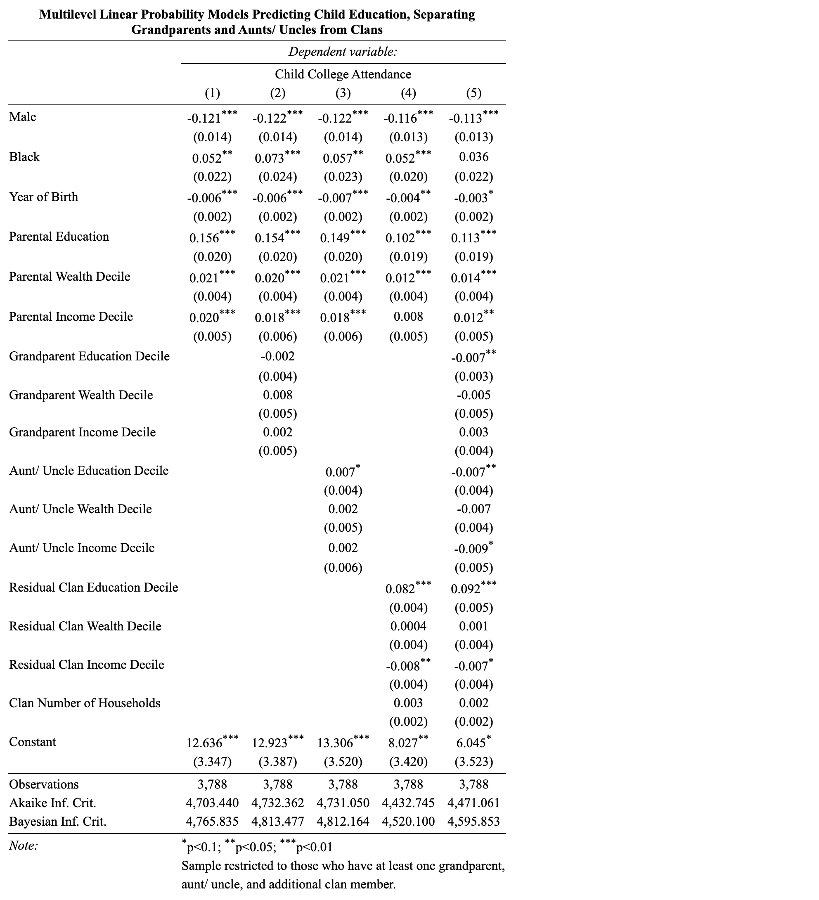

As for parental resources, Model 1 finds that parental education and economic resources are positive predictors of children’s college attendance. Children with at least one parent who attended college are 15.6 percentage points more likely to attend compared with children who do not have a parent who attended college. Additionally, with every decile of parental wealth, a child’s probability of attending college increases by 2.1 percentage points, and with every decile of parental income, a child’s probability of attending college increases by 2.0 percentage points, everything else being equal.

Model 2 and Model 3 in Table 4 add the “usual suspects” from the literature on extended families: grandparents, aunts, and uncles, respectively. These models, which use the smaller restricted sample, only partially recreate the findings of prior studies. While the models show that grandparental and aunts’/uncles’ income and wealth are each positively correlated with children’s educational outcomes (Hällsten and Pfeffer 2017; Pfeffer and Killewald 2018), these effects are not statistically significant. Model 3 shows that aunts’/uncles’ educational level predicts adult children’s educational outcomes above and beyond parental resources (Erola et al. 2018; Jæger 2012), but only at a low threshold of statistical significance, while Model 2 indicates that grandparental educational levels do not predict grandchildren’s outcomes.

Isolating the roles of these family members allows Model 4 to examine the residual clan, an extended family unit that *excludes* grandparents, aunts, and uncles, as a distinct and independent channel associated with the educational outcomes of young adults. Model 4 investigates each characteristic of these residual clans – education, wealth, and income – and reveals that clan education positively predicts adult children’s tertiary educational attendance above and beyond parental education, even when grandparents and aunts/uncles are excluded from the clan. With every decile of residual clan college attendance, a child’s probability of attending college increases by 8.2 percentage points.

The clan income decile, meanwhile, shows a negative correlation with children’s educational attainment, and the clan wealth decile shows no statistically significant relationship with children’s college attendance when other clan, parental, and individual characteristics are kept constant. The negative relationship between clan income and children’s educational outcomes should be interpreted with caution, as it may be a statistical artifact of controlling for parental resources (Becker and Tomes 1979). Indeed, we find a positive unconditional correlation between each clan’s economic resources and children’s college attendance (reflected also in Table 2), but these associations turn negative once parental economic measures are included in the model.

Models 3 and 4 may be capturing the same latent association between extended family resources and child education. Model 5 therefore includes all discrete covariates representing clan members simultaneously. Indeed, it shows that clan education is not only still statistically associated with children’s educational outcomes once grandparents and aunts/uncles are separated, but its coefficient is even higher than it was when grandparents and aunts/uncles were excluded from the model altogether. This suggests that rather than grandparents and aunts/uncles “driving” any association between clan education and children’s education, it is the broader clan unit that is associated with children’s education, above and beyond parental, grandparental, and aunt/uncle characteristics.

Grandparents’ and aunts’/uncles’ levels of education, meanwhile, both turn negative and statistically significant once residual clan members are included. Drawing from Becker and Tomes (1979) and Solon (2014), we interpret these negative relationships as describing a sub-sample for whom the broader family unit (i.e., the clan), grandparents, and aunts/uncles fail to shape parental resources. In other words, mirroring Solon’s (2014) interpretation of negative grandparental coefficients when only parents are included in the model, negative grandparental and aunt/uncle education coefficients in our analysis likely reflect a particular group where both residual clan resources and grandparental and aunt/uncle resources fail to shape parental resources. For these families, other elements that are not captured by the model are probably at play, and these unobserved elements create a negative relationship between grandparents’ and aunts’/uncles’ educational levels on the one hand, and child educational outcomes on the other. The grandparental and aunt/uncle education coefficients were likely not negative and statistically significant in Models 2 and 3 because these latent factors were not significant enough in families where only grandparents or aunts/uncles do not influence parental resources. However, once we also specified a fixed relationship between residual clan members and parents, the coefficients turned negative and statistically significant.

Table 5 uses the same limited sample to delve deeper into the potential differential effects of clan resources by parental resources, and explores the role of race in mediating the relationship between familial resources and children’s educational outcomes. Specifically, it pursues two lines of inquiry: first, Model 1 shows that, when all familial resources are removed, adult children’s race predicts educational outcomes in the opposite direction, with Black adult children 4.3 percentage points *less likely* to attend college than non-Black children. This runs counter to the positive relationship between being Black and college attendance in Table 4, where familial resources are included. We interpret the change of direction of the race coefficient from negative to positive when familial resources are included as meaning that Black children receive less education than non-Black children overall (as a result of systemic racism, Banaji, Fiske, and Massey (2021)), but as they also start out with fewer resources, Black children over-perform in their educational attainment given their parental and extended family resources. Once these fewer familial resources are accounted for, Black children perform better than non-Black children (Pattillo 2021).

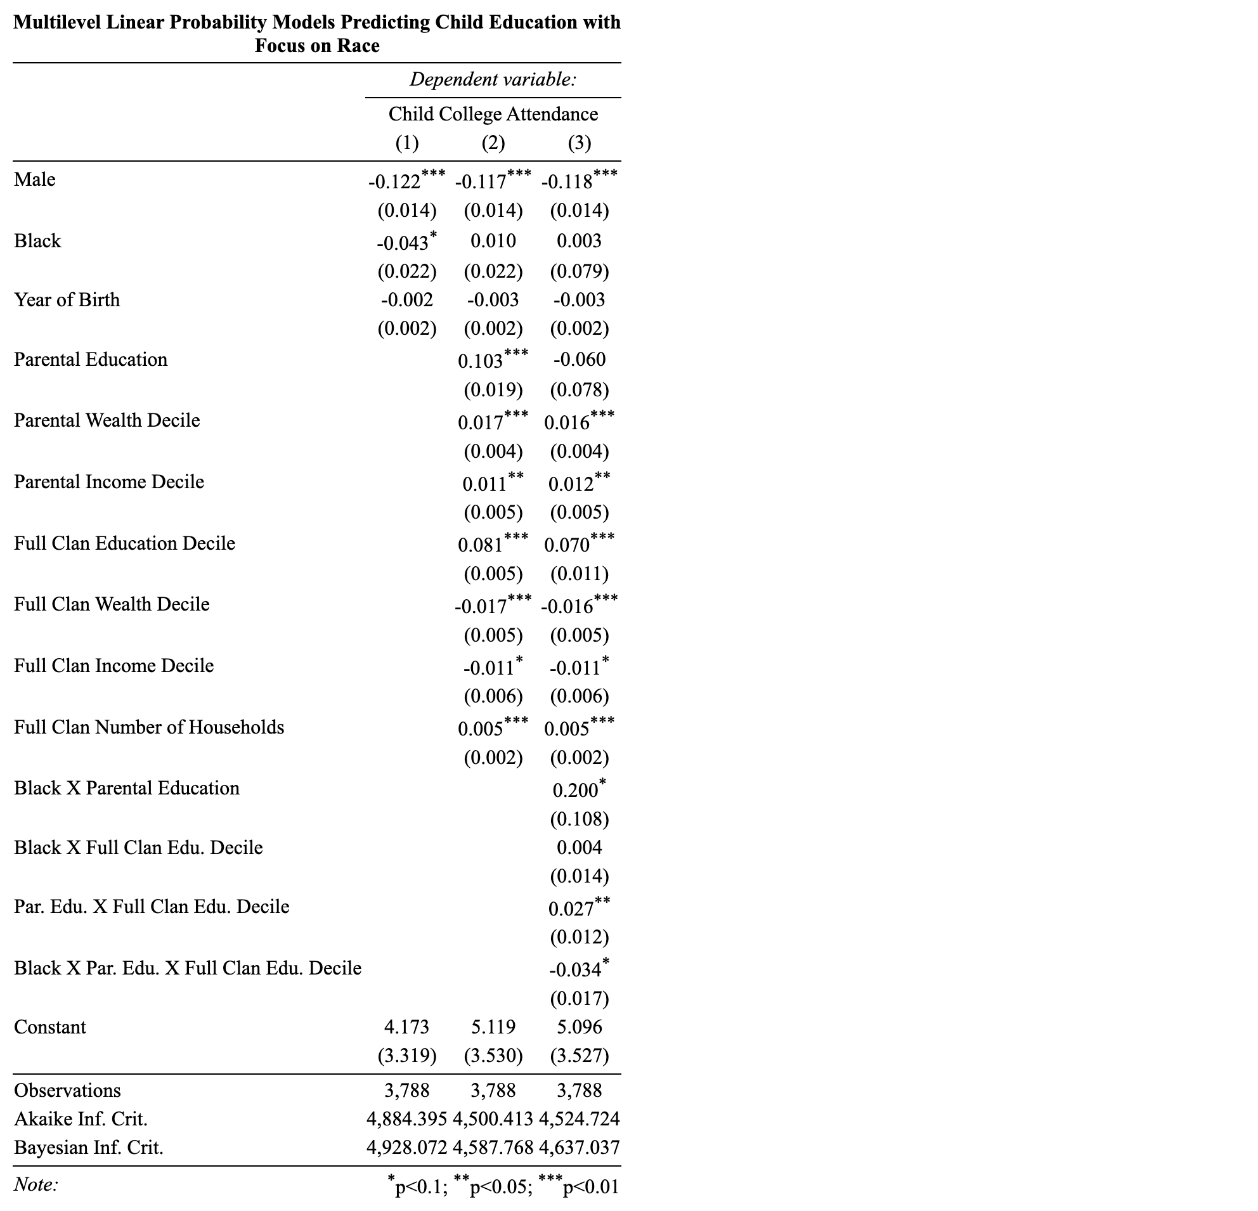

Second, Model 2 in Table 5 models educational attendance as an outcome of individual, parental, and clan characteristics, where clans comprehensively include grandparents, aunts/uncles, and all other related family members. The model differs from Model 4 in Table 4, which modeled residual clans, in important ways. Once grandparents, aunts/uncles, and residual clan members have been combined into “full” clans, children’s race and birth year lose their statistical significance, while parental income regains its positive and significant association with children’s education. Model 2 in Table 5 suggests that all three parental resources significantly predict a child’s educational attainment. As for the clan variables, full clan education and income (Model 2 in Table 5) operate in a similar way to residual clan education and income (Model 4 in Table 4). Full clan wealth, however, is different – now it is negative and statistically significant, like income. The number of households in the full clan, unlike that of residual clans, is a positive predictor of children’s education at a high threshold of statistical significance. We interpret this association to either mean that a greater variety of familial resources represented by a higher number of households in the (full) clan shapes children’s educational attainment, or that a greater number of clan households increases the influence that extended families exert on children.

Model 3 in Table 5 tests whether parental and clan resources interact with one another, and whether they vary in their association with college attendance for Black and non-Black children. Specifically, the model adds two-way terms of interaction between race and parental education, race and clan education, and parental education and clan education. It also adds a three-way interaction between race, parental education, and clan education. The terms of these interactions do not change the direction or significance of coefficients outside the interactions, as compared with Model 2.

Do clan resources multiply higher parental resources, or do they serve to compensate for lower parental resources? By testing all possible two- and three-way interactions (not presented here), we found that parental and full clan educational resources serve to multiply one another, whereas economic resources like wealth and income do not. Specifically, for every decile increase in clan education for non-Black children raised by parents who did not attend college, a child’s probability of attending college rises by 7.0 percentage points. For non-Black children from more educated households, this probability increases by 9.7 percentage points with every decile in clan education.

Model 3 provides a limited indication that this pattern differs by race, with the negative term of three-way interaction only statistically significant at a low 0.1 threshold. The model suggests that, for Black children raised by parents who did not attend college, each increase in clan education decile is associated with a 7.4 percentage points increase, whereas for those from more educated households, this probability increases at a *similar* rate of 6.8 percentage points with every decile of clan wealth. A relationship between clan and household resources that varies by race is only weakly supported.

To better understand these dynamics, Figure 2 plots the predicted probabilities of children’s tertiary educational attendance at every clan education decile separately for children from households with higher levels of education and those from households with lower levels of education, and separately for Black and non-Black children. As apparent from the positive slope of all the lines, the probability of attending college increases with every increase in clan education decile for every group. This aligns with other studies that find that extended family resources have an impact on children’s outcomes (Anderson et al. 2018; Chiang and Park 2015; Deindl and Tieben 2017; DiPrete and Eirich 2006). Moreover, for both Black and non-Black children, those with parents with higher levels of education have higher predicted probabilities of attending college throughout most of the clan educational continuum. However, the difference across parental education increases with every increase of clan education for non-Black children while it remains largely constant for Black children. In the lower four deciles of clan education, non-Black children with more and less educated parents alike do not differ in their probability of attending college. However, by the highest decile of clan education, the difference between the two groups amounts to almost twenty-five percentage points. Meanwhile, the difference in the predicted probability of college attendance between Black children from more educated households and those from less educated households *falls* by around 10 percentage points from one end of the clan education spectrum to the other. This difference is not statistically significant at either end, though it is significant in the middle four clan education deciles.

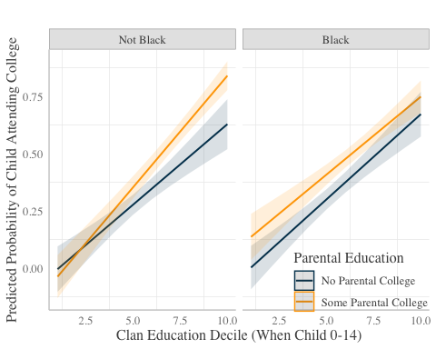

Figure 2: Predicted Probability of College Attendance by Clan Education, Parental College, and Child Race Using Restricted Sample

### Full Sample Including all Clan Compositions

The findings thus far indicate that one clan resource – education –positively predicts children’s educational outcomes above and beyond individual characteristics and parental, grandparental, and aunt/uncle resources, and it may do so differently by race. In order to assess the independent role played by clans, analyses have thus far restricted the sample to young adults who have at least one grandparent, aunt/uncle, and an additional clan member. Yet, some young adults do not have aunts, uncles, or clan members other than grandparents, aunts, and uncles. Relaxing the sample restrictions to include any young adult with at least one non-parental family member enables us to investigate the role played by clans for the population without arbitrary restrictions. In Table 6, we, therefore, recreate Table 5’s Models 2 and 3 using our full analytical sample, which includes 9,448 adult children nested within 6,040 households, linked to 2,060 clans.

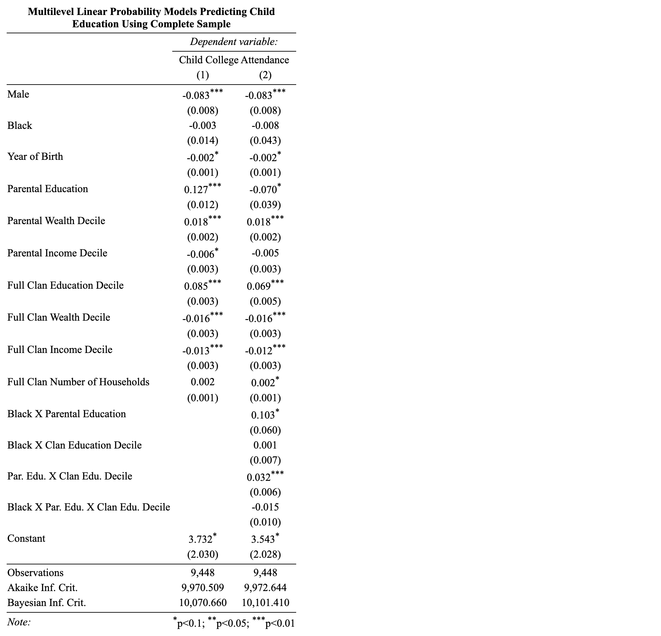

Figure 3: Multilevel Linear Probability Models Predicting Child Education

In both models, individual and parental coefficients are largely similar in terms of direction and statistical significance to models using the restricted sample. This is with the exception of year of birth, which became negative and significant at a low statistical threshold, and parental income, which switched from positive and statistically significant (Table 5) to either negative or not statistically significant (Table 6). As for clan characteristics, similarly to the previous analyses, clan education predicts adult child education above and beyond parental education. According to Model 1 in Table 6, when examining all potential clans, every decile of clan college attendance increases a child’s probability of attending college by 8.5 percentage points, all else being equal.

Clan wealth and income deciles also maintain their direction and significance – negatively predicting children’s college attendance. Again, supplementary analyses show that they are positively associated with children’s college attendance when using bivariate correlations, but turn negative once parental resources are introduced. In line with the analyses above, this suggests that, while clan education supplements parental education to enhance children’s probability of college attendance, clan economic resources appear to be negatively related to children’s educational outcomes as they reflect families in which extended family economic resources fail to shape parental resources. A household’s clan number returns to showing no statistically significant relationship with children’s college attendance in Model 1 when other clan, parental, and individual characteristics are kept constant.

Finally, Model 2 in Table 6 replicates Model 3 in Table 5 using the full sample of clans. Here, too, the main findings from Model 3 in Table 5 remain, but with crucial differences. Most importantly, the three-way interaction between race, parental education, and clan education loses statistical significance. Figure 4 plots predicted probabilities using the full clan sample analogously to Figure 2. It shows that, for the comprehensive set of clans that include those without aunts/uncles or non-grandparental, non-aunt/uncle family members, clan education still serves as a multiplier of parental education for non-Black children, but now also serves as a multiplier of parental education among Black children. When clans also include grandparents and aunts/uncles, beyond residual clan members, the different effects of clan education across parental education no longer vary by race. For this larger sample of comprehensive clans, there is no difference in the predicted probability of attending college among those with low clan education. Among higher-educated clans, both Black and non-Black children from households with higher levels of education are more likely to attend college by 20–25 percentage points compared with their counterparts from households with lower levels of education. Full clans in the unrestricted population serve as parental resource multipliers, regardless of race.

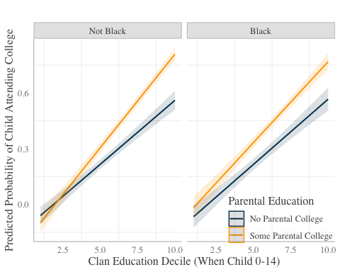

Figure 4: Predicted Probability of College Attendance by Clan Education, Parental College, and Child Race Using Complete Sample

## Discussion

Social stratification scholars study the transmission of advantages across generations within families. However, scholars typically examine dyadic familial relationships, such as parent-child (Blau and Duncan 1967; Erikson and Goldthorpe 1992; Shavit and Blossfeld 1993), grandparent-grandchild (Anderson et al. 2018; Chan and Boliver 2013; Hällsten and Pfeffer 2017; Møllegaard and Jæger 2015), and aunt/uncle-niece/nephew (Erola et al. 2018; Jæger 2012; Prix and Pfeffer 2017). This paper uses newly available waves of data from the PSID to broaden the conceptual lens beyond dyadic family relations to encompass extended family units, which we refer to as “clans.”

We introduce clans as extended family units that furnish their members with material, cultural, social, and emotional resources. Beyond investing time and money, clans also confer traditions, norms, attitudes, and preferences. We investigate whether clan resources are associated with the educational attainment of the children within the clan, even when accounting for parental resources and after netting out grandparents and aunts/uncles. To evaluate family resources comprehensively, we adopt a multidimensional perspective on stratification (Engzell et al. 2020), incorporating income, wealth, and education for both parents and members of the extended family. Echoing previous research on the effects of dyadic relations on children’s educational outcomes (Jæger 2012; Prix and Pfeffer 2017), we find that clans’ educational attainment is robustly associated with children’s educational attainment, persisting even after parental, grandparental, and aunt/uncle resources have been accounted for.

Notably, the economic resources held by more distant relatives exhibit a negative association with children’s outcomes. The absence of a positive association between economic resources and education might be surprising, considering the growing need for financial resources to access higher education in the United States (Hanson 2022). But, when accounting for parental resources, these negative relationships likely capture latent factors that prevent the resources of the extended family from shaping parental resources (Becker and Tomes 1979; Pfeffer 2014; Solon 2014). These negative relationships are consistent with much of the stratification literature (Møllegaard and Jæger 2015; Solon 2014) and pose a challenge in terms of understanding the role of the extended family’s economic resources, beyond parents, in families where the resources of more distant relatives also shape parental outcomes.

Our findings suggest that the association between clan characteristics and children’s characteristics is stronger and more robust than dyadic associations between specific members of the extended family and children. Therefore, when scholars point to such dyadic associations without accounting for larger clan units, they may be capturing part of the association between clan characteristics and child outcomes. These latent associations may be so diffuse across clan members that no combination of specific family members can adequately substitute for the overarching role of the clan. Some have argued that modernity has led to the decline of extended family structures and the singularity of the nuclear family in Western societies (Bengtson 2001; Burgess 1916). But even in the alleged hyper-individualistic context of the United States, our study reveals that the extended family unit continues to be prominent. In the intricate tapestry of familial connections, the oft-emphasized nuclear family unit is nested within broader, dynamic, and meaningful clan webs.

Furthermore, by testing interactions between extended and immediate family resources, this paper investigates whether the clan multiplies or compensates for parental resources. We find a positive interaction between clan resources and household resources; clan and household educational resources compound in their relationship with children’s educational outcomes. This suggests little “compensation” for lower household resources (Erola et al. 2018; Jæger 2012). Instead, it indicates that clans serve as a “multiplier” of parental resources (Deindl and Tieben 2017; DiPrete and Eirich 2006), whereby adult children who already benefit from higher parental resources benefit even more from additional clan resources, compared to those with fewer parental resources. There is some evidence of this multiplier effect differing across children’s race when clans exclude grandparents, aunts, and uncles, suggesting that clans’ educational attainment serves as a stronger multiplier of parental education for non-Black children. These findings point to the important and distinct role played by clans in intergenerational education, where they matter beyond grandparents, aunts, and uncles. A fuller understanding of the intergenerational transmission of advantages involves looking beyond specific dyadic familial relationships to assess the comprehensive role of extended families in children’s outcomes.

In this paper, we demonstrated how conceptualizing clans as comprehensive units allows us to assess the role played by family background, regardless of the particular family structure. For example, clans in this paper covered children who do not have living grandparents, children who have living great-grandparents, only children, children with many siblings, children from one-parent households, children in multigenerational households, and children who are reared by distant relatives. We believe that using these diverse family structures in our estimates allows us to capture the role of families in a way closer to how “family” is understood in daily life. Nonetheless, as family structures within the United States become more diverse (Fasang et al. 2014; Furstenberg 2020; Furstenberg et al. 2020), the composition of clans may be of greater consequence and necessitate additional examination. In particular, clan demographic behaviors like assortative mating, marriage, fertility, and survival may be consequential for children’s outcomes (Mare and Maralani 2006; Song and Mare 2017). Such demographic processes are intertwined with socioeconomic status and thus have consequences for intergenerational stratification (Mare 2011; Mare and Maralani 2006).

The proximity, spatial and otherwise, of family ties might be particularly important for clans. Existing studies have found that increased residential closeness (Bol and Kalmijn 2016; Zeng and Xie 2014) and overlapping lifespans (Braun and Stuhler 2018; Sheppard and Monden 2018) shape the influence that grandparents have on their grandchildren. Proximity is not only spatial; it can also be familial. Namely, family ties may differ by type, be it blood, marriage, or adoption. Our study illuminates the role of broader family structures, challenging the prevailing assumption that family dynamics take place only through specific dyadic ties. Investigating facets of spatial and familial proximity between family members would offer a fresh perspective for evaluating the intersection between traditional family structures and current demographic trends, providing a more comprehensive understanding of how familial ties influence various aspects of children’s lives in different contexts.

Investigating familial proximity through genetic similarity may offer further insights. Genetic relatedness to ancestors diminishes by half with each generation: a parent passes on approximately 50% of their genetic material to their child, a grandparent 25%, a great-grandparent 12.5%, and so forth (Hällsten and Kolk 2023). When comparing relatives of the same generation, siblings typically share around 50% of their genetic material, first cousins around 12.5%, and second cousins only 3.125%, rendering them effectively unrelated (ibid.). Thus, genetic relatedness ties children and parents together but attenuates across vertical and horizontal branches of the family tree (Adermon et al. 2021). Furthermore, empirical evidence does not robustly support the notion of biological determinism (Black et al. 2015; Pfeffer 2014). Studies consistently demonstrate that the contribution of genes to variations in socioeconomic outcomes is relatively modest compared to environmental factors (Bowles and Gintis 2002; Collado, Ortuño-Ortín, and Stuhler 2023; Piraino et al. 2014). Clark and Cummins (2014) show that social status in terms of education is even more strongly inherited than height. These findings align with recent insights gleaned from genome-wide association studies (Lee et al. 2018; Okbay et al. 2016). Additionally, genetic predispositions interact dynamically with environmental factors (Freese 2008; Piraino et al. 2014), further challenging the notion of genetic determinism. Deconstructing heritability into genetic, environmental, and socioeconomic factors thus presents a remarkable challenge (Solon 2014) and complicates nature-nurture deconstructions (Bowles and Gintis 2002). This complex interplay between genetic and non-genetic factors in shaping socioeconomic intergenerational transmission makes studying the role of clans fertile terrain for uncovering new insights.

In examining young adults’ educational attainment, our results also carry important implications for the literature on first-generation college graduates (FGCs). The attainment of a college degree can be transformative, improving a wide array of outcomes for individuals and even groups (Hout 2012). The rapid expansion of college in most Western societies since the mid-twentieth century (Arum, Gamoran, and Shavit 2007) has propelled upward intergenerational educational mobility in these settings. Consequently, the number of individuals surpassing their parents’ level of educational attainment has increased (De Pablos Escobar and Gil Izquierdo 2016; Gabay-Egozi and Yaish 2021; Moosbrugger and Bacher 2018), and a new and rapidly growing group of FGCs has emerged (Beattie 2018), drawing attention through dedicated federal, state, and institutional initiatives (Wildhagen 2015). Our findings demonstrate that stratification is a multigenerational, diffuse process that extends beyond parental households. Therefore, adopting a more nuanced definition of FGCs, one that considers the educational attainment of the entire clan, may be fruitful. In other words, recognizing the influence of the clan calls into question the traditional two-generation paradigm for identifying first- and second-generation college students; the generational distinction of “college graduate” status may benefit from reassessment. Furthermore, the clan perspective suggests potential variation among FGCs based on clan-level resources worth investigating: is there a threshold of clan education that serves to compensate for the absence of educated parents? Does the type of clan-member tie and their proximity to the child play a significant role in shaping these prospects? These critical questions offer the potential to deepen our understanding of the intricate dynamics influencing the educational mobility of FGCs, as well as assess the mobility of these individuals’ descendants.

The design of our study adopted one of at least two plausible ways to study the role of clans in social stratification. Another approach would have been to calculate cousin (or second-cousin, etc.) correlations, which rely on fewer assumptions than multilevel models (Hällsten 2014; Hällsten and Kolk 2023). Cousin correlations can be thought of as an omnibus measure of the importance of family and community effects (Björklund and Jäntti 2020). This method and ours have distinct advantages and disadvantages, and much can be learned not merely from pursuing both separately, but also by putting the two in conversation with each other (Björklund and Jäntti 2020). It is therefore imperative that future research complete our understanding of clans by investigating their role through correlations across younger family members.

Although our findings of the role that clans play may not be casual, they provide valuable descriptive information about resource transmission within the extended family beyond parental households and specific dyadic familial relations. Once clans have been acknowledged as meaningful social units that play a role in stratification, the overall population-level distribution of clan resources becomes important. Our findings point to race as a key stratifier for clan educational attainment. Therefore, to provoke future research, we calculate clan-level racial inequality in education in the United States, comparing it to household-level inequality for individuals aged between 25 and 41 in 2021. For these young adults, non-Black individuals’ clans are, on average, in the 7.56th decile of clan education.[8] Black individuals’ clans, meanwhile, are, on average, in the 6.33th decile of clan education. That means that the ratio of non-Black to Black *clan-level* education in the United States in 2021 is 1.20. For households, 66% of non-Black individuals have at least one parent who has attended college, whereas 61% of Black individuals come from such households. This means that the ratio of non-Black to Black *household-level* education in the United States in 2021 is 1.09. For young American adults, then, clan-level racial inequality in education is more stark than household-level racial inequality in education. Not only do clans seem to play a role in intergenerational inequality, but their resources – at least by some measures – are more unequally distributed than those of households.

Many of us have experienced caring and meaningful relationships within our extended families beyond the boundaries of the nuclear household. These ties often encompass a broad network of relatives and contribute to a vibrant tapestry of familial bonds. Tangible resources, intangible influences like preferences and aptitudes, family histories, and genetic material are shared and transferred from older to younger generations within these relationships. These relationships can thus play a pivotal role in shaping young adults’ sense of belonging, traits, and outcomes. Importantly, kin members do not only serve as givers but can also receive resources and influence within this intricate web of ties. Thus, these bonds are dynamic, evolving, and reciprocal. Delving into how these clan dynamics shape individuals’ social positions can provide a more accurate and nuanced understanding of the role that extended family relationships play in multigenerational and intergenerational processes of stratification and mobility.

## References

Adermon, Adrian, Mikael Lindahl, and Mårten Palme. 2021. “[Dynastic Human Capital, Inequality, and Intergenerational Mobility](https://doi.org/10.1257/aer.20190553).” *American Economic Review* 111(5):1523–48.

Adermon, Adrian, Mikael Lindahl, and Daniel Waldenström. 2018. “[Intergenerational Wealth Mobility and the Role of Inheritance: Evidence from Multiple Generations](https://doi.org/10.1111/ECOJ.12535).” *The Economic Journal* 128(612):F482–513.

Anderson, Lewis R., Paula Sheppard, and Christiaan W. S. Monden. 2018. “[Grandparent Effects on Educational Outcomes: A Systematic Review](https://doi.org/10.15195/V5.A6).” *Sociological Science* 5:114–42.

Anon. n.d. “Number of Recent High School Completers and Percent Enrolled in College, by Sex and Level of Institution: 1960 Through 2022.” *National Center for Education Statistics*.

Arum, Richard, Adam Gamoran, and Yossi Shavit, eds. 2007. *Stratification in Higher Education: A Comparative Study*. Stanford: Stanford University Press.

Banaji, Mahzarin R., Susan T. Fiske, and Douglas S. Massey. 2021. “[Systemic Racism: Individuals and Interactions, Institutions and Society](https://doi.org/10.1186/s41235-021-00349-3).” *Cognitive Research: Principles and Implications* 6(1):82.

Beattie, Irenee R. 2018. “[Sociological Perspectives on First-Generation College Students](https://doi.org/10.1007/978-3-319-76694-2_8).” Pp. 171–91 in *Handbook of the Sociology of Education in the 21st Century*, *Handbooks of Sociology and Social Research*, edited by B. Schneider. Cham: Springer International Publishing.

Becker, Gary S. and Nigel Tomes. 1979. “[An Equilibrium Theory of the Distribution of Income and Intergenerational Mobility](https://doi.org/10.1086/260831).” *Journal of Political Economy* 87(6):1153–89.

Becker, Tara Leigh. 2008. “When Equality Is Not Enough: The (Lack of) Stability in Relative Earnings Within Marriage.” PhD thesis, University of Wisconsin-Madison.

Beller, Emily. 2009. “[Bringing Intergenerational Social Mobility Research into the Twenty-First Century: Why Mothers Matter](https://doi.org/10.1177/000312240907400401).” *American Sociological Review* 74(4):507–28.

Bengtson, Vern L. 2001. “[Beyond the Nuclear Family: The Increasing Importance of Multigenerational Bonds](https://doi.org/10.1111/J.1741-3737.2001.00001.X).” *Journal of Marriage and Family* 63(1):1–16.

Berry, Brent. 2016. “[What Accounts for Race and Ethnic Differences in Parental Financial Transfers to Adult Children in the United States?](https://doi.org/10.1177/0192513X06291498)” *Journal of Family Issues* 27(11):1583–1604.

Björklund, Anders and Markus Jäntti. 2020. “[Intergenerational Mobility, Intergenerational Effects, Sibling Correlations, and Equality of Opportunity: A Comparison of Four Approaches](https://doi.org/10.1016/j.rssm.2019.100455).” *Research in Social Stratification and Mobility* 70:100455.

Black, Sandra E., Paul J. Devereux, Petter Lundborg, and Kaveh Majlesi. 2015. “[Poor Little Rich Kids? The Determinants of the Intergenerational Transmission of Wealth](https://doi.org/10.2139/ssrn.2655248).” *National Bureau of Economic Research*.

Blau, Peter and Otis Dudley Duncan. 1967. *The American Occupational Structure*. New York, NY: Wiley.

Bol, Thijs and Matthijs Kalmijn. 2016. “[Grandparents’ Resources and Grandchildren’s Schooling: Does Grandparental Involvement Moderate the Grandparent Effect?](https://doi.org/10.1016/j.ssresearch.2015.09.011)” *Social Science Research* 55:155–70.

Bourdieu, Pierre. 1984. *Distinction: A Social Critique of the Judgement of Taste*. Cambridge, MA: Harvard University Press.

Bowles, Samuel and Herbert Gintis. 2002. “[The Inheritance of Inequality](https://doi.org/10.1257/089533002760278686).” *Journal of Economic Perspectives* 16(3):3–30.

Braun, Sebastian Till and Jan Stuhler. 2018. “[The Transmission of Inequality Across Multiple Generations: Testing Recent Theories with Evidence from Germany](https://doi.org/10.1111/ecoj.12453).” *The Economic Journal* 128(609):576–611.

Burgess, Ernest W. 1916. *The Function of Socialization in Social Evolution*. Chicago: The University of Chicago Press.

Chan, Tak Wing and Vikki Boliver. 2013. “[The Grandparents Effect in Social Mobility: Evidence from British Birth Cohort Studies](https://doi.org/10.1177/0003122413489130/ASSET/IMAGES/LARGE/10.1177_0003122413489130-FIG2.JPEG).” *American Sociological Review* 78(4):662–78.

Chiang, Yi-Lin and Hyunjoon Park. 2015. “[Do Grandparents Matter? A Multigenerational Perspective on Educational Attainment in Taiwan](https://doi.org/10.1016/j.ssresearch.2014.09.013).” *Social Science Research* 51:163–73.

Clark, G. and NJ Cummins. 2014. “Is Most Wealth Inherited or Created: England, 1858-2012.” *Tax Law Review* 68:517.

Coleman, James. 1988. “Social Capital in the Creation of Human Capital.” *American Journal of Sociology* 94:S95–120. Retrieved February 17, 2023 (<https://www.jstor.org/stable/2780243>).

Collado, M. Dolores, Ignacio Ortuño-Ortín, and Jan Stuhler. 2023. “[Estimating Intergenerational and Assortative Processes in Extended Family Data](https://doi.org/10.1093/restud/rdac060).” *The Review of Economic Studies* 90(3):1195–1227.

De Pablos Escobar, Laura and María Gil Izquierdo. 2016. “[Intergenerational Educational and Occupational Mobility in Spain: Does Gender Matter?](https://doi.org/10.1080/01425692.2014.969397)” *British Journal of Sociology of Education* 37(5):721–42.

Deindl, Christian and Nicole Tieben. 2017. “[Resources of Grandparents: Educational Outcomes Across Three Generations in Europe and Israel](https://doi.org/10.1111/JOMF.12382).” *Journal of Marriage and Family* 79(3):769–83.

DiPrete, Thomas A. and Gregory M. Eirich. 2006. “[Cumulative Advantage as a Mechanism for Inequality: A Review of Theoretical and Empirical Developments](https://doi.org/10.1146/annurev.soc.32.061604.123127).” *Annual Review of Sociology* 32(1):271–97.

Engzell, Per, Carina Mood, and Jan O. Jonsson. 2020. “[It’s All about the Parents: Inequality Transmission Across Three Generations in Sweden](https://doi.org/10.15195/v7.a10).” *Sociological Science* 7:242–67.

Erikson, R. and JH Goldthorpe. 1992. *The Constant Flux: A Study of Class Mobility in Industrial Societies*. Oxford, England: Clarendon Press.

Erola, Jani, Elina Kilpi-Jakonen, Irene Prix, and Hannu Lehti. 2018. “[Resource Compensation from the Extended Family: Grandparents, Aunts, and Uncles in Finland and the United States](https://doi.org/10.1093/ESR/JCY021).” *European Sociological Review* 34(4):348–64.

Fasang, Anette Eva, Marcel Raab, A. E. Fasang, and M. Raab. 2014. “[Beyond Transmission: Intergenerational Patterns of Family Formation Among Middle-Class American Families](https://doi.org/10.1007/S13524-014-0322-9).” *Demography* 51(5):1703–28.

Featherman, David L. and Robert M. Hauser. 1978. *Opportunity and Change*. New York: Academic Press.

Freese, Jeremy. 2008. “Genetics and the Social Science Explanation of Individual Outcomes.” *American Journal of Sociology* 114(S1):S1–35. Retrieved April 1, 2024 (<https://www.jstor.org/stable/10.1086/592208>).

Furstenberg, Frank F. 2020. “[Kinship Reconsidered: Research on a Neglected Topic](https://doi.org/10.1111/JOMF.12628).” *Journal of Marriage and Family* 82(1):364–82.

Furstenberg, Frank F., Lauren E. Harris, Luca Maria Pesando, and Megan N. Reed. 2020. “[Kinship Practices Among Alternative Family Forms in Western Industrialized Societies](https://doi.org/10.1111/JOMF.12712).” *Journal of Marriage and Family* 82(5):1403–30.

Gabay-Egozi, Limor and Meir Yaish. 2021. “[Trends in Intergenerational Educational Mobility in Israel: 1983–2008](https://doi.org/10.1080/01425692.2021.1894548).” *British Journal of Sociology of Education* 42(5-6):752–74.

Goldberger, Arthur S. 1989. “Economic and Mechanical Models of Intergenerational Transmission.” *The American Economic Review* 79(3):504–13. Retrieved November 23, 2023 (<https://www.jstor.org/stable/1806859>).

Hällsten, Martin. 2014. “[Inequality Across Three and Four Generations in Egalitarian Sweden: 1st and 2nd Cousin Correlations in Socio-Economic Outcomes](https://doi.org/10.1016/J.RSSM.2013.09.002).” *Research in Social Stratification and Mobility* 35:19–33.

Hällsten, Martin and Martin Kolk. 2023. “[The Shadow of Peasant Past: Seven Generations of Inequality Persistence in Northern Sweden](https://doi.org/10.1086/724835).” *American Journal of Sociology* 128(6):1716–60.

Hällsten, Martin and Fabian T. Pfeffer. 2017. “[Grand Advantage: Family Wealth and Grandchildren’s Educational Achievement in Sweden](https://doi.org/10.1177/0003122417695791).” *American Sociological Review* 82(2):328–60.

Hansen, Marianne Nordli and Maren Toft. 2021. “[Wealth Accumulation and Opportunity Hoarding: Class-Origin Wealth Gaps over a Quarter of a Century in a Scandinavian Country](https://doi.org/10.1177/00031224211020012/ASSET/IMAGES/LARGE/10.1177_00031224211020012-FIG2.JPEG).” *American Sociological Review* 86(4):603–38.

Hanson, Melanie. 2022. “College Tuition Inflation Rate.” *EducationData.org*.

Hertel, Florian R. and Olaf Groh-Samberg. 2014. “[Class Mobility Across Three Generations in the U.S. And Germany](https://doi.org/10.1016/J.RSSM.2013.09.007).” *Research in Social Stratification and Mobility* 35:35–52.

Hogan, D. P., D. J. Eggebeen, and C. C. Clogg. 1993. “[The Structure of Intergenerational Exchanges in American Families](https://doi.org/10.1086/230194).” *American Journal of Sociology* 98(6):1428–58.

Hout, Michael. 1988. “More Universalism, Less Structural Mobility: The American Occupational Structure in the 1980s.” *American Journal of Sociology* 93(6):1358–1400. Retrieved November 23, 2023 (<https://www.jstor.org/stable/2780817>).

Hout, Michael. 2012. “[Social and Economic Returns to College Education in the United States](https://doi.org/10.1146/annurev.soc.012809.102503).” *Annual Review of Sociology* 38(1):379–400.

Hout, Michael. 2015. “[A Summary of What We Know about Social Mobility](https://doi.org/10.1177/0002716214547174).” *The ANNALS of the American Academy of Political and Social Science* 657(1):27–36.

Jæger, Mads Meier. 2012. “[The Extended Family and Children’s Educational Success](https://doi.org/10.1177/0003122412464040/ASSET/IMAGES/LARGE/10.1177_0003122412464040-FIG2.JPEG).” *American Sociological Review* 77(6):903–22.

Killewald, Alexandra, Fabian T. Pfeffer, and Jared N. Schachner. 2017. “[Wealth Inequality and Accumulation](https://doi.org/10.1146/annurev-soc-060116-053331).” *Annual Review of Sociology* 43(1):379–404.

Lareau, Annette. 2011. *Unequal Childhoods: Class, Race, and Family Life, with an Update a Decade Later*. Berkeley: University of California Press.

Lee, James J. et al. 2018. “[Gene Discovery and Polygenic Prediction from a Genome-Wide Association Study of Educational Attainment in 1.1 Million Individuals](https://doi.org/10.1038/s41588-018-0147-3).” *Nature Genetics* 50(8):1112–21.

Lindahl, Mikael, Mårten Palme, Sofia Sandgren Massih, and Anna Sjögren. 2015. “[Long-Term Intergenerational Persistence of Human Capital: An Empirical Analysis of Four Generations](https://doi.org/10.3368/jhr.50.1.1).” *Journal of Human Resources* 50(1):1–33.

Mare, Robert D. 2011. “[A Multigenerational View of Inequality](https://doi.org/10.1007/S13524-011-0014-7).” *Demography* 48(1):1–23.

Mare, Robert D. and Vida Maralani. 2006. “[The Intergenerational Effects of Changes in Women’s Educational Attainments](https://doi.org/10.1177/000312240607100402).” *American Sociological Review* 71(4):542–64.

McGonagle, Katherine A., Robert F. Schoeni, Narayan Sastry, and Vicki A. Freedman. 2012. “[The Panel Study of Income Dynamics: Overview, Recent Innovations, and Potential for Life Course Research](https://www.ncbi.nlm.nih.gov/pmc/articles/PMC3591471).” *Longitudinal and Life Course Studies* 3(2):188.

Merton, Robert K. 1988. “The Matthew Effect in Science, II: Cumulative Advantage and the Symbolism of Intellectual Property.” *The History of Science Society* 79(4):606–23. Retrieved October 11, 2023 (<https://www.jstor.org/stable/234750>).

Møllegaard, Stine and Mads Meier Jæger. 2015. “[The Effect of Grandparents’ Economic, Cultural, and Social Capital on Grandchildren’s Educational Success](https://doi.org/10.1016/J.RSSM.2015.06.004).” *Research in Social Stratification and Mobility* 42:11–19.

Moosbrugger, Robert and Johann Bacher. 2018. “[The End of Educational Mobility: Toward a Two-Class Structure in Austria’s Educational System?](https://doi.org/10.1080/00207659.2018.1483052)” *International Journal of Sociology* 48(3):274–93.

O’Brien, Rourke L. 2012. “[Depleting Capital? Race, Wealth and Informal Financial Assistance](https://doi.org/10.1093/SF/SOS132).” *Social Forces* 91(2):375–96.

Okbay, Aysu et al. 2016. “[Genome-Wide Association Study Identifies 74 Loci Associated with Educational Attainment](https://doi.org/10.1038/nature17671).” *Nature* 533(7604):539–42.

Oliver, Melvin and Thomas Shapiro. 2006. *Black Wealth / White Wealth: A New Perspective on Racial Inequality, 2nd Edition*. New York, NY: Routledge.

Olivetti, Claudia, M. Daniele Paserman, and Laura Salisbury. 2018. “[Three-Generation Mobility in the United States, 1850–1940: The Role of Maternal and Paternal Grandparents](https://doi.org/10.1016/J.EEH.2018.07.001).” *Explorations in Economic History* 70:73–90.

Pattillo, Mary. 2021. “Black Advantage Vision: Flipping the Script on Racial Inequality Research.” *Issues in Race & Society* 10:5–39.

Pfeffer, Fabian. 2011. “Status Attainment and Wealth in the United States and Germany.” Pp. 109–37 in *Persistence, Privilege, and Parenting: The Comparative Study of Intergenerational Mobility*, edited by T. M. Smeeding, R. Erikson, and M. Jantti. New York: Russell Sage Foundation.

Pfeffer, Fabian T. 2014. “[Multigenerational Approaches to Social Mobility. A Multifaceted Research Agenda](https://doi.org/10.1016/J.RSSM.2014.01.001).” *Research in Social Stratification and Mobility* 35:12.

Pfeffer, Fabian T. and Alexandra Killewald. 2018. “[Generations of Advantage. Multigenerational Correlations in Family Wealth](https://doi.org/10.1093/sf/sox086).” *Social Forces* 96(4):1411–42.

Piketty, Thomas. 2014. *Capital in the Twenty-First Century*. Cambridge: Harvard University Press.

Piraino, Patrizio, Sean Muller, Jeanne Cilliers, and Johan Fourie. 2014. “[The Transmission of Longevity Across Generations: The Case of the Settler Cape Colony](https://doi.org/10.1016/j.rssm.2013.08.005).” *Research in Social Stratification and Mobility* 35:105–19.

Prix, Irene and Fabian Pfeffer. 2017. “[Does Donald Need Uncle Scrooge? Extended Family Wealth and Children’s Educational Attainment in the United States](https://doi.org/10.4337/9781786432568.00013).” Pp. 112–35 in *Social Inequality Across the Generations. . The Role of Compensation and Multiplication in Resource Accumulation*, edited by J. Erola and E. Kilpi-Jakonen. Cheltenham; Northampton, MA: Edward Elgar Publishing.

Sarkisian, Natalia, Mariana Gerena, and Naomi Gerstel. 2007. “[Extended Family Integration Among Euro and Mexican Americans: Ethnicity, Gender, and Class](https://doi.org/10.1111/J.1741-3737.2006.00342.X).” *Journal of Marriage and Family* 69(1):40–54.

Sarkisian, Natalia and Naomi Gerstel. 2016. “[Kin Support Among Blacks and Whites: Race and Family Organization](https://doi.org/10.1177/000312240406900604).” *American Sociological Review* 69(6):812–37.

Schmidt, Sara Yvonne. 2018. *Kinship Support Tree Overview and Technical Documentation Waves 1 & 2*. Africa Population Health Research Center.

Semyonov, Moshe and Noah Lewin-Epstein. 2001. “[The Impact of Parental Transfers on Living Standards of Married Children](https://doi.org/10.1023/A:1011081529592/METRICS).” *Social Indicators Research* 54(2):115–37.

Sewell, William H. and Robert M. Hauser. 1975. *Education, Occupation, and Earnings: Achievement in the Early Career.* New York: Academic Press.

Shavit, Yossi and Hans-Peter Blossfeld. 1993. *Persisting Inequality: Changing Educational Attainment in Thirteen Countries*. edited by Y. Shavit and H.-P. Blossfeld. Boulder, CO: Westview Press. Retrieved April 26, 2020 (<https://www.ncbi.nlm.nih.gov/pubmed/10180297>).

Sheppard, Paula and Christiaan Monden. 2018. “[The Additive Advantage of Having Educated Grandfathers for Children’s Education: Evidence from a Cross-National Sample in Europe](https://doi.org/10.1093/esr/jcy026).” *European Sociological Review* 34(4):365–80.

Solon, Gary. 1992. “Intergenerational Income Mobility in the United States.” *The American Economic Review* 82(3):393–408. Retrieved February 17, 2023 (<https://www.jstor.org/stable/2117312>).

Solon, Gary. 2014. “[Theoretical Models of Inequality Transmission Across Multiple Generations](https://doi.org/10.1016/j.rssm.2013.09.005).” *Research in Social Stratification and Mobility* 35:13–18.

Song, Xi and Robert D. Mare. 2014. “[Prospective Versus Retrospective Approaches to the Study of Intergenerational Social Mobility](https://doi.org/10.1177/0049124114554460).” *Sociological Methods and Research* 44(4):555–84.

Song, Xi and Robert D. Mare. 2017. “[Short-Term and Long-Term Educational Mobility of Families: A Two-Sex Approach](https://doi.org/10.1007/s13524-016-0540-4).” *Demography* 54(1):145–73.

Song, Xi and Robert D. Mare. 2019. “[Shared Lifetimes, Multigenerational Exposure, and Educational Mobility](https://doi.org/10.1007/S13524-019-00772-8).” *Demography* 56(3):891–916.

Spilerman, Seymour. 2000. “[Wealth and Stratification Processes](https://doi.org/10.1146/annurev.soc.26.1.497).” *Annual Review of Sociology* 26(1):497–524.

Stack, Carol. 1983. *All Our Kin: Strategies For Survival In A Black Community*. Basic Books.

Swartz, Teresa Toguchi. 2009. “[Intergenerational Family Relations in Adulthood: Patterns, Variations, and Implications in the Contemporary United States](https://doi.org/10.1146/annurev.soc.34.040507.134615).” *Annual Review of Sociology* 35(1):191–212.

Warren, John Robert and Robert M. Hauser. 1997. “Social Stratification Across Three Generations: New Evidence from the Wisconsin Longitudinal Study.” *American Sociological Review* 62(4):561–72. Retrieved November 23, 2023 (<https://www.jstor.org/stable/2657426>).

Weber, Max. 2013. *The Agrarian Sociology of Ancient Civilizations*. Verso Books.

Wildhagen, Tina. 2015. “[‘Not Your Typical Student’: The Social Construction of the ‘First-Generation’ College Student](https://doi.org/10.1007/s11133-015-9308-1).” *Qualitative Sociology* 38(3):285–303.

Willekens, Mart and John Lievens. 2014. “[Family (and) Culture: The Effect of Cultural Capital Within the Family on the Cultural Participation of Adolescents](https://doi.org/10.1016/J.POETIC.2013.11.003).” *Poetics* 42(1):98–113.

Zeng, Zhen and Yu Xie. 2014. “The Effects of Grandparents on Children’s Schooling: Evidence From Rural China.” *Demography* 51(2):599–617. Retrieved January 23, 2024 (<https://www.jstor.org/stable/42920015>).

## Appendix I

Table 4: Descriptive Statistics for Sample with 2021 Weights and 2021 Population

|  |  |  |  |  |
| --- | --- | --- | --- | --- |
|  | Sample Descriptive Statistics | | Weighted Descriptive Statistics | |
|  | **No College** | **Some College and Above** | **No College** | **Some College and Above** |
| Female | 537 (44%) | 1,454 (57%) | 44% | 52% |
| Black | 743 (61%) | 1,070 (42%) | 21% | 13% |
| Year of Birth | 1989 (5) | 1988 (5) | 1988 (5) | 1988 (5) |
| At Least One Parent Attended College | 630 (51%) | 1,950 (77%) | 47% | 74% |
| Parental Wealth Decile | 4 (3) | 6 (3) | 5 (3) | 7 (3) |
| Parental Income Decile | 4 (2) | 6 (2) | 5 (2) | 6 (2) |
| Clan College Attendance Decile | 6 (2) | 8 (2) | 5 (3) | 8 (2) |
| Clan Wealth Decile | 5 (3) | 6 (3) | 6 (3) | 7 (3) |
| Clan Income Decile | 5 (2) | 6 (3) | 6 (3) | 7 (3) |
| Clan Number of Households | 8 (6) | 6 (5) | 6 (5) | 5 (4) |
| Restricted to 2021 Cohort – No College N = 1,224, Some College and Above N = 2,529; Mean (S.D.) or Frequency (%). | | | | |

1. Henceforth we will talk of “advantage” to refer to both advantages and disadvantages, acknowledging that both can accrue over time and across generations.
2. For instance, parents who are the first in their family to attain a college education often exhibit higher levels of motivation. Given that parental motivation positively impacts a child’s education, it could have a negative mediating effect on the influence of grandparents’ characteristics.
3. See, however, Engzell, Mood, and Jonsson (2020): extended family compensation for parental resources may be a consequence of greater difficulties of observing status at the lower end of the distribution.
4. All analyses use the unweighted sample. However, Appendix I presents descriptive statistics using 2021 weights, as well as sample statistics for the sample containing those weights. Model results are robust to restricting the sample to its SRC component – the simple random sample portion of the 1968 PSID sample.
5. As discussed by Hällsten and Kolk (2023:1732), averaging over repeated observations to capture the underlying value of the extended family aligns with the standard treatment of classical measurement errors (Solon 1992). It also corresponds to the notion that individuals can be viewed as potentially erroneous realizations of their kinship lineage (Adermon, Lindahl, and Palme 2021).
6. Results are substantively identical when using multilevel logistic random effects models.
7. College attendance and birth cohort exhibit a nonlinear relationship (not shown here). College attendance trends show the expected rise for those born between 1980 and 1985, but sharp dips for cohorts born from 1986 to 1996. This corresponds to a broader decline in college enrollment from 2010 onwards (Anon n.d., Table 302.10), likely influenced by economic fluctuations and rising education costs in the 2000s.
8. We use decile thresholds from our original unweighted sample.