Who A(m) I? Quantile Frequency Connectedness Between AI and IoT Tokens

Drawing on the quantile connectedness approach (QVAR) proposed by Ando et al. (2022), the key concern of this study is to examine spillover connectedness between AI and IoT tokens. Our study aims to explore static and dynamic connectedness between our variables of interest at the lower, middle, and upper quantities of return distribution. Our results indicate moderate levels of connectedness that are also asymmetric and subject to variations across different tails of the return distribution. There is a connectedness between AI and IoT surges during periods of higher uncertainty, which signifies the need for proactive risk management strategies. Furthermore, our research confirms that the AI and IoT connectedness system is more sensitive to the lower and upper than the median quantile. The majority of IoT remain transmitters and AI tokens emerge as net recipients of return spillover from the system. Finally, results from our portfolio analysis indicate that AI and IoT offer both diversification and hedging benefits. Our findings suggest that the advantages of diversification might be more beneficial over the long rather than the medium and short runs. Our study makes significant contributions to the academic literature, providing valuable insights on AI and IoT connectedness, the dynamics of their exposure over time, and portfolio performance. The findings will be valuable to potential investors, portfolio managers, and hedge funds managers in making informed investment decisions.
Keywords: Connectedness, AI, IoT, QVAR, Portfolio diversification.
JEL classifications:

Highlights

- We employ a time frequency QVAR approach for AI and IoT tokens.
- Our aim is to identify the interlinkage between AI and IoT tokens.
- Static and dynamic analysis shows considerable changes in connectedness.
- Connectedness is quite strong in the short term, but weaker in the medium and long terms.
- Diversification benefits may be more useful in the long rather than medium or short terms.
- Such diversification benefits diminish in turbulent times of great fluctuations.
- The hedge ratios and portfolio weights are also impacted, contingent on both the frequency and quantile under investigation.

- Introduction
The contemporary digital revolution, also known as Industry 4.0, represents a transformative paradigm subject to the fusion of automation, digital technologies, and data-driven processes (Hassoun et al., 2023). Technological advancements over the past decade have led to the emergence of financial technology or “fintech” (Dhiaf et al., 2024). This field relies on a range of digital tools and technological applications, including blockchain, big data, machine learning, artificial intelligence, and the Internet of Things (IoT). Fintech disruption is possible due to the growing convergence of artificial intelligence (AI) and the IoT. Some see AI and IoT as transformative and pervasive economic phenomena that foster effectiveness and efficiency (e.g., Khan et al., 2024). The IoT is based on interconnected physical objects such as devices, sensors, operating systems, and networks that collect and process data (Dhar et al., 2024). However, it is turning the data into valuable information for informed decision-making that adds value and this is where AI becomes relevant (Li et al., 2023). AI is the brain while IoT is the body of the system. The convergence of AI and IoT fosters synergies that aid proactive decision making and even the creation of self-learning financial systems (Greco et al., 2023; Whig et al., 2024).
IoT collects and transmits the data, while AI enables these devices to learn from and unlock the power of data in a much more efficient way than humans. The disruption created by AI and IoT provides extremely impactful results that can transform every aspect of businesses, industries, and economies (Greco et al., 2023). The convergence of AI and IoT is attributed to higher operational efficiency in data processing, smart data analytics abilities, and improved forecasting for better risk management strategies. The transformative impact of AI and IoT remains so intense that industries are devoting a high volume of capital toward AI and IoT to realize higher levels of efficiency, reliability, and creativity (Li et al., 2023). The AI market is projected to exceed US$184bn by value in 2024, with a phenomenal growth rate of 28% from 2025–2023, which is projected to bring the AI market value up to US$826.7bn by 2030. The global IoT market is projected to capitalize at US$1,387bn in 2024 with a staggering growth rate of 13% projecting that to US$2,227bn by 2028. Due to such huge investment in AI and IoT, various sectors have experienced notable shifts. The financial sector is no exception in this regard, foster to integrate AI and IoT advancements to remain competitive in an ever-evolving market (Sami et al., 2020). The growing adoption of AI and IoT by financial and banking institutions is reflected in rising fintech market capitalization, the value of which is on course to reach a staggering US$340bn by 2024 and projected to be US$1,152bn by 20230.
There are several ways in which the fusion of AI and IoT is reshaping the conventional finance paradigm. One of the key applications of AI and IoT is in the application of machine learning algorithms to vast amounts of financial data to identify key trends and enable investors to make informed investment decisions (Firouzi et al., 2022). Likewise, AI and IoT synergies personalized financial advice to improve returns and mitigate risk in crucial ways (Lee & Lee, 2015). AI and IoT are also widely used to develop algorithms for analyzing blockchain data and detecting emerging patterns for devising robust, proactive investment strategies (Nair & Tyagi, 2023). The combination of AI and IoT alongside blockchain technology has led to the development of decentralized finance (Corbet et al., 2023). These technological disruptions empower financial market stakeholders to participate in a decentralized, transparent, and borderless financial ecosystem (Chen & Bellavitis, 2020).
The financial system has experienced staggering growth and unprecedented volatility in the proliferation of cryptocurrencies and tokens (Zimmer, 2017). Since the invention of Bitcoin as a peer-to-peer digital instrument, numerous others have emerged, including tokens, Decentralized Finance (DeFi), and Non-Fungible Tokens (NFTs). The crypto market has expanded phenomenally, offering wider investment opportunities (Swartz, 2018). The global cryptocurrency market’s capitalization stands at $2.44tn, with remarkable growth prospects. The surge in cryptocurrencies and tokens has captured the interest of financial market participants, fostering greater efficiency, inclusivity, and trust in financial transactions (Phiri & Anyikwa, 2024).
The emergence of cryptocurrencies has increasingly encouraged leading scholars to explore their complexities, from their impact on the traditional financial system to mapping their role in shaping regulatory frameworks, facilitating informed discourse and strategic decision-making in the evolving landscape of finance and technology (Osman et al., 2023). Studies have offered valuable insights into various aspects of the global cryptocurrency market, such as price determination, investment feasibility, its role in mitigating volatility, and the portfolio implications (Ahamad et al., 2022; Osman et al., 2023; Youssef et al., 2023). For example, Mercik et al. (2024) examines the firm’s integration of crypto-assets into its balance sheets and reveals that it amplifies its risk profiles. The findings confirm the higher risk propensity of crypto-assets that should be considered in investment decisions. Accordingly, a growing body of literature has examined the interrelation of cryptocurrencies to other financial markets and assets (e.g., Assaf et al., 2024; Hanif et al., 2023; Ugolini et al., 2023). In this regard, Ali, Umar, et al. (2024) examines the relationship between NFTs and equity sectors of US markets and reveals that the connectedness between US sectoral markets is asymmetrical in extreme market conditions. A body of literature focuses on the return and volatility transmission of cryptocurrencies, offering valuable investment decision insights (e.g., Bouri & Jalkh, 2023; Bouteska et al., 2023; Phiri & Anyikwa, 2024; Yadav et al., 2023). Aydoğan et al. (2024) examines the return spillover between cryptocurrencies and equity markets and finds that the relationship is unidirectional in most G7 countries, but bidirectional in some of them. Ali, Naveed, et al. (2024) examines the return and volatility spillover between green cryptos and the equity markets of G7 countries and finds that return and volatility transmission spike during heightened market uncertainty, insightfully indicating the portfolio implications of green cryptos for investors, hedge fund managers, and portfolio managers.
Given the COVID-19 pandemic’s perilous economic impact and other recent economic turmoil, academics, practitioners, and policymakers alike have paid significant attention to cryptos (Ali, Naveed, et al., 2024; Ali, Umar, et al., 2024; Phiri & Anyikwa, 2024). A growing number of studies has examined the safe haven properties of cryptos as compared to traditional assets (e.g., Rubbaniy et al., 2021; Syuhada et al., 2022; Xie et al., 2021). Scholars have also examined the hedging and portfolio diversification features of cryptos during COVID-19 and other crises, such as Russia-Ukraine conflict (Lei et al., 2023; Phiri & Anyikwa, 2024; Said & Ouerfelli, 2024). Studies have also examined the role of NFTs, DeFi, asset-backed tokens, derivative tokens, real estate tokens and AI tokens (Ali, Umar, et al., 2024; Corbet et al., 2023; Vidal-Tomás, 2022; Yousaf, Pham, & Goodell, 2024). The flourishing literature provides ample evidence regarding cryptos’ return and volatility relationships with other assets and markets (e.g., Ali, Naveed, et al., 2024; Assaf et al., 2024; Hanif et al., 2023), but on tokens remains limited (Corbet et al., 2023 and Vidal-Tomás, 2022). However, the token market is novel and evolving swiftly compared to DeFi, NFTs, and other types of crypto-asset. The expansion and growing diversity of tokens require greater study to compare their risk and return transmission with other assets and markets.
The risk and return transmission of tokens as compared to their digital and conventional counterparts is divergent (Yousaf & Gubareva, 2024). Risk and return transmission are also terms as return and volatility spillover. Return and volatility spillover refers to the relationship between return and volatility spillover of other assets and markets (Bouri & Jalkh, 2023). The body of literature on this so far has been largely concerned with exploring how changes in the risk and return level of one asset or market influence the risk and return level of another (Bouteska et al., 2023; Lei et al., 2023; Yadav et al., 2023; Yousaf & Gubareva, 2024). Understanding this is central to comprehending the mechanism of financial markets and making informed investment decisions (Assaf et al., 2024). Financial market stakeholders can identify diversification and hedging benefits to mitigate their investment risk through evaluating the relationship between assets and markets (Ali, Naveed, et al., 2024). Past studies have employed different techniques to determine the return and volatility spillover between assets/markets (e.g., Assaf et al., 2024; Hanif et al., 2023; Ugolini et al., 2023; Yousaf & Gubareva, 2024). The prevalent technique remains the Time-Varying Parameter Vector Autoregression (TVP-VAR). The TVP-VAR is robust for examining return and volatility spillover and is employed to estimate dynamic connectedness, which allows the capture of the time-varying coefficients and volatility (Assaf et al., 2024; Aydoğan et al., 2024; Bouri & Jalkh, 2023; Bouteska et al., 2023). Studies have also computed return and volatility spillover by using Quantile Vector Autoregression (QVAR) technique. QVAR models can provide a more complete picture of the behavior of a time series data collection and identify and characterize the impact of structural changes, shocks, and outliers. Many studies have used the QVAR model proposed by Ando et al. (2022) to examine the total connectedness and, more particularly, the return connectedness between variables of interest (Abdullah et al., 2023; Balcilar et al., 2021; Korsah & Mensah, 2023). The TVP-VAR model comparatively captures the dynamic changes in variables via its use of time-varying coefficients, which enables it to chart the ebb and flow of return and volatility spillover between assets and markets. The QVAR model remains a robust option for examining the lower and extreme quantiles of return and volatility transmission, enabling the detection of asymmetric transmission across assets and markets for proactive risk management purposes. Drawing on these attributes of the QVAR model, our study aims to determine the return spillover between AI and IoT tokens. Additionally, we also assess the portfolio implications of AI and IoT by analyzing their static and dynamic optimal weights, hedge ratios, and hedging effectiveness.
The literature regarding the return and volatility spillover of tokens particularly in the context of AI and IoT remains limited. We have found only three studies explicitly in the context of AI tokens conducted by (Jareño & Yousaf, 2023; Yousaf & Goodell, 2024; Yousaf, Ijaz, et al., 2024). Yousaf and Goodell (2024) employed quantile VAR technique to determine the static and dynamic connectedness between AI and ETFs and other asset classes. Their findings infer that AI tokens offer the feature of hedging and investors can optimize their portfolio through AI tokens. However, representative studies remain devoted toward examining the risk and return transmission of AI tokens in relation to AI-based stocks, fossil-fuel markets and other traditional asset markets. However, till date there are no such empirical evidence which have examine the connectedness between AI and IoT tokens. Extending this stream of literature our study aims to determine the return transmission between AI and IoT tokens.
The rationale for AI and IoT fusion is that they serve complementary functions. The IoT transmits the data while AI converts it into predictive information essential to make informed investment decisions. Expanding on this notion, our study contributes to this burgeoning literature in several ways. Firstly, it is a seminal exploration of the return connectedness between AI and IoT tokens that offers unique insights into the AI and IoT relational dynamics and, thus, enriches the discourse relevant to the integration of AI and IoT tokens. This provides valuable insights for financial market participants and policymakers alike. Secondly, it contributes to the discourse about AI and IoT token return transmission, extent to which shocks in one market affect returns in another. Our study provides data on return transmission at lower, middle, and upper quantiles that broaden our understanding of AI and IoT return transmission dynamics. Studies examining the return transmission of crypto-assets have provided much evidence for understanding the dynamics of their return transmission (Abdullah et al., 2023; Ali, Naveed, et al., 2024; Korsah & Mensah, 2023; Phiri & Anyikwa, 2024). For example, Yousaf and Goodell (2024) examines the tail connectedness between artificial intelligence tokens, artificial intelligence Exchange-Traded Funds (ETFs), and conventional assets and reveal that AI tokens offer batter returns as compared to their traditional counterpart. However, the fusion between AI and IoT has not been examined before. Thirdly, besides static and dynamic return connectedness at different quantiles, we also outline the portfolio implications for AI and IoT tokens in relation to their hedging and diversification benefits. We indicate the short-, medium- and long-term optimal weights and hedging effectiveness of AI and IoT tokens from which investors and portfolio managers can devise predictive investment strategies. The literature based on crypto-assets’ diversification benefits is well-established (Abdullah et al., 2023; Lei et al., 2023; Osman et al., 2023; Said & Ouerfelli, 2024; Youssef et al., 2023). For example, Abdullah et al. (2023) examines the connectedness between real estate tokens, real estate investment trusts (REITs), and conventional asset by inferring the real estate token’s hedging and diversification benefits compared to those of traditional counterparts.
We utilized the QVAR model and, by conducting thorough static and dynamic analyses of AI and IoT tokens, uncovered notable variations in the intensity of their relationship. Our analysis shows a moderate level of connectedness between AI and IoT tokens, significantly strong in the short term, but weaker in the medium and long term. Identifying the asymmetric nature of this connectedness provides valuable insights for market participants on the dynamic nature of these assets. Additionally, the position of the AI and IoT as return transmitters/recipient changes at lower, middle, and upper quantiles, which indicates the uneven nature of their connectedness. For example, at the lower, middle, and upper quantiles, the majority of IoT remain transmitters and AI as net recipient in the system. These findings again signal that the relationship between AI and IoT tokens deserves careful examination. It seems that the mutual innovations and the magnitude of their impacts depend on market conditions and the dynamics may require careful chronic analysis. Finally, the results of our portfolio analysis indicate that AI and IoT offer both diversification and hedging benefits. They suggest that the advantages of diversification might be more beneficial over the long than the medium or short terms. Such diversification benefits therefore decrease during significant turbulence and volatility and, depending on the frequency and quantile under study, the hedging ratios and portfolio weights are similarly affected. These insights have value for scholarship and practical stakeholder decision-making in the AI and IoT token markets navigating this complex landscape.
Incorporating AI and IoT tokens into portfolio construction not only lowers portfolio risk but also promotes long-term efficiency in financial markets. Our findings suggest that the spillovers of AI or IoT tokens are heavily influenced by market conditions and investment horizons. Policymakers should not overfocus on the short-term fluctuations, but adopt a flexible regulatory approach that takes the fluctuating levels of connectedness observed across different time frames and market conditions into account. During extreme market movements, especially in the short run, investors should use hedging instruments to compensate for a higher level of market uncertainty.

- Data
To investigate the spillover between AI and IoT tokens, we used the daily data of five AI—NEAR Protocol (NEAR); Render (RNDR); The Graph (GRAPH); Injective (INJ); and Theta Network (THETA)—and five IoT tokens: VeChain (VET); Fetch.ai (FET); Helium (HNT); JasmyCoin (JASMY); and IoTeX (IOTX). We selected our data from the top ten tokens based on capitalization, but data for the majority of the tokens begins after 2021, so we choose the top five for each based on the timeframe. The selected AI and IoT tokens represent approximately 51% and 76% of their respective categories. Based on data availability, our sample period runs from February 11, 2021 to March 15, 2024. Whereas JASMY determine the beginning of the sample period. The data for this study is sourced from Yahoo Finance.
- Methodology
3.1. Quantile frequency connectedness model
We used the quantile time frequency connectedness model based on the quantile connectedness model proposed by Ando et al. (2022) and the frequency connectedness model of Baruník and Křehlík (2018) to examine the interrelationship between AI and IoT tokens. using the quantile time frequency connectedness model allowed us to investigate connectedness between assets in both normal and extreme market conditions as well as at different time frequencies. To begin with, we used the quantile connectedness framework of Ando et al. (2022) with basic quantile VAR (QVAR) model with $n$ variables estimated at the $α$ conditional quantile:
$Y_{t}=μ_{(α)}+\sum_{l=1}^{p}{ }A_{l(α)}Y_{t-j}+ε_{t(α)},ε_{t(α)}∼N\left(0,Σ_{(α)}\right),$ (1)
where $Y_{t}$ is a $n×1$ vector of variables, $α∈(0,1)$ is a given conditional quantile, $p$ is the lag order, $μ_{(α)}$ is a $n×1$ vector of intercepts, $A_{l(α)}$ is the lth autoregressive parameter matrix, $ε_{t(α)}$ is the error vectors and $Σ$ is the variance-covariance matrix of the error term.
The quantile forecast error variance decomposition was then initiated by rewriting the QVAR model as a moving average representation:
$Q_{α}\left(Y_{t}∣Ω_{t-1}\right)=\sum_{i=0}^{∞}{ }B_{i(α)}ε_{t-i(α)},ε_{t(α)}∼N\left(0,Σ_{(α)}\right),$ (2)
where $Ω_{t-1}$ represents the information set available at time $t-1,B_{i(α)}=∑_{l=1}^{p} A_{l(α)}B_{i-l(α)}$ with $B_{0(α)}$ being an $n×n$ identity matrix and $B_{i}$ $(α)=0$ for $i<0$.
We then conducted the generalized forecast error variance decomposition (GFEVD) procedure to find the contribution of one variable to another. To measure the GFEVD, the conditional quantile is assumed to be fixed throughout the forecast horizon following the research of Ando et al. (2018). Based on this assumption, the $H$-step-ahead GFEVD can be obtained mathematically by:
$GFEVD⁡\left(y_{j},ε_{k(α)},H\right)=\frac{Σ_{kk}^{-1}\sum_{h=0}^{H-1}{ } {\left({\left(B_{h(α)}Σ\right)}_{jk}\right)}^{2}}{\sum_{h=0}^{H-1}{ } {\left(B_{h(α)}ΣB_{h(α)}^{'}\right)}_{jj}},$ (3)
where $GFEVD⁡\left(y_{j},ε_{k(α)},H\right)$ quantifies the contribution of the $k$ th idiosyncratic innovation, $ε_{k(α)}$, to the $H$-step-ahead forecast error variance of the $j$ th variable. In the following illustration, we define $Θ_{jk,(α)}(H)=GFEVD\left(y_{j},ε_{k(α)},H\right)$ for simplify. Then, Eq. (3) is standardized as:
${\tilde{Θ}}_{jk,(α)}(H)=\frac{Θ_{jk,(α)}(H)}{\sum_{j,k=1}^{n}{ } Θ_{jk,(α)}(H)}.$ (4)
By construction, $∑_{k=1}^{n} {\tilde{Θ}}_{jk,(α)}(H)=1$ and $∑_{j=1,k=1}^{n} {\tilde{Θ}}_{jk,(α)}(H)=n$. Based on Eq. (4), we can define the following connectedness indices:
$TCI_{(α)}(H)=\frac{\sum_{j=1,k=1,j≠k}^{n}{ } {\tilde{Θ}}_{jk,(α)}(H)}{\sum_{j=1,k=1}^{n}{ } {\tilde{Θ}}_{jk,(α)}(H)}*100,$ (5)
$TO_{j→,,(α)}(H)=\frac{\sum_{k=1,k≠j}^{n}{ } {\tilde{Θ}}_{kj,(α)}(H)}{\sum_{j=1,k=1}^{n}{ } {\tilde{Θ}}_{jk,(α)}(H)}*100,$ (6)
$FROM_{j←*,(α)}(H)=\frac{\sum_{k=1,j≠k}^{n}{ } {\tilde{Θ}}_{jk,(α)}(H)}{\sum_{j=1,k=1}^{n}{ } {\tilde{Θ}}_{jk,(α)}(H)}*100,$ (7)
$NET_{j,(α)}(H)=TO_{j→*,(α)}(H)-FROM_{j←*,(α)}(H),$ (8)
$NPDC_{jk,(α)}(H)=\left(\frac{{\tilde{Θ}}_{jk,(α)}(H)}{\sum_{j=1,k=1}^{n}{ } {\tilde{Θ}}_{jk,(α)}(H)}-\frac{{\tilde{Θ}}_{kj,(α)}(H)}{\sum_{j=1,k=1}^{n}{ } {\tilde{Θ}}_{jk,(α)}(H)}\right)*100,$ (9)
where ${TCI}_{(α)}⁡(H)$ represents the total connectedness index at $α$ quantile, capturing the overall connectedness among all the assets. $TO_{j}→$ $_{*,}(α)(H)$ is the TO connectedness index at $α$ quantile, measuring the shock intensity transmit from asset $j$ to all other assets $k$ at $α$ quantile. $FROM_{j} ^{*},(α)(H)$ in Eq. (7) is the FROM connectedness index at the $α$ quantile, revealing the shock intensity received by asset $j$ from all other assets $k$ at $α$ quantile. NET in Eq. (8) is the net directional connectedness quantifying the net contribution of asset $j$ to the whole asset system. An asset with positive (negative) NET can be regarded as a net information transmitter (receiver) of exogenous shocks. Finally, $NPDC_{jk,(α)}(H)$ in Eq. (9) represents the net pairwise directional connectedness.
The above quantile connectedness measure can be used to quantify the normal and extreme (tail) connectedness effects across multiple assets only in the time domain. As noted previously, connectedness among assets are idiosyncratic in different frequency domains for the heterogeneous frequency responses of assets to shocks (Baruník & Křehlík, 2018). Thus, to further quantify the connectedness effects at different quantiles as well as various frequencies, we construct a new quantile frequency connectedness measurement based on the works of Ando et al. (2022) and Baruník and Křehlík (2018) as follows:
Firstly, to capture the frequency-domain component of the connectedness at $α$ quantile, we define a frequency response function as:
$B_{(α)}\left(e^{-iω}\right)=\sum_{h=0}^{H-1}{ }e^{-iωh}B_{h(α)},i=\sqrt{-1}.$ (10)
Then, we define a generalized causation spectrum over the frequencies $ω∈(-π,π)$ as:
${\left(f_{(α)}(ω)\right)}_{jk}=\frac{Σ_{kk}^{-1}{\left|{\left(B_{(α)}\left(e^{-iω}\right)Σ\right)}_{jk}\right|}^{2}}{{\left(B_{(α)}\left(e^{-iω}\right)ΣB_{(α)}^{'}\left(e^{+iω}\right)\right)}_{jj}},$ (11)
where ${\left(f_{(α)}(ω)\right)}_{jk}$ measures the portion of the spectrum of variable $j$ at the frequency $ω$ due to the shock of variable $k$ at the $α$ quantile. The GFEVD is now measured by a weighting method as:
$Θ_{jk,(α)}(d)=\frac{1}{2π}\int_{d}{ }W_{j,(α)}(ω){\left(f_{(α)}(ω)\right)}_{jk}dω,$ (12)
where $d=(s,l)$ is a given frequency band where $s<l$ and $s,l∈(-π,π)$, and
$W_{j,(α)}(ω)=\frac{{\left(B_{(α)}\left(e^{-iω}\right)ΣB_{(α)}^{'}\left(e^{+iω}\right)\right)}_{jj}}{1/2π\int_{-π}^{π}{ } {\left(B_{(α)}\left(e^{-ir}\right)ΣB_{(α)}^{'}\left(e^{+ir}\right)\right)}_{jj}dr},$ (13)
is the weighting function. The contribution of the $k$ th idiosyncratic innovation, $ε_{k(α)}$, to the $H$-step-ahead forecast error variance of the variable $j$ can then be standardized by:
${\tilde{Θ}}_{jk,(α)}(d)=\frac{Θ_{jk,(α)}(d)}{\sum_{j,k=1}^{n}{ } Θ_{jk,(α)}(∞)},$ (14)
where
$Θ_{jk,(α)}(∞)=\frac{1}{2π}\int_{-π}^{π}{ }W_{j,(α)}(ω){\left(f_{(α)}(ω)\right)}_{jk}dω.$ (15)
Then, the above five connectedness in Eqs. (5) to (9) are updated as
${TCI}_{(α)}⁡(d)=\left(\frac{\sum_{j=1,k=1}^{n}{ } {\tilde{Θ}}_{jk,(α)}(d)}{\sum_{j=1,k=1}^{n}{ } {\tilde{Θ}}_{jk,(α)}(∞)}-\frac{Tr⁡\left\{{\tilde{Θ}}_{jk,(α)}(d)\right\}}{\sum_{j=1,k=1}^{n}{ } {\tilde{Θ}}_{jk,(α)}(∞)}\right)*100,$ (16)
${TO}_{j→*,(α)}⁡(d)=\left(\left(\sum_{k=1,j≠k}^{n}{ } {\tilde{Θ}}_{kj,(α)}(d)\right)\frac{\sum_{j=1,k=1}^{n}{ } {\tilde{Θ}}_{jk,(α)}(d)}{\sum_{j=1,k=1}^{n}{ } {\tilde{Θ}}_{jk,(α)}(∞)}\right)*100,$ (17)
$FROM_{j←*,(α)}(d)=\left(\left(\sum_{k=1,j≠k}^{n}{ } {\tilde{Θ}}_{jk,(α)}(d)\right)\frac{\sum_{j=1,k=1}^{n}{ } {\tilde{Θ}}_{jk,(α)}(d)}{\sum_{j=1,k=1}^{n}{ } {\tilde{Θ}}_{jk,(α)}(∞)}\right)*100,$ (18)
$NET_{(α)}(d)={TO}_{j→*,(α)}⁡(d)-FROM_{j←*,(α)}(d),$ (19)
$NPDC_{jk,(α)}=\left(\left({\tilde{Θ}}_{jk,(α)}(d)-{\tilde{Θ}}_{kj,(α)}(d)\right)\frac{\sum_{j=1,k=1}^{n}{ } {\tilde{Θ}}_{jk,(α)}(d)}{\sum_{j=1,k=1}^{n}{ } {\tilde{Θ}}_{jk,(α)}(∞)}\right)*100,$ (20)
respectively, where $Tr⁡(⋅)$ in Eq. (16) is the trace operator.

3.2. Minimum connectedness portfolios method
After estimating the spillover between AI and IoT tokens, this study further extends the analysis by computing multivariate portfolio weights, following Broadstock et al. (2022). This method minimizes the pairwise connectedness of clean energy with technology, substitutes, and raw materials by adopting the pairwise connectedness index (PCI) matrix. Thus, assets with lower/weak pairwise spillover will have higher portfolio weight, which is computed as:
$W_{Rt}=\frac{{PCI}_{t}^{-1}I}{{IPCI}_{t}^{-1}I}$ (21)
Here, $W_{Rt}$ is the weight of asset in portfolio, $I$ is the identity matrix.
Finally, the portfolio performance is evaluated using the hedging effectiveness measure in Ederington (1979), which is as follows:
$HE=1-\frac{V_{(y_{p})}}{V_{(y_{u})}}$ (22)
where $V_{(y_{p})}$ stands for the variance of the portfolio returns, and $V_{(y_{u})}$denotes the variance of the unhedged asset. The higher the hedge effectiveness is, the larger is the risk reduction, and vice versa.

- Results

  - Descriptive statistics

Table 1 presents the full descriptive analysis conducted for the key variables of our study. As can be seen from Table 1, there is a considerable variation in the daily return series, with RNDR (+0.378) and FET (+0.218) having the highest mean return, whereas GRAPH (-0.142) and JASMY (-0.373) are associated with negative and the lowest average returns across time. Moreover, examination of the dispersion statistics shows that all tokens exhibit a substantial degree of volatility. The AI RNDR token (8.500) and IoT JASMY token (11.190) are the most volatile and THETA (5.857) and VET (5.5852) the least volatile tokens. Observations from the third and fourth moments of the return distribution—namely, the skewness and kurtosis of the sample distributions—imply that all series depart from normality with excess kurtosis (leptokurtic) and skewness. The shape of the distribution some of the AI tokens examined is left-tailed (GRAPH, INJ, THETA) while right-tailed for the others (NEAR, RNDR). All of the AI tokens are characterized by fat-tails as indicated by the kurtosis values, meaning that the probability for extreme cases is higher than if one uses an assumption of normal distribution. All of the IoT tokens examined are right-tailed except for VET having asymmetry to the left. Like the AI tokens, the IoT tokens are leptokurtic. A Jarque-Bera test confirmed that the samples distribution departs from the assumption of normal distribution, which aligns with the former indication of asymmetry and leptokurtic shape, since we rejected the null hypothesis in all tokens series.

We also used an ARCH-LM test, also known as the Lagrange Multiplier Test for Autoregressive Conditional Heteroscedasticity (ARCH), to assess any evidence of conditional heteroscedasticity. We tested up to ten lagged squared residuals. As can be seen, we reject the null hypothesis apart from in relation to the HNT IoT token, indicating that the variance of the error term is not constant over time and the presence of heteroscedasticity or volatility clustering. In addition, we used two forms of the Ljung-Box test (L-B and L-B^2) to determine the existence of any autocorrelation in the tokens’ time series. Most of the results suggested rejection of the null hypothesis. Therefore, the quantile connectedness approach provides valuable insights if autocorrelation and/or heteroscedasticity are present, especially in situations where the distribution of the data or the relationship between tokens may vary across different quantiles. These initial indications further suggest to us that there are interesting and important insights to be gained from examining the tails, representing different periods or market conditions, thus calling for the examination of extreme behavior.
Finally, we conducted an Augmented Dickey-Fuller (ADF) test to confirm stationarity. As can be verified, the ADF test we utilized on the log return series suggests a stationary process and the absence of a unit root.

Figure 1 tracks the trend of the raw series and returns across time. As can be seen, there are several phases in which tokens have experienced a sharp rise, and conversely some points in time are associated with rapid decline in prices. Another insight which can be derived from Figure is a well stylized fact of volatility clustering. These indicators and the possible structural breaks which are far from uncommon in the cryptocurrency markets are again convincing prompts to explore the connectedness between AI and IoT tokens using the quantile connectedness approach. Aharon et al. (2023) demonstrate the importance of taking possible structural breaks in major cryptocurrencies into consideration. They show that ignoring them may lead to an underestimation of unpredicted news on price volatility and may adversely affect hedging strategies, including derivatives valuations and measurement of investors’ risk exposure in cryptocurrency markets. Using the quantile connectedness approach identifies shifts in the behavior of the tokens under extreme conditions and for different quantiles and time horizons, which were possibly induced by structural breaks.

Figure 2 reports the unconditional correlation matrix between AI and IoT tokens, with some correlations exceeding the value of +0.5 but some exhibiting relatively weak correlations. JASMY, for example, is associated consistently with weak correlations in the range of 0.17–0.30 with both IoT and AI tokens. These cases may suggest potential diversification benefits. All correlations, however, are found to be positive, which are also significant at the 1% level.

Following the Akaike Information Criteria (AIC) criterion, we used a QVAR (1) model and three quantiles representing typical or ordinary market conditions (τ = 0.5), bull market conditions (τ = 0.95), and bear market conditions (τ = 0.95), with a rolling window of 100 days and 20 days as the forecasting horizon. We defined three frequency domains—1 to 5 days (short-term), 5 to 22 days (medium term) and 22 onwards (long term)—corresponding to the respective investment timeframes.

  - Static short-term connectedness
Table 2 summarizes the results of the static short-term connectedness at the middle, upper, and lower quantiles. As can be seen, the total connectedness index (TCI) is quite high, regardless of the quantile examined. Specifically, the TCI equals 61.43%, 64.16% and 69.58%, for the middle, upper, and lower quantiles respectively. It seems that the dependence of the tokens is naturally high in each market state. Indeed, the diagonal values in each market condition are quite low, which means that only a small portion of the tokens’ variations are determined by their own innovations, while most of it is determined by the movements of the rest of the tokens in the system. However, the diagonal values are much lower under bull or bear market conditions, corresponding to the upper and lower quantiles respectively, than the corresponding values under the ordinary market conditions corresponding to the median quantile. As for the roles of each token, we can observe that for the AI tokens, NEAR, GRAPH and THETA are consistent transmitters of shocks regardless of the quantile under investigation, whereas RNDR is a consistent net recipient of return shocks. On the other hand, the IoT tokens results show that VET and FET are consistent transmitters of shocks regardless of the market condition and HNT, JASMY and IOTX are consistent net recipients of shocks.

Figure 3 is a graphical illustration of the connectedness reported in Table 2. The arrow thickness represents the overall degree of magnitude of transmission/reception for each network variable. In line with the results summarized in Table 2, HNT is the main absorber of return shocks from the either AI or IoT tokens in the system, and HNT’s role is a consistent one in all market conditions. Moreover, JASMY and IOTX play a similar role to HNT and receive most of the return shocks from the entire system. It seems that the magnitude of this impact strengthens moving away from the center toward the ends of the return distributions. This suggests that careful attention should be paid to extreme market conditions, not just normal ones. The VET exhibits different behavior in normal (median quantile) and bear (lower quantile) market conditions and is the most prominent transmitter of shocks. However, it seems that its transmission of shocks is negligible in bull market conditions. These findings again signal that the relationship between AI and IoT tokens deserves careful scrutiny and it seems that the mutual innovations as well as the magnitude of their impact depend on market conditions and their dynamics demand chronological analysis.

Figure 4 depicts the evolution of the TCI between AI and IoI tokens across time. All graphs account for the short-term impacts. The top graph tracks the degree of the connectedness for the middle quantile, whereas the center and bottom figure reports the TCI for the upper and lower quantiles respectively. While it is apparent that the interdependence of AI and IoI tokens is quite strong—such as in the final phase of the COVID-19 pandemic, and the early 2021 boom in the crypto market, and the 2022 Russia-Ukraine conflict— there are also brief episodes exhibiting weaker connectedness. This chronological analysis verifies our initial findings that the relationship is far from being constant and requires close monitoring, especially by investors and regulators who operate in the field of AI and IoT.

Support for this view is evident in Figure 5, which shows a continuous view of the net directional role of each token at different quantiles across time. A warmer/brighter color suggests net transmission (absorption) of shocks TO (FROM) the system. The vertical axis calibrates the quantiles under investigation and the horizontal axis represents time. Notably, the role of most of the tokens, whether AI or IoT, alters over time.

For the AI tokens, NEAR is mainly a net transmitter but is a net recipient around 2022. RNDR is mainly a net recipient of shocks, but in some periods, becomes a net transmitter. GRPAH and INJ switch roles between transmitter and recipient, but also switch roles under bull or market conditions, as represented by the end quantiles of its return distribution. THETA is the only one to play a quite consistent role over time and quantiles.

For the IoT tokens, VET plays a quite consistent role across time and quantiles, but there are also some times where it is a net recipient, especially in bull market conditions, as represented by the upper quantile. FET’s role switches from time to time. HNT is mainly a recipient of shocks, but one cannot assume that this is consistent so, as it evidently tended to transmit shocks to the system until mid-2022, even though those shocks were quite weak. JASMY is mainly a recipient of return shocks but became a net transmitter toward 2024. IOTX is a net recipient of return shocks until early 2022 when it turns into a net transmitter in bull market conditions, as represented in the upper quantile. From this point until 2024 its switches to being a transmitter of shocks and then turns back to being a recipient of shocks in 2024. This analysis shows that, at least for the short run, the relationships are dynamic and complex and require closer monitoring.

  - Static medium-term connectedness
The results of AI and IoT tokens static connectedness analysis for the medium term are summarized in Table 3. The token roles largely match those for the short term, but there are still several key differences. The most prominent one is that, while in the short term the total connectedness/dependence between the tokens is quite strong, the values of the TCI are quite low in the medium term, suggesting a low dependency. For example, the TCI was 5.32% in the median quantile, but nearly doubled to 10.98% and 9.43%, for the upper and lower quantiles respectively in extreme market conditions. Even these values are considerably lower than the corresponding short-term ones. Only about 10% of the return behavior is determined by the mutual innovations of the variables in the system whereas, in normal market conditions, only about 5% is determined by the fluctuations in prices of other tokens. In fact, the diagonal values show that even the token’s own variation plays only a minor part in determining their own behavior. For example, the idiosyncratic variation for the NEAR AI token is only 2.46%, 1.77%, and 1.74% for the middle, upper, and lower quantiles respectively. The rest must be determined by other factors within and outside of the system. Comparison of the middle term compared with the short-term results also suggests that a major part of the response of AI and IoT tokens to news is grasped in the short run.
As for the roles of each group in general and for each token in particular, Table 3 shows that, for the AI tokens, NEAR and RNDR are recipients of return shocks regardless of market conditions. GRAPH and THETA consistently play a transmission role across the middle, upper, and lower quantiles. The INJ AI token changes roles depending on the state of the market. Under normal and bear market conditions, it is a recipient of return shocks, but tends to transmit shocks to the system in the bull market.
For the IoT tokens, only FET consistently plays a transmission role across all market conditions. The roles of the other tokens vary depending on the quantile investigated. VET is a net transmitter in the middle and lower but not in the upper quantile. HNT is a net recipient in the middle and upper but not in the lower quantile. JASMY is a net recipient in the middle quantile, and a net transmitter in the upper lower quantiles. IOTX is a net transmitter in the middle quantile, and a net recipient in the upper and lower quantiles.
The results show that identifying the role of AI tokens, particularly IoT ones, is a real challenge for the medium term, meaning they require close monitoring across the various market conditions. Figure 6 illustrates the interaction of AI and IoT tokens in the system described in Table 3. RNDR and HNT are the main absorbers of return shocks from the tokens systemin all market conditions. JASMY and IOTX play similar roles and receive much of the return shocks from the entire system, but the degree of absorption of shocks for IOTX varies dramatically in the upper and lower quantiles from the middle. INJ seems generally to be a receiver of shocks but becomes a main transmitter in bull market conditions.
While it seems that the impact magnitudes increase away from the center toward the ends of the return distributions, the overall degree of connectedness in the system is quite weak. As a reminder, the entire connectedness equals 10.98% at the maximum. To illustrate this point, Figure 7 depicts the TCI in the medium term between the AI and IoT tokens over time. The results are calculated using a rolling window of 100 days and 20 days as forecasting horizon and a lag length of 1 based on AIC criteria The graph series is ordered in relation to the middle, upper, and lower quantiles respectively. In all three quantiles, the connectedness is relatively low, with the exception of several short spikes in the TCI that mainly occur in the upper quantile.
Figure 8 examines each token across time and quantile to map their particular roles more precisely. As noted, their roles switch in the short term, but identifying their roles in the medium term is even more complex. There is no obvious difference between AI and IoT tokens in the sense that their behavior is followed by many switches between transmitter and receiver roles. For example, the NEAR, THETA or JASMY tokens play no stable role, with the picture complex. The same applies to other AI or IoT tokens. This again underscores the necessity of closely monitoring their behavior and using a dynamic rather than a static connectedness approach. This supports our use of the QVAR method combined with frequency analysis, as the behavior is evidently dynamic across dimensions, times, and quantiles.

  - Static long-term connectedness
We now turn to analysis of the AI and IoT tokens’ relationships in the long term, defined here as an investment horizon of 22 onwards. Panels A, B and C in Table 4 report the main results for static connectedness for the middle ($τ$ =0.50), upper ($τ$ =0.95), and lower ($τ$ =0.05) quantiles respectively. As with the medium term, the dependence of the AI and IoT tokens is quite weak, in fact even weaker. For example, the TCI is 2.64% in normal market conditions, whereas we saw it was 5.32% in the medium term. In the upper quantile, the TCI is 10.52% in the long term, compared to 10.98% in the medium term. In the lower quantile, the TCI is 5.16% compared to 9.43% in the medium term. These results again support the view that most of the joint behavior and dependence between AI and IoT tokens is expressed over a very short time period, something of which market participants and decision makers should be aware.
The results in Table 4 show that, among the AI tokens, NEAR and RNDR are again recipients of return shocks regardless of market conditions, as we showed them to be in the medium term. As in the short and medium terms, GRAPH and THETA are consistent transmitters regardless of market condition in the long term except in the lower quantile. The INJ AI token results also conform to the previous results for the short and medium terms. It seems that INJ switches roles depending on the state of the market: Under normal and bear market conditions, it is a recipient of return shocks, but tends to transmit shocks in bull market conditions.
For the IoT tokens, FET is consistently a transmitter regardless of market conditions, as we saw to be the case in the short and medium terms. The other tokens switch roles across quantiles. VET is a net transmitter in the middle and lower but not in the upper quantile, similar to the medium term, but not as in the short term, where VET is a transmitter in all market conditions. Like in the medium term, HNT is a net recipient in the middle and upper but not in the lower quantile. This differs from the behavior observed in the short term, where HNT is a recipient in all market conditions. JASMY is a net recipient in the middle and lower quantiles, and a net transmitter in the upper quantile. We saw that, in the medium term, JASMY is a net recipient in the middle quantile, and a net transmitter in the upper and lower quantiles, whereas it is a transmitter in all market conditions in the short term. This means that even static analysis shows that JASMY is highly sensitive to both horizon and market condition. IOTX, just as in the short and medium terms, is a net transmitter in the middle quantile, and a net recipient in the upper lower quantiles.
Table 5 summarize the static analysis roles of each token by both horizon and market condition. The sign (+) indicates a transmitter and a minus (-) a net recipient role. For the AI tokens, GRAPH and THETA are consistently transmitters and RNDR a recipient of shocks. For the IoT tokens, only FET plays a consistent role of transmitting shocks. The roles of the rest varies depending on the state of the market and investment horizon. This means that examination of the AI and IoT requires particular attention and dynamic analysis.
Figure 10 presents dynamic analysis across time of the TCI in the long term, with graph series ordered, as before, by middle, upper, and lower quantiles respectively. As with the medium term, the level of interconnectedness remains relatively low across all market conditions. However, there are sporadic instances of heightened connectivity observed in the TCI, predominantly in the upper quantile.
Figure 11 further validates the use of the QVAR method coupled with frequency analysis, as the behavior of both AI and IoT tokens fluctuates across both time and quantile. In fact, the combined results show that the spillovers of AI or IoT tokens depend heavily on the market conditions and investment horizons involved. It seems that information and breaking news are spread most prominently in the short run and less so in the middle or long term.
Policymakers should focus on the fluctuations in the short-term frequency domain and adopt a flexible regulatory approach that takes the fluctuating levels of connectedness observed across different time frames and market conditions into account. During extreme market movements, especially in the short run, investors should use hedging instruments to compensate for the increased dependency and risk.
- Conclusions
This paper is a first attempt to identify which AI and IoT tokens function as receivers or transmitters of return shocks with IoT tokens. As technology advances, the integration of both AI and IoT is becoming more common, is producing increasingly sophisticated systems, a trend expected to continue. Given the rapidly growing interest in combining AI technologies with IoT—in parallel with the blockchain and cryptocurrency markets—it is necessary to examine AI and IoT tokens mutual behavior to better understand their roles. This study, based on quantile connectedness approach (QVAR) proposed by Ando et al. (2022), examined the spillover connectedness between AI and IoT tokens and both static and dynamic connectedness. Its findings show that there is a moderate level of connectedness observed between AI and IoT tokens and that the strength of connectedness diminishes over time, being particularly strong in the short term and gradually weakening in the medium and long term. Understanding the dynamism of these assets more precisely provides valuable insights to market participants.
The AI and IoT have varying levels of connectedness across quantiles. Capturing this asymmetry gives market participants a better understanding of this heterogeneity so that they can rebalance their portfolios more actively to capitalize the benefits of these digital assets. Our results suggest that most IoT tokens are transmitters while AI tokens are net recipients in the system. We found that AI and IoT provide significant diversification and hedging benefits and that diversification can offer greater benefits over the long term. During periods of turbulence and volatility, the benefits of diversification tend to decrease. Hedging ratios and portfolio weights are also differentially affected, depending on the frequency and quantile. Our findings provide important insights into aspects of investment, future regulation, and financial decision-making in the AI and IoT domains. We have shown how the dynamics of return spillover with AI and IoT tokens differ from those of traditional assets, aiding investors and portfolio managers in devising predictive investment strategies. Our findings confirm that adjusting portfolios according to the evolution of the dynamic spillover detected in the system has potential benefits.
The results of our study suggest several avenues for future research that would aid policymakers and investors alike, such as: Exploring the connectedness between these tokens and traditional assets, such as their traditional counterparts or other traditional assets/markets; examining how regulatory frameworks and policy interventions regarding crypto-assets diverge and what differential impacts on connectedness they have; and exploring how fintech tokens interact with the fusion of AI and IoT tokens to facilitate investors’ hedging and portfolio diversification in these emerging digital assets.

References
Aharon, D. Y., Butt, H. A., Jaffri, A., & Nichols, B. (2023). Asymmetric volatility in the cryptocurrency market: New evidence from models with structural breaks. International Review of Financial Analysis, 87, 102651.
Abdullah, M., Adeabah, D., Abakah, E. J. A., & Lee, C.-C. (2023). Extreme return and volatility connectedness among real estate tokens, REITs, and other assets: The role of global factors and portfolio implications. Finance Research Letters, 56, 104062.
Ahamad, S., Gupta, P., Acharjee, P. B., Kiran, K. P., Khan, Z., & Hasan, M. F. (2022). The role of block chain technology and Internet of Things (IoT) to protect financial transactions in crypto currency market. Materials Today: Proceedings, 56, 2070–74.
Ali, S., Naveed, M., Yousaf, I., & Khattak, M. S. (2024). From cryptos to consciousness: Dynamics of return and volatility spillover between green cryptocurrencies and G7 markets. Finance Research Letters, 60, 104899.
Ali, S., Umar, M., Gubareva, M., & Vo, X. V. (2024). Extreme connectedness between NFTs and US equity market: A sectoral analysis. International Review of Economics & Finance, 91, 299–315.
Ando, T., Greenwood-Nimmo, M., & Shin, Y. (2022). Quantile connectedness: Modeling tail behavior in the topology of financial networks. Management Science, 68 (4), 2401–31.
Assaf, A., Demir, E., & Mokni, K. (2024). Exploring connectedness among cryptocurrency, technology communication, and FinTech through dynamic and fractal analysis. Finance Research Letters, 63, 105260.
Aydoğan, B., Vardar, G., & Taçoğlu, C. (2024). Volatility spillovers among G7, E7 stock markets and cryptocurrencies. Journal of Economic and Administrative Sciences, 40 (2), 364–87.
Balcilar, M., Ozdemir, Z. A., & Ozdemir, H. (2021). Dynamic return and volatility spillovers among S&P 500, crude oil, and gold. International Journal of Finance & Economics, 26 (1), 153–70.
Baruník, J., & Křehlík, T. (2018). Measuring the frequency dynamics of financial connectedness and systemic risk. Journal of Financial Econometrics, 16 (2), 271–96.
Bouri, E., & Jalkh, N. (2023). Spillovers of joint volatility-skewness-kurtosis of major cryptocurrencies and their determinants. International Review of Financial Analysis, 90, 102915.
Bouteska, A., Sharif, T., & Abedin, M. Z. (2023). Volatility spillovers and other dynamics between cryptocurrencies and the energy and bond markets. Quarterly Review of Economics and Finance, 92, 1–13.
Broadstock, D. C., Chatziantoniou, I., & Gabauer, D. (2022). Minimum connectedness portfolios and the market for green bonds: Advocating socially responsible investment (SRI) activity. In Floros C., & Chatziantoniou, I. (eds.). Applications in Energy Finance: The Energy Sector, Economic Activity, Financial Markets and the Environment. Springer. pp. 217–53.
Chen, Y., & Bellavitis, C. (2020). Blockchain disruption and decentralized finance: The rise of decentralized business models. Journal of Business Venturing Insights, 13, e00151.
Corbet, S., Goodell, J. W., Gunay, S., & Kaskaloglu, K. (2023). Are DeFi tokens a separate asset class from conventional cryptocurrencies? Annals of Operations Research, 322(2), 609–30.
Dhar, S., Khare, A., Dwivedi, A. D., & Singh, R. (2024). Securing IoT devices: A novel approach using blockchain and quantum cryptography. Internet of Things, 25, 101019.
Dhiaf, M. M., Khakan, N., Atayah, O. F., Marashdeh, H., & El Khoury, R. (2024). The role of FinTech for manufacturing efficiency and financial performance: In the era of industry 4.0. Journal of Decision Systems, 33 (2), 220–41.
Ederington, L. H. (1979). The hedging performance of the new futures markets. Journal of Finance, 34 (1), 157–70.
Greco, C., Fortino, G., Crispo, B., & Choo, K.-K. R. (2023). AI-enabled IoT penetration testing: State-of-the-art and research challenges. Enterprise Information Systems, 17 (9), 2130014.
Hanif, W., Ko, H.-U., Pham, L., & Kang, S. H. (2023). Dynamic connectedness and network in the high moments of cryptocurrency, stock, and commodity markets. Financial Innovation, 9 (1), 84.
Hassoun, A., Aït-Kaddour, A., Abu-Mahfouz, A. M., Rathod, N. B., Bader, F., Barba, F. J., Biancolillo, A., Cropotova, J., Galanakis, C. M., & Jambrak, A. R. (2023). The fourth industrial revolution in the food industry—Part I: Industry 4.0 technologies. Critical Reviews in Food Science and Nutrition, 63 (23), 6547–63.
Jareño, F., & Yousaf, I. (2023). Artificial intelligence-based tokens: Fresh evidence of connectedness with artificial intelligence-based equities. International Review of Financial Analysis, 89, 102826.
Khan, I., Khan, I., Ikram, R. M. A., & Ali, M. A. (2024). Integrating FinTech with Industry 4.0 for sustainable mineral resource management: Exploring the interplay of technology, regulation, and economic dynamics. Resources Policy, 92, 104971.
Korsah, D., & Mensah, L. (2023). Geopolitical risk, economic policy uncertainty, financial stress and stock returns nexus: evidence from African stock markets. Journal of Capital Markets Studies. https://doi.org/10.1108/JCMS-08-2023-0031
Lei, L., Aziz, G., Sarwar, S., Waheed, R., & Tiwari, A. K. (2023). Spillover and portfolio analysis for oil and stock market: A new insight across financial crisis, COVID-19 and Russian-Ukraine war. Resources Policy, 85, 103645.
Li, J., Herdem, M. S., Nathwani, J., & Wen, J. Z. (2023). Methods and applications for Artificial Intelligence, Big Data, Internet of Things, and Blockchain in smart energy management. Energy and AI, 11, 100208.
Osman, M. B., Galariotis, E., Guesmi, K., Hamdi, H., & Naoui, K. (2023). Diversification in financial and crypto markets. International Review of Financial Analysis, 89, 102785.
Phiri, A., & Anyikwa, I. (2024). A multiscale analysis of returns and volatility spillovers in cryptocurrency markets: A post-COVID perspective. Investment Analysts Journal, 1–21.
Rubbaniy, G., Khalid, A. A., & Samitas, A. (2021). Are cryptos safe-haven assets during Covid-19? Evidence from wavelet coherence analysis. Emerging Markets Finance and Trade, 57 (6), 1741–56.
Said, A., & Ouerfelli, C. (2024). Downside risk in Dow Jones equity markets: Hedging and portfolio management during COVID-19 pandemic and the Russia-Ukraine war. Journal of Risk Finance, 25 (3), 443–70.
Sami, N., Mufti, T., Sohail, S. S., Siddiqui, J., Kumar, D., & Neha. (2020). Future Internet of Things (IOT) from Cloud perspective: Aspects, applications and challenges. Internet of Things (IoT) Concepts and Applications, 515–32.
Swartz, L. (2018). What was Bitcoin, what will it be? The techno-economic imaginaries of a new money technology. Cultural Studies, 32 (4), 623–50.
Syuhada, K., Hakim, A., Suprijanto, D., Muchtadi-Alamsyah, I., & Arbi, L. (2022). Is Tether a safe haven of safe haven amid COVID-19? An assessment against Bitcoin and oil using improved measures of risk. Resources Policy, 79, 103111.

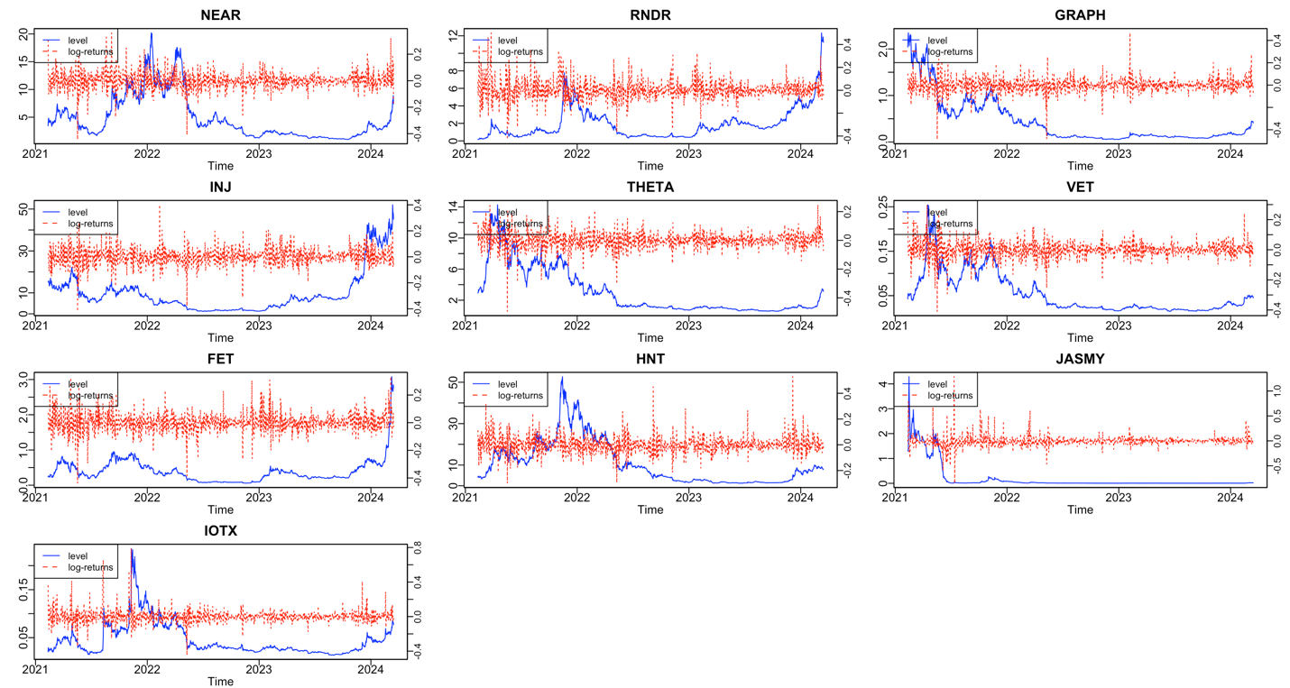
Figure 1: Price and returns of AI and IOT tokens
Notes: This figure shows the trends in the prices and returns of the AI and IOT tokens. NEAR Protocol – NEAR, Render – RNDR, The Graph – GRAPH, Injective – INJ, Theta Network – THETA, VeChain – VET, Fetch.ai – FET, Helium – HNT, JasmyCoin – JASMY, IoTeX – IOTX

Table 1: Descriptive statistics
 | Token | Mean | Median | Max | Min | SD | Skewness | Kurtosis | Jarque-Bera | L-B | L-B^2 | ARCH-LM(10) | ADF
AI | NEAR | 0.067 | -0.025 | 36.103 | -44.362 | 6.698 | 0.025 | 8.396 * | 1368.8 * | 9.565 | 42.5 * | 32.6 * | -9.747 *
 | RNDR | 0.378 | -0.074 | 50.183 | -43.017 | 8.500 | 0.595 * | 7.760 * | 1131.6 * | 12.82 | 190.7 * | 108.9 * | -9.214 *
 | GRAPH | -0.142 | -0.072 | 46.75 | -48.700 | 6.428 | -0.261 * | 12.157 * | 3954.0 * | 20.50 | 62.0 * | 42.6 * | -9.433 *
 | INJ | 0.097 | -0.081 | 40.069 | -41.960 | 6.804 | -0.130 | 7.215 * | 838.4 * | 10.94 | 116.3 * | 82.5 * | -9.736 *
 | THETA | 0.006 | 0.083 | 24.776 | -49.429 | 5.857 | -0.716 * | 9.887 * | 2325.3 * | 36.2 * | 70.3 * | 52.4 * | -8.765 *
IOT | VET | 0.005 | 0.147 | 29.892 | -40.902 | 5.582 | -0.298 * | 8.914 * | 1660.4 * | 42.0 * | 265.7 * | 142.6 * | -9.219 *
 | FET | 0.218 | 0.055 | 33.263 | -43.798 | 7.196 | 0.126 | 7.229 * | 843.5 * | 33.4 * | 115.1 * | 79.1 * | -8.999 *
 | HNT | 0.058 | -0.138 | 52.929 | -29.875 | 6.841 | 0.886 * | 9.445 * | 2100.2 * | 18.55 | 27.2 * | 20.50 | -8.819 *
 | JASMY | -0.373 | -0.713 | 128.811 | -84.978 | 11.190 | 2.129 * | 30.670 * | 36835.6 * | 35.0 * | 170.2 * | 151.8 * | -8.085 *
 | IOTX | 0.118 | 0.001 | 78.832 | -44.619 | 7.731 | 2.270 * | 24.365 * | 22422.6 * | 13.83 | 105.3 * | 107.4 * | -9.546 *

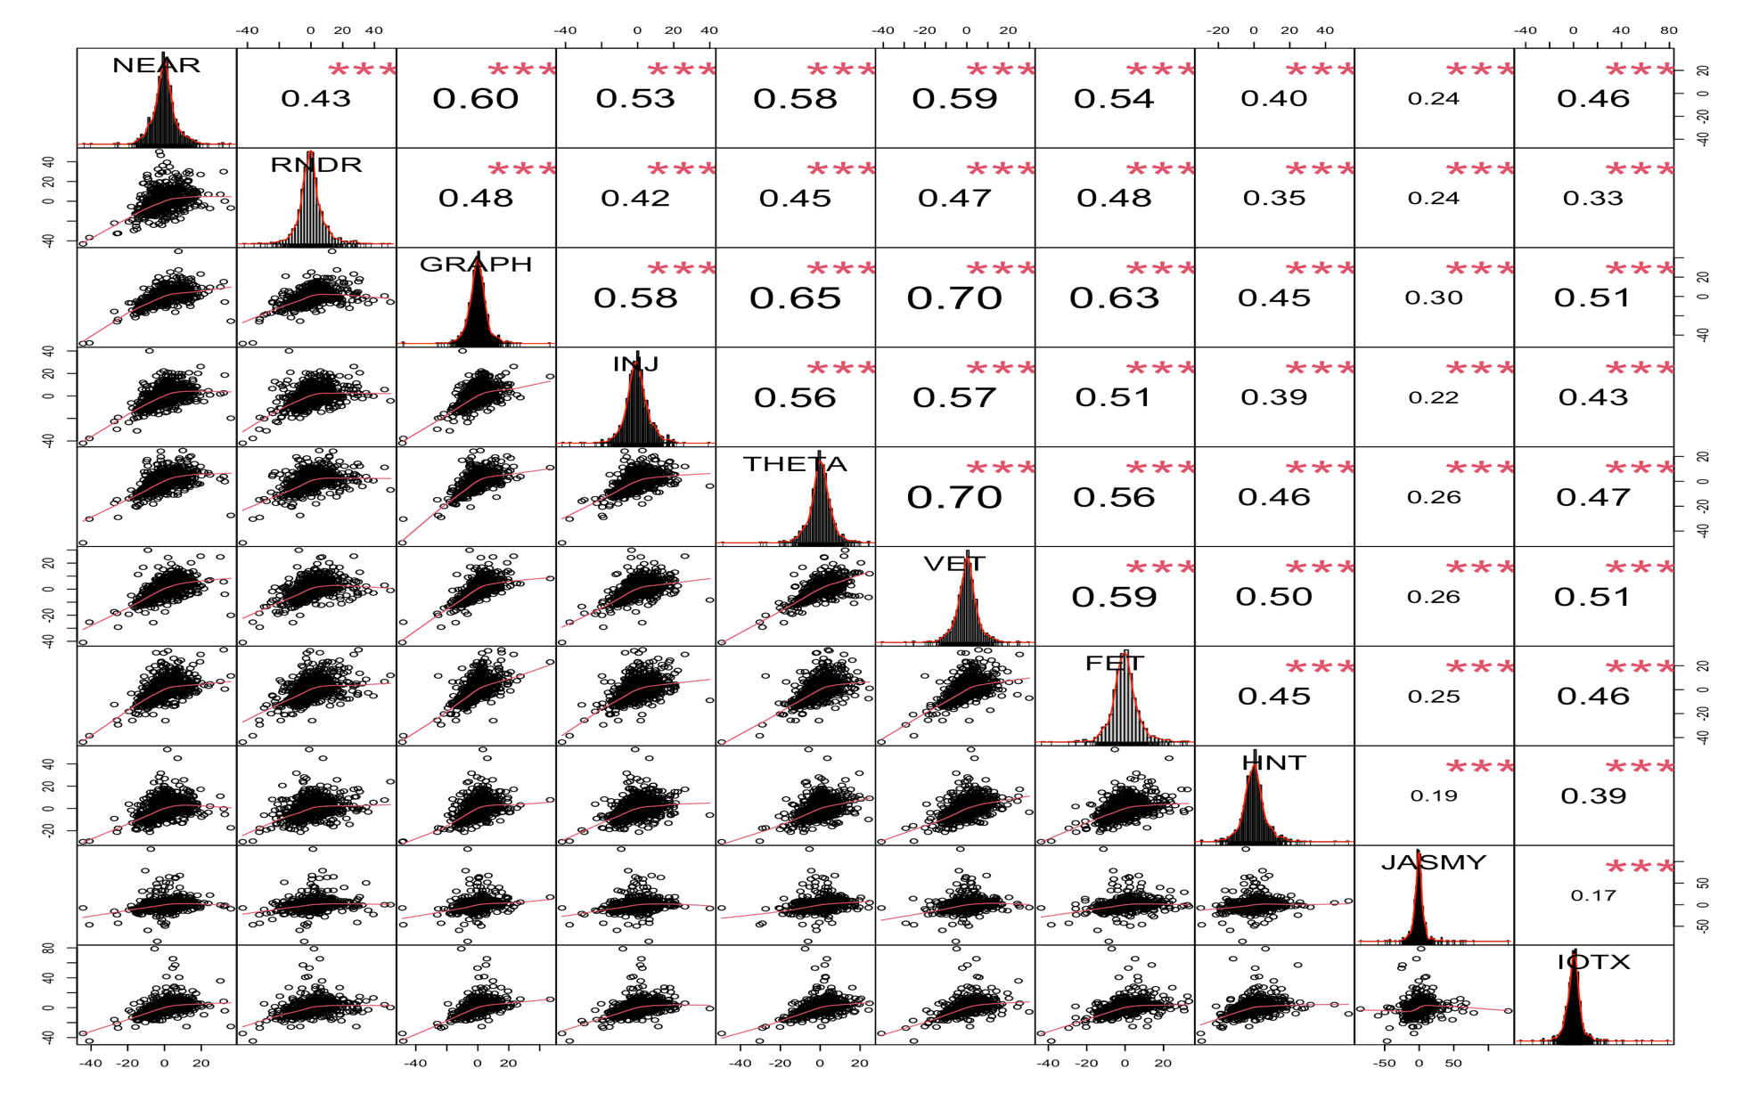
Figure 2: Correlation matrix
NEAR Protocol – NEAR, Render – RNDR, The Graph – GRAPH, Injective – INJ, Theta Network – THETA, VeChain – VET, Fetch.ai – FET, Helium – HNT, JasmyCoin – JASMY, IoTeX – IOTX

Table 2: Static short-term connectedness at middle, upper, and lower quantiles
 | NEAR | RNDR | GRAPH | INJ | THETA | VET | FET | HNT | JASMY | IOTX | FROM
Panel A: Middle quantile ($τ$ =0.50)
NEAR | 25.11 | 5.47 | 7.91 | 6.87 | 9.1 | 9.28 | 7.21 | 4 | 5.3 | 7.12 | 62.27
RNDR | 6.8 | 29.3 | 7.57 | 6.07 | 7.25 | 7.68 | 7.36 | 4.78 | 5.01 | 5.92 | 58.44
GRAPH | 7.61 | 6.43 | 21.75 | 6.36 | 9.58 | 10.67 | 8.32 | 4.69 | 5.66 | 6.79 | 66.1
INJ | 8.28 | 5.96 | 7.93 | 26.06 | 8.45 | 9.27 | 7.61 | 4.12 | 4.54 | 6.63 | 62.79
THETA | 8.67 | 5.53 | 9.27 | 6.82 | 21.56 | 11.46 | 7.26 | 5.03 | 5.54 | 7.13 | 66.71
VET | 8.48 | 5.72 | 10.03 | 7.12 | 11.22 | 20.59 | 7.34 | 5.43 | 5.01 | 7.33 | 67.69
FET | 7.39 | 6.82 | 9.04 | 6.75 | 8.07 | 8.48 | 25.12 | 5.19 | 5.36 | 6.27 | 63.37
HNT | 5.54 | 5.47 | 6.57 | 4.85 | 7.34 | 8.26 | 6.55 | 34.33 | 4.39 | 5.6 | 54.57
JASMY | 6.38 | 5.63 | 7.07 | 4.62 | 6.94 | 6.7 | 5.89 | 3.44 | 35.69 | 5.63 | 52.29
IOTX | 7.85 | 5.37 | 7.62 | 5.87 | 8.24 | 8.81 | 6.25 | 5.16 | 4.9 | 28.84 | 60.07
TO | 67.01 | 52.41 | 73 | 55.33 | 76.2 | 80.61 | 63.79 | 41.83 | 45.72 | 58.41 | 614.31
Inc.Own | 92.12 | 81.71 | 94.74 | 81.4 | 97.76 | 101.2 | 88.91 | 76.16 | 81.41 | 87.24 | TCI
Net | 4.74 | -6.03 | 6.89 | -7.46 | 9.49 | 12.92 | 0.42 | -12.74 | -6.57 | -1.67 | 61.43
Panel B: Upper quantile ($τ$ =0.95)
NEAR | 10.19 | 6.82 | 7.36 | 7.91 | 7.9 | 7.41 | 7.82 | 5.68 | 6.05 | 6.24 | 63.19
RNDR | 7.17 | 11.14 | 7.24 | 8.03 | 7.71 | 7.26 | 8.04 | 5.98 | 6.28 | 6.3 | 64
GRAPH | 7.52 | 7.29 | 10.53 | 7.99 | 8.31 | 7.94 | 8 | 5.93 | 6.37 | 6.4 | 65.74
INJ | 7.64 | 7.29 | 7.62 | 11.86 | 7.76 | 7.77 | 8.34 | 6 | 6.11 | 6.59 | 65.13
THETA | 7.44 | 6.87 | 7.67 | 7.9 | 10.79 | 7.8 | 7.54 | 6 | 6.34 | 6.52 | 64.08
VET | 7.61 | 7.16 | 7.93 | 8.2 | 8.47 | 10.06 | 7.89 | 6.2 | 6.14 | 6.55 | 66.14
FET | 7.56 | 7.41 | 7.69 | 8.18 | 7.86 | 7.49 | 11.38 | 6.17 | 6.22 | 6.36 | 64.94
HNT | 6.9 | 7 | 7.19 | 7.76 | 7.73 | 7.19 | 7.95 | 11.13 | 6.12 | 6.18 | 64.01
JASMY | 7.03 | 6.65 | 7.06 | 7.28 | 7.4 | 6.65 | 7.41 | 5.71 | 11.09 | 6.05 | 61.23
IOTX | 7.26 | 6.71 | 7.18 | 7.46 | 7.84 | 7.26 | 7.42 | 5.93 | 6.07 | 10.75 | 63.14
TO | 66.13 | 63.2 | 66.95 | 70.7 | 70.96 | 66.78 | 70.41 | 53.6 | 55.71 | 57.19 | 641.62
Inc.Own | 76.33 | 74.34 | 77.48 | 82.56 | 81.75 | 76.83 | 81.79 | 64.74 | 66.8 | 67.94 | TCI
Net | 2.94 | -0.8 | 1.2 | 5.57 | 6.88 | 0.63 | 5.47 | -10.41 | -5.53 | -5.95 | 64.16
Panel C: Lower quantile ($τ$ =0.05)
NEAR | 12.65 | 7.09 | 8.24 | 7.76 | 8.76 | 8.73 | 7.78 | 6.86 | 6.73 | 7.42 | 69.37
RNDR | 7.9 | 13.74 | 7.95 | 7.54 | 8.21 | 8.21 | 7.89 | 7.22 | 6.61 | 6.94 | 68.47
GRAPH | 8.23 | 7.3 | 12.13 | 7.68 | 8.93 | 8.95 | 8.24 | 7.13 | 6.87 | 7.42 | 70.74
INJ | 8.42 | 7.34 | 8.09 | 12.76 | 8.63 | 8.68 | 7.83 | 6.85 | 6.57 | 7.43 | 69.84
THETA | 8.61 | 7.12 | 8.6 | 7.78 | 12.26 | 9.33 | 7.86 | 7.2 | 6.95 | 7.55 | 70.99
VET | 8.19 | 7.14 | 8.59 | 7.67 | 9.28 | 11.81 | 7.75 | 7.2 | 6.56 | 7.55 | 69.93
FET | 8.28 | 7.51 | 8.46 | 7.52 | 8.55 | 8.49 | 12.76 | 7.12 | 6.75 | 7.32 | 70.01
HNT | 7.73 | 7.5 | 8.07 | 7.49 | 8.58 | 8.87 | 7.89 | 14.76 | 6.78 | 7.45 | 70.36
JASMY | 8.04 | 7.12 | 8.08 | 7.18 | 8.34 | 8.18 | 7.48 | 6.83 | 15.23 | 6.99 | 68.23
IOTX | 8.03 | 6.8 | 8.04 | 7.34 | 8.3 | 8.42 | 7.47 | 7.18 | 6.31 | 13.26 | 67.89
TO | 73.43 | 64.91 | 74.12 | 67.96 | 77.59 | 77.84 | 70.19 | 63.59 | 60.1 | 66.08 | 695.82
Inc.Own | 86.08 | 78.65 | 86.26 | 80.72 | 89.85 | 89.65 | 82.96 | 78.35 | 75.33 | 79.33 | TCI
Net | 4.06 | -3.55 | 3.38 | -1.88 | 6.6 | 7.91 | 0.19 | -6.76 | -8.13 | -1.82 | 69.58
Notes: This table reports the static short-term connectedness between AI and IOT tokens estimated using QVAR model with a rolling window of 100 days and 20 days as forecasting horizon and lag length of 1 based on AIC criteria. NEAR Protocol – NEAR, Render – RNDR, The Graph – GRAPH, Injective – INJ, Theta Network – THETA, VeChain – VET, Fetch.ai – FET, Helium – HNT, JasmyCoin – JASMY, IoTeX – IOTX

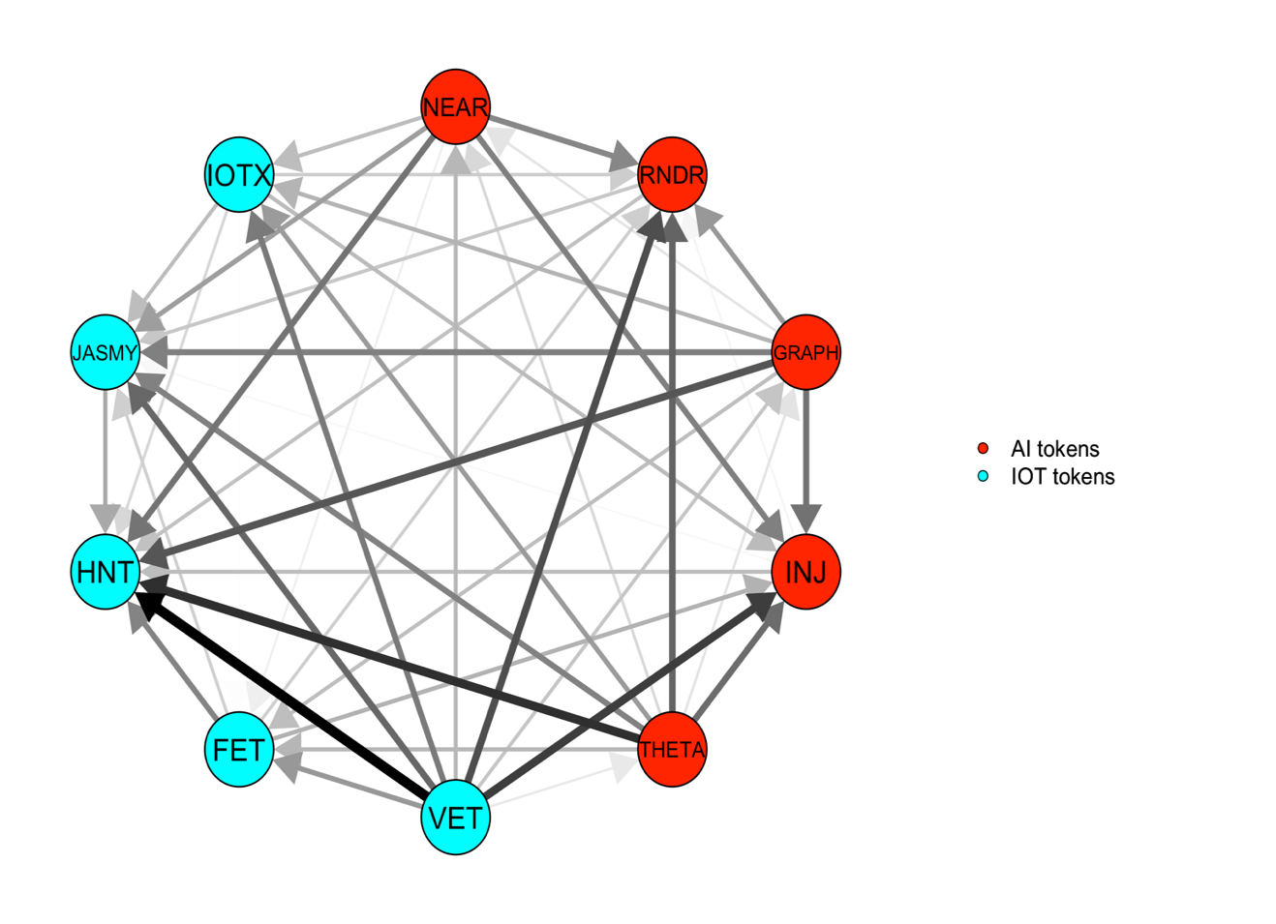 | 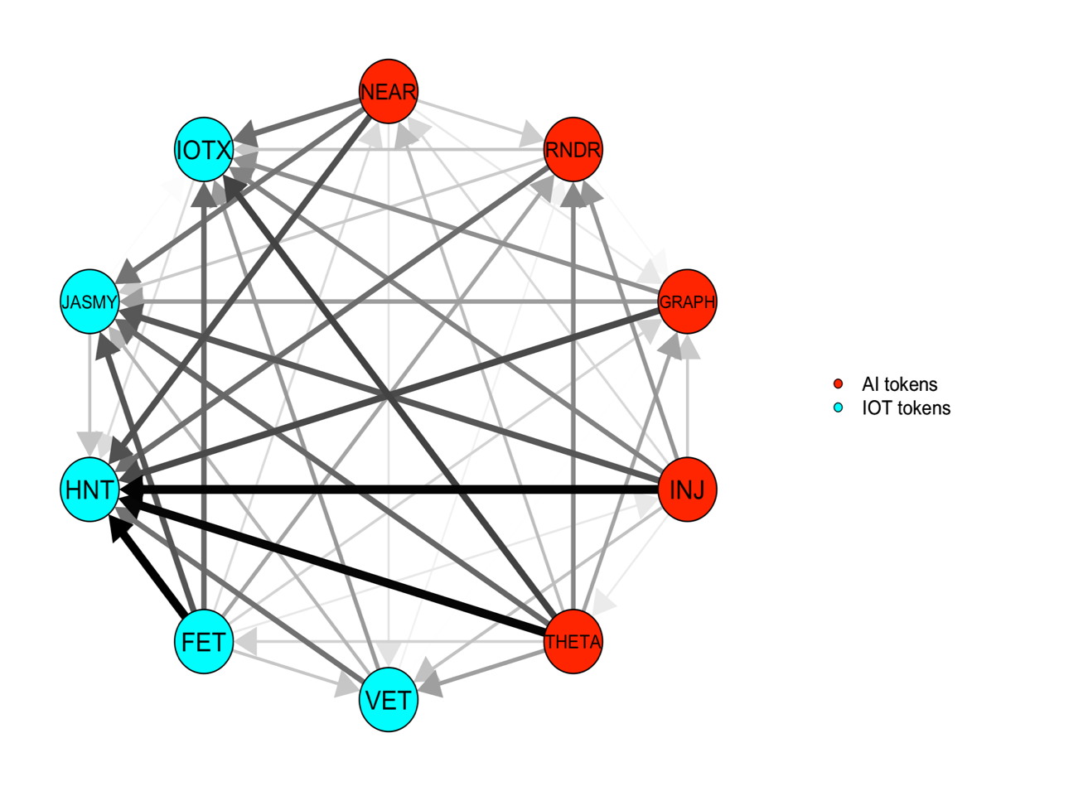 | 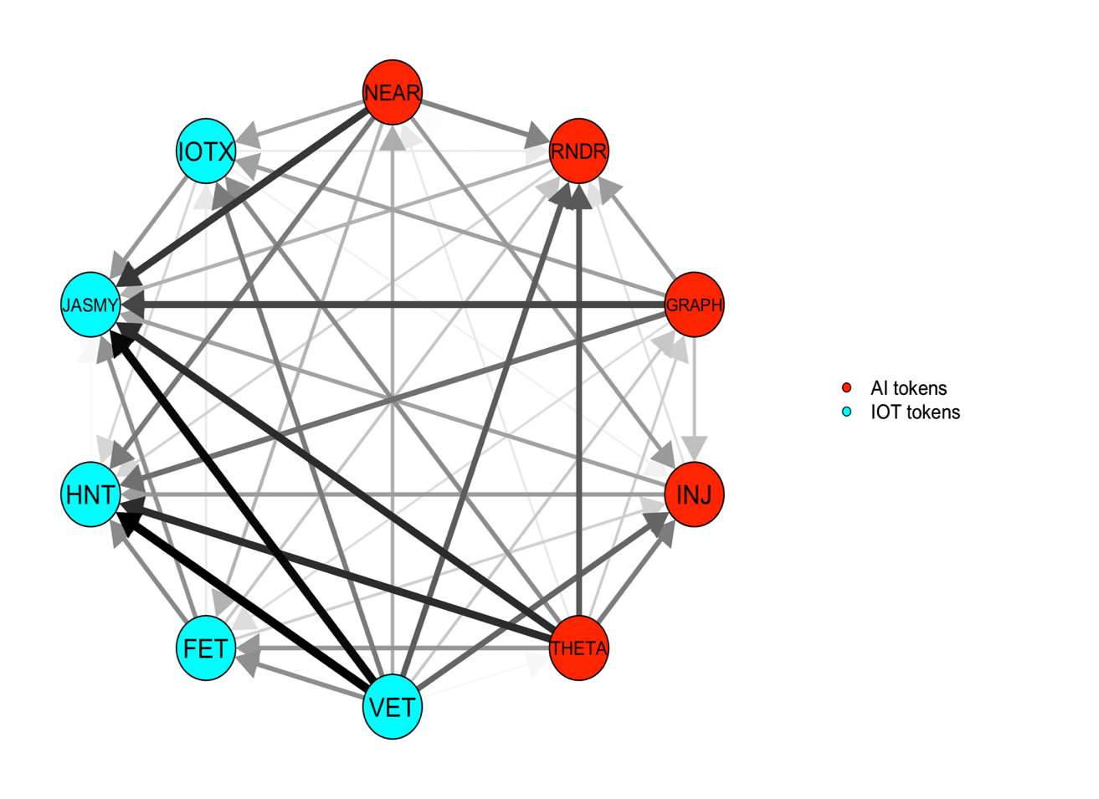
- Middle quantile (τ =0.50) | - Upper quantile (τ =0.95) | - Lower quantile (τ =0.05)
Figure 3: Short-term net pairwise directional spillover at middle, upper and lower quantile
Notes: NEAR Protocol – NEAR, Render – RNDR, The Graph – GRAPH, Injective – INJ, Theta Network – THETA, VeChain – VET, Fetch.ai – FET, Helium – HNT, JasmyCoin – JASMY, IoTeX – IOTX

Figure 4: Dynamic total short-term connectedness at middle, upper and lower quantiles
Notes: Results are estimated using QVAR model with a rolling window of 100 days and 20 days as forecasting horizon and lag length of 1 based on AIC criteria. PLEASE CHANGE THE t IN THE HEADING IT SHOULD BE TAU FOR QUANTILE

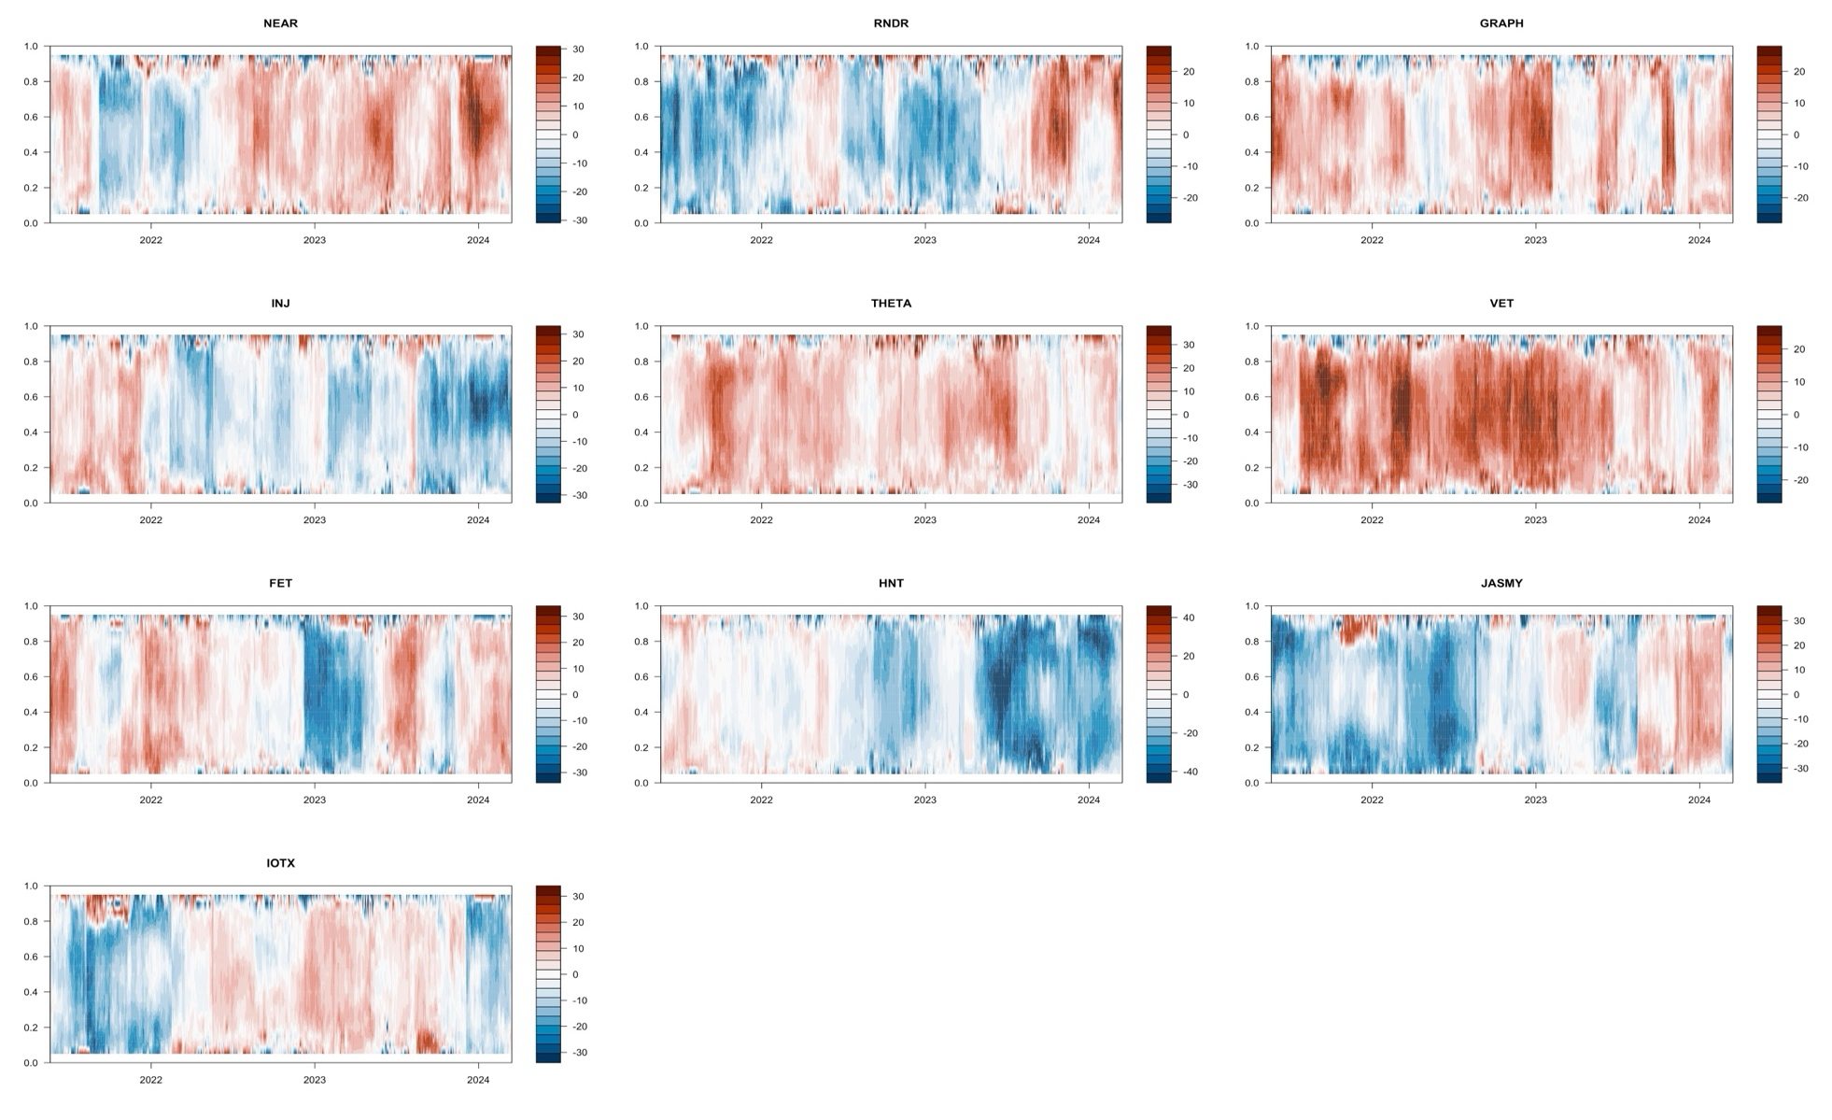
Figure 5: Short term net directional spillover at conditional quantiles
Notes: Results are estimated using QVAR model with a rolling window of 100 days and 20 days as forecasting horizon and lag length of 1 based on AIC criteria. NEAR Protocol – NEAR, Render – RNDR, The Graph – GRAPH, Injective – INJ, Theta Network – THETA, VeChain – VET, Fetch.ai – FET, Helium – HNT, JasmyCoin – JASMY, IoTeX – IOTX

Table 3: Static medium-term connectedness at middle, upper, and lower quantiles
 | NEAR | RNDR | GRAPH | INJ | THETA | VET | FET | HNT | JASMY | IOTX | FROM
Panel A: Middle quantile ($τ$ =0.50)
NEAR | 2.46 | 0.54 | 0.82 | 0.65 | 0.77 | 0.91 | 0.73 | 0.37 | 0.56 | 0.62 | 5.97
RNDR | 0.63 | 2.8 | 0.7 | 0.55 | 0.58 | 0.65 | 0.69 | 0.51 | 0.55 | 0.51 | 5.37
GRAPH | 0.82 | 0.43 | 2.01 | 0.64 | 0.8 | 1.01 | 0.78 | 0.44 | 0.55 | 0.66 | 6.12
INJ | 0.67 | 0.45 | 0.62 | 2.34 | 0.7 | 0.77 | 0.57 | 0.42 | 0.39 | 0.54 | 5.12
THETA | 0.74 | 0.44 | 0.86 | 0.59 | 1.94 | 1.07 | 0.61 | 0.49 | 0.47 | 0.62 | 5.9
VET | 0.73 | 0.45 | 0.95 | 0.69 | 0.88 | 1.88 | 0.67 | 0.54 | 0.42 | 0.61 | 5.96
FET | 0.72 | 0.45 | 0.84 | 0.63 | 0.67 | 0.79 | 2.15 | 0.42 | 0.48 | 0.53 | 5.54
HNT | 0.45 | 0.36 | 0.55 | 0.35 | 0.54 | 0.63 | 0.46 | 3.33 | 0.31 | 0.42 | 4.09
JASMY | 0.53 | 0.39 | 0.6 | 0.41 | 0.58 | 0.51 | 0.52 | 0.31 | 3.69 | 0.49 | 4.33
IOTX | 0.58 | 0.37 | 0.61 | 0.45 | 0.67 | 0.7 | 0.56 | 0.39 | 0.5 | 2.59 | 4.84
TO | 5.88 | 3.89 | 6.55 | 4.97 | 6.19 | 7.05 | 5.59 | 3.89 | 4.24 | 4.99 | 53.23
Inc.Own | 8.34 | 6.69 | 8.56 | 7.31 | 8.13 | 8.92 | 7.74 | 7.22 | 7.92 | 7.59 | TCI
Net | -0.09 | -1.48 | 0.43 | -0.15 | 0.29 | 1.09 | 0.05 | -0.19 | -0.1 | 0.16 | 5.32
Panel B: Upper quantile ($τ$ =0.95)
NEAR | 1.77 | 1.12 | 1.39 | 1.49 | 1.46 | 1.18 | 1.43 | 1.12 | 1.38 | 1.18 | 11.75
RNDR | 1.18 | 1.71 | 1.3 | 1.32 | 1.29 | 1.04 | 1.3 | 1.08 | 1.3 | 1.11 | 10.91
GRAPH | 1.22 | 1.02 | 1.75 | 1.35 | 1.34 | 1.08 | 1.33 | 1 | 1.23 | 1.07 | 10.64
INJ | 1.19 | 1.02 | 1.15 | 1.8 | 1.23 | 1.06 | 1.26 | 0.99 | 1.16 | 0.99 | 10.05
THETA | 1.29 | 1.08 | 1.34 | 1.43 | 1.86 | 1.25 | 1.35 | 1.16 | 1.38 | 1.15 | 11.42
VET | 1.24 | 1.01 | 1.29 | 1.43 | 1.37 | 1.46 | 1.31 | 1.06 | 1.25 | 1.1 | 11.05
FET | 1.29 | 1.02 | 1.32 | 1.39 | 1.32 | 1.08 | 1.81 | 1.07 | 1.25 | 1.11 | 10.84
HNT | 1.24 | 1.11 | 1.19 | 1.31 | 1.33 | 1.15 | 1.19 | 1.87 | 1.23 | 1.12 | 10.88
JASMY | 1.2 | 1.11 | 1.33 | 1.34 | 1.36 | 1.04 | 1.35 | 1.1 | 2.37 | 1.12 | 10.95
IOTX | 1.23 | 1.05 | 1.27 | 1.36 | 1.37 | 1.17 | 1.33 | 1.14 | 1.35 | 1.87 | 11.27
TO | 11.07 | 9.56 | 11.57 | 12.42 | 12.07 | 10.05 | 11.84 | 9.7 | 11.53 | 9.95 | 109.77
Inc.Own | 12.84 | 11.26 | 13.33 | 14.22 | 13.93 | 11.51 | 13.65 | 11.58 | 13.91 | 11.82 | TCI
Net | -0.68 | -1.36 | 0.93 | 2.37 | 0.65 | -1 | 1 | -1.18 | 0.58 | -1.32 | 10.98
Panel C: Lower quantile ($τ$ =0.05)
NEAR | 1.74 | 1.02 | 1.21 | 1.13 | 1.17 | 1.24 | 1.17 | 0.89 | 1.05 | 1.13 | 10.01
RNDR | 1.08 | 1.8 | 1.11 | 1.04 | 1.01 | 1.12 | 1.17 | 0.93 | 0.99 | 1.01 | 9.46
GRAPH | 1.07 | 0.98 | 1.58 | 0.98 | 1.08 | 1.21 | 1.12 | 0.88 | 1.04 | 1.06 | 9.42
INJ | 1.12 | 0.99 | 1.09 | 1.73 | 1.05 | 1.19 | 1.17 | 0.98 | 0.86 | 1.05 | 9.51
THETA | 1.07 | 0.93 | 1.13 | 1.01 | 1.51 | 1.26 | 1.01 | 0.92 | 0.92 | 1.06 | 9.32
VET | 1.2 | 1.02 | 1.27 | 1.15 | 1.23 | 1.69 | 1.14 | 1.04 | 1.02 | 1.15 | 10.21
FET | 1.07 | 0.99 | 1.18 | 1.01 | 1.09 | 1.24 | 1.72 | 0.92 | 0.91 | 0.99 | 9.4
HNT | 0.89 | 0.85 | 0.94 | 0.87 | 0.86 | 0.98 | 0.9 | 1.73 | 0.8 | 0.9 | 7.99
JASMY | 0.95 | 0.9 | 1.06 | 0.93 | 1.05 | 1 | 1 | 0.85 | 2.01 | 0.92 | 8.66
IOTX | 1.18 | 1.01 | 1.25 | 1.11 | 1.19 | 1.32 | 1.13 | 0.99 | 1.12 | 1.93 | 10.3
TO | 9.63 | 8.71 | 10.23 | 9.23 | 9.73 | 10.58 | 9.79 | 8.41 | 8.71 | 9.27 | 94.27
Inc.Own | 11.37 | 10.51 | 11.81 | 10.95 | 11.24 | 12.27 | 11.51 | 10.14 | 10.71 | 11.2 | TCI
Net | -0.38 | -0.76 | 0.82 | -0.28 | 0.41 | 0.37 | 0.38 | 0.42 | 0.05 | -1.03 | 9.43
Notes: This table reports the static medium-term connectedness between AI and IoT tokens estimated using QVAR model with a rolling window of 100 days and 20 days as forecasting horizon and lag length of 1 based on AIC criteria.
NEAR Protocol – NEAR, Render – RNDR, The Graph – GRAPH, Injective – INJ, Theta Network – THETA, VeChain – VET, Fetch.ai – FET, Helium – HNT, JasmyCoin – JASMY, IoTeX – IOTX

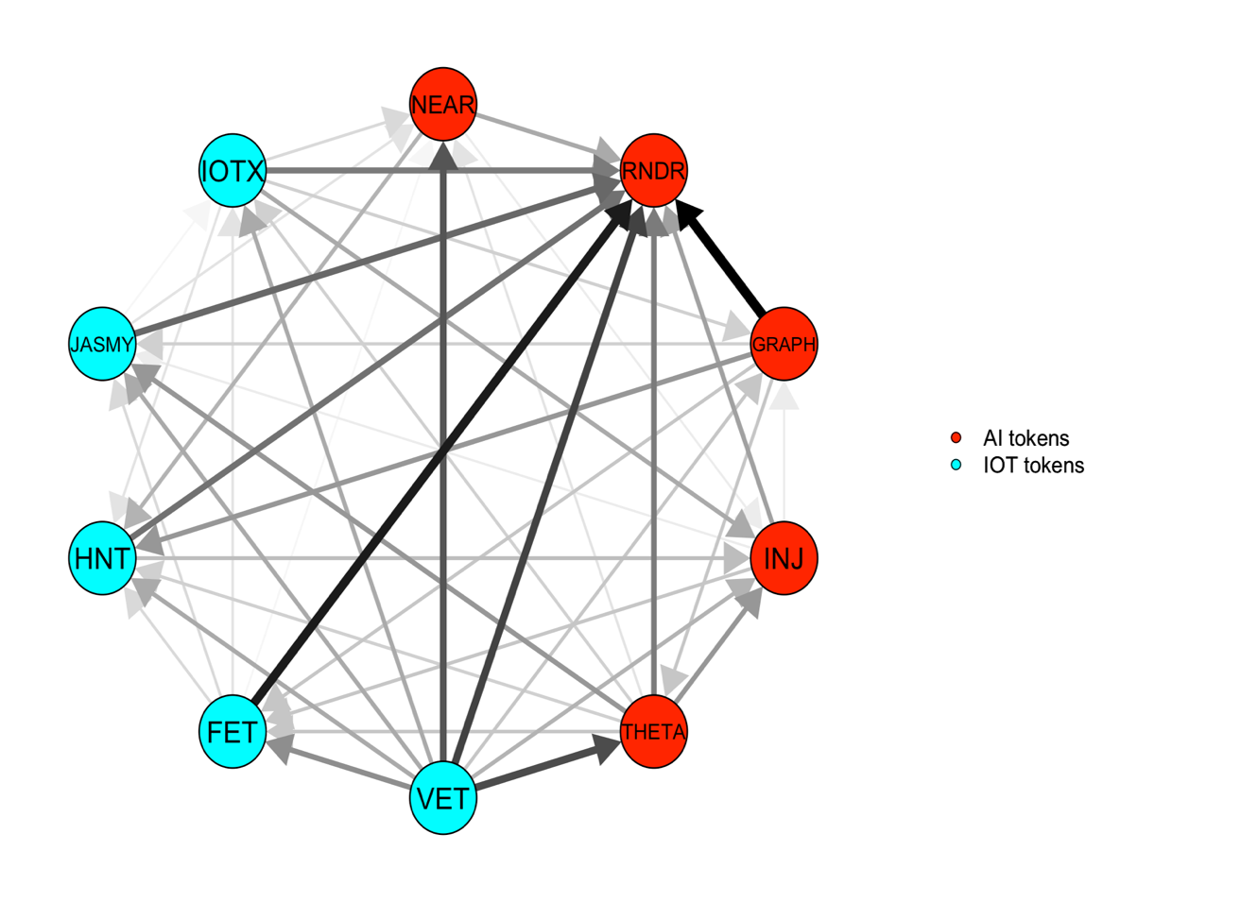 | 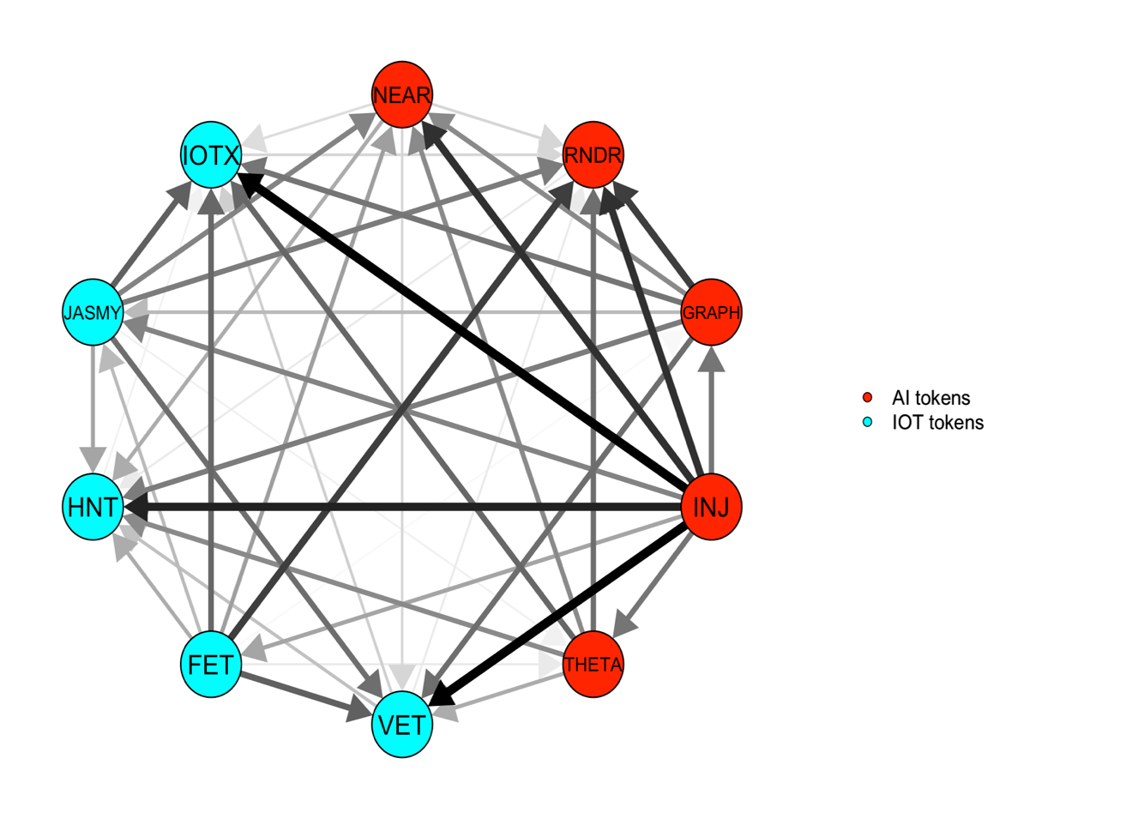 | 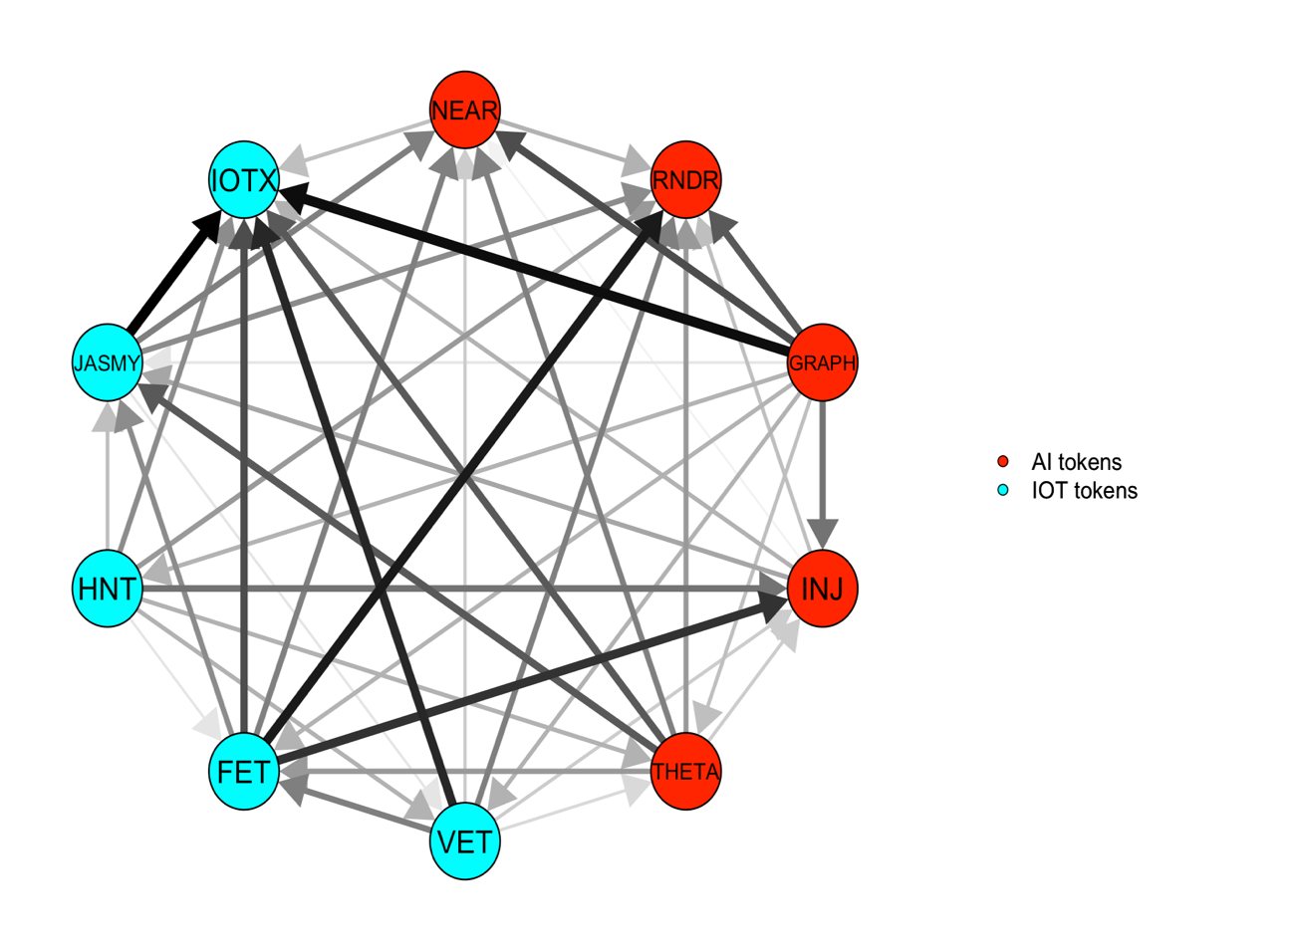
- Middle quantile (τ =0.50) | - Upper quantile (τ =0.95) | - Lower quantile (τ =0.05)
Figure 6: Medium-term net pairwise directional spillover at middle, upper, and lower quantiles
NEAR Protocol – NEAR, Render – RNDR, The Graph – GRAPH, Injective – INJ, Theta Network – THETA, VeChain – VET, Fetch.ai – FET, Helium – HNT, JasmyCoin – JASMY, IoTeX – IOTX

Figure 7: Dynamic total medium-term connectedness at middle, upper, and lower quantiles
Notes: Results are estimated using QVAR model with a rolling window of 100 days and 20 days as forecasting horizon and lag length of 1 based on AIC criteria.

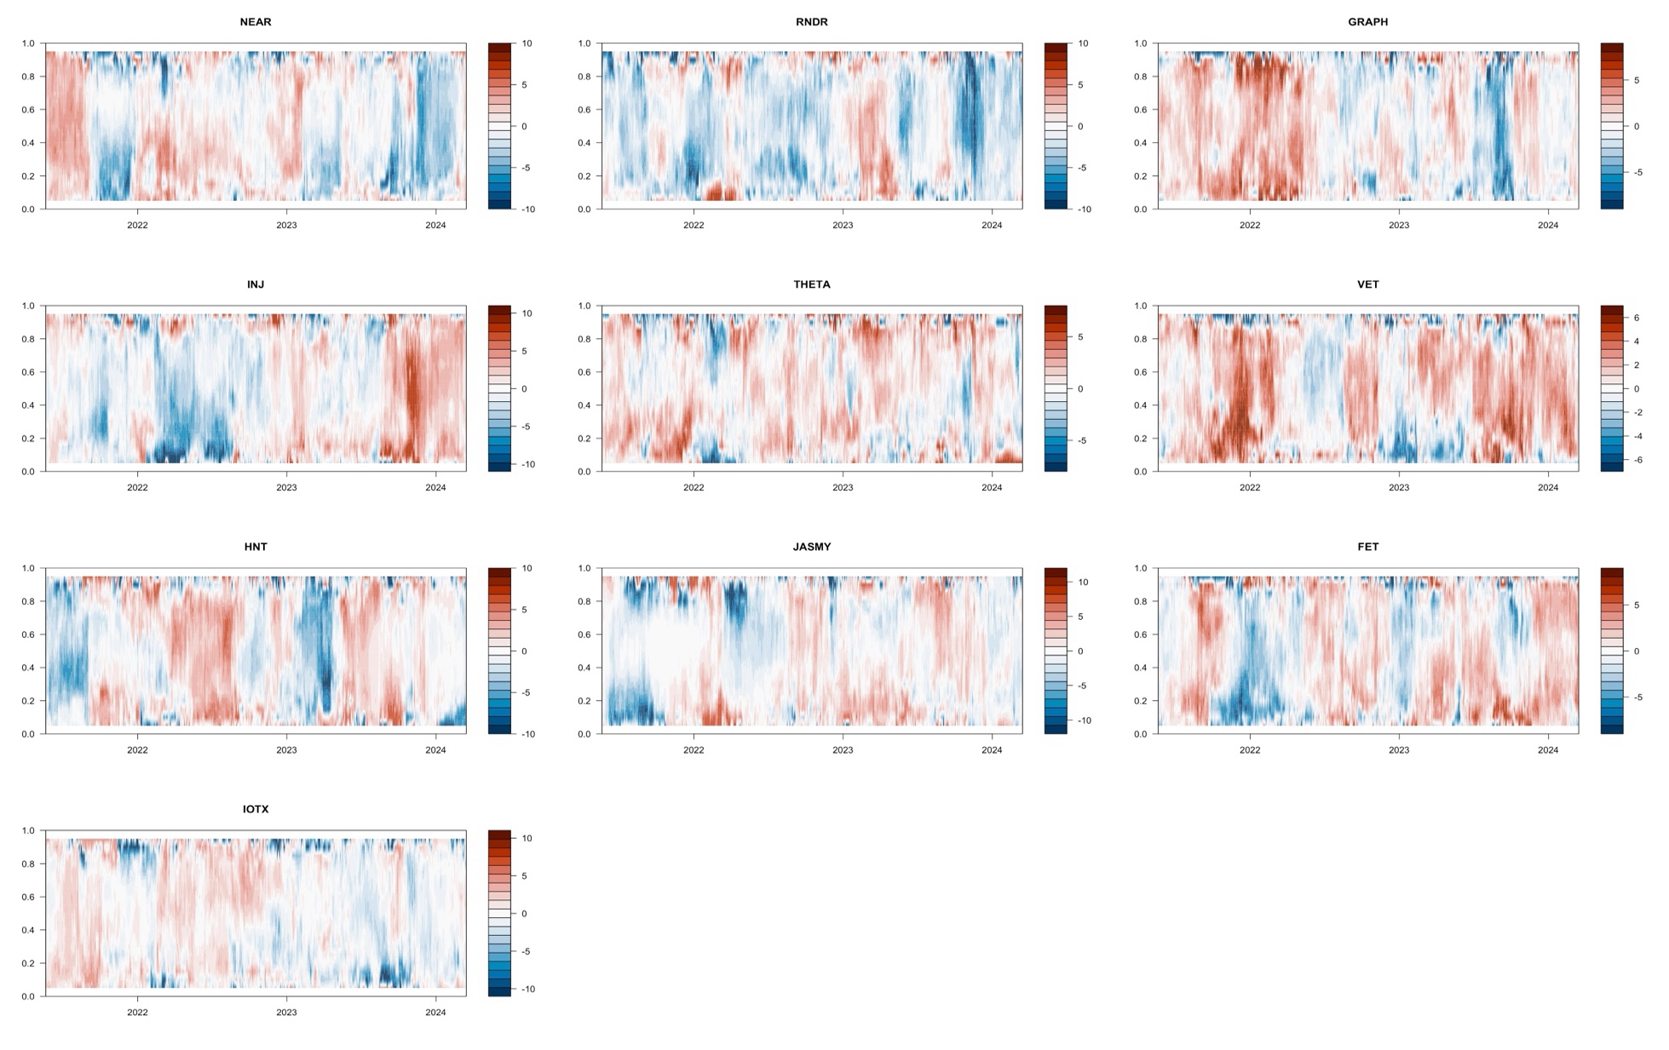
Figure 8: Medium term net directional spillover at conditional quantiles
Notes: Results are estimated using QVAR model with a rolling window of 100 days and 20 days as forecasting horizon and lag length of 1 based on AIC criteria. NEAR Protocol – NEAR, Render – RNDR, The Graph – GRAPH, Injective – INJ, Theta Network – THETA, VeChain – VET, Fetch.ai – FET, Helium – HNT, JasmyCoin – JASMY, IoTeX – IOTX

Table 4 Static long-term connectedness at middle, upper, and lower quantiles
 | NEAR | RNDR | GRAPH | INJ | THETA | VET | FET | HNT | JASMY | IOTX | FROM
Panel A: Middle quantile ($τ$ =0.50)
NEAR | 1.23 | 0.27 | 0.41 | 0.32 | 0.38 | 0.45 | 0.36 | 0.19 | 0.28 | 0.3 | 2.97
RNDR | 0.32 | 1.4 | 0.35 | 0.28 | 0.29 | 0.33 | 0.34 | 0.25 | 0.28 | 0.25 | 2.68
GRAPH | 0.41 | 0.21 | 0.99 | 0.32 | 0.39 | 0.5 | 0.38 | 0.22 | 0.27 | 0.33 | 3.03
INJ | 0.33 | 0.22 | 0.3 | 1.16 | 0.34 | 0.38 | 0.28 | 0.21 | 0.19 | 0.26 | 2.52
THETA | 0.37 | 0.22 | 0.43 | 0.3 | 0.96 | 0.53 | 0.3 | 0.24 | 0.23 | 0.31 | 2.93
VET | 0.36 | 0.23 | 0.47 | 0.35 | 0.43 | 0.94 | 0.33 | 0.27 | 0.21 | 0.3 | 2.95
FET | 0.36 | 0.22 | 0.42 | 0.32 | 0.33 | 0.39 | 1.07 | 0.21 | 0.24 | 0.26 | 2.75
HNT | 0.22 | 0.18 | 0.27 | 0.17 | 0.27 | 0.31 | 0.23 | 1.67 | 0.15 | 0.21 | 2.02
JASMY | 0.26 | 0.19 | 0.29 | 0.2 | 0.29 | 0.25 | 0.26 | 0.16 | 1.85 | 0.24 | 2.14
IOTX | 0.28 | 0.18 | 0.3 | 0.22 | 0.33 | 0.34 | 0.28 | 0.19 | 0.25 | 1.29 | 2.38
TO | 2.92 | 1.92 | 3.24 | 2.48 | 3.05 | 3.49 | 2.77 | 1.94 | 2.1 | 2.46 | 26.37
Inc.Own | 4.14 | 3.32 | 4.24 | 3.64 | 4.01 | 4.43 | 3.84 | 3.61 | 3.95 | 3.75 | TCI
Net | -0.05 | -0.76 | 0.21 | -0.04 | 0.11 | 0.54 | 0.02 | -0.08 | -0.05 | 0.08 | 2.64
Panel B: Upper quantile ($τ$ =0.95)
NEAR | 1.52 | 1.07 | 1.31 | 1.33 | 1.29 | 0.99 | 1.65 | 1.14 | 1.69 | 1.09 | 11.57
RNDR | 1.09 | 1.38 | 1.21 | 1.29 | 1.18 | 0.91 | 1.46 | 1.06 | 1.57 | 1.08 | 10.87
GRAPH | 1.05 | 0.92 | 1.44 | 1.24 | 1.14 | 0.88 | 1.42 | 0.99 | 1.36 | 0.89 | 9.89
INJ | 1.08 | 0.92 | 1.04 | 1.47 | 1.06 | 0.86 | 1.45 | 1.02 | 1.36 | 0.91 | 9.69
THETA | 1.12 | 0.97 | 1.14 | 1.23 | 1.4 | 0.92 | 1.45 | 1.08 | 1.51 | 1.03 | 10.46
VET | 1.05 | 0.91 | 1.1 | 1.22 | 1.09 | 1.06 | 1.44 | 1.01 | 1.43 | 0.97 | 10.23
FET | 1.1 | 0.89 | 1.07 | 1.12 | 1.09 | 0.79 | 1.69 | 1.04 | 1.29 | 0.94 | 9.34
HNT | 1.08 | 1.01 | 1.1 | 1.26 | 1.25 | 0.96 | 1.44 | 1.54 | 1.49 | 0.97 | 10.55
JASMY | 1.23 | 1.18 | 1.33 | 1.48 | 1.37 | 1.05 | 1.67 | 1.22 | 2.55 | 1.26 | 11.81
IOTX | 1.09 | 1.03 | 1.12 | 1.2 | 1.2 | 0.98 | 1.44 | 1.17 | 1.57 | 2.16 | 10.8
TO | 9.91 | 8.91 | 10.43 | 11.37 | 10.67 | 8.34 | 13.41 | 9.73 | 13.29 | 9.15 | 105.2
Inc.Own | 11.43 | 10.29 | 11.86 | 12.85 | 12.07 | 9.4 | 15.1 | 11.26 | 15.83 | 11.3 | TCI
Net | -1.66 | -1.95 | 0.54 | 1.69 | 0.21 | -1.89 | 4.08 | -0.83 | 1.48 | -1.66 | 10.52
Panel C: Lower quantile ($τ$ =0.05)
NEAR | 0.9 | 0.57 | 0.65 | 0.6 | 0.61 | 0.65 | 0.63 | 0.47 | 0.56 | 0.59 | 5.33
RNDR | 0.6 | 1.1 | 0.67 | 0.62 | 0.56 | 0.63 | 0.66 | 0.54 | 0.58 | 0.57 | 5.44
GRAPH | 0.57 | 0.62 | 0.88 | 0.55 | 0.58 | 0.66 | 0.62 | 0.48 | 0.59 | 0.58 | 5.25
INJ | 0.6 | 0.58 | 0.61 | 0.94 | 0.55 | 0.65 | 0.66 | 0.55 | 0.47 | 0.56 | 5.23
THETA | 0.57 | 0.56 | 0.62 | 0.56 | 0.8 | 0.68 | 0.55 | 0.5 | 0.51 | 0.58 | 5.11
VET | 0.63 | 0.57 | 0.68 | 0.62 | 0.64 | 0.9 | 0.63 | 0.55 | 0.53 | 0.61 | 5.46
FET | 0.57 | 0.58 | 0.66 | 0.56 | 0.58 | 0.68 | 0.95 | 0.5 | 0.49 | 0.53 | 5.15
HNT | 0.46 | 0.51 | 0.51 | 0.47 | 0.45 | 0.5 | 0.47 | 0.9 | 0.43 | 0.47 | 4.26
JASMY | 0.5 | 0.56 | 0.6 | 0.52 | 0.56 | 0.54 | 0.54 | 0.46 | 1.07 | 0.51 | 4.8
IOTX | 0.62 | 0.61 | 0.69 | 0.61 | 0.63 | 0.7 | 0.6 | 0.53 | 0.61 | 1.02 | 5.6
TO | 5.11 | 5.16 | 5.69 | 5.11 | 5.17 | 5.7 | 5.35 | 4.58 | 4.76 | 5.01 | 51.63
Inc.Own | 6.01 | 6.26 | 6.57 | 6.05 | 5.97 | 6.6 | 6.3 | 5.48 | 5.83 | 6.02 | TCI
Net | -0.22 | -0.28 | 0.44 | -0.12 | 0.06 | 0.24 | 0.2 | 0.32 | -0.04 | -0.6 | 5.16
Notes: This table reports the static long-term connectedness between AI and IoT tokens estimated using QVAR model with a rolling window of 100 days and 20 days as forecasting horizon and lag length of 1 based on AIC criteria. NEAR Protocol – NEAR, Render – RNDR, The Graph – GRAPH, Injective – INJ, Theta Network – THETA, VeChain – VET, Fetch.ai – FET, Helium – HNT, JasmyCoin – JASMY, IoTeX – IOTX

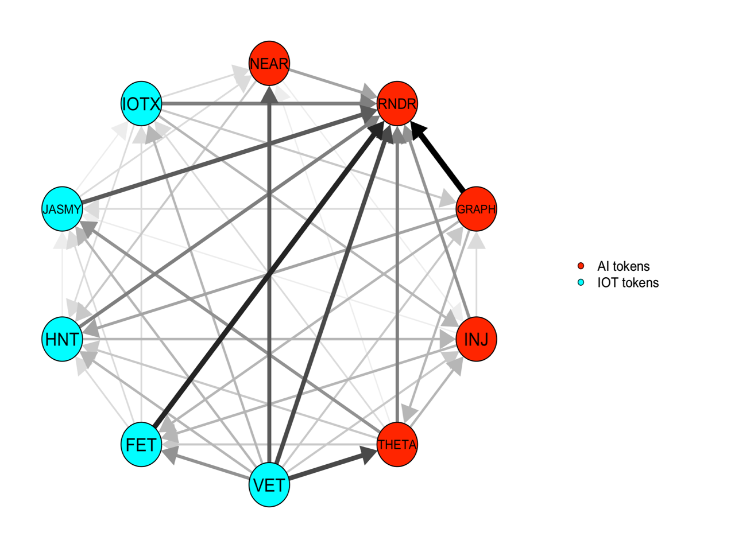 | 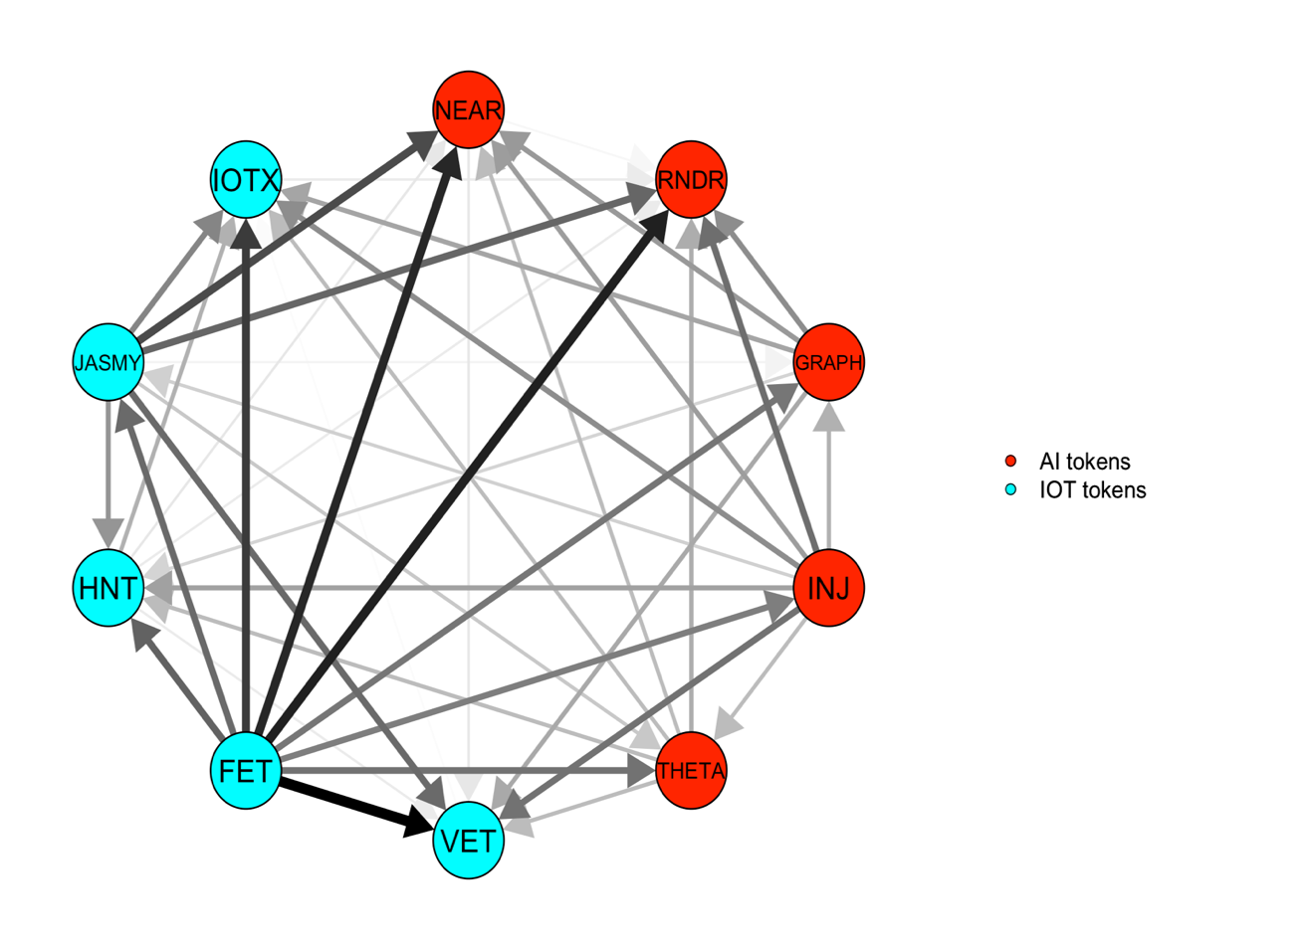 | 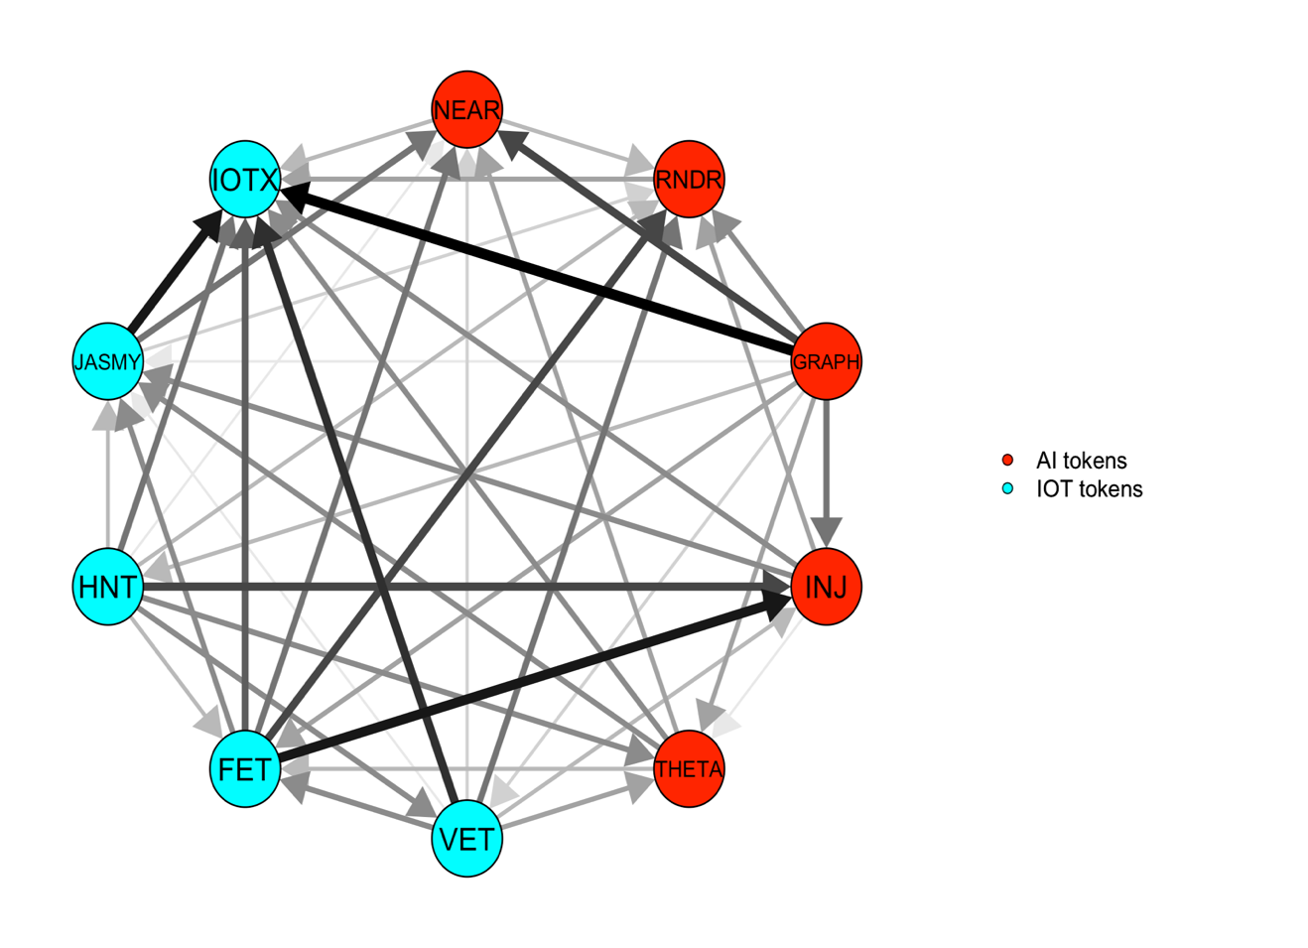
- Middle quantile (τ =0.50) | - Upper quantile (τ =0.95) | - Lower quantile (τ =0.05)
Figure 9: Long-term net pairwise directional spillover at middle, upper, and lower quantiles
Notes: NEAR Protocol – NEAR, Render – RNDR, The Graph – GRAPH, Injective – INJ, Theta Network – THETA, VeChain – VET, Fetch.ai – FET, Helium – HNT, JasmyCoin – JASMY, IoTeX – IOTX

Figure 10: Dynamic total long-term connectedness at middle, upper, and lower quantiles
Notes: Results are estimated using QVAR model with a rolling window of 100 days and 20 days as forecasting horizon and lag length of 1 based on AIC criteria.

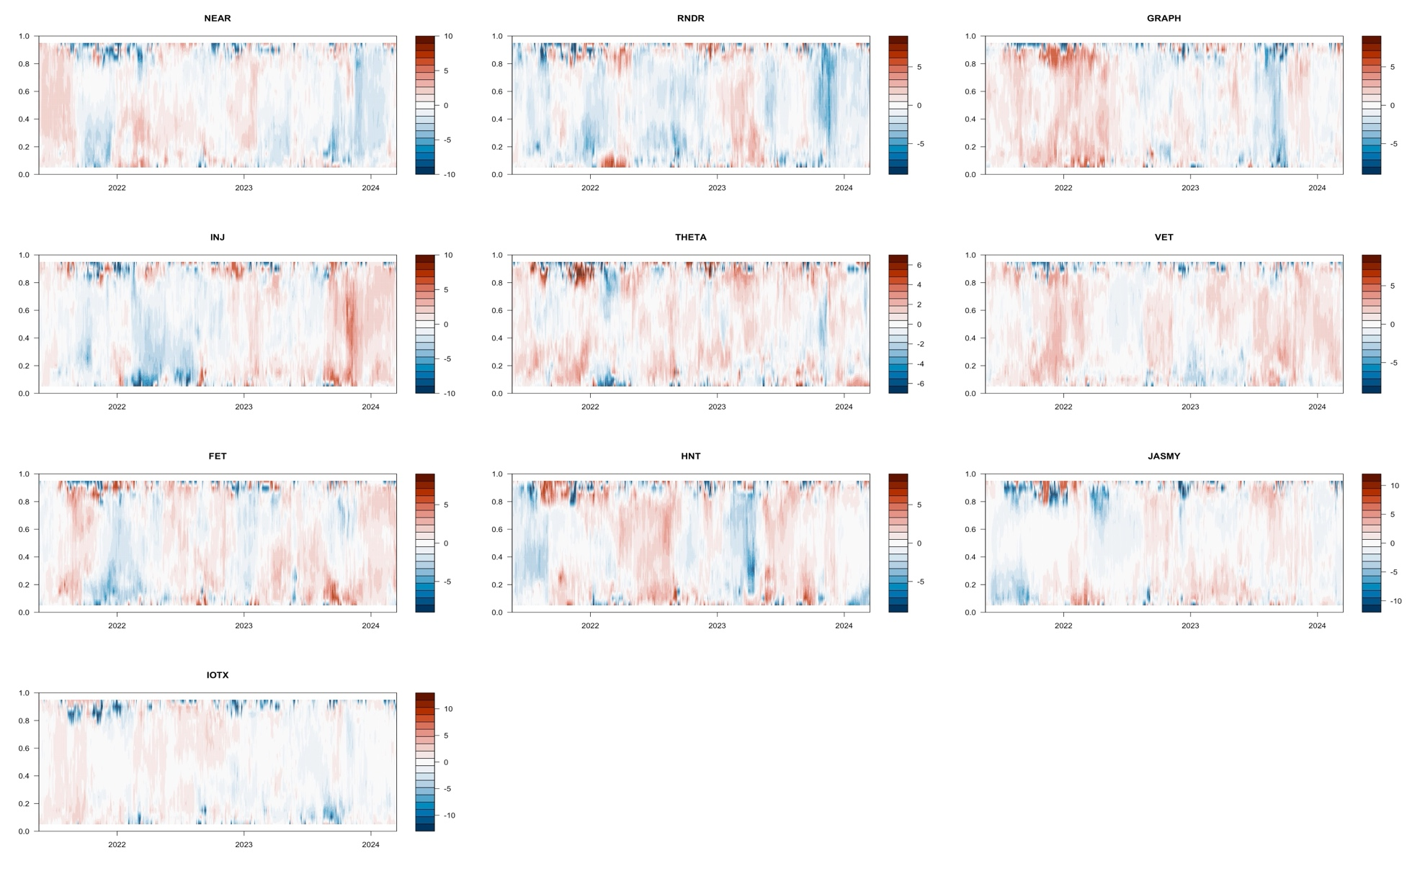
Figure 11: Long term net directional spillover at conditional quantiles
Notes: Results are estimated using QVAR model with a rolling window of 100 days and 20 days as forecasting horizon and lag length of 1 based on AIC criteria.
NEAR Protocol – NEAR, Render – RNDR, The Graph – GRAPH, Injective – INJ, Theta Network – THETA, VeChain – VET, Fetch.ai – FET, Helium – HNT, JasmyCoin – JASMY, IoTeX – IOTX

Table 5: Summary of static analysis - net roles of Ai and IoT tokens
 | SHORT |  |  | MEDIUM |  |  | LONG
 | Middle | Upper | Lower | Middle | Upper | Lower | Middle | Upper | Lower
NEAR | + | + | + | - | - | - | - | - | -
RNDR | - | - | - | - | - | - | - | - | -
GRAPH | + | + | + | + | + | + | + | + | +
INJ | - | + | - | - | + | - | - | + | -
THETA | + | + | + | + | + | + | + | + | +
VET | + | + | + | + | - | + | + | - | +
FET | + | + | + | + | + | + | + | + | +
HNT | - | - | - | - | - | + | - | - | +
JASMY | - | - | - | - | + | + | - | + | -
IOTX | - | - | - | + | - | - | + | - | -

Notes: This table reports the net role of each token by both the investment horizon and the quantile under investigation.

Table 6: Multivariate short-term optimal weights and hedging effectiveness
 | Middle quantile ($τ$ =0.50) |  |  |  | Upper quantile ($τ$ =0.95) |  |  |  | Lower quantile ($τ$ =0.05)
 | Mean | HE | p-value |  | Mean | HE | p-value |  | Mean | HE | p-value
NEAR | 0.082 | 0.291 | 0.000 |  | 0.095 | 0.28 | 0.000 |  | 0.079 | 0.28 | 0.000
RNDR | 0.136 | 0.506 | 0.000 |  | 0.098 | 0.498 | 0.000 |  | 0.134 | 0.498 | 0.000
GRAPH | 0.059 | 0.221 | 0.000 |  | 0.106 | 0.209 | 0.000 |  | 0.071 | 0.209 | 0.000
INJ | 0.133 | 0.319 | 0.000 |  | 0.103 | 0.308 | 0.000 |  | 0.109 | 0.308 | 0.000
THETA | 0.055 | -0.01 | 0.868 |  | 0.090 | -0.027 | 0.671 |  | 0.059 | -0.026 | 0.677
VET | 0.026 | -0.205 | 0.003 |  | 0.079 | -0.224 | 0.001 |  | 0.064 | -0.224 | 0.001
FET | 0.062 | 0.346 | 0.000 |  | 0.089 | 0.336 | 0.000 |  | 0.090 | 0.336 | 0.000
HNT | 0.178 | 0.303 | 0.000 |  | 0.109 | 0.292 | 0.000 |  | 0.110 | 0.292 | 0.000
JASMY | 0.154 | 0.751 | 0.000 |  | 0.124 | 0.747 | 0.000 |  | 0.135 | 0.747 | 0.000
IOTX | 0.116 | 0.448 | 0.000 |  | 0.106 | 0.439 | 0.000 |  | 0.149 | 0.439 | 0.000
Notes: This table reports the optimal weights for the portfolio comprising both the AI and IoT token. The results are estimated using QVAR model with a 100 days rolling window size, lag length of order 1 (AIC) and a 20-step-ahead generalized forecast error variance decomposition.
NEAR Protocol – NEAR, Render – RNDR, The Graph – GRAPH, Injective – INJ, Theta Network – THETA, VeChain – VET, Fetch.ai – FET, Helium – HNT, JasmyCoin – JASMY, IoTeX – IOTX

Table 7: Multivariate medium term optimal weights and hedging effectiveness
 | Middle quantile ($τ$ =0.50) |  |  |  | Upper quantile ($τ$ =0.95) |  |  |  | Lower quantile ($τ$ =0.05)
 | Mean | HE | p-value |  | Mean | HE | p-value |  | Mean | HE | p-value
NEAR | 0.071 | 0.396 | 0.000 |  | 0.093 | 0.299 | 0.000 |  | 0.096 | 0.38 | 0.000
RNDR | 0.109 | 0.579 | 0.000 |  | 0.093 | 0.512 | 0.000 |  | 0.082 | 0.568 | 0.000
GRAPH | 0.052 | 0.337 | 0.000 |  | 0.093 | 0.231 | 0.000 |  | 0.106 | 0.32 | 0.000
INJ | 0.122 | 0.42 | 0.000 |  | 0.104 | 0.327 | 0.000 |  | 0.097 | 0.405 | 0.000
THETA | 0.093 | 0.139 | 0.000 |  | 0.103 | 0.002 | 0.981 |  | 0.142 | 0.117 | 0.046
VET | 0.068 | -0.026 | 0.677 |  | 0.107 | -0.191 | 0.005 |  | 0.087 | -0.053 | 0.407
FET | 0.100 | 0.443 | 0.000 |  | 0.109 | 0.354 | 0.000 |  | 0.099 | 0.429 | 0.000
HNT | 0.152 | 0.407 | 0.000 |  | 0.097 | 0.312 | 0.000 |  | 0.101 | 0.391 | 0.000
JASMY | 0.125 | 0.788 | 0.000 |  | 0.097 | 0.754 | 0.000 |  | 0.090 | 0.782 | 0.000
IOTX | 0.108 | 0.53 | 0.000 |  | 0.104 | 0.455 | 0.000 |  | 0.099 | 0.518 | 0.000
Notes: This table reports the optimal weights for the portfolio comprising both the AI and IoT token. The results are estimated using QVAR model with a 100-days rolling window size, lag length of order 1 (AIC) and a 20-step-ahead generalized forecast error variance decomposition.
NEAR Protocol – NEAR, Render – RNDR, The Graph – GRAPH, Injective – INJ, Theta Network – THETA, VeChain – VET, Fetch.ai – FET, Helium – HNT, JasmyCoin – JASMY, IoTeX – IOTX

Table 8: Multivariate long term optimal weights and hedging effectiveness
 | Middle quantile ($τ$ =0.50) |  |  |  | Upper quantile ($τ$ =0.95) |  |  |  | Lower quantile ($τ$ =0.05)
 | Mean | HE | p-value |  | Mean | HE | p-value |  | Mean | HE | p-value
NEAR | 0.071 | 0.397 | 0.000 |  | 0.094 | 0.288 | 0.000 |  | 0.102 | 0.387 | 0.000
RNDR | 0.108 | 0.579 | 0.000 |  | 0.094 | 0.504 | 0.000 |  | 0.081 | 0.573 | 0.000
GRAPH | 0.054 | 0.338 | 0.000 |  | 0.100 | 0.218 | 0.000 |  | 0.099 | 0.327 | 0.000
INJ | 0.120 | 0.42 | 0.000 |  | 0.113 | 0.316 | 0.000 |  | 0.101 | 0.411 | 0.000
THETA | 0.094 | 0.14 | 0.015 |  | 0.097 | -0.014 | 0.819 |  | 0.138 | 0.126 | 0.031
VET | 0.070 | -0.025 | 0.689 |  | 0.104 | -0.21 | 0.002 |  | 0.089 | -0.042 | 0.510
FET | 0.101 | 0.444 | 0.000 |  | 0.107 | 0.344 | 0.000 |  | 0.100 | 0.435 | 0.000
HNT | 0.150 | 0.407 | 0.000 |  | 0.096 | 0.301 | 0.000 |  | 0.104 | 0.398 | 0.000
JASMY | 0.125 | 0.788 | 0.000 |  | 0.093 | 0.75 | 0.000 |  | 0.088 | 0.785 | 0.000
IOTX | 0.108 | 0.53 | 0.000 |  | 0.102 | 0.446 | 0.000 |  | 0.099 | 0.523 | 0.000
Notes: This table reports the optimal weights for the portfolio comprising both the AI and IoT token. The results are estimated using QVAR model with a 100 days rolling-window size, lag length of order 1 (AIC) and a 20-step-ahead generalized forecast error variance decomposition.
NEAR Protocol – NEAR, Render – RNDR, The Graph – GRAPH, Injective – INJ, Theta Network – THETA, VeChain – VET, Fetch.ai – FET, Helium – HNT, JasmyCoin – JASMY, IoTeX – IOTX

AI Market Capitalization, 2024. For details, please see: https://www.statista.com/outlook/tmo/artificial-intelligence/worldwide.
IoT Market Capitalization, 2024. For details, please see: https://www.statista.com/outlook/tmo/internet-of-things/worldwide.
Fintech Trends 2024. For details, please see: https://dashdevs.com/blog/fintech-trends-2024.
Global Crypto Market Capitalization, May 2024. For details, please see: https://coinmarketcap.com.

