**Sinking and Transport Pathways of Plastic Bags in the Southeastern Mediterranean Sea**

Xingyu Li1, Revital Bookman1, and Yael Segal2

1. The Dr. Moses Strauss Department of Marine Geosciences, Leon H. Charney School of

Marine Sciences (CSMS), University of Haifa, Haifa, Israel

2. Israel Oceanographic and Limnological Research, Haifa, Israel

**Submitted to ES&T** [](https://pubs.acs.org/journal/esthag)

**Highlights from the study**

1. The deep seabed of the southeastern Mediterranean Sea is one of the most polluted seafloors in the world.
2. The bottom litter is composed almost entirely of plastic bags, primarily made of polyethylene.
3. There are differences between the plastic bags found on the continental shelf and in the deep-sea basin.
4. We observed limited biofilm attachment on the plastic bags.
5. Various sources and transport pathways of the bottom litter were identified.

**Keywords**

**Plastic bags, seafloor, adhesion, tar, sinking, resuspension, source.**

**Graphical abstract**

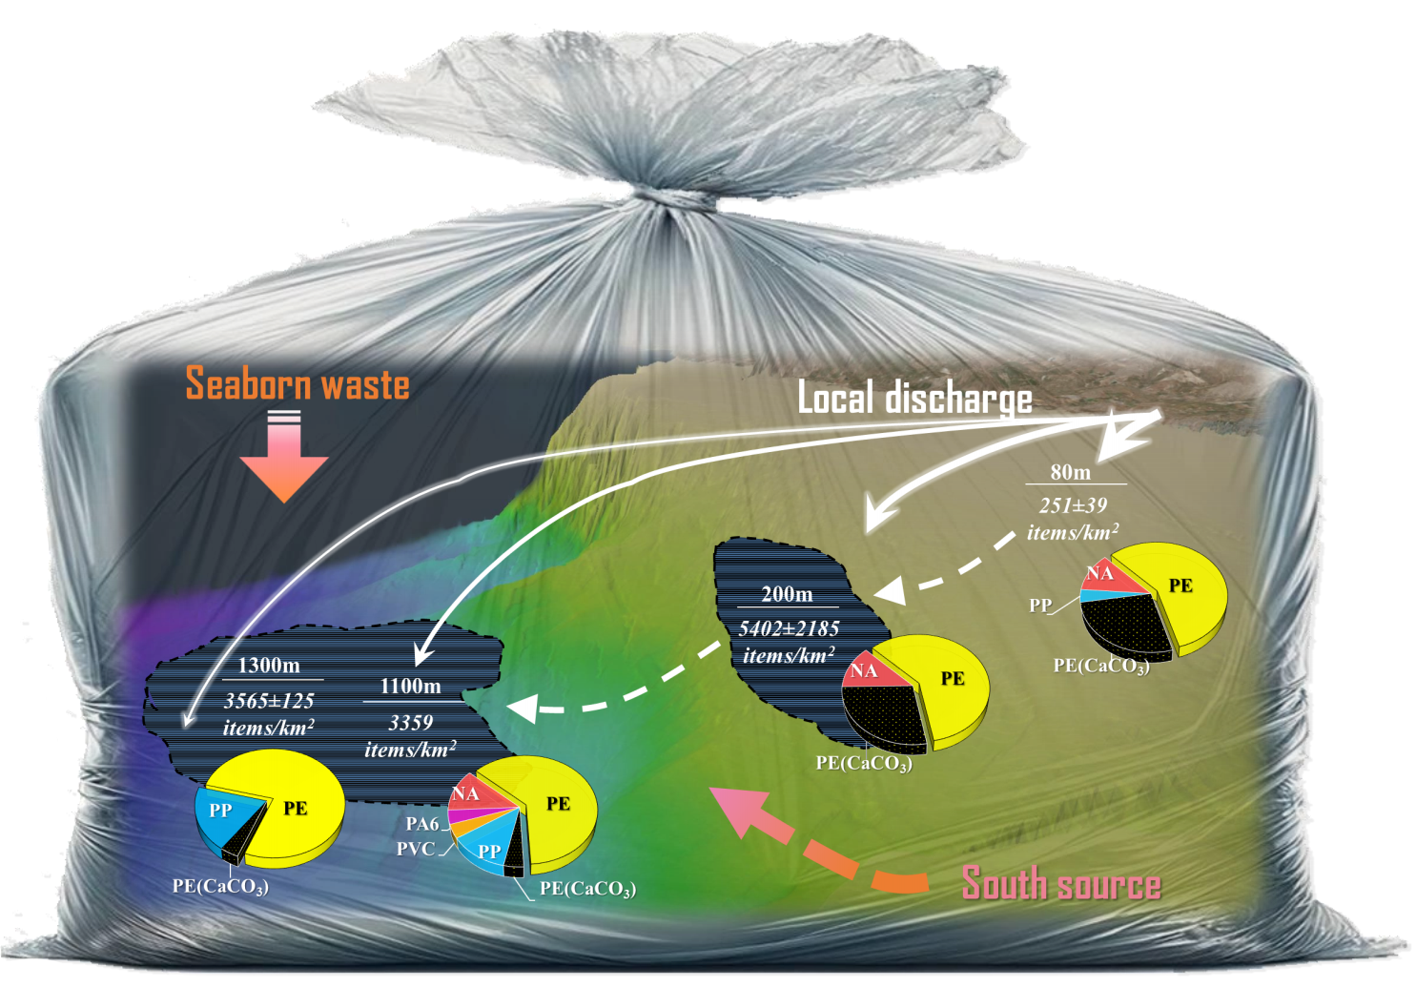

**Abstract:**

Plastic litter is ubiquitously distributed on the seafloor, although the transport trajectories of litter in the marine system remain undetermined. In 2022, we collected bottom debris (of size >2.5 cm) from the southeastern Mediterranean Sea at depths of 80–1300 m. The plastic concentration found in the deep sea is one of the highest in the world (3264.1 ± 86.2 items/km2); it mainly comprised plastic bags and wrappings (91.3 ± 2.2% of the total litter found). There was a significant difference between the shape of bags found at the continental shelf and in the deep sea, indicating the important influence shape has on the transport of plastic in the ocean. Calcium carbonate additive, which was found in almost half of the polyethylene bags on the continental shelf, was another factor that affected the trajectories of bags. Although 86.5% of the samples had a relatively low level of surface attachment (3 µg/mm2), adhesions on the bags, both organic and inorganic (biofouling, tar, sediments, and shells), could play a pivotal role in triggering plastic settlement and distribution. We suggest possible sources and trajectories of plastic bags at the bottom of the southeastern Mediterranean Sea.

**Synopsis**

# Introduction

In the “Plastic Age” (i.e., the period since the 1950s to the present), plastic has become indispensable for a huge range of products in human society.1 However, this has brought with it severe marine pollution due to inappropriate waste disposal, ubiquitous distribution, and ultra-slow natural degradation rates.2 The ever-increasing quantity of plastic debris entering the seas has led to marine litter becoming one of the greatest environmental threats to marine ecosystems worldwide, with critical implications for the economy and food security.3-5 Recent modeling suggests that the majority of marine plastic mass is located either at the ocean surface (59–62%) or in the deep ocean (36–39%), with a small proportion found on beaches (1.5–1.9%).6 These findings indicate that the journey of most marine litter will ultimately end at the seafloor.7 However, the transportation trajectory and sinking rate of litter remains under intense debate.8-11 For example, Koelmans and colleagues assumed that if the introduction of new plastic litter into the ocean suddenly stopped, more than 95% of plastic mass will have been removed from the sea surface within two years due to fragmentation and sinking.12 However, a newer model using similar assumptions suggested a dramatically lower removal of plastics from the marine environment, of just 10% within two years.6 Indeed, the fate of marine plastics remains elusive, and the mechanisms that drive the spatial distribution and long-term settlement of marine plastics are still under investigation.7, 13

Biofouling, currently the prevailing theory explaining the vertical migration of plastics, is defined as the growth and accumulation of organisms on a submerged surface, triggering hydrophobicity and buoyancy of plastic.14-16 If the density of plastic subjected to biofouling exceeds the density of seawater, the plastic begins to sink.17 This mechanism has been widely studied both in the laboratory15, 16, 18, 19 and the field.20-23 However, the accumulation of biofilms on plastics is influenced by physical forces, such as wind, currents, and waves,20, 24-26, and by nutrient levels.22, 27 The planktonic organisms responsible for biofouling tend to be most abundant in the photic zone, i.e., at a depth of up to approximately 200 m. Once plastic sinks to deeper than these organisms’ main habitat, it is anticipated that it will either remain suspended at the depth where its density equals that of seawater or will begin to float upward if the biofilm becomes detached or decomposes.19 It has been suggested that plastics will oscillate up and down in the upper water column until they accumulate sufficient biofilm to cause them to sink to the seabed, where they could persist for a long time, particularly in ultra-oligotrophic areas such as the southeastern Mediterranean Sea.28

In addition to biofouling, other factors such as sediment attachment20 and the characteristics of plastic debris, such as its size, density, and shape,29-31 could have a major impact on the speed at which it sinks. One of the problems currently is that the majority of research has been limited to “top-down” studies, where the sinking of plastics due to biofilms is observed in a limited experimental space.18-20, 22, 32 There is a paucity of research into the “endpoints”, i.e., the accumulation of plastics on the seafloor.

Large quantities of plastic litter have been recorded at the bottom of the Mediterranean Sea in the past two decades, the majority comprising large plastic bags.33-38 Plastic bags with a high surface-to-volume ratio could potentially inhibit gas exchange at the seafloor, possibly interfering with CO2 sequestration, while also changing the composition of or smothering benthic inhabitants in sediments.39-41 Compared with the widely researched microplastics,16, 17, 42-44 these large, primary plastics have yet to be systematically studied. Moreover, they evade several common pathways that transport microplastics, such as ingestion–defecation by marine organisms.17, 45 Thus, it remains a challenge to elucidate the sinking processes and transport trajectories of seafloor plastics, particularly plastic bags, which is crucial for understanding the sustained hazard they pose to the marine system and the biosphere more broadly .

Using samples of plastic litter collected from the seafloor of the southeastern Mediterranean Sea offshore of Israel during 2022, we aimed to provide a more systematic and precise theory of the sources of plastic bags and the mechanism via which they sink. We analyzed various characteristics of the litter, such as size, shape, structural integrity, and chemical composition. We also examined the surface adhesion and static buoyancy indexes to provide insights into the re-transport properties of plastics. Our research was primarily focused on macro-scale plastic bags: tracing their original source and trajectory, depicting their current distribution and surface condition, and predicting their future fate in the marine environment.

# Materials and Methods

## Sample Collection

The samples used in this study were collected offshore of Israel. Samples from the shelf (transect S1, at a depth of 80 m) were collected using a commercial trawl of 50-mm mesh size and 12-m opening width. Samples from the slope (transects D1 and D2, at depths of 200 and 500 m, respectively) and bathyal plains (transects D3 and D4, at depths of 1100 and 1300 m, respectively) were collected using an 8-m wide single-cable shrimp trawl, with a mesh size of 42 mm (**Figure 1**). Details of the trawling times and areas are shown in **Table S1**.

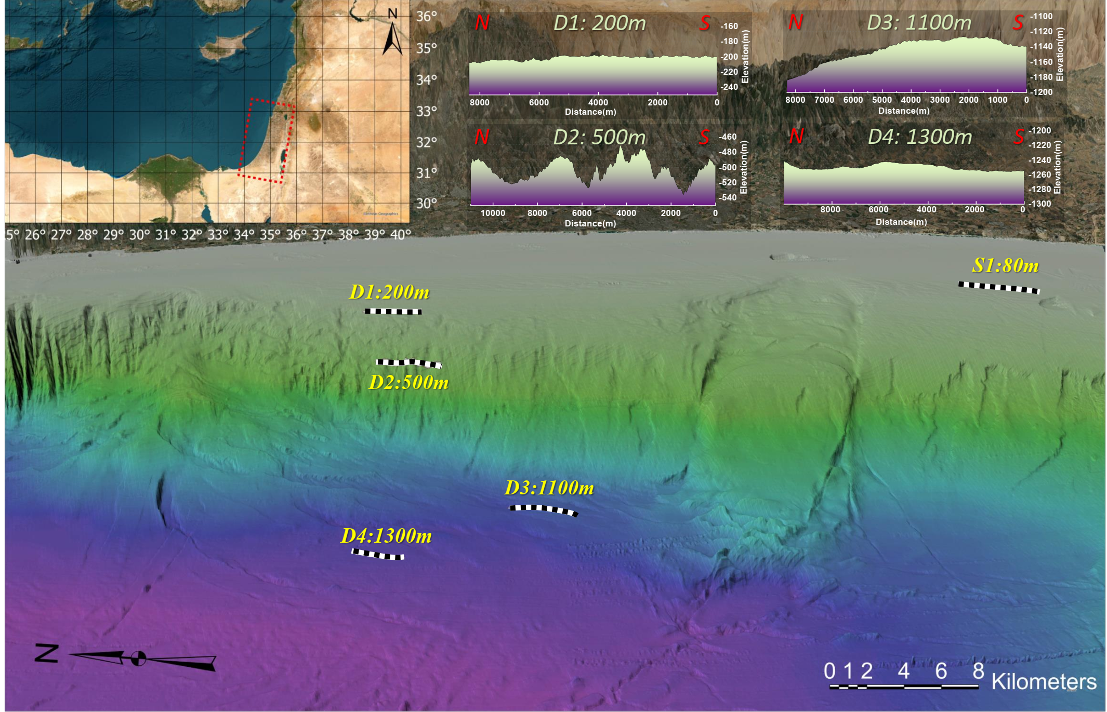

**Figure 1**. Three-dimensional map showing the locations of the trawl survey for seabed macro-litter. The bathymetric profiles of transects D1–D4 are listed at the top right of the figure.

## In Situ Buoyancy Test

Plastic bags of size more than 10 cm were selected for the in situ buoyancy tests carried out on board the ship during the deep-sea survey (transects D1–D4). Briefly, each sample was gently washed with seawater to remove any sediment that had accumulated during trawling. Each sample was then placed in a 100-L plastic container filled with seawater and released from the middle of the container at a depth of approximately 25 cm. After 30 seconds the final position of the sample was noted. The position was categorized as positive buoyancy (floating) if the sample floated on the water surface; neutral buoyancy (suspended), if the main part of the bag remained in the water column (at least 10% of the bag’s area was not touching either the water surface or the bottom of the tank); or negative buoyancy (sunk), if the plastic bag was deposited at the bottom of the container. The density of seawater utilized in this buoyancy test was approximately 1029.3 kg/m3 at a temperature of 15.6 ℃.46

## Classification of Plastic Bags

Plastic bags were separated from other bottom litter. They were then further characterized by size (2.5–10 cm, 10–30 cm, >30 cm), shape (T-shirt – original pocket shape, open polygon- irregular polygon without a pocket structure, and strip-length-to-width ratio larger than 4:1, **Figure S1**), color, completeness (intact bag, torn bag, part of a bag), whether a biofilm was present and to what degree (**Figure S2**), and presence of macrobiota. If a barcode was present we used this to identify the source of the packaging.

## Laboratory Sample Processing Procedures

Samples that had passed the buoyancy test were individually stored at 4 ℃ until further analysis (**Table 1**). As just eight samples from the 500-m deep transect fit the size standard , these were not included. New shopping bags were purchased and used as blank samples for each group, being subjected to the entire procedure described in **Table S2**.

Selected plastic bags were washed with deionized water, dried in an oven at 40 ℃ for 48 h, cut into three replicate pieces (3×5, 4×8, or 5×10 cm2), and weighed on a balance. The composition of each sample was characterized by Fourier transform infrared (FT-IR) spectroscopy, and samples were rinsed in a petri dish covered by black tarps with diluted eosin staining agent (1% aqueous solution of eosin in 50 mL of 99% ethanol). After 30 min, the stained samples were gently washed three times using 99% ethanol and then dried in an oven at 40 ℃. After capturing images of the stained samples (LEICA M205 C), each sample was placed in a glass jar filled with 60 mL 35% peroxide solution (Chen Shmuel Chemicals. Ltd). The jars were placed in an oven at 40 ℃ for 48 h to remove any adhesions from the plastic films.47 Following this digestion procedure, samples were washed with deionized water and dried. The hard tissue and mineral material in the resident solution were instructed by vacuum-filtration system using a cellulose filter with a pore size of 0.22 µm (Shanghai Xin Ya Purification Equipment Co. Ltd). Subsequently, the bleached plastic bags were weighed and measured using FT-IR. A second buoyancy test was then conducted, similar to the first buoyancy test but using seawater with a density of 1028.20 kg/m3 at a temperature of 19.3 ℃.

The mass of the removed adhesion (*Ma*) was determined by calculating the difference between the sample weight before and after digestion with hydrogen peroxide. To account for any losses in mass resulting from trawling samples from the seabed, each measured *Ma* was multiplied by a coefficient of 1.1. The mass of hard matter (*Mh*, shell and sediment) refers to matter peeled off from a plastic bag and collected using the microfilter (**Figures S14–18**). Finally, the dry weight of the soft tissue (*Ms*) was obtained by calculating the difference between the two (equation 1.1). The total adhesion weight per unit area (AWPA, equation 1.2) and the soft tissue weight per unit area (SWPA, equation 1.3) were calculated as the mass per surface area (Sp), µg/mm2.







## Composition Analysis Using FT-IR Spectroscopy

The chemical composition of the samples, adhesion, and degradation were analyzed using a Nicolet™ iS™ 5N FT-IR spectrometer (Thermo-Fisher Scientific) in the transmission mode. The absorbance was taken in the region of 400–4000 cm-1 wavenumbers. We used the adaptive iteratively reweighted penalized least squares (airPLS) method to correct baseline drift,48 to overcome baseline drifting problems that can blur or even swamp signals and distort the profile intensities. Considering the complexity of marine litter composition, the FT-IR spectra were identified by three libraries (the Aldrich Condensed Phase Sample Library, the Hummel Polymer Sample Library, and the HR Nicolet Sampler Library). Any matches with >70% search scores were accepted, while those with <70% were rejected and marked as unknown polymers (abbreviated as NA).

## Statistical Analysis

We used the chi-squared test to explore differences in the completeness and shape of plastic bags, as well as bags with calcium carbonate (CaCO3) addition among stations. We used the Kruskal–Wallis test to examine differences AWPA and SWPA of plastic bags distribution among the depths. We used linear regression models with T-test to find explore the relationships between the AWPA and SWPA of samples from each transect. Normality and homogeneity of variance were checked and the level of statistical significance was set to *p* < 0.05.

# Results and Discussion

## Distribution of Bottom Plastics

In total, 1399 bottom litter items were recorded across all five transect depths, but the composition and abundance of litter differed among the sites. A “hot belt” of 5402 ± 2185 items/km2 was detected at a depth of 200 m, on the edge of the continental shelf (**Table 1**), which is similar to previous findings in this area (**Figure S3**).37 Conversely, at a depth of 500 m the concentration of plastic items decreased significantly, to 733 ± 353 items/km2. This may be linked to the uneven seabed at this depth (**Figure 1**), where bottom litter could be carried into and trapped in the submarine canyons.49-51 Considering the low abundance of bottom litter and unique bathymetry profile, we did not further consider the data from the 500-m water depth. In the deep-sea basin, the concentration of litter at both the 1100- (3359 items/km2) and the 1300-m transects (3566 ± 125 items/km2) surpassed the highest value seen in the past ten years, indicating that the deep-sea basin is becoming another reservoir where marine litter accumulates. However, compared with the deeper transects, ultra-low bottom litter concentration at the near shore (80 m) shows that plastic debris was continuously transported to the deeper ocean, where it accumulated.

At our study site we found a high average quantity of bottom litter (2239 ± 2141 items/km2) for the Mediterranean (**Table 1**), with the highest quantity found in the deep sea (3462 ± 146 items/km2). Moreover, the fraction of plastic litter was extremely high (94.5 ± 3.8% of bottom litter), surpassing the proportion reported for any other bottom survey in the Mediterranean Sea, with plastic bags accounting for the majority (88.2 ± 6.2%) of the bottom litter (**Figure 2a**). Despite this, we found that the proportion of plastic bags in the bottom litter of both the 80- and 200-m-deep transects had decreased compared with the proportion reported over the past ten years.37 However, for the 1100- and 1300-m-deep transects, the proportion of plastic bags had increased from approximately 85% to 93% and 75% to 90%, respectively. This suggests that plastic bags are a major contributor to the increase in bottom litter in the deep-sea basin and are transferred to deeper sea areas more rapidly than other types of litter.

**Table 1.** Comparison of our results with other bottom-trawl surveys conducted in the Mediterranean Sea.

|  |  |  |  |  |  |  |
| --- | --- | --- | --- | --- | --- | --- |
| Location | Habitat | Year | Depth range (m) | Abundance of bottom litter | Proportion of plastic (%) | Reference |
| NW-Med (Murcian coast) | Shelf | 2009 | 40–80 | (medium) 43.05 ± 65.07 pd/ha | ~79.32 | 52 |
| NW-Med (Catalan coast) | Shelf | 2009 | 40–80 | (medium) 97.61 ±  151.63 pd/ha | ~65.28 | 52 |
| NW-Med (Northern and Central Adriatic Sea) | Shelf | 2014 | 0–100 | 913 ± 80 items/km2 | 80 | 53 |
| NW-Med (Gulf of Patti) | Slope/bathyal | 2021 | 525–576 | 128.1 items/km2 | 64 | 36 |
| NW-Med (Gulf of Sant Jordi) | Shelf | 2018 | 50–500 | 130 items/km2 | 77.8 | 54 |
| NW-Med (Gulf of Naples) | Slope/bathyal | 2019–2020 | 400–600 | 1140 items/km2 | 82 | 55 |
| CW-Med (Sardinia) | Shelf/bathyal | 2013–2019 | 0–800 | 29.8 items/km2 | 67 | 56 |
| NW-Med (Gulf of Lion) | Shelf | 1994–2017 | 10–200 | 49.63–289.01 items/km2 | 40–62 | 57 |
| NW-Med (Corsica coast) | Slope | 1994–2017 | 100–800 | 34.12–395.29 items/km2 | ~72 | 57 |
| NW-Med (Catalan coast) | Shelf/slope | 2019–2021 | 20–700 | 5.35–13.75 kg/km2 | ~64.2 | 58 |
| SW-Med (Bay of Bejaia) | Shelf | 2017–2020 | 40–200 | 125–594 items/km2 | 88 | 59 |
| SW-Med (Al Hoceima coast) | Shelf | 2022 | 24–200 | 297–957 items/km2 | 57.15 | 60 |
| NE-Med (Iskenderun Bay) | Shelf | 2009 | 10–100 | 450.94 item/km2 | 87 | 61 |
| NE-Med (Mersin Bay) | Shelf | 2017 | ~20 | 2670 items/km2 |  | 62 |
| NE-Med (Antalya Bay) | Shelf/slope | 2018 | 10–200 | 13.3–651.1 items/km2 | 71.2 | 63 |
| SE-Med (offshore Israel) | Shelf/bathyal | 2012–2021 | 20–1700 | 85–5797 items/km2 | 86.0 shelf 89.9 deep stations | 37 |
| SE-Med (offshore Israel) | **Shelf** | **2022** | **80** | **250±39 items/km2** | **88.4 ± 3.0** | **This study** |
| **Slope** | **200** | **5402±2185 items/km2** | **97.5 ±** **0.6** |
| **Slope** | **500** | **733±353 items/km2** | **98.2 ± 2.5** |
| **Bathyal** | **1100** | **3359 items/km2** | **95.3** |
| **Bathyal** | **1300** | **3566±125 items/km2** | **93.2 ± 0.3** |

CW-Med, central-western Mediterranean; NE-Med, northeastern Mediterranean; SW-Med, southwestern Mediterranean

Bags and wrappings from the 80-m deep transect were densely covered with macrobiota. Some of the shopping bags were entangled with ropes and vegetation stalks and were probably from riverine source inputs, particularly in the winter when runoff discharge is high. The downward movement of dense, sediment-laden water, referred to as “hyperpycnal flow”, initiates turbid currents offshore of the southeastern Mediterranean coast64, 65 and is likely to carry litter from river outlets into the deeper sea.66, 67 Macrobiota were rarely found on the bags collected from deeper transects (≥200 m). A considerable number of bags retrieved from the 200-m-deep transect were polluted with tar, while very few bags from the 1100-m-deep transect and none from the remaining transects showed tar pollution. The bags from the 1300-m-deep transect had fine sediments attached (**Figure S9**). In addition to plastic bags, polymer fibers were also found to be distributed throughout almost all depths (**Figure S10–12**), particularly at 1300 m, where fishing nets and large bundles of plastic thread were observed (**Figure S12**). Beverage packaging and patent leather from furniture were also found at this depth, suggesting that the densely packed regional shipping lines may also be a source of plastic bags found on the seabed, i.e., some of the waste we recovered could have been seaborne waste.

We could only identify the source of production of food/product packages using the barcode on them for a very limited proportion (2%) of the bags found. The 200-m-deep transect hotspot showed an accumulation of food packages from diverse sources (the number of bags is shown in brackets): Egypt (four), Gaza strip (one), Israel (three), and Turkey (three). At the 500- and 1100-m-deep transects, one bag each from Egypt and Lebanon was found. At the 1300-m-deep transect, one bag each from Egypt, Israel, and Saudi Arabia was found (**Figure S19**). The presence of bags manufactured in Egypt suggest that this southern source might play a role in plastic pollution in the study area.68

## Characteristics of Plastic Bags Collected from the Seabed

The plastic bags from the deep transects (at depths of 200, 500, 1100, and 1300 m) were characterized for completeness, visible biofilm, and shape, in addition to color and length, which were also recorded for plastic bags from the 80 m transect. Most of the bags collected from the seabed were white or colorless, followed by black or blue; these are all common colors used for shopping and rubbish bags (**Figure 2b**). Most of the debris was between 2.5 and 10 cm in length. However, ultra-large bags (>30 cm) made up more than 10% of bags from each depth and 20% of bags in the deep sea. Plastic debris previously collected from the surface of the Levantine sea was of a micro-scale (1.18 ± 0.1 mm),68 suggesting that larger debris (>2.5 cm) could have a short residence time at the sea surface. Therefore, there is likely a vertical size-gradient stratification in the water column.

The plastic bags were further analyzed by their completeness (**Figure 2d**), which showed a significant difference between depths (χ2: 176.7, *p*< 0.0001), as well as when removing the 500 m (χ2: 137.7, *p* < 0.0001). Torn bags, i.e., bags that were damaged but had not broken into smaller pieces, were almost uniformly distributed at a low proportion of approximately 4% at each depth. Compared with other plastic products, bags and wrappings are more likely to be deformed and fragmented by the mixing of winds or currents. The proportion of intact bags gradually decreased with increasing depth, from 10.9 ± 1.5% at 200 m to 8.5% at 1100 m and 4.2 ± 1.9% at 1300 m. (The 500-m-deep transect was excluded from this analysis due to its different topography. Terrestrial sources are considered to be the major sources (80%) of plastics released into the sea.(Geyer et al., 2017) Therefore, this decreasing trend in intact bags with increasing depth could represent the weathering and fragmentation of litter as its distance from the shore increases and it moves deeper into the environment.

More than 50% of the plastic bags did not exhibit an obvious biofilm (**Figure 2e)**. Findings from previous studies into the “tipping point” of the degree of biofilm necessary to sink plastics have suggested that floating plastic would not sink until its surface was covered with intensive algae-fouling.20, 21, 27 However, the observed biofilm density on the litter we recovered from the seabed seemed to be much lower than any of the previously proposed tipping points (**Figure S6–S9**). This could be linked to the very low levels of chlorophyll-a in the surface water in our study area,28 which results in the low biofouling accumulation rate.

We found a significant association between four depths and the composition of plastic bags according to shape (χ2: 280.022*, p* < 0.0001), as well as between three depths (excluding 500 m) (χ2: 277.093*, p* < 0.0001). Most of the plastic bags were open polygons, followed by strip-shaped bags (**Figure 2f)**. From water depths of 200 to 1100 m, the concentration of T-shirts decreased from 336 ± 263 items/km2 (6.6 ± 1.6%) to 172 items/km2 (5.5%). This further decreased to 31 ± 25 items/km2 (1.0 ± 0.6%) at 1300 m. This finding reveals that, similar to the distribution of intact plastic bags, T-shirt bags showed a decreasing trend with increasing distance from the shore. The pocket shape endows bags the priority in sinking by gathering the suspended sediments, resulting in its decrease with distancing from the shore. It is possible that T-shirt bags found at depths of 1100 and 1300 m are partially representative of seaborne waste.

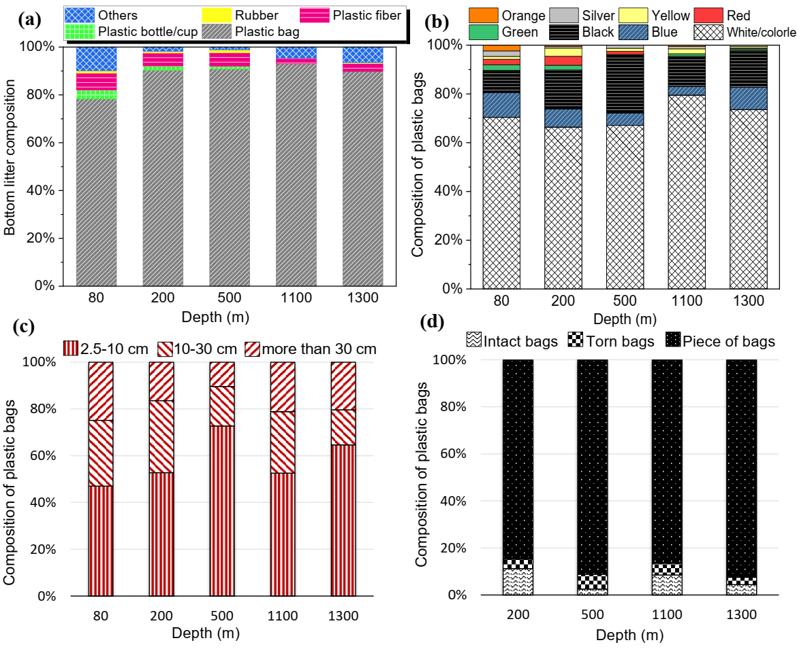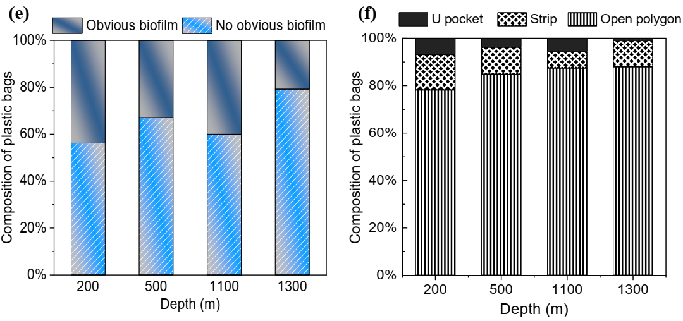

**Figure 2**. The relative contribution of bottom litter at each study depth by composition (a) and the plastic bags retrieved from the bottom by color (b), length (c), completeness (d), attached visible biofilm, and shape (f).

## Chemical Composition of Retrieved Plastic Bags by FT-IR Analysis

Polyethylene (PE) was the most common polymer type found in the samples studied (*n* = 122), accounting for 81.1% of the plastic bags (**Figure 3a**), followed by unrecognized plastics (NA) (9.8%), and PP (7.3%). Just one PVC and one PA6 bag was found, at 1100 m; these bags could represent seaborne waste given their high density.69 It has been reported that 44.8% of the plastic used in packaging is primarily composed of PE, PP, or polyethylene terephthalate (PET).1 However, we found no bags composed of PET in our bottom survey. This lack of PET in our study area may be a result of its ester bonds, which are readily chemically depolymerized or hydrolyzed in nature.70, 71 The absence of PET debris has also been reported by studies into plastic pollution at the Mediterranean Sea surface72 and on eastern Mediterranean beaches.73,74 Some polymers such as PET can be hydrolyzed at their ester bonds.75 However, it is extremely difficult for polyolefins (especially PE) to be degraded on the seabed,76 and they will remain at a macro-scale in deep-sea basins, possibly for centuries.77, 78

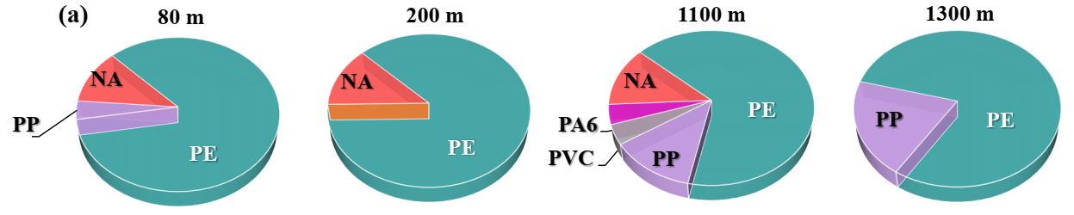

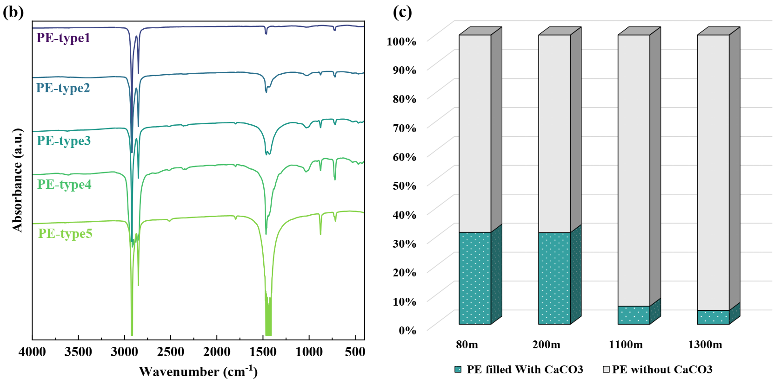

**Figure 3.** (a) Polymer composition of the bags (>10 cm) retrieved from different depths: 80 (*n* = 26), 200 (*n* = 47), 1100 (*n* = 24), and 1300 m (*n* = 25). (b) FT-IR spectra of different types of PE samples and (c) the composition of PE bags with and without CaCO3 (according to our FT-IR analysis) (*n* = 122).

PP and PE are less dense than water, meaning they can potentially be transported over long distances at the ocean’s surface. Work by Liubartseva et al. and Erni-Casola and colleagues79,80 found that the relative abundance of low-density polymers is highest at the surface of the open sea and lowest in subsurface water. However, the proportions of lightweight plastics (PP and PE) in the benthic zone we obtained in this study (88.5%) are consistent with their proportion at the sea surface (85–95%) indicated in previous studies.44 Bags composed of polyolefins dominate the bags found from the near-shore to the deep seafloor. This suggests that there are several gaps in our knowledge of the factors, other than their density, that determine the spatial distribution of these plastic bags.

Four peaks were characteristic peaks of PE: 2915 cm-1 (C–H2 asymmetrical stretching), 2851 cm-1 (C–H2 symmetrical stretching), 1465 cm-1 (C–H2 bending), and 718 cm-1 (C–H2 rocking) (**Figure 3b**).81, 82 The major difference between different types of PE appeared to be the intensity of the peak located between 1470 and 1400 cm-1, which indicates different concentrations of CaCO3. CaCO3 could also be validated by the appearance of several other characteristic peaks, at 876, 1796, and 2515 cm-1.83 Since the most distinguishable peak encompasses the intrinsic characteristics peaks of PE, rendering the exact addition of CaCO3 inauthentic as determined by FT-IR spectra. However, there was a significant decrease in the percentage of PE bags with CaCO3 moving from the continental shelf to the deep sea (**Figure 3c**) (χ2: 82.208, *p* < 0.0001). As a dense filler84 extensively used in PE shopping bags,85, 86 CaCO3 may reduce the buoyancy of plastic bags, restricting their transport pathways and ultimate location in the ocean. The inherent density (polymer together with fillers) is not the only factor that determines the buoyancy of plastic bags, as encountering organic or inorganic matter could cause them to sink.

## Adhesion of Organic and Inorganic Matter on Plastic Bags

We carried out a quantitative analysis of adhesion features by assessing the weight of the attached matter, including soft tissue, comprising tar and biofilm, and hard matter, which included sediment and shell. Notably, a large number of samples with tar adhering to them were collected at the 200-m-deep transect (**Figure S6**). These tar-adhered samples were removed from the samples for biofilm analysis. The distribution of biofouling weight per unit area (SWPA) was similar to the distribution of total adhesion weight per unit area (AWPA) (**Figure S20, Figure 4a**). In general, SWPA and AWPA were relatively low in the southeastern Mediterranean Sea, with 91.3% of samples having biofilm of less than 3 µm/mm2, and 86.5% of samples with adhesion less than 3 µm/mm2 (*n* = 327). There were significant differences found for both SWPA (Kruskal–Wallis test, *p* < 0.0001) and AWPA (Kruskal–Wallis test, *p* < 0.0001) between the depths. The largest interquartile range appeared in near-shore coastal water at the depth of 80 m (*n* = 78), and its mean and median values surpassed those at deeper depths; this could be due to being closest to the shoreline and in the photic zone.87-89 Next was the 200-m-deep transect (*n* = 83), which had the highest mean and median values among the deep transects. A few macro-scale organisms were attached to the samples at this depth (**Table S3**). There was a very narrow spread in 1100 and 1300 m, and their median and average value of SWPA are similar. Several studies have revealed that northward currents dominate the flow along the Levant margin in the southeastern Mediterranean Sea,88, 90, 91 where the seawater is highly stratified. The high-temperature and high-salinity Levant Surface Water (LSW) and Atlantic Water (AW) alternatively comprise the 80-m-deep water over the continental shelf, and the chlorophyll fluorescence concentration is much higher than other deeper stations in this study in most of the year. Deeper still, the 200-m-deep transect is dominated by Levantine Intermediate Water (LIW), which originates southeast of Crete.92 The chlorophyll-a concentration decreases at this depth, but is still much higher than in the deeper zone. The transects in the bathypelagic zone (1100- and 1300-m deep) were located within the Eastern Mediterranean Deep Water (EMDW), which has the lowest dissolved oxygen and chlorophyll-a concentration in the Levantine Basin.87, 93 Thus, it is suggested that there is a positive correlation between the average adhesion surface density of plastic bags found on the seafloor and the chlorophyll-a concentration. Nevertheless, this can only be characterized as an overall trend along the continental slope, as these stratified inhabitant zones may be vertically mixed by periodic gravity-driven flows.94 If the various rates of benthic decomposition and remineralization processes95, 96 were taken into consideration, the scenario of adhesion development would be more complicated.

Linear correlations were found between biofilm (SWPA) and overall attachment volume (AWPA) at each depth, as shown in **Figure 4b.** The slope of the linear fit decreased with water depths. Nevertheless, in cases where AWPA was <1.5 µm/mm2, the slope was close to 1 for depths of both 200 and 1100 m (for 200 m, y = 1.0414x + 0.169, R² = 0.6321; for 1100 m, y = 1.0653x + 0.248, R² = 0.6723). We assumed that, at each depth, there is a minimum biofilm concentration for additional adhesion of inorganic and hard matter (1 µm/mm2 at 200 m, 1.2 µm/mm2 at 1100 m, and >2 µm/mm2 at 1300 m). It has previously been reported that biofouling on plastic involves a gradual buildup of organic matter and organisms.32 Stimulated by the hydrophobicity of the plastic surface, organic substances are rapidly adsorbed, creating a “conditioning film”.30 This is followed by bacterial colonization and microalgal growth, with these organisms eventually sharing space with colonizing invertebrates.32, 97 The organic matter plays an important role in altering the surface tension, charge density, and roughness of the plastic surface,98-101 providing a more favorable surface for the settlement of other organic and inorganic matter. Sufficient organic matter is a prerequisite for the settlement of shells and minerals,20, 102, 103 and it seems that more biofouling is needed in aquatic environments with a low abundance of biomass. This was demonstrated by our finding that no such biofilm threshold was identified at the depth of 80 m.

The Levant Basin is a “hotspot” for oil pollution, due to a combination of various factors, such as regional political instability that hinders marine environmental surveillance, extensive coastal oil facilities that attract large numbers of tankers, and the lack of regional cooperation between countries.104, 105 Plastic waste inevitably comes into contact with spilled oil when it floats on the sea surface or settles on the tar-contaminated coast. The high concentration of plastic bags contaminated with tar (**Figure 4d**) on the seabed at a depth of 200 m might be linked to the major Mediterranean oil spill that occurred in 2021.106, 107 The extensively adhered tar makes samples from 200 m present a more complex adhesion condition. **Figure 4c** shows that the plastic bags can be divided into two groups, those with and those without the adherence of tar. The sediment absorbed by tar is significantly greater than that of only biofilm for a given quantity of SWPA, especially beyond the SWPA of 2 µm/mm2. Due to their hydrophobicity, organic pollutants such as polychlorinated biphenyls (PCBs), polycyclic aromatic hydrocarbons, polybrominated diphenyl ethers,108 and tar, can easily be absorbed onto the surface of plastic.109 Tar can increase the roughness and decrease the surface tension of plastic bags, resulting in higher rates of biofilm adhesion and community succession.27, 29, 110 Instead of a gradually colonizing biofilm, the interaction with tar might play an essential role in the rapid sinking mechanism of plastic bags at the 200-m deep transect.

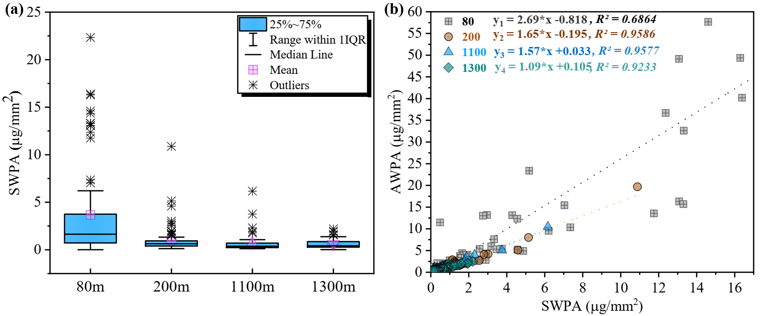

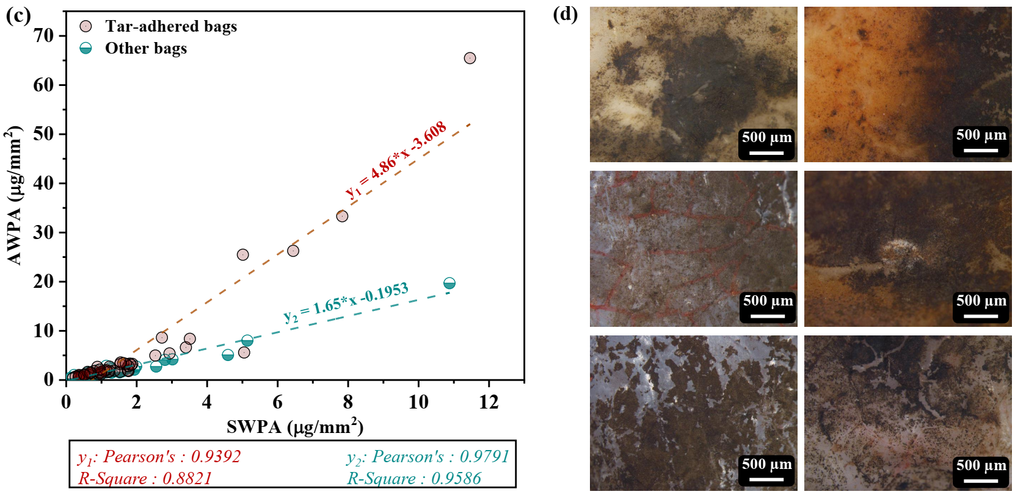

**Figure 4.** (a)Box-plots representing the distribution of soft tissue weight per unit area (SWPA) in each transect (*n* = 286). (b) Relationships between SWPA and total adhesion weight per unit area (AWPA) on the plastic bags from 80 m (*n* = 78, *p* < 0.0001), 200 m (without tar-adhered samples) (*n* = 83, *p* < 0.0001), 1100 m (*n* = 60, *p* < 0.0001), and 1300 m (*n* = 65, *p* < 0.0001) (samples with AWPA less than the control sample were removed). (c) Adhesion distribution of 200 m separated by tar-adhered samples (*n* = 51, y1: *p* < 0.0001) and other samples (*n* = 83, y2: *p* < 0.0001). (d) Images of plastic surfaces with tar adhering to them.

## Re-transport Capacity of the Bottom Plastics from the Deep-Sea Survey

Several previous studies have investigated the effect of incubating biofilm on changing plastic buoyancy, but few have directly tested the buoyancy of plastic collected from the seafloor.15, 17, 18, 20, 22, 27, 32, 101 Here, we investigated how a plastic’s buoyancy is influenced by its chemical composition and surface adhesion. A significant proportion of the samples from all depths regained positive buoyancy after being collected from the seabed and gently washed with deionized water (**Figure 5**). Approximately 52% of the samples from the pelagic area (1100- and 1300-m deep) and 61.7% from the continental shelf (200-m deep) were marked as floating or suspended. The primary cause that leads to plastics sinking remains uncertain, due to the knowledge gap regarding the timeframe during which plastics remain on the seafloor This made it challenging to accurately estimate the extent of biofilm degradation on the surface of the plastics. However, we can reasonably conclude that these plastics remained on the seafloor due to the continuous buildup of overlying sediments. At the same time, when faced with strong bottom currents that resuspend the covering sediments, primarily during the Israeli winter,111 the plastic debris, mostly in the shape of open polygon and had been fragmented into pieces, could be re-distributed. Additionally, intermediate nepheloid layers at the edge of the continental shelf, with high interpolated turbidity, could also be initiated by winter storms.112 This seasonal sediment transport can redisperse plastic debris toward the continental slope and the deep basin.113, 114 Therefore, the continental shelf area is subjected to periodic re-transportation, which can serve as a downslope transportation vector. Conversely, the mean annual current velocity in the deep basin (1300 m) is 3.5 cm s-1,with a maximum recorded velocity of 12.6 cm s-1,112 which is generally considered insufficient to trigger resuspension of seafloor silts and clays if the current is unidirectional.115 Thus, bottom plastic debris that reached the deep basin would remain there and accumulate. The “hot belt” of bottom litter we identified in this study at the 200-m-deep transect may be considered to be a “transfer stop” instead of a terminus for the accumulation of plastic debris, while the 1100-m-deep transect could be a receiving station. The deep-sea basin is considered to be the “final sink”, where plastic debris ultimately accumulates (**Figure S3**).

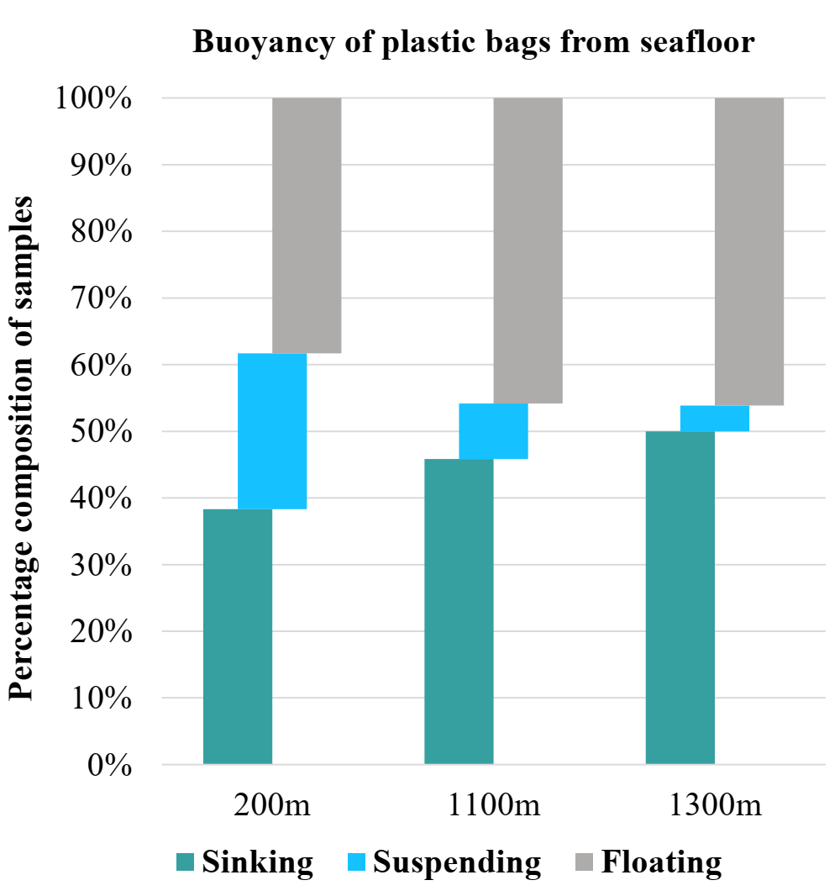

**Figure 5**. Buoyancy state of plastic bags from deep cruise (*n* = 104).

To study the factors that affected the sinking of plastic bags, the buoyancy state of each sample was recorded before and after the digestion process. The results showed that the buoyancy of lightweight plastic bags (80%) increased after digestion, meaning that surface attachments were the decisive factor in their sinking (**Figure 6**). PE samples were distributed in a broad range, which were separated into two groups: PE and PE (with CaCO3 filler) according to the FT-IR analysis. **Figure 6c** shows that 41.2% of PE and 75% of PE (with CaCO3) sank during the in situ buoyancy test conducted on board the ship. The average AWPA of NA (after moving the outlier of 41.6 µm/mm2, Ave: 2.86 ± 2.26 µm/mm2) was generally higher than that of PP (Ave: 0.42 ± 0.22 µm/mm2), but there was still 60% of NA floated in the first test. All types of plastics demonstrated a recovery of buoyancy following the digestion process, with the exception of PA6 and PVC (**Figure 6f**), which were inherently denser than seawater. In addition, while all of the PE left from the sinking state, 69% of PE (with CaCO3) did not recover positive buoyancy, indicating that CaCO3 reduces the buoyancy of PE. All NA plastics recovered positive buoyancy, indicating that these were lightweight plastics. The settling of these lightweight samples was significantly influenced by adhesions. However, the impact of adhesions on the buoyancy of plastic bags may vary according to the density, shape and size,25, 116, 117 which is a more intricate discussion.

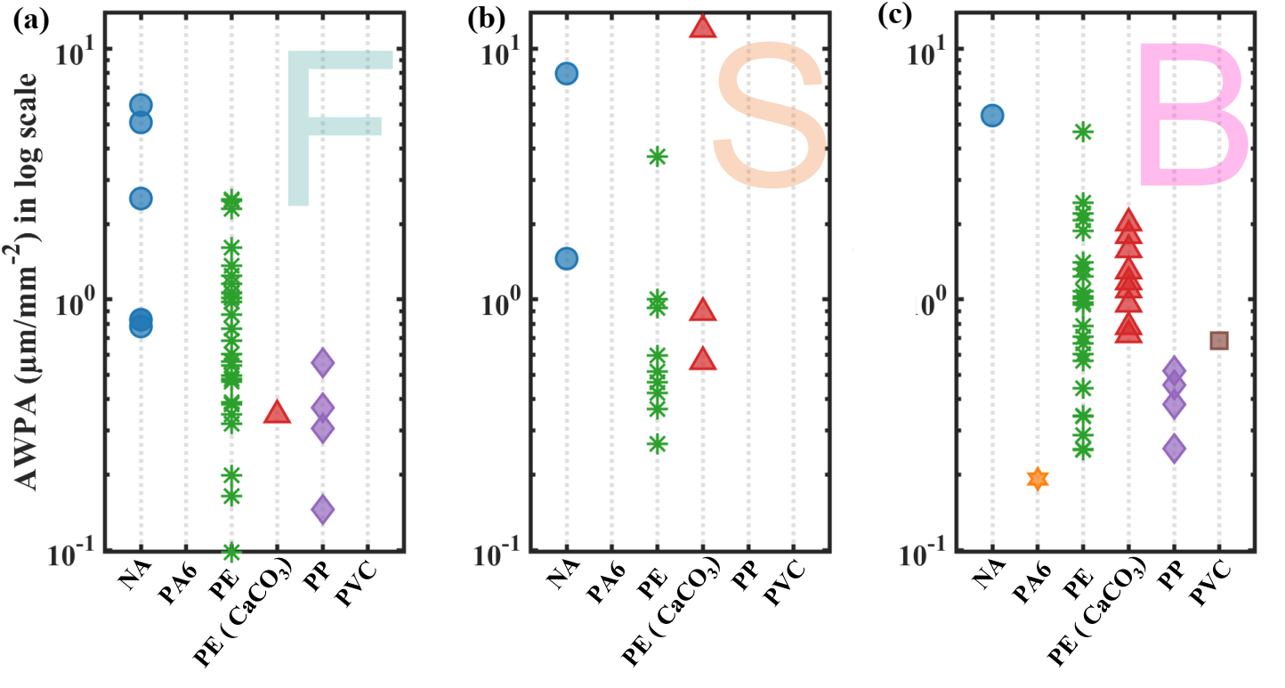

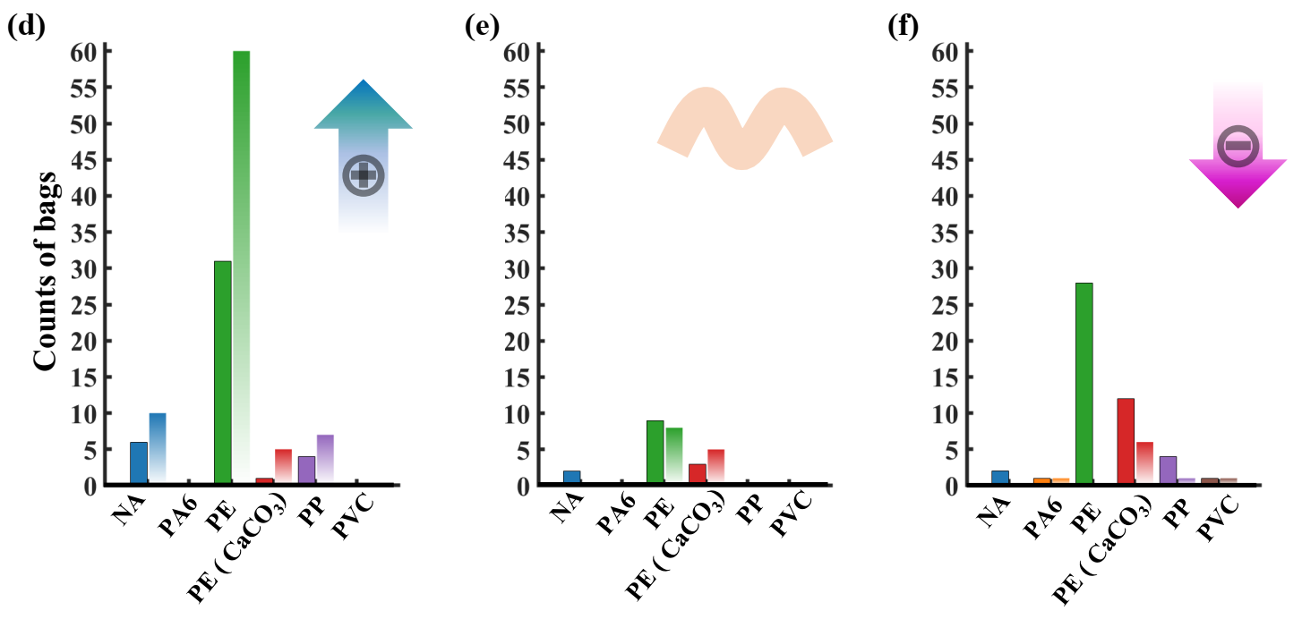

**Figure 6.** AWPA distribution before digestion for each category of plastic bag composition, broken down by buoyancy state, i.e., (a) floated, (b) suspended, and (c) sank; and counts of each category of plastic bag composition separated by buoyancy state, i.e., (d) floated, (e) suspended, and (f) sank before (solid-filled bars) and after digestion (gradient-filled bars) (red arrow marks the trend of the counts of each composition after digestion).

## Possible Sources and Trajectories of Plastic Litter in the Southeastern Mediterranean Sea

According to a recent simulation, the Mediterranean Sea, which has been predicted to accumulate the highest concentration of floating plastics, contains 21% to 54% of plastic particles globally and 5% to 10% of the total plastic mass globally.118 This is mainly due to the outflow of runoff water; densely populated coastlines; and intensive fishing, shipping, and industrial activities, all of which contribute substantial quantities of marine litter to the Mediterranean basin. PE predominantly contains 52% of the total plastics captured from western Mediterranean surface water, followed by PP (16%).119 The residence time of plastics on the surface of the Mediterranean Sea is estimated to be relatively short (between 7 and 60 days),79, 120 and may be further reduced in litter items or films with a high surface-to-volume ratio.29, 31 Compared with other shapes, such as fibers or spheres, film, which has the highest surface-to-volume ratio, was estimated to have the shortest time for fouling up by biota to the water density.121 This could lead plastic bags to rapidly sink to the seabed, probably in no more than a few days. Sinking velocity may be accelerated in bags with specific shapes, e.g., T-shirt-shaped, due to the accumulation of suspended sediments. The existence of relatively large and even some intact bags provided evidence to support this assumption.

Conversely, the ultra-oligotrophic conditions122 and relatively low concentration of plankton at the surface of the southeastern Mediterranean Sea could lead to the stratification of plastic litter based on shape and size. Apart from bags and wrappings, other plastic products that have more spherical-like morphology or greater thickness, such as cups, bottles, and sheets, appear not to accumulate sufficient biofouling to reach their tipping point of sinking. This could explain the high proportion of plastic bags and wrappings in the plastic litter we recovered from the seabed in our study. We thus propose that there are two routes via which plastic can be transported. The first route involves discarded plastic cups, bottles, and sheets in the southeastern Mediterranean Sea continuing to drift on the sea surface for a relatively long period until they reach the coast. Here, they become stranded and are rapidly fragmented into microplastic debris due to the action of UV-B radiation,76, 97 which is considered to be the primary factor responsible for the degradation of most plastics in the marine environment.123 These microplastics then either remain on the beach and further degrade into nano-size particles, or they are washed back into the water. The second route involves discarded plastic bags being carried in the water column where they readily sink to the seafloor following biofouling or the accumulation of sediments. After undergoing several re-transport events, they will ultimately accumulate on the deep seafloor at a macro-scale, potentially for hundreds of years.78

The residence time of bottom litter on the seafloor remains unknown, thus the effect of biofouling growing on plastics is unclear. It is difficult to deduce the primary factor responsible for the sinking of plastics. The complex dynamics and trajectories of plastic debris are influenced by multiple, interacting physical and biochemical processes. However, the variable distribution patterns seen, from the continental shelf to the deep sea, enabled us to propose different vertical transport scenarios based on the distance from the coastline. Sediment fluxes could be one of the mechanisms responsible for the settling of plastic bags on the continental shelf. At the outer continental shelf, plastic bags can mix with sediments carried by river discharge in the winter37, 112, 124 and be transported downslope by gravity and bottom currents. For instance, we collected torn bags tied with stem that had been washed out from the river. Due to their high surface-to-volume ratio and original T-shirt structure, these plastic bags are highly susceptible to sedimentation, which alters their buoyancy from positive to negative. At a depth of 200 m, this process is dominated by an intermediate nepheloid layer that is also active in the winter.112

Marine vessels are thought to contribute a considerable proportion of the waste found at depths of 1100 and 1300 m, which was supported by our collection of PA6 and PVC bags, as well as glass and building materials from these depths (**Figure S12**). Other possible pathways from land sources to the deep sea include the direct settling of plastics floating on the water surface to the deep seafloor and the movement of plastic litter, which was briefly present on the continental shelf and slope and then re-transported by gravity and bottom currents into the deep basin. The presence of bags with macrofauna and a high degree of AWPA (>2 µm/mm2) at a depth of 1100 m suggests that they originated from the “transfer station” on the continental shelf.

It is also likely that the sinking of plastics to the deep sea could be linked to the large, complex cyclonic circulation in the southeastern Mediterranean Sea. The continuous and powerful Libyan–Egyptian current flows from the Egyptian coast into the Levant Basin and continues spreading along the coast until it reaches the Turkish coast. Plastic waste can be transported by this current and suppressed by an intense, shore-directed, Stokes drift when it enters the Levant basin.68, 79 Indeed, we identified a significant proportion of food packaging from Gaza and Egypt from the deep seafloor along with the plastic bags. Floating plastics are likely to be trapped in the coupled system comprising the anticyclonic Cyprus Eddy and the Shikmona Eddies (consisting of the North and South Shikmona Eddies),125, 126 generating an isolated plastic sink from other sub-basins in the Mediterranean Sea.44, 127 This unique situation was further reflected at our study area by the extremely low PP/PE ratio of 0.091 (*n*= 122). This value is not only far below that of debris (0.31) found in the surface water of the Mediterranean Sea68 but also lower than the value determined from a series of studies of bottom litter,80 suggesting the southeastern Mediterranean Sea could be an isolated plastic sink.

# Conclusion

Large quantities of plastic debris, especially bags and wrappings, have been discovered on the seabed of the southeastern Mediterranean Sea in recent years. In this study, we observed an increasing trend in the quantity of bottom litter at a variety of water depths, indicating that plastic bags are continuing to accumulate at the bottom of the southeastern Mediterranean Sea. The plastic bags we recovered were mainly lightweight plastic (PE and PP), macro-scale pieces (2.5–10 cm), and white/colorless. The proportion of intact bags and T-shirt-shaped bags decreased with increasing distance from the continental shelf and moving out to the deep sea. This indicated a process involving the shape of a bag increasing its potential to be subjected to trapping by sediments and macrobiota, which would keep the bag at the seabed. PE bags that included calcium carbonate fillers represents a local source, due to its high density; this proportion decreased with increasing distance from the continental shelf and moving out to the deep sea.

We observed a noticeable decline in the number of macro-organisms attached to plastic bags as the depth increased. A similar trend was observed for biofilm distribution, with the mean and median SWPA decreasing with increasing distance from the continental shelf and out to the deep sea. Affected by the biomass concentration, shells and sediments were prone to be absorbed on the bags settled on the coastal area, and kept decreasing through the slope. Large numbers of plastic bags with tar on them were only found at the edge of the continental shelf (depth 200 m), which may have been related to an oil spill that occurred in 2021. Tar facilitates the attachment of minerals and colonization by macrofauna, which could lead to plastic bags being rapidly removed from the sea surface. More than 50% of the plastic bags did not sink during the in situ buoyancy test, and more than 80% had adhesion less than 3 µm/mm2. This suggests that turbidity currents play an important role in keeping plastic bags on the seabed and transferring them to deeper stations, until they reach their terminal accumulation site.

The buoyancy of plastic bags can be more easily regulated through biofilms, which has led to their dominance in the bottom litter. The sources of plastics found on the deep seafloor are more diverse than the sources of plastics found on the continental shelf. This may reflect direct sinking of land-originating plastics after drifting, re-transport of land-originating plastics which had undergone primary deposition on the continental shelf, and seaborne plastic.

Our study demonstrated the importance of acquiring and analyzing several sets of parameters, including shape, size, completeness, adhesion degree, and composition. These results will assist in the formulation of reliable assumptions regarding the dynamics of plastic waste in the ocean and in predicting the subsequent transport of bottom plastic. Further studies are required to enhance our understanding of the ambient aquatic environment in which plastics settle on the seafloor and their residence time there.

**Acknowledgement:**

We thank Dr. Mor Kanari for providing the GIS data used in this study.

**Funding Sources:**

This work was funded by Israel’s National monitoring Program for the ocean and a fellowship from the Strauss Department of Marine Geosciences at the Charney School of Marine Sciences, University of Haifa, Israel.

# References

(1) Geyer, R.; Jambeck, J. R.; Law, K. L. Production, use, and fate of all plastics ever made. *Science Advances* **2017**, *3* (7), e1700782. DOI: doi:10.1126/sciadv.1700782.

(2) Jambeck, J. R.; Geyer, R.; Wilcox, C.; Siegler, T. R.; Perryman, M.; Andrady, A.; Narayan, R.; Law, K. L. Plastic waste inputs from land into the ocean. *Science* **2015**, *347* (6223), 768-771. DOI: doi:10.1126/science.1260352.

(3) Ivar do Sul, J. A.; Costa, M. F. The present and future of microplastic pollution in the marine environment. *Environ Pollut* **2014**, *185*, 352-364. DOI: 10.1016/j.envpol.2013.10.036 From NLM Medline.

(4) Haarr, M. L.; Falk-Andersson, J.; Fabres, J. Global marine litter research 2015-2020: Geographical and methodological trends. *Sci Total Environ* **2022**, *820*, 153162. DOI: 10.1016/j.scitotenv.2022.153162 From NLM Medline.

(5) Deudero, S.; Alomar, C. Mediterranean marine biodiversity under threat: Reviewing influence of marine litter on species. *Mar Pollut Bull* **2015**, *98* (1-2), 58-68. DOI: 10.1016/j.marpolbul.2015.07.012 From NLM Medline.

(6) Kaandorp, M. L. A.; Lobelle, D.; Kehl, C.; Dijkstra, H. A.; van Sebille, E. Global mass of buoyant marine plastics dominated by large long-lived debris. *Nature Geoscience* **2023**, *16* (8), 689-694. DOI: 10.1038/s41561-023-01216-0.

(7) Bonanno, G.; Orlando-Bonaca, M. Ten inconvenient questions about plastics in the sea. *Environmental Science & Policy* **2018**, *85*, 146-154. DOI: 10.1016/j.envsci.2018.04.005.

(8) Woodall, L. C.; Sanchez-Vidal, A.; Canals, M.; Paterson, G. L.; Coppock, R.; Sleight, V.; Calafat, A.; Rogers, A. D.; Narayanaswamy, B. E.; Thompson, R. C. The deep sea is a major sink for microplastic debris. *R Soc Open Sci* **2014**, *1* (4), 140317. DOI: 10.1098/rsos.140317 From NLM PubMed-not-MEDLINE.

(9) Van Cauwenberghe, L.; Vanreusel, A.; Mees, J.; Janssen, C. R. Microplastic pollution in deep-sea sediments. *Environ Pollut* **2013**, *182*, 495-499. DOI: 10.1016/j.envpol.2013.08.013 From NLM Medline.

(10) Vegter, A. C.; Barletta, M.; Beck, C.; Borrero, J.; Burton, H.; Campbell, M. L.; Costa, M. F.; Eriksen, M.; Eriksson, C.; Estrades, A.; et al. Global research priorities to mitigate plastic pollution impacts on marine wildlife. *Endangered Species Research* **2014**, *25* (3), 225-247. DOI: 10.3354/esr00623.

(11) Onink, V.; Jongedijk, C. E.; Hoffman, M. J.; van Sebille, E.; Laufkötter, C. Global simulations of marine plastic transport show plastic trapping in coastal zones. *Environmental Research Letters* **2021**, *16* (6). DOI: 10.1088/1748-9326/abecbd.

(12) Koelmans, A. A.; Kooi, M.; Law, K. L.; van Sebille, E. All is not lost: deriving a top-down mass budget of plastic at sea. *Environmental Research Letters* **2017**, *12* (11). DOI: 10.1088/1748-9326/aa9500.

(13) Clark, J. R.; Cole, M.; Lindeque, P. K.; Fileman, E.; Blackford, J.; Lewis, C.; Lenton, T. M.; Galloway, T. S. Marine microplastic debris: a targeted plan for understanding and quantifying interactions with marine life. *Frontiers in Ecology and the Environment* **2016**, *14* (6), 317-324. DOI: 10.1002/fee.1297.

(14) Andrady, S. Y. a. A. L. Fouling of Floating Plastic Debris Under Biscayne Bay Exposure Conditions. *Marine Pollution Bulletin* **1991**, *22* (12), 608-613.

(15) Lobelle, D.; Cunliffe, M. Early microbial biofilm formation on marine plastic debris. *Mar Pollut Bull* **2011**, *62* (1), 197-200. DOI: 10.1016/j.marpolbul.2010.10.013 From NLM Medline.

(16) Kowalski, N.; Reichardt, A. M.; Waniek, J. J. Sinking rates of microplastics and potential implications of their alteration by physical, biological, and chemical factors. *Mar Pollut Bull* **2016**, *109* (1), 310-319. DOI: 10.1016/j.marpolbul.2016.05.064 From NLM Medline.

(17) Long, M.; Moriceau, B.; Gallinari, M.; Lambert, C.; Huvet, A.; Raffray, J.; Soudant, P. Interactions between microplastics and phytoplankton aggregates: Impact on their respective fates. *Marine Chemistry* **2015**, *175*, 39-46. DOI: 10.1016/j.marchem.2015.04.003.

(18) Jalon-Rojas, I.; Romero-Ramirez, A.; Fauquembergue, K.; Rossignol, L.; Cachot, J.; Sous, D.; Morin, B. Effects of Biofilms and Particle Physical Properties on the Rising and Settling Velocities of Microplastic Fibers and Sheets. *Environ Sci Technol* **2022**, *56* (12), 8114-8123. DOI: 10.1021/acs.est.2c01302 From NLM Medline.

(19) Kooi, M.; Nes, E. H. V.; Scheffer, M.; Koelmans, A. A. Ups and Downs in the Ocean: Effects of Biofouling on Vertical Transport of Microplastics. *Environ Sci Technol* **2017**, *51* (14), 7963-7971. DOI: 10.1021/acs.est.6b04702.

(20) Chen, X.; Xiong, X.; Jiang, X.; Shi, H.; Wu, C. Sinking of floating plastic debris caused by biofilm development in a freshwater lake. *Chemosphere* **2019**, *222*, 856-864. DOI: 10.1016/j.chemosphere.2019.02.015.

(21) Liu, S.; Huang, Y.; Luo, D.; Wang, X.; Wang, Z.; Ji, X.; Chen, Z.; Dahlgren, R. A.; Zhang, M.; Shang, X. Integrated effects of polymer type, size and shape on the sinking dynamics of biofouled microplastics. *Water Res* **2022**, *220*, 118656. DOI: 10.1016/j.watres.2022.118656 From NLM Medline.

(22) Miao, L.; Gao, Y.; Adyel, T. M.; Huo, Z.; Liu, Z.; Wu, J.; Hou, J. Effects of biofilm colonization on the sinking of microplastics in three freshwater environments. *J Hazard Mater* **2021**, *413*, 125370. DOI: 10.1016/j.jhazmat.2021.125370.

(23) Ashar, M.; Fraser, M. A.; Li, J.; Wang, C.; Huang, W.; Zhang, D.; Zhang, C. Interaction between microbial communities and various plastic types under different aquatic systems. *Mar Environ Res* **2020**, *162*, 105151. DOI: 10.1016/j.marenvres.2020.105151 From NLM Medline.

(24) He, S.; Jia, M.; Xiang, Y.; Song, B.; Xiong, W.; Cao, J.; Peng, H.; Yang, Y.; Wang, W.; Yang, Z.; Zeng, G. Biofilm on microplastics in aqueous environment: Physicochemical properties and environmental implications. *J Hazard Mater* **2022**, *424* (Pt B), 127286. DOI: 10.1016/j.jhazmat.2021.127286 From NLM Medline.

(25) Khatmullina, L.; Chubarenko, I. Transport of marine microplastic particles: why is it so difficult to predict? *Anthropocene Coasts* **2019**, *2* (1), 293-305. DOI: 10.1139/anc-2018-0024.

(26) Wang, Z.; Dou, M.; Ren, P.; Sun, B.; Jia, R.; Zhou, Y. Settling velocity of irregularly shaped microplastics under steady and dynamic flow conditions. *Environ Sci Pollut Res Int* **2021**, *28* (44), 62116-62132. DOI: 10.1007/s11356-021-14654-3 From NLM Medline.

(27) Fazey, F. M.; Ryan, P. G. Biofouling on buoyant marine plastics: An experimental study into the effect of size on surface longevity. *Environ Pollut* **2016**, *210*, 354-360. DOI: 10.1016/j.envpol.2016.01.026.

(28) Kress, N.; Gertman, I.; Herut, B. Temporal evolution of physical and chemical characteristics of the water column in the Easternmost Levantine basin (Eastern Mediterranean Sea) from 2002 to 2010. *Journal of Marine Systems* **2014**, *135*, 6-13. DOI: 10.1016/j.jmarsys.2013.11.016.

(29) Bravo, M.; Astudillo, J. C.; Lancellotti, D.; Luna-Jorquera, G.; Valdivia, N.; Thiel, M. Rafting on abiotic substrata: properties of floating items and their influence on community succession. *Marine Ecology Progress Series* **2011**, *439*, 1-17. DOI: 10.3354/meps09344.

(30) Artham, T.; Sudhakar, M.; Venkatesan, R.; Madhavan Nair, C.; Murty, K. V. G. K.; Doble, M. Biofouling and stability of synthetic polymers in sea water. *International Biodeterioration & Biodegradation* **2009**, *63* (7), 884-890. DOI: 10.1016/j.ibiod.2009.03.003.

(31) Ryan, P. G. Does size and buoyancy affect the long-distance transport of floating debris? *Environmental Research Letters* **2015**, *10* (8). DOI: 10.1088/1748-9326/10/8/084019.

(32) Kaiser, D.; Kowalski, N.; Waniek, J. J. Effects of biofouling on the sinking behavior of microplastics. *Environmental Research Letters* **2017**, *12* (12). DOI: 10.1088/1748-9326/aa8e8b.

(33) Pasanisi, E.; Galasso, G.; Panti, C.; Baini, M.; Galli, M.; Giani, D.; Limonta, G.; Tepsich, P.; Delaney, E.; Fossi, M. C.; Pojana, G. Monitoring the composition, sources and spatial distribution of seafloor litter in the Adriatic Sea (Mediterranean Sea) through Fishing for Litter initiatives. *Environ Sci Pollut Res Int* **2023**, *30* (39), 90858-90874. DOI: 10.1007/s11356-023-28557-y From NLM Medline.

(34) Angiolillo, M.; Fortibuoni, T.; Di Lorenzo, B.; Tunesi, L. First baseline assessment of seafloor litter on Italian coralligenous assemblages (Mediterranean Sea) in accordance with the European Marine Strategy Framework Directive. *Mar Pollut Bull* **2023**, *187*, 114597. DOI: 10.1016/j.marpolbul.2023.114597 From NLM Medline.

(35) Angiolillo, M.; Gerigny, O.; Valente, T.; Fabri, M. C.; Tambute, E.; Rouanet, E.; Claro, F.; Tunesi, L.; Vissio, A.; Daniel, B.; Galgani, F. Distribution of seafloor litter and its interaction with benthic organisms in deep waters of the Ligurian Sea (Northwestern Mediterranean). *Sci Total Environ* **2021**, *788*, 147745. DOI: 10.1016/j.scitotenv.2021.147745 From NLM Medline.

(36) Sciutteri, V.; Peda, C.; Longo, F.; Calogero, R.; Cangemi, G.; Pagano, L.; Battaglia, P.; Nannini, M.; Romeo, T.; Consoli, P. Integrated approach for marine litter pollution assessment in the southern Tyrrhenian Sea: Information from bottom-trawl fishing and plastic ingestion in deep-sea fish. *Mar Pollut Bull* **2023**, *188*, 114661. DOI: 10.1016/j.marpolbul.2023.114661 From NLM Medline.

(37) Segal, Y.; Lubinevsky, H. Spatiotemporal distribution of seabed litter in the SE Levantine Basin during 2012-2021. *Mar Pollut Bull* **2023**, *188*, 114714. DOI: 10.1016/j.marpolbul.2023.114714 From NLM Medline.

(38) Canals, M.; Pham, C. K.; Bergmann, M.; Gutow, L.; Hanke, G.; van Sebille, E.; Angiolillo, M.; Buhl-Mortensen, L.; Cau, A.; Ioakeimidis, C.; et al. The quest for seafloor macrolitter: a critical review of background knowledge, current methods and future prospects. *Environmental Research Letters* **2020**. DOI: 10.1088/1748-9326/abc6d4.

(39) Goldberg, E. D. Plasticizing the Seafloor: An Overview. *Environmental Technology* **1997**, *18* (2), 195-201. DOI: 10.1080/09593331808616527.

(40) Katsanevakis, S.; Verriopoulos, G.; Nicolaidou, A.; Thessalou-Legaki, M. Effect of marine litter on the benthic megafauna of coastal soft bottoms: a manipulative field experiment. *Mar Pollut Bull* **2007**, *54* (6), 771-778. DOI: 10.1016/j.marpolbul.2006.12.016 From NLM Medline.

(41) Uneputty, P.; Evans, S. M. The impact of plastic debris on the biota of tidal flats in Ambon Bay (eastern Indonesia). *Marine Environmental Research* **1997**, *44* (3), 233-242. DOI: <https://doi.org/10.1016/S0141-1136(97)00002-0>.

(42) Lagarde, F.; Olivier, O.; Zanella, M.; Daniel, P.; Hiard, S.; Caruso, A. Microplastic interactions with freshwater microalgae: Hetero-aggregation and changes in plastic density appear strongly dependent on polymer type. *Environ Pollut* **2016**, *215*, 331-339. DOI: 10.1016/j.envpol.2016.05.006 From NLM Medline.

(43) Cole, M.; Lindeque, P. K.; Fileman, E.; Clark, J.; Lewis, C.; Halsband, C.; Galloway, T. S. Microplastics Alter the Properties and Sinking Rates of Zooplankton Faecal Pellets. *Environ Sci Technol* **2016**, *50* (6), 3239-3246. DOI: 10.1021/acs.est.5b05905.

(44) Kedzierski, M.; Palazot, M.; Soccalingame, L.; Falcou-Prefol, M.; Gorsky, G.; Galgani, F.; Bruzaud, S.; Pedrotti, M. L. Chemical composition of microplastics floating on the surface of the Mediterranean Sea. *Mar Pollut Bull* **2022**, *174*, 113284. DOI: 10.1016/j.marpolbul.2021.113284 From NLM Medline.

(45) Choy, C. A.; Drazen, J. C. Plastic for dinner? Observations of frequent debris ingestion by pelagic predatory fishes from the central North Pacific. *Marine Ecology Progress Series* **2013**, *485*, 155-163. DOI: 10.3354/meps10342.

(46) Zodiatis, G.; Brenner, S.; Gertman, I.; Ozer, T.; Simoncelli, S.; Ioannou, M.; Savva, S. Twenty years of in-situ monitoring in the south-eastern Mediterranean Levantine basin: Basic elements of the thermohaline structure and of the mesoscale circulation during 1995-2015. *Frontiers in Marine Science* **2023**, *9*. DOI: 10.3389/fmars.2022.1074504.

(47) Pfeiffer, F.; Fischer, E. K. Various Digestion Protocols Within Microplastic Sample Processing—Evaluating the Resistance of Different Synthetic Polymers and the Efficiency of Biogenic Organic Matter Destruction. *Frontiers in Environmental Science* **2020**, *8*. DOI: 10.3389/fenvs.2020.572424.

(48) Zhang, Z. M.; Chen, S.; Liang, Y. Z. Baseline correction using adaptive iteratively reweighted penalized least squares. *Analyst* **2010**, *135* (5), 1138-1146. DOI: 10.1039/b922045c From NLM.

(49) Pierdomenico, M.; Bernhardt, A.; Eggenhuisen, J. T.; Clare, M. A.; Lo Iacono, C.; Casalbore, D.; Davies, J. S.; Kane, I.; Huvenne, V. A. I.; Harris, P. T. Transport and accumulation of litter in submarine canyons: a geoscience perspective. *Frontiers in Marine Science* **2023**, *10*. DOI: 10.3389/fmars.2023.1224859.

(50) Hernandez, I.; Davies, J. S.; Huvenne, V. A. I.; Dissanayake, A. Marine litter in submarine canyons: A systematic review and critical synthesis. *Frontiers in Marine Science* **2022**, *9*. DOI: 10.3389/fmars.2022.965612.

(51) Cau, A.; Alvito, A.; Moccia, D.; Canese, S.; Pusceddu, A.; Rita, C.; Angiolillo, M.; Follesa, M. C. Submarine canyons along the upper Sardinian slope (Central Western Mediterranean) as repositories for derelict fishing gears. *Mar Pollut Bull* **2017**, *123* (1-2), 357-364. DOI: 10.1016/j.marpolbul.2017.09.010 From NLM Medline.

(52) Sánchez, P.; Masó, M.; Sáez, R.; De Juan, S.; Muntadas, A.; Demestre, M. Baseline study of the distribution of marine debris on soft-bottom habitats associated with trawling grounds in the northern Mediterranean. *Scientia Marina* **2013**, *77* (2), 247-255. DOI: 10.3989/scimar03702.10A.

(53) Pasquini, G.; Ronchi, F.; Strafella, P.; Scarcella, G.; Fortibuoni, T. Seabed litter composition, distribution and sources in the Northern and Central Adriatic Sea (Mediterranean). *Waste Manag* **2016**, *58*, 41-51. DOI: 10.1016/j.wasman.2016.08.038 From NLM Medline.

(54) Saladié, Ò.; Bustamante, E. Abundance and Composition of Marine Litter on the Seafloor of the Gulf of Sant Jordi (Western Mediterranean Sea). *Environments* **2021**, *8* (10). DOI: 10.3390/environments8100106.

(55) Rizzo, L.; Minichino, R.; Virgili, R.; Tanduo, V.; Osca, D.; Manfredonia, A.; Consoli, P.; Colloca, F.; Crocetta, F. Benthic litter in the continental slope of the Gulf of Naples (central-western Mediterranean Sea) hosts limited fouling communities but facilitates molluscan spawning. *Mar Pollut Bull* **2022**, *181*, 113915. DOI: 10.1016/j.marpolbul.2022.113915 From NLM Medline.

(56) Cau, A.; Franceschini, S.; Moccia, D.; Gorule, P. A.; Agus, B.; Bellodi, A.; Cannas, R.; Carugati, L.; Cuccu, D.; Dessi, C.; et al. Scattered accumulation hotspots of macro-litter on the seafloor: Insights for mitigation actions. *Environ Pollut* **2022**, *292* (Pt A), 118338. DOI: 10.1016/j.envpol.2021.118338 From NLM Medline.

(57) Gerigny, O.; Brun, M.; Fabri, M. C.; Tomasino, C.; Le Moigne, M.; Jadaud, A.; Galgani, F. Seafloor litter from the continental shelf and canyons in French Mediterranean Water: Distribution, typologies and trends. *Mar Pollut Bull* **2019**, *146*, 653-666. DOI: 10.1016/j.marpolbul.2019.07.030 From NLM Medline.

(58) Balcells, M.; Blanco, M.; Colmenero, A. I.; Barria, C.; Santos-Bethencourt, R.; Nos, D.; Lopez-Perez, C.; Ribera-Altimir, J.; Sala-Coromina, J.; Garriga-Panisello, M.; et al. Fishing for litter, accidental catch in bottom trawl nets along the Catalan coast, Northwestern Mediterranean. *Waste Manag* **2023**, *166*, 360-367. DOI: 10.1016/j.wasman.2023.05.021 From NLM Medline.

(59) Mankou-Haddadi, N.; Bachir-Bey, M.; Galgani, F.; Mokrane, K.; Sidi, H. Benthic marine litter in the coastal zone of Bejaia (Algeria) as indicators of anthropogenic pollution. *Mar Pollut Bull* **2021**, *170*, 112634. DOI: 10.1016/j.marpolbul.2021.112634 From NLM Medline.

(60) Mghili, B.; Keznine, M.; Hasni, S.; Aksissou, M. Abundance, composition and sources of benthic marine litter trawled-up in the fishing grounds on the Moroccan Mediterranean coast. *Regional Studies in Marine Science* **2023**, *63*. DOI: 10.1016/j.rsma.2023.103002.

(61) Buyukdeveci, F.; Gundogdu, S. Composition and abundance of benthic marine litter in the fishing grounds of Iskenderun Bay, northeastern Levantine coast of Turkey. *Mar Pollut Bull* **2021**, *172*, 112840. DOI: 10.1016/j.marpolbul.2021.112840 From NLM Medline.

(62) Gundogdu, S.; Cevik, C.; Karaca, S. Fouling assemblage of benthic plastic debris collected from Mersin Bay, NE Levantine coast of Turkey. *Mar Pollut Bull* **2017**, *124* (1), 147-154. DOI: 10.1016/j.marpolbul.2017.07.023.

(63) Olguner, M. T.; Olguner, C.; Mutlu, E.; Deval, M. C. Distribution and composition of benthic marine litter on the shelf of Antalya in the eastern Mediterranean. *Mar Pollut Bull* **2018**, *136*, 171-176. DOI: 10.1016/j.marpolbul.2018.09.020 From NLM Medline.

(64) Mulder, T.; Syvitski, J. P. M.; Migeon, S.; Faugères, J.-C.; Savoye, B. Marine hyperpycnal flows: initiation, behavior and related deposits. A review. *Marine and Petroleum Geology* **2003**, *20* (6-8), 861-882. DOI: 10.1016/j.marpetgeo.2003.01.003.

(65) Jaijel, R.; Biton, E.; Weinstein, Y.; Ozer, T.; Katz, T. Observations of turbidity currents in a small, slope-confined submarine canyon in the Eastern Mediterranean Sea. *Earth and Planetary Science Letters* **2023**, *604*. DOI: 10.1016/j.epsl.2023.118008.

(66) Atwood, E. C.; Falcieri, F. M.; Piehl, S.; Bochow, M.; Matthies, M.; Franke, J.; Carniel, S.; Sclavo, M.; Laforsch, C.; Siegert, F. Coastal accumulation of microplastic particles emitted from the Po River, Northern Italy: Comparing remote sensing and hydrodynamic modelling with in situ sample collections. *Mar Pollut Bull* **2019**, *138*, 561-574. DOI: 10.1016/j.marpolbul.2018.11.045 From NLM Medline.

(67) van Sebille, E.; Aliani, S.; Law, K. L.; Maximenko, N.; Alsina, J. M.; Bagaev, A.; Bergmann, M.; Chapron, B.; Chubarenko, I.; Cózar, A.; et al. The physical oceanography of the transport of floating marine debris. *Environmental Research Letters* **2020**, *15* (2). DOI: 10.1088/1748-9326/ab6d7d.

(68) Pedrotti, M. L.; Lombard, F.; Baudena, A.; Galgani, F.; Elineau, A.; Petit, S.; Henry, M.; Trouble, R.; Reverdin, G.; Ser-Giacomi, E.; et al. An integrative assessment of the plastic debris load in the Mediterranean Sea. *Sci Total Environ* **2022**, *838* (Pt 1), 155958. DOI: 10.1016/j.scitotenv.2022.155958 From NLM Medline.

(69) Moroni, M.; Mei, A.; Leonardi, A.; Lupo, E.; Marca, F. L. PET and PVC separation with hyperspectral imagery. *Sensors (Basel)* **2015**, *15* (1), 2205-2227. DOI: 10.3390/s150102205 From NLM Medline.

(70) Taniguchi, I.; Yoshida, S.; Hiraga, K.; Miyamoto, K.; Kimura, Y.; Oda, K. Biodegradation of PET: Current Status and Application Aspects. *ACS Catalysis* **2019**, *9* (5), 4089-4105. DOI: 10.1021/acscatal.8b05171.

(71) Papadopoulou, A.; Hecht, K.; Buller, R. Enzymatic PET Degradation. *Chimia (Aarau)* **2019**, *73* (9), 743-749. DOI: 10.2533/chimia.2019.743 From NLM Medline.

(72) Suaria, G.; Avio, C. G.; Mineo, A.; Lattin, G. L.; Magaldi, M. G.; Belmonte, G.; Moore, C. J.; Regoli, F.; Aliani, S. The Mediterranean Plastic Soup: synthetic polymers in Mediterranean surface waters. *Sci Rep* **2016**, *6*, 37551-37561. DOI: 10.1038/srep37551.

(73) Munari, C.; Scoponi, M.; Mistri, M. Plastic debris in the Mediterranean Sea: Types, occurrence and distribution along Adriatic shorelines. *Waste Manag* **2017**, *67*, 385-391. DOI: 10.1016/j.wasman.2017.05.020 From NLM Medline.

(74) Rubin, A. E.; Omeysi, L.; Zucker, I. Mediterranean microplastic contamination: Israel's coastline contributions. *Mar Pollut Bull* **2022**, *183*, 114080. DOI: 10.1016/j.marpolbul.2022.114080 From NLM Medline.

(75) Nisticò, R. Polyethylene terephthalate (PET) in the packaging industry. *Polymer Testing* **2020**, *90*. DOI: 10.1016/j.polymertesting.2020.106707.

(76) Ryan, P. G.; Moore, C. J.; van Franeker, J. A.; Moloney, C. L. Monitoring the abundance of plastic debris in the marine environment. *Philos Trans R Soc Lond B Biol Sci* **2009**, *364* (1526), 1999-2012. DOI: 10.1098/rstb.2008.0207 From NLM Medline.

(77) Tokiwa, Y.; Calabia, B. P.; Ugwu, C. U.; Aiba, S. Biodegradability of plastics. *Int J Mol Sci* **2009**, *10* (9), 3722-3742. DOI: 10.3390/ijms10093722 From NLM Medline.

(78) Rangel-Buitrago, N.; Neal, W. J. A geological perspective of plastic pollution. *Sci Total Environ* **2023**, *893*, 164867. DOI: 10.1016/j.scitotenv.2023.164867 From NLM PubMed-not-MEDLINE.

(79) Liubartseva, S.; Coppini, G.; Lecci, R.; Clementi, E. Tracking plastics in the Mediterranean: 2D Lagrangian model. *Mar Pollut Bull* **2018**, *129* (1), 151-162. DOI: 10.1016/j.marpolbul.2018.02.019 From NLM.

(80) Erni-Cassola, G.; Zadjelovic, V.; Gibson, M. I.; Christie-Oleza, J. A. Distribution of plastic polymer types in the marine environment; A meta-analysis. *J Hazard Mater* **2019**, *369*, 691-698. DOI: 10.1016/j.jhazmat.2019.02.067 From NLM PubMed-not-MEDLINE.

(81) Fotopoulou, K. N.; Karapanagioti, H. K. Surface properties of beached plastics. *Environ Sci Pollut Res Int* **2015**, *22* (14), 11022-11032. DOI: 10.1007/s11356-015-4332-y From NLM Medline.

(82) Tziourrou, P.; Kordella, S.; Ardali, Y.; Papatheodorou, G.; Karapanagioti, H. K. Microplastics formation based on degradation characteristics of beached plastic bags. *Mar Pollut Bull* **2021**, *169*, 112470. DOI: 10.1016/j.marpolbul.2021.112470 From NLM Medline.

(83) Ramasamy, V.; Anand, P.; Suresh, G. Synthesis and characterization of polymer-mediated CaCO3 nanoparticles using limestone: A novel approach. *Advanced Powder Technology* **2018**, *29* (3), 818-834. DOI: 10.1016/j.apt.2017.12.023.

(84) Yuan, Q.; Shah, J. S.; Bertrand, K. J.; Misra, R. D. K. On Processing and Impact Deformation Behavior of High Density Polyethylene (HDPE)-Calcium Carbonate Nanocomposites. *Macromolecular Materials and Engineering* **2009**, *294* (2), 141-151. DOI: 10.1002/mame.200800300.

(85) Leong, Y. W.; Abu Bakar, M. B.; Mohd Ishak, Z. A.; Ariffin, A. Characterization of talc/calcium carbonate filled polypropylene hybrid composites weathered in a natural environment. *Polymer Degradation and Stability* **2004**, *83* (3), 411-422. DOI: 10.1016/j.polymdegradstab.2003.08.004.

(86) Radini, F. A.; Wulandari, R.; Nasiri, S. J. A.; Winarto, D. A. Performance comparison of plastic shopping bags in modern and traditional retail. *IOP Conference Series: Materials Science and Engineering* **2017**, *223* (1), 012058. DOI: 10.1088/1757-899X/223/1/012058.

(87) Schattner, U.; Gurevich, M.; Kanari, M.; Lazar, M. Levant jet system—effect of post LGM seafloor currents on Nile sediment transport in the eastern Mediterranean. *Sedimentary Geology* **2015**, *329*, 28-39. DOI: 10.1016/j.sedgeo.2015.09.007.

(88) Hecht, A., Pinardi, N., Robinson, A.R.,. Currents, water masses, eddies and jets in the

Mediterranean Levantine Basin. *Journal of Physical Oceanography* **1988**, *18* (10), 1320-1353.

(89) Barak Herut, A. A.-L., Natasja Jannink, Isaac Gertman The seasonal dynamics of nutrient and chlorophyll a concentrations on the SE Mediterranean shelf-slope. *OCEANOLOGICA ACTA* **2000**, *23* (7), 771-782.

(90) Malanotte-Rizzoli, P.; Artale, V.; Borzelli-Eusebi, G. L.; Brenner, S.; Crise, A.; Gacic, M.; Kress, N.; Marullo, S.; Ribera d'Alcalà, M.; Sofianos, S.; et al. Physical forcing and physical/biochemical variability of the Mediterranean Sea: a review of unresolved issues and directions for future research. *Ocean Science* **2014**, *10* (3), 281-322. DOI: 10.5194/os-10-281-2014.

(91) Rosentraub, Z.; Brenner, S. Circulation over the southeastern continental shelf and slope of the Mediterranean Sea: Direct current measurements, winds, and numerical model simulations. *Journal of Geophysical Research* **2007**, *112* (C11). DOI: 10.1029/2006jc003775.

(92) Millot, C. Another description of the Mediterranean Sea outflow. *Progress in Oceanography* **2009**, *82* (2), 101-124. DOI: 10.1016/j.pocean.2009.04.016.

(93) Kress, N., Herut, B.,. Spatial and seasonal evolution of dissolved oxygen and nutrients

in the Southern Levantine Basin (Eastern Mediterranean Sea): chemical characterization of the water masses and inferences on the N:P ratios. . *Deep Sea Research Part I: Oceanographic Research Papers* **2001**, *48* (11), 2347-2372.

(94) Leshno, Y.; Edelman-Furstenberg, Y.; Mienis, H.; Benjamini, C. Molluscan live and dead assemblages in an anthropogenically stressed shallow-shelf: Levantine margin of Israel. *Palaeogeography, Palaeoclimatology, Palaeoecology* **2015**, *433*, 49-59. DOI: 10.1016/j.palaeo.2015.05.008.

(95) Cavan, E. L.; Trimmer, M.; Shelley, F.; Sanders, R. Remineralization of particulate organic carbon in an ocean oxygen minimum zone. *Nature Communications* **2017**, *8* (1), 14847. DOI: 10.1038/ncomms14847.

(96) Eppley, R. W.; Peterson, B. J. Particulate organic matter flux and planktonic new production in the deep ocean. *Nature* **1979**, *282* (5740), 677-680. DOI: 10.1038/282677a0.

(97) Andrady, A. L. Microplastics in the marine environment. *Mar Pollut Bull* **2011**, *62* (8), 1596-1605. DOI: 10.1016/j.marpolbul.2011.05.030 From NLM Medline.

(98) Barth, E., Myrvik, Q. M., Wagner, W., and Gristina, A. G. In vitro and in vivo comparative colonization of Staphylococcus aureus and Staphylococcus epidermidis on orthopaedic implant materials. *Biomaterials 10*, 325-328. DOI: doi:

10.1016/0142-9612(89)90073-2.

(99) Xu, L. C., and Logan, B. E. Interaction forces between colloids and proteincoated surfaces measured using an atomic force microscope. *Environ. Sci.*

*Technol 9*, 3592–3600. DOI: doi: 10.1021/es048377i.

(100) Hwang, G.; Liang, J.; Kang, S.; Tong, M.; Liu, Y. The role of conditioning film formation in Pseudomonas aeruginosa PAO1 adhesion to inert surfaces in aquatic environments. *Biochemical Engineering Journal* **2013**, *76*, 90-98. DOI: 10.1016/j.bej.2013.03.024.

(101) Francius, G.; El Zein, R.; Mathieu, L.; Gosselin, F.; Maul, A.; Block, J. C. Nano-exploration of organic conditioning film formed on polymeric surfaces exposed to drinking water. *Water Res* **2017**, *109*, 155-163. DOI: 10.1016/j.watres.2016.11.038 From NLM Medline.

(102) Cooksey, K. E., and Wigglesworth-Cooksey, B. Adhesion of bacteria and diatoms to surfaces in the sea: a review. *Aquat. Microb. Ecol. 9*, 87-96. DOI: doi:10.3354/ame009087.

(103) Lynch, I.; Cedervall, T.; Lundqvist, M.; Cabaleiro-Lago, C.; Linse, S.; Dawson, K. A. The nanoparticle-protein complex as a biological entity; a complex fluids and surface science challenge for the 21st century. *Adv Colloid Interface Sci* **2007**, *134-135*, 167-174. DOI: 10.1016/j.cis.2007.04.021 From NLM Medline.

(104) Polinov, S.; Bookman, R.; Levin, N. Spatial and temporal assessment of oil spills in the Mediterranean Sea. *Mar Pollut Bull* **2021**, *167*, 112338. DOI: 10.1016/j.marpolbul.2021.112338 From NLM Medline.

(105) Levin, N.; Tulloch, A. I. T.; Gordon, A.; Mazor, T.; Bunnefeld, N.; Kark, S. Incorporating Socioeconomic and Political Drivers of International Collaboration into Marine Conservation Planning. *BioScience* **2013**, *63* (7), 547-563. DOI: 10.1525/bio.2013.63.7.8.

(106) Garcia-Sanchez, G.; Mancho, A. M.; Ramos, A. G.; Coca, J.; Wiggins, S. Structured pathways in the turbulence organizing recent oil spill events in the Eastern Mediterranean. *Sci Rep* **2022**, *12* (1), 3662. DOI: 10.1038/s41598-022-07350-w From NLM PubMed-not-MEDLINE.

(107) Herut, B.; Goldman, R.; Ozer, T.; Lazar, A.; Biton, E.; Gertman, I.; Silverman, J.; Segal, Y.; Sisma-Ventura, G.; Gertner, Y.; et al. Tar pollution event (2021) at the Southeastern Levantine oligotrophic basin, short-term impacts and operational oceanography perspectives. *Mar Pollut Bull* **2024**, *198*, 115892. DOI: 10.1016/j.marpolbul.2023.115892 From NLM Medline.

(108) Mai, L.; Bao, L.-J.; Shi, L.; Liu, L.-Y.; Zeng, E. Y. Polycyclic aromatic hydrocarbons affiliated with microplastics in surface waters of Bohai and Huanghai Seas, China. *Environmental Pollution* **2018**, *241*, 834-840. DOI: <https://doi.org/10.1016/j.envpol.2018.06.012>.

(109) Feng, Q.; An, C.; Chen, Z.; Yin, J.; Zhang, B.; Lee, K.; Wang, Z. Investigation into the impact of aged microplastics on oil behavior in shoreline environments. *J Hazard Mater* **2022**, *421*, 126711. DOI: 10.1016/j.jhazmat.2021.126711 From NLM Medline.

(110) Kerr, A.; Cowling, M. J. The effects of surface topography on the accumulation of biofouling. *Philosophical Magazine* **2003**, *83* (24), 2779-2795. DOI: 10.1080/1478643031000148451.

(111) Katz, T.; Crouvi, O. Sediment flux dynamics over the shallow (25 m depth) shelf of the Mediterranean Sea along the Israeli coast. *Marine Geology* **2018**, *406*, 1-11. DOI: 10.1016/j.margeo.2018.09.004.

(112) Katz, T.; Weinstein, Y.; Alkalay, R.; Biton, E.; Toledo, Y.; Lazar, A.; Zlatkin, O.; Soffer, R.; Rahav, E.; Sisma-Ventura, G.; et al. The first deep-sea mooring station in the eastern Levantine basin (DeepLev), outline and insights into regional sedimentological processes. *Deep Sea Research Part II: Topical Studies in Oceanography* **2020**, *171*, 104663. DOI: 10.1016/j.dsr2.2019.104663.

(113) Pham, C. K.; Ramirez-Llodra, E.; Alt, C. H.; Amaro, T.; Bergmann, M.; Canals, M.; Company, J. B.; Davies, J.; Duineveld, G.; Galgani, F.; et al. Marine litter distribution and density in European seas, from the shelves to deep basins. *PLoS One* **2014**, *9* (4), e95839. DOI: 10.1371/journal.pone.0095839 From NLM Medline.

(114) Tubau, X.; Canals, M.; Lastras, G.; Rayo, X.; Rivera, J.; Amblas, D. Marine litter on the floor of deep submarine canyons of the Northwestern Mediterranean Sea: The role of hydrodynamic processes. *Progress in Oceanography* **2015**, *134*, 379-403. DOI: 10.1016/j.pocean.2015.03.013.

(115) Miller, M. C.; McCave, I. N.; Komar, P. D. Threshold of sediment motion under unidirectional currents. *Sedimentology* **1977**, *24* (4), 507-527. DOI: 10.1111/j.1365-3091.1977.tb00136.x.

(116) Zhang, H. Transport of microplastics in coastal seas. *Estuarine, Coastal and Shelf Science* **2017**, *199*, 74-86. DOI: 10.1016/j.ecss.2017.09.032.

(117) Filella, M. Questions of size and numbers in environmental research on microplastics: methodological and conceptual aspects. *Environmental Chemistry* **2015**, *12* (5). DOI: 10.1071/en15012.

(118) van Sebille, E.; Wilcox, C.; Lebreton, L.; Maximenko, N.; Hardesty, B. D.; van Franeker, J. A.; Eriksen, M.; Siegel, D.; Galgani, F.; Law, K. L. A global inventory of small floating plastic debris. *Environmental Research Letters* **2015**, *10* (12), 124006-112417. DOI: 10.1088/1748-9326/10/12/124006.

(119) Suaria, G.; Avio, C. G.; Mineo, A.; Lattin, G. L.; Magaldi, M. G.; Belmonte, G.; Moore, C. J.; Regoli, F.; Aliani, S. The Mediterranean Plastic Soup: synthetic polymers in Mediterranean surface waters. *Scientific Reports* **2016**, *6* (1), 37551. DOI: 10.1038/srep37551.

(120) Baudena, A.; Ser-Giacomi, E.; Jalon-Rojas, I.; Galgani, F.; Pedrotti, M. L. The streaming of plastic in the Mediterranean Sea. *Nat Commun* **2022**, *13* (1), 2981. DOI: 10.1038/s41467-022-30572-5 From NLM Medline.

(121) Chubarenko, I.; Bagaev, A.; Zobkov, M.; Esiukova, E. On some physical and dynamical properties of microplastic particles in marine environment. *Mar Pollut Bull* **2016**, *108* (1-2), 105-112. DOI: 10.1016/j.marpolbul.2016.04.048 From NLM Medline.

(122) Sisma-Ventura, G.; Bialik, O. M.; Makovsky, Y.; Rahav, E.; Ozer, T.; Kanari, M.; Marmen, S.; Belkin, N.; Guy-Haim, T.; Antler, G.; et al. Cold seeps alter the near-bottom biogeochemistry in the ultraoligotrophic Southeastern Mediterranean Sea. *Deep Sea Research Part I: Oceanographic Research Papers* **2022**, *183*. DOI: 10.1016/j.dsr.2022.103744.

(123) Wang, J.; Tan, Z.; Peng, J.; Qiu, Q.; Li, M. The behaviors of microplastics in the marine environment. *Mar Environ Res* **2016**, *113*, 7-17. DOI: 10.1016/j.marenvres.2015.10.014 From NLM Medline.

(124) Lebreton, L. C. M.; van der Zwet, J.; Damsteeg, J. W.; Slat, B.; Andrady, A.; Reisser, J. River plastic emissions to the world's oceans. *Nat Commun* **2017**, *8*, 15611. DOI: 10.1038/ncomms15611 From NLM PubMed-not-MEDLINE.

(125) Barboni, A.; Lazar, A.; Stegner, A.; Moschos, E. Lagrangian eddy tracking reveals the Eratosthenes anticyclonic attractor in the eastern Levantine Basin. *Ocean Science* **2021**, *17* (5), 1231-1250. DOI: 10.5194/os-17-1231-2021.

(126) Mauri; Sitz; Gerin; Poulain; Hayes; Gildor. On the Variability of the Circulation and Water Mass Properties in the Eastern Levantine Sea between September 2016–August 2017. *Water* **2019**, *11* (9). DOI: 10.3390/w11091741.

(127) Estournel, C.; Marsaleix, P.; Ulses, C. A new assessment of the circulation of Atlantic and Intermediate Waters in the Eastern Mediterranean. *Progress in Oceanography* **2021**, *198*. DOI: 10.1016/j.pocean.2021.102673.