**The RSU Time Bomb: Regulating Startup Equity Compensation in the Unicorn Era**

Yifat Aran[1]*

# Introduction

In the high-stakes world of Silicon Valley, restricted stock units (RSUs) have emerged as a ticking time bomb for employees at fast-growing private tech companies (Temkin, 2023). RSUs represent a commitment by the company to grant shares of its common stock to an employee in the future, subject to certain “vesting” conditions. Startups do not issue standard “single-trigger” RSUs, but rather “double-trigger” RSUs, also known as “Facebook-type” RSUs. For these RSUs to vest, two conditions must be met: first, a service-based trigger that typically requires at least one year of continuous employment to earn part of the grant and a total of four years for full vesting; second, a liquidity event-based trigger that is activated when the company undergoes an initial public offering (IPO) or an acquisition (Baker McKenzie, 2022; Barton, 2019). This second condition ensures that the RSUs vest only when a liquid market is available, allowing employees to sell some shares to cover the tax obligations that arise upon vesting.

Although not legally mandated, a seven-year term for double-trigger RSUs has become an industry standard to establish a “substantial risk of forfeiture” under Section 409A of the US Internal Revenue Code (IRC), thus allowing for a tax deferral.[2] This provision stipulates that if the company does not undergo a liquidity event within seven years from the grant date, the RSU will simply expire.

While seven years may appear ample, over the past decade, the surge in available private capital has made it difficult to predict an IPO’s timing. The recent downturn further muddied the IPO forecasting waters due to business uncertainties. As a result, employees whose RSUs are bound by the prevalent seven-year expiration date are at risk of losing their hard-earned equity if a liquidity event does not transpire within the allotted time frame.

The current RSU predicament marks the most recent stage in the ongoing evolution of equity compensation practices in Silicon Valley. Tech professionals are often drawn to the enticing potential of startup equity, hoping to reap significant rewards upon their company’s IPO or acquisition. However, this dream can quickly turn into a dilemma, with employees relying on their company’s founders and directors to safeguard their hard-earned equity by pursuing an exit within the seven-year period. As startups postpone their public debuts and grapple with market downturns, employees whose RSUs are nearing expiration face an increasingly uncertain situation. The lack of mandatory guidelines results in a diverse range of strategies that companies deploy to navigate this complex issue.

In March 2023, Stripe, the digital payments behemoth, undertook a bold and unprecedented move by raising an astonishing $6.5 billion in a down round. This round marked one of the largest venture deals in history and was aimed at preventing the imminent expiration of its employees’ RSUs ([id.?]; see also Primack, 2023; Surane and Tan, 2023). The company used the funds to activate the RSUs, cover withholding taxes, and offer both current and former employees the opportunity to sell their shares at the new valuation.[3] Just over two years prior, in December 2020, Airbnb faced a similar time crunch, launching its IPO just in time to secure its employees’ valuable RSU grants (Weinberg, 2020). Conversely, in February 2022, Foursquare, the once-trending geolocation firm, ran the clock, resulting in over 100 former employees’ RSUs disappearing without a trace (Weinberg, 2023). Thus, the fate of employees’ sizable fortunes, frequently amounting to millions of dollars, remains precariously poised, dependent on the goodwill of founders and investors.

As this chapter describes, the unique features of double-trigger RSUs are largely driven by the peculiarities of US tax and securities laws. This regulatory landscape sets the stage for a critical tension: W hile deregulation of equity compensation enables companies to remain private longer, it also creates challenges for a compensation system designed for a time when firms transitioned to public markets more quickly. To explore this tension and its implications, this chapter moves beyond traditional corporate and securities law scholarship, which often neglects the role of human capital. Instead, it takes a comprehensive approach, exploring the reciprocal relationship between equity compensation strategies, the timing of venture-backed startups’ IPOs, and evolving regulations. By examining the interaction of these factors, the analysis reveals the ways equity compensation practices both shape and adapt to the changing dynamics of private capital markets.

Additionally, the chapter evaluates the Israeli legal framework for startup equity compensation, highlighting the competitive advantage provided by its tax treatment of employee stock options. Through this examination, it offers fresh insights into possible solutions for the challenges of startup equity compensation in the United States, hopefully benefiting both policymakers and industry professionals.

The chapter continues as follows: Section 2examines the origin and evolution of equity compensation in Silicon Valley, as well as the regulations governing these practices. It illustrates how securities laws and tax regulations have shaped the design of equity compensation plans throughout Silicon Valley’s history. Additionally, it explores how these regulations have evolved to meet the industry’s demands, creating a dynamic interplay between the regulatory framework and the development of equity compensation schemes. Section 3 offers an overview of the Israeli approach to equity compensation, highlighting key regulations and their implications in tax and corporate law. In Section4, the conclusion explores the wider ramifications for startups, employees, and policymakers.

# The History of Startup Equity Compensation: From “Engineering Transaction Costs” to “Coding Capital”

When exploring startup equity compensation origin and evolution, tension emerges between two important perspectives on the role of business lawyers and the implications of their actions. On one hand, Ronald Gilson’s transformative theory positions lawyers as “transaction cost engineers” (1984: 253). In his view, lawyers play a crucial role in shaping the efficiency and effectiveness of business transactions by reducing transaction costs. Viewed through Gilson’s lens, lawyers play an instrumental role in shaping equity compensation plans, particularly in Silicon Valley. Their specialized knowledge has not only streamlined structures and aligned incentives but has also minimized tax risks and spearheaded regulatory shifts that better serve private issuers.

An opposing view suggests that business lawyers are not mere facilitators of transactions but rather perform a central role in actively creating and shielding wealth and ultimately generating inequality (Pistor, 2019: 158–182). This perspective argues that the law selectively “codes” certain assets, endowing them with the ability to protect and generate private wealth. Within this framework, it becomes apparent that while equity compensation allows employees to convert their human capital into financial capital, the applicable laws tend to prioritize the interests of financial capital investors.

This contrast underscores the dual nature of equity compensation. It functions as both a potential equalizer and driver of social mobility, while simultaneously operating within an inherently unequal legal framework. The transaction cost engineering view highlights lawyers’ role in shaping efficient deal structures, while the coding capital perspective reveals how legal structures influence wealth creation and distribution. The evolution of equity compensation in Silicon Valley startups offers a unique lens through which to observe these competing theories in action.

## A. Intel and the Advent of Equity Compensation

The evolution of equity compensation in Silicon Valley traces back to the semiconductor industry’s early days, with Intel’s 1968 founding marking a pivotal moment in the creation of Silicon Valley (Aran, 2018: 1263; Blasi et al., 2003: 33). This story exemplifies the symbiotic relationship between employee ownership and venture capital that would come to define the region’s startup culture.

Visionaries Robert Noyce and Gordon Moore departed Fairchild Semiconductor to launch Intel, backed by venture capitalist Arthur Rock (Driscoll, 2023).[4] Recognizing that they were paying their employees less than what these employees could have earned elsewhere, Intel’s founders sought to provide additional compensation to motivate and retain their talent. They decided to grant stock options at a discounted price compared to what investors were paying, with these options to vest beginning after one year of employment, establishing the arrangement now known as the “one-year cliff” (Driscoll, 2023).

Intel’s revolutionary approach to compensation, which was contrary to the then-prevailing notion that equity compensation should be reserved for upper management only, rapidly spread among Silicon Valley startups (Aran, 2018: 1263), with venture capitalists, eager to replicate Rock’s success, fueling this trend. The adoption of this model laid the foundation for the now-standard four-year vesting schedule with a one-year cliff, providing Silicon Valley startups with a competitive edge in the talent acquisition arena against their East Coast rivals (Lécuyer, 2006: 265).

In Silicon Valley’s early days, startups often went public relatively quickly, and Intel was a prime example. The firm held its IPO in October 1971, about three and a half years after its July 1968 founding. This occurred before the end of the standard four-year vesting period for most employee stock options, meaning many employees had not yet fully vested their equity grants at the time of Intel’s IPO (Duggan, 2018).

Throughout the 1980s, the timeline to go public extended to six to eight ears, but during the peak of the 1990s dot-com boom, it contracted to five to six years (Ritter 2021). Yahoo’s 1996 IPO exemplifies this trend, occurring a mere year after its founding (Cable, 2017). At its IPO, Yahoo was a fledgling entity, boasting only 49 employees, net revenues of $1.3 million, and a market capitalization nearing $400 million (Cable, 2017).

The rapid transition of companies to public markets during these periods made the four-year vesting schedule a fitting approach to equity compensation, as it aligned employees’ payday with companies’ pace of growth and market conditions at the time Aran (2018: 1281). However, this equilibrium proved to be short-lived, as the dynamics of startup growth and public market transitions would soon undergo significant changes.

## B. Tech Titans’ Involuntary Passage to Public Markets in the Internet Age

Over time, with a growing influx of capital into private markets, prosperous startups have found it unnecessary to go public to fund their expansion, leading to equity compensation regulations becoming a source of frustration for these successful ventures. Specifically, Section 12(g) of the Securities Exchange Act’s limit on the number of shareholders (held-of-record) a private company can have before it becomes subject to public company reporting requirements, became a significant pain point. Initially set at a limit of 500 held-of-record, this rule became a contested issue when wide-based equity compensation plans within a small, yet pivotal subset of highly successful startups nudged these companies to go public (Aran, 2018: 1285; Rodrigues, 2015: 1536). Because of this provision, prominent tech giants such as Apple, Microsoft, Facebook and Google went public earlier than they would have otherwise.[5]

The friction between startups and regulators extends to another regulation—Rule 701 of the Securities Exchange Act (Aran, 2018: 930). This rule exempts compensatory equity issuances by private companies from the Act’s registration requirement,[6] but it imposes a threshold beyond which enhanced disclosure, including financial statements, must be provided to equity-compensated employees.[7] The influence of both Rule 701 and Section 12(g) of the Securities Exchange Act was evident in Google’s 2004 IPO.[8]

As Google neared the 500 held-of-record limit, it faced the potential requirement to adhere to public company reporting obligations (Rodrigues, 2015: 1536). Complicating matters further, Google’s General Counsel, David Drummond, came under fire from the SEC, accused of violating Rule 701 by not providing mandatory disclosures to employees once the company crossed the Rule’s enhanced disclosure threshold (Google, Inc., 2005). Despite being profitable and not in need of public funding, Google opted to go public to stop these alleged violations. Although it raised close to $2 billion, the IPO was perceived as a failure due to market volatility and pricing issues related, in part, to its unconventional application of a Dutch auction (Pisani, 2014).

Responding to industry pressures in the aftermath of Google’s “disastrous” IPO, the SEC revised its interpretation of Section 12(g), removing option holders from the held-of-record census and considering employees as shareholders only after their stock options have vested and they have purchased shares (Rodrigues, 2015: 1537).

For a visual representation of the timeline highlighting these market developments and corresponding regulatory accommodations, see Figure A.

The regulatory response in the aftermath of Google’s IPO can be viewed through the dual lenses mentioned at the beginning of this section. From a transaction cost engineering perspective, the exclusion of employee-option holders from Section 12(g) headcount reduced the regulatory burden on startups, enabling them to hire more employees using equity compensation, thus lowering cash burn and better aligning employee-investor interests. However, from a coding capital viewpoint, it also allowed companies to remain private longer, potentially leveraging delayed liquidity to retain employees and defer their financial independence, thereby serving investors’ interests at the expense of employees’ mobility.

Regardless of which view is more accurate, there is no doubt that the change relieved some pressure on startups to go public simply because they had issued stock options to too many employees. However, Section 12(g) continued to pose challenges for companies where employees had vested and exercised their options over time.

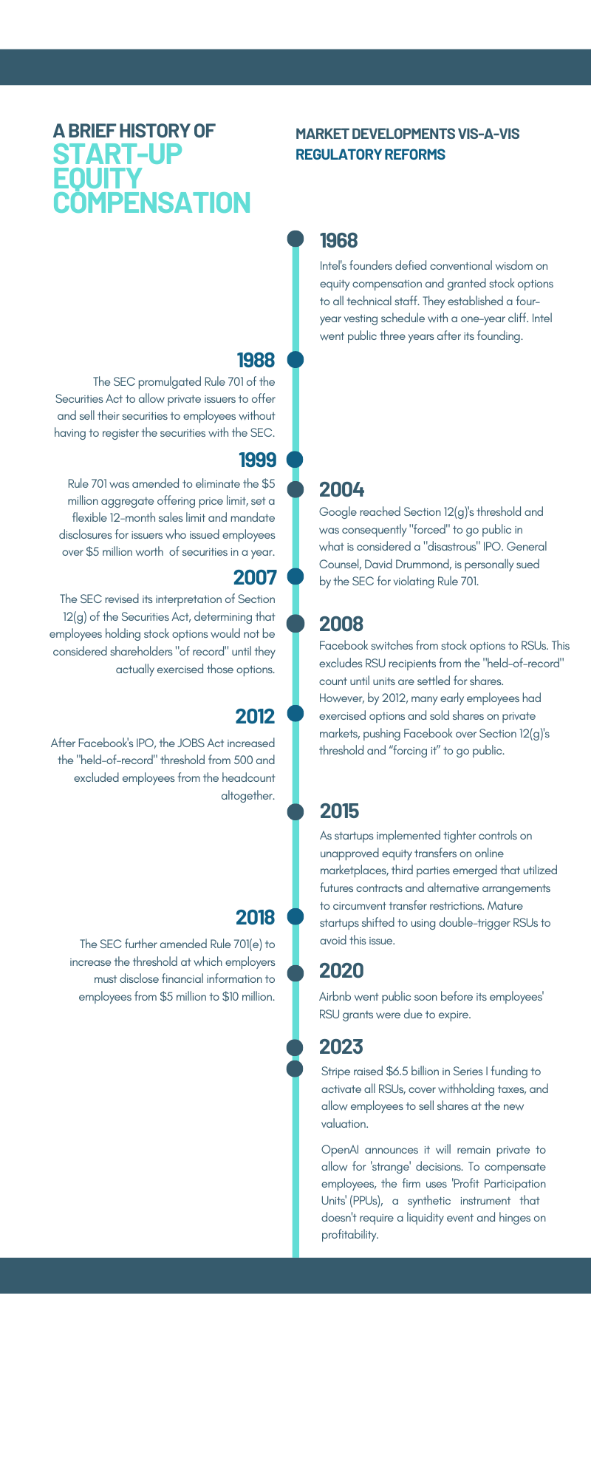

Figure A

The most illustrative example of a company grappling with these regulations was Facebook. Relatively early in its life cycle, Facebook’s operations were funded by advertising sales revenue, which, much like Google, negated the need for the company to go public to raise capital. However, Facebook found itself in the regulatory crosshairs due to its increasing shareholder headcount. Having been a private firm for eight years, long enough for numerous employees to vest their equity grants, Facebook was on the verge of reaching Section 12(g)’s holders-of-record threshold as employees exercised their options and became shareholders (Rodrigues, 2015: 1537).

Facebook’s high valuation in private markets also made it challenging to price employee stock options attractively enough for new hires. To understand this predicament, we need to briefly shift our focus from Silicon Valley to an unrelated corporate scandal that inadvertently shaped equity compensation practices in private firms.

The Enron scandal of the early 2000s, which exposed massive corporate accounting fraud, had far-reaching consequences for equity compensation practices in the United States. Enron executives had exploited tax code loopholes, deferring over $150 million under nonqualified deferred compensation plans and accelerating distributions of over $53 million just before the company’s bankruptcy.

In response, Congress enacted IRC Section 409A, which imposes strict limitations on deferred compensation. This regulation affects arrangements where workers have a right to receive payment for their services at a later date.[9] Section 409A includes an important exemption for stock options granted with an exercise price at or above the fair market value of the underlying stock on the grant date. However, stock options issued below fair market value are classified as “nonqualified deferred compensation” and face severe tax consequences, including a 20% penalty tax and interest at vesting.[10]

The requirement to price stock options’ exercise prices at or above the fair market value of the underlying stock poses a significant challenge for growth-stage private companies, like pre-IPO Facebook, because as their valuations increase, so does the exercise price of new stock option grants, potentially making these options less attractive to new hires due to exceedingly high out-of-pocket costs.[11]

In response to the regulatory hurdles and liquidity challenges, Facebook executed a major shift in its compensation arrangements in 2008, transitioning from stock options to double-trigger RSUs. This adjustment addressed two primary concerns:

1. *The held-of-record count.* By employing double-trigger RSUs, the grant vesting was strategically postponed until a liquidity event, such as an IPO or acquisition. Consequently, employees were not deemed shareholders until the RSU settlement took place. This deferral enabled Facebook to avoid the restrictive Section 12(g) 500 held-of-record threshold.
2. *The exercise cost.* Unlike stock options, which under Section 409A must be granted at an exercise price equal to or greater than the fair market value of the underlying shares, RSUs are granted without any out-of-pocket cost to employees. Once RSUs vest, employees receive shares of stock or, if stipulated in the grant, the equivalent value in cash.

The main differences between stock options and double-trigger RSUs are detailed in Figure B. It covers their primary functions, exercise costs, vesting, typical growth stages for issuance, outcomes when an employee leaves the company, expiration date if no liquidity event transpires, and opportunities for securing (at least partial) liquidity before the company goes public.

Figure B

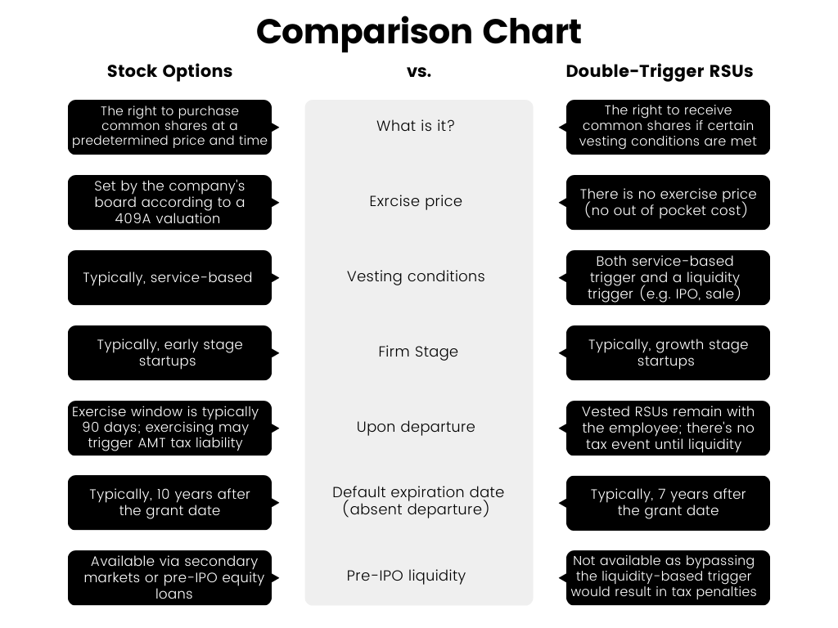

Accommodating this shift, the SEC clarified via a no-action letter in 2012 an exemption for RSU holders from Section 12(g)’s 500 held-of-record threshold, effectively allowing Facebook to maintain its private status as it prepared to go public, all the while continuing to offer equity compensation to new and existing employees.[12] This exemption allowed Facebook to further grow and hire more talent as a private company, releasing it from the regulatory burdens associated with a large shareholder base.

However, as Facebook’s tenure as a private company extended, employees who had exercised their stock options and held shares began seeking alternative avenues for liquidity, and started selling their shares to third-party buyers via emerging online marketplaces (see Pollman, 2012: 193, describing the rise of these secondary markets and discussing related securities law issues; Rodrigues, 2015: 1539). The sales of these shares ultimately triggered the 500 held-of-record threshold, compelling Facebook to go public (Aran, 2018: 1287; Rodrigues, 2015: 1539, explaining that sales on the secondary markets made it so “each sale—rather than substituting new shareholders for old—added to the growing shareholder-of-record tally”).

Similarly to Google’s scenario, despite Facebook’s immense success as a public company, its IPO was widely considered a disappointment, as it did not experience a “first-day pop.” Instead, the shares declined immediately upon market opening, and over the following few months, the stock value plummeted by more than 40% (Safdar, 2013).

In the wake of Facebook’s IPO, Silicon Valley startups responded by clamping down on unapproved transfers of securities by employees via online secondary marketplaces and lobbied to increase the 500 held-of-record limit (Aran, 2018: 1288; Cable, 2017: 628). They argued that Section 12(g) discourages job creation and economic growth by forcing companies to choose between going public prematurely and being able to hire a talented workforce that could only be recruited with equity-based compensation.

The lobbying efforts proved successful, and in 2012, the Jumpstart Our Business Startups (JOBS) Act increased the held-of-record threshold from 500 to either 2,000 shareholders or 500 shareholders who are non-accredited.[13] Furthermore, the Act exempted securities held by employees and service providers from the shareholders’ tally,[14] effectively eliminating Section 12(g)’s constraint on startups’ ability to recruit and remunerate employees with equity grants while maintaining private status.

Building on the earlier analysis, we can again examine these changes through the dual lenses: The transaction cost engineering perspective would view the JOBS Act as a further step in streamlining startup growth. Like the post-Google IPO reform, this legislation allows for broader equity compensation plans without forcing premature IPOs, potentially fostering more efficient value creation and talent acquisition. However, from a coding capital perspective, these changes can be seen as a continuation of the trend to increase firm control over human capital. By further prolonging private status and now exempting employee shares, companies gained additional leverage over IPO timing. The exclusion of employees from the shareholder count effectively creates a two-tier system where employee shareholders carry less weight in determining the company’s public reporting obligations compared to public investors, further emphasizing the primacy of investor interests over employee shareholders.

## C. Unicorns’ Soaring Valuations and Liquidity Challenges

Even after the significant relief provided by the JOBS Act, startups’ troubles with equity compensation did not dissipate. The Act and the abundance of capital flooding the private capital market ushered in the era of unicorns—private venture-backed companies with valuations of $1 billion or more (Aran, 2018: 1281–1284; Erdogan et al., 2016; Georgiev, 2021: 240–241; Kenney and Zysman, 2019: 37). Now when Section 12(g)’s threshold was no longer a problem, startups took their time and stayed private.

To offer solutions to frustrated employees, third-party funders such as ESO Fund, Equity Bee, SecFi, Liquid Stock, and Quid emerged to offer various loans and future contracts that ostensibly bypass the need for company approval for the securities transfer (Larcker et al., 2021). Other platforms, such as NASDAQ Secondary Markets and CartaX approach this differently, facilitating company-approved transactions (Larcker et al., 2021).

Nonetheless, startups still grappled with two lingering issues:

* First, Rule 701 still mandated the disclosure of financial information to employees once the annual offerings of equity compensation surpassed $5 million. Companies like Credit Karma encountered this barrier, resulting in an SEC enforcement action (Credit Karma, Inc., 2018). Following further lobbying efforts, an amendment to Rule 701(e) was enacted in 2018, raising the size-of-offering threshold from $5 million to $10 million, thereby alleviating this issue (SEC, 2018).
* Second, as stock options became less contentious due to the availability of secondary market liquidity solutions, the attention shifted to RSUs. As mentioned earlier, double-trigger RSUs carry a ticking time bomb—a seven-year grant-to-liquidity deadline. If companies remained private as this seven-year threshold approached, they faced a challenging decision: either go public or allow their employees’ RSUs to expire. Attempting to buy out employees’ rights before achieving a liquidity event would result in forfeiting the tax deferral and triggering substantial tax liabilities, a burden only exceptionally robust companies could shoulder.

The main regulations affecting the design of startup equity compensation schemes are detailed in Figure C.

Figure C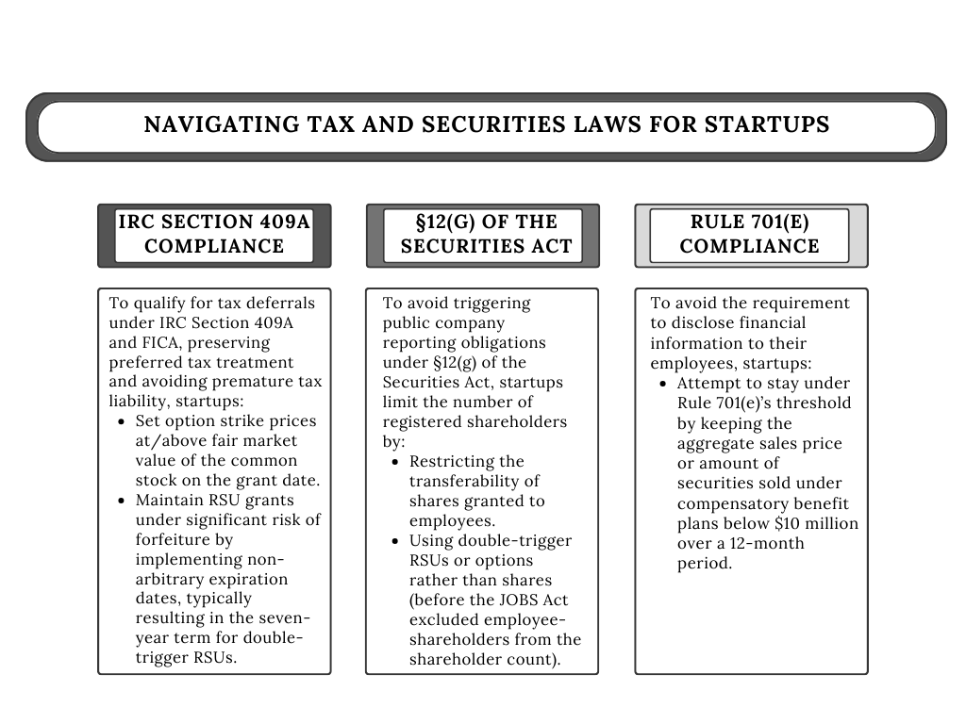

In the latest stage of the equity compensation evolution, OpenAI took a distinct path. CEO Sam Altman voiced his intention to keep the firm private, emphasizing the necessity of autonomy for making unconventional decisions, particularly as AI technology’s capabilities advance (Thomson, 2023). To facilitate this strategy, OpenAI opted for profit participation units (PPUs) over traditional equity instruments,[15] freeing the company from concerns that equity compensation would interfere with its decision if and when to go public.

In summary, deregulatory measures such as excluding employees from Section 12(g)’s held-of-record definition and increasing Rule 701(e) disclosure thresholds have facilitated private companies’ ability to stay private for extended durations. This regulatory environment allows companies to expand in size and valuation and to use equity compensation arrangements more liberally, all without the concern of taking on public company-like reporting and disclosure obligations.

These regulatory shifts offer private firms the advantage of sidestepping the costs and obligations of an IPO and the continuous reporting requirements of public companies. This newfound autonomy allows private companies to better control the timing of their IPOs, choosing moments of favorable market conditions, stable revenues, and high demand for their shares. However, this often leads to private firms achieving their peak growth potential before going public, thereby diminishing the opportunities for public market investors to benefit from these returns. Furthermore, a crucial aspect frequently goes unnoticed in this context.

As this chapter illuminates, these regulatory changes significantly alter the risk dynamics within startups. While startups once bore the risk of being pushed toward public markets as employees exercised their stock options, the landscape has evolved, transferring this risk to employees who may lose their RSUs if companies opt to remain private. This subtle yet profound shift in risk allocation highlights the changing relationship between startups and their employees, potentially carrying broader implications for the venture capital ecosystem. These implications are discussed in Section 5, but before that, Section 4 presents an interesting alternative to the regulation of startup equity compensation.

# Startup Nation’s Take on Startup Equity Compensation

As explored in Section 2, the regulation of equity compensation in the United States is shaped by a rigid tax law system, heavily influenced by the post-Enron focus on corporate misconduct (Polsky, 2012). This framework is designed to reduce fraud risks, but it also introduces restrictions that may hinder its ability to meet the needs of technology companies. To address these constraints, Silicon Valley lobbyists frequently engage with the SEC to introduce more flexibility, balancing the rigidity of tax law with a more lenient securities regulation regime.

In contrast, Israel’s approach presents an alternative standpoint. Notably, Israel is one of the only other countries in the world with a high level of VC activity focused on early-stage high-tech startups, thus providing an interesting contrast to Silicon Valley. This difference is exemplified Section 102 of the Israeli Income Tax Ordinance, which is more employee-friendly and less suspicion-based.[16] This provision was initially drafted and enacted as part of the State Economy Arrangement Law 1988, a component of Israel’s budgetary legislation known for its fast-track legislative mechanism.[17] The urgent needs of a fast-growing company, serving as an early indicator of broader industry demands, spurred the swift, formulation, drafting, and Knesset approval of the bill in a single night.[18] Later amendments in 2002, following the recommendations of the second Rabinowitz Committee on income tax reform,[19] streamlined the provision but the foundational principles remained unchanged: Employers can choose to have employee stock options subject to capital gains tax rather than income tax, with the taxation event occurring only upon a liquidity event.

Section 102 provides employers with two advantageous tax routes for distributing equity compensation to Israeli employees and officeholders.[20] The first option, more favorable to employers, subjects the equity awards to standard employment taxation. This includes progressive income tax rates in addition to national insurance and health care contributions but also allows employers to recognize related expenses at the time of the options’ sale. The second, which is more commonly utilized and employee-favored, applies a capital gains tax rate of 25% with an additional probable surtax of 3% (excluding national insurance premiums) upon achieving liquidity. However, in this route, employers are unable to recognize expenses tied to the granted options. For both routes, the options must remain with a trustee for at least two years and employees cannot exercise the options within this period unless granted a special exemption.[21]

In essence, Israel’s Section 102 is closely akin to the IRC’s rules relating to ISOs, offering favorable tax treatment to employees, at the expense of employer deductions.[22] However, Section 102 stands out for its more flexible and streamlined approach, including the following differences:

1. Stock options are subject to a two-year holding period without the additional stipulation of more than one year from exercise to enjoy long-term capital gains treatment, as in Israel there is no such notion of short or long-term capital gains.[23] Taxation occurs after the options are exercised and the shares sold, and only if they yield profits. At this juncture, capital gains tax is levied, with no obligation for a minimum alternative tax in the year the options were exercised.[24]
2. In the case of a forced sale of the employer company before the two-year holding requirement is met, the Israeli Tax Authority may permit the trustee (via a ruling request) to retain the compensation from the stock options for the remaining holding period.[25] At the end of this period, the employee receives compensation and enjoys the benefits of capital gains tax treatment.
3. The exercise price can be set at a nominal price and does not have to reflect the fair market value. However, the tax treatment of in-the-money options varies between public and private companies.[26]
4. A trustee is mandated to manage the options, and when the employee exercises them, the shares are initially registered under the trustee’s name, not the employee’s.[27]
5. There is no requirement to obtain shareholders’ approval.

The following sections delve into the critical differences between the regulation of startup employee stock options in Israel and the United States, articulating why Israel’s approach to equity compensation may offer valuable insights, particularly given the prolonged time frames before tech companies go public.

## A. The Role of the Trustee in Israel’s Equity Compensation Framework

A primary difference between the Israeli and US approaches to employee stock option taxation is that, in Israel, all equity grants must be placed in escrow with a trustee to qualify for preferential tax treatment. The trustee is responsible for calculating, withholding, and remitting taxes to the Israeli Tax Authority.

In contrast to ISO rules, which may require alternative minimum tax to be paid at the end of the year when stock options are exercised,[28] Israeli law allows deferring the tax event until a liquidity event. In Israel, the tax event occurs upon the earlier of the two dates: either the transfer of shares from the trustee to the employee or the sale of the shares by the trustee.[29]

The escrow system reduces the financial risk for employees who need to exercise their stock options within a set time frame, such as following a layoff. By postponing the tax event until liquidity is reached, the Israeli framework mitigates the risk of paying taxes on paper gains that might not materialize.[30] Thus it also makes it easier for employees to exercise their options and partake in the wealth their efforts have helped generate.

## B. Exercise Prices and Expiration Dates of Employee Stock Options

Israeli tax treatment of employee stock options is also more lenient regarding the setting of the exercise price and the post-employment exercise window. First, as mentioned in Section 2, under Section 409A, stock options’ exercise prices must be equal to or greater than the fair market value of the underlying stock on the grant date. In contrast, the Israeli equivalent provision does not impose such a requirement.[31] As a result, it is quite common for Israeli startups to offer options with an exercise price of $0.01, even when the company’s valuation indicates a significantly higher price per common share. Consequently, in contrast to US companies, Israeli private firms generally avoid issuing RSUs to employees, even as they mature and increase in value.

Another area of relative flexibility concerns the post-employment exercise window for stock options. In Israel, following US practices, employees are customarily provided a three-month period to decide whether to exercise their vested options after leaving their employer, or else forfeit them.[32] It is important to note, however, that this practice is based on industry standards rather than being mandated by Israeli law. The duration of this post-employment exercise window is determined by the company’s stock options plan, and any modifications to the original terms should be carefully considered and confirmed with the Israeli Tax Authority to avoid potential tax implications.

## C. Corporate Law Implications of the Escrow System

Employee-option holders gain protection only after they exercise their options and become shareholders. Even then, under a Section 102 plan, the shares remain held by a trustee unless the employee chooses to take possession and pay the associated taxes. Therefore, the use of a trustee has significant implications in the corporate law domain, as it renders employee shareholders simply beneficiaries and not the holders of record of the shares. It is also customary that employees assign all voting rights through a power of attorney or proxy to a specific company position, with the chairman of the board being the most common choice.

Regarding this matter, a somewhat contentious guiding precedent was set by the Haifa District Court in *Navon v. Sol Chip Ltd.*[33] The ruling determined that shares falling under the purview of Section 102 are construed as primarily economic incentives. As such, while the shares confer rights to dividends (should the company choose to distribute them) as well as a stake in exit proceeds, they do not provide the rights to inspect the company’s financial records, participate in shareholders’ meetings, or partake in the nomination of board members.

Thus, the Israeli use of a trustee offers solutions to two distinct problems: First, the issue of creating shareholders of record. Unlike the amended Section 12(g), which completely excludes employees from the shareholder count,[34] the Israeli method establishes only one shareholder of record—the trustee. However, if employees elect to take the shares from the trustee and pay the associated taxes, they then become registered shareholders. Second, it addresses the emerging challenge regarding the enforceability of waivers of shareholder inspection rights in jurisdictions like Delaware and other states, where different standards and case law apply, and where it remains unclear whether these rights can be contractually waived.[35]

To summarize, Israel’s approach to equity compensation, which involves using a trustee to hold equity grants in escrow, has several key benefits. First, it delays taxation until there is a liquidity event, reducing financial risk for employees. This arrangement also allows startups greater flexibility in setting the exercise price of stock options and deciding the deadline for post-employment exercise, which helps in creating attractive incentive packages. However, it is important to note, as evidenced by current case law, that this escrow system, while tax-efficient for employees, does limit their rights under corporate law as shareholders. Despite this limitation, the system overall simplifies tax issues and creates a favorable environment for employee equity compensation. This makes Israel’s model an interesting one for other countries to consider. Israel’s unique equity compensation framework combines tax benefits, flexible stock option terms, and a lenient corporate law approach. Benefiting both employers and employees, it stands as a strong alternative approach to the contentious IRC Section 409A.

# Conclusion

This chapter has delved into the intricacies of equity compensation in startups, contrasting the regulations in the United States with those in Israel. Each system has its measures to protect the interests of companies, employees, and the public. However, gradual changes in the United States, particularly those introduced by the JOBS Act, have significantly shifted the risk associated with illiquidity and the timing of venture-backed IPOs, often to the detriment of employees.

In the past, Section 12(g)’s held-of-record threshold acted as a catalyst, encouraging companies with a broad shareholder base to go public. This push not only enhanced the scrutiny and accountability of these companies’ management but also invigorated public markets by compelling highly sought-after growth companies to go public. However, the implementation of the JOBS Act, which excludes employees from the shareholder tally, allows companies to maintain their private status regardless of their employee shareholder count, thereby eliminating the incentive for them to go public.

From a policy standpoint, I maintain that companies that offer and sell securities to numerous employees should be required to go public or at least assume public reporting obligations (Aran, 2018: 1291; Aran and Murciano-Goroff, 2023). Such a requirement would rightly classify employees as public investors,[36] granting them the same transparency and protections as other public market investors. It would also address the problem of adverse selection, where companies exhaust all avenues of private financing before going public, often to the disadvantage of new public shareholders.

However, if lawmakers and regulators hesitate to “force” companies to go public, they should at least amend tax laws to minimize the financial risks for the employees of these still-private companies.

As a source of inspiration, the Israeli escrow system under Section 102 offers a compelling blueprint. By deferring tax liability until a liquidity event, such as the sale of the company or an IPO, the Israeli framework reduces the risk of employees facing immediate taxes on paper gains that might never materialize. Additionally, the Israeli framework promotes labor mobility, as employees who choose to leave their employers while retaining their equity ownership only need to cover the exercise price, without facing a potentially substantial tax bill before achieving liquidity. From an employer’s perspective, the escrow system provides better control of the headcount, resulting in only one registered shareholder unless employees decide to take the shares and pay the taxes. It also enables employers to offer employees a share in the financial upside without complicating decision-making processes within the company or risking leaks of sensitive information. Overall, this approach creates a more balanced arrangement for both employers and employees.

# References

Alon-Beck, Anat (2019) “Unicorn Stock Options—Golden Goose or Trojan Horse?,” *Columbia Business Law Review* 107.

Alon-Beck, Anat (2021) “Bargaining Inequality: Employee Golden Handcuffs and Asymmetric Information,” 81 *Modern Law Review* 1165.

Aran, Yifat (2018) “Note, Beyond Covenants Not to Compete: Equilibrium in High-Tech Startup Labor Markets,” 70 *Stanford Law Review* 1235.

Aran, Yifat (2022) interview with Ephraim Abramson (September).

Aran, Yifat, and Raviv Murciano-Goroff (2023) “Equity Illusions,” ewad017 *Journal of Law, Economics, & Organization* 31.

Baker McKenzie (2022) “Double-Trigger RSUs and the Question of the Seven-Year Term,” www.bakermckenzie.com/-/media/files/insight/guides/2022/doubletrigger-rsus-and-the-question-of-the-sevenyear-term.pdf

Barton, Bruce (2019) “Pre-IPO Tech Giants Using ‘Double-Trigger’ RSU Vesting to Attract Talent,” *HR.com* (July 25) www.hr.com/en/magazines/hris_payroll_excellence_essentials/july_2019_hris_payroll/pre-ipo-tech-giants-using-%E2%80%9Cdouble-trigger%E2%80%9D-rsu-ves_jyilvxyf.html

Blasi, Joshep et al. (2003) *In the Company of Owners: The Truth about Stock Options (And Why Every Employee Should Have Them)* (New York: Basic Books).

Cable, Abraham J. B. (2017) “Fool’s Gold? Equity Compensation & the Mature Startup,” 11 *Virginia Law & Business Review* 615.

Code of Federal Regulations, Title 17 [US], §§ 230.701(c)(1), 230.701(d), 230.701(e).

Companies Law (1999) (5759) [Isr.].

Credit Karma, Inc. (2018) Securities Act Release No. 33-10469, 2018 WL 1257807 (March 12), www.sec.gov/litigation/admin/2018/33-10469.pdf

Driscoll, Sharon (2023) “Legal Matters: Arthur Rock on the Early Venture Capital Decision that Sparkes Decades of Innovation,” *Stanford Lawyer* (January 5), <https://law.stanford.edu/stanford-lawyer/articles/legal-matters-arthur-rock-on-the-early-venture-capital-decisions-that-sparked-decades-of-innovation/>

Duggan, Wayne (2018) “This Day in Market History: Intel Founded,” *Yahoo! Finance* (July 18), https://finance.yahoo.com/news/day-market-history-intel-founded-144415780.html

Erdogan, Begum et al. (2016) “Grow Fast or Die Slow: Why Unicorns Are Staying Private,” *McKinsey* (May 11).

ESO Fund, “How to Calculate ISO Alternative Minimum Tax (AMT),” *ESO Fund Blog*, www.esofund.com/blog/amt-tax (accessed November 8, 2023).

Fenwick & West LLP (2012) SEC No Action Letter, 2012 WL 457968 (February 13).

Georgiev, George (2021) “The Breakdown of the Public–Private Divide in Securities Law: Causes, Consequences, and Reforms,” 18 *NYU* *Journal of Law & Business* 221.

Gilson, Ronald J. (1984) “Value Creation by Business Lawyers: Legal Skills and Asset Pricing,” 94(2) *Yale Law Journal* 239.

Gilson, Ronald, and David Schizer (2003) “Understanding Venture Capital Structure: A Tax Explanation for Convertible Preferred Stock,” 116(3) *Harvard Law Review* 874.

Google, Inc. (2005) Securities Act Release No. 8523, 2005 WL 82435 (Jan. 13), www.sec.gov/litigation/admin/33-8523.htm

Gross, Joseph H. (1990) “Taxation of Allocation of Shares and Options to Employees,” 38(4) *The Accountant* 243 [in Hebrew].

Income Tax Ordinance [Isr.], §§ 3(i), 102.

Income Tax Ordinance [New Version] [Isr.], 5(1), §§ 102, 102(a), 102(b)(2), 102(b)(3).

Income Tax Regulations (2017) (5783) [Isr.] [in Hebrew].

IRC [US] §§ 409A, 421(a), 422.

Jumpstart Our Business Startups (JOBS) Act (2012) [US], Public Law No. 112-106, 126 Stat. 306.

Kamar, Ehud, Ayal Shenhav, and Shay Yanovsky (2020) “Start-Up Law in Israel,” in Alexandra Andhov and Pedro Telles (eds.), *Start-Up Law* (Cheltenham, UK: Edward Elgar Publishing).

Kenney, Martin, and John Zysman (2019) “Unicorns, Cheshire Cats, and the New Dilemmas of Entrepreneurial Finance,” 21(1) *Venture Capital* 35.

Larcker, D. F., B. Tayan, and E. M. Watts (2021) “Stock-Option Financing in Pre-IPO Companies,” Rock Center for Corporate Governance at Stanford University, Working Paper.

Lécuyer, Christophe (2006) *Making Silicone Valley: Innovation and the Growth of High Tech, 1930–1970* (Cambridge, MA: MIT Press).

Licht, Amir (2020) “Notes on Trust Law and Corporate Governance” [in Hebrew] (January 15), https://amirlicht.wordpress.com/2020/01/15/165/

Lipton, Ann (2023) “Inside Out (Or, One State to Rule Them All): New Challenges to the Internal Affairs Doctrine,” 58 *Wake Forest Law Review* 321, 349.

Memorandum of Law to Amend the Income Tax Ordinance (Amendment), 5767 (2002) [Isr.], www.gov.il/he/departments/units/tax-reforma-committee

Meydani, Assaf (2008) “Political Entrepreneurs and Electoral Capital: The Case of the Israeli State Economy Arrangement Law,” 19(4) *Constitutional Political Economy* 301.

*Navon v. Sol Chip Ltd* (December 16, 2019), CA (Haifa) 19042-03-18.

Navot, Suzie (2006) “Judicial Review of the Legislative Process,” 39(2) *Israel Law Review* 182.

Nguyen, Brian (2023) “OpenAI PPUs: How OpenAI’s Unique Equity Compensation Works,” *levels.fyi Blog* (June 19), www.levels.fyi/blog/openai-compensation.html

Pisani, Bob (2014) “Google’s IPO Was a Disaster . . . at the Time,” *CNBC* (updated August 19, 2014, 6:27 AM ET), www.cnbc.com/2014/08/18/pisani-googles-ipo-was-a-disasterat-the-time.html

Pistor, Katharina (2019) *The Code of Capital* (Princeton, NJ: Princeton University Press).

Pollman, Elizabeth (2012) “Information Issues on Wall Street 2.0,” *University of Pennsylvania Law Review* 179.

Polsky, Gregg D. (2012) “Fixing Section 409A: Legislative and Administrative Options,” 57 *Villanova University Law Review* 635.

Primack, Dan (2023) “Payments Giant Stripe Raises $6.5 Billion at a $50 Billion Valuation,” *Axios* (March 15), www.axios.com/2023/03/15/stripe-50-billion

Ritter, J. R. (2021) “Initial Public Offerings: Median Age of IPOs through 2020,” Working Paper, University of Florida, Gainesville.

Rodrigues, Usha R. (2015) “The Once and Future Irrelevancy of Section 12(g),” *University of* *Illinois Law Review* 1529.

Rustek, Chelsea (2023) “Stripe Employees: Here’s How the Fintech’s Liquidity Deal Affects Your Money,” *KD Financial Advisors* (March 23), https://kbfinancialadvisors.com/stripe-employees-heres-how-the-fintechs-liquidity-deal-affects-your-money/

Safdar, Khadeeja (2013) “Facebook, One Year Later: What Really Happened in the Biggest IPO Flop Ever,” *The Atlantic* (May 20), www.theatlantic.com/business/archive/2013/05/facebook-one-year-later-what-really-happened-in-the-biggest-ipo-flop-ever/275987/

SEC (2018) Exempt Offerings Pursuant to Compensatory Arrangements, Release No. 33-10520 (July 23), www.sec.gov/rules/final/2018/33-10520.pdf

*SEC v. Ralston Purina Co.*, 346 US 119, 126 (1953).

Securities Exchange Act (1934) [US], § 12(g).

State Economy Arrangement Law (1988) [Isr.].

Surane, Jenny, and Gillian Tan (2023) “Stripe Faces $3.5 Billion Tax Bill as Employees’ Shares Expire,” *Bloomberg* (March 7), [www.bloomberg.com/news/articles/2023-03-06/stripe-details-3-5-billion-tax-bill-in-latest-fundraising-round#xj4y7vzkg](http://www.bloomberg.com/news/articles/2023-03-06/stripe-details-3-5-billion-tax-bill-in-latest-fundraising-round#xj4y7vzkg)

Temkin, Marina (2023) “No Way Out: Stripe’s Share Rescue Plan Not an Option for Most Startups,” *PitchBook News & Analysis* (March 3), https://pitchbook.com/news/articles/stripe-ipo-down-round-tax-restricted-stock-unit

Thomson, Amy (2023) “ChatGPT Maker OpenAI Is Staying Private So It Can Make ‘Strange’ Decisions,” *Bloomberg* (June 6), www.bloomberg.com/news/articles/2023-06-06/openai-staying-private-and-free-to-make-strange-decisions

Thurm, Scott (2008) “Bailout Bill Provided Tech Workers with Tax Relief for Stock Options,” *Wall Street Journal* (November 10), www.wsj.com/articles/SB122628070388512411

United States Code, Title 26 (2023) [US], §§ 409A, 409A-1(a)(1), 409A-1(a)(1)(5), 422(a)(1), 422(a)(2), 422(b)(3).

Weinberg, Cory (2020) “As Airbnb Ponders Timing of Listing, Stock Grants Impose Deadline,” *The Information* (March 4), [www.theinformation.com/articles/as-airbnb-ponders-timing-of-listing-stock-grants-impose-deadline](http://www.theinformation.com/articles/as-airbnb-ponders-timing-of-listing-stock-grants-impose-deadline)

Weinberg Cory (2023) “The Private Tech Company that Let Employee Stock Grants Evaporate,” *The Information* (February 22), www.theinformation.com/articles/the-private-tech-company-that-let-employee-stock-grants-evaporate

1. * Assistant Professor, University of Haifa Faculty of Law. I thank Ephraim Abramson, Daniel Bias, Oz Halabi, Emil Lakkis, and Greg Polsky for helpful comments.
2. Id. As opposed to IRC-mandated 10-year expiration date of incentive stock options (ISOs). See 26 US Code § 422(b)(3).
3. Rustek (2023) explains that Stripe waived the liquidity-based trigger and settled the outstanding double-trigger RSUs that had already met the service-based trigger. To address the tax-withholding upon settlement, Stripe employed “net-settling,” namely retaining shares with a fair market value equivalent to the tax withholding amount and then forwarding the cash to the appropriate tax authorities. Double-trigger RSUs typically have their liquidity-based trigger serve as a “substantial risk of forfeiture” which is needed for the tax deferral. Therefore, if a company consistently waives the liquidity-based trigger for its double-trigger RSUs, it weakens the substantial risk of forfeiture for other outstanding RSUs, possibly jeopardizing the tax status of future awards. See Section 2.
4. Notably, this pioneering use of stock options in Silicon Valley predated the implementation of § 409A of the IRC. This later legislation would introduce substantial changes to the taxation of deferred compensation, including certain types of stock options, significantly altering the landscape of equity compensation. The specific implications of § 409A and its impact on equity compensation practices will be explored in detail later in this chapter.
5. Id.
6. This exemption allows private companies to offer and sell securities as part of their compensation plans without registering the securities with the SEC. To qualify for this exemption, private companies must meet certain criteria, such as issuing the securities as part of a written compensation agreement and offering them only to employees, directors, and certain consultants. See 17 CFR § 230.701(c)(1). Furthermore, the aggregate sales price or number of securities sold under the Rule during any consecutive 12-month period must not surpass the greater of $1 million, 15% of the total assets of the issuer, or 15% of the outstanding amount of the class of securities being offered and sold. See 17 CFR § 230.701(d).
7. Before securities are issued under Rule 701, issuers are required to meet some basic disclosure requirements. These include making the compensatory plan available to eligible recipients in a reasonable time frame before the sale of securities. Importantly, if the aggregate sales price of securities sold under Rule 701 surpasses $10 million within a 12-month period, the issuer is obligated to provide additional, more detailed disclosures. These enhanced disclosures must include financial statements prepared according to Generally Accepted Accounting Principles (GAAP), which should be dated no more than 180 days before the sale. See 17 CFR § 230.701(e).
8. Id at 935–936.
9. 26 USC § 409A (2023). See also Polsky (2012), arguing that § 409A is problematic and stems from an overreaction to alleged abuses in nonqualified deferred compensation plans as part of the Enron scandal that, in hindsight, remain unsubstantiated.
10. 26 USC § 409A-1(a)(1) and § 409A-1(a)(1)(5).
11. See Gilson and Schizer (2003: 893), discussing the prevalence of convertible preferred stock in venture capital, explaining its role in reducing taxes on equity-based compensation.
12. On February 13, 2012, the SEC issued a no-action letter granting relief from the Securities Exchange Act’s registration requirement when a company reaches the 500- shareholder limit due to the issuance of RSUs (Fenwick & West LLP, 2012).
13. See Public Law No. 112-106, 126 Stat. 306 (codified as amended in scattered sections of 15 USC). The JOBS Act amended the Securities Exchange Act of 1934, Public Law No. 73-291, 48 Stat. 881 (codified as amended in scattered sections of 15 USC).
14. Id.
15. A PPU holder is entitled to a slice of company profits. The PPU’s value is contingent on the company achieving profits above a designated “liquidation threshold.” A salient feature of PPUs is their favorable tax treatment: they are exempt from tax upon issuance and vesting. The only tax applied is the capital gains tax when the profit is realized, or the unit is sold. See Nguyen (2023).
16. Income Tax Ordinance [New Version], 5(1), § 102. See also Kamar et al. (2020).
17. The State Economy (Arrangements) Law, which is an annual legislation passed concurrently with the Annual Budget Law, serves the purpose of modifying existing laws. This legal practice is somewhat similar to the Reconciliation Bill in the United States. See Meydani (2008: 302); Navot (2006: 190).
18. In 1988, when US investor Bill Davidson invested in the fledgling Israeli electronics company Orbotech, the company’s valuation soared a hundredfold. Confronted with this sharp increase in valuation, CEO Yochai Richter grappled with the challenge of issuing employee stock options. Legal adviser Ephraim Abramson cautioned that the options could neither be distributed at a value lower than Davidson’s investment due to tax implications nor at the newly elevated valuation due to the associated risks for employees. Abramson reached out to Deputy Commissioner of Income Tax, Moshe Gavish, for a pre-ruling. Gavish, already grappling with the complexities of employee stock options, recognized Abramson’s arguments but encountered a “procedural” snag—he could not approve the request unless a legislative overhaul was carried out. Seizing the moment, Gavish and Tax Commissioner Yair Rabinovitz sought to expedite the legislative process by leveraging the State Economy Arrangement Law of 1988. See author’s interview with Ephraim Abramson (Aran, 2022) (September 2022). For an alternative perspective on the legislative background, linking the reform more closely with restructuring efforts in certain Israeli companies, see Gross (1990: 244–245).
19. Memorandum of Law to Amend the Income Tax Ordinance (Amendment), 5767 (2002), available at www.gov.il/he/departments/units/tax-reforma-committee.
20. Grants made to controlling shareholders, consultants, service providers, and other individuals who are ineligible for § 102 grants fall under § 3(i) of the Israeli Income Tax Ordinance. Taxation of § 3(i) grants occurs in two stages: First, when shares are issued, or in the case of options, when options are exercised, this income is treated as ordinary income and taxed at the recipient’s marginal tax rate, in addition to national insurance and health tax (with an applicable surtax if relevant). The company is responsible for withholding this tax at the source and submitting it to the Israel Tax Authority. Second, upon the sale of the shares, there could be an additional capital gains tax. The tax rate is 25%, subject to surtax if applicable.
21. Income Tax Ordinance [New Version], 5(1), § 102(b)(2). See also below note 66 and accompanying text.
22. IRC § 422 sets forth the criteria for ISO treatment. When employees exercise ISOs and meet the requirements of IRC § 422, which includes adhering to the post-exercise stock holding conditions, they remain untaxed until they choose to sell the underlying shares. At that juncture, they incur taxation at the capital gains rate on their entire gain, rather than being subject to the ordinary income rate, as specified in IRC § 421(a).
23. Income Tax Ordinance [New Version], 5(1), § 102(a); cf. 26 US Code § 422(a)(1).
24. See below note 69.
25. Income Tax Regulations (sale for which the end of the period is the date of sale), 2017 (5783) [in Hebrew].
26. Private companies have the flexibility to issue options with any exercise price, including those that are “in the money.” However, in public companies, the value of the benefit to the employee—calculated based on the company’s share price on the stock exchange as of 30 trading days prior to the grant date, minus the exercise price—will be taxed at the employee’s marginal tax rate. The remaining value of the option, the appreciation from the grant date to the date of sale, will be subject to the capital gains tax (Income Tax Ordinance [New Version], 5(1), § 102(b)(3)).
27. See Section 4(a).
28. ISOs are not subject to taxation for the employee when they are granted or exercised, but their value can trigger an alternative minimum tax (AMT) liability as the difference between the shares’ fair market value and the exercise price is an AMT adjustment, and if it exceeds federal thresholds, AMT may be owed. See ESO Fund (2023).
29. Income Tax Ordinance [New Version], 5(1), § 102(a) (definition of exercise date).
30. This issue is substantial. To illustrate, the tech stock boom and crash from 1999 to 2001 resulted in many tech employees facing taxes on stocks that had lost their value. To address this, the 2008 financial bailout bill in the United States, worth $700 billion, included a provision for tax relief targeted at tech workers affected by the stock crash. This relief, aimed at those with large tax bills sometimes over $1 million on devalued shares, cost the Treasury an estimated $2.3 billion. It primarily benefited not top executives but lower-level employees and middle managers in tech firms of the 1990s. See Thurm (2008).
31. The Israeli law differentiates between private and public companies in this context. See above note 67.
32. See 26 US Code § 422(a)(2); Aran (2018: 1266), discussing the implications of these out-of-pocket costs on startup employee mobility; Alon-Beck (2019), describing startup employee stock options as golden handcuffs.
33. CA (Haifa) 19042-03-18 *Navon v. Sol Chip Ltd* (December 16, 2019). The case centered on an employee who exercised options and became an ordinary shareholder, claiming entitlement to shareholders’ rights under Israel’s Companies Law 1999 (5759), including the right to inspect the company’s books and the right to vote in shareholders’ meetings. The employer argued that as shares were held by a trustee, the employee was not a shareholder. The employer’s stance was that since a trustee held the shares, the employee couldn't be considered a shareholder and, thus, had no corresponding rights. The court delved into the essence of the trust established by the Ordinance, identifying three distinct sets of obligations borne by the trustee to the Tax Authority, the company, and the employee. Crucially, the Court emphasized that the 102 Trustee’s primary fiduciary responsibility lay with the Tax Authority. Thus, concluded that as long as the employee retained shares under the custody of a trustee, the employee’s rights as a shareholder remained in abeyance. The decision was not appealed, which has left critical issues open to interpretation. One pressing question that remains is whether the trustee should assume shareholder responsibilities, such as participation in meetings or access to confidential information. Professor Amir Licht proposed a more nuanced interpretation of the Ordinance, suggesting that only the employee should be considered a beneficiary, with the securities being their exclusive property. Under this model, the company assumes the role of trust creator, while the trustee becomes bound to the company and the Tax Authority by contractual obligations only, including tax payment responsibilities and, where relevant, the duty to cast votes in accordance with board instructions. See Licht (2020).
34. See Section 3.B.
35. See Alon-Beck (2021), discussing the practice of having employees sign a waiver of their inspection rights as shareholders; Lipton (2023), addressing this issue through the lens of the internal affairs doctrine in corporate law.
36. See *SEC v. Ralston Purina Co.*, 346 US 119, 126 (1953) (where the Court stressed that, as a rule, “employees are just as much members of the investing ‘public’ as any of their neighbors in the community”).