**The reuse of water used for aquaculture to develop natural wetland habitats and birding areas in Kibbutz Ma’agan Michael, Israel**

(Draft 2)

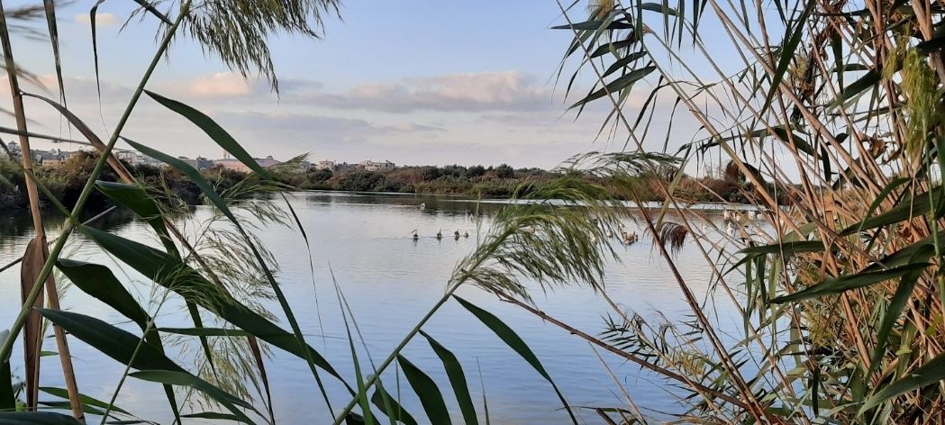

* Background
* Rationale
* Goals
* Water resources and usages – the current situation
* The Birding Park – a conceptual ecohydrological program
* Proposed hydrological operation
* Estimates of required water volumes

Society for the Protection of Nature in Israel

May 2023

**Background**

Ma’agan Michael is a traditional collective kibbutz in the north of Israel, located on the Mediterranean coast. Established in 1949, the kibbutz belongs to the Hof Carmel regional council, and is currently home to some 2,000 residents. It has several manufacturing plants, including the Plasson plant and the Suron plant, as well as dairy and poultry farming and aquaculture ponds.

Ma’agan Michael’s aquaculture ponds extend over a long, narrow strip along the Carmel Beach, from Tel Taninnim and the mouth of the Nahal Taninnim stream in the south to the mouth of Nahal Dalia stream in the north (Figure 1). The area has been known for many years as one of the most interesting birding regions in Israel, and also has international significance, in particular for the migration of wading birds and waterfowl. There are ongoing activities in the vicinity of the aquaculture ponds and beach, including numerous tours of the aquaculture ponds and along the stream and beach. Some of these are birding tours that include bird ringing and observation, as well as training and educational activities. The birdwatching activities in the area, the park, the swamps that were drained about a century ago were of tremendous importance for a large variety of fauna and flora and served as a vital stopover site for millions of migratory birds. For years, the aquaculture ponds have served as a partial substitute for the drained swamps. The park will create a habitat that includes a water management system adapted to bird migration seasons. It will partially restore the habitat for birds and other wildlife. In addition, it will resolve issues around the management of the area, making it accessible for visitors to the site now, and also serving as a unique biodiversity asset for future generations.

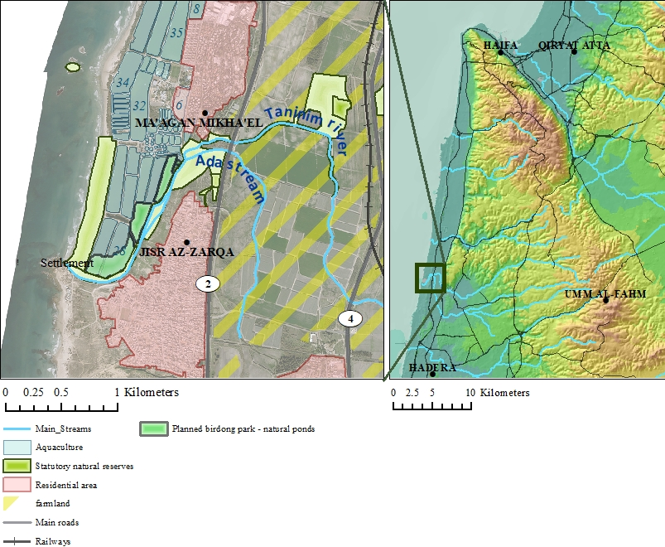

*Figure 1: Maagan Michael - Birding Park Location Map*

**Rationale**

The Nahal Tanninim stream is a remnant of the Kabara swamps landscape. The swamps extended into the coastal valley, and were home to fauna and flora of tropical origin. After the swamps were drained and dried, the wetland habitat was reduced to the Nahal Tanninim nature reserve, which is mainly fed by saltwater from the Enot Timsah spring. Nahal Tanninim is unique in that its waters are brackish, and its flow is a relatively unpolluted steady stream. Nahal Tanninim is also the last of Israel’s coastal streams that flows naturally from its source (the Enot Timsah spring) to the sea. Because of this, typical aquatic fauna and flora have been preserved here almost unharmed. The area contains a number of wetland habitats, including springs, open and closed wetland landscapes, seasonal floodplains, a stream and riverbanks, and an estuary.

The stream contains unique species of invertebrates, rare crustaceans, fish (Nile tilapia, catfish), *Mauremys* turtles, and softshell turtles. In the vicinity of the stream, a variety of waterfowl and wetland birds, as well as a rich variety of aquatic and riparian plants can be found. Some 200 wetland plant species have been recorded here (approximately 7 percent of all species in Israel), including submerged aquatic plants (the yellow water-lily, species of *potamogeton,* and hornwort).

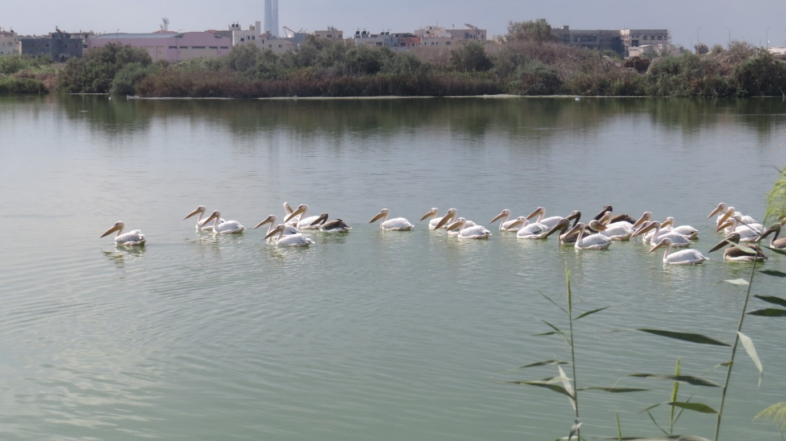

*Image 1: Migrating Pelicans at the Ma’agan Michael planned Birding Ponds, September 2022*

**Goals**

The goal is to create a high-quality wetland habitat, while simultaneously establishing infrastructure that will serve as an attraction for the general public, in particular for birding enthusiasts. To create the park, some of the existing aquaculture ponds will be altered (Figure 2). A water culvert and level maintenance system will be designed and a variable-height bottom created. The bodies of water will be divided using earthen embankments within the ponds. This will create a unique water management system that is adapted to the specific ecological needs of birding, and that will also serve to attract bird species to the park.

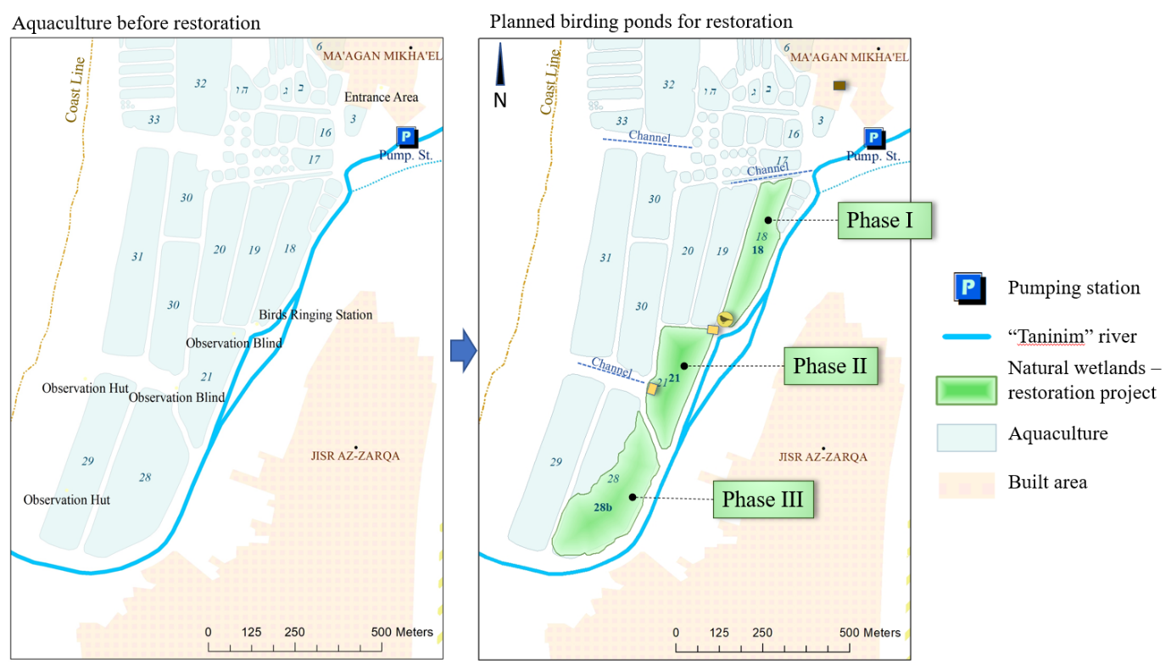*Figure 2: Conceptual plan – converting aquaculture to natural birding by ecohydrological restoration.*

**Water resources and usages – the current situation**

Average annual rainfall in the region is about 600mm, while the annual evaporation potential is about 1,500mm. The average volume of water flowing from the Enot Timsah spring to feed the Nahal Tanninim stream is around 20-30 million cubic meters per annum. Of this, approximately 0.5 million cubic meters per annum are pumped to irrigate agricultural land, and some 17.5 million cubic meters per annum are pumped into the aquaculture ponds by Kibbutz Ma’agan Michael. The agreement between Ma’agan Michael and the Israel Nature and Parks Authority includes provision for a continued flow of approximately 5 million cubic meters per annum along the Nahal Taninnim stream from the Roman dam to the sea.

Currently, all Ma’agan Michael’s ponds are used for aquaculture. Water is supplied to the aquaculture ponds by pumping water from Nahal Tanninim upstream (east of the Roman dam). From there, the water flows to the aquaculture ponds through gravity culverts. The pumping and drainage systems compensate for uncontrolled loss due to vertical and horizontal seepage from the sand and kurkar (sandstone) pond embankments, and vertical seepage in the western ponds. This is in addition to the volume of water required to fill the ponds to maintain high water levels and refresh the water for aquaculture.

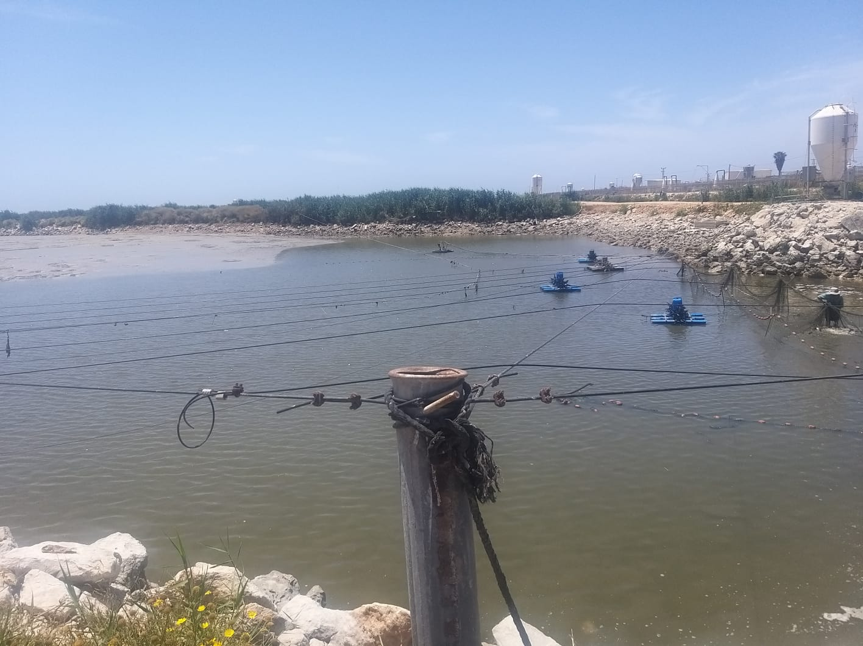

*Image 2: Current use at area of interest, active aquaculture pond, September 2022*

**The Birding Park – a conceptual ecohydrological program**

The planning principle that underpins the establishment of the Birding Park is the creation of a variety of habitats and ecological niches characterized by water depth and wetland/muddy soil to facilitate the production of planktonic biomass as a basis for the food web. Changes in water levels will follow the natural water level fluctuations of the ancient Kabara swamps, enabling the distribution of different habitats across seasons and spaces, and making the area an attractive source for local and migratory birds.

Another guiding principle is the restoration of plant colonies characterized by vegetation belts that vary from areas with permanent water levels, through wet banks, to dry habitats located above the banks. An additional fundamental principle is the restoration of ecosystems using water from the Kabara springs that was previously used only by the aquaculture industry, and that will now be reused to restore ecosystems. After use, water from the aquaculture pools will be made to flow through wetland vegetation on the riverbanks, which will improve its quality. It will then flow to the restored natural wetlands in the aquaculture ponds (Figure 3).

The Birding Park will be accessible to the general public in a way that will provide visitors with an optimal birding experience. The park will also create a unique water system that will attract birds all year round. The park’s amenities will include a reception area, birdwatching stations, hiking trails, a number of different ponds, and a water transmission system that enables flexible year-round operation.

The water management system planned for the park includes a system for filling and emptying ponds that is designed to meet the needs of migratory and local birds throughout the year. The ponds will operate in a synchronized way, which will enable the park to maintain a number of deep, shallow, and muddy habitats suitable for the various bird species that visit the ponds throughout the year.

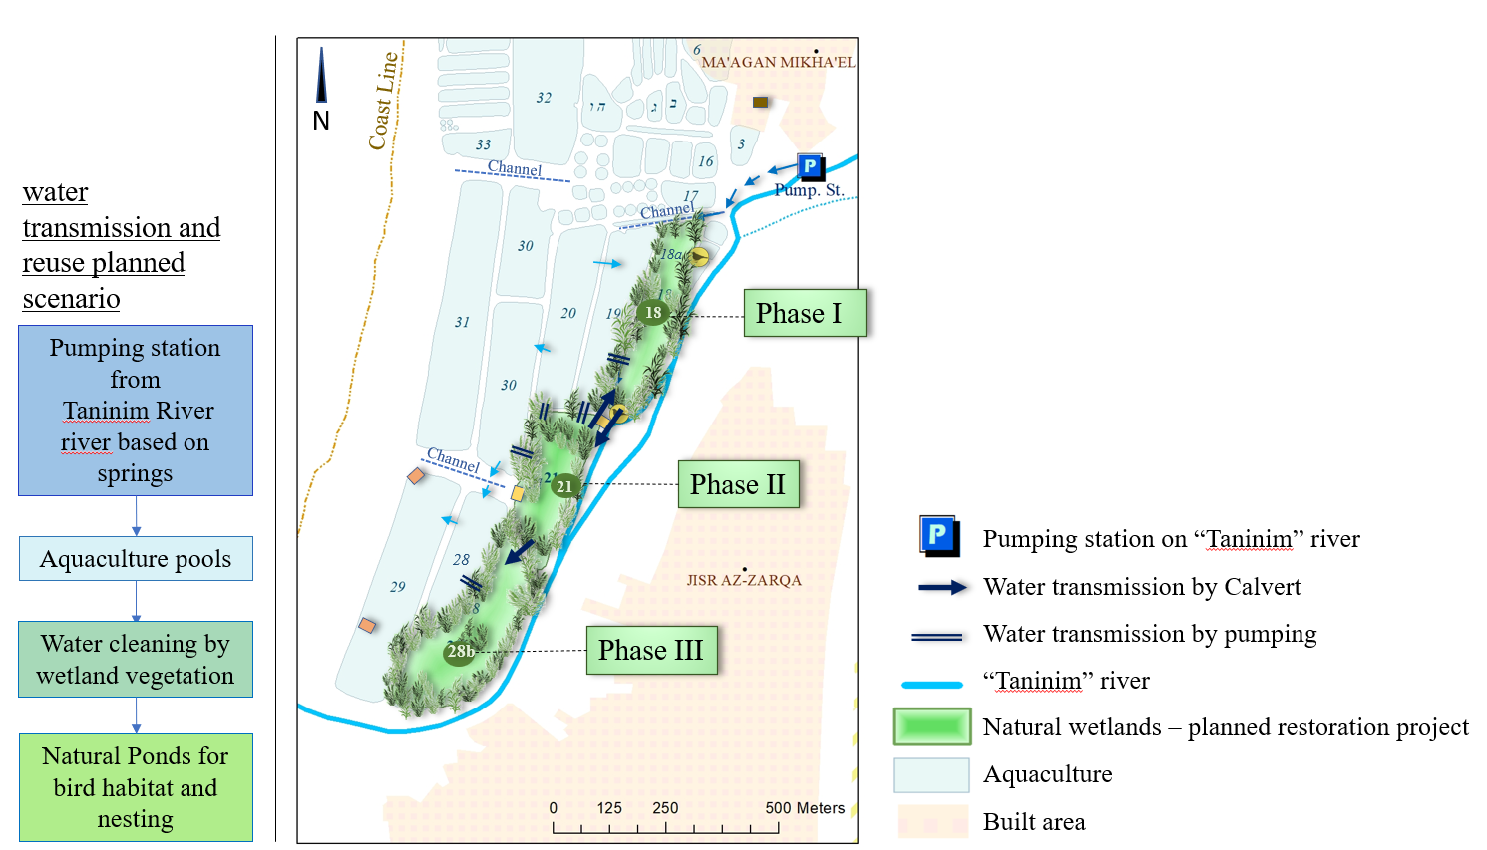

*Figure 3: Conceptual plan of water reuse and quality reclamation by wetlands*

The water levels in the park’s ponds are key to maintaining their unique functions as habitats within the park. The levels of water in the various ponds mimics those of natural bodies of water. In order to maintain the habitats in some of the ponds, the water levels must fluctuate throughout the year. The ponds will transition between being full, empty, or muddy with a saturated soil. (Water level adjustment will also be used as a management tool by the park to prevent the proliferation of the common reed, which would affect the planned function of the habitats.)

Ponds 18 and 21 will be completely drained once a year to allow the oxidation of organic matter, which simulates the almost total drying out of the body of water.

The habitats will be adjusted for the peak spring migration period in March, which continues until May. During this period, the park will maintain a variety of habitats with different water levels. During the migration of shorebirds in July and November, emphasis will be placed on mud habitats (with wetland water levels and wet pond bottoms.)

Due to water evaporation and infiltration via the ponds’ banks, an assessment was made of the volumes of water that are lost over the year, with a view to adding these volumes to the amounts required by the park’s water transportation systems (natural flow through water culverts and pumping using a water pump). Below is a quantitative calculation of the water consumption required to compensate for water loss as a result of infiltration and evaporation over the year (Tables 1 and 2):

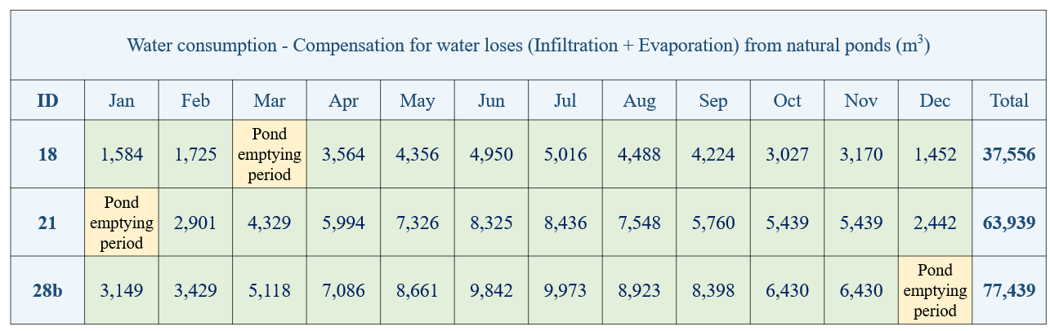

*Table 1: Water demand for loses compensation (Infiltration + Evaporation), m3/yr.*

*Table 2: Total water demand including refill and loses compensation, m3/yr.*

Clear boundaries between the park ponds and the aquaculture ponds will be defined by existing and planned embankments. The park ponds will be part of the water transmission between the aquaculture ponds, but will maintain operational independence in accordance with the park’s water management needs, as shown in Figure 4 below.

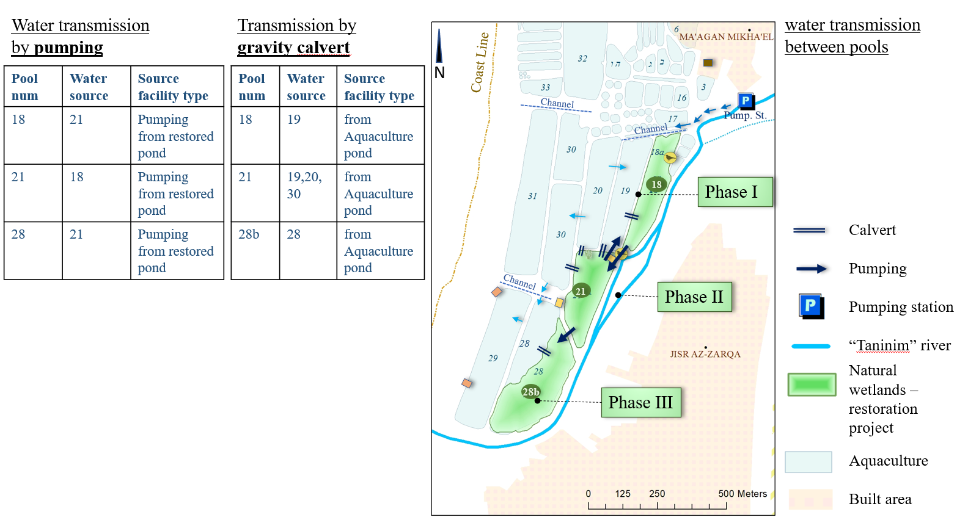

*Figure 4: Conceptual plan – Water supply and transmission between restored ponds schemes*

The bodies of water will have a meandering design, which aims to increase the contact area between the waterline and the banks, create hiding places, and generate variation in water flow. Riparian vegetation will hold the soil on the slopes in place. Bolder fill will be placed in areas where there is no vegetation, to prevent subsidence of the sandy soil. In these areas, a kind of water channel can be built between the bank and a higher strip of land (such as a low berm) in order to create a strip of reeds between the bank and the pond. The bodies of water will be designed with an embankment slope of 3% toward the emptying point (Figure 5).

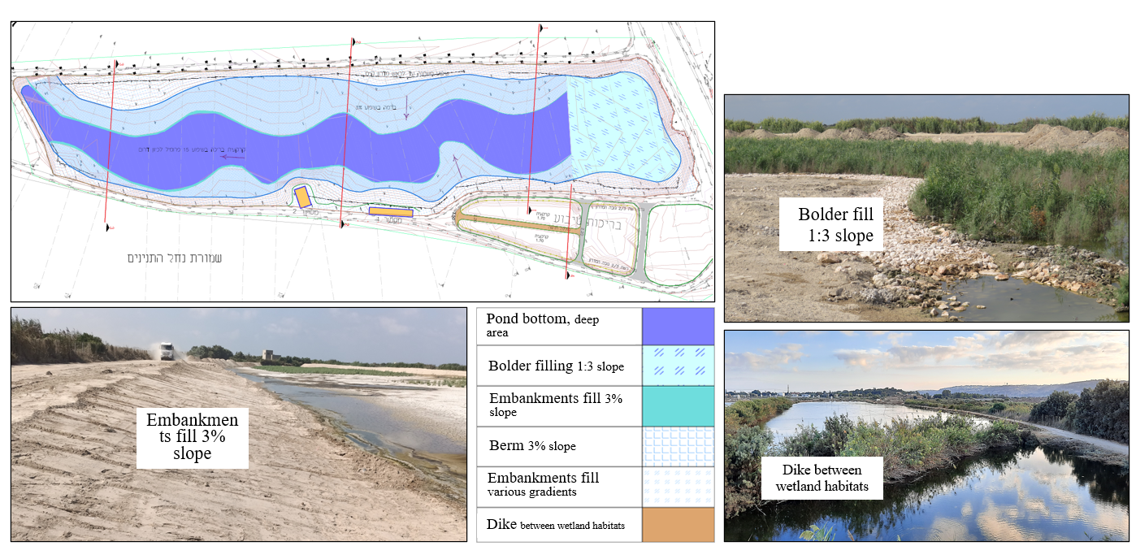

*Figure 5: Conceptual plan – Planned complexity of the pond infrastructure and physiographic shape*

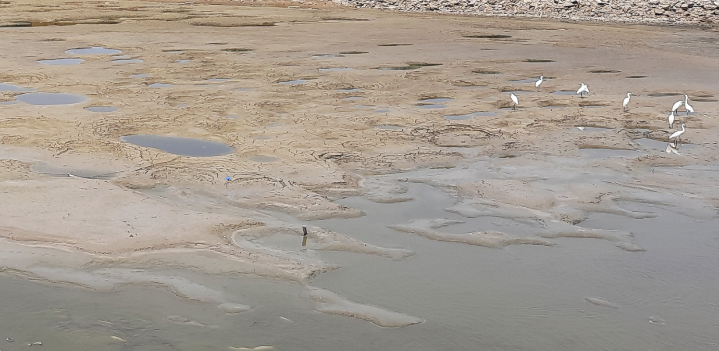

*Image 3: Egrets at the ponds, Sept. 2022*

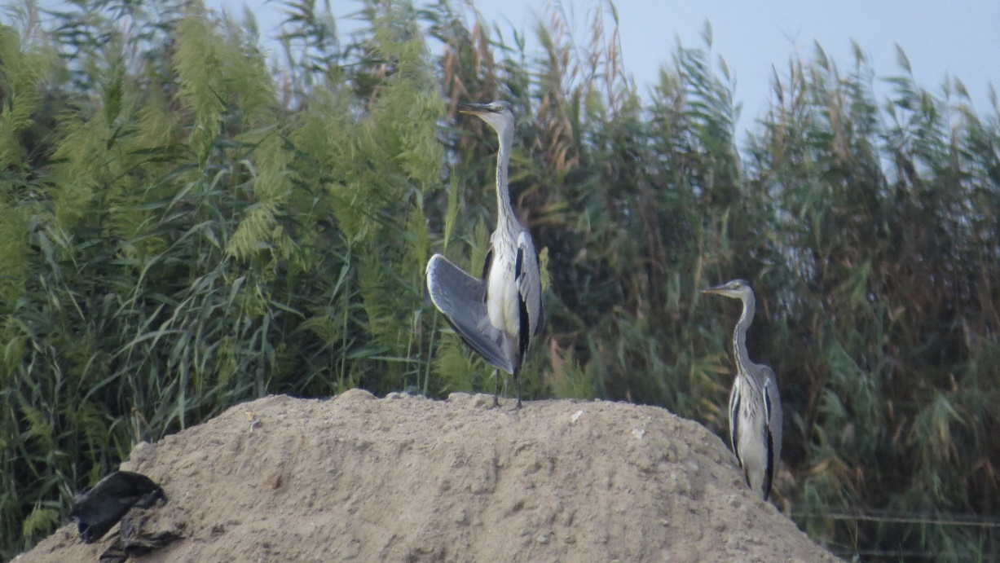

*Image 4: Gray herons at the ponds, Sept. 2022*

