Attached is a summary report for 2020 – Mobileye/Matan:

**Summary**

* Launch of the “Make a Difference” project – began on May 12, 2020 and continued through November 20, 2020.
* Intel transferred $250,000: $13,100 was transferred for operations/donations to Matan.
* Mobileye employees donated ₪754,340 to the campaign.
* Mobileye matched donations at a rate of 1:1. All donations to the community totalled to ₪1,508,680.
* Mobileye and employee donations were transferred to approximately 445 non-profits and organizations according to the following categories (according to the report from Rivi):

Improvement of quality of life for seniors in the community,:1%

Prevention and support programs for teenagers: 1%

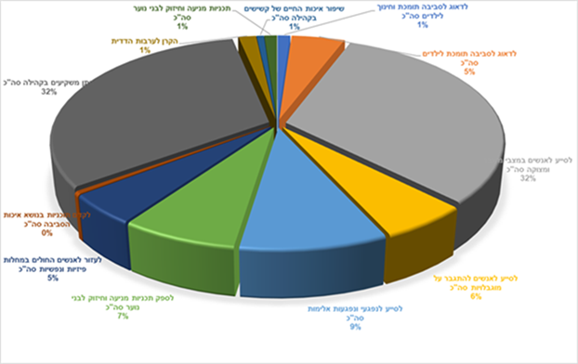

Investing in the community: 32%

Assisting people in need: 32%

Mutual aid fund:: 1%

Supportive environment and children’s education: 1%

Supportive environment for children: 5%

Assisting people in overcoming disabilities: 6%

Promoting projects dealing with the environment: 0%

Providing prevention and support programs for teenagers: 7%

Assisting victims of violence: 9%

Helping people with physical and mental illnesses: 5%

**Mobileye:**

Employees received an email with a document describing the standards and a document of FAQs, which were approved by the legal department.

* Employees could donate to any non-profit in Israel – “recognized organizations” with a Certificate of Good Governance, according to the standards.
* Employees could submit the [donation form](https://landing.matanisrael.org.il/%d7%98%d7%95%d7%a4%d7%a1-%d7%aa%d7%a8%d7%95%d7%9e%d7%94-%d7%9e%d7%95%d7%91%d7%99%d7%99%d7%9c%d7%99/) to Matan between the launch date and November 19, 2020.
* The donation could be processed as a one-time payment, or through installments until November 19, 2020.
* Donations were limited to ₪35,000. It was possible to donate a monthly sum deducted from the employees’ net monthly salary.
* It was possible to donate an amount higher than the employees’ net monthly salary by dividing it into five payments.
* Employees who wanted to be identified by the non-profit that they donated do could request to do so, and Matan reported the identities of those employees to the non-profit.
* The donation amount was deducted from the employee’s net salary and collectively transferred to Matan each month.
* Employees received a tax credit, according to Israeli law, in their December salaries.

**Matan**:

* After receiving the registration form from the employee, Matan confirmed with the non-profit that they met the criteria of the regulatory standards.
* Matan transferred employee donations to the organizations that met the program conditions in collective payments, three times during the year, in January, May, and September. Every four months, the non-profit received all of the donations from employees that had been collected during the previous four months.
* A matching donation from Mobileye was transferred following completion of the project at the end of the year.