**Special Appendix to the Report: Impact of the Swords of Iron War on Food Waste in the Agricultural Sector**

**July 2024**

# Impact of the Swords of Iron War on Food Waste and Rescue in the Israeli Agricultural Sector – Special Report

**Food insecurity has deteriorated due to the Swords of Iron War.**

Since 2015, Leket Israel and BDO, in collaboration with the Ministry of Environmental Protection and the Ministry of Health, have published an annual National Report on Food Waste and Rescue. This year, for the first time and following the Swords of Iron, an interim Report is being published highlighting the consequences of the war. These include an increase in food waste in the agricultural sector, rising food insecurity, and the need to strengthen local agriculture and food rescue to bolster national resilience.

The Swords of Iron War has exacerbated the problem of food waste in Israel and impacted food security. The additional cost of this loss to the national economy in the first six months of the war[1] amounts to approximately NIS 1 billion. This includes food waste valued at NIS 670 million, environmental costs due to food waste of NIS 135m, and additional health costs of about NIS 210m.

The increase in food waste, resulting from restricted access to agricultural fields and a labor shortage, has affected the supply of agricultural produce, leading to a rise in fruit and vegetable prices. Together, these factors have deepened the impact on food security. Additionally, the extent of food waste has likely increased in other segments of the food system as a result of the war, e.g. due to factory shutdowns, increased food stockpiling by consumers, transportation challenges, and similar issues, however these were not examined in this Report.

This Report describes the key processes that have exacerbated food waste and food insecurity in Israel during the Swords of Iron War. Here are the main findings:

1. **Loss of Agricultural Produce**

* Approximately 30% of Israel’s agricultural areas are located in the front-line zones of the conflict.
* As a result of the war, the agricultural workforce (consisting of foreign workers and Palestinians) decreased by about 38%.
* The result is increased food waste rates in the agricultural sector to a level of 22% in the first six months of the war compared to a pre-war rate of 9%.[2]
* In other words, the Swords of Iron War has led to an additional loss of 150,000 tons of agricultural produce[3] in the first half-year of the war, valued at approximately NIS 670m.

1. **Food Rescue**

* The impact on agricultural food waste was mitigated thanks to volunteers, who facilitated the harvesting of agricultural produce and helped prevent its waste.
* During the first six months of the war, over 600,000 volunteer days led to over 35,000 tons of produce being harvested, valued at approximately NIS 160m.
* The volunteers’ rescue efforts reduced food waste during this period from 25% to 22%.

1. **Food Insecurity**

* The decrease in the volume of local agricultural produce led to increased imports and reduced exports. However, there was still a 7% decrease in the volume of agricultural produce marketed in Israel[4] during the war.
* The shortage of agricultural produce led to a 14% increase in vegetable prices and an 8% increase in fruit prices.
* As a consequence, food insecurity was exacerbated due to decreased consumption of healthy foods, especially impacting vulnerable populations who are more severely affected by price hikes.

1. **Environmental Impact**

* The environmental cost of food waste in the agricultural sector during the war stands at approximately NIS 135m, resulting from lost land and water resources, greenhouse gas emissions, air pollutants, and waste management costs.

1. **Health Impact**

* Due to worsening food insecurity, we estimate additional annual health expenditures in Israel at approximately NIS 210m.

The current situation, resulting from the war and marked by instability in the local agricultural food supply, rising prices, and worsening food insecurity, highlights the critical importance of local Israeli agriculture for the state’s resilience and survival. The government’s import policy has proven inadequate in addressing the rising prices and produce shortages caused by the crisis. Importing agricultural produce, even under normal circumstances, is evidently insufficient for ensuring food security and carries inherent risks.

Nine months into the war, the economic reality has deteriorated, with an increase in the number of people experiencing food insecurity, a deepening of existing food insecurity, and a rise in food waste. This situation highlights the urgent need for food rescue policies and effective distribution of rescued food to vulnerable populations to support them during crises as well.

## Loss of Agricultural Produce

### Agricultural Produce in the Tkuma Region and the Conflict Zone along the Northern Border

In Israel, there are over 2.5 million dunams of agricultural land used for growing vegetables, fruit, and field crops. More than 30% of Israel’s agricultural areas are located in the front-line zones of the war,[5] with approximately 22% in the Tkuma Region (Gaza Envelope)[6] and about 10% in the northern border areas,[7] including 7% in the Galilee and 3% in the Golan Heights.

**Agricultural areas in the front-line zones of the war, in thousands of dunams**

|  |  |  |  |  |  |  |  |
| --- | --- | --- | --- | --- | --- | --- | --- |
| Total national area | Percent of national area | Northern Border | | | Percent of national area | Tkuma Region |  |
| **Total** | **Golan Heights** | **Galilee** |
| 1,172 | 7% | 78 | 22 | 56 | 25% | 295 | **Wheat and grains** |
| 684 | 21% | 142 | 45 | 97 | 10% | 65 | **Fruit** |
| 703 | 3% | 24 | 7 | 17 | 30% | 214 | **Vegetables** |
| 2,559 | **10%** | **244** | **73** | **170** | **22%** | **574** | **Total** |

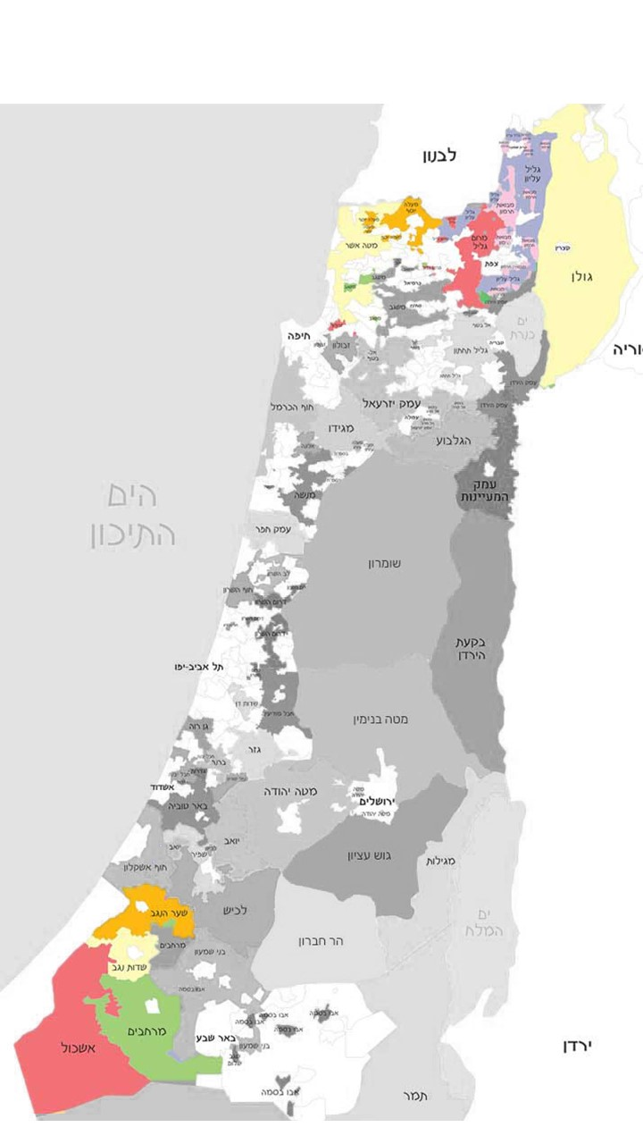**Infographic map of agricultural lands in the war zones including percentages relative to Israel’s total agricultural land area**

**Additional areas**

**68% of agricultural lands in Israel**

**Additional loss of 30,000 tons**

**Tkuma Region**

**22% of agricultural lands in Israel**

**Additional loss of 85,000 tons**

**Northern border**

**10% of agricultural lands in Israel**

**Additional loss of 35,000 tons**

Approximately 60% of Israel’s potato fields, 50% of its tomato fields, and 40% of its carrot and cabbage cultivation areas are located in the Tkuma Region, also known as Israel’s breadbasket. In addition, about 60% of Israel’s apple orchards and over 35% of its peach orchards are located in the war zone along the northern border, which also serves as a major production area for eggs and turkey meat.

|  |  |
| --- | --- |
| **% Agricultural Produce in the Tkuma Region Relative to the Total Country** | **% Agricultural Produce in the War Zone Relative to the Total Country** |

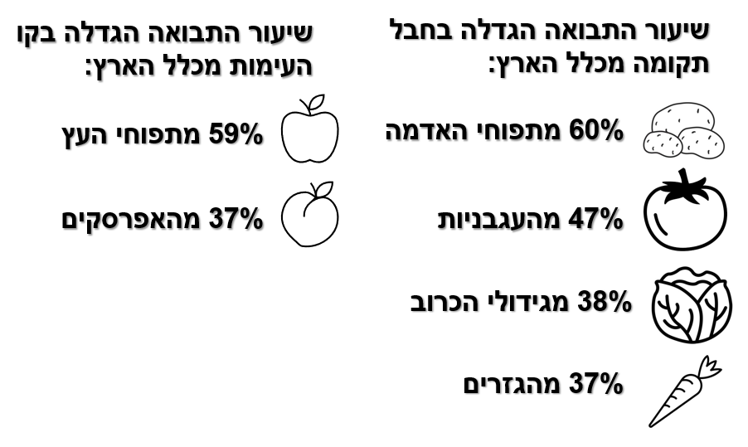

[Translation – top to bottom, left to right: of potato crops, of tomato crops, of cabbage crops, of carrot crops, of apple crops, of peach crops]

Source: CBS, Economic Impacts of the Swords of Iron War on the Agricultural Sector

### Changes in the Agricultural Workforce Due to the War

Before the war, Israel’s agricultural sector employed 51,000 workers, comprising foreign workers (primarily Thai) and Palestinians. The onset of the war led to an immediate and substantial reduction of about 30,000 workers, representing roughly 60% of the non-Israeli agricultural workforce prior to the conflict. These numbers included approximately 10,000 foreign workers who left the country and about 20,000 Palestinian workers who were barred from entry,[8] with the abrupt workforce loss severely affecting farmers and agriculture.

Six months into the war, the number of non-Israeli workers in the sector had decreased by around 40% compared to pre-war levels, primarily due to the entry ban on Palestinian workers, despite a 10% increase in the number of foreign workers compared to their pre-war numbers.

**Scope of foreign and Palestinian workers in Israeli agriculture, in thousands**

[Translation – left to right, top to bottom: Pre-war Oct. 2023 Nov. 2023 Dec. 2023 Jan. 2024 Feb. 2024 Mar. 2024 Palestinians Foreign workers]

Source: BDO analysis of data from the Ministry of Agriculture

### Food Rescue: Volunteerism as a Means of Reducing Food Loss

Following the war, Israeli agriculture faced a significant labor crisis, with the shortage of skilled labor leading to increased food waste. However, volunteers helped to reduce the extent of agricultural food waste from 25% to 22%.

Immediately after the outbreak of the war, tens of thousands of volunteers arrived to assist farmers and harvest the crops that had accumulated in the fields.

At the time, the Ministry of Agriculture estimated a daily need for 11,000 volunteers and allocated NIS 50 million to support these efforts. This funding covered transportation, food, and lodging for volunteers through about 20 organizations, including Leket Israel, Brothers in Arms, the Kibbutz Movement, Kadima, Ein Prat, and others. Additional initiatives to boost volunteerism included a collaboration between the Ministry of Agriculture and Ministry of Education, which mobilized high school students for agricultural volunteering. The IDF Education Corps also contributed by deploying around 500 non-combat soldiers daily for agricultural work in central and southern Israel. Furthermore, a partnership with the Ministry of Settlements and National Missions involved the National Service program, yeshiva students, religious girls' schools, and pre-military academies in agricultural activities. The Ministry of Environmental Protection also supported wartime food rescue with a NIS 1m grant.

**The hundreds of thousands of volunteers who participated in food rescue efforts during the first six months of the war helped compensate for the lack of labor. Approximately 600,000 days of volunteering, equivalent to around 3,000 daily agricultural workers, harvested over 36,000 tons of agricultural produce and rescued food valued at NIS 160m. However, substituting skilled labor with unskilled volunteers did not prevent a reduction in agricultural production.[9]**

Without the volunteers, the additional cost of food waste to the national economy resulting from the first six months of the war would have been about NIS 1.12b. This includes NIS 690m in food waste, NIS 165m in environmental costs due to food waste, and an additional NIS 260m in health costs.

### Agricultural Produce Losses Due to the War

The average monthly volume of locally marketed agricultural produce[10] is approximately 175,000 tons. [11] This Report reveals that food waste in Israel’s agricultural sector has risen to 22%, up from 9% before the war.

**Additional decrease[12] in agricultural produce during the war**

Source: BDO analysis of data from the CBS and Ministry of Agriculture

An examination of the increase in losses for major crops in the Tkuma Region and the northern border conflict zone reveals that the rate of additional waste due to the war is higher than the average, reaching approximately 18%.[13] Specifically, the war resulted in about 30% loss for potatoes and carrots, 23% for tomatoes and apples, 19% for cabbage, and 13% for cucumbers.

**Additional decrease in agricultural produce during the war, selected crops**

The first six months of the war can be divided into two periods, each with distinct characteristics that affected the extent of additional food waste[14]:

**October to December 2023** was marked by the initial shock, military closure of agricultural areas, and the departure of foreign workers, which led to food waste levels in the agricultural sector exceeding 27%.

**January to March 2024** was marked by the return of foreign workers to Israel and the arrival of new workers, rejuvenated agricultural operations in previously abandoned areas, food rescue initiatives, and the Ministry of Agriculture’s interventions. The latter included the repurposing of agricultural buildings for crops whose production was disrupted and the restoration of greenhouses and net houses damaged across the country, particularly those producing "Israeli salad" vegetables. All of these led to a reduction in waste levels, which stabilized at approximately 18%. Consequently, the average food waste rate in the agricultural sector during the first six months of the war stood at about 22%.

The table below shows the impact on agricultural production during the months of the war, based on the reduction in the agricultural workforce.

**Impact of the war on agricultural produce, kilotons per month**

|  |  |  |  |  |  |  |  |
| --- | --- | --- | --- | --- | --- | --- | --- |
|  | **October 2023** | **November 2023** | **December 2023** | **January 2024** | **February 2024** | **March 2024** | **Average for the period** |
| Agricultural areas in conflict zones | **32%** | **32%** | **32%** | **32%** | **32%** | **32%** | **32%** |
| Reduction in agricultural workforce | **-63%** | **59%-** | **-55%** | **-50%** | **-44%** | **-38%** | **-51%** |
| Loss of agricultural produce resulting from the war, in kilotons | **19.0** | **39.6** | **36.0** | **-** | **26.5** | **31.6** | **25.2** |
| Rate of additional waste relative to total agricultural production | **9%** | **21%** | **15%** | **-** | **15%** | **14%** | **12%** |

**The first six months of the war, from October 2023 to March 2024, led to additional waste of approximately 150,000 tons in Israeli agriculture, valued at approximately NIS 670m.** The environmental cost of this additional food waste is estimated at about NIS 135m, resulting from lost land and water resources, greenhouse gas emissions, air pollutants, and waste management costs.

## Food Insecurity

### Impact of the War on the Volume of Marketed Agricultural Produce

To compensate for the shortage of agricultural produce resulting from the war, food imports increased while exports decreased. However, the imports did not bridge the gap in local production, leading to a reduction in the supply of fruit and vegetables alongside rising prices.

**Agricultural Produce Imports during the Swords of Iron War**

To address the shortage, Israel significantly increased its imports of agricultural produce. In the first six months of the war, over 170,000 tons of fresh produce were imported - more than double the volume imported during the same period in previous years.

The primary suppliers during the war were Turkey, Jordan, and the Netherlands. Turkey became a major source for tomatoes and onions, at one point accounting for approximately 46% of the tomatoes and about 26% of the onions imported into Israel. However, in early May 2024, Turkey ceased all trade with Israel, forcing Israel to seek alternative import sources.

**Onion and tomato imports from Turkey during the war, in tons**

[Translation, left to right, top to bottom:   
October November December January February March April May Onions Tomatoes]

Source: BDO analysis of data from the Ministry of Agriculture

**Tomato import rates from Turkey and other countries alongside changes in tomato prices in Israel**

[Translation, left to right, top to bottom:   
October November December January February March April May  
Tomatoes from Turkey Tomatoes from other countries Average price of tomatoes]

Source: BDO analysis of data from the Ministry of Agriculture and the CBS

Thus, it is evident that relying on agricultural imports, even in routine times, is an inadequate strategy for ensuring food security and can even pose risks. The current situation, marked by instability in local food supply resulting from the war, underscores the importance of local Israeli agriculture for the nation’s resilience and survival.

**Agricultural Produce Marketed[15] and Consumed in Israel during the War**

Despite the increase in import volumes and the reduction in export volumes, the amount of produce marketed and consumed in Israel during the first six months of the war was about 7% lower compared to the same period in previous years. An analysis of market supply shows that the shortage peaked in November-December, with a supply decrease of approximately 18% that later improved. However, as of March 2024, produce supply stands at about 14% lower compared to the corresponding months in previous years.

**Average monthly decrease in agricultural produce marketed in Israel during the war**Kilotons per month

[Translation, left to right: Pre-war During the war]

Source: BDO analysis of data from the Ministry of Agriculture and the CBS

Importantly, the prohibition on entering agricultural areas in combat zones prevents the use of these sites for future growing cycles. This could lead to a further reduction in the volume of marketed local produce and a subsequent rise in prices.

### Impact of the War on Fruit and Vegetable Prices

Measures such as replacing local production with imports and reducing exports did not resolve the shortage of agricultural produce, which led to a sharp increase in prices during the war. Due to immediate produce shortages, fruit and vegetable prices soared in the initial months of the war, with this trend continuing as the war continued.

**Rate of change in agricultural produce prices**

|  |  |  |
| --- | --- | --- |
| Q1 2024 compared to Q1 2023 | **Q4 2023 compared to Q4 2022** |  |
| 40% | 27% | Potatoes |
| 35% | 42% | Onions |
| 22% | 26% | Carrots |

Source: BDO analysis of data from the CBS, the consumer price index, and average prices of selected consumer goods and services

In the last quarter of 2023, the fruit and vegetables index rose by approximately 10% compared to the corresponding period in the previous year. The vegetable price index increased by more than 14%, while the fruit price index rose by about 8%. In the first quarter of 2024, the fruit and vegetables index continued to climb, rising by about 13% compared to the same period last year. The vegetable price index increased by about 18%, while the fruit price index rose by about 12%.

**Rate of change in food price indices**

|  |  |  |
| --- | --- | --- |
| Q1 2024 compared to Q1 2023 | **Q4 2023 compared to Q4 2022** |  |
| 17.7% | 14.1% | Vegetable price index |
| 12.1% | 7.9% | Fruit price index |
| 13.1% | 10.2% | Fruit and vegetable price index |
| 3.3% | 4.1% | Food price index excluding fruits and vegetables |

Source: BDO analysis of data from the CBS and the consumer price index, by primary and secondary consumption groups

**Fruit and vegetable prices increased four times more than other food products, which saw a rise of about 3%. This sharp increase has led to reduced consumption of fruits and vegetables and diminished food security.**

### The War’s Impact on Food Security and Public Health

In our estimation, the impact on the volume of marketed agricultural produce, the rise in food prices - especially for fruit and vegetables - and the broader economic effects have exacerbated food insecurity among vulnerable populations and increased the number of people in need of food.[16]

During this period, fruit and vegetable prices rose by about 13%, while their consumption decreased by about 7%, suggesting that the population likely turned to cheaper and less nutritious food alternatives. We also estimate that stress-related conditions leading to poor mental health are an additional factor affecting the reduction in healthy food consumption, although this issue has not been investigated or discussed in this special appendix.

The Food Waste and Rescue Report as well as the National Insurance Institute’s Poverty and Inequality Report show a positive correlation between economic status and access to healthy food.[17] Hence it is likely that the reduction in fruit and vegetable consumption resulting from the war is particularly pronounced among disadvantaged populations who are unable to cope with the rising prices and are forced to turn to less healthy alternatives.

According to the CBS, food expenditure in the first quarter of 2024 increased by 3.4% compared to the corresponding period last year. During this period, Israel’s population grew by about 2%. As a result, the effective increase in food expenditure per capita was 1.4%, and as food prices rose by more than 1.4% during this period, this implies a decrease in the per capita volume of food purchased.

Last year, the amount of food required to bridge the gap between the actual consumption by the population facing nutritional insecurity and the normative consumption level (average consumption among the second to fifth deciles) was estimated at about NIS 3.6b. During the war, the reduction in food purchases, particularly fruit and vegetables, **widened this consumption gap by approximately 8%,** rising from NIS 3.6b to nearly NIS 4b per annum. **This represents an additional 1.5% of households in Israel experiencing nutritional insecurity.**

Moreover, as presented in the 2022 Food Waste and Rescue Report, the decrease in fruit and vegetable consumption and their replacement with nutritionally inferior food products have health implications. Leket Israel’s previous Report estimated that health expenditures in Israel due to nutritional insecurity amounted to NIS 5.2b last year.

In light of this, the additional 1.5% increase in food insecurity in Israel due to the war is expected to result in increased health expenditures of NIS 420m annually, corresponding to an additional NIS 210m for the first six months of the war.

## Conclusions and Recommendations

Food security is a fundamental component of national resilience. Recent experience has demonstrated that war-related damage to the agricultural sector resulted in decreased food security and consequently weakened national resilience.

Israel’s independence in terms of food security is critical for strengthening national resilience, further underscored by the reorientation and renaming of the Ministry of Agriculture to the “Ministry of Agriculture and Food Security.”

In light of climate change, geopolitical crises, and emergencies that may disrupt supply chains, impacting food security and national resilience, and due to the crisis faced by the agricultural sector during the war, the Ministry of Agriculture is currently working to “*reverse the trend - from relying on imports to focusing on local production, driven by a strong commitment to ensuring the food security of Israeli citizens and reducing dependence on foreign countries.”*[18]

1. **Damage to Agriculture: Impact on the Cost of Living and Food Security**

The Swords of Iron War doubled food waste in the agricultural sector. Produce valued at NIS 670m was lost due to labor shortages and restricted access to agricultural lands.

Despite reduced exports and increased imports, excess demand caused fruit and vegetable prices to rise by approximately 13%. Experience has clearly demonstrated that imports do not provide a sufficient alternative for ensuring food security or preventing shortages and price rises.

The price rises primarily affect disadvantaged populations and have led to a 1.5% increase in food insecurity as well as health-related damage estimated at about NIS 210m.

1. **The Importance of Food Rescue Volunteerism during the War**

The war has highlighted the importance of food rescue as a means for expanding food reserves and ensuring food security during both times of routine and crises. Volunteer activities throughout the war helped partially compensate for the shortage of labor. With 600,000 days of volunteering, equivalent to about 3,000 full-time agricultural positions, volunteers rescued food valued at NIS 160m and reduced food loss in the agricultural sector from 25% to 22%.

1. **Emergency Preparedness: Mobilizing Large Numbers of Volunteers Quickly**

Over 30% of the agricultural workforce[19] is currently still absent, underscoring the need to sustain support channels for agricultural volunteers.

During the COVID-19 pandemic, restrictions on the entry of foreign and Palestinian workers into Israel, coupled with quarantines and infections, led to significant labor shortages in the sector. This situation prompted the Ministry of Agriculture to fund agricultural volunteer activities. Given the conditions of the Israeli market, it is essential to plan for labor shortages and disruptions to food supply security.

The agricultural sector is unique due to its crucial role in ensuring the population’s food security and its inherent inflexibility in managing delays caused by labor shortages. To enhance national resilience, the state needs to develop an emergency preparedness plan that allows large numbers of volunteers to be mobilized with short notice. Expanding the agricultural labor base by establishing a civilian reserve force for agricultural volunteers would facilitate the acquisition of essential skills for regular agricultural work and enable their deployment as an alternative labor force during emergencies.

1. **Strengthening Agriculture and the Importance of Exports**

This Report indicates that during the crisis, reducing the volume of exports increased the availability of agricultural produce for the local market. Therefore, it is clear that agricultural exports during routine times enhance national resilience in emergencies. In light of this, as part of the recovery efforts, it is crucial not only to restore previous levels of agricultural production for the local market but also to develop a plan to boost agricultural exports, as exports strengthen the ability to maintain a steady supply to the local market during crises. To achieve this, support for agriculture should be expanded to enhance production rather than relying on increased imports.

1. From October 2023 to March 2024.
2. ?
3. Fruit and vegetables
4. “Marketed agricultural produce” refers to produce sold in retail chains, markets, small shops, greengrocers, and so on; “consumed agricultural produce” refers to the agricultural produce that Israel’s population consumes/eats.
5. According to data from the Central Bureau of Statistics (CBS) - Economic Implications of the Swords of Iron War on the Agricultural Sector.
6. Referring to the size of agricultural fields in regional councils in the Gaza Envelope, which include the Ashkelon Coast, Sha’ar HaNegev, Sdot Negev, Eshkol, and Merhavim.
7. Referring to the size of agricultural lands in regional councils along the northern border, which include the Upper Galilee, Mevo’ot HaHermon, Mateh Asher, Ma’ale Yosef, Merom HaGalil, and the Golan Heights.
8. Based on data from the Ministry of Agriculture.
9. Any volunteering done on a given day is considered a full day, and every volunteer is registered separately.
10. Fruit and vegetables.
11. BDO analysis of data from the CBS - Quarterly Agricultural Statistics for October-March 2019-2024, Ministry of Agriculture, Economic Overview of the Agriculture Sector in Israel.
12. Decrease in agricultural produce during and resulting from the war in addition to the food waste rate in the agricultural sector in routine times.
13. BDO analysis of data from the CBS.
14. BDO analysis of data from the CBS - Quarterly Agricultural Statistics for October-March 2019-2024
15. Local agricultural produce minus exports plus imports.
16. According to the definitions of the World Health Organization and the UN, which also serve to guide Israel’s National Insurance Institute, food security is achieved when the flowing four criteria are met:

    a. Availability: Food must be physically available, meaning a regular supply of safe and nutritious food must be ensured at the national level, in sufficient quantity and quality to support proper growth, development, and an active, healthy lifestyle;

    b. Accessibility: Food must be accessible at the household level, meaning households should have adequate resources to obtain sufficient food;

    c. Consumption: Food consumption should involve nutritional diversity and appropriate eating habits at the individual level, including maintaining proper sanitation, water access, and awareness about appropriate food use; and

    d. Stability: Access to food must be stable across all levels, ensuring consistency in availability, accessibility, and consumption over time.
17. See the National Insurance Institute Report on Poverty and Income Inequality for 2022.
18. <https://www.gov.il/he/pages/agriministrynationalplanfoodsecurity>
19. Non-Israelis.