SOCIAL JUSTICE DOMAIN
STRATEGIES
Safeguarding Civil Society and Activists: The Civil Society Protection Hub | Advancing Religious Freedom and Fighting Religious Extremism |  | Combating Crime & Violence in Palestinian Israeli Society | Strengthening Anti-Racism Initiatives & Organizations | Fighting the Occupation |  | Promoting Shared Society
Advancing Equity in Land, Planning & Housing |  | Strengthening Gender Equality NGOs |  | Safeguarding Human & Civil Rights |  | Strengthening Palestinian-Israeli Society
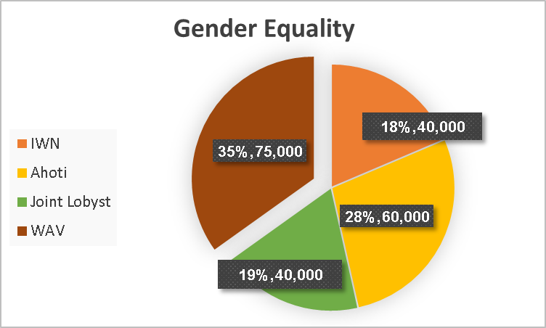
The organization was established in: 1993
NIF Funding Type | Past Years of Support
General Support | 1993–2006; 2017–2022
Project Support | 2007–2015
DA Support (in 2022): $5,168
Rapid Response Support (2023): $29,000
Link to Organizational Website: https://www.wavo.org/en
Link to Proposal: https://nif.my.site.com/Portal/a0NAb000000Q5mk?btdid=00120000018gJiN
Link to Interim Reports: https://nif.my.site.com/Portal/a0N3X000019mvry?srPos=5&srKp=a0N
INTRODUCTION
The overall current expected impact of the program as a strategy for advancing NIF’s overall mission of a just and democratic Israel:
Especially in the current reality with the most anti-feminist government in Israel’s history, and as a mandatory component of any just society, gender equality will be advanced and anti-feminist forces thwarted in measurable ways, through the widening of public knowledge and dialogue and the strengthening of activists and organizations working with wider and more diverse (especially disenfranchised) populations, including ultra-Orthodox, Palestinians, Mizrachi.
The grantee uses strategies of: Public education and consciousness raising, leadership and activism development; advocacy campaigns; networking. WAV also operates shelters for women who are victims of violence.
These are the goal(s) of the organization/project and then some expected relevant benchmark outcomes on the way to achieving the goals.
WAV’s goals include advancing the rights of Palestinian women, expanding their influence on centers of power, and eliminating gender-based violence.
Interim benchmark outcomes on the way to achieving these overall goals include:
- Promoting educational programs for teenagers and young adults, in schools and elsewhere, on issues linked with the status of women, domestic abuse, women’s rights, coping with violence against women, and so on.
- Improving the skills of professionals in various fields, including social workers, educators, journalists, and local authority department heads in matters related to violence against women, preventing sexual harassment, ways of dealing with these. Etc.
- Developing young leadership that is more deeply involved and politically active
- Upgrading skills and capacities to advance the campaign to prevent violence against Arab women
- Raising awareness and encouraging action in the campaign to prevent violence against Arab women
- Increasing national and local decision-makers’ motivations to enlist in the campaign to prevent violence against Arab women
- Quantitative and qualitative improvement in collaboration between Jewish and Palestinian civil society organizations and activists in the campaign to prevent violence against Arab women
Main Indicators for the grant include (among others, the total list of indicators and targets can be found in the Salesforce):
- The number and quality of educational programs for young people in schools and elsewhere
- The number and quality of training programs
- The number and caliber of participants in these programs who are women with disabilities
- The number of views, comments, and shares of the organization’s social network and media campaigns
- The number of young people who take part in the political education programs and go on to become political activists themselves
- The number and quality of meetings with national and local decision-makers who enlist in the campaign to prevent violence against Arab women
- The number of civil society organizations and Jewish and Arab activists who are involved in the network of organizations that WAV promotes and the caliber of their involvement in the campaign
Added value of this grant (for the project and in general) include that:
WAV is the main Palestinian organization (among the very few) that is engaged in advocacy about violence against women on the national level. The organization plays a key role in the inclusion of the issues of violence and crime against Palestinian women in the government committees and discussions.

Additionally, the organization plays a key role in addressing two significant challenges facing the Palestinian community in Israel. First, in response to the rise in crime and violence in the Arab community, the organization is a central player in the roundtable against crime and violence. This is in coordination with the local authorities committee and Shatil, where it amplifies feminist voices regarding crime and violence against Palestinian women in Israel. Second, in light of the silencing and persecution of Palestinians in Israel as a result of comments made after October 7, the organization plays a major role in providing legal support and guidance in the face of this silencing.
For organizations receiving support 5 or more years) Significant PAST achievements - relevant to this program or not - of the grantee since NIF began support include:
- During the pandemic, WAV developed a Chat service to provide an alternative way for women to access the crisis-center services without actually calling. This avenue increased anonymity and thereby life-changing engagement.
- In May 2023, 19 Palestinian social workers who could not find jobs in the profession because their degrees were from non-Israeli colleges, graduated from the University of Haifa University through a pilot program founded by WAV and coordinated with the “Genda” College.
- The International Women’s Day 2023 Campaign, screened in 22 Arab localities and in Tel Aviv, raised a voice against the current Government and its odious policy towards women and advanced the critical message that “Women Rights are not a Game, Occupation = Violation.”
- WAV surveyed 15 municipal plans for preventing violence against women. Through the process, municipal leaders engaged with one another and WAV staff, resulting in new relationships and ongoing networking opportunities. The next stage of the work included one-on-one consultation with the local authorities by Ms. Shahira Shalaby (previously of Shatil), who helped each community draft its own violence prevention workplans. As of today almost all these plans have been completed.
- On November 25, 2021, as part of the International Day to Prevent Violence Against Women, WAV held a public consciousness-raising campaign under the slogan Bekafi (“Enough” in Arabic). The event included artistic expressions opposed to violence against women, data, and messages, and included the publication of names of women who recently lost their lives to violence.
- As a member organization of the Personal Status Committee, WAV directed a play based on the research of polygamy in the Arab community in Israel. The play was presented at three main events in the community to raise awareness of this phenomenon. In addition, the project, in cooperation with the Hebrew University, ran a large conference on personal status issues in Israel, with the participation of law students.
PROGRESS
Overall Progress Evaluation: Fully Met Expectations
Explanation re Score:
Despite the many challenges faced by Palestinian society in Israel since October 7, the organization successfully met its goals for 2023. It continued to position itself as the leading national actor in the campaign to prevent violence against Palestinian women in Israel, both by providing individual support as well as promoting policies and engaging with authorities. The organization works effectively within local authorities and implements programs targeting young people, with the goal of influencing the agenda within Palestinian society in Israel. Further, it has successfully initiated long-term processes to change societal attitudes toward women in the Palestinian community.
The organization adapted extremely well after October 7 to the challenges that emerged. It provided legal protection and advice regarding the silencing within Palestinian society in Israel, in addition to offering support to Palestinians who had been evacuated from northern Israel.

Main Progress in 2022/2023:
Outcomes:
- Working with local authorities to prevent sexual harassment in the workplace: WAV conducted strategic planning with 15 municipalities (out of 75) and wrote action plans for most of them, each based on the local own needs and realities.
- In December 2023, the first social enterprise for Palestinian women in a shelter for survivors of violence was opened. The social enterprise, a laundry service in collaboration with the Fauzi Hotel, enables women living in the shelter to earn a living. It is the result of extensive efforts by WAV, starting in 2005, to find a suitable model for creating social enterprises for survivors of violence in shelters.
- WAV supported the professional team from Arab al-Aramshe, who were evacuated to Nazareth following the October 7 war and the attacks in the North. They provided them with resources to prevent domestic violence and gender-based violence during their stay in the hotel.

Outputs:
- Crisis Center: despite a drop in inquiries since October 7, the center handled 664 cases this year (an increase of around 100 cases compared to the previous year) related to physical violence and sexual assaults. The center supported 74 women in legal proceedings with the State Prosecutor’s Office and the police, three times more than in the previous year.
- The organization delivered 92 seminars to approximately 750 teens and young people in Palestinian society in Israel on issues of gender violence, gender inequality, and feminism, with the aim of creating a feminist network of teens who are committed to gender equality in the Palestinian community in Israel.
- Training sessions were conducted for 12 women in key roles within the Palestinian community in Israel (including senior researchers in academia, and in significant roles within municipalities) to empower them as agents of change to raise awareness of the importance of advancing women in decision-making positions.
- The organization’s staff conducted six training sessions for medical and care teams on addressing sexual and gender-based violence in the Palestinian community in Israel. Among the teams that received this training were social workers at Nahariya Hospital, employees of the Nazareth Prosecutor’s Office, and maternity ward staff at Nahariya Hospital.
- WAV organized the first conference bringing together women’s organizations from Palestinian and Jewish communities in Israel since the outbreak of the war. This involved the participation of 30 representatives from feminist organizations across Israel.

Particular challenges of the organization:
The challenges faced by WAV since the outbreak of the war have been significant. They have included contending with trends of silencing within the Palestinian community, and the emergency situation in the North. This has required the development of plans for the potential evacuation of shelters in the region. To address these challenges, new staff were recruited to manage this emergency, and a psychologist was appointed to work with the organization, alongside a lawyer who could provide legal assistance. The organization, together with the Arab Society Emergency Coalition, is preparing and assessing organizational resources that will be allocated during such emergencies, particularly in the event of escalation or war in the North.
Significant partnership with Shatil: The organization cooperates with Shatil and takes part in its various training programs and campaigns.
2022 Organizational Income: $880,000 (not including the budget of the shelters for battered women, which are funded by the Welfare Ministry)
2023 Expected Organizational Budget: $824,000(not including the budget of the shelters).
2023 RECOMMENDATION
2022 Grant: $50,000
2023 Staff Recommendation: $75,000
% of NIF Grant out of Total Organizational Budget: 9%

Explain Staff Recommendation:
Women Against Violence is the only Palestinian organization in Israel that focuses on a countrywide campaign to prevent crime and violence against Palestinian women. It runs a broad array of programs, as described above, and manages to reach and influence thousands of people each year. It is also NIF’s only Palestinian grantee that focuses on the campaign to prevent crime and violence against Palestinian women and is an anchor organization in this field.
Despite the many challenges, the organization is growing and developing long-term plans as well as new programs for 2024. These programs include the operation of a mobile support center in the Negev, in partnership with Itach-Ma’aki, for unrecognized villages, and research on how the media addresses the issue of gender-based violence in the Palestinian community in Israel.
Recommendation of Board/Grants Committee 2023:

