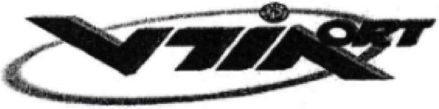

ORT COMPREHENSIVE SCHOOL AND COLLEGE  
KIRYAT BIALIK 27101 P.O.B. 137 ISRAEL

Tel: 04-8462222 Fax: 04-8400926

Ort comprehensive school and college – Kiriat Bialik

January 2nd, 2024

Certificate of confirmation

Student: Merily Batito

ID no.: 039063680

Studied at our educational institution during the academic school year of 2000.

Program: Executive and Secretarial Studies

Track: Matriculation

She completed 12 years of study in the year 2000.

This certificate of confirmation was given at the student’s request.

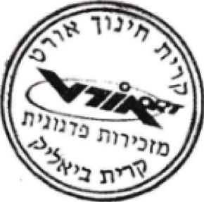Sincerely,

Elisha Lutati

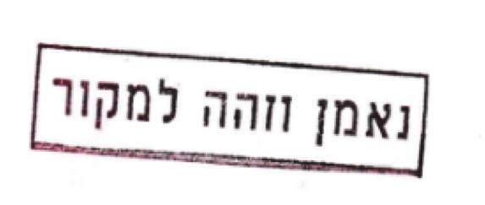Administrative manager

ת/זיוה/מ/מ/1578