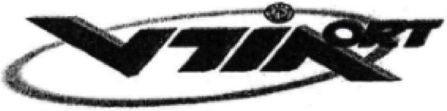

ORT COMPREHENSIVE SCHOOL AND COLLEGE  
KIRIAT BIALIK 27101 P.O.B. 137 ISRAEL

Tel: 04-8462222 Fax: 04-8400926

Ort comprehensive school and college – Kiriat Bialik

January 2nd, 2024

Certificate of confirmation

Merily Shitreet, ID no.: 039063680, studied at our educational institution during the academic school year of 2000 in the Executive and Secretarial Studies program, matriculation track.

She completed 12 years of study in the year 2000.

This certificate of confirmation was given at the student’s request.

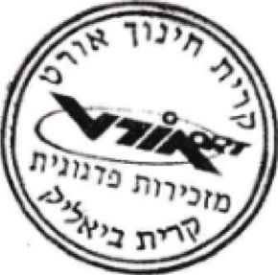Sincerely,

Elisha Lutati

Administrative manager

ת/זיוה/מ/מ/1578

This translation is true to the original.