# Fostering Understanding of Inclusion Relationships Through Mathematical Events

Aehsan Haj-Yahya 1,2, Juhaina Awawdeh Shahbari1 and Huda Shayeb1

1 Al-Qasemi Academic College of Education, Baqa-El-Gharbia, Israel; aehsanhajyahya@gmail.com

2 The Arab Academic Institute for Education, Israel

**Abstract**

This study examined the impact of analyzing mathematical events on prospective teachers’ understanding of inclusion relationships among quadrilaterals. Initially, most participants struggled to identify these relationships, relying on prototype examples rather than shape definitions. After an intervention involving mathematical event analysis, participants showed significant improvement in recognizing inclusion relationships, using geometrical definitions and critical attributes to explain their responses. This approach enhanced their ability to extend concept images to non-prototypical examples*.*

## Introduction

Inclusion relationships among geometric shapes are fundamental to advanced mathematical thinking, as outlined in van Hiele’s model (van Hiele & van Hiele-Geldov, 1958). At the third level of geometric understanding, mastery of these hierarchical connections is crucial. This comprehension serves as a gateway to higher-order reasoning, particularly in constructing geometric proofs. Without a solid grasp of inclusion relationships, students face significant barriers in progressing to more complex mathematical concepts and problem-solving techniques.

Research consistently reveals widespread difficulties in comprehending hierarchical relationships among quadrilaterals. Okazaki and Fujita’s (2007) cross-cultural study of Japanese students and Scottish teachers found shared challenges in categorizing rectangles as parallelograms and squares as rectangles or rhombuses, with subtle differences between these two populations. Zeybek’s (2018) study of pre-service math teachers in the United States initially showed similar struggles but demonstrated improvement after targeted instruction. These findings highlight the pervasive nature of these conceptual challenges across diverse groups.

Numerous studies have highlighted the significant impact of non-critical attributes in prototype examples on students’ misidentification of inclusion relationships among geometric shapes (Fujita & Jones, 2007; Okazaki & Fujita, 2007; Pickreign, 2007). These non-critical attributes, often characterized by strong visual elements, frequently override formal definitions in students’ reasoning processes. The powerful influence of visual factors is exemplified in Haj-Yahya and Hershkowitz’s (2013) unexpected finding that 10th-grade students performed better on verbal tasks than on visual ones when identifying inclusion relationships between squares. This counterintuitive result underscores the potent effect of visual cues on geometric reasoning.

In a recent study, Haj-Yahya and Hershkowitz (2024) uncovered significant challenges in geometric concept formation among 11th-grade students. Their analysis revealed that many students excessively rely on prototypical examples, a tendency that severely impedes their ability to construct proofs related to the attributes of these concepts. This finding illuminates a significant shortcoming in geometry education: students’ limited ability to extrapolate from specific instances to overarching geometric principles.

Various interventions, including dynamic geometry software and concept-mapping techniques, have been employed to enhance students’ understanding of inclusion relationships in geometry (Haj-Yahya et al., 2024; Maymon-Erez & Yerushalmy, 2007). While these approaches have shown promise, the specific impact of event analysis—a method that engages students with real-world or hypothetical scenarios to apply mathematical concepts—remains under-explored. Event analysis offers a unique opportunity to deepen students’ understanding. By providing students with contextualized scenarios, event analysis can make learning more engaging and meaningful. Additionally, it can encourage students to actively apply their understanding and justify their reasoning, fostering a deeper level of comprehension.

## Mathematical events in educational research

Mathematical events are occurrences in mathematics classrooms that present pedagogical challenges requiring teacher intervention (Markovitz, 2003). These events have become a valuable tool in teacher education and research (e.g., Shulman, 1992; Tirosh et al., 2019). Engaging with mathematical events benefits teachers’ professional development by enhancing their awareness of student thinking patterns and appropriate responses to them (Markovitz, 2003). Stockero et al. (2019) assert that these events provide opportunities to build upon students’ mathematical thinking, facilitating a deeper understanding of critical concepts.

The significance of mathematical events lies in the discourse they generate, fostering a learning community based on argumentative dialogue where students articulate reasoning, listen actively, and engage constructively with peers’ arguments (Toulmin, 2003). This study examines the impact of analyzing mathematical events on identifying and justifying inclusion relationships between various quadrilaterals.

## Methods

### Research participants and context

## This study involved 20 prospective teachers who were pursuing their teaching certification for first and second grades at a teacher training college of the Arab community in Israel. The course content was centered on four areas of geometric thinking: properties of shapes, spatial relationships, transformations and symmetry, and visualization. The research specifically focused on three sessions that emphasized inclusion relationships. The teaching and learning process throughout the course was grounded in discussions during mathematical events, highlighting various ways of thinking and addressing common errors in the selected topics. The three events, each comprising several sections, were developed based on literature and the researchers’ experience in teaching geometry (see Figure 1). One of the researchers conducted the course and was accompanied by other researchers. She presented events that encouraged participants to promote understanding of inclusion relationships. Her role was to facilitate learning and motivate students to independently promote their understanding while providing opportunities for them to explore methods of justification and engage in discussions.

### Data sources, procedures, and analyses

The data were collected from three sources. The first two were pre- and post-questionnaires, which included verbal and visual tasks related to inclusion relationships among quadrilaterals (e.g., Is a square a kite? Yes/No/Don’t know. Explain your answer). The third source was observations of class discussions, which were recorded on video and transcribed verbatim.

Initial information was collected regarding participants’ understanding through their responses to the pre-questionnaire, followed by participants’ engagement in analyzing mathematical events. Finally, the post-questionnaire was administered. The pre-questionnaire and post-questionnaire data were analyzed using thematic content analysis (Braun & Clarke, 2006). The researchers categorized the data based on frameworks provided by Haj-Yahya and Hershkowitz (2013) and additional categories that emerged during the analysis. The observations were analyzed in two stages. The first was based on Toulmin’s (2003) argumentation model, beginning with creating an argument log. This log was based on observing all discussions in the classroom and highlighting discussions whenever participants drew conclusions. These conclusions were marked, collected, and organized according to the components of the argument model: data, claim, warrant, backing, rebuttal, and qualifier.

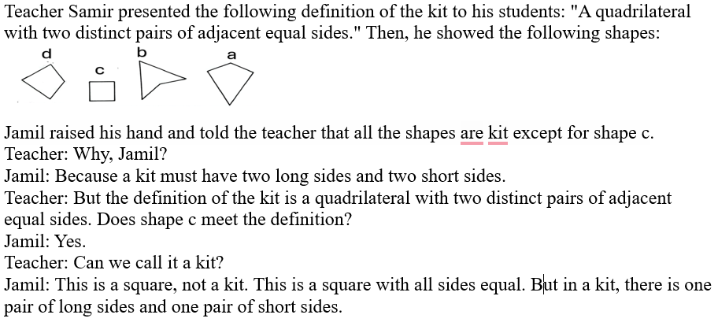

Figure 1

*The Second Mathematical Event: The Square and the Kite*

## Findings

## The findings reveal significant shifts in participants’ understanding and identification of inclusion relationships among various shapes, particularly squares, rectangles, parallelograms, and kites. This emerged through both verbal and visual tasks administered before and after engagement with mathematical events. The results demonstrate marked improvements in participants’ ability to recognize and justify inclusion relationships, moving from narrow, prototypical understandings to broader, more inclusive conceptualizations of geometric shapes. The following sections detail these changes, highlighting the specific improvements in participants’ understanding of shape hierarchies and their ability to explain them.

## The findings reveal a significant transition in participants’ understanding of inclusion relationships among shapes (see Table 1). There is a clear shift from misidentification to correct identification of these relationships, evident not only in the participants’ responses but also in their underlying reasoning. Initially, participants tended to base their judgments on non-critical attributes exclusive to prototypical examples. However, post-intervention, their reasoning evolved to reflect a more sophisticated understanding. Participants began to justify their responses based on formal definitions of the containing group, explicitly explain how one group is included within another, or demonstrate an understanding that the attributes of one shape are fully encompassed within the attributes of another shape.

Table 1

*Examples from Identification of Inclusion Relationships - the Verbal Tasks*

|  |  |  |  |  |
| --- | --- | --- | --- | --- |
| Claim | pre | | post | |
|  | Acceptance of the claim | Examples of justification | Acceptance of the claim | Examples of justification |
| The square is a rectangle. | 22.3% | A rectangle is different from a square because one pair of sides is longer than the other. | 83.3% | The attributes of a rectangle are included in the attributes of a square. |
| The rectangle is a parallelogram. | 55.5% | The rectangle has all angles equal to 90 degrees, but the parallelogram does not. | 83.4% | The rectangle has all the attributes of a parallelogram. |
| The square is a kite. | 11.1% | Kite sides are not of equal length. | 72.2% | A square is a kite with all sides of equal length. |

We found significant improvements in participants’ ability to identify non-prototypical examples such as squares as rectangles, parallelograms, or kites in the visual task, with substantial increases in correct identifications from pre-questionnaire to post-questionnaire. This trend of enhanced recognition extended to the identification of rectangles as parallelograms, mirroring the positive shifts observed in the verbal identification task and indicating a consistent improvement in participants’ understanding of shape relationships across different tasks.

Table 2

*Identification of Inclusion Relationships - the Visual Tasks*

|  |  |  |  |  |  |
| --- | --- | --- | --- | --- | --- |
| The shape | Questionnaire | Identified as a square | Identified as a rectangle | Identified as a parallelogram | Identified as a kite |
|  | Pre-questionnaire | 100% | 33.3% | 16.6% | 0 |
| Post-questionnaire | 100% | 100% | 88.8% | 94.4% |
|  | Pre-questionnaire | 44.4% | 11.1% | 0 | 5% |
| Post-questionnaire | 100% | 100% | 77% | 88.8% |
|  | Pre-questionnaire | 11.1% | 49.4% | 33.3% | - |
| Post-questionnaire | - | 100% | 94.4% | - |
|  | Pret-questionnaire | 11.1% | 100% | 16.6% | - |
| Post-questionnaire | - | 100% | 88.8% | - |

Table 2 shows that participants’ identification of the square as a rectangle, parallelogram, or kite improved dramatically from the pre-questionnaire to the post-questionnaire. The same direction was observed regarding the identification of a rectangle as a parallelogram. This tendency was in the same direction as in the visual identification task. Additionally, as seen in Table 2, the participants identified inclusion relationships that were not directly addressed to them through these mathematical events, particularly the inclusion relationship between a square and a parallelogram. The participants also recognized that while every square is a rectangle, the converse is not true.

## Identification of inclusion relationships through analyzing mathematical events

The findings indicate that by analyzing the mathematical events, participants developed their understanding according to the identification and justification of the inclusion relationship. The evidence for this is reflected in the number of correct and incorrect arguments. It was observed that the number of incorrect arguments decreased over the course of the three mathematical events. For example, in the initial discussion, there were more incorrect arguments reflecting misconceptions about inclusion relationships, but as the events progressed, the number of incorrect arguments diminished, indicating a clearer understanding of inclusion relationships. Due to space constraints, one episode was chosen. Episode 1 describes the development of the discourse regarding inclusion relations between a square and a kite, especially regarding one of the common features: the main diagonal is perpendicular to the secondary diagonal and crosses it.

Episode 1: One of the common features of kites and squares

1 Rima: I am sure that form a (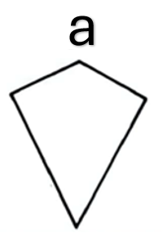) because its appearance is different.

2 Lecturer: How about examining which features of the kite exist in these shapes, and see if they exist in the square? Especially in terms of diagonals; try to examine the diagonals.

3 Seaham: I want to draw on the board and draw a straight line between all the parallel vertices which are the diagonals... I will do it like this, it doesn’t matter even if it is out of shape. I want to show you this [Seaham went to the board and drew the diagonals].

4 Lecturer: Thank you, Seaham. What was the result you got from the diagonals you drew?

5 Seaham: Hmmm...

6 Maas: The diagonals are perpendicular to each other.

7 Lecturer: Yes, the diagonals are perpendicular. Let’s check this feature on your page. Each of you will draw the diagonals in the three shapes and check if right angles are formed.

8 The students: [drawing the diagonals and checking] Yes. All are perpendicular.

9 Lecturer: If so, what is the first feature of the kite that you discovered?

10 The students: The diagonals are perpendicular in all three.

11 Lecturer: What does it mean that the diagonals are perpendicular?

12 Rime: They form a 90-degree angle.

13 Lecturer: Right, they form an angle of 90 degrees. What else do you see about the diagonals?

During the discussion, two arguments were raised (Arguments 4 and 5 below), which are presented in Figures 1 and 2. The numbering of the following arguments reflects the chronological order of their appearance in the discussion relevant to the presented mathematical event. Regarding the inclusion relationship event about a square and a kite, a claim was made by Rima, who debated whether a square is a rectangle or not [1]. According to Toulmin’s model, Rima’s claim can be broken down as shown in Figure 2.

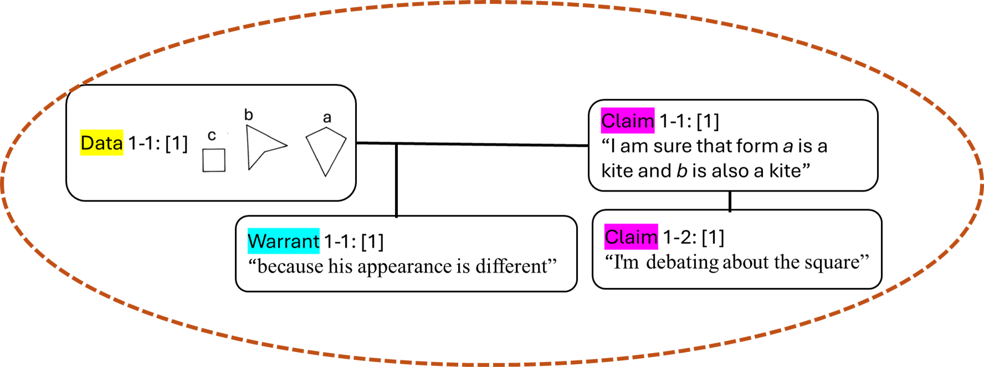

**Figure 2**

*Argument 4 -The Visual Appearance of the Square Does Not Resemble a Kite*

Figure 2 shows the participant’s deliberation and thought process during the discussion, illustrating how visual judgment can lead to confusion or uncertainty about critical geometric features and the relationships between them. Subsequently, the participants began to break down the properties of the kite and the properties of the square and to look for the relationships between them. As a result, Argument 5 arose, which refers to common features between a square and a kite, especially because the diagonals are perpendicular to each other. The next argument, about the common properties of a kite and a square, was made by a participant named Maas (see Figure 3).

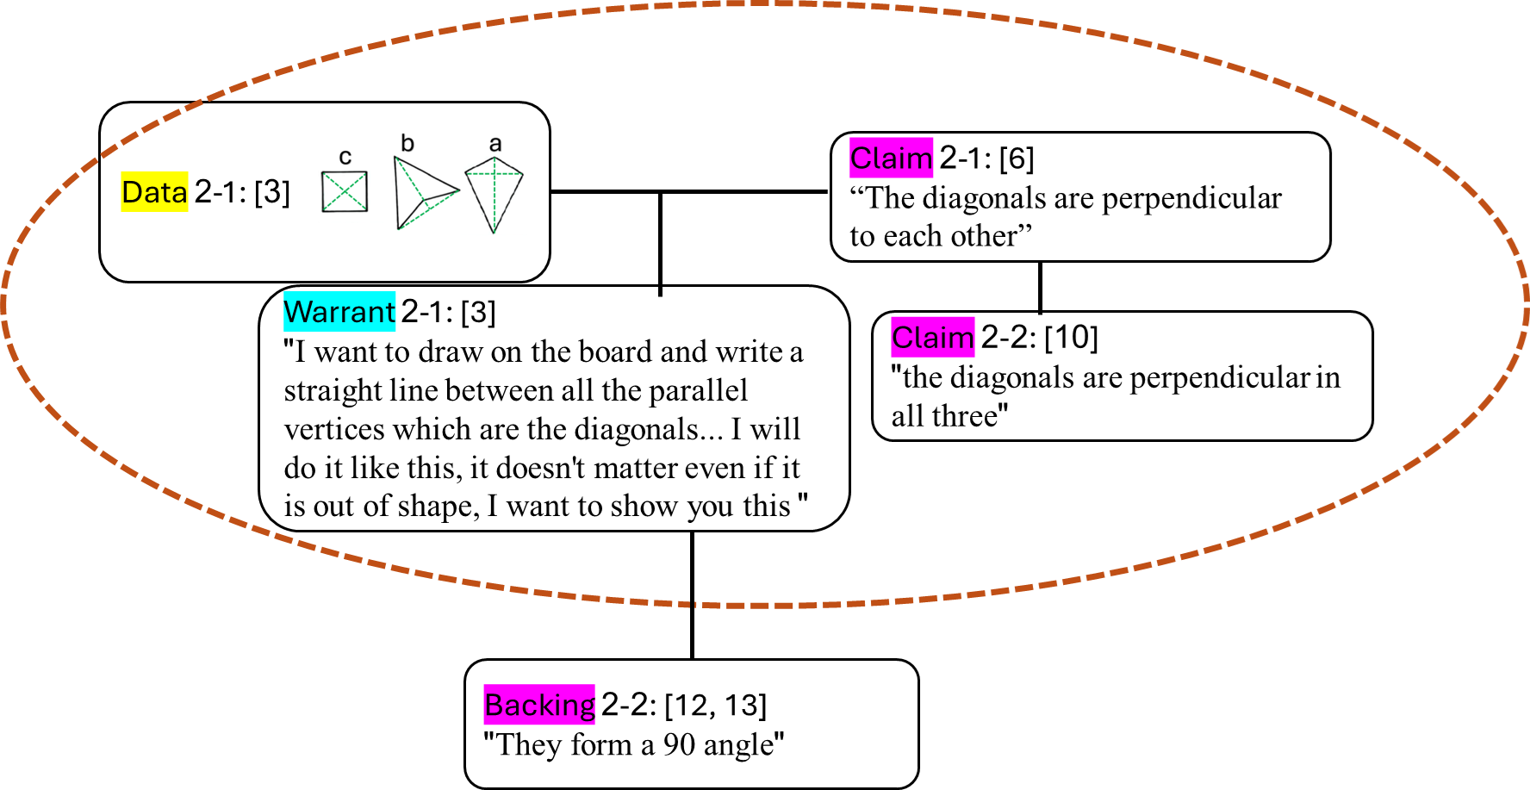

**Figure 3**

*Argument 5 - A common Property of a Kite and a Square: Two Diagonals are Perpendicular to Each Other*

Figure 3 illustrates a process by which the participants identified the critical feature of the perpendicularity of the diagonals in prototypical and non-prototypical kites. By presenting the data, examining it, and concluding that perpendicularity is a property common to the square and the kite, they concluded that it is an important property common to all these shapes.

## Discussion

The objective of the current study was to examine the impact of analyzing mathematical events on identifying and justifying inclusion relationships between various quadrilaterals. The findings indicated that the discussion of mathematical events helped in revealing participants’ reliance on non-critical attributes that are exclusive to prototypical examples. Moreover, the need to explain and support their claims led them to use formal definitions or critical attributes, which contributed to them seeing that certain shapes share attributes and belong to broader categories. For example, as presented in Episode 1, the discussion progressed from initial visual uncertainty to a systematic comparison of the properties of a kite and a square, leading participants to identify critical shared attributes and ultimately concluding that a square possesses the properties of a kite. The results that emerged in the current study align with previous studies (e.g., Markovitz, 2003; Stockero et al., 2019) that emphasize the effectiveness of engagement with analyses of mathematical events. The application of the Toulmin model effectively highlights how structured reasoning changed, such as presenting warrants and backing in the transition from initial misunderstanding to a more nuanced and accurate grasp of mathematical inclusion relationships between shapes.

Before the intervention, the vast majority of the participants struggled to identify the inclusion relationships between several quadrilaterals in both the visual tasks and verbal tasks. In addition, when they were asked to provide explanations for their responses, the majority of them tended to use the attributes of the prototype examples instead of the definitions of the shapes (see Table 1). In the post-questionnaire, the participants identified the inclusion relationships between the quadrilaterals correctly and provided explanations based on geometrical definitions of the concepts or critical attributes of these concepts. The intervention might have improved their comprehension of inclusion relationships and the development of concept images that are not limited to prototype examples (Haj-Yahya et al., 2024; Maymon-Erez & Yerushalmy, 2007). However, the mathematical events focused on only three inclusion relationships, and not all of the study participants joined the discussion of the mathematical events. The findings revealed improvement in most participants’ understanding of most inclusion relationships.

## Acknowledgments

MOFET Institute funded the current study.

## References

Braun, V., & Clarke, V. (2006). Using thematic analysis in psychology. *Qualitative Research in Psychology, 3*(2), 77–101. https://doi.org/10.1191/1478088706qp063oa

Fujita, T., & Jones, K. (2007). Learners’ understanding of the definitions and hierarchical classification of quadrilaterals: towards a theoretical framing. *Research in Mathematics Education*, *9*(1-2), 3–20. https://doi.org/10.1080/14794800008520167

Haj Yahya, A., & Hershkowitz, R. (2024). Interference of prototypical geometry representations in students’ construction of concepts and development of proofs. *Mathematical Thinking and Learning*, 1–22. https://doi.org/10.1080/10986065.2024.2386619

Haj-Yahya, A. & Hershkowitz, R. (2013). When visual and verbal representations meet the case of geometrical figures. In Lindmeier, A. M. & Heinze, A. (Eds.). *Proceedings of the 37th Conference of the International Group for the Psychology of Mathematics Education* (Vol. 2, pp. 409–416). Kiel, Germany: PME.

Haj-Yahya, A., Mahameed, A., & Haj-Yahya-Arisha, H. (2024). Does the use of concept maps affect the defining and the understanding of inclusion relationships? *Mathematical Thinking and Learning*. 1–30. https://doi.org/10.1080/10986065.2024.2310038

Markovich, C. (2003). *Analysis of mathematical events in the classroom*. Moffet Institute.

Maymon-Erez, M. & Yerushalmy, M. (2007). “If you can turn a rectangle to a square then you can turn a square to a rectangle…”: On the complexity and importance of psychologizing the dragging tool by young students. *International Journal of Computers for Mathematical Learning*, *11*(3), 271–299. https://doi.org/10.1007/s10758-006-9106-7

Okazaki, M., & Fujita, T. (2007). Prototype phenomena and common cognitive paths in the understanding of the inclusion relations between quadrilaterals in Japan and Scotland. In J. H. Woo, H. C. Lew, K. S. Park, & D. Y. Seo (Eds.), *Proceedings of the 31st Conference of the International Group for the Psychology of Mathematics Education* (Vol. 4, pp. 8-41). Seoul, South Korea: PME.

Pickreign, J. (2007). Rectangles and rhombi: How well do pre-service teachers know them? *Issues in the Undergraduate Mathematics Preparation of School Teachers*, *1*, 1–7.

Shulman, L. (1992). Towards a pedagogy of cases. In J. Shulman (Ed.), *Case methods and teacher education* (pp. 1–30). Teachers College Press.

Stockero, S. L., Leatham, K. R., Ochieng, M. A., Zoest, L. R., & Peterson, B. E. (2019). Teachers’ orientations toward using student mathematical thinking as a resource during whole-class discussion. *Journal of Mathematics Teacher Education*, *23*, 237–267. https://doi.org/10.1007/s10857-018-09421-0

Tirosh, D., Tsamir, P., Levenson, E. S., & Barkai, R. (2019). Using theories and research to analyze a case: Learning about example use. *Journal of Mathematics Teacher Education*, *22*(2), 205–225. https://doi.org/10.1007/s10857-017-9386-y

Toulmin, S. (2003). *The uses of argument* (2nd ed.). Cambridge University Press. https://doi.org/10.1017/CBO9780511840005

Van Hiele, P. M., & van Hiele-Geldov, D. (1958). A method of initiation into geometry. In H. Freudenthal (Ed.), *Report on methods of initiation into geometry* (pp. 67–80). J. B. Wolters.