**JOURNALS to consider**

* **International Journal of the Sociology of Language**
* **Linguistic Landscape: An International Journal**
* **International Journal of Multilingualism**
* **Journal of Multilingual and Multicultural development**

**Commercial Shop Signage in the Palestinian Border Village of Barta’a**

Muhammad Amara

**Abstract**

Over the past decade, interest in linguistic landscapes in border regions has increased, shedding light on the complex relationship between language use and socio-political factors. Comparative studies have revealed how national policies, cultural identities, and historical influences shape sociolinguistic dynamics, offering insights into language presence, dominance, and hybridity in these unique geopolitical contexts. Border regions are crucial for understanding how language influences identity and cross-cultural interactions.

The current study explores the language diversity and associated identities on commercial shop signs in Barta’a, a border Palestinian village, with its eastern side governed by the Palestinian Authority and its western side within Israel. By analyzing 320 shop signs from both the Eastern and Western sides of the village through quantitative and qualitative methods, including photographs and interviews with six shop owners, the research uncovers interesting patterns in language use. The results reveal a complex linguistic landscape in Barta’a, where Arabic, Hebrew, and English are used on commercial shop signs on both the eastern and western sides of the village. Arabic dominates, appearing on 38% of signs in Eastern Barta’a and 21% in Western Barta’a. Bilingual and multilingual signs are prevalent, with Arabic playing a central role. On the eastern side, 44% of signs are monolingual, primarily in Arabic, while Hebrew is absent as a monolingual language. In contrast, Western Barta’a has a higher occurrence of bilingual (41%) and trilingual (24%) signs, with Arabic-Hebrew as the dominant bilingual combination, reflecting the region’s political and cultural divide. English appears infrequently as the sole language but is common in bilingual and trilingual signs, demonstrating its role as a supplementary or global language. The findings illustrate the nuanced ways in which language choices and cultural identities are manifested and divided within this border village.

**Keywords:** Border villages; political division; identity; language choice; conflict.

**Introduction**

The linguistic landscape of commercial shop signage offers a vivid portrayal of the cultural and linguistic dynamics within a community. In border villages like Barta’a, these signs do more than provide information—they reflect the intricate interplay of identity and language influenced by socio-political factors. Barta’a, a Palestinian village split into Eastern and Western sections (with the Eastern side under the Palestinian Authority and the Western side part of Israel), serves as a unique case study for examining how shop signage reflects distinct identities, language choices, and the broader socio-political context.

Given Barta’a’s complex socio-political situation, this study investigates the linguistic diversity and language preferences which are evident in its commercial signage. The research explores how these signs not only showcase visible language choices but also uncover deeper, often implicit layers of identity and cultural representation. This exploration provides insights into how political divisions and cultural dynamics shape the visual communication within a village deeply affected by specific political realities. The following sections will cover: an analysis of linguistic landscapes in border regions, an examination of the language situation in Palestine/Israel and its impact on linguistic landscapes, and a brief background on Barta’a.

**1.1 Linguistic Landscapes in Border Regions**

The last decade has witnessed a growing body of research focused on border regions, aiming to illustrate the unique linguistic landscapes which are shaped by differences in language use on either side of a border, as influenced by political, ideological, and social changes.

Various researchers have employed a comparative approach in the studies of border regions. For instance, Lazdiņa (2019) studied the linguistic landscape of the twin towns of Valka-Valga on the Latvia-Estonia border, revealing distinct sociolinguistic perspectives. Despite similar patterns, differences in language order and prevalence were notable, with the national state language taking precedence on each side, while the supplementary languages English and Russian maintained a presence.

Similar results emerged in the study by Ruzaitė (2017) on tourist resort towns near the Lithuania-Poland border, highlighting variations in language presence. Marten et al. (2012) explored six Baltic States towns, revealing the impact of proximity to the border on linguistic dynamics. Kudžmaitė and Juffermans (2020) examined the Lithuanian-Polish border, emphasizing strict language regulations for Lithuanian.

The German-Polish border study by Gerst and Klessmann (2015) highlighted the role of cross-border organizations and businesses in promoting German-Polish bilingualism. Fedorova and Baranova (2022) investigated Ivangorod and Narva on the Russian-Estonian border, showing a monolingual linguistic landscape on the Russian side- with a few signs that had some English, but Estonian completely absent- and complexities influenced by Russian propaganda.

Muth (2014, 2015) investigated Transnistria, revealing the significant roles that language and cultural identity play in delineating borders. In this region, Russian not only holds a prominent position as the dominant language but also functions as a second language within the public sphere of Moldova.

Themistocleous (2019, 2020) studied the contested buffer zone in Nicosia, Cyprus, focusing on the use of English in public signs. Tsiplakou (2023) also explored the identical buffer zone, investigating grammatical, semantic, and pragmatic mixing in texts. The study observed linguistic hybridity, characterized by the use of Cypriot Greek, the alternation between Cypriot and Standard Greek, and the incorporation of other languages, displaying a nuanced layering of linguistic elements and intertextual allusions. Within official signage, Standard Greek held a dominant position.

Anthropological studies, such as Bray (2000, P. 2), highlighted that "the communities on either side of the frontier have markedly different cultures, reflecting the dominant influences of the state of which each forms part. In parallel, however, both share a common Basque cultural and linguistic heritage."

Gorter (2016), in his comparison of the Basque towns Hendaye/Hendaia and Irun situated at the state border, emphasizes the significance of adopting a linguistic landscape perspective for interdisciplinary border studies. The usage of the Basque language is substantial on both sides of the border, reflecting changes on the Spanish side since the return to democracy in the late 1970s and gradual shifts on the French side.

The studies regarding the Basque region reveal that the multilingual patterns of the signs exhibit systematic differences: on the French side, French prevails, characterized by official bilingual French–Basque signs. In contrast, the Spanish side reveals more variability, with bilingual signs alternating between featuring Basque and Spanish on top, accompanied by a growing number of signs in three or more languages (Wilson & Donnan, 2012).

In the Asian context, along the border between China and Vietnam, Li et al. (2022) noted a prevalence of Chinese in the linguistic landscape of Hekou County, China. Bilingualism is widespread, involving English and local minority languages. Vietnamese surfaces primarily in bilingual signs for official notices, trade, banners, and certain trilingual signs at key locations such as hospitals, stations, road signs, and border control. In Asia, Li et al. (2020) observed the Chinese dominance in Hekou County on the China-Vietnam border, with bilingualism and trilingualism common.

To conclude, the past decade has seen an increasing interest in exploring linguistic landscapes within border regions, revealing a complex interplay between language use and the socio-political context. Comparative studies across various borders have illuminated the diverse linguistic dynamics shaped by factors such as national policies, cultural identities, and historical influences. These studies provide valuable insights into the complexities of language presence, dominance, and hybridity in these unique geopolitical contexts. Border regions remain interesting sites for comprehending the broader implications of language in shaping identities and fostering cross-cultural interactions.

**1.2 Language Situation in Palestine/Israel and Linguistic Landscape**

Palestine has undergone significant geo-political transformations, impacting its linguistic and cultural landscape (Amara, 2003). Throughout its history, Palestine has been characterized by various cultures and languages.

The turning point in the dominance of the Arabic language in Palestine occurred with the spread of Islam during the early decades of the 7th century CE. Palestine, then part of Syria, was occupied by the Arabs, and Arabic replaced the Syriac Aramaic language, which had been the lingua franca of the region at that time. Since then, Arabic has become the mother tongue of Palestinian Arabs, prevailing prominently in public domains. During the presence of the Crusaders in Palestine, French, German, and English were used, but Arabic remained the prevalent language for daily communication. Later, the Franciscan fathers who arrived in Palestine after the Crusader period introduced Italian to Christians in Bethlehem and Jerusalem (Giacaman, 1990).

In 1517, Palestine was conquered by the Ottoman Turks, who ruled until 1917. Turkish became the official language of the government, weakening the Arabic language, although it remained the most widely used language in the public sphere (Ayish et al., 1983). In the 19th century we witnessed a cultural revival due to Napoleon's campaign in Egypt and Syria in 1799. Arabic received additional reinforcement with the establishment of Western missionary schools in Syria, Lebanon, and Palestine (Hassassian, 1987).

Highlighting the competition between Christian denominations, each church taught in its own language: French or Italian (Catholic), English (Anglicans, Presbyterians, and Quakers), German (Lutherans), and Russian (Orthodox). Spolsky and Cooper (1991) described the linguistic diversity in Jerusalem at the end of the 19th century, as including Arabic dialects, classical Arabic, Turkish, Greek, Latin, French, Armenian, English, and German. Towards the end of Ottoman rule in Arab countries, including Palestine, Turkish became the official language, and Arabic was relegated to a secondary status. Despite attempts to diminish the Arabic language during the Young Turks' nationalist policies, Arabic remained dominant in Palestine, as reflected in daily practices (Amara, 2003).

The developments of the 20th century, following the end of Ottoman rule in Palestine in 1917 and the British occupation, led to profound changes in all aspects of life, including the linguistic landscape. The British Mandate in Palestine elevated the status of Hebrew, which became an official language alongside Arabic and English (Amara, 2002; Amara & Mar’i, 2002; Saban & Amara, 2002). Despite separate schools for Arab and Jewish communities, linguistic interaction occurred, and Jews primarily learned Arabic through informal contact with Palestinians rather than in schools.

The establishment of the State of Israel in 1948, with the dominance of Hebrew in daily interactions and all aspects of life, had a deeper impact on the status of the Arabic language in Israel. In 1948, Israel seized control of most of Mandatory Palestine, except for the West Bank and Jerusalem (which was annexed by Jordan) and the Gaza Strip, administered by Egypt. Arabic remained the official language in Jordan and Egypt, while English was taught as a foreign language in government schools in the West Bank and Gaza (Tushyeh, 1990). Private schools also taught French, German, and Spanish, in addition to English. Jordanian and Egyptian curricula were effective in the West Bank and Gaza during Israel's occupation from 1967 to 1994. English served as a neutral language between Palestinians who did not know Hebrew and Israelis who did not know Arabic during Israel's occupation of the West Bank and Gaza. English was considered a neutral language (Al-Masri, 1988).

The establishment of the Palestinian National Authority in Gaza and Jericho in 1994, and later in major Palestinian cities in 1995 and 1996 (following the Oslo Accords), did not fundamentally change the multilingual situation. However, some changes were noted in the teaching of English, Hebrew, and other languages (Abu-Lughod, 1997; Amara, 2003).

With the establishment of the state of Israel, Arabic was designated as an official language alongside Hebrew, but in reality, its status has been inferior to that of Hebrew in every way. The July 2018 Basic Law: Israel as the Nation-State of the Jewish People, declared that “[t]he Arabic language has a special status in the state; Regulating the use of Arabic in state institutions or by them will be set in law.” This law has essentially revoked the status of Arabic as an official language in Israel, despite the country’s location in the heart of the predominantly Arab Middle East, where Arabic is the lingua franca (Amara, 2021).

Arabic is the mother tongue and the national and cultural language of over two million Arab Palestinians, citizens of Israel. Similarly, Arabic serves as a language for hundreds of thousands of Mizrahi Jews who came from Arab countries, as it was their ancestors' language for centuries. Arabic is taught as a mother tongue in Arab schools from the first grade to the twelfth grade and as a foreign language to tens of thousands of Jews (Amara, 2002; Amara & Mar’i, 2002).

In short, the linguistic landscape of Palestine and the status of the Arabic language have been fundamentally influenced by geopolitical transformations. Today, Arabic is a prominent language in the West Bank and Gaza, thanks to the rule of the Palestinian National Authority. However, in Israel, the dominance of Hebrew, due to Jewish control, has marginalized the Arabic language.

As to the linguistic landscape, the only comparative study is East Jerusalem, as part of the West Bank under the Palestinian Authority, compared to Palestinian localities in Israel (Ben-Rafael et. al, 2006).[1]

Figure 1 below indicates prominent differences between Palestinian localities in Israel and East Jerusalem. As the results show, Hebrew stands out as the dominant language in the linguistic landscape of the Palestinian localities, occurring as a single language even more often than does Arabic. This is not the case in East Jerusalem, where no instances exist of Hebrew as the only language in the city's landscape.

What about the status of Arabic? In Palestinian localities, Arabic exists as the single language in less than 5% of the linguistic landscape, with Hebrew having a more prevalent single-language presence (24.1%). Arabic is present in bilingual signs (44.6% of the signs) and in trilingual Hebrew-Arabic-English signs (24.1% of the signs). Arabic has a significant presence as a single language in East Jerusalem (21%). In contrast to Palestinian localities where Hebrew-Arabic are the dominant bilingual signs, the bilingual signs in East Jerusalem are primarily in Arabic-English (55.8%).

**Figure 1: Linguistic Landscape Items by Language and Region (%)**

**Source:** Ben-Raphael et. al (2006: 17).

The linguistic landscape reveals clear differences between Palestinian localities in Israel and East Jerusalem. In East Jerusalem, Hebrew is absent from the private linguistic landscape and exists in the public trilingual landscape: Hebrew-Arabic-English. This means that each group uses the language of the other when necessary, particularly when written from top-down to bottom-up. In contrast, in Palestinian localities in Israel, Hebrew has a prominent presence in both the private and public linguistic landscapes and stands out more prominently in private contexts.

**1.3 A brief Background to Barta'a**

Barta'a is a Palestinian village located in the Ara valley, between the Jordan River and the Mediterranean, approximately fifteen kilometers north of Hadera, Israel, and twenty-five kilometers south of Afula and the West Bank town of Jenin. Palestinian settlements in the area date back about four hundred years, and until 1934, the region was ethnically Arab and religiously Moslem, with agriculture as the primary source of income (Amara, 1999).

The village of Barta’a was divided in 1949 following the Rhodes agreement, with the eastern part joining Jordan and the western part becoming part of Israel. This division lasted until 1967 when, after the June War, the physical barrier was removed, but the political division remained. The eastern side stayed with the West Bank, and the western side with Israel. The division led to different economic and social developments, with the western side experiencing growth and the eastern side facing challenges under Jordanian rule (Amara & Kabaha, 1996).

From 1949 to 1967, smuggling was the primary form of contact between the two sides. Following the June War, the village came under Israeli control, enabling direct contact and the renewal of family and social ties. However, differences in views and education persisted, especially among the youth. Over time, both sides saw improvements in living standards and integration into their respective regions, with the western side economically integrating into Israel and the eastern side socially into the West Bank.

Barta’a’s isolation decreased over time, leading to increased outside influence and multidimensional relationships with other Palestinian villages and cities in Israel for the western side, and stronger ties with the West Bank and Jordan for the eastern side. Education played a significant role in shaping the new generation, with the Intifada of 1987 highlighting the ongoing differences.

After the uprising in 2000 known as the Second Intifada, many Palestinian cities and markets, including notable ones like Jenin, Nablus, and Qalqilya, were closed. These closures affected their primary customer base, which consisted of Palestinian communities within Israel. Consequently, the village of Barta’a, situated on the border of the West Bank and accessible to Israel, saw a surge in commerce (Amara, 2018). Numerous merchants from the West Bank seized the opportunity to establish businesses in Eastern Barta’a. This trend also motivated merchants from Western Barta’a and other Arab towns within Israel to open shops in Western Barta’a. Over time, the village underwent significant growth, evolving into a bustling hub with large markets and shops managed by prominent merchants from various Palestinian cities. The village attracts thousands of customers daily from different Palestinian towns in Israel. Additionally, before October 7, 2023, prior to the War on Gaza, many Jewish customers frequented both sides of the village.

Top of Form

**2. The Study**Given the distinctive socio-political context outlined above, this study examines language diversity and choice evident in the commercial signage within the border Palestinian Village of Barta’a, comprising its Eastern and Western sides.

**2.1 Research Questions**

This research addresses the following questions:

1. Which languages are employed on both sides of the border Palestinian village of Barta’a?
2. What parallels and distinctions exist between the linguistic landscapes on each side?
3. What insights can be gained about the divided nature of Barta’a from these linguistic landscape patterns?

**2.2 Hypotheses**

* 1. **Arabic** will be the most prevalent language on commercial shop signs on both the Eastern and Western sides of Barta’a, reflecting its role as the dominant language in the region.
  2. **Monolingual Hebrew signs** will be absent on the Eastern side of Barta’a, reflecting the cultural and political divide between the areas governed by the Palestinian Authority and Israel.
  3. **Bilingual signs**, especially those featuring both Arabic and Hebrew, are expected to be more common on the western side of the village, while Arabic-English signs will be more prevalent on the eastern side
  4. **English** will frequently appear as a supplementary language on commercial shop signs but will rarely be used on monolingual signs, indicating its role as a global or secondary language in the local context.

**2.3 Methodology**

This study utilized a combination of quantitative and qualitative research methods to collect data. A total of 320 photographs of commercial shop signs were taken in June and July 2023 in Barta’a, with 150 from Western Barta’a and 170 from the Eastern side. The sample included various types of shops such as clothing stores, barbershops, tailors, boutiques, supermarkets, cosmetics shops, coffee shops, restaurants, recreational outlets, private offices, garages, car services, computer and electronics stores, and others.

In Western Barta’a, the sample was limited to the main street, whereas in Eastern Barta'a, samples were collected from multiple shopping streets. The Eastern side features numerous shopping streets. Every shop on both sides was photographed. Additionally, six interviews were conducted with shop owners to explore the reasons behind their language choices on the signs, the significance of those choices, their characteristics, and symbolism.

The languages were classified into five categories – Arabic-only, Hebrew-only, English-only, Bilingual (specifying the combination, such as Arabic-Hebrew or Arabic-English), and Multilingual - due to the observed language diversity in shop signs. The quantitative approach aimed at determining the distribution of languages, while the qualitative aspect focused on the intended functions of the signs.

Six face-to-face interviews were conducted with shop owners in September 2023, each representing one variant of language use on signs: Arabic, Hebrew, English, Arabic-Hebrew, Arabic-English, and Arabic-Hebrew-English. The interviews centered around the usage of language on the linguistic landscape, exploring various aspects of the shop signage, and covered a range of questions related to the shop owner's background, shop details, language choice rationale, impact on customer attraction, language symbolism, and language use.

The interviews, conducted in Arabic, ranged from 21 to 35 minutes in duration. A total of five men and one woman participated, with three men interviewed on the eastern side and two men and one woman on the western side. The interviewees were asked the following questions:

1. How long has your shop been in operation?
2. What inspired you to open this particular shop?
3. Could you explain the choice of your shop's name?
4. Why did you choose the language(s) for your shop sign, and are you satisfied with this choice?
5. In your opinion, how important is the language used on your shop sign?
6. Did you consult a specialist when deciding on the language for your shop sign? If so, whom did you consult and why?
7. Has the language on your shop sign influenced customer attraction? If so, how?
8. What does the chosen language represent for your shop, and what are its key characteristics?
9. In your daily business interactions, which languages are commonly spoken?

**Results**The results of the study reveal that Arabic, Hebrew, and English are utilized in signs on both sides of Barta'a. The examination focused on how these three languages were distributed in the linguistic landscapes of commercial shop signs.

The results indicate that Arabic is the most prevalent language in both the eastern and western sides of the village, with 38% of signs on the eastern side and 21% in the western side displaying only Arabic. Additionally, there is significant use of Arabic on bilingual and multilingual signs. These findings support the first hypothesis, confirming that Arabic is the dominant language on commercial shop signs throughout both the eastern and western sides of Barta’a, underscoring its role as the region's primary language.

On the Eastern side of Barta'a, the results reveal that 44% of the signs were monolingual, the highest percentage observed. Bilingual signs followed closely, constituting 43% of the total, while trilingual signs represented the lowest percentage at 13% (See Fig. 1). Arabic dominated as the sole language on commercial shop signs, appearing on 38% of them, the highest percentage observed. English appeared as the exclusive language on only 6% of the signs, while Hebrew was entirely absent as a monolingual option. This finding supports the hypothesis that **monolingual Hebrew signs** would be absent on the eastern side of Barta’a, reflecting the cultural and political divide between the areas governed by the Palestinian Authority and Israel.

**Fig. 1** The Languages used on signs in Eastern Barta’a.

Regarding Western Barta'a, the results indicate that 41% of the signs were bilingual, the highest percentage observed. Monolingual signs followed at 35%, while trilingual signs represented the lowest percentage at 24%. Breaking down each language individually, Fig. 2 shows that Arabic was the most prevalent language on commercial shop signs, appearing solely on 21% of the signs. English as the exclusive language appeared on 11% of the signs, and Hebrew lagged behind, representing 3% as the sole language.

**Fig.2** The Languages used on signs in Western Barta’a.

When comparing the two sides, notable differences emerged. Arabic-only signs in Eastern Barta'a were more common than in Western Barta'a, constituting 38% compared with 21%. Hebrew-only signs on the Western side reached 3%, a relatively low percentage, while they were absent in Eastern Barta'a. English-only signs on the Western side were more prevalent at 11%, compared with 6% in Eastern Barta'a.

Regarding the use of more than two languages, trilingual shop signs were more frequent on the Western side than on the Eastern side, with the Western side comprising 24%, compared with the Eastern side's 13%.

In terms of bilingual shop signs on both sides, they were nearly equal in percentage, with 43% in Eastern Barta'a and 41% in Western Barta'a, with only a 2% difference favoring the Eastern side (See Figure 3).

It is interesting to examine the bilingual signage, as the languages used differ on either side of the village. Two major patterns emerge: Arabic-Hebrew and Arabic-English signs. The results show that in Western Barta'a, the dominant bilingual pattern is Arabic-Hebrew, with 54 signs (87% of the bilingual signs), while only 8 signs (13%) are in Arabic-English. Conversely, a different pattern is observed on the eastern side, where Arabic-English dominates with 69 signs (94%), and Arabic-Hebrew appears on just 4 signs (6%). These results support the third hypothesis, which states that bilingual signs featuring both Arabic and Hebrew are expected to be more common on the western side of the village, while Arabic-English signs will be more prevalent on the eastern side (See Figure 4).

The results of the study provide strong support for the fourth hypothesis that "English will frequently appear as a supplementary language on commercial shop signs but will rarely be used on monolingual signs, indicating its role as a global or secondary language in the local context." The data shows that while English is used on commercial shop signs on both sides of Barta’a, it is primarily found on bilingual and trilingual signs, supporting the idea that it serves as a supplementary or secondary language. For instance, the dominant bilingual pattern on the eastern side is Arabic-English (94% of bilingual signs), and although English appears frequently, its role is supplementary alongside Arabic.

The results also confirm that English is rarely used as the sole language on signs. On the eastern side, only 6% of the signs are in English only, and in the western side, this number is slightly higher at 11%. These figures are much lower than the prevalence of monolingual Arabic signs, further emphasizing English’s secondary role.

English's relatively low occurrence as the only language on signs, yet frequent use alongside Arabic in bilingual and trilingual signs, underscores its role as a global language. It serves as a bridge for broader communication, possibly for tourists or non-local audiences, but it does not replace Arabic as the primary language in the region.

In summary, the results support the hypothesis that English functions as a supplementary language in Barta’a’s linguistic landscape, with its limited use as a monolingual option highlighting its secondary status.

While the quantitative data provided valuable insights into various aspects of the linguistic landscape in the two sides of the village, they did not explain the underlying reasons for language diversity and the associated identities. To address this, I will analyze the primary patterns that emerged from the signs, using interviews with six shop owners who represent different language choices on their signs. Ben-Said (2011) emphasizes the importance of incorporating 'voices from the people as an essential part of interpreting the linguistic landscape' (p. 68) in future research.

This **Arabic-only** shop sign is prominently utilized on Eastern Barta’a, surpassing its prevalence on Western Barta’a, as shown in Picture#1, where the sign is exclusively in the Arabic language. The owner of this shop is a young man, approximately 41 years old, who explained, "*For me, I chose Arabic because we are situated in an Arab region, and Arabic serves as the primary means of communication among people in this region. Since the store's inception, we've attracted mainly Arab customers, and their preferred code of communication is Arabic*."

Discussing the significance of the sign's language, he emphasized, "*The language displayed on the sign is crucial, as it serves as the primary attraction for customers entering the store. The selection must be made thoughtfully*." He further raised a significant point, stating, "*Arabic is accessible, providing clear communication for those who understand it, with rich nuances. Describing items or store collectibles in Arabic enhances sales. Conversely, describing them in another language may pose challenges for customer comprehension, especially if the language is not mastered."*

The owner also explains that he sees the Arabic language on the sign from a religious and national perspective, contending, "*I cannot use any language other than Arabic. Even if we have non-Arab customers, I refrain from using Hebrew, Russian, or English. The language of our Qur’an alone should appear on our signs*."

In summary, the choice of an Arabic-only shop sign in Eastern Barta’a holds deep significance, aligning it with the cultural and linguistic context of the Arab region. The strategic decision is based on the predominant use of Arabic in the community and has proven successful in attracting mainly Arab customers. From a religious and national perspective, the owner defends the exclusivity of Arabic on the sign, relating it to the language of the Qur’an and expressing a personal and professional commitment, even when dealing with non-Arab customers. Overall, the Arabic-only sign becomes not just a linguistic choice, but a reflection of cultural identity and a strategic business decision rooted in the owner's profound beliefs and experiences.

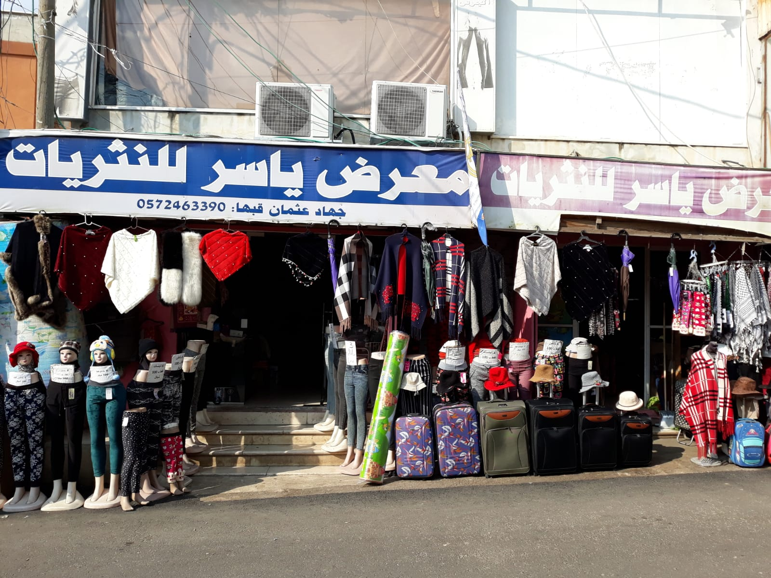**Picture no. 1. Arabic-only sign on a Miscellaneous Shop in Eastern Barta'a**

**English-only** shop signs are not common in the village, with Arabic-only signs being far more prevalent. On the eastern side, Palestinian Arabs generally view English as a second language, while on the western side, it's often learned as a third language, after Hebrew. Picture no. 2 illustrates an English-only shop sign.

When asked about his choice of language, the 25-year-old shop owner from Western Barta'a explained, "*English serves as a unifying factor for both Arabs and Jews. I deemed it unnecessary to include Hebrew since not everyone in this region is proficient in Hebrew due to the shop's proximity to the dividing line between Eastern and Western Barta'a. Given that our customer base comprises not only Arabs but also international visitors, I chose to feature English on the store sign. It serves as a common language for the various communities*."

He further clarified, "*I opted for English to enhance visibility. The name 'Royal Tech' might not resonate if written in Arabic or Hebrew, as its meaning is inherently English. As a universal language, English holds preference over others.*"

Regarding whether language affects customer attraction, he remarked, "*The language itself may not necessarily influence customer attraction. It's the logo and images that offer an initial impression of the store, influencing and attracting customers. Not everyone can read, even in their mother tongue. The exterior images convey the store's offerings, allowing potential customers to understand its direction before entering.*"

On the absence of Arabic on his sign, the owner said, "*English imparts prestige, credibility, and modernity. In today's context, people may not be overly concerned about the language of the name. Additionally, with visible exterior pictures, people can comprehend the store's offerings without relying solely on the language, whether in Arabic or any other language.*"

In a nutshell, English-only shop signs are notably less prevalent compared to Arabic-only signs. Noteworthily mentioning that customer attraction is more influenced by the logo and images than the language itself, suggesting that the exterior visuals convey the store's offerings effectively. Regarding the absence of Arabic on the sign, English is associated with prestige, credibility, and modernity, asserting that, in today's context, the language may be secondary to visible images in conveying the store's essence. Overall, the English-only sign is a deliberate choice aimed at fostering inclusivity and attracting a diverse customer base, highlighting the perceived universal appeal and practicality of English in the context of the shop's offerings and clientele.

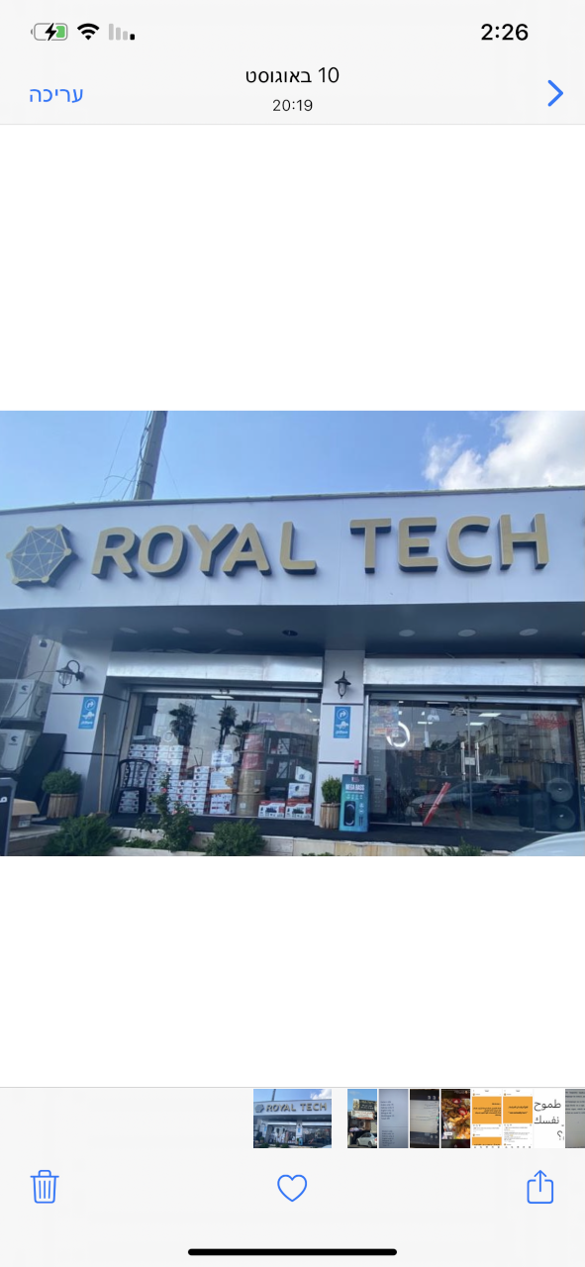 **Picture no. 2. English**-only sign on a computer and electronics shop sign in Western Barta'a

**Bilingual Arabic-Hebrew** signs are common in Western Barta'a, though rare in Eastern Barta'a. Picture #3 shows a computer and electronics shop sign featuring both languages. The shop owner, a 43-year-old man from Eastern Barta'a , explained, "*We originally had only Arabic on the sign, but added Hebrew as Jewish customers began visiting Eastern Barta'a. It became necessary for the sign to be bilingual.*"

He opted not to include English, stating, "*There are no foreign customers here. Our shared cultural background revolves around Arabic and Hebrew, which fits with our focus on computers in this region. I might add Russian later for the Russian community, but for now, Arabic and Hebrew are enough.*"

On the significance of the languages, he said, "*Arabic represents our identity as an Arab shop. Most of our customers are Arabs, and I take pride in my language. Hebrew, though the language of the occupiers, is necessary for communication and marketing with Jewish customers.*"

In essence, Arabic reinforces Palestinian identity, while Hebrew is a practical tool for business, reflecting the complex dynamics of daily interactions with the Jewish community. The consideration of Russian for the future highlights adaptability to the evolving customer base.

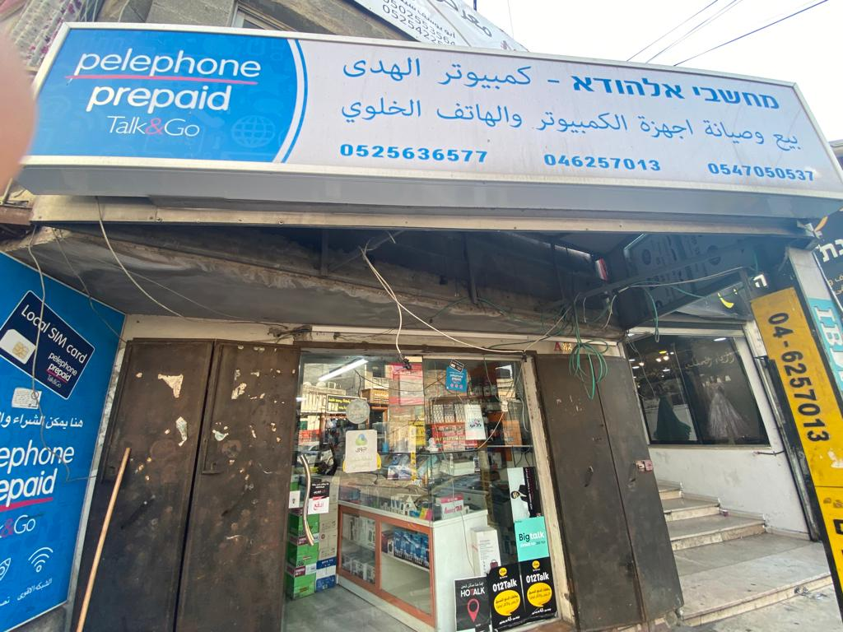**Picture no. 3.** Arabic-Hebrew Bilingual sign on computer and electronics shop in Eastern Barta'a

**Bilingual Arabic-English** signs are common in Eastern Barta'a, while io the Western side, English is often used on multilingual signs (Arabic-Hebrew-English). Picture #4 shows an Arabic-English phone shop sign. The 30-year-old shop owner explained, "*English holds international prominence, and most people visiting Barta'a are familiar with it. It helps locals and visitors quickly recognize that the store specializes in phones and accessories. But many people, especially in our Arab society, aren't as familiar with English, so I also included Arabic*."

Regarding the absence of Hebrew, he noted, "*I would have preferred to include Hebrew since many in our society are more accustomed to it due to school and cultural influences. I may add it when I redesign the sign*."

He emphasized, "*Arabic symbolizes our presence as an Arab shop, reflecting our culture and customs, while English connects to international companies like Apple. Everyone recognizes it today, and with the Apple logo, customers know we specialize in Apple products*."

The shop owner highlighted English's global reach, saying, "*English is universally recognized, even in places like China, whereas Arabic is mainly used in the Arab world*."

The use of bilingual Arabic-English signs in Barta'a is strategic, catering to both locals and visitors. English attracts a broad audience and enhances international recognition, while Arabic reflects cultural identity. Though Hebrew is absent, the owner is open to adding it in the future due to its economic importance. This language choice balances local identity with global appeal.

Top of Form

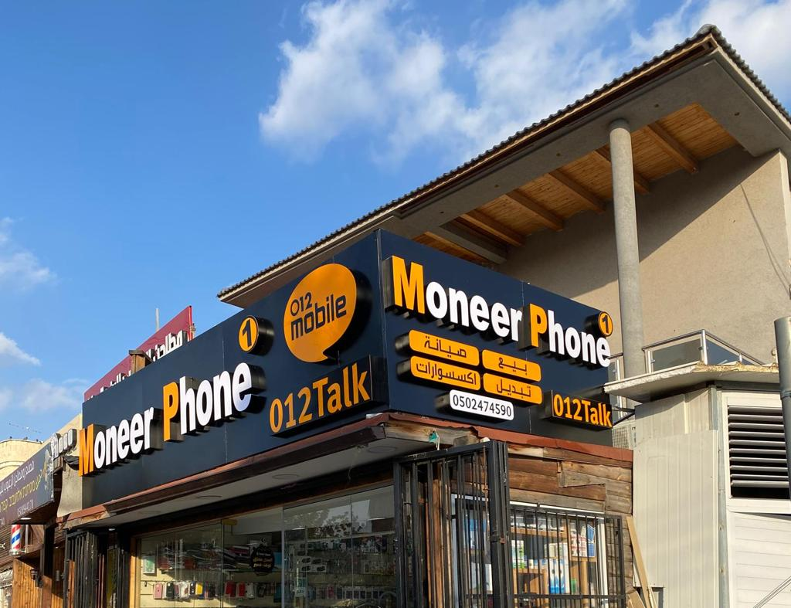  
**Picture no. 4. Arabic and English bilingual sign of a phone shop in Western Barta'a**

**Trilingual Arabic-Hebrew-English** shop signs are more common on the western side of Barta'a, likely due to the use of Hebrew by many in that region. Picture #5 shows a clothes shop sign featuring all three languages. The 40-year-old shop owner explained, "*The choice of languages is influenced by our customers—both Arabs and Jews—and Barta'a's unique location near the separation wall, which attracts locals and foreign tourists. So, we included Arabic, English, and Hebrew.*"

He emphasized the importance of these languages: "*They are crucial for communication. Whether it's a foreigner or a Jewish customer, the languages on the sign reflect the store's contents and help convey what we offer.*"

Regarding customer attraction, he stated, "*Language plays a big role. If I see a sign in Arabic, I'll feel invited to enter. The same goes for Jews or foreigners—if they see English and a familiar brand like Adidas, they’ll be drawn in*."

In Barta'a, trilingual signs are a strategic choice, enabling effective communication with a diverse customer base. The inclusion of Arabic, English, and Hebrew recognizes the area's linguistic diversity and helps attract both locals and tourists.

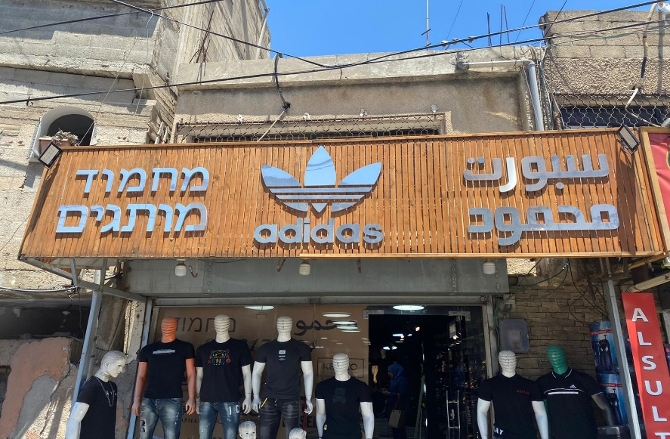

**Picture no. 5, Arabic- Hebrew-English multilingual sign of a clothes shop’s name in Eastern Barta'a**

Picture #6 features a shop sign in Arabic, English, and a rarely used foreign language. The 27-year-old gift shop owner explained her decision to include a foreign language: "*I was inspired by a Turkish shop name, Lavita, which captivated me. I was torn between Lavita (Turkish) and Mersal (Arabic), but I chose the Turkish name. Foreign languages carry more* *prestige and attract attention. To improve visibility, I added English with the tagline 'something different' so customers would understand the shop's contents*."

Reflecting on her choice, she said, "*At first, I was happy with it, but now I have some reservations. People naturally gravitate towards Arabic. If I could go back, I would choose Arabic.*"

Regarding the foreign language, she admitted, "*It didn’t have a specific meaning but conveyed modernity and prestige. English added a sense of luxury, and the phrase 'something different' would catch people's attention.*"

In short, while foreign languages initially felt prestigious, the owner now acknowledges that Arabic holds a stronger connection with her customers. Her reflections highlight the evolving nature of language choices and their impact on a shop's identity.

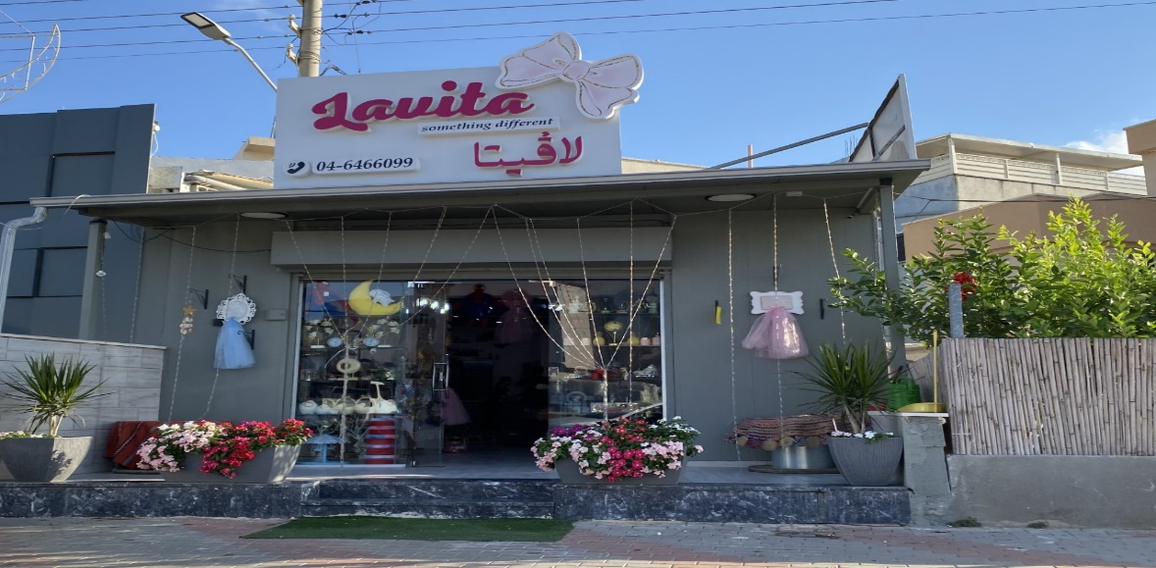 **Picture no. 6. Arabic-English-Turkish Multilingual gifts shop sign in Western Barta'a.**

**Discussion and Conclusions**

The exploration of the multilingual nature of commercial shop signs in Barta'a provides an insightful perspective on how language functions as a reflection of socio-economic, cultural, and political complexities, particularly in border regions. Situating these findings within the broader framework of linguistic landscape studies reveals notable parallels and divergences with other research conducted in similar border contexts.

The dominance of Arabic in Barta'a, especially in Eastern Barta'a, aligns with the findings of previous studies which have emphasized the prominence of a dominant national or ethnic language in border areas. For instance, Lazdiņa's (2019) study of the Latvian-Estonian border and Muth's (2014, 2015) work on Transnistria demonstrate how a primary language often holds sway, reflecting the ethnic and cultural identity of the local population. This reinforces the concept that linguistic landscapes in such regions serve as markers of identity, fostering a sense of belonging and continuity within the community.

In contrast, the relatively rare occurrence of Hebrew-only signs, particularly in Eastern Barta'a, reflects the linguistic dynamics documented in the German-Polish border study by Gerst and Klessmann (2015). Their research showed that while cross-border interactions promote bilingualism, they do not necessarily lead to an equal status for both languages. In Barta'a, as in the German-Polish context, the secondary role of the neighboring state's language highlights how socio-political boundaries can shape language visibility and status, even in areas with strong historical or cultural connections.

The strategic incorporation of English in conjunction with other languages aligns with Gorter's (2016) observations in the Basque towns of Hendaye/Hendaia and Irun. The presence of English often signals an attempt to cater to diverse audiences, showcasing how globalization influences linguistic choices in commercial settings. This phenomenon, also observed by Kachru (1992) concerning English as a global lingua franca, underscores how commercial landscapes in border regions respond to broader market demands, transcending local linguistic practices.

The prevalence of bilingual and multilingual signs, particularly in Western Barta'a, resonates with Ruzaitė's (2017) findings from the Lithuania-Poland border. This trend reflects a pragmatic adaptation to cross-cultural interactions and economic considerations, illustrating that linguistic landscapes in border areas are inherently dynamic and responsive to the evolving needs of their audiences. Spolsky (2004) noted that such linguistic adaptability often signifies a strategic communication approach, as businesses aim to be inclusive and accessible to a diverse clientele.

Political divisions play a crucial role in shaping language choices, as seen in Barta'a, where the East-West divide results in distinct linguistic landscapes. This dynamic parallels Fedorova and Baranova's (2022) research on the Russian-Estonian border, where political ideologies and national boundaries significantly impacted language visibility. In Barta'a, the differing prominence of languages between the East and West reflects the geopolitical realities of the division between the West Bank and Israel, reaffirming the role of political contexts in influencing linguistic landscapes, as suggested by Ben-Rafael et al. (2006).

Additionally, the study's findings regarding the interplay of Arabic, Hebrew, and English echo the linguistic hybridity observed in Themistocleous (2019, 2020) and Tsiplakou's (2023) research on Cyprus's buffer zone. These studies highlight how multilingual landscapes in border regions often involve a negotiation between preserving cultural heritage and accommodating external influences, a phenomenon that is evident in Barta'a’s signage.

In conclusion, Barta'a's linguistic landscape encapsulates the broader trends characteristic of border regions worldwide. The coexistence and interplay of Arabic, Hebrew, and English not only serve functional purposes but also symbolize markers of identity, cultural affiliation, and political stance. This study underscores that linguistic landscapes in border areas are more than mere communication tools; they are dynamic expressions of the community's historical, socio-political, and economic realities. By documenting how languages intersect, blend, and assert themselves in Barta'a, this research contributes to a deeper understanding of the ways in which border regions function as spaces of linguistic negotiation, reflecting the lived experiences and aspirations of their communities.

**References**

Abu-Lughod, Ibrahim. 1997. Plenary lecture, Third Annual Symposium of PATEFL, Bethlehem university, 17 April 1997.

Al-Masri, Nathmi. 1988. *Teaching Culture in the Foreign language Classroom with Particular Reference to the Gaza Strip*. Unpublished M.A. Thesis, University of Salford, England.

Amara, M. (1999). *Politics and Sociolinguistic Reflexes: Palestinian Border Villages.*Amsterdam/ Philadelphia: John Benjamins.

Amara, M. (2002). The Place of Arabic in Israel. *International Journal of the Sociology of Language,*158: 53-68.

Amara, M. (2003b). Recent foreign language education policies in Palestine. *Language Problems and Language Planning,*27 (3), 217-231.

Amara, M. (2021). My Enemy, My neighbor: Characteristics and Challenges of Arabic Instruction in Israeli-Jewish Society*. Journal of Holy Land and Palestine Studies* 20 (1), 28-44.

Amara, M. (2018).*Language, Identity, and Conflict: Arabic in Israel*. London & New York: Routledge.

Amara, M. (2020). *My Language is My Identity Towards a Comprehensive Language Policy to Meet the Challenges of Arabic in Israel.*Kufur Kare’ and Amman: Dar Al-Huda and Dar Al-Fiker (In Arabic).

Amara, M., & Kabaha, S. (1996). *Split Identity: Political Division and Social Reflexes in a Divided Palestinian Village*. The Institute for Peace, Giv'at Haviva. (In Hebrew)

Amara, M. & Mari, A. (2002***).*** *Language Education Policy: The Arab Minority in Israel*. Dordrecht/Boston/London: Kluwer Academic Publishing.

Ayish, H., W. Al-Jabri, and Y. Jum’a. 1983*. Modern and Contemporary Arab History* (in Arabic). n.p.

Ben-Rafael, E., Shohamy, M., Amara & Trumper-Hecht, Nira (2006). Linguistic Landscape as a Symbolic Construction of the Public Space: The Case of Israel. *International Journal of Multilingualism* 3(1), 7-30.

Ben-Said, S. (2011). Data triangulation as a resource in multilingual research: Examples from the linguistic landscape. In Proceedings of the International Conference: Doing Research in Applied Linguistics. Bangkok, Thailand: King Mongkut’s University of Technology Thonburi and Macquarie University Retrieved from <http://arts.kmutt.ac.th/dral/> PDF%20 proceedings%20on %20Web/62-70_Data_Triangulation_as_a_Resource_in_Multilingual Research.pdf

Bray, Z. (2000)*. Boundaries and Identities on the Franco-Spanish Frontier. A working paper*. Queen’s University Belfast.

Fedorova, K. and Baranova, V. (2022) ‘Non-identical twins’: Monolingual bias and linguistic landscapes of the twin cities of Ivangorod/Narva. In D. Smakman, J. Nekvapil and K. Fedorova (eds) *Linguistic Choices in the Contemporary City* (pp. 213–238). Abingdon: Routledge.

Gerst, D. and Klessmann, M. (2015) Multilingualism and linguistic demarcations in border regions. The linguistic border landscape of the German-Polish twin cities Frankfurt (Oder) and Słubice. *Rhetoric and Communications E-Journal* 15, 1–31. https://rhetoric .bg /wp -content /uploads /2015 /02 /Gerst Klessmann_- Linguistic BorderLandscape -PhD -issue -15 -January -2015 -last .pdf**.**

Giacaman, Hanna. 1990. *Educational Institutions in Bethlehem: A Historical Glimpse* (in Arabic). *Antonian Charitable Society Magazine* (Bethlehem): 38–45

Gorter, D. (2016) Multilingual contact zones and the possibilities of linguistic landscape research. Paper at the BOMOCULT conference: Interpreting European crisis and its consequences for bordering, mobilities and cultural encounters. University of EasternFinland, Joensuu, 28–29 September.

Hassassian, Manual. 1987. Christians and Muslims confronting the British Mandate. Paper presented at Al-Liqa’ Center, Jerusalem August 1987

Kachru, B. (1992). World Englishes: Approaches, Issues and Resources. *Language Teaching*, 25, 1-14. [https://doi.org/ 10.1017/S0261444800006583](https://doi.org/%2010.1017/S0261444800006583)

Kudžmaitė, G. and Juffermans, K. (2020) Politically open – sociolinguistically semipermeable: A linguistic landscape view into the Lithuanian-Polish borderland. In D.Malinowski and S. Tufi (eds) *Reterritorializing Linguistic Landscapes: Questioning*

*Boundaries and Opening Spaces* (pp. 262–283). London: Bloomsbury.

Lazdiņa, S. (2019) ‘We don’t really have a preferred language’: A case study of language practices in the Latvian-Estonian border area (Valka and Valga twin-towns). *Valoda: Nozīme un forma* (10), 114–130.

Li, Y., Lee, H. and Choi, B. (2022) Developing beginning language learners’ (meta-) cultural understanding via student-led linguistic landscape research. *Linguistic Landscape* 8 (1), 56–84. https://doi .org /10 .1075 /ll .20022 .li

Marten, H.F., Van Mensel, L. and Gorter, D. (2012) Studying minority languages in the linguistic landscape. In D. Gorter, H.F. Marten and L. Van Mensel (eds) *Minority Languages in the Linguistic Landscape* (pp. 1–18). Basingstoke: Palgrave

Macmillan. Muth, S. (2014) Linguistic landscapes on the other side of the border: Signs, language and the construction of cultural identity in Transnistria. *International Journal of the Sociology of Language* 227, 25–46.

Muth, S. (2015) ‘Ruralscapes’ in post-Soviet Transnistria: Ideology and language use on the fringes of a contested space. In M. Laitinen and A. Zabrodskaja (eds) *Dimensions of Sociolinguistic Landscapes in Europe: Materials and Methodological Solutions* (pp. 199–231). Frankfurt am Main: Peter Lang.

Ruzaitė, J. (2017) The linguistic landscape of tourism: Multilingual signs in Lithuanian and Polish resorts. *Journal of Estonian & Finno-Ugric Linguistics* 8 (1), 197–220. https://doi .org /10 .12697 /jeful .2017 .8 .1 .1

Saban, I. & Amara, M. (2002). The Status of Arabic in Israel: Reflections on the Power of Law to Produce Social Change. *Israel Law Review*36 (2): 5-39**.**

Spolsky, B. (2004). *Language Policy: Key topics in sociolinguistics*. Cambridge: Cambridge University Press.

Spolsky, B. & Shohamy, E. (1999). *Languages of Israel: Policy, Ideology and Practice*. Multilingual Matters Ltd.

Themistocleous, C. (2019) Conflict and unification in the multilingual landscape of a divided city: The case of Nicosia’s border. *Journal of Multilingual and Multicultural Development* 40 (2), 94–114. https://doi .org /10 .1080 /01434632 .2018 .1467425

Themistocleous, C. (2020) Multilingual voices of unification in ‘No man’s land’: Evidence from the linguistic landscape of Nicosia’s UN-controlled buffer zone. *Linguistic Landscape* 6 (2), 155–182. https://doi .org /10 .1075 /ll .19030 .the

Tsiplakou, S. (2023) Conflictual translanguaging in the linguistic landscape of a divided city. *Journal of Language Aggression and Conflict*. https://doi .org /10 .1075 /jlac .00081 .tsi

Tushyeh, Hanna Y. Jerusalem: AMID19E9A0SbT. *The English Language Teaching Situation in the West Bank*.

Wilson, T.M. and Donnan, H. (eds) (2012) *A Companion to Border Studies.* Oxford: Wiley Blackwell.

1. . This is a contested issue between Israel and the Palestinian Authority. Israel claims that East Jerusalem is part of Jerusalem and falls under Israeli sovereignty, while the Palestinian Authority claims it as part of a future Palestinian state.