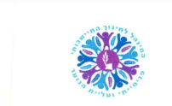 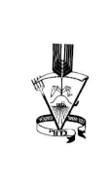

The State of Israel

Kadoorie Agricultural High School

Administration of Rural Education

Ministry of Education

27 June, 2023

18 Tammuz 5783

**Authorization of Study**

It is hereby confirmed that the student Mimon, Moran I.D. # 061233607 studied at our school between 1 September 1995 and 30 June 2000 from grade 8 to 12 and thereby completed 12 years of schooling.

