**Disruptive Technology for Indoor Air Quality Purification and Carbon Capture**

Company Overview & Valuation

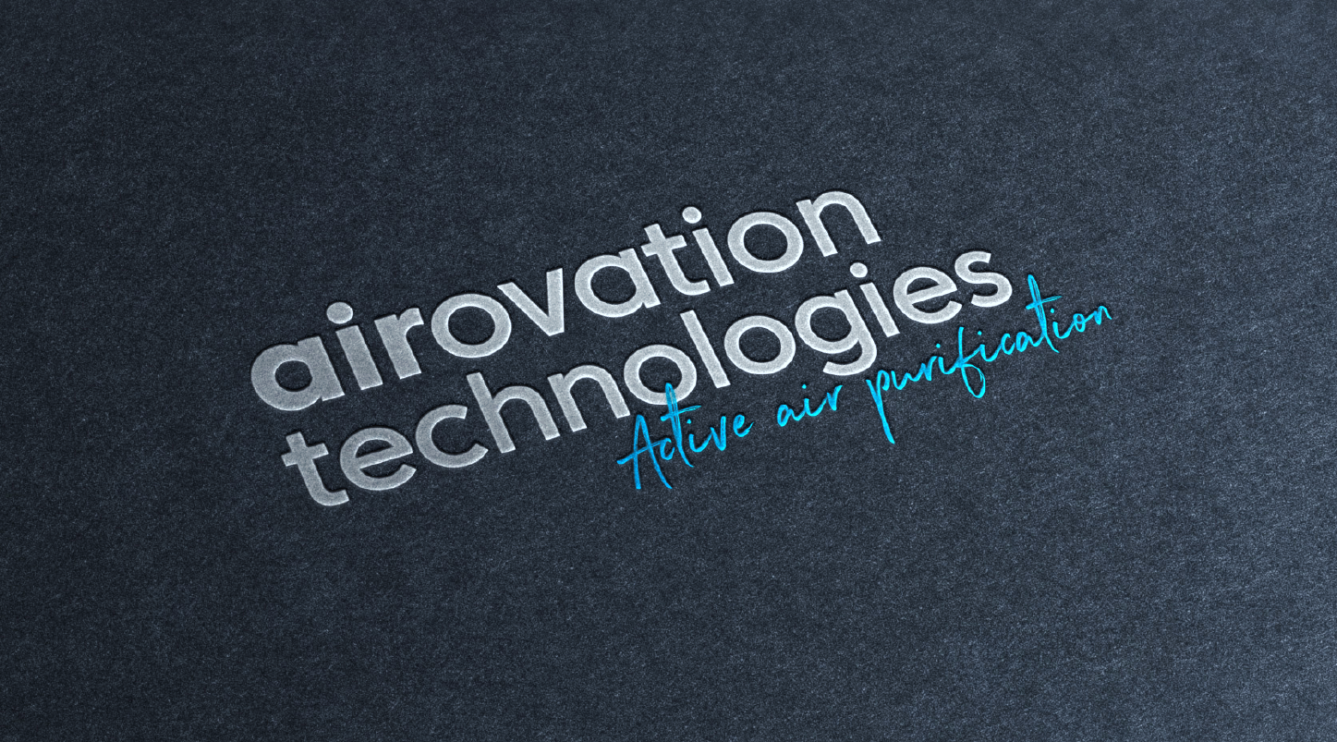

Prepared by

March 2021

**Disclaimer / Information Regarding Airovation Technologies** **and Financial Assessment**

Frost & Sullivan was assigned by Airovation Technologies to provide an independent investment opportunity assessment.

This report was prepared by Frost & Sullivan Business & Financial Services with a purpose of presenting characteristics of Airovation Technologies' market and business to investors and financiers, such as banks, financial institutions, and strategic partners.

The standard of value presented for Airovation Technologies' business is Fair Market Value, which is the price, in cash or equivalent, that a buyer could reasonably be expected to pay, and a seller could reasonably be expected to accept, if the business was exposed for sale on the open market for a reasonable period of time, with both buyer and seller being in possession of the pertinent facts and neither being under any compulsion to act.

Our opinion of Fair Market Value relies on a going concern premise, which assumes that the company will be successful, under the detailed assumptions, in executing its plans and can be viewed as an ongoing business enterprise with management operating in a rational way with a goal of maximizing shareholder value.

Our analysis is based on Airovation Technologies' internally prepared information, as well as information from public and private sources, including sources commonly used in the industry, present at the valuation date. Our opinion might have been different if another valuation date was used.

Frost & Sullivan makes no warranty or representation, express or implied, as to the accuracy or completeness of either the material contained herein or any other written or oral information provided by Airovation Technologies to the recipient, and no liability shall attach thereto.

Nothing contained in this business valuation is, or should be relied on as, a promise or representation as to the future. The projected financial information contained herein was prepared expressly for use herein and is based upon the stated assumptions and Frost & Sullivan's analysis of information available at the time that this business valuation was prepared. There is no representation, warranty, or other assurance that any of the projections set forth herein will be realized. This report does not purport to contain all of the information that may be required to evaluate Airovation Technologies and any recipient hereof should conduct its own independent investigation and analysis of the business described herein.

This document contains forecasts and other "forward-looking statements" relating to future events, identified by words such as "may," "expects," "intends," "anticipates," "plans," "assumes," "predicts," "believes," "scheduled," "estimates," or words of similar meaning. Such statements are based on our current expectations, estimates, projections and assumptions, describe opinions about future events and involve certain risks and uncertainties that are difficult to predict and are not guarantees of future performance. Airovation Technologies' actual results, performance or achievements could differ materially from those anticipated in these forecasts or expressed or implied by such forward-looking statements due to a variety of factors, many of which are beyond our control, including as a result of certain risk factors. Frost & Sullivan disclaims any obligation or commitment to update these forecasts and other forward-looking statements to reflect future events or developments or changes in expectations, estimates, projections and assumptions.

Contents

Investment Opportunity Summary 4 - 9

1. New Era of Wellness Inside Buildings is Powering the Global Indoor Air Quality Systems Market  10 - 15

2. Airovation Technologies: Company Overview  16 - 18

3. Next Generation Solutions in the Global Indoor Air Quality Systems Market and Airovation Technologies' Value Propositions 19 - 29

4. Company Financial Analysis & Valuation 30 - 37

Appendix 1: Capitalization Rate (WACC) for Airovation Technologies 38 - 39

**Investment Opportunity Summary**

**COVID-19 has reset the key aspects of risks and resilience pertaining to indoor air quality (IAQ) and the associated parameters of wellness and well-being within buildings.**

The vision of Airovation Technologies’ is to have an impact the well-being and safety of urban communities with the key objective of air purification. Its overall mission is to deliver routine and emergency treatment solutions in partnership with global OEMs and manufacturers.

Airovation Technologies’ solution represents a world first, as it is the only air purifier that treats viruses, harmful volatile organic compounds (VOCs), and CO2, and generates oxygen.

As businesses and society begin to recover from COVID-19 and return to a post-pandemic era, there will be a renewed and acute focus on hygiene and safety both in homes and on business premises. Pre-COVID studies highlighted the estimated costs of air pollution to the global economy at around US$225 billion, and this is expected to sharply increase in the post-COVID world.

Airovation Technologies provides innovative and patented air purification solutions. Its air purification technology is the fruit of 15 years of collaberative research with the Hebrew University that resulted in a breakthrough oxidizing chemical reaction–based solution. The unique advantages of Airovation Technologies’ solution include the following:

* It offers the only technology in the world that currently treats viruses, harmful VOCs, and CO2, and generates oxygen.
* Its unique patented core technology goes beyond that used by conventional air purifiers, as the superoxide radical placed in the treatment unit is able to eliminate pollutants.
* In comparison to conventional HEPA filter–based air purifiers, Airovation Technologies’ solution is fully effective in:
  + Treating particulate matter (PM) <2.5, as well as converting toxic gases such as CO, NOx, volatile organic compounds (VOCs), and total organic carbon (TOC).
  + Treating bacteria, mold, and other biological contaminants.
  + Reducing the formaldehyde levels.
* In addition, it is capable of reducing CO2 and increasing O2.

*The company*

* Airovation Technologies was established in 2015. Its research and know-how is recognized by the Israeli Innovation Authority (IIA), from which it receives $1M in funding for specific projects.
* Airovation Technologies consists of a strong team of experts who have key skills and expertise in areas such as institutional finance, entrepreneurship, and value creation. They also have subject-matter expertise in mechanical engineering and chemistry for the application markets of air treatment.

*Pilot, joint ventures, and related developments*

* In June 2018, Airovation Technologies prototypes underwent a series of experiments in at Underwriters Laboratories (UL), a third-party laboratory in Northbrook, Illinois, the United States. The tests results confirmed both the stability and efficacy of the technology.
* In September 2018, Airovation Technologies signed a letter of intent (LOI) and collaborated with the Israeli Ministry of Environmental Protection to conduct a proof of concept (POC) for industrial emission treatment in a defense facility plant. The results were monitored and recorded by a certified laboratory.
* In October 2018, Airovation Technologies won the prestigious EU Horizon 2020 Grant in the cleantech category.
* In May 2019, Airovation Technologies finalized its home air purifier POC under the name "H-Air."
* In June 2019, an LOI was received from the Israeli Ministry of Public Security that indicated an interest in the B-Air solution, which provides smoke-free, safe zones in the areas around elevators on each floor of a building in the event of fire by converting the incoming smoke into cooled and breathable air. Airovation Technologies was then invited to deploy its B-Air system at the Israel Fire and Rescue Authority’s training center.
* In October 2019, Airovation Technologies obtained an exclusive license for an additional key patent that strengthened its IP.
* In June 2020, Airovation Technologies signed an agreement with LG Electronics with the objective of licensing its technology in home appliance and HVAC systems.
* Airovation Technologies is currently negotiating a collaboration with a Japanese conglomerate for an application to reduce food transport and storage waste.
* Airovation Technologies is also currently discussing a collaboration with the SK Group in South Korea to target the direct carbon capture and emissions treatment market.

**The Global Indoor Air Quality Systems Market**

* *Size*
  + Total volumes: 22.5 Mn units in 2019 = $7 Bn; 44.1 Mn units by 2026 = $11.94 Bn.
* *Current challenges*
  + High capital investment and high maintenance costs: These represent a major deterrent for the purchase of air purifiers, especially in the residential segment.
  + Lack of enabling regulations to encourage adoption: There have been several recommendations from government and environmental agencies regarding regulations, but there are no mandates as of now.
  + Hazardous by-products: Some air purifiers produce emissions such as ozone or nitrous oxide that pose a severe threat to occupants.
* *Airovation Technologies’ value offering*
  + Provides safe and clean air that is free not only from PM 2.5 but also from viruses and CO2, and enriches air quality by increasing the amount of pure oxygen;
  + Improves productivity and safety in offices and schools by eliminating viruses as well as CO2 via a single device.

**Global Carbon Capture Market**

* *Size*
  + The climate calculations of various agencies suggest a need for 10–20 Gt CO2 per year. At an average cost of $50–100/ton for capture and removal, this will create an industry that is at least three times as large as the current oil and gas (O&G) industry.
* *Current challenges*
  + There are no known solutions for capturing carbon at any cost above 38 Gt CO2e/year.
  + The cost of carbon abatement rises quickly at larger volumes to over $1000 Gt CO2e/year; this cost should ideally be below $100 per ton to ensure economic viability.
  + Global figures are already moving toward 80 Gt CO2e/year.
  + No carbon technology is currently able to address legacy CO2 removal, which constitutes 95% of the CO2 abatement problem.
* *Airovation Technologies’ value offering*
  + Airovation Technologies offers next-generation technologies that are tackling the carbon capture issue at a more fundamental level by monetizing captured CO2 and creating directly useful products.
  + Airovation Technologies takes a highly modular approach to technology.
  + The company boasts an impressive x%+ carbon capture efficiency that meets or exceeds industry standards and causes the smallest environmental footprint, far outperforming competing technologies.

**We see three layers of investment opportunity in Airovation Technologies:**

* **License fees and royalties related to hardware, chemistry, and software;**
* **Product as a service model with a maximal focus on selling Air O's proprietary consumable chemical cartridges.**

**However, like any technology firm, Airovation Technologies is in the scale-up phase, with proven technology and the initiation of vast sales. Consequently, we see more of a challenge in the marketing/sales side than in the technology aspects.** Thus, Airovation Technologies is seeking investments to boost its marketing and business development efforts.

**1. New era of Wellness inside buildings is powering the Global Indoor Air Quality Systems Market**

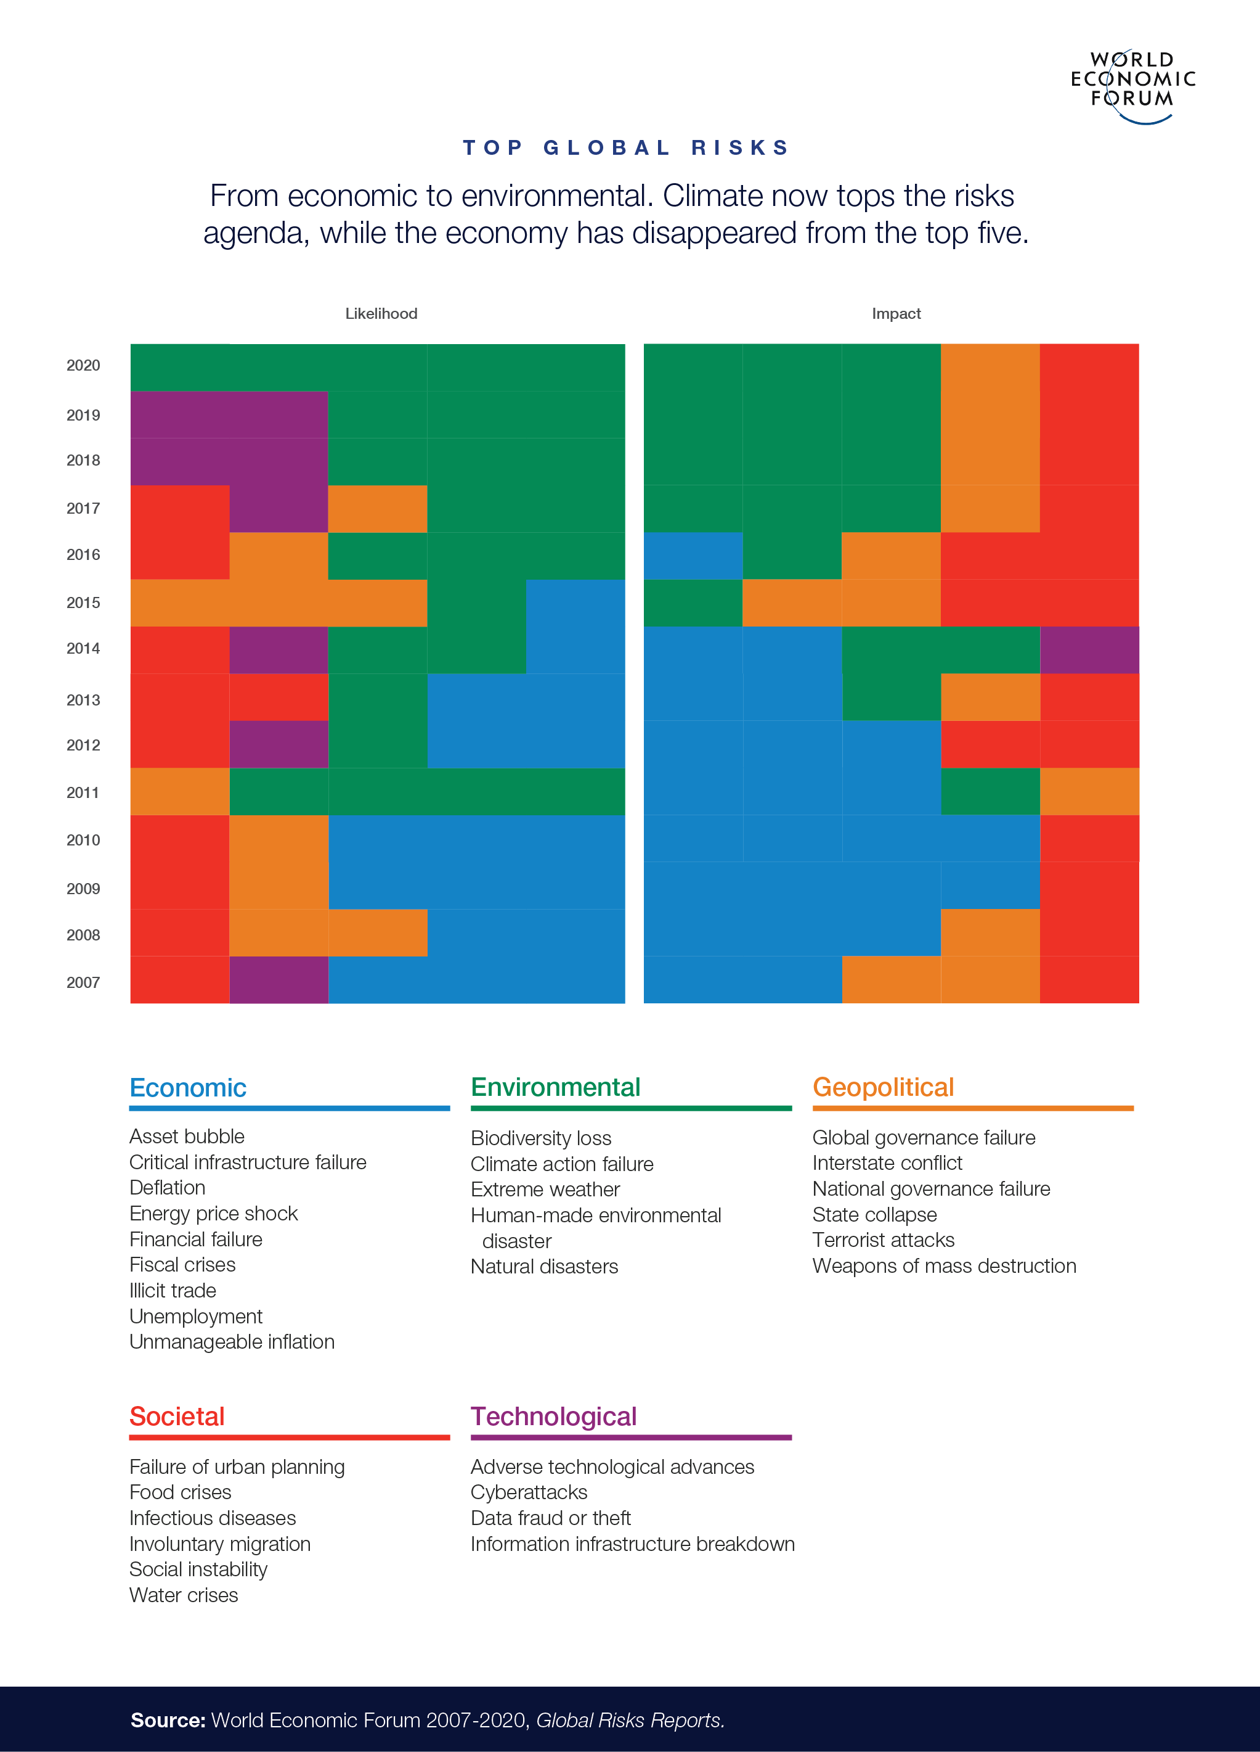The Global Risks Report 2020 of the World Economic Forum (WEF) for the first time had environmental risks in its Top 5 Risks – Climate action failure, Biodiversity loss, Extreme weather, Human-made environmental disaster and Natural disasters. With a lack of political consensus, there is an urgent need for the other stakeholders such as industry and financial institutions to partner and collaborate across industry value chains under the framework of the Sustainability Development Goals in building a resilient world in the face of the current socio-economic challenge presented by COVID-19.



Sources: World Economic Forum

Sustainability Development Goals (SDG's) adopted at the 2015 United Nations Summit provides the principles, framework and targets for all the stakeholders across the value chains to identify key development areas to enhance and seek continual improvement with regards to sustainability, good health and well-being and climate action.

**Figure 1: The 17 United Nations Sustainable Development Goals(SDG's)**



All the 17 SDG's have a strong role to play in ensuring a systemic shift for socio-economic and environmental improvement. SDG 3 – good health and wellbeing is playing an increasing important role with an overall objective of ensuring healthy lives and promote well-being for all at all ages. COVID-19 has already highlighted instances where it can pose significant stress and at times also overwhelm some of the established healthcare systems – it also has the potential to reverse significant improvements made in healthcare systems globally.

In October/November 2018, the First World Health Organisation(WHO) Conference on Air Pollution and Health was convened in Geneva under the theme – Improving Air Quality, Combating Climate Change: Saving Lives. With diseases and deaths from air pollution estimated to be around 7 million lives a year- there was strong consensus for an urgent and global response. One of the goals set in the 'Geneva Action Agenda to Combat Air Pollution' at the conference was to reduce the number of deaths from air pollution by two thirds by 2030

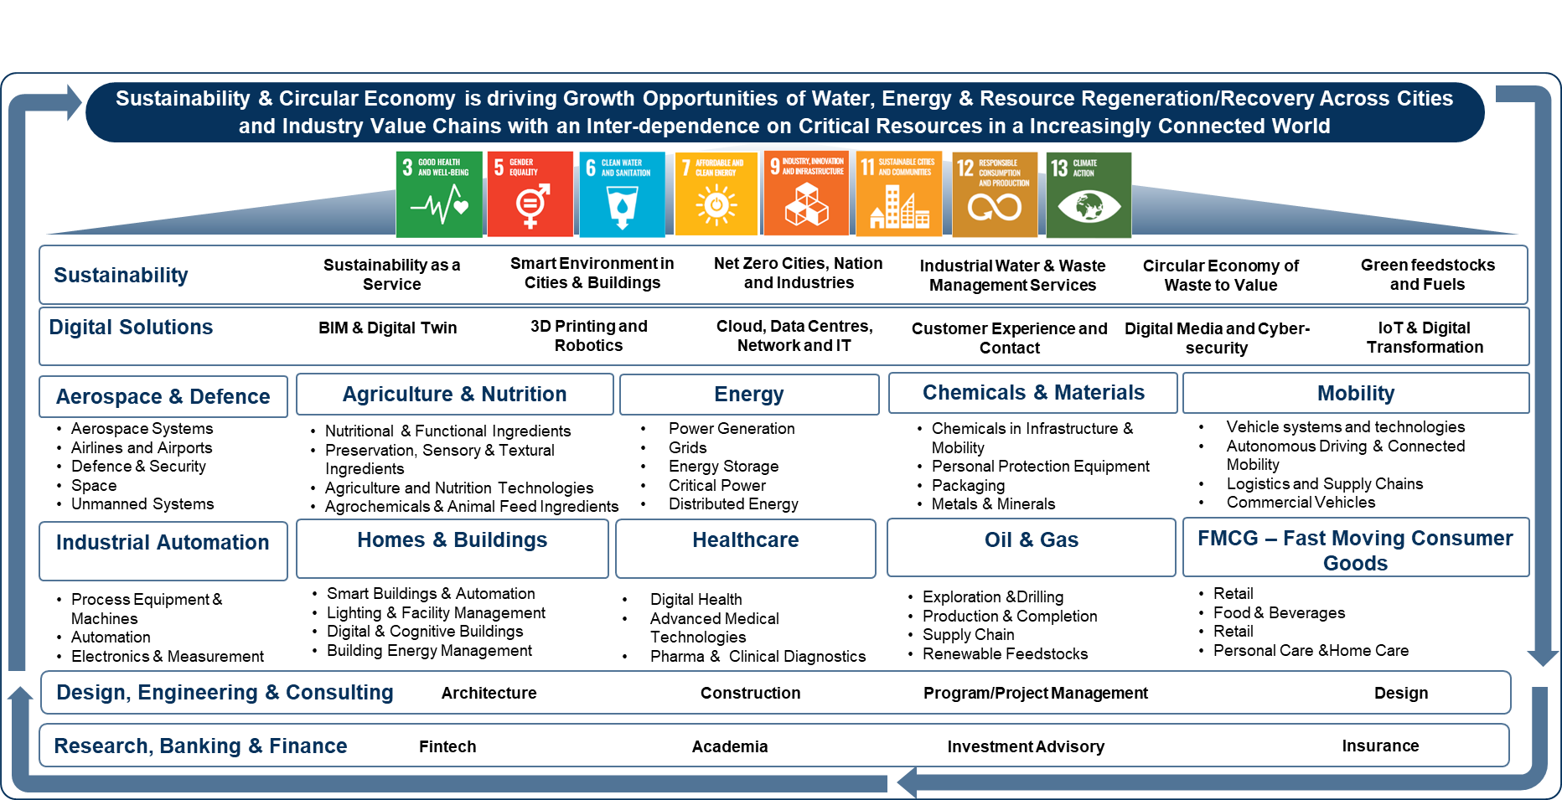**Digital Sustainability in the New Normal**

Sustainability and Circular Economy is driving opportunities for air purification in the Homes and Buildings segment. Key digital solutions such as BIM and Digital Twin as well as sustainability themes such as sustainability as a service, smart environment in cities & buildings as well as net zero cities will draw on the inter-dependence on critical resources in an increasingly connected world.

The efforts to tackle air pollution has contributions to multiple SDG's – the main being SDG 3 for good health and well-being, SDG 7.2 – access to clean energy in the home, SDG 11.6 on air quality in cities, SDG 11.2 on access to sustainable transport and SDG 13 on climate action.

Though air quality monitoring and air purifying products are mostly targeted towards B2C customers, B2B remains a lucrative market that can boost a company's earnings.

Suppliers are building on the SDG-driven priorities of B2B customers and rapidly evolving circular economy business models to position themselves as strategic partners to customers in the journey. Building owners with multiple properties, corporate offices, and large hospitality buildings present a lucrative opportunity for adding a consistent revenue stream.

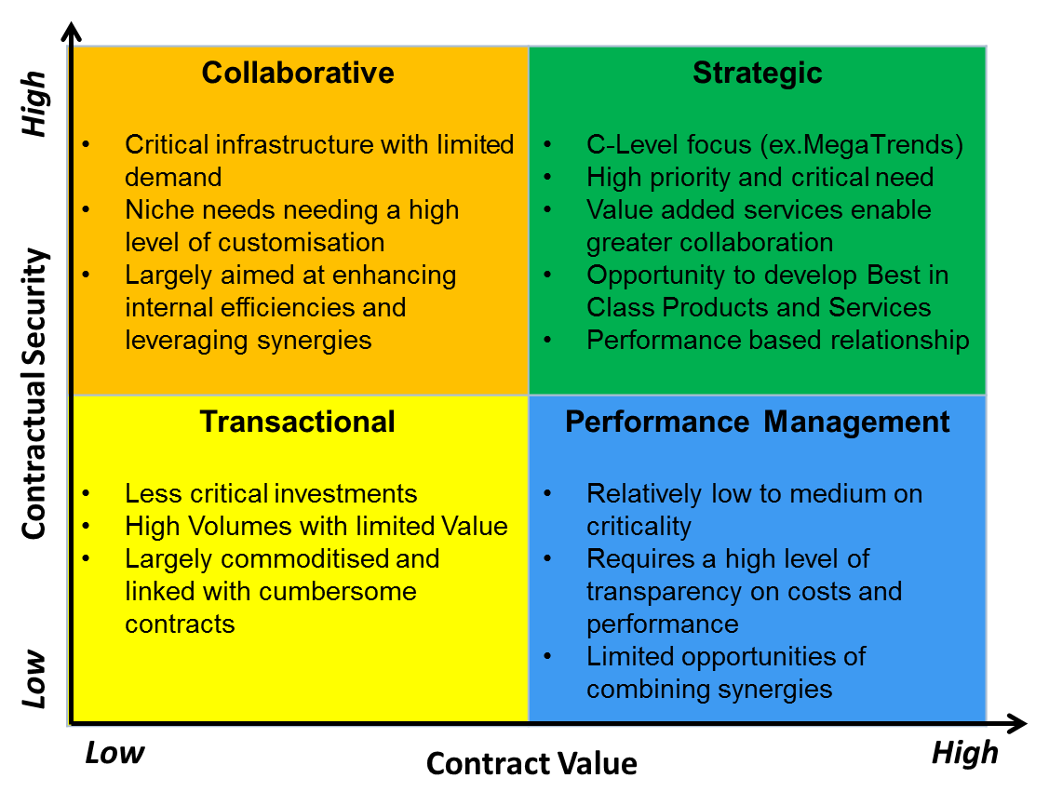**Figure 2: Sustainability As a MegaTrend and C-Level Focus in the Strategic Quadrant**

Sources: Frost & Sullivan

The WHO has clearly highlighted that air pollution as a global health priority as it affects more than 90% of the world population. Various studies have also highlighted the extreme negative costs to economies both in terms of healthcare as well as productivity costs.

**Figure 3: Global PM 2.5 Pollution Levels, Top 20 Cities, 2019**

|  |  |  |
| --- | --- | --- |
| **Rank** | **City, Country** | **2019 AVG** (µg/m³) |
| 1 | Ghaziabad, India | 110.2 |
| 2 | Hotan, China | 110.1 |
| 3 | Gujranwala, Pakistan | 105.3 |
| 4 | Faisalabad, Pakistan | 104.6 |
| 5 | Delhi, India | 98.6 |
| 6 | Noida, India | 97.7 |
| 7 | Gurugram, India | 93.1 |
| 8 | Raiwind, Pakistan | 92.2 |
| 9 | Greater Noida, India | 91.3 |
| 10 | Bandhwari, India | 90.5 |
| 11 | Lucknow, India | 90.3 |
| 12 | Lahore, Pakistan | 89.5 |
| 13 | Bulandshahr, India | 89.4 |
| 14 | Muzaffarnagar, India | 89.1 |
| 15 | Bagpat, India | 88.6 |
| 16 | Kashgar, China | 87.1 |
| 17 | Jind, India | 85.4 |
| 18 | Faridabad, India | 85.0 |
| 19 | Coraut, India | 85.0 |
| 20 | Bhiwadi, India | 83.4 |

Source: IQAir

COVID-19 has certainly stepped up the focus on indoor air quality monitoring and management. As governments are setting out plans to tackle the pandemic with roll-out of vaccination programs – there is also a thought that this particular virus or similar and contagious viruses can become ever more frequent in the years to come. Therefore there is a need for a strategy to see how homes and buildings can be equipped with better systems to enhance resilience and minimize risk. Recent research has also highlighted that enhancing indoor air quality(IAQ) has the potential to reduce aerosol transmission of viruses as compared to vaccinating 50% to 60% of the population.

Quality of air, both outdoors and indoors, has been deteriorating and has failed to meet the safe levels prescribed by the WHO. Several countries have taken measures to reduce air pollution and improve the standard of living by encouraging green or sustainable transportation. However, there are still hotspots across the world, especially in APAC, where the air quality is inferior as compared to WHO standards.

Though there is no direct correlation between COVID-19 and air pollution, researchers in Italy have found coronavirus in air pollution samples. Air pollutants might act as a carrier for this virus, thereby increasing chances of its airborne transmission. As a result, air quality system manufacturers are working towards educating end users by raising awareness about air pollution in the new normal.

A decline in prices of air purifiers due to the market entry of consumer-appliance brands is also expected to drive the demand further. Seasonal demand in several countries serve as the peak demand periods – examples are the stubble burning in Punjab and Haryana during winters in India, bushfires in Australia during peak summer, and the wildfires in California spanning two seasons.

**2. Airovation Technologies: Company Overview**

**Airovation Technologies** has developed the world's first air purifier that treats viruses, harmful VOC's and CO2 while also generating valuable oxygen.

Figure 4: The Unique Patented Core Technology



Source: Airovation Technologies

***The Technology***

Airovation Technologies has a unique and patented technology developed on the back of 10 years of research at the Hebrew University in Israel. The technology brings in a new value proposition to the air purifier market as it not only purifies the air but it also eliminates viruses, harmful VOC's as well as converting CO2 into valuable oxygen.

The technology is based on generating, stabilizing and controlling superoxide radical in a liquid phase- which forms a core part of the technology.

The key value proposition of the Airovation Technologies solution is to enable next generation indoor air purification with the following distinct offerings:

* Full treatment of PM <2.5
* Full conversion of toxic gases such as CO, NOx, VOC and TOC
* Reduction of CO2 and enhancing O2 levels
* Full treatment of bacteria, mold and other contaminants

**Box #.1: Competitive Advantage of Airovation Technologies Air Purifier technology in comparison to standard HEPA filter based air purifiers**



Couple of value-add and unique benefits of the Airovation Technologies air purifier are - decrease CO2 levels and increase O2 levels – which in return significantly increases productivity and performance in environments such as offices and schools

Airovation Technologies is pursuing a clear three-stage roadmap for market entry:

1. Market adoption in leading regional market such as South Korea – Adoption of the solution by Korean home appliance manufacturer provides a strong launch for the product in a mature market with a strong acceptance for innovative and sustainable solution.
2. Licensing, OEM and Strategic Partnerships with global partners – Building on the adoption in leading regional market to establish itself as an industry benchmark and also increase adoption with licensing models with leading OEM's in key regional markets.
3. Product as a Service(PaaS) – Build on prior two points to then focus on the selling Air O's proprietary consumable chemical cartridges.

**The Airovation Technologies business model is to be a B2B service platform to accelerate collaboration and partnership in target segments of indoor air purification and carbon capture and conversion. It aims to have multiple revenue streams that will grow and compound over time and comprise of – a technology license fee and recurring PaaS payment.**

**We will focus on indoor air purifier market as the main growth engine for Airovation Technologies future operations.**

**3. Next Generation Solutions in the Global Indoor Air Quality Systems Market and Airovation Technologies' Value Propositions**

**Key Takeaways**

* **Frost & Sullivan estimates the market for IAQ systems was worth $7.00 billion in 2019. Indoor air purifiers with in-built monitors are the most sought product ahead of standalone air quality monitors.**
* **Partnerships with building management system (BMS) and heating, ventilation, and air condition (HVAC) solution providers; affordable pricing; ability to track and contain multiple pollutants, and a multi-channel growth strategy are the top success factors in this market.**
* **Indoor air purifiers and monitors are gaining widespread popularity due to their effect in reducing asthma and other breathing related ailments. The impact of COVID-19 has added momentum to the already growing market. Though manufacturers do not expect a manifold growth in 2020, they agree that the growth will be significantly higher than before.**
* **Institutional building segments comprising schools and hospitals will witness massive growth during the forecast period followed by transport and public buildings. Offices are likely to increase spend on improving air quality while the residential segment will maintain its current growth.**

Quality of air, both outdoors and indoors, has been deteriorating and has failed to meet the safe levels prescribed by the WHO. Several countries have taken measures to reduce air pollution and improve the standard of living by encouraging green or sustainable transportation. However, there are still hotspots across the world, especially in APAC, where the air quality is inferior as compared to WHO standards. With the COVID-19 situation, the focus on air quality is more than ever. Though there is no direct correlation between COVID-19 and air pollution, researchers in Italy have found coronavirus in air pollution samples. Air pollutants might act as a carrier for this virus, thereby increasing chances of its airborne transmission. Air quality system manufacturers are working toward educating end users by raising awareness about air pollution through promotional activities. This is expected to boost the demand for these systems. A decline in prices of air purifiers due to the market entry of consumer-appliance brands is also expected to drive the demand further.

Seasonal demand in several countries serve as the peak demand periods; examples are the stubble burning in Punjab and Haryana during winters in India, bushfires in Australia during peak summer, and the wildfires in California spanning two seasons.

**Figure 5: IAQ Systems Market: Top Air Purification Technologies, Global, 2019**

|  |  |  |
| --- | --- | --- |
| **Technology** | **Advantages** | **Disadvantages** |
| HEPA Filters | * Effective in removing 99.97% of 0.3-micrometer particles * No ozone production or other harmful by-products | * Noisy and have a short lifespan * High energy consumption * Ineffective in removing viruses, harmful gases, and odors |
| Activated Carbon | * Effective in removing viruses, harmful gases, and odors | * Short lifespan * Ineffective in removing airborne particles |
| Ionization | * Electrostatic filters are washable and supposedly reusable, thereby incurring low maintenance costs. * Ionization increases the efficiency of capturing contaminants without using chemicals. | * Surfaces must be cleaned regularly to remove ionized particles * Ozone production |
| Ultraviolet Germicidal Irradiation (UVGI) | * Effective in sterilizing air that passes through UV lamps via forced air | * Ineffective in removing airborne particles |
| Electrostatic filters | * Able to remove airborne particles, viruses, and odors * Relatively longer lifespan | * May not less effective than traditional filters |

Source: Frost & Sullivan

Frost & Sullivan recently analyzed the Global IAQ Systems Market, focusing on the three market segments of IAQ monitors and purifiers, humidifiers and dehumidifiers, and software/analytical services.

**Figure 6: Indoor Air Quality Systems Market—Key Segments**

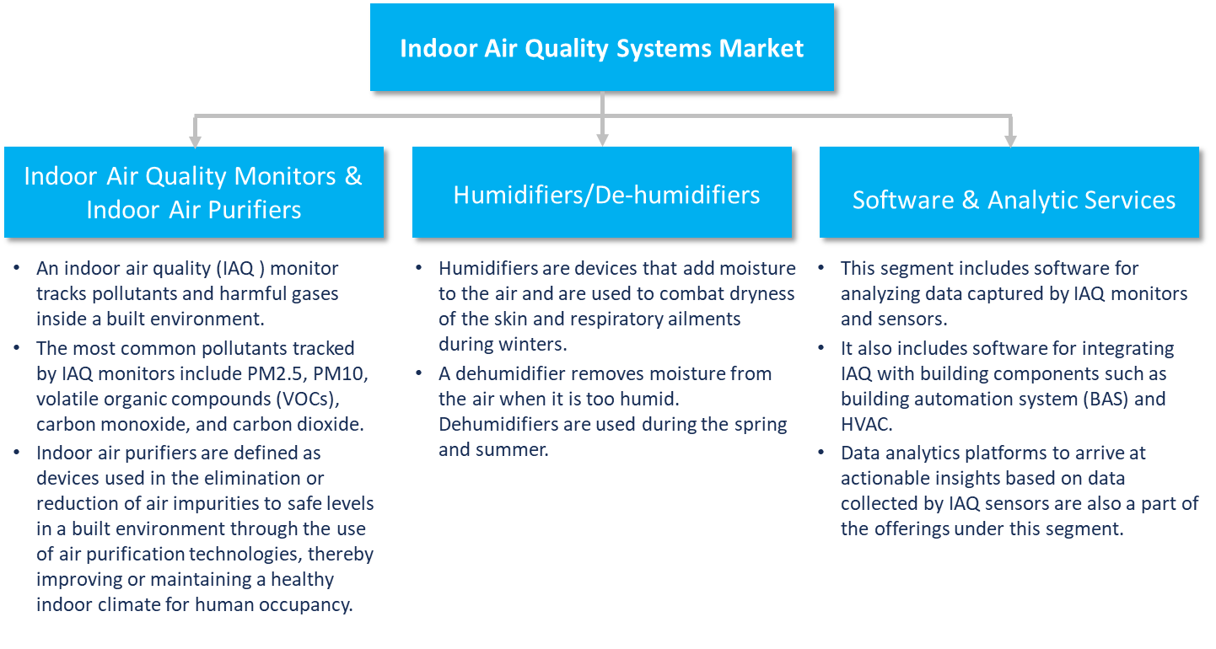

Source: Frost & Sullivan

Frost & Sullivan analyzes market prospects and potential based on force field analysis using key market drivers and restraints. The shortlisted drivers are then ranked based on the intensity of their impact (low–medium–high) over the intervals of the forecast period.

The leading market drivers include rising pollution levels and deteriorating air quality in major cities, in addition to increased consumer awareness about poor air quality. Closely following these is rising concern over the growing incidence of airborne diseases, especially in light of the severe impact of COVID-19.

The uppermost restraint is the high capital investment, and high maintenance costs are also a major deterrent for the purchase of air purifiers, especially in the residential segment. In addition, there are few enabling regulations encouraging adoption.

**Figure 7: Indoor Air Quality Systems Market: Growth Drivers, Global, 2020–2026**

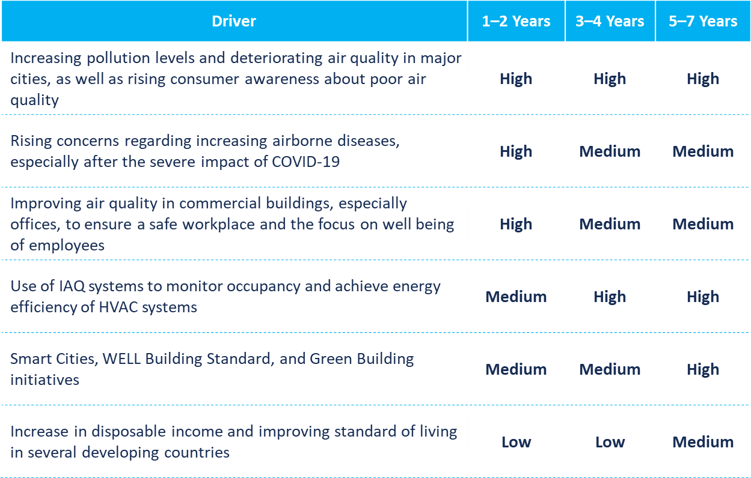

Source: Frost & Sullivan

**Figure 8: Indoor Air Quality Systems Market: Growth Restraints, Global, 2020–2026**

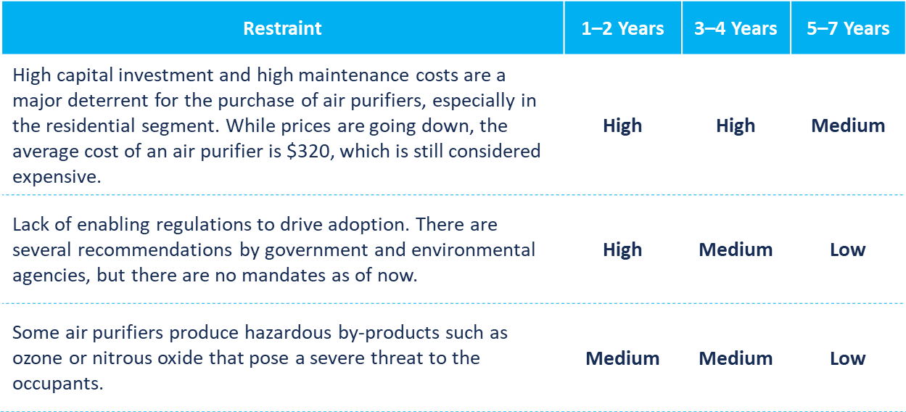

Source: Frost & Sullivan

The Global Indoor Air Quality(IAQ) Systems Market is estimated to be around $7 bn in 2019 and with a CAGR of 7.9% is set to reach $11.94 Bn by 2026. The market is witnessing a high degree of innovation with the "Degree of Technical Change" estimated to be at a high of 8 on a scale of 1 to 10.

**Figure 9: Indoor Air Quality Systems Market: Key Metrics, Global, 2020-2026**

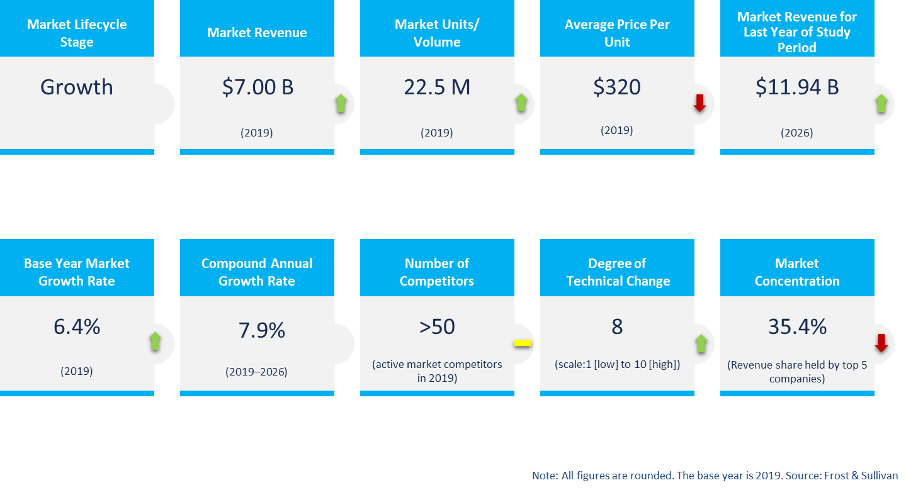

The IAQ Systems market is also witnessing a strong growth in the key segment of software & analytics – building on the increasing installation of indoor air quality monitors in the treatment systems that generate valuable data that support the growing number of tools.

The price of IAQ systems varies across geographies and also acorss product segments when clustered as base, mid-segment and premium segment. The average price is the highest in North America for all three product segments.

|  |  |  |  |  |
| --- | --- | --- | --- | --- |
| **Average Price of IAP & Monitor ($ per unit)** | **North America** | **Europe** | **Asia Pacific** | **Rest of the World** |
| **Premium** | 550 | 535 | 525 | 510 |
| **Mid-segment** | 350 | 330 | 350 | 315 |
| **Base-segment** | 200 | 180 | 150 | 150 |

The price of an air quality monitor or an air purifier is determined by factors such as the type of filter technology used, different types of pollutants it monitors, size and grade of filters, coverage area, and CADR. CADR is an indicator of how much air is cleaned and sent back into the environment.

Sensors used to measure particulate matter (PM), VOC, and other harmful gases account for a major component of the selling cost of air quality monitors. The signals from sensors are important in determining the level of PM and VOC in the air.

Sensors developed for indoor air quality monitoring are getting more precise with faster response times. Low-cost sensors are gaining more traction but their sensitivity to external conditions is a cause of concern.

**Figure 10: Indoor Air Quality Systems Market: Revenue by Product Segment, Global, 2020-2026**

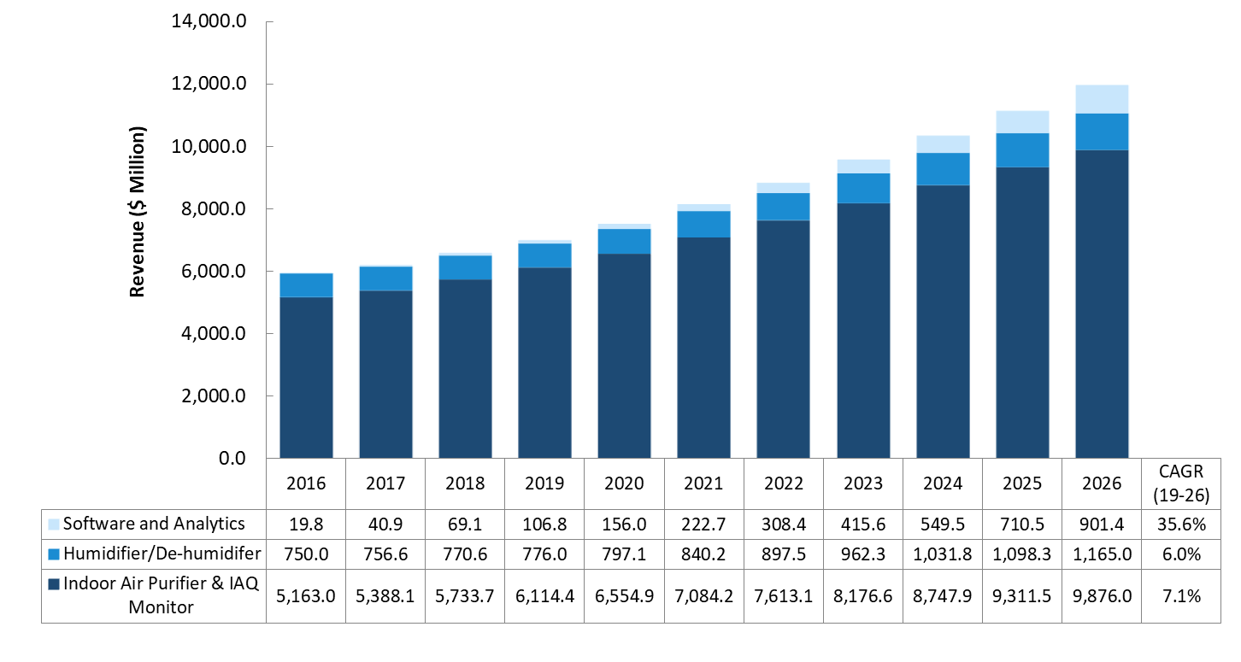

Source: Frost & Sullivan

Indoor air quality monitoring market will continue to grow on the back of advanced data monitoring and predictive analytics solutions offered by product manufacturers. Real-time, continuous measurement by IAQ monitors can be used to detect pollutant sources and provide information on the variation in pollutant levels throughout the day, and also over a course of weeks or months.

Increasing focus on health and well-being of the occupants in a building will prompt building owners and facility managers to install IAQ monitors in their premises. With rising concerns over airborne transmission of COVID-19, IAQ monitors will be expected to track harmful viruses and bacteria that cause diseases. R&D focus on developing sensors to identify and track disease-causing pathogens will be on the rise. Makers of HVAC equipment will partner with IAQ system manufacturers to integrate air quality monitors, especially in their ventilation systems to ensure clean air circulation within a building.

Software and analytical services for the indoor air quality systems market is expected to register a whopping 35.6% growth in the forecast period, driven by the need for insights on tackling air quality inside a building. The need for real-time monitoring, preventive maintenance of HVAC systems, and adjusting ventilation inside a built environment will be major drivers for the growth of software services.

Software that predict the quality of indoor air by tracking outdoor pollution and traffic, and suggesting ways to tackle it, will be in high demand. Web-based software that is compatible with multiple products will be preferred by residential customers whereas commercial customers might opt for proprietary software that can track specific pollutants based on their location and historical data.

**Figure 11: Indoor Air Quality Systems Market: Revenue by Region, Global, 2020-2026**

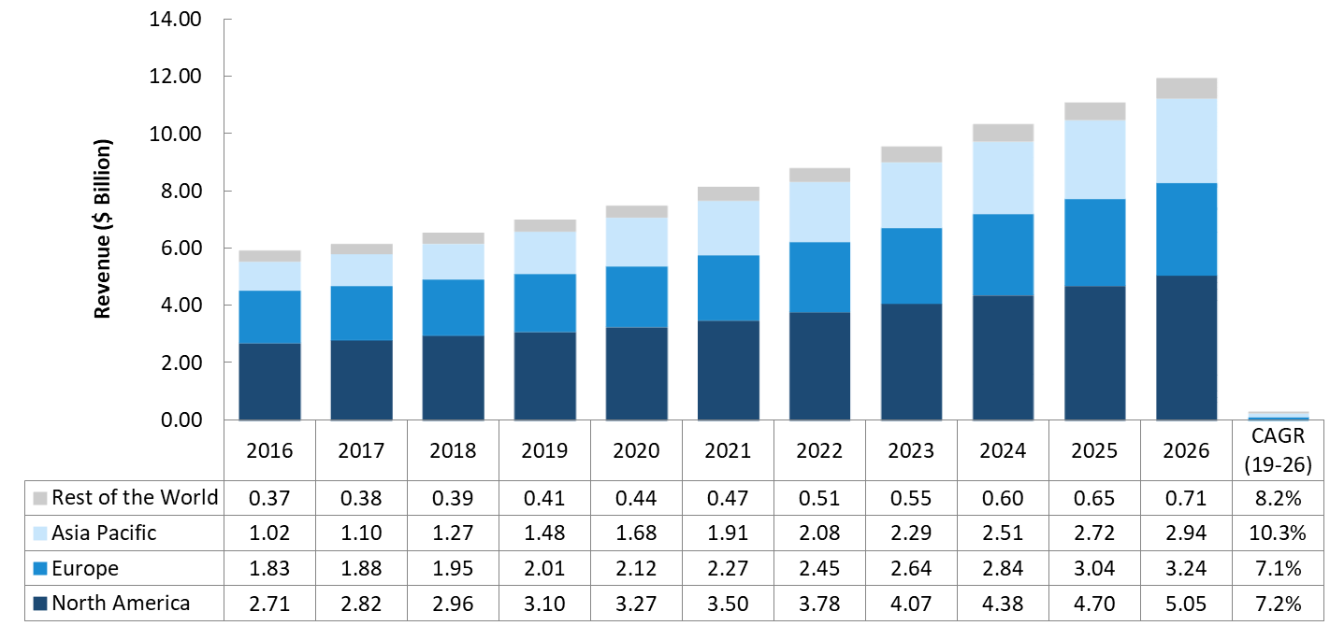

North America is the leading regional segment in the global IAQ systems market with an estimated revenue of $3.1 bn in 2019. Rising vehicular traffic and CO2 emissions from industries are leading to a rise in respiratory diseases, consequently improving the sales of air purifiers across the region. The rise in natural calamities, ranging from forest fires to heat waves, affects the environment, resulting in outdoor and indoor pollution.

Europe with a revenue of $2.01 Bn is the second largest regional market. The European Union (EU) has formulated a clean air policy which is based on ambient air quality standards, national air pollution control programs, and emission and energy efficiency standards for vehicle emissions. More fatalities are reported due to respiratory illness, which will increase the focus on usage of air purifiers and air quality monitors in the future.

APAC with revenue of $1.48 bn. Rapid urbanization and deteriorating air quality in the APAC region coupled with increase in consumer spending is set to drive growth momentum for the region. Annual stubble burning remains a common practice across India, China, and parts of Southeast Asia, compounding the problem of air pollution in the region. Forest fires in Indonesia spread toxic haze to nearby countries including Malaysia, Singapore, Thailand, and Vietnam. Bushfires in Australia are a regular phenomenon that results in property damage and loss of life. The IAQ systems market in the region is expected to grow at a rate of 10.3% over the next 6 years, making it the second largest market after North America in 2026.

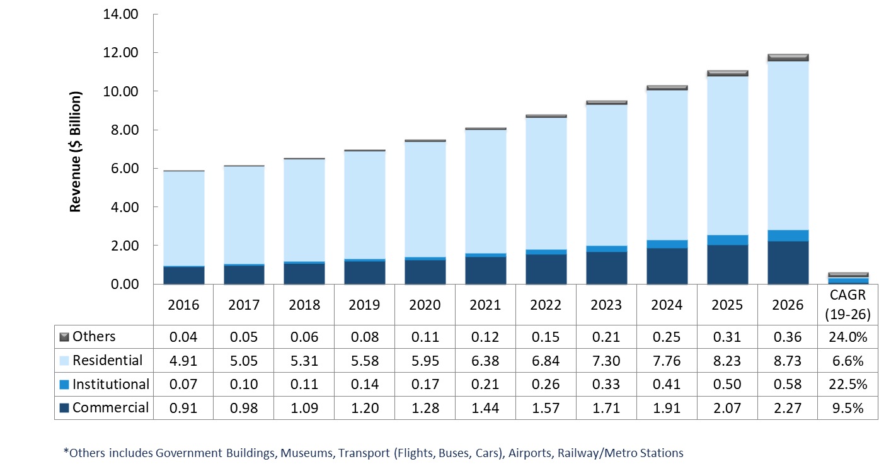**Figure 12: Indoor Air Quality Systems Market: Revenue by Vertical, Global, 2020-2026**

Residential is the most established and mature segment with estimated revenue of $5.58 bn in 2019 followed by commercial segment estimated to be around $1.2 bn.People spend an average of 10 to 12 hours in their homes every day. Dust particles and pollutants from vacuuming carpets and window shades, soot and smoke from kitchen, and outdated or uncleaned HVAC systems can trigger health issues in residences. Residents of densely populated countries in APAC and other health-conscious European countries will be the major adopters of IAQ solutions in the future. The residential segment will remain the largest vertical through 2026, growing at a CAGR of 6.6% from 2019.

The fastest growing segment is the institutional – comprising of schools – with growth estimated to be around 22.5% over the forecast period. Educational and healthcare buildings need better air quality as they house people who are more susceptible to illness. Schools and colleges with laboratories, packed classrooms, and assembly halls are more likely to suffer from lead, asbestos, and radon contamination and effects of outdoor pollution. Poor air quality inside hospitals can lead to delays in recovery or trigger new complications in patients and hospital faculty. These factors make the segment highly attractive for market participants.

The commercial buildings space is one of the most exciting markets for IAQ systems. Air purification technologies and air filtration in HVAC systems are the products in demand within the commercial segment. Software and analytics to monitor air quality that has a direct correlation to workplace productivity and occupant well-being will also be in demand in this commercial segment. New York, London, Tokyo, Los Angeles, Paris, Shanghai, Hong Kong, Singapore, Sydney, Toronto, Munich, and Beijing are the global hotspots for commercial real estate that are witnessing an increase in demand for air quality solutions.

The demand for IAQ systems in the transportation sector and public buildings is expected to catch up faster. In-vehicle pollution is high inside cars and buses as emissions from other vehicles and pollutants enter through air vents and other openings.

Similarly, buildings that see large public gatherings like museums and concert halls are also wary about the effects of indoor air pollution. IAQ systems designed for installation in vehicles and equipped with high Clean Air Delivery Rate (CADR) will be in high demand.

**Competitive Landscape**

The Global Indoor Air Quality Systems Market is relatively fragmented with the top five players accounting for about one-third of the cumulative market share. Recent trends indicate that several prominent consumer appliance brands will look to enter the market to exploit the opportunity.

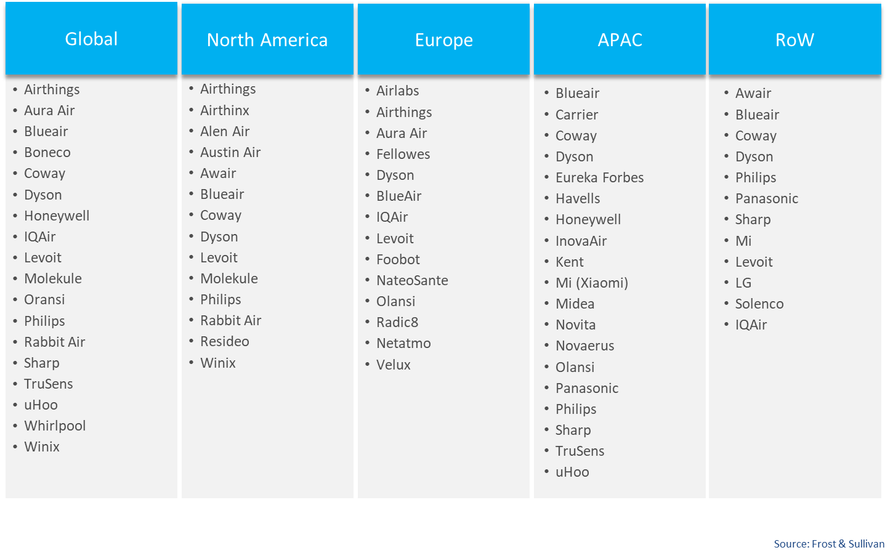

The competitive environment of the global indoor air quality systems market comprises of more than 100 competitors in a relatively fragmented market.. The top 5 competitors have a cumulative market share of 35.4%.

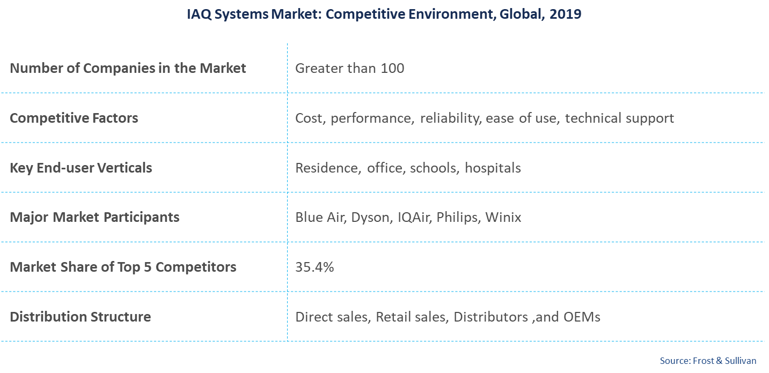

The tier-share of the leading players in the global indoor air quality systems market is presented in the figure below.

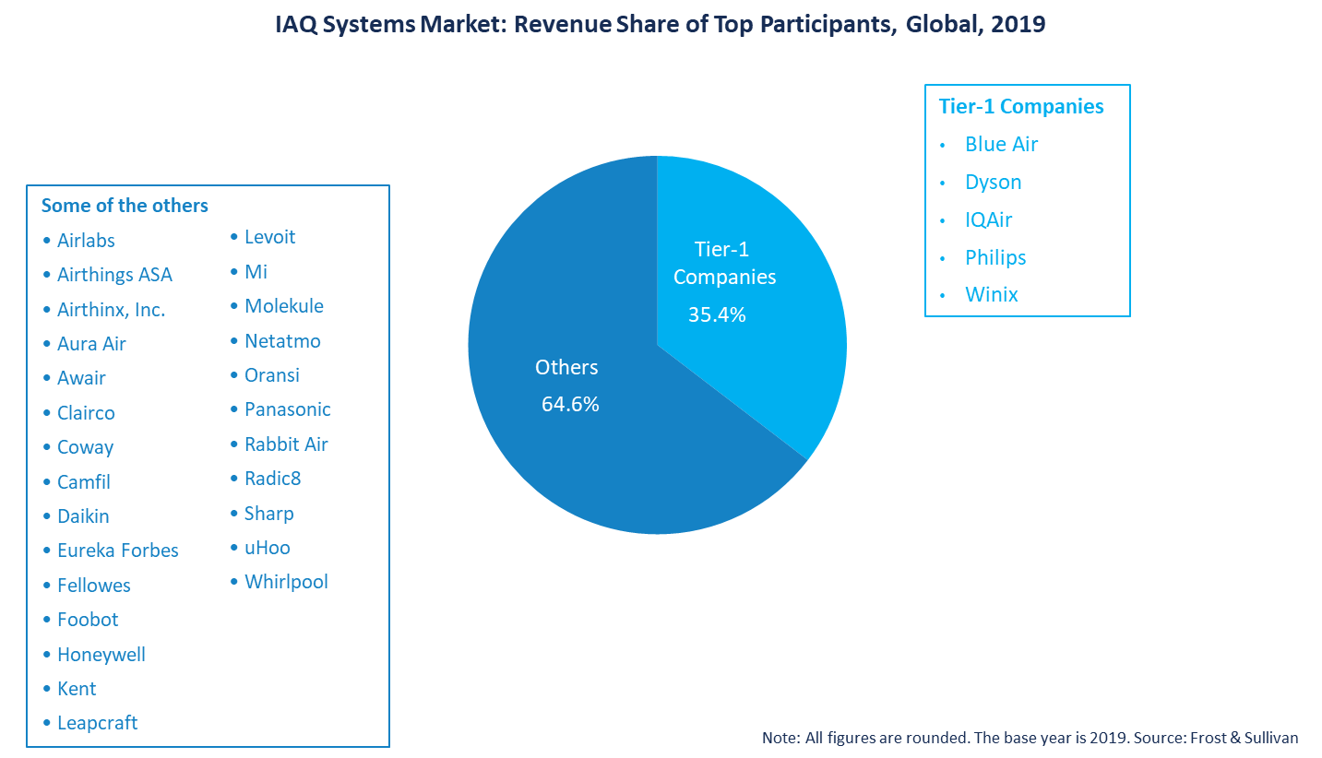

**4. Company Financial Analysis & Valuation**

**Valuation method & approach**

The valuation of a startup company in its early stages can be challenging due to limited cash flow (if any) and uncertainty regarding the future. As part of a Discounted Cash Flow (DCF), the accepted method used in financial valuations, there are several modifications to a startup company's valuation. In general, there are three primary methods within the DCF method:

1. Real options - valuation method designated for pre-clinical and early-stage clinical programs/companies where the assessment is binary during the initial phases and based upon scientific-regulatory assessment only (binomial model with certain adjustments).
2. Pipeline assessment - A valuation method used for early-stage companies before the market stage where time-to-market may be a few years for full operations. The company's value is the total discounted cash flow for its products/signed agreements plus unallocated costs and its technology platform assessment.
3. DCF valuation - this method applies to companies with products that have a positive cash flow from operations.

Airovation Technologies doesn't have revenues yet; however, it has a solid business model accompanied by signed LOIs with leading global conglomerates. Therefore, Airovation Technologies' valuation was conducted under the DCF valuation method. We also explored recent deals as a benchmark for Airovation Technologies' value.[1]

**Valuation by DCF Method**

Airovation Technologies was founded in 2015 and is an Air-tech solutions provider. The company has an air treatment technology that uses its patented chemical reaction to convert gases and biological indoor air threats into safe and breathable air. **The company is also expanding its operations to the carbon capture market.** The company targets the carbon capture market since its technology applies to that use-case and since it has promising business potential. To date, the company didn't have revenue and is expected to have initial sales in 2022 in the Asia Pacific region. In our revenue forecast, we accounted for a royalties business model.

Airovation Technologies' main revenue stream:

1. Air Purifiers - the company developed a versatile product that can be used for residential or commercial purposes. The company mainly focuses on the commercial client segment, including offices, hotels, hospitals, and other public indoor spaces. The device enables controlled indoor air quality; gas levels can be measured, treated, and balanced. The system's output is a cooled and balanced blend of oxygen, hydrogen, and nitrogen specifically designed to match ideal breathing conditions. The device can operate in several different modes, each leading to different air quality results. The device can also react in real-time to changes in air quality.
2. Cartridges - The Company developed a compatible cartridge for its air purifiers. The lifespan of the cartridge may vary depending on usage mode and the environment air quality.

**In our view, at this point, the carbon capture business vertical has a vast business potential; however, as we maintain a conservation outlook, we did not include it in our valuation. Therefore, we considered in our model only air Purifies and cartridges revenue.**

**Revenue (Indoor) Forecast**

We estimated the company value based on data received from the company and our team analysis while using the procedure and parameters that are described below.

* Total Air Purifies Revenue was calculated based on the following process:
  + Air purifiers' **global market size** and growth estimations, focusing on the company's target markets: Asia Pacific, Europe, North America, India, China, and Latin America.
  + Then, we applied an estimated **premium factor** of 10%-20% to quantify the B2B/average-premium segment size for each market.
  + Later, we applied an expected **penetration rate** for the company in each market. We estimated a lower penetration market in the first years, with gradual growth over the years. By 2027, we anticipate that Airovation Technologies air purifiers sold will reach approx. 1.5%-2% of the global units sold of air purifiers.
  + Total units sold = Global market size * Premium factor * Penetration rate.
  + Total Air Purifies Revenue = Total units sold * 5% Royalties payment.

Based on its business model, Airovation Technologies will be entitled to receive a 5% royalties payment for each air purifier sold.

* Total Cartridges Revenue was calculated based on the following process:
  + Total number of Cartridges sold per year = Number of air purifiers sold in the current year + number of cartridges sold in the past year.
  + Based on current price levels, we estimated the annual willingness to pay for cartridges and used it as a benchmark in our model.
  + Total Cartridges Revenue = Total number of Cartridges sold per year * 7% Royalties payment.

Based on its business model, Airovation Technologies will be entitled to receive a 7% royalties payment for each cartridge sold.

* Air purifies sales are expected to begin in 2022. We estimated that the company sales would start initially in Asia pacific and gradually expand to Europe and North America during 2023; India and China during 2024, and eventually to Latin America in 2025. We accounted for a growing penetration rate for each market.
* Further, we conservatively assumed a gradual price decrease for both air purifiers (~33% decrease in total) and cartridges (~20% decrease in total) from 2022 to 2027. This assumption aligns with the company's plan to reach the medium client segment (characterized by a lower willingness to pay than the premium segment) and with the prediction that increased competition will drive prices down.

Below, we present our forecasting for the company's revenue (indoor) by product in 2022 – 2027:

|  |  |  |  |  |  |  |
| --- | --- | --- | --- | --- | --- | --- |
| ***USD*** | **2022** | **2023** | **2024** | **2025** | **2026** | **2027** |
| AIR-O system | 12,960 | 2,119,282 | 6,963,421 | 15,693,010 | 19,186,022 | 24,817,852 |
| *YoY change* | *-* | *-* | *229%* | *125%* | *22%* | *29%* |
| Cartridges | 3,629 | 597,028 | 2,626,943 | 7,277,029 | 11,513,386 | 19,852,185 |
| *YoY change* | *-* | *-* | *340%* | *177%* | *58%* | *72%* |
| ***Total Revenue*** | **16,589** | **2,716,310** | **9,590,364** | **22,970,039** | **30,699,408** | **44,670,037** |
| *YoY change* | ***-*** | ***-*** | ***253%*** | ***140%*** | ***34%*** | ***46%*** |
| *% Air Purifiers of Total Sales* | *78%* | *78%* | *73%* | *68%* | *62%* | *56%* |

Below, we present our forecasting for the company's revenue (indoor) by region in 2022 – 2027:

|  |  |  |  |  |  |  |
| --- | --- | --- | --- | --- | --- | --- |
| ***USD*** | **2022** | **2023** | **2024** | **2025** | **2026** | **2027** |
| **Asia Pacific** | 16,589 | 1,593,389 | 4,662,818 | 10,226,358 | 11,693,838 | 15,347,384 |
| *% of revenues* | *100%* | *59%* | *49%* | *45%* | *38%* | *34%* |
| **North America** | 0 | 678,393 | 1,751,102 | 3,490,703 | 3,517,585 | 4,341,358 |
| *% of revenues* | *0%* | *25%* | *18%* | *15%* | *11%* | *10%* |
| **India** | 0 | 0 | 660,056 | 2,674,214 | 4,640,555 | 7,678,233 |
| *% of revenues* | *0%* | *0%* | *7%* | *12%* | *15%* | *17%* |
| **China** | 0 | 0 | 1,252,262 | 3,915,193 | 7,600,781 | 13,307,738 |
| *% of revenues* | *0%* | *0%* | *13%* | *17%* | *25%* | *30%* |
| **Europe** | 0 | 444,528 | 1,264,127 | 2,149,501 | 2,296,787 | 2,836,577 |
| *% of revenues* | *0%* | *16%* | *13%* | *9%* | *7%* | *6%* |
| **Latin America** | 0 | 0 | 0 | 514,069 | 949,863 | 1,158,746 |
| *% of revenues* | *0%* | *0%* | *0%* | *2%* | *3%* | *3%* |
| **Total revenues** | **16,589** | **2,716,310** | **9,590,364** | **22,970,039** | **30,699,408** | **44,670,037** |

**Costs:**

We estimated the company expenses in the forecasted years based on bottom-up analysis:

* **Cost of goods -** As Airovation Technology is a technology development company and not a manufacturer, we didn't account for cost of goods.
* **Operating Expenses** - As is conventional for the valuation of an early-stage company, we higher costs in the 'ramp up' years. From 2026, we estimated a steady-state relative to revenue growth.

**R&D** – From 2026, R&D costs will be a fixed 15%.

**S&M** - From 2026, S&M costs will be a fixed 10%.

**G&A** – From 2026, G&A costs will be a fixed 6%.

* **Tax** – The company has losses carry forward; thus, we assume that the company will pay taxes starting from 2024 alongside its revenue growth based on the Israeli statuary tax (23%).

Below, we present our P&L forecasting for the years 2022 – 2027:

|  |  |  |  |  |  |  |
| --- | --- | --- | --- | --- | --- | --- |
| ***USD*** | **2022** | **2023** | **2024** | **2025** | **2026** | **2027** |
| **Total Revenue** | 16,589 | 2,716,310 | 9,590,364 | 22,970,039 | 30,699,408 | 44,670,037 |
| *Growth* |  |  | *253%* | *140%* | *34%* | *0%* |
| **Gross Profit** | **16,589** | **2,716,310** | **9,590,364** | **22,970,039** | **30,699,408** | **44,670,037** |
| ***Operating Expenses*** |  |  |  |  |  |  |
| R&D | 2,116,347 | 2,308,863 | 2,877,109 | 4,594,008 | 4,604,911 | 6,700,506 |
| *% of revenues* |  | *85%* | *30%* | *20%* | *15%* | *15%* |
| S&M | 730,353 | 1,358,155 | 1,438,555 | 2,756,405 | 3,069,941 | 4,467,004 |
| *% of revenues* |  | *50%* | *15%* | *12%* | *10%* | *10%* |
| G&A | 502,459 | 1,086,524 | 1,150,844 | 1,837,603 | 1,841,964 | 2,680,202 |
| *% of revenues* |  | *40%* | *12%* | *8%* | *6%* | *6%* |
| **Total Operating Expenses** | **3,349,159** | **4,753,542** | **5,466,508** | **9,188,015** | **9,516,817** | **13,847,711** |
| **Operating Income (EBITDA)** | **(3,332,570)** | **(2,037,232)** | **4,123,857** | **13,782,023** | **21,182,592** | **30,822,325** |

**Equity Value – Indoor Activity**

We calculated Airovation Technologies' value, also based on the following parameters:

* Non-operational assets/liabilities - The Company has $1.9M cash as of 30/09/2020 with $2.5M loans.
* CapEx – Over the life of an asset, total depreciation will be equal to the net capital expenditure. Due to Airovation Technologies' business model, depreciation is insignificant. Hence, we assume there is no capital expenditure.
* Working capital (WC) changes – based on the current balance sheet and future WC needs, we assume 30 days of working capital needs (8% of revenues delta).
* WACC – we calculate WACC to be 19.08% (see appendix A).

**Sensitivity analysis**

The table below presents Airovation Technologies' equity value matched with different capitalization rates (along with a 1.5% growth rate). We set a range of 0.5% change from our WACC model (see Appendix A).

|  |  |
| --- | --- |
| *Sensitivity analysis – Equity Value vs. Cap. Rate* | |
| *Cap. Rate (%)* | ***Equity value (USD)*** |
| 18.08 | 54,891,265 |
| **18.58** | **52,028,512** |
| **19.08** | **49,356,972** |
| **19.58** | **46,860,004** |
| 20.08 | 44,522,785 |

**We value the Company's equity value, using the DCF method in the range of $46.86M to $52.03M and on average $49.35M.**

Recent deals as a valuation benchmark

We also estimated Airovation Technologies' value based on similar competitors benchmarking using Pitchbook data.[2] We identified companies that are similar to Airovation Technologies in their operating verticals/industries and growth stage. Below we present pre and post-money valuation for similar companies (2019 – 2020):

|  |  |  |  |  |  |
| --- | --- | --- | --- | --- | --- |
| **Company Name** | **Description** | **Deal Date** | **Pre-money Valuation** | **Post Valuation** | **Country** |
| WeavAir | Developer of functional, modular fabrics and accessories designed to monitor, purify and condition the air. The company's modular fabrics combines sensor array technology and pattern recognition to track and communicate alerts and data by monitoring air pollution through a connected air filter technology, enabling users to gain protection from mosquitoes & insects, improve health and save money with the help of early warnings and actionable insights. | 2020 | 0.3 | 0.3 | Canada |
| Aeris Health | Manufacturer of air purifiers intended to promote healthy living and clean air. The company's purifiers comes with proprietary air quality sensor technology and minimalist design to diminish impact of pollution from harmful pollutants, germs and gases, enabling customers to breath clean air indoors and maintain their health. | 2020 | 8.0 | 11.3 | Switzerland |
| Skytree | Operator of a clean air technology company intended to create better air systems in enclosed spaces for health, safety and improved efficiency. The company's flagship product Ersa is a carbon dioxide filter which scrubs CO2 and water in a car cabin, protecting the driver and passengers from harmful pollutants while drastically cutting the energy needed by the air-conditioner. | 2020 | 13.3 | 16.7 | Netherlands |
| Smartac | Developer of a smart device and platform intended to serve AC owners. The company offers three sensors that monitor temperatures, airflow, air filter life, and drain lines to ensure the health of critical HVAC components and the platform notifies users of a potential breakdown before it occurs, thereby enabling users to digitize the experience of AC ownership, extend equipment life and save money. | 2020 | 15.0 | 25.0 | United States |
| Second Nature | Provider of filter subscription services intended to offer subscription-based HVAC air filter fulfillment services to residents and corporates. The company provides correct size HVAC air filters which conveniently delivered to home or office doorsteps so they may be replaced on a regular basis, thus enabling customers to sign up online for automatic, regular shipments of air filters for heating and air-conditioning systems that are delivered to their doorstep. | 2020 | 90 | 100 | United States |
| Molekule | Developer of molecular air purification devices intended to provide pollutant free air anytime. The company's devices utilize photo electrochemical oxidation (PECO) nanotechnology and machine learning to combat and destroy allergens, mold, bacteria, viruses and airborne chemicals on a molecular level, enabling users to have clean breathable air at home and workplace. | 2019 | 207 | 230 | United States |

Due to data limitation (relatively small sample with large variance), we decided to base our valuation primary on our DCF model. Nevertheless, we believe that similar deals benchmarking does represent, to some extent, the ecosystem of Airovation technologies and may serve as a benchmark.

**Thus, the average pre-money valuation for these similar deals is $55.6M.**

**Carbon Capture Valuation**

There is a great demand on global markets for carbon capture solutions. The climate math propounded by various agencies suggest a need for 10-20 Gt CO2 per year. At an average cost of $50-100/ton for capture and removal, that creates an industry at least thrice as large as the current size of the Oil and Gas industry.

Airovation technologies can be a key player in this emerging market based on its innovative technology and engagement with other big key players. **Thus, we see an upside in Airovation technologies valuation we did not include in our valuation.**

**We conducted an analysis for the CC activity using DCF model based on two main materials (potassium and sodium carbonate). We estimate the CC additional value to the indoor activity of the company will be at the range of $62.9M to $69.5M and at a mean of $66.1M.**

**Valuation summary**

Indoor activity –

We conducted Airovation Technologies value using market benchmarks from recent deals (top-down analysis); we also analyzed bottom-up valuation using DCF method based on Airovation Technologies business model.

In view of all aforementioned findings and assessments, we value the Company's equity value, using the DCF method in the range of $46.86M to $52.03M and on average $49.35M

CC activity –

***We conducted an analysis for the CC activity using DCF model based on two main materials (potassium and sodium carbonate). We estimate the CC additional value to the indoor activity of the company will be at the range of $62.9M to $69.5M and at a mean of $66.1M.***

**Appendix 1: Capitalization Rate (WACC) for Airovation Technologies**

The cost of equity capital (ke) represents the return required by investors. The capitalization rate is calculated using the WACC (Weighted Average Cost of Capital) model. It is based on Israel's long-term 30-year governmental bond with a market risk premium and based on Professor Aswath Damodaran's (NY University) commonly used sample ([www.damodaran.com](http://www.damodaran.com)). As of July 2020, the equity risk premium for Israel was estimated at 6.26%. A three-year market regression averaged Beta is 1.11, according to a sample of 104 companies representing global Office Equipment, Environmental & Waste Services companies. We used an unleveraged beta of this sample, which is higher than a leveraged beta, due to the high rate of cash versus debt. The implied WACC is 19.08%.

The weighted average cost of capital model (WACC) was estimated as follows:

*WACC = Rd(1-t)*(D/D+E)+Ke(E/D+E) + ArP*

*{Ke = R(f)+βe*(R(m) R(f))}*

Airovation Technologies is a small-cap company in which marketability and size premiums need to be considered. Duff and Phelps' data research in 1963-2020 indicates that a 10.24% premium needs to be added to the WACC for small-cap companies. Due to company structure and early growth stage, an additional executive turnover risk premium of 4% should be considered. Therefore, we estimate the company's WACC to be 19.08%.

|  |  |  |  |
| --- | --- | --- | --- |
| **WACC** | **Parameter** | **Data** | **Source** |
| Long-term (30 years) T-bond | R(f) | 1.91% | Rf - Israeli treasury bonds - 30 years,  as of 20/12/2020 |
| Market risk primium | R(m)- R(f) | 6.26% | Based on Damodaran (July 1, 2020) - Israel |
|  |  |  |  |
| Beta | βe | 1.11 | Beta sample - Office Equipment & Services, Environmental & Waste Services (Damodaran, 2020) |
|  |  |  |  |
| Cost of Capital | Ke | 8.85% |  |
| Debt, rate | Rd | 2.5% |  |
| Debt (%) | D/(D+E) | 57.91% | Q3 2020 financial data |
| Equity (%) | E/(D+E) | 42.09% | Q3 2020 financial data |
| Tax | t | 23.00% |  |
| Size Premium - micro cap |  | 10.24% | 10z decimel - Duff & Phelps, 2020 |
| Additional Risk Premium | ArP | 4.00% |  |
| WACC= Rd(1-t)*(D/D+E)+Ke(E/D+E) + ArP | | 19.08% |  |

1. For further info on valuation methodologies for early-stage firms see here: Rothman, T. *Valuations of Early-Stage Companies and Disruptive Technologies: How to Value Life Science, Cybersecurity and ICT Start-ups, and their Technologies*. Springer Nature.‏
2. https://pitchbook.com/