In-vehicle, end-to-end, cyber-security protection

**ABOUT C2A SECURITY**

C2A Security was founded in 2016 by Michael Dick, who previously co-founded NDS. C2A is dedicated to providing the automotive industry with end-to-end in-vehicle cyber-security protection. Combining multi-disciplinary world-renowned leaders from the automotive, embedded security and academic domains, C2A has created a new approach for in-vehicle cyber-security, providing car manufacturers with comprehensive, yet practical, vehicle security solutions.

All C2A’s products are production-ready and available directly either from C2A Security or via a Tier 1 partnership.

For more information on C2A Security, please email: [info@c2a-sec.com](mailto:info@c2a-sec.com) or visit our website

C2A’s automotive approach

As modern cars evolve into highly-sophisticated and internet-connected machines, it is incumbent on automotive companies to adopt cyber-protection measures in an effort to safeguard vehicles and passengers' lives, something no less important than the deployment of airbags or the use of ABS.

For the automotive industry to face the cyber-security challenge head-on, it needs to embrace a new approach, with products designed from the point of view of the automotive manufacturer, assuring the best fit for their needs. Only a supplier that ‘speaks’ the language of the automotive producers is able to deliver such a bespoke solution.

As an automotive company, C2A’s in-vehicle cyber-security approach focuses on the **needs of the automotive industry,** in terms of:

**Reliability and safety**

* a multi-layered approach
* automotive-relevant protection
* safety compatibility

**White box approach**

* bespoke solutions
* visibility and control
* empowering security teams

**Practical solutions**

* easy to integrate
* negligible impact on performance
* cost-optimized

**Security lifecycle management**

* ongoing risk assessment
* maintaining and deploying cyber-security
* owning the security lifecycle

C2A’s holistic approach

The automotive industry is unique, with a complicated supply chain, varied technical needs and safety requirements. It is a well-planned industry, with a defined product life cycle and liability, and a known architecture and topology throughout the entire life cycle. Comprehensive state-of-the-art security requires a holistic and integrated approach that covers the entire system, addresses each stage in the life cycle, while not neglecting organizational aspects.

C2A has created a truly holistic approach to in-vehicle cyber-security. We empower OEMs and Tier-1 suppliers by providing solutions from the planning phase, through onboard embedded security, up to the ongoing management of the vehicle's security life cycle. This unique approach provides the automotive industry with a comprehensive, multi-layered solution for in-vehicle cyber-security protection.

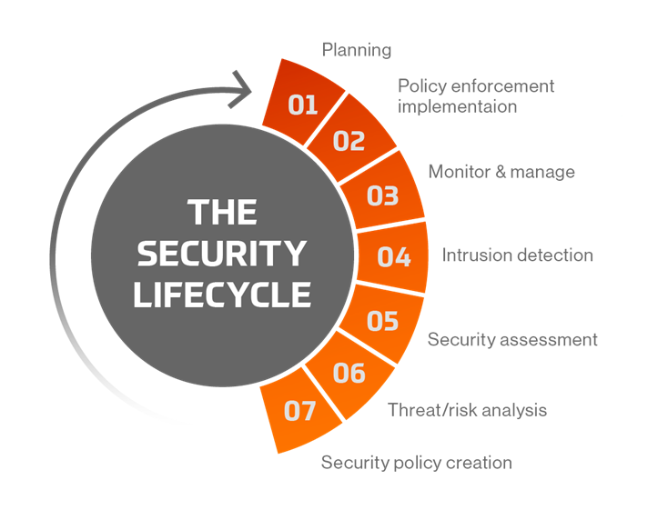

C2A products provide

Security Lifecycle Management by means of a comprehensive in-vehicle cyber-security management platform  
  
Multi-layer protection

Perimeter – penetration prevention, securing devices with CAN bus access

Network – IDPS safeguarding in-vehicle networks

Endpoint – embedded runtime protection, preventing malicious activity at ECU level

Maintenance – in-vehicle end-to-end secured software diagnostics and maintenance solution