Effort Pays Off – Decline Is Curbed

In the last generation, the formula for Israeli success consisted of having a full matriculation certificate and a Bachelor’s degree. These opened the doors to employment with a reasonable salary and a good standard of living. Thanks to government policy, serious efforts were made to ensure that many students would be eligible for a matriculation certificate and be accepted to undergraduate programs. Vocational high school tracks shut down, new high school tracks opened, regional colleges were founded, and many new teaching positions were approved. The results were not slow in coming: the rate of matriculation certificate holders and B.A. eligibility in Israel doubled. This welcome shift created extraordinary accessibility to higher education; today, about half of the country’s population has a high school matriculation certificate.

But his important policy came at a cost that became apparent when the gates of higher education would open no further. Because the job market did not grow at the same rate as the educational system did, the gap that had once separated those eligible for high school matriculation from those who were not was now expressed in the quality of the matriculation certificate. The formula for success had changed. Today, the desirable university departments that open the doors to relatively remunerative employment give preference to high school graduates who took the five-unit matriculation exams in math, English, and a science.

The policy calling for increased numbers of students eligible for a matriculation certificate created a clear set of priorities in the school system and encouraged principals and teachers to make an effort to ensure their students’ eligibility. This placed undue emphasis on grades and came at the expense of the quality and level of learning. Consequently, for years, schools all over Israel preferred not to encourage girls and boys capable of studying math and the sciences at a high level to challenge themselves—to choose a five-unit track in math and physics—instead of making do with easier courses.

According to a report issued by the Henrietta Szold Institute, of the 988 schools whose students took the matriculation exams in 2010, only 484 had students taking the physics exams and only 520 schools offered five-unit math classes. The significance of this data is that, in many places in Israel, students were denied the opportunity to study math and science at a high level even if they had the desire and capabilities required to succeed. In 2012, fewer than 8,900 Israeli high school students (i.e., only 9 percent of high school graduates) completed five units of math, a fact that placed Israel in a very low spot relative to the OECD nations.

Expanding the circle of excellence in math and science is not only critical for positioning Israel in a better place to face the second quarter of the twenty-first century and the challenges it is sure to pose but also a social desideratum for providing equal opportunities to all Israeli teens and closing social gaps. Many Israeli teens are capable of studying math and the sciences at a high level and succeeding. They live in the country’s center and in its geographical periphery; they are Jews and Arabs, religious and secular, boys and girls. They would do so if only the challenge were placed before them and they were provided with excellent instruction adapted to their capabilities, problems, learning styles, and rates of progress. When these students maximize their potential, they will build a better future for themselves and their families, and ensure the resilience and prosperity of the state and its society.

[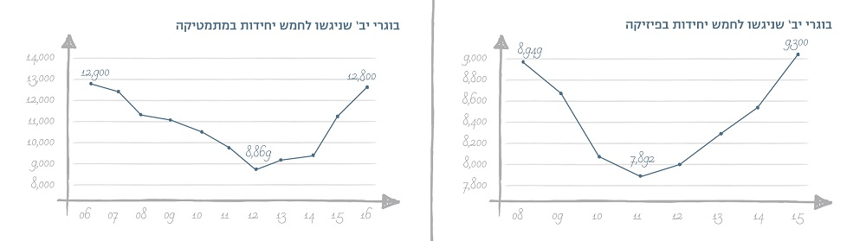](http://www.trump.org.il/scoreboard/?lang=he)

[left caption:] [right caption:]

12th grade graduates who took five-unit math exams 12th grade graduates who took the five-unit physics exams

For more data, see Results Table.

Given the crisis, many important parties from several economic and social sectors came together to improve the situation. Prominent commercial companies, school networks, philanthropic foundations, and other organizations acted on behalf of this national mission declared by the Education Ministry, which defined its objective as doubling the number of students in the five-unit math track within five years despite the fact that matriculation levels not only did not drop – they rose. Efforts were focused primarily on the most significant factors affecting student success, namely the teachers working to construct the subject together from the inside, setting high goals for their students, and enabling them to succeed. At the same time, the Education Ministry promoted a series of steps designed to make the choice of the five-unit math course more attractive to students, such as increasing the university acceptance bonus to 35 points and ensuring a safety net for students not passing the five-unit examinations.

The joint effort carried out over time has already borne fruits. In June 2016, the Education Ministry published the official data indicating that the downward trend had been reversed and that the number of five-unit math graduates in 2016 was identical to the number before the decline began. A look at the number of 10th and 11th grade students shows that the demand for five-unit math classes is on the rise and that the potential for doubling the number of five-unit math graduates is within reach if the trend of curbing the five-unit dropout rate is maintained.

The halt in decline and the reversal of the trend are milestones on a long journey. Thanks to excellent teachers, the participation of many partners, and a clear government policy, Israel is emerging from the crisis in math studies. These are great news, but we mustn’t rest on our laurels. Resolutely and consistently, we must continue to make the effort to transition from stopping the decline to increasing the momentum for expanding the circle of excellence and allowing students up for the challenge to go as far as they can.

The coming years will determine if the schools, while setting goals of excellence, will also place their faith in the teachers so that they can lead a professional change, develop and disseminate their professionalism together and from the inside, and prepare a new generation of excellent teachers. If this happens, ending the decline will turn into significant, sustainable growth. Philanthropy will play a crucial role in this effort. It must continue to serve as a catalyst for innovation, identify and publicize successful performance, encourage coordination and dialog, and spearhead the implementation of growing circles. Together with the government and educational organizations focused on this goal, everyone must work together so that the opportunity now within Israel’s grasp will in fact be attained.