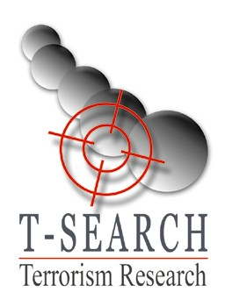

Terror and Political Violence

Dr. Shimon Carmi

Terrorism ‘from within’: Strategies, dynamics, decision points, and ideologies in the test of attacks and politics. What stands behind the strategy of terror organisation? What is the secret framework where the struggle between terrorism and those fighting it takes place? Where is the public in all this? And how does this connect to the current terror?

In the lectures, we will rip off the veil of secrecy that cloaks the activities of the terrorist organisations and we will get to know how decisions are made, the policies of attacks, and the political goals that the organisations set for themselves.
A special emphasis will be placed on the Islamist, Palestinian organisations and the international ones such as the Front for Global Jihad, al-Qaeda, and others.
- Lectures and courses
- Conferences
- Workshops
- Discussion and focus groups
- Simulations
- Advanced methodology
- News updates

Contact:

Mobile: 0524-522050
Telefax: 04-9984217
Email:
tsearch@netvision.net.il

Sample topics:
The civil war in Syria: The internal and external players in the violent turmoil and bloodbath. Ideas for political solutions.
ISIS in Iraq: Violence and terror, the Iranian involvement, and the nominal central government.
The Kurds: The main winners in Syria and Iraq.
The preventative struggle: Foundations of intelligence in preventing terror.
The ideology of radical Islam: From the Muslim Brothers to ISIS, characteristics and expectation for the future
The Israeli-Palestinian conflict: The violence after the Oslo Process. Ideas for escalation and political reconciliation.
ISIS in the West: Analysis of the dangers and recommendations for dealing with them.
Preventing terror in the current era: Intelligence as a key player
The IRA: The conflict in Northern Ireland and the peace agreement.

הטרור החדש: טרור כלכלי, אקולוגי ורשתי.

Dr. Shimon Carmi is a researcher of the behavior of terror organizations in strategic decision-making situations. In this framework, he conducts research about the political motives for the activities of the terror organization in different situations, including their entry into peace processes.
Dr. Carmi is an expert on intelligence against terrorism and has personal experience of 20 years in intelligence dealings with various terror organizations. His operative experience of many years in the intelligence field preventing Palestinian terror, integrated with his current academic research, provides Dr. Carmi with a unique perspective for examining the behavior of terror organizations from within.
Dr. Carmi lectures about terror in the Israeli defense establishment and its various branches and in training groups about preventing terrorism in Israel and abroad. Out of his own sense of personal duty, Dr. Carmi works to disseminate knowledge about terror also within the community and in the Israeli academia.

