



INDEPENDENT EQUITY RESEARCH

**Weebit Nano Ltd.**

INITIATION OF COVERAGE

February XX, 2021

Stock Exchange

**ASX**

Symbol

**WBT**

**Weebit Nano Ltd. is a leader in the development of next-generation memory technology. Operating since 2015, Weebit addresses the growing need for data storage and embedded non-volatile memory (NVM) technology with its new resistive random-access-memory (ReRAM) technology.**

The data storage industry is expanding exponentially, with the demand for high-speed and energy-efficient memory constantly increasing. While flash storage is now most prevalent technology, its limitations, arising from factors such as scalability, endurance, and retention are opening an opportunity for emerging NVM technologies.

Due to Weebit's positioning and technological solutions, we believe it will play a vital role in the growing NVM market. We consider Weebit an excellent investment opportunity. Because Weebit, like many technology firms, is still in the scale-up phase, with a proven technology and initiating sales efforts, its current challenge involves marketing and sales more than technology.

We conducted Weebit's valuation from the bottom up, using market benchmarks from recent transactions and relevant market multiples, via the DCF method. We value Weebit’s equity at US$325M; the stock price target is in the range of US$2.51 to US$2.92, with a mean of US$2.71.

Sector

**Technology**

|  |  |  |
| --- | --- | --- |
| Year | Revenues (000 US$) | EBITDA (000 NIS) |
| 2021E | 1,000 | (12,000) |
| 2022E | 4,000 | (11,200) |
| 2023E | 9,000 | (8,420) |

WIP

Stock Performance (since June 2020)

**X%**

Average daily

trading volume

**X stocks**

No. of shares

**X M NIS**

Market cap

**X M NIS**

Closing price

**XX.X NIS**

Stock price target

**US$2.51**

Sub-sector

**Semiconductors**



**Company name**

Full date

Contents

**Investment Thesis** 1

**1. Company overview** 2

**2. Technology overview** 3

**3. Business model overview** 4

**4. Markets overview** 5

**5. Competitive landscape** 6

**6. Financial analysis & valuation** 7

**7. Contact Details & Management** 8

**Appendix #.1: Capital Asset Pricing Model (CAPM) model** 9

**Appendix #.2: About Frost & Sullivan** 10

**Appendix #.3: Team biographies** 11

**Disclaimers, disclosures, and insights for more responsible investment decisions** 12

# Executive Summary

## Investment Thesis

Weebit Nano Ltd. is an Israeli company that is publicly traded on the Australian Securities Exchange (ASX: WBT). Weebit's vision is to disrupt the memory industry by replacing the reigning flash memory technology with faster, more reliable, and energy-efficient non-volatile memory (NVM) technology that is ideal for embedded applications. The company is revolutionizing NVM through silicon oxide (SiOx)–based resistive RAM (ReRAM) technology, in collaboration with CEA-Leti, a French research institute, after receiving licensing patents from Rice University in the United States.

**The Global Emerging Memory Technologies Market**

*Size[1]*

* The NVM market is expected to reach around US$88 billion by 2025, with a steady growth rate of 10.6%.
* Embedded memory:
  + The AI chipset market is expected to enjoy a rapid growth rate of 31.7% from 2020 to 2025.
  + Sales of multi-core system-on-chips (SoCs) are growing at a steady rate of 17.3% per year. Around US$45 billion is contributed by the mobile and automobile SoC market.
  + In 2019, 24 billion Internet of Things (IoT) devices were in service. According to Frost & Sullivan's analysis, there will be 58 billion IoT devices in service worldwide by 2026, with a growth rate of 15.5%.[2]
* Discrete and persistent memory is expected to accelerate, with a growth rate of 11.8% from 2021 to 2025.

*Current Challenges*

* Cost-effectiveness—The key challenge for ReRAM companies lies in maintaining the competitive pricing of their memory modules' in comparison to other NVM technologies.
* Optimized Storage Capacity and Density—Achieving storage density and capacity optimization is important before integrating into a product design. The amount of available memory in a device is critical for its use with AI and IoT applications.
* The Competitive Landscape of Emerging New Technologies—NVM is a highly competitive market, with new technologies such as MRAM gaining momentum.

*Weebit's Opportunities*

* As a crucial element of edge AI chips, memory must have a small geometry while storing more data; ReRAM represents an ideal answer to this challenge.
* Weebit’s ReRAM offers a perfect memory alternative in SoCs as, unlike flash, it can shrink to fit smaller geometries.
* IoT represents an excellent market opportunity for Weebit's SiOx ReRAM. IoT and other connected devices can be embedded with SiOx ReRAM because of its low power consumption and 10-year retention, even at high temperatures, which is a requirement for IoT field deployment.
* Various components of the wireless communication infrastructure of 5G, such as 5G chipsets, can use SiOx ReRAM as their embedded memory.
* Weebit's cost-effective back end of line (BEOL) solution, requiring only two added masks and no special fab equipment, is a good target for many cost-sensitive analog ICs for smartphones, consumer electronics, industrial applications, and more.

*Weebit's Value Offering*

* Key application areas—Weebit focuses on three key areas—embedded, discrete, and neuromorphic computing—to commercialize its SiOx ReRAM technology.
* Technological advantages—Weebit is scalable to low geometries, offers high-temperature reliability, provides manufacturing flexibility, and enables a higher number of program and erase cycles than flash and other NVM technologies. The company has successfully demonstrated working 1 megabit (Mbit) arrays at 40 nanometres. The company has also demonstrated 10-year retention at 150C, which opens opportunities for automotive and industrial applications.
* Cost-effective—The production cost of Weebit's ReRAM modules is lower than that of other NVMs owing to several disruptive features of its ReRAM technology, such as its use of SiOx, making the entire process complementary metal-oxide-semiconductor (CMOS) fab compatible; its need for only limited masks; and the minimal number of steps incorporated in its fabrication process. As a result, the ReRAM technology can be considered a cost-effective memory solution compared to other emerging technologies.
* Strategy and business model—The company is adopting two licensing strategies. The flexibility of these business models can be leveraged by various electronic device original equipment manufacturers (OEMs) to incorporate Weebit's SiOx ReRAM in their product designs.

**The memory industry is expanding exponentially, with the demand for high-speed and energy-efficient memory on the rise. While flash storage is the most prevalent technology, limitations related to factors such as scalability, endurance, and retention are opening an opportunity for emerging NVM technologies. Due to Weebit's positioning and technological solutions, we believe that the company will play a vital role in the growing NVM market, making it an excellent investment opportunity. However, because Weebit, like many technology firms, is still in the scale-up phase, with a proven technology and initiating sales efforts, its current challenge involves marketing and sales more than technology.**

## Valuation Summary

Weebit Nano Ltd. was established in Israel in 2015 (based on an R&D partnership with CEA-Leti, France). In 2016 the company moved its base to Melbourne, Australia, and it has been publicly traded on the Australian Securities Exchange since August 2016 (ASX: WBT). The company develops its NVM using a ReRAM technology based on SiOx.

Over the years, Weebit has raised A$26.7 million through six funding rounds—a seed round of A$1.6M, and five Post-IPO equity funding rounds of various sizes. To date the company has not generated any revenue; however, it is expected to generate its first revenue during the current year (2021).

Below, we present our P&L forecast for the years 2021–2026:

|  |  |  |  |  |  |  |
| --- | --- | --- | --- | --- | --- | --- |
| *In US$ 000* | **2021** | **2022** | **2023** | **2024** | **2025** | **2026** |
| **Total Revenues** | **1,000** | **4,000** | **9,000** | **16,000** | **40,000** | **65,000** |
| **Operating Expenses** |  |  |  |  |  |  |
| R&D | 10,000 | 11,000 | 12,000 | 2,880 | 6,400 | 9,750 |
| S&M | 1,000 | 2,000 | 3,000 | 3,500 | 4,000 | 5,200 |
| G&A | 2,000 | 2,200 | 2,420 | 2,662 | 2,928 | 3,221 |
| **Total Operating Expenses** | **13,000** | **15,200** | **17,420** | **9,042** | **13,328** | **18,171** |
| **Operating Income** | **(12,000)** | **(11,200)** | **(8,420)** | **6,958** | **26,672** | **46,829** |

## Equity Value

Sensitivity analysis

The table below presents Weebit's price matched with different capitalization rates (along with a 3% growth rate). We set a range of 0.5% change from our CAPM model (see Appendix A). The company has 120,119,536 shares as of February 18, 2021.

|  |  |
| --- | --- |
| *Cap. Rate (%)* | *Price target (US$)* |
| 10.8 | 3.17 |
| **11.3** | **2.92** |
| **11.8** | **2.71** |
| **12.3** | **2.51** |
| 12.8 | 2.34 |

**We estimate the price target to be in the range of US$2.51 to US$2.92, with a mean of US$2.71.**

Valuation by EV/Revenue multiple

We examined the industry in which Weebit operates—the semiconductor industry—using 70 comparable organizations. We found that the average EV/revenue was 7.16 (as of the end of 2020[3]). Using the First Chicago Method and our company's revenue forecast for Weebit, we value its equity at $TBCM.

Valuation Summary

***We conducted Weebit's valuation from the bottom up, using market benchmarks from recent deals and relevant market multiples, via the DCF method. We value the company's equity to be in the range of US$301.7 million to US$351.3 million*** ***in view of all aforementioned findings and assessments.***

# 1. Company overview

Weebit Nano Ltd. (ASX: WBT), hereafter "the Company" or "Weebit," is an Israeli company publicly traded on the Australian Securities Exchange. Weebit's vision is to disrupt the computer memory industry by replacing the reigning flash memory technology with a faster, more reliable, and energy-efficient non-volatile memory (NVM) technology ideal for embedded applications. The Company is revolutionizing NVM through silicon oxide (SiOx)-based resistive RAM (ReRAM) technology, in collaboration with CEA-Leti, a French research institute specializing in electronics and information technologies, after licensing patents from US-based Rice University. The company operates out of its HQ in Hod Hasharon, Israel.

The computer memory industry is witnessing transformational growth because of the emergence of new technologies, such as non-volatile memory (NVM) storage (such as magnetic random access memory (MRAM) and ferroelectric RAM (FRAM)) and cloud storage. These emerging NVM technologies facilitate the evolution of the Internet of things (IoT), smart cities, industrial automation, and artificial intelligence (AI). Because of the rapid increase in the use of electronic gadgets, such as smartphones, tablets, and laptops, data generation has risen exponentially, leading to the growth of embedded applications. As a result, the need for high-density, high-volume, high-speed, and high-performance memory catering to a wide range of embedded applications is growing significantly.

Flash technology, which is the core memory deployed in devices such as computers and smartphones, has currently reached its scalable endpoint. With the recent move from flash to 3D NAND, even though storage density in single chips has increased significantly, NAND storage has hit significant limitations in embedded applications because of size constraints. On the other hand, despite being fast and exhibiting high endurance, dynamic RAM (DRAM) cannot be extensively used for embedded applications. That's because DRAM is not compatible with CMOS, expensive, exhibits high data volatility, and a low data refresh rate. These limitations of DRAM and flash memory technologies have created a void that needs to be filled before the demand for alternative memory in embedded applications skyrockets.

The 3D NAND technology revived the flash memory industry; It became a major contributor to the discrete memory sector, leading to increased memory density and storage capacity; Hindering the development of other NVM technologies. Weebit realized that there was no immediate need to replace the flash memory. Thus, it shifted its focus to emerging markets, such as artificial intelligence (AI), wherein flash memory cannot be deployed because of its scalability constraints. The company states that the ReRAM technology is cost-effective, scalable, offers manufacturing flexibility, and a higher number of program/erase cycles than flash and other NVM technologies.

Weebit focuses on three key application areas to commercialize its SiOx ReRAM technology, with embedded applications being the prime focus in the near term. The company is developing a memory module that can be embedded within a system on chip (SoC) or a sensor.

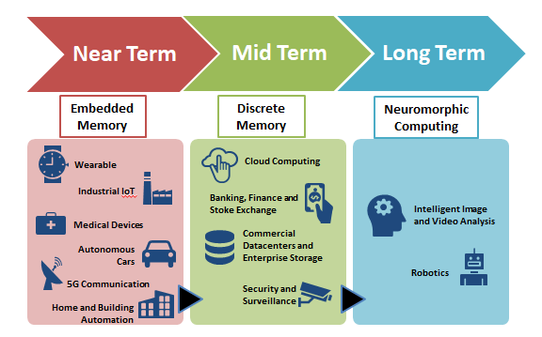

**Fig 1: Application Landscape of SiOx ReRAM Technology**

Flash memory has dominated the NVM industry because of its ease of use in various applications, ranging from smartphones to data centers. As a result, any new NVM technology faces stiff competition from flash memory. To prevail in the NVM storage's competitive landscape, Weebit Nano immediately realized that the fastest path to generating revenue is by investing in embedded applications. Primary in embedded applications that would benefit from the SiOx ReRAM technology such as wearables, medical implants, and home and industrial automation devices like speakers and advanced driver assistance systems (ADAS). The company also realized the potential of SiOx ReRAM in emerging applications, such as 5G, AI, Big Data, and IoT, where flash storage cannot be deployed because of its scalability and power efficiency limitations.

Moreover, Weebit's ReRAM memory modules could make steady inroads into flash dominated discrete memory sector. The NOR flash memory cannot be stacked in three dimensions unlike NAND flash or ReRAM paving way for an opportunity for ReRAM to penetrate discrete memory sector. The SiOx ReRAM modules can be stacked in enterprise storage, cloud storage, and other commercial datacentres used by hospitals, governmental bodies, and education institutes as data repositories. In the future, ReRAM can be used for brain-computer interface devices and advanced AI, making it a promising memory technology for neuromorphic computing.

Weebit realigned its vision by adjusting its offering based on the ever-changing memory industry's needs while strengthening its core technological offering, SiOx ReRAM, through constant research and indigenization.

## Strategy and Business Model

Weebit was founded in 2015 after the company licensed six patents, pursued by Professor James Tour, from Rice University in the SiOx ReRAM technology domain. In 2016, the company completed a reverse merger with an Australian shell company called Radar Iron, thereby listing on ASX, and completed a placement of shares worth US$3 million. The company is rapidly moving towards deploying the technology to a production fab after successfully demonstrating the working of 1 megabit (Mbit) arrays at 40 nanometres (nm) in collaboration with CEA-Leti, which has been tested and verified by a third party.

Weebit used its expertise, gained from years of experience in the semiconductor industry, to accelerate its SiOx ReRAM technology development. Unlike flash memory, the resultant prototypes of SiOx ReRAM displayed high endurance and performance in terms of high-speed programming reading and operations while being energy-efficient.

The future of Weebit's SiOx ReRAM technology will center on the company's commercialization strategies and its approach toward gaining new customers. The company is adopting licensing strategies that include the following two coinciding types of business models:

**Model 1:** Semiconductor fabricators that want to venture into the ReRAM industry can pay manufacturing licensing fees to Weebit to leverage the process IP (intellectual property) in various process nodes and design products as per customer requirements.

**Model 2:** Semiconductor customers integrating embedded memory products can license the SiOx ReRAM technology and fabricate ReRAM in collaboration with their desired fabrication facilities.

These business models' flexibility can be leveraged by various electronic device original equipment manufacturers (OEMs) to incorporate SiOx ReRAM in their product designs such as internet-of-thing (IoT) sensors. By employing a new memory technology which is rich with features such as high endurance and retention, the OEMs will be able to significantly boost the device performance as well as making it compact. Moreover, fabricators can easily integrate Weebit's ReRAM technology into their existing manufacturing lines due to the technology being CMOS (complementary metal-oxide-semiconductor) friendly.

## Company Structure

Weebit's share structure can be divided into three key entities.

* Top 20 Shareholders excluding the Board and Management

**Other includes the buyers of Weebit shares in the ASX.

**Fig 2: Share Breakdown of Weebit Nano Ltd**

## Timeline

Weebit is gearing up for taping out ReRAM memory module in collaboration with CEA-Leti that will be demonstrated for customers in embedded electronics.

Demonstrated first prototype of a single cell at 130nm

Completed process optimization of 1mb array and achieved external technology validation from Chinese company XTX Technology.

2017

2021

2020

2019

2018

Weebit successfully developed its 4 Kb array with 40 nm process node and scaled it up to 1 mb.

Completed Stabilization process and signed the letter of intent with Chinese companies, XTX Technology and SiEn.

Weebit is aggressively pursuing its' primary goals for 2021, aiming to demonstrate the finished memory module and sign a commercial agreement. Transferring the technology into a production fab would be a significant milestone that will enable Weebit to productize the memory cell, followed by a memory module's qualification process. By the end of September 2021, Weebit will demonstrate the company's first selector-one resistor (1S1R) memory cell that integrates the SiOx ReRAM cell with a selector, thereby creating a platform for the development of discrete memory modules in the near future. Such a selector is a crucial entity of 3DXPoint technology co-developed by Intel and Micron. The company has underlined 2023 as the milestone year for its ReRAM technology to be embedded in a full-fledged product, with 2022 focusing on quality improvements and volume production.

|  |  |  |  |
| --- | --- | --- | --- |
| **Milestone** | **Significance** | **Timeline** | **Status** |
| Weebit will demonstrate its first 1S1R memory cell that integrates the SiOx ReRAM cell with a selector | **High** | **Q3-2021** | **Achived** |
| Quality improvements and volume production – in numbers? | **Medium** | **2022** |  |
| Successful embed its ReRAM technology in a full-fledged product | **High** | **2023** | **Achived** |
|  |  |  |  |

## Products and Technology

One of the key limitations of flash storage and some NVM technologies is their inability to scale below 28 nanometers (nm). In contrast, ReRAM has no problem going beyond 20 nm. With the future of semiconductor chipsets moving toward miniaturization, ReRAM's ability to fit within the smallest geometry could be disruptive. Moreover, while 3D NAND technology has provided a great reprieve for secondary storage devices, such as solid-state drives (SSDs), it is not feasible for embedded storage, thus making ReRAM an interesting proposition for applications relying on embedded NVM.

Unlike the traditional memory, where the data is stored in the form of an electrical charge, ReRAM technology leverages special resistive material sandwiched between two electrodes whose resistance is varied to record the binary data (0s and 1s) by applying an external voltage.

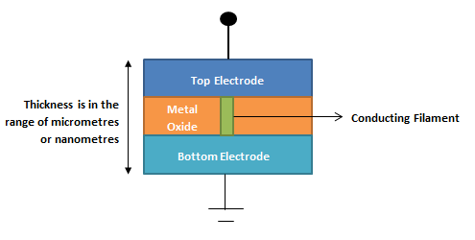

**Fig 3: Schematic Representation of ReRAM cell**

The ReRAM cell developed by Weebit comprises two metal layers separated by a layer of SiOx. On applying a positive voltage on the cell, a conductive filament is formed while the cell attains Low Resistive State (LRS). The filament is broken on applying negative voltage resulting in the cell attaining a High Resistive State (HRS). The transition from LRS to HRS and vice versa is used to store the data.

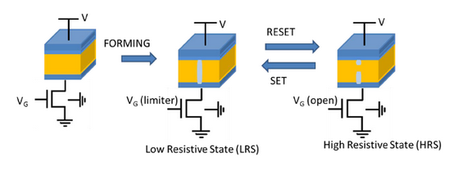

**Fig 4: Functional Diagram of Weebit’s ReRAM Cell**

*Image Source: Weebit Nano Ltd*

A key differentiator of Weebit's ReRAM technology that sets it apart from competing solutions is the use of standard fab-friendly materials such as SiOx, which is the most common semiconductor material for fabricating chips, unlike other ReRAM companies that rely on materials such as praseodymium (Pr), manganese (Mn), calcium (CA), and tellurium (Te), which are uncommon in the semiconductor industry. SiOx has accelerated the company's product development phase while firmly placing Weebit in positioning to forge partnerships with global fabricators proficient in silicon, paving the way for a smooth technology transfer.

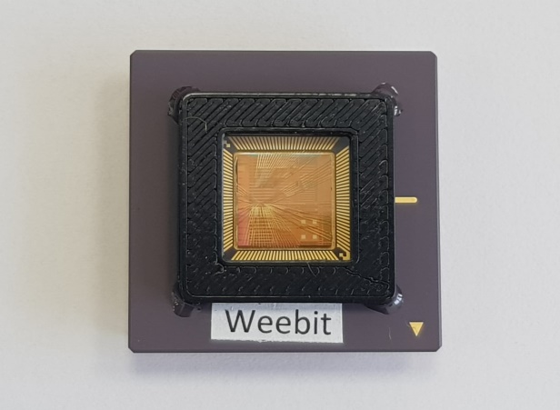

**Fig 5: SiOx ReRAM Package**

*Image Source: Weebit Nano Ltd*

Weebit uses the standard tools and technology available in the semiconductor industry. To maintain this standardization, the company ensures that its devices and machines used in the cleanroom of its in-house fabrication facility are common in any global fabrication facility. As a result, Weebit has successfully produced its memory cells on different process nodes associated with various fabrication facilities, thus providing an impetus to the company's goal of establishing a fabrication-friendly technology. Another key aspect of Weebit's SiOx ReRAM technology is its ease of integration into existing CMOS-fabricating facilities, which will significantly the time to market and cost of production.

Weebit has completed the stabilization process, which is an essential precursor for production. The uniformity through the cell and the die was validated as no changes were observed in the wafer characteristics. Moreover, the same level of endurance was observed across multiple wafers.

**Additional Benefits of Weebit's SiOx ReRAM Technology include:**

* **High Endurance:** The memory cell exhibits a very high endurance of one million cycles, unlike flash storage, which has a maximum endurance of few thousand cycles.
* **High Retention:** The memory cell can withstand high temperatures of up to 150 Celsius degrees, with data retention of 10 years.
* **Short Read/Write Time:** The time taken by the cell to read/write data is in the order of tens of nanoseconds, unlike flash, which offers a read/write time of few microseconds, thereby making ReRAM a high-speed memory.
* **Low Power Consumption:** The memory cell consumes around 0.1 Joule for writing one bit of data.
* **Scalability:** The ReRAM architecture could possibly be shrunk (full shrinking potential is still under research) to few nanometres of 20, 16, or 5, unlike flash, which doesn't shrink below 40 nm.
* **Futuristic Memory Technology:** The ReRAM architecture resembles biological synapses found in the human brain, making it an ideal starting point for the design of brain-inspired AI systems.

## Significant Partnerships and LOIs:

Strategic collaborations were a vital factor in driving the technology development and laying down the foundation for future commercialization of Weebit's technology. The company's long-standing partnership with CEA-Leti has enabled Weebit to accelerate its development process in terms of improving performance and gaining the capability to enter new sectors such as discrete memory and neuromorphic computing.

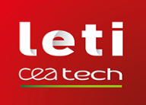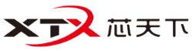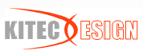

**CEA-Leti**

Risks involved in converting academic research into a commercialized product posed another major challenge for Weebit. To mitigate these risks, the company availed CEA-Leti's manufacturing experience and capabilities by forming a strategic partnership in 2016. Together with CEA-Leti, Weebit successfully lowered the risks associated with production and achieved its project milestones within four years, unlike its competitors that have spent more than seven years in technology development. Weebit and CEA-Leti are broadening their strategic partnership to carry out additional research activities in enhancing the features of the SiOx ReRAM technology and memory module development to address customer needs and meet the desired production levels. Some of the recent key patents jointly filed by Weebit and CEA-Leti include methods for implementing multi-level storage in ReRAM, enabling high memory yield and uniformity across the memory cells along the wafer. Moreover, in collaboration with CEA-Leti, Weebit builds an advanced neuromorphic demonstration system equipped with sophisticated AI algorithms.

**Silvaco Inc**

Weebit has entered into a strategic collaboration with Silvaco Inc, a leading global electronic design automation (EDA) tools and semiconductor IP provider. This collaboration has resulted in a model of Weebit’s ReRAM solution which allows potential partners/customers to experiment with the technology without having to manufacture and measure results. The resulting platform from the collaboration is an exciting proposition for embedded original equipment manufacturers (OEMs) because they will be able to replace flash memory, thus shrinking the size of the embedded device by using ReRAM. Apart from EDA providers, Weebit Nano is in talks with chip manufacturers, fabricators, and product companies worldwide.

**Academic**

As ReRAM poses an entirely new alternative to brain simulation in the form of emulating brain signals, Weebit has established academic partnerships with global universities, such as the Indian Institute of Technology in New Delhi and Politecnico di Milano (Polimi) in Italy. Their prime focus will be on developing neuromorphic ReRAM. Weebit and Polimi have successfully demonstrated Spiking Neural Network (SNN) based AI module capable of performing unsupervised learning tasks. Moreover, Weebit Nano is collaborating with Technion (Israel Institute of Technology) to develop 'Real Processing in Memory,' which will assess the benefits of employing ReRAM in a novel computing architecture in terms of processing speed, memory transfer rate, and processing latency.

**China**

China is emerging as a major global player in the semiconductor industry with its goals set on achieving 80% of semiconductor production domestically by 2025. Memory has been one of the major semiconductor imports for China. At present, around 30 fabrication facilities with standard SiOx manufacturing capabilities are being built all over the country, thereby offering a significant inroad in the embedded memory segment for Weebit in China. Weebit announced letters of intent (LOIs) for cooperation with a few Chinese semiconductor players, namely XTX Technology and SiEn. After signing the LOI with XTX Technology in 2019, Weebit works alongside XTX to investigate methods to leverage SiOx ReRAM technology in its products. In early 2020, Weebit signed an LOI with SiEn (QingDao) Integrated Circuits Co., Ltd and will be exploring the possibilities of embedding ReRAM in SiEn's IoT devices.

# 2. Market Overview of Emerging Memory Technologies

The data storage industry is expanding exponentially, with the demand for high-speed and energy-efficient memory on the rise. Because of the revival of flash storage, major data storage participants, such as Samsung, Intel, Micron, Western Digital (WD), Toshiba, and SanDisk, are developing their own proprietary 3D NAND flash technology. As a result, the NVM industry has facilitated the growth of small and medium data storage companies focusing on emerging NVM technologies, such as MRAM, ReRAM, and FRAM. The semiconductor memory industry is pursuing research and development in the emerging NVM technologies to integrate notable features of conventional memory storage such as the high switching speed of static RAM, storage density equivalent to dynamic RAM, and non-volatile functionality of flash memory. The successful culmination of all the features mentioned above will result in an attractive NVM solution for computation-intensive workloads.

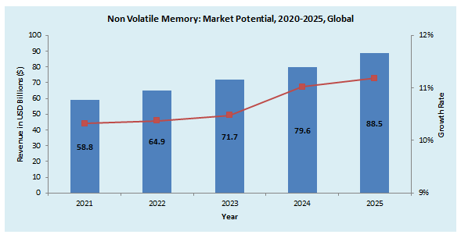

**Fig 6: Market Potential of NVM**

*Source: Frost & Sullivan*

NVM market is expected to reach around $88 billion by 2025, with a steady growth rate of 10.6%. The NVM market will be dominated by flash memory with new flash variants such as 3D NAND, NVMe (non-volatile memory express). Still, its limitations, such as scalability, endurance, and retention, will create a platform for emerging NVM technologies and companies like Weebit to play a vital role in the embedded device sector.

As per the SIA data (Semiconductor Industry Association), the global semiconductor industry reported sales of $414 billion in 2019, making it one of the highly lucrative markets at present. This will give an ample commercial drive for the growth of ReRAM and Weebit as its technology can be embedded in almost all of the semiconductor products ranging from logic, analog, MPUs (microprocessor units), MCUs (microcontroller units), sensors, and signal processors. Below is a split of various semiconductor products and their sales recorded, which will give a clear overview of the potential SiOx technology to disrupt the semiconductor industry while defining the market opportunity for Weebit.

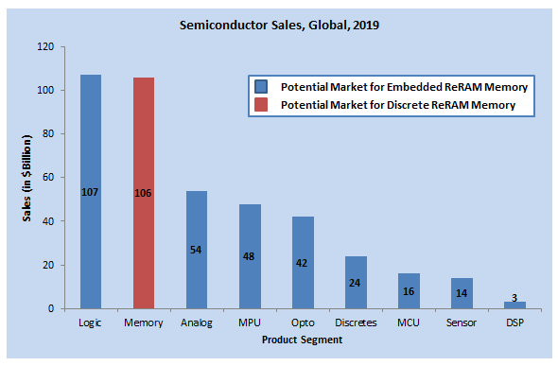

* Discretes in the graph represent the discrete electronic components such as transistors

**Fig 7: Global Semiconductor Sales for 2019**

*Source: SIA*

## Market Drivers

|  |  |  |
| --- | --- | --- |
| Influencing Factors | Degree of Importance | Additional Comments |
| Growing Demand for Low Power Consuming Memory Devices | **High** | The rise of smart devices such as wearables can be accredited to the innovations in circuit designs in recent years. Low power consumption is a key feature as it eliminates regular maintenance of the devices. Hence memory technologies that consume significantly less power are in high demand. |
| Need for NVM with High Endurance Cycle | **High** | The endurance cycle of flash is 100 times lower than ReRAM which makes a great memory module for devices such as IoT sensors that need to be operated for long periods while being subjected to constant read/write operations. |
| The intent of Fabrication of New Technologies by the Foundries across the globe | **Medium** | As the device size keeps shrinking, the fabricators are developing technologies to manufacture semiconductor chips with process nodes as low as 5nm. As a result, they are welcoming memory technologies capable of scaling down below 40nm wherein Weebit's SiOx ReRAM fits in perfectly. |

## Market Challenges

|  |  |  |
| --- | --- | --- |
| Influencing Factors | Degree of Importance | Additional Comments |
| Cost-Effectiveness | **High** | The key challenge for ReRAM companies is to maintain competitive pricing of their memory modules in contrast to other NVM technologies. Weebit should tackle this challenge effectively as it uses SiOx, one of the most commonly available materials in the semiconductor industry. Unlike MRAM or flash technology which requires many masks,lengthy process steps and rare materials (in case of MRAM only), usage of CMOS fab compatiblematerial like SiOx, requirement of only 2 masks as well as minimal steps in the fabrication process will bring down the production costs of Weebit's ReRAM modules significantly lower than other NVM technologies, which will significantly impact the pricing of the final products in which the memory module will be embedded. |
| Optimized Storage Capacity and Density | **Medium** | Achieving storage density and capacity optimization is important before integrating into a product design. The amount of available memory in a device is critical for its usage for AI and IoT applications. Weebit has successfully developed a 1 megabit memory array cell that caters to most connected devices and is working to increase the capacity to address the data storage demand. |
| Competitive Landscape With Emergence of New Technologies | **Medium** | NVM is a highly competitive market with new technologies such as MRAM gaining momentum at present. As a result, Weebit will be facing stiff resistance from domestic and global players who are investing significantly in developing alternative storage technologies, including ReRAM. On a positive note, the competition will also drive the market of NVM as the demand for non-volatile, high-speed, and high-endurance memory modules are significantly high, which can be cashed in by Weebit going ahead. |

## Competitive Landscape

Flash memory is the dominant player in the NVM segment as it caters to the growing need for data storage across various applications, especially in the datacentres. Simultaneously, its limitations pertaining to scalability and endurance have paved the way for the proliferation of other memory technologies such as MRAM, ReRAM, FRAM, and PCM. All these NVM technologies have distinct features and limitations, enabling system designers to avail the most appropriate NVM for their chips.

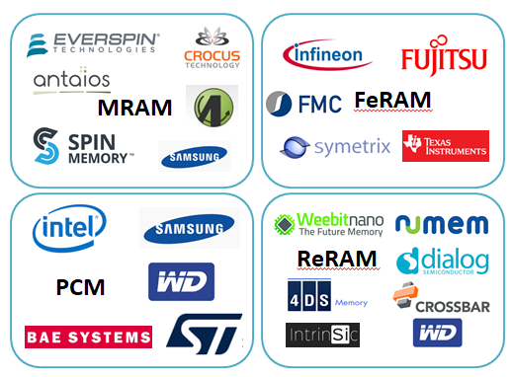

The emerging memory technologies such as MRAM, FeRAM, PCM, and ReRAM aim to solve the limitations observed in conventional storage. The key limitation of the charge storage-based technology such as Flash is its inability to scale beyond 40-28nm due to loss of stored charge at small geometries hampering the storage module's performance and reliability. The key features desirable for an ideal memory are: long endurance cycles, low operating voltage, high data retention time, low power consumption, and highly scalable architecture.

The companies pursuing the development of the above-mentioned emerging NVM technologies aim towards partial fulfilment of ideal memory features. For example, Fujitsu is a great supporter and shipper of discrete ReRAM, on top of FeRAM; TSMC and Global Foundries have publicly announced their support for ReRAM; Winbond and Panasonic also have ReRAM-enabled products already. Weebit's ReRAM technology inherits all the ideal memory features, thereby making it a promising technology to look out for in the near future.

## Competing Technologies

**MRAM –** Magnetic RAM is a NVM technology that leverages the electron's spin for storing the data. The MRAM structure comprises magnetic tunnel junctions (MTJ), which facilitates reading/writing of data. On application of electric currents, the magnetic field is created, which changes the electron's magnetic state, thereby changing the junction's resistance and hence writing the data. MRAM offers superior features such as resistance to high radiation, operation in extremely high temperature, and low power consumption making it ideal for industrial, automotive and military applications.

MRAM stack is very complex and sensitive, especially when compared to ReRAM. Moreover, the usage of magnetic and other exotic materials in the process leads to deployment of deidacted equipment, dedicated cleanroom space, and many modifications to the process flow such as usage of equipment to seal the magnetic charges thereby increasing the overall product cost. - complex fabrication. Secondly, magnetic material can cause interference in the circuit that can impact the overall performance.

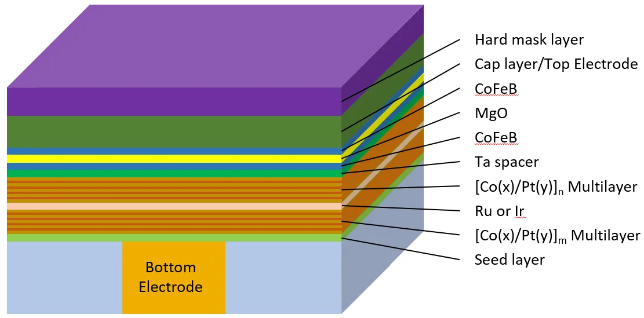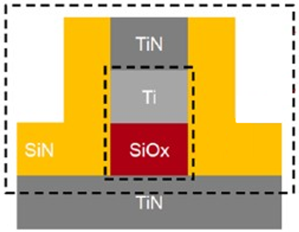

**Fig 8: Comparison Between MRAM stack and Weebit’s SiOx ReRAM Stack**

MRAM technology has been pursued by few companies across the globe, such as:

* **Everspin Technologies Inc** is a publicly listed US based company that develops two variants of MRAM:
  + Toggle MRAM which uses the electron spin magnetism for storing data.
  + Spin transfer torque (STT) MRAM which is built on perpendicular MTJ structure that leverages the spin transfer toque property of the electrons for reading/writing the data.
* In collaboration with Global Foundries, the company is developing embedded MRAM capable of replacing embedded flash in any CMOS compatible designs.
* **Spin Memory Inc** is a US-based emerging MRAM start-up that is developing STT MRAM technology based on its Precessional Spin CurrentTM (PSCTM) Structure that significantly improves the efficiency of MJT, thereby improving the data retention capability. The company collaborates with Arm and Applied Materials to commercialize its product, which can replace on-chip NVM.

**FeRAM –** Ferroelectric RAM is one of the earliest NVM technologies to enter the market. The technology leverages the properties of ferroelectric materials to store data. On applying the electric field across the capacitor made from the ferroelectric material such as lead zirconate titanate (PZT), movement of atoms is observed in the direction of the applied field. This results in a state change whereas reversing the electric field will change the direction of movement of particles resulting in a state change. The state changes are used to store the binary data. Although FeRAM offers high retention and high read/write endurance cycles the NVM technology failed to make it big due to limitations such as low storage densities and high manufacturing costs.

* **Ferroelectric Memory Company (FMC)** is a German start-up developing embedded NVM using a ferroelectric material Hafnium oxide. With Global Foundries as the manufacturing partner, the company is actively working towards commercializing its designs. FMC recently raised an investment of $20 million from leading venture capitalists such as SK Hynix Inc.

**PCM –** Phase change memory is an emerging NVM technology which uses the unique property of a material called chalcogenide glass which transitions between amorphous and polycrystalline state on application of current. The change of resistance in the states is used to store the binary data. Few limitations such as non-standard materials, high manufacturing cost, and unintentional phase change have hampered its evolution to enter the mainstream storage media like flash memory. But some of the major memory manufacturers such as Intel, Samsung, and Western Digital have ventured into the PCM technology.

* **Intel Corporation,** in collaboration with Micron Technology, has developed Intel Optane solid-state drives based on its 3D Xpoint technology, which uses chalcogenide materials such as Germanium (Ge), Arsenic (As), Antimony (Sb), and Tellurium (Te).

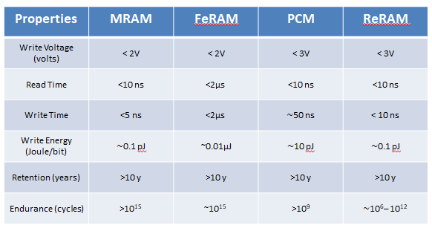

**Fig 8: Comparison of NVM Technologies**

## Competitors of Weebit in ReRAM Technology

Apart from Weebit, few other players are investing in the ReRAM technology.

* **4DS Memory** is an Australian start-up pursuing ReRAM technology known as Interface Switching ReRAM to develop memory cells in collaboration with HGST, a Western Digital subsidiary. The company is developing an industry-standard fabrication compatible process using 300mm wafers in partnership with the Belgium-based Interuniversity Microelectronics Centre (IMEC) and aims to create a megabit chip. Weebit is well ahead of 4DS as it has already demonstrated the SiOx ReRAM megabit memory cell and is gearing up for the transition from prototyping to production. 4DS is yet to demonstrate a working array and provide actual endurance and retention data.
* **Crossbar Inc** is a US-based semiconductor memory company that was one of the early movers of ReRAM technology. The company leverages silicon-based material in the switching medium for hosting the metallic filament. The company has licensed its technology to Microsemi Corporation and are jointly developing ReRAM solutions for Microsemi products. Moreover, Crossbar is also part of the AI consortium called SCAiLE (SCalable AI for Learning at the Edge) along with other members such as Gyrfalcon Technology Inc., mtes Neural Networks Corporation (mNN) and Robosensing Inc. Crossbar hasn't been vocal about its advancements in the ReRAM technology since 2019 unlike Weebit.
* **Dialog Semiconductors PLC** is a UK based fabless company that specializes in offering integrated chips for IoT applications. The company completed the acquisition of Adesto Technologies Corporation who had developed Conductive Bridging RAM (CBRAM) technology, a type of ReRAM that leverages electrochemical action to create and break the filament resulting in a change of resistance, which translates to binary data storage. After the acquisition, it remains to be seen how Dialog will be leveraging Adesto's CBRAM technology in its product development with a particular focus on IoT devices.

## Core Focus Areas of Weebit Nano Ltd

**Embedded Memory**

Today, AI has penetrated every mainstream industry, such as agriculture, automotive, finance, manufacturing, education, entertainment, and healthcare, thereby propelling intelligent chipsets' innovations. In particular, edge AI's demand is gaining momentum due to the special feature of edge intelligence. The data is processed locally on the device instead of the conventional method of cloud-based data processing. As a critical part of edge AI chips, memory needs to have a small geometry and store more data, which is where ReRAM can be an ideal solution. As per Frost & Sullivan's analysis, the AI Chipset market will be accelerating at a growth rate of 31.7% from 2020 to 2025. The growth rate will pick up pace by 2022 due to advancements in various technologies such as lithography, memory storage, display and software algorithms that form the core of the AI ecosystem. With the commercialized ReRAM modules of Weebit slated to be released by 2022, the company will be looking forward to cash-in on the steep growth of the AI chips market by embedding its memory technology in the edge AI devices

System-on-chips (SoCs) are becoming an integral part of the system design of major electronic devices used across various industries, such as consumer electronics, automotive, healthcare, and energy. The next generation of multi-core SoCs will be embedded with features, such as AI, which will bring in automation capabilities to the process chain and significantly impact the manufacturing and processing industry. Multi-core SoCs bring the capabilities of multiple processing instances interfaced with other features, such as signal antennas, sensor interfaces, which are vital to embedded systems. With the devices becoming feature-rich and shrinking in size with each passing day, multi-core SoCs will play a pivotal role in realizing this transition. Frost & Sullivan analysis indicates that multi-core SoCs are growing at a steady rate of 17.3% due to technological advancements in circuit miniaturization and the introduction of multiple-core processors in the integrated circuits. Around US$45 billion is contributed by the mobile and automobile SoC market. Embedded memory would be a vital entity of SoCs as it will have to process multiple actions simultaneously. ReRAM can be a perfect memory alternative in SoCs as it can shrink to smaller geometries, unlike flash.

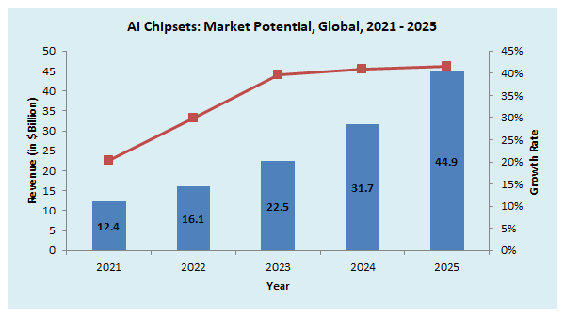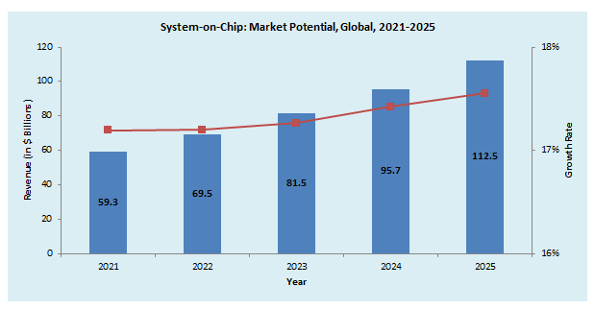

**Fig 9: Market Potential of AI Chips and SoCs**

*Source: Frost & Sullivan*

IoT is a critical component of digital transformation observed across various industries. Banking upon its core concepts that include real-time connectivity and advanced data analytics, IoT is making significant inroads across different application areas ranging from healthcare to manufacturing and retail. Frost & Sullivan's analysis indicates that 24 billion IoT devices were in service in 2019 and predicts there will be 58 billion IoT devices in service worldwide by 2026, with a growth rate of 15.5%. The key areas where IoT is being leveraged include asset monitoring and tracking, connected cars, automotive infotainment, smart grid, smart energy meters, smart home appliances, building automation, security and surveillance, digital signage, ATMs, retail outlets, industrial automation, and medical devices. In particular, the connected devices sector has undergone a rapid transition owing to the constant upgrades and innovations observed in the IoT domain. Electronic gadgets are becoming intelligent day by day as they are now capable of automating various sophisticated tasks through wireless connectivity with Bluetooth and Wi-Fi. The intelligence of the electronic devices can be accredited to the growth of SoCs and NVM. As devices are shrinking, IoT poses a great market opportunity for Weebit's SiOx ReRAM as IoT and other connected devices, such as wearables, drones, robots and Bluetooth speakers that can be embedded with SiOx ReRAM because of its low power consumption and small geometry.

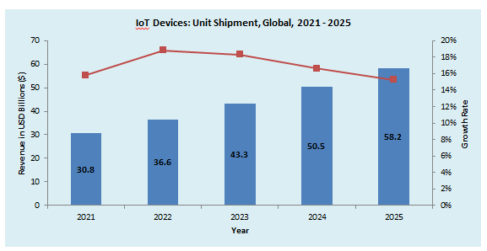

*Source: Frost & Sullivan*

**Fig 10: Unit Shipment Forecast of IoT Devices**

Finally, the wireless communication market inclusive of 5G communication is on the verge of commercialization pose a potential opportunity for Weebit's ReRAM technology. Wireless technology is used to establish connectivity between different communication networks located in and around enterprises, public places, and residential premises. 5G will be a key enabler for the digital transformation in the near future. It brings in faster speed, high bandwidth, and low latency, which will spur innovations and the deployment of billions of connected devices globally. The key application segments for this market are automotive, consumer electronics, healthcare, public safety, wearable devices, energy, etc. Various components of the wireless communication infrastructure of 5G, such as 5G chipsets, can use SiOx ReRAM as its embedded memory.

**Discrete and Persistent Memory**

In the discrete memory sector, Flash memory (in particular, NAND flash) has been enjoying a global supremacy in terms of market share, which is further boosted by developing 3D architecture of NAND Flash. With the worldwide demand for data storage across consumer electronic devices, industrial equipment or automobiles rely on flash storage. But the major area wherein Flash usage has seen a rapid growth is the cloud storage and data centers. As massive data processing using AI and machine learning increases, the storage demand has to be met accordingly. Weebit's ReRAM offers great benefits for endurance and retention in comparison to Flash memory. We expect the company to target the NOR Flash and EEPROM replacement by 2024 -2025, enabling Weebit to enter the discrete memory market comprehensively. Moreover, the ability to scale in three dimensions will enable Weebit to develop 3D ReRAM in the future, thereby aiming to acquire a significant NAND flash market share.

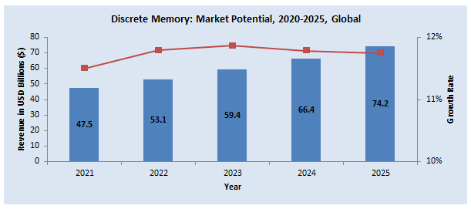

**Fig 11: Market Potential of Discrete Memory**

*Source: Frost & Sullivan*

Another key memory segment targeted by Weebit is the standalone memory chips that offer better endurance, speed, and retention in comparison to flash memory. One of the major limitations found in today's data storage industry is the void found between DRAM (dynamic RAM), the primary memory which is very fast and volatile and the secondary memory, which is slow and non-volatile, hampering the overall processing capabilities of systems in datacentres and cloud computing networks. An emerging memory technology called persistent memory, which is non-volatile, is gaining momentum due to its ability to accelerate secondary storage. Weebit's ReRAM offers high read/write speed and low power consumption, making it a perfect solution for persistent memory. In collaboration with CEA-Leti, the company has launched a three-stage program to develop the SiOx ReRAM based discrete memory modules by 2024.

**Neuromorphic Computing**

Conventional artificial intelligence (AI)-enabled processors are based on rule-based algorithms and are optimized for applications, such as real-time monitoring and reporting. However, with the increasing demand for fully autonomous solutions, there is a need for wise solutions capable of making probabilistic decisions, replicating the human brain. With technology advancements in chipset architecture and algorithms, neuromorphic chipsets are processing powerhouses that are logically analogous to neurons in human biological brains and efficiently perform complicated decision-making tasks. Neuromorphic computing (NC) holds the potential to emerge as a vital breakthrough in applications across the healthcare, manufacturing, and aerospace & defense sectors. With increased funding and related support from government bodies and Tier-1 OEMs, neuromorphic solutions are poised to witness exponential traction from venture capitalists (VCs) and government bodies in the years to come.

The biologically-inspired approach of neuromorphic computing has enabled the creation of highly connected synthetic neurons and synapses that can be leveraged for modelling neuroscience theories and solves challenging machine learning problems. The electronics industry recognizes neuromorphic computing as a promising tool for enabling high-performance computing and ultra-low power consumption to achieve these goals. Edge computing is gaining prominence recently due to its features of localized computing, storage, and processing capabilities critical to successfully implementing IoT devices. Neuromorphic chips will further advance the capabilities of edge computing. Frost & Sullivan's analysis predicts that Neuromorphic Computing will see a steady growth rate of 20.4% due to the advancements in hardware architecture and software algorithms.

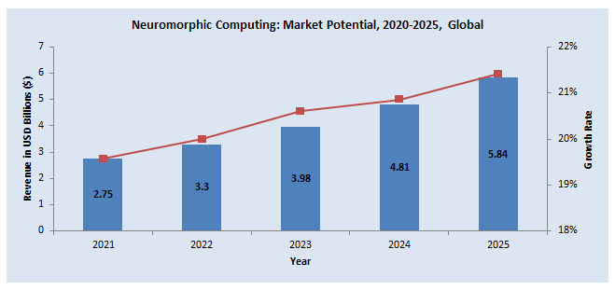

**Fig 12: Market Potential of Neuromorphic Computing**

*Source: Frost & Sullivan*

From a future perspective, neuromorphic computing is an interesting opportunity for Weebit, wherein its SiOx ReRAM will play a vital role. To date, researchers have mainly focused on simulating the human brain through various neural network algorithms and sensors, which has yet to yield satisfactory results. ReRAM poses an entirely new alternative to brain simulation in the form of emulating brain signals because it resembles the human brain's synapses.

Weebit presented the SPIRITneuromorphic demo developed in collaboration with CEA-Leti in the International Solid-State Circuit Conference (ISSCC)2020 in San Francisco held in February 2020. The demonstration showcased the capability of Weebit’s SiOx ReRAM to run the Spiking Neural Network (SNN) algorithms for implementing synapses that are analogous to human brain and hence significantly improving the parallel processing capabilities of any AI computing process.

# 6. Financial analysis & valuation

**Valuation method & approach**

Valuation of a start-up company in its early stages can be challenging due to limited cash flow (if any) and uncertainty regarding the future. As part of a Discounted Cash Flow (DCF), the accepted method used in financial valuations, there are several modifications to a start-up company's valuation. In general, there are three primary methods within the DCF method:

1. Real options – this valuation method is designated for pre-clinical and early-stage clinical programs/companies where the assessment is binary during the initial phases and based upon scientific-regulatory assessment only (binomial model with certain adjustments).
2. Pipeline assessment – a valuation method used for early-stage companies before the market stage where time-to-market may be a few years for full operations. The company's value is the total discounted cash flow for its products/signed agreements plus unallocated costs and its technology platform assessment.
3. DCF valuation - this method applies to companies with products that have a positive cash flow from operations.

Weebit has a solid business model accompanied by a relatively mature technology (embedded application). Therefore, we assume a short time to market with increasing cash flow in coming years. Consequently, we applied the DCF valuation method to conduct Weebit's valuation. We also explored industry multiples and recent deals as a benchmark for Weebit's value.

**Valuation by DCF Method**

***Revenues Forecast***

Over the years, Weebit raised US$29M within six funding rounds. The company is expected to generate its first agreements during the current year. Weebit's success will rely on the company's commercialization strategies and its approach toward acquiring new customers.

We segmented Weebit's revenue stream into three main categories. We describe below our assumptions and revenue forecast by revenue stream:

1. **Embedded Memory** - As a critical part of edge AI chips, memory needs to have a small geometry and store more data, which is where ReRAM can be an ideal solution. As per Frost & Sullivan's analysis, the AI Chipset market will grow at a 31.7% rate from 2020 to 2025. With the commercialized ReRAM modules of Weebit, scheduled to be released during 2021, the company will be looking forward to cash-in on the AI chips market's steep growth by embedding its memory technology in the edge AI devices.

Weebit characterized two main types of clients and designed different licensing strategy for each:

1. **Fabrication plants** **(Fabs)** - Semiconductor fabricators (such as TSMC, Global Foundries, UMC, etc.) that want to venture into the ReRAM industry. Fabs can pay manufacturing licensing fees to leverage Weebit's IP (intellectual property) in various process nodes and offer ReRAM modules as per customer requirements.
2. **Semiconductor customers (SC) -** Fabless companies (such as Apple, Qualcomm, Nvidia, etc.) offering System on Chips (SoCs) can license the SiOx ReRAM technology and embedded ReRAM into their complex designs, in collaboration with their desired fabrication facilities.

**Assumptions for embedded:**

Based on the business model commonly used in industry, we expect that Weebit will charge licensing and NRE fees; we estimate that Weebit will be entitled to royalty payments on future product sales.

*Assumptions for semiconductor customers:*

1. License fee + NRE/project: We estimated 800K in the first year. Hereafter we assumed an increase in received fees per project over the years (around ~US$100K per year) as the company would establish its brand.
2. Royalty/project - We estimated US$200K royalties' payments per project, per year; we accounted for royalties in the consequent year following each project's launch year.
3. We assumed only 50% of the projects would reach mass production one year after NRE.

*Assumptions for fabs clients:*

1. Up-front License Fee + NRE: US$1M fee.
2. Additional Geometries License fee + NRE: US$750K.

We estimate that in 2021, Weebit will acquire one semiconductor customer/fab client. Therefore, the total forecasted revenues for 2021 are about US$1M. Over the years, as the company will establish further agreements and increase its' market share, we expect the company to reach a total of 55-75 semiconductor customers and 5-15 fabs by 2027.

1. **Discrete and Persistent Memory -** Weebit's ReRAM enables high read/write speed and low power consumption. Weebit's discrete or standalone memory chips provide better endurance, speed, and retention than flash memory, making it a perfect solution for persistent memory. We assumed that Weebit would gradually capture a significant share of this market. We estimate that the company will launch its discrete product in 2024. We foresee high growth in this market; hence, we estimate that this business vertical will become the company's main growth engine. Eventually, we forecast that at some point in 2026, discrete sales will surpass embedded application sales.
2. **Neuromorphic Computing** – is a computer engineering method that models computer elements after systems in the human brain and nervous system. The term refers to the design of both hardware and software computing elements. Weebit invests many resources in developing its current technology to address this market hardware needs. Based on its innovative technology and engagement with other big players, Weebit can be a key player in the neuromorphic computing market.

We see Weebit as a growth firm. Thus, we based our valuation on current and future market trends and the company's management actions. Weebit's business model is based on establishing business partnerships with leading fabrication plants and semiconductor clients along further developing its' technology.

From our standpoint, the Neuromorphic Computing business vertical is currently not mature enough to be included in our valuation. Nonetheless, upon maturity, this vertical could add a substantial upside to Weebit's valuation. **Thus, we see an upside in Weebit's valuation we did not include in our valuation.**

Below, we present our forecasting for the company's revenue in 2021– 2026:

|  |  |  |  |  |  |  |
| --- | --- | --- | --- | --- | --- | --- |
| *USD in (000)* | **2021** | **2022** | **2023** | **2024** | **2025** | **2026** |
| **Total revenue** | 1,000 | 4,000 | 9,000 | 16,000 | 40,000 | 65,000 |
| *Growth* |  | *300.0%* | *125.0%* | *77.8%* | *150.0%* | *62.5%* |

***Costs:***

We calculated the company expenses in the forecasted years based on bottom-up analysis, and standard industry benchmarks.

* **Operating Expenses** R&D and S&M - We assume higher costs in the ramp up years of development and then a steady-state relative to revenue growth until the launch of discrete products; i.e., from 2024, R&D costs will be a fixed 18%, and S&M will be 10%.

From 2025 onward, we assumed R&D and S&M costs as a percentage of revenue would reduce gradually. We estimate that R&D costs will be a fixed 15%, and S&M will be 7% by 2027.

G&A – We took the company G&A expenses for 2020 and added 10% growth to that amount over the years.

* **Tax** – Weebit is an Israeli company. Therefore, the average corporate tax rate for the company is 23%. The company has losses carry forward; thus, we assume that the company will pay taxes starting from 2026 alongside its revenue growth.

Below, we present our P&L forecasting for the years 2021 – 2026:

|  |  |  |  |  |  |  |
| --- | --- | --- | --- | --- | --- | --- |
| *USD in (000)* | **2021** | **2022** | **2023** | **2024** | **2025** | **2026** |
| **Total Revenues** | **1,000** | **4,000** | **9,000** | **16,000** | **40,000** | **65,000** |
| **Operating Expenses** |  |  |  |  |  |  |
| R&D | 10,000 | 11,000 | 12,000 | 2,880 | 6,400 | 9,750 |
| S&M | 1,000 | 2,000 | 3,000 | 3,500 | 4,000 | 5,200 |
| G&A | 2,000 | 2,200 | 2,420 | 2,662 | 2,928 | 3,221 |
| **Total Operating Expenses** | **13,000** | **15,200** | **17,420** | **9,042** | **13,328** | **18,171** |
| **Operating Income** | **(12,000)** | **(11,200)** | **(8,420)** | **6,958** | **26,672** | **46,829** |

**Equity Value**

We also calculated Weebit's value based on the following parameters:

* Non-operational assets/liabilities - The company had US$14.5M cash as of 31/12/2020 and no loans.
* CapEx – Over the life of an asset, total depreciation will be equal to the net capital expenditure. Assuming Weebit will manufacture via foundries, we don't expect any significant CapEx investment on behalf of the company in the forecasted period.
* Working capital (WC) changes – based on the current balance sheet and future WC needs, we assume 30 days of working capital needs.
* CAPM – we calculate CAPM to be 11.83% (see appendix A).
* Growth rate – We estimated a 3% growth rate due to the expected high growth in the company target markets.

***Sensitivity analysis***

The table below presents Weebit's price matched with different capitalization rates (along with a 3% growth rate). We set a range of 0.5% change from our CAPM model (see Appendix A). The company has XXXM shares as of 31 December 2020.

|  |  |
| --- | --- |
| *Cap. Rate* | *Price target (US$)* |
| 10.8% | 3.17 |
| **11.3%** | **2.92** |
| **11.8%** | **2.71** |
| **12.3%** | **2.51** |
| 12.8% | 2.34 |

***Using the DCF method, we estimate the price target to be in the range of US$2.51 and US$2.92, with a mean of US$2.71.***

***Valuation by EV/Revenue multiple***

A revenue multiple measures the value of the equity of a business relative to its revenue. As with other multiples, other things remaining equal, firms that trade at low multiples of revenues are viewed as cheap compared to firms that trade at high multiples of revenues. Companies that are evaluated based on future growth are expected to sustain high growth rates over a longer period, have a significant TAM with insignificant penetration, and have a significant competitive advantage over their competitors. The multiple used is often a function of the sustained growth rates. However, we see the downside of focusing on revenues, which can lead to high values for firms generating high revenue growth while losing significant amounts of money, ending in raising more funds and diluting existing shareholders.

As long as the increase in valuation is based on high growth rates, rather than the dilutive factor – shareholder value is sustained. As a general note, ultimately, a firm has to generate earnings and cash flows to have value. We examined Weebit's industry, the semiconductor industry, using data on 70 firms (as of 2020**[4]**). We found that the average EV/Revenue was 7.16.

Weebit didn't have revenues up to date. Therefore, to use valuation multiples, we applied the First Chicago Method, which VCs use to evaluate growth firms like Weebit[5]. According to our forecast, the company revenue will be approx. US$90M in 2027 (our model's last year), alternatively, US$43.5M at present (using our CAPM rate). Thus, following the first Chicago method, Weebit's current EV will be US$43.5M multiplied by 7.16, which equals US$311.6M. Adding the cash as a non-operational asset, we reach an equity value of US$326.1M.

We also identified relevant similar companies to Weebit that operates in the semiconductor industry. We calculated the following revenue multiple:

|  |  |  |  |  |  |
| --- | --- | --- | --- | --- | --- |
| **Currency** | **Company (Ticker)** | **Market Cap. (M)** | **TTM Revenue (K)** | **R&D Expenses (K)** | **EV/Rev** |
| USD | NVE Corporation (NVEC) | $335 | $24,850 | $3,691 | 13.5 |
| USD | Rambus Inc. (RMBS) | $2,488 | $224,027 | $156,815 | 11.1 |
| TWD | eMemory Technology Inc. | $55,048 | $1,641,867 | $565,110 | 33.5 |
| USD | CEVA, Inc. (CEVA) | $1,555 | $100,493 | $59,945 | 15.5 |
| USD | DSP Group, Inc. (DSPG) | $422 | $116,878 | $36,880 | 3.6 |
| USD | Xperi Holding Corporation (XPER) | $2,222 | $280,067 | $112,345 | 7.9 |
|  |  |  |  | **Average** | **14.2** |

Source: Yahoo Finance, as of 16.02.2021

The revenues multiple for the mentioned sample is 14.2, higher than the commonly used revenue multiple in the industry. We suggest that our multiple is higher since we used IP vendors companies in our sample; thus, our multiple reflects a specific industry segment. However, we see this group as very similar to Weebit. According to our sample multiple, applying the first Chicago method, we reach an equity value of US$631M. However, due to the small sample size, along with a relatively high standard deviation (=10.4) for the calculated multiple, we decided to take a more conservative approach and rely on the commonly used multiple of 7.2 in our valuation.

This finding further validates the company valuation via multiple benchmarking.

***Recent deals as a valuation benchmark***

We present another benchmark to Weebit's equity value by pointing to specific deals we identified as highly relevant to Weebit:

* In February 2020, Dialog Semiconductor, a leading provider of power management, charging, AC/DC power conversion, Wi-Fi, and Bluetooth low energy technology, announced its intention to acquire Adesto Technologies Corporation, a leading provider of innovative custom integrated circuits (ICs) and embedded systems for the Industrial Internet of Things (IIoT) market, for approximately US$500M enterprise value. The acquisition was carried out later on in 2020.
* In April 2010, Microchip Technology Incorporated, a leading provider of microcontrollers and analog semiconductors, acquired Silicon Storage Technology Inc., a technology company producing non-volatile memory devices and related products, for about US$292 million.

**Price Forecast Risks**

Semiconductor companies, particularly those specialized in research and development, are relatively high-risk companies. Key risks (not exhaustive) that may affect Weebit include:

**Risks involved in obtaining sources of financing, resulting in delay/postponement of technology development**

Failure to raise funds, or fundraising under conditions that are not beneficial to the company, may affect its value. Weebit's future growth is heavily based on further developing its current technology to address the discrete and neuromorphic computing market needs. If the company fails to raise sufficient funding to ensure its technology development, it could harm its value.

**Risks related to competition and new technologies**

The industry in which Weebit is involved is subjected to increased domestic and global competition. Big players such as Intel, TSMC, and others, veer into the ReRAM ecosystem. Various companies are also developing other technologies than ReRAM as alternative data storage solutions.

**Valuation summary**

***We conducted Weebit's valuation using market benchmarks from recent deals and relevant market multiples; we analyzed bottom-up valuation using the DCF method based on Weebit's updated business model. We value the company's stock price target to be in the range of AUD TBC to AUD TBC in view of all aforementioned findings and assessments.***

# Appendix: Capital Asset Pricing Model (CAPM) model for Weebit

The cost of equity capital (ke) represents the return required by investors. The capitalization rate is calculated using the CAPM (Capital Asset Pricing Model). It is based on an Australian long-term 30-year governmental bond with a market risk premium and based on Professor Aswath Damodaran's (NY University) commonly used sample ([www.damodaran.com](http://www.damodaran.com) ). As of January 2021, the equity risk premium for Australia was estimated at 4.72%. A three-year market regression averaged Beta is 0.94, according to a sample of 70 companies representing global Semiconductor companies. We used an unleveraged beta of this sample, which is higher than a leveraged beta due to the high cash versus debt rate.

CAPM model (ke) is estimated as follows***: ke = rf + β(rm-rf) + P***

Weebit is a small-cap company, in which marketability and size premiums need to be considered. Duff and Phelps' data research in 1963-2020 indicates that a 6.24% premium needs to be added to the CAPM for small-cap companies. Therefore, we estimate the company's CAPM to be 11.83%.

|  |  |  |  |
| --- | --- | --- | --- |
| CAPM Model |  | Value | Source |
| **Long-term (10 years) Bond** | R(f) | 1.17% | Australian Governmental Bonds (10Y) (01/02/2021) |
| **Market Risk Premium** | R(m)- R(f) | 4.72% | Based on Damodaran (8.1.2021) - Australia |
| **Beta Unleveraged** | Β | 0.94 | Averaged Beta, a sample of 70 semiconductor firms (01/21) |
| **Cost of Capital** | Ke | 5.59% |  |
| **Size Premium** | P | 6.24% | Duff and Phelps data, 10dz. |
| **CAPM** | **CAPM** | 11.83% |  |

## Disclaimers, disclosures, and insights for more responsible investment decisions

Definitions: "Frost & Sullivan" – A company registered in California, USA with branches and subsidiaries in other regions, including in Israel, and including any other relevant Frost & Sullivan entities, such as Frost & Sullivan Research & Consulting Ltd. ("FSRC"), a wholly owned subsidiary of Frost & Sullivan that is registered in Israel – as applicable. "The Company" or "Participant" – The company that is analyzed in the report**;**"Report", "Research Note" or "Analysis"  – The content, or any part thereof where applicable, contained in a document such as a Research Note and/or any other previous or later document authored by "Frost & Sullivan", regardless if it has been authored in the frame of the "Analysis Program", if included in the database at www.frost.com and regardless of the Analysis format-online, a digital file or hard copy**;**"Invest", "Investment" or "Investment decision" – Any decision and/or a recommendation to Buy, Hold or Sell any security of The Company. The purpose of the Report is to enable a more informed investment decision. Yet, nothing in a Report shall constitute a recommendation or solicitation to make any Investment Decision, so Frost & Sullivan takes no responsibility and shall not be deemed responsible for any specific decision, including an Investment Decision, and will not be liable for any actual, consequential, or punitive damages directly or indirectly related to The Report. Without derogating from the generality of the above, you shall consider the following clarifications, disclosure recommendations, and disclaimers. The Report does not include any personal or personalized advice as it cannot consider the particular investment criteria, needs, preferences, priorities, limitations, financial situation, risk aversion, and any other particular circumstances and factors that shall impact an investment decision. Nevertheless, according to the Israeli law, this report can serve as a raison d'etre off which an individual/entity may make an investment decision.

Frost & Sullivan makes no warranty nor representation, expressed or implied, as to the completeness and accuracy of the Report at the time of any investment decision, and no liability shall attach thereto, considering the following among other reasons: The Report may not include the most updated and relevant information from all relevant sources, including later Reports, if any, at the time of the investment decision, so any investment decision shall consider these; The Analysis considers data, information and assessments provided by the company and from sources that were published by third parties (however, even reliable sources contain unknown errors from time to time); the methodology focused on major known products, activities and target markets of the Company that may have a significant impact on its performance as per our discretion, but it may ignore other elements; the Company was not allowed to share any insider information; any investment decision must be based on a clear understanding of the technologies, products, business environments, and any other drivers and restraints of the company's performance, regardless if such information is mentioned in the Report or not; an investment decision shall consider any relevant updated information, such as the company's website and reports on Magna;  information and assessments contained in the Report are obtained from sources believed by us to be reliable (however, any source may contain unknown errors. All expressions of opinions, forecasts or estimates reflect the judgment at the time of writing, based on the Company's latest financial report, and some additional information (they are subject to change without any notice). You shall consider the entire analysis contained in the Reports. No specific part of a Report, including any summary that is provided for convenience only, shall serve per se as a basis for any investment decision. In case you perceive a contradiction between any parts of the Report, you shall avoid any investment decision before such contradiction is resolved. Frost and Sullivan only produces research that falls under the non-monetary minor benefit group in MiFID II. As we do not seek payment from the asset management community and do not have any execution function, you are able to continue receiving our research under the new MiFiD II regime. This applies to all forms of transmission, including email, website and financial platforms such as Bloomberg and Thomson.

Risks, valuation, and projections: Any stock price or equity value referred to in The Report may fluctuate. Past performance is not indicative of future performance, future returns are not guaranteed, and a loss of original capital may occur. Nothing contained in the Report is or should be relied on as, a promise or representation as to the future. The projected financial information is prepared expressly for use herein and is based upon the stated assumptions and Frost & Sullivan's analysis of information available at the time that this Report was prepared. There is no representation, warranty, or other assurance that any of the projections will be realized. The Report contains forward-looking statements, such as "anticipate", "continue", "estimate", "expect", "may", "will", "project", "should", "believe" and similar expressions. Undue reliance should not be placed on the forward-looking statements because there is no assurance that they will prove to be correct. Since forward-looking statements address future events and conditions, they involve inherent risks and uncertainties. Forward-looking information or statements contain information that is based on assumptions, forecasts of future results, estimates of amounts not yet determinable, and therefore involve known and unknown risks, uncertainties and other factors which may cause the actual results to be materially different from current projections. Macro level factors that are not directly analyzed in the Report, such as interest rates and exchange rates, any events related to the ecosystem, clients, suppliers, competitors, regulators, and others may fluctuate at any time. An investment decision must consider the Risks described in the Report and any other relevant Reports, if any, including the latest financial reports of the company. R&D activities shall be considered as high risk, even if such risks are not specifically discussed in the Report. Any investment decision shall consider the impact of negative and even worst case scenarios. Any relevant forward-looking statements as defined in Section 27A of the Securities Act of 1933 and Section 21E the Securities Exchange Act of 1934 (as amended) are made pursuant to the safe harbor provisions of the Private Securities Litigation Reform Act of 1995.

The Report shall include a description of the Participant and its business activities, which shall inter alia relate to matters such as: shareholders; management; products; relevant intellectual property; the business environment in which the Participant operates; the Participant's standing in such an environment including current and forecasted trends; a description of past and current financial positions of the Participant; and a forecast regarding future developments and any other matter which in the professional view of Frost & Sullivan (as defined below) should be addressed in a research Report (of the nature published) and which may affect the decision of a reasonable investor contemplating an investment in the Participant's securities. An equity research abstract shall accompany each Equity Research Report, describing the main points addressed. A thorough analysis and discussion will be included in Reports where the investment case has materially changed. The named lead analyst and analysts responsible for this Report certify that the views expressed in the Report accurately reflect their personal views about the Company and its securities and that no part of their compensation was, is, or will be directly or indirectly related to the specific recommendation or view contained in the Report. Neither said analysts nor Frost & Sullivan trade or directly own any securities in the company. The lead analyst has a limited investment advisor license for analysis only.

This research paper is not intended for, and should not be used by, investors in Australia. Frost & Sullivan does not hold an Australian financial services licence and is not regulated by the Australian Securities and Investments Commission in connection with the preparation of this research paper or its publication. This research paper is for information purposes only and should not be treated as an opinion, proposal, recommendation or advice for the investment in, holding or disposal of the securities described in it. It has been prepared without taking into account any client's individual circumstances and investors should therefore consider whether an investment in the securities described in this research paper (Securities) is appropriate for them having regard to their own circumstances. Investors should seek their own independent professional advice from an appropriately licensed person before making any such decision. Any advice contained within this research paper is only intended for wholesale investors. Recipients of this research paper, including the issuer of the Securities, are strictly prohibited from permitting retail investors to view, obtain or download a copy of the research paper or placing it on a website or other forum where a retail investor may obtain access to it.

© 2021 All rights reserved to Frost & Sullivan and Frost & Sullivan Research & Consulting Ltd. Any content, including any documents, may not be published, lent, reproduced, quoted or resold without the written permission of the companies.

**Endnotes**

1. Frost & Sullivan annual reports: Top 50 Emerging Technologies: Spawning Growth Opportunities of Strategic Imperative, 2018, 2019, 2020
2. Frost & Sullivan annual reports: Total Internet of Things (IoT) Device Forecast, 2017-2025
3. <http://pages.stern.nyu.edu/~adamodar/New_Home_Page/datacurrent.html#multiples>
4. <http://pages.stern.nyu.edu/~adamodar/New_Home_Page/datacurrent.html#multiples>
5. Rothman, T. “Valuations of Early-Stage Companies and Disruptive Technologies: How to Value Life Science, Cybersecurity and ICT Start-ups, and their Technologies’’, Springer Nature, 2020.