STATE OF ISRAEL | 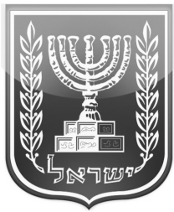 | MINISTRY OF THE INTERIOR
DEATH CERTIFICATE

Surname | Rindenau | First Name | Mordechai
First Name  of Father | Milton | First Name  of Mother | Fanette
 |  | Identity Number | 3 1034111 0
Hebrew  Date of Birth | 15 Nissan 5717 | Gregorian  Date of Birth | 27 March 1956
Gender | Male | Personal Status | Married
Nationality | Jewish | Religion | Jewish
Hebrew  Date of Death | 16 Shvat 5781 | Gregorian  Date of Death | 28 January 2021
Place of Death | Safed | Name of Hospital | Rebecca Sieff
Causes of Death

I hereby certify that the death was registered in the Death Registry for 2021
and this certificate was given in accordance with Section 30 of the Population Registration Law 5725 – 1965.
Issued in the Ashdod Population an Immigration Authority Bureau
On 11 Adar 5781 23 February 2021

This certificate was issued from the computerized (round stamp)
system of the Population Registry Population and Immigration
Authority
CL/10 State of Israel Ministry of the Interior
Ministry of the Interior 05/2020

To
Akiva Rindenau

Netzer Hazani 1113
Netzer Hazani 7681401

