Microbial evolution reshapes soil carbon feedbacks to climate warming

Elsa Abs1,2*, Scott R. Saleska3, Regis Ferriere2,3,4

**Affiliations:**

1 Department of Ecology and Evolutionary Biology, University of California, Irvine, CA 92697, USA

2 International Center for Interdisciplinary Global Environmental Studies (iGLOBES), CNRS, Ecole Normale Supérieure, Paris Sciences & Lettres University,

University of Arizona, Tucson, AZ 85721, USA

3 Department of Ecology & Evolutionary Biology, University of Arizona,

Tucson, AZ 85721, USA

4 Institut de Biologie (IBENS), Ecole Normale Supérieure,

Paris Sciences & Lettres University, CNRS, INSERM, 75005 Paris, France

**E-mail addresses:**

Elsa Abs: eabs@uci.edu

Scott Saleska: saleska@email.arizona.edu

Regis Ferriere: regisf@email.arizona.edu

**Short running title:** Climate warming and microbial eco-evolutionary feedback

**Keywords:** Climate change, carbon cycle, decomposition, microbial evolution, adaptive dynamics, soil-climate feedbacks.

**Type of article**: Letters

**Number of words in the abstract:** 149

**Number of words in the main text:** 4,978

**Number of words in text box 1:** 635

**Number of words in text box 2:** 657

**Number of references:** 59

**Number of figures:** 4

**Number of tables:** 0

**Number of text boxes:** 2

**Corresponding author:** Elsa Abs. Mail: Department of Ecology and Evolutionary Biology, University of California, Irvine, CA 92697, USA. Phone: (520) 208-1112. Email: eabs@uci.edu.

**Statement of authorship:** R.F. conceived the study. All authors developed the model. E.A. performed the mathematical and numerical analysis. All authors analysed the results. E.A. and R.F. wrote the first version of the manuscript. All authors finalized the paper.

**Data accessibility statement:** No datasets were generated or analysed during the current study. The sensitivity analysis and figures that support the findings of this study were coded with Mathematica. The code file has been deposited in “MicFigCode”, <https://github.com/elsaabs/MicFigCode/tree/master>.

**Abstract**

Microbial decomposition of soil organic matter is a key component of the global carbon cycle. As Earth’s climate changes, the response of microbes and microbial enzymes to rising temperatures will largely determine the soil carbon feedback to atmospheric CO2. While increasing attention has focused on the physiological and ecological mechanisms governing microbial responses, the role of evolutionary adaptation remains understudied. To address this gap, we developed an ecosystem-evolutionary model of a soil microbe-enzyme system under warming conditions. Constraining the model with observations from five contrasting sites reveals evolutionary aggravation of soil carbon loss to be the most likely outcome, although temperature-dependent increases in mortality have the potential to instead cause an evolutionary buffering effect. In general, this model predicts a strong latitudinal pattern ranging from relatively limited evolutionary effects at low latitudes to notably larger effects at high latitudes. Accounting for microbial evolutionary adaptation will likely be critical for efforts to improve projections of Earth system responses to climate change.

**INTRODUCTION**

Microorganisms are key drivers of global biogeochemical cycles [(Falkowski *et al.* 2008)](https://paperpile.com/c/1K6Ucj/cFGkr). In terrestrial ecosystems, soil microbes decompose organic matter, returning carbon to the atmosphere as carbon dioxide (CO2) [(Waksman & Starkey 1931)](https://paperpile.com/c/1K6Ucj/fuot7). *In vitro* and *in situ* experiments suggest that changes in microbial decomposition associated with warming represent an important model of climatic feedback [(Davidson & Janssens 2006; Singh *et al.* 2010; Frey *et al.* 2013)](https://paperpile.com/c/1K6Ucj/7IOOg+CGcJE+sB4ml). Soil microbial populations may respond to increasing temperature through physiological mechanisms such as individual metabolic adjustment [(Bradford *et al.* 2008; Tucker *et al.* 2013)](https://paperpile.com/c/1K6Ucj/qsIKX+jyeS1) and ecological mechanisms such as shifts in population abundance or community composition [(Wei *et al.* 2014; Creamer *et al.* 2015)](https://paperpile.com/c/1K6Ucj/tSgbi+XprP5). Given the short generation time, large population sizes, and genetic variations observed for many microbial organisms, adaptive evolutionary responses of these microbial populations to warming are also likely [(Padfield *et al.* 2016; Schaum *et al.* 2017)](https://paperpile.com/c/1K6Ucj/DqCP7+15EMc). Indeed, the rapid evolutionary adaptation of microbial populations to environmental change are well documented in laboratory systems, particularly for temperature gradients [(Bennett & Lenski 2007)](https://paperpile.com/c/1K6Ucj/D1W5d). However, the functional, ecosystem-level consequences of microbial adaptive evolution remain poorly understood, and how microbial evolutionary adaptation to warming may contribute to carbon-climate feedback is unknown [(Monroe *et al.* 2018)](https://paperpile.com/c/1K6Ucj/WErmq).

The production of extracellular exoenzymes that diffuse in the soil and bind to soil organic matter is integral to the microbial decomposition of this organic matter [(Ratledge 1994)](https://paperpile.com/c/1K6Ucj/Mxqss). While the fitness costs of exoenzyme production [(Harder & Dijkhuizen 1983)](https://paperpile.com/c/1K6Ucj/phTWO) (reduced growth allocation, Fig. 1a) are paid by individual microbes, the fitness benefits derived from the larger resource pool are accessible to microbial collectives [(Velicer 2003)](https://paperpile.com/c/1K6Ucj/fOPvw), and as such, we expect genetic variations in exoenzyme production [(Trivedi *et al.* 2016)](https://paperpile.com/c/1K6Ucj/rHdCB) to be under strong selection [(Rainey & Rainey 2003; Velicer 2003)](https://paperpile.com/c/1K6Ucj/fOPvw+goGCN). The goal of this study was to evaluate how exoenzyme production responds to selection under conditions of environmental warming, and how the evolutionary response of exoenzyme production impacts decomposition and soil organic carbon (SOC) levels. Our focus is on soil bacteria, which typically exhibit a marked potential for rapid evolutionary adaptation to environmental change [(Koskella & Vos 2015)](https://paperpile.com/c/1K6Ucj/0iPjc).

To achieve these goals, we developed and analyzed a novel ecosystem-evolutionary model, starting with an ecosystem model of microbe-enzyme decomposition first proposed by Allison *et al.* (2010) (Fig. 1a) that was modified to take microbial evolutionary adaptation into account. Of the published ecosystem models of soil microbial decomposition (reviewed in Abs and Ferriere (2020)), Allison *et al.*’s model is the simplest of the *CDMZ* type, where *C* denotes the size of a single pool of SOC, *D*, the size of the dissolved organic carbon (DOC) pool, *M*, the microbial biomass, and *Z*, the size of a single pool of exoenzymes. The focal microbial trait is the fraction of assimilated carbon allocated to exoenzyme production [(Sinsabaugh & Moorhead 1994; Allison 2012; Steinweg *et al.* 2013)](https://paperpile.com/c/1K6Ucj/UgbYj+VAkjq+OPK0N), or the ‘exoenzyme allocation fraction’, denoted by *φ*. The balance of assimilated carbon, 1 − *φ*, is allocated to microbial growth. The effect of temperature on soil microbial activity is mediated by enzyme kinetics, with exoenzymes driving the decomposition rate, and by intracellular enzymes involved in resource uptake and microbial biomass synthesis. In general, as temperature increases, Allison *et al*.’s (2010) ecosystem model predicts a decline in equilibrium SOC due to more rapid enzyme kinetics, thus resulting in a positive feedback to atmospheric CO2 and warming.

To investigate how evolutionary adaptation to warming may affect decomposition, we sought to account for the existence of heritable variation [(Alster *et al.* 2016; Trivedi *et al.* 2016)](https://paperpile.com/c/1K6Ucj/kahLi+rHdCB) in the exoenzyme allocation fraction, *φ*. We then used evolutionary game theory and adaptive dynamics modeling [(Geritz *et al.* 1998; Brännström *et al.* 2013)](https://paperpile.com/c/1K6Ucj/RWSI7+ZHMGw) to derive the selection gradient of trait *φ* and compute the microbial evolutionarily stable strategy (ESS), *φ*\*, at any given temperature. Changing temperature alters the selection gradient, thus affecting *φ*\*. Knowing how the evolutionarily stable trait value *φ*\* changes as temperature increases, we can evaluate how the ecosystem equilibrium shifts in response to both the direct effect of warming on enzyme kinetics, and the indirect effect mediated by microbial evolutionary adaptation to warming (Fig. 1b, c). By comparing the response of the SOC stock that our ecosystem evolutionary model predicts (EVOL response) to the response predicted by the ecosystem *CDMZ* model in the absence of evolution (ECOS response, assuming *φ* to be a fixed parameter), we can evaluate the contribution of microbial evolutionary adaptation (EVO effect) to the direction and magnitude of the SOC stock responses to climatic warming (Fig. 1b, c).

To illustrate how EVO effects may vary in real ecosystems, we utilized available data [(German *et al.* 2012)](https://paperpile.com/c/1K6Ucj/2E3vn) on the decomposition kinetic parameters from five sites with increasing latitudes and decreasing mean annual temperatures. We then evaluated ECOS and EVOL responses for each site, and compared them within and among sites. Overall, our analysis identified parameters and temperature dependencies that critically influence the strength of evolutionary effects., supporting a discussion of how these evolutionary effects relate to previous consideration of ‘adaptation’ in the context of microbial responses to climate warming [(Allison *et al.* 2010; Wieder *et al.* 2013; Allison 2014)](https://paperpile.com/c/1K6Ucj/1jfFc+a9clM+RJlGD). We also discuss how, in natural systems, evolutionary adaptation may interact with ecological responses such as species sorting and community shifts [(O’Brien *et al.* 2013; Boon *et al.* 2014; Strauss 2014)](https://paperpile.com/c/1K6Ucj/EvDhx+BiA6Q+dykXA), and highlight how our results have the potential to inform future empirical work, ultimately concluding with an overview of the implications of these findings for Earth system modeling and forecasting.

**METHODS**

**Ecosystem model and temperature dependencies**

We used Allison et al.’s (2010) microbe-enzyme model of litter decomposition to describe the ecosystem dynamics of *C*, *D*, *M*, and *Z*, given litter input, leaching rates, and soil temperature (equations (1a-d) in Box 1, Fig. 1a and Supplementary Fig. 1). DOC taken up by individual cells is allocated to exoenzyme production (fraction *φ*) or microbial biomass, with enzyme production efficiency denoted by *γ*Z and microbial growth efficiency (MGE) denoted by *γ*M.

At the molecular and cellular level, the effect of warming on microbial decomposition is mediated by the temperature sensitivity of intra- and extra-cellular enzymatic activity [(Wallenstein *et al.* 2009; German *et al.* 2012; Burns *et al.* 2013)](https://paperpile.com/c/1K6Ucj/fnZ1o+2E3vn+KxMYe). In the baseline ‘kinetics-only’ scenario of temperature-dependent decomposition, microbial uptake parameters (maximum uptake rate, half-saturation constant) and exoenzyme kinetics parameters (maximum decomposition rate, half-saturation constant) increase with temperature [(Hochachka & Somero 2002; Davidson & Janssens 2006)](https://paperpile.com/c/1K6Ucj/AB6eO+sB4ml) in a logistic manner (equations (2a-d) in Box 1). Two other scenarios have been proposed for the influence of temperature on decomposition. In the microbial mortality scenario, the microbial death rate also increases with temperature (equation (3) in Box 1). This could be due to a higher risk of predation or pathogenic infection at higher temperatures, or faster microbial senescence due to higher protein turnover [(Hagerty *et al.* 2014)](https://paperpile.com/c/1K6Ucj/Uzd4w). In the microbial growth efficiency (MGE) scenario, MGE, which corresponds to the fraction of carbon allocated to growth that actually contributes to microbial biomass as opposed to being released as CO2 via growth respiration, decreases with warming [(Allison *et al.* 2010; Wieder *et al.* 2013)](https://paperpile.com/c/1K6Ucj/RJlGD+a9clM) (equation (4) in Box 1), potentially owing to higher maintenance costs at higher temperatures [(Sinsabaugh *et al.* 2013)](https://paperpile.com/c/1K6Ucj/14qyk).

For this study, model parameters including microbial life history parameters, thermal dependencies, enzyme parameters, and carbon inputs were constrained by experimental and observational data [(Allison *et al.* 2010; Allison 2012; German *et al.* 2012)](https://paperpile.com/c/1K6Ucj/RJlGD+VAkjq+2E3vn) (see Abs and Ferriere 20 for a review, Supporting Notes 2 for details, and Supplementary Table 1). Within these parameter ranges, the ecosystem model outputs are consistent with target empirical values (target *C* of the order of 100 mg cm-3, *M* about 2% of *C*, *Z* about 1% of *M*, and limiting *D* close to zero). [Zhang *et al.*](https://paperpile.com/c/1K6Ucj/LrIVX) (2014) provided more direct validation by successfully fitting a *CDMZ* model to time series field measurements of soil respiration from a specific ecosystem (semiarid savannah subject to episodic rainfall pulses). The impacts of temperature dependence and parameter values on equilibrium *C* responses to temperature changes are shown in Supplementary Fig. 4 and discussed in Supplementary Note 3.

**Evolutionary model of exoenzyme production**

Assuming heritable variation in the exoenzyme allocation fraction trait, *φ*, we used the framework of adaptive dynamics [(Metz *et al.* 1992; Geritz *et al.* 1998)](https://paperpile.com/c/1K6Ucj/c4xIu+RWSI7) to predict the strength and direction of selection on trait *φ* and the evolutionarily stable value, *φ*\*. In this framework, evolution is modeled as a competition between a ‘resident strategy’ (wild-type) and alternate strategies (mutants) within a set of feasible phenotypes. In a given environment (*e.g.* at a given temperature), an evolutionarily stable strategy (ESS) is a phenotype that, when resident, is not susceptible to invasion by mutants. The adaptive dynamics framework provides the mathematical criteria to identify ESSs and check their attractivity, i.e. that they can be reached by a sequence of small evolutionary steps, with each step involving the replacement of a resident phenotype by a mutant phenotype. Here the set of feasible phenotypes at a given temperature is the range (*φ*min, *φ*max), for which the non-trivial ecosystem equilibrium exists (see Box 1). The derivation of the selection gradient and evolutionarily stable trait value, *φ*\*, as a function of temperature *T*, is presented in Box 2.

**Ecosystem response (ECOS) and ecosystem evolutionary response (EVOL) to warming**

As temperatures rise from *T*0 to *T*, the direction and magnitude of the microbial adaptive response is measured with the formula $∆φ=φ^{*}\left(T\right)-φ^{*}\left(T_{0}\right)$, which varies based on the scenario of temperature dependence. The ecosystem-evolutionary (EVOL) response of SOC is given by the following equation:

(9) EVOL response = Δ*C*EVOL (*T0*, *T*) = *C*(*T*, *φ*\*(*T*)) – *C*(*T0*, *φ*\*(*T0*))

where *C*(*T*, *φ*) corresponds to ecosystem equilibrium *C* at temperature *T*, given enzyme allocation fraction *φ*. The EVOL response can then be compared with the response in the absence of evolution (ECOS response):

(10) ECOS response = Δ*C*ECOS (*T*0, *T*) = *C*(*T*, *φ*\*(*T*0)) – *C*(*T*0, *φ*\*(*T*0))

in which the enzyme allocation fraction is fixed at its *T*0 -adapted value, *φ*\*(*T*0) (Fig. 1c).

We measured the magnitude of the evolutionary (EVO) effect as the difference between the EVOL response averaged over the temperature range (*T*0, *T*) and the ECOS response averaged over the same temperature range, normalized by the ECOS response:

(11) EVO effect = $\frac{\left|\int_{T_{0}}^{T}{}∆C_{EVOL}(T_{0},T)-\int_{T_{0}}^{T}{}∆C_{ECOS}(T_{0},T)\right|}{\left|\int_{T_{0}}^{T}{}∆C_{ECOS}(T_{0},T)\right|}$

This evaluation allowed us to compare EVO effects across systems that differ in the magnitude of their ECOS response. In all simulations we used $T=T_{0}+ΔT$ where Δ*T* = 5 °C. In general, the ECOS and EVOL responses are monotonic, close-to-linear functions of *T* over the temperature ranges $(T_{0}, T_{0}+ΔT)$, rendering our comparative analyses largely insensitive to our choice of Δ*T*.

**Sensitivity analysis**

We analyzed the sensitivity of this model by varying parameters over two orders of magnitude (as in [(Allison *et al.* 2010)](https://paperpile.com/c/1K6Ucj/RJlGD)), with the exception of *γ*M and *γ*Z for which we used the whole range over which the non-trivial ecosystem equilibrium is stable (Supplementary Table 2). To assess the significance of our findings for real ecosystems, we focused on five sites for which empirical data [(German *et al.* 2012)](https://paperpile.com/c/1K6Ucj/2E3vn) could be used to constrain the model. The five sites vary markedly in their initial temperature, *T*0, and decomposition kinetics, $v_{max}^{D}(T)$ and $K_{m}^{D}(T)$ for which we selected the Arrhenius equations (equations (2a-d) in Box 1) that best fit the relations used in [(German *et al.* 2012)](https://paperpile.com/c/1K6Ucj/2E3vn) (Supplementary Table 3).

**RESULTS**

**ESS enzyme allocation fraction at a given temperature**

The exoenzyme allocation fraction ESS, *φ*\*, corresponds to a maximum of microbial fitness relative to other trait values, and therefore depends on the parameters defining microbial net growth rate, i.e. MGE (*γ*M), maximum uptake rate ($v_{max}^{U}$), mortality (*d*M), and local competitive advantages for exoenzyme producers, or ‘competition asymmetry’ (*c*0):

(8)

Note that *c*0, the degree of competition asymmetry, measures the differential availability of enzymatically produced dissolved organic carbon (DOC) to different microbial strains. Competition asymmetry is shaped by the diffusion of exoenzymes and DOC, and by microbial mobility, and is thus likely influenced by soil physical properties such as texture or moisture. For simplicity, we assume that competition asymmetry is independent of temperature.

At a fixed temperature, the model predicts that microbes invest less in exoenzymes when exposed to hostile conditions, resulting in high rates of mortality (*d*M), low MGE (*γ*M), low maximal uptake rate ($v_{max}^{U}$), and/or low competitive advantage to producers (*c*0). Conversely, microbes are subject to selective pressure to allocate more resources to exoenzyme production when more favorable growth conditions yield a better ‘return on investment’ [(Schimel & Weintraub 2003)](https://paperpile.com/c/1K6Ucj/RjWAl).

**Effect of warming on the enzyme allocation fraction ESS**

According to equation (8), the adaptive response of exoenzyme allocation to warming depends on how the MGE, maximum uptake, and mortality vary with temperature. We investigated how parameters influence the direction and sensitivity of the exoenzyme allocation fraction ESS to temperature by calculating the derivative of *φ*\* with respect to *T*, for each scenario of temperature dependence (Supplementary Note 4, Supplementary Fig. 5a-d). In the baseline ‘kinetics-only’ scenario (in which $v_{max}^{U}$ is the only parameter in equation (8) that depends on temperature), increasing temperature creates more favorable growth conditions through higher resource uptake capacity (higher $v_{max}^{U}$), which selects for higher investment in exoenzyme production (Supplementary Fig. 5a), resulting in lower equilibrium SOC. This is an evolutionary amplification of the positive feedback to warming driven by the ECOS response. Because d*φ*\*/d*T* is proportional to both exp(1/*T*) and 1/*T*2, the sensitivity of *φ*\* to temperature is strongest across low temperatures(Supplementary Note 4, Supplementary Fig. 5a). The adaptive response is generally greatest, and the amplification of the positive climate feedback is strongest, when warming enhances microbial growth potential (by increasing $v_{max}^{U}$) under initially hostile conditions (high $d_{M}$, low $γ_{M}$, low $v_{max}^{U}$ due to low intrinsic uptake rate $v_{0}^{U}$ and/or high activation energy $E_{v}^{U}$, low initial temperature *T*0).

In the temperature-dependent mortality scenario, both mortality and uptake respond exponentially to temperature. Microbes evolve to invest more heavily in exoenzyme production in response to warming if the change in resource uptake capacity remains greater than the change in mortality rate; otherwise, microbes evolve to invest less heavily in this process (Supplementary Note 4 and Supplementary Fig. 5b, c). In the MGE-temperature dependent scenario, the response of *φ*\* to temperature is proportional to the inverse of an exponential function of temperature (through the uptake rate, $v_{max}^{U}$) times a linear function of temperature (through MGE) [(Hagerty *et al.* 2014)](https://paperpile.com/c/1K6Ucj/Uzd4w). As a consequence, at a low initial temperature, the adaptive response of the allocation strategy to warming is mainly driven by the thermal dependence of resource uptake, and microbes adapt by increasing their resource investment in exoenzyme production. For ecosystems that are initially warmer, the microbial evolutionary adaptation to warming (lower allocation to exoenzymes) is mainly driven by the reduction of MGE (Supplementary Note 4 and Supplementary Fig. 5d).

We therefore conclude that microbial evolutionary adaptation to warming generally leads to larger resource allocation to exoenzyme production and a stronger positive carbon feedback to warming, with a greater response in initially colder ecosystems. There are two cases where positive soil C feedbacks to warming due to higher enzyme kinetic rates could be attenuated or even reversed: temperature-sensitive mortality, or temperature-dependent MGE in an initially warm ecosystem (Supplementary Fig. 5c, d). Accordingly, we next examined the magnitude of the amplification, attenuation, or reversal of positive carbon feedback to warming.

**Comparisons of the ECOS and EVOL responses to warming**

The evolutionary ecosystem response of SOC equilibrium to warming combines the non-evolutionary response of the ecosystem and the evolutionary adaptive response of exoenzyme production (Fig. 1c). In all three scenarios of temperature dependence, the SOC non-evolutionary equilibrium generally decreases as temperature or resource allocation to exoenzymes increases (Fig. 1b, Supplementary Figs. 3 and 4, Supplementary Note 3). The negative effect of temperature results from the SOC equilibrium being most sensitive to the maximum decomposition rate ($v_{max}^{D}$) (Supplementary Note 3). As the maximum decomposition rate increases with warming, the SOC equilibrium thus decreases. The SOC equilibrium is always lower in systems where microbes invest more resources in exoenzymes as, when all other parameters are fixed, a larger exoenzyme allocation fraction ensures higher levels of exoenzyme production per unit time, resulting in greater SOC decomposition per unit time (Supplementary Note 1).

We therefore predict that, in the absence of evolution, the equilibrium soil carbon stock shrinks as the climate warms in all scenarios of temperature dependence (Fig. 3). The strongest losses occur in initially cold systems due to the non-linear response of the maximum decomposition rate ($v_{max}^{D}$), and thus of SOC equilibrium, to temperature (Fig. 3, Supplementary Figure 4). We expect microbial evolutionary adaptation to alter non-evolutionary responses in a context-dependent manner, with effects ranging from the aggravation of soil carbon loss in systems where microbes adapt to warming via increased exoenzyme production, to the buffering of soil carbon loss in scenarios where microbes adaptively respond to warming with a lower exoenzyme allocation fraction (Fig. 1c).

As expected, the simulated ecosystem-evolutionary change in SOC equilibrium in response to warming (Figs. 2, 3) mirrors the evolutionary adaptive response of the exoenzyme allocation fraction to warming in all scenarios of temperature dependence (Supplementary Figs. 5a-d). In the baseline scenario, microbes always evolve a higher enzyme allocation fraction in response to rising temperature. As a consequence, evolutionary adaptation amplifies the non-evolutionary soil carbon loss due to warming (Fig. 3a). The effect of evolution is strongest in ecosystems characterized by conditions that are hostile to microbial growth (low initial temperature, *T*0; high mortality, $d_{M}$; low MGE, $γ_{M}$; low maximum uptake rate, $v_{0}^{U}$) (Fig. 2, Fig. 3a, Supplementary Fig. 6), where the adaptive response of the exoenzyme allocation fraction is most pronounced (Supplementary Fig. 5a). Strong evolutionary effects are robust to the variation of other model parameters – enzyme parameters (efficiency, production) and environmental parameters (litter input, leaching) (Supplementary Figs. 6 and 7, Supplementary Note 5), which have no influence on the relationship between *φ*\* and temperature (equation (8)). The model also predicts stronger evolutionary effects when the differential access to resources between microbial strains is small (low *c*0) (equation (8), Fig. 2c, d). Low levels of competition asymmetry select for microbes that allocate few resources to exoenzyme production (low *φ*\*). Due to the non-linear response of SOC equilibrium to *φ*, this causes the SOC equilibrium to be more sensitive to variations in the exoenzyme allocation fraction (Supplementary Note 1, Supplementary Fig. 3).

In the temperature-dependent mortality scenario, the strength of the effect of temperature on mortality is an important determinant of the evolutionary adaptive response to warming. When mortality is moderately sensitive to temperature, the positive response of *φ*\* to warming is attenuated. As a result, the evolutionary aggravation of soil carbon loss is less severe (Fig. 3b). When mortality is strongly sensitive to temperature, warming creates more hostile conditions for microbial growth such that *φ*\* decreases with warming. Evolutionary adaptation then buffers the loss of soil carbon (negative EVO effect, Fig. 3c).

In the temperature-dependent MGE scenario, the direction (positive or negative) of the response of *φ*\* to warming is determined by the initial temperature *T*0. The evolutionary effect parallels the response of *φ*\*. At low *T*0, *φ*\* increases strongly with temperature, resulting in the aggravation of soil carbon loss (positive evolutionary effect). In contrast, at high *T*0, *φ*\* decreases readily with warming, thereby opposing the non-evolutionary response (negative evolutionary effect) and instead promoting carbon sequestration (Fig. 3d). At an intermediate *T*0, *φ*\* is weakly sensitive to temperature, and the effect of evolutionary adaptation to warming is negligible.

**Model predictions using empirical data from five sites**

To illustrate how evolutionary effects may vary in real ecosystems, we used available data [(German *et al.* 2012)](https://paperpile.com/c/1K6Ucj/2E3vn) pertaining to the decomposition kinetic parameters from five sites with increasing latitudes and decreasing mean annual temperatures (Costa Rica, California, West Virginia, Maine, and Alaska, Fig. 4). We evaluated non-evolutionary and evolutionary responses for each site under three levels of competition asymmetry as quantified by the local competitive advantage to producers (*c*0) (Fig. 4a-h). Under our baseline scenario, EVO effects correlate strongly with mean annual temperature, even more so for low levels of competition asymmetry (Fig. 4i). Stronger EVO effects occur in colder sites, as found in the general analysis (Fig. 3a). In contrast, the non-evolutionary response does not correlate with mean annual temperature (Fig. 4a). As a result, a temperate site such as Maine exhibits a weak non-evolutionary response that can be strongly amplified by evolution, whereas the warm Costa Rica site exhibits a strong non-evolutionary response that is largely unaffected by evolution.

These results are quantitatively attenuated but qualitatively unaffected when microbial mortality increases moderately with temperature (Fig. 4b, f, j). With a stronger effect of temperature on microbial mortality, all sites exhibit an evolutionary buffering effect (Fig. 4k), as found in the general analysis (Fig. 3c). The intensity of evolutionary buffering is independent of the sites’ mean annual temperature, whereas it varies significantly with competition asymmetry (Fig. 4k). Under the temperature-dependent MGE scenario, non-evolutionary and evolutionary responses are reduced in magnitude relative to the baseline scenario (Fig. 4d, h), particularly in cold sites. However, in these sites, EVO effects are dramatically enhanced (Fig. 4l). Thus, in a site as cold as Alaska, a significant evolutionary loss of soil carbon is predicted, whereas the non-evolutionary-driven loss of soil carbon would be negligible (Fig. 4l).

**DISCUSSION**

Our general analysis of the ecosystem *CDMZ* model revealed that the non-evolutionary response of equilibrium SOC to warming always entails soil carbon loss and may only vary in amplitude (Fig. 1). In contrast, the evolutionary adaptive response of microbial exoenzyme allocation, which is shaped by interactions among the non-linear temperature dependencies of microbial traits, can drive negative as well as positive responses of equilibrium SOC to warming. The size of evolutionary effects is most sensitive to MGE, microbial mortality, activation energy of uptake maximal rate, competition asymmetry, initial temperature (Fig. 2), and to the temperature sensitivity of a given trait (Fig. 3). By specifying the model for five contrasting sites for which exoenzyme kinetics data are available [(German *et al.* 2012)](https://paperpile.com/c/1K6Ucj/2E3vn), we found evolutionary aggravation of soil carbon loss to be the most likely outcome, with these effects exhibiting a strong latitudinal pattern ranging from relatively weak evolutionary effects at lower latitudes to large evolutionary effects at higher latitudes (Fig. 4). The strong temperature-dependence of microbial mortality, however, would dramatically alter these evolutionary patterns, possibly causing the attenuation of soil carbon loss or even carbon sequestration in response to warming.

**Model predictions and empirical data**

The model results are broadly consistent with empirical work showing that changes in soil C stocks are driven by changes in microbial enzyme activity [(Carreiro *et al.* 2000; Waldrop *et al.* 2004)](https://paperpile.com/c/1K6Ucj/b1kbW+h1AmY), and that these changes arise from the multiple temperature-dependent effects on enzyme kinetics, microbial pool size, and microbial allocation to exoenzymes [(Steinweg *et al.* 2013; Malik *et al.* 2019)](https://paperpile.com/c/1K6Ucj/OPK0N+Tmvyn). Empirical data suggest that natural enzyme allocation fraction values are low [(Schimel & Weintraub 2003; Burns *et al.* 2013)](https://paperpile.com/c/1K6Ucj/RjWAl+KxMYe) and fall in the range for which our model predicts large evolutionary decomposition responses to warming. Measured mass-specific potential enzyme activity, used as a proxy for allocation to exoenzymes, generally increases with warming, a pattern also predicted by our evolutionary model [(Steinweg *et al.* 2013)](https://paperpile.com/c/1K6Ucj/OPK0N). Strikingly, Steinweg *et al*. found that the rise in enzyme allocation was greatest for moderate warming and less pronounced for strong warming, matching the predictions of our model under a temperature-dependent MGE scenario.

Many empirical observations and controlled experiments at various time and spatial scales have highlighted a general response of soil respiration and soil C stocks to warming, involving an ephemeral increase in respiration and a decrease in microbial biomass with no significant change in SOC. These patterns were only matched by the temperature-dependent mortality scenario incorporating evolutionary modeling. It has been argued, however, that most experiments remain insufficiently robust to exclude model predictions that diverge from these patterns [(Sulman *et al.* 2018)](https://paperpile.com/c/1K6Ucj/vwtrd). Furthermore, the physiological, ecological, and/or evolutionary mechanisms by which exoenzyme allocation and soil respiration vary in these experiments remain unknown. For a further discussion of ecosystem modeling predictions of soil C responses to warming, see Supplementary Note 6.

**Evolutionary adaptation *vs.* physiological acclimation**

The acclimation responses whereby individuals’ physiological mechanisms buffer the effect of warming on kinetics and maintain homeostasis norms for key life-history traits such as growth and maintenance are sometimes referred to as ‘adaptation’ (e.g. microbial carbon use efficiency in response to warming ) [(Allison *et al.* 2010; Wieder *et al.* 2013; Allison 2014)](https://paperpile.com/c/1K6Ucj/1jfFc+a9clM+RJlGD). However, this is phenotypic plasticity at the individual level, rather than evolutionary adaptation at the population level. In our model, constant mortality (in the baseline and temperature-dependent MGE scenarios) and constant MGE (in the baseline and temperature-dependent mortality scenarios) can be interpreted as manifestations of microbial acclimation [(Allison *et al.* 2010; Hagerty *et al.* 2014)](https://paperpile.com/c/1K6Ucj/RJlGD+Uzd4w). Our results show that such plasticity, whereby individual cells buffer growth efficiency and/or mortality against temperature variation, does not necessarily impede or overwhelm evolutionary adaptation to climate warming. Strikingly, it is under the assumptions that MGE and mortality remain constant with respect to temperature that the strongest adaptive changes in exoenzyme allocation are predicted. For further discussion of implications regarding the ‘adaptation’ of microbial carbon-use efficiency see Supplementary Note 7.

The exoenzyme allocation fraction itself might be plastic. Indeed, Steinweg *et al.* (2013)interpreted the positive effect of temperature on the allocation to enzyme production as a cell-level response to larger nutrient needs driven by higher maintenance costs. In our model, warming causes larger rates of nutrient uptakes (higher $v_{max}^{U}$) and this can lead to an adaptive increase in the enzyme allocation fraction (equation (8)). Based on the general evolutionary theory of phenotypic plasticity [(Scheiner 1993)](https://paperpile.com/c/1K6Ucj/M0Ygu), we expect the evolutionary optimal reaction norm of the enzyme allocation fraction to follow this same pattern such that *φ* increases with temperature, provided that the cost of plasticity is not too high and does not alter the selection gradient too markedly. Future investigation of this topic is warranted to test this possibility.

One interesting approach to testing the role of evolutionary adaptation *vs.* plasticity would be to monitor the effects of warming on experimentally evolving bacterial communities at different levels of medium diffusivity or porosity [(Rebolleda-Gómez & Travisano 2018)](https://paperpile.com/c/1K6Ucj/7i1Au). Our model predicts that the diffusion of resources (DOC), which is likely dependent on the physical properties of the soil medium, has a strong influence on the adaptive evolution of microbial exoenzyme production in response to warming, whereas it is unlikely to impact non-evolutionary ecosystem responses driven by enzyme kinetics and physiological plasticity. Thus, comparing population-scale decomposition and respiration across treatments that factorially cross temperature and medium physical properties may ultimately help disentangle the relative effects of adaptation and plasticity.

**Evolutionary adaptation and ecological community responses**

In natural soils exposed to climate change, microbial evolutionary adaptation is expected to interact with ecological responses such as species sorting or community shifts in species or functional group abundance [(O’Brien *et al.* 2013; Boon *et al.* 2014; Strauss 2014)](https://paperpile.com/c/1K6Ucj/BiA6Q+EvDhx+dykXA). Indeed, there is growing experimental evidence for soil bacterial communities shifting in response to climatic conditions, with functional consequences for decompositional processes [(Glassman *et al.* 2018)](https://paperpile.com/c/1K6Ucj/78p0m). This underscores the challenge of assessing the relative importance of evolutionary and ecological mechanisms when examining the response of microbial decomposition to warming. Available empirical evidence suggests that both could be significant. For example, recent experiments using *Pseudomonas* bacteria revealed that local evolutionary adaptation was as important as community composition when shaping the community response to elevated temperature over the course of a two-month experiment [(Gómez *et al.* 2016)](https://paperpile.com/c/1K6Ucj/Bbdvp).

Our model could be extended to integrate evolutionary adaptation and ecological shifts in response to warming. To represent the functional diversity of a microbial community exploiting diverse substrates, different SOC pools could be included [(Wang *et al.* 2013)](https://paperpile.com/c/1K6Ucj/DypIr), in addition to specifying different types of enzymes and different microbial functional groups that produce them [(Allison 2012)](https://paperpile.com/c/1K6Ucj/VAkjq). In our model parameterization, microbial functional groups would potentially differ in traits such as MGE ($γ_{M}$), enzyme cost ($γ_{Z}$) and uptake rate () [(Allison 2012)](https://paperpile.com/c/1K6Ucj/VAkjq). Assuming that variation in these traits is heritable, their evolution should drive the adaptive response of the microbial functional community to environmental change. In an evolution experiment using *Neurospora discreta* as a model system to assess the adaptation of soil fungi to warming [(Romero-Olivares *et al.* 2015)](https://paperpile.com/c/1K6Ucj/KTOY8), Allison *et al.* (2018) did find evidence for evolutionary responses in MGE and uptake rates. By allowing multiple traits to evolve, our model can be extended to multiple substrates to generate an evolutionarily stable community at a given temperature (in line with Sauterey *et al*.’s [(Sauterey *et al.* 2015)](https://paperpile.com/c/1K6Ucj/ysJMi) approach to incorporating evolutionary dynamics into models of ocean planktonic communities), thereby enabling the subsequent analysis of both ecological and evolutionary responses to warming.

**Scaling up**

Despite an increasing effort to document and understand the impact of microbial physiological and ecological responses to climate warming on ecosystems [(Allison *et al.* 2010; Treseder *et al.* 2012; Wieder *et al.* 2013)](https://paperpile.com/c/1K6Ucj/RJlGD+a9clM+GSqaO), no Earth system model that seeks to represent the role of living organisms in climate feedbacks has yet incorporated evolutionary mechanisms of adaptation. This model is a critical first step towards that goal. When predicting geographic variations in evolutionary responses and effects across large geographic scales, our results highlight the need for more empirical data regarding the variability of ecosystem (competition) traits, particularly with respect to how the competitive advantages of exoenzyme producers vary with soil physical properties and microbial physiological traits, particularly microbial mortality. For further discussion of the effect of the temperature dependence of microbial traits on ecosystem-evolutionary responses, see Supplementary Note 8. On the modeling side, three steps will be needed to further advance these models: the ability to account for soil carbon stabilization on a timescale longer than respiration [(Tang & Riley 2014)](https://paperpile.com/c/1K6Ucj/ANUIo), the diversity of organic substrates in litter and the corresponding diversity of microbial decomposers [(Allison 2012)](https://paperpile.com/c/1K6Ucj/VAkjq), and the interaction of biogeochemical cycles and associated stoichiometric constraints [(Harte & Kinzig 1993; Sinsabaugh & Moorhead 1994; Schimel & Weintraub 2003; Allison 2012; Kaiser *et al.* 2015)](https://paperpile.com/c/1K6Ucj/RjWAl+4KTGN+UgbYj+VAkjq+ldWA1). As demonstrated by the successful Earth-scale modeling of phytoplankton abundance and distribution in the global ocean [(Follows *et al.* 2007)](https://paperpile.com/c/1K6Ucj/lOf6S), future models that take these steps will trade some of their added structural complexity for ‘self-parameterization’ driven by the process of adaptive trait evolution itself. As this research program unfolds, we expect projections of future climate and carbon cycle feedbacks, and their uncertainty, to be significantly impacted by microbial evolutionary adaptation from local to global scales.

**ACKNOWLEDGEMENTS**

We thank Rachel Gallery, Pierre-Henri Gouyon, Moira Hough, Hélène Leman, Laura Meredith, and Mitch Pavao-Zuckerman for discussion. E.A. was supported by fellowships from Ecole Doctorale Frontières du Vivant and MemoLife Laboratory of Excellence (PIA-10-LBX-54).S.R.S. was supported by a grant from the Genomic Science Program of the United States Department of Energy (DOE) (DE-SC0016440) and the University of Arizona’s Agnese Nelms Haury Program in Environment and Social Justice. R.F. acknowledges support from FACE Partner University Fund, CNRS Mission pour l’Interdisciplinarité, PSL University (IRIS OCAV and PSL-University of Arizona Mobility Program) and a grant from the Dimensions of Biodiversity program of the United States National Science Foundation (DEB-1831493).

**REFERENCES**

[Allison, S.D. (2012). A trait-based approach for modelling microbial litter decomposition. *Ecol. Lett.*, 15, 1058–1070.](http://paperpile.com/b/1K6Ucj/VAkjq)

[Allison, S.D. (2014). Modeling adaptation of carbon use efficiency in microbial communities. *Front. Microbiol.*, 5, 571.](http://paperpile.com/b/1K6Ucj/1jfFc)

[Allison, S.D., Wallenstein, M.D. & Bradford, M.A. (2010). Soil-carbon response to warming dependent on microbial physiology. *Nat. Geosci.*, 3, 336.](http://paperpile.com/b/1K6Ucj/RJlGD)

[Alster, C.J., Baas, P., Wallenstein, M.D., Johnson, N.G. & von Fischer, J.C. (2016). Temperature Sensitivity as a Microbial Trait Using Parameters from Macromolecular Rate Theory. *Front. Microbiol.*, 7, 1821.](http://paperpile.com/b/1K6Ucj/kahLi)

[Bennett, A.F. & Lenski, R.E. (2007). An experimental test of evolutionary trade-offs during temperature adaptation. *Proc. Natl. Acad. Sci. U. S. A.*, 104 Suppl 1, 8649–8654.](http://paperpile.com/b/1K6Ucj/D1W5d)

[Boon, E., Meehan, C.J., Whidden, C., Wong, D.H.-J., Langille, M.G.I. & Beiko, R.G. (2014). Interactions in the microbiome: communities of organisms and communities of genes. *FEMS Microbiol. Rev.*, 38, 90–118.](http://paperpile.com/b/1K6Ucj/BiA6Q)

[Bradford, M.A., Davies, C.A., Frey, S.D., Maddox, T.R., Melillo, J.M., Mohan, J.E., *et al.* (2008). Thermal adaptation of soil microbial respiration to elevated temperature. *Ecol. Lett.*, 11, 1316–1327.](http://paperpile.com/b/1K6Ucj/qsIKX)

[Brännström, Å., Johansson, J. & von Festenberg, N. (2013). The Hitchhiker’s Guide to Adaptive Dynamics. *Games*, An Introduction to Population Genetics Theory, 4, 304–328.](http://paperpile.com/b/1K6Ucj/ZHMGw)

[Burns, R.G., DeForest, J.L., Marxsen, J., Sinsabaugh, R.L., Stromberger, M.E., Wallenstein, M.D., *et al.* (2013). Soil enzymes in a changing environment: Current knowledge and future directions. *Soil Biol. Biochem.*, 58, 216–234.](http://paperpile.com/b/1K6Ucj/KxMYe)

[Carreiro, M.M., Sinsabaugh, R.L., Repert, D.A. & Parkhurst, D.F. (2000). MICROBIAL ENZYME SHIFTS EXPLAIN LITTER DECAY RESPONSES TO SIMULATED NITROGEN DEPOSITION. *Ecology*, 81, 2359–2365.](http://paperpile.com/b/1K6Ucj/b1kbW)

[Creamer, C.A., de Menezes, A.B., Krull, E.S., Sanderman, J., Newton-Walters, R. & Farrell, M. (2015). Microbial community structure mediates response of soil C decomposition to litter addition and warming. *Soil Biol. Biochem.*, 80, 175–188.](http://paperpile.com/b/1K6Ucj/tSgbi)

[Davidson, E.A. & Janssens, I.A. (2006). Temperature sensitivity of soil carbon decomposition and feedbacks to climate change. *Nature*, 440, 165–173.](http://paperpile.com/b/1K6Ucj/sB4ml)

[Driscoll, W.W. & Pepper, J.W. (2010). Theory for the evolution of diffusible external goods. *Evolution*, 64, 2682–2687.](http://paperpile.com/b/1K6Ucj/2eLpy)

[Falkowski, P.G., Fenchel, T. & Delong, E.F. (2008). The microbial engines that drive Earth’s biogeochemical cycles. *Science*, 320, 1034–1039.](http://paperpile.com/b/1K6Ucj/cFGkr)

[Follows, M.J., Dutkiewicz, S., Grant, S. & Chisholm, S.W. (2007). Emergent biogeography of microbial communities in a model ocean. *Science*, 315, 1843–1846.](http://paperpile.com/b/1K6Ucj/lOf6S)

[Frey, S.D., Lee, J., Melillo, J.M. & Six, J. (2013). The temperature response of soil microbial efficiency and its feedback to climate. *Nat. Clim. Chang.*, 3, 395.](http://paperpile.com/b/1K6Ucj/7IOOg)

[Geritz, S.A.H., Kisdi, E., Mesze´NA, G. & Metz, J.A.J. (1998). Evolutionarily singular strategies and the adaptive growth and branching of the evolutionary tree. *Evol. Ecol.*, 12, 35–57.](http://paperpile.com/b/1K6Ucj/RWSI7)

[German, D.P., Marcelo, K.R.B., Stone, M.M. & Allison, S.D. (2012). The Michaelis-Menten kinetics of soil extracellular enzymes in response to temperature: a cross-latitudinal study. *Glob. Chang. Biol.*, 18, 1468–1479.](http://paperpile.com/b/1K6Ucj/2E3vn)

[Glassman, S.I., Weihe, C., Li, J., Albright, M.B.N., Looby, C.I., Martiny, A.C., *et al.* (2018). Decomposition responses to climate depend on microbial community composition. *Proc. Natl. Acad. Sci. U. S. A.*, 115, 11994–11999.](http://paperpile.com/b/1K6Ucj/78p0m)

[Gómez, P., Paterson, S., De Meester, L., Liu, X., Lenzi, L., Sharma, M.D., *et al.* (2016). Local adaptation of a bacterium is as important as its presence in structuring a natural microbial community. *Nat. Commun.*, 7, 12453.](http://paperpile.com/b/1K6Ucj/Bbdvp)

[Hagerty, S.B., van Groenigen, K.J., Allison, S.D., Hungate, B.A., Schwartz, E., Koch, G.W., *et al.* (2014). Accelerated microbial turnover but constant growth efficiency with warming in soil. *Nat. Clim. Chang.*, 4, 903.](http://paperpile.com/b/1K6Ucj/Uzd4w)

[Harder, W. & Dijkhuizen, L. (1983). Physiological responses to nutrient limitation. *Annu. Rev. Microbiol.*, 37, 1–23.](http://paperpile.com/b/1K6Ucj/phTWO)

[Harte, J. & Kinzig, A.P. (1993). Mutualism and competition between plants and decomposers: implications for nutrient allocation in ecosystems. *Am. Nat.*, 141, 829–846.](http://paperpile.com/b/1K6Ucj/4KTGN)

[Hochachka, P.W. & Somero, G.N. (2002). *Biochemical Adaptation: Mechanism and Process in Physiological Evolution*. Oxford University Press.](http://paperpile.com/b/1K6Ucj/AB6eO)

[Kaiser, C., Franklin, O., Richter, A. & Dieckmann, U. (2015). Social dynamics within decomposer communities lead to nitrogen retention and organic matter build-up in soils. *Nat. Commun.*, 6, 8960.](http://paperpile.com/b/1K6Ucj/ldWA1)

[Koskella, B. & Vos, M. (2015). Adaptation in Natural Microbial Populations. *Annu. Rev. Ecol. Evol. Syst.*, 46, 503–522.](http://paperpile.com/b/1K6Ucj/0iPjc)

[Li, J., Wang, G., Allison, S.D., Mayes, M.A. & Luo, Y. (2014). Soil carbon sensitivity to temperature and carbon use efficiency compared across microbial-ecosystem models of varying complexity. *Biogeochemistry*, 119, 67–84.](http://paperpile.com/b/1K6Ucj/iZSZf)

[Malik, A.A., Puissant, J., Goodall, T., Allison, S.D. & Griffiths, R.I. (2019). Soil microbial communities with greater investment in resource acquisition have lower growth yield. *Soil Biol. Biochem.*, 132, 36–39.](http://paperpile.com/b/1K6Ucj/Tmvyn)

[Metz, J.A.J., Nisbet, R.M. & Geritz, S.A.H. (1992). How should we define “fitness” for general ecological scenarios? *Trends Ecol. Evol.*, 7, 198–202.](http://paperpile.com/b/1K6Ucj/c4xIu)

[Monroe, J.G., Markman, D.W., Beck, W.S., Felton, A.J., Vahsen, M.L. & Pressler, Y. (2018). Ecoevolutionary Dynamics of Carbon Cycling in the Anthropocene. *Trends Ecol. Evol.*, 33, 213–225.](http://paperpile.com/b/1K6Ucj/WErmq)

[O’Brien, S., Hodgson, D.J. & Buckling, A. (2013). The interplay between microevolution and community structure in microbial populations. *Curr. Opin. Biotechnol.*, 24, 821–825.](http://paperpile.com/b/1K6Ucj/EvDhx)

[Padfield, D., Yvon-Durocher, G., Buckling, A., Jennings, S. & Yvon-Durocher, G. (2016). Rapid evolution of metabolic traits explains thermal adaptation in phytoplankton. *Ecol. Lett.*, 19, 133–142.](http://paperpile.com/b/1K6Ucj/DqCP7)

[Rainey, P.B. & Rainey, K. (2003). Evolution of cooperation and conflict in experimental bacterial populations. *Nature*, 425, 72–74.](http://paperpile.com/b/1K6Ucj/goGCN)

[Ratledge, C. (1994). Biodegradation of oils, fats and fatty acids. In: *Biochemistry of microbial degradation* (ed. Ratledge, C.). Springer Netherlands, Dordrecht, pp. 89–141.](http://paperpile.com/b/1K6Ucj/Mxqss)

[Rebolleda-Gómez, M. & Travisano, M. (2018). The Cost of Being Big: Local Competition, Importance of Dispersal, and Experimental Evolution of Reversal to Unicellularity. *Am. Nat.*, 192, 731–744.](http://paperpile.com/b/1K6Ucj/7i1Au)

[Romero-Olivares, A.L., Taylor, J.W. & Treseder, K.K. (2015). Neurospora discreta as a model to assess adaptation of soil fungi to warming. *BMC Evolutionary Biology*.](http://paperpile.com/b/1K6Ucj/KTOY8)

[Sauterey, B., Ward, B.A., Follows, M.J., Bowler, C. & Claessen, D. (2015). When everything is not everywhere but species evolve: an alternative method to model adaptive properties of marine ecosystems. *J. Plankton Res.*, 37, 28–47.](http://paperpile.com/b/1K6Ucj/ysJMi)

[Schaum, C.-E., Barton, S., Bestion, E., Buckling, A., Garcia-Carreras, B., Lopez, P., *et al.* (2017). Adaptation of phytoplankton to a decade of experimental warming linked to increased photosynthesis. *Nat Ecol Evol*, 1, 94.](http://paperpile.com/b/1K6Ucj/15EMc)

[Scheiner, S.M. (1993). Genetics and evolution of phenotypic plasticity. *Annu. Rev. Ecol. Syst.*, 24, 35–68.](http://paperpile.com/b/1K6Ucj/M0Ygu)

[Schimel, J.P. & Weintraub, M.N. (2003). The implications of exoenzyme activity on microbial carbon and nitrogen limitation in soil: a theoretical model. *Soil Biol. Biochem.*, 35, 549–563.](http://paperpile.com/b/1K6Ucj/RjWAl)

[Singh, B.K., Bardgett, R.D., Smith, P. & Reay, D.S. (2010). Microorganisms and climate change: terrestrial feedbacks and mitigation options. *Nat. Rev. Microbiol.*, 8, 779–790.](http://paperpile.com/b/1K6Ucj/CGcJE)

[Sinsabaugh, R.L., Manzoni, S., Moorhead, D.L. & Richter, A. (2013). Carbon use efficiency of microbial communities: stoichiometry, methodology and modelling. *Ecol. Lett.*, 16, 930–939.](http://paperpile.com/b/1K6Ucj/14qyk)

[Sinsabaugh, R.L. & Moorhead, D.L. (1994). Resource allocation to extracellular enzyme production: A model for nitrogen and phosphorus control of litter decomposition. *Soil Biol. Biochem.*, 26, 1305–1311.](http://paperpile.com/b/1K6Ucj/UgbYj)

[Steinweg, J.M., Dukes, J.S., Paul, E.A. & Wallenstein, M.D. (2013). Microbial responses to multi-factor climate change: effects on soil enzymes. *Front. Microbiol.*, 4, 146.](http://paperpile.com/b/1K6Ucj/OPK0N)

[Stone, M.M., Weiss, M.S., Goodale, C.L., Adams, M.B., Fernandez, I.J., German, D.P., *et al.* (2012). Temperature sensitivity of soil enzyme kinetics under N-fertilization in two temperate forests. *Glob. Chang. Biol.*, 18, 1173–1184.](http://paperpile.com/b/1K6Ucj/KR1jH)

[Strauss, S.Y. (2014). Ecological and evolutionary responses in complex communities: implications for invasions and eco-evolutionary feedbacks. *Oikos*, 123, 257–266.](http://paperpile.com/b/1K6Ucj/dykXA)

[Sulman, B.N., Moore, J.A.M., Abramoff, R., Averill, C., Kivlin, S., Georgiou, K., *et al.* (2018). Multiple models and experiments underscore large uncertainty in soil carbon dynamics. *Biogeochemistry*, 141, 109–123.](http://paperpile.com/b/1K6Ucj/vwtrd)

[Tang, J. & Riley, W.J. (2014). Weaker soil carbon–climate feedbacks resulting from microbial and abiotic interactions. *Nat. Clim. Chang.*, 5, 56.](http://paperpile.com/b/1K6Ucj/ANUIo)

[Treseder, K.K., Balser, T.C., Bradford, M.A., Brodie, E.L., Dubinsky, E.A., Eviner, V.T., *et al.* (2012). Integrating microbial ecology into ecosystem models: challenges and priorities. *Biogeochemistry*, 109, 7–18.](http://paperpile.com/b/1K6Ucj/GSqaO)

[Trivedi, P., Delgado-Baquerizo, M., Trivedi, C., Hu, H., Anderson, I.C., Jeffries, T.C., *et al.* (2016). Microbial regulation of the soil carbon cycle: evidence from gene-enzyme relationships. *ISME J.*, 10, 2593–2604.](http://paperpile.com/b/1K6Ucj/rHdCB)

[Tucker, C.L., Bell, J., Pendall, E. & Ogle, K. (2013). Does declining carbon-use efficiency explain thermal acclimation of soil respiration with warming? *Glob. Chang. Biol.*, 19, 252–263.](http://paperpile.com/b/1K6Ucj/jyeS1)

[Velicer, G.J. (2003). Social strife in the microbial world. *Trends Microbiol.*, 11, 330–337.](http://paperpile.com/b/1K6Ucj/fOPvw)

[Waksman, S.A. & Starkey, R.L. (1931). *The soil and the microbe*. John Wiley And Sons; New York.](http://paperpile.com/b/1K6Ucj/fuot7)

[Waldrop, M.P., Zak, D.R., Sinsabaugh, R.L., Gallo, M. & Lauber, C. (2004). NITROGEN DEPOSITION MODIFIES SOIL CARBON STORAGE THROUGH CHANGES IN MICROBIAL ENZYMATIC ACTIVITY. *Ecol. Appl.*, 14, 1172–1177.](http://paperpile.com/b/1K6Ucj/h1AmY)

[Wallenstein, M.D., Mcmahon, S.K. & Schimel, J.P. (2009). Seasonal variation in enzyme activities and temperature sensitivities in Arctic tundra soils. *Glob. Chang. Biol.*, 15, 1631–1639.](http://paperpile.com/b/1K6Ucj/fnZ1o)

[Wang, G., Post, W.M. & Mayes, M.A. (2013). Development of microbial-enzyme-mediated decomposition model parameters through steady-state and dynamic analyses. *Ecol. Appl.*, 23, 255–272.](http://paperpile.com/b/1K6Ucj/DypIr)

[Wei, H., Guenet, B., Vicca, S., Nunan, N., AbdElgawad, H., Pouteau, V., *et al.* (2014). Thermal acclimation of organic matter decomposition in an artificial forest soil is related to shifts in microbial community structure. *Soil Biol. Biochem.*, 71, 1–12.](http://paperpile.com/b/1K6Ucj/XprP5)

[Wieder, W.R., Bonan, G.B. & Allison, S.D. (2013). Global soil carbon projections are improved by modelling microbial processes. *Nat. Clim. Chang.*, 3, 909.](http://paperpile.com/b/1K6Ucj/a9clM)

[Zhang, X., Niu, G.-Y., Elshall, A.S., Ye, M., Barron-Gafford, G.A. & Pavao-Zuckerman, M. (2014). Assessing five evolving microbial enzyme models against field measurements from a semiarid savannah—What are the mechanisms of soil respiration pulses? *Geophys. Res. Lett.*, 41, 6428–6434.](http://paperpile.com/b/1K6Ucj/LrIVX)

**Figure Captions**

**Figure 1. The effects of temperature and enzyme allocation fraction on SOC ecosystem equilibrium. a**, Structure of the microbial-enzyme ecosystem model (see Methods for details): SOC stock is the balance of plant input, *I*, and loss by exoenzyme-mediated degradation to DOC (*D*), which in turn is allocated between the production of exoenzymes (*Z*) (fraction *φ*) and the growth of microbial biomass (*M*) (fraction 1−*φ*). **b**, Effect of temperature and exoenzyme allocation fraction, *φ*, on SOC equilibrium, *C*, in the baseline scenario of temperature dependence. **c**, Response of SOC ecosystem equilibrium, *C*, to a 5°C increase in temperature (from 20 °C to 25 °C) as a function of exoenzyme allocation fraction, *φ*. Parameters are set to their default values (Supplementary Table 1), except ${I=5 10}^{-3}$, $v_{0}^{U}={10}^{5}$, $E_{v}^{U}=38$, $c_{0}=1.17$.

**Figure 2. Effect of microbial evolutionary adaptation on the SOC equilibrium response to + 5 °C warming (EVO effect).** Temperature influences enzyme kinetics only (baseline scenario of temperature dependence). **a**, Influence of microbial biomass production efficiency, *γ*M, and microbial mortality rate, *d*M. **b**, Influence of microbial resource acquisition traits $v_{0}^{U}$ and $E_{v}^{U}$. **c-d**, Influence of competition asymmetry, *c*0, and initial temperature, *T*0. In all figures, constant parameters are set to their default values (Supplementary Table 1) and *I* is set to 5 10-3.Points A1 and B1 indicate the default parameter values. Point A2 exemplifies values of *γ*M and *d*M (B2, $v_{0}^{U}$ and $E_{v}^{U}$) for which the EVO effect is strong. Panel **c** (resp. **d**) shows the influence of *c*0 and *T*0 on the EVO effect at A2 (resp. B2).

**Figure 3. Ecosystem (ECOS) and ecosystem-evolutionary (EVOL) responses of SOC equilibrium to warming (up to + 5 °C) for three scenarios of temperature dependence.** Ecosystem and ecosystem-evolutionary changes in SOC equilibrium *C* given by equation (10) (without evolution, dashed curves) and equation (9) (with evolution, solid curves) are plotted as a function of the increase in temperature.*Blue curves*, initial temperature *T*0 = 5°C. *Black curves*, *T*0 = *T*ref = 20°C. *Red curves*, *T*0 = 30°C. *Insets*, Direction and magnitude of EVO effect (%), from - 150 % to + 150 %, color code indicates *T*0 as before. **a**, Baseline scenario of temperature dependence (enzyme kinetics only). **b**, Temperature-dependent microbial mortality, with *E*dM = 25 < $E_{v}^{U}$. **c**, Temperature-dependent microbial mortality with *E*dM = 55 > $E_{v}^{U}$. **d**, Temperature-dependent MGE, with *m* = 0.014. Parameters values correspond to point B2 in Fig. 2 (${I=5 10}^{-3}$, $v_{0}^{U}={10}^{5}$, $E_{v}^{U}=38$, $c_{0}=1.17$). Other parameters are set to their default values (Supplementary Table 1).

**Figure 4. Ecosystem (ECOS) and ecosystem-evolutionary (EVOL) responses of SOC equilibrium to + 5 °C warming as predicted for five sites. a-d**,ECOS response. **e-h**,EVOL response. **i-l,** EVO effect given by equation (11). AK: Alaska, boreal forest, *T*0 = 0.1°C. ME: Maine, temperate forest, *T*0 = 5°C. WV: West Virginia, temperate forest, *T*0 = 9°C. CA: California, temperate grassland, *T*0 = 17°C. CR: Costa Rica, tropical rain forest, *T*0 = 26°C. First row (**a, e, i**): baseline kinetics-only scenario of temperature dependence. Second row (**b, f, j**): temperature-dependent microbial mortality scenario with *E*dM = 25 < $E_{v}^{U}$. Third row (*c*, *g*, *k*): temperature-dependent microbial mortality scenario with *E*dM = 55 > $E_{v}^{U}$. Fourth row (**d, h, l**): temperature-dependent MGE scenario (*m* = - 0.014). The influence of competition asymmetry, *c*0, is shown (low: *c*0 = 1.17, intermediate: *c*0 = 1.34, high: *c*0 = 1.5). For clarity, the vertical axes for ECOS and EVOL responses are truncated at -65 mg C cm-3. Actual values for AK with *c*0 = 1.17 are ECOS response = -170 mg C cm-3 and EVOL response = -556 mg C cm-3; actual values for WV with *c*0 = 1.17 is EVOL response = -92.8 mg C cm-3. Parameter values correspond to point B2 in Fig. 2 (${I=5 10}^{-3}$, $v_{0}^{U}={10}^{5}$, $E_{v}^{U}=38$, $c_{0}=1.17$); other parameters are set to their default values (Supplementary Table 1).**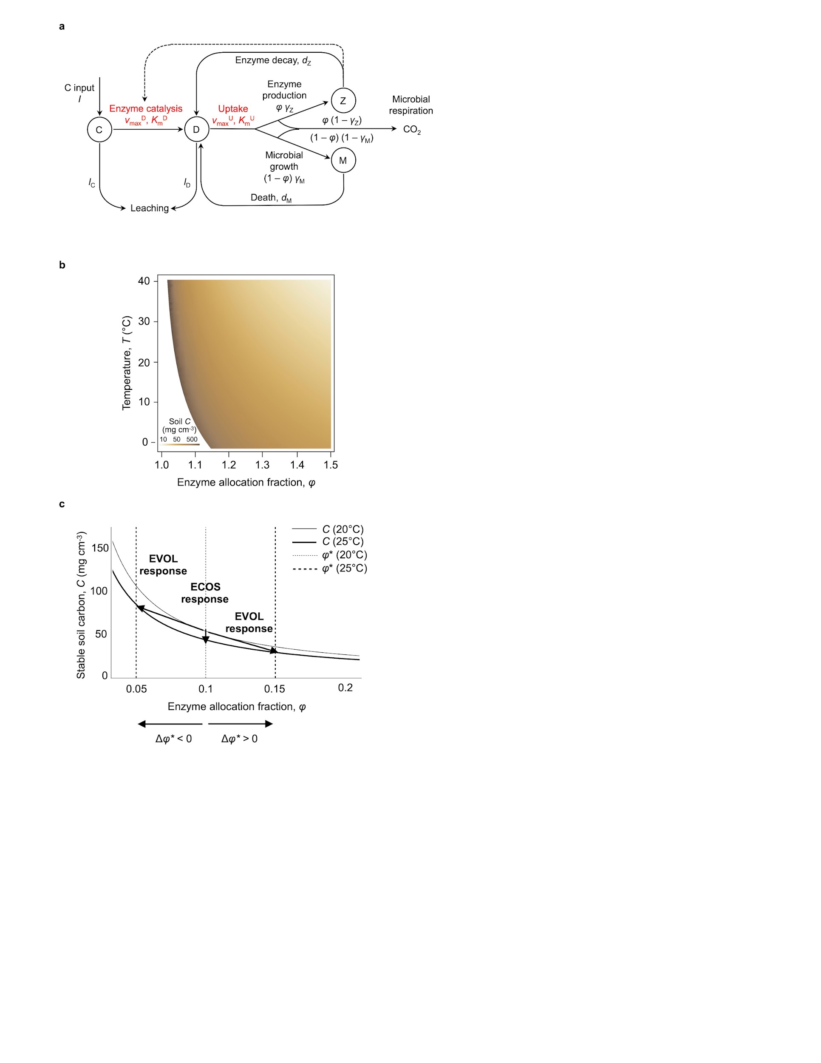Figure 1**

**Figure 2**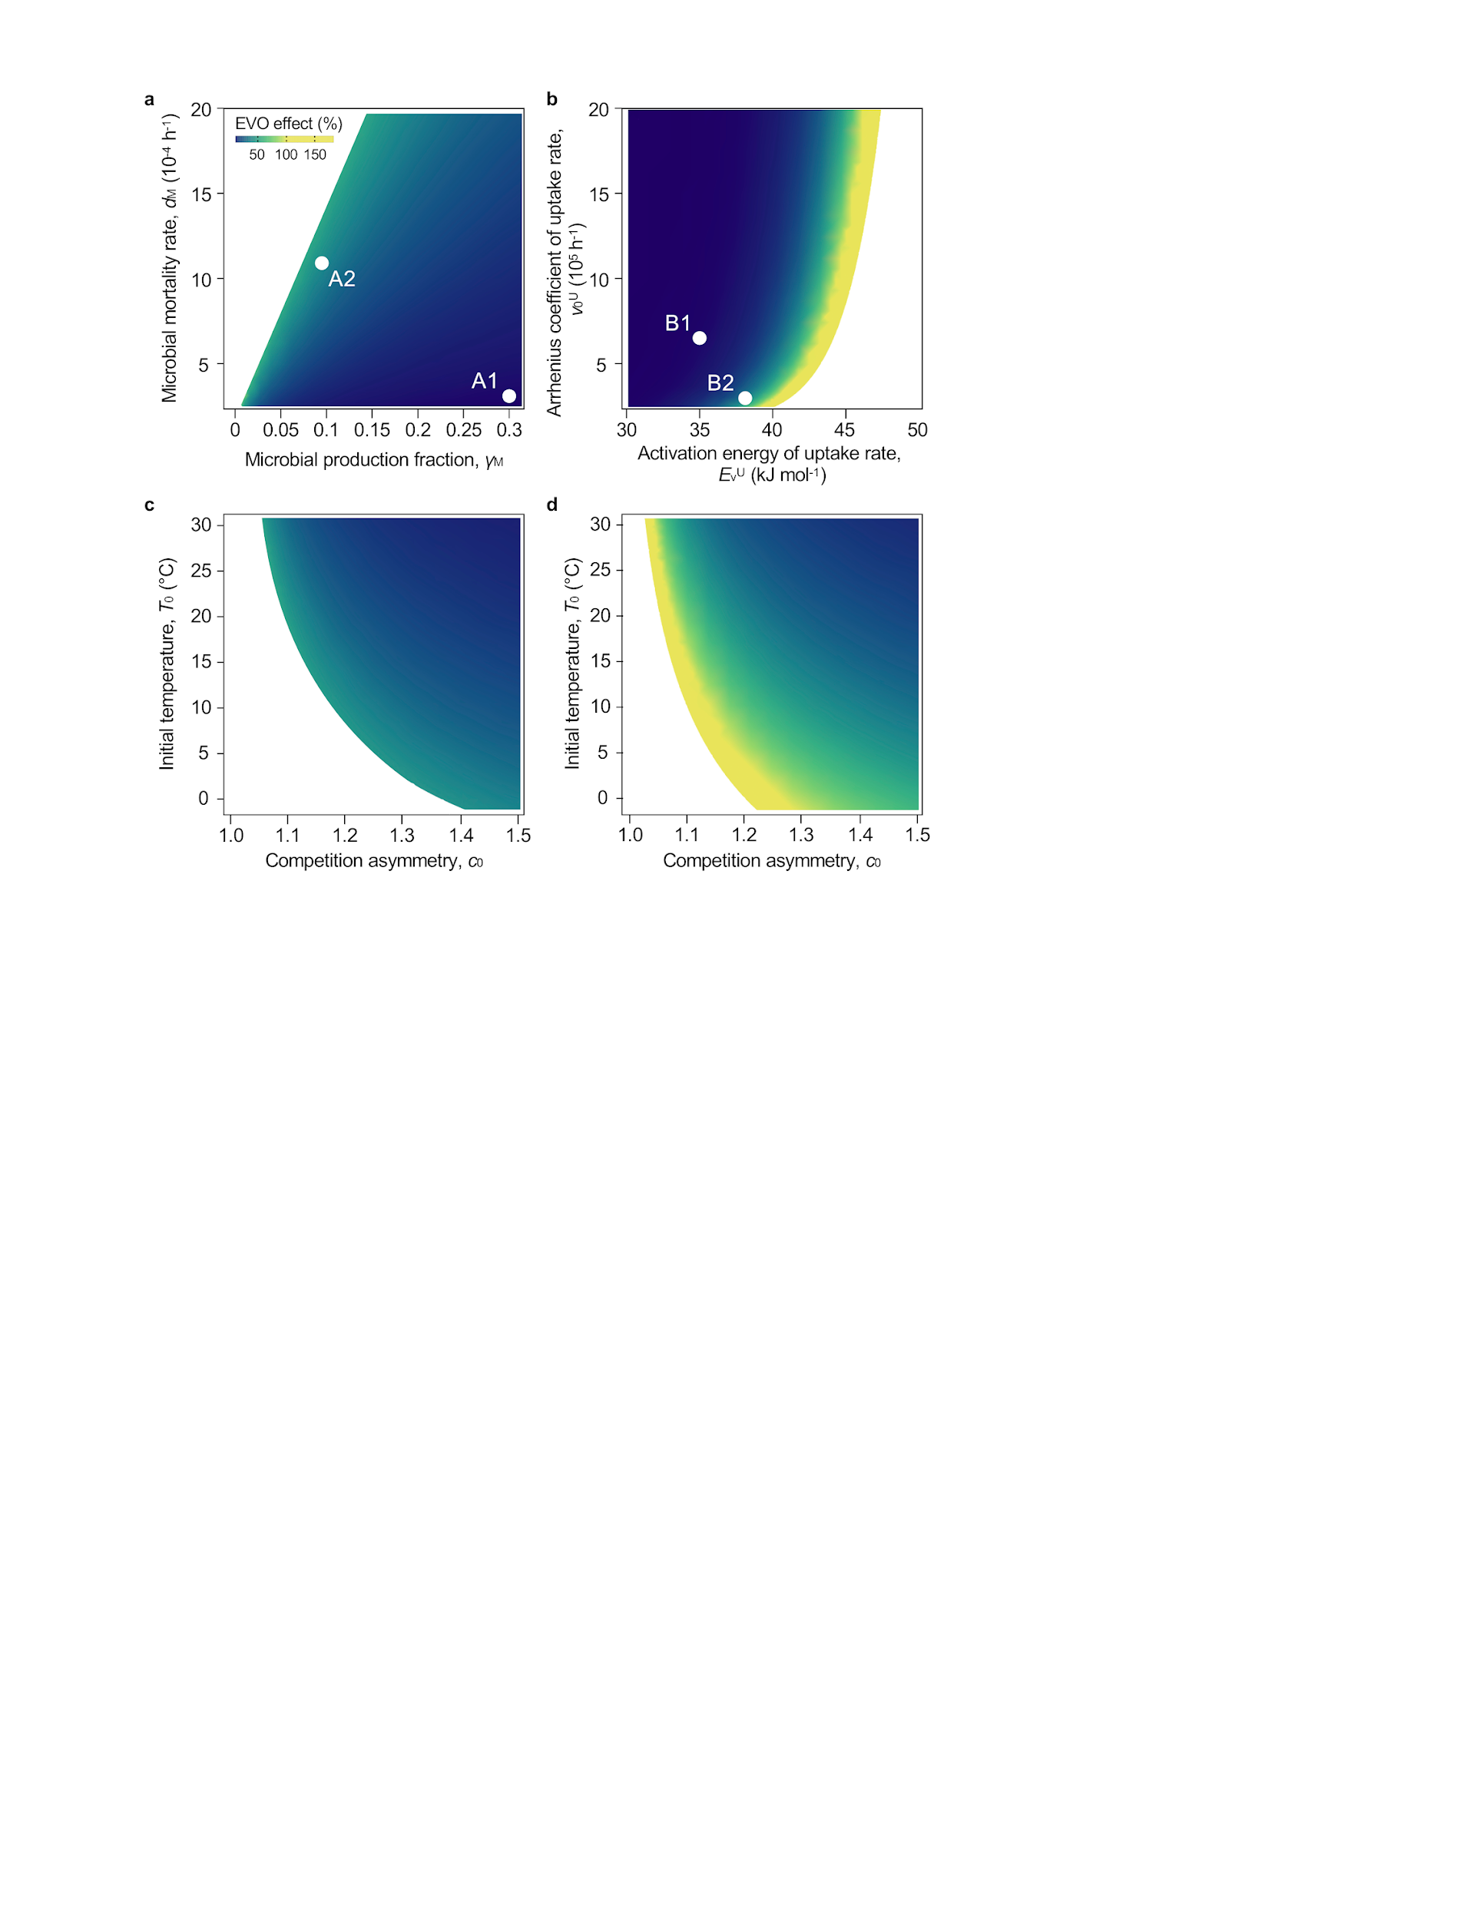

**Figure 3**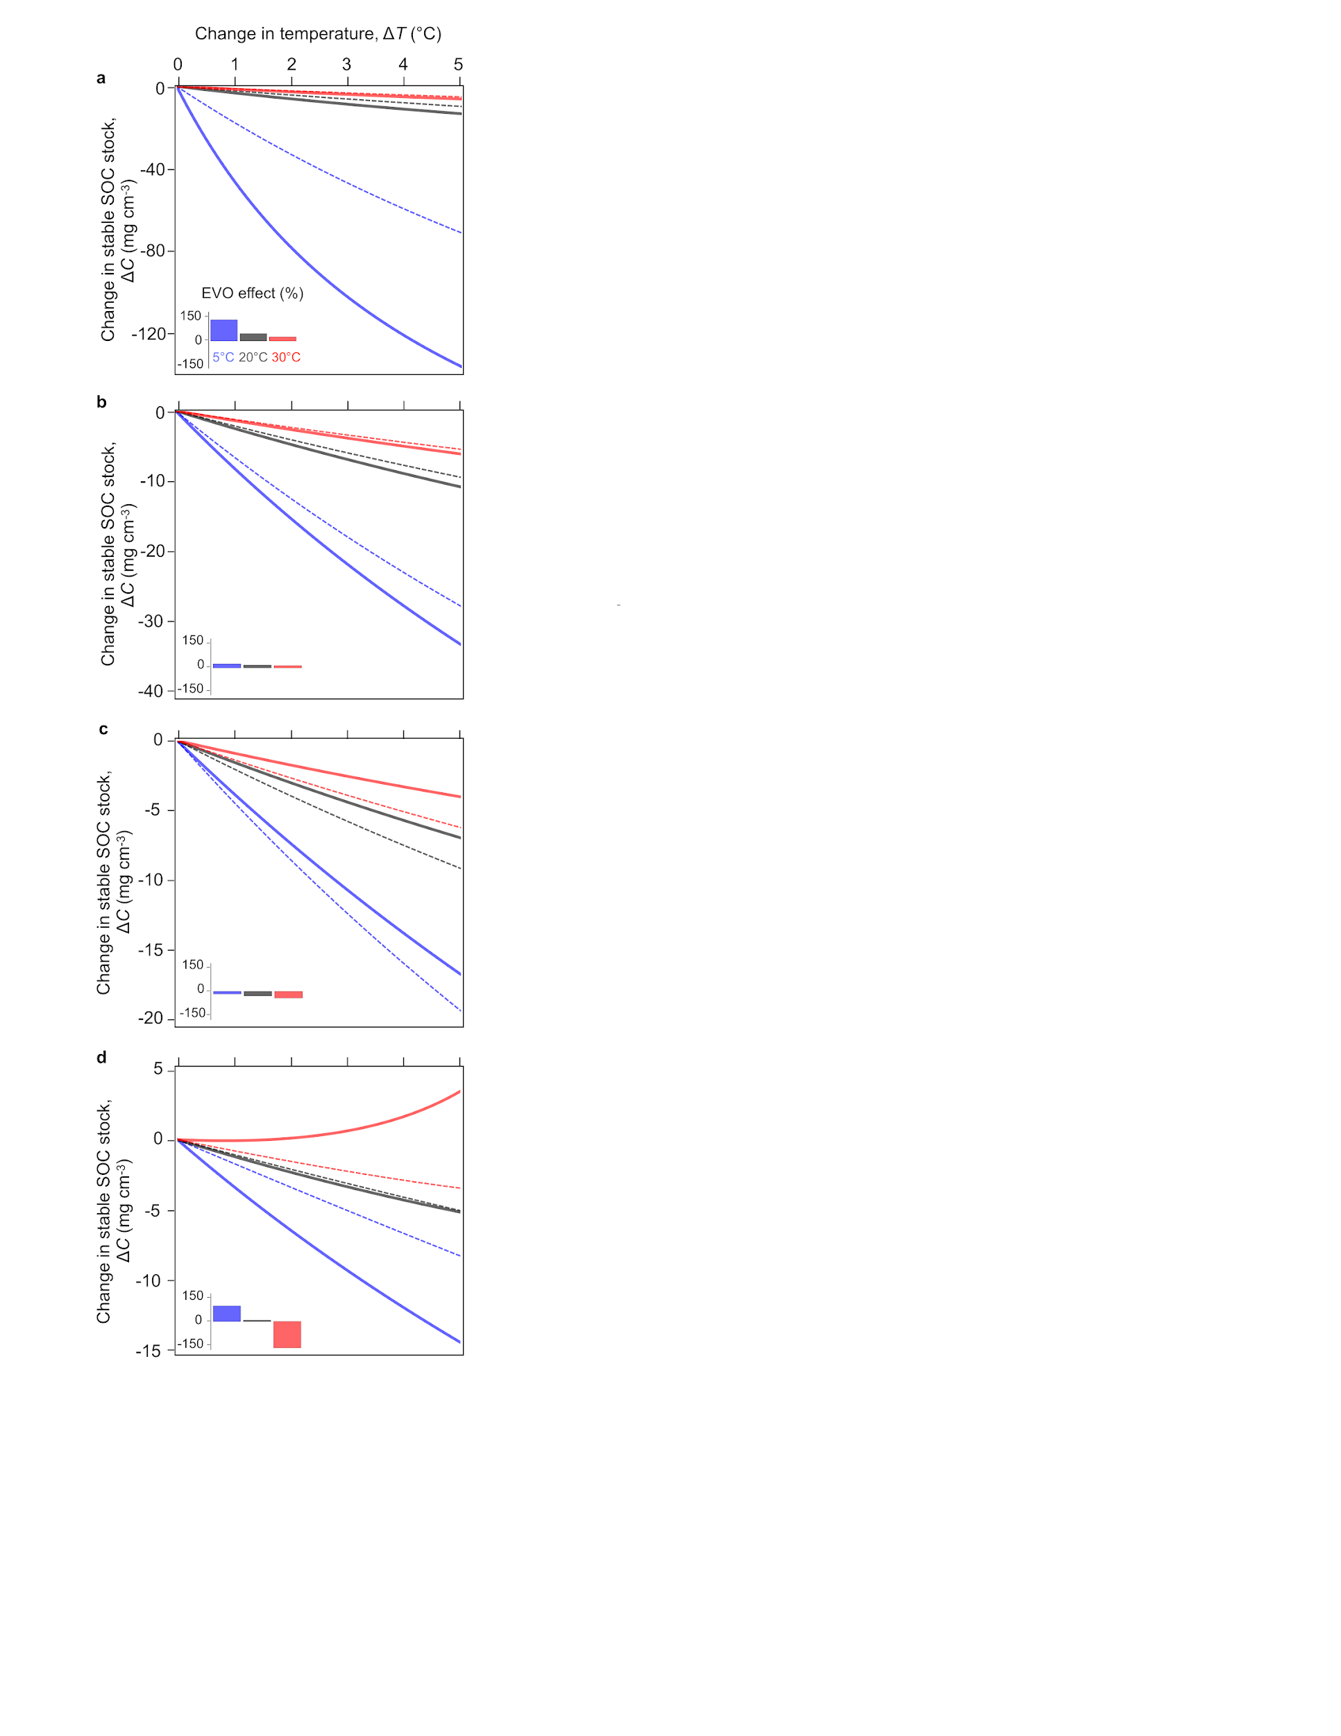

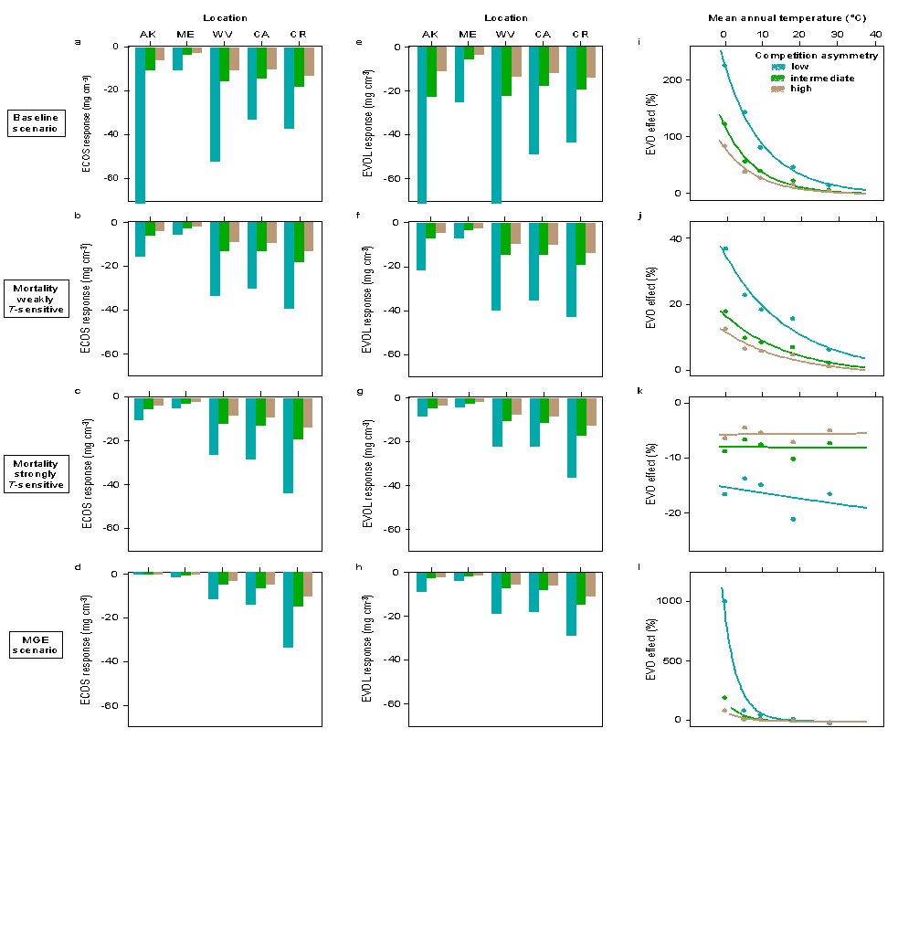**Figure 4**

**Box 1: Ecosystem *CDMZ* model and temperature dependencies.**

Based on a prior study [(Allison *et al.* 2010)](https://paperpile.com/c/1K6Ucj/RJlGD) (Fig. 1a, Supplementary Fig. 1), the developed ecosystem model has four state variables measured in unit mass of carbon: soil (non decomposed) organic carbon (SOC), *C*; soil decomposed soluble organic carbon (DOC), *D*; microbial biomass, *M*; and exoenzyme concentration, *Z*. Exoenzyme production drives the decomposition process of *C* into *D*, which is the only source of carbon for microbes. The model accounts for microbial production and death, exoenzyme decay, the recycling of dead microbes and degraded exoenzymes, *C* input from plant litter, and the leaching of *C* and *D*.

*Model equations.* State variables *C*, *D*, *M*, and *Z* obey equations (1a-d):

(1a) $\frac{dC}{dt}=I-\frac{v_{max}^{D}C}{K_{m}^{D}+C}Z-e_{C}C$

(1b) $\frac{dD}{dt}=\frac{v_{max}^{D}C}{K_{m}^{D}+C}Z+d_{M}M+d_{Z}Z-\frac{v_{max}^{U}D}{K_{m}^{U}+D}M-e_{D}D$

(1c) $\frac{dM}{dt}=\left(1-φ\right)γ_{M}\frac{v_{max}^{U}D}{K_{m}^{U}+D}M-d_{M}M$

(1d) $\frac{dZ}{dt}=φγ_{Z}\frac{v_{max}^{U}D}{K_{m}^{U}+D}M+d_{Z}Z$

In equation (1a), decomposition follows from Michaelis-Menten kinetics of *Z* binding substrate *C*; there is a constant input, *I*, of soil organic (non decomposed) carbon from aboveground litter, and a loss due to leaching at constant rate *e*C. In equation (1b), *D* is produced by decomposition and the recycling of dead microbial biomass and inactive enzymes; *D* is consumed by microbial uptake, and lost by leaching at constant rate *e*D. In equation (1c), the growth of microbial biomass *M* is driven by the rate of *D* uptake (a Monod function of *D*) times the fraction of uptaken *D* converted into biomass, (1 – *φ*) *γ*M, minus microbial mortality at constant rate *d*M. In equation (1d), enzyme variation is driven by the rate of *D* uptake times the fraction allocated to enzyme production, *φ*, and production efficiency, *γ*Z, minus enzyme deactivation at constant rate, *d*Z.

*Ecosystem equilibria.* The ecosystem model (equations (1a-d)) possesses either one globally stable equilibrium, or three equilibria (one of which is always unstable) (Supplementary Note 1, Supplementary Fig. 2). There are thresholds *φ*min and *φ*max such that the single globally stable equilibrium exists for *φ* < *φ*min or *φ* > *φ*max and is given by *C* = *I*/*eC*, *D* = 0, *M* = 0, *Z* = 0. Thus, at this equilibrium, the microbial population is extinct and no decomposition occurs. For *φ*min < *φ* < *φ*max, the microbial population can either go extinct, in which case the system stabilizes at the same equilibrium as before, or persists at or around a non-trivial equilibrium that can be solved for analytically (Supplementary equation (1)). Note that *φ*min and *φ*maxdepend on all microbial and model parameters (Supplementary Note 1, Supplementary Fig. 3).

*Effect of temperature on model parameters.*Decomposition is predicted to respond to warming [(Davidson & Janssens 2006)](https://paperpile.com/c/1K6Ucj/sB4ml) due to the temperature sensitivity of enzymatic activity [(Wallenstein *et al.* 2009; German *et al.* 2012; Stone *et al.* 2012)](https://paperpile.com/c/1K6Ucj/fnZ1o+KR1jH+2E3vn). Microbial assimilation may also vary with temperature if the microbial membrane proteins involved in nutrient uptake are sensitive to warming. Following [(Allison *et al.* 2010)](https://paperpile.com/c/1K6Ucj/RJlGD), we assume that exoenzyme kinetics parameters (maximum decomposition rate $v_{max}^{D}$ and half-saturation constant $K_{m}^{D}$) and microbial uptake parameters (maximum uptake rate $v_{max}^{U}$ and half-saturation constant $K_{m}^{U}$) follow Arrhenius relationships with temperature. This defines our baseline ‘kinetics-only’ scenario of temperature-dependent decomposition:

(2a) $v_{max}^{D}= v_{0}^{D}e^{-\frac{E_{v}^{D}}{R\left(T+273\right)}}$

(2b) $K_{m}^{D}= K_{0}^{D}e^{-\frac{E_{K}^{D}}{R\left(T+273\right)}}$

(2c) $v_{max}^{U}= v_{0}^{U}e^{-\frac{E_{v}^{U}}{R\left(T+273\right)}}$

(2d) $K_{m}^{U}= K_{0}^{U}e^{-\frac{E_{K}^{U}}{R\left(T+273\right)}}$

where *T* is the temperature in Celsius, *R* is the ideal gas constant, and the *E* parameters denote the corresponding activation energies.

We consider two additional scenarios for the influence of temperature on decomposition. In the temperature-dependent microbial mortality scenario [(Hagerty *et al.* 2014)](https://paperpile.com/c/1K6Ucj/Uzd4w), the microbial death rate *d*M depends on temperature according to:

(3) $d_{M}\left(T\right)= d_{M0}e^{-\frac{E_{dM}}{R\left(T+273\right)}}$

as in [(Hagerty *et al.* 2014)](https://paperpile.com/c/1K6Ucj/Uzd4w).

In the temperature-dependent microbial growth efficiency (MGE) scenario, the MGE decreases with temperature [(Allison *et al.* 2010; Wieder *et al.* 2013; Hagerty *et al.* 2014)](https://paperpile.com/c/1K6Ucj/RJlGD+a9clM+Uzd4w), which is modeled by making the microbial growth efficiency *γ*Mvary linearly with temperature [(Allison *et al.* 2010; German *et al.* 2012; Wang *et al.* 2013; Li *et al.* 2014)](https://paperpile.com/c/1K6Ucj/RJlGD+2E3vn+DypIr+iZSZf):

(4) $γ_{M}\left(T\right)= γ_{M,ref}-m\left(T-T_{ref}\right)$

with *T*ref = 20 °C.

**Box 2: Adaptive dynamics analysis.**

*Interactions between resident and mutant strains.* To model the competition effect of a resident phenotype, *φ*res, on the population growth of a mutant phenotype, *φ*mut, we extend the ecosystem model written for a single type (equation (1c) in Box 1). To account for the localized nature of the interactions between rare mutants and common resident cells, we introduce a function (hereafter denoted by *c*) corresponding to the difference between *φ*res and *φ*mut to measure how local decomposition by mutant and resident cells differ from ‘mean field’ (average) decomposition by resident cells. Thus, for given *C*, *D*, and *Z* parameters, the growth of the mutant population is governed by:

(5) $\frac{dM_{mut}}{dt}=\left(1-φ\right)γ_{M}\frac{v_{max}^{U}\left(1+c\left(φ_{mut}-φ_{res}\right)\right)D_{res}}{K_{m}^{U}+\left(1+c\left(φ_{mut}-φ_{res}\right)\right)D_{res}}M_{mut}-d_{M}M_{mut}$

where *D*res is the equilibrium *D* predicted by the ecosystem model for the resident phenotype *φ*res. Here, function *c* satisfies *c*(0) = 0, *c*(*z*) > 0 if *z* > 0 and *c*(*z*) < 0 if *z* < 0.

The underlying assumption is that each microbe has access to DOC partly as a public good and partly as a private good [(Driscoll & Pepper 2010)](https://paperpile.com/c/1K6Ucj/2eLpy). The public good component results from the diffusion of exoenzymes. The private good component results from local decomposition of cells and the exoenzymes that they produce at the microscopic scale. A mutant cell that invests more (or less) in exoenzymes has access to more (or less) DOC than the average resident cell because that cell’s private good allocation is greater (or smaller), whereas all cells share the same public good. In a spatially implicit model like ours, diffusion is not directly modeled, but its effect on the accessibility of DOC to a mutant strain can be phenomenologically accounted for by a parameterization that puts mutant cells at a competitive advantage for DOC if the mutant phenotype invests more in exoenzyme production than the resident phenotype, or at a competitive disadvantage if the mutant phenotype invests less. This parameterization is achieved with the function *c* in equation (5), where *c* < 1 when *φ*mut < *φ*res and *c* > 1 when *φ*mut > *φ*res. This phenomenological approach is consistent with the mathematical construction and numerical analysis of a spatially explicit model of resident-mutant local interaction that accounts for soil diffusion, which will be reported elsewhere.

*Invasion fitness and selection gradient.* Mutant fitness $s\left(φ_{mut},φ_{res}\right)$ is given by the mutant population growth rate per unit biomass:

(6) $s\left(φ_{mut},φ_{res}\right)=\left(1-φ\right)γ_{M}\frac{v_{max}^{U}\left(1+c\left(φ_{mut}-φ_{res}\right)\right)D_{res}}{K_{m}^{U}+\left(1+c\left(φ_{mut}-φ_{res}\right)\right)D_{res}}-d_{M}$

The selection gradient is then obtained by taking the first order derivative of the invasion fitness with respect to the mutant trait:

(7) $∇s\left(φ\right)=\frac{d_{M}}{1-φ}\left(\left(1-φ-\frac{d_{M}}{v_{max}^{U}γ_{M}}\right)c_{0}-1\right)$

where $c_{0}=c'(0)$ measures the local competitive advantage to stronger exoenzyme producers, which we call ‘competition asymmetry’. Note that by definition, $c_{0}>0$. Variation in $c_{0}$ may be caused by different soil diffusion properties such as physical texture or moisture.

*Evolutionary singularity.* Trait values that nullify the selection gradient are called ‘evolutionary singularities’. An evolutionary singularity can be attractive or repelling, and invadable or non-invadable. Evolutionary singularities that are attractive and non-invadable represent potential end-points of evolutionary adaptation. Evolutionary singularities that are attractive and invadable can lead to evolutionary branching [(Geritz *et al.* 1998)](https://paperpile.com/c/1K6Ucj/RWSI7).

In a given environment (fixed parameters, constant temperature) there is at most one evolutionary singularity given by defining $φ$* as the value of $φ$ that makes $∇s\left(φ\right)$ = 0 in equation (7):

(8) $φ^{*}=1-\frac{d_{M}}{v_{max}^{U}γ_{M}}-\frac{1}{c_{0}}$.

The existence of *φ*\* > 0requires $\frac{d_{M}}{v_{max}^{U}γ_{M}}<1$ and $c_{0}>\frac{1}{\left(1-\frac{d_{M}}{v_{max}^{U}γ_{M}}\right)}$. Thus, the (cooperative) trait *φ* can evolve above zero only if the local competitive advantage of stronger enzyme producers is large enough. The condition for *φ*\* to be evolutionarily stable is $c''\left(0\right)<2 c_{0}^{2}$ and no other condition than existence is required for *φ*\* to be always convergent. Here we assume that function *c* is such that *φ*\* is evolutionarily stable and attractive.

Equation (8) shows that more cooperation (larger *φ*\*) should evolve in microbial populations with lower mortality, greater nutrient uptake, and/or higher MGE. When comparing microbial populations with similar life-history traits *γ*M, and *d*M, a stronger exoenzyme producer competitive advantage (i.e. higher *c*0) selects for larger *φ*\* values.