Date: 8/2020

Observation no. 222

**Commercial observation: The effectiveness of the Bio T Plus preparation in controlling Anarsia in organic almond, Ein Harod Meuhad, July 2020**

**By: David Sarid, Eran Shilo—BioYome Company**

**Aim:**

To test the effectiveness of the Bio T Plus preparation in controlling Anarsia in almond.

**Methods and materials:**

**The crop:** The commercial observation was conducted in an organic orchard of the Umm el-Fahm almond variety, planted in Ein Harod Meuhad in 2014.

Drip irrigation. Medium soil.

**Phenological stage**: fruit (from fruitlet and up to after the hull split)

**Application method and spraying volume:** Spraying was carried out using a commercial air blast twin fan sprayer. Spray volume: 120 L/dunam (1000m2)

**Evaluation method:** Counting of live larvae, approximately 250 fruit/ treatment.

Monitoring traps for adults (four traps/treatment).

**Treatments dates:** 19/4/2020, 2/5/2020, 31/5/2020, 2/7/2020

**Date of hanging the monitoring traps:** 26/2/2020

**Fruit sampling dates:** 12/7/2020, 19/7/2020

**Preparations:**

* Bio T Plus, SC containing Bacillus thuringiensis subsp. Kurstaki at 16,000 international units (ITU)/mg per litre
* CheckMate dispensers containing 320 mg (E)-5-Decen-1-yl acetate 8.34%, (E)-5-Decen 1-ol 1.73%

**Treatments:**

|  |  |  |
| --- | --- | --- |
| **No.** | **Treatment** | **% or dispensers/ dunam (1000 m2)** |
| 1 | Bio T Plus | 0.4% |
| 4 | CheckMate Anarsia | 40 |
| 5 | Control |  |

**Results:**

Treating the orchard with Bio T Plus four times during the season substantially reduced Anarsia infestation compared with control. No signs of phytotoxicity were observed with any of the treatments.

**Table 1 Percentage of live larvae infestation**

|  |  |  |  |
| --- | --- | --- | --- |
| Treatments | Concentration %  or dispensers/dunam | Larvae infestation in almond (%) | |
| 12/7/2020 | 19/7/2020 |
| Bio T Plus | 0.4% | 1.9% | 1.8% |
| CheckMate Anarsia (ADAMA Makhteshim)—commercial standard | 40 | 6.4% | 1.4% |
| control |  | 7.2% | 6.8% |

**Graph 1. Monitoring male Anarsia in pheromone traps (Delta BioYome)**

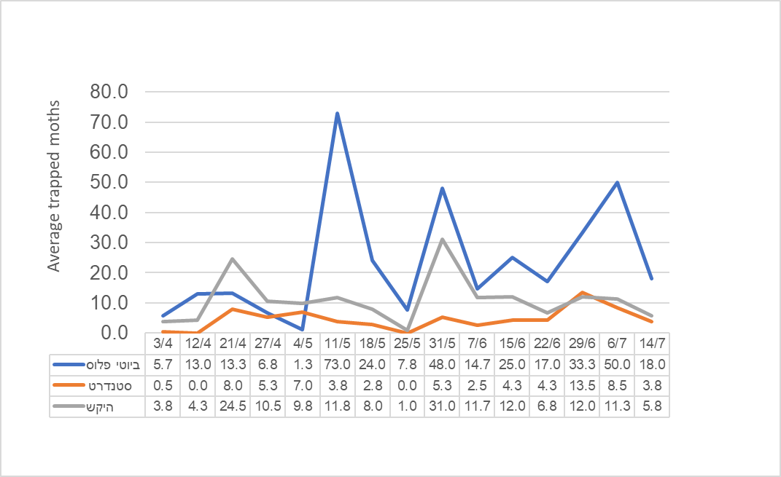

Monitoring male Anarsia in pheromone traps−–almond,

Ein Harod Meuhad, 2020

Bio T Plus

standard

control

**Discussion and conclusions:**

Bio T Plus (0.4%) effectively eliminates Anarsia larvae in almonds and reduces fruit infestation.

No phytotoxicity was observed in the crop. No effects on foliage were observed during crop growth.

**Acknowledgements:**

We thank Hillel and Vered for allocating the plot and assisting in the observation and counting.