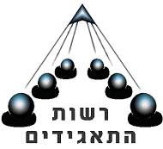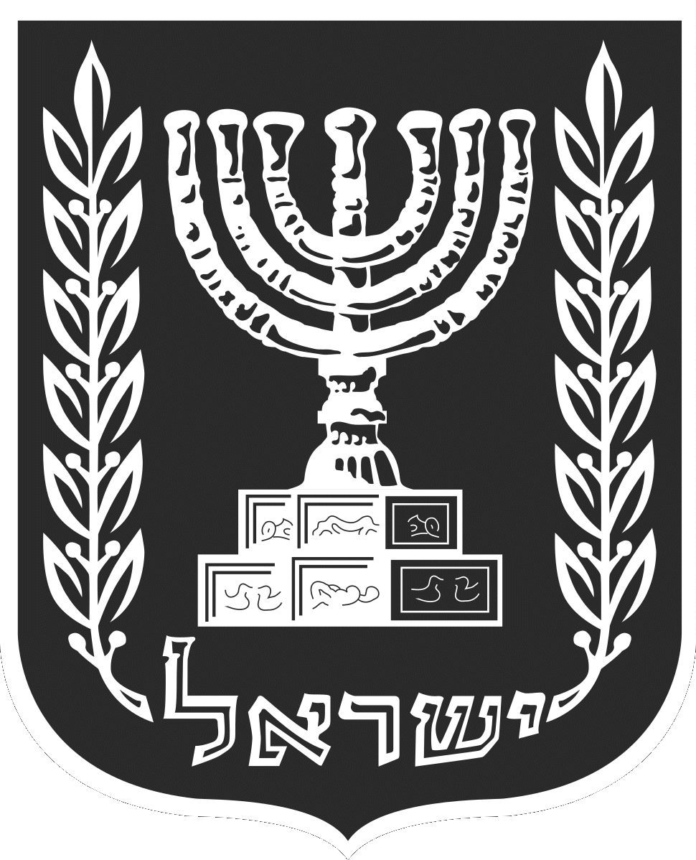**State of Israel**

**Ministry of Justice - Corporations Authority**

**Registrar of Companies and Partnerships**

**Certificate of Incorporation of Company**

**This is to certify that the company:**

|  |
| --- |
| **DIAMINING LTD**  **Number 514873850** |

**was incorporated and registered on 24 January 2013, 13 Shvat 5773**

**pursuant to the Company Law, 5759-1999, as a limited liability company.**

**Given in Jerusalem on:**

24 January 2013 (stamp) Ministry of Justice

13 Shvat 5773 Registrar of Companies and Partnerships

(-) Ofir Namani

Corporations Authority

Registrar of Companies and Partnerships



Confirmation that this document, digitally signed, constitutes a copy of the (original or copy of) a document located on the date of signature in the file of the corporation at the Corporations Authority