**הנחיות לכתיבת המאמר:**

**Special Article**

Reports scientific results of original research in such areas as economic policy, ethics, law, and health care delivery.

[**SEE EXAMPLE**](https://www.nejm.org/doi/full/10.1056/NEJMsa1600011#t=article)

**Maximum words:** 2,700

**Elements:**

* Abstract
* Maximum of five (5) tables and figures
* Up to 40 references

Study design, population and settings

Data collection and quality control  
General information  
Outcome measures

Statistical analysis + algorithm about population

**What do we know about contributing factors for 'Never Events' in the Operating Rooms? Machine learning analysis**

**Background:**

Adverse medical events can lead to significant morbidity and mortality and increase healthcare expenditures (Kjellberg et al, 2017). A Never Event (NE) is an unacceptable adverse event, which is preventable and unjustified, and maintains a goal of reducing its occurrence to zero thorough quality improvement (Robert, Choi et al, 2015), (Flug, Ponce et al 2018). Major NEs in perioperative care are incorrect surgery sites and retained foreign bodies during surgeries (NHS, 2018), (NHS Improvement, 2019). In the United States, there are an estimated 4,000 perioperative NEs annually (Mehtsun, Ibrahim et al, 2013).The incidence of incorrect surgery site is estimated to be 12.7% of all perioperative events, most prevalent in orthopedic surgery (35%), then general surgery (27%) and neurosurgery (17%) (Moshtagi et al, 2017). According to the OECD, in 2017, the incidence of a retained foreign body 5.2 per 100,000 hospital discharges worldwide. (<https://doi.org/10.1787/888934016018>)

Human error is a main contributor to perioperative NEs (Elbardissi & Sundt, 2012, Gawande et al, 1999, Weigmann et al, 2010), including surgeon distraction (Jung et al, 2019), lack of situational awareness of the surgical team to possible error, and miscommunication between team members (Fann et al, 2016). Institutional factors, in which work environment conditions, increased workload and pressure placed on clinicians, create a work climate inconsistent with the required standards to maintain patient safety (Smith et al, 2009), also may lead to NE? (Green et al, 2016).

Thus, in order to ensure a safe environment in the Operating Room (OR), two main standards were implemented both nationally and internationally (Papadakis, 2019). A 'Surgical Safety Checklist' released in 2008 by the WHO (Treadwell, Lucas, & Tsou, 2014) with a partial compliance (Papadakis, 2019), what decreases its efficacy (Rothman et al, 2016). The second standard, also partially complied, is a strict counting of all surgical instruments used during the surgery (Lean, Page & Vincent, 2018), (Stawicki, et al., 2009).

This study seeks to identify additional possible contributing factors to NEs, using machine learning methods (Logan-Phellan, 2018), a proactive prediction of risk in relation to non-trivial possible factors (Feldman et al., 2018), such as the combination of different surgical specialty and staff characteristics. Previous studies leveraging machine learning methods in healthcare have demonstrated the benefits of analyzing and revealing non-trivial insights from diverse data types compared to traditional methods (Doupe et al, 2019). To the best of our knowledge, this is the first study to use machine learning methods to identify potential contributing factors to the occurrence of NEs in ORs.

**Methods:**

**Study Design**

We utilized a supervised machine learning approach called Random Forest (RF) (Shalev-Schwartz and Ben-David, 2014), which uses the popular Extra Tree classifier (Pierre et al., 2016).

RF is an ensemble learning method that trains multiple “simple” decision tree models and merges them together to get a more accurate and stable prediction. The use of RF brings about several desired properties needed for conducting the analysis for this study appropriately: 1) RFs are used to rank the importance of features in a natural way. Specifically, the importance of features can be determined by looking at how much the tree nodes that use that feature reduce the impurity (i.e., the uncertainty in classification) across all trees in the forest; 2) RFs are known to cope well with imbalanced datasets, as is the case in this study, as well as avoid overfitting the data; and 3) empirically, RF compared favorably with several other supervised machine learning algorithms we tested using our data including deep neural networks, support vector machines and others. It is worthwhile mentioning that RFs have been used extensively in the medical field such as identifying risk factors and survival indicators for various diseases (e.g., Mohammaad et al., 2011 and Wongvibulsin et al. 2020).

**Safety Standards in the OR**

Work protocols aim to improve the safety of the surgical safety checklist and surgical counts. The surgical safety checklist is based on the WHO's surgical checklist (WHO, 2008) and divided to safety verification in three phases of the surgery: pre-procedure, sign in and time-out. The surgical counts are based on the Association of perioperative Registered Nurses AORN standards are performed in three phases of the surgery: prior to skin incision, upon initiation of closure of fascia/cavity, after skin closure (AORN, 2010). Both were regulated in Israel in 2016.   
The RCA, performed to each NE, explores the contributing factors that influenced the happening of the event and enables required implementation of the factors in the surgical checklist and counts. It was regulated in Israel in 2013.

**Data Collection and Annotation**

Data were collected from 29 Israeli-based hospitals. Five of them are considered “Large” (number of beds greater than 400), 10 are considered “Medium” (400-800 beds) and 14 are considered “Small” (number of beds smaller than 400). Geographically, 7 of the 29 hospitals are situated in rural areas while 22 are in urban areas. Most of the hospitals are academically affiliated and six of which also act as trauma centers.

Our data consists of two types of data entries: *observations* of surgeries between January 2018 and February 2019 in which no has occurred, and *root-cause analyses* of NEs which occurred between January 2016 and February 2020. We discuss these two types of data entries below.

*Observations*

Passive observations are routinely performed in ORs by medical students (third year and above) or physicians, nursing students (fourth year) or nurses. The observers undergo an eight-hour long designated training that includes simulations. In each OR, at least two observers passively observed surgeries randomly selected and annotated the surgery process using a pre-defined set of features as discussed below. The results of the observation are typed on tablets and automatically transferred to a central database and routinely assessed for variability and reliability. Each observation is thus translated into a 93-feature long vector, each corresponds to one of the issues annotated by the observers. To maintain the reliability of the annotations, entries in which there is more than 5% discordance between the annotators in one OR are discarded.

We were able to obtain the full set of 9,234 observations conducted between January 2018 and April 2019. The data is of high quality in terms of low inter-observer discordance (<5% of all entry values) and in terms of missing values (<0.1% of all entry value).

*Root-Cause Analyses*

The data regarding NEs were collected from RCAs performed by the hospitals to two types of 'Never Events' investigated in this study. The RCAs were performed between January 2016 to February 2020. Thus, we gained access to the full set of 101 NEs that have occurred during this period; 49 of type A and 52 type B. The obtained RCAs were manually annotated by the authors using the same representation as that of the observations, resulting in 101 vectors of 98 features. Unlike the observations used in this study, RCAs were performed *retrospectively* and thus a significant portion of the features was missing and could not be obtained. Therefore, missing data for some features of the work protocols was gathered from insights of the RCAs. For all NEs, name of the hospital, length of surgery, patient’s gender and age, surgeon’s specialty, number of physicians, and nurses present during surgery were always provided. However, up to 40% of all other feature values were missing.

**Pre-Processing and Analysis Technique**

As some features were non-binary (e.g., age, length of surgery), we first discretized them (e.g., age was rounded to the closest multiplication of 10, length was rounded to the closest full hour), resulting in 250 binary features. This step, as well as the following steps, were performed using a designated Python 3 program implemented by the authors, which uses the standard scikit-learn machine learning package.

Examination of 40% missing entries revealed that most missing feature values were strongly dependent on the NE type. Namely, for type A, features that are assumed to be more related to NEs of type B are not recorded and vise-versa. For example, for an NE where the wrong hand was operated on, there is no record of whether the surgeon scanned the surgical cavity for retained surgical item before closure. To mitigate this artifact, we used a standard iterative data imputation approach where we predicted the value of each missing feature, relying on the present features and available examples. Specifically, using the entire dataset, for each missing value we used a Decision-Tree Regressor to estimate the missing feature values.

In addition, balancing steps were taken to cope with the high imbalancement t of the dataset. Specifically, with more than 9,000 observations and 101 NEs, we adopted a cost-sensitive training approach where our learned was penalized for prediction mistakes on the minority class (NEs) by an amount proportional to how under-represented it was (in our case, about 90 times under-represented).

We trained three RF models using the data: Model 1) distinguishing between observations and NEs; Model 2) distinguishing between observations and NEs - type A; Model 3) distinguishing between observations and NEs - type B. We use a standard 10-cross validation technique to evaluate the model’s metrics and adopt the standard Gini impurity measure to estimate the importance of features and the combination thereof in our models.

The study was approved by the University's ethics committee and the MOH's Helsinki committee. (reference number MOH 032-2019 at 27.12.19). There was no industry involvement in or support for the study. The authors vouch for the accuracy and completeness of the data.

**Results**

**Characteristics of the data sets**

*Table 1: Characteristics of the data sets*

|  |  |  |  |  |  |  |  |
| --- | --- | --- | --- | --- | --- | --- | --- |
| Observations | | | | | | | Never Events |
| Average age: 50.8 years (SD 20.4)  Gender: Male (n=388 (49.8%)), Female (n=391 (50.2%))  Length of surgery: up to 1 hour: 2124 (23%), 1-2 hours: 4340 (47%), 3-4 hours: 2031 (22%), more than 4 hours: 739 (8%) | | | | | | | n=101 average age: 46 Gender: Male (n=46 (45.5%))  Female n=55 (54.5%)  Length of surgery: up to 1 hour: 54 (53.5%), 1-2 hours: 13 (12.9%) 3-4 hours: 17 (16.8%), more than 4 hours: 17 (16.8%) |
| Phase  Specialty | *Pre procedure (n=1,539) (missing data on 760 cases) | Sign in  (n=1,504) | Time out (n=1,498) | First count (n=1,518) | Second count (n=1,501) | Third count  (n=1,498) |  |
| Urology | 72 | 156 | 148 | 124 | 118 | 124 | 7 (6.93%) |
| Orthopedics | 185 | 331 | 324 | 341 | 302 | 326 | 16 (15.84%) |
| ENT | 64 | 105 | 105 | 99 | 102 | 93 | 3 (2.97%) |
| Gynecology | 63 | 143 | 139 | 149 | 153 | 153 | 17 (16.83%) |
| General surgery | 313 | 537 | 558 | 576 | 623 | 604 | 19 (18.81%) |
| Plastic surgery | 22 | 39 | 37 | 40 | 36 | 42 | 2 (1.98%) |
| Vascular surgery | 18 | 45 | 42 | 45 | 42 | 43 | 5 (4.95%) |
| Neurosurgery | 7 | 25 | 19 | 22 | 19 | 19 | 5 (4.95%) |
| Dermatology | 7 | 16 | 26 | 21 | 22 | 24 | 2 (1.98%) |
| opthamology | 12 | 41 | 34 | 33 | 19 | 18 | 8 (7.92%) |
| maxillofacillary | 3 | 12 | 10 | 8 | 10 | 11 | 2 (1.98%) |
| Cardiac and cardiothoracic | 13 | 54 | 56 | 60 | 55 | 41 | 15 (14.85%) |

The majority of the NEs (62.32%) occurred in six main department (general surgery 19 (18.81%), gynacology 17 (16.83%), orthopedics 16 (15.84%) cardiac and cardiothoracic 15 (14.85%), opthamology 8 (7.92%) and yrology 7 (6.93%). Therefore, our analysis focused on main features influencing the occurrence of NEs in these six departments.

**Features Importance**

We perform a feature importance ranking using the trained RF model and for each identified feature, report the change in NEs occurrence probability given the entire data set. Namely, we consider each identified feature separately and calculate the probability of NE occurrence when that feature assumes the value True as compared to the value False. Table 2 presents the top 5 features contributing to the models given 6 representative departments along with the probability change.

*Table 2: Top 5 contributing features for the six examined departments*



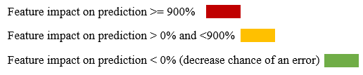

The top five features vary significantly across departments, and there is no single feature-set which is consistently more informative across all operations in predicting errors. For example, feature [C] – **Discrepancy in second count** significantly varies across departments (160% to 1950%). Feature [B] **Surgery is paused because of discrepancy in third count,** appears in four of the six departments, and its associated probability change varies dramatically as well, between 269% and 1,540%. There are 10 features that consistently decrease the chance of an NE: [F] - **Surgeon scans the cavity/fascia before closure during the second count**, which affected five departments out of 6 and was rther consistent in its probability change between 65% -100%. Features I,J,K,L,M,N] decreased the chances of NEs between 2%-100% in three departments. Three features [A] - **Discrepancy in absorbing materials**, [E] **Surgery time > 4 hours** and [G] **Surgery time < 1 hour** appear just once across departments with a medium impact on the occurrence of NEs.

When analyzing the results per department, we see a variation of contributing factors and their probability. In Oophthalmology the probability is consistently-100 in five features decreasing the chance of an error. In general surgery, two features varies between 1168-1283% that increase probability of an error (feature (B)- **Surgery is paused because of discrepancy in third count, and (C)- Discrepancy in second count).** Two features were found to decrease the probability of NE between -81% and -100%, both related to scanning the fascia before closure. I orthopedics, the same two features increase the probability of error (1540-1950%) and three features decrease the probability ((F)-**Surgeon scans the cavity/fascia before closure,** (H)- **Second count is performed before closure of fascia/cavity,** (I)- **Procedure's type is compared to the one written in patient's file** (-65 to -87%). Same as Urology where the same two features had increase probability for occurrence of NE varied from 1125-1150%, one feature had a decreased probability of -100% for occurrence of NE (D)- **Length of surgery 1-2 hours** (-100%) and two feature had increased probability for occurrence of NE (11-577% (A)- **In case of discrepancy in the count of absorbable items, their package is taken out from the OR,** (E)- **Length of surgery >4 hours).** In Cardiology, only two features were found to have increased probability to error in smaller impact of 128-160% ((C)- **Discrepancy in second count,** (G)- **Length of surgery <1 hour)**, while three features have impact of -100% to decrease the probability of NE. In the gynecological department, three features have decreased probability for an error (-2.78 to -77%) and two features were found to increase the probability (269%) and are related to discrepancies in second and third count (feature (B) and feature (C)).

**Effects of Feature Combinations**

In the following analysis (Figure x) , the prediction rate of the **top** 15-20 pairs of features are shown for each department and an accumulated impact on increased probability is shown to an error of 2000-3150% . Evaluation of combined features allowed us to examine non-trivial features and their predictive power. As before, we first examined the contribution of each combination of features using the trained RF model and calculated the probability change when both features assume the value True compared to all other cases in the database. In Figure 1, we present the probability change of each of the identified feature combinations. Interestingly (in general surgery, there are 14 feature combinations that bring about a probability change of 13,600% (Figure 1A). In comparison, the single feature analysis done above (Table 2), revealed a probably change of 1,287% and 1,168%, surprisingly by two features that are not part of the 14 feature combinations identified here.

In Figure 1B (gynecology), the effect of every identified feature combination is assosiated with a probability change of 1000-2000%. In the single feature analysis (Table 2), the effect of every single feature was <900%, Specifically, for only two features, and the rest lagged behind with <150%.

Among ENT surgery, results show that the accumulated effect of 2 features together, there are dozens of pairs with an effect of 3150-2000%, while the effect of a single feature is up to 1350% impact on error, for only 2 features, while the rest are lagging behind with <50% (Figure 1C).

In graph 1D (Urology), results show there are dozens of pairs with an effect of 1900-2500%. While the effect of a single feature was <1150% indication of an error, for only 2 features, and the rest are lagging behind.

In graph 1E (Orthopedics) the accumulated effect of 2 features together, show a dozen pairs with an effect of 1900-4200%. while the effect of a single feature is <1950% indication on error, and the rest are lagging behind.

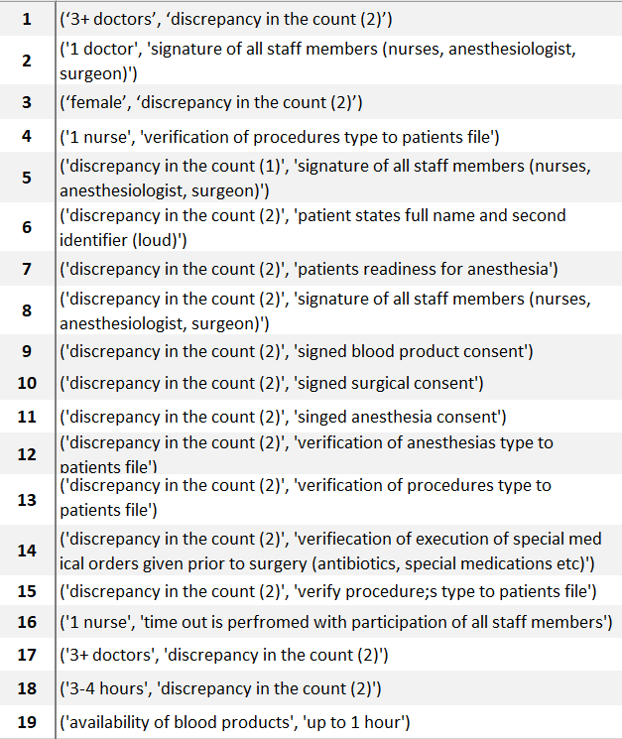G*raph 1: Effect of two features combination on prediction by surgical departments*

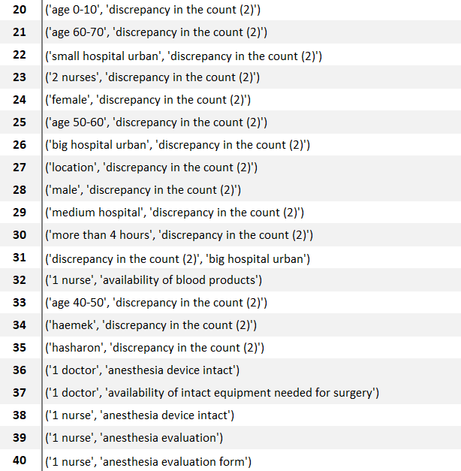

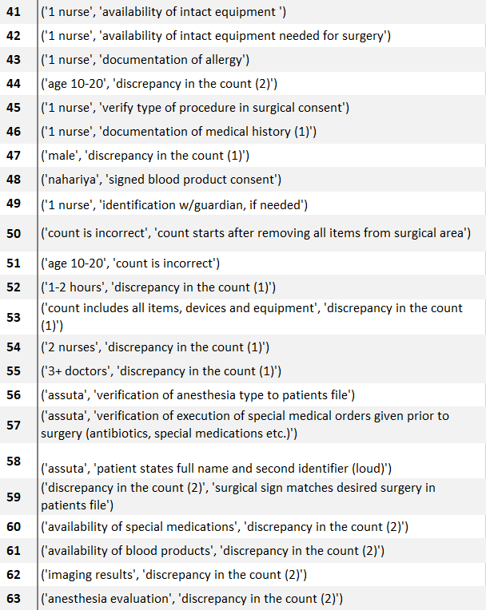

**Compare results in the 2 use cases**

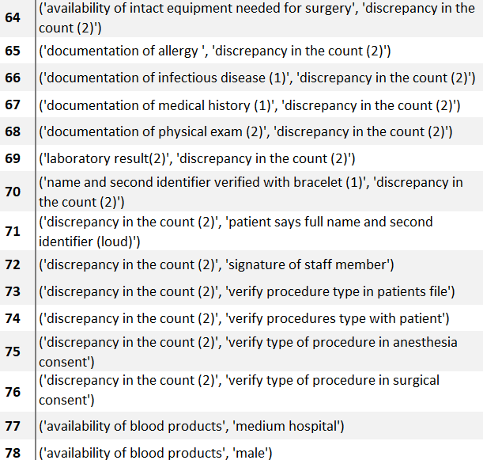

**Features affecting Type A and B**

In addition to the analysis of NEs in general, we further trained two RF models: First to distinguish between Type A NEs (wrong site surgery) and Type B NEs (retained foreign item). The top five contributing features in both models overlap in three features: 1) Presence of two nurses suffers from greater occurrence of Type A NEs by 66%, and by 85% for Type B NEs; 2) An operation which lasts under one 1 hour had a greater occurrence of Type A NEs by 122%, and by 87% for Type B NEs; and 3) When the operation lasted between 1-2 hours, both Type A and B NEs were less frequent, decreasing by60% and 74%, respectively.

The remaining two features in the top 5 for each model are different: For Type A error, the department was found to have significant influence with eye surgeries having greater NE prevalence of 504% and general surgery is associated with a decrease of 63% in Type A NEs prevalence (graph 2). For the Type B error, the two remaining features are staff driven; the feature “more than3 doctors” was associated with an increased prevalence of Type B NEs by 122%, and “2 doctors” associated with a decreased prevalence of 52% (Figure 3).

***Figure 2 – Effecting features on wrong site surgery***

***Graph 3: Effecting features on retained foreign item during surgery***

**Discussion**

Despite the widespread use of the surgical safety checklist and strict counts during the surgery, perioperative NEs still occur. The aim of this study was to automatically identify and investigate contributing factors leading to occurrence of NEs. This automatic identification utilized machine learning methods that are not part of the standard risk assessment of patient safety in the OR.

Our results show that although the existing checklists supposedly address the main contributing factors to NE occurrence, their goal of 'one custom fits all' may not consider potential risk factors that evolve from human aspects and work environments. These involve contributing factors such as length of surgery and number of staff participating in the surgery. For example, a shorter urologic surgery has a decreased probability of a NE as compared to a longer surgery in which the probability for such event is increased.

Moreover, the results suggest that the risk for occurrence of prevention of NEs may be graded differently among surgical specialties. For example, discrepancy in a second count was graded with higher impact in orthopedics, general surgery and urology when compared to gynecology and cardiology. One of the possible reasons is the amount of equipment and dressings used in this surgery that complicates the count. A possible solution to improve the count process in these surgeries is to use technological methods such radio frequency identification (RFID) and data matrix code (DMC) (Teng et al, 2014).

The paired features analysis further predicts combination of contributing factors that reveals additional risks related to the length of the surgery and number of staff members participating in the surgery that in combination of discrepancy in the count and failure to verify data required to the surgery. Such combinations of factors can increase the chance of NE's occurrence.

When evaluating the risk for specific type of NE, we saw a consistency in regards to the length of the surgery between Type A and B events. While a surgery that takes between to 1-2 hours decreased the risk of NE, a shorter surgery can increase its risk. A possible explanation is that in shorter surgeries the staff is rushing and 'skips' some phases of the checklists (Thomas et al, 2020).

In conclusion, the use of machine learning methods has surprisingly revealed further contributing factors to NEs that are not addressed in the standard checklists. Moreover, the use of a pair combination analysis increased the predictive power by ten times compared to the single features. The paired combination analysis further expended the list of possible risk factors contributing to the occurrence of NEs. The results can suggest an adjusted risk assessment that rely and individual characteristics of surgical fields and ORs environment and by that improve patient safety.

A possible limitation of our study is small number of NE analyzed compared to the number of analyzed observations. Therefore, the feature impact to prevention of NE is relatively low. We overcame this problem using grounded statistical techniques and plan to further strengthen the results in the future given newly obtained data. In addition, the use of transfer learning in which NEs from other countries will be used to better inform our model will be considered as well.

***In my opinion, to reduce article by 1,000 most of results should be removed from discussion, as well as words describing results, and replaced by the figures.***

**References:**

## Understanding Machine Learning: From Theory to Algorithms Shalev-Schwartz and Ben-David, 2014, Chapter 18.3),

## Geurts, Pierre, Damien Ernst, and Louis Wehenkel. "Extremely randomized trees." Machine learning 63.1 (2006): 3-42.

## Khalilia, Mohammed, Sounak Chakraborty, and Mihail Popescu. "Predicting disease risks from highly imbalanced data using random forest." BMC medical informatics and decision making 11.1 (2011): 51.

### Clinical risk prediction with random forests for survival, longitudinal, and multivariate (RF-SLAM) data analysis Wongvibulsin et al. 2020

Robert, M.A. Choi, C.J., Saphiro, F.E., Urman, R.D. & Samir, M. (2015). Avoidance of serious medical errors in refractive surgery using a custom preoperative checklist, Journal of Cataract and Refractive Surgery, 41 (10), 2171-2178. DOI: <https://doi.org/10.1016/j.jcrs.2015.10.060>

# The WHO safer surgery checklist time out procedure revisited: Strategies to optimise compliance and safety [RSS](https://cdn.clinicalkey.com/rss/issue/17439191.xml) [Download PDF](https://www-clinicalkey-com.moh-ez.medlcp.tau.ac.il/service/content/pdf/watermarked/1-s2.0-S174391911930158X.pdf?locale=en_US&searchIndex=)

* [Marios Papadakis](https://www-clinicalkey-com.moh-ez.medlcp.tau.ac.il/#!/search/Papadakis%20Marios/%7B%22type%22:%22author%22%7D)
* , [Abdulwares Meiwandi](https://www-clinicalkey-com.moh-ez.medlcp.tau.ac.il/#!/search/Meiwandi%20Abdulwares/%7B%22type%22:%22author%22%7D)
* and [Andrzej Grzybowski](https://www-clinicalkey-com.moh-ez.medlcp.tau.ac.il/#!/search/Grzybowski%20Andrzej/%7B%22type%22:%22author%22%7D)

International Journal of Surgery, 2019-09-01, Volume 69, Pages 19-22, Copyright © 2019 IJS Publishing Group Ltd

Kjellberg, J., Wolf, R. T., Kruse, M., Rasmussen, S. R., Vestergaard, J., Nielsen, K. J., & Rasmussen, K. (2017). Costs associated with adverse events among acute patients. *BMC health services research*, *17*(1), 651. https://doi.org/10.1186/s12913-017-2605-5

Recommended practices for sponge, sharp, and instrument counts.Perioperative Standards and Recommended Practices.2010.AORN, Inc Denver, CO:pp. 207-216

OECD ilibrary, Health at a Glance 2019 : OECD Indicators , Safe acute care – surgical complications and health care-associated infections <https://www.oecd-ilibrary.org/sites/4dd50c09-en/1/3/6/2/index.html?itemId=/content/publication/4dd50c09-en&_csp_=82587932df7c06a6a3f9dab95304095d&itemIGO=oecd&itemContentType=book>

Rosenfeld, Ariel, Benrimoh, David, Armstrong, Caitrin, Mirchi, Nykan, Langlois-Therrien, Timothe, Rollins, Colleen, Tanguay-Sela, Myriam, Mehltretter, Joseph, Fratila, Robert, Israel, Sonia, Snook, Emily, Perlman, Kelly, Kleinerman, Akiva, Saab, Bechara, Thoburn, Mark, Gabbay, Cheryl, & Yaniv-Rosenfeld, Amit (2019, March 12). Big Data Analytics and AI in Mental Healthcare..

Doupe, P., Faghmous, J., & Basu, S. (2019, July). Machine Learning for Health Services Researchers. *Value in Health*, *22*(7), 808-815. <https://doi-org.moh-ez.medlcp.tau.ac.il/10.1016/j.jval.2019.02.012>

NHS. (2018). *Provisional publication of Never Events reported as occurring between 1 February and 31 March 2018.* Retrieved from https://improvement.nhs.uk/documents/2613/Never_Events_1_February_to_31_March_2018_.pdf

NHS Improvement. (2019). *Provisional publication of Never Events reported as occurring between 1 April 2018 and 31 January 2019.* Retrieved from <https://improvement.nhs.uk/documents/4872/Provisional_publication_-__NE_1_April_to_31_Jan_FINAL.pdf>

Stawicki, S. P., Evans, D. C., Cipolla, J., Seamon, M. J., Lukaszczyk, J. J., Prosciak, M. O., . . . Steinberg, S. M. (2009). Retained surgical foreign bodies: a comprehensive review of risks and preventative strategies. *Scandanavian Journal of Surgery, 98*, 8-17. doi:10.1177/145749690909800103

Chan, B., & Cochrane, D. (2016). *Measuring Patient Harm in Canadian Hospitals.* CIHI, Ottawa. Retrieved from https://secure.cihi.ca/free_products/cihi_cpsi_hospital_harm_en.pdf

Cima, R. R., Kollengade, A., Garnatz, J., Storsveen, A., Weisbrod, C., & Deschamps, C. (2008). Incidence and Characteristics of Potential and Actual Retained Foreign Object Events in Surgical Patients. *Journal of the American College of Surgeons, 207*(1), 80-87. doi:10.1016/j.jamcollsurg.2007.12.047

de Vries, E. F., Prins, H. A., Crolla, R. M., den Outer, A. J., van Andel, G., van Helden, S. H., . . . BoerMeester, M. A. (2010). Effect of a Comprehensive Surgical Safety System on Patient Outcomes. *New England Journal of Medicine, 363*, 1928-1937. doi:10.1056/NEJMsa0911535

Hariharan, D., & Lobo, D. N. (2013). Retained surgical sponges, needles and instruments. *Annals of the royal college of surgeons in England, 95*(2), 87-92. doi:10.1308/003588413X13511609957218

Haynes, A. B., Weiser, T. G., Berry, W. R., Lipsitz, S. R., Breizat, A. H., Dellinger, E. P., . . . Gawande, A. A. (2009). A Surgical Safety Checklist to Reduce Morbidity and Mortality in a Global Population. *New England Journal of Medicine, 360*, 491-499. doi:10.1056/NEJMsa0810119

Hempel, S., Maggard-Gibbons, M., Nguyen, D. K., Dawes, A. J., Miake-Lye, I., Beroes, J. M., . . . Shekelle, P. G. (2015). Wrong-Site Surgery, Retained Surgical Items, and Surigcal Fires. *JAMA Surgery, 150*(8), 796-805. doi:10.1001/jamasurg.2015.0301

Kwaan, M. R., Studdert, D. M., Zinner, M. J., & Gawande, A. A. (2006). Incidence, Patterns, and Prevention of Wrong-Site Surgery. *Jama Surgery, 141*(4), 353-358. doi:10.1001/archsurg.141.4.353

Logan-Phelan, T. (2018). The Buzz around Learning Analytics – Enablers and Challenges Identified through the Ireland Project, *Irish Journal of Technology Enhanced Learning*, 3(2). DOI: 10.22554/ijtel.v3i2.46}

Mehtsun, W. T., Ibrahim, A. M., Diener-West, M., Pronovost, P. J., & Makary, M. A. (2013). Surgical never events in the United States. *Surgery, 153*(4), 465-472. doi:10.1016/j.surg.2012.10.005

Moppett, I. K., & Moppett, S. H. (2016). Surgical caseload and the risk of surgical Never Events in England. *Anaesthesia, 71*, 17-30. doi:10.1111/anae.13290

National Patient Safety Consortium. (2015). *Never Events for Hospital Care in Canada - Safer Care for Patients.* Ottawa. Retrieved from https://www.patientsafetyinstitute.ca/en/toolsResources/NeverEvents/Documents/Never%20Events%20for%20Hospital%20Care%20in%20Canada.pdf

NHS Improvement. (2018). *Never Events list 2018.* National Health Service, London. Retrieved from https://improvement.nhs.uk/documents/2266/Never_Events_list_2018_FINAL_v5.pdf

Patient Safety Network. (2019). *Never Events.* Patient Safety Primer. Retrieved from https://psnet.ahrq.gov/primers/primer/3/never-events

Stawicki, S. P., Evans, D. C., Cipolla, J., Seamon, M. J., Lukaszczyk, J. J., Prosciak, M. O., . . . Steinberg, S. M. (2009). Retained surgical foreign bodies: a comprehensive review of risks and preventative strategies. *Scandanavian Journal of Surgery, 98*, 8-17. doi:10.1177/145749690909800103

The Joint Commission. (2017). *Sentinel Events.* Oak Brook. Retrieved from https://www.jointcommission.org/assets/1/6/CAMH_SE_0717.pdf

The Joint Commission. (2019). *Most Commonly Reviewed Sentinel Event Types.* The Joint Commission, Oak Brook. Retrieved from https://www.jointcommission.org/assets/1/6/Event_type_4Q_2018.pdf

The World Health Organization. (2009, 1). *Surgical Safety Checklist.* Retrieved from World Health Organization: https://apps.who.int/iris/bitstream/handle/10665/44186/9789241598590_eng_Checklist.pdf;jsessionid=1908B5C90ED0DC4F1362F25B6DE63AEA?sequence=2

Teng, Y.C., Ward, J., Horberry, T., Patil, V. & Clarckson, P.J.(2014). Retained Surgical Instruments: Using Technology for Prevention and Detection, *ReasearchGate*, Conference Paper. https://www.researchgate.net/publication/315771425

Treadwell, J. R., Lucas, S., & Tsou, A. Y. (2014). Surgical checklists: a systematic review of impacts and implementation. *BMJ Quality and Safety, 23*(4), 299-318. doi:10.1136/bmjqs-2012-001797

Appendix A- Surgical safety standards checklist

**Appendix 1- Structure of Observations (based on MOH regulations)**

* 1. Surgical Checklist:

Phase 1. Pre-procedure

|  |  |  |  |
| --- | --- | --- | --- |
| **N/A** | **NO** | **Yes** | **Statement** |
|  |  |  | Patient states full name and second identifier |
|  |  |  | Name and second identifier verified |
|  |  |  | Identification w/guardian, if needed |
|  |  |  | Verify procedure type with patient |
|  |  |  | Verify procedure type to patient's file |
|  |  |  | Verify type of procedure in surgical consent |
|  |  |  | Verify type of procedure in anesthesia consent |
|  |  |  | Surgical sign matches the desired surgery |
|  |  |  | Documentation of medical history |
|  |  |  | Documentation of physical exam |
|  |  |  | Documentation of infectious disease |
|  |  |  | Anesthesia evaluation |
|  |  |  | Documentation of allergy |
|  |  |  | Laboratory results |
|  |  |  | Imaging results |
|  |  |  | Availability of blood |
|  |  |  | Availability of medications |
|  |  |  | Availability of equipment |
|  |  |  | Signature |

Phase 2. Sign-in:

|  |  |  |  |
| --- | --- | --- | --- |
| **N/A** | **NO** | **Yes** | **Statement** |
|  |  |  | Sign-in performed by surgeon, anesthesiologist and nurse |
|  |  |  | Patient states full name and second identifier |
|  |  |  | Name and second identifier verified |
|  |  |  | Verification procedure type to patient's file |
|  |  |  | Verification anesthesia type to patient's file |
|  |  |  | Surgical sign matches the patient's file |
|  |  |  | Readiness for anesthesia |
|  |  |  | Anesthesia device intact |
|  |  |  | Documentation of medical history |
|  |  |  | Documentation of physical exam |
|  |  |  | Documentation of infectious disease |
|  |  |  | Anesthesia evaluation |
|  |  |  | Signed surgical consent |
|  |  |  | Signed anesthesia consent |
|  |  |  | Signed blood product consent |
|  |  |  | Documentation of allergy |
|  |  |  | Laboratory results |
|  |  |  | Imaging results |
|  |  |  | Availability of blood |
|  |  |  | Availability of medications |
|  |  |  | Availability of equipment |
|  |  |  | Execution of medical orders |
|  |  |  | Signature (surgeon, anesthesiologist, nurse) |

Phase 3. Time Out:

|  |  |  |  |
| --- | --- | --- | --- |
| **N/A** | **NO** | **Yes** | **Statement** |
|  |  |  | Sign-in performed by all staff members |
|  |  |  | Time out is before surgical cut |
|  |  |  | Time out performed with the patient |
|  |  |  | All staff members stop and listen |
|  |  |  | Patient identified by 2 identifiers |
|  |  |  | Procedure compared to patient's file |
|  |  |  | Surgical sign matches the patient's file |
|  |  |  | Signed surgical consent |
|  |  |  | Signed anesthesia consent |
|  |  |  | Time out for each procedure |
|  |  |  | Verbal agreement of all staff members |
|  |  |  | Repeat time out in surgeon's exchange |
|  |  |  | Signature of all staff members |

* 1. Surgical Counts - Observations by surgical phase and type of count:

First Count - Prior to skin incision:

|  |  |  |  |
| --- | --- | --- | --- |
| **N/A** | **NO** | **Yes** | **Statement** |
|  |  |  | Count performs by scrubbed nurse or two nurses |
|  |  |  | Count is out loud before the beginning of surgery, with opening the sterile equipment |
|  |  |  | Equipment count is out loud compared to the list |
|  |  |  | Count of absorbable items is out loud while separating |
|  |  |  | In case of no matching in absorbable items it is removed out from the OR |
|  |  |  | Documentation of the count on a dedicated form |
|  |  |  | Items are not removed from the OR while counting |
|  |  |  | No match in the count |
|  |  |  | Nurses announce the non-match to surgeon |
|  |  |  | Surgery stops due to non-match |
|  |  |  | Searching the missing item |
|  |  |  | Ordering imaging test for finding the missing item |

Second count- closure of fascia/cavity is initiated:

|  |  |  |  |
| --- | --- | --- | --- |
| **N/A** | **NO** | **Yes** | **Statement** |
|  |  |  | Count performed by scrubbed nurse or two nurses |
|  |  |  | Count performed before closure of fascia/cavity |
|  |  |  | Equipment count is out loud with the participation of all staff members |
|  |  |  | Surgeon announces out loud about intention for closure before closure of fascia/cavity |
|  |  |  | Surgeon reviews the cavity before closure |
|  |  |  | Two nurses perform the count |
|  |  |  | Closure begins after verifying correct count |
|  |  |  | No match in the count |
|  |  |  | Nurses announce the non-match to surgeon |
|  |  |  | Surgery stops due to non-match |
|  |  |  | Searching the missing item |
|  |  |  | Ordering imaging test for finding the missing item |

Third count - After Skin Closure:

|  |  |  |  |
| --- | --- | --- | --- |
| **N/A** | **NO** | **Yes** | **Statement** |
|  |  |  | Count performed by scrubbed nurse or two nurses |
|  |  |  | Count is after removing items from surgical area |
|  |  |  | Count is made out loud with the participation of all staff members |
|  |  |  | Count includes all items, devices and equipment |
|  |  |  | Count is declared when there are no items left in the surgical field |
|  |  |  | Count is documented in a dedicated form |
|  |  |  | Sterile nurse declares out loud that count is correct |
|  |  |  | Nurses’ names and results of count are documented |
|  |  |  | Surgeon verifies out loud that count is correct |
|  |  |  | **Count does not match** |
|  |  |  | Nurses announce the non-match to surgeon |
|  |  |  | Surgery stops due to non-match |
|  |  |  | Search for the missing item |
|  |  |  | Order imaging test to find the missing item |

***In discussion, need to compare to current knowledge on NESurgical never events and contributing human factors***

***CA Thiels, TM Lal, JM Nienow, KS Pasupathy… - Surgery, 2015***

[A systematic review of natural language processing for classification tasks in the field of incident reporting and adverse event analysis](https://scholar.google.com/scholar_url?url=https://www.sciencedirect.com/science/article/pii/S1386505619302370%3Fcasa_token%3De3DZcqIQAdUAAAAA:jz4fdNYFlWrnr6JyqgHFnYnyOzlWL5QSkWRU-QLIXHB4265EGBzB9mJXT8Oe-XxFI7gvn0ZvWKvi&hl=en&sa=T&oi=gsb-ggp&ct=res&cd=0&d=6746070726727103444&ei=5ZboX-mVKpDWmgGqw6_ICw&scisig=AAGBfm1uMHalx4Vb0xRDq0ddd1N2P3NJKw)

***These are some significant articles in the field, need to compare and say how your analysis makes a unique contribution***