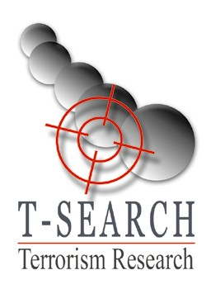

Terrorism and Political Violence

Dr. Shimon Carmi

Terrorism ‘from within’: Strategies, dynamics, decision points, and ideologies facing the challenge of terror attacks and politics. What stands behind the strategy of terror organisations? What is the secret web where the struggle between terrorism and those fighting it takes place? Where is the public in all this? And how does it connect to terrorism today?

In these lectures, we will tear away the veil of secrecy that cloaks the activities of terrorist organisations and will understand how decisions are made, the policy of terror attacks, and the political goals that the organisations set for themselves.

A special emphasis will be placed on Islamist, Palestinian and international organizations such as the Front for Global Jihad, al-Qaeda and others.
- Lectures and courses
- Conferences
- Workshops
- Discussion and focus groups
- Simulations
- Advanced methodology
- News updates

Contact:

Mobile: 0524-522050
Telefax: 04-9984217
Email:
tsearch@netvision.net.il

Sample topics:
The civil war in Syria: Who are the internal and external players in this bloody, violent turmoil? What are some ideas for a political solution?
ISIS in Iraq: What are the roles of violence and terror, the Iranian involvement, and the nominal central government?
The Kurds: Are they the main winners in Syria and Iraq?
The preventative struggle: What are the foundations of anti-terror intelligence.
The ideology of radical Islam: From the Muslim Brothers to ISIS, what are its characteristics and the outlook for the future?
The Israeli-Palestinian conflict: Why did violence follow the Oslo Process? What are some ideas for reconciliation and political resolution?
ISIS in the West: What are the dangers and how can they be confronted?
Preventing terrorism today: Why is intelligence a key player?
The IRA: How did the conflict in Northern Ireland result in a peace agreement?
The new terrorism: What are the roles of economic, ecological and internet terror?

Dr. Shimon Carmi is a researcher focusing on the behavior of terror organizations in strategic decision-making situations. In this framework, his research deals with the political motives behind the activities of terror organizations in different situations, including their entry into peace processes.
Dr. Carmi is an expert on anti-terror intelligence and has 20 years’ experience in the intelligence struggle against various terror organizations. His years-long operative experience in the intelligence field preventing Palestinian terror, in combination with his current academic research, provides Dr. Carmi with a unique perspective in examining the behavior of terror organizations from within.
Dr. Carmi lectures about terrorism in the Israeli defense establishment and its various branches and in training groups on terror prevention in Israel and abroad. Out of a sense of personal duty, Dr. Carmi also works to disseminate knowledge about terrorism in the community and in Israeli academia.

