### Importance of Controlling in the Supply Chain

Supply chain controlling (SCC) is a sub-function of corporate governance and is therefore ascribed directly to the supply chain management. SCC ensures a continuous, comprehensive and up-to-date flow of information to the supply chain management about procedures and company results. This includes regular bulletins at defined intervals (monthly reports and quality statistics) as well as *ad hoc* queries (quality of the supply chain in relation to certain customers).

Supply chain controlling is tasked with mapping all planning, control and monitoring processes and activities within the supply chain and keeping all stakeholders updated.

Supply chain management should be viewed as a control loop, in other words, a system whereby certain events prompt certain types of feedback, whether positive or negative. This entails defining a given control variable within the control loop (in this case, the supply chain).

The number of customer complaints is one example: A logistics company stipulates that the number of complaints should not exceed 1.5% of the total delivery volume. While controlling the quality metrics, an excessive complaint rate of 3% is ascertained. This will lead to a dent in sales or profits, as customers dissatisfied with the company’s performance either demand a free replacement or cancel their orders altogether because the goods are no longer needed. The logistics company will also incur additional freight costs for replacements/re-deliveries or will not be reimbursed for freight costs because the clients are unable to sell their products due to late or non-existent delivery. This constitutes negative feedback.

Basic Principles of Supply Chain Controlling

If sales rise thanks to exceptional delivery reliability, this is an example of positive feedback. Satisfied customers will order more goods, which translates into a higher freight turnover for the logistics company.

As a control loop, therefore, the supply chain includes various measurement and control ranges which must be repeatedly checked and modified. The supply chain managers act as "controllers" within the control loop. Based on the information they receive from the controlling system, they determine appropriate measures for optimizing the supply chain.

The control variables monitored by SCC may cover various areas, all of which are directly reflected in the balance sheet. These may include stock levels, freight costs, set-up costs, throughput times, personnel costs and material costs.

Particular consideration is given to capital tie-up due to high inventories at every stage in the value chain, because all companies are reliant on sufficient liquidity. As a general rule of thumb, the smaller the inventories, the higher the cash surplus (cash flow). Free capital also generates (interest) profits, while high inventories incur opportunity costs (e.g. for warehousing). The company’s operating result can be optimized by increasing the KPIs for inventory range and inventory turnover, both of which are directly reflected in production costs and hence in the profit and loss account. The correlations are illustrated in the following diagram of a positive feedback loop:

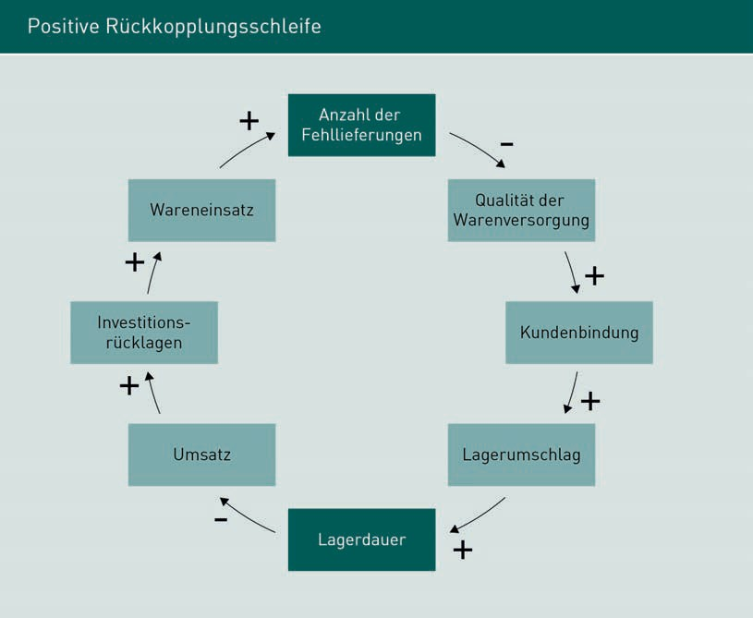

Capital tie-up due to high inventories is a major and costly challenge. Efficient supply chain controlling should aim to minimize capital tie-up as far as possible using cost tracking to ensure transparency about the effectiveness of company activities.

### Cost Tracking

Cost tracking is part of the reporting system. As a systematic control tool within supply chain controlling, it gages the proportion of certain activities in the supply chain and their contribution to corporate success. Within supply chain controlling, cost tracking is typically applied to the areas of inventories, material costs and freight costs. The same forms are always used to produce standardized results. Monitoring and analyzing the aforementioned areas helps to support business decisions.

These forms are used to compare actual figures with planning data and calculate weightings. Cost tracking is useful for budgeting within the strategic framework and supports the operational management team with its duties:

Basic Principles of Supply Chain Controlling

Inventory monitoring allows the prompt identification of high inventory levels and the associated capital tie-up and storage costs so that management can take appropriate measures to reduce them.

If material prices and freight costs are too high, they may be offered out for tender to reduce costs where necessary.

Overall, cost tracking is not a stand-alone solution, but is used in conjunction with other control mechanisms to streamline corporate processes and to identify and implement potential cost savings.

### Different Types of Supply Chain Controlling

There are different types of supply chain controlling, which also vary according to the desired form of cooperation within a supply chain. They are briefly described below.

Relationship (or partnership) controlling is one form of SCC. The interactions between supply chain participants are crucial to its success, so it is very important for supply chain monitoring to gage the quality of cooperation, incorporating both soft and hard factors (Wiedemann/Dunz 2000, pp. 42ff.). Relationship management (Weber 2010) entails comparing target and actual values using jointly agreed, quantifiable targets within a defined controlling cycle (= hard factors), combined with trust controlling which measures the so-called “soft factors”.

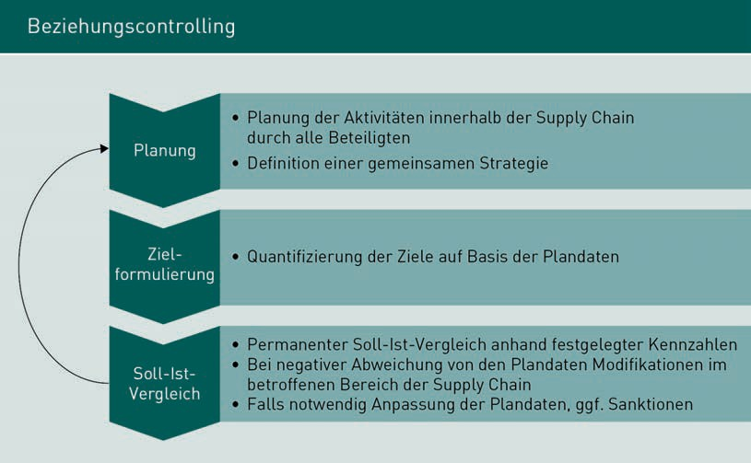

As illustrated in the "Relationship Controlling" diagram, the aim is to monitor compliance with jointly planned activities and strategies and the achievement of set targets (Weber/Bacher/Groll 2003, p.17). The cross-company control cycle shown above assists with implementation of these tasks.

CPFR

Collaborative Planning, Forecasting and Replenishment

(by all supply chain stakeholders).

Trust controlling and relationship controlling are closely intertwined, as trust is clearly a very important factor in supply chain management. In **CPFR** systems in particular, the aspired form of cooperation relies on mutual trust. Controlling this soft factor helps to create the necessary basis of trust.

The "trust" factor is difficult to objectively measure and assess, as it is a psychological phenomenon influenced by multiple aspects. Trust can be (indirectly) measured by regularly surveying all supply chain stakeholders, for example, on issues such as discretion, integrity, reliability, competence, consistency, open-mindedness, fairness and accessibility (Weber/Bacher/Groll 2003, p.18).

Surveys by independent third parties (such as market research institutes), ideally using closed questions or statements with an evaluation scale, are an easier, pragmatic and objective form of evaluation. For example: Rate the telephone availability of Partner X for incoming orders on a scale of 1 to 5 (where 1 = very good, 5 = poor). This type of information-gathering produces undistorted and clear results.

Trust controlling in supply chains is useful for identifying and remedying any trust issues that may be inhibiting successful cooperation between the individual parties, as well as

Basic Principles of Supply Chain Controlling

reminding all stakeholders about the objectives of their collaboration and reinforcing the spirit of partnership. The downside is the amount of work involved in introducing a trust controlling system, which ties up resources which could be used elsewhere, and the cost of using a market research institute, for example. In the long term, however, the cost and effort are justified, as a supply chain’s success depends on trust and cooperation between all partners.

The third type of supply chain controlling is performance measurement. This is closely related to the SCOR model.

Summary

Supply chain controlling entails measuring and evaluating customer-, innovation- and process-related aspects as well as monetary variables to derive a fair and meaningful picture of the prevailing structures for all stakeholders. Supply chain controlling identifies cause-effect relationships within the value chain and highlights potential modifications where necessary. Carefully designed supply chain controlling provides all stakeholders with an early warning system to allow timely intervention and the rectification of errors.

The fundamental problem when introducing an efficient supply chain controlling system is that procedures within the value chain are constantly evolving due to continuous monitoring and associated learning effects. All supply chain stakeholders should therefore agree long-term, transparent cross-company targets and rules of conduct and align them with their respective corporate philosophies.

Supply chain controlling uses cost tracking as a systematic control tool and part of reporting. It serves to gage the proportion of certain activities in the supply chain and their contribution to corporate success.

Supply chain controlling typically applies cost tracking to the areas of inventories, material prices and freight costs, not as a stand-alone solution, but in conjunction with other control mechanisms.

There are different types of supply chain controlling, which also vary according to the desired form of cooperation within a supply chain: Relationship controlling, trust controlling and performance measurement. All types of controlling serve to foster cooperation within the supply chain and promote long-lasting success.

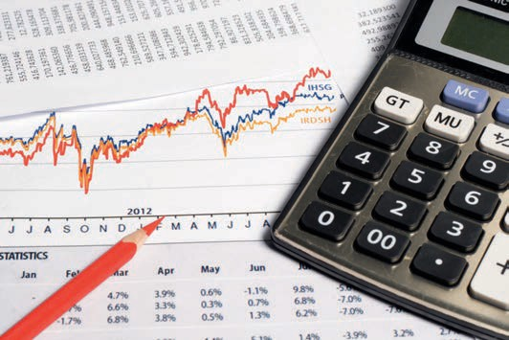

# Unit 2

## KPI Systems in the Supply Chain

#### STUDY GOALS

After working through this unit, you will be familiar with ...

… the importance of KPIs for controlling.

… how KPIs are classified.

… the types of KPIs used in supply chain controlling.

… how to visualize KPIs.

DL-D-MWCH02-L02

1. KPI Systems in the Supply Chain

### Introduction

Controlling and KPIs are inextricably linked. KPIs are quantitative variables (expressed as figures) describing certain information within or between companies. KPIs can assist with forthcoming decisions and identify any deviations or weaknesses within the company or supply chain.

Controlling would not be possible without KPIs. They can shed light on cause-effect chains and enable realistic comparisons between your own company or supply chain and similar organizations. KPIs facilitate success monitoring as well as internal and external comparisons, and they set standards by which an organization is measured, for example in relation to its aspired targets.

One of the main tasks of controlling is to set up a system of indices highlighting correlations and development trends. It is not sufficient to simply record actual values as KPIs; reference variables are also needed to enable comparisons. Planning data is often used, but figures from previous years’ equivalent financial periods are also suitable.

Benchmarking In business management, benchmarking is the objective comparison of quantitative or qualitative features of products and services, both internal and external.

The meaningfulness and value of KPIs depends on comparability and the ability to draw the correct conclusions from the comparison. Comparisons may refer to specific time periods (such as: sales in the same quarter of the previous year), competitors (e.g. what were our competitors’ sales figures? = benchmarking) or target and actual figures (e.g. were projected sales figures met?).

When setting up a controlling system, the main problem is to filter out and process the most suitable KPIs for a particular company or supply chain from the range of options available. Industry KPIs published by industry associations (such as those published by the ZVEI (Germany’s Central Association of the Electrical Industry)) are useful comparison variables. Collections of business formulae may also be useful when devising and planning a controlling system.

### Importance of KPIs

The importance of KPIs varies. Internal comparisons within an organization compare similar KPIs from different periods, to enable the tracking and evaluation of trends.

KPI Systems in the Supply Chain

KPIs also support external comparisons, for example, to gage an organization’s position in relation to its competitors or the general market situation. These types of comparisons use industry KPIs commonly found in the trade journals published at regular intervals by the relevant industry associations. Industry KPIs are often broken down into sales groups for ease of comparability.

For other KPIs, the comparison values are based on objective requirements. Return on Investment (ROI) or Return on Total Assets (ROTA) are indicators providing information about an organization’s assets or stability. Profitability is the relationship between a company’s or organization’s input and output. Return on total assets (ROTA) is the relationship between capital employed and profit, whereby profit is defined as the amount remaining after deducting the cost of generating sales from turnover.

A company’s overall profitability is compared with the interest rate it pays (or would fictitiously pay) to finance its capital. If overall profitability exceeds the (potential) interest rate payable, the company’s assets are increased by the (potential) surplus. If overall profitability is below the highest interest rate currently payable, its assets are reduced by the difference. If this amount is negative, KPIs can be used, for example, to determine how long it will take for the company’s liquidity to dry up, or how long the business can keep going under these circumstances, and appropriate countermeasures can then be initiated.

Return on investment (ROI) is considered analogously to ROTA. Like ROTA, ROI is used to gage the return on invested capital and draw conclusions about the company’s assets but in a more specific form by providing information on capital composition. ROI provides a very realistic representation of a company’s situation by including both capital and assets. It is calculated using the so-called DuPont pyramid (DuPont System of Financial Control), a KPI system developed in 1919 by American company E. I. Du Pont de Nemours and Company. As one of the world’s oldest and best-known KPI systems, the DuPont pyramid is founded on the theory that a company's success is determined by maximizing ROI rather than by maximizing profits. The system draws on a range of particularly meaningful global variables (Preißler 2008, pp. 48ff.).

Capital

Sums invested to generate revenue.

Assets A company’s available material and monetary assets or claims thereto.

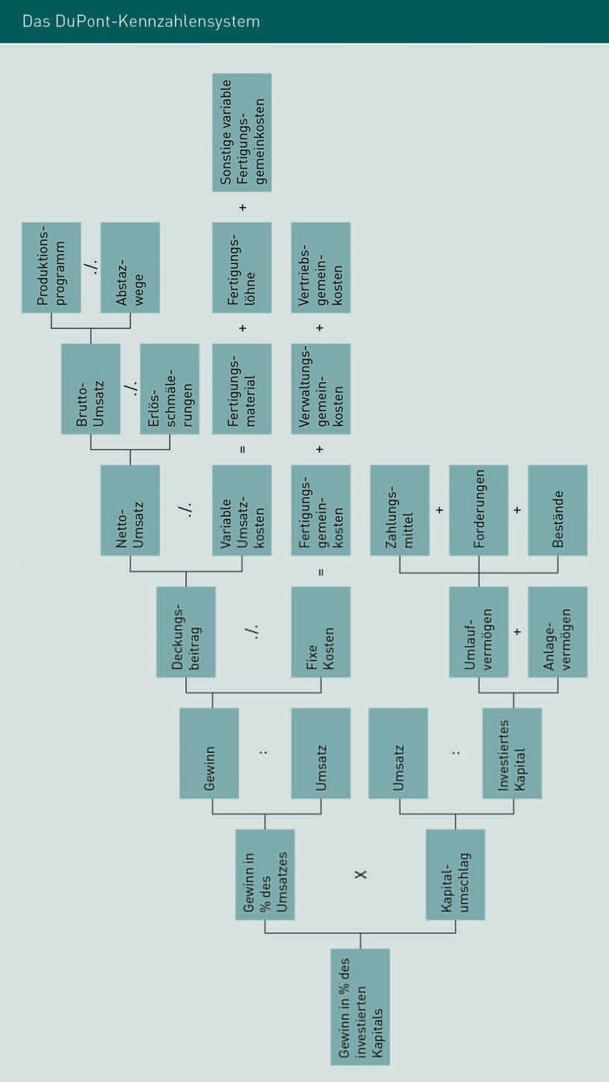

KPI Systems in the Supply Chain

As explained above, a KPI’s comparability is pivotal to its meaningfulness. An indicator’s elements must therefore be precisely defined and only defined elements used for future KPI calculations.

### Types of KPIs in the Supply Chain

KPIs provide up-to-date, realistic business information and are the principal variables used in any controlling report. However, not all company metrics are necessarily KPIs, as the meaningfulness and significance of individual metrics may vary. While some metrics relate solely to cost, others reflect performance-related business factors.

Metrics are only meaningful if viewed in context. The periodic (within specified time frames) review and comparison if internal and external aspects produces objectively usable, long-term results.

Within a supply chain, a fundamental distinction is made between operational and strategic KPIs. Strategic KPIs consider the entire supply chain and create transparency about collaborative partnerships, while operational KPIs are internal valuations offering an overview of in-house corporate divisions or highlighting individual business units.

The following example illustrates the identification and calculation of KPIs. It elucidates how metrics are based on corporate targets to produce useful and informative KPIs. It also shows which data must be made available for processing by the relevant employees and consolidation into KPIs.

KPIs

Key Performance Indicators for assessing target achievement or critical success factors.

|  |  |  |
| --- | --- | --- |
| Identification and development of logistical and supply chain KPIs | | |
| 1. | Define the reasons for using logistical KPIs and the relevant objectives | Why create logistical KPIs? |
| 2. | Derive KPIs from the strategic objectives | Which logistical objectives should these KPIs meet? |
| 3. | Systematize and link the KPIs | Have the principal KPIs been recorded? Who should be given access to them, and how often? |

|  |  |  |
| --- | --- | --- |
| Identification and development of logistical and supply chain KPIs | | |
| 4. | Determine the data sources | How and where is data generated? |
| 5. | Define logistical KPIs and their interpretation | How are the KPIs calculated and how are the values interpreted? |
| 6. | Integrate the KPI systems into the in-house IT system | Which EDP options are available? |

KPIs are generally divided into four different types, which are explained in greater detail below (Werner 2020, p. 404ff.):

* + 1. Statistical differentiation (absolute and relative indicators)
    2. Target-oriented KPIs (performance and liquidity indicators)
    3. Performance KPIs (strategic and operational indicators)
    4. Object-related KPIs (performance and cost indicators)

###### Absolute and Relative KPIs

Absolute KPIs are derived from the values themselves such as sales, cash flow and contribution margin, while relative indicators are ratios, i.e. they place two selected criteria in relation to one other. The thinking is that absolute KPIs such as "sales" are not particularly meaningful in themselves. An example of a relative KPI might be "Q2 sales in relation to number of employees". The following diagram illustrates how KPIs may comprise multiple components to enhance the informative value (in this instance, proportions, ratios and indices).

|  |  |  |
| --- | --- | --- |
| Typology of relative metrics | | |
| Indicator type | Meaning | Example |
| Proportions | Part of the whole | Absolute market share in % |
| Ratios | Standardization of base numbers | Sales per employee, per period |

KPI Systems in the Supply Chain

|  |  |  |
| --- | --- | --- |
| Indicator type | Meaning | Example |
| Indices | Assessment of development over time | Price index for raw materials |

###### Performance and Liquidity KPIs

Performance KPIs are used to determine and assess a company's performance. This is illustrated in the following table using the example of a rate of return.

|  |  |  |
| --- | --- | --- |
| Performance KPIs | | |
| ROS = | Profit · 100/sales | Return on Sales |
| ROE = | Profit · 100/equity | Return on Equity |
| ROTC = | (Profit + borrowings – interest) · 100/equity + Borrowings | Return on Total Capital |

ROCE (Return on Capital Employed) and ROA (Return on Assets) are also becoming increasingly widely used:

ROCE = 100 · EBIT

Invested capital

ROA = 100 · net income

Invested capital

These KPIs are a reflection of operating performance, as they relate directly to EBIT (Earnings Before Interest and Taxes) or gross profit as performance indicators.

Return on Investment (ROI) is a direct indication of a company’s situation and the key profitability ratio used in supply chain management (Tempe 2007, pp. 89ff.; Wiehle et al. 2011, p. 64ff.).

The importance of performance and liquidity KPIs is illustrated by the following example:

By introducing dedicated measures, a company manages to reduce its inventories by 20% (in absolute terms, by €20 million, from €110 million to €90 million). As a result, the company’s assets are also reduced by €20 million (from €234 million to €214 million). This significantly increases capital turnover from 2.31 to 2.52, while ROI is likewise substantially increased from 12.82% to 14.03%. The interpretation of this example would be that a 20% reduction in inventories improves ROI by 1.21%, corresponding to a relative increase in profitability of 9.5% (Werner 2020, p. 297).

However, reducing inventories "at any cost” should be avoided. Any reductions should always be considered in relation to freight, material and production costs. While a reduction in inventories may lead to lower warehousing costs and a short-term increase in working capital or liquidity, there will be a deterioration in other areas (so-called "trade-off effects", i.e. exchanging one cost type for another, which may be even higher).

Whenever trade-off effects come into play, reducing inventories becomes less appropriate and the effects must be closely analyzed, otherwise overall profitability may deteriorate despite cutting costs in one area.

Cash flow is a liquidity KPI representing financial flows. Lewe/Schneider (Lewe/Schneider 2004, p. 41f.) coined the term “pragmatic cash flow”, which is calculated as follows:

Net income

+ / − Depreciations/write-ups

+ / − Increase/decrease in provisions

= "Pragmatic cash flow"

This pragmatic cash flow fails to elucidate the major impact of supply chain management on cash surplus, unlike the following extended cash flow approach (Stölzle/Gareis 2002, p. 291), which also incorporates various change indicators:

Net earnings

+/ – Depreciations/write-ups of assets

+ Changes provisions

+ Changes in special tax-allowable reserves

+ Changes in value adjustments

+ Changes in inventories

+ Changes in receivables

+ Changes in deferred expenses and accrued income

- Own work capitalized

= Extended cash flow

KPI Systems in the Supply Chain

Economic Value Added (EVA), referring to the operational surplus, is another important KPI. It calculates the actual return on investing a specified capital volume. The EVA approach defines profit as value-added if the difference between the invested capital and the realized return is higher than the cost of capital. EVA is calculated as follows:

(EVA) = realized return – cost of capital · invested capital

###### Strategic and Operational KPIs

Strategic KPIs are also known as effectiveness indicators, while operational KPIs are indicators of efficiency. Some examples are shown in the table below.

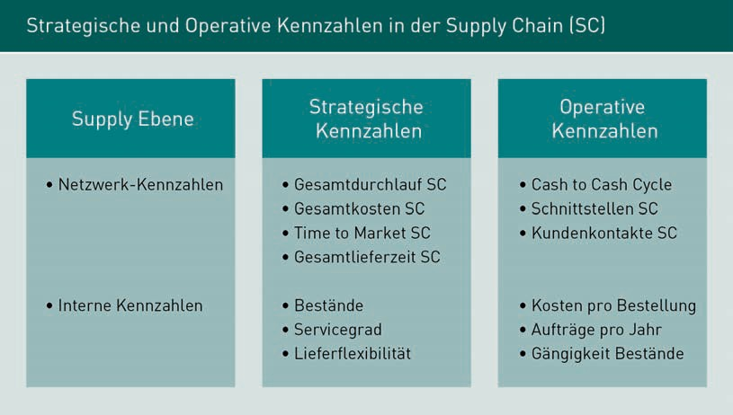

###### Overview of Performance and Cost KPIs

The main task of supply chain management is to generate synergy effects for all stakeholders in the areas of benefits and costs. These goals are closely linked to the time and quality requirements monitored by supply chain controlling. The following diagram illustrates the different categories of performance and cost KPIs with examples.

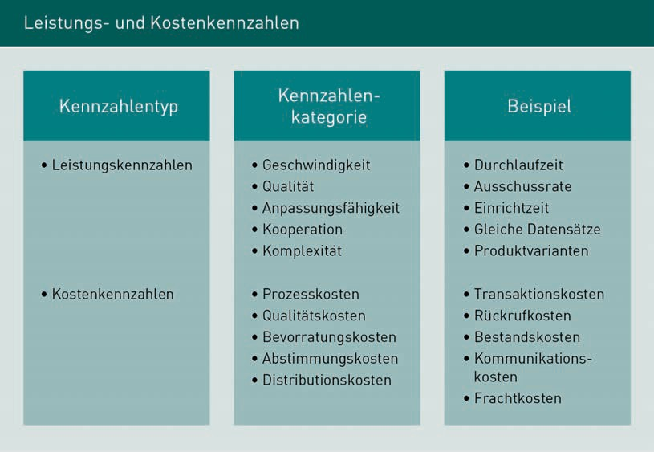

Performance and cost KPIs take absolute values and relate them to one another to allow for both "soft factors" (such as cooperativeness and adaptability) and cost indicators such as quality, inventory and distribution costs.

### Visualization of KPIs

To enable the productive use of KPI systems, numerous requirements must be taken into account during the design phase. The correctness and meaningfulness of an indicator are pivotal, so the database used to calculate a KPI must always be accurate, up-to-date, and validated. Furthermore, the availability of up-to-date indicators must be guaranteed at all times, as this is the only way to identify crises and ensure prompt intervention. Alongside the points already mentioned, the standardized calculation of KPIs is also important, i.e. the same calculation methods must always be used to allow comparability. Unambiguous definitions of KPIs must be agreed and documented to prevent misinterpretations by KPI users and decision-makers.

Once all the above aspects have been considered, the KPIs should be visualized and made available in a readable format for users. Please note that tabular formats are rarely accepted and understood, as they can often look like “numerical hieroglyphics”.

KPI Systems in the Supply Chain

Experience has shown that converting KPIs into diagrams or other graphical representations makes them easier to understand. Individual KPIs should be visualized in different contexts depending on the user, to accommodate different data analyses and perspectives depending on the task in hand.

Various types of diagrams may be used to support decision making. Some of the most popular types are illustrated below.

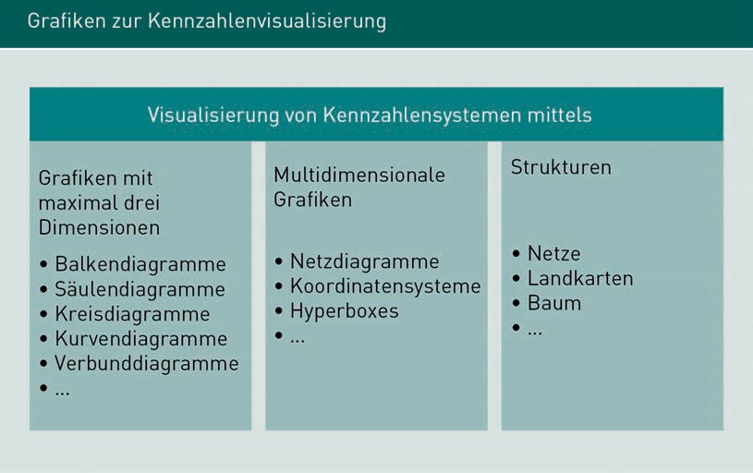

Conventional, three-dimensional diagrams are used to visualize relationships between different KPIs and serve as a decision-making aid. The three dimensions might be: (1.) Sales in a (2.) specific region over (3.) a given period. The above illustration shows some of the types of diagrams used, and they may also be combined to create combination charts. However, operational decision-making often involves mapping and evaluating more than three dimensions. In practice, multidimensional diagrams are not widely used due to the high level of complexity and the required input. The third variant (the structure diagram) is more popular. Maps may be used to illustrate topological conditions, such as the regional distribution of retail branches, networks used to map logistical networks, and tree diagrams used to illustrate organizational structures (e.g. organizational charts and decision trees).

KPIs may be depicted in a variety of ways, such as the spider diagram and KPI diagram shown below.

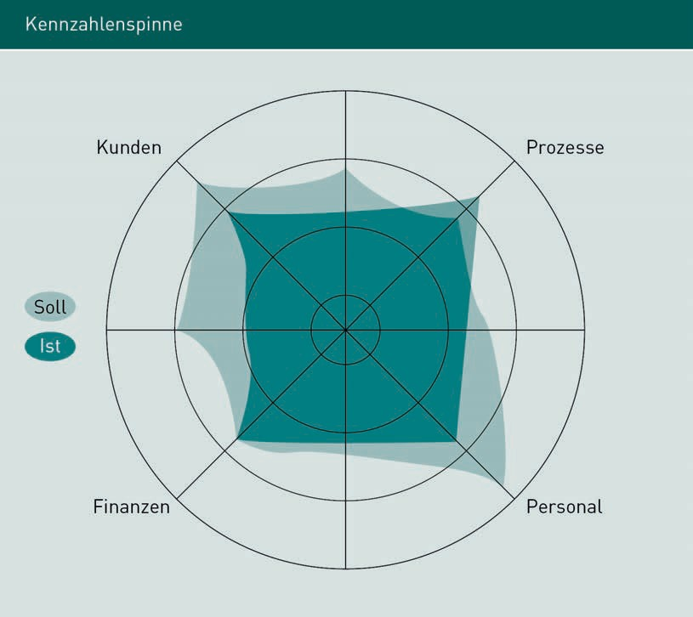

A spider diagram can clearly visualize an organization’s actual status versus the plan (target status). In this instance, the KPIs are not explicitly stated; only the differences are shown.

KPI Systems in the Supply Chain

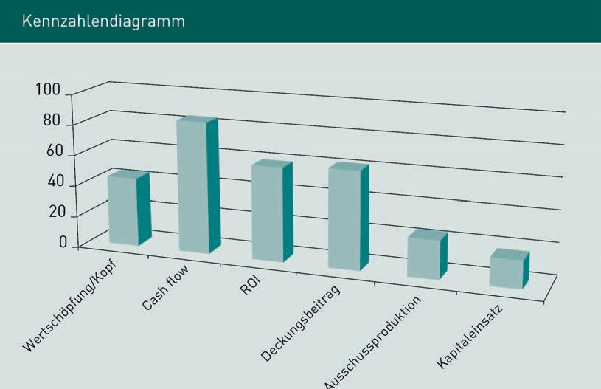

The KPI diagram above elucidates the importance of integrating all areas into the controlling system.

As we have seen, maintaining and processing a KPI system can be quite labor-intensive with regard to collecting, managing, evaluating and visualizing the database.

Summary

KPIs are quantitative variables that describe internal or inter-company information. Controlling would not be possible without KPIs, as they provide support with pending decisions and help to identify any deviations or weaknesses in the company or its supply chain.

There is a fundamental distinction between operational and strategic KPIs within a supply chain. Strategic KPIs are used to analyze the entire supply chain and create transparency about collaborative partnerships. Operational KPIs are internal assessments that provide an overview of in-house divisions or scrutinize individual business units. They may be further differentiated into absolute & relative KPIs, success & liquidity KPIs (which address the achievement of corporate targets) and performance & cost KPIs (each of which has a specific object reference).

When designing and implementing a KPI system, it is important to visualize it in a way users will understand. Converting KPIs into diagrams or other graphical representations is a well-established way of enhancing intelligibility. Individual KPIs are visualized in different contexts depending on the user.



# Unit 3

## Supply Chain Controlling Tools

#### STUDY GOALS

After working through this unit, you will be familiar with ...

… the tools used in supply chain controlling.

… why a combination of traditional and innovative controlling tools is used.

… the types of supply chain controlling tools available.

DL-D-MWCH02-L03

1. Supply Chain Controlling Tools

### Introduction

The tools used to calculate KPIs in supply chain controlling must satisfy a variety of requirements. A conservative approach uses traditional controlling tools to control value chains. In this chapter, we will consider both traditional and innovative controlling tools and how they can add value.

Supply chain controlling tools can generally be divided into two categories. One of the aims of a supply chain is to create uniform processes, so tools such as supply chain maps or SCOR models are used and modified to accommodate company-specific and cross-company targets (Weber 2010) as the basis for controlling approaches.

The second type of controlling tool refines and intensifies the opportunities for strategic and operational control of companies and can be used throughout the entire value chain. Weber cites four different tools that should be used in supply chain controlling, always interlinked with due regard for "soft factors" (Weber 2010). He combines relationship controlling with comprehensive activity-based costing, selective corporate KPIs and the supply chain scorecard. Relationship controlling is an essential part of the entire controlling process, by controlling relationship-relevant factors and identifying synergies and potential in the supply chain partnership. All supply chain partners share a common strategy whereby plans, activities and goals are agreed and combined with a cross-company controlling cycle. Target/actual comparisons are used to gage the success of the supply chain. Any significant deviations from the planning phase can be identified and suitable analyses triggered. Relationship controlling includes the basis for trust as a soft factor which contributes to the success of a supply chain partnership. The basis is regularly measured, for example using employee, customer and supplier surveys. If the results are unsatisfactory, processes must be initiated to correct individual and structural causes in a collaborative problem-solving process.

### SCOR Models as Control Mechanisms

Supply chain controlling also incorporates activity-based costing aimed at minimizing cost allocation inaccuracies and identifying process cost drivers.

Supply Chain Controlling Tools

Activity-based accounting aims to create a uniform database and a common understanding of cost and performance data exchange to help all supply chain participants to identify cost drivers and understand their impact. This creates an appraisable cost and performance structure.

The SCOR model is globally recognized as an efficient tool for planning and controlling supply chains by creating a common basis with uniform definitions and demarcations. A shared database, a common understanding of the process and cross-company activity-based costing leads to: 1. Common metrics for determining overall efficiency, 2. A shared decision-making basis for changes and modifications, 3. Continuous process benchmarking, 4. Shared control of profit distribution via optimization measures in the supply chain, 5. Common target costing, e.g. when evaluating logistics costs and implementing target cost planning downstream in the supply chain.

Selective KPIs are applied to three levels:

1. At the level of supply chain partners throughout the value chain
2. At the relational level, which relates the KPIs of two supply chain partners to one another and
3. At the company level, where KPIs refer solely to that company (Wiedemann/Dunz 2000, pp. 25ff.).

The Supply Chain Operations Reference Model (SCOR Model) was designed in the United States by the Supply Chain Council to describe all business processes within and between companies. In 1996, it was made available to the business market as a standard method for analyzing, describing and mapping all relevant aspects of a supply chain. The five essential supply chain management processes (plan, source, make, deliver and return), coupled with business process reengineering, benchmarking, and best-practice analyses, provide the basis for the first level of detail found solely in strategic corporate planning.

* + In process planning, demand is aggregated with supply to create an initial snapshot of the target process.
  + Sourcing maps all required products and services.
  + Making/production includes the manufacturing of finished and semi-finished products as goods or services. It also includes make-to-stock, make-to-order and engineer-to-order.
    - Delivery represents the logistics process. End products (goods and/or services) are delivered to the customers on time and in the correct quantity by means of warehouse, order and transport management.
    - The return process covers the return of faulty products, empties and/or remnants depending on the sector focus.

The second level in the SCOR model is the configuration level, comprising three process types: Planning, execution, and support processes.

The third level is the so-called design level where individual subprocesses are defined in greater detail and mapped.

Implementation is the fourth level and combines individual roll-outs, including all technological solutions, adapted to the relevant stakeholders.

### From Traditional to Innovative Tools

The focus here is on mapping and shaping the supply chain strategy and organization. The three tools outlined below - the supply chain map, the stress and resilience portfolio and supply chain valuation - are used to map the processes (and process combinations) together with so-called soft factors.

Firstly, the supply chain map creates transparency by determining and assessing a supply chain partner’s position within the value chain in relation to other partners, such as upstream or downstream value-creation levels. Secondly, the stress and resilience portfolio then assesses and categorizes these relationships. Finally, supply chain valuation is recommended for downstream evaluation of the resultant management recommendations.

###### Supply Chain Maps

Supply chain maps are used to map chain architectures and provide a holistic overview of all relevant market partners.

These may be aimed at both upstream and downstream value-creation levels. An overall view may also be created, but in practice this is rarely used due to its complexity and density.

Supply Chain Controlling Tools

Rather than documenting every detail of upstream value-creation stages, which may be extremely labor-intensive due to the size of the company or the depth of procurement, it is advisable to work with clusters subdivided into suppliers, products, warehouses or materials, for example, or any other preferred grouping (Kaufmann/Germer 2001, pp. 182ff.).

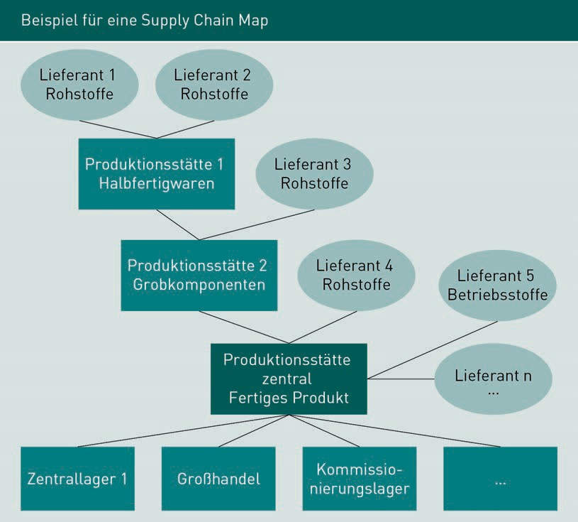

The above example of a supply chain map illustrates the different stages in the supply chain and includes all stakeholders, from the various suppliers, to manufacturers of prototypes and components, as well as warehouses and distributors. The diagram does not exhaustively cover every detail (such retail warehouses, finished products, office supplies or other stages), but merely represents the relevant strands.

If we were to plot coordinates on this supply chain map, the company being considered is always at level "zero". All downstream value creation levels are positive (i.e. +1 and above), while all upstream levels are negative (i.e. –1 and lower). The controlling assumptions are defined within these levels to enable comparative analyses.

Taking level 1 as an example, we can map the connections to direct suppliers for each product group. This might include the number of actual suppliers, all contractual options including the duration of the contract, nature and scope of cooperation, pricing and price fixing, sliding-scale clauses and many other parameters. In many organizations, this information is not depicted in an overall "map" or transparently documented as a combined overview, making comparisons within the supply chain difficult. It is important to synchronize the master data and check the underlying data in supply chain maps at regular intervals (annual or quarterly cycles) to ensure it is up-to-date. The main challenge here is the level and depth of aggregation (Kaufmann/Germer 2001, page 182ff.).

The deeper the queries and assumptions (i.e. the further away from the company itself (level 0)), the more indirect the content becomes, such as the mapping of technical, legal, political or even macroeconomic information and developments. The more global the topic and the supply chain, the greater their practical relevance. Country analyses are needed to comprehensively map all political, cultural and geographical differences and roles. If “soft” conditions (such as negotiating skills, gender issues, the basis of trust) are taken into account alongside the “hard” factors, this is the most challenging level when mapping a chain architecture. The individuals responsible for presenting the supply chain map begin by defining the analysis depth of the value creation stages and the information flow conditions (such as distributing tasks, moderating or evaluating of workshops), the individual levels and, where applicable, the interview partners. A meaningful supply chain map must consistently consolidate all essential data and information.

###### Stress and Resilience Portfolio

The stress and resilience portfolio is another tool used to analyze the strengths and weaknesses of individual supply chain participants.

It can be useful to prioritize all members of the value chain and identify the critical sections. This transparency allows companies to monitor and improve cooperation with supply chain stakeholders who fall short of the defined criteria. If necessary, an emergency plan can be drawn up or a particular section of the organization replaced as appropriate. The stress and resilience portfolio compares two core variables: stress on the supply chain member and resilience. If the stress placed on a member does not match their resilience, various strategic and operational measures may be developed and implemented. This also helps to overcome fluctuations during peak and trough times, for example. Current factors are used to gage the momentum and robustness of the ongoing business cycle.

Supply Chain Controlling Tools

Ongoing quality improvements, active risk mitigation and current measures to stabilize the supply chain member may be included in a quantitative measurement, but not a qualitative measurement. This is probably the main disadvantage of the stress/resilience portfolio, because measures with a high cost-benefit ratio may be implemented to increase the supply chain’s resilience, whereby action is clearly needed but the potential cost is unknown. The stress/resilience portfolio may therefore be supplemented with the dimension of cost to create a stress, resilience and cost portfolio. A stress, resilience and cost portfolio can identify and generate hidden optimization potential and hidden costs. The higher the cost factor, the greater the sum to be used for risk-mitigation or risk-controlling measures.

The most practical approach is to draw up a set of questions with an ordinal scale of 1 to 5 ("very true" = 1, "not applicable" = 5). This makes cardinal and ordinal variables comparable and allows individual KPIs to be weighted according to importance, as with a scoring model. The weighting can be modified at any time to reflect changing factors, a new company joining the supply chain or different strategic goals.

|  |  |  |  |  |  |  |  |  |  |
| --- | --- | --- | --- | --- | --- | --- | --- | --- | --- |
| Weighting of KPIs using a qualitative supplier assessment as an example | | | | | | | | | |
| Qualitative suppliers | | | | | | | | | |
| Assessment criteria | Basic data | | | Scale | | | | | |
| Fac-tor I | Fac-tor II | Fac-tor III | 1 | 2 | 3 | 4 | 5 | Total |
| Location |  |  |  |  |  |  |  |  |  |
| Ability to deliver |  |  |  |  |  |  |  |  |  |
| Punctuality of deliveries |  |  |  |  |  |  |  |  |  |
| Sales/performance capability |  |  |  |  |  |  |  |  |  |
| Image |  |  |  |  |  |  |  |  |  |

|  |  |  |  |  |  |  |  |  |  |
| --- | --- | --- | --- | --- | --- | --- | --- | --- | --- |
| Qualitative suppliers | | | | | | | | | |
| Assessment criteria | Basic data | | | Scale | | | | | |
| Fac-tor I | Fac-tor II | Fac-tor III | 1 | 2 | 3 | 4 | 5 | Total |
| Up-to-dateness |  |  |  |  |  |  |  |  |  |
| Sales system |  |  |  |  |  |  |  |  |  |
| Contact and goodwill behavior |  |  |  |  |  |  |  |  |  |
| Cooperation partners |  |  |  |  |  |  |  |  |  |
| Qualitative assessment | – | – | – | – | – | – | – | – |  |

In the above example of a qualitative supplier assessment, each assessment is made by awarding points combined with a weighting factor. Other assessment options might include the supplier’s areas of expertise, for example, by assessing variant diversity or reference customers. In project processing, assessment might focus on the speed or technical competence with which bids are handled. The structure of the bids and relevant calculations can be rated in terms of consistency, clarity or detail. For quality management, key criteria might be certification or third-party monitoring. Every area – including research and development – can be evaluated, including the use of innovative technologies. The more criteria are evaluated, the more in-depth the overall supplier assessment becomes. The more closely the actual supplier resembles the pre-defined supplier, the less critical their behavior in the supply chain will be.

###### Supply Chain Valuation

Supply chain valuation is a tool for determining value contribution in supply chain optimization. The cost of additional management activities triggered by critical behavior among supply chain members must be compensated by value-creation revenues.

Supply chain valuation simulates the effect of specific, practical SCM projects (in the target analysis) or measures the actual values. There is no recognized, uniform definition. One example might be implementation of an ERP system to strengthen and measure critical sections of the supply chain (Kaufmann/Germer 2001, pp. 189ff.).

Supply Chain Controlling Tools

This methodology is no substitute for activity-based costing but provides a more in-depth and holistic view of all supply chain participants. It assesses all investment costs and cost-benefit factors for all stakeholders.

As illustrated above, supply chain controlling uses both traditional and innovative tools. Key starting points include anchoring supply chain controlling in supply chain management, gathering empirical evidence of comprehensive supply chain success, assessing the feasibility of globalized supply chain management and adapting traditional controlling tools to supply chain controlling.

Summary

The tools used to identify KPIs in supply chain controlling must meet a wide range of requirements. A conservative approach to supply chain controlling draws on traditional tools, but these cannot not satisfy the requirements of supply chain management, because they focus primarily on individual companies rather than global value chains.

Approaches such as the SCOR model are therefore used alongside more conventional controlling tools. Other innovative tools include the Supply Chain Map, Supply Chain Valuation and BBP / BBAP.

The crucial aspect with all these tools is that they consider the entire supply chain and the impact of individual stakeholders’ contributions.

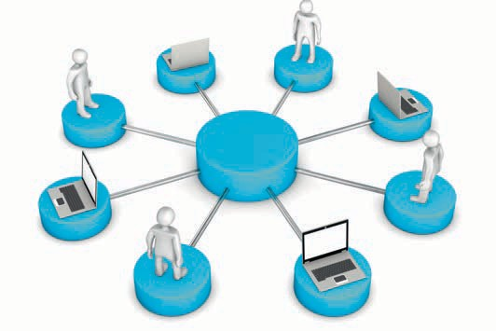

# Unit 4

## Controlling the Supply Chain with IT

#### STUDY GOALS

After working through this unit, you will be familiar with ...

… why information technology is used in controlling.

… the aspects to consider when implementing SCM software.

… the problems that can arise when implementing complex SCM software.

DL-D-MWCH02-L04

1. Controlling the Supply Chain with IT

### Introduction

Application systems IT-assisted information systems, either bespoke or off-the-shelf.

In business practice, controlling walks a tightrope between the desired controlling concepts and the IT systems needed to implement them. Controlling benefits greatly from the developments that the IT sector has made in recent years, especially regarding the up-to-dateness and rapid availability of the required data. Today's controlling requirements make it almost impossible to perform the required tasks without IT support. Controlling therefore draws on a wide range of applications, including data warehouses, external databases, data mining tools, online analytical processing tools and operational systems such as enterprise resource planning (ERP) systems.

In the field of business management software, CRM (Customer Relationship Management) and SCM systems are popular extensions to ERP systems for process mapping beyond company boundaries, for example in supply chain management. These applications not only map and control corporate processes, but also help companies to secure their own market positions and facilitate growth.

### ERP Systems

ERP systems are business software systems used to map a company’s internal processes. ERP software covers all internal processes relating to production planning & control and materials management from procurement through to warehousing, as well as all logistical aspects. ERP systems also cover human resources management as well as cost calculation and accounting.

ERP systems integrate all the aforementioned areas into one central system, to allow the concerted operation of internal processes and create consistently recognizable and traceable process lines.

Companies that strive to achieve their strategic business goals and secure competitive advantages use ERP software.

Controlling the Supply Chain with IT

This is where controlling comes into play. Often, the primary aim when using ERP software is to reduce operating and process costs. An optimum ERP software can map the entire corporate structure and process landscape to render optimization potential transparent.

ERP systems also help to improve service and/or quality and to accelerate business decision-making by ensuring the constant availability of pertinent information. For controlling, the crucial factor is to incorporate KPIs into the ERP system to provide meaningful decision-making support for management.

ERP systems are therefore ideal for mapping internal processes, but when it comes to integrating external factors, as is the case in supply chain management, they reach their limitations.

### CRM and SCM Systems

In supply chain management and value chain controlling, the focus is on incorporating all supply chain participants. ERP systems are essentially designed for individual companies. Supply chain management focuses on processes that control the entire logistics chain from supplier to end-user alongside the management of customer relationships. CRM or SCM tools should therefore be used for a more holistic view.

CRM systems focus on processes that are directly or indirectly related to customer management. The portfolio ranges from market research, sales and marketing measures to the generation of new business contacts and the establishment of comprehensive service processes. Tender management and product management are often integrated into CRM systems as well.

Today’s markets require companies to respond to customer concerns in an increasingly individualized manner, prompting the development of CRM systems. Companies must refocus, modify and optimize their processes. To be able to adapt flexibly to changing competitive conditions, an up-to-date, transparent database is needed which can be rapidly realigned.

SCM systems align internal and external logistics and supply chains with an increasingly globalized economy. International supply chain participants face growing cost pressure and need tools to help them secure their own market positions and generate market advantages over their competitors. The key drivers behind the development of such systems are therefore the need to optimize existing supply chains, tap into future supply chains and streamline costs.

Many companies are also keen to optimize the value chain by tying supply chain partners more closely to them. This should ideally include automated information exchange, as is already practiced by many companies with ERP systems between their own production facilities.

Globalization is another factor behind the growing popularity of SCM systems, as companies are forced to procure raw materials and distribute goods on the global market. Integrated systems create greater transparency in the international supply chain. As a further consequence of globalization, global shipments must comply with international trade regulations, and software systems must allow for this. Carefully planned, practical logistics are a pivotal success factor. Companies must quickly and effectively adapt their logistical process chains to the ever-changing requirements of customers and market environments if they are to survive in the long term. Management therefore focuses increasingly on strategic planning of logistical concepts to address essential changes in logistics processes. Supply chain controlling should make updated KPIs available at all times to support decision-making and allow the simulation of future developments.

The performance requirements faced by all areas of a company's business operations – from the implementation of delivery processes to controlling the value chain – are crucial when developing a logistics system. The type and quantity of orders handled via the system provide the underlying basis, whereby orders to suppliers, internal requirements (e.g. procurement or production) and customer orders should all be mapped and incorporated. Planning is not based solely on performance requirements, but also includes the mandate to minimize costs and accommodate existing restrictions. When setting up SCM systems, the supply chain requirements from supplier management through to controlling must be clearly described.

SCM system design builds on the basic assumption that all requirements are distributed evenly and all eventualities are considered. On this basis, the supposed cheapest alternatives are selected. This selection is then narrowed down further to those best-placed to adjust and accommodate anticipated changes and fluctuations in incoming orders. The remaining shortlist is then re-evaluated from a cost perspective. Having repeatedly scrutinized every detail of the supply chain system in this way, the most financially attractive solution is deduced. A final check is carried out to gage performance in the event of simulated fluctuations and, if necessary, modified further. The basic data obtained in this way and incorporated into the SCM system is the target state which guides all supply chain activities.

Controlling the Supply Chain with IT

The SCM system itself compares actual values with target KPIs and supplies controlling with this information so it can intervene in the supply chain where necessary (Gudehus 2010, p. 538).

The next step is to define the individual segments of the value chain and integrate these theoretically derived values into the supply chain as target KPIs. This is achieved via a range of processes including order handling and communications within the supply chain. The subsequent requirements placed on IT systems are derived from these defined processes.

One positive side-effect of implementing an SCM system, with an emphasis on simplicity, is that mapping the supply chain in an IT system leads to the optimum logistics solution with the shortest chains and minimum number of partners. When developing SCM systems, it is worth noting that in keeping with the approximation principle, it is generally sufficient to use the accuracy of the basic data as a basis for the accuracy of the related algorithms.

As previously explained, the supply chain may develop in two divergent directions when implementing SCM software with related modification and optimization of the process chains. Firstly, the current status may be developed at minimal cost to achieve the defined requirements as closely as possible. Alternatively, the target solution may be identified using the steps mentioned and then reinstalled from scratch. The second option (radical restructuring) should only be considered if the first option appears completely unworkable. With low-cost implementation, even minor tweaks can often have a fairly major impact. An optimum solution can also be achieved within a reasonably time frame by continuously refining the system (Gudehus 2010, pp. 537–538).

### Case Study: Implementing an SCM System

The implementation of SCM software is a highly complex process. The following case study illustrates how an SCM system can optimize the handling of even the most complex logistical processes:

Our case study considers a supply chain with a fictitious wine merchant in Germany selling high-quality wines from all over the world, including South America. We will look at the entire value chain from wine production to distribution among wine merchants.

The key points to consider within the value chain are as follows:

* The South American wine has long production times and transport routes, so stock cannot always be easily reordered. As a result, the wine merchant starts stockpiling more and more wine in order to meet customer demands and avoid jeopardizing sales, fearful that customers could migrate to its competitors instead.
* Because of the lengthy procurement times and transport routes, demand cannot be met promptly if stock levels are too low.
* The logistics costs are immense, especially with high-end wines aimed at a very exclusive clientèle, as they are only purchased in small quantities with higher transport costs.

To ensure the appropriate implementation of SCM software, all parties involved in the value chain must be identified. The next step is to clarify the technical options for connecting individual participants to the SCM software to make it accessible to all of them. The winemakers in South America could pose the first stumbling block, as the local Internet capacity and speed may not match European standards. Nevertheless, a standard process must be defined and supported by all participants to prevent isolated solutions for each vineyard and create greater transparency with identical, standardized processes. In a best-case scenario, this could also generate the first cost savings.

A simplified supply chain might look something like this: The South American winemakers are responsible for production, including the various upstream stages such as delivery, cultivation and care of the vines, the procurement of barrels and bottles etc. After bottling, the wines are transported from the winemaker to the export port by local logistics service-providers then stored in customs warehouses before being loaded and shipped to Europe. The port companies responsible for processing must be included in the supply chain together with the customs authorities and local customs agents.

Another logistics provider is responsible for shipping and purchases cargo space from shipping companies. The cargo is unloaded, stored and cleared by customs in the European port by one or more additional service-providers. The importer – the German wine merchant – then commissions one or more logistics service-providers to distribute the wine across Germany and Europe, where applicable including order-picking and warehousing. If the logistics service-provider does not have its own fleet, it will use carriers to deliver the goods to distribution centers for transshipment and delivery by local couriers to the retailers.

Controlling the Supply Chain with IT

The retailers are equipped with POS systems that document sales and (the more modern versions) initiate reorders where necessary, or at the very least provide a continuous inventory as the basis for new orders. All information is collated by the wine importer’s logistics department for demand planning.

The above account illustrates how many players are involved in a complex value chain. Certain process steps may involve many more participants. The task of SCM software is to find a single solution to the many and varied approaches adopted by individual supply chain partners.

### Success Factors for Using SCM Software

As we have seen, implementing SCM software to control value chains is a complex task. The needs and current framework conditions of countless internal and external value chain participants must be considered and integrated. An interdisciplinary, cross-company project team is usually deployed, supported by the relevant management teams. a process-oriented, proven implementation approach is usually appropriate when setting up a new SCM system. Suitable project and risk management systems must be in place to eliminate budget and schedule overruns as far as possible. The early involvement of central units such as procurement, capacity and sales planning to identify and optimally coordinate mutually influencing interfaces is also pivotal to success. This includes the early information and involvement of future SCM software users so that valuable employee experience can be incorporated into the new system. This will boost the project’s chances of success by comprehensively communicating the anticipated improvements for employees and companies, either by involving employees directly in the project, or by communicating the current project status to non-participating employees via training and communication plans.

To achieve the project objectives – namely, to optimize the supply chain with cost degression effects – supply chain controlling will accompany the entire project from start to finish and deliver KPIs during the planning phase so that target achievement can be measured and communicated. These KPIs must be adapted to the relevant project phase by breaking the project down into milestones, culminating in target values to aim for once the supply chain software has been successfully implemented.

As we have seen, the efficient use of SCM software can mean the difference between success or failure to a company, especially as it is almost impossible to control complex supply chains without appropriate IT support.

Summary

Supply chains are under growing cost pressure. The supply chain management needs tools to help it secure the company’s market position and create a market lead over its competitors. When developing and implementing SCM systems, the main drivers are to optimize existing supply chains, develop future supply chains and streamline costs.

The requirements placed on supply chain controlling are so complex, they would be almost impossible to achieve without IT support. Controlling benefits greatly from recent developments in IT, especially regarding the rapid availability of up-to-date data.

Implementing SCM software to control value chains can be extremely labor-intensive. The needs and current framework conditions of numerous internal and external value chain participants must often be considered and inegrated. However, the effort is justified, because the efficient use of SCM software can mean the difference between success and failure. IT support is vital for calculating KPIs and maintaining an overview so that any problems can be promptly addressed.



# Unit 5

## Controlling Tools in the Supply Chain

#### STUDY GOALS

After working through this unit, you will be familiar with ...

... the subdivision of controlling into groups.

… the controlling tools available.

… how controlling tools are used in practice.

DL-D-MWCH02-L05

1. Controlling Tools in the Supply Chain

### Introduction

Corporate management’s objectives can be divided into strategic and operational goals. Strategic goals are long-term, while operational goals are for short-term implementation. A strategic goal is to safeguard the company's existence, while success and liquidity goals are operational. Strategic and operational controlling requirements are derived from the management objectives and are met using a range of tools.

Strategic controlling supports management with a forward-looking mindset and promotes a particular corporate culture throughout all functional areas of the company. Strategic controlling also performs vital coordination tasks to support the strategy planning and implementation process.

Operational controlling is responsible for establishing a performance-based planning and control system. It coordinates target achievement measures and assists management with decision-making.

Operational and strategic controlling are mutually dependent and complement one another. Strategic controlling cannot be effective unless operational controlling fulfils its tasks.

Just as there are two types of controlling, the tools used are also divided into two groups. Contribution margin accounting, KPI (systems), ABC analysis, budgeting, break-even analysis, activity-based costing and many other tools (which vary depending on the specific controlling task) are classified as operational controlling tools, while benchmarking, various analysis techniques and the balanced scorecard are classed as strategic controlling tools.

Below, we consider activity-based costing as an example of operational controlling and benchmarking as an example of strategic controlling.

### Activity-based costing (ABC)

Activity-based costing, an established cost accounting system, draws on some of the tried-and-trusted methods used in full cost accounting systems. The weakness of traditional cost accounting methods is that overheads are not proportionally assigned to cost centers; instead, imputed surcharges are distributed among all cost centers at a fixed rate. Consequently, in traditional accounting systems some units face disproportionately high overhead costs which are in fact attributable to other units, potentially distorting the results of individual departments or divisions.

Controlling Tools in the Supply Chain

Activity-based costing improves cost allocation by distributing overhead costs proportionally for easier planning and control of individual departments. Costs must be allocated proportionally so that potential cost savings in individual departments can be identified and implemented by breaking them down transparently among individual products and services rather than general business units.

The reference points here are the organization’s value chain and the calculation of individual processes. Each task handled by the organization’s cost centers is divided into process-related activities to allow the identification of cost drivers and corresponding allocation of costs. This calculation leads to process cost-unit rates, which are used to divide the process-related overhead costs among the organization’s services and products.

Activity-based costing therefore meets the objective of proportionally allocating internal services and improving cost transparency in indirect (non-directly attributable) areas, such as administration costs, sales, infrastructure costs and similar areas, known collectively as "overheads".

Activity-based costing requires a detailed analysis of each task within a cost center so that unproductive tasks become transparent and readily identifiable (Steger 2010, p. 577ff.).

###### Process Identification

Before implementing activity-based costing, the entire value chain must first be broken down into individual processes and activities (Mayer 1999, p. 85ff.).

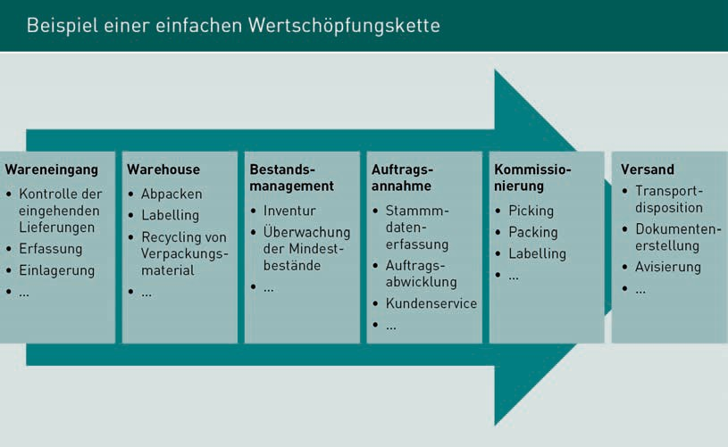

As illustrated above, various activities are assigned to each area of the value chain and evaluated using activity-based costing. These activities are identified by questioning process participants as well as by reviewing and analyzing existing documents (such as job descriptions, order documents, cargo lists and much more). As well as the obvious activities, these analyses can also measure the time taken for certain activities, which are then included in the cost calculation. One example is the set-up time for machines, which is used to determine and evaluate downtime as a proportion of total production time.

The activities assigned to individual cost centers are grouped together into logical subprocesses. The cost drivers and influencing variables are identified, and all subprocesses acting on the same variables and cost drivers are grouped together. Main processes derived in this way may span multiple cost centers (Mayer 1999, pp. 85ff.), as illustrated below.

Controlling Tools in the Supply Chain

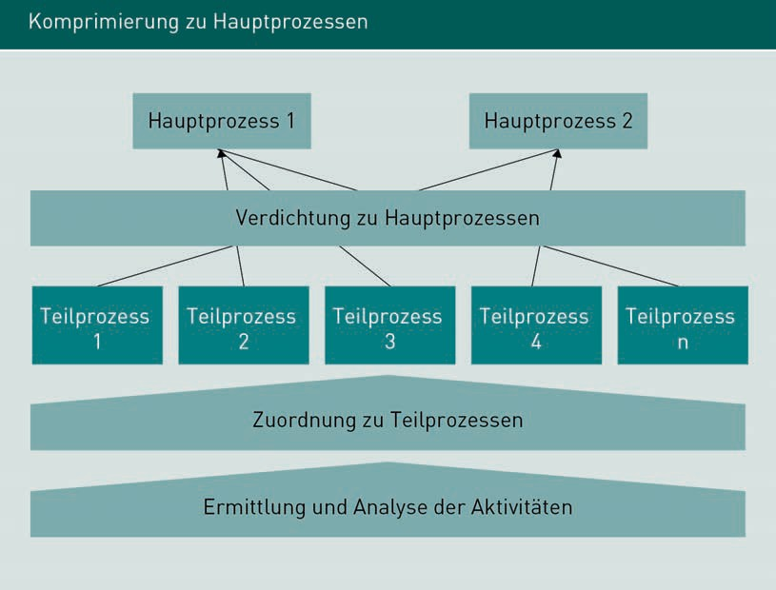

###### Activity-Based Costing and Cost Allocation

Once an organization’s processes have been identified and quantified, the process cost rate (= cost rate per quantity unit) can be calculated by dividing a process’s total costs by the number of processes.

Experience has shown that the following approach is the most effective (Czenskowsky et al. 2010, p. 130ff.):

* Demarcate the areas to be investigated
* Analyze the main processes and associated cost drivers
* Analyze the activities
* Group similar activities into sub-processes
* Determine capacity per sub-process and cost center as the basis for cost allocation
* Calculate sub-process costs via apportionment (distribution of costs among sub-processes)
* Group sub-processes into main processes
* Assign cost drivers to individual cost centers.

This produces the following formula for calculating process costs:

Process costs per main process unit = Sub-process costs

Cost drivers

Assuming that warehouse management is a key process in a company or value chain, we can illustrate this formula with the following example: In warehouse management, individual stock items are classed as cost drivers. Each warehousing operation represents a stock item. 100,000 stock items (= 100,000 deliveries) are warehoused per calculation period. In this case, costs of €800,000 were apportioned to the material procurement sub-process over the same period. The costs per cost driver (= incoming delivery in this example) are calculated using the formula below and amount to €8.00 per warehousing operation.

Process cost rate = Process cost = Cost per cost driver

Process performance

€800,000 = €8 per warehousing operation

€100,000

As these explanations show, activity-based costing is a straightforward but efficient controlling technique for mapping the operational costs of processes within the value chain.

### Benchmarking

We will now explore benchmarking (a topographical concept offering a reference point or unit of measure for comparison purposes) as an example of a strategic controlling tool. Benchmarking was originally used to compare operations, and its variants include functional, internal and competitive benchmarking. Benchmarking is a useful controlling tool, as it not only provides information about an operational unit’s success or failure but also acts as a motivator by comparing competitors to identify potential process improvements and strategic realignments. However, the disadvantage of benchmarking is that it does not always compare like with like, such as subsectors with similar but completely unrelated processes. For example, different products may use similar production processes but are not comparable because the products are marketed in completely different environments.

When comparing operations, it is often difficult to find a comparable operation with similar process sequences. Once a comparable operation has been found and works effectively, copying the superior company’s processes is a proven technique for improving your own processes.

Controlling Tools in the Supply Chain

While often effective in the short term, the long-term effectiveness of this approach is very limited. Merely copying another company without incorporating your own innovations offers minimal chances of long-term growth.

Benchmarking is a continuous comparison process, preferably with a company’s stronger or strongest competitors (best in class), with a view to learning from and adapting their success formulae and incorporating them into your own strategy.

Benchmarking was introduced in 1979 by Rank Xerox, as the company faced fierce pressure from Japanese competitors and needed to rethink its corporate strategy in order to survive. It began by comparing its manufacturing costs with those of its competitors and analyzing them in fine detail, which revealed a number of extreme discrepancies to the detriment of Rank Xerox. Production was subsequently reorganized using data obtained from the competition. As the measures to cut production costs proved so successful, the system was also extended to all other business areas and achieved measurable cost degressions there too.

Rank Xerox’s success with the benchmarking tool led to comparisons being made with other leading companies in their fields, rather than with internal divisions.

Benchmarking could therefore be defined as the hunt for the best methods in search of excellence. Note that benchmarking is a continuous process for identifying potential improvements that are implemented directly in the company. Ongoing comparisons and corresponding internal KPIs supplied by controlling as comparison variables allow strategic goals to be adapted directly to the required internal and external changes.

In today’s markets, globalization and other megatrends have led to extremely short innovation cycles. Continuous benchmarking helps companies to promptly identify trends and implement any required adjustments.

The benchmarking process itself can be divided into seven phases:

1. Analyze the company’s strength and weaknesses.
2. Identify where changes are urgently needed and/or where the best market opportunities are.
3. Analyze the "best in class".
4. Understand why this organization is so successful.
5. Identify potential adaptations within your own company.
6. Formulate and implement (new) strategic goals.
7. Success analysis / target-actual comparison; if the desired result is not achieved, repeat steps 1. to 4.

There are three different types of benchmarking:

Shadow benchmarking means directly comparing your organization with your competitors without their knowledge. It is comparatively simple to transfer the results to your organization, as processes and methods are usually similar. However, it may be difficult to obtain information, as the reference organization may not make all relevant KPIs publicly accessible.

Functional benchmarking may be carried out with organizations in a completely different industry, for example with a focus on innovation processes. While it may be relatively easy to obtain information, as world-class companies tend to participate in studies and other published reports, transferring the processes to another environment may prove more difficult.

Finally, internal benchmarking compares different business units, departments or supply chain partners within your own organization. Obtaining information is simple, as the required KPIs are already available from controlling and must simply be placed in relation to one another. One disadvantage of internal benchmarking is that it rarely generates innovation potential because it is limited to the same environment. Furthermore, the procedure may trigger internal competition between departments or other business units, potentially to the detriment of the company's success.

All forms of benchmarking share one thing in common: They can be applied to the service and production sectors as a way of realigning strategic goals, supported by the KPIs generated by controlling.

Summary

In the same way that company management objectives are divided into strategic and operational targets, controlling is divided into the same two categories. Strategic controlling supports management with a forward-looking mindset that promotes a particular corporate culture across all functional areas of the company and performs important coordination tasks to support the strategy planning and enforcement process.

By contrast, operational controlling is responsible for establishing a performance-oriented planning and control system. It coordinates target achievement measures and supports the company management with decision-making.

Controlling Tools in the Supply Chain

The tools used in controlling are also divided into two categories: Contribution margin accounting, KPI (systems), ABC analysis, budgeting, break-even analysis, activity-based costing and many other tools (which vary depending on the specific controlling task) are classified as operational controlling tools, while benchmarking, various analysis techniques and the balanced scorecard are classed as strategic controlling tools.

All the tools listed can also be effectively used within the context of supply chain controlling and assist management with the optimization of value chain processes.

# Unit 6

## Risk Management

## in the Supply Chain

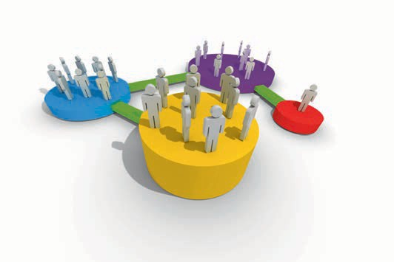

#### STUDY GOALS

After working through this unit, you will be familiar with ...

… why risk management is used within supply chains.

… the different risk sources.

… how risks affect a supply chain’s success.

DL-D-MWCH02-L06

1. Risk Management in the Supply Chain

### Introduction

Global value chains are dynamic, occasionally fragile constructs with numerous interdependencies. They are influenced by various trends and megatrends which permanently transform the market situation, including globalization of the economy, competition between individual supply chains, the procurement of cheap raw materials and supply parts from developing and emerging countries, and trends toward single-sourcing and outsourcing. All these aspects may impede planned operations in a value chain and pose major challenges for supply chain management. It is also important to consider product development alongside the simultaneous development of supply chain processes. Increasingly, the market is demanding closed cycles to regulate the distribution and return of packaging materials, end-of-life equipment and other residual materials. Market research should continuously compare supply and demand. The internationalization of markets is making value chains increasingly susceptible to disasters and disruptions.

One example is the March 2011 earthquake disaster in Japan, when the devastating destruction caused by the earthquake was further exacerbated by the fact that most of the reactors at the Fukushima nuclear power plant were destroyed. An entire region had to be evacuated because of radiation. This catastrophe virtually paralyzed the Japanese economy for weeks and had a serious impact on the global economy: Because Japanese manufacturers are market leaders in certain high-tech fields, companies around the globe import computer chips and other key components from them. The production stoppages in Japan caused by the destruction of production facilities and energy bottlenecks meant that the requirements of the world market could not be satisfied. The opportunities for substitution were limited due to Japan’s position as world market leader in certain technology sectors. A lack of supplies led to production bottlenecks among high-tech manufacturers worldwide and sales plummeted.

Given the aforementioned interdependencies, supply chains must implement a risk management system capable of identifying and correcting any risks early on. This entails the identification, forecasting, monitoring and control of vulnerable interfaces within the supply chain.

### Risks in the Supply Chain

Within the supply chain management context, the prevailing trend toward lean value supply chains and globalization means that companies are exposed to growing supply chain risks. The fact that global value chains are so complex makes hazardous events more likely to occur.

Risk Management in the Supply Chain

As different supply chains become ever more closely intertwined, they become more susceptible to disruptions. All types of disruption occurring within a supply chain adversely impact the enterprise value of its participants.

A supply chain risk is defined as damage which is assessed according to the likelihood of its occurrence, affecting more than one company in a value chain and originating from a supply chain participant or in the immediate vicinity of the supply chain. If a risk occurs among one supply chain participant, one or more of the other participants will experience it as a demand or supply risk. For risk assessment purposes, it is irrelevant whether the risk is triggered directly by a supply chain partner or an environmental factor.

Risks occurring within value chains trigger consequential losses among one or more supply chain partners. This effect is known as the supply chain’s "vulnerability".

Note that there are different categories of risks associated with a supply chain: "Black swan" events are unpredictable and extremely unlikely. They cannot be influenced by supply chain participants. Natural disasters are one such example. They disrupt the value chain by destroying logistics routes, temporarily limiting access to raw materials etc. Supply chain management can only counter these risks with emergency plans, but however carefully planned, they cannot always be implemented, depending on the type of disaster.

Supply Chain Risk Management (SCRM) is a holistic approach covering all risks affecting internal events in the supply chain and is therefore an integral part of supply chain management.

SCRM incorporates all processes, institutions, measures, strategies and technologies capable of minimizing the risk of disruptions to the supply chain. By mitigating supply chain risks, it reduces the supply chain’s vulnerability and makes the value chain more robust.

### Risk Sources in the Supply Chain

Supply chain risks can be categorized depending on where they arise (the risk source).

###### Supplier-Side Risks

Supplier-side risks are disruptions caused by a supplier failure, for whatever reason, and also include quality problems with supplied parts or price fluctuations on the procurement markets.

Consider this example of a supplier-side risk in the automotive industry: The world market leader for diesel injection pumps failed to spot a defective Teflon coating in a small 1.5 cm socket. Its quality control department could not identify the culprit – either a machining error by the socket manufacturer, or the delivery of sub-standard, contaminated Teflon by its supplier. The defective socket only costs a few cents, but the assembly lines at two leading car manufacturers had to be shut down. As well as damaging the reputations of both the diesel injection pump manufacturer and the two car manufacturers, several thousand vehicles had to be recalled, leading to material damages in the three-figure millions.

###### Customer-Side Risks

Customer-side risks are disruptions affecting customers of a supply chain product. One example is the bullwhip effect, a phenomenon whereby the entire supply chain is imbalanced by limited local information and associated local decisions, because even a small fluctuation in customer demand can impact demand at every subsequent stage in the supply chain and become increasingly dispersed. The resulting knock-on effect gives upstream stages of the supply chain a false picture of the demand situation, so surplus stock levels are accumulated throughout the entire supply chain to meet this fictious demand. Shortages may nevertheless arise at the point of sale. The requirements placed on suppliers by trade and manufacturers do not reflect actual demand and, in extreme cases, lead to stockpiling and significant capital tie-up for both material goods and storage costs. This makes a mockery of the supply chain concept. Other customer-side risks include inaccurate forecasting of major demand fluctuations and customer credit risks.

###### Bureaucratic Risks

Bureaucratic risks are another category which should not be underestimated, and range from laws and regulations to administrative restrictions.

Risk Management in the Supply Chain

The entry into force of the Closed Substance Cycle Waste Management Act (KrWAG) on 6 October 1996 is a pertinent example. It is Germany’s main waste management law and has since been amended several times and renamed the Closed Substance Cycle Act (KrWG) in 2012.

The original entry into force in 1996 imposed significant changes to the treatment and reuse/recovery of waste, and parts of the relevant supply chains had to be completely restructured. The law obligated goods producers to accept the return of used equipment and packaging materials, necessitating a complete rethink of logistical structures. Consumers were also able to return end-of-life batteries (as hazardous waste) to collection containers at the points of sale. This necessitated the development of logistics structures involving the distribution of collection containers to retailers and organizational structures for returning the batteries. Freight carriers needed permits to transport the batteries, which are only issued to suitably qualified persons, usually after completing a training course. This change in the law created a huge amount of extra work for supply chain participants: The supply chain had to be extended to include disposal logistics and changes made to both personnel (training) and the vehicle fleet or logistics service-providers (designated vehicles for transporting waste, logistics service-providers with the appropriate legal permits).

###### Infrastructure Risks

Infrastructure risks may include various disruptions, such as an IT failure or production capacity failure due to machine damage. Risks associated with employees may include illness, strike or even fraud. Supply disruptions, such as power outages, are another critical issue. In a hospital, for example, power outages represent a significant impairment to the supply chain and must therefore be incorporated into risk management. In February 2008, the Boberg Hospital, one of the largest paraplegic centers in Germany, suffered a complete power outage when the emergency power generator short-circuited and there was no regular or emergency electricity available to power the equipment keeping many patients alive. They had to be manually ventilated, for example, until the fault could be repaired by hospital staff. Risk management must include an emergency plan for such situations, however improbable (failure of both the regular power supply and the back-up generator).

###### Disaster Risks

As the name suggests, disaster risks arise from catastrophic events. The definition of a catastrophe (from the Greek word katastrephein, "overturn") is a damage event with lasting effects which constitutes a potential risk. In the broader sense of the word, disasters may also include acts of terrorism, political instability such as wars or civil wars, unrest, coups etc. There are also natural disasters such as earthquakes, tsunamis, hurricanes, floods, droughts, extreme cold snaps and much more.

The eruption of Iceland’s Eyjafjallajökull volcano in March 2010 led to flight cancellations throughout Europe, as the resultant ash cloud made it impossible to pilot aircraft safely in many regions. Many supply chains rely on air freight, especially for their small components, so these companies developed strategies to circumvent the problem by organizing flights via Russia, for example, where the airspace was clear.

###### Endogenous and Exogenous Risk Sources

In addition to the above risk source types, they may also be classified into endogenous and exogenous risk sources.

Endogenous risk sources originate from the company or supply chain itself and can be further subdivided into corporate risks and supply chain-specific risks. Corporate risks include market, operating and financial risks, and legal risks. Supply chain-specific risks include coordination, integration and cooperation risks. Exogenic risks are those which impact an organization from the outside and include market risks, continuing natural risks, country risks and legal risks.

### Risks and Corporate Success

The more complex the supply chain, the greater the risk of vulnerabilities. Risk management must therefore be incorporated into both strategic planning and supply chain controlling.

Risk Management in the Supply Chain

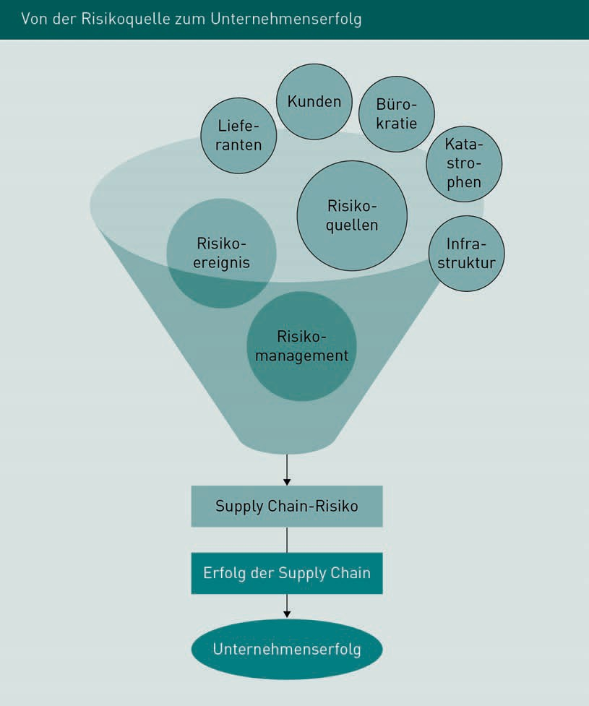

The above chart illustrates how a company’s success is determined by risks: A risk event arises from the various identified risk sources, i.e. an event occurs which triggers a risk. The timing and location of this event are identifiable. At this point, risk management implements risk mitigation measures to limit the supply chain’s vulnerability and minimize the risk. The less the supply chain is influenced by risks, the greater its chance of success, which in turn means a greater chance of success for the company.

Complex simulations may be used to scrutinize the problem from every perspective and gage how risks influence the supply chain and which events might trigger which impacts.

Summary

Global value chains are dynamic, occasionally fragile structures with numerous interdependencies that are influenced by many different market parameters. Alongside the globalization of the economy, competition between individual supply chains and the procurement of cheap raw materials and parts from developing and emerging countries, recent trends focus on single-sourcing and outsourcing. All these issues may hinder planned processes in a value chain and pose major challenges for supply chain management. It is therefore vital to implement a risk management system that can identify and resolve emerging risks early on. This requires the identification, forecasting, monitoring and control of vulnerable interfaces within the supply chain.

Risk sources which may impact the supply chain are classified into endogenous and exogenous factors.

Endogenous risks are those which impact the supply chain from within, while exogenous influences (i.e. those outside the supply chain) include customers and suppliers as well as disasters, infrastructure and bureaucracy.

Risk management is important for supply chains because it helps to minimize adverse influences which may impact the value chain and safeguard its long-term success.

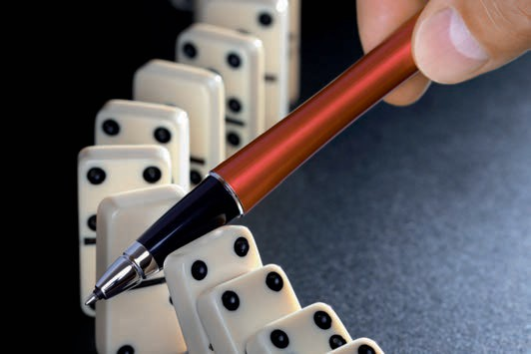

# Unit 7

## Risk Policy Strategies in the Supply Chain

#### STUDY GOALS

After working through this unit, you will be familiar with ...

… the risk management strategies available.

… what is meant by a risk control loop.

… the sub-sections of risk management.

… the meaning of a risk factor.

DL-D-MWCH02-L07

1. Risk Policy Strategies in the Supply Chain

### Introduction

In the area of risk management, there is a major divergence between necessity, acceptance and actual execution, so this task area is often neglected, despite being crucial for every organization to mitigate the adverse consequences of occurring risks (Schnorrenberg/Goebels 1997, p. 4 ff.).

A risk is an event which adversely impacts an organization and obstructs planned achievements. It also has a certain likelihood of occurrence and there are identifiable causes for its occurrence. To minimize the impact of potential risks, they must first be identified so that corrective measures (i.e. measures to mitigate potential damage) or preventive measures (i.e. measures to avert potential damage) can be planned.

To assist with planning measures, essential supply chain planning variables must be identified and targets set in connection with profit planning, anticipated costs and expenditure, and general framework conditions.

As previously explained, risks are events with adverse impacts. Risk management means identifying risks and employing suitable measures to evade, mitigate or counteract them. Risk management is used whenever there is a certain risk potential. Risk potential is based on three factors: A specific, well-founded threat; a weak link in the supply chain; and potential damage to a significant asset. If the likelihood and impacts of a negative event are unknown, it is classed as a hazard. The planned success of a supply chain is influenced by the likelihood of a risk scenario and potential resultant losses.

### Risk Management Within the Supply Chain

Unless an organization applies the risk management concept and function in the same way as crisis management (i.e. measures are only taken when there is an acute risk (=crisis)), the risk management system should come into play before risks are pending or arise. The success of risk management depends on the early identification and analysis of risks in a periodic process.

A lack of planning, unclear tasks, high levels of complexity and departmental egos are examples of potential risks that risk management must address but which are often neglected when designing a supply chain, potentially leading to major problems in active operation.

Risk Policy Strategies in the Supply Chain

The risk management process is illustrated with the example of implementing a manufacturing process for a new product and its impact on the supply chain.

Risk management begins within the context of strategic planning, i.e. at the concept development phase. Ideally, the aim is to identify all risks and use suitable analytical means to determine whether there is a balanced cost/benefit ratio when implementing the new product.

The concept development phase is followed by the decision-making phase, which begins with the decision to manufacture the new product and continues through the detailed planning and target-setting phase to the start of production. In this phase, risk management is responsible for identifying any special risks exist in terms of costs, deadlines, contractual structures or supply chain capacity. By this stage, there should be a detailed understanding of the various risks involved and counteractive measures to be taken in an acute situation. In practice, however, deficiencies often manifest themselves during this phase due to imprecise formulations in the contract, a lack of proper consensus between supply chain partners or other outstanding issues that have not yet been addressed.

This is followed by the "Go Live” phase of actual production, which reveals whether the concept development and decision-making phases have allowed for all eventualities. The speed at which new processes are integrated into the value chain and the diligence shown in preceding phases will determine the risk management effort involved. In principle, the next step is to consider all known risks and their development. If risk-controlling measures are considered necessary, they must be evaluated and their effectiveness checked. Any new or previously unidentified additional risks arising during the production process must also be periodically analyzed from a result perspective.

During the ongoing production process, risk management aims to promptly identify and describe any new risks, outline in detail the measures taken, evaluate their success and prevent the risks from occurring or minimize their impacts and probability. Exogenous factors play a more significant role during this phase. As this involves the manufacture of a new product, consideration must be given to quality aspects, for example, as some defects only become apparent when the product is used by the end customer. In this connection, warranty periods may also become risks. This phase also shows whether stated delivery dates can be met or whether production deviations are likely to cause longer production intervals and hence longer delivery times. All these points represent potential risks for the success of the new product and must therefore be addressed by risk management, especially as they may otherwise become very costly for supply chain participants.

Risk management itself comprises three key elements: Risk identification and analysis, the implementation of measures (i.e. control of emerging risks) and risk monitoring. These are illustrated in the following risk control loop diagram.

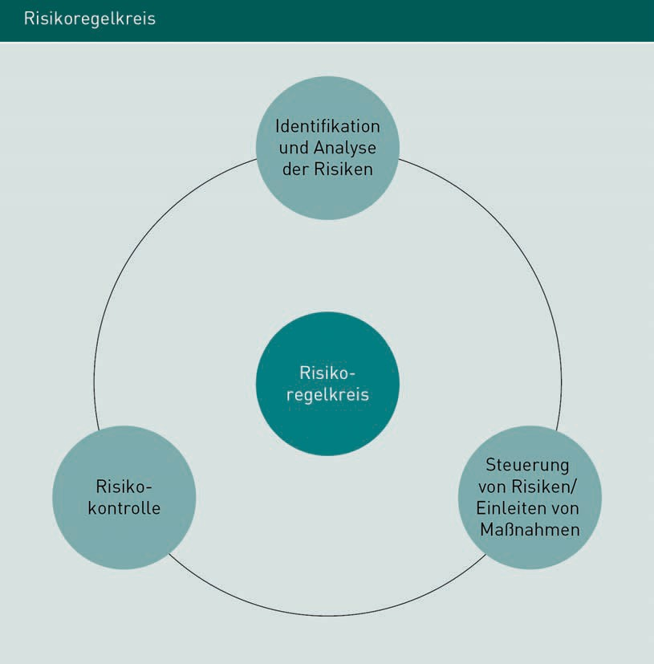

### Risk Analysis

Risk management uses a range of analytical techniques with differing costs and inputs. The information requirements also vary depending on the technique: Simple methods tend to fast and cost-effective, while more complex methods are often lengthy and costly to implement and require a high level of information. The advantage of the more complex techniques is that they produce sound, reliable results.

Risk Policy Strategies in the Supply Chain

Essentially, a risk analysis comprises three phases from which a specific risk catalog is generated: Risk identification, risk classification, and risk documentation.

Risk checklists are a tried-and-tested risk analysis technique prepared by a company based on its past experiences. They usually draw on historical records supplemented by more recent experiences. These empirical values are made tangible by documenting processes and deviations, ideally with detailed consideration of the triggers of any adverse influences or events.

Every product and service within a supply chain has specific risks depending on the market environment, however marginal the differences may be. For each of these individual risks, the checklists should be supplemented by a specific risk analysis. Product-specific risks or damage events may be triggered by error, intent or coincidence. All three areas are addressed using targeted questions to identify and eliminate specific risks, such as whether production is guaranteed within a certain time frame, whether all appropriate tools are available (these may differ from previous products (e.g. specialist tools) or may be required in greater quantities) or whether the new product is genuinely compatible with the previous range and/or how the new product might affect the substitution of established products.

From a commercial perspective, analysis will include topics such as currency stability (when importing supplier parts from abroad) or the effects of possible market price hikes affecting raw materials, while the human resources aspect investigates whether sufficient numbers of suitably qualified personnel are available or can be recruited.

Other key factors are linked to the corporate environment, such as legal requirements and standards, political risks and competitor behavior.

Signed contracts, quality awareness and adherence to deadlines by suppliers may also merit closer examination.

The risks identified in these search areas relate to the original activity and service segments involved in the product’s manufacturing. Risk analysis will produce a document outlining the potential risks, the interrelated causes and effects, the probable date of occurrence and requisite peripheral conditions, and the potential implications of one or more risks.

### Risk Assessment

Once the risk analysis is complete, the potential risks must be compared and evaluated using selected yardsticks supported by statistics. Risk assessment typically focuses on the dimensions of “extent of damage” and “likelihood of occurrence” and includes three different variants:

In variant I. evaluation is based on cardinal scalable variables (a scale using real numbers). A cardinal scale is also referred to as a ratio or interval scale because different values are placed in relation to one other. Calculating the transport costs per km is one such example. The distance driven in kilometers and the costs incurred are compared in € on a cardinal scale to produce an evaluation of the costs (= €) per km.

Variant II. uses ordinal scalable variables (also known as a ranking scale). The ordinal scale orders values in a sequence according to the order of certain factors, rather than absolute numbers. Examples of an ordinal scale include listing suppliers in order of reliability or listing employees in order of their length of service.

Variant III. uses nominal scalable variables (an enumeration with no evaluation, ranking or sequencing, for example: yellow, blue and red cars).

The advantage of cardinal scales is that they are the only of the three variants that can be calculated. However, they do not lend themselves to all types of risks. Changes in transport costs and the associated risk of reduced earnings can be quantified in figures. However, a failure to meet deadlines would also have to consider damage to reputation as well as the risk of contractual penalties. Because the impacts are so varied, in practice risk assessment often uses ordinal scales.

Risks that cannot be assessed on one of these scales are summarized in business terms. This type of assessment decides on measures without analyzing their potential impact. Risk assessment criteria may include brand awareness, company image or macroeconomic assessment criteria.

Risk Policy Strategies in the Supply Chain

### Risk Prevention

Once the project risks have been identified and analyzed, countermeasures are planned and initiated using a so-called TREE structure. The identified risks (Rohrschneider 1998, p. 1105) are individually assessed according to the following structure:

* Description of the risk
* Impacts of the risk
* Causes of the risk
* Risk mitigation measures.

Planned measures are usually classified into preventive and corrective actions.

Risk management measures are beneficial for the supply chain, but also incur costs. Consequently, risk management should always include a dedicated cost-benefit analysis. The supply chain risk level is decisive here – in other words, what is the potential extent of the impacts on the global value chain if the risk is not addressed, or how high is the residual risk when countermeasures are taken? Corrective measures usually limit the potential risk impacts, while prevention controls the likelihood of a risk occurring.

Risk factors facilitate a neutral assessment of a risk’s impacts and are calculated by multiplying its impact (I) by its probability (P). To measure the efficiency risk mitigation measures, determine the difference between the risk factors before and after implementation of the relevant measure. The greater the difference between the risk factors, the more efficient it is.

Fires pose a major risk in the wood processing industry. Minimizing the fire risk is therefore a top priority during the design phase. In this example, a sprinkler system was installed in the various plants, which reduces the severity of fire damage, but not the fire risk itself.

Company A presents the following risk factors:

Before: 10 (I) · 3 (P) = 30 (risk factor before sprinkler system). After: 9 (I) · 3 (P) = 27 (risk factor after sprinkler system). Difference between risk factors: 30 − 27 = 3

At company B, employees are additionally trained in the prevention of fires and fire damage. This produces the following risk factors:

Before: 10 (I) · 3 (P) = 30 (risk factor before sprinkler system). After: 4 (I) · 1 (P) = 4 (risk factor after sprinkler system). Difference between risk factors: 30 − 4 = 26

We can therefore conclude that the second measure is more effective than the first.

The cost-benefit analysis is prepared in tabular form and serves as a decision-making aid with risk mitigation measures.

|  |  |  |  |  |
| --- | --- | --- | --- | --- |
| Benefit evaluation: Measures versus risks | | | | |
| Risk | Benefit difference | Cost in T€ | T€ per benefit unit | Ranking |
| 1 | 60 | 29 | 0.45 | 1 |
| 2 | 45 | 47 | 1.05 | 4 |
| 3 | 40 | 32 | 0.80 | 3 |
| 4 | 27 | 42 | 1.40 | 5 |
| 5 | 25 | 14 | 0.50 | 2 |

After selecting the measures, they are assigned to the person responsible for implementation.

In practice, however carefully risk management measures have been planned, unforeseen acute events can occur which demand rapid damage limitation. These risks should then be carefully analyzed to prevent similar problems in the future or allow them to be rectified more easily. Risk management cannot anticipate every possible risk, because the market environment and internal supply chain tend to be very dynamic. As a continuous process, however, risk management helps to contain individual risks and limit the overall risk level.

Modern risk management uses special software to address risks that have already arisen and draw on past experiences to solve new risks. Simulations are also carried out to minimize potential risks. Depending on the scope of the program, extensive risk control options are also provided.

Risk Policy Strategies in the Supply Chain

Summary

Risk management entails identifying risks and employing measures to evade, mitigate or counteract them. Risk management is used whenever there is a certain risk potential. Risk potential is based on three factors: A specific, well-founded threat; a weak link in the supply chain; and potential damage to a significant asset. When planning measures, it is necessary to identify supply chain variables and define suitable targets for profit planning, anticipated costs and expenditure, as well as general framework conditions.

Risk management itself comprises three key elements: Risk identification and analysis, the control of emerging risks, and risk monitoring. These three elements are mutually interdependent in a continuous cycle and are depicted as risk control loops. Risk prevention is part of risk management.

Risk factors enable the neutral assessment of risk management efficiency. The risk factor is calculated by multiplying impact (I) by probability (P). To gage the effectiveness of risk mitigation measures, determine the difference between the risk factors before and after implementation of the relevant measure. The greater the difference between the risk factors, the more efficient it is.

Risk management is an important corporate management tool in fast-moving markets where value chains are subject to exacting demands.



# Unit 8

Systems Thinking and Simulation Approaches to Organizational Design

#### STUDY GOALS

After working through this unit, you will be familiar with ...

… what is meant by systems thinking and system simulations in organizational design within the context of system dynamics.

… why system dynamics is used in supply chain management.

… which other approaches are used in data warehouses for mapping a holistic supply chain with supply chain controlling and risk management.

DL-D-MWCH02-L08

1. Systems Thinking and Simulation Approaches to Organizational Design

### Introduction

Organizational design is a key strategic and operational management task for effective supply chain mapping with end-to-end controlling and risk management. Within the supply chain, corporate management, strategy development and organizational development are extended to include the development of technology and information management for all supply chain partners.

Particularly when mapping supply chain processes, it is important to promptly identify changes and make them transparent to everyone, since all areas are interconnected via interfaces, and the effects of any changes are not confined to directly impacted units. Effects both positive and negative can ripple out through the entire supply chain with a time delay.

Some findings dating back to the 1950s remain valid to this day in the field of organization, organizations and organizational design. During that era, motivation to work was in crisis and companies began to question monotonous processes with an extreme division of labor. This prompted a radical rethink of the role of humans in production and in companies, accompanied by the introduction of the first electronic production controls. Even today, when designing production systems and company organizations, research centers around collaboration and the human motivation to work, the extent of automation and human/technology relationships.

Back in the early 1980s, organizational development experts in Germany devised now-familiar supply chain management approaches and incorporated them into organizational design. For the first time ever, the organization, its people and its products/services were viewed as a single entity and their relationships and interdependencies were mapped. In modern-day supply chains, organizational development incorporates strategic aspects, in recognition of the weaknesses of earlier systems in the 1980s and 1990s.

### Fundamental Principles of Organizational Design

An organization’s basic structure is based on five pillars: 1. Task structuring, followed by 2. Integration of human resources and processes then 3. Linking to the requirements of society, technologies and the environment, 4. Compliance with all formal expectations such as laws and regulations, contracts and agreements, corporate mission and vision and finally 5. Change and its management by all participants in the organization.

Systems Thinking and Simulation Approaches to Organizational Design

The term organization encompasses three different approaches: institutional organization (such as an institution, government authority, political party or church); structural organization; and functional/instrumental organization. Structural organization means that the company or supply chain already has a procedural and organizational structure in place. Core and secondary processes are anchored in process descriptions, manuals, and other guides. Organizational charts and hierarchies will have already been drawn up by supply chain management and summarized in role and job descriptions.

The actual task of organizing falls into the third category: functional/instrumental organization, whereby organizational activities are assumed on behalf of a third party. For example, a call center might provide scheduling on behalf of an insurance company, or a forwarding company might manage shipments on behalf of an industrial customer.

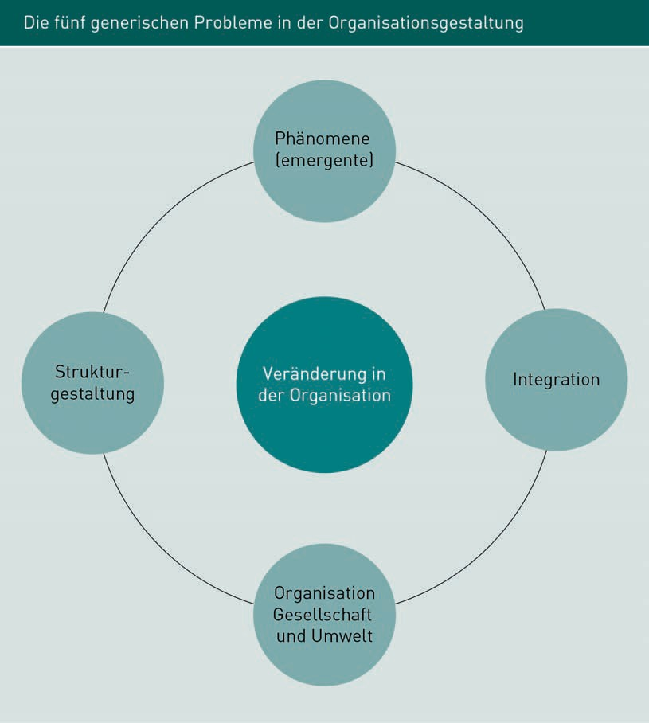

Organizational design is continually evolving among companies and in the supply chain. Its development is individual and may be triggered or caused by change, or may itself effect change, and/or may include measures to tackle change.

As early as 1918 Henry Fayol wrote the "14 Principles of Management" (Fayol 1963 [1918]), the pillars of which now form the basis of general organizational principles, organizational design and simulations of organizational design. Simulation models are used to predict strategic and operational impacts and facilitate controlling and risk management in complex supply chain systems.

Systems Thinking and Simulation Approaches to Organizational Design

### System Dynamics: Systems Thinking and Simulation

One fundamental principle firmly anchored in supply chain management is the holistic view of strategic and operational approaches. System dynamics is a technique designed to assist companies, supply chains and managers with mapping complex correlations through systems thinking and system simulations. Potential management-level decisions in the global value chain are derived, analyzed and simulated. A final decision is made with the simulation results in mind.

The systemic approach enables humans to recognize interactions and identify linear causes (i.e. chains of effects). Visualizing even the smallest system components can aid understanding of complex and dynamic systems and even the comprehension of counterintuitive behavior.

People tend to think in linear patterns. Systemic thinking is a non-linear, complex way of thinking with feedback structures. Interactions and causes of behavioral patterns are revealed by its multidimensionality, supported by the overarching architectures of quantities, qualities and other dynamic components.

Feedback is based on mathematical equations and forms the basis for quantitative modeling of interactions which are subsequently visualized in causal diagrams.

Feedback is therefore a "method of self-control in or via the development of control loops.” The system status (actual value) is checked, and if it deviates from the target, countermeasures are implemented. Feedback which allows a system to automatically self-correct within limits is known as a negative feedback loop; by contrast, positive feedback loops will cause the system to explode or freeze" (Fees 2010).

###### Fundamental Principles of System Dynamics-Based Simulations and Application Areas

A “system” is the main component of general systems theory as the basis for system dynamics-based simulations. Ulrich defines system theory as "the study of the structure, network structures and behavior of systems" (Ulrich 1970, p. 105), whereby "systems" refer to interrelated entities within a coherent whole which are ranked or sequenced in relation to one another or interconnected.

Systems thinking

= qualitative

System simulation

= quantitative

Simulation is an indispensable aspect of supply chain management and the principal tool for successful controlling and risk management. Simulation is a vital tool in many corporate divisions for simulating and investigating economic, scientific, technical and natural processes. A business administration dictionary defines simulation as follows: "[…] Simulation entails performing experiments on a model of reality to gain insights and subsequently exert a targeted influence on the real-life system" (Wittmann 1993).

The terms “model” and “simulation” are not synonymous. A model is a representation of a system, while a simulation imitates its utilization procedures. Simulations are subdivided into computer simulations which perform a series of tests according to specified decision-making rules, and simulations which combine human actions with technological support.

In the context of supply chain management, model experiments and simulations are often used as strategic decision-making tools when forecasting change management and optimization potential. In operational business it would be too expensive and risky to conduct real-life experiments due to the potential loss of customers or damage to reputation with a live version of a project.

Scientists are keen to examine the correctness of the simulation results. "Validity is an important criterion for the legitimacy of a scientific study and its results. A study is considered valid if it genuinely measures what it is supposed to or if the data collected reflects the issues being researched. A measurement tool which is very accurate but measures the wrong thing, is reliable but not valid. Consider an example where students are asked for their school grades. This will not necessarily produce a valid yardstick of the actual data. This would require consideration of individual students’ school reports. Alongside validity, other important criteria for gaging the quality of scientific investigations are reliability and objectivity (paraphrased from the definition of validity in a statistics dictionary).

Simulation calculations have a practical benefit, for example, when examining special events in supply chains and deriving potential counter-strategies as illustrated by the following example (Klink et al. 2020).

The Use of Simulations When Restarting a Supply Chain Following a Disruptive Event

The COVID19 pandemic gave a stark reminder of the high level of interdependency between companies worldwide due to the high division of labor in the global economy, and the fact that bottlenecks in one industry can restrict production in other industries.

Systems Thinking and Simulation Approaches to Organizational Design

Measures to isolate people, limit contact with others and consciously shut down certain aspects of public life radically impacted industry, trade and logistics: Restrictions on activities in seaports disrupted the global circulation of containers, so that some parts of the world were in desperate need of freight containers for the onward transport of finished products, while others had containers available but they could not be transported at all or in time. Concurrently, international air passenger volumes decreased, and many passenger flights also used for shipping cargo ("Bellyfreight") were canceled, meaning that air freight capacity was scarce. The cost of both air freight and sea freight increased as a result.

How to resume normal operation of supply chains after such events is a highly relevant issue for many companies. Specifically, these types of situations can produce the following problems:

* Information about the precise status of interrupted production is incomplete and unreliable, especially regarding stock levels and ranges of primary and intermediate products. Suppliers’ ability to deliver is also unclear.
* Previously used transport chains may be unavailable, unreliable or costly.
* The company finds it hard to plan utilization of its own production capacities because the supply of upstream products is disrupted. In addition, some personnel are unavailable for various reasons (e.g. unwell with COVID-19 or unable to travel to work due to transport issues).
* The in-house control and organizational structures are designed for standard operation. There are no plans for a rapid, complete production shutdown and subsequent restart, and this can prove difficult to overcome.
* Demand volumes from supply chain partners (providing the basis for production planning) entail huge uncertainties.

This gives some indication of the potential benefits of simulations. A simulation model can map the supply chain with all its dynamic processes and perform experiments on it. Simulations allow us to analyze specific moments in time ("What storage range for product X will we have on day Y at site Z?") and developments over the course of time ("How will the capacity utilization of plant X develop from week Y to week Z?"). It also enables the mapping of stochastic effects, e.g.

uncertainties about adherence to delivery dates or the availability of personnel. Conditions in the simulation model enable the calculation of typical control KPIs, helping decision-makers to gage the supply chain’s responses. Simulations are therefore ideal for comprehensively analyzing the effects of exceptional circumstances on a complex system such as a supply chain and the possible countermeasures, which in turn supports decision-making.

Simulation is a cross-sector, interdisciplinary field found at all supply chain interfaces, spanning all spheres of responsibility and all units.

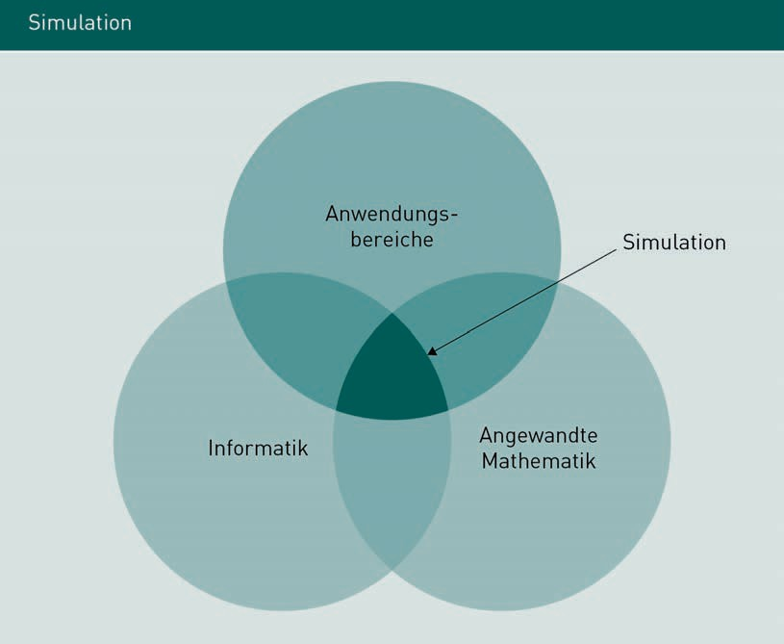

We generally distinguish between three simulation types as follows:

a) Human-human simulation or role play, b) Human-machine simulation or management game, c) Computer simulation (Wordelmann 1978, pp. 149 ff.).

The key factors here are the degree of formalization of the simulation model and the extent to which human behavior is incorporated into the simulation.

Systems Thinking and Simulation Approaches to Organizational Design

### Active Data Warehousing as a Technological Approach to Supply Chain Controlling and Risk Management

In supply chain controlling and at the interface to risk management, all analyses, ideas, strategic and operational decisions are based on shared, up-to-date, holistic sources of data and information.

Whereas in the past a simple reporting system for company data would suffice, today’s databases offer much more than just conventional master data and historical data, especially in the diverse supply chain environment. The latest databases serve as a platform for all data and information flows from enterprises or, more broadly, from supply chain architectures. An active data warehouse is capable of processing multiple different systems. Data and information flows from all operational, scheduling-related and strategic processes are mapped and KPIs are developed for supply chain controlling.

Naturally, conventional databases still have a role to play, but are supplemented by the aforementioned active data Warehouse, which operates at a higher evaluation level. Areas of the supply chain may be mapped together with strategies, such as decisions about decentralization versus centralization of corporate divisions, processes, real-time processes and related process communications, data qualities and other areas.

The term “data warehouse” covers all information systems, from local reporting to the multi-dimensional architecture of complex networks, which are mapped on different platforms and then merged. In terms of complexity, this enables the integration of applications alongside standard mapping such as data management or data mining. Based on the requirement profiles, all supply chain possibilities, effects and causes can be mapped and controlled.

At the next level of evaluation, developers and researchers aspire to up-to-date, real-time data throughout the entire database and a holistic supply chain for all participants. This would mean incorporating all operational processes, controlling all campaigns and actions, integrating all downstream and upstream business processes, and centralizing redundancy-free data records and aligning, aggregating and refining them at different levels (to give just two examples).

The conventional data warehouse is built on four pillars. Pillar one includes data storage. Pillar two is for mapping processes. Pillar three adds technology while pillar four describes the organization of the company.

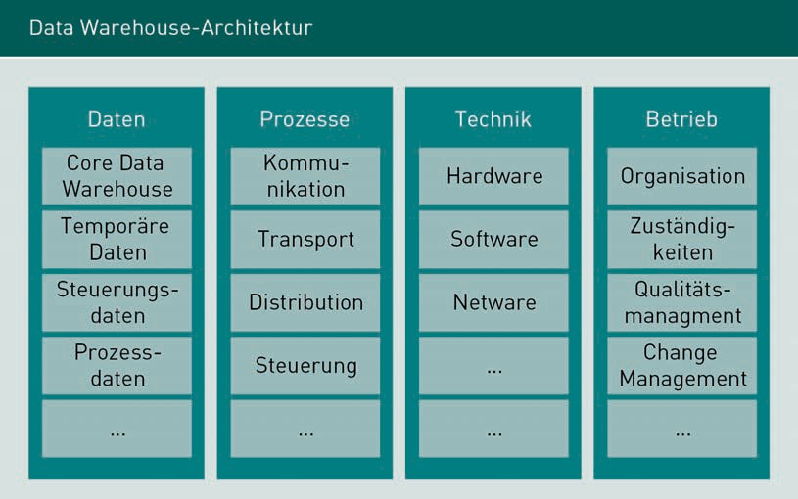

###### Individual Levels of Data Warehousing

Data architecture is primarily concerned with naming the created data layers. The data layers are always concerned with a) a comprehensive view of (all) data and b) the depth of data to be stored. For example, in the case of application data or control data, metadata or process data is stored. The following diagram, "Data architecture in nine points", comprehensively illustrates the architecture and data layers.

Systems Thinking and Simulation Approaches to Organizational Design

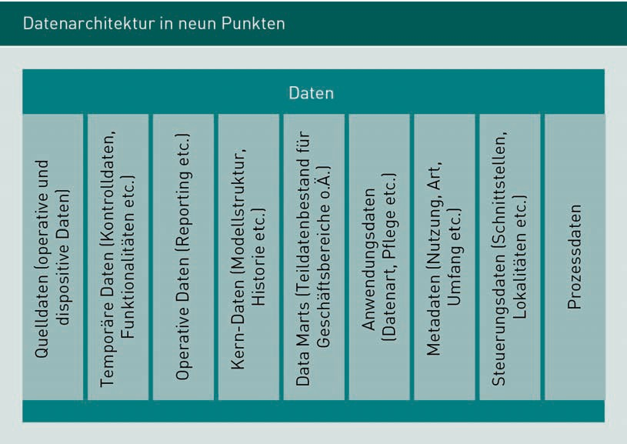

The technical architecture depends on the choice of hardware and software components and network type. Decisions regarding tools and protocols are made here. Within the technical architecture, the data warehouse options for all supply chain participants are shown.

The next level within a data warehouse is the operational level. An active data warehouse can map and accompany the organization’s entire operations (in this case, the supply chain landscape). A record is made of the processes and responsibilities, followed by a record of the organizational structures and procedures. The roles and tasks of each participant are defined, described and saved. Resource planning and reporting can be retrieved for simulation and evaluation purposes, thereby ensuring that meaningful strategic and operational information is continuously available. At an organizational and operational level, depending on the particular concerns of the supply chain, support is provided with mapping and control of organization and responsibilities, operations, change management, configuration management, test and process management, and communications and documentation.

The next level intensively addresses the individual operational concerns and tasks of each supply chain participant. This level aspires directly to the next level, which then regulates the internal procedures for each division within each supply chain participant’s operations.

This brief data warehouse presentation illustrates how a shared platform can map a holistic approach to supply chain management, chain risk management, and controlling. At the same time, this approach also elucidates that fact that the multiple different technologies existing among shareholders can make the journey to the data warehouse costly and time-consuming.

Summary

This lesson explains the technologies used to map, simulate, control, and organize the various different concepts involved while also considering the different stakeholders in a complex supply chain. Each participant must be able to weigh up the relevant risks and opportunities and act within the framework of their specific role and budget. Control functions should be applicable to everyone jointly. Strategic and operational (joint) processes must be mapped. The common supply chain goals are pursued and analyzed, always with a view to the overall architecture of the value chain. The system dynamics approach provides a basis for decision-making, as a technique to support companies, supply chains and their management teams in mapping complex correlations through systems thinking and system simulations. System simulations may be employed as a control tool and as a means of assessing possible risks. Other tools are available for planning, control, and monitoring of the shared value chain platform. The data warehouse is a holistic technological approach for monitoring an organization with internal and external stakeholders via a shared architecture.