**The Mask as a Shield Against Loneliness –** in the paintings of Chaya Agur[1]

Dr. Bina Nir

**Introduction**

W the advent of individualism in its modern sense, human beings may have become freer, but they have also become lonelier. Many are still willing to sacrifice their privacy, their liberty, their independence and their right to free thought and self-determination, all for the sake of a perceived sense of identity and belonging to the herd, rather than suffer loneliness.[2] Humans are constantly is search of simulated identity, argues Sartre, out of the fear of singularity – they are creatures of the masses.[3] No matter how low he has to stoop, man will take every measure so as not to stand out from the crowd, else he might find himself facing his own image.[4]

With the democratization of the political regimes in modern Western society, a process which anchored anthropocentrism as the dominant worldview in the West, the question arises whether individualism is a true expression of freedom in that it allows each person to fully experience their uniqueness, or whether individualism nowadays is a mere illusion, an example of wishful thinking, or an unconscious mask we don to protect ourselves from loneliness.

The culture of consumer capitalism encourages authentic individualism on the one hand, but, on the other, also promotes the tendency towards conformity. “Identity,” according to Illouz, has never been so fashionable. Consumer society allows us to change identities in an instant, and as a result, any identity we assume is subjected to a constant onslaught of skepticism and uncertainty. Consumerism puts at our disposal such a wide range of possible identities as to make the whole question of identity seem almost arbitrary.[5] In this article, I will examine various examples of simulated identity, while focusing on the role of the “mask” (the image we strive to present to the world) as a shield against loneliness – as expressed in the paintings of the contemporary artist Chaya Agur.

**Loneliness, the individual and society**

Loneliness is generally perceived as a psychological state of sadness and melancholy due to a lack of company. Robert Weiss, however, points out that loneliness is not caused by one’s state of solitude, but by a life that lacks fulfilling social relationships.[6] Loneliness is a subjective experience that is not paramount to social isolation; rather it stems from a deficiency in the individual’s social connections. Social loneliness is also not necessarily identical to psychological loneliness, and certainly not to creative solitude, or the solitude one seeks in order to examine one’s self. A person can be socially isolated and lead a fulfilling and intensely creative mental life. That being said, solitude is good when it is intermittent, when this private domain exists alongside friendship ties, when it does not take over one’s life, but is rather a coveted and voluntarily chosen part of it. People who have rich inner lives do not feel lonely when they are alone.

However, the encounter with the other is also important for one to be able to create him or herself as an individual. The process of revealing one’s self to the other is accompanied by discomfort and sometimes even pain. The other is not just another person located outside of the self, but the internalized other who resides in the hidden regions of the I-experience. The interaction created between the “I” and the “other” begins with recognizing the “I” as an individual, as the self. The general mechanism through which the self can develop is reflexive – it is the ability to examine one’s self through the eyes of others.[7]

**The individual, society and the mask**

Jung utilizes the term “persona” to refer to the social face that an individual presents to the world. In its original Latin meaning, “persona” is the mask that an actor puts on in order to play a role. According to Jung, it is but a fragment of the collective mind that one puts on (and which often takes great effort to remove) in order to create the false impression of individuality. The “persona” is not real – it is a compromise between the individual and the way society dictates a person should appear.[8] People rely on the mask of the “persona” to play their social role. The mask allows them, ostensibly, to belong and to escape their loneliness. Similarly, existentialist philosophy deals with self-alienation and the masks that individuals don in society out of shame and out of the fear of the gaze of the other, as Sartre illustrates well in his play *No Exit*.[9]

Carl Jung and the Jungian school of psychoanalysis use the word persona to designate the mask or the image we adopt in presenting ourselves to the world. Human beings choose, sometimes, to don a social mask in order to be deemed more acceptable to society. Consequently, Jung warns against heavy reliance on the “persona” device. He expresses concern that such overuse might lead one to lose one’s true personality in favor of one’s “persona”. That individual risks being swallowed up by this simulated image and becoming an artificial being, a victim of his or her own undoing.[10]

The mask also protects us from the fear of emptiness and meaninglessness.[11] One of the ways of escaping this void is to assume an identity - a protective “persona” that gradually solidifies and becomes permanent. According to Jeansen, as long as the social “actor” wearing an artificial mask is aware that he is playing a role, everything is ostensibly fine. However, if the person underneath the mask forgets that the mask is a fiction, they will no longer be able to fully grasp or fulfill themselves, and over time will come to realize their fundamental loneliness and even more so – their falseness.[12]

**The mask in the paintings of Chaya Agur**

The “Masks” series by the painter Chaya Agur, painted in the years 2001–2004, deals with the intricate relationship between the individual’s inner personality and his or her social mask by exploring, with a critical eye, the wide variety of “masks” one uses in different social situations; they are in fact images of the “masks of the soul” donned by the individual.[13] The mask, as depicted in ten works from Agur’s “Masks” series, becomes, in the painter's perspective, representative of the individual’s simulated identity, behind which he or she is hiding, having lost sight of his or her authentic identity. Through these works, Agur issues a criticism of contemporary society and warns us against overusing the “persona” device, similar to Jung's aforementioned claim that a person overusing the mask risks losing his or her true personality in favor of the “persona”, thus becoming an artificial being.

**“Expensive Hat”, mixed media, 30x40**

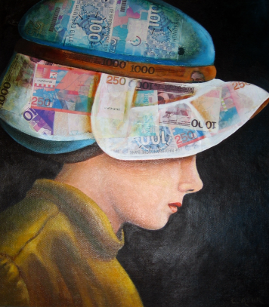

This painting, produced using mixed techniques, depicts a woman whose face is partially obscured by the titular “expensive hat”, representing capitalism. The image is a criticism of the overabundance of identities proffered to us in the age of consumerism – in other words, identity becomes yet another product for people to consume. In some senses, individualism too has fallen victim to the influence of the identity market in which the “I” is traded like so many other consumer goods.[14] The person becomes a brand, and identity becomes a “false need” – to borrow the term Marcuse’s uses in his book *One-Dimensional Man* – that he or she assimilates without even realizing it.[15] Marcuse, in his critique of consumerist ideology in the capitalist age, argues that manufacturers no longer care to address people’s real needs; instead the advertising industry creates the illusion of need in order to persuade people to buy products they don't actually need. These “false needs” perpetuate injustice, aggression, wastefulness, and the obsession with work. They prevent change from happening because change is only driven by real needs. Thus the industry concerns itself not only with manufacturing products but also with creating the need to consume them, the need to succeed, obtain, purchase.

**“Variations on Zoomorphism” (Cow-man), black and white drawing (46x33)**

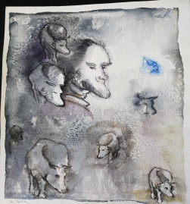

This humorous study by Agur is the visual interpretation of the literary device of “zoomorphism” – or “rhinomorphism” as it happens to appear in Eugene Ionesco’s 1959 play *Rhinoceros*,[16] a play that focuses on the scientifically proven phenomenon of conformity.[17] In the play, Ionesco expresses his dread of ideological conformity by presenting it in its extreme with his theatre of the absurd. The play critically portrays society as one that causes people to voluntarily relinquish independent thought, to assimilate in order to belong rather than feel lonely and left out. Agur, in turn, presents her criticism of the phenomenon visually. Conformism can cause a person with a "human" face, that is, a face that represent humanist values, to undergo a gradual and imperceptible metamorphosis into a cow (or a rhino…). It is a criticism of the modern herd mentality. As Zizek warns, contemporary society, which is based on market forces rather than humanist values, can only move in the direction of easy, animal-like pleasures and therefore its values are bound to degenerate.[18]

This, then, raises the question of whether today, in the age of social networks, with the pull of the herd being stronger than ever, it is still possible to detach from the collective, “inclusive” element of our natures and whether the possibility for the individual to define him or herself separately from the herd still exists.

As time passes, man finds himself in a new social state called “alone-together”. This is a social illusion which allows the individual to feel connected to society when in fact this connection is superficial and vague – a substitute for authentic and intimate inter-personal conversation. The individual chooses the precise extent to which they reveal themselves.[19]

**Carnival”, oil on canvas 40x60**

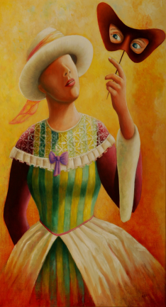

**“Carnival”, oil on canvas 40x60**

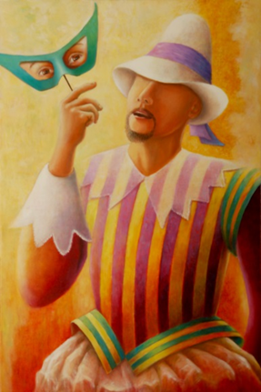

In this diptych, both the woman and the man are dressed in Renaissance clothing. The eye masks that each of them hold in their hands are typical of the Venetian carnival. When the masks are removed, they have no face – the eyes continue to look at the world through the perspective of the artificial persona. Even though they are already wearing costumes, they still need to hide the authentic truth peeking out of their eyes. The masks therefore represent the element of the assumed persona – they are made to impress, to hide the truth and to meet social expectations.

For Agur, the faceless figure behind the fixed, simulated identity of the mask is a recurring motif. The mask is personality, but it is also of course the illusion of identity as the Italian playwright Luigi Pirandello reveals in the series of plays entitled *Naked Masks*.[20] In his eyes, man is always wearing a mask, without meaning to and without being aware of it, yet the mask itself is naked, because nothing about it is real.[21]

“Carnival” for Agur expresses the idea that society gives one the mask, but also the chance to escape by means of the carnival, an event celebrated in different forms all over the world. The purpose of the carnival is to allow the individual to step out of his or her everyday personality in order to identify with that which he or she is not – it is a game in the theater of life. The struggle for survival makes life oppressive, while the carnival helps one to unload the stress of it all. It is liberation, Nitzsche’s Dionysus.

**“Body Language”,** **oil on canvas, 50x60**

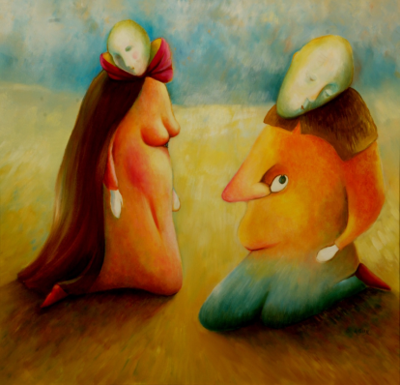

In this painting, Agur explores the truth of the body as opposed to that of the conscious mind – the human body has the ability to express nature’s “truth” even when our consciousness attempts to hide it. Our basic survival impulses, or the vulnerability of our subconscious when it feels exposed and threatened, express themselves in uncontrolled emotions such as anger, shame, and lack of confidence, all of which burst out into the open as “body language” even while we wear the mask or the persona of conscious behavior on our faces, and in a way that sometimes contradicts it. While, according to Samy Molcho, we have control over our faces and our speech (for instance, we are able to smile while we are angry), the body is the reflection of the soul and its language speaks from the heart.[22]

This is unlike the persona, which varies from culture to culture and from social class to social class and is personality-dependent. In the painting, this idea is expressed through the bodies being depicted as the actual true “face” of the person, speaking its own language, while the faces on the couple’s heads are depicted as drooping, lifeless masks. Any real communication between the two takes place by way of their bodies.

**“The Mask as an Escape from the Other’s Gaze”, oil on canvas, 50x70**

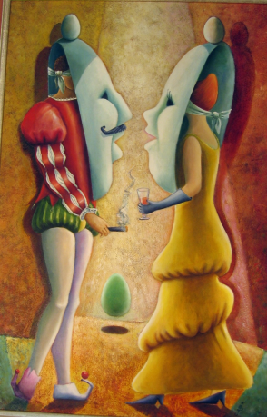

The couple wearing the giant masks in the painting are very much aware of the existence of the masks behind which they are hiding. Their real identities are purposefully concealed at the moment of contact because they are afraid to reveal their true selves. As we said earlier, according to Jung, the “persona” is a complicated relationship between an individual consciousness and society, a kind of mask the purpose of which is to impress those around us, on the one hand, and to hide our true natures, on the other.[23] Our intense desire to belong to the other in a meaningful relationship and to avoid the pain of loneliness makes us afraid of revealing our true identities and causes us to hide behind a giant mask that we wield like a shield against loneliness. Social interactions require people to act out a variety of roles on a variety of stages. Goffman terms this phenomenon “audience segregation”, referring to a situation in which an “actor” has to present different but coherent self-images to different audiences.[24]

**“Face Fan”, oil on canvas, 50x70**

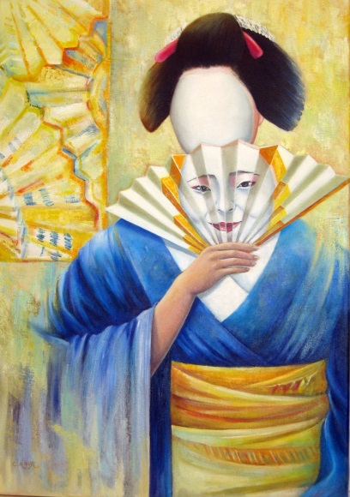

In this painting, the mask, the fan, and the traditional Japanese costume all represent a culture that is highly polite and ritualized, one that prescribes very strict rules of behavior in all aspects of life, which is why the persona is depicted as attached to the fan. The mask here represents the ritual dimension of society. When a society forces the individual to act in accordance with strict rules of conduct, it makes it difficult for the individual to develop any kind of authentic identity. In this critique, Chaya Agur represents a faceless figure under the mask, a figure devoid of unique identity, signifying that in a society which imposes its rules on the individual it is challenging for the individual to make the distinction between societal and personal, individual values.

**“Eve”, oil on canvas, 50x70**

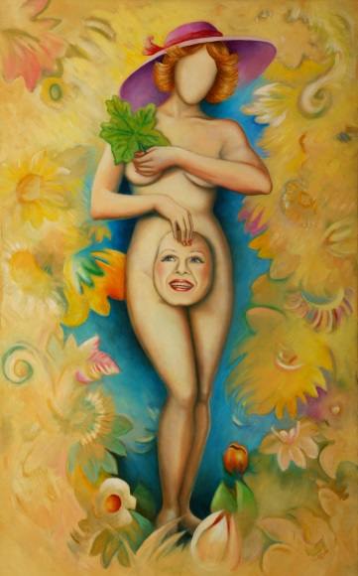

Eve is a universal symbol – she represents the primordial shame of being aware of one’s genitals, which in this case, are symbolic of personal exposure. The figure in the painting is a modern Eve (judging by her hairstyle and hat) hiding her nakedness with a mask of personality rather than a fig leaf. Here, the painter makes the distinction between physical nudity, which can be concealed with a garment or a fig leaf, and our primal need to conceal our inner nudity from the world with a protective persona. The Garden of Eden is a formative myth in Western culture; it symbolizes the beginning and the aftermath, the origin of foundational patterns and their violation, the space of sin, retribution, and longing. Moreover, the myth of the Garden of Eden touches upon basic universal questions, including the question of the relationship between the individual and society, and the process of revealing one’s self to the other, which is always accompanied by discomfort and even pain.[25] This painting depicts, on the one hand, the origin of shame as bound up with self-knowledge, the same knowledge that is the source of pain in life outside of the Garden of Eden: “And the Lord God commanded the man, saying: of every tree of the garden thou mayest freely eat;but of the tree of the knowledge of good and evil, thou shalt not eat of it: for in the day that thou eatest thereof thou shalt surely die.”[26] On the other hand, with her modern day styling, the Eve in the painting represents sexual liberation and the freedom from the need to hide one’s nudity. And yet, despite being free of the requirement for bodily concealment, according to Agur, the persona is more indispensable than ever. Modern Eve represents the awareness of nudity in its inner sense, the exposure of one’s soul that no clothes can hide.

**“Changing Faces”, oil on canvas, 60x80**

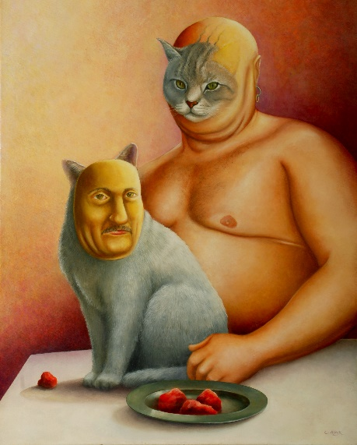

This painting represents our ability to adapt ourselves to our surroundings and the general flexibility of our psyche. On the one hand, identity contains an element of rigidity that impedes communication because some identities are fixed around a central trait that precludes adaptability (such as power, control, etc.). These identities are hard to deal with, both for the individual and to the outside world, and can cause difficulties, examples of which abound throughout human history. On the other hand, the psyche also has that great capacity for flexibility which allows it to adapt and emulate as necessary.

In the painting “Changing Faces”, Agur presents a comical depiction of a cat and its owner as a couple who have assimilated to each other over the course of time. Assimilation within the couple often creates a common identity that includes identical social preferences, reactions, values, tastes, lifestyles etc. – all of which attest to, on the one hand, a deep physical and mental adaptation to each other, and on the other, a loss of individual identity. Man trains the cat to act more human, while he, in this instance, takes on catlike traits. Both are depicted eating the same food, which happens to be raw meat.

1. The painter Chaya Agur, was born in Israel and lived in the Netherlands for 35 years. Since she has 1978 exhibited her paintings regularly in the Netherlands (Amsterdam, The Hague and Rosendale) and throughout Europe (Paris: The World Center for Contemporary Art, Nancy: Galerie Poirel, Barcelona: Marlborough Art Gallery). In Israel, Agur exhibited at the Municipal Gallery in Afula in 2009 and at the Jerusalem Theater for the Performing Arts in 2010. From 2002 to 2007, she ran a private gallery in central Amsterdam, "The Crane", and taught painting and drawing in her private studio in The Hague for many years. Agur, uses mixed techniques, oil paints, watercolors and drawings. Her art is influenced by Dali and Chagall and her style can be called surrealist-symbolic.
2. Fromm, *Escape from Freedom*.
3. Jean-Paul Sartre, *Being and Nothingness: An Essay on Phenomenological Ontology*, trans. Hazel Barnes (New York: Philosophical Library, 1956).
4. Ibid.
5. Eva Illouz, *The Culture of Capitalism*, Hebrew (Tel Aviv: Universita Meshuderet – Ministry of Defense Press, 2002).
6. Robert Stuart Weiss, *Loneliness: The Experience of Emotional and Social Isolation* (Cambridge, MA: MIT Press, 1975).
7. Martin Hollis, “Of Masks and Men”, in *The Category of the Person* ed. Michael Carrithers, Steven Collins, and Steven Lukes (Cambridge, UK: Cambridge University Press, 1993), page numbers; George Ritzer and Douglas J. Goodman, *Sociological Theory (6th edition)* (Boston: McGraw Hill, 2003).
8. Carl Gustav Jung, *Psychology of the Unconscious*, trans. Beatrice M. Hinkle (New York: Moffat, Yard, 1916).
9. Jean-Paul Sartre, *No Exit and Three Other Plays*, trans. S. Gilbert (New York: Vintage International, 1989).
10. Jung, *Psychology of the Unconscious*.
11. Paul Tillich, *The Courage To Be* (New Heaven: Yale University Press, 1952).
12. Francis Jeansen, *Sartre Par Lui-même*, French (Paris: Seuil, 1960).
13. Sue Jennings and Åse Minde, *Art Therapy and Drama Therapy: Masks of the Soul* (London and Philadelphia: Jessica Kingsley Publishers, 1993).
14. Strenger, *The Self, A Branding Project*, 42.
15. Herbert Marcuse, *One Dimensional Man* (London and New York: Routledge, 2006 [1964]).
16. Eugène Ionesco, *Rhinocéros*, French (Stuttgart: Gallimard, 2014 [1962]).
17. Vernon L. Allen and John M. Levine, “Consensus and Conformity”, *Journal of Experimental Social Psychology 5* (1969) 4: 389–399.
18. Slavoj Zizek, *Welcome to the Desert of the Real* (London and New York: Verso, 2002).
19. Sherry Turkle, *Alone Together: Why We Expect More from Technology and Less from Each Other* (New York, NY: Basic Books, 2011).
20. Luigi Pirandello, *Naked Masks: Five Plays*, ed. and trans. Eric Bentley (New York: Plume, 1957).

   
21. Luigi Pirandello, *One, None and A Hundred-Thousand,* trans. Samuel Putnam (Whitefish, MO: Kessinger Publishing, 2005).
22. Samy Molcho, *Body Speech* (New York: St. Martin’s Press, 1985).
23. Jung, *Psychology of the Unconscious*.
24. Erving Goffman, *The Presentation of Self in Everyday Life* (New York: Doubleday, 1956).
25. Ritzer and Goodman, *Sociological Theory (6th edition)*.
26. Genesis 2:16–17.